FIGURING OUT OF SUPERIOR MATCHING CARDINALITY IN SELF-SIMILARITY CANTOR SET AND HILBERT CURVE
P.Tharaniya¹
¹Assistant Professor, Department of Mathematics, Rajalakshmi Institute of Technology, Chennai, India, tharaniya.p@ritchennai.edu.in

ABSTRACT
This chapter's goal is to provide more insightful knowledge about numerous fractal Graphs. It examines angles, edges, and structural implementation for two distinct fractal graphs which is cantor set and hilbert curve. One of the more significant and broad topics in graph theory is matching. One of the main assessments is the evaluation of superior matching set and its cardinality for the graphs cantor set and hilbert curve. It determines that the fractal graph's constant formulae are followed for all iteration depends on the vertices and the edges. Theorems provided for superior matching, as can iterative methods for determining it. Real life application of superior matching in cantor set and hilbert curve are explained in detail.
Keywords: Matching, Fractals, Vertex, Edge
AMS Classification key:
- Introduction

Recent research area of graph theory is fractal graphs. [5] The majority of physical matter in the arctic and in nature lacks euclidean geometry's correct geometric shape. There are numerous approaches to define, compute, survey, anticipate, and forecast such natural phenomena using fractal geometry. The main component of nature's construction is fractals. Fractals are found throughout the natural world and demonstrate the essence of our existence. Even those who are unaware of it have witnessed fractals in their lives. The natural elements of our world, like trees, rivers, plants, the landscape, leaves, and so forth, cannot be reduced to geometric representations. The main focus of graph theory is matching. It has numerous real-world applications in fields like computer science, architecture, and medicine.
  - Related works
Graph theory is a vibrant branch of discrete mathematics, with applications ranging widely across social science, natural science, computing, and other fields.[3]. [1] determined the maximum and maximal cardinality of matching in a variety of graphs, including the wheel, cycle, null, regular, complete, and star graphs. In fractal graphs like the Sierpenski triangle, Sierpenski arrowhead arrow, and others, the maximum matching cardinality has been assessed. The edges and vertices can be used to derive the formulas.
[4] looked up information about the cantor set's and cantor function's history in the literature on cantor yields. [2] Examines the cantor set using the dimension of a box count. By taking a piece out of [0,1], it can be built. [5] Provided an introduction to fractal theory and its practical applications in mathematics. Two parts make up this. The general theory of fractals and their geometry is covered in Part I. The book's second part includes fractal examples, self-similar fractals, function graphs, Julia sets, random fractals, and applications. More interpretive are the effective length and variations of this type of self-similarity fractal antenna design.[6] It is better than other antennas available on the market. It is capable of transmitting electromagnetic radiation throughout its whole surface area. Metamaterial was used to construct the Hilbert Curve.

1.3 Matching
In Graph Theory, collection of non-touching edge from the graph is called as matching. [1] The set of collection of drawing non adjacent edges from the graph is called matching. Maximum matching cardinality is the number of edges of the matching set. The matching that cannot permit the allowance of even a single edge is known as superior matching. [9] In the provided graph, however, those edges are adjacent to every vertex; not a single vertex is absent from their adjacent pairs. The maximum matching cardinality of this set is the number of edges that belong to it.

2. Cantor set
A unit line segment it is called a cantor set. [4] It was found by Henry John Stephen Smith. Georg Cantor was the most well-known person to implement it later. At first, Cantor defined the set with two vertices and a single edge. It is extremely easy to construct. By subsidiary rule, it was built. It was constructed by removing the section that was divided into three parts. It suggests four vertices and two edges. Once more, the middle third of the line portion is eliminated and these two edges are divided into three parts. It has eight vertices and four non-adjacent edges. The same rule is following continuously
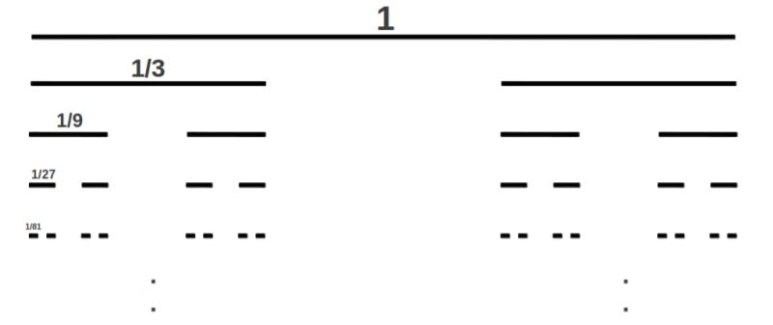
Fig 1: Different Iteration of Cantor Set
2.2 Theorem
The subintervals eliminated in the derivation have a total length of 1.
$I=\bigcap_{n=0}^{∞}{I_{n}}$ (1)
2.2 Calculation of vertices and edges in cantor set
If n=1, V(G)=2, E(G)=1, I₁=[0,1]
If n=2, V(G)=4, E(G)=2, I₁=[0,1/3]U[2/3,1]
If n=3, V(G)=8, E(G)=4, I₂=[0,1/9]U[2/9,1/3]U[2/3,7/9]U[8/9,1]
V(G)=$2^{n}$, E(G)=$2^{n-1} ∀ n=1 to ∞$ (2)
2.3 Superior Matching in Cantor Set
Cantor set is the union of every non-adjacent edge throughout iteration. Superior matching cardinality is defined as the number of edges in the corresponding iteration. [1] It is denoted by SMC(G). According to another rule, it can be computed as half of the vertices in the relevant iteration of the cantor set.
SMC(G)=$2^{n-1} ∀ n=0 to ∞$ (3)
3. HILBERT CURVE
One of the well-known structures of a fractal antenna is the Hilbert Curve. When compared to other antenna models, it is highly helpful to determine which antenna structure is the most well-known and valuable. Fractal design of this kind is self-similar.
Without a top side, begin at the unit square. It can be sketched using a 2 x 2 grid. U-shaped movement began at the left corner cell and proceeded downward, rightward, and upward. Arrow markings showed how the edges moved inward in order to complete the move in the Grids' right-hand cells. There are $4^{n}$ vertices in each iteration of this hilbert curve where n is the number of iteration. There are no edges that cross in this open walk. As a result, the total number of vertices is less than the total number of edges for all iteration. With three edges and four vertices at the beginning of the first iteration has started.
The next iteration began with the initial 2x2 grid cells. The first open square portion is pointing in the right direction here. Next grid placed in left direction. Third and fourth grid moves upward. Every 2x2 grid is joined by the edges designated as A, B, and C. In the second iteration, we finally obtain the self-similarity fractal Hilbert curve. As illustrated in Figure No.3. The movement direction is indicated by an arrow mark. Second iteration of Hilbert curve has 16 vertices and 15 edges.
Once more, it can be expanded into 4x4 grids in the third iteration. It now displays 8x8 grids. As shown in Figure No.4, the identical images from the second iteration should be positioned in each of the four-by-four grids. The pictures in the first four by four grids are oriented rightward, the second four by four grids are oriented leftward, and the third and fourth grids are oriented upward. The edges that are utilized to connect images in 4x4 grids are indicated by the arrow mark. The third iteration of the Hilbert Curve is depicted in the following figure 4.
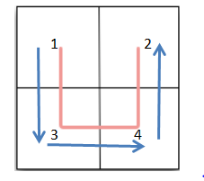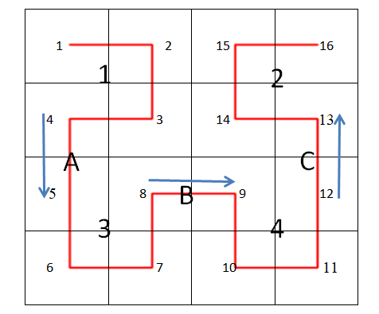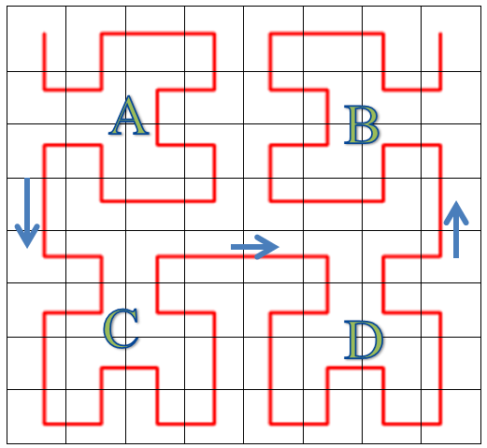
Figure 2: Iteration 1 Figure 3 : Iteration 2 Figure 4: Iteration 3
Result:
Vertices and edges have counted and the results indicate that its implementation ratio is constant for all iteration. Vertices growth occurs after the multiple of four elements. n^{th} iteration of hilbert curve have $4^{n}$ vertices and 4^{n}-1 edges.
3.2 Theorem
Let G be a fractal hilbert curve. In n^{th} iteration of hilbert curve has 4^{n} vertices and 4^{n}-1 edges then the cardinality of superior matching is $\frac{4^{n}-1}{3}$ .

4. Scope of the paper
To refute the simplistic belief that a "closed set" consists of a union of closed intervals plus a few single points when starting a real analysis. Fractal geometry: the Cantor set is homeomorphic to a large number of fractals. Mandelbrot refers to this phenomenon as "Cantor dust" to allude to its appearance. Every compact metrizable space can be defined as the image of the Cantor set under a continuous function. This is the formal expression for the Cantor set being the most general compact metrizable space. Cantor sets even occur naturally in number theory! Z_{p} are homeomorphic to the cantor set. Numerous fields, including computer science and mathematics, have utilized Cantor's theorem. The cardinality of the power set is frequently used as a measure of the complexity of the problem being solved in computer science, where it is employed in the analysis of algorithms and data structures. The distribution of energy levels in quantum systems and the behaviour of super fluids are two examples of physics phenomena that have been modeled using Cantor's theorem.

5. Highlights for Review and Applications
The specific structure of the effective or parasitical chunks is a crucial component of the antenna system. The benefit of fractal antenna with a larger bandwidth at a smaller size is better than traditional patch antennas. A conductance outer (the active patch) is positioned roughly parallel to a conductance ground plane, and a second conductance outer (the parasitic patch) is positioned parallel to conductance outer to form the foundation of the suggested antenna system. When compared to other antenna configurations, many advantage are available some of them are listed below. First one is Low, horizontal figure. For example, it is allowing the antenna to adapt to a vehicle’s surface. The next important things that beneficial fabrication technique. For example, an arbitrary shaped patch is to be printed over any printed circuit board substrate). Last but not least- Low of cost. This type of antennas has a narrow bandwidth, which becomes even more problematic when the size of the antenna is smaller than semi-wavelength. Using a parasitic patch, which increases the radiation mechanism and next chunk is placed on the top of the microstrip antenna with no feeding mechanism is a common method of expanding the bandwidth of micro-strip antennas.

6. Conclusion
Superior matching in the fractal graph, such as the cantor set and hilbert curve is evaluated in this paper. Here, the structure, properties, and number of vertices and edges are analysed for all iteration. Two general formulas are then provided for calculating the superior matching cardinality in those fractal graphs using the iterative function method. It is analysed the importance of fractal antenna like Hilbert curve and cantor set in various field and real life application. Let's extract the general formula for superior matching cardinality in different fractal antenna curves, such as the peano curve, in subsequent work. This new study combines the ideas of fractal graphs and matching.

REFERENCES

- Anitha.A., Tharaniya.P., Senthil.S., & Jayalalitha.G., (2020). Analyzation of Maximum Matching and Maximal Matching in Various Graphs. International Journal of Pharmaceutical Research, 12(3), 778-782.
- Choudhury G., Mahanta A., Sarmah H. K., & Paul R. (2020). Cantor set as a fractal and its application in detecting chaotic nature of piecewise linear maps. Proceedings of the National Academy of Sciences, India Section A: Physical Sciences, 90, 749-759.
- Douglas B.West. (2000), Introduction to Graph Theory, Second Edition, Prentice Hall.
- Fleron, J. F. (1994). A note on the history of the Cantor set and Cantor function. Mathematics Magazine, 67(2), 136-140
- Kenneth Falconer, (2014), Fractal Geometry Mathematical Foundation and Applications, Third Edition, WILEY.
- Krzysztofik W. J., & Brambila F., (2017), Fractals in antennas and metamaterials applications, Fractal Analysis-Applications in Physics, Engineering and Technology, 978-953.
- R.Suguna., P.Tharaniya., G.Jayalalitha.,(2020) Maximum Matching in Sierpenski Arrow Head Curves., Journal of Advanced Research in Dynamical & Control Systems, 12(3), pp. 1380-1385
- Tharaniya.P., & Jayalalitha.G. (2019). Maximum matching in fractal graph, The International Journal of Analytical and Experimental Modal Analysis, XI, 138-143.
- Tharaniya, P., & Jayalalitha, G. (2021). Maximal Matching in Fractal Graphs and Its Application, International Journal of Pharmaceutical Research, 13(1).
- Vallin, R. W. (2013). The elements of Cantor sets: with applications. John Wiley & Sons.

