Challenges and opportunities in RF MEMS for IoT applications
Dr.M.Subbulakshmi¹ , Dr.E.A.Mohamed Ali²,Dr.A.Ahila³ and S.Selvarathi Ponmalar⁴
¹AP LIII, Dept. Of AIDS, Bannari Amman Institute of Technology, Sathyamangalam 9003777449
²Assistant Professor, Dept. of ECE, JP College of Engineering, Tenkasi, 9842671027
³Associate Professor, Dept of ECE, Sri Sairam College of Engineering, Anekai, Bangalore, 8903919496
⁴Assistant Professor, Dept of ECE, Dr.G.U. Pope College of Engineering, Nazareth, 9944887994
¹subbulakshmi@bitsathy.ac.in
²ea_mdali2003@yahoo.co.in
³ahilaamarnath27@gmail.com
⁴rathidany@gmail.com
Abstract:
Revealing the Potential: Obstacles and Prospects of RF MEMS in the Internet of Things with its special combination of low power consumption, tunability, and downsizing, RF MEMS technology offers an attractive way to improve the Internet of Things (IoT) in the future. However, issues with cost, complexity of fabrication, and guaranteeing long-term durability stand in the way of its broad implementation. The various uses of RF MEMS in the Internet of Things are examined in this abstract, from wearables and smart sensors to linked infrastructure and next-generation wireless networks. It draws attention to particular use cases, like MEMS switches that allow for effective power management in wearables and MEMS resonators that enable accurate timing in smart cities [5].
The future of RF MEMS appears bright because to emerging trends like novel materials, sophisticated production methods [29], and creative device topologies. 3D printing transforms design possibilities, while piezoelectric materials provide energy harvesting capabilities. Metamaterials based on MEMS and reconfigurable MEMS have great potential for dynamic functionality and innovative signal processing uses. The conversation emphasizes how important it is to handle issues with reliability, standardize testing and design, and support environmentally friendly manufacturing techniques. Through surmounting these obstacles and leveraging nascent patterns, RF MEMS technology holds the capacity to transform the IoT's future, paving the way for a plethora of uses that enhance our quality of life and establish a more interconnected and productive global community.

- Introduction to RF MEMS:
Miniaturized mechanical and electromechanical components are produced using RF MEMS (Micro-Electro-Mechanical Systems) devices, which use the concepts of micro fabrication and microelectronics. These gadgets are employed in many different applications, such as wireless communications, radar systems, and sensors, and they normally function in the radio frequency (RF) range. Here are a few fundamental RF MEMS concepts:
Micro fabrication: The process of micro fabrication Methods employed in the semiconductor sector are comparable to those used in the fabrication of RF MEMS devices. This encompasses the steps involved in creating complex microstructures on a silicon substrate by photolithography, etching, and deposition.
Mechanical Structures: Electrical and magnetic fields, among other external stimuli, can cause mechanical structures in RF MEMS devices to move or deform. Bridges, membranes, and cantilevers are examples of common mechanical structures in RF MEMS.
Actuation: To regulate the motion of their mechanical structures, RF MEMS devices frequently need actuation mechanisms. Electrostatic, electromagnetic, or piezoelectric actuation techniques can be used to accomplish this.
RF Operation: Typically operating in the range of a few megahertz to several gigahertz, RF MEMS devices are made to function in this frequency range. Because of their great linearity, low insertion loss, and capacity for high power levels, they are employed in radio frequency applications.
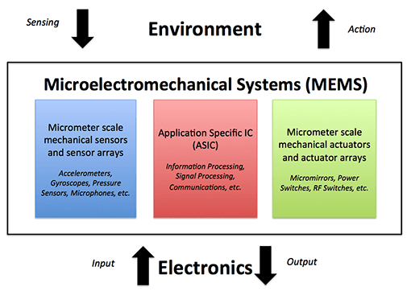
Fig 1.1 Functionality of a MEMS device
Switching and Tuning: These two tasks are frequent uses for RF MEMS. While RF MEMS tunable capacitors or resonators can be used to change an RF circuit's frequency, RF MEMS switches can be utilized to redirect RF signals within a circuit [9]. Compared to conventional RF components, RF MEMS devices provide a number of benefits, such as minimal insertion loss, excellent isolation, low power consumption, and high linearity. Additionally, they can be integrated with other electrical components on a single chip because to their great compatibility with conventional semiconductor production processes.
- FABRICATION TECHNIQUES
Surface Micromachining: To construct the appropriate mechanical and electrical structures, surface micromachining involves depositing and patterning thin films of different materials, such as silicon nitride and polysilicon, on a substrate. This method is frequently applied to RF MEMS switches and capacitors and is appropriate for building straightforward, flat structures [17].
Bulk Micromachining: To produce three-dimensional structures, bulk micromachining entails carefully etching the substrate. More intricate mechanical structures including membranes, beams, and cantilevers are made with this technology. Wet or dry etching methods can be used for bulk micromachining.
Lithography, Electroplating, and Moulding, or LIGA, is a method for creating structures with a large aspect ratio. It entails patterning a thick resist layer with X-ray lithography, depositing a metal structure via electroplating, and shaping the structure to imitate it in other materials. To create RF MEMS components with complex 3D forms, LIGA is utilized.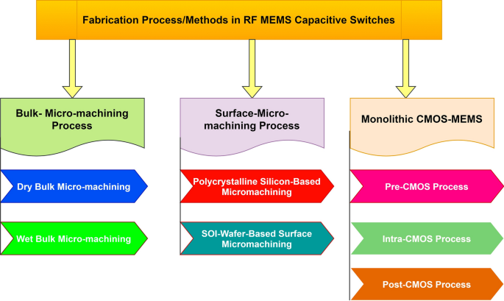
Fig 2.1 Fabrication techniques of RF MEMS
Wafer bonding: RF MEMS devices can be encapsulated or sealed cavities can be made via wafer bonding. It entails joining two or more wafers together by applying different bonding processes, such as adhesive, fusion, or anodic bonding. In order to manufacture fully functional RF MEMS devices, wafer bonding is frequently employed in concert with other fabrication processes [32].
Release and Packaging: Using sacrificial layers, the mechanical and electrical structures of an RF MEMS device are separated from the substrate once they are constructed. After the structures are released, they can be packaged to provide electrical connections and shield them from the elements.
- RF MEMS DEVICES
Radio Frequency Micro electromechanical Systems, or RF MEMS, are an intriguing combination of radio frequency technology and micro fabrication. These small-sized devices have distinct benefits over their conventional equivalents because they process signals in the radio frequency band using mechanical actuation. Let's examine the features and possible uses of three well-known RF MEMS devices: switches, varactors, and resonators [19].
3.1. RF MEMS Switches
Function: By physically flipping between "on" and "off" states, they regulate the flow of signals. Envision a little bridge that opens and closes a circuit.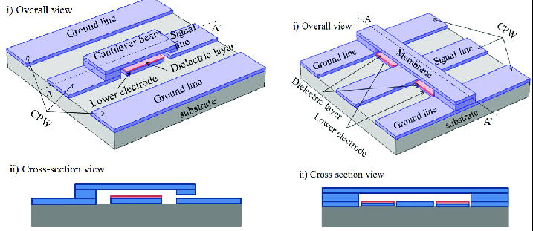
Fig 3.1 (a) Series type Fig.3.1 (b) Shunt type

Characteristics of Radio Frequency MEMS Switches:
High Resolution: Excellent attenuation between "off" states results in high isolation, which realty reduces undesired signal leakage.
Low Insertion Loss: Assuring effective transmission with minimal signal power drop when in the "on" state.
Quick Switching: Able to quickly transition between states, suitable for high-frequency applications.
Compact Size: Compared to traditional switches, this tiny footprint makes it perfect for downsizing. Switch types include ohmic contact, membrane, cantilever, and others.
Applications include beam forming in phased-array antennas, tunable filters, mobile phones, base stations, and more.
3.2 RF MEMS Varactors
Function: By altering the space between movable MEMS devices, they electrically adjust capacitance, acting as a tiny equivalent of a variable capacitor.
Characteristics of Radio Frequency MEMS Switches: Excellent attenuation between "off" states results in high isolation, which greatly reduces undesired signal leakage.
Low Insertion Loss: Assuring effective transmission with minimal signal power drop when in the "on" state.
Quick Switching: Able to quickly transition between states, suitable for high-frequency applications.
Compact Size: Compared to traditional switches, this tiny footprint makes it perfect for downsizing. Switch types include ohmic contact, membrane, cantilever, and others.
Applications: It include beam forming in phased-array antennas, tunable filters, mobile phones, base stations, and more.
3.2 RF MEMS VARACTOR
Function: By altering the space between movable MEMS devices, they electrically adjust capacitance, acting as a tiny equivalent of a variable capacitor.
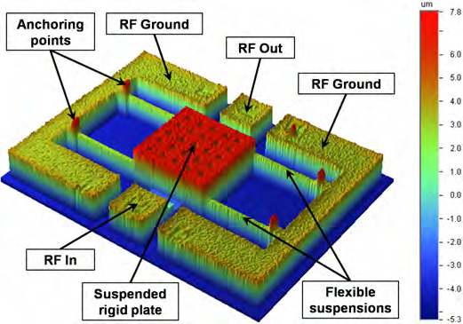
Fig 3.2 RF MEMS Varactors
Characteristics:
Wide Tuning Range: Mechanical actuation allows for a significant fluctuation in capacitance.
Low electricity Consumption: They require less electricity to tune than their electronic counterparts.
High Linearity: Capacitance changes predictably over the tuning range. Types include inter digitated comb varactors and parallel-plate varactors.
Uses: antenna tuning, power amplifiers, tunable filters, voltage-controlled oscillators (VCOs), etc.
3.3 RF MEMS Resonators
Function: As small tuning forks, they vibrate at particular frequencies and can filter or produce desired frequencies.

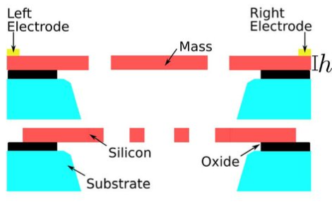
Fig 3.3 RF MEMS Resonators
Characteristics:
High Q Factor: Excellent selectivity at a specific frequency because of low energy loss in resonance.
Temperature Stability: There is minimal frequency drift despite temperature fluctuations.
Compact Size: Enables easy integration with a wide range of systems.
Among the various types are disk resonators, micro mirror resonators, and cantilever beam resonators, Filters, oscillators, sensors, timing circuits, and gyroscopes are a few examples of applications
Despite all of the advantages, there are still certain challenges with RF MEMS devices. Manufacturing costs could be higher than with standard technologies, and there's still work to be done to ensure durability in difficult environments. Ongoing research and development is improving materials, fabrication techniques, and device design in an effort to address these issues. RF MEMS has a promising future, particularly in areas such as miniature wireless devices and adaptive radio systems and 5G applications.

- INTEGRATION OF RF MEMS WITH IOT SYSTEMS
RF MEMS devices are a desirable option for incorporation into the constantly changing field of Internet of Things applications due to their size, versatility, and low power consumption. However, a number of obstacles prevent wider use. This is an explanation:
Challenges:
Cost: Although they are coming down, fabrication prices are still greater than those of conventional components, particularly in low-volume applications.
Packaging: Specialized packaging is needed to protect fragile MEMS structures from shock and moisture, which raises the complexity and cost of the process.
Power Consumption: Although typically less than more conventional options, certain MEMS devices, such as actuators, may increase an IoT device's total power footprint.
Integration Complexity: Because of varying production techniques and material characteristics, integrating MEMS devices with other electronic components on a single chip presents technological difficulties.
Standardization: Interoperability and scalability between various systems may be hampered by an absence of uniform design and testing procedures.
Uniformity Efforts: Standard design guidelines and testing procedures are being established by industry alliances and efforts such as the MEMS Industry Group (MIG).
Security: Strong security measures are essential to guard against vulnerabilities because MEMS devices are vital to data collecting and communication.
Reliability: It is important to handle long-term reliability in a variety of environmental circumstances, particularly for applications that are mission-critical.
Application-Specific Optimization: The secret to a successful implementation is to customize RF MEMS device selection and integration methodologies to particular applications and their particular needs. Exciting prospects arise from integrating RF MEMS with IoT systems, but doing so need strong cooperation between researchers, engineers, and business executives. RF MEMS have the potential to alter the linked world by solving issues related to cost, power consumption, packaging, and standardization.
- RF MEMS TESTING AND RELIABILITY
For RF MEMS devices to be successfully integrated into Internet of Things applications, it is imperative that they have long-term dependability and functionality. Below is a summary of testing approaches and tactics:
Methods of Testing: DC Electrical testing involves measuring variables such as leakage current, contact resistance, and actuation voltage in order to evaluate both probable failure mechanisms and basic operation.
RF Performance Testing: To guarantee signal integrity, insertion loss, isolation, return loss, and bandwidth are assessed at the planned operating frequencies.
Testing for switching speed is essential for high-frequency applications since it measures how long it takes the device to change states.
Life Cycle Testing: To replicate real-world settings and pinpoint possible wear-out causes, the device is repeatedly switched on and off and subjected to temperature changes and other environmental stressors.
In-Situ Monitoring: During operation, important parameters such as actuation voltage, capacitance, and resonance frequency can be monitored by integrating sensors or incorporating built-in self-testing features. This allows for early degradation detection.
Assurance Techniques: Choosing materials that are compatible with the fabrication process, have strong fatigue resistance, and low stress is known as material selection.
Design optimization: Using strategies to reduce wear and tear, such as fatigue-resistant microstructures, hermetic packaging, and stress-relieving features.
Process Control: Strictly enforcing quality control procedures during the fabrication process to guarantee uniform material qualities and device integrity.
Environmental Controls: Using appropriate packaging and encapsulation to shield devices from severe conditions like as high temperatures, high humidity, and mechanical shock.
Data-Driven Maintenance: Making use of data from in-situ monitoring to anticipate any malfunctions and carry out maintenance before serious problems develop.
5.1 Challenges and Solutions RF MEMS Testing And Reliability
Standardization: Comparisons and data sharing may be made more difficult by the absence of uniform testing procedures and reliability measures. The goal of the MEMS Industry Group (MIG) is to overcome this obstacle.
Cost-Effective Testing: New testing approaches and data-driven strategies are needed to strike a balance between the IoT devices' financial limits and the requirement for thorough testing. Long-Term Reliability Prediction: Complex modeling and machine learning approaches are needed to accurately predict wear-out and failure modes over long periods of time. Integrating RF MEMS into IoT systems requires careful consideration of testing and reliability assurance. We can fully realize the promise of these adaptable devices and guarantee their reliable operation in the connected world by utilizing data-driven maintenance, putting design and material optimization tactics into practice, and utilizing a variety of testing techniques.

- ADVANTAGES OVER TRADITIONAL TECHNOLOGIES
In RF (Radio Frequency) applications, RF MEMS (Micro-Electro-Mechanical Systems) have a number of advantages over conventional technologies. Here are a few main benefits:
Miniaturization: RF components can be made smaller by using RF MEMS devices, which can be produced on a tiny scale. This is especially useful for handheld and portable electronics with limited storage capacity.
Low Insertion Loss: When compared to more conventional technologies like semiconductor diodes or mechanical relays, RF MEMS switches and other components may have a lower insertion loss. As a result, RF circuits have better signal quality and efficiency [21].
High Linearity: In order to preserve signal integrity and decrease distortion in RF systems, RF MEMS devices often have high linearity.
Low Power Consumption: Due to their low power consumption, RF MEMS devices are a good fit for energy-efficient systems and battery-powered gadgets.
High-Quality Factor (Q Factor): To achieve narrow bandwidths and great selectivity in RF circuits, RF MEMS resonators and filters can have a high Q factor.
High Power Handling Capability: Certain RF MEMS switches and parts are appropriate for high-power radio applications because they can withstand high power levels.
Broad Frequency Range: RF MEMS devices are adaptable for a variety of RF applications because they can function across a broad frequency range, from a few megahertz to several gigahertz.
Compatibility with CMOS Technology: RF MEMS components can be integrated with digital and analog circuits on a single chip thanks to their compatibility with CMOS (Complementary Metal-Oxide-Semiconductor) technology.
APPLICATIONS OF RF MEMS IN IOT
Because of its special qualities—miniaturization, tunability, and low power consumption—RF MEMS are becoming more and more appealing for a wide range of uses in the rapidly developing Internet of Things. Here are a few fascinating instances and use cases:
7.1 Smart Sensors and Wearables:
RF MEMS switches: Optimize energy usage and prolong battery life by enabling effective signal routing and power management within sensors. As an illustration, MEMS switches are used by smart watches to seamlessly switch between several sensors, such as heart rate monitors and GPS [24].
RF MEMS varactors: Provide on-demand sensor antenna tuning, boosting data accuracy and signal reception. An illustration of this would be wearable health monitors that dynamically modify their antennas to maximize communication to various medical devices.
7.2. Connected Infrastructure and Industrial Automation:
RF MEMS resonators: In smart cities and industries, RF MEMS resonators ensure exact timing and dependable data transfer by acting as miniature oscillators and filters. As an illustration, consider smart meters that have MEMS resonators installed for precise time synchronization in a massive energy grid.
RF MEMS switches: Enable phased-array antennas for radar and long-range communication to use dynamic beam forming. As an illustration, consider industrial robots that use MEMS switches to enhance object identification and communication in challenging conditions [26].
7.3. Next-Generation Wireless Networks:
RF MEMS phase shifters: Expand network capacity and enhance signal coverage by enabling adaptive beam forming and beam steering in 5G and beyond. As an illustration, 5G base stations use MEMS phase shifters to transmit signals more effectively and precisely.
RF MEMS tunable filters: Provide dynamic spectrum allocation and improved spectrum efficiency by enabling instantaneous changes to filter properties. As an illustration, consider smartphones with MEMS filters, which automatically adjust to various frequency bands to maximize battery life and connection quality.
7.4. Smart Homes and Consumer Electronics:
RF MEMS varactors: Increase communication flexibility and enable tunable antennas for smart home devices. They can also adapt to various radio protocols. An example of this would be smart doorbells that dynamically alter their antennas to effortlessly connect to different Wi-Fi networks.
RF MEMS switches: Improve audio processing capabilities and maximize energy efficiency by facilitating power management and signal routing within smart speakers. As an illustration, smart speakers use MEMS switches to effectively control the amount of power used by various audio components [27]. Creating compact, adaptable, and low-power communication modules for a range of Internet of Things uses. Enhancing data transmission security and privacy with cutting-edge filtering and encryption capabilities. Enabling the IoT ecosystem's systems and devices to be monitored and controlled in real time. There is still room for development in manufacturability and cost optimization. It is essential to standardize across many device kinds and applications. For broad acceptance, long-term dependability and resilience in a variety of settings are essential.
8. FUTURE TRENDS AND OPPORTUNITIES
The fascinating field of RF MEMS is always changing as new materials, manufacturing processes, and gadget designs push the envelope of what's practical. Here are a few new developments that could lead to big breakthroughs in the Internet of Things:
8.1. Material Innovations:
Materials with piezoelectric and ferroelectric properties: These allow for improved tuning capabilities and novel functions like energy harvesting. Microfluidic integration: Enabling RF MEMS devices to sense and manipulate chemicals in real time. Biocompatible materials: Creating opportunities for implanted devices and wearable health monitors.
8.2. Fabrication Breakthroughs:
3D printing of micro mechanisms transforming the possibilities for design and facilitating quick prototyping. Integration with CMOS technology: Enabling MEMS and electronics to be co-fabbed on a single chip at a reasonable cost. Nano-scale MEMS: Redefining miniaturization to create ever more energy-efficient and compact gadgets.
8.3. Novel Architectures for Devices:
Reconfigurable radiofrequency microcontrollers (RF MEMS): Adaptable devices that can alter their operation in response to external factors or user demands.
Customizing material characteristics at the sub wavelength scale for innovative signal processing and filtering uses is possible with MEMS-based meta materials.
Integrated MEMS microfluidic systems: These IoT devices combine MEMS and microfluidic channels to provide lab-on-a-chip capabilities.
8.4 Possible Uses in the Future:
Radio communications based on cognitive processes: adjusting network protocols and spectrum usage dynamically in response to current circumstances.
Intelligent sensor networks: MEMS-equipped micro drones for monitoring the environment and responding to emergencies. MEMS-based biosensors for ongoing health monitoring and medication delivery are examples of implantable medical devices.
Improved security and privacy: MEMS-based authentication and encryption techniques for safe data transfer in the Internet of Things. Addressing durability and long-term functionality under prolonged operation circumstances. Creating standardized testing and design processes for broader use. Improving the environmental friendliness and sustainability of the manufacturing operations.
RF MEMS technology has the power to completely transform how we interact with the world around us and bring in an era of totally connected and intelligent settings if it can overcome these obstacles and take advantage of new trends. With its exciting potential for a wide range of applications that enhance our lives and make the world more connected and effective, this technology has the potential to significantly impact the direction of the Internet of Things.

9. CONCLUSION
Despite the enormous promise that RF MEMS technology has to transform the Internet of Things (IoT), a number of obstacles prevent its mainstream implementation. Cost reduction, complex fabrication procedures, and guaranteeing long-term dependability continue to be major issues in need of creative solutions. In spite of these challenges, RF MEMS has a bright future in the Internet of Things. Innovative fabrication methods, sophisticated materials, and novel device architectures are examples of emerging trends that present interesting opportunities. Dynamic functionality and new applications are made possible by reconfigurable MEMS and meta materials, 3D printing allows for greater design freedom, and piezoelectric materials promise energy harvesting.
It will need teamwork to close the gap between promise and reality. It is critical to address reliability issues through sophisticated testing and design optimization. More widespread usage and data sharing will be made possible by standardizing design and testing procedures. Furthermore, concentrating on environmentally friendly manufacturing techniques will guarantee sustainable growth.
Through leveraging these prospects and addressing current obstacles, RF MEMS technology has the capacity to unleash a new wave of developments in the IoT domain. The possibilities are boundless, ranging from wearables and smart sensors to networked infrastructure and next-generation networks. Adopting this technology can help create a future in which various applications improve our lives and create a world that is more intelligent, connected, and efficient. This conclusion emphasizes the collaborative effort needed to overcome challenges and highlights the potential impact of RF MEMS on the future of IoT.
REFERENCES
- Jacopo Iannacci, Girolamo Tagliapietra & Alessio Bucciarelli " Exploitation of response surface method for the optimization of RF-MEMS reconfigurable devices in view of future beyond-5G, 6G and super-IoT applications" Springer Natures (2022): 3543 (2022).
- Ali E, Ismail E, Nordin R, Abdullah NF (2017) Beam forming techniques for massive MIMO systems in 5G: overview, classification, and trends for future research. Front Inf Technol Electron Eng 18:753–772.
- V. Ziegler; W. Gautier; A. Stehle; B. Schoenlinner; U. Prechtel “Challenges and opportunities for RF-MEMS in aeronautics and space - The EADS perspective in IEEE Explorer 2010.
- Girolamo Tagliapietra & Jacopo Iannacci “RF-MEMS Technology and Beam forming in 5G: Challenges and Opportunities for a Pair with a Still Untapped” Micro and Nanoelectronics Devices, Circuits and Systems pp 437–453,2022.
- RF MEMS and its Potential,” IEEE Journal of the Electron Devices Society, vol. 1, no. 2, pp. 29–47, 2013.
- D.Rodrigo, L.Jofre, J.Romeu “RF MEMS antennas for wireless applications” Science direct DC, USA, 5–8 December 2013; pp. 176-206.
- Rebeiz, G.M. RF MEMS: Theory, Design, and Technology, 1st ed.; John Wiley & Sons: Hoboken, NJ, USA, 2003.
- Iannacci, J. RF-MEMS Technology for High-Performance Passives: The Challenge of 5G Mobile Applications, 1st ed.; IOP Publishing: Bristol, UK, 2017; pp. 1–166.
- Dubuc, D et al., RF-MEMS for smart communication systems with future 5G applications. In Smart Sensors and MEMS, 2nd ed.; Nihtianov, S., Luque, A., Eds.; Woodhead Publishing: Cambridge, UK, 2018; pp. 499–539.
- Zahr, A.H.; Zhang, L.Y.; Dorion, C.; Deveautour, A.; Beneteau, A.; Stefanini, R.; Blondy, P. RF-MEMS Switches for Millimeter-Wave Applications. - European Microwave Conference in Central Europe , Prague, Czech Republic, 13–15 May 2019; pp. 336–338.
- Iannacci, J. RF-MEMS technology as an enabler of 5G: Low-loss ohmic switch tested up to 110 GHz and its applications. Elsevier Sens. Actuators A Phys. 2018, 279, 624–629.
- Kim, M.; Hacker, J.B.; Mihailovich, R.E.; DeNatale, J.F. A DC-to-40 GHz four-bit RF MEMS true-time delay network properties” IEEE Microw. Wirel. Compon. Lett. 2001, 11, 56–58.
- Nguyen, C.T.-C. Micro electromechanical Devices for Wireless Communications. “An Investigation of Micro Structures, Sensors, Actuators, Machines and Systems”, Heidelberg, Germany, 25–29 January 1998; pp. 1–7.
- Nguyen “RF MEMS for wireless applications”. 60th DRC Digest Device Research Conference, Santa Barbara, CA, USA, 20–22 June 2012; pp. 9–12.
- Nguyen, C.T.-C. MEMS-based RF channel selection for true software-defined cognitive radio and low-power sensor communications. IEEE Commun. Magazine editor page. 2013, 51, 110–119.
- Karthick, R.; Babu, S.P.K. “Review on Radio Frequency Micro Electro Mechanical Systems (RF-MEMS) Switch”, Communication, Computing and Electronics Systems, Coimbatore, India, 21–22 October 2020; Springer: Berlin/Heidelberg, Germany, 2020; pp. 437–453.
- Cao et al., Y. Research Status and Development Trend of MEMS Switches: A Review. Micromachines 2020, 11, 694.
- Kurmendra, K.R. “A review on RF micro-electro-mechanical-systems switch for radio frequency applications”. Micro system technology. 2021, 27, 2525–2542.
- Tian, W.; Li, P.; Yuan, L.X. Research and Analysis of MEMS Switches in Different Frequency Bands. Micro machines 2018, 9, 185.
- Ma, L.-Y.; Soin, et al., “Comprehensive Study on RF-MEMS Switches Used for 5G Scenario”. IEEE open Access 2019, 7, 107506–107522.
- Saleem, M.M.; Nawaz, H. “A Systematic Review of Reliability Issues in RF-MEMS Switches. Micro Nano systems. 2019, 11, 11–33.
- Iannacci, J. RF-MEMS for high-performance and widely reconfigurable passive components—A review with focus on future telecommunications, IoT and 5G applications. J. King Saud Univ. Sci. 2017, 29, 436–443.
- Giacomozzi, F.et al, Development of high co efficient ratio RF MEMS shunt switches. Rom. J. Inf. 2008, 11, 143–151.
- Angira, M.; Sundaram, G.M.; Rangra, K.; Bansal, D.; Kaur, M. On the investigation of an inter digitated, high capacitance ratio shunt RF-MEMS switch for X-band applications. And technology connect 2013, 2, 189–192.
- Park, J.Y.; Kim, G.H.; Chung, K.W.; Bu, J.U. monolithically integrated micro machined RF MEMS capacitive switches. Sens. Actuators Phys. 2001, 89, 89–94.
- Persano, A.; Quaranta, F.; Cola, A.; Taurino, A.; De Angelis, G.; Marcelli, R.; Siciliano, P. Ta₂O₅ thin films for capacitive RF MEMS switches. J. Sens. 2010, 2010, 487061.
- Kim, M.W.; Song, Y.H.; Yang, H.H.; Yoon, J.B. An ultra-low voltage MEMS switch using stiction-recovery actuation. J. Micromech. Microeng. 2013, 23, 1–7. Dai, C.I.; Hsu, H.M.; Tsai, M.C.; Hsieh, M.M.; Chang, M.W. Modeling and fabrication of a microelectromechanical microwave switch. Microelectron. J. 2007, 38, 519–524.
- Aghaei, S.; Abbaspour-Sani, E. A low voltage vertical comb RF MEMS switch. Microsyst. Technol. 2010, 16, 919–924.
- Angira, M.; Rangra, K. Performance improvement of RF-MEMS capacitive switch via asymmetric structure design. Micro system Technology. 2015, 21, 1447–1452.
- Lin, C.Y.; Hsu, C.C.; Dai, C.I. Fabrication of a micro machined capacitive switch using the CMOS-MEMS technology. Micro machines 2015, 6, 1645–1654.
- Shekhar, S ety al., “Surface-Micro machined capacitive RF switches with low actuation voltage and steady contact.” J. Micro electromechanical Syst. 2017, 26, 643–652.
- Yongjaeand, I.; Filipovic, D. ANN based electromagnetic models for the design of RF MEMS switches. IEEE Microw. Wirel. Components Lett. 2005, 15, 823–825.
- Peyrou, D.; David, P.; Fabio, C.; Hikmat, A.; Fabienne, P.; Patrick, P.; Robert, P. Modeling and Simulation: A New Methodology for RF MEMS Simulation; IntechOpen: London, UK, 2008; pp. 433–452.
- Ducarouge, et al., Efficient Topology and Design Methodology for RF MEMS Switches. In Proceedings of the SPIE 5836, Micro technologies for the New Millennium, Sevilla, Spain, 9–11 May 2005; Volume 5836, pp. 535–539.
- Lysenko, I.; Tkachenko, A.; Ezhova, O.; Konoplev, B.; Ryndin, E.; Sherova, E. The Mechanical Effects Influencing on the Design of RF MEMS Switches. Electronics 2020, 9, 207.
- Tkachenko, A.; Lysenko, I. High capacitance ratio radio-frequency micromechanical switch. Probability Advanced Nano Electron System,. Dev. 2020, 3, 237–243.
- Lysenko, I.; Tkachenko, A.; Ezhova, O. Research of the micro electromechanical switch with different materials of metal membrane. In Proceedings of the SPIE 11022, International Conference on Micro- and Nano-Electronics, October 2018; Volume 10226, pp. 1–12.
- Sun, Z.; Bian, W.; Zhao, J. A zero static power consumption bi-stable RF MEMS switch based on inertial generated timing sequence method. J. Micro System Technologies. 2022, 28, 973–984.

