Brucella
Brucella are free-living, small, facultative, nonmotile, aerobic, non-motile, non-capsulated, gram negative coccobacilli or short bacilli arranged singly or in short chains. Many isolates require supplementary carbon dioxide for growth. Brucella was named after sir David Bause who isolate the first recognized species B. melitinsis. Brucella have been classified into 6 nomen species:
Species | Biovars | Co2 Requirement | H2S Production | Urease | Reservoir | Agglutination by antiserum A | Agglutination by antiserum M
B. mellitensis | 3 | - | - | Variable | Sheep, Goat | - | +
B. abortus | 9 | + | + | Slow | Cattle | + | -
B. suis | 5 | - | - | Rapid | Pig, Here, Reindeer, Rodents | + | +
B. canis | 0 | - | - | Rapid | Dog, | - | -
B. ovis | 0 | + | - | - | Sheep | + | -
B. neotomae | 0 | - | + | Rapid | Desert wood Rat

Epidemiology
Brucellosis is a zoonotic disease. The disease occurs worldwide, especially in Mediterranean and Persian Gulf countries, India, Central and South America. Farmers, shepherds, goatherds, butchers and abattoir workers are at high risk.
Pathogenesis
Each of the four Brucella spp. that are the pathogenic for humans has a limited number of preferred animal hosts. In the host, Brucella spp. tends to localize in tissues rich in erythritol (e.g., placental tissue), a four-carbon alcohol that enhances their growth. Humans become infected by many routes:
  - Ingestion of infected unpasteurized animal milk products (most common means of transmission)

  - Inhalation of infected aerosolized particles (laboratory -acquired infection is the most important source of transmission)
  - Direct contact with infected animal parts through ruptures of skin and mucous membranes
  - Accidental inoculation of mucous membranes by aerosolization
  - Rare cases of transmission by blood and bone marrow transplantation and by sexual intercourse
  - dairy farmers, livestock handlers, slaughterhouse employees, veterinarians, and laboratory personnel.
The organism has a very low infectious dose (< 100). Mishandling and misidentification of the organism is often associated with laboratory transmission of the organism.
Brucella sup. are facultative, intracellular parasites that are able to exist in both intracellular and extracellular environments. After infecting a host, brucellae are ingested by neutrophils, within which they replicate and causing cell lysis. Neutrophils containing variable organisms circulate in the bloodstream and are subsequently phagocytized by mononuclear phagocytic cells in the spleen, liver and bone marrow. If the infection goes untreated, granulomas develop in these organs and the brucellae survive in monocytes and macrophages. Brucellae tends to show a tendency to invade and persist in the human host by inhibiting apoptosis (programmed cell death). Resolution of the infection depends on the host’s nutritional and immune status, and the size of the inoculum and route of infection and the brucellae species causing the infection (B. melitensis and B.abortus) are most virulent to humans. Several and multiplication of Brucella in phagocytic cells are features essential to the establishment, development and chronicity of disease. Brucella use a type IV secretion system, Vir B for intracellular survival and replication. Vir B is involved in controlling the maturation of the brucella vacuole into an organelle that allow replication. If nucleic acid maturation occurs in this region, B. abortus is unable to establish chronic infection. Brucella produces urease that provide protection during passage through the digestive system when the organism is ingested in food products. Urease breakdown urea into ammonia that neutralizes the gastric pH.
Antigenic structure
Brucella has two major type of antigens which are LPS in nature. These antigens are present in different proportion in three major group of brucella. These antigens are -M & A.
Virulent colonies are smooth on primary isolation (having LPS antigens) but on repeat subcultures the loose their LPS antigen and became rough (not agglutinate with M & A antigen).
M antigen is prominent in B.melitensis and A antigen is prominent in B. abortus. B. suis contains either M or A antigen. B. canis have R (Rough) strain.
Clinical feature
The incubation period varies from 1 week to several months and the onset is either abrupt or more often insidious.
- Classical triad: Though the manifestations vary, the classic triad of fever with profuse night sweats, arthralgia/arthritis and hepatosplenomegaly are present in most patients.
- Typhoid like illness: Overall brucellosis resembles typhoid-like illness except that it is less acute, less severe with undulating pattern of fever and more musculoskeletal symptoms.
- Undulating fever: Fever has a typical remittent course, i.e. in between febrile periods (which last of weeks), there will be afebrile periods. It is also called Malta fever or Mediterranean fever.
- Musculoskeletal symptom: are present in about one-half of all patients, which may mimic skeletal tuberculosis. Vertebral osteomyelitis involves lumbar and low thoracic vertebrae commonly. Septic arthritis which commonly effects on knee, hip, sacroiliac and shoulder joints.
- Non-specific symptoms: These include abdominal pain, headache, diarrhea, rash, weakness/fatigue, weight loss, vomiting, cough and pharyngitis.
- CNS & CVS involvement and genitourinary manifestation will be there.
Laboratory diagnosis
1.Specimen- Blood, bone marrow, CSF, pleural and synovial fluids, urine, abscesses or other tissue. Blood should be collected during febrile period before starting antibiotics. Bone marrow culture remains positive after starting of antibiotics.
2.Motility
Brucellae are non-motile.
3.Direct microscopy
Gram staining- gram negative small coccobacilli resemble fine grains of sand which are non-capsulated and non-sporing.
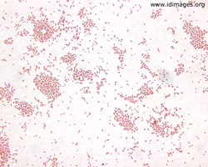
4.Culture
Fastidious organism so growth is enhanced by blood and serum. Growth requires prolonged incubation at 37°C. Blood culture with Castanada’s biphasic medium, BHI broth/agar and Serum dextrose broth/agar are used. Blood agar and chocolate agar are used for subcultures.
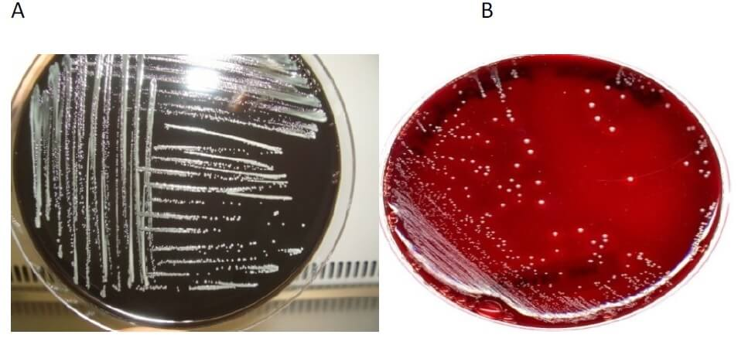

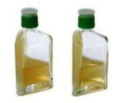

5.Bio-chemical reactions
- Catalase positive
- Oxidase positive
- Urease positive
- Nitrate positive
- Produce hydrogen sulfide
- Citrate, indole, MR and VP negative
6.Serological diagnosis
- SAT
- ELISA
- CFT
- SAT (Standard Agglutination Test)
  - Gold standard test
  - Detects IgM antibody.
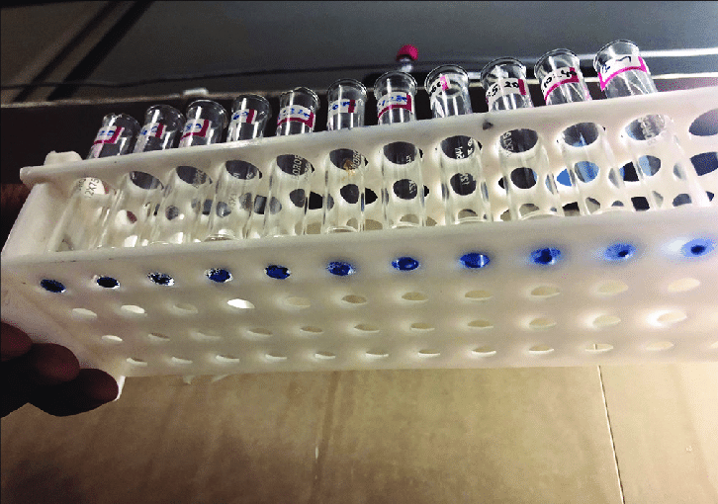
- It is a tube agglutination test in which equal volume of serial dilutions of patient’s serum is mixed with killed smooth
suspension of B. abortus (standard stain) and incubated at 37°C for 48 hrs.
- Titer more than 1:160 is considered as positive.
IgG antibody detection
- 2-mercaptoethenol agglutination test- Serum is treated with 2ME that destroys the agglutinability of IgM but not IgG.
- CFT
- ELISA
7.Molecular methods
- PCR
8.Older methods
- Brucellin skin test
- Guinea pig inoculation
Diagnosis in animal
- Isolation from milk and dairy products
- Milk ring test
- Rose Bengal card test
- Whey agglutination test
Treatment
- Streptomycin- gold standard in adults
- Rifampin- WHO recommended in adults
- Ceftriaxone
Prevention
- Vaccine- live attenuated 19-BA for human, 19 strain for cattle and rev-1 strain for goat & sheep.
- Use pasteurized milk
- Avoid direct contact with animals

