Chapter 4: Virus infection and host interaction

The capacity of a virus to cause disease is termed as virulence that represents the relative degree of pathogenicity. It varies widely among viral strains, categorizing them as pathogenic or non-pathogenic. The pathogenicity of a virus can range from mild to severe, depending on its virulence. Virulence serves as a quantitative measure of the virus's ability to multiply within the host, influenced by factors such as the host's immune status and environment.

Types of Infections:
Virus infections (Figure 35) can be categorized based on their outcomes in terms of progeny virus production. Productive infection results in the generation of progeny virus-

1. Lytic infection- The virus causes cell lysis (e.g., adenovirus, influenza virus).

2. Persistent/latent Infections- In persistent (latent) infections, the virus remains associated with the host cell without active replication or cell death. This can occur with or without integration of the viral genome into the host genome, as seen in retroviruses (integration) and herpes viruses (without integration). It can be of three types-

- Virus genome persists within the cell without active virus release (e.g., some retroviruses).
- Virus is released sporadically but remains latent for most of the time (e.g., herpes simplex).
- Virus is released continuously without lysing the host cell (e.g., hepatitis B virus).

Nonproductive infection, on the other hand, does not lead to progeny virus production-

- Latent infection- The virus remains dormant in the host cell until activation (e.g., herpes virus, HIV).
- Transforming infection-The virus integrates into the host genome and transforms cells into cancerous ones (e.g., human papillomavirus, Epstein-Barr virus, HBV).
- Abortive infection- The virus fails to replicate due to host immune responses or other factors (e.g., poliovirus, measles, respiratory syncytial virus).

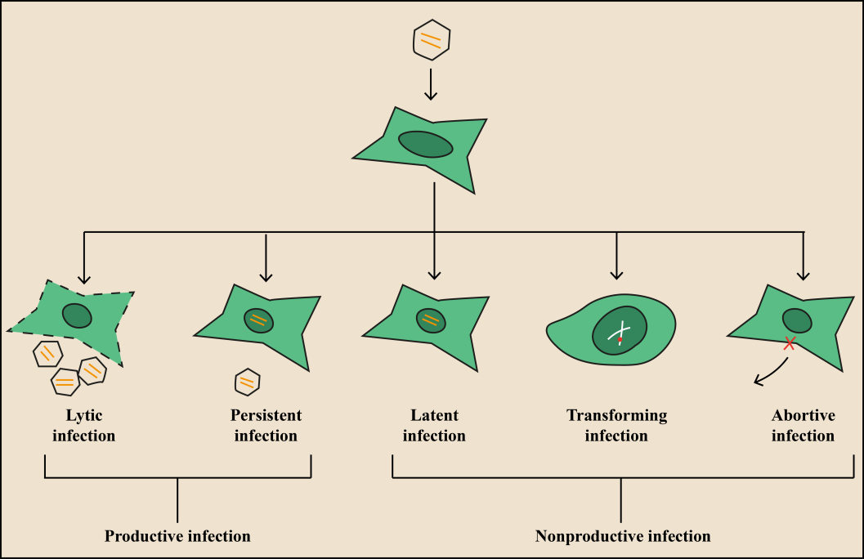

Figure 35: Types of viral infections

Additionally, virus infections can be classified based on clinical symptoms (Figure 36)-

1. Symptomatic infection- Symptomatic viral infections are those in which the infected individual exhibits clinical symptoms. Influenza infections typically present with symptoms such as fever, cough, sore throat, muscle aches, fatigue, and sometimes gastrointestinal symptoms like nausea and vomiting. In severe cases, influenza can lead to pneumonia and respiratory failure.

2. Asymptomatic infection- Asymptomatic infections are quite common, as seen in poliovirus infection, where only a small fraction of infected individuals show symptoms. These asymptomatic cases, also known as inapparent infections, typically result in limited viral replication and the development of antibodies in the infected individual.

3. Acute Infections- Acute infections prompt rapid onset of severe symptoms, often resulting in serious illness or death (e.g., influenza, viral hemorrhagic fever).

4. Chronic infections- These infections are prolonged, with the virus persisting in the host for an extended period (e.g., hepatitis, HIV).

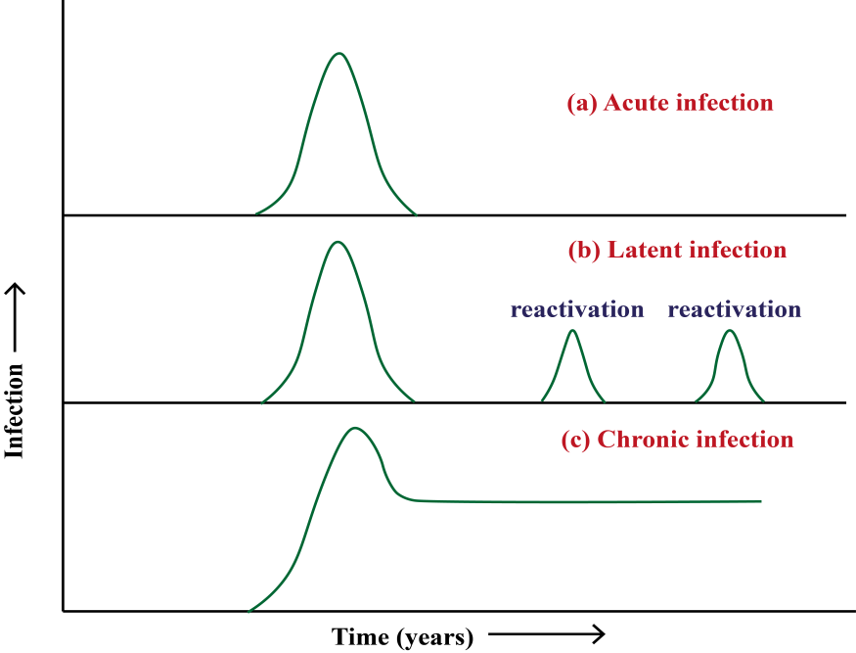

Figure 36: Schematic diagram of viral infection

Multiplicity of Infection (m.o.i.): It is a term used to quantify the ratio of total virus particles that have successfully infected target cells to the total number of target cells present in a given infection condition. In practical terms, it provides insight into the efficiency of viral infection in vitro, particularly within cell culture systems. For example, a high m.o.i. indicates that a large proportion of target cells have been infected by the virus, whereas a low m.o.i. suggests that only a small fraction of cells have been successfully infected.

Infectious dose50 (ID50) represents the dose or concentration of a virus required to infect 50% of the animals inoculated with the virus. It is a measure of the infectivity of the virus and provides valuable information regarding its potency. A lower ID50 indicates higher infectivity, as fewer virus particles are needed to initiate infection in a significant portion of the exposed population.

Lethal dose50 (LD50) is the dose or concentration of a virus required to cause death in 50% of the animals inoculated with the virus. It serves as an indicator of the virus's pathogenicity and lethality. A lower LD50 signifies greater virulence, as fewer virus particles are sufficient to induce fatal outcomes in a significant proportion of the infected animals.

Virus pathogenesis: Here is the flowchart of viral pathogenesis (Figure 37).

Virus entry through different routes

Primary viral infection

Targets different organs of respiratory tract, gastrointestinal and urinary tracts

Viremia (virus shedding in the blood stream)

Migrated from site of virus entry to specific targeted organ

The virus localizes to the lymph nodes and begins replicating its genome.

Secondary viral infection

Moves to various organs

Symptoms of the illness

Figure 37: Flowchart showing steps of viral pathogenesis

Incubation period:
The incubation period refers to the interval between the initial infection with a virus and the appearance of observable disease symptoms. This period can vary widely depending on the virus and host factors, ranging from a few days, as seen with some common cold causing viruses, to years, as observed with HIV. Understanding the incubation period is essential for disease surveillance, diagnosis, and implementing appropriate control measures. It provides insights into the dynamics of virus-host interactions and the progression of the infectious process within the host.

Cell-host interactions:

The interactions between viruses and host cells (Table 8) enable viruses to utilize cellular resources for their benefit, while simultaneously offering the host cell a mechanism to counteract viral infections. Virus host interaction causes potential changes to the different cells, ranging from no apparent cellular damage to cell destruction.

Table 8: Types of virus infections and cellular effects

Type of infection | Cellular effects | Examples
Cytocidal | Morphological changes in cells cause cell death | Enteroviruses, reoviruses, adenoviruses
Persistent, productive | Continuous cellular division, loss of cellular functions | Pestiviruses,  Arena viruses, rabies  virus, retroviruses
Persistent, nonproductive | Virus replication occurs inside the cell and produces defective progeny | Canine distemper virus in brain Polyomavirus, adenoviruses
Transformation | Changes in cellular morphology and produces tumor upon transplantation into experimental animals. | Oncogennic viruses-Murine, avian  leukosis, and  sarcoma  viruses
Permissive cells | support the complete replication of viruses, kills host cell (cytolytic effect , cell burst) | Human lung epithelial cells for H1N1, CD4+ T lymphocytes for HIV-1, neuronal cells for HSV, Human intestinal epithelial cells for poliovirus
Non-permissive cells | virus replication may be blocked at any stage of replication cycle, yields no infectious progeny (abortive). | Non-neuronal cell for HSV, Cells lacking the poliovirus receptor (CD155) for poliovirus, Cells lacking the measles virus receptor (CD150), for measles, non-immune cells for dengue virus

Cells can be damaged through different mechanisms-

- Virus can inhibit host cell nucleic acid synthesis. Poxviruses produce a DNAse that degrades cellular DNA.
- Viruses can inhibit host cell transcription and protein synthesis. Herpesviruses produce proteins that directly bind to specific sequences in viral DNA, thereby controlling the transcription of viral genes.
- Viruses can interfere with mRNA splicing. Viruses that suppress catalytic steps of splicing are- vesicular stomatitis viruses, influenza viruses, and herpesviruses.
- Viruses like influenzavirus, rhabdovirus, togavirus, poxvirus can inhibit mRNA translation thus interferes with the host cell protein synthesis machinery.
- When virus infects cell, immune cell (natural killer cells, cytotoxic T cells) releases perforin that forms pore in the cell membrane resulting in cell death.

Cytopathic effects of cell membrane: Virus infects host cell resulting in structural and functional changes in the host cell due to the infection. This is referred as cytopathic changes (CPE). CPE (Table 9) can be observed under low power optical microscope allows for the observation of changes such as cell rounding, cell lysis, syncytium formation, inclusion body formation, and other alterations in cellular morphology.

- Syncytia formation- Individual cells fuse together to create a multinucleated cell or syncytium. The plasma membranes of neighbouring cells merge, resulting in the shared cytoplasm and multiple nuclei within the fused cell structure (Figure 38). Examples- HIV, respiratory syncytial virus, morbillivirus , paramyxovirus.

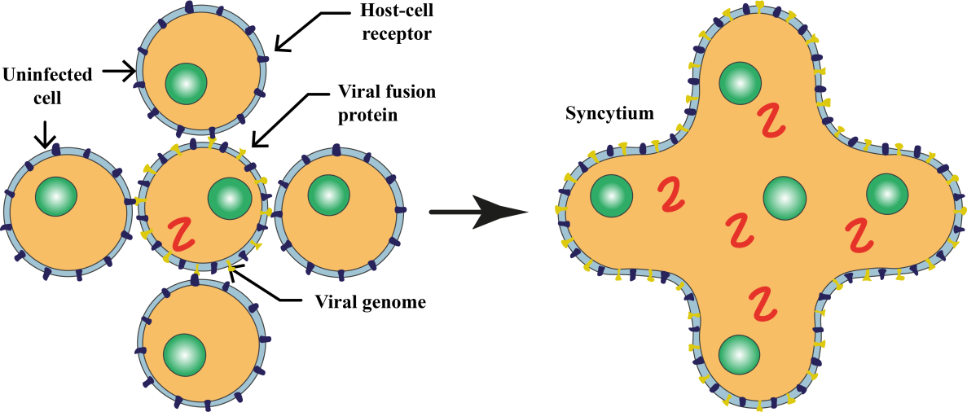

Figure 38: Syncytia formation

- Hemadsorption- Upon cell infection by a virus, specific viral proteins, specifically glycoprotein pelomers, are released and integrate into the plasma membrane. These proteins then act as receptors for ligands present on the surface of erythrocytes. As a result, erythrocytes adhere to the cell, a phenomenon known as hemadsorption and used in cell culture to determine viral growth. Specific antisera is used to perform hemadsorption inhibition test to identify virus from the positive culture. Examples-orthomyxoviruses, paramyxoviruses and togaviruses.

- Hemagglutination- Hemagglutination (Figure 39) is a phenomenon in which red blood cells agglutinate or clump together, induced by certain viruses (Influenza A & B) or antibodies (Cold agglutinin test for autoimmune disease).

- Virus Identification- The assay can help identify the presence of certain viruses based on their ability to agglutinate red blood cells.
- Determination of Viral Titers- Hemagglutination assays are used to measure the concentration or titer of viruses in a sample. The highest dilution of a virus that still causes hemagglutination is indicative of its titer.
- Antibody Detection- The assay can be employed to detect the presence of specific antibodies. If antibodies are present in a sample, they can inhibit the hemagglutination induced by a virus.

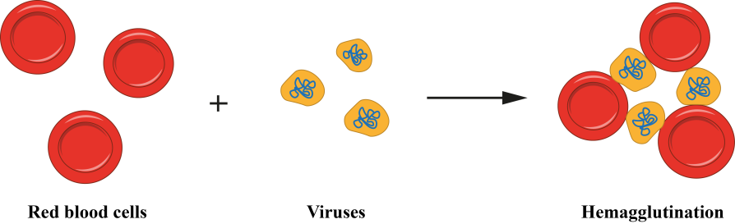

Figure 39: Haemagglutination

Table 9:CPE in cytoskeleton
CPE in cytoskeleton | Viruses
Depolymerization of actin-containing microfilaments | Canine distemper virus, vesicular stomatitis viruses, vaccinia virus
Extensive damage to microtubules | Enteroviruses

Non-cytocidal Changes in Cells infected by virus: Cellular metabolism is not affected, infected cell continue to replicate. It can be seen in RNA viruses.

1. Persistence infection- The virus or its genetic material persists within the cell through integration into the host cell DNA or carriage as an episome, allowing the cell to survive and potentially undergo repeated divisions. Examples include the concealment of viral progeny in sensory ganglia, as observed in herpesviruses.
2. Inclusion bodies- The hallmark histological manifestation in cells infected by viruses is the formation of inclusion bodies (Table 10). These structures exhibit unique characteristics in terms of size, shape, location, and staining properties, discernible under light microscopy in virus-infected cells. Inclusion bodies can be found in various cellular compartments, such as the cytoplasm (e.g., poxviruses), nucleus (e.g., herpesviruses), or both (e.g., measles virus). Typically acidophilic, they appear as pink structures when subjected to staining methods like Giemsa's or eosin methylene blue. Alternatively, some viruses induce the formation of basophilic inclusions. The identification and analysis of these inclusion bodies contribute significantly to the diagnostic process, aiding in the recognition and classification of viral infections based on their distinct morphological features observed in infected cells. Here are some key functions:

  - Viral Replication and Assembly: Inclusion bodies often play a role in the replication and assembly of new virus particles. They can serve as sites for the concentration of viral components, aiding in the efficient production of new viral progeny.

  - Protection of viral components- Inclusion bodies can protect viral components, such as nucleic acids and proteins, from host cell defenses. The sequestration of these components within inclusion bodies may shield them from degradation or recognition by the host immune system.

  - Facilitation of viral spread- Certain inclusion bodies assist in the dissemination of the virus within the host organism. For example, in some cases, inclusion bodies may contain large amounts of infectious virions, contributing to the spread of the virus to neighboring cells.

  - Host cell manipulation- Inclusion bodies can influence host cell functions to create a more favorable environment for viral replication. This may involve the modulation of cellular pathways, interference with host defense mechanisms, or alteration of cellular structures.

  - Diagnosis of viral infections- Inclusion bodies are valuable diagnostic indicators. Their presence and characteristics observed through microscopy can aid in the identification and classification of specific viruses, contributing to the accurate diagnosis of viral infections.

Table 10: Viral inclusion bodies
Intracytoplasmic | Inclusion bodies |  | Virus
 | Negri bodies (eosinophilic inclusions) |  | Rabies
 | Bollinger bodies (large inclusion bodies) |  | Fowl pox
 | Guarnieri bodies (smaller multiple inclusion bodies) |  | Vaccinia virus
 | Henderson-peterson bodies (20-30 µ large inclusion) |  | Molluscum Contagiosum
 | Paschen bodies |  | Small pox
Intranuclear  Cowdry (1934) | Acidophilic | Cowdry type A (variable size and granular) | Varicella zoster virus
 |  |  | Herpes simplex virus
 |  |  | Yellow fever virus
 | Basophilic | Cowdry type B (circumscribed and multiple) | Polio virus
 |  |  | Adeno virus
 |  |  | Cytomegalo virus

Necrosis/Apoptosis:

Apoptosis (programmed cell death)- A highly regulated process that eliminates damaged or infected cells without causing tissue inflammation. Some viruses (HIV, Influenza A, HSV, HPV, Hepatitis B, Varicella Zoster) can trigger apoptosis as part of their replication strategy. They encode specific proteins that interfere with cellular pathways, leading to the activation of apoptotic signals.

Mechanisms- Viruses may activate intrinsic or extrinsic apoptotic pathways. Intrinsic pathways involve mitochondrial damage and the release of pro-apoptotic factors, while extrinsic pathways are initiated by external signals binding to death receptors on the cell surface.

Apoptotic cells typically undergo characteristic morphological changes, such as cell shrinkage, chromatin condensation, and the formation of apoptotic bodies. These bodies are then phagocytosed by neighbouring cells without inducing inflammation.

Necrosis- It is a process of cell death that occurs as a result of cellular injury or damage, often leading to tissue inflammation. Certain viruses (Cytomegalovirus, Rotavirus, Huntavirus, Dengue virus), particularly those causing acute infections, can induce necrosis as a consequence of their destructive effects on host cells.

Mechanisms- Viral replication and the release of viral particles can cause cellular damage, disrupting membrane integrity and organelle function, ultimately leading to cell death.
Necrotic cells undergo swelling, loss of membrane integrity, and release of cellular contents into the extracellular space. This process can trigger inflammation and an immune response.

Host immune response to virus:

A. Innate Immune Response- Innate means in born, a non-specific rapid immune response that provides immediate protection by birth. This is considered as first line defense against viral infection. The components of innate immune response are-

1. Physical and chemical barrier-

a) Skin- Skin is the largest organ of the body and provides strong physical barrier. It contains antimicrobial peptides that can kill pathogen. Commensal flora present on skin promote wound healing and restrict microbial growth. Despite preventing viral entry, certain viruses such as HSV and HPV can enter in to the skin through abrasion.
b) Mucosal surface- The respiratory and gastrointestinal tracts are the major sites for the virus entry. The respiratory tract is lined by the ciliated epithelial and goblet cells, both key for the proper functioning of the mucociliary escalator. This mucus, produced by goblet cells, lines the epithelium and traps pathogens and other inhaled particulates, which is then removed from the airways by ciliated airway epithelial cells.

2. Pattern Recognition Receptors (PRRs)- Pattern Recognition Receptors (PRRs) are integral components of the innate immune system, residing on various cell types, including immune, epithelial, and endothelial cells. These receptors identify Pathogen-Associated Molecular Patterns (PAMPs), shared by pathogens and distinct from host elements, enabling the discrimination between self and non-self. PAMPs consist of substances like lipopolysaccharide (LPS), flagellin, and peptidoglycan found on bacterial surfaces, as well as genetic material from viruses and common components in microorganisms like fungi and parasites.
PRRs exhibit diverse cellular locations, with some on the cell surface for recognizing extracellular pathogens (mainly on immune and epithelial cells), while others are intracellular, targeting pathogens like viruses within endosomes or the cytoplasm. Toll-like receptors (TLRs), C-type lectin receptors (CLRs), Retinoic acid-inducible gene-I (RIG-I)-like receptors (RLRs), Nucleotide-binding oligomerization domain-like receptors (NLRs) constitute the four primary PRR groups.

3. Interferons: There are three types of interferons (Table 11).

Table 11: Types of interferons

Interferon types | Sub-types | Produced by | Functions
Type -I | interferon-alpha (IFN-α)and interferon-beta (IFN-β) | Various cell types, including leukocytes, fibroblasts, and epithelial cells, in response to viral infections and other immune stimuli. | Induce the expression of antiviral proteins within infected cells, inhibit viral replication, and enhance the immune response against viruses.  IFN-α is widely used in the treatment of chronic viral hepatitis and certain cancers, while IFN-β is approved for the treatment of multiple sclerosis (MS).
Type- II | interferon-gamma (IFN-γ) | Activated T cells and natural killer (NK) cells in response to antigenic stimulation | IFN-γ plays a central role in the adaptive immune response, particularly in activating macrophages and enhancing their antimicrobial activity.  It also regulates the differentiation and function of T and B cells and is involved in immune surveillance against tumors.
Type-III | interferon-lambda (IFN-λ),also known as interleukin-28 (IL-28) and interleukin-29 (IL-29) | Epithelial cells and dendritic cells, in response to viral infections. | Induction of antiviral responses and the inhibition of viral replication.  IFN-λ has been investigated for its therapeutic potential in viral infections such as hepatitis C and respiratory viruses.

4. Natural Killer (NK) Cells and Neutrophils- NK cells possess cytotoxic activity and can kill the cells directly upon viral infection. NK cells can produce cytokines such as IFN- γ, TNF-α to regulate immune response. They can interact with dendritic cells and can influence the activation and differentiation of T cells. Neutrophils are phagocytes and can release microbicidal substances, including reactive oxygen species (ROS) and antimicrobial peptides, to kill pathogens. Neutrophils release extracellular traps composed of DNA, histones, and antimicrobial proteins to ensnare and kill pathogens.

5. Antibodies- In the humoral immune response, antibodies such as IgG, IgM and IgA play a crucial role in defending the body against pathogens.

IgG (Largest antibody, pentamers)- provides long-term immunity, as it can cross the placenta from mother to fetus, providing passive immunity to newborns. Functions of IgG include neutralization of toxins and viruses, opsonization of pathogens for phagocytosis, activation of the complement system, and participation in antibody-dependent cell-mediated cytotoxicity (ADCC).

IgM- IgM is the first antibody produced during an initial immune response to an antigen. It plays a crucial role in the primary immune response and is produced early in infection. IgM levels typically decrease as IgG production increases during the course of an infection. In blood typing, IgM antibodies are responsible for the agglutination of incompatible blood types.

IgA- IgA is found predominantly in mucosal areas such as the respiratory, gastrointestinal, and genitourinary tracts, as well as in saliva, tears, and breast milk. It exists in two forms: secretory IgA, which is produced locally in mucosal tissues and serves as the primary defense against pathogens at mucosal surfaces, and serum IgA, which circulates in the blood. In breast milk, IgA provides passive immunity to infants, protecting them from infections until their own immune systems mature.

B. Adaptive Immune Response: The adaptive immune response is acquired after birth and persists until death. This is the most specific defense mechanism that the body employs to target and eliminate specific pathogens.
1. B cells and antibody-
- B cells, particularly plasma B cells responsible for antibody production, play a crucial role in the immune response against viruses.

- Antibody production forms the basis of vaccines, effectively combating various viral pathogens such as measles, rubella, smallpox, SARS-CoV-2 by generating neutralizing antibodies.

- These vaccines also stimulate the production of long-lived memory B cells, enabling rapid antibody production upon future encounters with the same pathogen.
- However, in some cases like SARS-CoV-2 and RSV infections, antibody production is short-lived, leading to the possibility of re-infection.
- Additionally, B cells have antibody-independent functions during viral infections. They produce pro and anti-inflammatory cytokines, including Bregs, which modulate the immune response of other cells.
- Furthermore, B cells present antigens to T cells via MHC class II molecules, influencing the T cell response to viral antigens.
2. CD4⁺ T cells- CD4+ T cells identify antigens presented on immune cells through their T cell receptor (TCR) bound to MHC class II molecules. They play a central role in adaptive immune responses by secreting cytokines and interacting with other immune cells. T helper cells are involved in activating and directing the activities of other immune cells, including B cells, cytotoxic T cells, macrophages, and dendritic cells. They are subdivided (Table 12) as-
Table 12: Classification of T cells
Th1 | Th2 | Treg
- Activates macrophages, promoting the differentiation of cytotoxic T cells (CD8+ T cells), and enhancing the production of antibodies of the IgG class.  - Secrete cytokines such as interferon-gamma (IFN-γ), interleukin-2 (IL-2), and tumor necrosis factor-alpha (TNF-α).  - They are associated with autoimmune diseases, chronic inflammatory conditions, and defense against intracellular pathogens. | - Regulates humoral immunity and allergic responses.  - Promotes antibody production (IgE, IgG1, IgA) Stimulates the activity of eosinophils and mast cells.  - Secretes cytokines such as IL-4, IL-5, IL-10, and IL-13.  - Associated with allergic diseases, such as asthma, atopic dermatitis, and allergic rhinitis, as well as with defense against helminth parasites. | - Maintains immune tolerance and prevents autoimmune responses.  - Suppress the activity of other immune cells, including T cells, B cells, and antigen-presenting cells (APCs), thus preventing excessive immune reactions against self-antigens.  - Produce immunosuppressive cytokines such as IL-10 and transforming growth factor-beta (TGF-β).  - can be divided into natural Treg cells (nTregs), which develop in the thymus, and induced Treg cells (iTregs), which are generated in peripheral tissues.  - Dysregulation of Treg cells is associated with autoimmune diseases, chronic inflammation, and impaired immune tolerance.

3. CD8⁺ T cells-

- Cytotoxic T cells (CTLs) are vital components of the adaptive immune system, responsible for eliminating virally infected or tumor cells.
- They recognize antigens presented on MHC class I molecules, which are found on the surface of all nucleated cells.
- CTLs employ two main mechanisms to kill target cells: the release of cytotoxic granules containing perforin and granzyme, and death receptor-mediated apoptosis via Fas/FasL interaction. These mechanisms involve the formation of an immunological synapse between the CTL and the target cell.
- CTLs also produce pro-inflammatory cytokines, such as TNF-α, IFN-γ, and IL-2, which stimulate further immune responses. Viruses can evade CTL activity by downregulating MHC class I expression on infected cells.

References:
Herbert, J.A., Panagiotou, S., 2022. Immune Response to Viruses, in: Encyclopedia of Infection and Immunity. Elsevier, pp. 429–444. https://doi.org/10.1016/B978-0-12-818731-9.00235-4
Hoenen, T., Groseth, A., 2022. Virus–Host Cell Interactions. Cells 11, 804. https://doi.org/10.3390/cells11050804
Whitaker-Dowling, P., Youngner, J.S., 1999. VIRUS-HOST CELL INTERACTIONS, in: Encyclopedia of Virology. Elsevier, pp. 1957–1961. https://doi.org/10.1006/rwvi.1999.0343

