**Title**: The Path Forward - Envisioning a Greener Future

Ms. Husaina Singapurwala1, Mr. Shubham Gupta2

1M.Sc, Parul Institute of Paramedical and Health Sciences, Faculty of Medicine, Parul University, Vadodara, Gujarat-391760.

2 Assistant Professor, Parul Institute of Paramedical and Health Sciences, Faculty of Medicine, Parul University, Vadodara, Gujarat-391760.

**ABSTRACT**

Climate change poses a major global health threat, prompting the need for sustainability and environmental protection in the healthcare industry. Limited environmental impact assessments reveal healthcare's significant resource and energy consumption, waste generation from disposable gowns, polypropylene fabric, gloves, plastics, cotton production, and anaesthetics contributing to ozone depletion. Thus, Green healthcare practices, focusing on environmental protection, community leadership, and cost savings, offer long-term benefits. Innovative resource and waste management practices, policy-relevant research, and patient-centred practices are crucial for reducing healthcare emissions by optimizing environmental footprint and considering public health impacts. Further in this chapter, we discussed the healthcare sector is increasingly utilizing life cycle assessment [LCA] to measure greenhouse gas emissions and environmental performance, aiding decision-makers in prioritizing equipment upgrades and waste management protocols. By using machine learning and robotics to optimize processes and lower carbon footprints, artificial intelligence [AI] has the potential to transform sectors such as medical care and green finance. By coordinating across several teams, including anaesthetists, facilities managers, engineers, surgeons, nurses, and perfusionists, healthcare innovators can optimize sustainable systems and improve patient safety and health outcomes.

Keywords— Climate Change, Global Health Threat, Sustainability, Green Healthcare, Life Cycle Assessment [LCA], Greenhouse Gas Emissions, Artificial Intelligence [AI], Health Outcomes.

**1. INTRODUCTION**

“In the twenty-first century, climate change is the greatest threat to world health.”(1) Agencies, companies, and consumers everywhere are realizing the need for sustainability and environmental preservation. Crucial research, innovation, and regulation have advanced quickly. Although the healthcare sector has been sluggish in adopting environmental concerns, the rise of "green healthcare" signifies a substantial change.

Facilities in the health sector are essential to providing services, safeguarding patients' health, curing illnesses, and saving lives. However, they also release carbon dioxide into the atmosphere, which triggers environmental degradation. Facilities in the health industry around the world emit CO2 by using a lot of resources and energy-intensive machinery. Perhaps ironically, as medical professionals, we are dedicated to the principle of "first, do no harm." Healing centres ought to set the standard rather than add to the burden of illness.(2)

Even though the scale may differ greatly, the health sector in every country releases greenhouse gases [GHG] both directly and indirectly through expenditures on energy, logistics and manufacturing, consumption, and recycling of products. Different hospital regions produce various types of waste as shown in Figure 1. To reduce the risks associated with hospital waste and guarantee its efficient handling, proper disposal procedures are essential. Because burning garbage releases toxic gaseous substances like carbon dioxide and methane, it is bad for the environment.

According to the report, the climate footprint of the healthcare industry equals 4.4% of global net emissions. The top three emitters in healthcare - the United States, China, and the European Union - together make up more than half of the global footprint. Additionally, 71% of emissions come from the healthcare supply chain.(3) These estimates of the healthcare industry's climate footprint are crucial for developing strategies and monitoring progress toward decarbonizing healthcare across the sector.

The climatic footprint of a nation's health sector and its health spending are strongly, though not always, correlated. In general, as a country's spending is expressed as a proportion of gross domestic product [GDP], its per capita healthcare emissions rise. Other elements are also quite significant, especially the economy's energy intensity and the energy system's emissions intensity. If a new trajectory toward zero emissions is coupled with the growth and investment in the health sector, the climate impact of medical services can be significantly mitigated even as spending on it rises. In this case, health care for everyone and other medical industry endeavours can be connected to climate goals around the world.

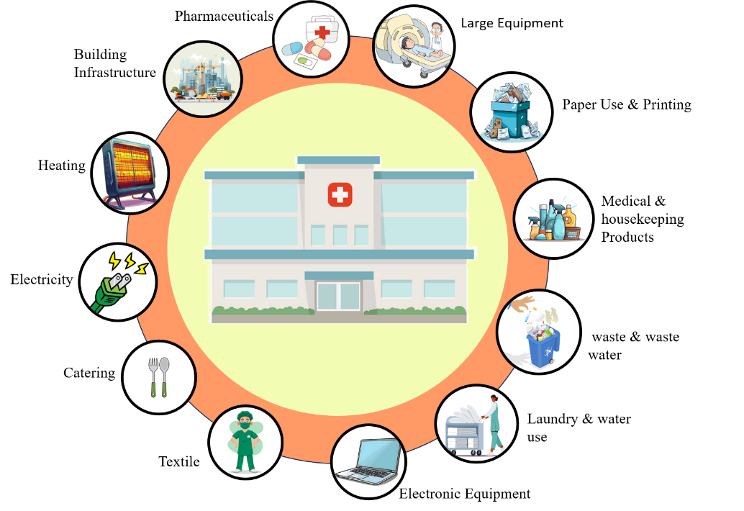

Figure 1: Basic Schematic of Important Hospital Waste Management Regions

Green healthcare, or the integration of ecologically sustainable methods into patient care, appeals to medical practitioners as well as organizations for a number of reasons. It offers the chance to safeguard the ecosystem, which is a problem that is becoming more and more urgent. It allows medical facilities to demonstrate leadership in their local communities. It can be used as a platform to educate the general public and pupils. It may also lead to financial savings.

During the Institute of Medicine's [IOM] green health care workshop, these arguments were acknowledged.

The workshop attendees, who are health professionals, might find green health care particularly convincing due to its ability to safeguard and enhance health, both directly and indirectly.

There are three ways that health benefits might function as shown in Figure 2.



Figure 2: Health advantages can work on three different levels

1. **Local:** At the local level, green operations and structures assist in safeguarding individuals, visitors, and staff at places like hospitals, medical facilities, and research centres. For instance: Choosing appropriate products for cleaning and reducing the usage of chemicals can reduce the risk of harm for individuals affected.
2. **Community:** Reducing a healthcare facility's ecological impact contributes to the preservation of the environment and the reduction of hazards to the environment at the level of the community. For example, transportation options and pedestrian infrastructure can help reduce vehicular congestion and improve air quality by linking healthcare facilities to the surrounding community. The quantity of garbage dumped in trash can also be reduced by using ecological dishes and flatware and minimizing packaging in medical facility cafeterias.
3. **Global:** Global environmentally friendly practices help manage limited supplies and reduce environmental damage. For example, a healthcare facility that purchases nourishment and supplies locally reduces the need to ship goods across far distances, thereby reducing greenhouse gas emissions that fuel climate change.

**2. GREEN HEALTH CARE**

Sustainable building is defined in a variety of ways, but generally speaking, it refers to the planning, development, operation, maintenance, and demolition of structures in a way that minimizes emissions and conserves biodiversity. All stages of the planning, building, and maintenance of healthcare facilities are included in this term. Prospects to enhance ecological sustainability in areas like choosing the right location, water preservation, efficient utilization of energy, use of low-emitting and renewable resources, alternative modes of conveyance, daylighting, minimizing waste, local and sustainable food consumption, and green cleaning supplies are outlined in the Green Guide for Health Services. (4)

During the planning and construction phases, certain decisions like site selection are made, while other choices, like where to buy food and how to clean are mainly related to the operation after a building is finished.

Throughout a facility's evolution, from its initial construction design to everyday operation and subsequent substitution, it is crucial to make and continuously uphold pledges to minimize energy consumption, sustainable utilization of resources, and related aspects. Modern hospital systems offer a chance to alter or lower their use of assets because they are major consumers of such assets.

Effectively defining the idea of green healthcare buildings that promote community and environmental sustainability is necessary to develop an approach that appeals to authorities and medical practitioners.

This framework ought to include attributes such as:

* Ambitious: Sustainable healthcare organizations aim to enhance health, reduce adverse effects, and aid with ecological rehabilitation.
* Cost-effective: Sustainable healthcare establishments may decrease cost by providing affordable substitutes.
* Cautious: Sustainable healthcare practices lower potential dangers including power expense swings, health problems associated with buildings, and impermanence of buildings.
* Long-term: throughout time, or even throughout a building's whole existence, some advantages of environmentally friendly construction become apparent.
* Perspective: In addition to offering advantages on their own property, sustainable constructions often help the community, sometimes even on a national or international scale.

In addition, big organizations provide strategic benefits as they train health science students, allowing for the demonstration and spread of effective green healthcare principles. Furthermore, numerous large institutions are currently engaged in construction projects, providing chances for broad influence. At all levels of the healthcare system, however, participants stressed the importance of ecologically responsible procedures.

**2.1 GREEN HEALTH CARE – OUTCOMES**

The concept, which is frequently referred to as "the community, the environment, and financial gain," contends that a business, organization as well, or structure would function best if it promotes humanitarian, ecological, and financial outcomes. Health consequences are included in the social component of health care facilities. Therefore, a hospital that successfully achieves the triple bottom line would show excellent fiscal performance, efficient use of the environment's resources with zero waste or environmental damage, and advantageous impacts on the physical wellness and well-being of its individuals, staff, and visitors. Numerous private businesses are aware that this approach not only advances their goals but also places them in a favourable market position, enhancing their reputation and winning over new clients. Sustainable healthcare is directly covered by these arguments.

**2.2 ETHICS**

Additionally, there are moral justifications for seeking green healthcare:

1. Ethics in the medical profession: The four guiding concepts of medical ethics are typically the following: self-determination, kindness, fairness, and Providing green health care is particularly in line with goodwill since it benefits both patients and employees, and with kindness because it prevents harm that some traditional methods could cause.
2. Ethics in General Well-being: Three traditions—utilitarianism, liberal principles, and communitarianism—have been connected to wellness ethics, and they provide a strong case for green healthcare.

Therefore, green health care is firmly rooted in the ethical traditions of both general wellness and biomedicine.

**2.3 HEALTH AGENDAS**

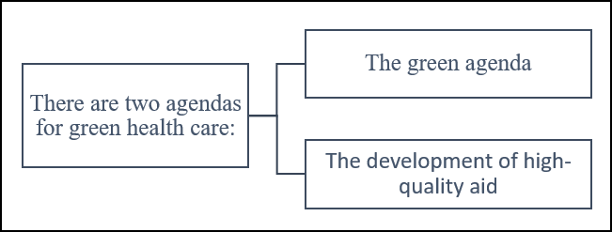

Figure 3: Two fundamental health agendas are depicted.

Two primary health agendas as shown in Figure 3, focus on public health improvement and medical facility reduction, while the other DQS involves understanding information, ideas, assurance, and choice-making

1. The Green Agenda: The green agenda involves analyzing the socioeconomic health impacts at various levels, from individuals in a building to the entire society. It is centred around the concept of a positive cycle. If a hospital is designed, built, and operated in line with sustainable development principles, it can have positive effects on the ecosystem, regional commerce, and population. This approach can enhance individual health and decrease the need for health services.
2. The Development of high-quality aid: This agenda aligns with the principles of sustainability. Like the sustainability agenda, this agenda promotes social and economic objectives, but it emphasizes leveraging design to enhance quality and safety results, including reducing errors and infections, minimizing staff turnover, shortening hospital stays, and increasing patient and family contentment. It encompasses a method where individuals comprehend the evidence, form hypotheses, validate the results, and integrate into decision-making processes.

**3. The Guidelines for Green Revolution Health Services**

The Green Guide for Health Care represents the first measurable sustainable design toolkit for the healthcare sector. It integrates improved environmental and health principles and practices into the planning, design, construction, operations, and maintenance of healthcare facilities. A climate-friendly hospital focuses on seven elements: waste management, water conservation, sustainable procurement, transportation, renewable energy, and green building design as shown in Figure 4. These components lower costs and foster innovation while lowering environmental pollution, enhancing resilience, spurring innovation, and generating financial returns.

This green guide for health care offers a voluntary, self-certifying metric toolkit of best practices for the healthcare sector. Designers, owners, and operators can use it to guide and assess their advancements towards high-performance healing environments.

The need to address climate change has been acknowledged by health professionals and urban planners for a long time. Environmental sustainability should be included in the seventh component of healthcare quality, along with patient-centred care, safety, timeliness, effectiveness, and efficiency.

Future hospitals may make a significant contribution to the battle against climate change by reducing their carbon emissions and by encouraging the people they serve to do the same. The required steps will greatly improve the financial sustainability of the services offered, even if they do not affect future climate circumstances.

**3.1 MAIN SOURCES OF WASTE IN HOSPITALS**

Hospitals rely on the $40.3 billion disposable medical supplies sector and generate 3.4 billion pounds of solid waste annually. Although there is little research on the subject, hospitals are beginning to evaluate how modern medical practices affect the environment, especially with regard to energy.(6)

The healthcare facility consists of a surgical suite, surrounding hallways, and an uncontaminated core that houses machinery and anaesthetic rooms, holding and recovery facilities before and after surgery, management offices, and facilities for detoxifying medical devices. Plenty of assets are needed for healthcare, including costly equipment, sterilization techniques, cutting-edge operating innovations, and vital life-sustaining systems. These operations generate huge amounts of garbage and use a lot of power and materials. Despite being widely acknowledged as essential to delivering excellent medical services, the climatic consequences have not been fully measured or critically assessed. The newborn's birth alone has a significant effect on the manufacturing of materials, utilization of energy, the sterilization process, and dumping.(7)

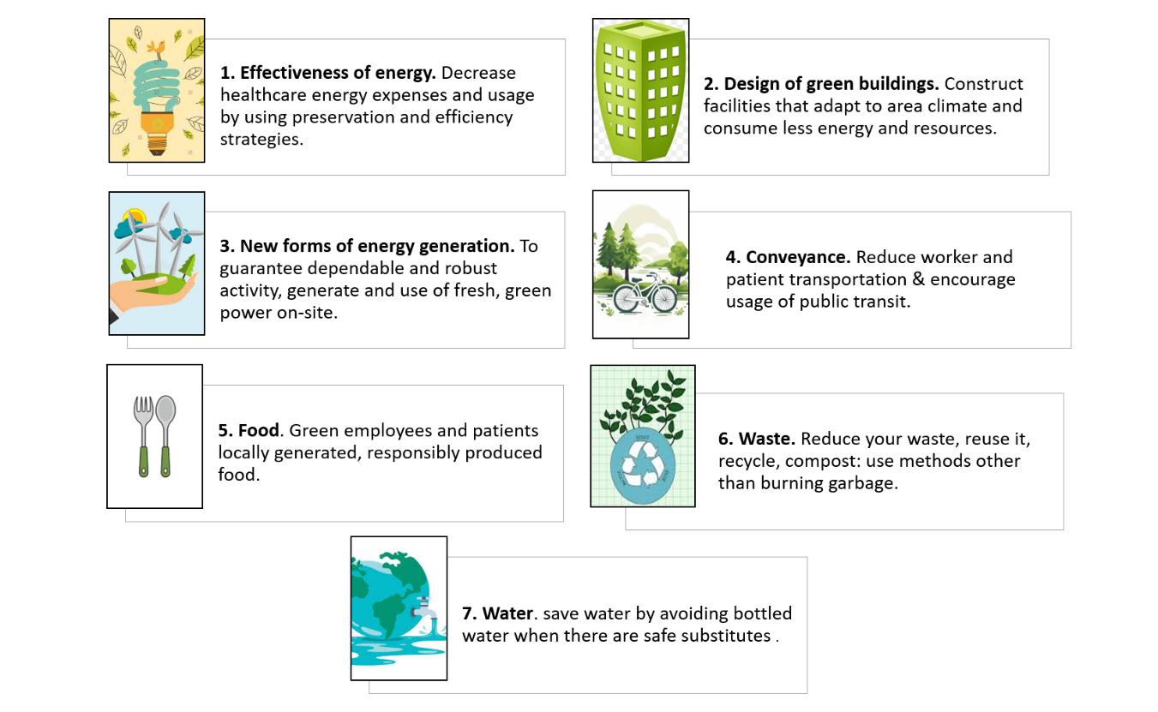Figure 4: seven components of a healthcare facility that is climate-friendly. (5)

There are several trajectories of Hospital waste, including infectious, pharmaceutical, and sharps waste, which requires specialized treatment at specialized facilities as shown in Figure 5. Landfills shouldn't be used for plastic trash disposal. When medical waste is improperly disposed of, it can pollute the air, leak chemicals into the water, and harm the environment. Landfills should manage garbage discharge, regulate surface water and drainage, prevent scavenging, employ a soil cover regularly, and restrict access to assure safety.

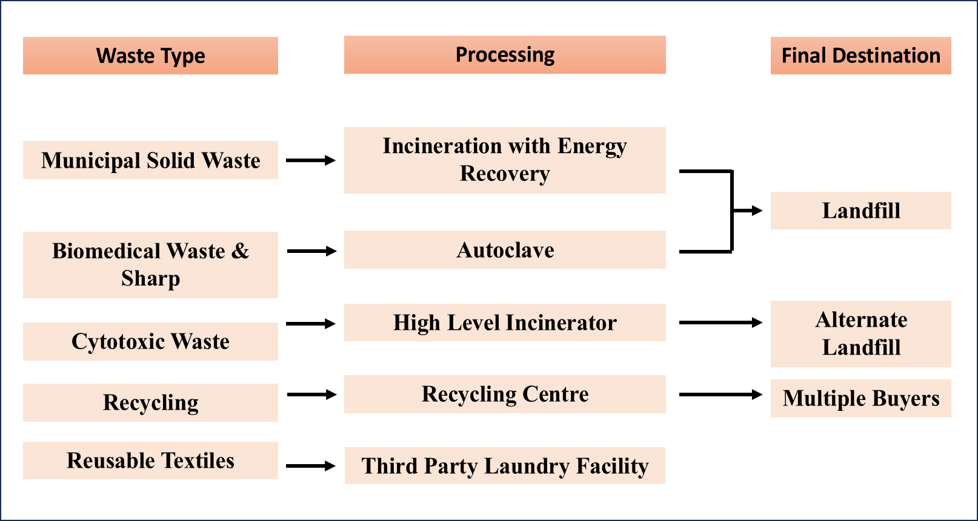

Figure 5: Several Trajectories of Hospital Waste(8)

The Hospital disposes of disposable gowns, drapes, and blue wrap made of polypropylene fabric, also referred to as spunbond-meltblown spunbond or SMS PP. This material contributes significantly to the waste stream in terms of weight. Gloves make up approximately 5% of the weight of waste generated in each surgery. Furthermore, approximately 36% of the total amount of solid waste from municipalities is made up of different kinds of polymers, such as rigid plastic boards and flexible wrapping paper packages. Although cotton-based goods make up just over five per cent of the total amount of municipal solid waste streams, the manufacture of cotton has the largest consequence on all single-use materials, especially in regard to contamination and health effects on people. The effects linked to the manufacturing of paper items like paper labels and cardboard packaging contribute to 1−7% of each impact category.(6)

Plastic has several benefits, but it also has drawbacks. Plastic, which is lightweight, strong, and reasonably priced to make. Numerous advancements in patient comfort, safety, and care have been made possible by plastics. For example, they have made it possible for the development of inexpensive, single-use disposable goods and protective sterile packaging, revolutionizing infection prevention and control. Plastic items play a significant role in implanted and wearable medical devices and are frequently utilized during and after surgery.

Plastics' entrance into the healthcare sector has resulted in a rise in single-use plastic products in the solid waste stream, which has had profound and unexpected effects on both human health and the environment. Di[2-ethylhexyl] phthalate [DEHP], a solvent used to increase the flexibility of plastic, is one of the most worrisome chemicals utilized in its manufacture. DEHP-containing products frequently wind up in landfills, which require room, upkeep, and lining to avoid contaminating the nearby soil, groundwater, and surface. Additionally, plastics can be burned. The problem of landfill space is addressed, however, hazardous dioxins are produced when polyvinyl chloride plastic items are burned. Dioxins pollute more than just the immediate environment because they cling to dust and air particles. Incinerators and landfills are major sources of greenhouse gas emissions. (9)

Anaesthetics possess significant greenhouse gas properties. Anaesthesiologists choose anaesthetics based on personal preference as part of their regular practice. The choice of anaesthetic can have a significant impact on the environmental effect of surgery. On average, anaesthetic usage accounted for 98% of the ozone depletion potential. The inhalation anaesthetics used, such as sevoflurane or desflurane with or without nitrous oxide [N2O] as a carrier gas, are themselves greenhouse gases with ozone depletion potential. Desflurane has a global warming potential 20 times higher than that of sevoflurane. Cotton and polyvinyl chloride components are manufactured in biodegradable bespoke packs, which contribute significantly to pollution and the destruction of ozone layer. Waste disposal and transportation are the main causes of the effect categories of cancer-causing agents, non-carcinogens, eutrophication, and environmental toxicity.

**3.2 REDUCING HEALTHCARE WASTE**

Waste from hospital care is abundant, with operating theatres contributing a large proportion. Placing potentially recyclable material in a "biohazard" container is twice as wasteful since "biohazard" waste needs to be disposed of using high-energy techniques, including burning. Nonetheless, there ought to be some methods for cutting down on clinical care waste as shown in Table 1.

The total quantity of greenhouse gases [GHGs] that a product or activity releases into the atmosphere [leads to global warming and climate change] is known as its "carbon footprint."

Every specialization has a unique carbon footprint and offers unique prospects for carbon and cost savings. For instance, the area of nephrology has extensively documented the carbon footprint of dialysis. The use of heat exchangers on dialysis machines, central dialysate supply, or on-site dialysate preparation are examples of ways to save money and carbon [any kind that prevents the delivery of dialysis treatment focus to every machine using a lot of polyethene packages].

Utilizing unwanted water from the process of reverse osmosis plants, which are used to supply exceptionally pure water for hemodialysis, can also result in substantial water conservation. Every kidney unit could save £7 million, 11,000 tons of carbon gases [CO2 equivalent], and 470 million litres of water a year if they implemented all of the "sustainable" measures compiled in a recent survey using the green nephrology network. (5)

Table 1: Presents Strategies for Reducing Clinical Care Waste (5)

|  |
| --- |
| Recommendation on cutting waste |
| 1. Utilize the waste reduction toolkit and adopt the principles of resource sustainability. |
| 2. Using tools like the NICE recommendation database and a well-curated list of low-value medicines, the work entails finding inefficient areas in the field and fixing them. |
| 3. Medical schools and local education boards should promote the acquisition of both clinical and leadership abilities for exceptional healthcare. |
| 4. Physicians ought to devote their effort to determining potential areas for resource waste reduction. |
| 5. Health commissioners ought to support clinical process waste reduction. |
| 6. Initiatives to eliminate resource waste in clinical settings should be developed and supported by public health authorities. |
| 7. Everyone involved in the health sector should take action to understand better the carbon costs associated with healthcare operations. |

Nurses can contribute to a variety of sustainability activities, such as educational programs, practice and policy reforms, and creative research, to help minimize plastic waste in health systems. Nurses are uniquely qualified to actively participate in training staff on how to appropriately dispose of, sort, and distinguish amongst waste streams at their institutions because they handle a range of materials that need to be disposed of on a daily basis. First, they ought to determine which kinds of plastic are recyclable in their state and locality. They could then make a chart for disposing of plastic waste, which would be a useful tool for employees who handle these items and are having trouble figuring out how to properly dispose of them. Products made of unsoiled plastic that don't leave any residue, like sterile and regular saline water containers, might be recyclable. Frontline nursing personnel should use their critical thinking abilities to recommend product and room design adjustments that would enable safe waste disposal and recycling, as they have the best view of workflow challenges that obstruct appropriate sorting at the bedside. To encourage staff and patients to participate in recycling initiatives, a nurse could, for instance, push for the installation of recycling bins in non-isolation rooms in addition to the regular trash can.(9)

One significant clinical concern is supplying waste. Reducing the number of supplies, reusing them when infection control guidelines permit, and recycling as much of the material as possible through local, state, and federal infrastructure should be the guiding principles. In isolation rooms, where most infection control standards require that items be thrown out when a patient is transferred or discharged, supply waste is particularly problematic. Nurses and other clinical team members should be careful when replenishing in-room supplies, particularly those made of plastic, and only bring in what is required to offer safe patient care when caring for patients in these rooms.

Since several waste and expenditure issues in healthcare influence the environment, unit-based activities to prevent wasted supplies can help reduce waste and expense. Table 2 below lists some potential solutions. The use, arrangement, nurse refilling preferences, and turnover of intensive care unit [ICU] supply carts—that is, the removal of unnecessary goods and the replenishment of the cart—were assessed in one nurse-led waste reduction project. As a result, supply waste was reduced by 45% to 80% and the cart changeover procedure in intensive care units was standardized across the organization. (9)

Table 2: A list of potential issues & their ecological effects and possible solutions. (6)

|  |  |  |
| --- | --- | --- |
| ISSUE | Environmental Impact Categories | Potential Reduction Strategies |
| Energy used to run HVAC | * Greenhouse Gas Emission * Pollution production * Risk for acidic condition * Pulmonary effects | * Constant machinery devices care * Equipment improvements * Less energy spill in connection & pipelines * Reduced ventilation speed * Increase use of green energy resources |
| Anesthetic Gases | * Greenhouse Gas Emission | * Install waste gas capturing technology * Apply the lowest fresh gas flow rate * Avoid desflurane |
| Production of Disposable Cotton | * Carcinogens * Non-Carcinogens * Ecotoxicity | * Reuse cotton * Recycle cotton * Use organic cotton * Use other fibers |
| Production of Disposable Gowns, Drapes, and Blue Wrap [SMS-PP] | * Non-Carcinogens * Ecotoxicity * Cumulative Energy Demand | * Recycle materials * Replace with reusable materials |
| Disposable of PP [Polypropylene] | * Eutrophication | * Recycle materials * Replace with reusable materials |
| Production of Disposable Surgical Instruments | * Ozone Depletion Potential * Greenhouse Gas Emission * Acidification Potential * Eutrophication * Respiratory Impacts * Cumulative Energy Demands | * Encourage environmental manufacturing * Utilize reusable instruments * Use third-party reprocessing |

**3.3 ENERGY CONSUMPTION**

One of the biggest contributors to greenhouse gas emissions globally is the energy supply area, which accounts for 35% of total emissions. (10) Hospital facilities consume significant energy as they operate year-round at high costs, house advanced medical equipment, and adhere to strict cleaning protocols and environmental standards. Compared to other building types, hospitals significantly impact the environment throughout their life cycle. Since cooling systems is seen to be essential for preventing infections, heating, ventilation, and air conditioning (HVAC) contribute to half of a hospital's consumption of energy within healthcare facilities, which are subject to stricter regulations than other industries. This is particularly noticeable in surgical suites, where 90% - 99% of energy is used for HVAC systems that enhance sterility for successful operations.

**3.4 ELECTRICITY CONSUMPTION**

Electric power generation is the second largest [emitter of carbon dioxide pollution](https://www.epa.gov/ghgemissions/sources-greenhouse-gas-emissions), contributing to [climate change](https://www.epa.gov/climate-change). Today's healthcare facilities rely mostly on electronic systems like lighting, ventilation, and interior settings because of their low energy content, which causes them to get heated up and cool off quickly. As seen in Figure 6, they use nearly twice as much energy annually as the typical industrial office structure. (4)

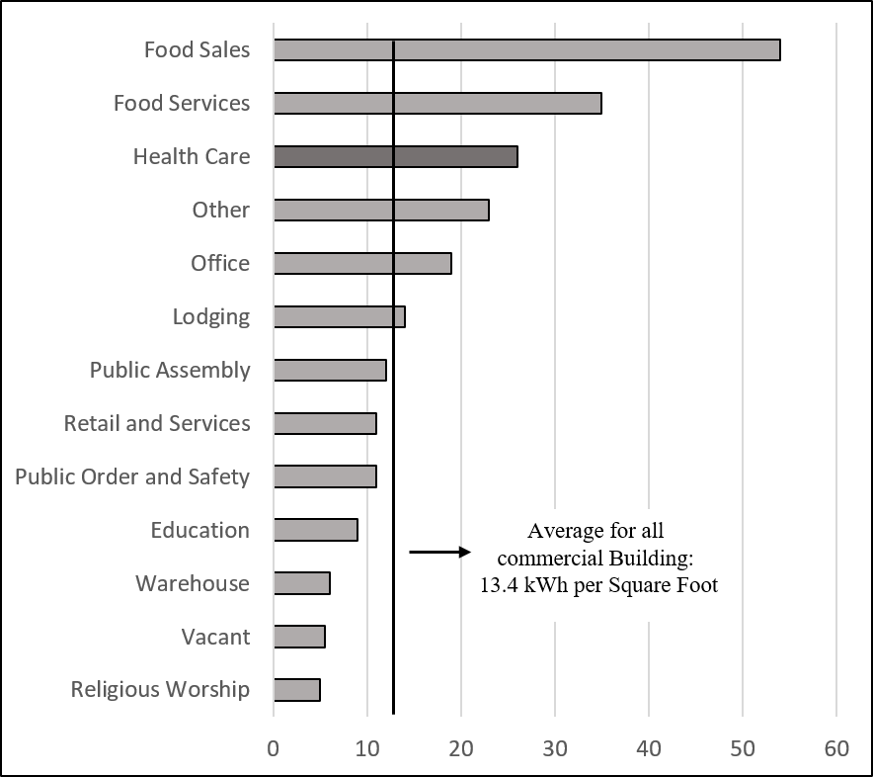

The amount of electrical power used per square foot [kWh]

Figure 6: Healthcare facilities use almost double as much energy as the median commercial building. (11)

**3.5 HVAC**

The heating, ventilation, and air conditioning [HVAC] are responsible for more than 70% of the energy impacts. The electricity needed to operate the machines in the Operating room contributes to 10-30% of each impact category studied, varying based on the type of surgery. (6) Equipment, illumination, and HVAC loads constituted the most proportion across all methods of distribution in each group of respiration impacts, the acidification process, and environmental change potential. This resulted from the requirement for energy from natural gas and electricity to run the HVAC system, lighting, and machinery for both production and consumption.

**3.6 ENERGY-SAVING SOLUTIONS**

Reducing energy use is the most obvious method that hospitals can help lower greenhouse gas emissions. Some examples of this include making improvements to lighting, heating, and insulation, turning off computers and monitors when not in use, and more. This has already resulted in significant financial and carbon savings for numerous estate departments.

According to the analysis of energy consumption data: Air conditioning, Boilers, and lighting systems in medical buildings are the main directions for energy-saving transformation in hospitals. (12)

1. Air conditioning: The fresh air volume in the central air-conditioning system remains constant and cannot be adjusted based on the actual number of people present. It is advisable to regulate the air supply based on indoor ${ CO}_{2}$ levels to reduce energy consumption for fresh air treatment. The air-conditioning hot and cold-water transmission and distribution system does not differentiate between 24-hour operation and operating time-only operation. As a result, the main pipe's hot and cold water necessitates continuous circulation for 24 hours, leading to wasted water pump energy. It is recommended to establish reasonable divisions based on usage conditions, such as outpatient service and office work, which only operate during working hours.
2. Boiler Equipment: The hospital's eatery and restrooms require residential water that is warm throughout the year, but the facility's capacity is barely twenty per cent of an individual boiler. The boiler is fewer per cent effective during the non-heating season because it runs at a reduced load capacity. To increase the effective utilization of the energy supply, it is advised to install a heat pump with an air source power unit that provides hot water for the home based on its real requirements.
3. Lightning system: The staff in every operational space currently controls the majority of the healthcare building's illumination, and the general public area's lighting management circuit is incorporated. It could not be modified to meet the requirements of the various subdivisions. To save vitality, it is advised to reorganize the lighting in areas with sufficient illumination, utilize multiple networks to separately regulate the illumination in each public space, and use a light sensor that is being tested to remotely control the daylight switching circuits. Furthermore, it has been discovered that the garage lights perpetually stay on, even when no cars are using the space. Additionally, the illuminations in the wide-open space are left on throughout the day, which wastes electricity. Using a microwave induction system is advised. The garage's external lighting is equipped with a light-sensing technology that turns it off remotely during the day.

**3.7 OTHER RECOMMENDED POTENTIAL INCLUDE:**

* Implementing systems that combine heat and power (CHP).
* Cutting back on HVAC systems in vacant areas.
* Using LED or equivalent environmentally friendly light bulbs in place of conventional lighting.
* Turning down or shutting off lights in spaces that aren't being used.
* Swapping out outdated medical instruments for more energy-efficient alternatives.
* HVAC system ductwork sealing.
* Rebuilding or upgrading inadequate or deteriorating insulator.
* Putting in place on-site power generating, including turbines for wind power or solar energy systems that are positioned outside.

The integration of innovative technologies and the use of an analytics-driven BMS can result in complete enhancements for sustainability over time, even though these individual actions can still have an effect.

**4. REDUCING POLLUTION**

Modern medicine is a major source of pollution that negatively impacts human health: the healthcare sectors in the US, Australia, the UK and Canada are estimated to collectively emit the equivalent of 748 million tons of carbon dioxide each year. These nations would be positioned seventh in worldwide rankings for greenhouse gas emissions if their health sectors were autonomous. (13) Food manufacturing, water availability, and the viability of communities along the coast are predicted to be severely disrupted unless substantial measures are taken to limit greenhouse gas [GHG] emissions.

Enhancing environmental sustainability in health care demands maximizing resource and waste removal procedures. Beyond simply identifying the least harmful solutions, as shown in Table 3, clinicians can Direct via Leading by putting sustainable practices into place both at work and at home. Innovation is required to lessen the negative environmental effects of healthcare operations. To direct oversight of government and company expenditures toward improved patients and general health outcomes, policy-relevant investigations are required. Effectiveness can be enhanced, risks and contamination can be decreased, and utilization of resources can be decreased with novel layouts. To create healthcare systems that are feasible in the short timeframes imposed by worldwide environmental change, the highest positions politicians could establish challenging objectives for healthcare delivery, create funding arrangements that match motivations with psychological well-being outcomes, and carry out institutional restructuring.

Table 3: Clinicians can "Lead by Example" by adopting sustainable practices both at work and at home. (9)

|  |  |
| --- | --- |
| Actions that healthcare professionals can do in the workplace that will last. | |
| 1. Professional behavior. | 2. Individual actions. |
| * Encourage eco-friendly purchasing, recycling, and waste rerouting. Use only what is required | * Use reusable utensils, bags, bottles, plates, and cups when you travel.  Sort compost, garbage, paper, and plastic. |
| * Create visual reminders, green teams, recycling protocols, and green projects. | * Inform friends, family, and coworkers about environmental activities. |
| * Share information with administrators, other departments, and at conferences. Utilize modern gadgets for communication. | * Support legislation that promotes recycling and reduces pollution. |

Cutting back on medical treatment Reducing pollution necessitates tackling unnecessary or inadequate resource usage, and improving the ecological effects of health care can contribute to better health for the population. Environmental sustainability is an undervalued aspect of healthcare quality. The comprehensive principles and validated tools of sustainability science can be applied to the healthcare sector to critically examine how current healthcare delivery depletes natural resources and produces toxic emissions that undermine the health of current and future generations. To reduce healthcare emissions, a comprehensive framework that prioritizes patients in sustainability research and promotes practice improvements is needed. In ambient evaluations, this paradigm should consider clinical resource utilization, environmental damage, medical conditions, and medical service costs. Additionally, industrial ecology principles and techniques can be logically applied to evaluate health services as shown in Figure 7.

The adverse health effects of pollution from both downstream and upstream operations within the supply chain, such as emissions into the atmosphere related to resources of nature the extraction process, manufacturing, wrapping, conveyance, usage, and elimination of waste, are not taken into account in traditional public health evaluations. The effects of these activities on public health must be taken into consideration when accurately accounting for healthcare expenses.

**5. GREEN HOUSE GASES**

Global warming and climate change can also be brought on by the emission of greenhouse gases [GHGs] into the atmosphere, such as carbon dioxide, water vapour, and methane. These emissions might be direct or indirect and come from a variety of human activities. The healthcare sector produces 4.4–4.6% of global greenhouse gas emissions. (15)

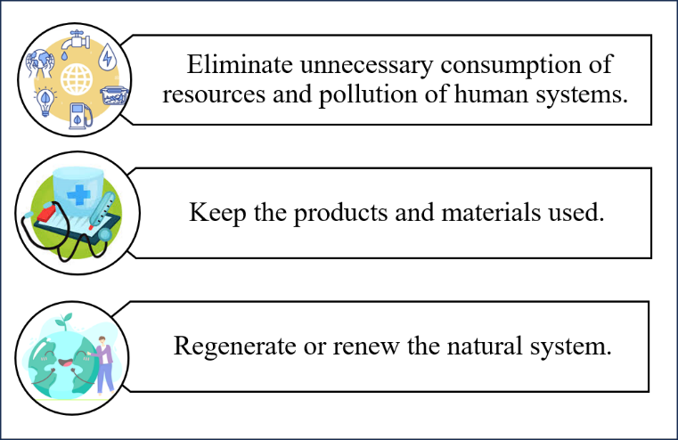

Figure 7: The industrial ecology's principles and techniques that might be used logically to assess health services. (14)

As seen in Figure 8, the Protocol addressing greenhouse gases sets out three types of emissions that must be tracked and reported. (8)

1. SCOPE 1: includes emissions that are directly generated inside the organization's borders, such as anaesthetic gasses.

Using their pharmacy purchase records, the institutions that participated hospitals calculated the yearly utilization of volatile anaesthetic drugs [desflurane, isoflurane, and sevoflurane]. Except for sevoflurane, which needed a 5% adjustment, the quantity given roughly matches the volume of waste anaesthetic gas because volatile anaesthetics undergo little in-vivo metabolism. Global Warming Potential [GWP100] values, which measure the effect of greenhouse gases on climate change over a 100-year period, were used to calculate emissions in CO2 equivalents [kg CO2e].

1. SCOPE 2: Takes into consideration indirect emissions from the use of power. The amount of thermal energy generated prerequisites for heating, ventilation, and air conditioning [HVAC] systems were determined based on the particular system used at each location. 52% of the energy requirements of inpatient healthcare facilities are attributable to HVAC systems. Therefore, HVAC system control should be the main emphasis of reducing energy consumption initiatives. Occupancy-based ventilation techniques can save a significant amount of energy by reducing needless airflow to empty space.
2. SCOPE 3: Includes all additional indirect emissions brought on by the activities of the company, such as eliminating waste and the healthcare chain of supply.

Municipal solid garbage, household waste, toxic waste, liquid debris, sharp instruments, toxicological waste, black box debris, recyclables, and reusable textiles were among the different categories into which surgical facility waste was divided. Because they only take into consideration the emissions included in the basic components and ignore the pollutants from manufacturing, the sterilization process, and conveyance, the emissions associated with the manufacturing process of surgical supplies are frequently underestimated. A considerably higher scope 3 footprints would probably be found by using specific item footprinting to calculate operational supply chain emissions more precisely.

A comprehensive life-cycle assessment is necessary to determine the environmental impact of one product compared to another.

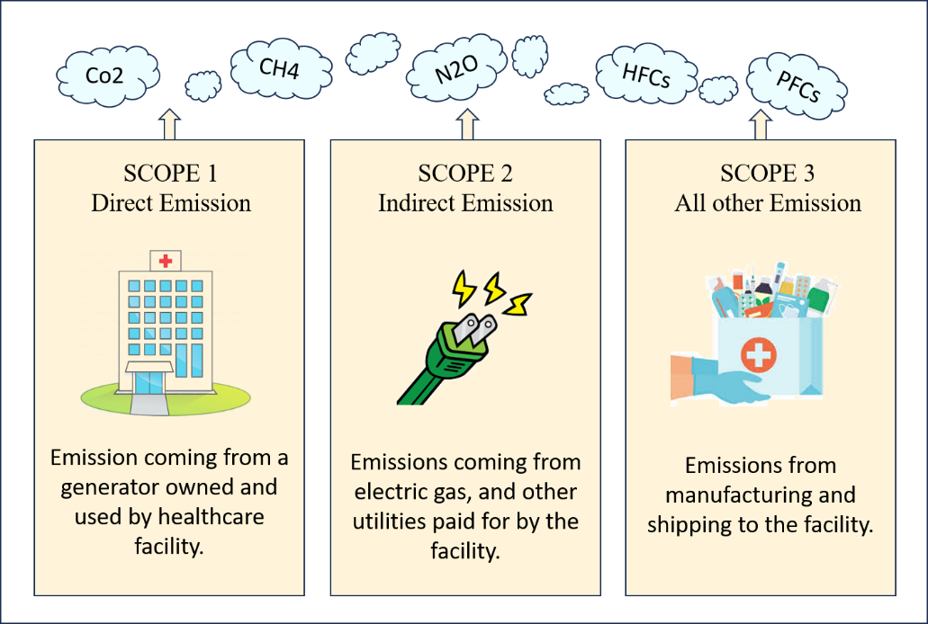

Figure 8: Scopes of Greenhouse Gas Emission

**6. LIFE CYCLE ASSESSMENT**

The healthcare sector is ready to adopt stricter ecological sustainability and greenhouse gas emission standards. A scientific method for evaluating solutions' effects on the natural world, pollutants, and demand for resources is life cycle assessment. Top priorities for mitigation can be identified by examining the movement of both energy and material resources needed for certain health services.(14)

Healthcare decision-makers can use measurement tools like life cycle assessment to determine priorities for clinical trials and healthcare practices, improvements to equipment, purchases of product priorities, and waste handling protocols. These tools also give them the information they need to determine the resource of negative environmental impacts.   
Life Cycle Assessment (LCA) examines how an operation or commodity affects the environment at every stage of its lifespan, including the raw materials transit in between manufacturing, producing, consumption, and destruction.

Process life cycle assessment follows ISO guidelines and is performed in four steps as shown in Figure 9. (7)

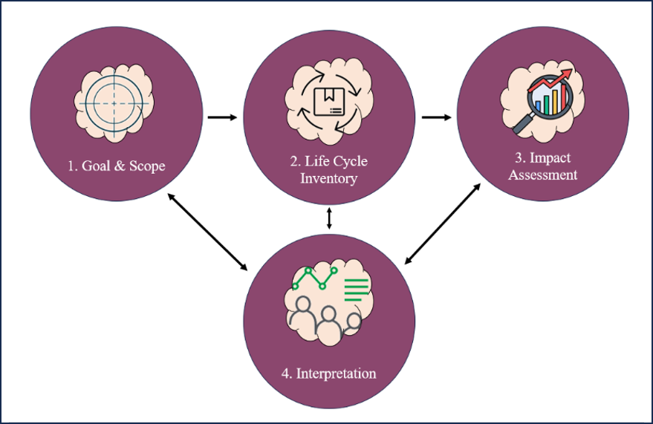

Figure 9: Four Stages of Life Cycle Assessment [LCA]

1. Step 1: The first phase specifies the system's functional unit and sets the boundary requirements for the system. The outcomes are standardized in this stage, which also offers a comparable comparison with other goods or procedures.
2. Step 2: The life cycle inventory [LCI], the second stage, compiles all raw data pertaining to systemic inputs and outputs. LCI calculates the energy and material consumption together with emissions that are linked to each contribution and result.
3. Step 3: The inventory data is transformed into effect categories (such as environmental toxicity or worldwide warming prospective) in the third step, life cycle impact assessment [LCIA].
4. Step 4: The inventory and impact assessment data are analyzed for system components with relatively substantial impacts on the environment in the fourth and final phase, interpretations.

Life cycle assessment, or LCA, is becoming more and more popular as a method for analyzing the effects of health care systems and medical care, despite its rarity.

**7. INDIRECT ACTIONS TO REDUCE GREENHOUSE GAS EMISSIONS**

7.1. REDUCTION IN PHARMACEUTICAL USE

The following steps could lower the financial and carbon costs of pharmaceuticals:

1. Cutting down on waste from drugs that are delivered to the ward but aren't utilized before they expire.
2. Using the patient’s drugs during inpatient episodes.
3. Collaborative choice-making: even though there is presently no evidence that any form of assistance may improve adherence, it is important to ensure that patients are included in the decision to take a drug before it has been prescribed and provided.
4. Using "beginning bundles" for new drugs and doing regular medication reviews to make sure that only one brief course of therapy remains ineffective if the patient is unable to take it: The use of multiple medications and improper medication are common among the elderly.

7.2 SUSTAINABLE TRAVEL SOLUTIONS

Employee transportation significantly increases the healthcare field's carbon impact. Hospitals can encourage active modes of transportation [traipsing or pedaling] by collaborating with the local government on suitable routes, offering secure storage spaces for bikes and shower/changing areas, promoting public transportation use [by partnering with regional providers], and putting in place car-sharing applications. To lessen the need for staff and patient accessibility, use renewable energy sources for hospital fleets, encourage walking and bicycling to the institution, encourage public transit for employees, customers, and community members, and strategically position healthcare facilities.

Guidelines for transport or travel with low carbon emissions

1. Every Trust's sustainable development management plan should include an active travel strategy that has been authorized by the Board.
2. In order to quantify emissions reductions from business-use road cars, organizations should set up regular monitoring procedures.
3. All organizations must set up procedures to regularly and methodically assess whether employees, patients, and guests need to travel.
4. The delivery of healthcare must keep getting closer to the patient's house.

7.3 SUSTAINABLE PROCUREMENT

Every time the products and services it uses are produced, the majority of its carbon footprint is created. The customer uses power to encourage their suppliers in order to ensure that the products and services they purchase have been manufactured in an ecologically friendly way. Adopting a policy of buying food from local vendors boosts the local economy and lessens the carbon footprint caused by food transportation. The life cycle of the things we decide to buy must be taken into consideration. It's time for healthcare organizations to review outdated procedures and implement new ones that will guarantee the best care for patients as well as the prospective health of the environment and individuals, particularly in view of the advent of safer, contemporary substitutes. Purchasing recycled materials and supplies with minimal packaging, as well as employing reusable bags and cartons for material transportation, can reduce environmental harm and increase sustainability. Replacing single-use throwaway plastic products with more environmentally friendly options is one approach to drastically cut down on the quantity of plastics that end up in landfills. single-use items manufactured of moulded pulp paper from 100% recycled post-consumer newspapers include toilet pee collectors, urinals, bedpans, and emesis basins. Before being disposed of through the sewer system and handled at municipal water treatment facilities, these products are ground into fine pieces in a machine after use. As a result, the hospital spends less on solid waste, uses fewer fossil fuels to make plastics, and has fewer nonbiodegradable medical goods in the waste stream.

7.4 INFLUENCING THE LOCAL COMMUNITY

Hospitals offer a big opportunity to influence public perception of the importance of sustainability for the environment. General Staff, patients, and visitors are informed that climate change is a real problem that we can all help to mitigate by a bold public proclamation that sustainability for the environment is a guiding concept in hospital architecture, procurement policy, and treatment system construction. Many hospitals already provide smoking cessation assistance to their employees; the service is also being urged to actively work on lowering employee obesity. Because obese people demand more food and because transporting a bigger population requires more fuel, obesity alone has a substantial carbon footprint.

7.5 SUSTAINABLE CARE PATHWAYS

Sustainability must be left to the estate department; there is much more to ensuring healthcare is environmentally [and economically] robust in the future than simply recycling and shutting off the lights. For example, cutting down on length of stay and needless hospital admissions will save money and carbon. 60% of hospital inpatients nowadays, according to some estimates, don't need to be there. These days, hospitals handle three quite diverse kinds of activities: elective surgery, emergency care, and outpatient consultations. These three activities must all take place at hospitals for no other reason than history and the convenience of certain physicians. To optimize the use of hospital operating rooms and beds, there is a strong case for elective procedures and emergency medical services to be physically located in separate buildings. The use of surgical beds for emergency admissions, which leads to the withdrawal of operating time, wastes money and carbon. Better, less costly, and environmentally friendly healthcare would be achieved by constructing multipurpose, flexible buildings for enlarged main care organizations, incorporated communities and social welfare workers, examinations, and expert consultation.

7.6 TELEMEDICINE

Regular review visits to outpatient clinics located in hospitals are only warranted if the consultation offers enough value. In contrast to disorders based on history and laboratory or radiographic investigation, diseases needing recurrent physical examinations necessitate in-person consultations. It is normal practice to bring patients to clinics for routine reviews, followed by a follow-up consultation in three months. In addition to providing inadequate treatment, this practice wastes money and carbon and demonstrates institutional disapproval for patients. Telemedicine has the potential to lower healthcare's carbon footprint, particularly for chronic disease patients who are already familiar with their physicians. Less is known, meanwhile, about whether telemedicine produces extra advantages like better patient empowerment or lower readmission rates. Additionally, telemedicine assists lowers the healthcare industry's carbon footprint. We expect that the factual data demonstrating the advantages of telemedicine for the environment will create more momentum and hasten the adoption of   
for the benefit of patients, healthcare professionals, and the environment, effective telemedicine systems and work models in health systems around the world. (16)

**8. DEVELOPING BEST PRACTICES AND TRAINING**

Anaesthetic selection and administration: In addition to more efficient choices, ecologically friendly substitutes are already available for products like anaesthetics. The risk of decreasing ozone levels and emission of greenhouse gases during surgery can be decreased by 65–95% by training anaesthesiologists and relevant personnel on how to select eco-friendly anaesthetics and steer clear of excessive fresh gas flow.

Healthcare practitioners must carefully evaluate the impact of growing usage of throwaway surgical equipment, especially those utilized for surgeries that are minimally invasive, since they incur considerable financial and ecological expenses. The reuse of and reconditioning disposable medical equipment has been promoted as a way to cut costs and wastage. Though certainly not as much as with reusable devices, this might greatly lessen the environmental effect of surgical equipment. Comparing one-time use, recycled, and reused versions of medical equipment using life cycle assessment (LCA) might make sense in order to identify more cost-effective and environmentally friendly options.

Artificial intelligence (AI) supports our lives and helps economies reduce their carbon emissions.(10) Building data-driven models to improve the entire process is made possible by the advancement of AI. By lowering the carbon footprint, this can help achieve governance, social, and environmental goals. The effective performance of algorithms intended to reduce emissions has been improved by the most recent machine-learning approaches. AI models must be made smaller, quicker, and more affordable by lowering the computational resources needed for their development and use. In order to better understand the manner in which artificial intelligence algorithms learn and analyze data, both business and academics are moving away from employing bigger theories, information sets, and gigantic computers and toward more effective learning methods.

Researchers are certain that their methodology can be applied to a variety of professions, which includes sustainable finance, carbon capture and storage, and the battle against greenwashing—the dishonest method of advertising goods claiming to be more environmentally conscious than they actually are—by utilizing artificial intelligence (AI) techniques and pollution tracking technological advances, such as gauges on carbon rubbish dumps, drones, as well as satellites.

Monitoring the level of carbon-dioxide emissions in specific regions is one of the most crucial aspects required for evaluating carbon tax and the outcomes of climate projects. To accomplish this, a fusion of multimodal data, such as remote sensing images and sensor data, is necessary, and AI is the appropriate technology for this purpose.

We integrate data on different scales and fidelities, enabling us to accurately estimate current emissions and predict future emissions.

Artificial intelligence [AI] and its associated technologies are becoming increasingly widespread in both business and society and are starting to be utilized in the healthcare sector(17).

These technologies have the potential to revolutionize numerous aspects of patient care, as well as the administrative procedures within providers, payers, and pharmaceutical organizations.

There are various types of AI, which encompass a range of technologies. While most of these technologies are directly relevant to the healthcare field, the specific processes and tasks they support can differ significantly.

These include:

* Machine learning [such as neural networks and deep learning]
* Natural language processing
* Rule-based expert systems
* Physical robots
* Robotic process automation.

**9. CONCLUSION**

Innovative healthcare professionals may enhance the security of patients, convenience, and wellness outcomes while maximizing the shift to a system that is more environmentally friendly. Reducing environmental implications in healthcare requires coordination among different team members. While engineers and facilities management optimize HVAC systems, anaesthetists can lower emissions of volatile agents. Perfusionists, nurses, and surgeons can reduce waste and encourage eco-friendly purchases. Reducing the environmental effects of surgical services requires a team effort to promote societal transformation and a culture that values environmental and social responsibility. Tools for sustainability and life cycle assessment may be used to find the best ways to cut emissions. Through process optimization and carbon footprint reduction, artificial intelligence (AI) is revolutionizing economies and enhancing lifestyles. The use of AI technologies and environmental tracking technology in the healthcare sector is revolutionizing

Reference:

1. Wang H, Horton R. Tackling climate change: The greatest opportunity for global health. Vol. 386, The Lancet. Lancet Publishing Group; 2015. p. 1798–9.

2. Karliner J, Slotterback S, Boyd R, Ashby B, Steele K. HEALTH CARE’S CLIMATE FOOTPRINT HOW THE HEALTH SECTOR CONTRIBUTES TO THE GLOBAL CLIMATE CRISIS AND OPPORTUNITIES FOR ACTION Health Care Without Harm Climate-smart health care series Green Paper Number One Produced in collaboration with Arup. 2019.

3. Wang J, Karliner J, Slotterback S, Boyd R, Ashby B, Steele K, et al. Regions for health case study: Turning Welsh legislation for sustainable development into everyday practice [Internet]. Available from: https://academic.oup.com/eurpub/article/30/Supplement_5/ckaa165.843/5914601

4. Frumkin Howard, Coussens Christine. Green healthcare institutions : health, environment, and economics : workshop summary. National Academies Press; 2007. 116 p.

5. Tomson C. HOSPITAL INFRASTRUCTURE Reducing the carbon footprint of hospital-based care [Internet]. Vol. 2, Future Hospital Journal. 2015. Available from: www.supplychain.nhs.

6. Thiel CL, Eckelman M, Guido R, Huddleston M, Landis AE, Sherman J, et al. Environmental impacts of surgical procedures: Life cycle assessment of hysterectomy in the United States. Environ Sci Technol. 2015 Feb 3;49(3):1779–86.

7. Campion N, Thiel CL, DeBlois J, Woods NC, Landis AE, Bilec MM. Life cycle assessment perspectives on delivering an infant in the US. Science of the Total Environment. 2012 May 15;425:191–8.

8. Macneill AJ, Lillywhite R, Brown CJ. Articles The impact of surgery on global climate: a carbon footprinting study of operating theatres in three health systems [Internet]. Vol. 1, planetary-health. 2017. Available from: www.thelancet.com/

9. Reducing Waste and Increasing Sustainability in Health Care Settings [Internet]. Available from: https://afyafoundation.org

10. Green future 4 B marking.

11. ENERGY CONSUMPTION.

12. Shen C, Zhao K, Ge J, Zhou Q. Analysis of building energy consumption in a hospital in the hot summer and cold winter area. In: Energy Procedia. Elsevier Ltd; 2019. p. 3735–40.

13. Sherman JD, MacNeill A, Thiel C. Reducing pollution from the health care industry. Vol. 322, JAMA - Journal of the American Medical Association. American Medical Association; 2019. p. 1043–4.

14. Sherman JD, MacNeill A, Thiel C. Reducing pollution from the health care industry. Vol. 322, JAMA - Journal of the American Medical Association. American Medical Association; 2019. p. 1043–4.

15. Eckelman MJ, Huang K, Lagasse R, Senay E, Dubrow R, Sherman JD. Health care pollution and public health damage in the united states: An update. Health Aff. 2020 Dec 1;39(12):2071–9.

16. Holmner Å, Ebi KL, Lazuardi L, Nilsson M. Carbon footprint of telemedicine solutions - Unexplored opportunity for reducing carbon emissions in the health sector. PLoS One. 2014 Sep 4;9(9).

17. Davenport T, Kalakota R. DIGITAL TECHNOLOGY The potential for artificial intelligence in healthcare. Vol. 6, Future Healthcare Journal. 2019.