A MICROBIOLOGICAL PERSPECTIVE ON OCULAR CONJUNCTIVITIS
Roshini Youvaraj, Santhosh Manikandan Kumaravel
Department of Optometry, Inlife Institute of Vision Science and Management, Coimbatore, Tamil Nadu, India.
ABSTRACT
Conjunctivitis (red eye or pink eye) is the most common anterior ocular condition. The conjunctiva can become inflamed due to internal and external reasons, although conjunctivitis caused by bacteria and viruses is more common than other causes. In general most conjunctivitis are initially treated with antibiotics and later on, appropriate therapies are chosen. The most common causes of bacterial and viral conjunctivitis in children and adults were reported to be Staphylococcus aureus, S. epidermidis, Streptococcus pneumoniae, Haemophilus influenza, Moraxella catarhalis, Varicella zoster virus, measles, and mumps virus. On the other hand, viral conjunctivitis was attributed to Adenoviral HAdV-D species, Herpes simplex virus, Varicella zoster virus, measles, and mumps virus. If treatment is not received, the pathogenic bacteria may cause moderate to severe visual impairment. It is seen to be crucial to implement the right treatment, management, and prevention stratergies for these epidemics. Preventive measures like immunization,good environmental hygiene, and sufficient isolation are needed to stop the outbreak. Though antimicrobial therapy is promising for this kind of infection, still we need a stewardship plan to overcome the resistance acquired by the clinical strains. Combination therapy could be one of the strategies that can be implemented to overcome the resistance and still, we need novel drugs to treat such infections. This chapter is designed to give an insight into various aspects of microbes involved in ocular conjunctivitis and its treatments.
KEYWORDS
Conjunctivitis, Ocular infections, Pathophysiology, Antibiotic therapy
INTRODUCTION
Conjunctivitis is a condition that is often evident as inflammation of the conjunctiva is commonly referred to as red eye or pink eye (AI-Mishhadani, 2020). Inflammation caused by this clinical condition can be characterized by cellular infiltration, exudation, and vascular dilation. In rare cases, chemosis and the accumulation of fluid are also seen. Conjunctivitis can be broadly classified as acute or chronic. Based on the microorganisms involved, they were also referred to as either infectious or non-infectious. The occurrence of the infections depends on the etiology, chronicity, severity, and degree of surrounding tissue. Viral and bacterial conjunctivitis are the most common conditions, followed by nutritional deprivation, immune-related syndromes, congenital metabolic syndromes, and other secondary ocular conditions like acute angle closure glaucoma, uveitis, endophthalmitis, carotid-cavernous fistula, anterior tumors, and cellulitis (Ali, 2023). Conjunctivitis is caused by various clinically important viral and bacterial microorganisms. Most of the conditions prevail due to allergic reactions. Type 1 allergies are responsible for most of the allergic conjunctivitis, and they are classified based on the presence or absence of proliferative changes, dermatitis, and mechanical irritation by foreign bodies, which can be classified as follows:
1.Allergic conjunctivitis [ divided as seasonal and perennial]
2.Atopic keratoconjunctivits [AKC],
3.Vernal keratoconjuctivitis, [VKC]
4.Giant papillary conjunctivitis [GPC]
GENERAL EPIDEMIOLOGY
Viral conjunctivitis is about 70% of all cases, and 30% of them are of bacterial origin. (Sameha A. Al-Eryani1, 2021). In general, viral infections are most commonly seen in the acute phase of conjunctivitis. This includes epidemic keratoconjunctivitis [EKC] and pharyngoconjunctival fever [PCF] caused by adenovirus, acute haemorrhage conjunctivitis [AHC] caused by enterovirus and coxsackievirus and herpetic conjunctivitis caused by herpes simplex virus [HSV], Varicella Zoaster Virus [VZV], measles and mumps virus (Tetsuaya Muto 1, 2023). The causes of bacterial conjunctivitis are Staphylococcus aureus, Staphylococcus epidermis, Streptococcus pneumonia, Haemophillus influenzae, Moraxella catarrhalis in rare cases, Chlamydia trachomatis and Neisseria gonorrhea, which can also lead to conjunctival infections (DeCory, 2020).
3. PATHOPHYSIOLOGY OF THE VIRAL INFECTIONS
3.1 ADENOVIRAL CONJUNCTIVITIS
Adenoviral conjunctivitis is most common among viral conjunctivitis. The adenoviruses are comprised of 51 distinct types of double-stranded DNA viruses that are structurally similar, but antigenically different serotypes. These highly stable viruses are found throughout the world and cause respiratory tract, genitourinary, gastrointestinal, and ocular infections. Adenoviral infection is usually self-limiting but can lead to fatal multiple-organ failure in immunocompromised individuals (Hoffman, 2020). Recent advances in genome sequencing of human adenoviruses [HAdV] identified that HAdV-D species have a strong relationship with viral conjunctivitis (Amir A. Azari, 2020). Adenoviral infection is seen as a common cause of viral conjunctivitis. Typical signs like conjunctival follicles, pseudomembrane associated with hyperaemia, sub-conjunctival haemorrhages are common in this infection (Hoffman, 2020). Preventative methods require that patients exercise frequent hand washing with soap, keep hands dry, avoid eye rubbing, etc. Povidone-iodine irrigation can be used as an initial step of treatment, followed by PVI as an antimicrobial agent. It demonstrates virucidal reduction for other HAdV types 3,4,5,7, AND 8 in various concentrations (Bisant A Labib, 2020).

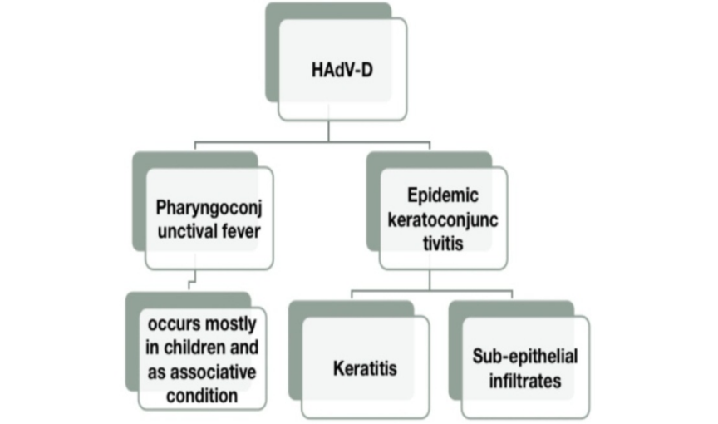
Fig 1: CLASSIFICATION OF HAdV-D INDUCED OCULAR INFECTION (Bisant A Labib, 2020)
3.2 ACUTE HEMORRHAGIC CONJUNCTIVITS
The second most common viral conjunctivitis is named AHC [Acute haemorrhagic conjunctivitis]. It may rarely be associated with systemic complications like respiratory symptoms and neurological complications. The primary causative organisms for AHC are coxsackievirus A24 and enterovirus 70 (Prabhudutta Mamidi, 2024). In many cases, it was found that CVA24 was more prevalent in the outbreak of AHC compared to enterovirus 70 (Nutan A. Chavan a, 2022).
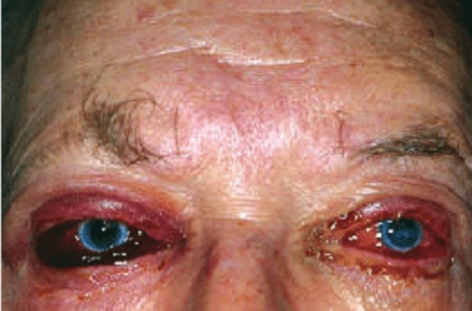
Fig 2: ACUTE HEMORRHAGIC CONJUNCTIVITIS (Hoarau, 2020)
3.3 HERPES SIMPLEX CONJUNCTIVITIS
The Herpesviridae family includes a large group of double stranded DNA viruses that can infect a wide range of animal species. Nine human herpes viruses have been identified and are classified into three subfamilies based on their genome organization, cell tropism, and characteristics: the alphaherpesvirinae, betaherpesvirinae and gammaherpesvirinae. The alphaherpesvirinae include HSV-1, HSV-2, and VZV (Hanna H. Schalkwijk, 2022). The Herpes simplex virus is categorized into two distinct types, HSV-1 and HSV-2. HSV-1 is transmitted through direct contact, via saliva, and commonly presents as cold sores or fever blisters, whereas HSV-2 is transmitted through sexual contact or during birth (Bagga, 2020). Herpes conjunctivitis is the rarest viral conjunctivitis, which is often associated with allergic conjunctivitis (SALAVA, 2022). The primary herpes virus and Epstein-Barr virus cause primary follicular conjunctivitis, which also involves lid inflammation, which further leads to corneal epithelial manifestation. In severe conditions, it is the main reason for other infections like rhinitis, respiratory issues, and dermatitis (Thomas d.Lindiquist, 2021). The discovery of the nucleoside analogue acyclovir [ACV] was a milestone in the management of HSV infections. The mode of administration and combination could be considered for the effectiveness of the treatment (Hanna H. Schalkwijk, 2022). Apart from this, trifluridine and topical ganciclovir can be used as alternatives for its treatment (Bagga, 2020).
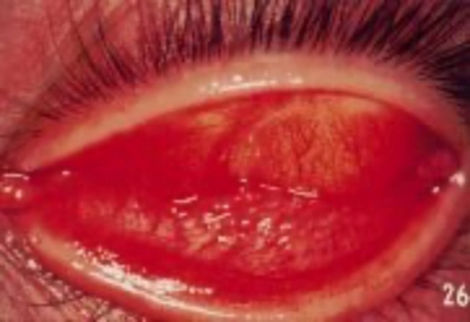
Fig 3: HERPES SIMPLEX CONJUNCTIVITIS (Hoarau, 2020)
3.4 VARICELLA ZOSTER CONJUNCTIVITIS
Varicella Zoster Conjunctivitis (VZV) is termed the human alpha herpes virus, which causes chickenpox infection and herpes zoster. VZV is a virus with a lipid-rich envelope acquired from cellular membranes where viral glycoproteins are inserted. Inside the envelope, a tegument layer formed by the regulation of protein surrounds an icosahedral nucleocapsid core containing the linear double-stranded DNA genome (Anna Bertelli, 2023). This affects children and becomes latent in neurons in peripheral autonomic, sensory, and cranial nerve ganglionic neurons in humans (Peter GE Kennedy1 & Trine H Mogensen2, 2020). VZV is considered to be a highly contagious airborne droplet. (Justin J. Grassmeyer, 2023). VZV reactivates in the trigeminal nerve and develops conjunctivitis, keratitis, and uveitis in the eye. The post-exposure treatment plan includes Vidarabine and IFN-alpha antiviral agents for immunocompromised patients. Acyclovir, Valacyclovir, Famciclovir, and other drugs like foscarnet and interferon are used as treatment medications for VZV infections (Anna Bertelli, 2023).
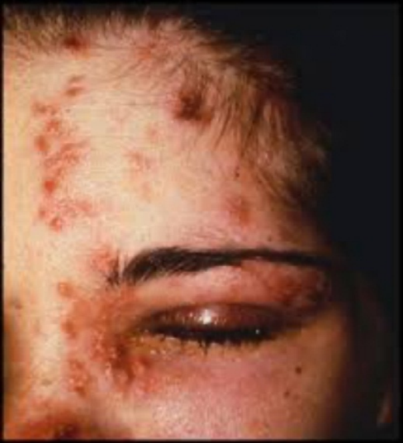
Fig 4: HZV CONJUNCTIVITIS (Ivan Vrcek, 2016).
3.5 MEASLES AND MUMPS VIRUS
Measles is an enveloped virus with a single-strand, non-segmented negative-sense RNA genome. The morbillivirus, the causative agent for measles, is a highly contagious illness that intensely affects children and adults. The typical febrile measles leads to fever, cough, conjunctivitis, coryza, and rash and can also lead to encephalitis in severe conditions. In measles, conjunctiva koplick patches are seen occasionally and are mostly associated with keratitis. (Tetsuaya Muto, 2023). The preventive and treatment measures include the measles vaccine, intravenous immunoglobulin, vitamin A, and even ribavirin. In addition to this, special precautions are required by hospital workers to help prevent the spread of viruses, which include N-95 masks and patient isolation in an airborne infection isolation room (Elise M. Alves Graber MD, 2020) Mumps is an acute transmissible viral illness caused by a single-stranded RNA paramyxovirus that spreads through droplets. The most common ocular conditions caused by the mumps virus are follicular conjunctivitis, episcleritis, dacryoadenitis, keratitis, scleritis, anterior uveitis, choroiditis, paralysis of extraocular muscles, in some rare cases, bilateral optic neuritis (Khan, 2020). The treatment for measles infection involves antipyretics, antitussives, hydration, and environmental controls. Treatment for mumps virus infection includes topical corticosteroids, cycloplegic and hyperosmolar solutions, and symptomatic therapy (Tetsuaya Muto 1, 2023).
4. PATHOPHYSIOLOGY OF BACTERIAL INFECTIONS
4.1 STAPHYLOCOCCUS AUREUS AND EPIDERMIDIS
Staphylococcus is a Gram-positive bacterium most frequently diagnosed in ocular infections. Staphylococcus aureus is a vital human pathogen that causes a spectrum of clinical diseases in immune-compromised patients. These infections range from purulent heat boils to superficial skin lesions like folliculitis to deep-seated abscesses and various pyogenic infections like endocarditis, osteomyelitis, etc. (Parija, 2023). Bacterial infections may occur due to exposure to external bacteria or invasion by internal bacteria that is transmitted through the bloodstream. The colonies are characterized as grape-like clusters and nonmotile (Sara Mohamed, 2020). It causes a range of ocular diseases in the eye, including keratitis, blepharitis, and conjunctivitis, as well as infectious or non-infectious contact lens-related infections. This bacterium secretes toxins and other virulence determinants that play an important role in the pathogenesis of infection. S.aureus virulence factors are categorized based on their biological activities and include products involved in adhesion to host tissues or fomites [adhesins], evasion of host defence mechanisms [evasins], and invasion of host tissue [invasion] (Madeeha Afzal1, 2022). The Antibiotic Resistance Monitoring in Ocular Microorganisms (ARMOR) study showed that 39% of S.aureus isolates were resistant to methicillin or oxacillin, and most of the MRSA isolates were also resistant to azithromycin and ciprofloxacin. Almost two-thirds of isolates were susceptible to clindamycin, and close to half of the isolates were susceptible to tobramycin (Chocky, 2023). Trimethoprim was the only medication that was highly effective against Methicillin Resistant Staphylococcus aureus (MRSA), whereas other antibiotics like azithromycin, penicillin, polymyxin B, tobramycin, and fluroquinolones were not found to be that effective against MRSA. The alternative treatment for MRSA could be vancomycin in a highly effective susceptible profile (Chocky, 2023).
4.2 STREPTOCOCCUS PNEUMONIAE
Streptococcus is a bacterial genus of nonmotile, Gram-positive cocci arranged in pairs or chains. It belongs to the phylum Bacillota, order Lactobacillales. They are predominantly facultative anaerobes that are categorized by their haemolytic properties; they induce partial haemolysis of red blood cells. The estimated bacterial conjunctivitis is 6 million per year in the US and causes a significant social and economic burden. The virulence factors of Streptococci pneumonia include polysaccharide capsules, surface proteins, and pnemolysin, which differ from Group A Streptococci which have hyaluronic acid-containing capsules, cytoplasmic membranes, and fimbriae adhesins. Group B Streptococci contain pore-forming toxins, sialic acid capsular polysaccharide, and pili that work to facilitate the intracellular survival of pathogens and limit the host’s innate immune system (Upeka Nanayakkara BMed, 2023) The significance of S. pneumoniae in eye infections is well-known, a detailed analysis with sero-grouping is still important to compare with serotypes associated with invasive pneumococcal diseases (DLB Piyasiri1, 2020). Streptococcus pneumoniae is a common organism found in ocular flora. It can cause meningitis, pneumonia, otitis media, sinusitis, and acute conjunctivitis. It forms colonies in the nasopharynx and transmits through airborne droplets (Yasser Helmy Mohamed1, 2021). Apart from conjunctivitis, it also involves keratitis, endophthalmitis, dacryocystitis, and orbital cellulitis. It is most common in the paediatric population. The isolated bacterium is sensitive to penicillin, chloramphenicol, and about 70% was vaccine-related serotypes, suggesting the possibility of vaccination as a means of reducing infection in children with risk factors such as naso-lacrimal duct obstruction (DLB Piyasiri1, 2020).
4.3 HAEMOPHILUS INFLUENZA
Haemophilus influenza is the organism that causes influenza. The bacterium is completely sequenced genome. It’s a Gram-negative coccobacillus with a variable shape. It grows both aerobically and anaerobically. It is classified as a typeable or non-typeable strain. Approximately 20% of infants are colonized in the first year of life and rise progressively over the years. It spreads through airborne droplets and contact with secretions (King, 2012). H. influenza is a major human pathogen that is associated with meningitis, otitis media, and ocular inflammations like conjunctivitis, keratoconjunctivitis, endophthalmitis, and Brazilian purpuric fever. H.influenza causes 80% of all cases of conjunctivitis in children. And most of the time, in the initial phase, it is asymptomatic (P. R. SANKARIDURG, 1996). Purulent conjunctivitis associated with otitis and paranasal sinusitis is commonly seen in Haemophilus influenza and other Gram-negative bacteria. It also found that the outbreak of the condition would be more common in the spring season. It is plausible that a single microbial invasion may feature in these conditions due to the continuity of the mucous in the upper respiratory tract associated with conjunctivitis and otitis media syndrome. They are considered to be more virulent in conjunctiva compared to S. pneumoniae. Many H.influenza strains may produce biofilm, which leads to the failure of antibiotic treatment and can reoccur more frequently (Ya-Li Hu1, 2021). The treatment of H.influenza infection can be more effective with second-generation fluoroquinolones which include ciprofloxacin, ofloxacin, and norfloxacin. Topical macrolides like azithromycin, and erythromycin are well tolerable and less effective against H.influenza (Jasmina Alajbegović-Halimić1, 2023).
4.4 MORAXELLA CATARRHALIS CONJUNCTIVITIS
Moraxella catarrhalis is a Gram-negative, piliated, auto-agglutinating, non-encapsulated pathobiont. It is a kidney-shaped diplococci with a diameter of 0.5–1.5nm, commonly occurring in the upper respiratory tract. The prevalence of this bacterium is higher in young children and the elderly. Infection and disease caused by this organism are multifactorial processes reliant on numerous virulence factors. Such factors facilitate the adhesion of M. catarrhalis to host cells, the acquisition and utilization of nutrients, the formation of biofilms, and the resistance of host immunity, to name a few key functions, all of which allow for the survival of M. catarrhalis and the development and persistence of infection (Morris, 2021). The conjunctivitis that is caused by M.catarrhalis is generally non-exudative, persistent, and shows no sign of redness. It is a rare infection compared to other bacterial conjunctivitis and is also reported in several other ocular clinical conditions like blepharitis, conjunctivitis, dacryocystitis, keratitis, and endophthalmitis. It is more prevalent in the cornea compared to other ocular structures. Through molecular assessment, it is evident that the species is present in respiratory organs (Ahmad Farajzadeh Sheikh1, 2020). The primary treatment for mild-to-moderate bacterial conjunctivitis is tobramycin. In moderate-to-severe infections or antibiotic-resistant infections and immunocompromised patients, fluoroquinolones are recommended. These include ofloxacin, ciprofloxacin, moxifloxacin and gatifloxacin (N. Schellack, 2020).
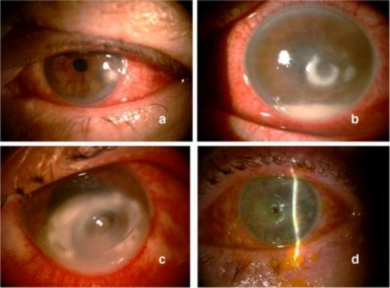
Fig 5: MOROXELLA CATARRHALIS CONJUNCTIVITIS (Hoarau, 2020)
4.6 CHLAMYDIA TRACHOMATIS & NEISSERIA GONORRHOEA
Chlamydia trachomatis (CT) and Neisseria gonorrhoea (NG) are two of the most common bacterial sexually transmitted infections in pregnancy (Gonorrhoeae, 2020). WHO estimated that about 127.2 million and 86.9 million new cases of chlamydial and gonorrhoea are reported, respectively. CT and NG infections in women result in pelvic inflammatory diseases, infertility, ectopic pregnancy, miscarriage, preterm labor, post-abortal and postpartum endometristis, neonatal conjunctivitis, and neonatal pneumoniae (Gonorrhoeae, 2020) Chlamydia is an obligate intracellular bacterium that exists in both resting and infectious forms within the epithelium of an infected host. The commonest species implicated in STI is C.trachomatosis whose servers have an affinity for the epithelial cells of the urogenital tract, migrating from the cervix to the uterus and fallopian tubes, causing a chronic and asymptomatic infection (J. Godoy-Mancilla, 2021). Gonococcal ocular infections can also occur in neonates after vaginal delivery by infected mothers. Chlamydial conjunctivitis is primarily present in concurrent genital infections (Hauswirth, 2020). Screening and detecting STIs in early pregnancy is very essential. Antibiotics like erythromycin, clindamycin, amoxicillin, and azithromycin are used to treat chlamydial infection, and ceftriaxone, cefixime, amoxicillin, plus probenecid and spectinomycin have been used for Neisseria gonorrhoeae (Gonorrhoeae, 2020).
Fig 6: NEONATAL CONJUNCTIVITIS (Ivan Vrcek MD, 2016)
CONCLUSION
Infections that are caused by the organisms are widespread in the environment. These infections can be either from hospital settings or maybe community-associated. Conjunctivitis is one of the most common ocular infections that can be treated with antibiotics based on the organisms involved. In most cases, viral conjunctivitis is more prevalent when compared to bacterial origins. In both cases, treatments are available, but the emergence of drug resistance and the organisms attaining resistance are global concerns. Among the available treatments, the synergism of antibiotics could help us to relieve the symptoms soon, which need to be standardized.
ACKNOWLEDGEMENT
We would like to thank Mrs. Pamela Suresh, Principal - Inlife Institute of Vision Science & Management, Coimbatore for her contribution to this manuscript.
REFERENCES
- Afzal, M., Vijay, A. K., Stapleton, F., & Willcox, M. (2022). Virulence genes of Staphylococcus aureus associated with keratitis, conjunctivitis, and contact lens–associated inflammation. Translational Vision Science & Technology, 11(7), 5-5.
- Al-Eryani, S. A., Alshamahi, E. Y. A., Al-Shamahy, H. A., Alfalahi, G. H. A., & Al-Rafiq, A. A. (2021). Bacterial conjunctivitis of adults: causes and ophthalmic antibiotic resistance patterns for the common bacterial isolates. Universal Journal of Pharmaceutical Research, 6(1), 25-28.
- Alajbegovic-Halimic, J., Jovanovic, N., & Halimic, T. (2023). Microbiological evaluation of bacterial conjunctivitis in children. Acta Medica Saliniana, 53(1).
- Ali, S. A., Ali, S., & Jahan, I. (2023). Allergies to Infections: Understanding the Spectrum of Conjunctivitis. International Journal of Pharmaceutical Drug Design.
- Azari, A. A., & Arabi, A. (2020). Conjunctivitis: a systematic review. Journal of ophthalmic & vision research, 15(3), 372.
- Chocky OD, M. (2023). Diagnosis and Management of a Patient with Methicillin-resistant Staphylococcus aureus Conjunctivitis. Optometric Clinical Practice, 5(2), 33.
- Cory, H. H., Sanfilippo, C. M., Proskin, H. M., & Blondeau, J. M. (2020). Characterization of baseline polybacterial versus monobacterial infections in three randomized controlled bacterial conjunctivitis trials and microbial outcomes with besifloxacin ophthalmic suspension 0.6%. PLoS One, 15(8), e0237603.
- Farajzadeh Sheikh, A., Feghhi, M., Torabipour, M., Saki, M., & Veisi, H. (2020). Low prevalence of Moraxella catarrhalis in the patients who suffered from conjunctivitis in the southwest of Iran. BMC Research Notes, 13, 1-4.
- Godoy-Mancilla, J., Oyarzun-Barrientos, C., Marín-Cornuy, M., Carrasco-Sanhueza, E., & Águila-Torres, P. (2022). Bacterial eye infections associated with sexual transmission infections: A review. Archivos de la Sociedad Española de Oftalmología (English Edition), 97(1), 17-27.
- Grassmeyer, J. J., Bellsmith, K. N., Bradee, A. R., Pegany, R. B., & Redd, T. K. (2023). Conjunctival Lesions Secondary to Systemic Varicella Zoster Virus Infection. Cornea Open, 2(4), e0022.
- Graber, E. M. A., Andrade Jr, F. J., Bost, W., & Gibbs, M. A. (2020). An update and review of measles for emergency physicians. The Journal of Emergency Medicine, 58(4), 610-615.
- Hoffman, J. (2020). Adenovirus: ocular manifestations. Community Eye Health, 33(108), 73.
- Hu, Y. L., Lee, P. I., Hsueh, P. R., Lu, C. Y., Chang, L. Y., Huang, L. M., ... & Chen, J. M. (2021). Predominant role of Haemophilus influenzae in the association of conjunctivitis, acute otitis media and acute bacterial paranasal sinusitis in children. Scientific Reports, 11(1), 11.
- Kennedy, P. G., & Mogensen, T. H. (2020). Determinants of neurological syndromes caused by varicella zoster virus (VZV). Journal of NeuroVirology, 26(4), 482-495.
- Khan, B., Nasir, S., & Hanif, S. (2020). Bilateral optic neuritis: a rare complication of mumps. Cureus, 12(4).
- Labib, B. A., Minhas, B. K., & Chigbu, D. I. (2020). Management of adenoviral keratoconjunctivitis: challenges and solutions. Clinical Ophthalmology, 837-852.
- Li, E., & Bacorn, C. (Eds.). (2023). Ophthalmology Clerkship: A Guide for Senior Medical Students. Springer Nature.
- Lindquist, T. D., & Lindquist, T. P. (2021). Conjunctivitis: an overview and classification. Cornea, E-Book, 358.
- Miyazaki, D., Takamura, E., Uchio, E., Ebihara, N., Ohno, S., Ohashi, Y., ... & Fujishima, H. (2020). Japanese guidelines for allergic conjunctival diseases 2020. Allergology International, 69(3), 346-355.
- Mohamed, S., Elmohamady, M. N., Abdelrahman, S., Amer, M. M., & Abdelhamid, A. G. (2020). Antibacterial effects of antibiotics and cell-free preparations of probiotics against Staphylococcus aureus and Staphylococcus epidermidis associated with conjunctivitis. Saudi Pharmaceutical Journal, 28(12), 1558-1565.
- Mohamed, Y. H., Toizumi, M., Uematsu, M., Nguyen, H. A. T., Le, L. T., Takegata, M., & Yoshida, L. M. (2021). Prevalence of Streptococcus pneumoniae in conjunctival flora and association with nasopharyngeal carriage among children in a Vietnamese community. Scientific reports, 11(1), 337.
- Muto, T., Imaizumi, S., & Kamoi, K. (2023). Viral conjunctivitis. Viruses, 15(3), 676.
- Nanayakkara, U., Khan, M. A., Hargun, D. K., Sivagnanam, S., & Samarawickrama, C. (2023). Ocular streptococcal infections: a clinical and microbiological review. Survey of Ophthalmology.
- Olaleye, A. O., Babah, O. A., Osuagwu, C. S., Ogunsola, F. T., & Afolabi, B. B. (2020). Sexually transmitted infections in pregnancy–An update on Chlamydia trachomatis and Neisseria gonorrhoeae. European Journal of Obstetrics & Gynecology and Reproductive Biology, 255, 1-12.
- Parija, S. C., & Chaudhury, A. (Eds.). (2022). Textbook of parasitic zoonoses. Singapore: Springer.
- Piyasiri, D. L. B., Chandrasiri, P., & Wijesinghe, P. R. (2020). Bacterial pathogens in conjunctivitis and corneal ulcers with special reference to Streptococcus pneumoniae, in early 2008, in the National Eye Hospital, Sri Lanka. Sri Lankan Journal of Infectious Diseases, 10(2).
- Salonen, J., Remitz, A., Salonen, J., Lauerma, A., & Salava, A. (2022). Allergic conjunctivitis: a risk factor for recurrent herpes simplex virus infections in patients with atopic dermatitis. European Journal of Dermatology, 32(5), 607-614.
- Sankaridurg, P. R., Willcox, M. D., Sharma, S., Gopinathan, U., Janakiraman, D., Hickson, S & Holden, B. A. (1996). Haemophilus influenzae adherent to contact lenses associated with production of acute ocular inflammation. Journal of clinical microbiology, 34(10), 2426-2431.
- Schalkwijk, H. H., Snoeck, R., & Andrei, G. (2022). Acyclovir resistance in herpes simplex viruses: Prevalence and therapeutic alternatives. Biochemical Pharmacology, 206, 115322.
- Vrcek, I., Choudhury, E., & Durairaj, V. (2017). Herpes zoster ophthalmicus: a review for the internist. The American journal of medicine, 130(1), 21-26.
- Yeu, E., & Hauswirth, S. (2020). A review of the differential diagnosis of acute infectious conjunctivitis: implications for treatment and management. Clinical Ophthalmology, 805-813.

