Title: **Diabetic Retinopathy & its Management by Micronutrition**

**Authors: Prof. Prasenjit Das,** Assistant Professor, Department of Optometry, Dr. B. C. Roy Academy of Professional Courses, Durgapur, West Bengal.

**Abstract:** Diabetes, a chronic illness, is brought on by insufficient insulin production by the pancreas or by inefficient insulin utilisation by the body. Blood sugar is controlled by the hormone insulin. One common consequence of untreated diabetes is hyperglycemia, often known as elevated blood glucose or elevated blood sugar, which over time causes major harm to numerous bodily systems, including the blood vessels and neurons. Untreated diabetes can damage our kidneys, eyes, nerves, and other organs due to elevated blood sugar brought on by polygenic sickness. High blood sugar brought on by diabetes is the cause of diabetic retinopathy (DR). The portion of our retina that senses light and transmits messages to our brain via the optic nerve might become damaged over time if blood sugar levels are too high. So it is very important to treat & control diabetes as early as possible. Micronutrients have a big impact on managing and preventing DR. Research suggests that eating a Mediterranean diet and consuming dietary vitamins A, B, C, D, and E can help prevent DR, but consuming more calories has been associated with a higher risk of developing DR.

**Keywords:-** Diabetes mellitus, Diabetic Retinopathy (DR), Anti-VEGF, Micronutrients

**Introduction:-**

Diabetes mellitus is a condition of macromolecule metabolism marked by a decreased body's capacity to respond to hormones and maintain appropriate blood sugar (glucose) levels.(Editors of Encyclopaedia Britannica. 2024) May be a chronic condition that develops when the duct gland can no longer generate endocrine or when the body is unable to utilise the endocrine that it does create. Endocrine may be an endocrine produced by the duct gland that functions as a kind of key to allow aldohexose from the food we frequently eat to enter the body's cells and provide energy by passing through the bloodstream. All foods high in macromolecules are converted by the blood into aldohexose. Endocrinology facilitates aldohexose uptake by cells.(International Diabetes Federation. 2020) The endocrine system transports blood sugar into our cells so that it can be stored or utilised as fuel. When we have polygenic disease, our body either won't produce enough endocrine or won't use the endocrine it does produce well. If left untreated, high blood sugar caused by polygenic illness can harm our kidneys, eyes, nerves, and other organs.(Kumar.R et al 2020)

This century, diabetes, or more accurately diabetes mellitus, is rife with epidemics. Over the last ten years, the incidence of diabetes has increased by 50% (Danaei, G. et al,2011). Given that diabetes is one of the oldest diseases in the world and has been documented in historical records of civilizations like those found in ancient Egypt, Persia, and India, this present epidemic is somewhat surprising (Forbes, J. M., & Cooper, M. E., 2013). According to the World Health Organisation, 347 million individuals globally—or 9.5% of the adult population—had diabetes in 2008. (Kumar.R et al 2020). Estimates indicate that the prevalence of diabetes is rising quickly, and that by 2030, the population may nearly double. Although it can occur anywhere in the world, wealthier nations have higher rates of diabetes mellitus.However, Asia, the Middle East (Butler, D. 2012), and Africa are predicted to experience the most growth in incidence in the near future; by 2030, it is estimated that diabetes will have increased in these regions by around 50% (Shaw, J. E et al, 2010).

**Types of diabetes:**

Type 1 and type 2 diabetes are the two main kinds, though they can also appear during pregnancy and in other circumstances such as pharmacological or chemical toxicity, genetic abnormalities, endocrinopathies, insulin receptor problems, and pancreatic exocrine disease (American Diabetes Association. 1997).

Hyperglycemia resulting from either relative or chronic insulin deficiency is the clinical hallmark of diabetes (Mathis, D.et al, 2001).

**Type 1 Diabetes:-**

Hyperglycemia in type 1 diabetes is caused by a multifactorial disease process including genetic and environmental variables that trigger an autoimmune reaction that is not yet fully understood (Davies, J. L.et al 1994). Although a subgroup has high residual C-peptide synthesis, this state is primarily dependent on exogenous insulin delivery for life due to the destruction of pancreatic cells within the islets of Langerhans during this process (Keenan, H. A.et al,. 2010). Given that the prevalence of type 1 diabetes is rising in westernised nations, it is regarded as a "disease of wealth" (Harjutsalo, V. et al,2008).

**Type 2 Diabetes:-**

About 85% of cases of diabetes are type 2 diabetes, which accounts for the majority of the disease burden. In this variant of the illness, the reduction in islet secretory function may be preceded by compensatory hypersecretion of insulin from the pancreatic islets and peripheral insulin resistance. Because of their unique needs for glucose uptake and metabolism, skeletal muscle, the liver, and adipose tissue are the tissues that most conspicuously show diminished insulin sensitivity. Nonetheless, there is growing consensus that the ultimate step leading to hyperglycemia in the majority of patients is a relative decrease in insulin secretion (Kang, Y. S.,et al 2010).

**Complications:-**

Diabetes is linked to several problems.Diabetic ketoacidosis resulting from abnormally elevated blood sugar levels is one of the acute metabolic disorders linked to death.low blood glucose levels (hypoglycemia) and coma as a result of elevated glucose concentrations (hyperglycemia). This analysis will concentrate on the long-term vascular problems of diabetes, which are perhaps the disease's most destructive effect. These issues are extensive and primarily caused by persistently elevated blood glucose levels, which damage blood vessels (angiopathy)(Figure 1).

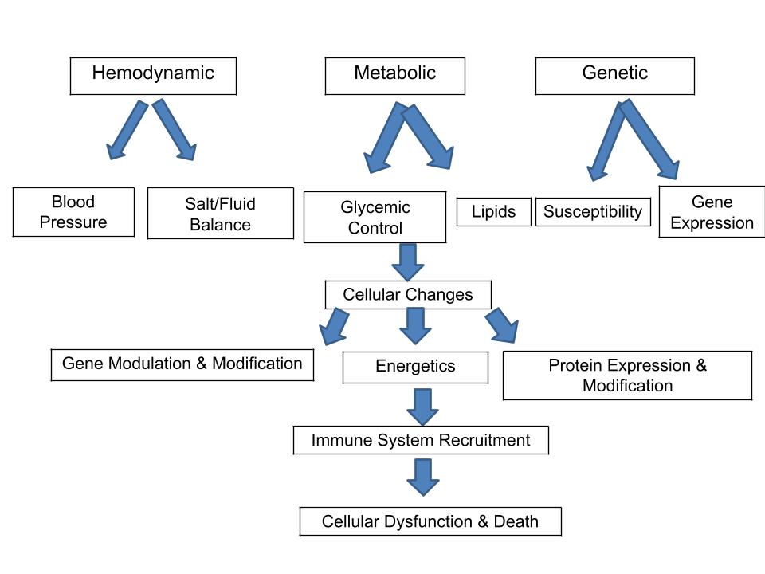

(Schematic overview of the major areas contributing to diabetic complications.)

Diabetes-related problems are classified as "macrovascular disease" (coming from damage to the arteries) and "microvascular disease" (resulting from damage to small blood vessels).

Microvascular consequences include renal illness, also known as "nephropathy," eye disease, or "retinopathy," and nerve damage, also known as "neuropathy." The two main macrovascular consequences are strokes from cerebrovascular disease and accelerated cardiovascular disease that causes myocardial infarction. Diabetes-related myocardial dysfunction also seems to be, at least partially, independent of atherosclerosis, however the exact cause is yet unknown. Among the other long-term effects of diabetes include depression, (Nouwen, A. et al 2011).

**Diabetic Retinopathy:-**

A significant microvascular consequence of diabetes mellitus is diabetic retinopathy, which damages the retinal capillaries and, if untreated, results in blindness or vision loss (International Diabetes Federation, & The Fred Hollows Foundation. 2015). As a further problem, diabetic macular edema can potentially develop at any point in its progression and thicken the retina's macular area, which can cause significant vision loss (International Federation on Ageing, International Agency for the Prevention of Blindness, & International Diabetes Federation. 2016). Due to rising diabetes rates and population aging, diabetic retinopathy has emerged as a major cause of blindness in the working-age population in the Western world. Retinopathy is responsible for an estimated 2.4 million occurrences of blindness globally (Prokofyeva, E., & Zrenner, E. 2012), of which 15–17% occur in the US and Europe and 3–7% in Southeast Asia and the Western Pacific (Resnikoff, S.et al 2004).It is critical to comprehend the aetiology of diabetic retinopathy since, in addition to its danger to vision, studies indicate that it is linked to an elevated risk of cardiovascular events and/or all-cause mortality (Kramer, C. K.,et al. 2011). Diabetic retinopathy has a considerable detrimental influence on quality of life (Coyne, K. S., et al 2004, Federation, I. D. 2017).

**Pathogenesis of diabetic retinopathy:-**

A microangiopathy of the retina is diabetic retinopathy.It involves modifications to the blood's rheological characteristics as well as the vascular wall. When these conditions come together, capillary occlusion occurs, which causes retinal ischemia and leaking that can be seen angiographically. The basilar membrane thickening and the loss of pericytes and endothelial cells are common histological alterations. Pathognomonic microaneurysms are areas of outward ballooning of the capillary wall (Figure 2).

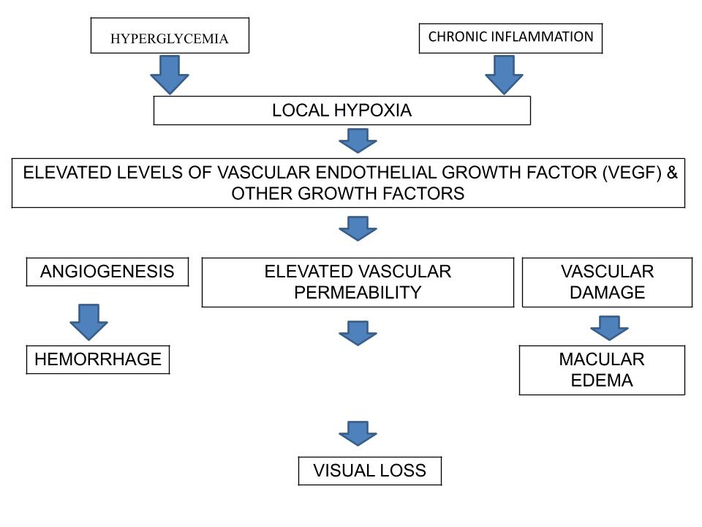

(Schematic flow chart for the pathogenesis of diabetic retinopathy)

In terms of the blood's rheological characteristics, the following elements result in reduced fibrinolysis and increased blood viscosity (Hamilton AMP,et al 1996):

* Reduced erythrocyte deformability,
* Increased platelet aggregation,
* Increased levels of fibrinogen and α2-globulin,
* Decreased levels of serum albumin.

There are several biochemical signalling processes at play. Advanced glycation end products (AGE) are produced as a result of elevated protein kinase C activity and protein glycosylation. These ultimately result in neo-vascularization in the anterior and posterior parts of the eye, increased vascular permeability leading to leakage, and collapse of the inner blood-retina barrier through cell interactions involving vascular endothelial growth factor (VEGF). AGEs appear to mediate almost all complications of diabetes, including vasoconstriction and inflammatory vessel wall changes linked to the formation of atheromatous plaques and affecting the function of endothelial cells and macrophages. AGEs are taken exogenously through food and are also formed endogenously in greater quantities due to hypoglycemia.The current therapy strategy, which involves intravitreous injection of glucocorticoids, targets alterations in the inflammatory vascular wall (Jonas, J. B. 2007).

**Classification of diabetic retinopathy:-**

There are two types of diabetic retinopathy:-

1. **Non-proliferative diabetic retinopathy (NPDR**) :- The early stages of the disease, known as NPDR, are characterised by minimal or nonexistent symptoms. The blood arteries in the retina weaken in NPDR, allowing microscopic bulges known as microanuerysms to emerge from their walls. The macula may expand as a result of fluid leakage from the microanuerysms into the retina. (Kumar, K. S.,et al 2012)
2. **Proliferative diabetic retinopathy (PDR)**:- The disease's more severe variant is called PDR. At this point, circulation issues lead to oxygen deprivation in the retina. As a result, the vitreous, the gel-like fluid that covers the back of the eye, may start to fill with new, delicate blood vessels in the retina. Vision may be obscured by blood leaking into the vitreous from the new blood vessel. Glaucoma development and retinal detachment as a result of scar tissue formation are other PDR consequences. The eye condition known as glaucoma is characterised by increasing optic nerve damage. Excessively high intraocular pressure is the cause of nerve injury in proliferative diabetic retinopathy patients. Proliferative diabetic retinopathy can result in blindness or significant visual loss if treatment is not received. (Kumar, K. S.,et al 2012)

**Symptoms of diabetic retinopathy:-**

Diabetic retinopathy symptoms can worsen over time and include:

* Spots or dark strings floating in your vision (floaters)
* Blurred vision
* Fluctuating vision
* Dark or empty areas in your vision
* Vision loss
* Difficulty with color perception
* Diabetic retinopathy usually affects both eyes.

**Treatment for diabetic retinopathy:-**

Diffuse diabetic macular edema and clinically diabetic macular edema are treated with focal and grid laser photocoagulation. A 50% reduction in the probability of blindness was seen after focal laser photocoagulation of microaneurysms and leakage (Rosenstock, J.,et al 2009). Retinal oxygenation is increased by focal laser photocoagulation because it improves oxygen diffusion from choroidal veins. Additionally, endothelial cells and retinal capillaries' pigment are stimulated by focal laser photocoagulation (Nentwich, M. M., & Ulbig, M. W. 2015). Because grid laser photocoagulation has a worse functional prognosis, intravitreal anti-vascular endothelial growth factor (anti-VEGF) therapy should be used instead (Bhagat, N.,et al 2009). Because of its connection to the breakdown of the blood-retinal barrier, vascular endothelial growth factor has been linked to retinal edema and leakage (Qaum, T.,et al 2001). Intravitreal administration of anti-VEGF drugs allows for a low systematic exposure that needs to be repeated, particularly in individuals with center-involving diabetic macular edema. Intravitreal anti-VEGF therapy is safe, with an average of no more than seven injections in the first year and four injections in the second year (Stefanini, F. R., et al 2014).

**Role of micronutrients in the management of diabetic retinopathy:**

**Vitamin A and Carotenoids:-** Vitamin A, also known as retinal, is a class of fat-soluble retinoids derived from animals that are essential for immune system function, cell division and growth, and vision. Vitamin A is a part of the photosensitive pigment called rhodopsin in the eye. Zeaxanthin and lutein are plant-derived, water-soluble carotenoids that readily pass through the blood-brain and blood-retina barriers (Mohn, E. S., et al 2017). They function as potent antioxidants that stabilise cell membranes and guard against oxidative stress when concentrated in the macula. Similar to AMD, higher lutein and zeaxanthin levels were linked to a significantly decreased chance of developing diabetic kidney disease, according to Brazionisa et al. (Brazionis, L., et al 2008).

**Group B Vitamins:-**Thiamine, or vitamin B1, is a powerful free radical scavenger that controls intracellular glucose and inhibits the polyol pathway's activation, which is brought on by excessive intracellular glucose levels (Okai, Y.,et al 2007). It is hypothesised that DR in rats and humans is caused by hyperglycemia-induced disruption of the polyol pathway (Dagher, Z., et al 2004). The vascular endothelium is shielded from harm by high serum thiamine levels against advanced glycation end products. High doses (50–100 mg/day) of thiamine supplements are safe and effective for treating and preventing end-organ damage, such as diabetic nephropathy and DR (Shi, C., et al 2020).

**Vitamin C:-** Water-soluble vitamin C is essential for the renewal of other antioxidants including glutathione and vitamin E (Vitamin, D.National Institutes of Health 2020). In patients with primary hypertension, it lowers blood pressure (Guan, Y., Dai, P., & Wang, H. 2020). Studies on diabetic patients and animals have demonstrated that oral vitamin C reduces capillary endothelial dysfunction (Thosar, S. S et al 2015). Proliferative DR patients are more likely to develop diabetic macular edema and have a 10-fold reduced amount of ascorbate in the vitreous humour (Park, S. W.,et al 2019). When combined with statins, vitamin C reduces nonproliferative DR more than statins alone can (dose-dependently) (Gurreri, A., et al2019).

**Vitamin D:-** For insulin release, insulin sensitivity, inflammation reduction, and vascular stiffness, the right dosage of vitamin D is essential (Shi, C., et al 2020). Recent research has demonstrated that DR risk and severity can be decreased by maintaining an optimal vitamin D level (Long, M., et al 2017).The activity of the pancreatic cells is influenced by vitamin D (Rashidi, B., et al 2017).

**Vitamin E:-** Supplementing with vitamin E reduces blood pressure somewhat, particularly the systolic pressure (Shi, C., et al 2020). A Joslin Institute study found that vitamin E administration at a daily dose of 1800 IU enhanced retinal blood flow in people with T1DM who had had the condition for less than ten years (Bursell, S. E.et al 1999). After vitamin E therapy, oxidative stress—which is increased in DR—is decreased (Chatziralli, I. P.,et al 2017). When vitamin C is taken along with vitamin E, the benefits seem to be much greater (Stoyanovsky, D. A.,et al 1995 ).

**Zinc:-** Zinc is an essential cofactor for immune system function, cell division, DNA synthesis, and the metabolism of proteins and carbohydrates. Chronic pathogenic diseases like metabolic syndrome, diabetes, diabetic microvascular complications, and DR are known to worsen with a zinc shortage (Miao, X.,et al 2013). Diabetes duration, higher HbA1c, hypertension, and microcirculatory problems are all associated with low serum zinc levels. The length and severity of DR cause a progressive decrease in the serum's zinc level (Luo, Y. Y.,et al 2015).

**Conclusion:-** To sum up, micronutrients can play a significant role in both DR prevention and management. Research indicates that dietary Vitamin A, B,C,D,E and a Mediterranean diet help protect against DR, whereas a higher calorie consumption has been linked to an increased risk of DR.These results may help medical professionals counsel diabetic patients who are at risk of developing DR by providing evidence-based dietary advice. To better inform therapeutic guidelines, however, it may be necessary to examine the impact of other important dietary components on DR, such as proteins, fatty acids, antioxidants, alcohol, and popular beverages.

**Reference:-**

* American Diabetes Association. (1997). Clinical practice recommendations 1997. *Diabetes Care, 20*(Suppl 1), S1–S70
* Bhagat, N., Grigorian, R. A., Tutela, A., & Zarbin, M. A. (2009). Diabetic macular edema: pathogenesis and treatment. *Survey of ophthalmology*, *54*(1), 1-32.
* Brazionis, L., Rowley, K., Itsiopoulos, C., & O'Dea, K. (2008). Plasma carotenoids and diabetic retinopathy. *British Journal of Nutrition*, *101*(2), 270-277.
* Bursell, S. E., Clermont, A. C., Aiello, L. P., Aiello, L. M., Schlossman, D. K., Feener, E. P., ... & King, G. L. (1999). High-dose vitamin E supplementation normalizes retinal blood flow and creatinine clearance in patients with type 1 diabetes. *Diabetes care*, *22*(8), 1245-1251.
* Butler, D. (2012). The soaring incidence of diabetes is driving the United Arab Emirates' science ambitions. *Nature*, 482(7385), 276-277. https://doi.org/10.1038/482276a
* Chatziralli, I. P., Theodossiadis, G., Dimitriadis, P., Charalambidis, M., Agorastos, A., Migkos, Z., ... & Keryttopoulos, P. (2017). The effect of vitamin E on oxidative stress indicated by serum malondialdehyde in insulin-dependent type 2 diabetes mellitus patients with retinopathy. *The open ophthalmology journal*, *11*, 51.
* Coyne, K. S., Margolis, M. K., Kennedy-Martin, T., Baker, T. M., Klein, R., Paul, M. D., & Revicki, D. A. (2004). The impact of diabetic retinopathy: perspectives from patient focus groups. *Family practice*, *21*(4), 447-453.
* Dagher, Z., Park, Y. S., Asnaghi, V., Hoehn, T., Gerhardinger, C., & Lorenzi, M. (2004). Studies of rat and human retinas predict a role for the polyol pathway in human diabetic retinopathy. *Diabetes*, *53*(9), 2404-2411.
* Danaei, G., Finucane, M. M., Lu, Y., Singh, G. M., Cowan, M. J., Paciorek, C. J., ... & Ezzati, M. (2011). National, regional, and global trends in fasting plasma glucose and diabetes prevalence since 1980: systematic analysis of health examination surveys and epidemiological studies with 370 country-years and 2· 7 million participants. *The lancet*, *378*(9785), 31-40.
* Davies, J. L., Kawaguchi, Y., Bennett, S. T., Copeman, J. B., Cordell, H. J., Pritchard, L. E., ... & Todd, J. A. (1994). A genome-wide search for human type 1 diabetes susceptibility genes. *Nature*, *371*(6493), 130-136.
* Editors of Encyclopaedia Britannica. (2024, July 2). *Diabetes mellitus*. Encyclopaedia Britannica.<https://www.britannica.com/science/diabetes-mellitus>
* Federation, I. D. (2017). IDF diabetes atlas 8th edition. *International diabetes federation*, 905-911.
* Forbes, J. M., & Cooper, M. E. (2013). Mechanisms of diabetic complications. *Physiological reviews*, *93*(1), 137-188.
* Guan, Y., Dai, P., & Wang, H. (2020). Effects of vitamin C supplementation on essential hypertension: A systematic review and meta-analysis. *Medicine*, *99*(8), e19274.
* Gurreri, A., Pazzaglia, A., & Schiavi, C. (2019). Role of statins and ascorbic acid in the natural history of diabetic retinopathy: a new, affordable therapy?. *Ophthalmic Surgery, Lasers and Imaging Retina*, *50*(S1), S23-S27.
* Hamilton AMP, Ulbig MW, Polkinghome P: Management of diabetic retinopathy. London, BMJ Publishing Group, 1996.
* Harjutsalo, V., Sjöberg, L., & Tuomilehto, J. (2008). Time trends in the incidence of type 1 diabetes in Finnish children: a cohort study. *The Lancet*, *371*(9626), 1777-1782.
* International Diabetes Federation, & The Fred Hollows Foundation. (2015). *Diabetes eye health: A guide for health care professionals*. Brussels, Belgium.
* International Diabetes Federation. (2020, March 26). About IDF. International Diabetes Federation. <https://www.idf.org/who-we-are/about-idf.html>
* International Federation on Ageing, International Agency for the Prevention of Blindness, & International Diabetes Federation. (2016). *The Diabetic Retinopathy Barometer Report: Global Findings*. 11-10-2017.
* Jonas, J. B. (2007). Intravitreal triamcinolone acetonide for diabetic retinopathy. *Diabetic Retinopathy*, *39*, 96-110.
* Kang, Y. S., Lee, M. H., Song, H. K., Ko, G. J., Kwon, O. S., Lim, T. K., ... & Cha, D. R. (2010). CCR2 antagonism improves insulin resistance, lipid metabolism, and diabetic nephropathy in type 2 diabetic mice. *Kidney international*, *78*(9), 883-894.
* Keenan, H. A., Sun, J. K., Levine, J., Doria, A., Aiello, L. P., Eisenbarth, G., ... & King, G. L. (2010). Residual insulin production and pancreatic β-cell turnover after 50 years of diabetes: Joslin Medalist Study. *Diabetes*, *59*(11), 2846-2853.
* Kramer, C. K., Rodrigues, T. C., Canani, L. H., Gross, J. L., & Azevedo, M. J. (2011). Diabetic retinopathy predicts all-cause mortality and cardiovascular events in both type 1 and 2 diabetes: meta-analysis of observational studies. *Diabetes care*, *34*(5), 1238-1244.
* Kumar, K. S., Bhowmik, D., Harish, G., Duraivel, S., & Kumar, B. P. (2012). Diabetic retinopathy-symptoms, causes, risk factors and treatment. *The Pharma Innovation*, *1*(8).
* Kumar.R, Saha, Purabi, Kumar,Yogendra, Sahana,Soumitra (2020, October). A review on diabetes mellitus: Type 1 & Type 2. *World Journal of Pharmacy and Pharmaceutical Sciences*. https://doi.org/10.20959/wjpps202010-17336
* Long, M., Wang, C., & Liu, D. (2017). Glycated hemoglobin A1C and vitamin D and their association with diabetic retinopathy severity. *Nutrition & diabetes*, *7*(6), e281-e281.
* Luo, Y. Y., Zhao, J., Han, X. Y., Zhou, X. H., Wu, J., & Ji, L. N. (2015). Relationship between serum zinc level and microvascular complications in patients with type 2 diabetes. *Chinese medical journal*, *128*(24), 3276-3282.
* Mathis, D., Vence, L., & Benoist, C. (2001). β-Cell death during progression to diabetes. *Nature*, *414*(6865), 792-798.
* Miao, X., Sun, W., Miao, L., Fu, Y., Wang, Y., Su, G., & Liu, Q. (2013). Zinc and diabetic retinopathy. *Journal of diabetes research*, *2013*(1), 425854.
* Mohn, E. S., Erdman Jr, J. W., Kuchan, M. J., Neuringer, M., & Johnson, E. J. (2017). Lutein accumulates in subcellular membranes of brain regions in adult rhesus macaques: Relationship to DHA oxidation products. *PLoS One*, *12*(10), e0186767.
* Nentwich, M. M., & Ulbig, M. W. (2015). Diabetic retinopathy-ocular complications of diabetes mellitus. *World journal of diabetes*, *6*(3), 489.
* Nouwen, A., Nefs, G., Caramlau, I., Connock, M., Winkley, K., Lloyd, C. E., ... & European Depression in Diabetes (EDID) Research Consortium. (2011). Prevalence of depression in individuals with impaired glucose metabolism or undiagnosed diabetes: a systematic review and meta-analysis of the European Depression in Diabetes (EDID) Research Consortium. *Diabetes care*, *34*(3), 752-762.
* Okai, Y., Higashi-Okai, K., Sato, E. F., Konaka, R., & Inoue, M. (2007). Potent radical-scavenging activities of thiamin and thiamin diphosphate. *Journal of clinical biochemistry and nutrition*, *40*(1), 42-48.
* Park, S. W., Ghim, W., Oh, S., Kim, Y., Park, U. C., Kang, J., & Yu, H. G. (2019). Association of vitreous vitamin C depletion with diabetic macular ischemia in proliferative diabetic retinopathy. *PLoS One*, *14*(6), e0218433.
* Prokofyeva, E., & Zrenner, E. (2012). Epidemiology of major eye diseases leading to blindness in Europe: a literature review. *Ophthalmic research*, *47*(4), 171-188.
* Qaum, T., Xu, Q., Joussen, A. M., Clemens, M. W., Qin, W., Miyamoto, K., ... & Adamis, A. P. (2001). VEGF-initiated blood–retinal barrier breakdown in early diabetes. *Investigative ophthalmology & visual science*, *42*(10), 2408-2413.
* Rashidi, B., Hoseini, Z., Sahebkar, A., & Mirzaei, H. (2017). Anti‐atherosclerotic effects of vitamins D and E in suppression of atherogenesis. *Journal of cellular physiology*, *232*(11), 2968-2976.
* Resnikoff, S., Pascolini, D., Etya'Ale, D., Kocur, I., Pararajasegaram, R., Pokharel, G. P., & Mariotti, S. P. (2004). Global data on visual impairment in the year 2002. *Bulletin of the world health organization*, *82*(11), 844-851.
* Rosenstock, J., Fonseca, V., McGill, J. B., Riddle, M., Hallé, J. P., Hramiak, I., ... & Davis, M. (2009). Similar progression of diabetic retinopathy with insulin glargine and neutral protamine Hagedorn (NPH) insulin in patients with type 2 diabetes: a long-term, randomised, open-label study. *Diabetologia*, *52*, 1778-1788.
* Shaw, J. E., Sicree, R. A., & Zimmet, P. Z. (2010). Global estimates of the prevalence of diabetes for 2010 and 2030. *Diabetes research and clinical practice*, *87*(1), 4-14.
* Shi, C., Wang, P., Airen, S., Brown, C., Liu, Z., Townsend, J. H., ... & Jiang, H. (2020). Nutritional and medical food therapies for diabetic retinopathy. *Eye and Vision*, *7*, 1-16.
* Stefanini, F. R., Badaró, E., Falabella, P., Koss, M., Farah, M. E., & Maia, M. (2014). Anti‐VEGF for the management of diabetic macular edema. *Journal of immunology research*, *2014*(1), 632307.
* Stoyanovsky, D. A., Goldman, R., Darrow, R. M., Organisciak, D. T., & Kagan, V. E. (1995). Endogenous ascorbate regenerates vitamin E in the retina directly and in combination with exogenous dihydrolipoic acid. *Current eye research*, *14*(3), 181-189.
* Thosar, S. S., Bielko, S. L., Wiggins, C. S., Klaunig, J. E., Mather, K. J., & Wallace, J. P. (2015). Antioxidant vitamin C prevents decline in endothelial function during sitting. *Medical science monitor: international medical journal of experimental and clinical research*, *21*, 1015.
* Vitamin, D. (2020). Health Professional Fact Sheet. *National Institutes of Health*.