Chapter 07

Gastroretentive Drug Delivery Systems (GRDDS): An In-Depth Analysis of Approaches, Advantages, Disadvantages, and Applications in Controlled Drug Delivery

T. M. Vijayalakshmi ^{1,*}, Abhijit Anil Gaikwad ², Meenu Beniwal ³, Jailani.S ⁴

¹ Assistant Professor, Department of Medical Biochemistry Dr. ALM Post Graduate Institute of Basic Medical Sciences University of Madras Taramani Campus Chennai 600 113
² Assistant Professor, Department of Chemistry, Savitribai Phule Pune University Pune’s Nutan Vidya Prasarak Mandal’s Arts Commerce & Science College Lasalgaon, Nashik, Maharashtra, Pin Code:422306
³ Assistant Professor, Department of Pharmaceutical Education and Research (DPER), Bhagat Phool Singh Mahila Vishwavidyalaya (BPSMV), Khanpur Kalan, Sonipat, Haryana-131409, India.
⁴ Research Scholar, Dept. of Pharmacy, Annamalai University, Faculty of Engineering and Technology Chidambaram, Tamilnadu. India.

*Corresponding Author:
T. M. Vijayalakshmi
Assistant Professor Department of Medical Biochemistry Dr. ALM Post Graduate Institute of Basic Medical Sciences University of Madras Taramani Campus Chennai 600 113

Abstract:
This book chapter explores the complex world of gastroretentive drug delivery systems (GRDDS), providing an in-depth analysis of various approaches, pros, cons, and uses in the controlled drug delivery field. The importance of attaining gastroretention for prolonged drug release within the gastrointestinal tract is highlighted by the study's comprehensive examination of the various methodologies applied in the design of GRDDS. Through a thorough examination of the pros and cons of GRDDS, this study sheds light on the intricacies and compromises of using these systems for regulated medication delivery. This research shows that GRDDS has the ability to improve treatment results by delivering drugs more precisely and over longer periods of time. A more nuanced awareness of these systems' limitations and improvement prospects can be fostered by addressing the issues that come with them. The study also elucidates new approaches and potential uses for regulated medication delivery that are just starting to emerge. Offering a comprehensive and current review of GRDDS, this exploration is designed to cater to the demands of researchers, practitioners, and pharmaceutical experts. This research is significant for guiding future developments and breakthroughs in controlled drug delivery systems since it presents a balanced perspective on the tactics, benefits, drawbacks, and applications of GRDDS.

KEYWORDS:

Background and Rationale Study:
In an effort to improve the accuracy and efficiency of controlled drug administration, research into gastroretentive drug delivery systems (GRDDS) has become an important focus in pharmaceutical science. Problems with maintaining therapeutic concentrations of medications in the gastrointestinal tract are a common cause of subpar treatment results and decreased patient compliance with traditional drug delivery methods. Investigating GRDDS is warranted since these systems are one-of-a-kind in their capacity to increase bioavailability and ensure sustained drug release by extending stomach residence duration. Floating, bioadhesive, and expandable systems are only a few of the many methodologies used to build GRDDS, which offer a range of strategies to overcome the limits of traditional delivery methods. The purpose of this comprehensive review is to weigh the benefits and drawbacks of GRDDS. In order to fully utilise these systems and overcome obstacles associated with formulation, biocompatibility, and patient acceptance, it is crucial to grasp their intricacies. With the goal of giving researchers, practitioners, and pharmaceutical experts a thorough grasp of the field's present status, this book chapter delves into the complexities of GRDDS.

In addition, GRDDS has the potential to revolutionise therapeutic approaches, as shown by its investigation into controlled drug delivery. Advancements in GRDDS have great potential for more precise medication distribution, fewer adverse effects, and higher levels of patient compliance in the ever-changing pharmaceutical industry. To summarise, the crucial need for an in-depth analysis of GRDDS, which have the potential to revolutionise controlled drug delivery, is the context and motivation of this study. This book chapter helps move pharmaceutical science forward and provides new drug delivery systems that are better suited to patients' needs by outlining the many methods, pros, cons, and uses.
RECENT ADVANCEMENTS IN THE FIELDS OF FOLLOWING:
The pursuit of more effective and precise regulated medication delivery has propelled the development of Gastroretentive medication Delivery Systems (GRDDS) to the forefront of pharmaceutical technology. Suboptimal treatment results and decreased patient compliance are common outcomes of traditional drug delivery systems that struggle to maintain therapeutic concentrations of medicines throughout the gastrointestinal tract. The unique capacity of GRDDS to increase bioavailability and ensure sustained drug release by extending stomach residence time is the reason to investigate these systems. There is a spectrum of solutions to overcome the inherent limits of conventional delivery methods that are applied in the varied approaches to creating GRDDS, including as floating, bioadhesive, and expandable systems. We hope to weigh the benefits and drawbacks of GRDDS in this comprehensive analysis. Using these systems to their full potential while overcoming obstacles with formulation, biocompatibility, and patient acceptability requires an in-depth understanding of their subtleties. This study aims to fully inform academics, practitioners, and pharmaceutical experts about the present state of the field by delving into the complexities of GRDDS. Research on GRDDS's potential uses in controlled drug delivery further highlights the game-changing effects this technology can have on medical treatments. Targeted medication distribution, less side effects, and more patient compliance are all goals of new developments in GRDDS, which are changing the face of the pharmaceutical industry. In conclusion, the important requirement for an in-depth analysis of GRDDS is addressed by this study's background and reasoning, which acknowledge their potential to revolutionise controlled drug delivery.
KEY QUESTIONS:
1. What are the primary approaches employed in Gastroretentive Drug Delivery Systems (GRDDS) to enhance gastric residence time?

2. How do GRDDS address the limitations of traditional drug delivery systems in sustaining therapeutic drug concentrations within the gastrointestinal tract?

3. What are the advantages associated with GRDDS in terms of sustained drug release and improved bioavailability?

4. What are the key challenges and disadvantages associated with the formulation and implementation of Gastroretentive Drug Delivery Systems?

5. How do different types of GRDDS, such as floating, bioadhesive, and expandable systems, impact drug delivery and patient outcomes?

6. What is the current state of research and innovation in GRDDS, and how do these advancements contribute to controlled drug delivery?

7. How can the understanding of GRDDS contribute to the optimization of drug formulations, addressing biocompatibility issues and improving patient acceptance?

8. What applications in controlled drug delivery are explored through GRDDS, and how do they compare to conventional delivery methods?

9. How can the insights gained from this in-depth analysis of GRDDS contribute to advancements in pharmaceutical science and the development of targeted drug delivery systems?

10. What transformative impact do GRDDS have on therapeutic interventions, including the potential for reduced side effects and improved patient compliance?

INTRODUCTION
Despite continual developments in medication delivery technologies, oral administration remains popular due to its ability to provide patient comfort and convenience. Controlled release medicine delivery systems are designed specifically for oral administration. These drug delivery strategies demonstrate a predetermined, anticipated, and controlled release of medication. They are not appropriate for drugs that have limited bioavailability due to concerns about stability or absorption [1]. These issues can be improved using contemporary methodologies that aim to enhance the retention of these medications in the stomach for a prolonged duration. Gastroretentive drug delivery systems (GRDDS) refer to drug delivery systems designed specifically to remain in the stomach for an extended period of time. Gastroretentive drug delivery systems (GRDDS) are appropriate for medications that exhibit absorption from the stomach (such as albuterol) [2], are unstable under alkaline conditions (such as ranitidine and metformin) [3], have low solubility under alkaline conditions (such as furosemide and diazepam) [4], and have a restricted absorption range (such as riboflavin and levodopa) [5]. The use of GRDDS offers several benefits, including enhanced patient compliance by reducing dosing frequency, improved effectiveness of drugs with a short half-life, targeted delivery of medications to specific sites, controlled and sustained release of drugs in the stomach, prolonged presence of drugs at the absorption site, improved bioavailability from the gastrointestinal tract, and prevention of dose dumping of medicines [6]. The development of GRDDS involves the utilisation of various materials such as ion-exchange resins, mucoadhesives, high-density substances, raft forming agents, magnetic materials, and super porous hydrogels [7,8]. This book chapter offers a succinct overview of the different characteristics of recently established methods for GRDDS.
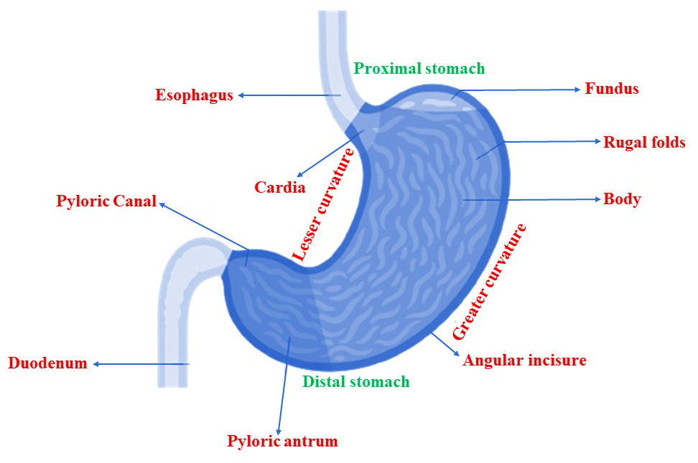
Figure 1: The anatomical aspects of the stomach will be elucidated, with a detailed description of each component.
Anatomy and physiology of the stomach

Understanding the structure and function of the stomach is crucial for developing effective gastroretentive medications. The stomach is anatomically divided into three regions, as depicted in Figure 1. The section closest to the esophagus is called the fundus, which is followed by the body. The body acts as a reservoir for ingested food, and the antrum is the final segment that connects the body to the small intestine. Antrum facilitates peristaltic contractions and promotes the process of stomach emptying [9]. During the fasting state, a periodic series of contractions takes place in the stomach and intestine every 120-180 minutes. This series is known as the migrating myoelectric cycle. It is additionally segmented into four stages. The alteration in muscle contractions during a state of being fed is referred to as the digestive motility pattern [10]. The pattern consists of four phases: phase 1 (basal phase), phase 2 (preburst phase), phase 3 (burst phase), and phase 4 [11].Figure 2 illustrates the movement pattern in the gastrointestinal tract.

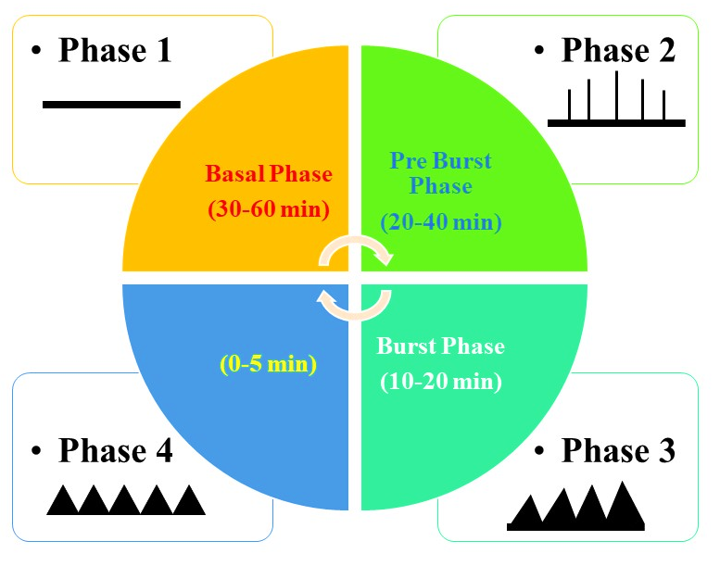

Figure 2: Motility pattern in gastrointestinal tract

Physicochemical properties of GRDDS

The formulation of GRDDS is significantly influenced by the physicochemical features of density, size, and shape of the dosage form. Dosage forms with a lower density than the gastric contents will float to the surface, while systems with a higher density will sink to the bottom of the stomach. The density of an optimal formulation should fall within the range of 1.0-2.5 g/cm [3]. Pharmaceutical formulations with a diameter exceeding 7.5 mm exhibit enhanced gastric residence time (GRT). Devices with circular, spherical, or tetrahedron shapes exhibit exceptional gastroretentive characteristics [12].

Physiological factors affecting retention of GRDDS in the stomach

Key determinants of stomach retention time for dosage forms include the individual's state of being fed or unfed, the characteristics of the meal consumed, the caloric value of the meal, and the frequency of feeding. In a fasting setting, stomach retention time decreases as a result of increased gastrointestinal motility. Gastric content is emptied during peristalsis. If the occurrence of peristalsis aligns with the delivery of the dosage form, then the duration of stomach residency is brief. Nevertheless, following meals, the movement of peristalsis is slowed down, which can potentially enhance the amount of time the formulation stays in the stomach. A meal that is rich in calories and consists of proteins, lipids, and fibrous substances leads to an extended period of time that food stays in the stomach. When there are several meals, the stomach retains food for a longer period of time compared to a single meal because peristalsis, the movement of the digestive tract, is continuously suppressed. Additionally, stomach retention is influenced by various variables, including gender and age. Females exhibit a slower rate of stomach emptying compared to males, regardless of their height, weight, and body surface area. An individual over the age of 70 demonstrates an extended General Response Time (GRT). Neonates exhibit lower Gastrointestinal Transit (GRT) rates when compared to geriatric patients, as indicated by previous studies [13, 14, 15].

Gastroretentive dosage form approaches

Recent years have seen ongoing research and progress in different methods of developing gastroretentive dose formulations. These methods of GRDDS facilitate the controlled and prolonged delivery of medication through the gastrointestinal tract, as depicted in Figure 3.

Figure 3: Methods for gastroretentive drug delivery system

Classification of GRDDS
GRDDS can be categorized into two primary types: floating and non-floating systems. Floating systems can be categorized into two types: effervescent systems and non-effervescent systems, depending on the mechanism of floating. On the other hand, non-floating systems are divided into four classes according on the method employed for gastroretention. Figure 4 illustrates the categorization of the GRDDS.

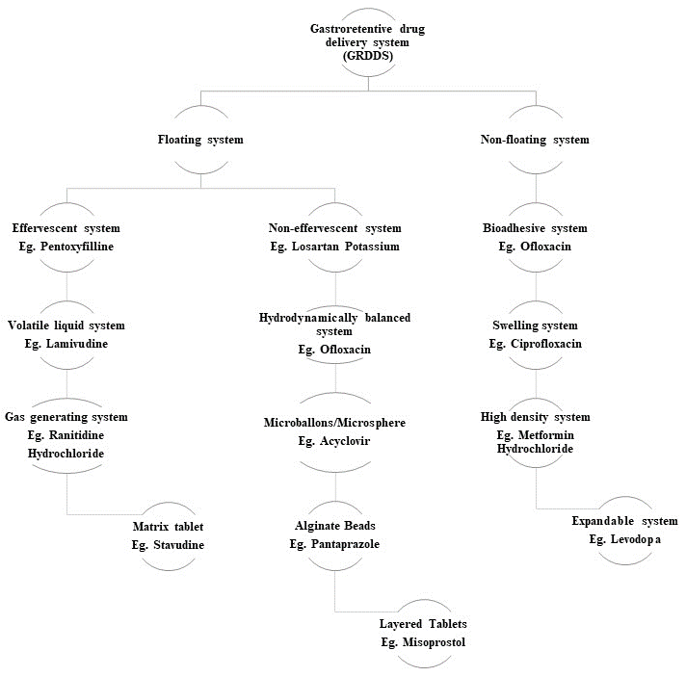

Figure 4: Classification of gastroretentive drug delivery system

I- High-density system

When making the GRDDS, the dosage form density is a key consideration. As a means of retention, a high-density system makes use of its own weight. A drug's density needs to be higher than the normal stomach content (1.004 g/mL) in order to improve its gastric residence time in the stomach [16]. The idea of a dense system is shown in Figure 4A. With the use of gamma scintigraphy, Clarke et al. evaluated the gastrointestinal transit of placebo pellet systems with different densities. According to their findings, the GRT of this formulation may be increased from an average of 5.8 hours to 25 hours, with the increase being more influenced by the density of the pellets than their diameter [17].

II- Floating or low-density system

Using a dose form with a lower density than the typical gastric content is another way to enhance gastric residence. These devices offer continuous medication release and stay buoyant because of their decreased density. By doing so, they enhance the drug's bioavailability and GRT [18].

(A) Effervescent system
In order to produce carbon dioxide (CO2) on the spot, this technique makes use of carbonates, such as sodium bicarbonate [19, 20]. To makes the reaction go more quickly, organic acids like tartaric and citric acid are added to the dosage form, making it less dense so it stays afloat in the stomach [20]. There are two groups into which it falls:
a) Type: Vacuum-containing volatile liquid there are three subcategories for them.

i) Inflatable system

A pullout system containing a chamber of evaporating liquids at room temperature makes up the system. So, the system floats when it is inserted into the stomach because the chamber inflates. Polymers such as polyvinyl alcohol and polyethylene make up the bioerodible polymer filament that makes up the inflatable chamber. The polymer slowly degrades and releases the medication as the inflated chamber floats in the esophageal fluid. The inflatable part eventually pops because the polymer dissolves with time [19, 20].

ii) Intragastric floating system
A microporous chamber acts as a medication reservoir, while the device itself incorporates a vacuum-filled chamber [20]. A floating intragastric device is shown in Figure 5. Using the gel-forming chemicals hydroxypropyl methylcellulose (HPMC), carbopol, and xanthan gum, Patel et al. created verapamil HCl intragastric floating tablets. Sodium bicarbonate and anhydrous citric acid were mixed to create a bubbly mixture that was added to attain buoyancy. The optimized formulation showed promising results with a regulated drug release for up to 24 hours, a total buoyant time of over 24 hours, and a low buoyancy lag time of 36 seconds [21].
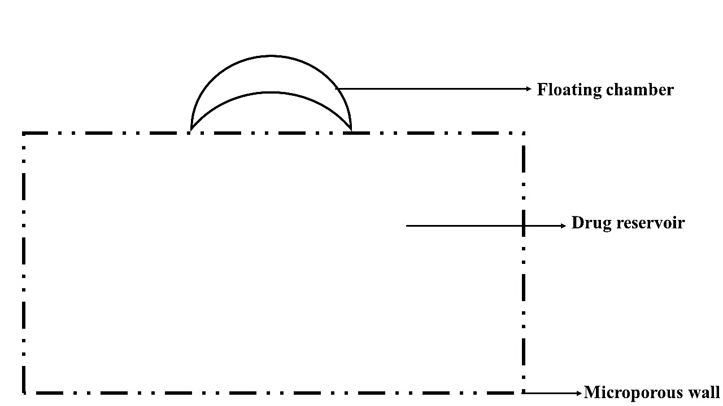
Figure 5: Intragastric floatation for the administration of gastrointestinal drugs.

iii) Intragastric-osmotically controlled system
Inflatable floating support congestion and an osmotic pressure-controlled medication delivery device can be combined in a biodegradable capsule to accomplish osmotic control [22,23]. An oral push-pull osmotic pump was produced by Zhao et al. using mesoporous silica nanoparticles loaded with fenofibrate. For the suspension agent, we chose polyethylene oxide (100,000) and for the expansion agent, we chose polyethylene oxide (6,000,000). A semipermeable membrane composed of cellulose acetate and polyethylene glycol 6,000 was utilized to enhance flexibility and regulate the membrane's permeability. According to reports, the prepared system has a longer half-life in the stomach (21.72 h vs. 12.48 h for the reference tablet) and a more consistent drug delivery pattern (24 h vs. 12.48 h) [24].
b) Matrix tablets: Both bilayer and single-layer matrix tablets are available. A hydrocolloid-forming gel and a medicine are the ingredients in the single-layer matrix tablet, while a bilayer matrix tablet has two layers: one for immediate release and another for prolonged release. By utilizing a direct compression process, Saisivam et al. created losartan potassium single-layer floating matrix tablets with varying amounts of HPMC-K4M and karaya gum as retarding polymers and sodium bicarbonate as an effervescent ingredient. An in vivo investigation of the improved formulation revealed that the tablet floats in stomach content and extends the GRT to about 12 hours. X-ray imaging research in albino rabbits showed that the tablet remained in the stomach for 12 hours after administration [25].
c) Gas generating systems: Effervescent chemicals and hydrophilic polymers are used to prepare gas-generating devices.

i) Floating capsules

Drugs are enclosed in hydrophilic polymers, such as ethyl cellulose and eudragit RS-100, in these dosage formulations combined with carbonating agents (calcium carbonate, sodium bicarbonate, etc). Nicardipine hydrochloride and hydrocolloids were combined in a hydrodynamically balanced capsule by Moursy et al. The capsule's outer shell dissolves and swells when it comes into touch with gastric fluid, creating a gelatinous barrier that floats for a long time in the stomach juice [26].

ii) Floating pills

A variety of oral floating dosage forms have been created, each with an effervescent ingredient inside and a hydrophilic polymer outside. Hydrophilic polymer layer on the outside expands and sinks in stomach fluid, but effervescent agent on the inside releases carbon dioxide gas, causing the system to float [27,28]. In order to boost the drug's overall bioavailability and prolong the GRT, Meka et al. developed a gas formation approach to create multiple-unit minitabs of captopril. Utilizing the direct compression method, they created drug-containing core units that were subsequently covered with three alternating layers: an inner seal coat, an effervescent layer made of sodium bicarbonate, and an outer gas-entrapped polymeric membrane composed of polymethacrylates (eudragit RL30D, RS30D, or a mix of the two). Drug release was shown to be lowered as the coating amount of the gas-entrapped polymeric membrane was increased [29].

iii) Floating systems with ion exchange resins

One primary use for these floating systems is to increase the GRT of ion exchange resin dosage forms. Beads covered with hydrophilic polymers and filled with bicarbonate ions make up the drug resin complex [30]. It makes the beads float by reacting with the gastric juice, which in turn generates carbon dioxide gas. A floating system was created by Atyabi et al. using ion exchange resin. This resin is composed of resin beads that have bicarbonate and a medicine linked to them, which is negatively charged. After subjecting two resins—Amberlite IRA-400 and Dowex 2 x 10—to a standardized technique, researchers found that both had in vitro floating durations of more than 24 hours. With the non-coated approach, the coated dose form stayed in the stomach for more than three hours, and its retention was much higher than with the standard formulation [31].

(B) Non-effervescent systems

The medicine expands when it comes into touch with stomach fluid in non-effervescent floating systems. Because it keeps its form and density below one, it floats on the surface of gastric fluid. These floating systems make use of hydrocolloids of the swellable, matrix-forming, or gel-forming varieties [32]. There are additional ways to categorize them:

i. Hydrodynamically balanced systems (HBS)

The essential component of these systems is a combination of hydrocolloids and medications, which, when exposed to gastric fluid, swell to create a gelatinous barrier. Being less dense than gastric fluid causes it to float for a long time in the stomach. To improve the regulation of theophylline distribution in the stomach for an extended period with a minimum floating time of 6 hours, Nayak and Malakar created gastroretentive theophylline HBS capsules with the following ingredients: lactose, ethylcellulose, liquid paraffin, polyethylene oxide, and polyvinylpyrrolidone [33].

ii. Microballoons

A drug-containing emulsion is slowly added to a volatile solvent to form microballoons. An internal hole in the drug-polymer microsphere is created as the solvent evaporates, releasing gas from a dispersed polymer droplet. The emulsion solvent diffusion method is another name for it [22]. The amount and kind of polymer utilized in the formulation determine the floating time of microspheres. By utilizing eudragit L100 and an emulsion solvent diffusion process with a non-effervescent methodology, Gupta et al. created microspheres filled with pantoprazole sodium. The drug-release pattern that was determined to be most effective in healing ulcers and increasing bioavailability was supported by both in vitro and in vivo investigations [34].

iii. Alginate beads

The hydrocolloid gel-forming agent and sodium alginate are the interlocking agents used to construct these systems. The hydrocolloid binds to stomach fluid and creates a barrier, trapping air within the polymer. This causes the polymer to swell, which in turn allows the dosage form to float, allowing the medicine to be released over an extended period of time. Using an emulsion gelation technique, Ghareeb and Radhi created trimetazidine calcium alginate floating beads with sodium alginate solution (2, 3, and 4% w/v), hydrophobic polymer complexes (HPC), and peppermint oil (15, 20, and 25% v/v). They discovered that floating beads encased in oil showed promise for maintaining the drug's release throughout a 10-hour period [35].

iv. Layered tablets
Layered tablets are more popular due to ease of their preparation, low cost, and high stability.
a. Single-layered floating tablets: The formulation of these tablets involved incorporating gas-generating chemicals into the matrix tablet along with the medication. Because of their increased gastric reflux time (GRT) and relatively low bulk density compared to gastric fluid, these formulations maintain their buoyancy in the stomach [36]. Using wet granulation and compaction, Kim et al. created non-effervescent gastroretentive tablets of pregabalin that are to be taken once daily. In vitro solubility and floating characteristics of the manufactured tablets were determined to be significantly impacted by the concentrations of HPMC and crospovidone. Figure 6 shows a diagram of floating tablets with only one layer [37].
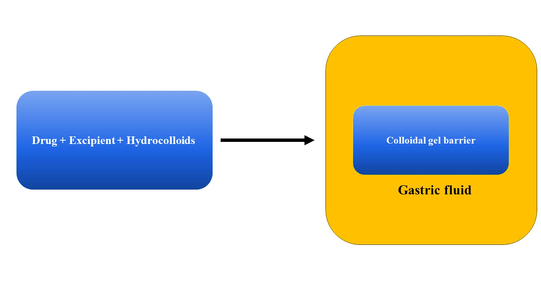
Figure 6: Mechanism of single layer tablet
b. Double-layered floating tablets: With two distinct release patterns, it consists of two formulations stacked on top of each other [3,38].Using the direct compression method, Kuldeep et al. created a bilayer floating tablet with two layers: one layer that releases metoprolol succinate over time, and the other layer that releases rosuvastatin calcium immediately. The gel-forming agents utilized were HPMC K100, K4M, and K15M, whereas the super disintegrants were cross carmellose sodium, sodium starch glycolate, and crospovidone. An effervescent agent is sodium bicarbonate's primary function. The in vitro buoyancy investigation found that the floating lag time reduces with increasing concentrations of gas-generating agents. Both the floating lag time and the total floating duration were seen to be affected by the polymer gas producing agent ratio [39].

III- Mucoadhesive and bioadhesive systems

The sticky qualities of a mucoadhesive or bioadhesive system allow for the long-term localization of a medicine to a certain area of the body. In Figure 4D, we can see a GRDDS mucoadhesive system. Bioadhesive and mucoadhesive polymers are employed most often for this purpose [40]. A variety of polymers, both natural and semisynthetic, are utilized for mucoadhesion. Natural polymers include guar gum, sodium alginate, gelatin, and lectins. Semisynthetic polymers include carbopol, sodium carboxymethyl cellulose, and HPMC. Receptor interactions, hydration, or bonding mediate the adherence [41,42]. The itraconazole sustained-release pills were created by Madgulkar et al. with the help of the mucoadhesive polymer carbopol 934P and HPMC K4M. Albino rats were shown to have stomach retention and sustained drug release for six hours [43].

IV- Swelling system

After swelling, these systems remain clogged in the stomach because they enlarge substantially in response to gastric fluid, surpassing the size of the pyloric sphincter. One more name for this is a "plug type system" [44]. With the right excipient, controlled and sustained medication release can be accomplished. In a hydrophilic polymer network, the amount of cross-linking determines the swelling ability of the material. When the cross-linking degree is high, the system stays intact, but when it's low, the polymer swells up and dissolves quickly [45].

V- Superporous hydrogels

A three-dimensional network of hydrophilic polymers with multiple super-size pores inside is called a superporous hydrogel. Capillary soaking via interconnected open pores causes superporous hydrogels to expand. Certain components, such as initiators and cross-linkers, are utilized to commence the cross-linking process in the development of superporous hydrogels [46]. In addition, there were foaming agents, foaming aids, and foam stabilizers. A superporous hydrogel system was created by Desu et al. with the following components: polyvinyl alcohol, ammonium persulfate, N, N-tetramethylenediamine, Span 80, and N', N'-methylene bisacrylamide, which were used as cross-linking operators and composite specialists, respectively. To create a gas-forming porous structure, they are employed as a froth stabilizer [47].

VI- Magnetic system

This technology allows for the control of the movement of a gastroretentive formulation with a small internal magnet by applying a powerful magnetic field onto the body surface using a strong magnet. According to multiple accounts, this system has been successful; nonetheless, picking the magnet's location with extreme precision is crucial to the system's operation [48]. Magnetized acyclovir depot tablets were created by Gröning et al. for oral administration. The administration of acyclovir and the length of time it took for the dose form to reach the bloodstream were both affected by the use of an extracorporeal magnet. The acyclovir plasma concentration-time profiles were established in an in vivo investigation including five healthy male volunteers. The impact of GRT on the plasma concentration-time profiles of acyclovir was demonstrated by computer simulations of acyclovir depot preparations [49].

In vitro assessment

To forecast gastric transit behavior, in vitro evaluation is crucial for GRDDS. New gastroretentive formulations should take the following factors into account.

i. Buoyancy lag time

It is the duration it takes for gastroretentive formulations to reach the dissolving medium's surface. The test medium, which is kept at 37°C and contains 900 mL of 0.1 N HCl solution, is used in a USP dissolving equipment to determine it. Floating lag time is the amount of time it takes for various dose forms to float [50].

ii. Floating time

The buoyancy of the dose form is determined by this. The dosage form determines the specific dissolution equipment utilized in this test, which involves 900 mL of dissolution media maintained at 37°C. Just by looking at the dosage form, you can tell how long it will float [51, 52].

iii. Specific gravity/density

Estimates of specific gravity are crucial for GRDDS of low and high density. According to the displacement method is used to find specific gravity [53].

iv. Swelling index

To find the swelling index, the pills are submerged in 0.1 N HCl at 37°C and taken out at regular intervals [54].

v. Water uptake
In this investigation, a weight change is assessed after removing the dosage form from the dissolution medium at the regular intervals [55].
Water uptake (WU) = (W_{t} - W_{o}) * 100/W_{o}
where W_{t}= weight of the dosage form at time t, W_{o}= initial weight of the dosage form

vi. Weight variation

The weight variation can be calculated according to a number of approved procedures recommended by pharmacopeias. It is standard practice to document both the average and individual weight of twenty pills. The average weight and the weight variation are computed using these data points [56,57].

iii. Hardness and friability
A variety of testers, including those made by Pfizer, Monsanto, and Strong Cobb, are used to ascertain the hardness or crushing strength of materials. A Roche friabilator is used to determine the strength (or friability) of tablets [58,59].

viii. In vitro dissolution tests

By employing the USP dissolve type II apparatus (paddle) and keeping the stomach and intestines at 37°C for a predetermined amount of time, this test can ascertain the rate of drug release from GRDDS [59,60].

Evaluation of microsphere and beads

The size of the beads and microspheres was measured using an optical microscope. A scanning electron microscope is used to assess the surface morphology as well as the cross-sectional morphology.

In vivo assessment

a. Radiology

The primary application of this method is to ascertain, by means of X-ray, the location within the body of a gastroretentive dose form containing barium sulfate, a radio-opaque marker. In order to document the precise location of the dose form, X-ray photographs are obtained at various intervals [61, 62].

b. Scintigraphy

It is utilized to determine the floating behavior of the gastroretentive dose form in vivo, similar to radiology. Instead of using an X-ray to envelop the formulation and record the image, scintigraphy uses 99mTc pertechnetate as the emitting material [63, 64].

c. Gastroscopy

Visual inspections of gastroretentive dose forms are commonly performed using gastroscopy. In this method, a thin, illuminated tube called a "endoscope" is inserted into the body to examine internal organs such the small intestine, esophagus, and stomach [65,66].

d. Ultrasonography

It is a method of diagnosing medical conditions by creating pictures of the inside of the body using ultrasound. One major drawback of this test is that it cannot detect entrails [1,66,67].

e. ¹³C octanoic acid breath test

The amount of medication absorption from GRDDS is evaluated using radioactive 13C octanoic acid. Radiolabeled octanoic acid can be measured by comparing the amount of CO₂ exhaled after its metabolism to the amount of the chemical absorbed from the duodenum. Isotope ratio mass spectroscopy was used to measure the radiolabelled CO2 [65,66].

f. Magnetic marker monitoring
This procedure is safer than radiography and scintigraphy because it does not use radiation [67,68]. In it, the dose form is monitored in real-time as it travels through the digestive tract [69,70]. The dissolving behavior and gastrointestinal motility of drugs are the primary areas of research that make use of this method. This method involves labeling the dosage form as a magnetic dipole by adding a trace of ferromagnetic particles and then detecting the field strength using a device that can detect bio-magnetic signals [71,72,73].
ADVANTAGES OF GRDS
1. Peptic ulcer disease has been treated with it.
2. It is rarely employed for drugs with a wide therapeutic window in order to reduce the frequency of dose.
3. Drug bioavailability is enhanced.
4. It's a good fit for medications that don't do well in the digestive tract.
5. Its primary function is to ensure the therapeutic withdrawal of a high concentration of medications by providing their continuous supply [74].
DISADVANTAGES OF GRDDS:

1. It is not possible to synthesize drugs as GRDDS if they are unstable in highly acidic environments, have extremely low solubility in acid environments, or irritate the gastric mucosa.

2. To ensure optimal flotation and performance, FDDS (Floating Drug Delivery Systems) necessitate a high stomach fluid level. Therefore, it is necessary to drink extra water when taking this dosage form [75,76].

Applications of gastroretentive delivery systems
A regulated release of the medicine to the site of action is achieved with gastroretentive dosage forms [77]. Substances like riboflavin and levodopa, which undergo metabolism in the upper esophagus, are made more bioavailable with the aid of these systems [78,79]. By increasing GRT, gastroretentive dosage forms assist decrease the frequency of administration and enhance patient compliance for medications with a short half-life. Additionally, they aid in local therapy by providing a steady and extended release of medications in the intestines and stomach [80, 81, 82].

Conclusion: Finally, research into GRDDS is a major step forward in the development of controlled drug delivery procedures. This chapter provides a comprehensive overview of GRDDS by analyzing its numerous approaches, pros, cons, and applications. Floating, bioadhesive, and inflatable systems are just a few examples of the various approaches used to lengthen the amount of time a medicine spends in the stomach. These methods show promise for longer drug retention and better bioavailability. Although there are some obstacles to overcome, such as complicated formulations and possible drawbacks, GRDDS show great promise in overcoming the shortcomings of conventional drug delivery methods. Pharmaceutical researchers are interested in GRDDS because of its potential benefits, which include prolonged medication release, improved patient compliance, and fewer side effects. New developments in this area hold great potential for improving patient outcomes, resolving biocompatibility concerns, and optimizing medication formulations. This study provides a thorough insight that enhances the existing body of knowledge in pharmaceutical science and also points the way for future research and development. The profound influence of GRDDS on regulated drug delivery is demonstrated by their numerous uses, which cover a wide range of issues, from gastrointestinal diseases to the enhancement of therapeutic interventions. The promise of revolutionary advances in tailored drug delivery systems and improved treatment regimens is high as pharmaceutical researchers keep digging into the complexities of GRDDS. The importance of Gastroretentive Drug Delivery Systems in promoting patient-centered healthcare and their crucial role in defining the future of regulated drug delivery are both highlighted by this in-depth exploration.

FUTURE SCOPE:

The in-depth analysis of Gastroretentive Drug Delivery Systems (GRDDS) presented in this study unveils promising avenues for future research and development. The following aspects outline the potential future scope and directions for advancing GRDDS:

1. Innovative Formulation Strategies: Continued exploration of novel formulation strategies, such as the integration of advanced polymers, nanotechnology, and smart materials, can contribute to overcoming existing challenges and enhancing the performance of GRDDS. Innovations in formulation techniques will likely lead to optimized drug delivery systems with improved biocompatibility and stability.

2. Tailored Drug Release Profiles: Future research should focus on tailoring drug release profiles based on specific therapeutic requirements. The development of customizable GRDDS that allow for precision in drug release rates and duration will be instrumental in achieving targeted therapeutic outcomes for diverse medical conditions.

3. Biocompatible Materials: Advancements in identifying and utilizing biocompatible materials will be crucial for addressing concerns related to safety and tolerability. Research efforts should be directed towards the selection and modification of materials that ensure optimal performance, minimal side effects, and efficient elimination from the body.

4. Patient-Centric Approaches: Future studies should aim at incorporating patient-centric approaches into the design of GRDDS. Personalized drug delivery systems, considering individual patient variations and needs, have the potential to revolutionize the field, improving treatment adherence and overall healthcare outcomes.

5. Clinical Translation and Validation: Bridging the gap between laboratory research and clinical application is vital. Conducting extensive clinical trials to validate the safety, efficacy, and feasibility of GRDDS in diverse patient populations will be a critical step toward their widespread adoption in real-world medical practices.

6. Combination Therapies: Exploring the integration of multiple therapeutic agents within a single GRDDS could pave the way for innovative combination therapies. This approach holds the potential to address complex medical conditions and enhance treatment efficacy while simplifying drug administration for patients.

7. Regulatory Considerations: As GRDDS continue to evolve, regulatory frameworks need to adapt to accommodate these innovative drug delivery systems. Collaborative efforts between researchers, pharmaceutical companies, and regulatory bodies are essential to establish standardized guidelines and ensure the safe deployment of GRDDS in clinical settings.

Ultimately, GRDDS research aims to expand the frontiers of innovation, overcome existing restrictions, and provide real advantages to patients and healthcare providers through the application of scientific discoveries. The future of controlled drug delivery is bright for GRDDS as interdisciplinary collaboration takes off.
REFERENCES

1. Schneider F, Koziolek M, Weitschies W. In vitro and in vivo test methods for the evaluation of gastroretentive dosage forms. Pharmaceutics. 2019;11:416. [PMC free article] [PubMed] [Google Scholar]
2. Boulton DW, Fawcett JP. Enantioselective disposition of albuterol in humans. Clin Rev Allergy Immunol. 1996;14:115–138. [PubMed] [Google Scholar]
3. Chandira RM, Palanisamy P, Jaykar B. Formulation and evaluation of bilayered floating tablets of metformin hydrochloride. Int Res J Pharm. 2012;3:257–267. [Google Scholar]
4. Menon A, Ritschel WA, Sakr A. Development and evaluation of a monolithic floating dosage form for furosemide. J Pharm Sci. 1994;83:239–245. [PubMed] [Google Scholar]
5. Levy G, Jusko WJ. Factors affecting the absorption of riboflavin in man. J Pharm Sci. 1966;55:285–289. [PubMed] [Google Scholar]
6. Badoni A, Ojha A, Gnanarajan G, Kothiyal P. Review on gastroretentive drug delivery system. J Pharm Innov. 2012;1:32–42. [Google Scholar]
7. Malpure PS, Chavan BR, Maru AD, Bhadhane JS, Thakare EB, Sonawane PS. Gastroretentive drug delivery systems. World J Pharm Pharm Sci. 2019;8:506–528. [Google Scholar]
8. Kumar M, Kaushik D. An Overview on various approaches and recent patents on gastroretentive drug delivery systems. Recent Pat Drug Deliv Formul. 2018;12:84–92. [PubMed] [Google Scholar]
9. Pund AU, Shendge R, Pote AK. Current approaches on gastroretentive drug delivery system. J Drug Deliv Ther. 2020;10:139–146. [Google Scholar]
10. Gunda RK. Formulation development and evaluation of gastroretentive drug delivery system. A review. J Pharm Res. 2017;8:11–20. [Google Scholar]
11. More S, Gavali K, Doke O, Kasgawadek P. Gastroretentive drug delivery system. J Drug Deliv Ther. 2018;8:24–35. [Google Scholar]
12. Tomar A, Upadhyay A, Gupta S, Kumar S. An overview on gastroretentive drug delivery system: current approaches and advancements. Res Pharm Sci. 2019;9:12–16. [Google Scholar]
13. Taylor K, Aulton M. Aulton’s Pharmaceutics. The design and manufacture of medicines (4th ed) Churchill Livingstone; London. 2007;397. [Google Scholar]
14. Gandhi A, Verma S, Imam SS, Vyas M. A review on techniques for grafting of natural polymers and their applications. Plant Arch. 2019;19:972–978. [Google Scholar]
15. Chudiwal V, Shahi S, Chudiwal S, Ahale D. Innovative technologies for gastro-retentive. Asian J Pharm Res. 2017;6:22–28. [Google Scholar]
16. Devkant S, Anjali S. Gastro retentive drug delivery system. A review. Asian Pac J Health Sci. 2014;1:80–89. [Google Scholar]
17. Clarke GM, Newton JM, Short MB. Comparative gastrointestinal transit of pellet systems of varying density. Int J Pharm. 1995;114:1–11. [Google Scholar]
18. Streubel A, Siepmann J, Bodmeier R. Gastroretentive drug delivery system. Expert Opin Drug Deliv. 2006;3:217–233. [PubMed] [Google Scholar]
19. Garg R, Gupta GD. Progress in controlled gastroretentive delivery systems. Trop J Pharm Res. 2008;7:1055–1066. [Google Scholar]
20. Thapa P, Jeong SH. Effects of formulation and process variables on gastroretentive floating tablets with a high-dose soluble drug and experimental design approach. Pharmaceutics. 2018;10:161. [PMC free article] [PubMed] [Google Scholar]
21. Patel A, Modasiya M, Shah D, Patel V. Development and in vivo floating behavior of verapamil HCl intragastric floating tablets. AAPS PharmSciTech. 2009;10:310–315. [PMC free article] [PubMed] [Google Scholar]
22. Nayak AK, Maji R, Das B. Gastroretentive drug delivery systems: a review. Asian J Pharm Clin Res. 2010;3:2–10. [Google Scholar]
23. Nasa P, Mahant S, Sharma D. Floating systems: a novel approach towards gastro retentive drug delivery systems. Int J Pharm Pharm Sci. 2010;2:2–7. [Google Scholar]
24. Zhao Z, Wu C, Zhao Y, Hao Y, Liu Y, Zhao W. Development of an oral push-pull osmotic pump of fenofibrate-loaded mesoporous silica nanoparticles. Int J Nanomedicine. 2015;10:1691–1701. Erratum in: Int J Nanomedicine. 2022;17:15-16. [PMC free article] [PubMed] [Google Scholar]
25. Saisivam S, Ulla MR, Shakeel F. Development of floating matrix tablet of losartan potassium: in vitro and in vivo evaluation. J Drug Deliv Sci Technol. 2013;23:611–617. [Google Scholar]
26. Moursy NM, Afifi NN, Ghorab DM, El-Saharty Y. Formulation and evaluation of sustained release floating capsules of nicardipine hydrochloride. Pharmazie. 2003;58:38–43. [PubMed] [Google Scholar]
27. Samal HB, Dey S, Kumar D, Kumar DS, Sreenivas SA, Rahul V. Formulation, characterization and in-vitro evaluation of floating microspheres of nateglinide. Int J Pharm Bio Sci. 2011;2:147–157. [Google Scholar]
28. Pal P, Sharma V, Singh L. A review on floating type gastroretentive drug delivery system. Int Res J Pharm. 2012;3:37–43. [Google Scholar]
29. Meka L, Kesavan B, Chinnala KM, Vobalaboina V, Yamsani MR. Preparation of a matrix type multiple-unit gastro retentive floating drug delivery system for captopril based on gas formation technique: in vitro evaluation. AAPS PharmSciTech. 2008;9:612–619. [PMC free article] [PubMed] [Google Scholar]
30. Verma R, Kumar A, Purohit S, Bhandari A. Overview of gastro-retentive drug delivery system. J Natura Conscientia. 2011;2:423–436. [Google Scholar]
31. Atyabi F, Sharma HL, Mohammad HAH, Fell JT. In vivo evaluation of novel gastric retentive formulation based on ion exchange resin. J Control Release. 1996;42:105–113. [Google Scholar]
32. Ali A, Shahid MA, Hossain MD, Islam MN. Antibacterial bi-layered polyvinyl alcohol (PVA)-chitosan blend nanofibrous mat loaded with Azadirachta indica (neem) extract. Int J Biol Macromol. 2019;138:13–20. [PubMed] [Google Scholar]
33. Nayak AK, Malakar J. Formulation and in vitro evaluation of hydrodynamically balanced system for theophylline delivery. J Basic Clin Pharm. 2011;2:133–137. [PMC free article] [PubMed] [Google Scholar]
34. Gupta P, Kumar M, Kaushik D. Pantoprazole sodium loaded microballoons for the systemic approach: in vitro and in vivo evaluation. Adv Pharm Bull. 2017;7:461–467. [PMC free article] [PubMed] [Google Scholar]
35. Ghareeb MM, Radhi ZA. Formulation and in vitro evaluation of trimetazidine dichloride floating beads. Int J Pharm Pharm Sci. 2014;6:456–440. [Google Scholar]
36. Vinchurkar K, Balekar N. Formulation and evaluation of floating multilayered coated tablets. J Adv Pharm Technol Res. 2015:212–222. [Google Scholar]
37. Kim S, Hwang KM, Park YS, Nguyen TT, Park ES. Preparation and evaluation of non-effervescent gastroretentive tablets containing pregabalin for once-daily administration and dose proportional pharmacokinetics. Int J Pharm. 2018;550:160–169. [PubMed] [Google Scholar]
38. Soni RP, Patel AV, Patel RB, Patel NM. Gastroretentive drug delivery systems. A review. Int J Pharm World Res. 2011;2:1–24. [Google Scholar]
39. Kuldeep V, Sheetal M, Jitendra S, Masheer K. Formulation and evaluation of once a day dual component gastroretentive drug delivery system. Asian J Sci Technol. 2019;10:10247–10254. [Google Scholar]
40. Shep S, Dodiya S, Lahoti SR, Mayee R. Swelling system: a novel approach towards gastroretentive drug delivery system. Indo Global J Pharm Sci. 2011;1:234–242. [Google Scholar]
41. Rocca DJ, Omidian H, Shah K. Progresses in gastroretentive drug delivery systems. Business Briefing Pharmatech. 2003:152–156. [Google Scholar]
42. Zate SU, Mahale GH, Kapse KP, Anantwar SP. Gastroretentive bioadhesive drug delivery system: a review. Int J PharmTech Res. 2010;2:1227–1235. [Google Scholar]
43. Madgulkar A, Kadam S, Pokharkar V. Studies on formulation development of mucoadhesive sustained release itraconazole tablet using response surface methodology. AAPS PharmSciTech. 2008;9:998–1005. [PMC free article] [PubMed] [Google Scholar]
44. Yeole PG, Khan S, Patel VF. Floating drug delivery systems. Need and development. Indian J Pharm Sci. 2005;67:265–272. [Google Scholar]
45. Dolas RT, Hosmani A, Bhandari A, Kumar B, Somvanshi S. Novel sustained release gastroretentive drug delivery system: a review. Int J Pharm Res Dev. 2004;2:26–41. [Google Scholar]
46. Hardenia SS, Jain A, Patel R, Kaushal A. Floating drug delivery systems. A review. Asian J Pharm Life Sci. 2011;1:284–293. [Google Scholar]
47. Desu P, Paasam V, Kotra V. Formulation and in vitro evaluation of superporous hydrogel based gastroretentive drug delivery system of vildagliptin. J Pharm Res. 2019;23:873–885. [Google Scholar]
48. Joshi P, Patel P, Modi H, Patel MR, Patel KR, Patel NM. A review on gastro retentive drug delivery system. J Pharm Sci Bio-Sci Res. 2012;2:123–128. [Google Scholar]
49. Gröning R, Berntgen M, Georgarakis M. Acyclovir serum concentrations following peroral administration of magnetic depot tablets and the influence of extracorporal magnets to control gastrointestinal transit. Eur J Pharm Biopharm. 1998;46:285–291. [PubMed] [Google Scholar]
50. Hilton AK, Deasy PB. In vitro and in vivo evaluation of an oral sustainedrelease floating dosage form of amoxycillin trihydrate. Int J Pharm. 1992;86:79–88. [Google Scholar]
51. Sangekar S, Vadino WA, Chaudhary I, Parr A, Beinh R, Digenis G. Evaluation of the effect of food and specific gravity of tablets, on gastric retention time. Int J Pharm. 1987;35:187–191. [Google Scholar]
52. Patel N, Nagesh C, Chandrashekhar S, Jinal P, Devdatt J. Floating drug delivery system: an innovative acceptable approach in gastroretentive drug delivery. Asian J Pharm Res. 2012;2:7–18. [Google Scholar]
53. Pham AT, Lee PI. Probing the mechanisms of drug release from hydroxypropylmethyl cellulose matrices. Pharm Res. 1994;11:1379–1384. [PubMed] [Google Scholar]
54. Sharma N, Agarwal D, Gupta MK, Mahaveer PK. A comprehensive review on floating drug delivery system. Int Res J Pharm. 2011;2:428–441. [Google Scholar]
55. Caldwell LJ, Gardner CR, Cargill RC. Drug delivery device which can be retained in the stomach for a controlled period of time. US patent no: 4735804. April 05. 1988. [Google Scholar]
56. Shivkumar HG, Vishakante GD, Pramodkumar TM. Floating controlled drug delivery systems for prolong gastric residence. Indian J Pharm Edu Res. 2004;38:172–179. [Google Scholar]
57. Singh BN, Kim KH. Floating drug delivery systems: an approach to oral controlled drug delivery via gastric retention. J Control Release. 2000;63:235–259. [PubMed] [Google Scholar]
58. Burns SJ, Corness D, Hay G, Higginbottom S, Whwlan I, Attwood D, Barnwell SG. Development and validation of an in vitro dissolution method for a floating dosage form with biphasic release characteristics. Int J Pharm. 1995;121:37–34. [Google Scholar]
59. Timmermans J, Moës AJ. Factors controlling the buoyancy and gastric retention capabilities of floating matrix capsules: new data for reconsidering the controversy. J Pharm Sci. 1994;83:18–24. [PubMed] [Google Scholar]
60. Hendee WR. In: Textbook of diagnostic imaging. Fundamentals of diagnostic imaging: Characteristic of radiographic image. WB Saunders Co, Philadelphia (1th ed) 1994;1:9–10. [Google Scholar]
61. Koner P, Saudagar RB, Dharwal SJ. Gastro-retentive drugs: a novel approach towards floating therapy. J Novel Drug Deliv. 2007;1:2211–2215. [Google Scholar]
62. Biller S, Baumgarten D, Haueisen J. Magnetic marker monitoring: a novel approach for magnetic marker design. Ifmbe Proceedings. 2010;29:260:263. [Google Scholar]
63. Bathool A, Gowda DV, Khan MS, Ahmed A, Vasudha SL, Rohitash K. Development and evaluation of microporous osmotic tablets of diltiazem hydrochloride. J Adv Pharm Technol Res. 2012;3:124–133. [PMC free article] [PubMed] [Google Scholar]
64. Bhise SB, Aloorkar NH. Formulation and in vitro evaluation of floating capsule of theophylline. Indian J Pharm Sci. 2008;70:224–227. [PMC free article] [PubMed] [Google Scholar]
65. Savale S. Formulation and evaluation of metformin HCl microbeads by ionotropic gelation method. Der Pharmacia Lettre. 2016;8:189–196. [Google Scholar]
66. Arza RA, Gonugunta CS, Veerareddy PR. Formulation and evaluation of swellable and floating gastroretentive ciprofloxacin hydrochloride tablets. AAPS PharmSciTech. 2009;10:220–226. [PMC free article] [PubMed] [Google Scholar]
67. Vinodbhai PK, Gohel M, Suthar S. Sustained release floating microspheres of acyclovir: formulation, optimization, characterization and in vitro evaluation. Int J Drug Dev. 2011;3:242–251. [Google Scholar]
68. Suthakaran R, Akkala M. Formulation and evaluation of sustained release floating matrix tablet of an antiretroviral drug. JPSBR. 2016;5:82–83. [Google Scholar]
69. Yin L, Qin C, Chen K, Zhu C, Cao H, Zhou J, He W, Zhang Q. Gastro-floating tablets of cephalexin: preparation and in vitro/in vivo evaluation. Int J Pharm. 2013;452:241–248. [PubMed] [Google Scholar]
70. Munir R, Massud A, Inam S, Umber A. Development and evaluation of gastroretentive tablet of furesomide. Int J Adv Pharm Res. 2013;4:2362–2370. [Google Scholar]
71. Wang YP, Gan Y, Zhang XX. Novel gastroretentive sustained-release tablet of tacrolimus based on self-microemulsifying mixture: in vitro evaluation and in vivo bioavailability test. Acta Pharmacol Sin. 2011;32:1294–1302. [PMC free article] [PubMed] [Google Scholar]
72. Jiménez-Martínez I, Quirino-Barreda T, Villafuerte-Robles L. Sustained delivery of captopril from floating matrix tablets. Int J Pharm. 2008;362:37–43. [PubMed] [Google Scholar]
73. Sharma M, Kohli S, Dinda A. In-vitro and in-vivo evaluation of repaglinide loaded floating microspheres prepared from different viscosity grades of HPMC polymer. Saudi Pharm J. 2015;23:675–682. [PMC free article] [PubMed] [Google Scholar].
74. Pandey A, Kumar G, Kothiyal P and Barshiliya Y. Review on current approches in gastroretentive drug delivery system. Asian Journal of Pharmacy and Medical Science. 2012; 2(4):60-77.
75. Vyas SP. Controlled drug delivery: Concept and Advances. Vallabh Prakashan. 2006;196-217.
76. Joseph R. Controlled drug delivery fundamentals and application. Revised and Expanded Marcell. Dekker Inc. 2nd edition. New York, 2009.
77. Wadher KJ, Kakde RB, Umekar MJ. Formulation and evaluation of a sustained-release tablets of metformin hydrochloride using hydrophilic synthetic and hydrophobic natural polymers. Indian J Pharm Sci. 2011;73:208–215. [PMC free article] [PubMed] [Google Scholar]
78. Rudraswamy-Math NR, Gupta VR. Formulation and evaluation of gastroretentive controlled release tablets of alfuzosin hydrochloride. Pak J Pharm Sci. 2015;28:2147–2152. [PubMed] [Google Scholar]
79. Sonani NG, Hiremath SP, Dasankoppa FS, Jamakandi VG, Sreenivas SA. Design and evaluation of gastroretentive mucoadhesive cephalexin tablets. Pharm Dev Technol. 2010;15:178–183. [PubMed] [Google Scholar]
80. Gangurde HH, Chordiya MA, Tamizharasi S, Senthilkumaran K, Sivakumar T. Formulation and evaluation of sustained release bioadhesive tablets of ofloxacin using 3(2) factorial design. Int J Pharm Investig. 2011;1:148–156. [PMC free article] [PubMed] [Google Scholar]
81. Gattani SG, Londhe SG, Chalikwar SS, Amrutkar JR. Formulation and evaluation of gastroretentive drug delivery of verapamil hydrochloride. Eur J Parenter Pharm Sci. 2010;15:125–129. [Google Scholar]
82. Saritha D, Sathish D, Rao YM. Formulation and evaluation of gastroretentive floating tablets of domperidone maleate. J Appl Pharm Sci. 2012;2:68–73. [Google Scholar].

