# Title:- Overview of Intestinal Coccidian Parasites in Human Beings

**Introduction**

Intestinal Coccidian parasites are a group of protozoan parasites belong to phylum Apicomplexa ,class coccidea , family Eimeriidae. [Table-1] Some of the common intestinal coccidian parasites that infect humans include Cryptosporidium spp., Cyclospora cayetanensis, and Isospora spp. The importance of intestinal coccidian parasites in immunocompromised patients lies in the increased risk of severe disease and the potential for opportunistic infections. In immunocompetent individuals, infection with intestinal coccidian parasites may cause self-limiting symptoms such as loose stool, pain abdomen, nausea and vomiting. However, in immunosupressed individuals , such as those with HIV/AIDS, organ transplants, or undergoing chemotherapy, these infections can lead to severe and potentially life-threatening complications. Immunocompromised individuals are more susceptible to developing chronic and disseminated infections with intestinal coccidian parasites. The parasites can cause prolonged diarrhea, malabsorption, weight loss, dehydration, and electrolyte imbalances in these patients. Additionally, coccidian parasites may lead to extra-intestinal manifestations, such as biliary tract involvement or systemic dissemination, leads to significant morbidity and mortality in immunocompromised individuals. Monitoring and managing coccidian parasite infections in immunocompromised patients are crucial to prevent complications and improve clinical outcomes. Strategies for prevention, early detection, and treatment of coccidian parasite infections are essential in this vulnerable patient population.

Table 1: classification of phylum Apicomplexa

|  |  |  |  |  |  |
| --- | --- | --- | --- | --- | --- |
| Kingdom | Subkingdom | Phylum | Class | Order | Genus |
| Protozoa | Neozoa | Apicomplexa (Sporozoa ) | Coccidea | Eimeriida | Eimeria  Toxoplasma  **Cryptosporidium**  **Cyclospora**  **Isospora**  Sarcocystis |
| Haemosporida | Plasmodium |
| Piroplasmida | Babesia |

**Epidemiology:**

The burden of intestinal coccidian parasitic infections is significant, with estimates suggesting that millions of cases occur annually worldwide. These infections mostly associated with vulnerable populations, like children, older individuals, and persons with weakened immune systems. The epidemiology of intestinal coccidian parasites is influenced by factors such as poor sanitation, overcrowding, inadequate healthcare infrastructure, and socioeconomic disparities. The lack of comprehensive surveillance data and the limited availability of diagnostic tools pose challenges in assessing the true burden of these infections in the country.

1. **Cryptosporidium spp.**: Intestinal Cryptosporidiosis associated with a leading cause of diarrheal illness worldwide, particularly in resource limited countries with poor sanitation and water quality. Outbreaks of Cryptosporidium infection have been reported in settings such as childcare facilities, healthcare institutions, and recreational water sources.
2. **Cyclospora cayetanensis**: Cyclosporiasis is more commonly reported in tropical and subtropical regions with inadequate sanitation and water treatment systems. Outbreaks of Cyclospora infection have been associated with the consumption of contaminated fresh berries and leafy vegetables.
3. **Isospora spp.**: Infection with Isospora parasites is also prevalent in areas with poor sanitation and hygiene practices. The transmission of Isospora oocysts associated with consumption of contaminated food or water, leading to symptomatic infections, especially in immunocompromised individuals.

**Lifecycle**

The life cycle of intestinal coccidian parasites, such as Cryptosporidium spp., Cyclospora cayetanensis, and Isospora (Cystoisospora) spp., involves complex stages of development within the host's gastrointestinal tract. Overviews of the typical life cycle of these coccidian parasites are as follows

1. **Oocyst Stage**: The infective stage of coccidian parasites is the oocyst, a thick-walled structure that contains sporulated sporozoites. Oocysts are present in the stool of infected hosts which pollute the food and water sources.
2. **Ingestion and Excystation**: The host, usually through the consumption of infected food or water, got the oocysts. Once inside the host's gastrointestinal tract, oocysts undergo excystation, in which the sporozoites are released from the oocyst wall.
3. **Invasion and Replication**: The released sporozoites invade the host's intestinal epithelial cells, where they undergo asexual replication (merogony). This process involves the formation of merozoites, which further invade and multiply within adjacent cells, leading to the development of schizonts or meronts.
4. **Formation of Gametocytes**: Some parasites differentiate into sexual stages, the male (microgametocytes) and female (macrogametocytes) gametocytes. Fertilization occurs when microgametocytes release microgametes that fertilize macrogametes, forming zygotes.
5. **Oocyst Formation and Shedding**: Zygotes develop into oocysts, which undergo sporogony, leading to the formation of sporulated oocysts containing infective sporozoites. These sporulated oocysts are shed in the host's feces, completing the life cycle and providing a source of transmission to other hosts.
6. **Environmental Contamination**: Shed oocysts contaminate the environment, including water sources, soil, and food. This contamination can lead to the ingestion of oocysts by susceptible hosts, perpetuating the cycle of infection.
7. **Cycles of Infection**: In the case of Cryptosporidium spp., the life cycle involves both asexual and sexual reproduction stages within the host's intestinal epithelium. The rapid replication of the parasites and the production of large numbers of oocysts contribute to the persistence of infection and the potential for environmental contamination. Fig1- 3 showing life cycle of coccidian parasites

**Figure-1 : Showing life cycle of Cryptosporidium species (source- CDC)**

**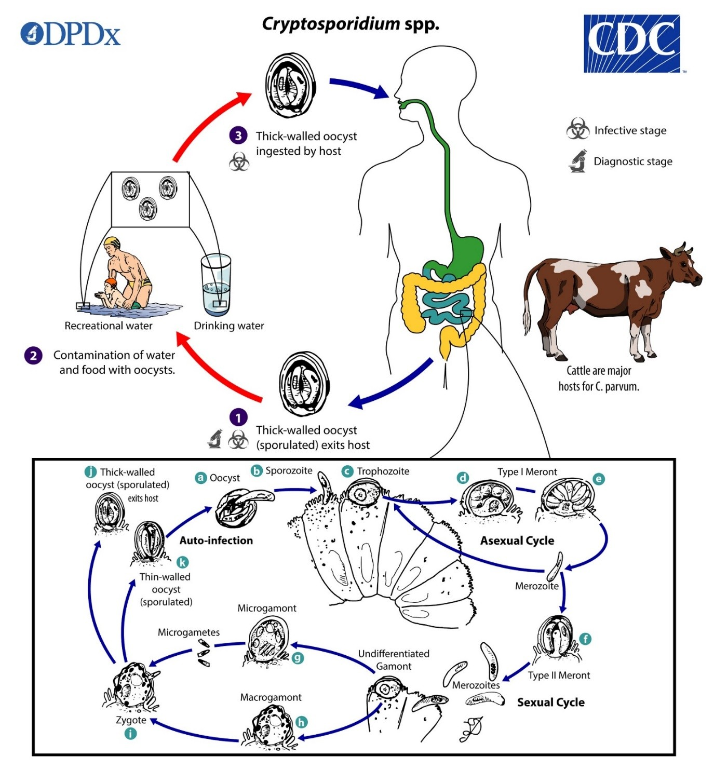**

1. Sporulated oocysts, containing 4 sporozoites, are passed in the stool of infected host

2. Transmission of Cryptosporidium spp. Occurs mostly by ingestion of water and food mixed with infected stool

3. After ingestion by a suitable host  , excystation of oocyst  (a) take place. After that sporozoites are expressed and infest over the epithelial cells ( b , c ) of the elementry tract . In the brush border of epithelial cells, undergo asexual multiplication (schizogony or merogony) of parasites occurs ( d , e , f ) followed by sexual multiplication (gametogony) producing microgamonts  (male g) and macrogamonts (female ,h)  . Fertilization occurs between the macrogamonts & microgametes ( i ) , which result in formation of zygote. Zygotes developed into two types of oocysts (thick-walled and thin-walled). Thick-walled oocysts are released by the host into the environment (j) , while thin-walled oocysts are associated with autoinfection and are not passed in the host stools (k) . Oocysts are infective by fecal-oral transmission ,when freshly passed in stool. The role of Extracellular stages in life cycle is not properly defined.

**Figure-2 : Showing life cycle of Cystoisospora species (source- CDC)**

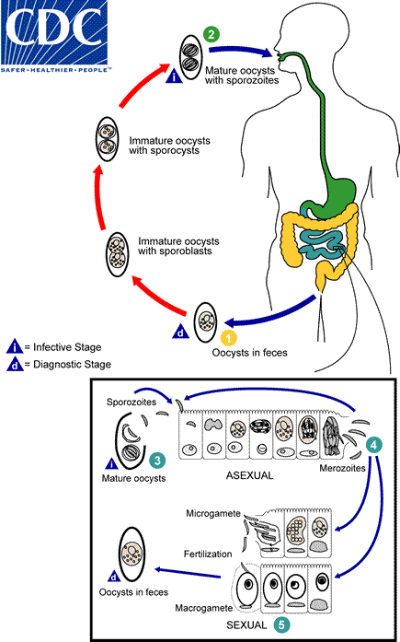

1. Immature oocyst with sporoblast released in the stool. After further maturation sporoblast secretes cyst wall and developed into sporocyst inside the oocyst follwed by further twice division of oocyst, resulting in mature oocyst with sporozoites.

2. ooysts with sporozoites are infective stage for host , after excystation invade the duodenal and jejuna epithelial cell of small intestine and enters into schizogony stage.

3. Merozoites released from the schizonts, followed by merozoites invade the new epithelial cells, and further continue asexual cycle.

4. Some of the merozoite transform into macrogametocyte & microgametocyte.

5. Fertilization of macrogametocyte & microgametocyte resulting in formation of oocysts, which are released in the faeces.

**Figure-3 : Showing life cycle of Cyclospora species (source- CDC)**

**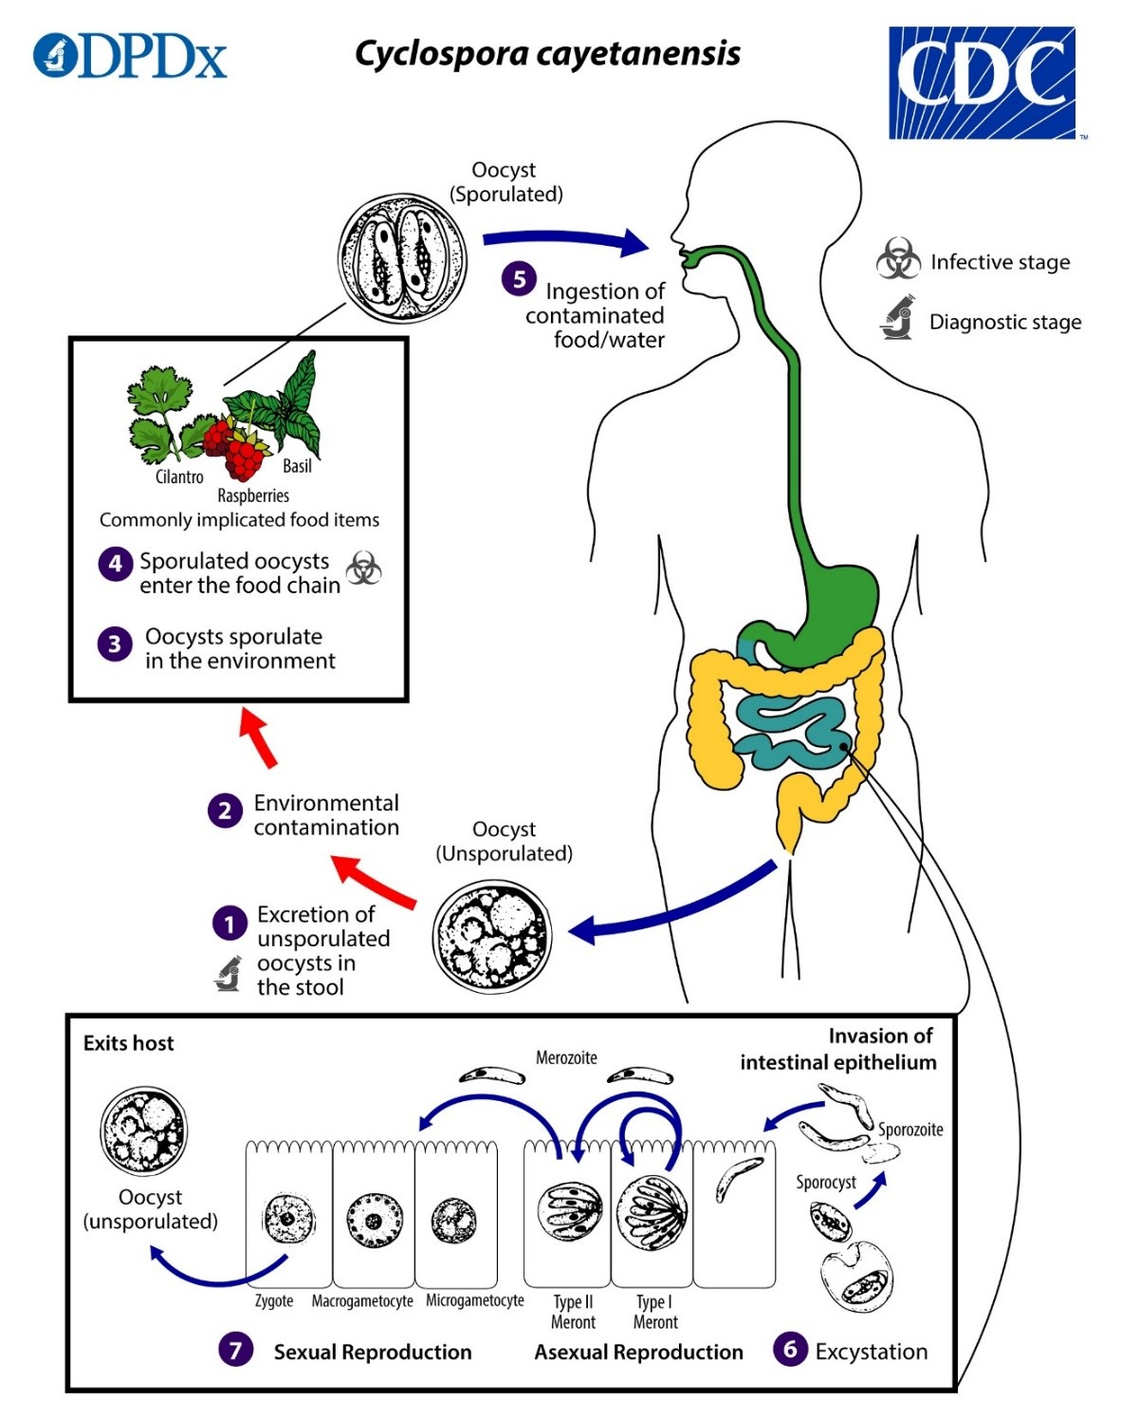**

1. Unsporulated oocysts is present in the freshly passed stool

2&3. Sporulation of occyst occurs in the environment (soil) resulting in development of sporocyst ,which contain sporozoites.

4&5. The sporulated oocysts are enters into food chain and also infective stage for human.

1. In the intestinal tract excystation of sporulated oocyst occurs and releases of sporozoites, which invades s intestinal epithelium .
2. Asexual multiplication occurs inside the epithelial cells, results in formation of type I and type II meronts, which is further developed into merozoites. Merozoites from type I meronts remains in the asexual cycle and merozoites from type II meronts enters in the sexual cycle. On course of sexual development macrogametocytes and microgametocytes are formed followed by fertilization between them result in formation of zygote.

7 . Inside the cells they undergo asexual multiplication into type I and type II meronts. Merozoites from type I meronts remain in the asexual cycle, while merozoites from type II meronts undergo sexual development into macrogametocytes and microgametocytes upon invasion of another host epithelial cell. Fertilization occurs, and the zygote develops to an oocyst which is released from the host cell and passed through the feces.

**Pathogenesis**

The pathogenesis of these parasites involves several key factors that contribute to their ability to cause disease in vulnerable hosts:

1. **Infectivity and Replication**: Opportunistic coccidian parasites have a unique life cycle that involves both asexual and sexual reproduction stages. Upon ingestion of infectious oocysts through contaminated food or water, sporozoites are released and invade the intestinal epithelial cells. These parasites replicate asexually within the host cells, leading to the production of numerous merozoites and ultimately more oocysts. This continuous cycle of invasion and replication contributes to the parasite's ability to establish and maintain infection in the host.
2. **Host-Parasite Interaction**: The interaction between opportunistic coccidian parasites and the host immune system is critical in determining the outcome of infection. In immunocompromised individuals, such as those with HIV/AIDS or undergoing immunosuppressive therapy, the immune response is impaired, leading to inadequate control of parasite replication. This allows the parasites to proliferate unchecked in the intestinal epithelium, leading to severe and chronic infections.
3. **Intestinal Damage and Malabsorption**: Opportunistic coccidian parasites, particularly Cryptosporidium spp., are known to cause significant damage to the intestinal epithelium. Parasite attachment and invasion of enterocytes result in villous blunting, inflammation, and disruption of the mucosal barrier. This can lead to malabsorption of nutrients, electrolyte imbalances, and impaired intestinal function, contributing to symptoms such as diarrhea, weight loss, and dehydration.
4. **Extra-intestinal Manifestations**: In addition to intestinal pathology, opportunistic coccidian parasites can disseminate beyond the gastrointestinal tract in immunocompromised patients. This extra-intestinal spread can involve organs such as the biliary tract, respiratory system, liver, and gallbladder, leading to complications such as cholecystitis, pneumonia, and hepatitis. Disseminated infections are associated with increased morbidity and mortality in susceptible individuals.
5. **Chronic Infection and Immune Evasion**: Opportunistic coccidian parasites have developed strategies to evade host immune responses and establish chronic infections in immunocompromised hosts. Factors such as antigenic variation, intracellular survival mechanisms, and inhibition of immune signaling pathways contribute to the persistence of infection and the difficulty in eradicating the parasites.

Understanding the pathogenesis of opportunistic coccidian parasites is essential for developing effective prevention strategies, diagnostic approaches, and treatment interventions to mitigate the impact of these infections on immunocompromised individuals. Targeting key aspects of parasite infectivity, host-parasite interactions, and disease progression can help improve clinical outcomes and reduce the burden of infection in vulnerable populations.

**CLINICAL SIGNIFICANCE**

**Nausea, vomiting, loose stool, pain abdomen, loss of appetite are common symptoms associated with gastrointestinal pathogens. Clinical infections with symptoms usually found in child of age group** 4–10 years in endemic regions. About 50% of these patients presenting with diarrhea and other gastrointestinal discomforts like anorexia, bloating & malaise. Most of the time symptoms resolve spontaneously, which suggest good immunity associated with rapid clearance of infections. In case of isosporiasis in human, present with more severe symptoms in persons having AIDS or people with suppressed immunity. Most frequent symptoms are malaise ,fever , loss of weight, chronic and persistent loose stool & steatorrhea and even associated with death.

**Diagnosis**

Diagnostic methods for detecting intestinal coccidian parasites in immunocompromised patients play a crucial role in early identification, treatment, and management of infections. Several laboratory techniques are available for diagnosing these parasites. Here are some of the common diagnostic methods used:

1. **Stool Examination**: Microscopic examination of stool samples is a primary and widely used method for detecting coccidian parasites. Routine stool examination by using saline wetmount and Specific staining techniques, such as modified acid-fast stains (e.g., Ziehl-Neelsen stain), can help visualize oocyst of Cryptosporidium spp., Cystoisospora spp and Cyclospora cayetanensis. The presence of oocysts, sporulated oocysts, or other parasite stages in stool samples confirms the infection. (Figure 1a-3a & 1b-3b)
2. **Direct Fluorescent Antibody (DFA) Test**: DFA testing is a sensitive and specific method for detecting Cryptosporidium spp. and other coccidian parasites in stool samples. The procedure involves using specific fluorescent-labeled antibodies that bind to the parasites, allowing visualization under a fluorescent microscope.
3. **Polymerase Chain Reaction (PCR)**: PCR-based assays are highly sensitive molecular techniques used to detect and identify coccidian parasites in clinical samples. Targeting specific genetic markers, PCR can provide rapid and accurate diagnosis, even in low parasite concentrations. It also allows for species identification and differentiation.
4. **Enzyme-Linked Immunosorbent Assay (ELISA)**: ELISA tests can detect parasite-specific antigens in stool samples, providing a rapid and sensitive method for diagnosing infections caused by coccidian parasites like Cryptosporidium. ELISA kits are commercially available and offer high throughput for diagnostic laboratories.
5. **Microscopy of Duodenal Biopsy Samples**: In cases where other diagnostic methods are inconclusive or when assessing extra-intestinal involvement, duodenal biopsy samples may be examined microscopically for the presence of coccidian parasites in intestinal mucosa.
6. **Immunofluorescence Assay (IFA)**: IFA can be used to detect specific antibodies against coccidian parasites in patient serum samples, indicating recent or past infections. Serological testing is not usually used for primary diagnosis but can be helpful in epidemiological studies or surveillance.
7. **Antigen Detection Tests**: Rapid antigen detection tests, such as lateral flow assays, are available for diagnosing Cryptosporidium infections in stool samples. These tests provide quick results without the need for sophisticated laboratory equipment.

|  |  |  |
| --- | --- | --- |
| **C:\Users\DELL\Desktop\Cryptosporidiosis06.jpeg**  1a | **C:\Users\DELL\Desktop\...jpg**  2a | **C:\Users\DELL\Desktop\IMG_20240202_165939.jpg**  3a |
| **C:\Users\DELL\Desktop\IMG_20240117_205049.jpg**  1b | **C:\Users\DELL\Desktop\Cyclospora1.jpg**  2b | **C:\Users\DELL\Desktop\IMG_20240103_193658.jpg**  3b |
| **C:\Users\DELL\Desktop\cryptosporidium images.jpg**  1c | **C:\Users\DELL\Desktop\microorganisms-09-01863-g002.png**  2c | **C:\Users\DELL\Desktop\C_belli_oocyst.jpg**  3c |

**Figure 1a to 1c:** Cryptosporidium species

(1a). Round oocyst (4-6µm) in saline wet mount

(1b). ModifiedZiehl-Neelsen stain shows red color round oocyst against blue background.

(1c). Direct fluorescent antibody staining shows brilliant green fluroscent oocysts

**Figure 2a to 2c:** Cyclospora species

(2a). Round unsporulated oocyst (08-10µm) in saline wet mount)

(2b). ModifiedZiehl-Neelsen stain shows red color round oocyst against blue background.

(2c). UV fluorescence microscopy shows oocyst wall is autofluorescent

**Figure 3a to 3c:** Cystoisospora species

(3a). Oval sporulated oocyst (25-35µm) in saline wet mount

(3b). ModifiedZiehl-Neelsen stain shows red color oval unsporulated oocyst

(3c). UV fluorescence microscopy shows fluorescent oocyst

**Treatment**

The treatment of coccidian parasites, such as Cryptosporidium spp., Cyclospora cayetanensis, and Isospora (Cystoisospora) spp., typically involves the use of specific medications aimed at controlling the infection. It is important to note that treatment options may vary depending on the specific parasite involved, the severity of the infection, and the immune status of the patient. Here are some commonly used medications for treating coccidian parasitic infections:

1. **Nitazoxanide**: Nitazoxanide is the first-line treatment for Cryptosporidium infection in both immunocompetent and immunocompromised individuals. It can also be effective against Cyclospora and Isospora infections. Nitazoxanide disrupts parasite metabolism and replication, helping to alleviate symptoms and clear the infection. It is available in both pediatric and adult formulations.
2. **Trimethoprim-sulfamethoxazole (TMP-SMX)**: TMP-SMX is another medication commonly used to treat coccidian parasitic infections. It has shown efficacy against Isospora infections in particular. TMP-SMX works by inhibiting the parasite's folic acid synthesis, preventing replication and controlling the infection. However, its use in immunocompromised patients with severe infections may be limited due to the risk of adverse effects and the potential for developing drug resistance.
3. **Spiramycin**: Spiramycin is an antibiotic used to treat certain parasitic infections, including Cryptosporidium infections in immunocompetent individuals. While it may not be as effective in immunocompromised patients, it can be considered as a treatment option in selected cases.
4. **Supportive Care**: In addition to specific antiparasitic medications, supportive care is important to manage symptoms and prevent complications associated with coccidian parasitic infections. This may include oral rehydration solutions, electrolyte replacement, nutritional support, and management of associated gastrointestinal symptoms.

It is crucial to consult with a healthcare professional or infectious disease specialist for accurate diagnosis and appropriate management of coccidian parasitic infections. The specific treatment regimen will depend on factors like the parasite species, the severity of the infection, the immune status of the patient, and any associated medical conditions.

**Comprehensive approach to preventing Coccidian Parasite Infections:**

There are various approach to prevent infection from Coccidian parasites which includes personal hygiene practices, regular hand washing, Ensuring safe drinking water for communities by implementing proper filtration and disinfection, Practicing good food hygiene, including proper cooking and washing of fruits and vegetables before use. Livestock and pets must be kept in good sanitation conditions, deworming at regular interval and proper veterinary care to reduce the spread of coccidian parasites within animal populations and to humans. These practices play a vital role in reducing the risk of coccidian parasite infections.