CHAPTER 4
Lean Manufacturing Techniques in Packaging Solution
Ms.Viny Dave^{*1}, Mr. Sandeep Mukati², Dr. Shikha Jaiswal³, Dr.Sudha Vengurlekar⁴
- Department of Pharmacy, Oriental University, Indore(M.P.).
- Department of Pharmacy, Oriental University,Indore(M.P.).
- Department of Pharmacy, Oriental University,Indore(M.P.).
- Department of Pharmacy, Oriental University,Indore(M.P.)
CONTENT
- Introduction
- Waste Elimination
- Lean Six Sigma
- Lean Technology in Pharmaceutical Industry
- Relationship between Lean practices and Innovation Skills

- Introduction
Lean manufacturing is an organized method for finding waste (non-value-added operations) and getting rid of them through constant improvement that aims for excellence by moving the product at the customer's request. Eight wastes were discovered by Lean in the manufacturing process: excess inventory, overproduction, waiting, transportation, overprocessing or wrong processing, defects, and underutilized employee innovation.
The system concentrated on locating major sources of waste and removing the waste with the help of techniques like production smoothing, JIT, and others. To eliminate waste and achieve better productivity, smoother flow, shorter cycle times, and many other benefits, lean manufacturing uses a variety of tools such as value stream mapping (VSM), 5S, visual management, kanban, Kaizen, line balancing, just in time (JIT), single minute exchange of dies (SMED), standardized work, etc. One of the most important industries in every nation is packaging.
In food packaging, vertical form fill seal machines are important. Every industry aspires to enhance and standardize its product by eliminating any procedures that do not contribute value. Lean manufacturing methods are a useful tool for streamlining the process of creating new products and improving existing ones. (Mahesh Babu Purushothaman et al.Waste reduction using lean tools in a multicultural environment J. Clean. Product. (2020))
- Waste elimination
Any process in an organization that is not adding value is considered as waste and the goal of Lean is to eliminate wastes (Nicholas, 2010). The adding value or non-adding value processes must be identified through a customer perspective. Ohno’ seven wastes is a simple concept that will be used for identifying the wastes that Lean tries to eliminate in order to improve the chain of values. This seven wastes approach can be applied to many services even though these wastes categories were originally for
manufacturing (Bicheno & Holweg, 2009).
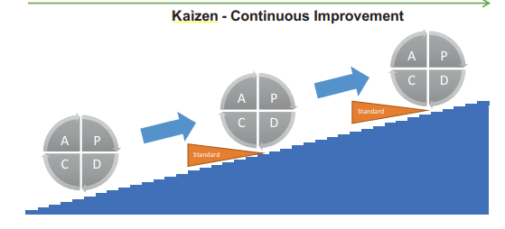

Figure 1 - Kaizen cycle (PDCA) (adapted with permission from Helmold, 2020, p.27).
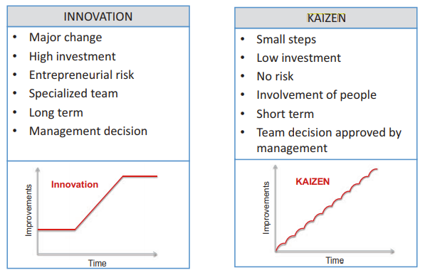

Figure 2 - Innovation vs Kaizen (adapted with permission from Helmold, 2020, p.27).
2.1.The waste of overproduction
While the ideal situation should be to make exactly what is required in terms of quantities, on time and with high quality, overproduction is making too much and too early. A process should not encourage output that is not needed. As a consequence, it leads to excessive lead time and it may also lead to situations where defects are not detected and products are deteriorated 6 (Bicheno & Holweg, 2009). So whatever the reason, making a quantity of products that exceeds the demand is wasteful. Waste from overproduction is also difficult to identified unless the quantity of products sold is compared to the quantity shipped (Nicholas, 2010).
2.2. The waste of waiting
This waste is related to flow and it takes many forms like waiting for materials or orders from preceding processes. It may also occur in automated processes when an operator who turns on a machine after having loaded it, remains in front of the machine and waits for the end of the process (Nicholas, 2010). Waiting is a waste that must be avoided as it results into reduced productivity and efficiency. Indeed, it causes longer lead times and it may also decrease engagement and motivation of employees (Helmold, 2020).
2.3. The waste of unnecessary motions
Unnecessary motions is the excessive movement of material or machines within the work area. It leads to higher cost due to the decrease of productivity. This is due to the fact that unnecessary motions require more time or capacity in operations than actually required in a process where unnecessary movements are eliminated (Helmold, 2020).
2.4. The waste of transporting
Any movement of materials can be considered as a waste because the customer does not pay for having goods moved around. In addition to that, the likelihood of damage increases with the number of operations of material handling and transport (Bicheno & Holweg, 2009). However, this waste cannot be fully eliminated. The supply of goods on a market requires a minimum of transport from the manufacturing to the delivery to the final customer.
2.5. The waste of overprocessing
Overprocessing refers to actions and procedures that exceed what the client requires or anticipates. In other words, adding more value than the customer requires is a waste of overprocessing. Simplification of the activities reduce these wastes (Helmold, 2020). The origin of this waste seems less intuitive. Indeed, why does a company put energy on processes which the customer does not pay for? Some possible reasons could be inappropriate 7 or not capable processes that require additional work in order to meet the expectations of the customer.
2.6. The waste of unnecessary inventory
Inventory can be classified in three types: raw material, work in process (WIP) or semi-finished goods and end items. Their causes of existence and priorities for decrease are quite different. Inventory in raw material may be necessary due to constraints at supplier level while the inventory in end items helps to adapt to market in case of customer demand increase. But in general excessive inventory is a waste as it represents a risk of obsolescence (Bicheno & Holweg, 2009), items are waiting for something to happen which represents a situation where costs are generated and time is lost since no value is being added to them (Nicholas, 2010). In Lean, the reduction of inventory is not an end in itself but it must be considered as an opportunity for exposing wasteful practices as shown in the analogy of a ship on water where
inventory is compared to water depth and where problems like poor scheduling, quality issues, machine breakdown or long changeover are huge boulders into the sea (Nicholas, 2010).
2.7. The waste of defects
Defects impact the quality of products which deviate from the standards of their design or from the customer’s expectation. Defective products must be replaced and require additional work to process it. In some circumstances, it may cause as well loss of customers (Helmold, 2020). Product defects are ideally detected and handled before products are released on the market. However this activity represents also a waste because correcting defects increases production lead times which can lead to other delays in the process (Nicholas, 2010). The results of waste reduction can be measured by efficiency indicators and among the most used metrics are lead time, on-time delivery, Overall Equipment Effectiveness, WIP and many others (Chiarini, 2012). The presentation of the seven wastes ends this introduction about what is Lean. The choice of the TPS house as core concept allows to approach the ultimate aim of Lean through a global view. It describes also Lean as a complex system in which every single element contributes to the whole. Before to discuss the spreading of Lean in Six Sigma philosophy and in the Supply Chain discipline, it is important to present two configurations in which Lean can be deployed: the mechanistic and the organic systems.
- Lean Six Sigma
3.1. What is Six Sigma?
The Six Sigma philosophy is based on an organized approach to problem-solving with the goal of removing waste, errors, and unpredictability from a process. Define, Measure, Analyze, Improve, Control (DMAIC) is the name of this framework, where
(i) Define is for the definition of the problem that needs to be addressed;
(ii) Measure is for the measurement of the problem and the process from which it was
produced;
(iii) Analyze is for the analysis of the process to identify the root causes of defects and
the opportunities for improvement;
(iv) Improve is for the improvement of the process;
(v) Control is for the implementation and the control of the improvements.

Most of the Six Sigma decision-making instruments are derived from statistics (Muralidharan, 2015). In truth, the Six Sigma methodology is grounded in data and facts. "Sigma level" around the target is used to validate all project results. This sigma level can be related to the cost of poor quality (CPQ) and the quantity of defects in a process (Chiarini, 2012).
3.2. From Lean to LSS
Similarities can be seen between DMAIC and the Kaizen cycle (PDCA) from Lean. Both problem-solving approaches are made of steps coming one after another with the goal of achieving an improvement of the process. Though DMAIC is implemented and occurs within the framework of a clearly defined project, Kaizen is more dynamic than DMAIC since it is a continual improvement philosophy. 10 Combining Lean and Six Sigma changes the DMAIC approach by adding an emphasis on speed, while Lean concentrates on simplifying a process by identifying and eliminating wastes. Variability in the process frequently leads to wastes like scrap and rework. So there is an opportunity for connecting Six Sigma and Lean to form LSS whose the goal is to supply quality products that meet customer requirements as effectively and efficiently as possible (Muralidharan, 2015). But isn’t what Lean seeks to achieve already? Certainly but the use of statistical tools for data analysis and process control brings more accuracy. Six Sigma can also be considered as a prerequisite for Lean that needs process stability to work which is exactly what Six Sigma aims for (Friedli, Mänder & Bellm, 2013).

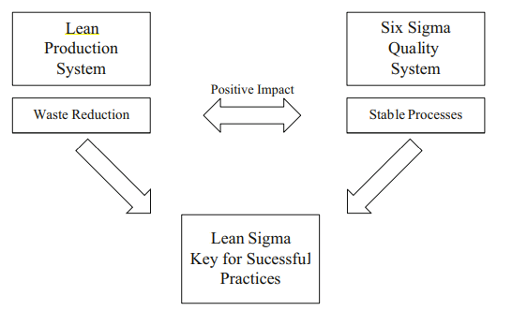

Figure 3: illustrates the interaction between Lean and
Six Sigma.

- Lean Technology in Pharmaceutical Industry
The Pharmaceutical Industry is very complex as it involves challenges to coordination among
multiple actors. According to Shah (2004), there are five categories of players in the Pharmaceutical Industry, including:
- Businesses having many manufacturing facilities and Research and Development (R&D) departments;
- Generic manufacturers, who create off-patent goods and over-the-counter counter products;
- Local manufacturing businesses that produce branded and generic goods under license or contract while working within their own nation;
- Contract manufacturing companies (CMOs) that offer outsourcing services for the creation of finished goods or active ingredients (AI);16
- A biotechnology startup with no substantial capacity for production;
4.1 Approach
The departments of Production Logistics and Health Care Logistics of Fraunhofer IML operate under the principle of "intelligent optimization of manufacturing." To optimize intelligently, a production must be taken into account while keeping in mind each employee's unique skills and goals. A comprehensive perspective is often absent from pharmaceutical sector reorganization strategies due to their narrow focus. Only by thoroughly examining the entire system of personnel, technology, and processes and by tailoring the system to each customer's unique requirements can cost-, time-, and service-benefits be realized.
The Fraunhofer IML works in a process- and system-oriented manner, carefully examining work flows while keeping the real market demands in mind at all times. The Fraunhofer ideology states that we operate as impartial, unbiased consultants. Project teams with individual staff members create environmentally friendly manufacturing methods that are supported by your company's workforce.
4.2. Benefits
• Pharma-specific production concepts that are exactly customized to meet your needs
• Comprehensive interplay among all the resources in your business
• Productive, adaptable, and customer-focused manufacturing
• Increased ability to compete on a worldwide scale
4.3. Analysis of the potential for Lean Pharma
• Analyzing your current state (process mapping and data collection);
• Formulating a fundamental idea;
• Evaluating the anticipated advantages Concept of holistic reorganisation
• Setting up a production system employing a lean material flow approach through detailed planning
4.4. Lean Manufacturing principles
Assistance with implementation Simulation, performance validation, robustness checking with stochastic simulation, and future development analysis
4.6. Our area of consulting
We provide you with direction and expert advice when choosing and implementing Lean Manufacturing techniques. As a result, we facilitate sustained business success by integrating several techniques into an all-encompassing manufacturing system.
4.7. Production of Active Pharmaceutical Ingredients (API)
Production of APIs is frequently the initial stage in the manufacturing process when value is created for pharmaceutical manufacturing businesses. As a result, when market conditions change, this link in the value chain is the first to be impacted. Reducing cycle durations and batch sizes is crucial to increasing flexibility and overcoming these challenges. Rather, many API manufacturers attempt to increase their stock levels in order to offset volatile market needs. Following the principles of Lean Manufacturing, organizations can achieve the necessary flexibility with much less inventory by reorganizing the common multi-purpose factories into dedicated and partially dedicated facility networks.
4.8. Drug production
Differentiating dose formulations for different markets leads to an increase in production complexity. Smaller batch sizes result from the need for current technology to accommodate an increasing number of dosage form changes. Once more, this results in a rise in laborious switchovers. At the end, this leads to batch-and-queue production due to uneven capacity of individual machines and unpredictable work flow routing. A set routing system and specially designed lean techniques can assist solve this issue and increase production efficiency.
4.9. Packaging
High volume packing machines were the norm during the blockbuster production era, but those days are long gone. Customized packaging for every nation results in low volume/high mix production, which is driven by the growing need for tiny lot sizes. In addition to switching from high performance packing machines to flexible machines, production concepts need to be reorganized. Reducing changeover times, standardizing work flows, and raising machine availabilities are all benefits of lean manufacturing techniques. Ultimately, even for very tiny lot-sizes, this is necessary to achieve operational excellence in packaging.
Lean Management in the pharmaceutical industry According to IMS (Intercontinental Marketing Services) the global pharmaceutical industry will be worth US$1.160 billion in 2016 .(IMS Health Market Prognosis, June 2013,http://www.imshealth.com/deployedfiles/imshealth/ Global/Content/Corporate/Press%20Room/Total_World_Pharma_Market_Topline_metrics_2012- 17_regions.pdf)
A number of researchers and organizations have identified the following key developments and issues in the industry:
• Shifts in the growth of pharmerging countries (Figure 1 and 2)
• The expiration of patents of products which were launched during the industry's 'golden era' in the 1990s and the progressive introduction of less expensive generic alternatives
• A common strategy of industrial concentration which has been adopted in order to deal with the growing costs of R&D.

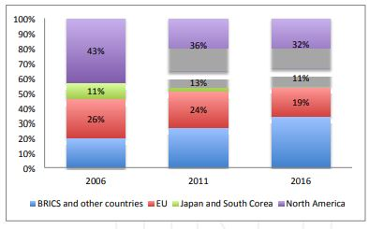
Figure 5: Global pharmaceutical market (% of total size)

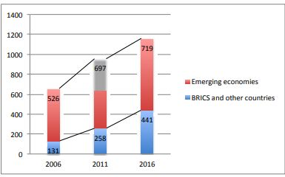
Figure 6: Global pharmaceutical market growth (billions of dollars and average annual growth rate)

4.10. Application of Lean Management

4.10.1. Value = f (Quality, Service, Cost)
4.10.2. Customers
Big C: patients/ doctors/ pharmacists/ health care providers/ regulators
Small c: Internal customers
4.10.3. Quality
Patient safety
Fit for purpose
4.10.4. Quality by Design
Critical to Quality Parameters; Variability in Process Outputs; Range and Interaction of Factors; Robustness and Optimization of Process Design Risk-based management, process performance, capability, and control, parameter design λ Source quality as opposed to repeated checking disparities surrounding a desired value versus adherence to guidelines
4.10.5. Process Understanding Capability & Control
- Robust process design & development
- Robust technology/ process transfer
- DMAIC
- PF/CE/CNX/SOP
- Design of Experiments
- Control Charting: Address causes of OOC symptoms before they become OOS
- Understand sources of variation: Process vs measurement system
- Measurement System Analysis : prospective vs retrospective
- Error proofing
- Standard work
4.10.6. Waste & Variation
- SOP vs standard work
- VA vs NVA activities
- 7 Wastes
- Process RFT
- Testing RFT
- Documentation RFT
- Line/ equipment OEE
4.10.7. Flow
- FIFO vs Laboratory scheduling
- Visual control vs Spreadsheets
- Relationship between Lean practices and Innovation Skills
The majority of studies highlight the fact that services firms are less developed than manufacturing, particularly in the case of pharmaceutical production, in terms of operations and innovations. Numerous pharmaceutical companies are dealing with issues related to development and improvement, including rising expenses, recurrent medical blunders, and heightened efforts to boost the effectiveness and caliber of pharmaceutical products. Therefore, it is asserted that using lean concepts is crucial for resolving such issues and creating an environment conducive to innovation (Angelis & Fernandes, 2012; Hoerl & Gardner, 2010).
According to the literature currently in publication, there was a notable increase in the practice of lean production between 2002 and 2008, with the majority of applications taking place in the public healthcare systems of the United States and the United Kingdom (Box & Woodall, 2012). This illustrates how lean manufacturing is emerging as a fruitful strategy for enhancing pharmaceutical products. Nat Natarajan (2006) examined the possibilities and obstacles in the healthcare industry for assimilating and applying best practices from other industries to advance employee skill development and foster innovation.
One major problem is that healthcare organizations' performance measurement and improvement programs don't accurately pinpoint the issues because outside companies' efforts and those of "the Joint Commission on Accreditation of Healthcare Organizations" (JCAHO) may be hampered by worries about "legal vulnerabilities or punitive actions." "The application of lean and human factors engineering (HFE) initiatives can improve quality and patient safety within diverse healthcare delivery problems," as Rousek (2012) demonstrates. Lean attempts to reduce waste in order to make the workplace more productive, whereas HFE concentrates on human potential and constraints in order to improve performance. Through the review of five case studies, the research achieved its goals. Each examined and enhanced procedures that have a detrimental impact on the caliber of healthcare delivery.
The perspectives on process implications and development approaches in a complex business of a UK National Health Service Trust were investigated by Al-Balushi et al. (2014). This comprehensive qualitative study promotes "lean thinking" in process improvements to improve the effectiveness and competency of healthcare facility distribution. In the end, the research shows that lean fosters innovation while utilizing fewer resources to raise capacities and maintain gains. In particular, McGrath (2007) studied in-depth understandings of human behavior connected with lean by applying a case study involving two Irish medical device businesses.
The study's conclusions highlight how lean manufacturing has a significant impact on innovation and is regarded as a strategic tool to support a company's competitive advantage. One of the primary advantages of lean manufacturing is its ongoing development, which yields sustained value and future business development. From the foregoing discussion, it is clear that any lean organization needs a highly inventive human capital that is comprehensive, continuous, intellectual, and self-reinforcing. Dibia and Onuh (2010) assert that human resources are seen as the face of lean, the hands of continuous progress, and the eyes of true greatness.

