Chapter 9

Exploring Advanced Drug Delivery Systems: Concepts, Approaches, Advantages, and Applications of Liposomes, Niosomes, Nanoparticles, and Monoclonal Antibodies

Deepak Prashar ^{1,*}, Bharti Sharma ², Sahil Kumar ³, Namrata ⁴, Lalit Sharma ¹, Nisha Rani ²

¹ Department of Pharmaceutical Sciences, Shanti Niketan College of Pharmacy, Ratti Mandi HP
² KC Institute of Pharmaceutical Sciences, Pandoga Una HP
³ Department of Pharmacy, Aakash Institute of Medical Sciences, Nalagarh HP
⁴ Department of Pharmacy, Rayat Bahra Institute of Pharmacy, Hoshiarpur, Punjab

*Corresponding Author:
Dr. Deepak Prashar
Professor, Department of Pharmaceutical Sciences, Shanti Niketan College of Pharmacy, Ratti Mandi HP

ABSTRACT

Advanced drug delivery systems have revolutionized the field of pharmaceuticals, offering innovative strategies to increase the effectiveness, the safety and viability of medicinal substances. This thorough book chapter dives into the principles, methodologies, benefits, and diverse applications of four key drug delivery platforms: liposomes, niosomes, nanoparticles, and monoclonal antibodies. Liposomes, lipid-based vesicles, exhibit exceptional versatility in encapsulating a wide range of drug molecules, thereby improving their bioavailability and targeted delivery. Niosomes, a novel alternative, offer advantages like improved stability and reduced toxicity while maintaining efficient drug encapsulation. Nanoparticles, with their precise size control and surface modifications, provide remarkable potential for targeted drug delivery and sustained release. Monoclonal antibodies, engineered to specifically target disease markers, bring a new dimension to personalized medicine and immunotherapy. This book chapter will explore the underlying principles, various approaches, and advantages of each system, shedding light on their unique abilities to overcome the challenges of drug delivery. Furthermore, it will cover a wide range of applications for these systems, including as cancer therapies, infectious illnesses, and neurodegenerative disorders. By combining the most recent breakthroughs in these delivery methods, the goal of this book chapter is to raise awareness of their potential to impact the future direction of personalized medicine and medication research.
Top of Form

KEYWORDS:

Background and Rationale Study:
Recent years have seen a notable transformation in the drug delivery industry, with an increasing focus on cutting-edge methods intended to enhance the effectiveness, safety, and precision of medicinal medicines. The difficulties with conventional medication administration, including low bioavailability, non-specific targeting, and unfavourable side effects, have prompted the search for efficient drug delivery systems. Researchers have investigated and created a wide variety of cutting-edge drug delivery technologies, including as liposomes, niosomes, nanoparticles, and monoclonal antibodies, to address these problems.

Liposomes:
Liposomes, which are phospholipid-based vesicles, have emerged as versatile drug carriers. Their capacity to include molecules that are both hydrophilic and hydrophobic in nature has made them invaluable in improving drug solubility and stability. Liposomes offer controlled release capabilities and the potential for targeted delivery to specific tissues, thus reducing systemic toxicity.

Niosomes:
As an alternative to liposomes, non-ionic surfactant vesicles are known as niosomes. These structures offer better flexibility and stability when it comes to adding different medications. The potential of niosomes to overcome the drawbacks of liposomes, including their low drug loading capacity and oxidation susceptibility, has drawn attention.

Nanoparticles:
Drug delivery has shown considerable promise for nanoparticles, particularly lipid and polymeric nanoparticles. Precise drug targeting is made possible by their adjustable characteristics, including size, surface charge, and surface changes. Numerous medicinal substances can be encapsulated in nanoparticles, which also improve the pharmacokinetics and biodistribution of those substances.

Monoclonal Antibodies:
Monoclonal antibodies represent a different dimension of drug delivery, particularly in the context of precision medicine. Engineered to recognize specific antigens, monoclonal antibodies allow for targeted therapy with minimal off-target effects. They have revolutionized cancer treatment and hold immense potential in addressing various diseases with well-defined markers.

The rationale for this study lies in the need to comprehensively explore these advanced drug delivery systems. Each system offers unique advantages and capabilities, and their selection based on the specific specifications of a medicinal product and the targeted disease. Understanding the underlying concepts, approaches, and advantages of these systems is crucial for optimizing drug delivery and improving patient outcomes. Furthermore, these advanced systems have found applications across a wide spectrum of medical conditions, from cancer to infectious diseases to neurodegenerative disorders. Investigating their applications in different clinical contexts is essential for harnessing their full potential and advancing the field of pharmaceutical science.

In summary, this study aims to provide a thorough overview of liposomes, niosomes, nanoparticles, and monoclonal antibodies as advanced drug delivery systems, shedding light on their principles, approaches, and advantages. Through this exploration, we seek to facilitate the creation of more focused and efficient medication delivery methods that will ultimately help patients and advance medical research.

RECENT ADVANCEMENTS IN THE FIELDS OF FOLLOWING:
Recent advancements in the fields of liposomes, niosomes, nanoparticles, and monoclonal antibodies in drug delivery systems:

Recent Advancements in Liposomes:
RNA and Gene Delivery: Liposomes have evolved for the delivery of RNA-based therapeutics, including mRNA vaccines. Recent advancements involve using liposomes to encapsulate and deliver RNA molecules effectively, opening up new possibilities in gene therapy and vaccination.
Hybrid Lipid Nanoparticles: Increasing stability and controlling drug release have been demonstrated by combining lipids with polymers or inorganic nanoparticles to form hybrid liposomes.
Targeted Liposomes: Specialised liposomes have been created that have ligands that can bind to particular disease signs. With less off-target effects, these tailored liposomes improve medication delivery precision.

Recent Advancements in Niosomes:
Improved Stability: Niosome formulation advances have focused on increasing their stability, making them more durable carriers for a range of medicines, particularly those sensitive to environmental conditions.
Enhanced Drug Loading: Innovative approaches have been devised by researchers to boost the drug-loading capacity of niosomes, making them more efficient carriers for a wide spectrum of medicinal medicines.
Transdermal Drug Delivery: Niosomes have gained attention in transdermal drug delivery, providing a non-invasive route for drug administration. Recent advancements have improved their skin penetration capabilities.

Recent Advancements in Nanoparticles:
Personalized Medicine: Nanoparticles are increasingly being customized to cater to individual patient needs, enabling personalized medicine. This involves tailoring nanoparticle properties for specific drug delivery requirements.
Biodegradable Nanoparticles: Because of their ecologically friendly nature and controlled medication release capabilities, biodegradable nanoparticles, such as those manufactured from polymers such as PLGA (polylactic-co-glycolic acid), are gaining favor.
Theranostic Nanoparticles: Theranostic nanoparticles, which combine therapeutic and diagnostic functions, are a recent trend. They allow for simultaneous treatment and monitoring of disease, offering potential for early intervention.

Recent Advancements in Monoclonal Antibodies:
Bispecific and Trispecific Antibodies: Recent advancements in monoclonal antibodies include the development of bispecific and trispecific antibodies. These molecules can simultaneously target multiple disease markers, increasing the specificity and efficacy of treatment.
Immunoconjugates: Monoclonal antibodies are being conjugated with cytotoxic agents or radionuclides to create immunoconjugates. These are utilized in targeted cancer therapies, enhancing the precision of treatment.
Nanobody Technology: Nanobodies, or smaller antibody fragments, have gained popularity. They have advantages in terms of tissue penetration and clearance speed, making them suitable for a variety of applications, including intracellular drug delivery.
Recent breakthroughs in liposomes, niosomes, nanoparticles, and monoclonal antibodies demonstrate the dynamic and innovative nature of drug delivery research. They have the potential to have a significant impact on the efficacy and safety of drug therapies for a wide range of medical conditions.

KEY QUESTIONS
- What are the fundamental concepts underlying advanced drug delivery systems, and how do liposomes, niosomes, nanoparticles, and monoclonal antibodies fit into this framework?
- What are the key approaches and techniques used in the formulation and engineering of drug-delivery liposomes, niosomes, nanoparticles, and monoclonal antibodies?
- What are the distinct benefits of each of these advanced drug delivery systems over traditional drug administration methods?How can these advanced systems enhance the bioavailability of drugs, and what impact does this have on treatment outcomes?
- What are the challenges associated with the scale-up and commercial production of liposomes, niosomes, nanoparticles, and monoclonal antibodies for widespread clinical use?
- How do these systems address the need for targeted drug delivery while reducing off-target side effects, and what are the implications for patient safety and comfort?
- What are the recent advancements and breakthroughs in the development of liposomes, niosomes, nanoparticles, and monoclonal antibodies for drug delivery?
- How are advanced drug delivery systems used to treat specific medical conditions like cancer, infectious diseases, and neurological disorders?
- What role will personalized medicine play in the future of these advanced drug delivery systems, and how can they be tailored to individual patient requirements?
- What are the ethical and regulatory implications of these advanced drug delivery systems, and how can they be navigated to ensure patient safety and compliance with medical standards?
- How do these systems interact with emerging technologies like artificial intelligence and nanotechnology to create smarter, more adaptive drug delivery solutions?
- What cooperative efforts are being made to progress the field of improved drug delivery systems by researchers, pharmaceutical corporations, and healthcare organizations?
- These key questions serve as a framework for a thorough examination of the concepts, approaches, benefits, and applications of advanced drug delivery systems, providing valuable insights into the rapidly changing landscape of pharmaceutical science and healthcare?

INTRODUCTION
The method of delivering an active pharmaceutical ingredient (API) to optimise therapeutic effects while reducing side effects and enhancing convenience is known as drug distribution (DD) [1]. A formulation or apparatus intended to precisely direct the administration of an API or regulate its release at certain periods is referred to as a drug delivery system (DDS) (immediate, delayed, or sustained). It's crucial to remember that the DDS only improves the safety and effectiveness of the conveyed API; it has no therapeutic action of its own[2].
For medical purposes, each API has a therapeutic window (TW) that specifies the range of acceptable and productive bloodstream concentrations. There is an upper limit to avoid obvious adverse effects and a lower limit for therapeutic benefit in this range. The blood's total content of API is made up of both free molecules and bound API that is joined to lipoproteins and albumin, two types of carrier proteins [3, 4], or, in the case of nanomedicine, contained inside delivery vehicles [5, 6]. In this context, nanomedicine refers to API carriers that are nanoscale, such as micelles, liposomes, or polymer-drug conjugates.
The pharmacological activities of the free API or, occasionally, its active metabolites determine a drug's efficacy and safety [7]. One strategy, which is frequently employed in hospitals, is continuous medication infusion to maintain the API concentration inside the therapeutic window by altering infusion rates for APIs with a limited therapeutic window. Patients who are mobile are suited for portable infusion pumps.
The goal of the first generation of drug delivery technology (DDT) was to control or alter the release rates from a DDS over an extended period of time in order to accomplish the therapeutic window of a particular API [8, 9]. Based on comparatively straightforward concepts, this idea led to numerous successes in implantable DDS and oral medicine, improving convenience and lowering toxicity [10, 11]. As demonstrated by the transdermal drug delivery system in the past, DDT also investigated novel delivery methods to improve patient compliance or more effectively treat particular medical diseases [12, 13]. For both regional and systemic effects, it expanded to include pulmonary, ocular, vaginal, nasal, and rectal delivery methods in addition to oral and enteral administration routes and transdermal DDS [14–18]. With the exception of oral administration, these approaches try to avoid the first stage of hepatic metabolism.When systemic distribution is not a practical option, "site-directed applications" as defined by the DDS definition might use both internal and external local medication delivery, concentrating an API at specific sites with less transport hurdles, so benefiting patients. For instance, ocular administration can be used to treat eye disorders locally [19]. Changing the therapeutic window has been the focus of a recent nanomedicine concept. By altering the biodistribution patterns of the API and encouraging the accumulation of the API at its target sites, this entails lowering the lower limit of the therapeutic window for a particular API and indication. Theoretically, the carrier enters deep tissues through blood channel openings at tumour or inflammatory locations, stays there for a long time because of inadequate lymphatic drainage [20]. The API is more locally bioavailable to target cells or is absorbed by the cells when the nanomedicine delivers the API gradually. The increased permeability and retention (EPR) impact and drug affinity targeting strategies are the two main concepts introduced in this notion [21]. It was therefore thought that the total plasma concentration may be kept at a lower level in order to obtain the same free drug concentration at the target site. Targeting and the EPR effect are now essential components of polymer therapy and nanomedicine [22, 23], and have lately been covered in numerous sources' book chapters and discussions [24]. Reducing toxicity and raising the upper limit is another strategy for changing the biodistribution characteristics of the API. This is accomplished by drastically lowering the nanomedicine's distribution volume thanks to the size effect of the carriers. Even at high total concentrations, drugs with slower release remain low in the bloodstream in terms of free drug concentration. An further aspect of drug delivery technology is the use of innovative techniques to improve the solubility of medications that are poorly soluble in water [25,26]. Unfortunately, a considerable amount of nanomedicine has the tendency to collect in the spleen and liver [27, 28].
New Delivery Routes/Pathways: Drug delivery technology (DDT) innovation entails investigating new channels and routes that can get over major physiological and biological barriers, improving drug distribution and absorption to the intended illness sites. It's imperative that these methods work well in therapeutic settings, which makes this a promising field for further DDT advances.
Liposomes constitute a very promising method of drug administration with the potential to greatly increase the efficacy of medications. These drug delivery systems (DDSs) decrease undesirable side effects, lengthen the duration of medication presence in certain target cells, and raise drug concentration [29]. They accomplish this by using nano-sized vehicles to carry the active medication to the targeted site of action, thereby enhancing the pharmacological properties of free medicines and reducing their disadvantages, including problems with drug pharmacokinetics and biodistribution. These automobiles also act as drug reservoirs [30, 31].
Depending on their intended use, these nanoscale vehicles—often referred to as nanoparticles (NPs)—can range in size from a few nanometers to several hundred nanometers [32]. They are made of a range of materials, such as metals, polymers, and ceramics. and lipids [32]. In this situation, liposomes, micelles, and other NP forms are frequently used [33, 34, 35]. Usually, entrapment, surface attachment, or encapsulation is the physical interactions that allow therapeutic medicines to be integrated into these nanoparticles [36]. The distinct qualities of various nanoparticles can be used to improve the features of conventional treatments [36]. By enabling the administration of diverse biological agents for the treatment, prevention, and diagnostics of a wide range of diseases, this field of nanomedicine presents the chance to build novel therapeutic choices at the nanoscale [29, 37]. Many nanoparticle-based drug delivery systems have difficulties with loading capacity and the requirement for more accurate targeting of specific locations, despite significant advancements in this field [38]. To fully realise the potential of these drug delivery systems, highly customised high-capacity nanocarriers with recognition ligands targeting particular overexpressed biomarkers are necessary to be designed [39]. Liposomes, among other nanocarriers, have become one of the most researched platforms for the targeted delivery of medications. Liposomes present a very promising way to distribute drugs and have the potential to significantly increase the efficacy of medications. These drug delivery systems (DDSs) decrease unwanted side effects, extend the time that medications are present in particular target cells, and raise drug concentration [29]. They accomplish this by employing nano-sized vehicles to transport the active medication to the targeted site of action, thereby enhancing the pharmacological properties of free medications and reducing their disadvantages, including problems with drug pharmacokinetics and biodistribution. These automobiles also act as drug reservoirs [30, 31]. Depending on their intended use, these nanoscale vehicles, also known as nanoparticles (NPs), range in size from a few nanometers to several hundred nanometers [32]. They are made of a variety of materials, including as metals, polymers, and ceramics and lipids [32]. Liposomes, micelles, and other NP forms are frequently used in this situation [33, 34, 35]. Usually, entrapment, surface attachment, or encapsulation are the physical interactions that allow therapeutic medicines to be integrated into these nanoparticles [36]. The distinct qualities of several nanoparticles can be used to improve conventional treatments [36]. The study of nanomedicine provides the chance to create novel therapeutic approaches at the nanoscale, facilitating the administration of different biological agents for the diagnosis, treatment, and prevention of a broad spectrum of illnesses [29, 37]. Nanoparticle-based drug delivery systems face numerous obstacles despite significant advancements in the field, such as loading capacity and the requirement for more accurate targeting of particular locations [38]. Developing highly-capable nanocarriers that are specifically designed with recognition ligands targeting specific overexpressed biomarkers is essential to maximizing the potential of these drug delivery platforms [39]. Developing highly-capable nanocarriers that are specifically designed with recognition ligands targeting specific overexpressed biomarkers is essential to maximising the potential of these drug delivery platforms. Liposomes, among other nanocarriers, have become one of the most researched platforms for the targeted delivery of medications..
The diameter of liposomes, which are spherical lipid vesicles, usually ranges from 50 to 500 nm. They are created by emulsifying lipids, either synthetic or natural, in an aqueous solution [40, 41]. Since their creation in the 1960s, these lipid-based nanocarriers have grown to be one of the most popular drug delivery methods [42]. Because of their high drug loading efficiency, stability, ease of production, high biocompatibility, and use of safe excipients in their formulations, liposomal nano emulsions are highly favoured in the field of nanomedicine [43-46].
Liposomes' size and hydrophilic and hydrophobic characteristics allow them to encapsulate medicinal molecules either in their lipophilic membrane or in their watery interior [47]. Liposomes therefore have a great deal of potential as medication delivery systems. The Food and Medication Administration (FDA) has approved numerous liposome-based drug delivery systems for the treatment of a range of illnesses [48, 49]. Furthermore, liposomes can be administered by a variety of routes, including parenteral, pulmonary, ophthalmic, oral, and transdermal, for both diagnostic and therapeutic purposes [50-56]. Phospholipids, like soybean phosphatidylcholine, or synthetic dialkyl or trialkyl lipids make up the majority of liposomes [57] [58]. Liposomes must contain cholesterol because it modifies the permeability of membranes, alters their fluidity, and increases their stability when exposed to biological fluids such as blood and plasma [59] [60]. In order to increase the efficacy of the encapsulated medications, prolong their circulation half-life, and optimize biodistribution profiles, liposomal formulations may also contain polymers and membrane proteins [61] [62] [63]. Moreover, Stealth stabilised liposomes—a term for liposomes that have polyethylene glycol (PEG) linked to them—have shown to be an effective method for altering the pharmacokinetic characteristics and biodistribution patterns of liposomes [64]. This extensive book chapter offers information on the types, composition, techniques of synthesis, and clinical uses of liposomes.
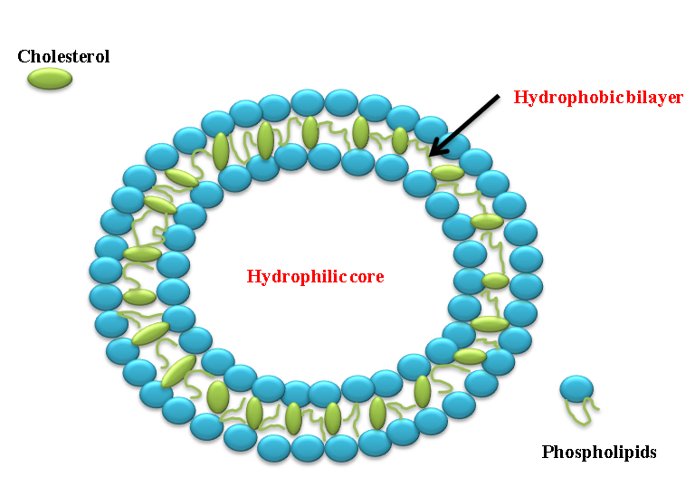

Figure 1: Schematic representation of liposomes

2.1. Liposomal Composition
2.1.1. Lipids and Phospholipids Used in Liposomes
When diacyl-chain phospholipids are dissolved in an aqueous solution, they self-assemble to create spherical or multilayered structures called liposomes, which are bilayer lipid structures [65]. There is a hydrophilic head and a hydrophobic tail in this phospholipid membrane [66, 68], resulting in their amphiphilic character. Phospholipids can be synthesized or naturally occurring while creating liposomes [67]. The selection of lipid composition has a substantial influence on a number of liposome properties, such as stability, stiffness, fluidity, and electric charge [69, 70]. Liposomes derived from naturally occurring unsaturated phosphatidylcholine, such as that present in egg or soybean phosphatidylcholine, demonstrate elevated permeability accompanied by reduced stability. Liposomes based on saturated phospholipids, such as dipalmitoyl phosphatidylcholine, on the other hand, form strong, practically impermeable bilayer forms [68]. Lipids' hydrophilic portion can be negatively, positively, or zwitterionically charged (containing both negative and positive charges within the same molecule). Through electrostatic repulsion, the hydrophilic segment's charge adds to stability. The length, symmetry, and saturation of the acyl chain in the hydrophobic portion of lipids can change [71].
2.3. Techniques for Liposome Preparation
There are several ways to make liposomes, and the final liposomes' properties are mostly determined by the phospholipids used in the manufacturing process [74]. The following categories apply to the ways in which liposomes are produced:
2.3.1. Thin Film Hydration Method (Bangham Method)
Using this method, a round-bottom flask containing all of the lipids and the hydrophobic medication is dissolved in the proper organic solvent [72]. To create a thin film layer, the organic solvent is then gradually evaporated under low pressure [73]. After that, an aqueous buffer solution is used to hydrate the resulting thin film, keeping it at a temperature higher than the lipid's transition point (Tm). Drugs that are hydrophilic may be present in the hydration solution and loaded into the watery core of the liposomes. The rate of hydration influences the efficacy of drug encapsulation; slower rates of hydration lead to more efficaciousness of encapsulation. [72]. By employing polycarbonate membranes with specified pore diameters for extrusion or bath or probe sonicators, one can regulate the liposome size, lamellarity types, and particle dispersion. Compared to sonication, extrusion guarantees the creation of stable liposomes with a better encapsulation efficiency. Sonication usually results in the production of tiny unilamellar vesicles (SUVs), but it can also cause encapsulated medicines or lipids to hydrolyze or degrade. Additionally, liposome suspensions may be exposed to possible metallic source contamination during probe sonication (as depicted in Figure 8) [73].

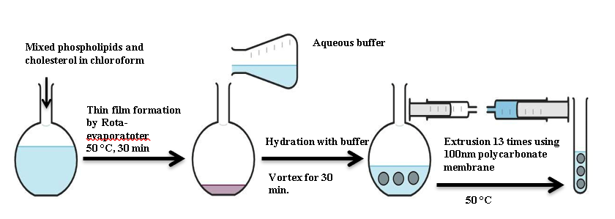

Figure 2: Liposomes preparation via thin-film hydration extrusion technique.
2.3.2. Solvent Injection Methods
Solvent injection techniques can be classified according to the particular organic solvent that is utilised, as illustrated in Figure 9 [75]. These methods include quickly introducing an organic solvent that contains hydrophobic active ingredients and lipids into an aqueous medium. For instance, using diethyl ether enables direct solvent evaporation at a temperature higher than the solvent's boiling point during the mixing process [76]. If ethanol is selected for injection, an aqueous solution that has been diluted 10–20 times is needed. Ethanol can be extracted under vacuum using a rotary evaporator, dialysis, or filtration. It's crucial to remember that using this technique frequently produces liposomal formulations with high polydispersity indices (PDIs) [77]. Furthermore, extended exposure to high temperatures and chemical solvents may jeopardise the drug's and the lipids' stability [78].
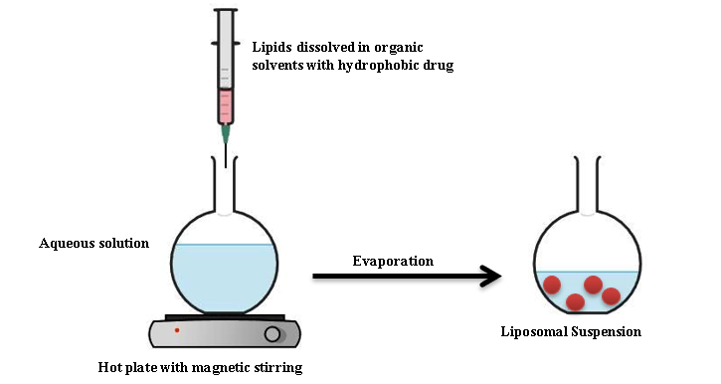
Figure 3: Lipid dissolution and hydrophobic medication evaporation process result in the formation of liposomal suspension.

2.4. Liposome Description
Examining various physicochemical properties is part of the process of characterising liposomes. This involves computing factors like the mean and size distribution that are commonly stated as the polydispersity index (PDI). The assessment includes a review of the liposome shape, lamellarity, encapsulation efficiency, phase behaviour or polymorphism, and in vitro release pattern. Additionally offered is zeta potential, or surface charge (see Table 2).

Table 1; Represent different techniques used for the assessment of liposome parameters
Liposomes characteristics | Characterization technique | References
Average particle size | Dynamic light scattering (DLS) and several microscope techniques, like cryogenic-TEM (Cryo-TEM), atomic force microscopy, and scanning and transmission electron microscopy (SEM/TEM), are among the technologies utilised for characterisation (AFM). | [79, 80]
Zeta potential/Surface charge | DLS, Electrophoretic mobility | [81]
Particle shape/morphology | , AFM Cryo-TEM and TEM | [82]
Lamellarity | 31P-NMR and ​Cryo-TEM | [83]
Phase behavior | The analysis techniques include thermogravimetric analysis, differential scanning calorimetry (DSC), and X-ray diffraction (XRD) (TGA). | [83,84]
Encapsulation efficiency/Drug release | Centrifugation, dialysis, and subsequent drug content determination utilizing chromatographic and/or spectrophotometric techniques are the steps in the procedure. | [84,85]

Clinical Applications of Liposomes: Clinical areas where liposome-based formulations have demonstrated potential include cancer treatment, pain management, and fungus infections [86]. Since the first liposomal anticancer drug, Doxil®, received clinical approval in the USA in 1995, a variety of liposomal formulations, including stealth liposomes generated by PEGylation and pH gradient active loading, have been employed in clinical settings. This was a historic moment [86, 87]. When extending the circulation half-life is not the main goal, conventional liposomes without PEGylation remain a desirable choice [88]. A popular progressive drug release technique that guarantees a long-lasting therapeutic effect by supplying a steady flow of medication is called DepoFoam [89].

Niosomes
Paul Ehrlich first proposed targeted drug delivery in 1909. Minimizing contact with non-target tissues while precisely delivering therapeutic medications to the intended site of action is its goal. A kind of drug delivery system known as "niosomes" entails the encapsulation of medications in vesicles made of a bilayer of a non-ionic surface-active substance [90]. These vesicles are usually made with non-ionic surfactants such as Span-60 and stabilised with the addition of cholesterol and a small amount of anionic surfactant such as dicetyl phosphate [91]. Paul Ehrlich's methodology made targeted drug delivery feasible and paved the way for the development of niosomes.

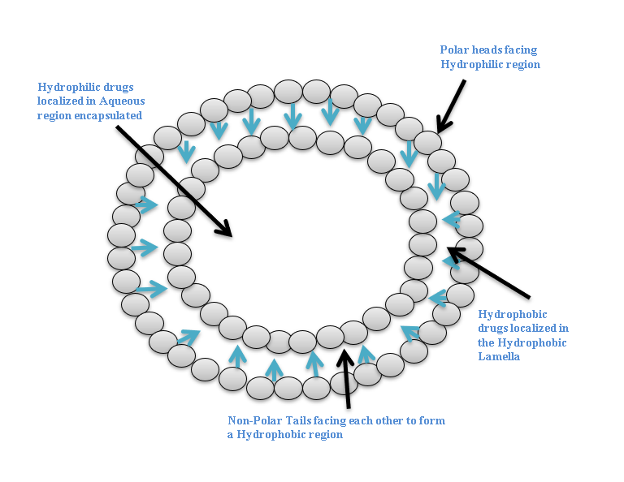
Figure 4: Structure of Niosomes

Paul Ehrlich, in 1909, initiated the era of development for targeted delivery when he envisaged a drug delivery mechanism that would target directly to diseased cell. Drug targeting can be defined as the ability to direct a therapeutic agent specifically to desired site of action with little or no interaction with non target tissue. In niosomes drug delivery system the medication is encapsulated in a vesicle. (Baillie et al., 1985) The vesicle is composed of a bilayer of non-ionic surface active agents and hence the name niosomes. In niosomes, the Vesicles forming amphiphilic is a non-ionic surfactant such as Span – 60 which is usually stabilized by addition of cholesterol and small amount of anionic surfactant such as dicetyl phosphate. (Hunter et al., 1988) Paul Ehrlich, in 1909, initiated the era of development for targeted delivery when he envisaged a drug delivery mechanism that would target directly to diseased cell. Drug targeting can be defined as the ability to direct a therapeutic agent specifically to desired site of action with little or no interaction with non target tissue. In niosomes drug delivery system the medication is encapsulated in a vesicle. (Baillie et al., 1985) The vesicle is composed of a bilayer of non-ionic surface active agents and hence the name niosomes. In niosomes, the vesicles forming amphiphilic is a non-ionic surfactant such as Span – 60 which is usually stabilized by addition of cholesterol and small amount of anionic surfactant such as dicetyl phosphate. (Hunter et al., 1988)

Table 2: Advantage and Disadvantages of niosomes
Advantages of niosomes | Disadvantages of niosomes
- The vesicle's characteristics, such as its size and lamellarity, can be modified to meet certain needs or specifications. | - Fusion
- The medicine can be released gradually and under control using the vesicles as a depot. | - Aggregation
- Niosomes can be used for a variety of medications since its structure allows for the accommodation of hydrophilic, lipophilic, and amphiphilic drug components. | - Leaking of entrapped drug
- Compared to oil-based solutions, the water-based vesicle suspension improves patient compliance. | - Physical instability
- These vesicles stay stable and show osmotic action. | - Drugs that are encapsulated undergo hydrolysis, which shortens the dispersion's shelf life.

Niosome Composition [92]: The two main ingredients of niosome formulations are cholesterol and nonionic surfactants..
Cholesterol Steroid- derived cholesterol is used to give niosome compositions shape and structural support.
Nonionic Surfactants: Many nonionic surfactants, including Spans (e.g., Span 60, 40, 20, 85, 80), Tweens (e.g., Tween 20, 40, 60, 80), and Brijs, are commonly employed while making niosomes (e.g., Brij 30, 35, 52, 58, 72, 76). A nonionic surfactant has a hydrophilic head and a hydrophobic tail.

Methods for Niosome Preparation:
Ether Injection Method: This method involves progressively adding a surfactant solution dissolved in diethyl ether to warm water that is kept at 60°C. Single-layered vesicles are formed as the ether vaporises; the size of the vesicles varies depending on the particular circumstances applied and usually ranges from 50 to 1000 nm.
Sonication Method: This approach involves filling a glass vial with a mixture of cholesterol and surfactant, then adding a medication solution in a buffer. The mixture is then subjected to three minutes of probe-sonication at 60°C using a titanium probe-equipped sonicator, which causes niosomes to develop.
Bubble Method: Using this procedure, a water bath is used to regulate the temperature of a round-bottomed flask with three necks. A 70°C combination of surfactant and cholesterol is created, and a high-shear homogenizer is used to homogenise the dispersion for 15 seconds. By utilising nitrogen gas to "bubbly" the mixture at 70°C, niosomes are produced.

Factors Influencing Niosome Formulation:
Drug: The charge and stiffness of the vesicle bilayer are influenced by the kind of medication that is added to niosomes. The degree of drug entrapment depends on the hydrophilic-lipophilic balance of the substance [95].
Nature and Type of Surfactant: Because of changes in hydrophobicity, the mean size of niosomes increases with higher HLB values of surfactants, such as when they go from Span 85 (HLB 1.8) to Span 20 (HLB 8.6). A hydrophilic head and a hydrophobic tail, which may contain steroidal or perfluoroalkyl groups, are the characteristics of an ideal surfactant.
Resistance to Osmotic Stress: The diameter of suspended niosomes decreases upon the addition of a hypertonic salt solution.
Hydration Temperature: The size and form of niosomes are influenced by the temperature during hydration.

Applications of Niosomes:
There is a following application of niosomes [97-98].
- The study of immunological responses brought on by antigens makes use of niosomes.
- With an emphasis on drug targeting, they function as drug delivery systems.
- Niosomes are used in anti-neoplastic cancer therapies.
- They are used to treat mucocutaneous and skin infections, as well as disorders like leishmaniasis.
- Hemoglobin can be transported by niosomes.
- They make peptide medication delivery easier.
- Niosomes are used in the delivery of medications to the eyes.
- The distribution of drugs transdermally is possible with these devices.
- Niosomes are employed as diagnostic agents as well.

Nanoparticles: The idea of nanotechnology was first introduced in 1959 when physicist Richard Feynman gave a ground-breaking talk titled "There's Plenty of Room at the Bottom" [99]. Significant progress in the field of nanotechnology was spurred by this idea. The study of extremely small structures at the nanoscale, usually between 1 and 100 nanometers, is known as nanotechnology [101]. Because of their submicroscopic size, nanoparticles have special material properties and are useful in a variety of sectors, such as engineering, drug delivery, nanomedicine, environmental protection, and catalysis. Additionally, they are used in the treatment of particular illnesses like melanoma, liver ailments, skin issues, cardiovascular diseases (CVD), and more. Thus, the combination of nanotechnology with medicine has the potential to significantly increase therapeutic efficacy and bioavailability [102].

Table 3: Benefits and Drawbacks of nanomedicine.

Nanomedicine Names | Benefits | Drawbacks | References
NPs made of polymers and tacrine | NPs are biocompatible, affordable, have a lengthy half-life in the brain, control the release of medications, and conjugate selectively with ligands. | Gradually deteriorating, sometimes unclear toxicity | [103]
Polymeric NPs filled with rivastigmine. | They increase the drug's concentration in the brain and stop RES from phagocytosing the drug.. | an increase in oxidative stress and toxicity | [104]
sodium-loaded SLNPs | comprehensive research, decreased side effects of medication, improved therapeutic advantages, and raised drug solubility | Low loading capacity that is easily cleared by the reticuloendothelial system. | [105]
Liposomes laced with folic acid | Very biocompatible and biodegradable, with a high bioavailability and stability that is unique to the active surface | Low stability, trouble binding to lipids, and pace of drug transport | [106]
Beta-asarone-loaded nanoemulsions | increased bioavailability and the ability to hydrolyze drugs that are both hydrophilic and hydrophobic | Thermodynamic instability combined with rapid drug release | [107]
Drug Delivery Mechanism: The drugs included in the nanoparticles travel to their target location in the bones through the bloodstream. The process of guiding these nanoparticles is depicted in Figure 5.
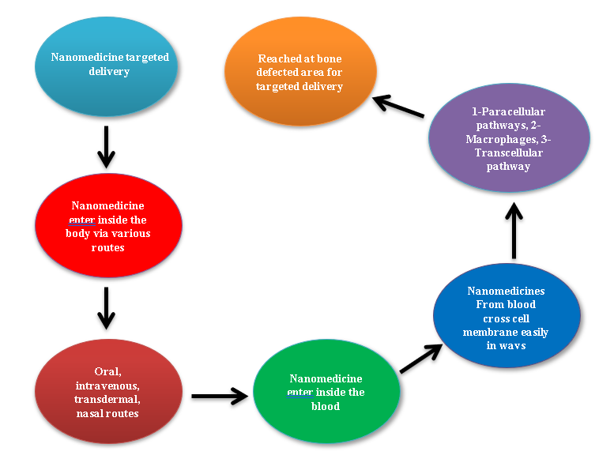
Figure 5: Delivery mechanism of nanomedicines in bone disorders.

Advances in Drug Delivery for Bone Diseases: A broad range of disorders, including fractures, trauma, osteoporosis, arthritis, infections, and other underlying causes, are together referred to as bone illnesses. It is a very complicated process to effectively manage these disorders by encouraging bone repair. A mix of biological and nanomaterials has been used to aid with bone mending. Because of this combination, there is no longer a requirement for traditional bone implants because bone bioscaffolds have been developed [108].
Challenges Ahead in Nanomedicine: Nanomedicine has made numerous advancements that have demonstrated its value in a variety of clinical and medical domains. Many researchers have looked at the potential of nanomedicine in an attempt to reduce the death and morbidity rates linked to cancer therapy. Nonetheless, there are still significant obstacles in the field of nanomedicine [109]. The public health sector, insurance companies, and regulatory agencies will all pose obstacles to the clinical implementation of nanomedicine. Products containing nanoparticles are not currently subject to any particular FDA regulations. Due to lack of standardization and safety concerns, US agencies including the EPA and NIOSH have reduced funding for research on nanoparticles.

Monoclonal Antibodies: Monoclonal antibodies, also referred to as mAbs or MAbs, are clones of parent cells, specifically plasma cells, which are a type of white blood cell [110]. These antibodies are essential for disease diagnosis and therapy, including cancer treatment, as well as for biomedical research. They are created by taking clones or cell lines from animals that have been immunised against specific antigens. Myeloma cells and B cells from these immunised mice are fused together to create these cell lines. The two methods utilised to produce the required monoclonal antibodies are in vitro tissue culture and in vivo injection into the mouse peritoneal cavity, which is also known as the mouse ascites method. Hybridoma technique, developed in 1975 by Georges J.F. Kohler and Cesar Milstein—for which they received the 1984 Nobel Prize—is essential to the production of monoclonal antibodies [111].
Treatment of Innate Immune Diseases with Monoclonal Antibodies: Monoclonal antibodies, including Infliximab and Adalimumab, have been shown to be effective in treating conditions like rheumatoid arthritis, ulcerative colitis, and Crohn's disease. These antibodies bind to released TNF, TNF-α, and interleukin-2 (IL-2) to prevent their release from activated T-cells. In a similar vein, daclizumab and basiliximab block these elements and help to avoid acute rejection following kidney transplantation. Omalizumab is effective in treating different types of allergic asthma because it notably decreases human IgE. Daclizumab is another potent monoclonal antibody drug that is effective in treating T-cell lymphoma. In patients receiving steroid-resistant solid organ transplants, OKT3 (Muromonab, Orthoclone), the first therapeutic monoclonal antibody (mAb) licensed by the FDA, is used to boost immunosuppression and prevent foreign [112, 113].
Manufacturing of Monoclonal Antibodies [114, 115]: Single B-lymphocytes that bind to the same epitope are the source of monoclonal antibodies. The hybridoma technique, first described in 1975, is used to manufacture them, usually in mice. To make hybridomas, a certain species is immunized against a specific antigen epitope, and its B-lymphocytes are taken out of the spleen. This procedure is illustrated in Figure 5.

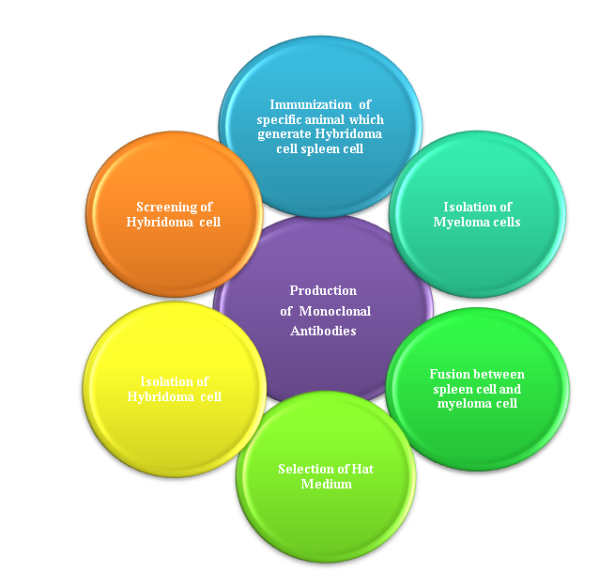

Figure 6: Steps for the production of Monoclonal Antibodies

Isolation of Myeloma Cells: The bone marrow is the source of malignant cells, particularly myeloma cells. Two prominent features of myeloma cells are their fast multiplication rate and their seemingly endless survival [116].
Fusion of Spleen and Myeloma Cells: PEG (polyethylene glycol) or electrofusion methods can be used to carry out the fusion process. Five different types of cells are produced when myeloma cells and spleen cells combine:
- Plasma cell fusion
- Combined myeloid cells
- Hybridoma cells
- Distinct plasma cells
- Unfused myeloma cells

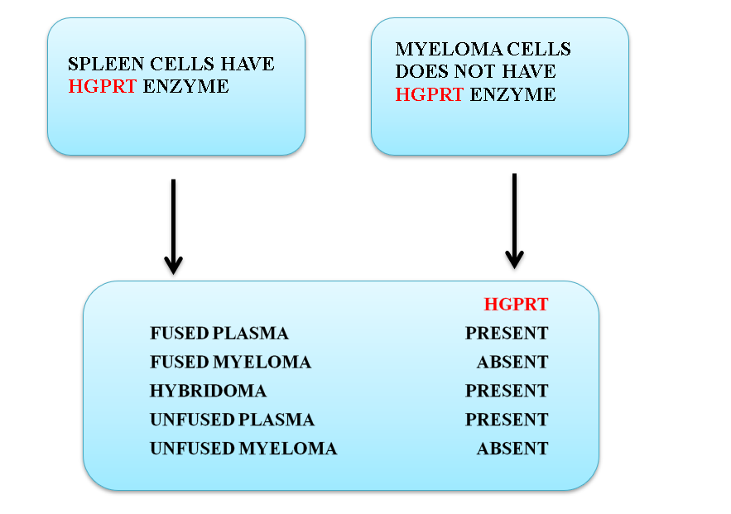
Figure 7: Isolation and Fusion of Spleen and Myeloma Cells

Selection of HAT Medium: The acronym HAT, which stands for HYPOXANTHINE, AMINOPTERIN, and THYMIDINE, is essential to this procedure. Antibodies must synthesise new copies of DNA via two different mechanisms of nucleotide synthesis before they may reproduce.
The salvage pathway: Old nucleotide segments that have deteriorated can be recycled to create new ones.
De-novo synthesis: converting simple compounds into nucleotides. Aminopterin, which is present in the HAT medium, prevents cells from undergoing de novo synthesis by inhibiting the dihydrofolate enzyme, which is essential for these processes. Hypoxanthine Guanine Phospho-Ribosyl Transferase, or HGPRT, is a necessary enzyme for synthesis to proceed via the salvage pathway. For this, the enzyme uses hypoxanthine and thymidine as precursors.

Isolation of Hybridoma Cells: Because they lack the HGPRT enzyme, both fused and unfused myeloma cells cannot grow in HAT media. While both fused and unfused plasma cells are endowed with the HGPRT enzyme, their lives are not long. On the other hand, because they have the splenic HGPRT enzyme, hybrid cells are able to divide indefinitely, much like myeloma cells. Isolating these hybrid cells is essential because they are the only ones that can thrive in HAT medium.

Screening of Hybridoma Cells: After hybridoma cultures are screened using ELISA, a coloured result is produced that shows the presence of hybridoma cells. Using an in-vivo technique, ascetic fluid is used to collect antibodies after hybridoma cells are inserted into an animal's peritoneal cavity. The in-vitro method includes isolating and purifying antibodies once hybridoma cells are grown under the right circumstances. During this technique, a hybridoma colony is created that grows and produces antibodies in a culture medium like RPMI-1640. Liquid nitrogen is used for the last storage. Figure 7 shows a visual representation of the complete procedure [117].

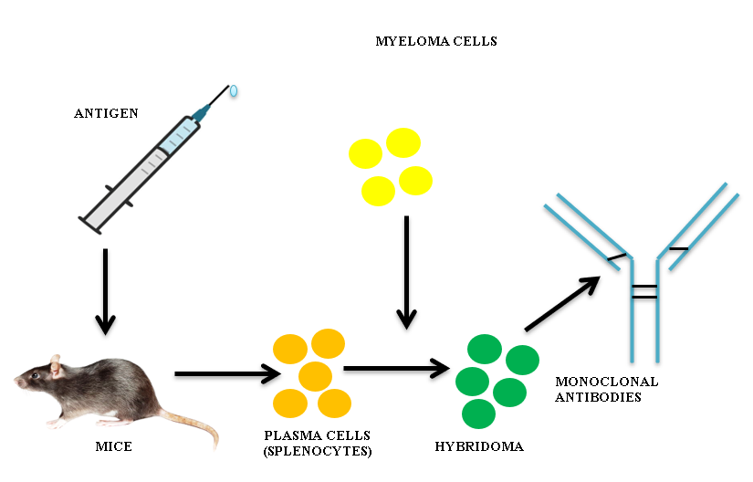

Figure 8: Process for the production of Monoclonal Antibody

CONCLUSION
In conclusion, research on cutting-edge drug delivery technologies including monoclonal antibodies, liposomes, niosomes, and nanoparticles shows how revolutionary they can be for the field of pharmaceutical science. These systems provide a wide range of ideas, creative methods, many benefits, and adaptable uses. They represent a dynamic frontier in contemporary medicine that has promise for improving accuracy, treatment efficacy, and patient outcomes. For these industries to reach their full potential and improve patient care and healthcare as a whole, more research and development is required.

FUTURE SCOPE:
Advanced drug delivery technologies, which include liposomes, niosomes, nanoparticles, and monoclonal antibodies, have a very bright future ahead of them. These cutting-edge technologies have the potential to completely change the pharmaceutical and healthcare industries. The following gives an idea of each of these drug delivery systems' potential in the future:
- Liposomes:
It is believed that liposomes will play a significant role in personalised medicine, allowing for tailored drug delivery to suit individual patient demands. To achieve certain therapeutic goals, this can include altering the liposomes' size and surface.
Combination Therapies: Liposomes are used in combination therapies, which deliver multiple drugs at once in a targeted and controlled way in an effort to maximise therapy efficacy while minimising side effects.

Intracellular Drug Delivery: The effectiveness of intracellular drug transport should be improved by developments in liposome architecture, offering new therapeutic options for a variety of illnesses, including genetic abnormalities.

2. Niosomes:
Biomedical Imaging: Niosomes may be used more frequently in biomedical imaging as contrast agents in diagnostic procedures. They have the capacity to contain imaging agents, enabling focused and accurate visualisation of disease areas.
Sustained Release: It is anticipated that continued research into niosome formulations would result in better sustained and regulated drug release, extending therapeutic effects and lowering dose frequencies.
Transmucosal Drug Delivery: For transmucosal drug delivery, niosomes may develop, enabling non-invasive drug administration through mucous membranes. This may provide access to novel treatment options for diseases affecting mucosal surfaces.

3. Nanoparticles:
Nanomedicine Advancements: Innovations in nanomedicine will still be fueled by nanoparticles. With the addition of therapeutic chemicals and disease-specific indicators, they will become more and more specialized to treat particular diseases in a highly efficient and targeted manner.
Biodegradable Nanoparticles: Concerns over the effects of nanomedicine on the environment are expected to be addressed by the rise in popularity of environmentally benign biodegradable nanoparticles.
Cross-Disciplinary Collaborations: The future of nanoparticles is found in interdisciplinary teams that combine knowledge of biology, medicine, and nanotechnology to develop cutting-edge answers to challenging medical problems.

4. Monoclonal Antibodies:
Immunotherapy Revolution: Monoclonal antibodies will remain at the vanguard of immunotherapy, providing ground-breaking cures for infectious diseases, autoimmune disorders, and cancer.
Precision Medicine: More accurate targeting of disease markers will be possible because to developments in monoclonal antibody engineering, which will usher in a new era of highly customized and efficient treatments.
5. Combination Therapies: In order to maximize therapeutic outcomes, monoclonal antibodies will be used in combination therapies with conventional medications, nanoparticles, or other drug delivery methods.
As these sophisticated drug delivery systems continue to be researched and developed, we may anticipate that these technologies will converge to form hybrid systems with even more power and adaptability. Future developments in artificial intelligence and nanotechnology will enable intelligent drug delivery systems that can instantly adjust to a patient's changing circumstances.

The ability of these cutting-edge drug delivery systems to solve the changing healthcare concerns of our day and improve medicine's precision, efficacy, and patient-centeredness is essentially what will define their future scope. Researcher, pharmaceutical, and regulatory body collaboration will be essential to achieving this potential and guaranteeing that these developments result in improved global patient outcomes.

REFERENCES

[1] Lawrence, J. (2018). Making drugs work better: four new drug delivery methods. Lung Cancer, 15(05).

[2] Update, E. L. G. (2007). GATS Update.

[3] Veronese, F. M., Bevilacqua, R., Schiavon, O., & Rodighiero, G. (1979). Drug-protein interaction: plasma protein binding of furocoumarins. Il Farmaco; edizione scientifica, 34(8), 716-725.

[4] Scherphof, G., Roerdink, F., Waite, M., & Parks, J. (1978). Disintegration of phosphatidylcholine liposomes in plasma as a result of interaction with high-density lipoproteins. Biochimica et biophysica acta, 542(2), 296-307.

[5] Larson, N., & Ghandehari, H. (2012). Polymeric conjugates for drug delivery. Chemistry of Materials, 24(5), 840-853.

[6] Xu, X., Ho, W., Zhang, X., Bertrand, N., & Farokhzad, O. (2015). Cancer nanomedicine: from targeted delivery to combination therapy. Trends in molecular medicine, 21(4), 223-232.

[7] Baillie, T. A. (2008). Metabolism and toxicity of drugs. Two decades of progress in industrial drug metabolism. Chemical research in toxicology, 21(1), 129-137.

[8] Higuchi, T., & Hussain, A. (1978). U.S. Patent No. 4,069,307. Washington, DC: U.S. Patent and Trademark Office.

[9] Pitt, C. G., Jeffcoat, A. R., Zweidinger, R. A., & Schindler, A. (1979). Sustained drug delivery systems. I. The permeability of poly (ϵ‐caprolactone), poly (DL‐lactic acid), and their copolymers. Journal of biomedical materials research, 13(3), 497-507.

[10] Elzwi, S. (2022). Genesis Journal of Surgery and Medicine.

[11] Blackshear, P. J. (1979). Implantable drug-delivery systems. Scientific American, 241(6), 66-73.

[12] Bae, Y. H., & Park, K. (2020). Advanced drug delivery 2020 and beyond: Perspectives on the future. Advanced drug delivery book chapters, 158, 4-16.

[13] Shaw, J., & Urquhart, J. (1979). Programmed, systemic drug delivery by the transdermal route. Trends in Pharmacological Sciences, 1(1), 208-211.

[14] Edwards, D. A., Hanes, J., Caponetti, G., Hrkach, J., Ben-Jebria, A., Eskew, M. L., ... & Langer, R. (1997). Large porous particles for pulmonary drug delivery. Science, 276(5320), 1868-1872.

[15] Wong, V. G., Hu, M. W., & Berger Jr, D. E. (2001). U.S. Patent No. 6,331,313. Washington, DC: U.S. Patent and Trademark Office.

[16] Pavelić, Ž., Škalko-Basnet, N., & Schubert, R. (2001). Liposomal gels for vaginal drug delivery. International journal of pharmaceutics, 219(1-2), 139-149.

[17] Hasçiçek, C., Gönül, N., & Erk, N. (2003). Mucoadhesive microspheres containing gentamicin sulfate for nasal administration: preparation and in vitro characterization. Il Farmaco, 58(1), 11-16.

[18] Breimer, D. D., De Boer, A. G., & De Leede, L. G. J. (1985). Rate controlled rectal drug delivery in man. Journal of Controlled Release, 2, 39-46.

[19] Barar, J., Javadzadeh, A. R., & Omidi, Y. (2008). Ocular novel drug delivery: impacts of membranes and barriers. Expert opinion on drug delivery, 5(5), 567-581.

[20] Greish, K. (2010). Enhanced permeability and retention (EPR) effect for anticancer nanomedicine drug targeting. Cancer nanotechnology: Methods and protocols, 25-37.

[21] Iyer, A. K., Khaled, G., Fang, J., & Maeda, H. (2006). Exploiting the enhanced permeability and retention effect for tumor targeting. Drug discovery today, 11(17-18), 812-818.

[22] Acharya, S., & Sahoo, S. K. (2011). PLGA nanoparticles containing various anticancer agents and tumour delivery by EPR effect. Advanced drug delivery book chapters, 63(3), 170-183.

[23] Torchilin, V. (2011). Tumor delivery of macromolecular drugs based on the EPR effect. Advanced drug delivery book chapters, 63(3), 131-135.

[24] Youn, Y. S., & Bae, Y. H. (2018). Perspectives on the past, present, and future of cancer nanomedicine. Advanced drug delivery book chapters, 130, 3-11.

[25] Francis, M. F., Piredda, M., & Winnik, F. M. (2003). Solubilization of poorly water soluble drugs in micelles of hydrophobically modified hydroxypropylcellulose copolymers. Journal of controlled release, 93(1), 59-68.

[26] Pouton, C. W. (2006). Formulation of poorly water-soluble drugs for oral administration: physicochemical and physiological issues and the lipid formulation classification system. European journal of pharmaceutical sciences, 29(3-4), 278-287.

[27] Moghimi, S. M., & Hunter, C. (2001). Capture of stealth nanoparticles by the body’s defences. Critical Book chapters™ in Therapeutic Drug Carrier Systems, 18(6).

[28] Demoy, M., Andreux, J. P., Weingarten, C., Gouritin, B., Guilloux, V., & Couvreur, P. (1999). Spleen capture of nanoparticles: influence of animal species and surface characteristics. Pharmaceutical research, 16, 37-41.

- Kim, B. Y. S., Rutka, J. T., & Chan, W. C. W. (2010). Effect of Coumarate 3-zhydroxylase Down regulation on lignin structure. Nanomed. N. Engl. J. Med, 363, 2434-2443.

- Allen, T. M., & Cullis, P. R. (2004). Drug delivery systems: entering the mainstream. Science, 303(5665), 1818-1822.

- Khater, D., Nsairat, H., Odeh, F., Saleh, M., Jaber, A., Alshaer, W., ... & Mubarak, M. S. (2021). Design, preparation, and characterization of effective dermal and transdermal lipid nanoparticles: A book chapter. Cosmetics, 8(2), 39.

- Yezhelyev, M. V., Gao, X., Xing, Y., Al-Hajj, A., Nie, S., & O'Regan, R. M. (2006). Emerging use of nanoparticles in diagnosis and treatment of breast cancer. The lancet oncology, 7(8), 657-667.

- Sahoo, S. K., & Labhasetwar, V. (2003). Nanotech approaches to drug delivery and imaging. Drug discovery today, 8(24), 1112-1120.

- Nsairat, H., Khater, D., Odeh, F., Al-Adaileh, F., Al-Taher, S., Jaber, A. M., Alshaer, W., Al Bawab, A., & Mubarak, M. S. (2021). Lipid nanostructures for targeting brain cancer. Heliyon, 7(9). https://doi.org/10.1016/j.heliyon.2021.e07994

- Celia, C., Paolino, D., & Santos, H. A. (2021). Advanced nanosystems for clinical translation. Advanced Therapeutics, 4(1), 2000215.

- Haley, B., & Frenkel, E. (2008, January). Nanoparticles for drug delivery in cancer treatment. In Urologic Oncology: Seminars and original investigations (Vol. 26, No. 1, pp. 57-64). Elsevier.

- Doane, T. L., & Burda, C. (2012). The unique role of nanoparticles in nanomedicine: imaging, drug delivery and therapy. Chemical Society Book chapters, 41(7), 2885-2911.

- Alexis, F., Pridgen, E. M., Langer, R., & Farokhzad, O. C. (2010). Nanoparticle technologies for cancer therapy. Drug delivery, 55-86.

- Alshaer, W., Hillaireau, H., & Fattal, E. (2018). Aptamer-guided nanomedicines for anticancer drug delivery. Advanced drug delivery book chapters, 134, 122-137.

- Sun, T., Zhang, Y. S., Pang, B., Hyun, D. C., Yang, M., & Xia, Y. (2014). Engineered Nanoparticles for Drug Delivery in Cancer Therapy. Angewandte Chemie International Edition, 53(46), 12320-12364. https://doi.org/10.1002/anie.201403036

- Jha, S., K Sharma, P., & Malviya, R. (2016). Liposomal drug delivery system for cancer therapy: advancement and patents. Recent patents on drug delivery & formulation, 10(3), 177-183.

- Sercombe, L., Veerati, T., Moheimani, F., Wu, S. Y., Sood, A. K., & Hua, S. (2015). Advances and challenges of liposome assisted drug delivery. Frontiers in pharmacology, 6, 286.

- Noble, G. T., Stefanick, J. F., Ashley, J. D., Kiziltepe, T., & Bilgicer, B. (2014). Ligand-targeted liposome design: challenges and fundamental considerations. Trends in biotechnology, 32(1), 32-45.

- Hafner, A., Lovrić, J., Lakoš, G. P., & Pepić, I. (2014). Nanotherapeutics in the EU: an overview on current state and future directions. International journal of nanomedicine, 1005-1023.

- McClements, D. J., & Rao, J. (2011). Food-grade nanoemulsions: formulation, fabrication, properties, performance, biological fate, and potential toxicity. Critical book chapters in food science and nutrition, 51(4), 285-330.

- Chen, T., Gong, T., Zhao, T., Fu, Y., Zhang, Z., & Gong, T. (2018). A comparison study between lycobetaine-loaded nanoemulsion and liposome using nRGD as therapeutic adjuvant for lung cancer therapy. European Journal of Pharmaceutical Sciences, 111, 293-302.

- Fathi, S., & Oyelere, A. K. (2016). Liposomal drug delivery systems for targeted cancer therapy: is active targeting the best choice?. Future medicinal chemistry, 8(17), 2091-2112.

- Bulbake, U., Doppalapudi, S., Kommineni, N., & Khan, W. (2017). Liposomal formulations in clinical use: an updated book chapter. Pharmaceutics, 9(2), 12.

- Akbarzadeh, A., Rezaei-Sadabady, R., Davaran, S., Joo, S. W., Zarghami, N., Hanifehpour, Y., ... & Nejati-Koshki, K. (2013). Liposome: classification, preparation, and applications. Nanoscale research letters, 8, 1-9.

- Ebrahim, S., Peyman, G. A., & Lee, P. J. (2005). Applications of liposomes in ophthalmology. Survey of ophthalmology, 50(2), 167-182.

- He, H., Lu, Y., Qi, J., Zhu, Q., Chen, Z., & Wu, W. (2019). Adapting liposomes for oral drug delivery. Acta Pharmaceutica Sinica B, 9(1), 36-48. https://doi.org/10.1016/j.apsb.2018.06.005

- Mehta, P. P., Ghoshal, D., Pawar, A. P., Kadam, S. S., & Dhapte-Pawar, V. S. (2020). Recent advances in inhalable liposomes for treatment of pulmonary diseases: concept to clinical stance. Journal of drug delivery science and technology, 56, 101509.

- Pierre, M. B. R., & dos Santos Miranda Costa, I. (2011). Liposomal systems as drug delivery vehicles for dermal and transdermal applications. Archives of dermatological research, 303, 607-621.

- Barenholz, Y. C. (2012). Doxil®—The first FDA-approved nano-drug: Lessons learned. Journal of controlled release, 160(2), 117-134.

- Cevenini, A., Celia, C., Orrù, S., Sarnataro, D., Raia, M., Mollo, V., ... & Salvatore, F. (2020). Liposome-embedding silicon microparticle for oxaliplatin delivery in tumor chemotherapy. Pharmaceutics, 12(6), 559.

- Kirui, D. K., Celia, C., Molinaro, R., Bansal, S. S., Cosco, D., Fresta, M., ... & Ferrari, M. (2015). Mild hyperthermia enhances transport of liposomal gemcitabine and improves in vivo therapeutic response. Advanced healthcare materials, 4(7), 1092-1103.

- Sahoo, S. K., & Labhasetwar, V. (2003). Nanotech approaches to drug delivery and imaging. Drug discovery today, 8(24), 1112-1120.

- Hattori, Y., Hu, S., & Onishi, H. (2020). Effects of cationic lipids in cationic liposomes and disaccharides in the freeze-drying of siRNA lipoplexes on gene silencing in cells by reverse transfection. Journal of Liposome Research, 30(3), 235-245.

- Laouini, A., Jaafar-Maalej, C., Limayem-Blouza, I., Sfar, S., Charcosset, C., & Fessi, H. (2012). Preparation, characterization and applications of liposomes: state of the art. Journal of colloid Science and Biotechnology, 1(2), 147-168.

- Bulbake, U., Doppalapudi, S., Kommineni, N., & Khan, W. (2017). Liposomal formulations in clinical use: an updated book chapter. Pharmaceutics, 9(2), 12.

- Mori, A., Klibanov, A. L., Torchilin, V. P., & Huang, L. (1991). Influence of the steric barrier activity of amphipathic poly (ethyleneglycol) and ganglioside GM1 on the circulation time of liposomes and on the target binding of immunoliposomes in vivo. FEBS letters, 284(2), 263-266.
- Tadokoro, S., Hirashima, N., & Utsunomiya-Tate, N. (2016). Effect of Complexin II on membrane fusion between liposomes containing mast cell SNARE proteins. Biological and Pharmaceutical Bulletin, 39(3), 446-449.

- Pasut, G., Paolino, D., Celia, C., Mero, A., Joseph, A. S., Wolfram, J., ... & Fresta, M. (2015). Polyethylene glycol (PEG)-dendron phospholipids as innovative constructs for the preparation of super stealth liposomes for anticancer therapy. Journal of controlled release, 199, 106-113.

- Pasut, G., Paolino, D., Celia, C., Mero, A., Joseph, A. S., Wolfram, J., ... & Fresta, M. (2015). Polyethylene glycol (PEG)-dendron phospholipids as innovative constructs for the preparation of super stealth liposomes for anticancer therapy. Journal of controlled release, 199, 106-113.

- Wu, X., Dai, X., Liao, Y., Sheng, M., & Shi, X. (2021). Investigation on drug entrapment location in liposomes and transfersomes based on molecular dynamics simulation. Journal of molecular modeling, 27, 1-10.

- Nakhaei, P., Margiana, R., Bokov, D. O., Abdelbasset, W. K., Jadidi Kouhbanani, M. A., Varma, R. S., ... & Beheshtkhoo, N. (2021). Liposomes: structure, biomedical applications, and stability parameters with emphasis on cholesterol. Frontiers in bioengineering and biotechnology, 9, 705886.

- Pavelić, Ž., Škalko-Basnet, N., & Jalšenjak, I. (2005). Characterisation and in vitro evaluation of bioadhesive liposome gels for local therapy of vaginitis. International journal of pharmaceutics, 301(1-2), 140-148.
- Akbarzadeh, A., Rezaei-Sadabady, R., Davaran, S., Joo, S. W., Zarghami, N., Hanifehpour, Y., ... & Nejati-Koshki, K. (2013). Liposome: classification, preparation, and applications. Nanoscale research letters, 8, 1-9.
- Sahoo, S. K., & Labhasetwar, V. (2003). Nanotech approaches to drug delivery and imaging. Drug discovery today, 8(24), 1112-1120.
- Grazia Calvagno, M., Celia, C., Paolino, D., Cosco, D., Iannone, M., Castelli, F., ... & Fresta, M. (2007). Effects of lipid composition and preparation conditions on physical-chemical properties, technological parameters and in vitro biological activity of gemcitabine-loaded liposomes. Current drug delivery, 4(1), 89-101.

- Large, D. E., Abdelmessih, R. G., Fink, E. A., & Auguste, D. T. (2021). Liposome composition in drug delivery design, synthesis, characterization, and clinical application. Advanced drug delivery book chapters, 176, 113851.

- Lian, T., & Ho, R. J. (2001). Trends and developments in liposome drug delivery systems. Journal of pharmaceutical sciences, 90(6), 667-680.

- Lasic, D. D. (1995). Applications of liposomes. Handbook of biological physics, 1, 491-519.
- Pradhan, B., Kumar, N., Saha, S., & Roy, A. (2015). Liposome: Method of preparation, advantages, evaluation and its application. Journal of Applied Pharmaceutical Research, 3(3), 01-08.
- Has, C., & Sunthar, P. (2020). A comprehensive book chapter on recent preparation techniques of liposomes. Journal of liposome research, 30(4), 336-365.

- Szoka Jr, F., & Papahadjopoulos, D. (1978). Procedure for preparation of liposomes with large internal aqueous space and high capture by reverse-phase evaporation. Proceedings of the national academy of sciences, 75(9), 4194-4198.

- Jaafar-Maalej, C., Charcosset, C., & Fessi, H. (2011). A new method for liposome preparation using a membrane contactor. Journal of liposome research, 21(3), 213-220.

- Maherani B., Arab-Tehrany E., Mozafari M., Gaiani C., M L. Liposomes: a book chapter of manufacturing techniques and targeting strategies. Curr. Nanosci. 2011;7:436–452. [Google Scholar]

- Mahmood, S., Mandal, U. K., Chatterjee, B., & Taher, M. (2017). Advanced characterizations of nanoparticles for drug delivery: investigating their properties through the techniques used in their evaluations. Nanotechnology Book chapters, 6(4), 355-372.

- Mourdikoudis, S., Pallares, R. M., & Thanh, N. T. (2018). Characterization techniques for nanoparticles: comparison and complementarity upon studying nanoparticle properties. Nanoscale, 10(27), 12871-12934.

- Senn, A., & Pilet, P. E. (1981). Electrophoretic mobility, zeta potential and surface charges of maize root protoplasts [Zea mays]. Zeitschrift fuer Pflanzenphysiologie (Germany, FR).

- Zhao, Z., Katai, H., Higashi, K., Ueda, K., Kawakami, K., & Moribe, K. (2019). Cryo-TEM and AFM observation of the time-dependent evolution of amorphous probucol nanoparticles formed by the aqueous dispersion of ternary solid dispersions. Molecular pharmaceutics, 16(5), 2184-2198.

- Zamani-Babgohari, F., Irannejad, A., Khayati, G. R., & Kalantari, M. (2023). Non-isothermal decomposition kinetics of commercial polyacrylamide hydrogel using TGA and DSC techniques. Thermochimica Acta, 725, 179532.

- Clout, A., Buanz, A. B. M., Prior, T. J., Reinhard, C., & Wu, Y. (2016). O′ Hare D., Williams GR, Gaisford S. Anal. Chem, 88, 10111-10117.

- Panwar, P., Pandey, B., Lakhera, P. C., & Singh, K. P. (2010). Preparation, characterization, and in vitro release study of albendazole-encapsulated nanosize liposomes. International journal of nanomedicine, 101-108.

- Lamichhane, N., Udayakumar, T. S., D’Souza, W. D., Simone, C. B., Raghavan, S. R., Polf, J., & Mahmood, J. (2018). Liposomes: clinical applications and potential for image-guided drug delivery. Molecules, 23(2), 288.

- Cabanes, A., Even-Chen, S., Zimberoff, J., Barenholz, Y., Kedar, E., & Gabizon, A. (1999). Enhancement of antitumor activity of polyethylene glycol-coated liposomal doxorubicin with soluble and liposomal interleukin 2. Clinical cancer research, 5(3), 687-693.

- Fukuda, A., Tahara, K., Hane, Y., Matsui, T., Sasaoka, S., Hatahira, H., ... & Nakamura, M. (2017). Comparison of the adverse event profiles of conventional and liposomal formulations of doxorubicin using the FDA adverse event reporting system. PLoS One, 12(9), e0185654.

- Angst, M. S., & Drover, D. R. (2006). Pharmacology of drugs formulated with DepoFoam™: a sustained release drug delivery system for parenteral administration using multivesicular liposome technology. Clinical pharmacokinetics, 45, 1153-1176.

- Baillie, A. J., Florence, A. T., Hume, L. R., Muirhead, G. T., & Rogerson, A. (1985). The preparation and properties of niosomes—non‐ionic surfactant vesicles. Journal of pharmacy and pharmacology, 37(12), 863-868.

- Hunter, C. A., Dolan, T. F., Coombs, G. H., & Baillie, A. J. (1988). Vesicular systems (niosomes and liposomes) for delivery of sodium stibogluconate in experimental murine visceral leishmaniasis. Journal of pharmacy and pharmacology, 40(3), 161-165.

- Devi, S. G., & Udupa, N. (2000). Niosomal sumatriptan succinate for nasal administration. Indian Journal of Pharmaceutical Sciences, 62(6), 479-481.

- Uchegbu, I. F., & Vyas, S. P. (1998). Non-ionic surfactant based vesicles (niosomes) in drug delivery. International journal of pharmaceutics, 172(1-2), 33-70.

- Mujoriya, R., Bodla, R. B., Dhamande, K., & Patle, L. (2011). Niosomal drug delivery system: The magic bullet. Journal of Applied Pharmaceutical Science, (Issue), 20-23.

- Handjani-Vila, R. M., Ribier, A., Rondot, B., & Vanlerberghie, G. (1979). Dispersions of lamellar phases of non-ionic lipids in cosmetic products. International journal of cosmetic Science, 1(5), 303-314.

- Weissmann, G., Bloomgarden, D., Kaplan, R., Cohen, C., Hoffstein, S., Collins, T., ... & Nagle, D. (1975). A general method for the introduction of enzymes, by means of immunoglobulin-coated liposomes, into lysosomes of deficient cells. Proceedings of the National Academy of Sciences, 72(1), 88-92.

- Malhotra, M., & Jain, N. K. (1994). Niosomes as drug carriers. Indian Drugs-Bombay-, 31, 81-81.
- Alsarra, I. A., Bosela, A. A., Ahmed, S. M., & Mahrous, G. M. (2005). Proniosomes as a drug carrier for transdermal delivery of ketorolac. European journal of pharmaceutics and biopharmaceutics, 59(3), 485-490.

- Prasad, R. D., Charmode, N., Shrivastav, O. P., Prasad, S. R., Moghe, A., Sarvalkar, P. D., & Prasad, N. R. (2021). A book chapter on concept of nanotechnology in veterinary medicine. ES Food & Agroforestry, 4, 28-60.

- Lateef, A., Darwesh, O. M., & Matter, I. A. (2021). Microbial nanobiotechnology: the melting pot of microbiology, microbial technology and nanotechnology. Microbial Nanobiotechnology: Principles and Applications, 1-19.

- Mansor, N. I., Nordin, N., Mohamed, F., Ling, K. H., Rosli, R., & Hassan, Z. (2019). Crossing the blood-brain barrier: a book chapter on drug delivery strategies for treatment of the central nervous system diseases. Current drug delivery, 16(8), 698-711.

- Mughal, T. A., Ali, S., Hassan, A., Kazmi, S. A. R., Saleem, M. Z., Shakir, H. A., ... & Gulzar, N. (2022). Phytochemical screening, antimicrobial activity, in vitro and in vivo antioxidant activity of Berberis lycium Royle root bark extract. Brazilian Journal of Biology, 84, e249742.

- Agrawal, M., Saraf, S., Saraf, S., Antimisiaris, S. G., Hamano, N., Li, S. D., ... & Alexander, A. (2018). Recent advancements in the field of nanotechnology for the delivery of anti-Alzheimer drug in the brain region. Expert opinion on drug delivery, 15(6), 589-617.

- Shah, P., Chavda, K., Vyas, B., & Patel, S. (2021). Formulation development of linagliptin solid lipid nanoparticles for oral bioavailability enhancement: Role of P-gp inhibition. Drug delivery and translational research, 11, 1166-1185.

- Xinming, L., Tsibouklis, J., Weng, T., Zhang, B., Yin, G., Feng, G., ... & Mikhalovsky, S. (2016). Nano carriers for drug transport across the blood–brain barrier. Journal of Drug Targeting, 25(1), 17-28.

- Majumder, J., Taratula, O., & Minko, T. (2019). Nanocarrier-based systems for targeted and site specific therapeutic delivery. Advanced drug delivery book chapters, 144, 57-77.

- Majumder, J., Taratula, O., & Minko, T. (2019). Nanocarrier-based systems for targeted and site specific therapeutic delivery. Advanced drug delivery book chapters, 144, 57-77.

- Jogani, V. V., Shah, P. J., Mishra, P., Mishra, A. K., & Misra, A. R. (2008). Intranasal mucoadhesive microemulsion of tacrine to improve brain targeting. Alzheimer Disease & Associated Disorders, 22(2), 116-124.

[109] Tewabe, A., Abate, A., Tamrie, M., Seyfu, A., & Abdela Siraj, E. (2021). Targeted drug delivery—from magic bullet to nanomedicine: principles, challenges, and future perspectives. Journal of Multidisciplinary Healthcare, 1711-1724.

- Berger, M., Shankar, V., & Vafai, A. (2002). Therapeutic Applications of Monoclonal Antibodies. The American Journal of the Medical Sciences, 324(1), 14-30. https://doi.org/10.1097/00000441-200207000-00004.

- Liu, J. K. (2014). The history of monoclonal antibody development–progress, remaining challenges and future innovations. Annals of medicine and surgery, 3(4), 113-116.

- Fischer, A., Cavazzana-Calvo, M., Jabado, N., & Sarnacki, S. (1995). Monoclonal Antibodies to Adhesion Molecules in Bone Marrow and Organ Transplantation. Monoclonal Antibodies in Transplantation, 137-153. https://doi.org/10.1007/978-3-662-22195-2_5

- Lu, R. M., Hwang, Y. C., Liu, I. J., Lee, C. C., Tsai, H. Z., Li, H. J., & Wu, H. C. (2020). Development of therapeutic antibodies for the treatment of diseases. Journal of biomedical science, 27(1), 1-30.

- Castelli, M. S., McGonigle, P., & Hornby, P. J. (2019). The pharmacology and therapeutic applications of monoclonal antibodies. Pharmacology research & perspectives, 7(6), e00535.

- Friend, D. R., & Pangburn, S. (1987). Site‐specific drug delivery. Medicinal research book chapters, 7(1), 53-106.

- Rowland, A., McKenzie, I., & Pietersz, G. (1994). Enhanced antitumour effects using a combination of two antibodies conjugated to different drugs. Journal of Drug Targeting, 2(2), 113-121.

- Schechter, B., Pauzner, R., Arnon, R., Haimovich, J., & Wilchek, M. (1987). Selective cytotoxicity against tumor cells by cisplatin complexed to antitumor antibodies via carboxymethyl dextran. Cancer Immunology, Immunotherapy, 25, 225-230.

