Consumer-Centric Packaging Solutions: Balancing Cost and Aesthetic Appeal

Dipali Trivedi
Department of Pharmacy
Oriental University
Indore, M.P., India
dipali.trivedi3005@gmail.com

Abstract:
In the upcoming ten years, the packaging industry's success will depend on developing a close knowledge and relationship with the empowered customer. Shops will have to adopt disruptive technology and creative manufacturing techniques as consumers place a greater importance on variety, control, convenience, and experience. Robotic automation will be one of the largest changes to the manufacturing supply chain. Innovative technologies are being driven by the need for flexible, integration-ready equipment that can handle quick changeovers, a range of sizes and SKUs, and bespoke packaging. The research showed that each of these little adjustments not only reduced the cost of packaging but also—and perhaps most importantly—improved the foil or film's efficiency. Even if an image is unrelated to the work at hand, its aesthetic appeal can have an impact on how well someone performs in a time-sensitive situation.
Keywords: Packaging costs, blister packaging, aesthetic appeal, balancing costs, consumer-centric.

Introduction:
The pharmaceutical industry is always threatened by a constantly evolving and strict regulatory environment, as well as the high cost of manufacturing required to comply with the requirements. When you combine this with the growing rivalry and costs associated with product development, the business begins exploring for new ways to reduce production costs.
Packing is still one of the most often disregarded ways to cut production costs and boost profits, even if many pharmaceutical companies concentrate on R&D and operations to do so. Packaging costs can be decreased by focusing on particular aspects such improved design, production processes, and material selection. These improvements can also lead to cost savings in product packaging.
Packaging involves many different aspects, from materials to processes. For packaging films and foils, which are important parts of the pharma packaging arsenal, selecting the appropriate material can have a substantial impact on the overall cost of packaging. Recently, a number of studies evaluated the effect of packaging material thickness (aluminum) on product functionality and overall costs. The findings of the studies indicated that a few minor adjustments to the fundamental parts of blister packaging could result in a significant reduction in the overall cost of packaging.

Consumer-Centric: Placing the client first and at the core of all you do is known as customer-centric.

Packaging:
For most consumers, product packaging represents their first impression of a brand and its sustainability credentials.
A coordinated system of preparing commodities for sale, transportation, warehousing, logistics, and final usage is known as packaging. Packing serves to confine, safeguard, preserve, convey, inform, and sell goods.
For the customer, items and packaging go hand in hand. It becomes evident as you examine your buyer's journey that packaging is important at several points along the route. Packaging should be designed with the needs of the customer in mind; after all, they are the ones in charge. Customers are less likely to purchase from you in the future and may give up on their current course entirely if you put obstacles in their way and make them stop short of their destination.

Focusing on What is Important to the Customer:
Your customer's demands are constantly changing based on where they are in the Buyer's Journey, and your packaging needs to adapt to meet those needs as well. Here are some of the expectations that consumers could have of packaging as they proceed along their path:
- Effective product protection
- Comprehensive product information
- Ease of use to open and remove the product
- Ease of disposal – is it recyclable, or can it be re-used?
- Memorable brand experience
- Simple to return the product in if necessary
- Efficiency of materials – not creating excessive waste
Consumers expect your packaging to be adaptable to their needs and fit into their lifestyle – they’re not worried about fitting into yours.
The studies analyzed the impact of:
- selecting the right aluminum thickness of cold-form laminates and push-through foils
- choosing the right aluminum thickness of lid foils
- switching from strip packs to CFFs or tropical blisters
- replacing extruded polyethylene with push-through foils with lacquer sealing
Balancing Cost:
Balancing responsibility is defined in a wide sense for the sake of this paper, namely the obligation of a power generator to match its forecasted electricity output in real-time.
Figure 1: Balancing cost and Medicine
The Importance of Negotiation in Pharmaceutical Procurement
Every choice you make in the enormous world of the pharmaceutical industry matters. The medications created have the capacity to transform lives, heal, and shape healthcare's future. The procurement process, which sources the final items, packaging, and raw materials, is essential to this purpose. Here, negotiating is an art form that establishes the fundamentals of the final product, not just a financial strategy.
To put it briefly, negotiating in pharmaceutical procurement involves more than just coming to an agreement. It's about preserving the pharmaceuticals' quality and making sure those in need can obtain them affordably. It's a duty that necessitates knowledge, vision, and a thorough comprehension of the nuances of the sector.
Understanding the Suppliers
Having a thorough understanding of your suppliers is essential for successfully navigating the tricky waters of supplier negotiation in the pharmaceutical sector. Negotiations can be more strategic and informed when one is aware of the other party's business strategy, cost structure, and motivations. Here are the main things to concentrate on:
- Business Model
- Cost Structures
- Motivations
By delving deep into these areas, procurement managers can position themselves in a place of strength. Understanding your suppliers isn’t just about gaining negotiation leverage; it’s about building partnerships that are beneficial for both parties, ensuring a steady supply of quality products at reasonable costs.
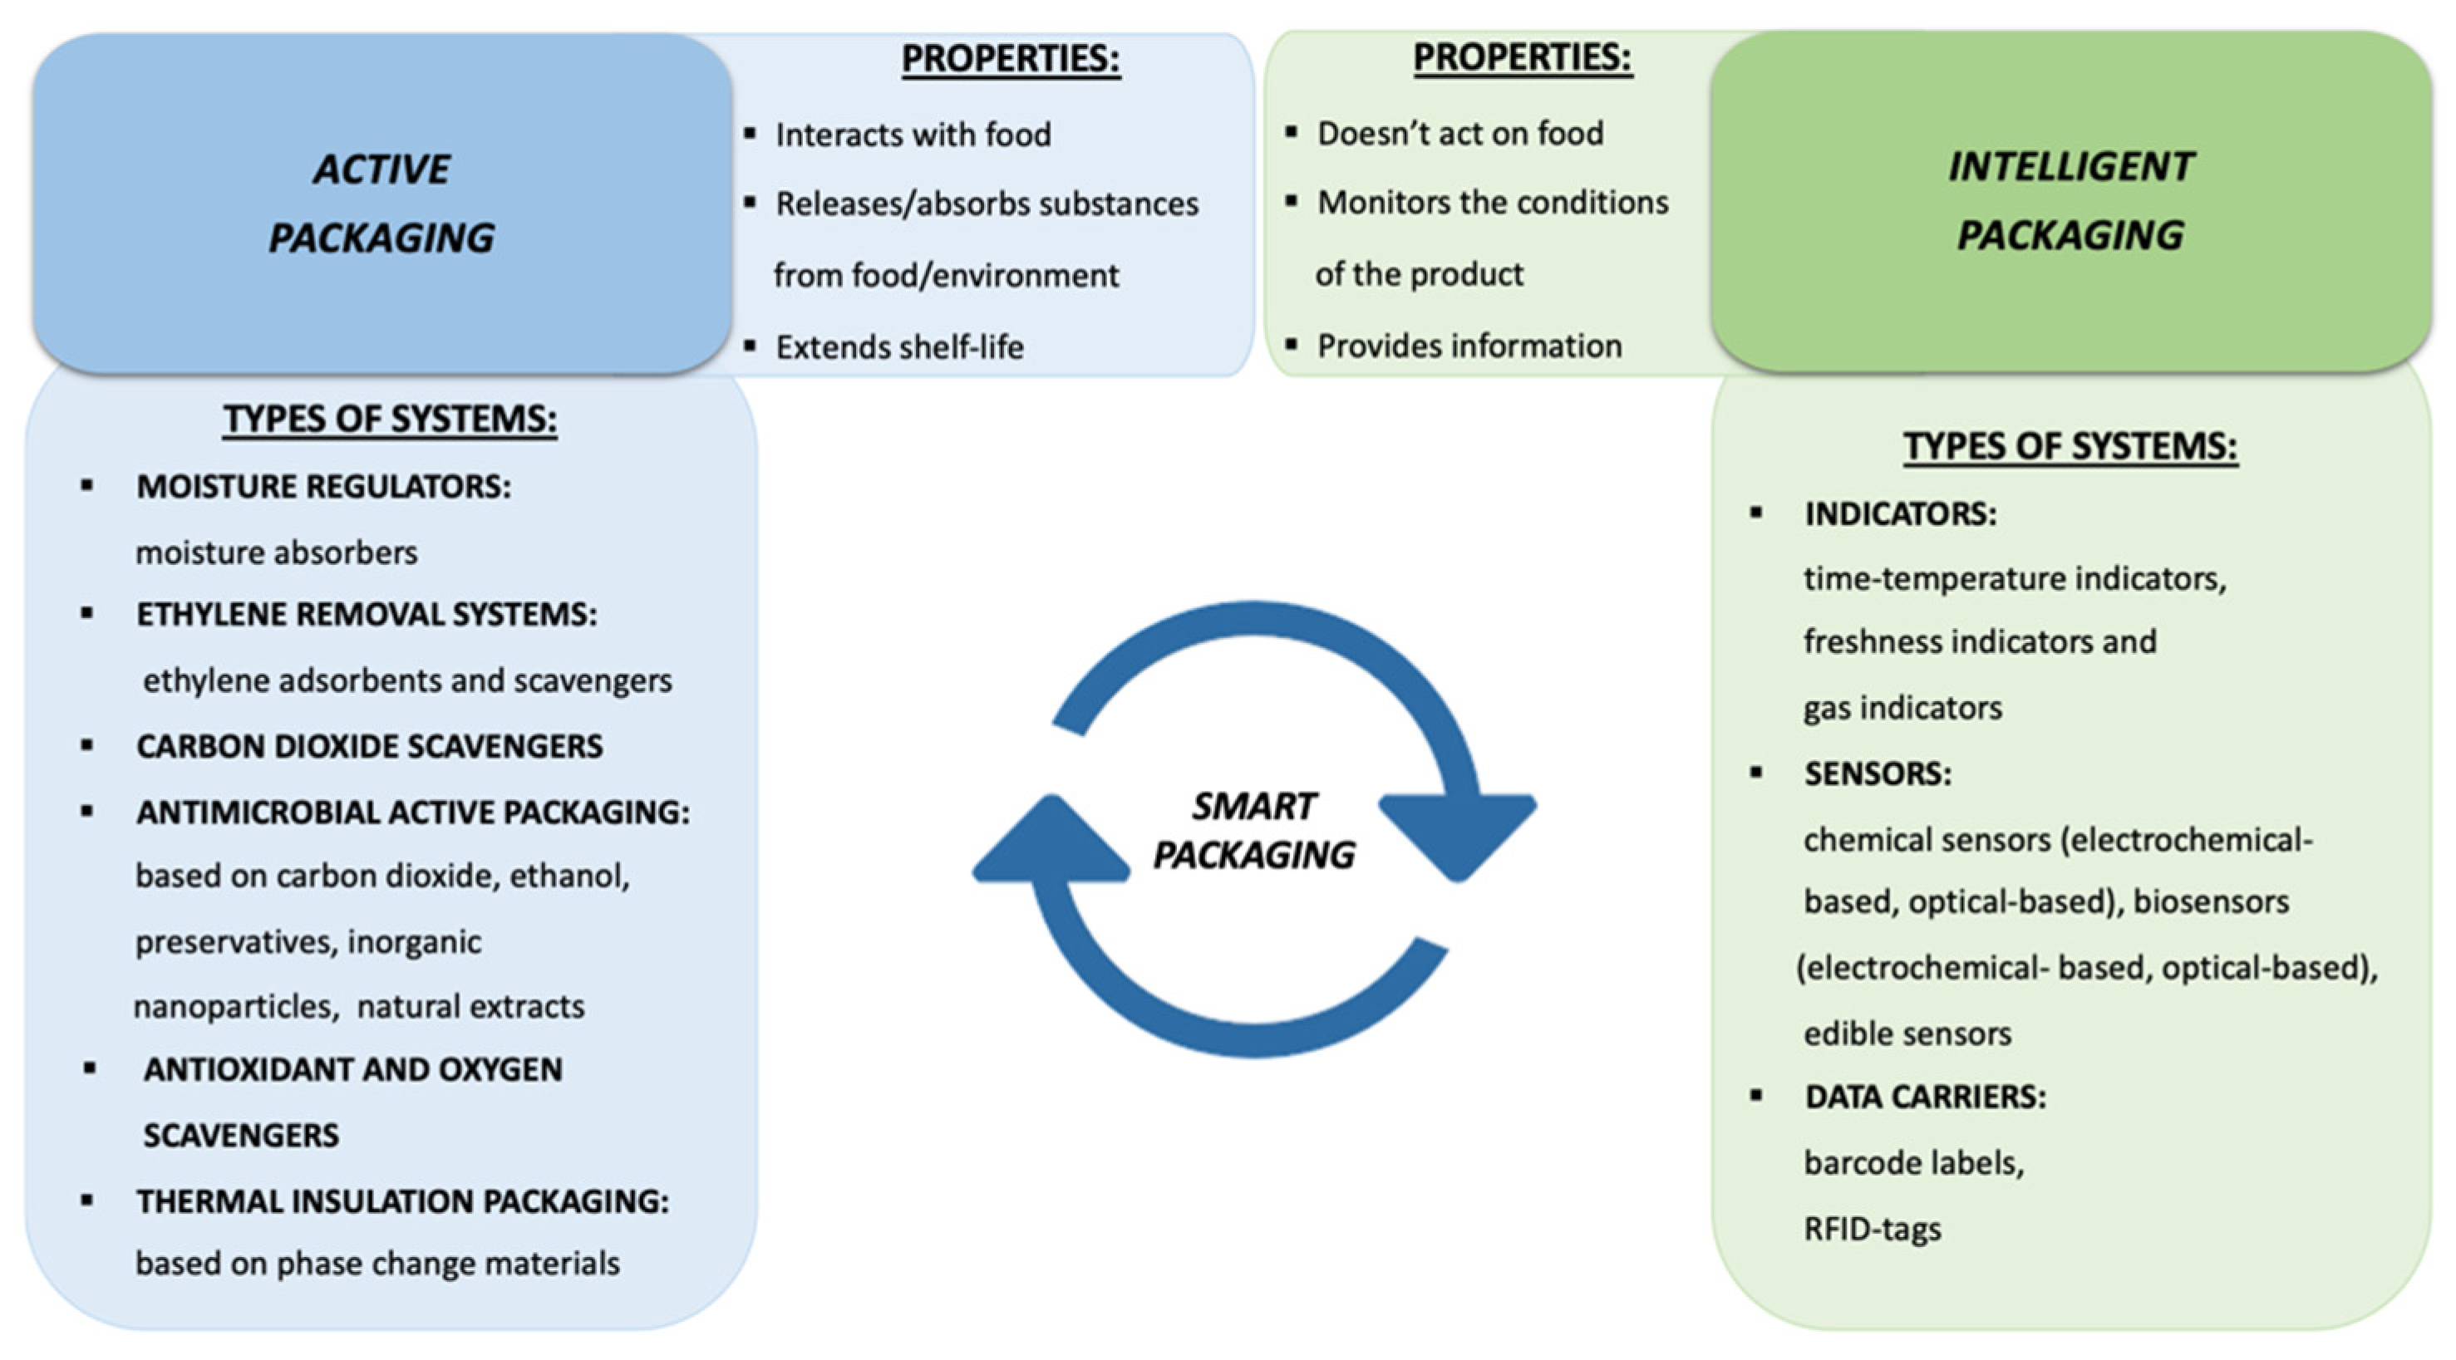
Figure 2: Active Packaging Vs Intelligent Packaging

Developing a Negotiation Strategy
To successfully complete a procurement in the pharmaceutical business, one must have a solid negotiating strategy. Securing the best deal is crucial, but it's also critical to check that the terms align with the company's long-term goals and core values. This is a how-to guide that will walk you through developing a sustainable strategy:
1. Set Clear Objectives:
- Purpose: Understand the primary goal of the negotiation. Is it cost reduction, quality assurance, long-term partnership, or a combination of these?
- Quantifiable Targets: Define specific targets, such as a percentage reduction in costs or a set quality benchmark.
- Flexibility: While it’s essential to have clear objectives, be prepared to adjust based on the negotiation dynamics.
2. Understand Your BATNA (Best Alternative to a Negotiated Agreement):
- Definition: BATNA is your best alternative if the negotiation fails. It’s the benchmark against which any proposed agreement should be measured.
- Strength: Knowing your BATNA gives you negotiation power. If the current deal isn’t better than your BATNA, you have the leverage to walk away.
- Continuous Assessment: As negotiations progress, regularly reassess your BATNA to ensure it remains relevant.
3. Research and Preparation:
- Supplier Insights: As discussed earlier, understanding your suppliers is crucial. Dive deep into their business models, motivations, and constraints.
- Market Trends: Stay updated with the latest trends in the pharmaceutical industry. This can provide valuable context during negotiations.
- Historical Data: Analyze past negotiations with the supplier or similar suppliers to identify patterns and potential areas of compromise.
4. Define Your Concessions:
- Prioritize: Determine which terms you’re willing to be flexible on and which are non-negotiable.
- Value Proposition: Understand the value of each concession from the supplier’s perspective. This can be a powerful tool during discussions.
5. Communication and Relationship Building:
- Open Dialogue: Foster a culture of open communication, ensuring that both parties feel heard and understood.
- Long-Term Vision: Focus on building a long-term relationship rather than just a transactional interaction. This can pave the way for more favourable terms in the future.

You can make sure that your procurement procedures support the goals of the business and preserve the careful balance between quality and cost by carefully planning your negotiation approach and being ready for any eventuality.

To successfully negotiate the procurement environment in the pharmaceutical sector, one must possess both tactical expertise and strategic vision. While it's not an easy undertaking, using the right tactics will help you achieve cost and quality balance.
More than simply financial savvy is needed to navigate the complex pharmaceutical sector; a careful balancing act between strategy, empathy, and foresight is needed. After completing this investigation, a number of important conclusions become clear:
- The art of negotiation is central to pharmaceutical procurement, where the stakes are not just financial but also pertain to product integrity and patient well-being.
- Understanding your suppliers, from their business models to their motivations, is foundational to crafting a negotiation strategy that benefits both parties.
- Developing a robust negotiation strategy involves setting clear objectives, understanding your BATNA, and being prepared for various scenarios.
- Specific tactics, such as leveraging volume discounts, diversifying the supplier base, and fostering collaborative partnerships, can help strike the right balance between cost and quality.
- Even in the face of challenging negotiations, a blend of patience, active listening, and relationship-building can pave the way for successful outcomes.
Aesthetic Appeal
Aesthetics is a body of knowledge that deals with the definition and evaluation of beauty. Design aesthetics are crucial since no buyer wants to purchase ugly icons or pictures. Rather, they would rather purchase goods that are visually appealing and would appear fantastic on their website, application, or presentation. Even if an image is unrelated to the work at hand, its aesthetic appeal can have an impact on how well someone performs in a time-sensitive situation.
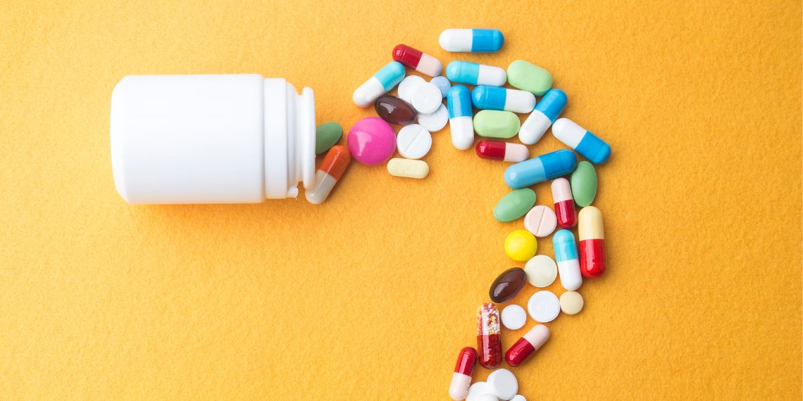
Figure 3: Aesthetic Appeal
Comparison Between Pharma & Food Packaging:
Pharma Packaging:
The right packaging for pharmaceutical items is essential to maintaining the quality and preservation of a drug, which is something that should never be compromised. The smallest leak in packaging might cause a product to go bad.
Food Packaging:
The materials used to encapsulate and safeguard food products are referred to as food packaging. Food packaging resists tampering and satisfies the physical, chemical, and biological requirements of the food product it holds in addition to provide physical protection.
The comparison as given below:
- Barrier Protection: Various sectors have various requirements for barrier protection in packaging. Compared to the pharmaceutical business, the amount of barrier protection required in food product packaging is comparatively minimal.
- Aesthetic View: In the food sector, packaging's aesthetic appeal is crucial to drawing in customers; however, in the pharmaceutical industry, aesthetic appeal is not necessary.
- Performance Test: In the pharmaceutical business, performance testing for packaging, like stack load and impact strength, are quite essential. These tests do not have the same weight in the food industry.
- Documentation: It is essential to record each stage of the packaging process when it comes to pharmaceutical products. As a result, much documentation is needed. Documentation plays a significant role in the food industry, however not as much as it does in the pharmaceutical sector.
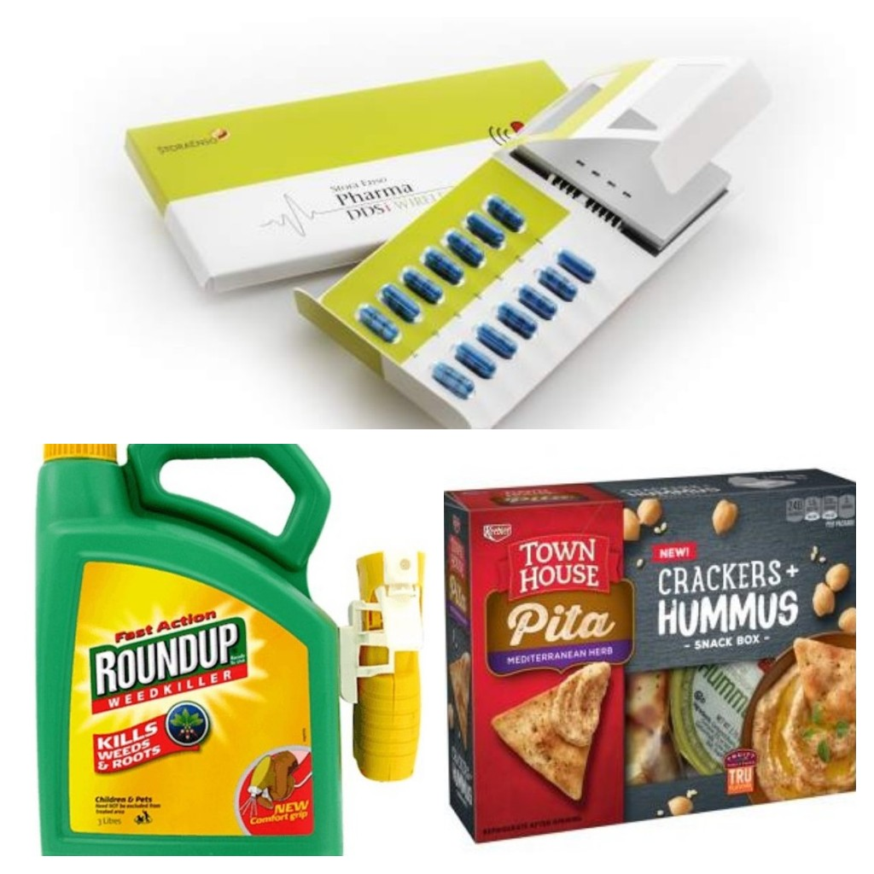
Figure 4: Pharma Packaging Vs Food Packaging

Sustainable Pharma Packaging:
The success of a product can be determined by comparing single-use, non-recyclable, and wasteful packaging with its environmentally friendly alternatives.
But changing materials isn't the only difficulty facing the pharmaceutical industry. An industry that ranks among the worst pollutants in the world is forced to strike a balance between meeting the demands of contemporary eco-conscious consumers and industry authorities regarding health and safety.
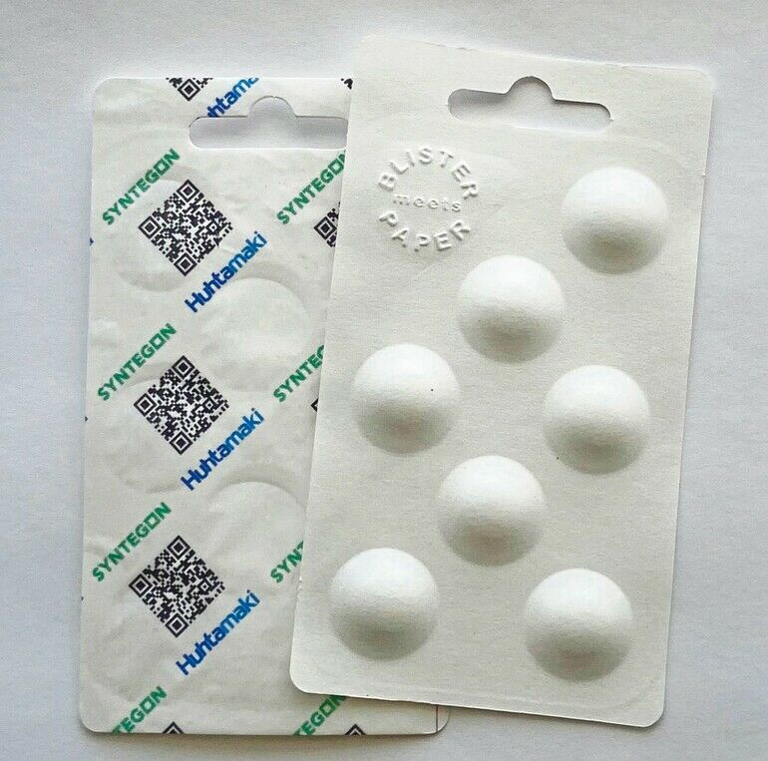
Figure 5: Sustainable Pharma Packaging

Identification of Problems with Overcoming Solutions:
Although manufacturers and packagers around the globe are still prioritizing sustainability in their work, the pharmaceutical sector has more obstacles than most.
When it comes to packaging design, many people place the highest value on aesthetic appeal and user experience. However, health and safety continue to be the top priorities when it comes to pharmaceutical products.
To maintain product integrity and performance, it is imperative that the items themselves be shielded from environmental elements such as humidity, temperature, light, oxygen, and other contaminants. However, the packaging also has an important role to play in safeguarding the patient.
This covers a variety of health and safety requirements, the most evident of which are kid resistance and preventing others from having access to potentially hazardous or harmful substances.
In addition to the potential for inadvertent ingestion, there are regulatory standards pertaining to component profiles and safe medication administration, which encompass product accessibility and dosing.
The difficulty, though, is that many of the materials that are crucial to delivering these health and safety benefits—such as preventing contamination and dispensing medication in the form of sprays, injectables, and blister packs—also pose sustainability issues.
To create pharmaceutical containers that are suitable for their intended use, a range of materials are frequently blended together, including metals, glass, cardboard, paper, and other plastic polymers. However, these mixtures cannot be recycled separately.
Comparably, producing such complex machinery requires an excessive amount of energy and resources; the pharmaceutical sector alone is accountable for 300 million tonnes of plastic trash annually, half of which is single-use.
Prevention of Waste:
Industry leaders are encouraged to think about waste prevention at the earliest feasible stage via reuse and recycle programs, since the waste hierarchy indicates that this prioritization of prevention is the most effective option. This entails testing environmentally friendly materials within the health and safety frameworks that regulate and restrict the pharmaceutical packaging sector.
- 3-D Visualization: Rather than sending products straight into the pricy and wasteful traditional testing stage, three-dimensional (3D) visualisation and printing technology are becoming more and more important in the packaging design stage. They allow for the controlled testing of novel sizes, shapes, and functionalities.
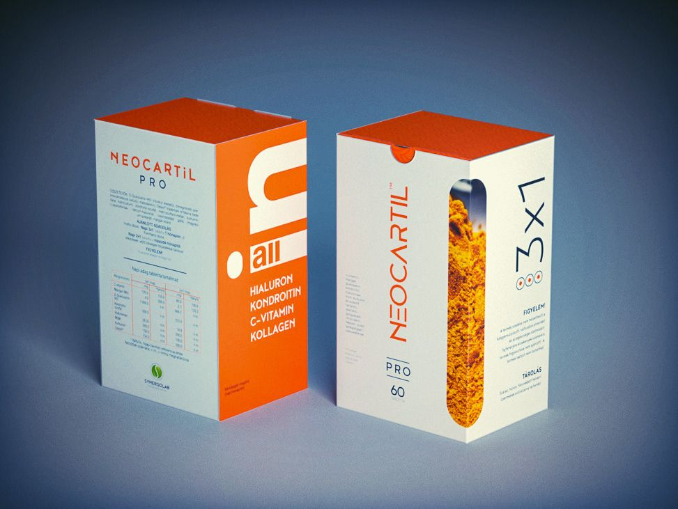
Figure 6: 3-D Visualization Packaging
- Eco Packaging: Rather than integrating various characteristics later in the supply chain, eco packaging incorporates essential product features right into primary and secondary packaging at the outset.
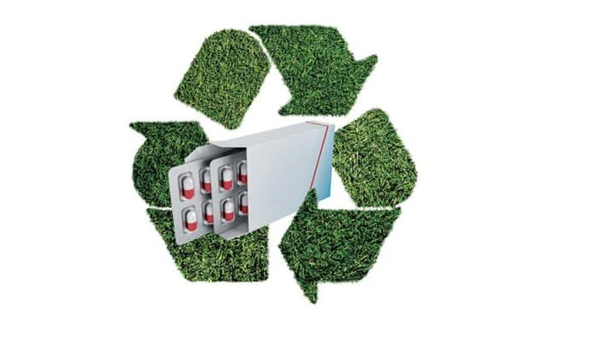
Figure 7: Eco-friendly Packaging
- Quick Response (QR) codes: In a similar vein, QR codes applied to bottles, containers, blister packaging, and other items enable patients to obtain digital versions of product dosage instructions and information about minimizing excess materials without sacrificing vital patient safety standards.
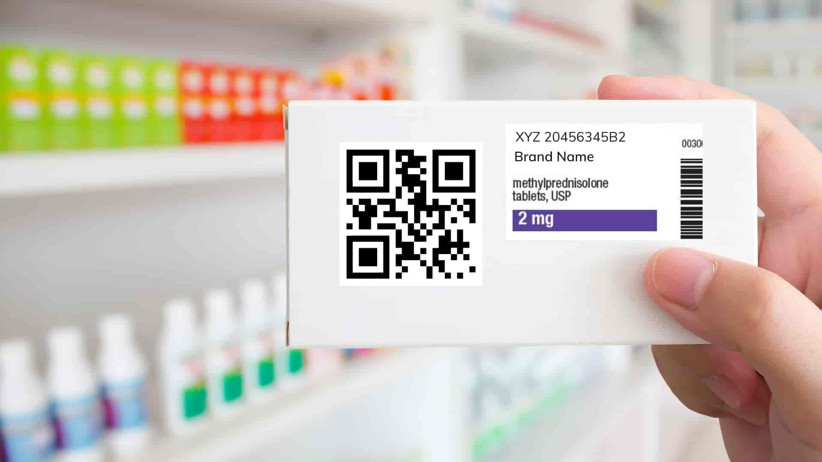
Figure 8: QR code Packaging

Conclusion:
Bio-based and renewable materials are now being researched by pharmaceutical packaging companies. Utilizing sugarcane ethylene, a carbon-negative process that uses carbon dioxide (CO2) and releases oxygen during cultivation, is one new innovation. Pharma packaging producers face bigger risks than nearly any other business when it comes to not meeting safety standards, therefore the issue is finding materials that can exceed green requirements without sacrificing integrity or performance.

References:
- Reppa, I., & McDougall, S. (2022). Aesthetic appeal influences visual search performance. Springer, 84(8), 2483–2506.
- Tsimiklis, P., Ceschin, F., Green, S., Qin, S., Song, J., Baurley, S., Rodden, T., & Makatsoris, C. (2015). A Consumer-Centric Open Innovation Framework for food and packaging manufacturing. International Journal of Knowledge and Systems Science, 6(3), 52–69.
- Zadbuke, N., Shahi, S. R., Gulecha, B., Padalkar, A. N., & Thube, M. (2013). Recent trends and future of pharmaceutical packaging technology. Journal of Pharmacy and Bioallied Sciences, 5(2), 98.
- Kenagy, J. W., & Stein, G. C. (2001). Naming, labeling, and packaging of pharmaceuticals. American Journal of Health System Pharmacy, 58(21), 2033–2041.
- Shafi, H., & Bajpai, M. (2023). A review on Importance of biodegradable packaging for foods and pharmaceuticals. Current Nutrition & Food Science, 19(1), 9–21.
- Priyadarshi, R., & Rhim, J. W. (2020). Chitosan-based biodegradable functional films for food packaging applications. Innovative Food Science and Emerging Technologies, 62, 102346.
- Ibrahim, I. D., Hamam, Y., Sadiku, R., Ndambuki, J. M., Kupolati, W. K., Jamiru, T., Eze, A. A., & Snyman, J. (2022). Need for sustainable packaging: An overview. Polymers, 14(20), 4430.
- Sustainable pharma packaging: breaking down the barriers to adoption. (2022, October 5). European Pharmaceutical Review.
- Dainelli, D., Gontard, N., Spyropoulos, D., Beuken, E. Z. D., & Tobback, P. (2008). Active and intelligent food packaging: legal aspects and safety concerns. Trends in Food Science and Technology, 19, S103–S112.
- Said, N. S., Howell, N. K., & Sarbon, N. M. (2021). A review on potential use of gelatin-based film as active and smart biodegradable films for food packaging application. Food Reviews International, 39(2), 1063–1085.
- Medley, S. (2008). The feeling’s neutral for pharmaceutical packaging: how the pharmaceutical aesthetic equals the Modernist aesthetic. Australasian Medical Journal, 146–151.
- Srivastava, P., Ramakanth, D., Akhila, K., & Gaikwad, K. K. (2022). Package design as a branding tool in the cosmetic industry: consumers’ perception vs. reality. SN Business & Economics, 2(6).
- Kulkarni, S., Agrawal, A., Sharma, S. B., & Jain, S. (2015). Creative innovations in pharmaceutical packaging. Indian Journal of Pharmacy and Pharmacology, 2(4), 230.
- Menditto, E., Orlando, V., De Rosa, G., Minghetti, P., Musazzi, U. M., Cahir, C., Kurczewska-Michalak, M., Kardas, P., Costa, E., Lobo, J. M. S., & Almeida, I. F. (2020). Patient Centric Pharmaceutical Drug Product Design—The Impact on Medication Adherence. Pharmaceutics, 12(1), 44.
- Rajput, K., & Pandey, R. K. (2022). Pharmaceutical Marketing: A Literature Review. International Journal of Engineering and Management Research, 12(2), 56–63.
- Wilson, M. W. (2016). Manufacturing platforms for Patient-Centric drug products. In AAPS advances in the pharmaceutical sciences series (pp. 447–483).
- Mohammad Asif, Mahtab Alam, & Qumre Alam. (1). Future of Pharmaceutical Marketing in India-An Extensive Review. International Journal of Pharma Professional’s Research (IJPPR), 14(3), 164-185.
- Singh, A., Sharma, P. K., & Malviya, R. (2011). Eco friendly pharmaceutical packaging material. World Applied Sciences Journal, 14(11), 1703-1716.
- Ashiwaju, B. I., Orikpete, O. F., Fawole, A. A., Alade, E. Y., & Odogwu, C. (2024). A Step toward Sustainability: A Review of Biodegradable Packaging in the Pharmaceutical Industry. Matrix Science Pharma, 7(3), 73-84.
- Mittal, S., Wadhwani, B., & Lakhani, M. (2021). Innovations in Pharma Packaging Technologies. Journal of Young Pharmacists, 13(3), 197.
- Shafi, H., & Bajpai, M. (2023). A Review on Importance of Biodegradable Packaging for Foods and Pharmaceuticals. Current Nutrition & Food Science, 19(1), 9-21.
- Dharmadhikari, S. (2012). Eco-friendly packaging in supply chain. IUP Journal of Supply Chain Management, 9(2), 7.
- Bassani, F., Rodrigues, C., Marques, P., & Freire, F. (2022). Ecodesign approach for pharmaceutical packaging based on Life Cycle Assessment. Science of The Total Environment, 816, 151565.

