BIOTECHNOLOGY IN VACCINES
TUSHAR DEWANGAN
UG Student, Department of Biotechnology, GD Rungta College of Science and Technology, Bhilai, Chhattisgarh
Corresponding author- tushardewangan232@gmail.com
- INTRODUCTION
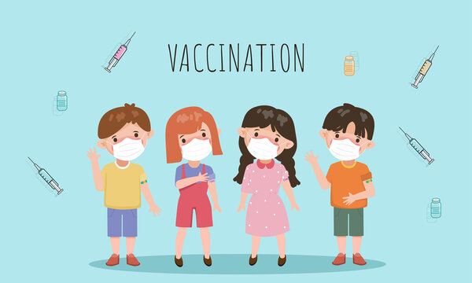
Vaccines are chemicals which are prepared biologically to fight against contagious diseases.They identify and fight disease causing agents such as bacteria and viruses.The primary goal of developing and administering vaccines is to create immunity within an individual so that the disease can not be spread in a community.
Vaccines can be administered through injections[subcutaneous and intramuscular] or can be taken orally.They play a determining role in fortifying the public from dangerous outbreaks.Researchers worldwide are tackling various concerns regarding the hesitancy and availability of vaccines.To maintain vaccination at higher rates the public should be educated and aftions should be made at global levels to fight against communicable diseases.
Disease like smallpox is completely eliminated from the world as a result of vast vaccination campaigns.Presently vaccines are contributing against diseases like polio,measle shepatitis etc.

- HISTORY
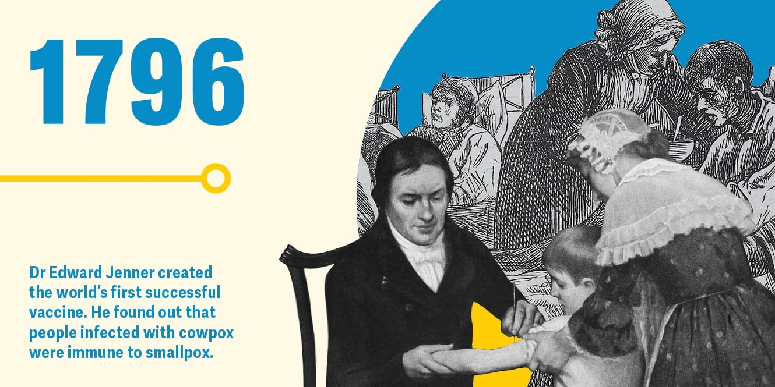
The term vaccine comes from a Latin word “vacca” which means cow.

The credit of establishing world’s first vaccine goes to Edward Jenner.He was a British physician.In 1796 he injected an 8 year old boy James Philips with pus extracted from cowpox wound. As result of which the boy developed some fever and restlessness.Later, Jenner administered Philips with various substances as a routine method of inoculation at that time.It was found that Philips never went through smallpox later in his life.Jenner then got to know that if a person is inoculated with cowpox, he or she can become immune to small pox disease.He was later came to be recognized as the “FATHER OF IMMUNIZATION”.
In 1885 a vaccine for rabies was advantageously developed by Louis Pasteur by the process of vaccine attenuation[weakening].
Between 1960s to 1970s vaccines for MMR[Measles, Mumps, Rubella] were introduced.
Vaccine for HPV[Human papiloma virus] a major causative agent of cervical cancer in females was introduce in 2006.
The latest case of vaccine development is the covid vaccines which were developed in 2020.

- DEFINITION
Vaccine: Vaccine can be defined as a biological production that works by stimulating the immune system by remembering,recognizing and defending against harmful pathogens like bacteria and viruses.
Vaccination: Vaccination can be defined as the process of delievering vaccine for the immune system to stimulate and provide protection against harmful disease causing pathogens.

- TYPES OF VACCINES
Each particular type of vaccines has its own benefits and mediations.the selection of vaccine depends upon various factors such as causative agent,harmlessness, and productiveness.
Inactivated vaccines contains weakened from of live virus.
Virus Like Particle[VLP vaccines] mimic the structure of viruses but they don’t have the genetic material for replication.
Vector vaccines use a non dangerous virus vectorfor the delievery of genetic material.
Below is the picture of various types of vaccines:

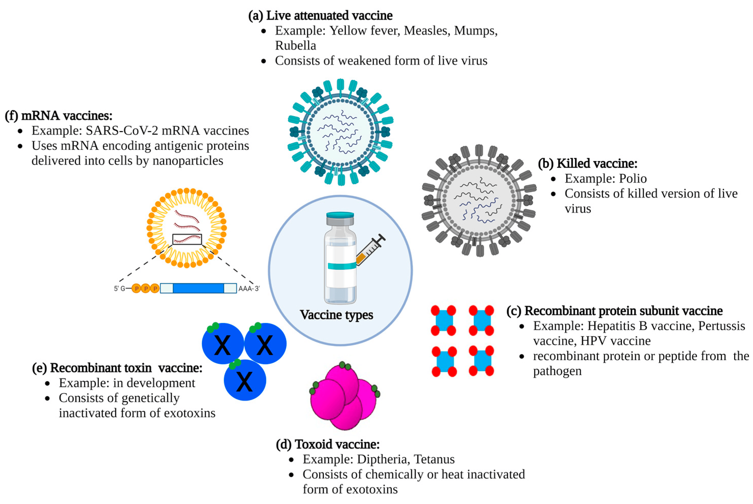

- ROLE OF BIOTECHNOLOGY IN COVID19 VACCINE
The medical biotechnologists started their research even before the pandemic was reported in their country. The most effective solution against the pandemic were vaccines the production of which falls under the field of medical biotechnology.There were three clinical trial phases before which the vaccine was administered publicly: Pre-clinical, Phase 1, Phase 2 and Phase 3.

- THE MANUFACTURING OF COVID VACCINES IN INDIA
Covishield was developed by Serum Institue of India.
Covaxin was developed by Bharat Biotech.
CorBEvax is manufactured by Biological E Ltd.
Covovax developed by Serum Institute of India.
ZyCoV-D developed by Zydus Cadila.

- TRADITIONAL BIOTECHNOLOGICAL VACCINE PRODUCTION METHODS
Researchers first had to grow the bacteria or viruses in large quantites and consistency to manufacture the vaccines which can be fabricated at a mass level.Viruses cannot replicate by themselves whereas a bacteria can be grown in a laboratory if provided a suitable growth medium.Therefore material for bacterial vaccines can be grown in a lab without laboratory animals whereas to develop material for viral vaccines the researchers face an additional challenge.Since the techniques for growing viruses outrside living hosts are unavailable the researchers are limited to obtain materials from infected animal hosts.the researchers in their early efforts for developing a vaccine against polio got to know that the virus can harm monkeys too and not only humans.

- MODERN BIOTECHNOLOGICAL VACCINE PRODUCTION:
Modern biotechnological methods have significantly advanced vaccine development, enabling the creation of vaccines that are safer, more effective, and faster to produce

- Cell-Culture Technology:Uses mammalian or insect cells for the production of vaccines, moving away from traditional methods involving chicken eggs.

- Adjuvants: Adjuvants are substances added to vaccines to enhance the immune response.
Research Focus: Ongoing research aims to develop novel adjuvants to improve the effectiveness and longevity of immune responses.

- Reverse Vaccinology:Involves using genomic information to identify potential vaccine targets without culturing the pathogen.

- Structural Biology and Computational Approaches:Techniques like cryo-electron microscopy and computational modeling help researchers understand the three-dimensional structures of pathogens, facilitating the design of targeted vaccines.

- ROLE OF BIOREACTOR TECHNOLOGY FOR CELL CULTURE BASED VIRAL VACCINE PRODUCTION

Below is the diagramatic representation of application of bioreactor cell culture technology:
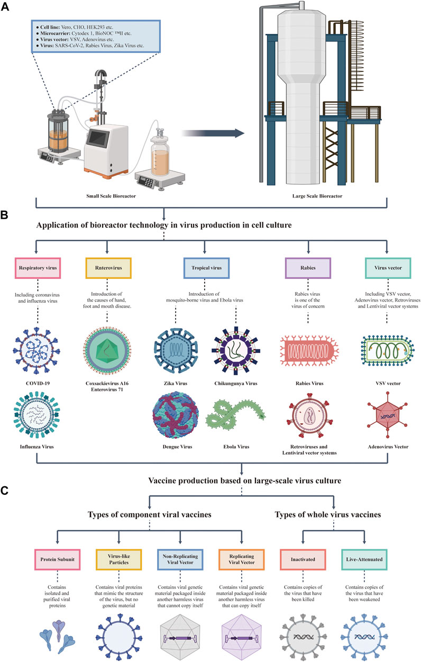
- RECOMMENDATION FOR POLICYMAKERS, RESEARCHERS AND HEALTHCARE PROFESSIONALS TO ADDRESS CHALLENGES AND HARNESS THE FULL POTENTIAL OF BIOTECHNOLOGY IN VACCINES

By implementing these recommendations, stakeholders can collectively contribute to overcoming challenges, maximizing the benefits of biotechnology in vaccines, and ensuring the global population receives the most effective and innovative immunization strategies available. Collaboration, education, and adaptability are key elements in navigating the evolving landscape of biotechnological vaccine development and deployment.

For Policymakers:
1.Investment in Research and Development:
- Allocate funding for research and development in biotechnology, supporting innovation in vaccine development.

2.Regulatory Frameworks:
- Establish clear and adaptive regulatory frameworks that facilitate the approval of cutting-edge biotechnological vaccines while ensuring safety and efficacy.

3.Public Health Campaigns:
- Implement robust public health campaigns to educate the public on the importance of biotechnological vaccines, dispelling myths and addressing vaccine hesitancy.

4.Global Collaboration:
- Foster international collaboration to share resources, knowledge, and best practices in biotechnological vaccine development, particularly during global health crises.

5.Incentives for Industry Collaboration:
- Provide incentives, such as tax credits or grants, to encourage collaboration between biotech companies, pharmaceutical industries, and academic institutions for vaccine development.

For Healthcare Professionals:

- Education and Training:
- Provide ongoing education and training for healthcare professionals on the latest biotechnological advancements in vaccines, ensuring they can effectively communicate with the public.

- Community Engagement:
- Engage with local communities to understand their concerns, address misinformation, and build trust in biotechnological vaccines.

- Integration of Digital Technologies:
- Utilize digital technologies for improved vaccine distribution, monitoring, and communication, enhancing overall healthcare infrastructure.
- Adaptive Healthcare Systems:
- Develop adaptive healthcare systems capable of rapidly integrating new biotechnological vaccines into routine immunization schedules.

- Patient-Centric Approaches:
- Adopt patient-centric approaches in vaccine delivery, taking into account individual preferences and ensuring personalized healthcare.

- COMPARATIVE ANALYSIS OF ADVANTAGES AND DISADVANTAGES OF VACCINES-
Advantages of Vaccines:
- Disease Prevention:
Vaccines are effectual in preventing infectious diseases, reducing the spread of pathogens within communities.

- Public Health Impact:
Vaccination programs have contributed to the control and even elimination of certain diseases, such as smallpox.

- Global Health Improvement:
Vaccines play pivotal role for control of diseases across borders.

- Cost-Effective:
Vaccination are economic than treating diseasesthey , as it decreases load on healthcare systems.

- Long-Term Protection:
Vaccines can provide long-lasting immunity, sometimes for a lifetime, preventing recurrent infections.

Disadvantages and Challenges of Vaccines:

- Logistical Challenges:
Proper storage and distribution of vaccines, especially in remote or resource-limited areas, can be challenging.

- Emerging Variants:
Viruses can mutate, potentially reducing the effectiveness of existing vaccines against new variants.

- Rare Adverse Events:
In very rare cases, some vaccines have been associated with serious adverse events. However, the benefits of vaccination typically outweigh the risks.

- Incomplete Protection:
While vaccines are highly effective, they may not provide 100% protection, and breakthrough infections can occur.

- Limited Coverage:
In some cases, not all individuals within a population may have access to vaccines, leading to disparities in coverage.

- Research and Development Challenges:
Developing vaccines for certain diseases can be challenging, and not all infectious diseases have effective vaccines.

- CONCLUSION
Vaccines represent one of the most significant advancements in public health, playing a pivotal role in preventing and controlling infectious diseases. These biological preparations stimulate the immune system by introducing antigens, typically derived from weakened or inactivated forms of pathogens.

- REFERENCE

1]Schlake T, Thess A, Fotin‐Mleczek M, Kallen KJ. Developing mRNA‐vaccine technologies. RNA Biology. 2012;9(11):1319-1330. DOI: 10.4161/rna.22269

2]Plotkin SA. Vaccines: Past, present and future. Nature Medicine. 2005;11(4 Suppl):S5‐S11. DOI: 10.1038/nm1209

3]Skibinski DA, Baudner BC, Singh M, O’Hagan DT. Combination vaccines. Journal of Global Infectious Diseases. 2011;3(1):63-72. DOI: 10.4103/0974‐777X.77298, DOI:10.4103%2F0974‐777X.77298#pmc_ext

4]Ferraro B, Morrow MP, Hutnick NA, Shin TH, Lucke CE, Weiner DB. Clinical applications of DNA vaccines: Current progress. Clinical Infectious Diseases. 2011;53(3):296-302. DOI: 10.1093/cid/cir334

5]Cockrell AS, Baric RS. An effective DNA vaccine platform for Middle East respiratory syndrome coronavirus. Annals Translational Medicine. 2016;4(24):499. DOI: 10.21037/atm.2016.11.40

6]Hansson M, Nygren PA, Stahl S. Design and production of recombinant subunit vaccines. Applied Biochemistry and Biotechnology. 2000;32(Pt 2):95-107. DOI: 10.1042/BA20000034

7]Alessandro S, Rino R. Review: Reverse vaccinology: Developing vaccines in the era of genomics. Immunity. 2010;33(4):530-541. DOI: 10.1016/j.immuni.2010.09.017

8] Khan S, Muhammad Wajid Ullah, Rabeea Siddique, Ghulam Nabi, Sehrish Manan et al. (2016) Role of recombinant DNA technology to improve life. International journal of genomics.

9] (WHO) W.H.O. Immunization,Vaccines and Biologics.

10] Dauphin G, S Zientara (2007) West Nile virus: recent trends in diagnosis and vaccine development. Vaccine 25(30): 5563-5576

11] Pardi N, Michael J Hogan, Frederick W Porter, Drew Weissman (2018) mRNA vaccines-a new era in vaccinology. Nature reviews Drug discovery 17(4): 261.

12] John, S. et al. Multi-antigenic human cytomegalovirus mRNA vaccines that elicit potent humoral and cell-mediated immunity. Vaccine 36, 1689–1699 (2018).

13] Midoux, P. & Pichon, C. Lipid-based mRNA vaccine delivery systems. Exp. Rev. Vacc. 14, 221–234 (2015).

14] Badraoui, R.; Alrashedi, M.M.; El-May, M.V. Acute respiratory distress syndrome: A life threatening associated complication of SARS-CoV-2 infection inducing COVID-19. J. Biomol. Struct. Dyn. 2021, 39, 6842–6851. [Google Scholar] [CrossRef]

15] Kupferschmidt, K.; Cohen, J. Will novel virus go pandemic or be contained? Science 2020, 367, 610–611. [Google Scholar] [CrossRef] [Green Version]

INTRODUCTION OF WRITER

The topic BIOTECHNOLOGY IN VACCINES is written by TUSHAR DEWANGAN from Bsc Biotechnology 2nd year. I chose this topic because Biotechnology plays a vital role in the development of crucial vaccines for a variety of diseases in which one of the major vaccine developed was of COVID19. I hope my research will provide a deep insight on the types of vaccines and various technologies involved vaccine development.

