**Chapter 1: General Virology**

**Properties of viruses**

In the complex microscopic world, viruses emerge as mysterious beings, small but powerful, capable of changing the fabric of life. Outside the visible spectrum, virus represents a class of entities that straddle the line between living and non-living things without the cellular apparatus necessary for autonomous living, these molecular architects of illness possess an amazing capacity to enter the cellular environments of every living thing, ranging from the smallest bacterium to the most intricate multi-cellular beings, such as humans. However, despite the threat they pose, viruses have also become important tools in biotechnology and scientific discovery, revealing unexpected opportunities for treatment, disease and technological developments.

Some of the Key features of the virus are-

**1. Size-**

* Viruses are too small (about 20 to 300 nm in diameter) to be seen under the light microscope, hence called as ‘ultramicroscopic’.
* The size and shape of viruses are determined by the quantity and configuration of their proteins and nucleic acids.
* Although viruses thought to be smaller than the bacteria, certain strains of Mycobacteria can be 10 times smaller than the viruses. Most phages range in size from 24-200 nm in length (Figure 1; Table 1).

**Table 1: Description of size of viruses**

|  |  |  |
| --- | --- | --- |
| Virus size | | |
| Types | **Small** | **Large** |
| Animal viruses | Picornaviridae (Smallest animal virus, about 20-30 nm) | Poxvirus (Largest animal virus, around 250 to 300 micron) |
| Plant viruses | Tobacco necrosis satellite virus (smallest  plant virus-18 nm | Recently discovered very large viruses that  infect amoebas:  Megavirus-400 nm  Mimivirrus-750 nm  Pandoravirus-Elliptical or ovoid, 1000 nm  Citrus tristeza (positive sense ssRNA, largest plant virus) |

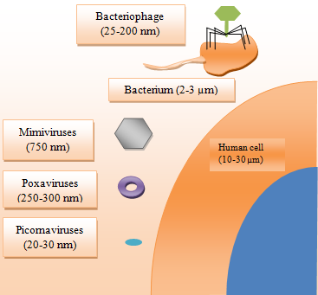

**Figure 1: Human viruses usually range in size from 20 to 200 nm in diameter. In contrast, bacteria are typically 2–3 μm long, while an average human cell measures between 10 and 30 μm.**

**2**. **Genetic material**-

* Viral genomes contain either RNA or DNA (Table 2), which can be double-stranded (ds) or single-stranded (ss).
* A typical viral genome ranges from 7,000 to 20,000 base pairs (7–20 kilobases).
* While most viruses have small genomes, some dsDNA viruses, like herpesviruses, have larger genomes of 120–200 kb, and pandoraviruses can have genomes up to 2.5 million bases.
* "Sense" and "antisense" refer to the orientation of the RNA transcript but not the DNA strand itself; either DNA strand can act as the sense or antisense strand.

**Table 2: Types of viral RNA and their characteristics**

|  |  |  |
| --- | --- | --- |
| Type | Description | Example |
| Positive-sense/+sense (5′-to-3′) | Viral RNA genome can act as mRNA and be immediately translated by the host cell. | Coronaviridae |
| Negative-sense/- sense (3′-to-5′) | Complementary to viral mRNA; requires an RNA-dependent RNA polymerase to produce a positive-sense RNA before translation. | Influenza |
| Ambi-sense | Single-stranded genome utilized in both positive-sense and negative-sense capacities. | Bunya (3 ssRNA), Arena [3 (-) ssRNA except part of the 5′ ends of the large and small segments]. |

**3. Obligate intracellular parasite**-

Viruses are named as such because they entirely rely on the host cell's internal environment to produce new infectious particles, or virions.

**4. Structure-**

The structure of viruses can be determined using X-ray crystallography, X-ray fiber diffraction, cryo-electron microscopy (cryoEM), and cryo-electron tomography (cryo-ET). Before a virus can infect other cells or individuals, it must be released from the host cell. Regardless of whether their nucleic acids are dsDNA, ssDNA, dsRNA, or ssRNA, viruses must protect their genomes. When exposed to external environment, the virus may experience enzymatic breakdown, physical stress (air or fluid movement that can cause nucleic acid degradation) and may be susceptible to ultraviolet radiation or electric damage. If neuclic acid undergo any of this damages, it is unable to produce new virions.

**Capsid-** To protect the delicate nucleic acid from the hostile environment, the virus wraps it with a protein shell known as the capsid (Figure 2), derived from the Latin capsa, which means "box." The capsid is made up of one or more different types of proteins that repeat themselves to build the whole capsid, much as how numerous bricks join together to form a wall. This repeated arrangement results in a robust but slightly flexible capsid. The capsid's tiny size makes it physically tough to break open and adequately protects the nucleic acid inside. The nucleic acid and capsid constitute the nucleocapsid of the virion. The capsid consists of a finite number of protein subunits referred to as capsomeres, typically associating with or being in close proximity to the nucleic acid within the virion. Viruses primarily exhibit two main shapes for their capsids: helical and icosahedral.

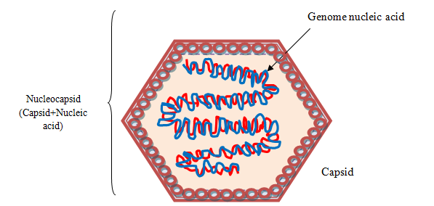

**Figure 2: Virus structure of virus** - Viral genome nucleic acid is protected by protein capsid. Nucleocapsid consists of both the capsid and nucleic acid.

**i. Helical-** In helical capsids (Figure 3), the capsomers are arranged in a helical or spiral pattern around the viral genetic material, which is often a single-stranded RNA. The entire structure resembles a helix. Examples of viruses with helical capsids include the tobacco mosaic virus (rod-shaped virus), rabies virus (bullet-shaped virus) and influenza virus (spherical shaped virus). Helical viruses can either have an envelope (e.g., influenza virus, measles virus, mumps virus, rabies virus, Ebola virus) or be naked (plant viruses). The tobacco mosaic virus is a well-studied example of a helical rod-shaped virus, crystallized by Wendell Stanley in 1935. The length of the helical virus capsid is dictated by the length of the nucleic acid molecule, which serves as the scaffold for assembling the capsid proteins.

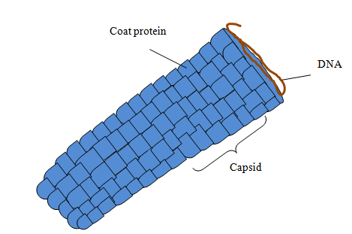

**Figure 3: Helical capsid structure**

**ii. Icosahedral-**

* The capsomers are symmetrical, 20-sided polyhedron known as an icosahedron. This is a geometric shape with 20 equilateral triangle faces, 12 vertices, and 30 edges.
* Icosahedral viruses (Figure 4) can be naked (human papillomavirus, rhinovirus, adenovirus) or enveloped (herpesvirus, hepatitis B, influenza virus) as well. Virions exhibit rotational symmetry across three axes: fivefold, threefold, and twofold (2–3–5 symmetry).
* Viral proteins constitute the faces of the icosahedral capsid, each face being a small triangle. A face is created by assembling at least three viral protein subunits (identical or different) and forms the structural unit. This repeats to construct the complete capsid of the virion.
* The larger sides of the icosahedron in virions are created by repeating structural units, and the number of these units forming each side is referred to as the triangulation number (T). This term describes how many units shape each triangular face of the icosahedron. For example, a T = 1 virus has one unit per face, while a T = 4 virus has four units per face. In T = 3 viruses, three units form each face, overlapping to create six half-units spanning adjacent faces. Similarly, T = 7 viruses have units that slightly skew compared to the triangular face.
* In icosahedral viruses, capsomeres typically appear as pentons (consisting of five units) or hexons (consisting of six units), forming distinct patterns on the surface of the icosahedrons.

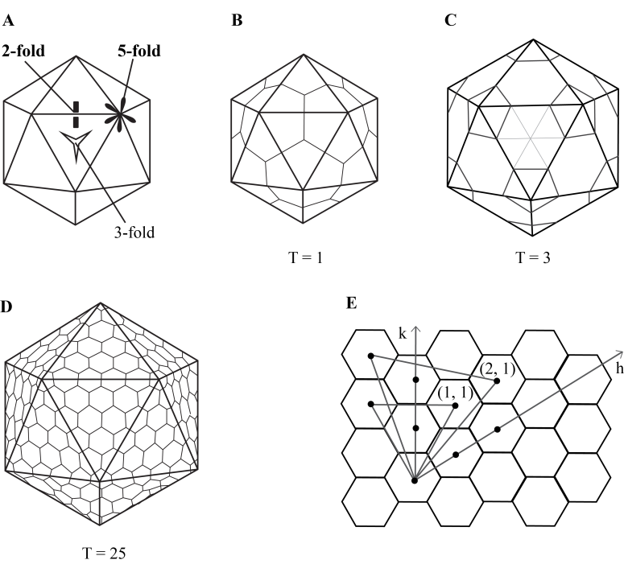

**Figure 4: Icosahedral structure.** A) An icosahedron, B) T=1, C) T=3, D) T=25, E) The geometric principle behind forming surface lattices for icosahedral structures (Karhu, 2006).

**iii. Complex capsid structure**-

* Some viruses have a more complex capsid structure that does not fit strictly into the helical or icosahedral categories. These viruses may have additional features, such as tails, fibers, or other irregular shapes. Examples include* bacteriophages (Figure 5A & B), which infect bacteria.
* A complex capsid is a combination of helical and icosahedral shapes. Examples of viruses with complex structures include poxviruses, geminiviruses and bacteriophages.
* Complex capsid viruses exhibit more intricate and varied shapes. The complexity of their capsids allows for greater flexibility in accommodating genetic material and may contribute to their ability to infect a diverse range of hosts. Poxviruses, such as those causing smallpox or cowpox, are large, oval or brick-shaped particles measuring 200–400 nm in length. The complex virion features a dumbbell-shaped core that contains the viral DNA, flanked by two "lateral bodies."
* **Bacteriophage:** Bacteriophages (Figure 5) were discovered by Frederick Twort and the term "bacteriophage" was coined by d'Herelle. Bacteriophages typically range from 24-200 nm in length. The head or capsid, which varies in size and shape, encloses the nucleic acid. The tail fibers aid in host recognition and attachment, while the base plate facilitates phage binding to the bacterial cell surface. Bacteriophages have two main life cycles:

1. **Lytic Cycle**: The phage attaches to the bacterium, injects its genetic material, and takes over the bacterial machinery to produce new phages. This results in the lysis (bursting) of the bacterial cell and the release of new phages.
2. **Lysogenic Cycle**: The phage's genetic material is integrated into the host bacterium's genome, where it can remain dormant for a period of time. The phage DNA is replicated along with the host DNA during cell division. Environmental triggers can later activate the lytic cycle.

* Phages are used as tools in genetic engineering and molecular biology research. Phage therapies are being explored as alternatives to antibiotics, especially against antibiotic-resistant bacteria.

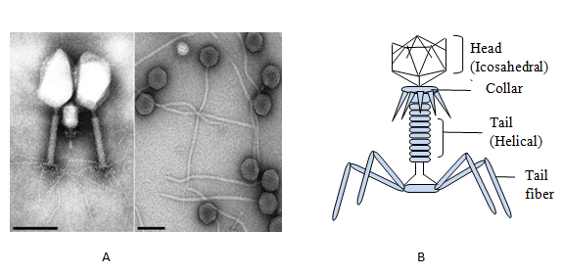

**Figure 5: Complex structure of bacteriophage.** A. Bacteriophage under electron microscopy B. Complete structure of bacteriophage (both the icosahedral and helical forms are present).

Functionally, the capsid plays three essential roles:

1. It functions as a protective barrier, shielding the genetic .23material from the effects of digestive enzymes.
2. Utilizing specific sites within its structure, the capsid facilitates attachment to the host cell membrane.
3. The capsid contains enzymes or proteins that enable the virion to penetrate host cell membranes and transport the nucleic acid into the host cells.

**Envelope-**

* The majority of viruses possess protective lipid membrane around the capsid, called as envelope. The envelope originates from cell membranes, typically the plasma membrane, through budding; consist of phospholipids and neutral lipids, predominantly cholesterol.
* It may also derive from endoplasmic reticulum, Golgi complex, or the nuclear membrane, depending upon virus. The envelope is connected to the capsid by matrix protein. Lipoprotein envelopes form unit membranes comprising two lipid layers interspersed with proteins (lipoprotein bilayers).
* Some of the Viruses lack the presence of envelope and are known as non-enveloped or naked virus.
* A virus attachment protein (facilitates virus entry by enabling the virus to dock onto the plasma membrane.) incorporated in its outer-most layer and is located in the capsid (naked virus; Figure 6A), or the envelope (enveloped virus; Figure 6B).
* Examples of enveloped viruses are influenza, human cytomegalovirus, HIV, respiratory syncytial virus, vaccinia virus and SARS-CoV-2; and non-enveloped viruses are adenovirus, human papillomavirus, polyomavirus.

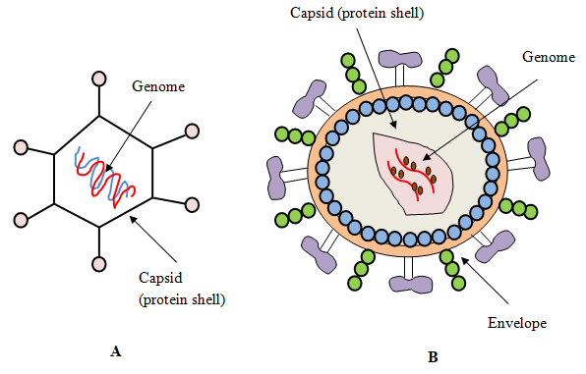

**Figure 6: Comparative structure of naked and enveloped virus.** A. Naked virus B.

Enveloped virus

**Chemical properties of virus-**

**A. Nucleic acids-**

* All viral genomes are haploid, containing a single copy of each gene, except retrovirus genomes, which are diploid. Viral DNA or RNA can be double-stranded (ds) or single-stranded (ss).
* By 1985, the complete genome of Epstein-Barr virus, consisting of 172 kilobase pairs, was sequenced.
* The (+) sense RNA of retroviruses is not infectious because replication occurs only after a DNA provirus is produced by a virion-associated reverse transcriptase.
* All DNA consist of a single molecule, typically double-stranded, except for parvoviruses, and can be linear or circular. The DNA of papovaviruses and hepadnaviruses is circular.
* The circular DNA of papovaviruses forms a supercoiled circle, or superhelix, within the virion, resembling the DNA of bacterial plasmids and mitochondria.
* The linear dsDNA of some herpesviruses and the linear ssRNA of retroviruses contain repeat sequences at the ends of the molecule. Certain iridoviruses (genus Ranavirus) have a high percentage of 5-methylcytosine instead of cytosine.
* Viral DNA genomes ranges from 4.5 kilobases (kb) to over 200 kbp, whereas ssRNA varies from 7.5 to 22 kbp. RNA can be categorized based on its polarity or sense.
* Three methods are available for extracting nucleic acids: (i) phenol-chloroform, an organic extraction procedure; (ii) proteinase K and salting out, an inorganic extraction method; and (iii) NCM/Nylon membrane, a kit approach for nucleic acid separation.

**B. Protein-**

**1. Structural proteins:** Structural proteins are the part of the virion and provide protections to the viral genome. Targeting structural proteins can disrupt the ability of virus to infect host cells and are essential for developing antiviral drugs and vaccines. These proteins are crucial for virus attachment and entry to the host cell. They are consists of:

1. **Capsid Proteins**- Provide outer protective coat to the genetic material. It gives structural integrity. Capsid proteins assemble in the virion to generate capsomers, which are observed in electron micrographs. Examples of capsid proteins are-p24 of HIV, HBcAg of Hepatiis B virus, VP5 of herpes simplex virus, VP1-VP4 of poliovirus.
2. **Envelope Proteins-** The viral envelope proteins are made up of glycoproteins (proteins with attached carbohydrate molecules) and are the smallest structural proteins. Glycoproteins promote viral fusion with the host cell membranes during cellular infection. The peplomers that protrude from the envelope are composed of glycoprotein. Examples are-Influenza viruses have surface glycoproteins Hemagglutinin (HA) and Neuraminidase (NA), gp120 and gp41 of HIV, L1 glycoprotein of human papillomavirus.
3. **Matrix (Membrane) Proteins-** Enveloped viruses contain matrix proteins (most abundant protein) beneath their viral envelope. Matrix proteins connect envelope to the capsid and stabilize virus structure.. M1 protein of influenza, p17 of HIV, M protein of paramyxovirus and coronavirus.
4. **Spikes or Peplomers-** These proteins are protruding structures on the surface of the virus, usually composed of glycoproteins. They help in attachment of the virus with host cell receptors on the cell surface and facilitates virus entry into the host cell. Spike (S) protein of SARS-CoV-2 binds to the angiotensin-converting enzyme 2 (ACE-2) receptor of human cell to facilitate virus entry. Rabies virus has 400 peplomers on its surface.

**2. Non-structural proteins (NSPs):** Viruses encode non-structural protein but they are not a part of mature virion particles. NSPs are multifunctional and play crucial role in virus replication, transcription, and evasion of the host immune response. Here are some common examples:

1. **Polymerases-** Some of the viruses encode their own RNA-dependent RNA polymerases (RdRp) or DNA polymerases as non-structural proteins. These are essential for replicating the viral genome. Example- NS5 of flaviviridae, NSP12 of coronaviridae.
2. **Proteases-** Proteases cleave viral polyproteins into functional units. This in turn helps in maturation of the virus and its ability to replicate. Examples- 3c and 2A of picornaviridae, NS3 of flaviviridae.
3. **Helicases-** Helicases unwind the double-stranded nucleic acid during replication or transcription. Examples- NS3 of togaviridae, NSP13 of coronaviridae.
4. **Methyltransferases-** Many viruses encode methyltransferases that modify viral RNA to evade host detection or improve translation efficiency. Examples-NSP13 of coronaviridae, VP39 of herpesviridae.
5. **RNA Capping Enzymes-** Certain viruses have non-structural proteins responsible for adding a 5' cap structure to viral RNA. This modification is essential for the stability and translation of the viral RNA. Examples-PB2 of orthomyxoviridae, NSP14 of coronaviridae.
6. **Modulators of Host Immune Response-** Some non-structural proteins interfere with the host cell's antiviral response. For example, they may inhibit interferon production or interfere with the host's immune signaling pathways. Examples- NS3/4A of hepatitis C virus, Vif of HIV.

**C. Lipid-**

In enveloped viruses, approximately 30-35% of the dry weight comprises lipids, as the envelope is obtained from cellular lipids. Therefore, the lipid content depends on the cellular membrane lipid. Phospholipid constitutes about 50-60% of the lipid and remaining are made up of cholesterol. Cellular lipid is present in the envelopes of the influenza, pox, and HIV viruses.

**D. Carbohydrate-**

While carbohydrates are commonly linked with the nucleic acid of viruses, they can also constitute components of glycoproteins. These glycoproteins consist of peplomers, which have hydrophobic ends that are buried in the envelope's lipid bilayer and hydrophilic ends that have been glycosylated and extended into the surrounding media. Examples include the incorporation of internal glycoproteins in the core membrane of pyxviruses and the observation of glycosylation in the rotavirus outer capsid.

**Resistance:**

**A. Temperature-** Usually viruses are heat labile, inactivated within seconds at 55-600C and are stable at low temperature. Therefore, viruses can be kept at -700C for long term storage or can be lyophilised or freeze dried at -1960C. Polioviruses cannot withstand freeze drying. Enveloped viruses are susceptible to heat than non-enveloped viruses. Respiratory syncytial virus, inactivates by freezing and subsequent thawing, due to disruption of the virion by ice crystals.

**B. pH-** Viruses disrupt under alkaline condition. In general, viruses thrive an isotonic environment at a physiological pH. Although enveloped viruses loose their viability at pH 5-6 adenoviruses, picornaviruses and enteroviruses are resistant to acidic pH of stomach.

**C. Radiations-**

* UV radiation (UV-C, 200-280 nm range) has germicidal activity and is effective against viruses. It damages genetic material of viruses to prevent replication. UV-C acts as disinfection in water treatment, air purification, and on surfaces.
* Ionizing radiations (X-rays, Gamma rays) posses penetrating effect and damage genetic material of viruses. Microwave radiation is not effective against viruses.
* Solar radiation inactivates viruses naturally. Infrared does not have direct impact on virus destruction rather it can induce thermal effect which in turn can denature viral protein.

**D. Disinfectants and Lipid solvents-**

* The lipid bilayer of enveloped viruses are disrupted by lipid solvents (ether, chloroform, bile salts), whereas non-enveloped viruses are resistant to lipid solvents.
* Soaps and detergents can breakdown lipid membrane of enveloped viruses.
* Oxidizing agents such as hydrogen peroxide, potassium permanganate, hydrochlorites are the most effective virucidal.
* Phenolic disinfectants are weakly effective against viruses.
* Formaldehyde and beta propiolactone are virucidals used to prepare killed virus vaccine. 2% formalin can inactivate all the viruses.
* An incubation of 30 mins. at 270C can kill all the enveloped and non-enveloped viruses.

**Viral multiplication:**

In order to invade the host cell, the virus must attach itself to the host cell surface. Upon entering into the cell, the virus undergo uncoating that exposes its genetic material. This process allows the virus to initiate transcription and translation using host machinery. The complete steps of virus replication is described below (Figure 7):

**1. Attachment-** Viruses require specific host cell receptors (Table 3) to bind onto the cell surface. For example, presence of hemagglutinin on the surface of influenza virus that binds with the glycoprotein receptor of respiratory epithelium. Receptor destroying enzyme (RDE) prevents viral adsorption by destructing receptor binding sites. In case of SARS-CoV-2, spike protein attaches with the human angiotensin-converting enzyme 2 (ACE-2) receptors. Adequate concentration of ions are necessary to diminish electrostatic repulsion yet unaffected by temperature and energy. A cell's susceptibility is constrained by the presence of suitable receptors, and not every cell within an otherwise susceptible organism exhibits these receptors. For example, human kidney cells lack receptors for poliovirus within the organ, but receptors become apparent when renal cells are cultivated in cell culture. The presence of neuraminidase on the surface of orthomyxoviruses and paramyxoviruses can elute viruses from their receptors.

**2. Penetration-**

Viruses enter into the cell through phagocytosis (Table 4) and the process is called viropexis. Penetration involves three steps:

1. Virus particle moves through the plasma membrane.
2. Virion enters by endocytosis and accumulates inside the cytoplasmic vacuoles
3. Virus envelope fuses with cell membrane.

The first two steps are observed in the non-enveloped virus. For example, while transported through plasma membrane, the capsid of the poliovirus undergoes modification and loss of integrity. In case of enveloped viruses, the virion particles fuse with host cell membrane and release the nucleocapsid into the cytoplasm.

**Table 3: Viral receptors**

|  |  |  |  |
| --- | --- | --- | --- |
| Type | Virus | Entry protein | Receptor |
| DNA Virus | Adenovirus | Fiber, Penton base | CAR*, integrin |
| HSV-1 | Glycoprotein D (IgD) | HveA**, nectin-1 |
| Polyoma virus [Simian Virus 40 (SV40)] | VP1 | GM1 gangliosides |
| Epstein Barr virus (EBV) | gp350 | CD21 |
| Parvo virus (Adeno-associated virus) | CAP*** | HSPG# (FGFR##, integrin) |
| RNA virus | Influenza A | Hemagglutinin | Salic acid |
| SARS-CoV-2 | Spike protein (S1) | ACE-2### |
| HIV-1 | gp160/gp120 | CD4 |
|  |  |  |
| Poliovirus | Capsid shell (Vp1-Vp3) | CD155 |
| Rhino virus | Capsid shell (Vp1-Vp3) | ICAM-1σ |
| Rabies virus | G protein | NCAM-1σσ/CD56 |
| Dengue virus | E glycoprotein | DC-SIGNθ |
| Reo virus | Spike protein S1 | JAM-Aθθ |
| Hepatitis B virus | Pre-S1 | NTCP@ |
| Measles | Hemagglutinin protein | CD46, CD150 |
| Vesicular stomatitis virus | G protein | Phosphatidyl serine |
| Human papilloma virus | L1 protein | Heparan sulfate, integrins |
| *CAR-Coxsackievirus and adenovirus receptor; ** HveA- Herpesvirus entry mediator A; ***CAP-Catabolite activator protein; #HSPG-Heparan sulfate proteoglycan; ##FGFR-Fibroblast growth factor receptor; ###ACE-2- Angiotensin-converting enzyme 2;; σICAM-1- Membrane-bound intercellular adhesion molecule-1; σσNCAM-1-Neural cell adhesion molecule 1; θDC-SIGN- dendritic cell-specific ICAM-grabbing non-integrin; θθJAM-A-Junctional Adhesion Molecule-A ; @NTCP-Sodium taurocholate–cotransporting polypeptide  ; | | | |

**Table 4: Virus-host entry pathway**

|  |  |
| --- | --- |
| Type of penetration (entry) | Virus |
| Endocytosis by clathrin | Dengue, Hepatitis C, reovirus, Adeno, Parvo B19, West Nile |
| Endocytosis by Caveolin | Human papillomavirus, SV40, Hepatitis B |
| Entry by fusion | HIV, Influenza, Respiratory syncytial virus, Herpes simplex, Dengue, Ebola |

**3.** **Uncoating-** After penetration, viral genetic material is released from its outer protective coat capsid into the cell. The nucleocapsid of some viruses (adenovirus, herpesvirus, papillomavirus) transported to the nuclear pore and the genome (DNA) is released directly into the nucleus. In orthomyxoviruses, the particle is internalized within an endocytic vesicle. An ion channel present in viral envelope induces acidification of the virus particle, causing a modification in the hemagglutinin structure. This modification facilitates the fusion of the viral envelope with the vesicular membrane, leading to the release of viral ribonucleoprotein (RNP) into the cytoplasm. In case of reoviruses, only a part of the capsid is removed and genome expressed its functions although it is not released completely from the capsid. The uncoating of the poxvirus genome occurs in two phases: during the initial stage, host enzymes remove the outer covering, while the subsequent release of viral DNA from the core seems to depend on the involvement of viral gene products produced after infection.

**4. Replication-** In this stage, virus regulatory proteins are synthesized, hindering normal cellular metabolism and providing instructions for the sequential production of viral components. DNA viruses synthesize nucleic acids within the host cell nucleus (excluding poxviruses, which carry out synthesis in the host cell cytoplasm). RNA viruses produce their components in the cytoplasm (with the exception of orthomyxoviruses, paramyxoviruses, and retroviruses, which partly synthesize components in the nucleus). Viral proteins are exclusively synthesized in the cytoplasm. Synthesis occurs through the following steps:

1. Transcription of messenger RNA.
2. Translation of mRNA into early proteins. These non-structural early proteins initiate and sustain the synthesis of viral components and activate measures to hinder host machinery.
3. Replication of viral nucleic acid.
4. Production of late or structural proteins, which constitute the components of daughter virion capsids.

**5. Assembly-** After the synthesis viral components undergo assembly to produce immature virion particles. Assembly takes place either in nucleus or cytoplasm. Non-enveloped DNA viruses typically assemble in the nucleus, utilizing nuclear pores for protein import. Larger DNA viruses may traverse the nuclear envelope, induce cell lysis, or trigger apoptosis for nucleus escape. Enveloped viruses often assemble at the plasma membrane. Helical viruses protect their nucleic acid genome with repeating capsid proteins, allowing simultaneous wrapping. Icosahedral viruses may complete capsid assembly before genome insertion. Larger icosahedral viruses, like herpesviruses and adenoviruses, utilize scaffolding proteins to orchestrate assembly.

**6. Maturation-** Virus maturation is a dynamic process involving conformational changes in assembled virion particles to acquire infectivity. Viral envelopes are acquired via budding from the membrane of the host cell and is modified by incorporating virus-specific antigens. For instance, myxoviruses bud from the cell surface, and their envelope is derived from the altered cytoplasmic membrane.Viruses can also bud from rough endoplasmic reticulum, Golgi complex, or the nuclear envelope. The capsid encapsulates the viral genetic material, safeguarding it from external factors. Assembled virions are positioned in specific regions of the host cell, such as the cytoplasm or cellular membranes, depending on the virus type.

**7. Release-** This is the final stage of virus replication cycle where newly assembled mature virion particles are released from the host cell to initiate infection to the neighbouring cells. Bacterial viruses release progeny virions through infected bacterium lysis, while animal viruses typically exit cells without causing lysis. Enveloped viruses may also exit via exocytosis. Lytic viruses damage the plasma membrane, leading to cell lysis and the release of nascent virions for infecting new cells. Numerous non-enveloped human viruses are emitted through cell lysis as well.Therefore, the procedures of assembly, maturation, and release are intricately connected, each essential for generating infectious progeny virions that can perpetuate the infection cycle.

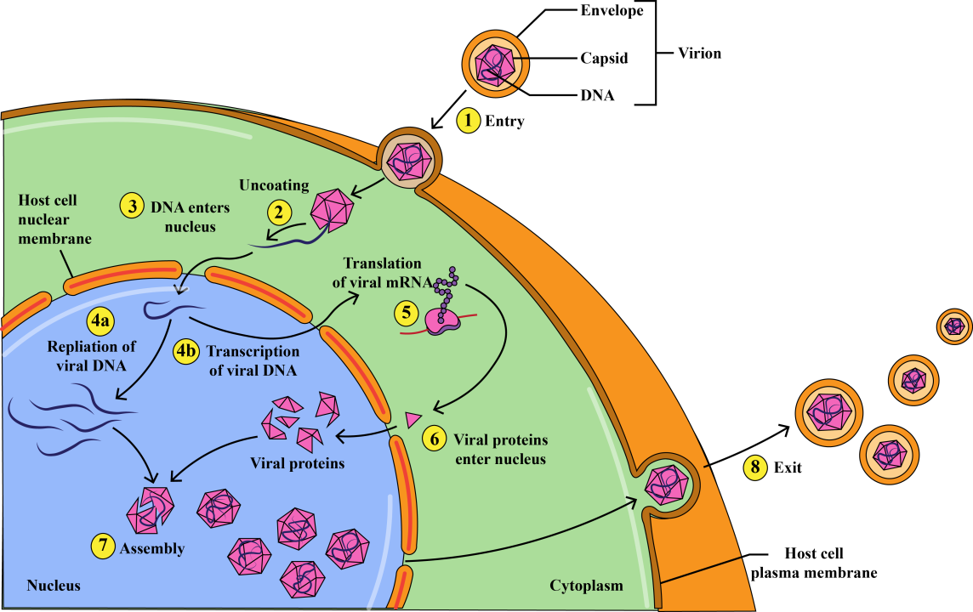

**Figure 7: Virus replication**

**Classification of viruses**

The categorization of viruses serves multiple purposes, including facilitating comparisons between different viral types and providing insights into newly identified viruses by comparing them to similar ones. Additionally, virus classification enables investigation of the origins and evolutionary trajectories of viruses over time. However, virus classification (Figure 8) is a complex endeavour, given the vast diversity of over 2800 distinct viral species, each with unique characteristics.

**Classification of DNA virus**:

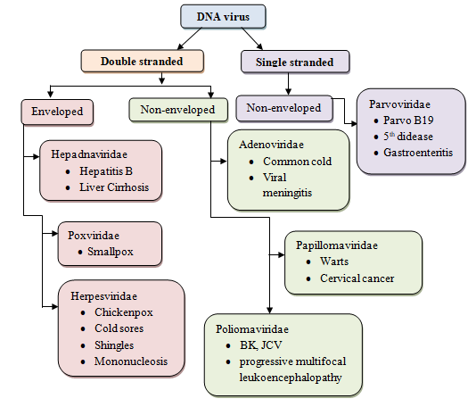

**Figure 8: The flowchart illustrates the classification of DNA viruses**

One notable classification framework, established in the 1970s by Nobel winner Baltimore, organizes viruses according to their nucleic acid types and replication methods. This system further subdivides single-stranded RNA viruses (Figure 9) into positive strand (+) and negative strand (−) groups. Positive-strand RNA can be directly translated into proteins, akin to cellular messenger RNA (mRNA), while negative-strand RNA requires transcription into positive-strand RNA before protein synthesis can occur.

**Baltimore's classification**

Baltimore's classification also accounts for viruses capable of reverse transcription, a procedure in which DNA is synthesized from an RNA template, a capability absent in cells. Collectively, these criteria delineate the seven classes within the Baltimore classification system.

**Classification of RNA virus**:

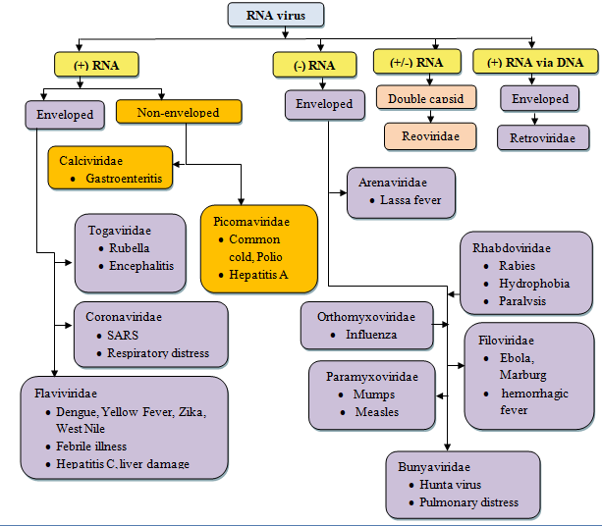

**Figure 9: The flowchart illustrates the classification of RNA viruses**

**a) Class I: dsDNA viruses-**

* Double-stranded DNA (dsDNA) genome (Figure 10), for eg;,T4 bacteriophages and lambda (ʎ), possess a genome identical to that of their host cells, enabling them to utilize host enzymes for replication and protein synthesis.
* Genome replication necessitates a DNA-dependent DNA polymerase from either the virus or the host cell.
* Viruses mostly regulate gene expression to produce viral products during replication. For instance, in T4 phage, early viral proteins modify host RNA polymerase to transcribe early genes immediately upon DNA injection into the cell, followed by modification to recognize viral genes for middle and late-stage proteins, ensuring orderly protein production.
* When a dsDNA virus is packed into a capsid, a viral endonuclease cleaves the concatemer to the right length. Concatemers are short single-stranded sections containing terminal repeats that connect multiple viral genomes together.

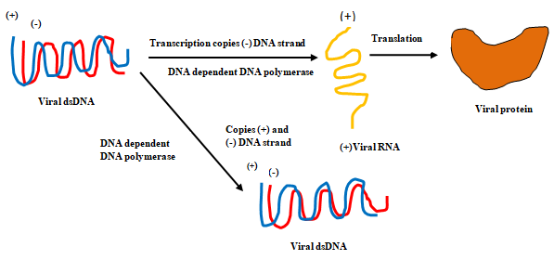

**Figure 10: dsDNA replication**

**b) Class II: ssDNA viruses-**

* ssDNA viruses, including parvoviruses, typically follow the same information flow pathway: DNA → mRNA → protein.
* On the other hand, the viral genome (Figure 11) can either match the mRNA base sequence (plus-strand DNA) or be its complementary sequence (minus-strand DNA).
* A complementary DNA strand must first be produced to create a double-stranded replicative form (RF), which serves as a template for viral genome replication and protein formation.
* • The genome of (-) strand DNA viruses is capable of producing mRNA on its own, but genome replication still requires a complementary copy.

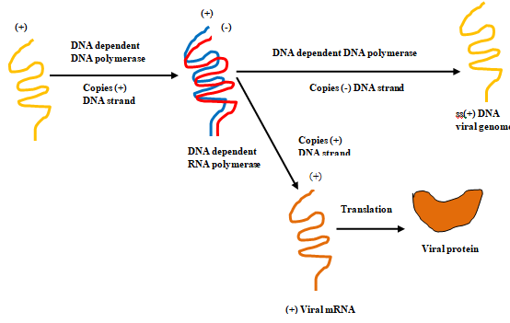

**Figure 11: ssDNA replication**

* Rolling-circle replication (Figure 12) can be achieved by nicking one strand and extending the free 3' end with replication enzymes. As a complementary strand is

formed, the 5' end is displaced, forming a developing displaced strand.

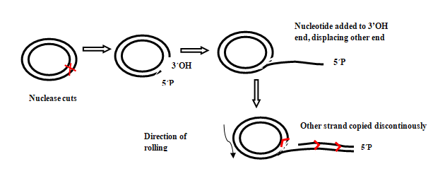

**Figure 12: Rolling circle replication**

**Class III: dsRNA viruses-**

* dsRNA viruses inducing infections in multiple organisms, for example- diarrhoea causing rotavirus(Figure 13).
* Cells do not use dsRNA and have mechanisms to eliminate it. Thus, the viral genome in dsRNA produced must be protected from cellular enzymes.
* The RNA-dependent RNA polymerase of viruses replicates the RNA genome and acts as a transcriptase, converting mRNA.

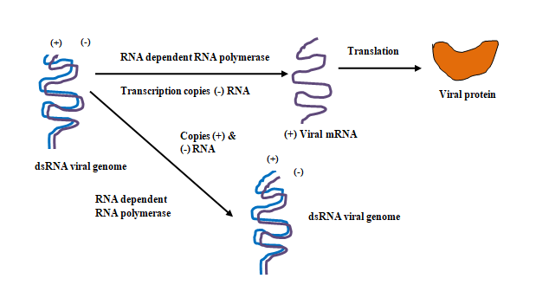

**Figure 13: dsRNA virus replication**

**Class IV: positive-sense ssRNA viruses-**

* Viruses containing (+) strand RNA, such as poliovirus (Figure 14), utilize the entire genome as mRNA and are translated by host ribosomes upon reaching the cell.
* The viral gene expresses an RNA-dependent polymerase that converts the (+) strand genome into (-) strand RNA. Minus-strand RNA acts as a template for additional plus-strand RNA, which is then employed as mRNA or the genome of new viruses.
* The poliovirus genome is translated into a polyprotein that self-cleaves into shorter proteins such as capsids and an RNA-dependent RNA polymerase.

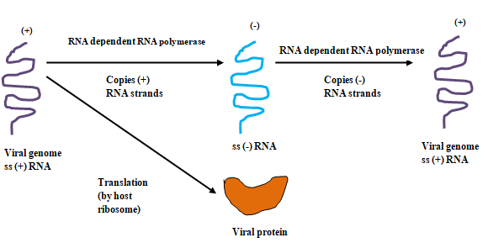

**Figure 14: Plus-ssRNA replication**

**Class V: negative-sense ssRNA viruses-**

* Human-pathogenic viruses, including those that cause influenza, rabies, and ebola, are classified under (-) strand RNA viruses (Figure 15).
* Since these viruses contain an RNA-dependent RNA polymerase in their capsid, their genomes are unable to act as mRNA directly.
* The polymerase enters the host cell to generate (+) strand RNAs that act as mRNA for protein production.
* If viral genomes are needed, (+) strand RNAs serve as templates for the generation of (-) strand RNA.

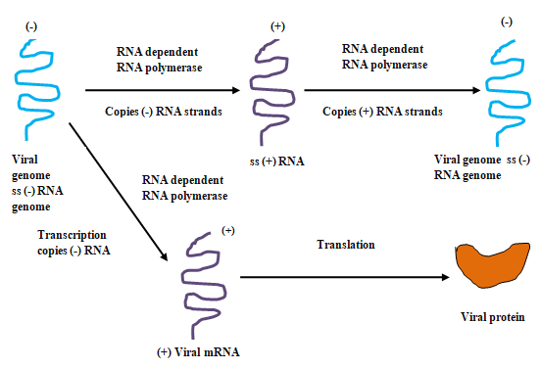

**Figure 15: -ssRNA replication**

**Class VI: RNA viruses that reverse transcribe-**

* To create a complementary ssDNA strand, the virus uses its reverse transcriptase (Figure 16).
* In addition, reverse transcriptase has ribonuclease activity that breaks down the RNA strand of the hybrid RNA-DNA.
* Further the enzyme serves the role of a DNA polymerase, creating a dsDNA molecule by generating a complementary copy of the ssDNA. This enables the virus to merge into the host chromosome and produce a provirus by integrating its genome in dsDNA form.
* A provirus, as opposed to a prophage, has the ability to either express viral genes and produce new viruses or to stay dormant for an extended period of time. For gene expression, the provirus is not excised.

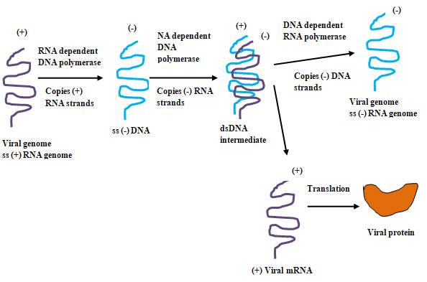

**Figure 16: +ssRNA, retroviruses replication**

**Class VII: DNA viruses that reverse transcribe-**

* Hepadnaviruses possess a partially dsDNA, with a single-stranded region.
* Upon entering the cell nucleus, host cell enzymes facilitate the filling of the gap with complementary bases, resulting in the formation of a closed-loop dsDNA.
* Reverse transcriptase functions as an RNA-dependent DNA polymerase and contributes to the production of the pre-genome, a (+) strand RNA, during gene transcription.
* The pre-genome acts as a template for reverse transcriptase to create (-) strand DNA genomes. A small fragment of the pre-genome functions as a primer to produce the double-stranded segment of the genome.

**Viral assays**

**A. Cultivation of virus:**

Virus cultivation refers to the process of growing viruses in controlled laboratory conditions to study their biology, behaviour, and interaction with host cells. Cultivating viruses is essential for various purposes, including research, vaccine development, diagnostic testing, and the production of viral vectors for gene therapy. As viruses rely on host cells for replication, they are unable to cultivate on inert culture media. Three approaches are used for viral cultivation:

**1. Animal inoculation-** The earliest method used to cultivate viruses leading to human diseases involved inoculating them into human volunteers. Reed and colleagues (1900) pioneered this approach in their research on yellow fever. Subsequently, Theiler (1903) introduced the usage of white mice, expanding the possibilities of animal inoculation, which remains a cornerstone in virology. Infant mice, particularly vulnerable to coxsackie and arboviruses, serve as valuable hosts for viruses that may not grow in other systems. Mice, guinea pigs, and rabbits serve roles in both attenuating virus strains and assessing vaccines. For instance, the foot and mouth disease virus vaccine underwent initial testing in guinea pigs before progressing to trials in cattle and pigs. Mice can be inoculated via various routes (Figure 17), including intracerebral, subcutaneous, intraperitoneal, or intranasal. Other animals like guinea pigs, rabbits, and ferrets are also utilized in specific conditions. Virus growth in inoculated animals can be indicated by death, disease manifestations, or visible lesions. Sometimes, multiple blind passages are required before detecting evidence of viral growth. Animal inoculation has drawbacks, such as interference from existing immunity and the potential for latent viral infections in animals. However, it remains crucial for studying pathogenesis, immune responses, epidemiology, and oncogenesis.

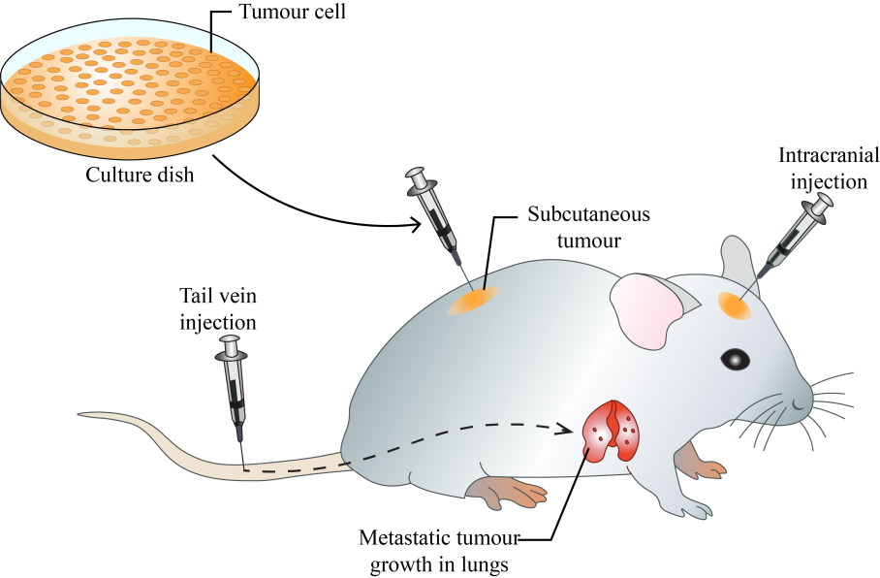

**Figure 17: Animal inoculation**

**2. Embryonated eggs-** Embryonated egg cultivation (Figure 18), pioneered by Goodpasture in 1931 and developed by Burnet, is a method used to propagate viruses by introducing them into fertilized bird eggs, typically chicken eggs. The process involves delicately drilling a small hole into the eggshell to inoculate the virus without harming the developing embryo. Once inoculated, the eggs are sealed and placed in an incubator under controlled conditions. As the embryo develops, the virus infects various embryonic tissues, leading to viral replication and propagation. Depending on the route of inoculation, for example, the chorioallantoic membrane (CAM), allantoic cavity, amniotic sac, or yolk sac, different viruses can be cultured. For example, inoculating on the chorioallantoic membrane produces visible lesions, aiding in the assay of pock-forming viruses (variola or vaccinia).

Embryonated eggs offer an ideal environment for virus cultivation due to their rich nutrients, growth factors, and supportive membrane system. This method provides a cost-effective means of producing large quantities of virus for research, diagnostics, and vaccine development. Notably, it is particularly effective for rapidly growing viruses like influenza.

However, there are limitations to this technique, including the need for specialized equipment and expertise, as well as ethical considerations regarding the use of animal embryos. Despite these challenges, embryonated egg cultivation remains a valuable tool in virology for studying viral pathogenesis, tropism, and host immune responses, as well as for producing vaccines like those for yellow fever (17D strain) and rabies (Flury strain).   
Duck eggs, being larger and having a longer incubation period compared to hen's eggs, offer a superior yield of rabies virus. Consequently, they were employed in the production of the inactivated non-neural rabies vaccine.

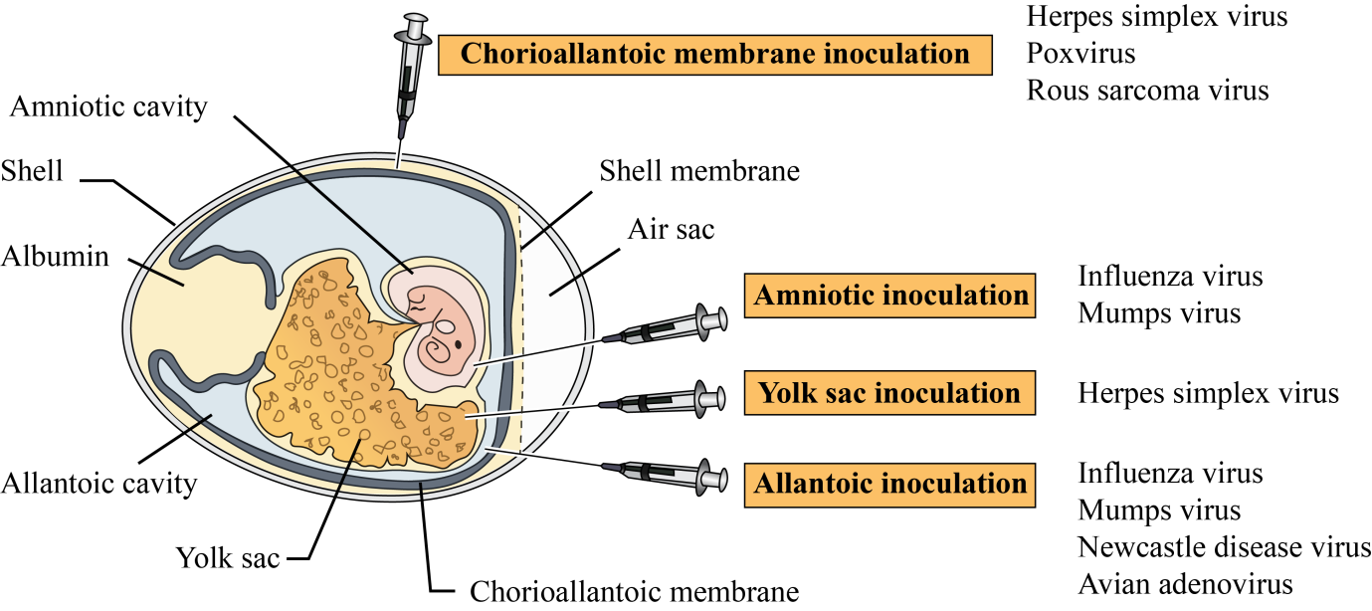

**Figure 18: Virus cultivation in embryonated egg**

**3. Virus tissue culture-** Virus tissue culture, a pivotal technique in virology, involves growing viruses in lab-grown living cells from various sources. This method has transformed virology research, facilitating the exploration of virus-host interactions, viral pathogenesis, vaccine production and antiviral drugs. Initially, bacterial contamination posed a significant challenge to tissue culture until antibiotics became available for prevention. The breakthrough came with Enders, Weller, and Robbins in 1949, demonstrating that poliovirus, previously thought strictly neurotropic, could thrive in non-neural tissue cultures. Since then, nearly all human viruses have been successfully cultivated using tissue culture methods.

**a) Organ culture-** Virus organ culture involves the cultivation of small fragments of organs in laboratory conditions to study virus-host interactions and isolate viruses that target specific tissues. These cultures can maintain the original architecture and function of the organs for extended periods, making them valuable tools for virology research. The process starts with the acquisition of tissue samples from the desired organ, which are then dissected into small fragments. These fragments are placed into a culture medium containing nutrients, growth factors, and other necessary components to support cell viability and growth.

The culture is incubated at a suitable temperature and environment to mimic physiological conditions. However, virus organ culture also has limitations. It requires specialized equipment and expertise for tissue dissection and maintenance. Moreover, the availability of human organ tissues for culture is limited, often necessitating the use of animal models, which may not fully recapitulate human physiology. Examples are- tracheal ring organ cultures for studying respiratory viruses such as coronaviruses, brain organ cultures to study neurotropic viruses like herpes simplex virus or Zika virus.

**b) Explant culture-** Small pieces of minced tissue can be cultured as "explants," either incorporated in plasma clots or grown in suspension. Explant culture preserves the structural and functional integrity of the original tissue. Adenoid tissue explant cultures can be utilized for isolating adenoviruses. Brain explant cultures can be infected with neurotropic viruses to investigate neuronal infection and associated pathology. Similarly, respiratory explant cultures can be used to study viruses that target the respiratory tract, such as influenza or respiratory syncytial virus (RSV). The lifespan of explant cultures is limited, as the cells eventually senesce or undergo apoptosis over time.

**c) Cell culture-** Ross Harrison achieved successful cell culture (Table 5,6 and 7) for the first time in 1907, while in 1885, Roux was the first to maintain embryonic chick cells in a cell culture. This method is commonly used to culture viruses, involving the dissociation of tissues into individual cells through enzymatic action, like trypsin, and mechanical agitation. After washing and counting, the cells are suspended in a growth medium including essential amino acids, vitamins, salts, glucose, and a buffer system with 5% carbon dioxide. Fetal calf serum (5%), antibiotics, and phenol red are often added to prevent contamination and monitor cell health. Cultures are typically incubated for 24-48 hours in containers where cells attach to the surface to form a monolayer (Figure 19) within one week. These cultures can be incubated stationary or rolled in special drums for aeration. They are classified based on origin, chromosomal features, and maintenance capacity.

**Table 5: Types of cell cultures**

|  |  |  |  |
| --- | --- | --- | --- |
| Cell culture types | Definition | Examples | Usage |
| Primary cell cultures | Cultures consist of cells freshly isolated from the body; Unable to persist in serial culture and capable of only a restricted cultural growth | Monkey kidney, Human embryonic kidney, Human amnion, Chick embryo cell cultures. | Primary cell cultures are valuable to isolate viruses and cultivate them for vaccine generation |
| Diploid cell strains (finite culture) | Before passing through senescence, cells undergo limited serial sub-cultivation while maintaining their original diploid chromosomal number | Derived from human fibroblasts | They are prone to various human viruses and are crucial for isolating fastidious pathogens and producing vaccines. |
| Continuous cell lines | These cells can be cultivated indefinitely; can be maintained by serial sub-cultivation; can be stored (-700C) for future use | Derived from cancer cells - HeLa, HEp-2, and KB cell lines | Some, like vero cells, are authorized for vaccine production, such as rabies vaccines. Viral growth in infected tissues is often detected by the presence of inclusions. |

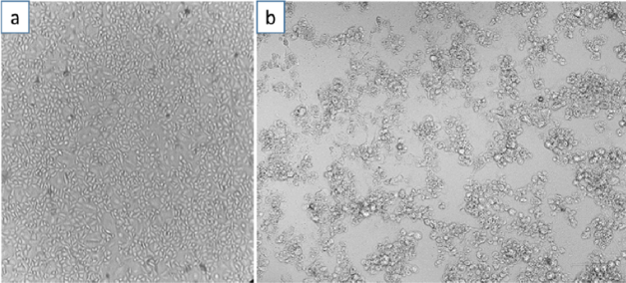

**Figure 19: Vero cell culture- a) Healthy vero cells b) Infected vero cells with SARS**

**CoV-2 showing CPE (Nugroho et al., 2023)**

**Table 6: Cell lies infected by viruses**

|  |  |  |  |
| --- | --- | --- | --- |
| Cell culture types | Examples | Origin | Cell line infected by virus |
| Primary cell cultures | RhMK | Rhesus monkey kidney cell culture | adenovirus, coxsackie B, simian virus 40, polio virus (virus propagation in inactivated Polio vaccine), influenza, vaccinia (smallpox vaccine) |
| HAEpiC | Human amniotic epithelial cell culture | rubella, herpes simplex virus (HSV), cytomegalovirus, adenovirus, influenza |
| CEF | Chick embryo fibroblast cell culture | Avian Leukosis Virus, Avian Influenza, Newcastle Disease Virus, Infectious Bronchitis Virus |
| Diploid cell strains | Wl-38 | Human embryonic lung cell strain | poliomyelitis, measles, mumps, rubella, varicella (chicken pox), herpes zoster, adenovirus, rabies and Hepatitis A |
| HL-8 | Rhesus embryo cell strain | Simian T-lymphotropic virus, Herpes B, Simian Virus 40 (SV40), Simian immunodeficiency virus |
| Continuous cell lines | Hela | Human carcinoma of cervix cell line | rhino virus, human papillomavirus (HPV), HIV, HSV |
| HEp-2 | Human epithelioma of larynx cell line | Human parainfluenza, Coxsackie, Polio, Respiratory syncytial virus (RSV), Adenovirus, HSV, HPV |
| KB | Human carcinoma of nasopharynx cell line | Measles, Epstein–Barr virus, HPV 16 & 18, Influenza, Rhino virus, RSV |
| McCoy | Human synovial carcinoma cell line | Human herpesvirus 8 (HHV 8), HSV, Cytomegalovirus, HSV 1 & 2, Enteroviruses, Varicella-zoster virus (VZV) |
| Detroit 6 | Sternal marrow cell line | Influenza, Parainfluenza, Enteroviruses, Adeno-associated virus, Parvo B-19 |
| Chang C/I/L/K | Human conjunctiva (C) Intestine (I), Liver (L) and Kidney (K) cell lines | Mumps, Swine influenza, Adenovirus, Poliovirus |
| Vero | Vervet monkey kidney cell line | Dengue, Zika, Ebola, Measles, Mumps, Yellow fever, SARS-CoV-2 (Vero E6) |
| BHK-21 | Baby hamster kidney cell line | Adenovirus 25, HSV, Vaccinia, Chikungunya, Reovirus, Foot and mouth disease virus, Japanese encephalitis, Semliki forest virus (Togavirus), Rift valley fever virus (Bunyavirus) |
| MDCK | Madin-Darby canine kidney | Influenza virus (isolation and vaccine production), Canine parvovirus, Canine distemper virus |

**Cell culture media**- The culture medium stands as a pivotal component in the culture environment, furnishing essential nutrients, growth factors, and hormones vital for cell growth, while also regulating pH and osmotic pressure. Initially, cell culture experiments relied on natural media extracted from tissue or body fluids. However, the demand for standardized, high-quality media prompted the development of definedmedia. Serum (growth factors), adhesion factors, hormones, lipids and minerals are essential for cell culture. Despite its benefits, serum poses challenges such as cost, variability, and potential contamination. Commonly used media are -DMEM (Dulbecco’s Modified Eagle’s Medium), RPMI (Roswell Park Memorial Institute), GMEM (Glasgow’s Modified Eagle’s Medium) and EMEM (Eagle’s Minimal Essential Medium).

**Table 7: Detection of virus growth**

|  |  |
| --- | --- |
| Detection assay | Assay procedure |
| Cytopathic Effect (CPE)- | Many viruses induce morphological changes in cultured cells, known as cytopathic effects (CPE). These changes, such as cell rounding (polio), syncytium formation (retroviruses, paramyxoviruses), or granular clumping (adenoviruses-grape like cluster), can be observed microscopically and aid in identifying the infecting virus. Different viruses produce characteristic CPE, facilitating the presumptive identification of virus isolates |
| Metabolic Inhibition- | Virus growth in cell cultures can inhibit cellular metabolism, leading to a lack of acid production in the culture medium. This metabolic inhibition can be detected by changes in the color of the indicator (e.g., phenol red) incorporated into the medium |
| Hemadsorption- | Hemagglutinating viruses, for example influenza and parainfluenza viruses, can cause erythrocytes (red blood cells) to adhere to the surface of infected cells in culture. This phenomenon, known as hemadsorption, indicates viral replication within the culture |
| Interference- | The growth of a non-cytopathogenic virus in cell culture can be assessed by challenging the culture with a known cytopathogenic virus. If the first virus inhibits the infection by the second virus, it suggests interference between the two viruses. For example, certain strains of influenza virus can inhibit the replication of other influenza virus strains or unrelated viruses. |
| Transformation- | Oncogenic viruses can induce cell transformation, leading to the loss of contact inhibition and the formation of piled-up growth patterns resembling microtumors |
| Immunofluorescence- | Virus-infected cells can be stained with fluorescent conjugated antiserum specific to viral antigens. Examination under a UV microscope allows for the visualization of virus antigens, providing early detection of viral infection and finding wide application in diagnostic virology |

Media can be categorized into three types:

**a. Basal media-** Supplemented with amino acids, vitamins, salts, and glucose, require additional serum.

**b. Reduced-serum media-** enriched with nutrients and animal-derived factors, decrease serum dependency.

**c. Serum-free media-** substitute serum with adequate quantity of nutrients and hormones providing selectivity for specific cell types. This method offers flexibility in tailoring the medium to suit various cell cultures.

Additionally, maintaining optimal pH, CO2 levels, and temperature is crucial for cell growth. Most mammalian cell lines thrive at pH 7.4, with some exceptions (some transformed cell lines). CO2 concentration influences medium pH and is vital for buffering cells against pH fluctuations. Temperature settings vary depending on cell origin, with most human and mammalian cell lines cultured at 36°C to 37°C. Insect, avian, and cold-blooded animal cell lines have distinct temperature requirements.

**Subculture-** Subculture, also known as passaging or splitting, is the procedure whereby cells are moved from one culture vessel to another in order to sustain their growth and proliferation. This procedure is essential for preventing overcrowding of cells, replenishing nutrients, and ensuring the longevity of the cell line.

Cell growth in culture typically follows a standard pattern, starting with a lag phase after seeding, followed by exponential growth known as the log phase. However, growth eventually slows down as cells reach confluence in adherent cultures or surpass the medium's capacity in suspension cultures. To maintain optimal growth, cells should be subcultured or passaged when they cover the plate or exceed the medium's capacity. This ensures cells remain at an optimal density for continued growth, maximizing the number of healthy cells available for experiments.

**Cryopreservation-** Cryopreservation involves preserving biological samples at ultra-low temperatures to maintain their viability for long-term storage. Freezing media, also known as cryoprotective agents or cryopreservation solutions, play a crucial role in this process by protecting cells from damage during freezing and thawing. These solutions typically consist of a combination of cryoprotectants, buffers, and other additives that help maintain cell integrity and viability. The composition of freezing media varies based on the specific cells being preserved and the precise requirements of the cryopreservation protocol. Common components of freezing media include:

* **Cryoprotectants-** These are chemicals that help prevent the formation of ice crystals within cells during freezing. Common cryoprotectants consist of dimethyl sulfoxide (DMSO), glycerol, and ethylene glycol.
* **Buffers:** Buffers help maintain the pH of the solution, ensuring optimal conditions for cell survival. Phosphate-buffered saline (PBS) and HEPES are commonly used buffers in freezing media.
* **Serum or protein supplements:** Addition of serum (preferably fetal bovine serum) or proteins such as albumin can provide additional protection to cells during freezing and thawing.
* **Antioxidants:** Antioxidants such as vitamin E or beta-mercaptoethanol may be included in freezing media to protect cells from oxidative damage.
* **Sugars:** Sugars like sucrose or trehalose may be added to freezing media to help stabilize cell membranes during freezing.
* Freezing media are carefully formulated to minimize cell damage and maximize cell survival during the cryopreservation process, allowing for long-term storage of biological samples at ultra-low temperatures.

**B. Microscopy-visualization of virus:**

**1. Light microscopy-** Light microscopes utilize visible light within the range of 400–700 nm wavelengths to visualize objects. While they are generally not capable of magnifying viruses due to their small size, some of the largest known viruses, such as Mimivirus, Pithovirus, Megavirus, and Pandoravirus, can be observed using light microscopy when infecting amoebas. Light microscopy remains valuable for detecting virally induced changes in infected cells. For instance, Negri bodies (inclusion bodies) found in neurons infected with rabies. The analysis of CPE through light microscopy is a common method for diagnosis, where modifications in cellular morphology, such as swelling, shrinking, and syncytium formation, are assessed. The timeframe for observing CPE varies depending on the virus, ranging from 24 hours for herpes to 10–30 days for CMV. The duration of CPE incubation serves as an important characteristic for viral identification and characterization.

**2. Immunofluorescence microscopy-** The assay employs fluorescence microscopy to detect viruses within infected cells. This method utilizes specific antibodies tagged with fluorophores, such as fluorescein, which bind to viral antigens within the cell. When exposed to excitation light, the fluorophores emit fluorescence, allowing visualization of infected cells under the microscope. This technique offers high sensitivity and specificity, enabling the identification of viral particles and infected cells with high precision. Additionally, fluorescence microscopy can facilitate the study of viral replication dynamics, host-virus interactions, and the effects of antiviral agents on viral propagation. Direct and indirect immunofluorescence microscopy are techniques utilized to identify certain antigens in biological samples.

In direct immunofluorescence (Figure 20) microscopy, fluorescently labeled antibodies directly bind to the target antigen in the sample. This results in immediate visualization of the antigen-antibody complex under the microscope. On the other hand, indirect immunofluorescence (Figure 20) microscopy involves two steps. First, unlabeled primary antibodies bind to the target antigen. Then, fluorescently labeled secondary antibodies, which recognize the primary antibodies, are added to the sample. This secondary antibody amplifies the signal, making the antigen-antibody complex easier to detect under the microscope.

**3. Electron microscopy-** During 1930s, German physicist, Ernst Ruska, achieved a major breakthrough in virology with the introduction of electron microscopy (EM), which enabled the visualization of individual viruses for the first time. Unlike traditional light microscopy, EM utilizes an electron beam and electromagnets to achieve exceptional resolution and magnification, up to approximately 10,000,000 times.

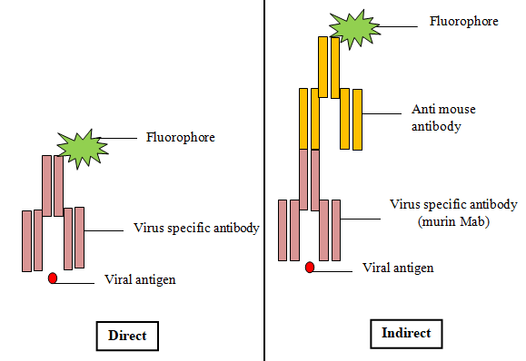

**Figure 20: Types of immunofluorescence**

Despite its remarkable capabilities, EM has notable drawbacks. Samples prepared for EM are typically fixed and processed, rendering them dead and subject to significant damage from the electron beam, which interacts with organic matter. Nevertheless, EM unveiled the basic structures and crystalline nature of viruses, establishing itself as a fundamental tool in virology. One technique employed in EM, known as negative staining, involves coating virus particles with heavy metals to create a detailed surface representation while preserving structural integrity. However, this method provides limited insight into internal structures.

EM has long served as a valuable means of directly detecting viruses in various biological samples, such as body fluids, stools, and histopathologic specimens, through visual counting of viral particles. Nevertheless, its effectiveness relies on the presence of a high virion count in samples and demands skilled expertise.

**C. Assay of infectivity (quantitative assay):**

An assay of infectivity is a method employed in laboratories to quantify the ability of a virus or other infectious agent to infect cells or organisms.

**1. TCID50 assay-** TCID50 (Tissue Culture Infectious Dose 50) assay is a endpoint dilution method used in virology to determine the concentration of a virus sample that is capable of infecting 50% of the inoculated cell cultures. This assay is especially beneficial for assessing the infectious titer of viruses that can replicate in cell culture.

To perform the TCID50 assay, the virus stock is serially diluted and each dilution is inoculated onto multiple wells of a cell culture plate. After an incubation period, typically several days, the cultures are examined for evidence of viral infection, such as cytopathic effects (CPE) or specific staining patterns. The dilution at which 50% of the cultures show signs of infection are then calculated using statistical methods such as the Reed-Muench method.

While endpoint dilution assays are primarily conducted in cell cultures, they can be carried out as well in animals, with outcomes stated as Infectious Dose 50% (ID50) or Lethal Dose 50% (LD50) if death is the endpoint. It's important to reminder that virus titers are relative values, contingent upon the specific cells or animals utilized for the assay.

**2. Plaque assay-** The plaque assay (Figure 21), a widely used and esteemed quantitative virus assay, involves infecting a cell monolayer with various dilutions of a lytic virus. After infection, an overlay medium (eg: agarose) is added to avert viral spread, allowing plaques (zones of cell death) to form due to viral replication. Plaque development typically takes 2 to 14 days, based on the virus and host cells. Plaques are manually counted after staining with neutral red or crystal violet, and the viral titer is calculated in terms of plaque forming units (PFU) per milliliter (PFU/ml), assuming each plaque reflects one infective virus particle. This assay, introduced by Dulbecco in 1952, confines viral spread to the region around infected cells, allowing visible plaques to indicate infectivity. Some viruses, such as herpesvirus, can develop plaques lacking an agar overlay, while oncogenic viruses can be assessed using the transformation technique, which detects cell transformation indicative of micro-tumors.

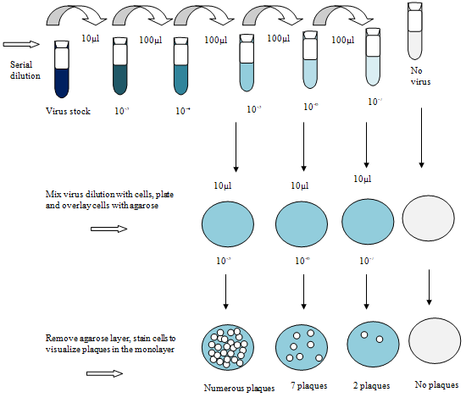

**Figure 21: Plaque assay**

**3. Focus Forming Assays (FFAs) -** This can be considered variations on plaque assays that use antibody-based staining to determine cells with infection. In contrast to plaque assays, FFAs identify both lytic and non-lytic viruses with higher sensitivity and shorter incubation periods. However, this technique requires specific antibodies and only detects viral protein subunits, not infectious virions. Results are reported as focus forming per milliliter (FFU/ml).

**4. Serum neutralization test (SNT)-** The serum neutralization test (Figure 22) is a method employed in laboratories to determine the presence of neutralizing antibodies in a serum sample against a specific virus. In this test, the serum sample is serially diluted and mixed with a fixed quantity of virus. Further, these are added to susceptible cells in culture. If neutralizing antibodies exist in the serum, they will bind to the virus and prohibit it from infecting the cells. The highest dilution of serum that prevents virus infection is determined as the neutralizing titer. This test is valuable in assessing immunity to viral infections and evaluating the effectiveness of vaccines.

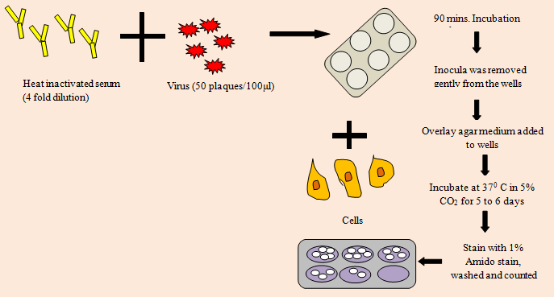

**Figure 22: SNT assay**

**D. Serological assay:**

**1. Hemagglutination assay-** Hemagglutinin is a crucial protein found on the envelope of various viruses such as arboviruses, influenza, and parainfluenza subtypes. Its primary function is to bind to red blood cells (RBCs), causing them to aggregate and form a lattice-like structure known as agglutinated cells. In the hemagglutination assay (Figure 23), different dilutions of the virus are mixed with RBCs, and the samples are observed for the presence of agglutinated cells.

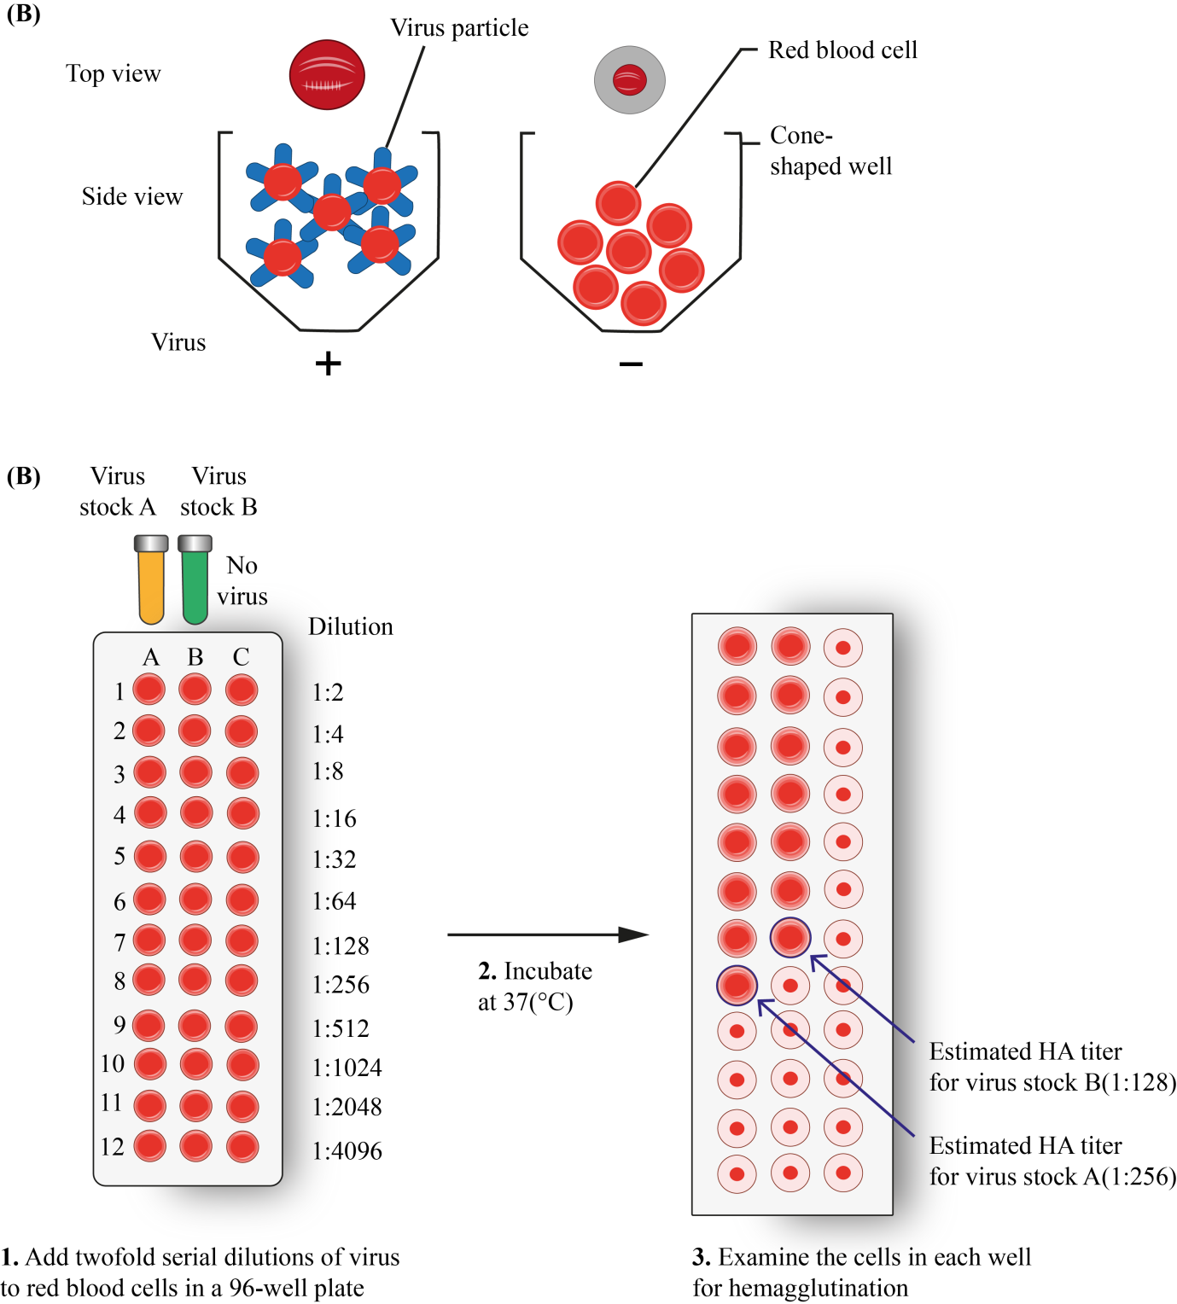

**Figure 23: Haemagglutination assay**

**Hemagglutination inhibition assay-** The assay is utilized to evaluate the levels of specific antibodies present in serum samples. When antibodies are present in sufficient concentrations, they interfere with the attachment of the virus to the RBCs, preventing the formation of agglutinated cells. This inhibition of hemagglutination denotes the existence of neutralizing antibodies in the serum.

**2. Enzyme-Linked Immunosorbent Assay (ELISA)-**ELISA serves as a pivotal tool for detecting antibodies produced in response to infections or viral antigens in serum samples. It assesses the presence and concentration of specific antibodies, which can persist in the bloodstream long after the infection has resolved. Therefore, a positive ELISA result indicates patient immunity due to prior encounter with the virus, reinfection, or a reactivation condition, rather than active infection. ELISAs are indispensable for epidemiological studies as they enable the analysis of disease prevalence in different populations over time.

The ELISA procedure involves immobilizing a viral antigen or antibody against the pathogen onto the surface of a microplate well. When serological samples containing viral antibodies or specific viral proteins are added to the well, they recognize and bind to the immobilized molecules. Subsequently, specific labeled antibodies recognize the bound molecules of interest often involving enzymes for example horseradish peroxidase (HRP) or alkaline phosphatase (AP) for signal amplification and generate a detectable signal, such as colorimetric, chemiluminescent, or fluorescent, which is measured by a microplate reader. The intensity of the signal corresponds to the amount of specific antigen or antibody present in the sample. ELISAs can be of different types (Figure 24)-

* **Direct ELISA-** Direct ELISA detects antigens directly by immobilizing specific antibodies on a microplate, allowing antigen binding and subsequent detection with enzyme-conjugated secondary antibodies, providing a rapid and sensitive method for antigen detection.
* **Indirect ELISA-**Indirect ELISAs involve a 2 step process, where a non-labeled primary antibody interacts with the antigen or viral antibody, followed by recognition by a labeled secondary antibody.
* **Sandwich ELISA-** Sandwich ELISA involves capturing the target antigen between two specific antibodies: one immobilized on the surface and the other enzyme-conjugated, enabling highly sensitive and specific detection of antigens in complex samples.
* **Competitive ELISA-** ELISAs can be conducted in a competitive manner to measure antigen concentration by measuring signal interference. In this approach, the sample antigen competes with a reference antigen for binding to a specific labeled antibody, leading to a weaker signal proportional to the quantity of antigen in the sample.

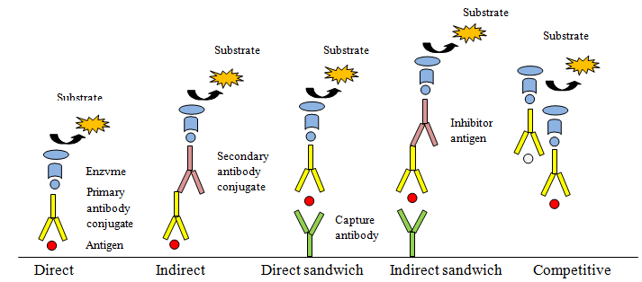

**Figure 24: Types of ELISAs**

**3. Homogenous assay:** This offers another approach to conventional heterogeneous ELISAs, eliminating the need for washing steps to reduce background interference and detect bound complexes. This means there's no requirement for separating unbound components from the well, simplifying the assay procedure to a straightforward add-and-read protocol. This streamlined process minimizes handling steps and operating time, making homogeneous assays ideal for automation-supported screening applications. Examples of homogeneous virus assays include fluorescence polarization immunoassays, Time-Resolved Fluorescence (TRF) and Time-Resolved Fluorescence Resonance Energy Transfer (TR-FRET) based assays.

**4. Fluorescent antibody assay (Immunofluorescence)-** The fluorescent antibody assay, also known as immunofluorescence assay (IFA), is a method used to detect and localize precise antigens (usually viral proteins) in cells or tissues using fluorescently labeled antibodies. The steps involved are-

* **Antigen Detection-** The first step involves fixing and permeabilizing the cells or tissue samples to allow access for the antibodies. Then, the samples are incubated with a primary antibody that specifically binds to the target viral antigen.
* **Primary Antibody Binding-** If the target viral antigen is present in the sample the primary antibody will bind to it, forming an antigen-antibody complex.
* **Fluorescent Labeling-** After washing away unbound primary antibodies, the samples are incubated with a secondary antibody conjugated to a fluorescent dye. This secondary antibody identifies and attaches to the primary antibody, forming a sandwich.
* **Visualization-** When exposed to light of the appropriate wavelength, the fluorescent dye emits fluorescent light that allows visualization of the location of the viral antigen within the sample. This can be observed under a fluorescence microscope.

There are two types of fluorescent antibody assays used in virology (Figure 25)-

1. **Direct Immunofluorescence Assay (DFA)-**In DFA, a single fluorescently labeled antibody directly binds to the specific viral antigen present in the sample. This method is relatively simple and rapid, but it requires high-affinity antibodies and may lack sensitivity compared to other techniques.
2. **Indirect Immunofluorescence Assay (IFA)-**In IFA, a primary antibody binds to the viral antigen, and then a secondary antibody conjugated to a fluorescent dye binds to the primary antibody. This amplifies the signal and enhances sensitivity, allowing for the detection of low levels of viral antigens.

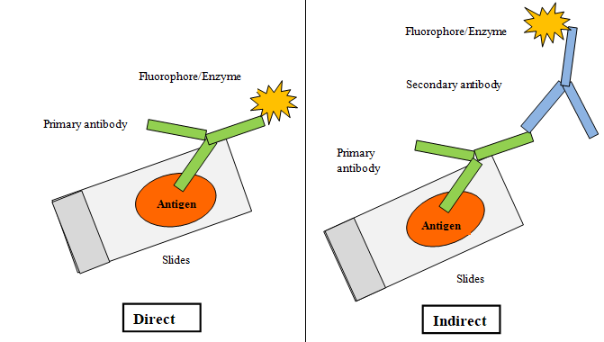

**Figure 25: Immunofluorescence assay**

**E. Molecular assay:**

**NAAT-** Nucleic Acid Amplification techniques (NAATs) revolutionize viral infection diagnosis, offering heightened sensitivity, rapidity, and reliability. By targeting and amplifying specific viral genome regions, NAATs can detect existence of virus yet earlier than the appearance of antigens or antibodies in the bloodstream. The process involves DNA/RNA extraction, purification, and quality testing, often measured by absorbance using a spectrometer-based microplate reader. Fluorescence intensity methods like Hoechst or PicoGreen provide increased sensitivity by distinguishing between ds and ss nucleic acids. There are several types of molecular assays used for detecting and studying viruses-

**Polymerase Chain Reaction (PCR)-** This is a method (Figure 26) employed to amplify specific regions of DNA or RNA. It is highly sensitive and can identify even minute quantity of viral genome. Variations of PCR include quantitative PCR (qPCR) for quantifying viral load and nested PCR for increased specificity.

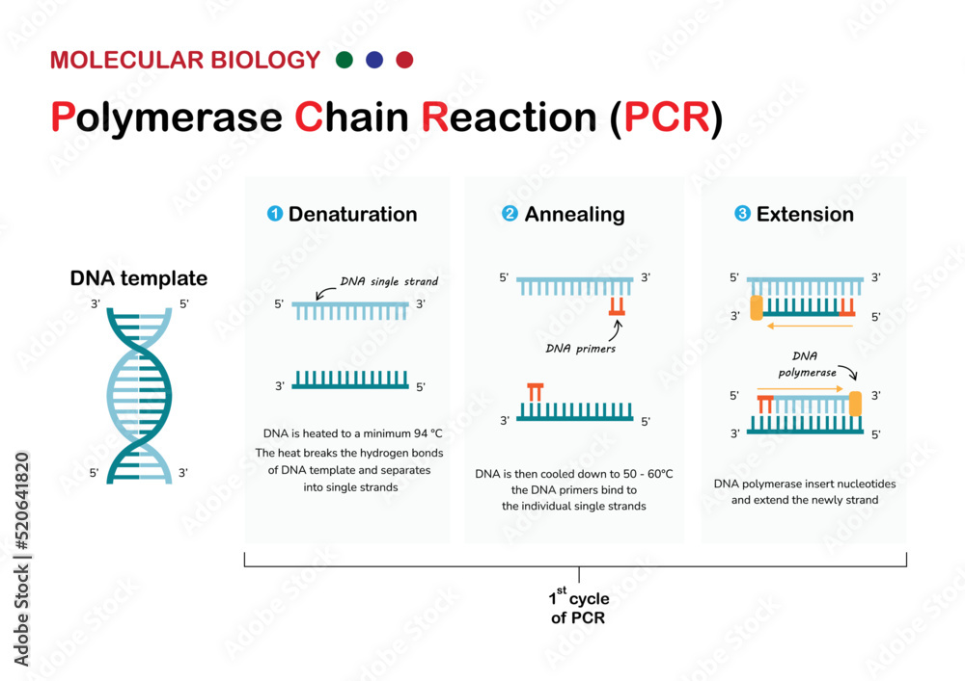

**Figure 26: PCR technique**

**Reverse Transcription Polymerase Chain Reaction (RT-PCR)-** This detects RNA viruses by converting RNA into complementary DNA (cDNA) utilizing reverse transcriptase enzyme. The cDNA is then amplified using PCR.

**Real-time PCR-** Real-time PCR (Figure 27) with TaqMan probes is a molecular biology technique that combines PCR amplification with real-time fluorescence detection using TaqMan probes. These probes are oligonucleotide sequences containing a fluorescent reporter dye and a quencher molecule. During PCR amplification, the TaqMan probe anneals to the target sequence, and when the polymerase extends the primer, it cleaves the probe, separating the reporter dye from the quencher molecule. This results in an increase in fluorescence intensity, which is monitored in real-time and correlates with the total target nucleic acid available in the sample. TaqMan-based real-time PCR provides high specificity, sensitivity, and quantitative capabilities for the identification and measurement of specific DNA or RNA sequences.

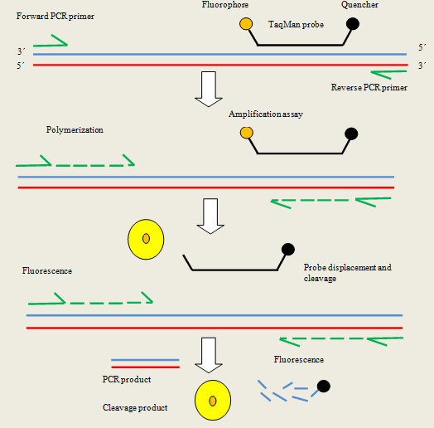

**Figure 27: Real time TaqMan PCR**

**Nucleic Acid Sequencing-** Sequencing techniques are used to determine the exact order of nucleotides in a viral genome. This allows for the identification of specific viral strains and mutations.

**Nucleic Acid Hybridization-** This technique involves the use of complementary nucleic acid probes to detect specific viral sequences. It can be used for both qualitative and quantitative analysis of viral nucleic acids.

**Loop-mediated Isothermal Amplification (LAMP)-**This is a technique to amplify DNA under isothermal conditions. It is rapid that can be performed at a single temperature, making it appropriate for point-of-care testing.

**Next Generation Sequencing (NGS)-**The assay provides high-throughput sequencing of nucleic acids that allows the assessment of entire viral genomes and the identification of novel viral strains.

**In situ Hybridization-** This technique allows for the visualization of viral nucleic acids within cells or tissues. It is commonly used for studying viral tropism and localization in infected tissues.

**F. Flowcytometry:**

This is a potent method for examining the molecular and physical properties of cells or particles embedded in a fluid. It entails directing a laser beam through a suspension of cells or particles, where various properties such as size, granularity, and fluorescence are measured. Each cell or particle passing through the laser beam generates signals that are collected by detectors, allowing for the characterization of individual cells or particles within the sample. The movement of sheath fluid propels the particles, confining them to the center of the sample core. This phenomenon is termed hydrodynamic focusing. Flow cytometry (Figure 28) is widely used in immunology, cancer research, microbiology, and many other fields for cell counting, sorting, and biomarker analysis.

A flow cytometer comprises three primary systems: fluidics, optics, and electronics.

* **The fluidics system** conveys a stream of particles to the laser beam for analysis.
* **The optics system** includes lasers that illuminate the particles in the sample stream and optical filters that send the generated light signals to the suitable detectors.
* **The electronics system** transforms the detected light signals into electrical impulses that are compatible with computer processing. In equipment with a sorting capability, the electronics system can initiate sorting selections to charge and deflect particles.

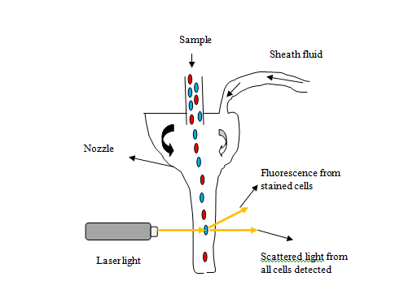

**Figure 28: Flowcytometry assay**

**Virus purification:**

Viruses cultivated in cell cultures undergo various processes for purification, quantification, imaging, and biochemical analysis (Figure 29). The initial virus concentration determines the ease of purification, with higher concentrations facilitating separation from cell debris and media components. Cytopathic viruses are found amidst cell debris and media, while cell-associated viruses require gentle lysis to release them. Low-speed centrifugation (~5000×g) is employed to pellet cell debris, separating virions in the supernatant. Subsequent high-speed centrifugation (~30,000–100,000×g) isolates the virus, followed by optional purification through density gradient centrifugation using substances like sucrose or glycerol. This gradient separates sample components based on buoyant density, enabling finer separation and visible band formation for virus collection.

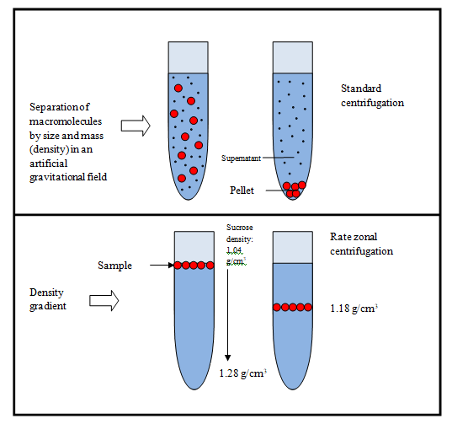

**Figure 29: Purification of virus (Centrifugation)**

**Virus infection and host interaction**

The ability of a virus to spread illness is termed as virulence that represents the relative degree of pathogenicity. It varies widely among viral strains, categorizing them as pathogen or non-pathogen. Based on its virulence, a virus might have a low to severe pathogenicity. Virulence serves as a quantitative measure of the virus's ability to multiply within the host, influenced by factors such as the host's immune status and environment.

**Types of Infections:** Virus infections (Figure 30) can be categorized based on their outcomes in terms of progeny virus production. **Productive infection** results in the generation of progeny virus-

**1. Lytic infection-** The virus causes cell lysis (e.g., adenovirus, influenza virus).

**2. Persistent/latent Infections-** In persistent (latent) infections, In the absence of active replication or cellular death, the virus continues to be related to the host cell. This can occur with or without integration of the viral genome into the host genome, as seen in retroviruses (integration) and herpes viruses (not integrating). It can be of 3 types-

* The virus gene remains in the cell even in the absence of active virus release (e.g., Retroviruses).
* Virus is released sporadically but remains latent for most of the time (e.g., HSV).
* The virus frequently releases itself without causing the host cell to lyse (e.g., HBV).

**Nonproductive infection**, on the other hand, does not lead to progeny virus production-

1. **Latent infection-** The virus remains dormant in the host cell until activation (e.g., herpes virus, HIV).
2. **Transforming infection-**The virus integrates into the host genome and transforms cells into cancerous ones (e.g., human papillomavirus, Epstein-Barr virus, HBV).
3. **Abortive infection-** The virus fails to replicate due to host immune responses or other factors (e.g., poliovirus, measles, and respiratory syncytial virus).

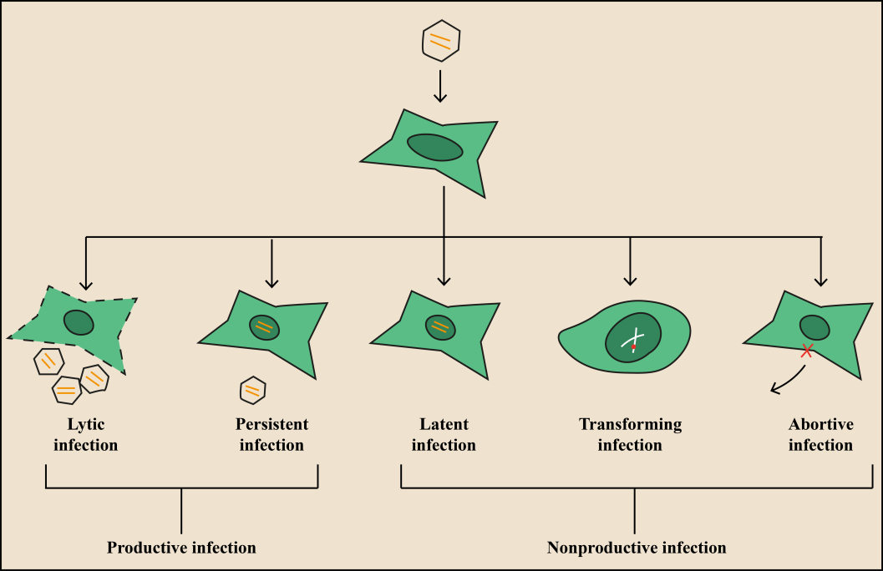

**Figure 30: Types of viral infections**

Additionally, virus infections can be classified based on clinical symptoms (Figure 31)-

**1. Symptomatic infection-** Symptomatic viral infections are those in which the infected individual exhibits clinical symptoms. Influenza infections typically present with symptoms including fever, cough, sore throat, muscle pain, fatigue, and even gastrointestinal problems like nausea and vomiting. In severe cases, influenza can lead to pneumonia and respiratory failure.

**2. Asymptomatic infection-** Asymptomatic infections are quite common, as seen in poliovirus infection, where only a small fraction of infected individuals show symptoms. These asymptomatic cases, also known as inapparent infections, typically result in limited viral replication and the development of antibodies in the infected individual.

**3. Acute Infections-** Acute infections prompt sudden onset of severe symptoms, which frequently lead to fatalities or serious illnesses (e.g., influenza, viral hemorrhagic fever).

**4. Chronic infections-** These infections are prolonged, with the virus persisting in the host for an extended period (e.g., hepatitis, HIV).

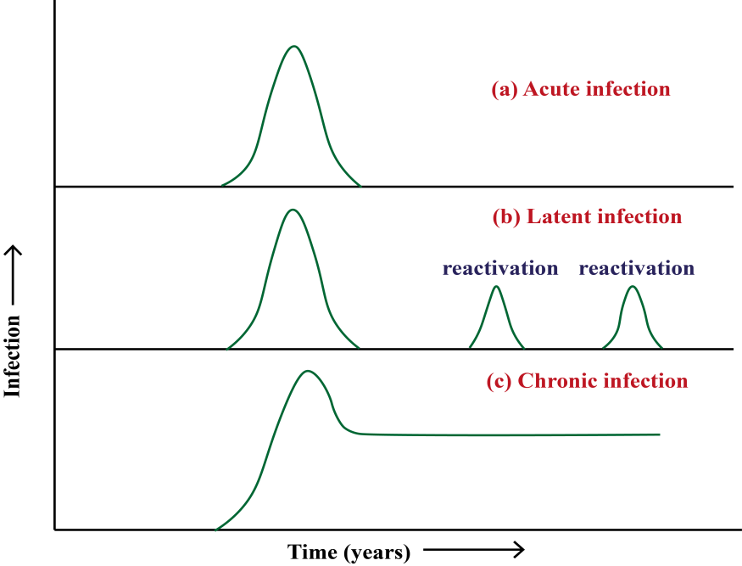

**Figure 31: Schematic diagram of viral infection**

**Multiplicity of Infection (m.o.i.):** It is a term used to quantify the proportion of all viral particles that have successfully infected target cells to the total no. of target cells present in a given infection condition. In practical terms, it provides insight into the efficiency of viral infection in vitro, particularly within cell culture systems. For example, a high m.o.i. indicates that a large proportion of target cells have been infected by the virus, whereas a low m.o.i. suggests that only a small fraction of cells have been successfully infected.

**Infectious dose50 (ID50)** represents the dose or concentration of a virus required to infect 50% of the animals inoculated with the virus. It is a measure of the infectivity of the virus and provides valuable information regarding its potency. A lower ID50 indicates higher infectivity, as fewer virus particles are needed to initiate infection in a significant portion of the exposed population.

**Lethal dose50 (LD50)** is the dose or concentration of a virus needed to cause death in 50% of the animals inoculated with the virus. It serves as an indicator of the virus's pathogenicity and lethality. A lower LD50 signifies greater virulence, as fewer virus particles are sufficient to induce fatal outcomes in a significant proportion of the infected animals.

**Virus pathogenesis:** Here is the flowchart of viral pathogenesis (Figure 32).

Virus entry through different routes

Primary viral infection

Targets different organs of respiratory tract, gastrointestinal and urinary tracts

Viremia (virus shedding in the blood stream)

Migrated from site of virus entry to specific targeted organ

The virus localizes to the lymph nodes and begins replicating its genome

Secondary viral infection

Moves to various organs

Symptoms of the illness

**Figure 32: Flowchart showing steps of viral pathogenesis**

**Incubation period:** The incubation period is known as the interval between the initial infection with a virus and the appearance of observable disease symptoms. This period can vary widely depending on the virus and host factors, ranging from a few days, as seen with some common cold causing viruses, two years, as observed with HIV. Understanding the incubation period is essential for disease surveillance, diagnosis, and implementing appropriate control measures. It provides insights into the dynamics of virus-host interactions and the progression of the infectious process within the host.

**Cell-host interactions:** The interactions between viruses and host cells (Table 8) enable viruses to utilize cellular resources for their benefit, while simultaneously offering the host cell a mechanism to counteract viral infections. Virus host interaction causes potential changes to the different cells, ranging from no apparent cellular damage to cell destruction.

**Table 8: Types of virus infections and cellular effects**

|  |  |  |
| --- | --- | --- |
| Type of infection | Cellular effects | Examples |
| Cytocidal | Morphological changes in cells cause cell death | Enteroviruses, reoviruses, adenoviruses |
| Persistent, productive | Continuous cellular division, loss of cellular functions | Pestiviruses,  Arena viruses, rabies  virus, retroviruses |
| Persistent, nonproductive | Virus replication occurs inside the cell and produces defective progeny | Canine distemper virus in brain Polyomavirus, adenoviruses |
| Transformation | Changes in cellular morphology and produces tumor upon transplantation into experimental animals. | Oncogennic viruses-Murine, avian  leukosis, and  sarcoma  viruses |
| Permissive cells | support the complete replication of viruses, kills host cell (cytolytic effect , cell burst) | Human lung epithelial cells for H1N1, CD4+ T lymphocytes for HIV-1, neuronal cells for HSV, Human intestinal epithelial cells for poliovirus |
| Non-permissive cells | Virus replication may be blocked at any stage of replication cycle, yields no infectious progeny (abortive). | Non-neuronal cell for HSV, Cells lacking the poliovirus receptor (CD155) for poliovirus, Cells lacking the measles virus receptor (CD150), for measles, non-immune cells for dengue virus |

Cells can be damaged through different mechanisms-

* Virus can inhibit host cell nucleic acid synthesis. Poxviruses produce a DNAse that degrades cellular DNA.
* Viruses can inhibit host cell transcription and protein synthesis. Herpesviruses produce proteins that directly attach to specific sequences in viral DNA, thereby controlling the transcription of viral genes.
* Viruses can interfere with mRNA splicing. Viruses that suppress catalytic steps of splicing are- vesicular stomatitis viruses, influenza viruses, and herpesviruses.
* Viruses like influenza, rhabdo, togavirus, pox can inhibit mRNA translation thus interferes with the host cell protein synthesis machinery.
* When virus infects cell, immune cell (natural killer cells, cytotoxic T cells) releases perforin that forms pore in the cell membrane resulting in cell death.

**Cytopathic effects of cell membrane:** Virus infects host cell resulting in structural and functional changes in the host cell due to the infection. This is referred as cytopathic changes (CPE). CPE (Table 9) can be observed under low power optical microscope allows for the observation of changes for example cell rounding, cell lysis, syncytium formation, inclusion body formation, and other alterations in cellular morphology.

* **Syncytia formation-** Individual cells fuse together to create a multinucleated cell or syncytium. The plasma membranes of neighbouring cells merge, resulting in the shared cytoplasm and multiple nuclei within the fused cell structure (Figure 33). Examples- HIV, respiratory syncytial virus, morbillivirus, paramyxovirus.

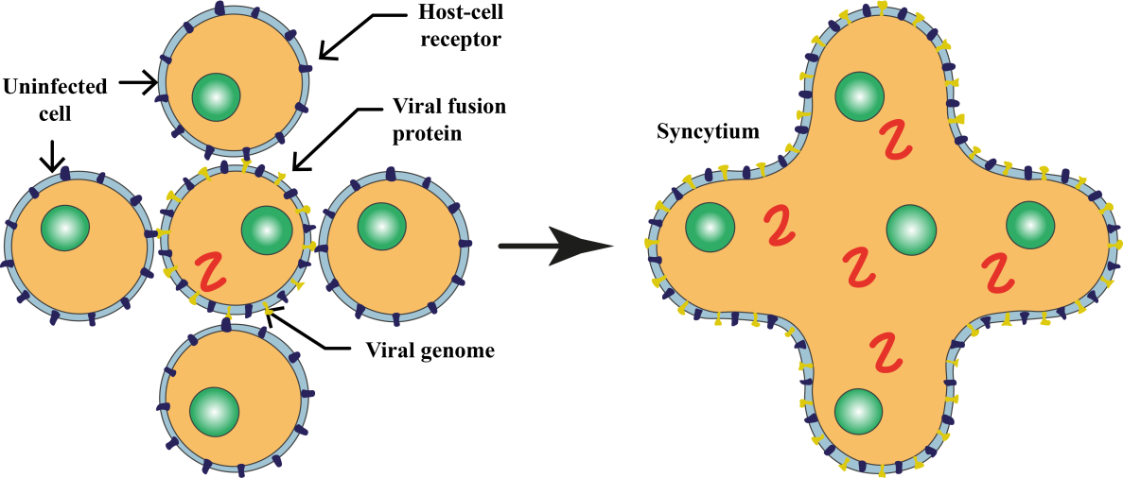

**Figure 33: Syncytia formation**

* **Hemadsorption-** Upon cell infection by a virus, specific viral proteins, specifically glycoprotein pelomers, are released and integrate into the plasma membrane. These proteins then act as receptors for ligands present on the surface of erythrocytes. As a result, erythrocytes adhere to the cell, a phenomenon known as hemadsorption and used in cell culture to determine viral growth. Specific antisera is used to perform hemadsorption inhibition test to identify virus from the positive culture. Examples-orthomyxoviruses, paramyxoviruses and togaviruses.
* **Hemagglutination-** Hemagglutination (Figure 34) is a phenomenon in which red blood cells agglutinate or clump together, induced by certain viruses (Influenza A & B) or antibodies (Cold agglutinin test for autoimmune disease).

1. **Virus Identification-** The assay can help identify the presence of certain viruses based on their ability to agglutinate red blood cells.
2. **Determination of Viral Titers-** Hemagglutination assays are used to measure the concentration or titer of viruses in a sample. The highest dilution of a virus that still causes hemagglutination is indicative of its titer.
3. **Antibody Detection-** The assay can be employed to detect the presence of specific antibodies. If antibodies are present in a sample, they can inhibit the hemagglutination induced by a virus.

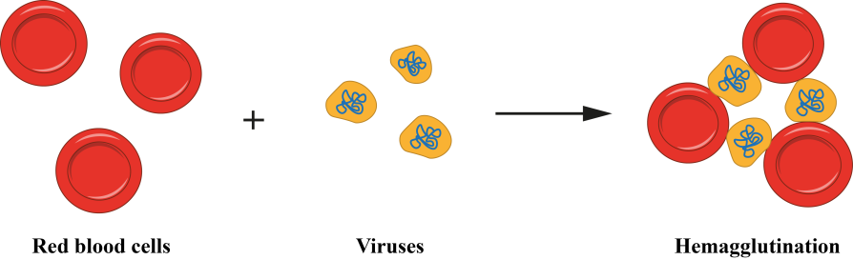

**Figure 34: Haemagglutination**

**Table 9: CPE in cytoskeleton**

|  |  |
| --- | --- |
| CPE in cytoskeleton | Viruses |
| Depolymerization of actin-containing microfilaments | Canine distemper virus, vesicular stomatitis viruses, vaccinia virus |
| Extensive damage to microtubules | Enteroviruses |

**Non-cytocidal Changes in Cells infected by virus:** Cellular metabolism is not affected, infected cell continue to replicate. It can be seen in RNA viruses.

**1. Persistence infection-** The virus or its genetic material persists within the cell through integration into the host cell DNA or carriage as an episome, allowing the cell to survive and potentially undergo repeated divisions. Examples include the concealment of viral progeny in sensory ganglia, as observed in herpesviruses.

**2. Inclusion bodies-** The hallmark histological manifestation in cells infected by viruses is the production of inclusion bodies (Table 10). These structures exhibit unique characteristics in terms of size, shape, location, and staining properties, discernible under light microscopy in virus-infected cells. Inclusion bodies can be found in various cellular compartments, such as the cytoplasm (e.g., poxviruses), nucleus (e.g., herpesviruses), or both (e.g., measles virus). Typically acidophilic, they appear as pink structures when subjected to staining methods like Giemsa's or eosin methylene blue. Alternatively, some viruses induce the formation of basophilic inclusions. The identification and analysis of these inclusion bodies contribute significantly to the diagnostic process, aiding in the recognition and classification of viral infections based on their distinct morphological features observed in infected cells. Here are some key functions:

1. **Viral Replication and Assembly:** Inclusion bodies are frequently involved in the replication and assembly of new virus particles. They can serve as sites for the concentration of viral components, aiding in the efficient production of new viral progeny.
2. **Protection of viral components-** Inclusion bodies can protect viral components, such as nucleic acids and proteins, from host cell defenses. The sequestration of these components within inclusion bodies may shield them from degradation or recognition by the host immune system.
3. **Facilitation of viral spread-** Certain inclusion bodies assist in the dissemination of the virus within the host organism. For example, in some cases, inclusion bodies may contain large amounts of infectious virions, contributing to the spread of the virus to neighbouring cells.
4. **Host cell manipulation-** Inclusion bodies can influence host cell functions to create a more favourable environment for viral replication. This may involve the modulation of cellular pathways, interference with host defense mechanisms, or alteration of cellular structures.
5. **Diagnosis of viral infections-** Inclusion bodies are valuable diagnostic indicators. Their presence and characteristics observed through microscopy can aid in the identification and classification of specific viruses, contributing to the accurate diagnosis of viral infections.

**Table 10: Viral inclusion bodies**

|  |  |  |  |
| --- | --- | --- | --- |
| Intracytoplasmic | Inclusion bodies | | Virus |
| Negri bodies (eosinophilic inclusions) | | Rabies |
| Bollinger bodies (large inclusion bodies) | | Fowl pox |
| Guarnieri bodies (smaller multiple inclusion bodies) | | Vaccinia virus |
| Henderson-peterson bodies (20-30 µ large inclusion) | | Molluscum Contagiosum |
| Paschen bodies | | Small pox |
| Intranuclear  Cowdry (1934) | Acidophilic | Cowdry type A (variable size and granular) | Varicella zoster virus |
| Herpes simplex virus |
| Yellow fever virus |
| Basophilic | Cowdry type B (circumscribed and multiple) | Polio virus |
| Adeno virus |
| Cytomegalo virus |

**Necrosis/Apoptosis:**

**Apoptosis (programmed cell death) –** It is a highly controlled procedure that eradicates of diseased or damaged cells without triggering tissue inflammation. Some viruses (HIV, Influenza A, HSV, HPV, Hepatitis B, Varicella Zoster) can trigger apoptosis as part of their replication strategy. They encode specific proteins that interfere with cellular pathways, leading to the activation of apoptotic signals.

**Mechanisms-** Viruses may activate intrinsic or extrinsic apoptotic pathways. Intrinsic pathways involve mitochondrial damage and the releasing of pro-apoptotic factors, while extrinsic pathways are triggered by outer impulses attaching to death receptors on the cell surface. Notable morphological shifts that occur in apoptotic cells include chromatin condensation, shrinking of the cell, and the production of apoptotic bodies. Further, the bodies are phagocytosed by neighbouring cells without inducing inflammation.

**Necrosis-** It is a procedure wherein cellular damage results in cell death injury or damage, often leading to tissue inflammation. Certain viruses (Cytomegalovirus, Rotavirus, Huntavirus, Dengue virus), particularly those causing acute infections, can induce necrosis as a consequence of their destructive effects on host cells.

**Mechanisms-** Viral replication and the release of viral particles can cause cellular damage, disrupting membrane integrity and organelle function, ultimately leading to cell death. Necrotic cells undergo swelling, loss of membrane integrity, and release of cellular contents into the extracellular space. This process can trigger inflammation and an immune response.

**Host immune response to virus:**

**A. Innate Immune Response-** Innate means in born, a non-specific rapid immune response that provides immediate protection by birth. This is considered as first line defense against viral infection. The components of innate immune response are-

**1. Physical and chemical barrier-**

**a) Skin-** The body's largest organ, the skin acts as an extensive physical barrier. It contains antimicrobial peptides that can kill pathogen. Commensal flora on the skin helps to heal wounds and prevents the growth of microorganisms. Despite preventing viral entry, certain viruses such as HSV and HPV can enter in to the skin through abrasion.

**b)** **Mucosal surface-** The respiratory and gastrointestinal tracts are the major sites for the virus entry. Mucociliary escalator activity depends on either goblet cells or ciliated epithelial cells, which line the respiratory tract. The mucus generated by goblet cells coats the epithelium, capturing pathogens and other inhaled particles. Ciliated airway epithelial cells subsequently eliminate the mucus from the airways.

**2. Pattern Recognition Receptors (PRRs) -** Pattern Recognition Receptors (PRRs) are integral components of the innate immunity, residing on different types of cells, including immune, epithelial, and endothelial cells. These receptors identify Pathogen-Associated Molecular Patterns (PAMPs), shared by pathogens and distinct from host elements, enabling the discrimination between self and non-self. PAMPs consist of substances like lipopolysaccharide (LPS), flagellin, and peptidoglycan found on bacterial surfaces, as well as genetic material from viruses and common components in microorganisms like fungi and parasites.

PRRs exhibit diverse cellular locations, with some on the cell surface for recognizing extracellular pathogens (mainly on immune and epithelial cells), while others are intracellular, targeting pathogens like viruses within endosomes or the cytoplasm. Toll-like receptors (TLRs), C-type lectin receptors (CLRs), Retinoic acid-inducible gene-I (RIG-I)-like receptors (RLRs), Nucleotide-binding oligomerization domain-like receptors (NLRs) constitute the four primary PRR groups.

**3. Interferon:** There are three types of interferon (Table 11).

**Table 11: Types of interferon (IFNs)**

|  |  |  |  |
| --- | --- | --- | --- |
| **Interferon types** | **Sub-types** | **Produced by** | **Functions** |
| **Type -I** | IFN-α, IFN-β | Various cells that notably leukocytes, fibroblasts, and epithelial cells, in reaction to viral infections and other immune stimuli. | IFN-α and IFN-β are antiviral proteins used in treating chronic viral hepatitis, certain cancers, and multiple sclerosis, respectively, by inhibiting viral replication and enhancing immune response. |
| **Type- II** | IFN-γ | Activated T cells and natural killer (NK) cells in response to antigenic stimulation | IFN-γ is crucial in the adaptive immune response, activating macrophages, enhancing antimicrobial activity, regulating T and B cell function, and assisting in tumor immune surveillance. |
| **Type-III** | IFN-λ, known as interleukin-28 (IL-28), IL-29 | Epithelial cells and dendritic cells, in response to viral infections. | IFN-λ, a cytokine, has been studied for its potential in treating viral infections like hepatitis C and respiratory viruses by inducing antiviral responses and inhibiting viral replication. |

**4. Natural Killer (NK) Cells and Neutrophils-** NK cells possess cytotoxic activity and can kill the cells directly upon viral infection. NK cells can produce cytokines for example IFN- γ, TNF-α to regulate immune response. They can interact with dendritic cells, regulating the activity and proliferation of T cells.Neutrophils are phagocytes and can release microbicidal substances, including reactive oxygen species (ROS) and antimicrobial peptides, to kill pathogens. Neutrophils release extracellular traps made of DNA, histones, and antimicrobial proteins to capture and eliminate pathogens.

**5. Antibodies-** In the humoral immune response, antibodies such as IgG, IgM and IgA are essential for the body's defense against infections.

**IgG (Largest antibody, pentamers)-** provides persistent immunity, because it can traverse the placenta from mother to fetus, conferring passive protection to neonates. Functions of IgG include neutralization of toxins and viruses, opsonization of pathogens for phagocytosis, activation of the complement system, and participation in antibody-dependent cell-mediated cytotoxicity (ADCC).

**IgM-** The first antibody to be created during the early stages of an immunological response to an antigen is IgM. It performs a crucial role in the primary immunity and is produced early in infection. IgM levels typically decrease as IgG production increases during the course of an infection. In blood typing, IgM antibodies are crucial for the agglutination of incompatible blood types.

**IgA-** IgA is present predominantly in mucosal regions for example the respiratory, gastrointestinal, genitourinary tracts, and also in saliva, tears, and breast milk. It exists in two forms: secretory IgA, which is produced locally in mucosal tissues and serves as the primary defense against pathogens at mucosal surfaces, and serum IgA, which circulates in the blood. In breast milk, IgA provides passive immunity to infants, protecting them from infections until their own immune systems mature.

**B. Adaptive Immune Response:** The adaptive immune response is acquired after birth and persists until death. This is the most specificdefense mechanism that the body employs to target and eliminate specific pathogens.

**1. B cells and antibody-** B cells, especially plasma B cells, are crucial for antibody production and immunity against viruses. Vaccines work by generating neutralizing antibodies, combating viruses like measles, rubella, smallpox, and SARS-CoV-2. They also produce long-lived memory B cells for rapid antibody production upon re-exposure to the same pathogen. However, antibody production can be short-lived in some cases, like SARS-CoV-2 and RSV, leading to possible reinfections. B cells also play antibody-independent roles by producing cytokines that regulate immune responses and presenting antigens to T cells via MHC class II molecules, influencing the T cell response to viral antigens.

**2. CD4+ T cells-** CD4+ T cells recognize antigens presented on immune cells via their T cell receptor (TCR) bound to MHC class II molecules. They are crucial in adaptive immune responses, secreting cytokines and interacting with other immune cells. T helper cells activate and guide the actions of other immune cells, such as B cells, cytotoxic T cells, macrophages, and dendritic cells. They are further categorized into various subsets (Table 12).

**3. CD8+ T cells-** Cytotoxic T cells (CTLs) are crucial players in the adaptive immune system, tasked with eradicating virally infected and tumor cells. They detect antigens presented by MHC class I molecules on all nucleated cells. CTLs utilize two primary methods to kill target cells: releasing cytotoxic granules containing perforin and granzyme, and inducing apoptosis through Fas/FasL interaction. These actions require the formation of an immunological synapse between the CTL and the target cell. Additionally, CTLs secrete pro-inflammatory cytokines such as TNF-α, IFN-γ, and IL-2 to enhance immune responses. However, viruses can evade CTL attacks by downregulating MHC class I expression on infected cells.

**Table 12: Classification of T cells**

|  |  |
| --- | --- |
| **T cells** | **Function** |
| Th1 | * Activates macrophages, promotes differentiation of cytotoxic T cells (CD8+ T cells), and enhances IgG antibody production. * Secretes cytokines like interferon-gamma (IFN-γ), interleukin-2 (IL-2), and tumor necrosis factor-alpha (TNF-α). Associated with autoimmune diseases, chronic inflammatory conditions, and defense against intracellular pathogens. |
| Th2 | * Regulates humoral immunity and allergic responses by secreting cytokines such as IL-4, IL-5, IL-10, and IL-13. * Promotes production of antibodies (IgE, IgG1, IgA) and stimulates eosinophil and mast * cell activity. Associated with allergic diseases (asthma, atopic dermatitis, allergic   rhinitis) and defense against helminth parasites. |
| Treg | * Maintains immune tolerance and prevents autoimmune responses by producing immunosuppressive cytokines like IL-10 and TGF-β. * Suppresses the activity of other immune cells, including T cells, B cells, and antigen-presenting cells (APCs), to prevent excessive immune reactions against self-antigens. * Consists of natural Treg cells (nTregs) that develop in the thymus and induced Treg cells (iTregs) that form in peripheral tissues. Dysregulation of Treg cells is linked to autoimmune diseases, chronic inflammation, and impaired immune tolerance. |

**References:**

Fenner, F., Bachmann, P.A., Gibbs, E.P.J., Murphy, F.A., Studdert, M.J., White, D.O., 1987. Structure and Composition of Viruses, in: Veterinary Virology. Elsevier, pp. 3–19. https://doi.org/10.1016/B978-0-12-253055-5.50005-0

Foster, J.E., Mendoza, J.A., Seetahal, J., 2018. Viruses as Pathogens, in: Viruses. Elsevier, pp. 157–187. https://doi.org/10.1016/B978-0-12-811257-1.00007-3

Herbert, J.A., Panagiotou, S., 2022. Immune Response to Viruses, in: Encyclopedia of Infection and Immunity. Elsevier, pp. 429–444. https://doi.org/10.1016/B978-0-12-818731-9.00235-4

Hoenen, T., Groseth, A., 2022. Virus–Host Cell Interactions. Cells 11, 804. https://doi.org/10.3390/cells11050804

Karhu, N., 2006. The genome packaging machinery of dsDNA bacteriophage PRD1.

Louten, J., 2016. Virus Structure and Classification, in: Essential Human Virology. Elsevier, pp. 19–29. https://doi.org/10.1016/B978-0-12-800947-5.00002-8

Nugroho, H.A., Agustiyanti, D.F., Angelina, M., Ningrum, R.A., Rahmani, S., Wisnuwardhani, P.H., 2023. Biosafety protocol verification to inactivate Indonesian isolate SARS CoV-2 using formaldehyde. Presented at the PROCEEDINGS OF THE 9TH INTERNATIONAL SYMPOSIUM ON INNOVATIVE BIOPRODUCTION INDONESIA ON BIOTECHNOLOGY AND BIOENGINEERING 2022: Strengthening Bioeconomy through Applied Biotechnology, Bioengineering, and Biodiversity, Bogor, Indonesia, p. 080002. https://doi.org/10.1063/5.0183716

Payne, S., 2017. Methods to Study Viruses. Viruses 37–52. https://doi.org/10.1016/B978-0-12-803109-4.00004-0

The Baltimore Classification of Viruses 50 Years Later: How Does It Stand in the Light of Virus Evolution? | Microbiology and Molecular Biology Reviews [WWW Document], n.d. URL https://journals.asm.org/doi/10.1128/mmbr.00053-21 (accessed 4.13.24).

Wadell, G., 1983. Cultivation of viruses, in: Textbook of Medical Virology. Elsevier, pp. 38–44. https://doi.org/10.1016/B978-0-407-00253-1.50010-4

Whitaker-Dowling, P., Youngner, J.S., 1999. VIRUS-HOST CELL INTERACTIONS, in: Encyclopedia of Virology. Elsevier, pp. 1957–1961. https://doi.org/10.1006/rwvi.1999.0343