**Advancements and Challenges of Real-Time Data in Remote Sensing Scene Classification with Deep Learning Techniques**

1P. Deepan, 2L.R. Sudha, 3R.Santhoshkumar, 4B. Rajalingam, 5R. Vidya

1,5Associate Professor, Department of CSE(AI&ML) St. Peter’s Engineering College, Hyderabad

2Associate Professor, Department of CSE, Annamalai University, Tamilnadu

3,4Associate Professor, Department of CSE, Martin’s Engineering College, Hyderabad

[deepanp87@gmail.com](mailto:deepanp87@gmail.com), [sudhaselvin@ymail.com](mailto:sudhaselvin@ymail.com), [santhoshkumar.aucse@gmail.com](mailto:santhoshkumar.aucse@gmail.com), [rajalingam35@gmail.com](mailto:rajalingam35@gmail.com), [vidyarajesh23@gmail.com](mailto:vidyarajesh23@gmail.com)

**Abstract:** The Remote Sensing Image Scene Classification (RSI-SC) is a fundamental and challenging task in a remote sensing community area and used for earth observation application such as agricultural monitoring, civilian monitoring in military, city planning, crop planning, geomorphology, Land Use and Land Cover (LULC), metrology and soil mapping. In remote sensing image analysis, satellite and drone-captured images are used to study the Earth’s surface. The goal of image classification systems in this field is to assign meaningful labels to captured images, allowing them to be organized in a semantic structure. Such semantic ordering of images has wide applications in digital image processing and computer vision, including remote sensing, image retrieval, object recognition, image annotation, scene analysis, content-based image analysis, and video analysis.

Feature extraction and representation at lower and intermediate levels was the mainstay of earlier approaches to remote sensing image analysis. The use of smaller image datasets hindered these approaches, but their great performance was demonstrated by combining numerous features and applying machine learning techniques. There has been a recent trend toward using deep learning models for remote sensing picture analysis, with hybrid deep learning approaches outperforming single models. This review article provides an in-depth examination of current deep learning methodologies, including low- and mid-level feature representation. It also provides a synopsis of image standards that are available to the public for use in remote sensing image analysis. We also compare different techniques that represent recent advances in deep learning models, addressed the challenges of remote sensing images and discussed about current applications in the field.

**Keywords: *Remote sensing image, Scene classification, Object detection, Crop monitoring, Land use Land cover, Inter-class similarity and Inter-class similarity.***

1. **INTRODUCTION**

In the field of research pertaining to natural resources and the environment, Remotely Sensed Images (RSI) are becoming an increasingly significant asset. In addition to forestry management, crop monitoring, land use monitoring and management, water resources management, urban planning and development, traffic management, natural disaster recovery, military observation, soils mapping, archaeological investigations, mineral prospecting, ocean resources, climate change analysis, and deforestation, there are a multitude of other applications that could potentially benefit from the utilization of remotely sensed data. In addition to the enormous amount of data that is contained inside the photos that satellites capture, the amount of data that is generated from these photographs has also expanded. We have chosen Google Earth cropped benchmark photos as RGB color 3 channel images for the purpose of accomplishing this research.

With the publication of Simonyan and Zisserman's (2015) research in Neural Information Processing Systems (NIPS) 2012 and the success of the International Large Scale Visual Recognition Challenge (ILSVRC) 2012 ImageNet competition, the breakthrough of deep neural networks on the image classification and recognition problem gained a lot of attention and became very popular. Deep learning is currently a very popular issue in the field of vision research, and this performance boost prompted a large number of other researchers to concentrate their attention on deep neural networks in order to solve their own unique difficulties. Deep learning is being used to better the solutions to vision difficulties, and almost every day, a new scientific study is being published to further this mission. In contrast, researchers are able to acquire greater quantities of remote sensing data with higher spectral and spatial resolution as a result of the availability of sensors of a high quality, as well as the improvement of the aerospace and satellite industries.

As a result, researchers are able to tackle this issue and utilize deep learning for remote sensing thanks to the increasing quality and quantity of remote sensing photos. A fully automated system that is capable of classifying geographical objects and land cover into distinct categories, such as airplanes, barren ground, buildings, cultivated fields, forests, roadways, runways, ships, storage tanks, water, and so on, is one of the tasks that deep learning in remote sensing is tasked with doing. For the purpose of managing urban growth and keeping track of the ongoing changes that occur on Earth, it is of utmost importance to be able to categorize land use and land cover.

Due of the limited amount of remote sensing data that is available with ground truth labels, the utilization of machine learning techniques for this purpose is both extremely important and rather difficult. A large number of computer vision researchers have, as a result, suggested a variety of deep learning algorithms for the purpose of extracting information from remote sensing photos. These researchers have also made major contributions to the body of literature in the subject of computer vision and remote sensing. Two primary categories can be used to classify the research topics that pertain to satellite image analysis:

* Scene classification
* Object Detection
  1. **Scene Classification**

In 2010, with the introduction of land use and land cover area, the evolution of remote sensing imagine categorization begins. This progression begins at the pixel and object level and moves up to the scene level. "Scene" refers to a local area that has been cropped from a large-scale satellite image in this context. The Remote Sensing Image Scene Classification (RSISC) task, which has garnered a lot of attention, is an attempt to categorize remote sensing photographs with a set of semantic categories. This is accomplished by analyzing the differences in the spatial arrangement and structural pattern of ground targets. As an illustration, Figure 1 depicts the process of classifying an image of an urban region into an industrial area, a residential area, and a commercial structure.

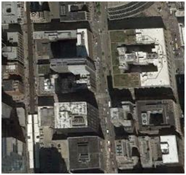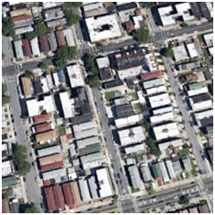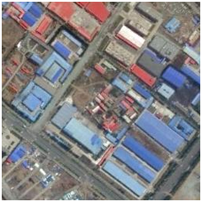

|  |  |  |
| --- | --- | --- |
| 1. **commercial building** | 1. **residential area** | 1. **industrial area** |

**Fig. 1** Sample classes of urban area in remote sensing images

When compared with object-based classification, scene classification is a challenging and difficult task due to the presence of various complex spatial ground objects in the scenes, which don’t have a unique shape and structure. For example, an industrial scene may contain roads, trees, buildings and so on.

* 1. **Object Detection**

Object detection is a technique used in remote sensing image analysis that seeks to ascertain the precise location of the items that are present in the image. It has a wide range of applications, including intelligent monitoring, urban planning, precision agriculture, danger identification, military investigation, and many more. It plays an important part in picture interpretation and makes a significant contribution to the field. This requirement, in conjunction with the extensive feature learning capabilities of deep neural networks, has generated a significant amount of interest in the use of deep learning to the detection of objects. There have been significant advancements in the field of object identification produced by deep learning models in recent years. These models include You Only Look Once (YOLO), Region based CNN (R-CNN), and their refined variations. On the basis of whether or not they generate region proposals, present-day deep learning models can be divided into two distinct categories: region proposal based models and regression based models.

This is because region-based methods are more effective than regression-based methods when it comes to identifying multi-class items in remote sensing photos. The majority of researchers are currently using these methodology. In spite of the fact that the majority of the models that are currently accessible have shown substantial achievement, they continue to be time intensive, and as a result, the task of object detection is still incomplete. Figure 2 depicts the overall process from beginning to end of the object detection process.

Training Phase

Training and Annotated Data

Detection Model

Backbone Network

Detection

Layer

Trained

Model

Testing Data

Bounding Box

Class

Label

**Fig. 2** General architecture of object detection

Through a series of stages that include pre-processing, feature extraction, classification, and localization, the objective of object detection is to identify and specify the location of an object. There are still many obstacles to overcome when it comes to object detection in aerial photos. These obstacles include low image resolutions, complicated backdrops, and fluctuations in the sizes and orientations of objects in the photographs. Deep learning techniques have been utilized in a multitude of research projects for the purpose of object detection. These research works may primarily be divided into two categories: one stage detection, which is based on regression, and two stage detection, which is based on area based detection.

When it comes to determining the position of the objects of interest, one-stage approaches are those that make use of a feed forward CNN. This allows for the determination of the coordinates of the bounding boxes. The situation is similar to that of models such as the Single Shot Multi-box Detector (SSD) and the You Only Look Once (YOLO) model. It is not necessary for these models to generate region ideas, which makes them more straightforward and expedient. Having said that, this does result in certain performance issues, such as difficulty when attempting to detect small objects or when attempting to carry out additional tasks, such as mask prediction.

The two-stage approaches, on the other hand, include R-CNN, Fast R-CNN, Faster R-CNN, R-FCN, and Mask R- CNN. These are all examples of this type of method. As an initial phase, these models make use of CNN that is based on regions. A CNN that is based on regions takes an image as its input and generates a number of potential regions of interest that are possible locations for the items that are depicted in the image. After that, the vector that contains the various features that were collected from each suggested region serves as the input for a collection of fully connected layers that produce a variety of classes and a confidence score. With the help of the confidence score, a ranking is created with the ideas, and only the ones that have the highest level of confidence are taken into consideration. Two models, one in each category, have been implemented by us for the purpose of object detection, and they are presented in the following section.

1. **METHODOLOGY USED FOR RSI IMAGE PROCESSING**

Remote Sensing Image Scene classification (RSI-SC) analysis using satellite images is a challenging but necessary problem. Remote sensing images of natural areas such as beach, forest and river need to be analyzed. Moreover, dealing with the large amount of remote sensing images requires automating the scene classification analysis and Object detection. The automation can be done through various deep learning models such as Convolutional Neural Networks, Deep CNN (AlexNet, VGG-16 Net, InceptionV3, GoogleNet) models, Fast Region-CNN, Faster R-CNN, Mask R-CNN and YOLO model.

* 1. **CNN Model- Scene Classification**

CNNs are the foundational models for processing and analyzing visual data, especially large-scale images like satellite images. They consist of three primary layers—Convolutional layers, Pooling layers, and Fully Connected layers—each performing essential tasks to learn and recognize patterns in images.

**Convolutional Layers:** These layers apply a set of learnable filters (kernels) across the input image. Each filter captures specific spatial features, such as edges, textures, or other visual patterns. In satellite images, CNNs can detect unique terrain features (e.g., river edges, forest textures).

**Activation Function (ReLU):** After convolution, each layer applies a non-linear activation function, commonly ReLU (Rectified Linear Unit), which introduces non-linearity, allowing the network to learn more complex patterns.

**Pooling Layers:** Pooling layers (e.g., Max Pooling) reduce the spatial dimensions, focusing on the most prominent features and reducing computational load. This is particularly useful for reducing the size of high-resolution satellite images while preserving critical information.

**Fully Connected Layers:** These layers process the flattened feature maps to predict the class or scene. In RSISC, they help in classifying scenes into categories like forest, urban, or water body.

* 1. **Deep CNN Model- Scene Classification**

Deep CNNs are extensions of basic CNNs, designed with more layers and unique architectural elements that improve feature extraction, especially in large and complex image datasets. These models are highly effective for detailed RSISC tasks.

**AlexNet:** AlexNet features a layered structure comprising eight layers, which includes five convolutional layers and three fully connected layers. The input layer accepts images resized to 227×227 pixels. The first convolutional layer utilizes 96 filters of size 11×11 with a stride of 4, capturing prominent features and followed by a max pooling layer with 3×3 filter size and stride of 2. Subsequent convolutional layers utilize 256 filters with 5×5 kernels, and later layers apply 384 filters and 256 filters with 3×3 kernels.

**VGG-16 Net Model:** VGG-16 is characterized by a deeper architecture, consisting of 16 layers in total, with 13 convolutional layers and 3 fully connected layers. The input layer also accepts images resized to 224×224224×224 pixels. VGG-16 uniquely employs small 3×33×3 convolutional filters throughout the network, allowing for a deeper configuration that enhances feature extraction while keeping the model complexity manageable. The architecture is structured in blocks, where each block consists of two or three convolutional layers followed by a max pooling layer with 2×22×2 filter size and stride of 2. This pooling occurs after every two convolutional layers, progressively reducing the spatial dimensions of the feature maps. Each convolutional layer is activated using the ReLU function, which improves training efficiency. The last three layers consist of fully connected layers, where the first two layers have 4096 neurons each, followed by a softmax layer for classification.

* 1. **YOLO Model- Object Detection**

YOLO is an advanced, real-time object detection model that can simultaneously predict multiple bounding boxes and class probabilities for each object within an image.

**Grid-Based Detection:** YOLO divides the input image into an S×SS×S grid. Each grid cell is responsible for predicting bounding boxes and class probabilities for objects within its cell.

**Single Neural Network:** Unlike traditional object detection methods, YOLO uses a single neural network that processes the image in one pass, making it exceptionally fast.

**Bounding Box Prediction:** Each grid cell outputs bounding boxes, objectness scores (confidence scores), and class probabilities, enabling YOLO to detect and localize multiple objects in real-time.

1. **REAL TIME REMOTE SENSING IMAGE DATASET COLLECTION**

The development and evaluation of a variety of scene categorization models are both significantly aided by the dataset. The scene classification of remotely sensed photos was accomplished with the use of three datasets that are freely accessible to the public. The Aerial Image Dataset (AID), the Northwest Polytechnical University (NWPU) 45 class dataset, the Pattern Net dataset, the RSSCN dataset, the SIRI-WHU dataset, and the UC Merced Land Use dataset are some of the benchmark datasets that we have gathered in this section.

* 1. **Aerial Image Dataset (AID Dataset)**

There are a total of 10,000 images and 30 different types that make up the Aerial Image Dataset (AID), which is the initial dataset. Every class is comprised of between 220 and 420 images, each of which has a resolution of 600×600. The spatial resolution of images can range anywhere from 0.5 meters to 8 meters.

* 1. **PatternNet Dataset**

The second dataset is called PatternNet, and it has a total of thirty-four hundred and eighty-four photos across its 38 classifications. Each class is comprised of a total of 800 images, each of which has a resolution of 256×256 pixels. A range of 0.062 meters to 4.69 meters is represented by the spatial resolution of images.

* 1. **RSSCN Dataset**

The remote sensing image classification dataset is an extensive collection of images acquired through Google Earth Engine, offering comprehensive geographic coverage across diverse landscapes. This dataset is specifically structured to support remote sensing and classification tasks by providing high-quality images for varied scene recognition.

The third RSSCN dataset is organized into seven unique classes, each representing quintessential types of scenes commonly encountered in remote sensing imagery. These categories are designed to capture a range of environmental and structural features, allowing for detailed analysis and classification. Each image in the dataset is precisely sized at 400 × 400 pixels, ensuring consistency and compatibility across machine learning and image processing applications.

* 1. **SIRI-WHU Dataset**

The Scene Image Research Institute at Wuhan University (SIRI-WHU) dataset image is captured at a high spatial resolution of 2 meters per pixel, ensuring detailed visual information suitable for analysis of fine-scale features. The image dimensions are standardized at 200 × 200 pixels, representing an area of 400 square meters per image. This consistent size enables efficient processing while preserving the resolution necessary for robust feature detection. The dataset is comprehensive, containing a significant total number of images that are systematically divided into multiple classes, with each class containing a predefined number of images.

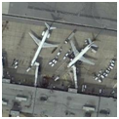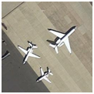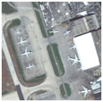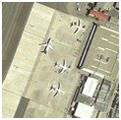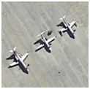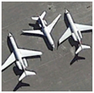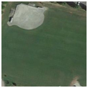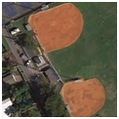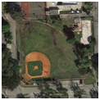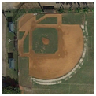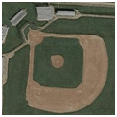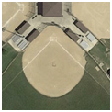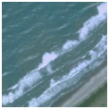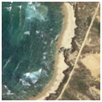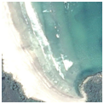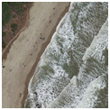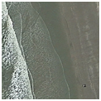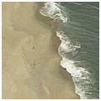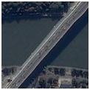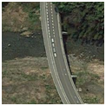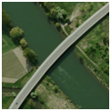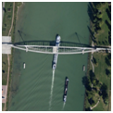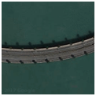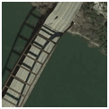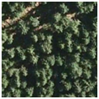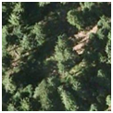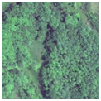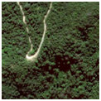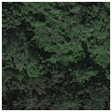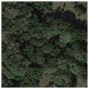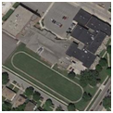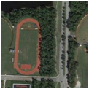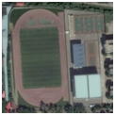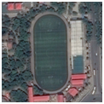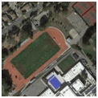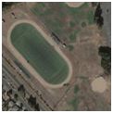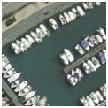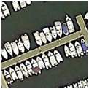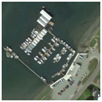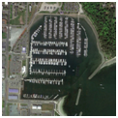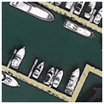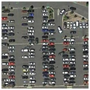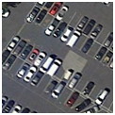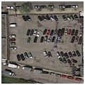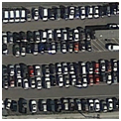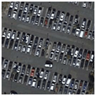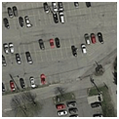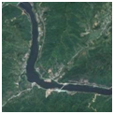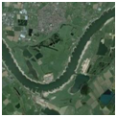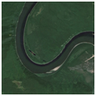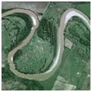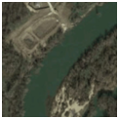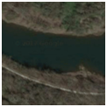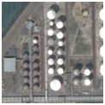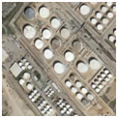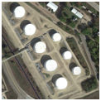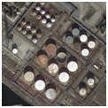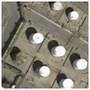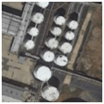

|  |  |  |
| --- | --- | --- |
| (a) | (b) | (c) |

**Fig. 3** Sample images from benchmark datasets (a) NWPU 45-class dataset (b) AID Dataset (c) PatternNet

* 1. **NWPU 45 class Dataset**

A high resolution remotely sensed image from more than one hundred countries is included in the NWPU 45-class dataset, which is the fifth dataset that was taken from Google Earth. This dataset, which is currently the largest scene categorization dataset, was made available by North Western Polytechnical University. 31 500 remote sensing photos are included in this dataset, and they are organized into 45 different categories. The Red-Green-Blue (RGB) color space has seven hundred images, each of which has a resolution of 256×256 pixels and is categorized into each of the classes. It is possible for the spatial resolution to range anywhere from 30 meters to 0.2 meters for each pixel.

When compared with all other datasets, NWPU 45-class is a complex dataset due to the large scale variation in the scene, complex background, inter class similarity between scenes and high intra-class diversity. To evaluate the effectiveness of the proposed approach, we have chosen ten common classes, namely airplane, baseball diamond, beach, bridge, forest, ground track, harbor, parking lot, river and storage tank from the above mentioned three benchmark datasets for scene classification. The sample images from three benchmark datasets are shown in Figure 3.

1. **CHALLENGES IN REMOTE SENSING IMAGE**

Over the last several decades, researchers have examined RSISC in many ways, but no system has been created that can reliably categorize RSI sceneries. Scene classification and object detection using remote sensing images presented the researchers with a number of obstacles, including the ones listed below.

* In remote sensing images, there is a lot of variety within the same class.
* A lot of the scenarios are very similar to each other throughout classes.
* In comparison to ground-based images, aerial views provide a far wider range of scales.
* A complex background landscape with multiple ground objects.

Along with these issues, the significant processing cost caused by the images' quantity and quality also makes near-real time applications challenging.

* 1. **Intra-class diversity / Within-class diversity**

Within-class diversity is a challenge due to the wide range of appearances of ground objects within the same semantic class. Remote sensing image ground objects often differ in style, shape and size that make it difficult to classify scene images correctly. For example, in Figure 4 commercial buildings and play grounds are depicted in a variety of structural types, while beach and lakes are depicted in a variety of shapes. Furthermore, when remote sensing images are captured by Unmanned Aerial Vehicle (UAV) or airborne platforms, significant variations in color and radiation intensity can occur within the same semantic class due to imaging conditions, which can be affected by factors such as temperature, fog, weather and so on.

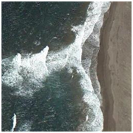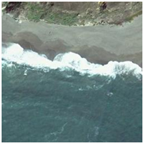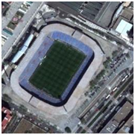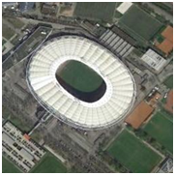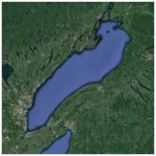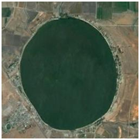

**Fig. 4** Within-class variation in remote sensing images

* 1. **Inter-class similarity / Between-class similarity**

In the case of inter-class similarity, the challenge is mainly caused by the presence of the same objects in different classes of scenes or by a high semantic overlap between categories of scenes. For example as shown in Figure 5, scene categories basketball courts and tennis courts, both contain the same group elements. Similarly, the “harbour” vs. “parking lot”, “playground” vs. “stadium” and “commercial building” vs. “industrial area” share a lot of semantic information and so it is extremely difficult to classify these scene classes.

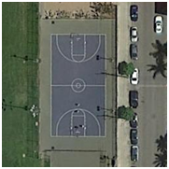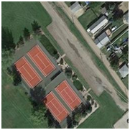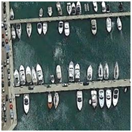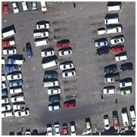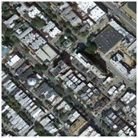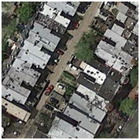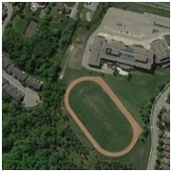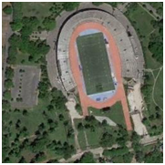

**Fig. 5** Inter-class scene variation in remote sensing images

* 1. **Large scale variation**

The wide range of scene variation or scene scales is a major challenging task in remote sensing image scene classification. Sensors in remote sensing imaging work at different altitudes, ranging from a few hundred kilometers to over ten thousand kilometers, resulting in imaging altitude variation. Under various imaging altitudes, the scenes of an aircraft, ship, storage tank and bridge have huge scale variations as shown in Figure 6.

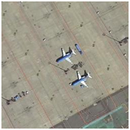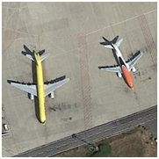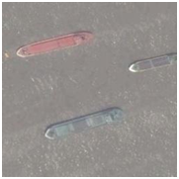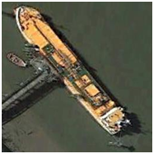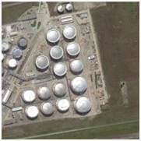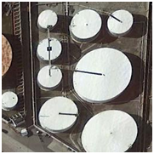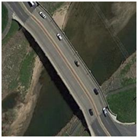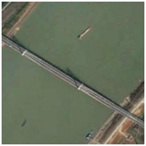

**Fig. 6** Large scale variations in remote sensing images

* 1. **Multiple ground objects with complex background**

Since remote sensing image contains multiple ground objects with complex background, it may be very difficult to classify the scenes. As shown in Figure 7, scenes of tennis court may also include trees, roads, vehicles and parking lots. Similarly, scenes of playgrounds may include buildings, roads, trees and residential area; scenes of baseball court may include roads, vehicle and residential area.

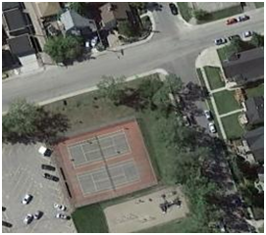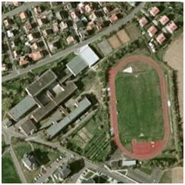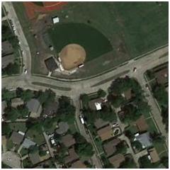

**Fig. 7** Multiple ground objects in the same scene with complex background

1. **DEEP LEARNING APPLICATIONS IN REMOTE SENSING IMAGES**

In recent years, deep learning methods have gained substantial traction in the research community, especially within the field of remote sensing image classification (RSIC). This surge in popularity is due to deep learning’s powerful ability to process and analyze vast amounts of high-resolution remote sensing data, making it invaluable across a wide spectrum of applications. The application of remote sensing images in the field of deep learning has been shown in Figure 8.

Precision Agricultural

Crop Monitoring

Forestry

Environmental Monitoring

Land Mapping and Management

Land Use Land Cover

**Fig. 8** DL applications in remote sensing images

**Agriculture:** Deep learning is transforming agriculture by enabling automated detection of crop types, growth stages, and health conditions. For instance, convolutional neural networks (CNNs) are used to monitor plant health through leaf color and texture analysis, identifying diseases before they are visible to the naked eye. This proactive approach helps farmers mitigate potential yield losses and optimize resource usage, particularly in precision farming, where drone and satellite imagery are analyzed to provide field-specific insights.

Crop Monitoring: Researchers and the agricultural sector increasingly leverage deep learning and remote sensing (RS) technology to enable real-time monitoring of various agricultural factors, including crop growth, plant morphology, and overall plantation health. One of the key advantages of integrating real-time intelligent RS technology into crop management is its capacity to provide detailed insights into the growth environment. This understanding allows for optimization of agricultural practices, ultimately leading to enhanced production efficiency and improved crop quality. Furthermore, real-time monitoring through RS technology facilitates the detection of fluctuations in critical parameters such as biomass levels, nitrogen content, and yield predictions. By accurately assessing these variables, farmers and agronomists can make informed decisions regarding fertilization and other management practices, ensuring that interventions are timely and tailored to the specific needs of the crops.

**Forestry:** In forestry, deep learning methods enable high-accuracy tree species classification and forest inventory monitoring. Forest management agencies leverage techniques like recurrent neural networks (RNNs) for time-series data analysis to assess forest health trends and predict deforestation risks. Additionally, by analyzing multispectral and hyperspectral images, researchers can monitor canopy structure and density changes, vital for assessing carbon sequestration levels and biodiversity conservation.

**Environmental Monitoring:** Deep learning models aid in detecting subtle changes in environmental quality, such as pollution levels in water bodies or soil degradation. With generative models like GANs, researchers can also predict how environmental variables might change under different scenarios, aiding in policy-making for climate adaptation. Monitoring long-term environmental trends through image classification helps in understanding the effects of human activities and natural processes on ecosystems.

**Land Mapping and Management:** Deep learning supports highly detailed land cover mapping, allowing researchers to classify urban, rural, and natural areas with sub-meter precision. Semantic segmentation models, for instance, enable automated mapping of specific land features like buildings, roads, and water bodies, which are critical in urban planning, resource allocation, and environmental impact assessments. These maps also support policy-making in zoning, development, and conservation areas.

1. **CONCLUSIONS**

Remote sensing image analysis is widely applied across real-time domains such as Earth monitoring, urban development, town planning, water resource engineering, construction, and agriculture. However, image analysis and classification remain challenging research problems for those working with remote sensing applications. The recent advancements in imaging technology have led to an exponential increase in multimedia content, particularly in video and digital images. This surge in digital image data makes automated image classification an open research area within computer vision. Although numerous research models have emerged in recent years, there remains a significant gap between human understanding and machine perception. This gap drives ongoing research in remote sensing image analysis to explore new methods that could bridge this divide. Traditional approaches relied on low- and mid-level feature extraction, showing promising results on small-scale datasets with limited samples. Incorporating discriminative feature representation and multiscale features has been shown to improve model performance, yet these methods generally support single-label assignments, while the need for multi-label classification is increasing.

A major requirement for deep learning models in this field is the development of large-scale image benchmarks that encompass a wide range of remote sensing image classes. The lack of such benchmarks presents a research challenge, as existing models often depend on fine-tuning and data augmentation to compensate for limited training data. With large-scale benchmarks, learning models could better optimize parameters. However, current models primarily use supervised learning, which is time-intensive and computationally demanding. Exploring unsupervised and semi-supervised learning methods is a promising direction for reducing computational complexity. Deep learning models in remote sensing typically rely on high-performance computing, especially GPUs, for training. Designing models that require fewer computations could make remote sensing analysis accessible on devices with lower processing power. Additionally, few-shot and zero-shot learning methods represent potential avenues for advancement, offering new possibilities for remote sensing image classification with minimal data requirements.

1. **REFERENCES**
2. C. Shi, X. Zhang, J. Sun, and L. Wang, Remote sensing scene image classification based on self-compensating convolution neural network, Remote Sensing, vol. 14, no. 3, p. 545, 2022.
3. P.Deepan and L.R. Sudha, “[Object Classification of Remote Sensing Image Using Deep Convolutional Neural Network](https://www.sciencedirect.com/science/article/pii/B9780128163856000088)”, The Cognitive Approach in Cloud Computing and Internet of Things Technologies for Surveillance Tracking Systems, pp.107-120, 2020. https://doi.org/10.1016/B978-0-12-816385-6.00008-8.
4. Toan NT, Cong PT, Hung NQV, Jo J (2019) A deep learning approach for early wildfire detection from hyperspectral satellite images. In: 2019 7th international conference on robot intelligence technology and applications (RiTA), IEEE, pp 38–45
5. P.Deepan and L.R. Sudha, "Scene Classification of Remotely Sensed Images using Ensembled Machine Learning Models", Proceedings in Lecturer Notes on Electrical Engineering, Springer Nature, pp.535-550, 2021, <https://doi.org/10.1007/978-981-16-0289-4_39>
6. Zhao Z-Q, Zheng P, Xu S-T, Wu X (2019) Object detection with deep learning: a review. IEEE Trans Neural Netw Learn Syst 30(11):3212–3232
7. P.Deepan and L.R. Sudha, “Effective Utilization of YOLOv3 Model for Aircraft Detection in Remotely Sensed Images”, Materials Today: Proceedings, Elsevier, 2021. <https://doi.org/10.1016/j.matpr.2021.02.831>
8. Kussul N, Lavreniuk M, Skakun S, Shelestov A, Deep learning classification of land cover and crop types using remote sensing data, IEEE Geosci Remote Sens 14(5), 778–782, 2017.
9. P.Deepan, L.R. Sudha, K. Kalaivani and J. Ganesh, “Scene Classification of Remotely Sensed Images using Optimized RSISC-16 Net Deep Convolutional Neural Network Model”, EAI Endorsed Transactions on Scalable Information Systems, Vol. ,2022, <https://doi.org/10.4108/eai.1-2-2022.173292>.
10. Ball JE, Anderson DT, Chan CS. Comprehensive survey of deep learning in remote sensing: theories, tools, and challenges for the community. J Appl Remote Sens. 2017;11(4): 042609.
11. P.Deepan and L.R. Sudha, “Object Detection in Remote Sensing Aerial Images: A Review”, International Journal of Scientific Research in Computer Science Applications and Management Studies, Vol. 7, Issue 4, pp.11-18, 2018, ISSN 2319 – 1953.
12. Pritt M, Chern G. Satellite image classification with deep learning. In 2017 IEEE Applied Imagery Pattern Recognition Workshop (AIPR). IEEE. 2017, pp. 1–7.
13. P. Deepan and L.R. Sudha, “Fusion of Deep Learning Models for Improving Classification Accuracy of Remote Sensing Images”, Journal of Mechanics of Continua and Mathematical Sciences, Vol.14, pp.189-201, 2019, ISSN: 2454-7190.
14. Zhang J, Chaoquan L, Li X, Kim H-J, Wang J. A full convolutional network based on DenseNet for remote sensing scene classification. Math Biosci Eng. 2019;16(5):3345–67.
15. P.Deepan and L.R. Sudha, “Remote Sensing Image Scene Classification using Dilated Convolutional Neural Networks”, International Journal of Emerging Trends in Engineering Research, Vol. 8, No.7, pp.3622-3630, 2020, ISSN: 2347-3983.
16. Mohanty SP, Czakon J, Kaczmarek KA, Pyskir A, Tarasiewicz P, Kunwar S, Rohrbach J, et al. Deep learning for understanding satellite imagery: an experimental survey. Front Artif Intell 2020, 85.
17. P.Deepan and L.R. Sudha, “Comparative Analysis of Remote Sensing Images using Various Convolutional Neural Network”, EAI End. Transaction on Cognitive Communications, 2021. ISSN: 2313-4534, doi: 10.4108/eai.11-2-2021.168714.