6. Futuristic Innovations and Paradigms in Arid Agriculture: Vertical Farming, Hydroponics, and Beyond

^{1*}Dr. Lopamudra Jena  Assistant Professor (Horticulture)  Faculty of Agriculture, Sri Sri University  Cuttack-754006, Odisha, India  Email address: lopamudrajena50@gmail.com | ²Dr. Meikam Ichancha  Assistant Professor (Horticulture)  South Asian Institute of Rural and Agricultural Management,  Langjing Achouba, Imphal- West, 795113, Manipur, India | ³Swayan Sikha Priyadasini, ⁴Swadhin Priyadarsinee, ⁵Prakriti Debnath, & ⁵Bikramjeet Ghose  Ph.D. Research Scholar  Bidhan Chandra Krishi Viswavidyalaya  Nadia-741252, West Bengal, India

Abstract
Arid agriculture otherwise known as dry land agriculture can be precisely defined as raising food crops in areas devoid of irrigation facilities, where soil moisture evaporation rate exceeds rainfall. Though characterized by highly fluctuating climatic conditions, scarce water resource as well as poor soil for crop cultivation, the arid regions of world still account for 46% of the global land coverage accommodating nearly 2 billion of population. As the present-day arid lands are on a verge of deterioration owing to the population invasion, urbanization as well as industrialization, there is a need for introduction of new innovative methodologies and novel paradigms to boost the crop production, amidst the stressful environment under arid ecosystem, to meet food demand of exploding population all the while considering sustainability and restoration into account. One of such innovations is vertical farming, where plants are cultivated in stacked layers under enclosed environment ensuring resource optimization. Hydroponics, on the other hand, represents another highly acclaimed achievement in the sector of soilless cultivation, offering significant water savings of up to 90%. This technology has proven to be a remarkable boon for arid farming regions. Through the use of a nutrient-rich water solution, crops are grown in a closed-loop system that minimizes both surface runoff and evaporative water loss, ensuring more efficient use of water resources. This innovative approach has been widely recognized and praised for its potential to revolutionize agricultural practices in water-scarce areas, providing a sustainable solution to traditional soil-based farming challenges. A set of revolutionary smart farming practices such as precision technology, development of tolerant cultivars, automation and mechanization etc. have been discussed in this chapter to augment the crop productivity, which in turn will aid in enhancing economic status and livelihood security of the farmers in arid zones.
Key words: Arid agriculture, innovation, vertical farming, hydroponics
I. Introduction

The global population is evolving and it is predicted to surpass 9.7 billion by the end of 2050 [1]. It would necessitate an increase in provision of food by 50% in 2030, and by 70% in the coming 40 years in order to meet the soaring demand for food [2]. However, the cultivable land for producing food is being invaded by the growing population, urbanization as well as industrialization, and is expected to reduce one-third of its current availability [3]. Arid agriculture, in general, encounters several challenges concerning degradation of arable land, desertification, pest incidence, and climatic adversity together resulting in lower production of food crops [4][5]. A frequent use of high dose synthetic fertilizers for augmenting crop yield and pesticides for protecting the crop from detrimental pest and pathogens has been observed in arid agriculture [6]. Extension of urbanization and industrialization is contributing towards aggravated emission of greenhouse gases ultimately leading to the present day climate crisis. Arid agriculture requires a climate smart crop production technology that proficiently makes use of land, water, fertilizer, plant protection chemicals as well as other essential farm inputs to augment the crop harvest [7][8]. The modern faming era is bestowed with many efficient technologies that not only save valuable time but also help in optimization of limited agricultural resources [9]. Keeping the sustainability in mind, the newly emerging food production technologies should be designed in such a way that they will be able to transform agriculture in response to rising population, limited available resources, and climatic variability [10][11].
According to United Nations Convention to Combat Desertification (UNCCD, 1994), drylands are defined as area with aridity index below than 0.65. The global coverage of dryland accounts 46% of the total land surfaces available [12] accommodating about 2 billion people (1/3rd of world population), 90% of which is confined in developing countries. Globally, dryland constitutes hyper arid, arid, semi-arid and dry sub humid regions [13], whereas in India, mostly arid, semi-arid, and dry-subhumid areas are reported (Figure 1). Dryland are contemplated to be highly vulnerable towards change in environment, particularly desertification which ultimately leads to degradation of arable land [14]. The climatic aberration is causing an extension in global dryland area, the recorded data depicting already 4% increase in dryland area since 1948–1962. It has also been estimated that a spatial increase in dryland area by 11-23% is likely to occur by 2100 that will comprise a coverage of 56% of the world terrestrial surface as arid regions [15]. A significant portion of the planet being arid or semi-arid, faces a variety of challenges such as extended periods of drought, inconsistent and low rainfall, significant wind and water erosion, intense heat waves and frequent droughts, exposed and deteriorated soil, and salinity issues in some low-lying areas [16].
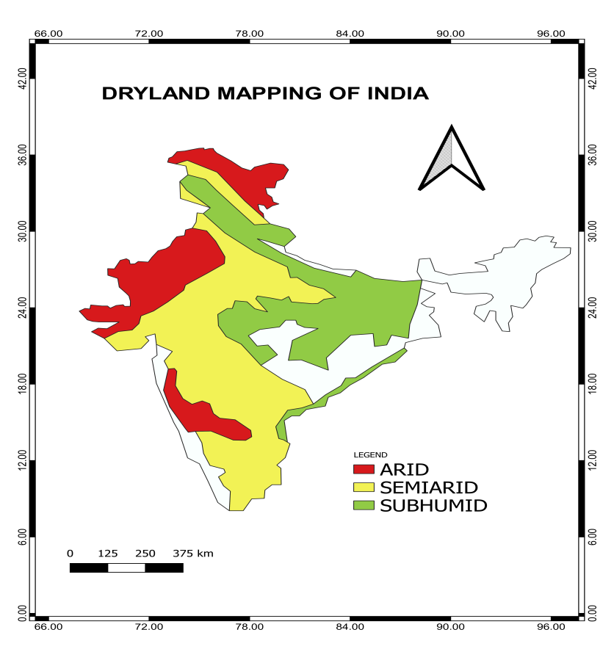
Figure 1: Dryland mapping of India depicting the spatial distribution of arid, semi-arid and sub-humid regions
Climate change poses a potential threat exacerbating not only the extent and severity of land deterioration but also diminishing the efficiency and sustainability of restoration operations. As arid farming in India constitutes 45% of the total agriculture, it is a high time for adoption of technological innovations, opening new opportunities to boost the crop productivity in this sector [17]. The majority of people in these arid regions who depend on agriculture for a living are unable to handle these issues due to a lack of resources, low production, and a variety of unfavourable social and economic conditions [16]. The agriculture production system in arid and semi-arid regions must reduce these issues while raising the income, boosting productivity, lowering risk, conserving and using resources effectively and mitigating and adapting to climate change. Addressing the various climatic and environmental issues in these arid regions, researchers have developed a variety of agricultural systems and management options. The following chapter explores the various approaches to farming in arid zones. It will cover a range of innovative and futuristic technologies that have been developed and adapted to cope with the challenges posed by the arid environments.

II. Challenges faced in Arid Agriculture:

The long term change in the day to day weather parameters lead to changes in climate. Significant temperature fluctuations, patterns of rainfall, frequency of occurrence of cyclones, droughts are some of the indicators of climate change [18]. Deforestation, burning of fossil fuels, different industrial processes is some of the factors that have enhanced climate change during the past decade. Since the start of the Industrial Revolution, human activities have pumped a lot of chlorofluorocarbons into the air, like CO₂, CH₄, and NO₂. Up to 2011, about 2040 billion tons of carbon dioxide was released into the atmosphere, and around 40% of that has stayed there, heating up the planet [19]. The rest got absorbed by plants, soil, and the oceans. The oceans took in about 30% of that carbon dioxide, which made them more acidic. Almost half of all the carbon dioxide released happened just in the last 40 years. Recent extreme weather events like scorching heat waves, devastating droughts, rampant floods, powerful cyclones, and raging wildfires are showcasing just how vulnerable both ecosystems and human societies are to the unpredictable twists of today's climate (Figure 2). In many places around the world, heavy rainstorms are becoming more common, causing floods in more areas than before. A trend has been observed of more intense downpours and higher water levels in certain river areas, which means there's a growing risk of flooding in those regions. Since the IPCC's Fourth Assessment Report (AR4), more evidences have been gathered pointing to human activities affecting the climate. It's now very likely that over half of the rise in the average temperature of Earth’s surface between 1951 and 2010 was due to humans increasing greenhouse gas levels and other human-induced factors [20].

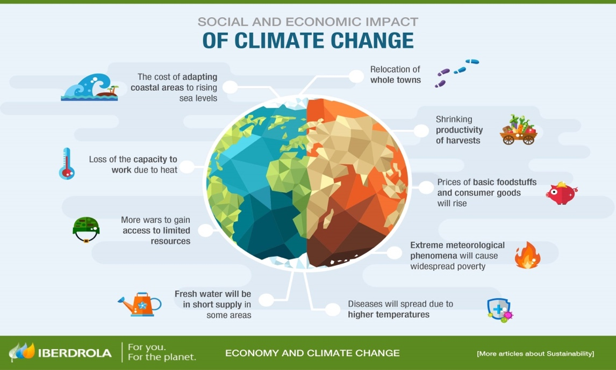
Figure 2: Climate change and its effects on society and economy (Source: www.encompasshk.com/climatechange/, Accessed on 26th May, 2024)

Climate changes have varied effects on social and economic sectors. Disruption in the patterns of rainfall leads to less agricultural production which in turn gives rise to food shortages. Less availability of fresh drinking water, water for irrigation is some of the major problems due to water scarcity. Human health also gets affected due to climate change. Prolonged exposure to sun and heat waves cause heat related illness. Productivity and capacity of human also gets affected.
Every year, the average global temperature keeps going up. According to Statista's August 2023 report (Figure 3), August marked the highest temperature increase compared to the base period of 1880. The increase in greenhouse gases is directly linked to the rising atmospheric temperature. These gases, like oxides of carbon, ozone (O₃), and water vapour (H₂O), trap the heat radiated by the atmosphere and surface of earth, causing the planet to warm up.
Climate change has huge impacts on arid land resources. The impacts are as follows:
A. Increased aridity:
In the 21st century, the probability of occurrence of droughts will become more widespread globally, leading to severe mega-droughts. This shift in climate from the previous millennium poses a significant challenge for adaptation. In the future, droughts will occur in much warmer places with higher temperatures compared to recent data, which will greatly stress natural ecosystems and agriculture. Additionally, recent years have seen a widespread depletion of non-renewable groundwater reserves, which is crucial for adaptation [21].

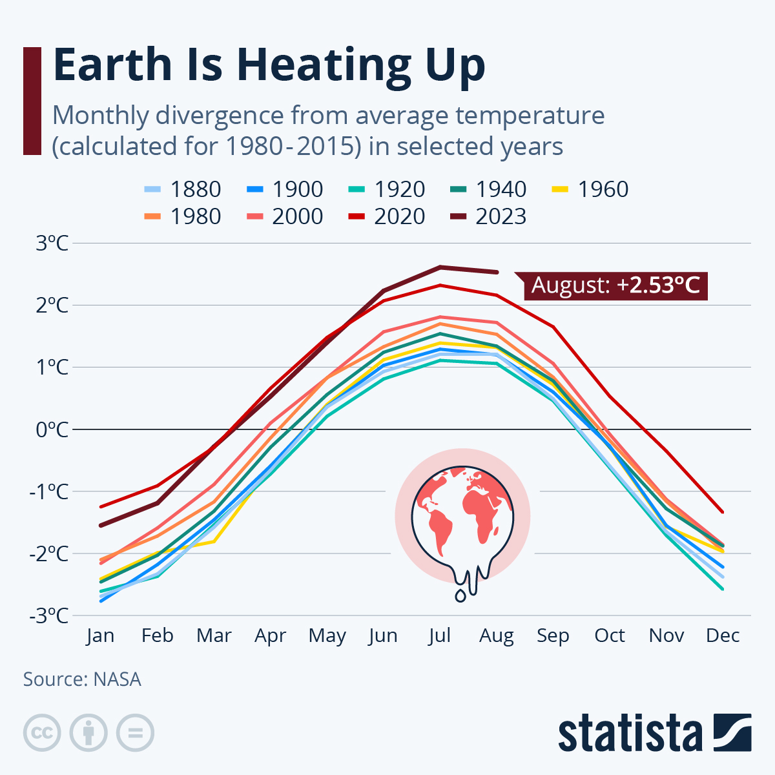
Figure 3: Rise in monthly average temperature in the selected years (Source: https://www.statista.com/chart/19048/global-warming-monthly-divergence, Accessed on 26th May, 2024)

B. Desertification:
Desertification characterised by land use change and soil degradation in arid, semiarid, and dry sub humid regions that occurs by multiple factors, inclusive of climatic fluctuations and human activities according to United Nation Convention to Combat Desertification (1994). It has been a key topic in global discussions on nature’s sustainability. An estimated 6 to 12 million square kilometres of land worldwide are affected by desertification, posing serious risks to the environment, societies, and livelihoods [22]. The combined effect of technology and human has made land degradation and desertification a serious issue. Desertification occurs when there's a chronic imbalance between the needs of people and livestock in dry areas and the ability of ecosystems to provide essential services. Dryland ecosystems face growing demands for services like food, water, fuel, construction materials, and sanitation, placing increasing strain on these environments [23]. The rise in desertification is the result of both human-induced and climate-related factors. Human factors include population growth, socioeconomic influences, policy decisions, and global phenomena such as disruptions in international food markets. Additionally, direct human activities like land use practices contribute to desertification [24]. Climate-related factors, such as droughts and the anticipated decrease in freshwater resources due to global warming are also significant concerns.

C. Water Scarcity:
The rapid increase in water demand for both agricultural and non-agricultural purposes, coupled with inadequate water infrastructure and climate change impacts, leads to water scarcity [19]. When water becomes scarce, its impact is primarily felt in agriculture, which is the biggest consumer of water in India. Nationally, the overall requirement for water, including both agricultural as well as non-agricultural sectors, rises by around 0.4%, equivalent to approximately 2.3 billion cubic meters, referred to the base year. This increase accounts to switch in the productivity of rain-fed as well as irrigated crops triggered by climatic changes. Consequently, the combined effects of climate change and water scarcity result in a decrease in food production output in India by $2,132 million in 2030 referred to the base year [25].

D. Loss of bio diversity:
Increase in atmospheric concentrations of CO₂ and use of chlorofluorocarbons have added to climate change which in turn have caused in biodiversity losses. Alterations in land use, such as converting temperate grasslands to croplands or tropical forests to grasslands, lead to the disappearance of many plant species and the animals that depend on them for habitat. Land-use changes also have a significant impact on below-ground organisms [26]. The FAO predicts a roughly 70% surge in worldwide food demand between 2000 and 2050, potentially resulting in more habitat destruction to accommodate expanded cropland. Apart from deforestation for agriculture and pasture, commercial exploitation of forests poses an additional threat to biodiversity, particularly in tropical regions [27].

E. Increased wildfire risk:
Climate change is behind the surge in wildfires, fuelled by fluctuating moisture levels that alternate between wet and dry conditions, promoting the growth of biomass which then catch fire [28]. Rising drought occurrences, along with warmer temperatures, further aggravate the situation, intensifying wildfire activity. The impact of climate on wildfire risks grounds largely upon moisture availability. A wet growing season encourages the lush growth of vegetation, particularly fine fuels, while dry conditions expand the flammability of both living and dead vegetation, serving as fuel for wildfires during fire seasons [29].

F. Impact on agriculture:
A temperature increase of 1.5°C would lead to a 13% decrease in crop net revenues, equivalent to a loss of US$93 billion annually. Doubling that temperature rise to 3°C would result in a 28% reduction in net revenues, totalling a yearly loss of US$195 billion [30]. The connections among climate change, agriculture and food production is deeply interconnected, with rapid shifts in climatic conditions posing a significant warning to world food security. World Food Programme (WFP) report of 2018 highlighted that the growth in per hectare crop yield is considerably lagging behind as the rate of population increases. In 2016 Food and Agriculture Organization (FAO) published data that suggests , if current trends of not only greenhouse gas emissions but also climate change persists, a decrease in the production of key cereal crops will be seen by the year 2100. This decline could be for maize yields ranging from 20% to 45%, for wheat 5% to 50%, and 20% to 30% for rice.

III. Adaption measures to combat climatic adversity over arid agriculture
Climate change is a key global concern that affects water supply worldwide. Only 0.5% of Earth's water is useable freshwater, and its availability is being impacted by climate change. Over the last two decades, terrestrial water storage has dropped by 1 cm per year, mainly affecting dry and semi-arid regions. This loss exacerbates already challenging water management issues, particularly in the Middle East, North Africa, and portions of Asia and the Americas. Furthermore, climate change-induced changes in precipitation patterns, such as lower rainfall frequency but increased intensity, are projected to result in more frequent droughts and floods. These changes will influence not just local economies, but also related areas, increasing overall water stress.

A. Management of water resources:
Water resource management is the complete planning, development, and conservation of water supplies, addressing both quantity and quality concerns in various sectors including agriculture, industry, and residential usage. It involves the construction of organisations, infrastructure, and laws to optimise water use while protecting against dangers such as floods, drought, and contaminants. Achieving water security is critical in the face of rising water shortages, climate change effects, and aquatic ecosystem degradation. Water's interaction with socioeconomic variables and ecological health requires integrated water management techniques.
Initiatives such as Rajasthan's 'Mukhya Mantri Jal Swavlamban Abhiyan' focus on the grassroots adoption of water conservation and harvesting practices in rural regions to improve water supply. Similarly, Maharashtra's 'Jalyukt-Shivar' initiative aims to alleviate water scarcity by introducing watershed management methods in hundreds of communities every year. In Telangana, the 'Mission Kakatiya' effort seeks to increase agricultural output and revenue for small and marginal farmers. It accomplishes this by upgrading minor irrigation infrastructure, encouraging community-based water resource management, and implementing extensive tank repair programmes.
These efforts highlight the significance of using localised, community-driven approaches to successfully manage water concerns. Water management activities may be integrated with wider development goals to improve resilience to climate change, promote sustainable water usage, and provide equitable access to this crucial resource for all.

B. Crop and biodiversity conservation:
Arid areas, with their scarce rainfall and severe climatic conditions, provide distinct challenges to agricultural techniques and biodiversity protection. Striking a balance between crop production and the preservation of vulnerable ecosystems in these locations is critical to ensuring food security and environmental sustainability. Agroecosystem management in dry places can play an important role in sustaining global biodiversity levels [31]. Diversification strategies that combine components of biodiversity have been proposed as a way to lessen agricultural production's environmental effect while maintaining output. A few methods for biodiversity conservation are mentioned below:

Methods of Biodiversity Conservation
a) In-situ conservation: This strategy is primarily concerned with the protection and preservation of natural habitats and ecosystems in their original condition. It entails the creation and maintenance of protected places including national parks, animal reserves, marine sanctuaries, and biodiversity hotspots. These regions act as refuges for a wide variety of species, providing critical habitat for animals to thrive. In situ conservation initiatives seek to sustain ecosystem integrity and function by protecting essential habitats, biological processes, and biodiversity hotspots. In situ conservation includes not just protected areas, but also habitat restoration, sustainable land management, and community-based conservation projects [32]. Conservation biologists and land managers collaborate to determine conservation priorities based on species richness, habitat diversity, and ecosystem services. Habitat restoration programmes may rehabilitate and restore damaged habitats to their natural state, improving biodiversity and ecosystem resilience.

b) Ex-situ conservation: Ex-situ conservation refers to the protection of species outside of their natural environments. This strategy is especially crucial for species that are highly endangered, extinct in the wild, or under urgent threat in their natural habitats. Ex situ conservation approaches include captive breeding, botanical gardens, zoos, seed banks, and germplasm repositories. Captive breeding programmes are critical for keeping endangered species alive and averting extinction. Botanical gardens and seed banks protect plant species by collecting and storing seeds, tissues, or live specimens for later use in restoration and reintroduction efforts. Zoos and aquariums educate the public while also helping to conserve animals via research, breeding programmes, and conservation education projects.

c) Restoration ecology: Restoration ecology is a multidisciplinary field that focuses on repairing and restoring damaged ecosystems to their original or close-to-natural form. Human actions such as deforestation, habitat fragmentation, pollution, and invasive species have all contributed to ecosystem degradation, resulting in the loss of biodiversity and ecosystem services. Restoration initiatives seek to reverse these trends and strengthen ecosystem resilience by restoring ecological processes, habitats, and species diversity.
Restoration initiatives may include reforestation, wetland restoration, riparian buffer establishment, and habitat rehabilitation. These initiatives frequently need meticulous planning, monitoring, and adaptive management to achieve success. Restoration ecology also includes ecological succession, habitat construction, and ecosystem engineering strategies to speed up the recovery of damaged ecosystems and conserve biodiversity [33].

d) Sustainable use practices: Sustainable use techniques involve managing natural resources in such a manner that they remain viable in the long run while serving the demands of current and future generations. This approach acknowledges the intrinsic importance of biodiversity and seeks to strike a balance between conservation objectives and socioeconomic development goals. Sustainable use techniques cover a wide range of activities, including sustainable agriculture, forestry, fishery, tourism, and hunting. Agroforestry, organic farming, integrated pest control, and sustainable land management techniques are examples of sustainable agricultural systems that help to conserve biodiversity while improving food security and livelihoods [33]. Sustainable forestry strategies, such as selective logging, reduced-impact logging, and forest certification systems, seek to preserve forest biodiversity and ecosystem services while also promoting timber production and forest-based enterprises.

e) Legislation and policy: Legislation and policy frameworks play an important role in biodiversity conservation because they provide a legal and regulatory framework for preserving species, habitats, and ecosystems. Governments, international organisations, and non-governmental organisations (NGOs) pass legislation, rules, and policies to protect biodiversity, control land use, and manage natural resources sustainably. Protected area designations, wildlife protection legislation, environmental impact assessments, land-use planning restrictions, and biodiversity conservation programmes are examples of legal and policy tools used to safeguard biodiversity. International agreements such as the Convention on Biological Diversity (CBD), and the Convention on International Trade in Endangered Species of Wild Fauna and Flora (CITES) serve as foundations for international cooperation for biodiversity protection [34].

f) Community engagement and education: Community participation and education are critical components of any biodiversity protection program. Engaging local communities in conservation initiatives and creating knowledge about the value of biodiversity fosters stewardship and ownership among local stakeholders. Community-based conservation initiatives enable local people to engage in decision-making, share traditional knowledge, and carry out culturally and socially acceptable conservation actions.
Education and outreach programmes assist in raising knowledge of biodiversity conservation challenges, encourage sustainable behaviour change, and create capacity in local communities, schools, and institutions. These programmes may involve environmental education, participatory workshops, community-based monitoring, and ecotourism activities that benefit residents while supporting conservation objectives [34].

g) Combatting invasive species: Invasive species are non-native organisms that can grow quickly, outcompete native species, interfere with ecosystems, and cause environmental and economic damage. Invasive species pose a severe danger to biodiversity and ecosystem function globally, particularly on islands and in vulnerable ecosystems with high endemism. To mitigate the effects of invasive species and conserve native biodiversity, it is critical to prevent their introduction, detect them early, respond quickly, and apply control measures. Integrated management techniques include prevention, eradication, containment, and control strategies adapted to the unique characteristics of invasive species and ecosystems. Biosecurity measures, quarantine rules, invasive species risk assessments, and public awareness campaigns are critical components of invasive species control measures.

h) Ecological networks and corridors: Ecological networks and corridors are essential for sustaining landscape connection and promoting species migration across fragmented habitats. Human activities such as urbanisation, infrastructure development, and agriculture cause habitat fragmentation, which poses a danger to biodiversity by separating populations, limiting genetic diversity, and impeding species dispersion and migration [35].
Ecological networks are created by connecting protected areas, wildlife corridors, greenways, and habitat patches to form contiguous habitat networks that allow animals to migrate across landscapes. These networks improve ecosystem resilience, encourage gene flow, and aid in adaptation to environmental change by allowing species to move, disperse, and colonise new habitats. Ecological corridors also provide valuable ecological services such as pollination, seed dissemination, and natural pest control, benefiting wildlife and human settlements.

i) Research and monitoring: Research and monitoring are critical to biodiversity conservation because they provide scientific knowledge and evidence-based information to help guide decision-making and adaptive management practices. Conservationists can use monitoring programmes to track changes in species populations, habitats, and ecosystems across time.

C. Rehabilitation of marginal lands
Marginal lands, which are frequently marked by low soil quality, limited water supplies, and harsh environmental circumstances, have long been disregarded in the quest for agricultural output. However, as the need to address climate change concerns grows, these ignored regions have emerged as critical components in the struggle to reduce its consequences. The restoration of marginal areas provides a diverse strategy to mitigate the effects of climate change. These areas can be turned into resilient and productive ecosystems by using sustainable land management strategies like agroforestry, which integrates agricultural, animal, and tree production systems.
Restoring deteriorated farmlands, which are often abandoned worldwide, can play a significant role in combating climate change. These areas spontaneously restore flora and soil carbon by absorbing CO2 from the atmosphere. However, active restoration efforts can improve this process by sequestering carbon through measures such as plant diversity promotion, renewable energy use, and biochar use [36]. Rehabilitating marginal lands helps to minimise climate change while also addressing land degradation and promoting sustainable land management practices. To properly restore these areas, a variety of strategies have been proposed and applied, including restoring plant diversity and using biochar. These activities provide a critical opportunity to improve environmental sustainability while combating climate change. A few methods are:

a) Agroforestry Systems: Agroforestry is the integration of trees or shrubs into agricultural systems, which provides several benefits such as carbon sequestration, improved soil health, biodiversity protection, and climate change adaptation. Agroforestry, which combines tree planting with farming or grazing, increases land productivity while sequestering carbon in biomass and soil. It combats climate change by lowering and storing carbon dioxide emissions, as well as improving adaptation via ecosystem variety and resistance to harsh weather. Agroforestry also improves soil quality, lowers erosion, and promotes nutrient cycling, all of which contribute to more sustainable agriculture. Overall, it provides several benefits, including habitat extension, clean water, biodiversity support, and agricultural genetic variability, making it an important strategy for climate change mitigation and adaptation.

b) Restoration of afforestation: Restoration afforestation is an integrated approach that involves re-establishing forests in deforested or degraded areas to restore ecosystem functioning, increase biodiversity, reduce climate change, and give socioeconomic advantages. It starts with site selection and preparation, followed by the selection and multiplication of appropriate tree species in nurseries. Planting and establishment use a variety of strategies customised to site circumstances and species characteristics. Restoration afforestation offers critical ecological services such as carbon sequestration, soil erosion management, and habitat supply while also benefiting local populations through livelihood possibilities and cultural values. Furthermore, regenerated forests contribute to climate resilience by concealing carbon [33].

c) Soil amendment techniques: Soil amendment procedures, such as biochar application, composting, and mulching, are critical for improving soil fertility, structure, and carbon storage. Biochar enhances soil health by boosting nutrient retention and microbial activity, whereas composting enriches soil organic matter and increases nutrient availability for plants. Mulching retains soil moisture and controls temperature, boosting plant development while reducing weeds. These measures not only increase agricultural output but also trap carbon in soils, therefore reducing climate change by storing atmospheric CO₂. They also increase soil resistance to environmental pressures like drought and erosion, which promotes sustainable land management and ecosystem health.

d) Grassland restoration: Grassland restoration involves reviving degraded grasslands or turning croplands back to natural perennial grasses, which provides several benefits to ecosystems and communities. It focuses on native grass species to increase biodiversity and ecological resilience. Restored grasslands trap carbon, improve soil fertility, and retain moisture, contributing to climate change mitigation and sustainable land management. They offer critical habitat for native plants and animals, promoting biodiversity and ecological services such as pollination. Grassland restoration also decreases soil erosion, enhances water infiltration, and helps to buffer droughts and floods, so increasing landscape resilience. Additionally, it generates socio-economic opportunities through sustainable grazing, ecotourism, and cultural preservation. Overall, grassland restoration combines environmental protection, climate action, and community well-being to create resilient and sustainable landscapes for future generations [32].

e) Integrated Landscape Management (ILM): Integrated Landscape Management (ILM) is a comprehensive approach to land management that balances ecological, social, and economic goals across connected landscapes, making it an effective tool for combating climate change. It addresses the complex relationships of land users, ecosystems, and stakeholders, emphasising collaborative decision-making and adaptive management. ILM optimises resource usage, reduces disputes, and maximises ecosystem benefits by combining various activities such as agriculture, forestry, conservation, and urban development. It discovers climate change possibilities by utilising natural processes like reforestation and sustainable agriculture to increase carbon sequestration and resilience [35]. Stakeholder participation ensures that multiple viewpoints are considered, promoting inclusive planning and execution. Adaptive management constantly modifies tactics to reflect landscape dynamics and stakeholder demands, fostering resilience and sustainability.
The Western Ghats environment in India is an example of integrated landscape management (ILM), since it is a UNESCO World Heritage Site and one of the world's eight hottest biological diversity hotspots. The Western Ghats region is a mosaic of habitats that include tropical rainforests, grasslands, wetlands, and agricultural landscapes, all of which support a diverse range of flora and wildlife. However, this biodiversity hotspot is experiencing several difficulties, including deforestation, habitat fragmentation, land degradation, and climate change effects. In response to these challenges, a variety of stakeholders, including government agencies, non-governmental organisations (NGOs), local communities, and private sector actors, have collaborated to implement integrated landscape management approaches aimed at preserving biodiversity, promoting sustainable land use practices, and improving climate resilience.

D. Role of science and technology
According to the UN Under-Secretary-General for Economic and Social Affairs, Liu Zhenmin, science and technology are critical in solving climate change. Renewable energy, carbon capture, and innovative farming techniques have enormous potential for lowering greenhouse gas emissions and increasing climate resilience. When combined with scientific research, such measures give comprehensive insights and practical answers across several industries. Science and technology provide a variety of techniques for combating climate change and promoting global collaboration, ranging from the use of renewable energy to enhanced monitoring systems [36]. By combining these tools, society can manage climate difficulties and work towards a more sustainable and resilient future for everyone.

a) Renewable Energy Technologies: Solar photovoltaic (PV) systems are an excellent illustration of how technology is accelerating the shift to sustainable energy. Advances in PV technology have resulted in higher efficiency and lower prices, making solar energy more affordable and competitive with fossil fuels. Integrated systems, such as solar microgrids, provide dependable power to isolated populations while reducing reliance on polluting energy sources. Furthermore, grid-scale solar farms add considerable amounts of renewable energy to national electrical networks, replacing emissions from coal and natural gas power plants. For example, arid places have plenty of sunshine, making them excellent for solar power generation. Solar PV systems can be installed in these regions to convert solar energy into electricity. These solar projects not only cut greenhouse gas emissions by replacing fossil fuel-based electricity generation, but they also help to provide energy security and economic growth in dry regions [32].

b) Carbon Capture and Storage (CCS): CCS systems capture and store CO₂ emissions from industrial processes and power plants, keeping them from entering the environment. One example is the Sleipner Project in Norway, which captures CO₂ from natural gas production and injects it into subterranean geological formations for long-term storage [34]. CCS can drastically cut emissions from big industrial sources, allowing for a smoother transition to a low-carbon economy and reducing climate change.

c) Climate Modelling and Predictive Analytics: Advanced climate models simulate future climate scenarios using various emission trajectories, assisting policymakers and stakeholders in understanding possible consequences and developing adaption measures. High-resolution weather forecasting models provide early warnings for extreme weather occurrences, lowering the danger to people and property. For example, the European Centre for Medium-Range Weather Forecasts (ECMWF) delivers accurate hurricane, typhoon, and other severe weather forecasts, allowing authorities to adopt appropriate evacuation and disaster response plans. Advanced climate monitoring technologies, such as remote sensing, satellite images, and weather forecasting models, provide useful information for analysing climate change consequences and implementing adaptation strategies. Early warning systems for extreme weather events, such as droughts, floods, and heatwaves, help communities plan and respond efficiently to climate-related risks, lowering catastrophe risk and saving lives [31]. For example, Bangladesh's Integrated Flood Management System (IFMS) is an excellent climate monitoring and early warning system. It uses a network of monitoring stations to gather real-time information on weather patterns, river levels, and rainfall intensity. This data is used to anticipate flood risks, and early warnings are distributed to communities via a variety of communication methods. The method encourages community involvement and stakeholder collaboration to ensure prompt reaction and adaptation actions. Post-event evaluations guide adjustments to increase resilience and lessen the effects of climate-related catastrophes. Overall, the IFMS illustrates how climate monitoring and early warning systems may successfully reduce risks and protect populations vulnerable to climate change-related catastrophes such as floods [33].

IV. Vertical farming
The rapid population growth along with the shift to urbanization is already exerting an immense pressure on the food production systems [37]. Moreover, it has been projected that the global population will peak to 9.7 and 10.4 billion by 2050 and 2100, respectively [38][39] and it became crucial to increase the food production by 50 % [40]. Cultivable regions take up of about 41 % of the global landmass [41] and semi-arid and arid regions have always been considered marginal for any agriculture related activities. These regions have had long term significant challenges in acquiring food security and agricultural sustainability [42]. However, with the increasing food demand, it has become imperative to intensify agriculture efforts by using these arid regions for farming. Vertical farming is one of the technological approaches for bridging the gap between these arid regions and food demand [43].
Vertical farming is a system of crop production in which the plants are cultivated by artificially stacking them vertically above one another, thereby, maximizing the utilization of land [44]. Vertical farming typically relies on soil-less growing methods like hydroponics or aeroponics, which are dependent on water and air to produce an artificial environment conducive to plant growth and development. These indoor production procedures use Controlled Environment Agriculture (CEA) technology, allowing year-round cultivation. Vertical farming uses advanced techniques to create controlled environments in which many elements are carefully regulated to optimize plant development. This accuracy enables crops to thrive more efficiently than traditional soil-based agricultural approaches and it can assist in addressing wide range of social and environmental problems, such as food security, water scarcity and climate change.

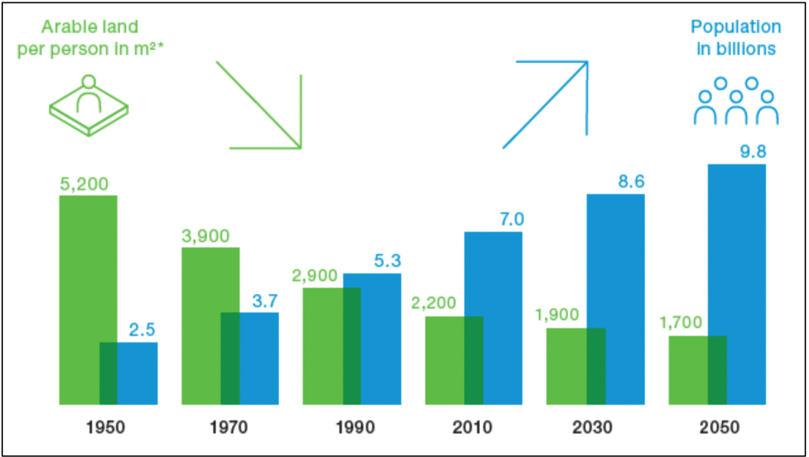
Figure 4: Estimated population by 2050 (Source: FAO, 2011)

Out of the many benefits of using vertical farming over the conventional methods of farming, mentioned may be made of the increased crop yield due to the precise control over the growing condition, reduced land use, less water consumption of about 95 % lesser than the conventional method, higher nutrient use efficiency, all year round crop production, reduced use of pesticides, herbicides and agricultural pollution and lesser cost of transportation [45][46][47] (Table 1). Additionally, because plants grow on soilless media, this method produces less waste and recycles and reuses other natural resources like water and nutrients. Vertical farming thus, results in a lower carbon footprint and significantly less environmental impact. According to [48], the adoption of vertical farming around the world is limited to a small but gradually growing numbers.

A. Types of vertical farming
Vertical farming in arid zones aims to maximize the production of food crops with the limited amount of resources available in the regions such as utilization of the vast non-arable land, increase water and nutrient use efficiency while reducing the infestation of pests and maximizing the quality of food production [49]. With the advent of population explosion, various types of vertical farming have been introduced based on the types of systems used and processes adopted [50].

The systems
According to the system adopted, vertical farming has been classified such as i. Despommier Skyscrapers, ii. Mixed Use Skycrapers and iii. Stackable Shipping Containers.

a) Despommier Skyscrapers: These are structures in which the shelves are stacked vertically and the crops are produced in large quantity in controlled environments, unaffected by weather conditions. Consequently, these skyscrapers can be constructed anyplace, despite the various agrnonomic constraints. It may also be mentioned that vertical farming utilizes less energy while producing less pollution than other traditional agricultural methods as it also has the provision of integrating renewable energy technologies. Various renewable energy devices as solar panels, wind turbines, and hydroelectric power are used, either individually or in combination, so as to meet the energy requirements of these skyscrapers. Moreover, it has the potential to provide numerous jobs to local residents [50][51]. Cities such as Dubai and Abu Dhabi are epitomized as the future of food production with their towering skyscrapers that seem a bit distant from the image of rural life and open fields. The tall skyscrapers are envisioned to house not only people and offices but also diverse crops such as date palms, tomatoes peaches, etc. Vertical farming with Despommier system involves high-rise urban greenhouses powered by solar energy and urban sewage. The Gulf region has been identified as a prime candidate for the initial implementation of vertical farming. The region's year-round sunshine and rapidly urbanizing population make it an ideal location for such system [52].
All the proposed ideas based on this concept will function only when the enthusiasts follow the process of recycling everything organic including water, human and animal waste efficiently. It is also crucial that this concept be backed by the government with fully funded economic incentives to the universities, institutes and private sectors, thereby, supporting the research and development on this concept [53].

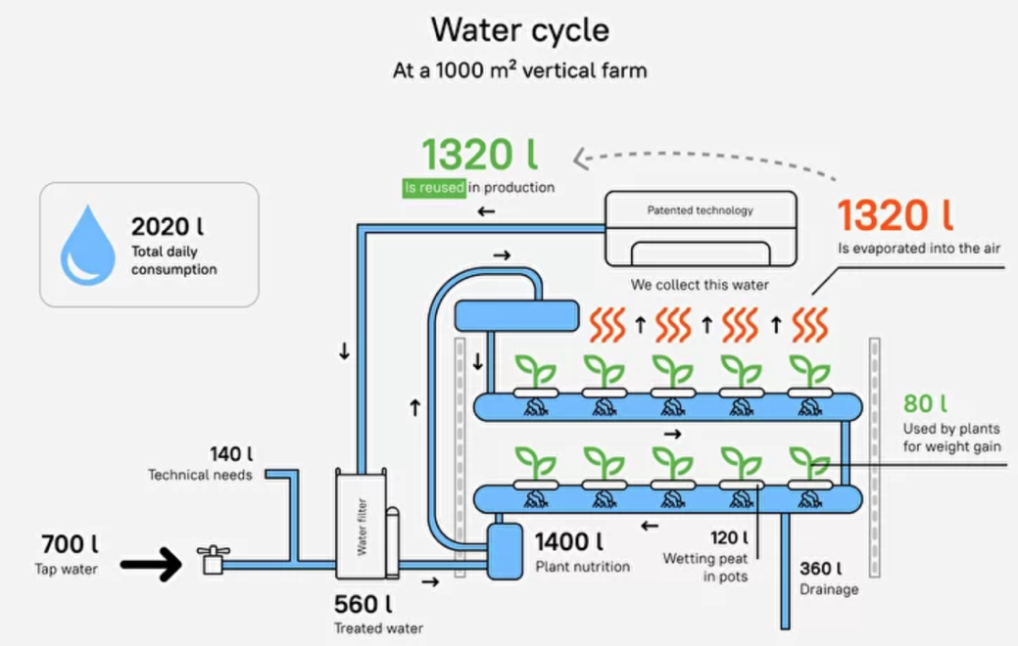
Figure 5: Reduction of water wastage with vertical farming (Source: https://www.igrow.news/igrownews/how-vertical-farming-helps-save-water, Accessed on 15th May, 2024)

b) Mixed-use Skyscrapers: Introduced by an architect named Ken Yeang, these structures integrate conventional agricultural practices with the concept of vertical farming. In these, crops are cultivated under the sunlight, such as on the topmost floors of a building that receives ample natural light, rather than in a highly regulated and enclosed environment [54][50]. High density hydroponics or aeroponics modules are used to cultivate a variety of plants all year-round by utilizing controlled weather and lighting conditions and hence, optimizing plant growth, productivity, and quality. While taking into account the integration of complete design, operation, cost and infrastructure for homes and ecological balance, a systematic approach is required to comprehend and streamline the intricate system. This type of skyscraper is designed to provide a high end solution for regions that struggle with water scarcity, a severe lack of arable land and a demand for reasonably priced agricultural products [55]. Mixed-use skyscrapers offer an advantage over Despommier skyscrapers due to their lower initial costs. Conversely, Despommier skyscrapers necessitate the microclimate within the structure to be regulated and monitored according to the requirements of the crops [54].

c) Stackable Shipping Containers: As hydroponics and Controlled Environment Agriculture (CEA) gain popularity, stackable shippable container farms are emerging as a new technological advancement that makes hydroponics more convenient and easier to manage. This system has been consistently enhanced to maximize efficiency and effectiveness in crop production. Ongoing research continues to focus on identifying optimal metrics for crop production and improving labour and energy efficiency [56]. In vertical farming system, shipping containers can be refurbished and arranged in stacked configurations to be utilized for cultivating lush green vegetables, luxury mushrooms, and berries. The shipping containers are furnished with hydroponic setups, LED grow lights, control systems for temperature, heating and ventilation, and monitors for the environmental conditions within these stackable containers, which are specially provided by specialized companies [57]. Regardless of the external weather conditions, the interior environment is optimized for food cultivation using advanced climate controls. As a result, shipping container farms can produce food throughout the year, with crops shielded from the effects of extreme weather and sub-optimal growing conditions.

The processes
As per the processes used for regulating the nutrient solutions, vertical farming have been categorized into three types and they are elucidated as below:

a) Hydroponics: Hydroponics, the method of growing plants without soil by using mineral nutrient solutions in an aqueous solvent, is revolutionizing the field of agriculture [58]. This innovative approach has numerous advantages over the conventional soil-based agriculture, including increased yield, rapid growth rates with higher efficient use of resources. As the global population continues to rise and arable land becomes scarcer, hydroponics has become a viable and sustainable solution to meet the growing demand for food [59][44]. Hydroponics consume 60-70% less water than any of the traditional farming methods [60]. These pose as an admirable solution for areas impacted by drought or arid weather conditions.
There are several methods for creating hydroponic systems. Nonetheless, commercial techniques for recirculating nutrient solutions include aeroponics, deep water culture (DWC) and the nutrient-film technique (NFT). According to [61], DWC ensures that exposed roots on a slightly sloped bed receive continuous nourishment by recirculating the nutrient solution dependent on the water level. Similar to ebb and flow systems, the NFT and the modified deep flow technique (DFT) are widely used in vertical farming [62]. Hydroponics saves a lot of water and minimizes evaporation; yet, even with automated watering, system failures can still impact results. The nutrients added in a hydroponic system are Ca(NO₃)₂, K₂SO₄, KNO₃, KH₂PO₄ and MgSO₄. Micronutrient used include boron, chlorine, copper, iron, manganese, sodium, zinc, molybdenum, nickel, cobalt and silicon. By minimizing water usage and eliminating the dependency on soil, hydroponics plays a crucial role by providing a viable agricultural method for arid areas, ensuring food security and resilience against harsh climatic conditions. The intricate details of hydroponic systems and the impact in arid zones will be explored thoroughly in the subsequent sections of this chapter.

b) Aeroponics: Aeroponics represents an innovative approach to plant cultivation, where plants are nurtured in a misty environment devoid of soil or any solid substrate. The core principle underlying aeroponic techniques revolves around the suspension of plants within an enclosed or partially enclosed space. In this setup, the dangling roots and lower stems of the plants are meticulously nourished by being intermittently sprayed or misted with a solution infused with essential nutrients. This method not only facilitates the efficient absorption of nutrients by the plants but also promotes optimal growth conditions by ensuring that the roots are adequately hydrated and supplied with vital nutrients. Aeroponic is the most effective vertical farming system as it uses 90% lesser water than other hydroponics [50].
Plants cultivated within aeroponic systems have demonstrated an enhanced capacity to absorb minerals and vitamins, contributing to their overall health and potential nutritional value. Within these suspended environments, aeroponic plants benefit from a full supply of oxygen and carbon dioxide, reaching the entire portions of the plants without hindrance. This unimpeded access accelerates biomass growth and reduces the time required for rooting. Moreover, the elevated biomass yield observed in aerial plant parts under aeroponic conditions suggests that this cultivation method holds promise not only for root crops but also for a wide array of other plant varieties. Additionally, aeroponic systems enable higher planting densities since competition among plants for nutrients and water is effectively mitigated. The versatility of true aeroponic systems allows for the cultivation of virtually any plant species, facilitated by the precise control over the micro-environment within these setups [63]. Aeroponic has been classified into three categories [63] as follows.
- Low pressure aquaponic systems: In low-pressure aeroponic systems, plant roots are dangled above a nutrient tank or a connected conduit. The nutrient solution are delivered through jets or ultrasonic transducers powered by a low pressure pump, which then trickles back into the tank. However, as plants mature, dry root sections may impede the uptake of these nutrients. These units often lack purification features due to cost and are primarily used for small-scale benchtop growing and educational demonstrations of aeroponics.
- High pressure aquaponic systems: High-pressure aeroponic systems generate mist using high-pressure pumps and are commonly employed for cultivating high-value crops. This method incorporates technologies that purify air and water, sterilize nutrients and polymers.
- Commercial units: The biological systems and high-pressure device hardware are features of the commercial system and thesel systems matrix ensures the improvement with longer plant life and crop maturation.

c) Aquaponics: A production system involving aquatic organisms and plants in which over 50% of the nutrients necessary for optimal plant growth come from the waste produced by feeding the aquatic organisms [64]. In this method, both the aquatic organisms and plants get mutual benefits. Plants derive their nutrients from the aquaculture effluents that have been processed through microbial transformation while purifying the water simultaneously [65]. In aquaponics, minerals or fertilizers are not utilized as fish feed provides primary mineral sources. A stable pH and adequate iron content in the solvents are maintained by using minimal alkaline salts and ferrous salts respectively. Aquaponic production minimizes land footprints required for commercial units and eliminates the necessity for arable land. Water consumption is much lesser than the normal production system, and coupling with the recently introduced water recirculation technology, it has become more convenient and cost efficient to use the aquaponic system.
Aquaponic innovations have the potential to boost food security and sustainable development in hot arid regions. They capitalize on efficient water usage, high productivity, and minimal environmental impact. Solar energy can power essential equipment, reducing costs and supporting the growth of aquaponic enterprises, from small ventures to large commercial operations. These techniques can be applied in arid regions where groundwater salinity hampers traditional farming. Many fish species tolerate low to medium salinities, allowing their production alongside salt-tolerant crops or edible halophytes [66].

B. Technological components of Vertical Farming

a) Controlled Environment Agriculture (CEA): Vertical farming often incorporates Controlled Environment Agriculture (CEA), a method utilizing various technologies to create optimal growing conditions for plants. CEA manages factors such as temperature, lighting, and humidity, enabling the cultivation of crops that would not thrive in the local climate. Vertical farms use sensors, automation, and monitoring systems to control the air and root environments at all cultivation stages. Wireless communication and IoT connect these systems with users. Data is collected by computer controllers, which activate lighting, cooling, ventilation, recirculating fans, dehumidification, nutrient solution controllers, pumps, and CO₂ suppliers as needed [67][68]. The irrigation system is vital for CEA systems, supplying plants with nutrients and water, and increasing indoor humidity. Poor management can spread crop infections, waste water and nutrients, and contaminate the environment. Hydroponics grows plants on non-soil substrates or in water-nutrient solutions. Common substrates, like rock wool, perlite, peat, coir, and zeolite, retain water and nutrients while enhancing root oxygen availability [69][70].
These systems allow year-round cultivation, regardless of external weather conditions. By controlling the environment, vertical farming can prevent crop loss due to adverse weather, pests, and diseases, which are common in traditional farming, especially in arid regions [71]. CEA offers numerous advantages. It reduces the occupational risks found in traditional farming. Indoor farming excludes wildlife, preventing conflicts between farmers and native species. It also protects farmers from dangers like malaria, toxic chemicals, and other life-threatening challenges. Additionally, the absence of hazardous chemical runoff ensures the safety of nearby communities.

b) Light Emitting Diodes (LED): Lighting is the main issue in any crop growing endeavours. For ensuring a good and quality production, it is necessary to use both natural and artificial light. However, with crops being grown in stacked structures in vertical farming, it is crucial to use more of efficient artificial lighting system. Grow light is the light that supplements the growth of plants by either providing a light spectrum that is similar to that of the sun or by providing that is tailored to the requirements of the plants being cultivated. Supplementing of light to the plants by grow light depends on the type of plant, stage of cultivation whether it’s at germination, vegetative or flowering/fruiting phase. In addition to the abovementioned conditions, the photoperiod, specific spectrum, luminous efficacy and color temperature required by the plants are some desired conditions [72].
LED grow-lights are luminaires that uses LED chips in a more proficient way to provide light to the growing plants. They come in many shapes and sizes and the chips have the most of the effect on the quality of spectrum and brightness of light emitted. It is evidently different from the traditional light sources as incandescent, fluorescent and gas discharge lamps. An LED does not use mercury, lead, gas or filament and no fragile glass bulb is used with failure prone moving parts. The diodes used in LED grow lights are manufactured according to the specific and accurate descriptions to emit the required wavelength and maintain its integrity over time. They are made from exotic semi-conductor compounds such as GaAs, GaP, GaAsP and SiC or GaInN, all combined together at different ratios to produce a specific wavelength of colour. One of the advantages of LED grow light over those traditional lights is the ability to match the light to the needs of plants. LED grow lights deliver lights that are photosynthetically valuable to the plants and are known for its energy efficiency since electricity is not used for light that has no benefits to the plants. These lights may be relatively dim when perceived by the eyes.

c) IoT: The Internet of Things (IoT) connects physical devices via sensors and software to exchange data over the internet. It enables remote control, data collection, and monitoring across industries like agriculture, healthcare, manufacturing, and smart home. The synergy between the Internet of Things (IoT) and vertical farming has revolutionized modern agriculture, more or less in the arid zones too. IoT allows vertical farming to overcome traditional limitations, enhancing efficiency, sustainability, and crop yield. Sensors and cameras monitor parameters like temperature, humidity, light, CO₂ levels, and nutrients, providing real-time data for optimal growing conditions. Automated systems adjust lighting, irrigation, and nutrient delivery based on this data, improving crop quality and yield. Advanced analytics and machine learning analyze the data, helping farmers make decisions on crop management and disease detection. Predictive analytics anticipate issues, enabling proactive interventions to prevent crop loss. IoT also allows remote monitoring and control of farms via smartphones or computers, beneficial for urban farming. This integration promotes sustainable practices by reducing water usage, transportation needs, and chemical use, thus lowering the ecological footprint of food production [73].

d) Robotics: The incorporation of robotics in vertical farming has become immensely vital due to the restrictions and shortcomings of human labour and the efficiency provided by technologies utilizing sensors, big data, robotics, and AI. Cultivation of high-density crops coupled with the physical constraints of vertical structures render human labour inefficient. Robotics excel in complicated tasks such as precise harvesting, maintaining controlled environments, reducing human error, and ensuring consistent crop quality and yield. Automation in vertical farming ranges from manual to advanced systems while affecting the labour and energy efficiency. With increase costs for human labour, which remains significant (25–30%), these robots emerge as efficient tools for mitigating the operational and fixed cost. Efficient and consistent environmental control by robots enhances overall performance and reduces costs. Incorporating smart technologies improves crop productivity and resource efficiency as well maintains sustainability through CEA [61].

C. Advantages of Vertical Farming
Vertical farming offers a wide range of benefits of giving space efficiency without compromising with the crop yields (Table 1 and Figure 6). It ensures year round production with consistent harvests regardless of the weather and season, efficient use and recycling of water. It reduces the adverse effects of pesticides and herbicides residues on environment, minimizes soil erosion and carbon footprints. Vertical farming also ensures that it decreases the dependency on external sources whilst producing higher quality produce and increased harvests. Additionally, because plants grow on soilless media, this method produces less waste while recycling and reusing other natural resources like water and nutrients. Thus, vertical farming results in a lower carbon footprint and significantly less environmental impact.
Table 1: Benefits of Vertical farming [74][75]
Sl.No. | Benefits | Environmental | Social | Economic
1. | Reduction in traveling distance | Lessening of air pollution level | Increase in the health condition of human due to improved quality of air | Reduction in energy use for packaging and fuel for transporting
2. | Reduction in wastage of water with more efficiency put in crop production | Reduction of wastage of water due to surface run-off | Availability of more potable water | Reduction in the cost due to limitation of water wastage
3. | Management of organic waste | Lowering of the requirement of landfill for their management | Beneficial to the consumers’ health due to improved quality of food | Conversion of waste into assets
4. | Job opportunities for local people | Lowering of commuting time | Building of social network among the workers | Financial stability for the local people
5. | Decrease in the use of pesticides herbicides and fertilisers | Revamping the ecological niche | Production of quality food and improvement in the human health | Reduction of cost of production
6. | Increase in the crop productivity | Lowering of space utilisation for cultivation | Creation of interest among the workers in the working space | Increase of yield and hence higher earnings for the locals
7. | Minimization of crop loss due to natural and unexpected calamities | Aid damage control after the disasters | Food security | Prevention of economic lost
8. | Possibility of crop production in all seasons | All year round production | Better response to public food demand | Possibility of earning all year round
9. | Employment of reusable energy | Reduction of environmental destruction due to less dependency on fossil fuels | Improvement in the quality of life | Reduction of cost
10. | Closer to nature | Creation of biodiversity | Mental health improvement thereby, improving the quality of life dear bye | More employment opportunities
11. | Possibility of high-tech agriculture | Lowering the harm caused to the environment | Generation of skilled workforce | Research and development based workers benefits
12. | Sustainable farming | Preservation of ecosystem for future generation | Improvement of overall health condition | Saving of money for damage control of the environment
13. | Using of abandoned buildings | No harm to the ecosystem | Broadening of social network | Re-invigorating of the economy

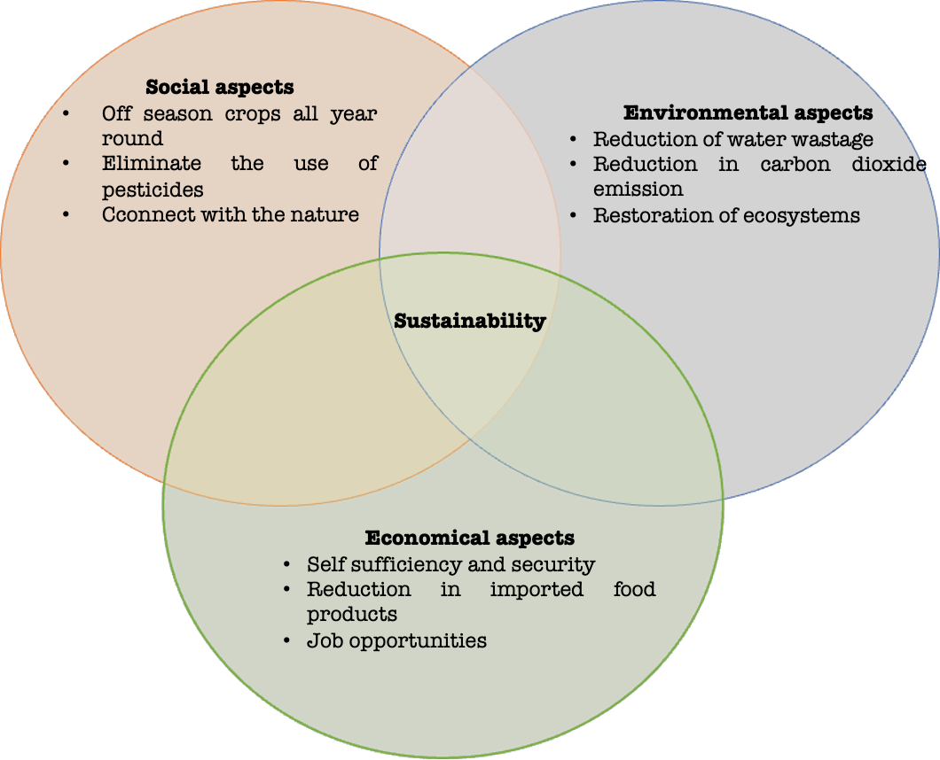
Figure 6: Benefits of Vertical Farming

D. SWOT Analysis of vertical farming

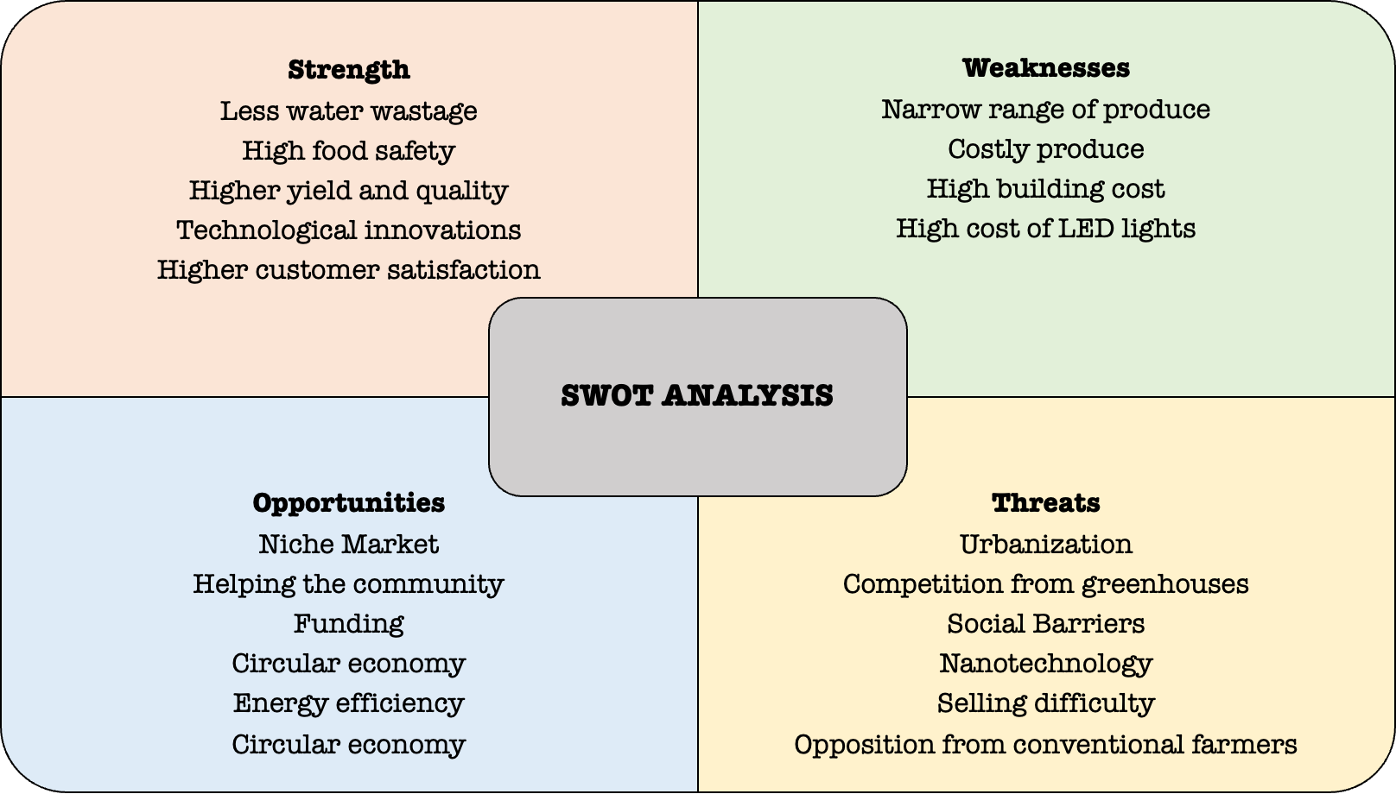
Figure 7: SWOT Analysis of Vertical Farming

E. Challenges in Vertical Farming
Even though vertical farming provides numerous opportunities for non-arable arid zones, it also faces various technological challenges. The constant dependent on energy sources has important implications for the economic feasibility and sustainability, especially in regions with less electricity production and high price. Precise control over water and nutrient delivery as well as any leaks is necessary for the intricate integration of growth systems in small areas. It's critical to maintain consistent irrigation throughout several layers, which calls for sophisticated sensor networks and efficient automation. Advanced technology and skilled labour must work together harmoniously, yet there is a dearth of workers with the necessary training [61]. The initial expense is high, and the challenges lie in modifying automation and robotics to work with sensitive crops while preserving reliability [76]. It's also difficult to control lighting systems so that plants develop to their full potential without suffering harm. Moreover, combining several sensor data streams necessitates precise calibration and quick adaptive responses, both of which present formidable obstacles [77][78].

V. Hydroponics
The word Hydroponic is derived from two Greek words; "hydro" meaning water and "ponos" meaning labour that together imply "working water" [79]. It rightfully means raising plants without soil but with an aid of nutrient rich solutions enriched with all sorts of nutrient elements in desirable concentrations to meet the plants’ nutritional demand, which is why it is commonly referred as soilless culture. Hydroponics can precisely manage the present day climate change concerns as the plants are raised under protection and also reported in promoting productivity as the inherent demand of crop can be successfully met with. For the first time, an English scientist namely W. J. Shalto Duglas introduced Hydroponics in India during 1946.
Growing hydroponic and aeroponic crop has caught a lot of attention lately, as it helps in maintaining and improving the quality of environment including enhanced crop yield and profitability over the time. Sustainability constitutes three basic aspects namely environmental health, economic viability, and social equity. The prerequisites of sustainability in dryland agriculture can be efficiently accomplished by hydroponics owing to its ability to control erosion, restriction upon chemical usage and water conserving potential up to 70% - 90%. It can be treated as a climate smart adaptable agricultural system, the adoption of which is encourage to mitigate climate change and to impose zero harm on the ecosystem unlikely the conventional intensive farming system. In addition to this, it offers effective use of scanty water resource, which is a key to success of hydroponics in arid agriculture.

A. Existing Growing Methods
Hydroponics, the soilless cultivation of crops can be classified into two broad categories i.e.
a) Solution/Liquid Culture: This method is also referred as "true Hydroponics" as the nutritional requirement of the plant is provided in form of solution in a continual cycle, where all other requisites like provision of aeration and necessary adjustment in parameters like pH, EC, as well as concentration of the nutrient are maintained [80].

b) Aggregate Culture: In this category, plants are supported with the help of an organic or inert media viz. rock wool, perlite, pumice, cocopeat etc and nourished with nutrient rich solution through a specific mode of irrigation. The system can either be of an open type, where the unconsumed solution is let out as waste or a closed type, where the solution is again re-circulated for further plant uptake [80].

B. Different Hydroponics Techniques in Use:
On the basis of adopted techniques dispense liquid nutrients to the root systems, the existing hydroponic system for cultivating crops can be further divided into following types;

a) Wick Technique: In this system (Figure 8), the nutrient rich solution is stored in a reservoir, where the level of oxygen is maintained with the help of an air stone kept at the bottom of the reservoir. A plastic tubing, often termed as wick is employed for drawing the liquid nutrients into the growing media, where the plant roots are embedded facilitating nutrient uptake by the plants [81].

b) Drip Technique: This technique has turned out to be the most efficient of all the other hydroponic systems (Figure 8). It performs as a clear - a clock controlling a submersed water pump that provides the liquid nutrient by means of trickle lines erected through the plant base over the growing medium. It is also called Trickle or Micro-irrigation system as equipped with small emitters to drip nutrient solution directly to plants by using a network of feeder lines. The surplus nutrient solution is again diverted back into the reservoir where that can be used again [81].

c) Deep Water Culture Technique (DWC): Technically all the hydroponics systems are believed to be evolved from this deep flow technique [82]. This simplified system consists of a reservoir, an air stone placed at the bottom for maintaining oxygen saturation, a timer for automated operation, tubing for nutrient solution circulation, an air pump facilitating air flow and a suspended platform containing plants (Figure 8) [83]. The water culture system strategizes continual air movement to keep up the disintegrated oxygen, as plants are cultivated in the suspended platform holding the nutrient solution of 4-6 cm height flowing continuously, where the plant roots are constantly submerged in the nutrient solution. In order to obtain optimal growth and development, it is essential to keep a track on the level of oxygen, nutrient concentration, salinity as well as pH record [30].

d) Ebb and Flow Technique: This technique is otherwise termed as “flood and drain” (Figure ) technique owing to its continuous and orbital rotation for pumping the liquid nutrient mixture from the reservoir into the tray accommodating plants and draining the surplus back to the tank [82]. The framework is quite simple constituting a tray containing the growing medium, where the plants are housed and the entire set up is placed over the tank of nutrient solution (Figure 8). It is also fitted with a timer to operate the submerged pump, where the nutrient solution is forced to tickle into the tray housing plants and recycling back again to the tank. The timer also ensures repetition of the process continuously at regulated time intervals [84].

e) Nutrient Film Technique (NFT): This technique was introduced for the first time in 1960 and still maintains its dignity for being universally accepted and preferred hydroponic system among the commercial growers and plant lovers as well. The system comprises of series parallel troughs laid on a slanting position (1-2% slope) facilitating constant flow of a shallow stream of nutrient solution passed through the bare plant roots (Figure 8). The nutrient solution stored in the catchment tank is drawn with the help of a pump and circulated around the plant root system. The solution is delivered through the delivery pipe and the surplus portion is collected by the return pipe back to the catchment tank facilitating further use of the solution. The only risk with this system is high susceptibility towards fungal incidence as the plant root system is constantly in contact with water [7].

f) Aeroponic: This technology is one of the most prominent and sustainable soilless cultivation practices that conserve up to 90% of the water in comparison to the convention hydroponic systems. In this system, plants are grown in specialized containers in a closed or semi-closed environment and their roots are suspended in the air [7]. The nutrient rich water solution is applied in form of fine spray to the dangling roots and the application of liquid nutrient is regulated by a timer connected to the water pump for lifting the solution. A control system is also operated to maintain the light, temperature and humidity level as per the requirement of the crop in the zone where the roots are suspended (Figure 8). In 1990, aeroponic was inspired by the initiative of the National Aeronautical and Space Administration (NASA) for discovering an effective mean for raising crops in space.

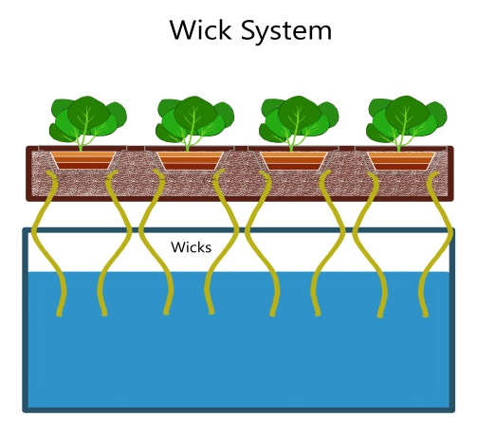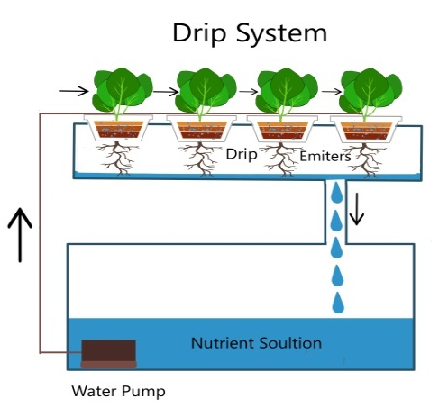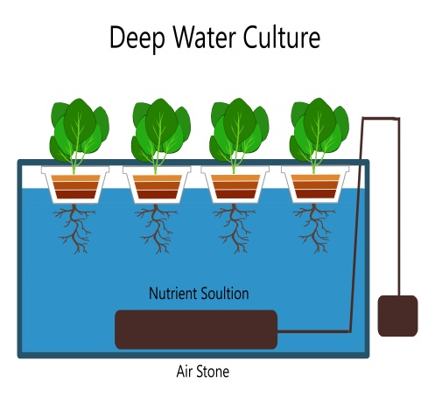
Water reservoir
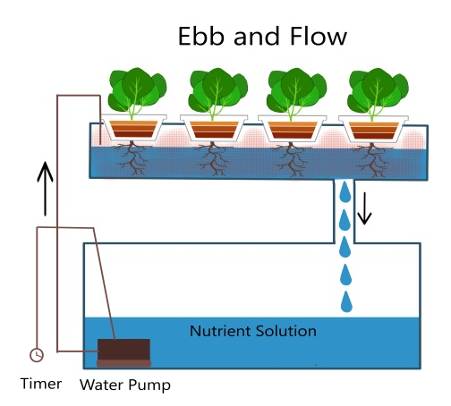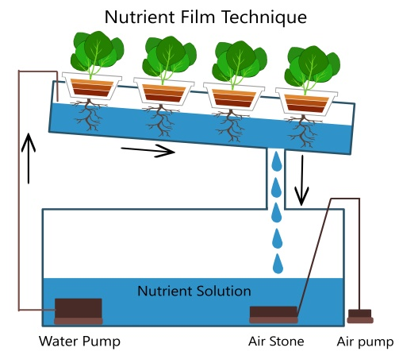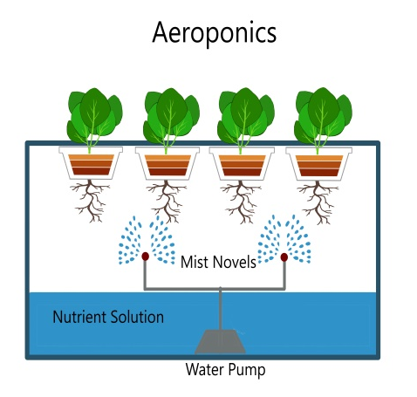
Figure 8: Different techniques of hydroponic based plant culture

Table 2: Crops suitable for growing under hydroponic system [85][86]
Serial Number | Hydroponic Techniques | Cereal crops | Fruits | Vegetables | Flowers and Herbs
1. | Wick technique | Not suitable | Not suitable for any fruit crops | Lettuce, Watercress | Peace lily, Petunia, and majority of the herbs
2. | Drip technique | Oats, and Maize | Melon, and Strawberry | Cucumber, Bean, Pea, Pepper, Pumpkin, Squashes, Zucchini, Radish, Onion, Lettuce, Leek, Leafy greens and Tomato | Marigold, Oregano, Basil, Rosemary, Lemon balm, and Chive
3. | Deep water culture technique | Rice, and Oat | Watermelon with provision of proper support, Raspberry, and Cranberry | Cabbage, Lettuce, Radish, Broccoli, Okra, Peppers, and Kale | Saffron, Lavender, and other bulbous ornamentals, Mint, Basil, Parsley, and Cliantro
4. | Ebb and flow technique | Rice, Soybean, and Maize | Strawberry, Grape, and Cantaloupe | Tomato, Eggplant, Spinach, Cucumber, Peppers, Peas, Lettuce, Beet, Chicory, Celery, Watercress, and Swisschard | Phlox, Orchid, Dahlia, Chrysanthemum, Dill, Lavender, Basil, Sage, Anise, Tarragon, Chamomile, Coriander, Chive, Thyme, Fennel, Mint, Rosemary, and Oregano
5. | Nutrient film technique | Rice, Wheat, Soybean and Oat | Strawberry, Blackberry and Blueberry | Lettuce, Spinach, Tomato, Kale, Broccoli, Cauliflower and Bell Peppers | Sunflower, Rose, Petunia, Marigold, Gerbera, Lavender, Carnation, Sage, and Basil
6. | Aeroponics | Not suitable | Watermelon, and Squashes | Potato, Tomato, Ginger, Pumpkin, Cucumber, and Leafy greens | Orchid, Rose, Tulip, Hibiscus, Lavender, Mint, Mustard greens, Thyme, and Rosemarry

C. Advantages of hydroponics in arid agriculture:

a) Water use efficiency and control: In order to obtain a bountiful crop harvest, water is considered as one of the most crucial input. Growing crop under protected condition necessitate a plenty usage of water for irrigation in absence of optimum precipitation for obtaining quality plant performance. In the hot, arid and semi-arid climatic regions of the world, water has been observed as a major limiting factor for crop cultivation concerning its availability, quality and so also the cost [5].
Hydroponics offers a quite convenient and economic irrigation facility, where the crop roots come in direct contact with the nutrient solution like NFT and other associated systems augmenting the water as well as nutrient use efficiency as compared to conventional agronomic practices. However, some other techniques of hydroponic utilize organic and inorganic growing media that may not serve the cause, as most of the growing media do not hold water as good as soil. Taking the water use efficiency (WUE) into consideration, the closed type hydroponic systems such as NFT ensure constant re-circulation of nutrient solution and make WUE undisputedly high by checking the drainage and evaporation loss, depending on the operational method and system design.

b) Elimination of unproductive soil usage: Hydroponic provides a better substitute by facilitating soilless crop cultivation particularly in those conditions, where the soil quality is a limiting factor for successful crop growth. The soil found in arid lands is detected not to be fertile enough to favour growing crops due to the poor aeration capability, salinity and often observed to be accumulated with heavy metals such as mercury, lead, cadmium etc. as well as heavily infested with a variety of soil borne pathogens. As hydroponic cuts off soil usage and use nutrient rich water solution instead for plant culture, can be rightfully considered as effective alternative paving a way towards futuristic farming under arid ecosystem.

c) Maximization in crop yield: Hydroponic is bestowed with modern technologies that make it a new venture of precision farming (Table 3). In hydroponic systems, the inherent need of the crop can be successfully met, ultimately resulting in rapid plant growth and profuse yield. The controlled environmental condition also checks the application of pesticides and herbicides, as plants are protected from external adverse factors.
It also ensures plants to be carefully monitored, so that their full potential can be harnessed. Hydroponic is an essential cultivation alternative for arid regions, where the environmental conditions makes the conventional farming quite a challenging and difficult job. The alteration in microclimate enables to take up intensive and productive cropping under hydroponic, that boosts the profitability at farmer’s end [87].

d) Environmental conservation and sustainability: Hydroponic can efficiently meet the requirements of sustainable agriculture. As saving water is the one of the primary motto for sustainable dryland agriculture, this technique is reported to conserve water way up to 70 - 80%, thereby enabling more efficient water usage in regions with limited water resource availability. Hydroponic is an intelligent farming system that offers flexibility to combat climatic vagaries and also considerably reduce the environmental destruction through conventional intensive farming. It is also noted to play a very potential role in minimizing erosion, bringing down the use of agrochemicals and conserving germplasm and base materials.

Table 3: Comparative Yield difference between Hydroponics versus Conventional farming [88][85]
Serial Number | Name of the crop plant | Average yield per acre under conventional farming (kg) | Average yield per acre under hydroponics (kg) | % boost in yield
Cereal crops
1. | Rice | 454 | 2268 | 399
2. | Wheat | 272 | 1860 | 583
3. | Maize | 680 | 3629 | 433
4. | Oat | 385 | 1361 | 253
5 | Soybean | 272 | 680 | 150
Vegetable crops
1. | Potato | 7257 | 63503 | 775
2. | Tomato | 9072 | 163293 | 1700
3. | Okra | 3628 | 8618 | 137
4. | French bean | 5443 | 19051 | 250
5. | Peas | 907 | 6350 | 600
6. | Cabbage | 5897 | 8165 | 39
7. | Cauliflower | 6804 | 13608 | 100
8. | Cucumber | 3175 | 12700 | 300
9. | Beetroot | 4082 | 9072 | 122
10. | Lettuce | 4083 | 9525 | 133

D. Challenges faced in hydroponic in arid agriculture
The major challenge faced by hydroponic is its lesser adoption and acceptance rate among commercial growers owing to the high installation, and maintenance cost, as it requires automated and computerized control system for regulating artificial illumination, irrigation, fertilization as well as application of plant protectants besides skilled manpower [5]. The choice of crop is also limited in hydroponics and unlike conventional soilbased cultivation, diverse crops can’t be taken up at a time in the similar place as the inherent requirement varies from crop to crop. For instance, a particular nutrient solution fed to a group of plants can’t be supplied to another group of plants, if they are non-related. Soilless farming necessitates modern infrastructure, hefty initial investment cost, and fair level of technical and scientific know-how for smooth conduction [89]. It also demands ample of energy for operating water pumps, heating as well as cooling loads, and supplementary artificial lighting arrangements that has been reported to use an average estimated energy of 90,000 kJ/kg under soilless farming [90][89][91]. As a result, it has become a challenge to introduce hydroponics to the farmers’ livelihood in substandard condition.

E. The way forward
In developing nations, hydroponic has become a powerful tool to fight against the soaring hunger of the growing population especially under arid and semi-arid climatic condition, keeping its profitability and feasibility in view. Application of herbicides and pesticides under conventional agriculture might bring alarming effect on people health as well as environmental stability. Instances of pesticides eliminating beneficial soil microbes and polluting ground water resource can’t be ignored. However, in hydroponics, the recycling of water restricts fertilizer or pesticide run off and as a result, imposes no adverse effect upon the environment and natural resources as well.

VI. Precision farming in arid agriculture
Precision agriculture defined as the site specific management of resources such as land, water, radiation etc. over spatio-temporally and economically to assist the farm producer by adopting advance geo-spatial technology such as Remote Sensing, Global Positioning Systems (GPS) and Geographic Information Systems (GIS) in a comprehensive approach towards economical optimization of crop production. GIS integrates this remote sensing data with other spatial information to take decision regarding the management strategies of pest, irrigation and fertilization in dry land areas. It is a matter of concerned that dryland agriculture often involves heterogeneous landscapes with varying soil types, topography, and microclimates. Remote sensing and GIS enable site-specific management practices, such as variable rate irrigation and precision fertilization, tailored to the unique conditions of different areas within a field. These are essential tools for enhancing productivity, sustainability, and resilience in dryland agriculture. By providing timely and accurate spatial information, they enable farmers, policymakers, and stakeholders to build appropriate decisions and enforce productive management practices to address the challenges of dryland farming.

Principles and Technologies of Precision Agriculture
Technology in agriculture, encompasses a wide range of innovations aimed to bring transformational changes towards increasing efficiency, productivity, and sustainability in farming practices. With the progress in different modern technology such as Remote Sensing, Global Positioning System (GPS), Internet of Things (IoT), Nano technology and Aerial photography, it become much easier and precise to monitor the health condition of crops, identify nutrient status of soil, manage proper irrigation system and other factors responsible for crop stress and reduction of yield [92]. Precision agriculture is a technology and information based three tier system. It uses different sources of data like soil parameter, pest, crop, yields, humidity, nutrients, moisture and temperature as input and analyzed in an advanced computerized programmer via data analysis and finally the decision making process which includes specialized equipment for assessment and evaluation for sustainability, profitability, production of crops and environmental protection. It also explains how these technologies can be tailored to suit the unique conditions of arid lands and improve resource management efficiency.

- Remote Sensing
Remote sensing provides a bird's eye view of large agricultural landscapes, which enable to monitor the health status of crop, moisture levels, nutrients content and types of soil, and other environmental factors efficiently. Satellite imagery, drones, and other remote sensing technologies are used to monitor crop health, soil moisture levels, and other important parameters over large areas. This real time data helps farmers to take instant and informed decisions about scheduling irrigation, fertilization, and pest management.

a) Remote sensing in Crop Health Monitoring and Assessment: Remote sensing data, obtained through satellite imagery or drones which are equipped with hyperspectral or multispectral sensors, used to capture the data at different wave length of light. Further these data used to monitor indirectly the health status of crop and different stress factors such as water scarcity, nutrient deficiencies and pest infestations by analyzing through different indices. NDVI (Normalized Difference Vegetation Index) is one of the most frequently used indices to check the crop condition instantaneously based on reflectance values of different bands over vegetation [93][94]. This index is calculated as the ratio of reflectance in the near infra-red (NIR) and red wave length (visible spectrum) [95]. The range of NDVI lies from -1 to 1. If the value is positive, it indicates the healthy condition of crops as there will be high reflectance in NIR band due to healthy stomata and for negative values indicate the crop in stress [96][97].

b) Remote sensing application in soil Moisture Monitoring: Remote sensing techniques, including microwave and thermal infrared sensors, can be used to estimate soil moisture levels across agricultural landscapes even in cloudy condition [98]. This information is crucial for optimizing irrigation scheduling, especially in dryland areas where water is scarce [99]. By monitoring changes in soil moisture over time, farmers can adjust the time of irrigation to ensure the adequacy of water received by crop without any wastage. Different indices are used for soil moisture status in root zone for arid and semi-arid region such as PDSI (Palmer Drought Severity Index), Drought Severity Index (DSI), Evapotranspiration Deficit Index (ETDI), Standardized Precipitation and Evaporation Index (SPEI) and NDWI (Normalized Difference Water Index) [100][101][102][103][104].
c) Land Use/Land Cover Mapping: For proper planning and management of resources in drylands mapping is necessary. To map a large area with different time period remote sensing data can be used to classify the land used and the resources covers pattern including cropland, forest land, and barren land [105]. Spatio-temporal changes of land utilization over a large area can provide valuable information for land management planning, allocation of resource and environmental monitoring. For example, they can help identify areas suitable for agricultural expansion or conservation efforts [106].

d) Drought Monitoring and Early Warning: Remote sensing data can be used to monitor drought conditions in dryland areas by tracking changes in the dynamics of vegetation, soil moisture status and other indicators of drought stress [107]. By combining satellite imagery with meteorological data and ground-based observations, authorities can provide early warning of impending droughts and implement appropriate mitigation measures to minimize the impacts on agriculture and water resources [108].

e) Yield Prediction and Crop Insurance: Remote sensing data, along with crop modeling techniques, were applicable to predict the status of yield loss in dryland areas. By scrutinizing the historical trends in vegetation growth and environmental conditions, farmers and insurers can estimate potential crop yields and assess the risk of yield losses due to factors such as drought, pests, or diseases. This information is valuable for crop insurance programs and financial planning purposes [109].

f) Erosion and Land Degradation Monitoring: Soil erosion and land degradation in dryland areas are vital. To monitor the changes in land surface characteristics over time a high-resolution hyperspectral satellite imagery data is required. Application of Remote sensing data can be used to assess the erosion status over large areas [110]. Hence LiDAR (Light Detection and Ranging) data can be used to identify areas prone to erosion, quantify soil loss rates, and evaluate the effectiveness of erosion control measures such as terracing or contour ploughing [111].

- Geographic Information Systems (GIS)
GIS technology is used to analyze the data related to soil types, topography, and weather patterns. By integrating this information with data collected from remote sensing, farmers can create detailed maps that guide site-specific management decisions [112]. VRT (Variable Rate Technology) helps farmers to alter the rate of inputs such as water, pesticides and fertilizer within a field based on specific needs identified through GIS data analysis. This targeted approach helps to optimize the usages of resource and improve crop yields. GIS technology provides information for mapping of as soil and nutrient status to monitor and enhance soil health and fertility in arid lands [113].

- GPS (Global Positioning Systems)
Global Positioning System (GPS) is highly advanced networking system in which satellites and computers used to gives the exact position in 24hr a day anywhere on the earth. This system constitutes in to three parts namely the space, user and control segment [114]. This technology has become increasingly vital in dry land agriculture due to its ability to enhance precision, efficiency, and productivity. Now a day’s modern farmers use GPS in precision farming which enables to map their fields precisely and track the inter-cultural activities such as planting, fertilizing, and harvesting. This precision allows for optimal allocation of resource, reducing waste and maximizing yields [115]. In essence, GPS technology revolutionizes dry land farming by providing precise positioning and data collection capabilities, empowering farmers to make instant decisions that enhance production and productivity with optimization of resources in order to minimize environmental impact [116].

a) VRT: With GPS, farmers can implement VRT, which adjusts inputs like water, fertilizers, and pesticides according to specific locations within the field. This ensures that resources are used efficiently, tailored to the needs of different soil types and crop zones [117].

b) Autonomous Machinery: GPS-guided tractors and other agricultural machinery can operate autonomously, following predefined paths with high accuracy. This reduces labor requirements and allows for round-the-clock operations, particularly useful in large-scale dry land farming. Yield Monitoring: GPS facilitates precise yield monitoring by geo-referencing data collected from harvesters. Farmers can then analyze this data to identify areas of the field with varying productivity levels and make informed decisions for future planning.

c) Boundary Mapping and Land Surveying: GPS is used to accurately map field boundaries and determine property lines. This aids in land management, legal delineation, and compliance with regulations.

d) Weather Monitoring and Forecasting: GPS-based weather stations provide real-time meteorological data specific to the farm's location. This information helps farmers make timely decisions regarding irrigation, pest control, and other management practices [118].

e) Soil Sampling and Analysis: GPS assists in systematic soil sampling across the field, ensuring representative samples are collected from different locations. These samples can then be analyzed for nutrient levels, pH, and other soil properties, guiding fertilization strategies.

f) Crop Monitoring and Scouting: Drones equipped with GPS technology can fly over fields, capturing high-resolution images for crop monitoring and pest scouting. This allows for early detection of issues such as disease outbreaks or nutrient deficiencies, enabling prompt intervention.

- IoT (Internet of Things)
The Internet of Things (IoT) refers to the interconnected network of physical devices immersed with multiple sensors, software, and other technologies that connect and exchange data with other devices and systems over the internet. These "things" range from ordinary household objects to sophisticated industrial tools, and they are designed to collect and share data to mechanize processes, improve efficiency, and enhance user experiences. Application of this technology in agriculture is very recent. It is applicable in Precision farming to monitor the soil conditions, control irrigation, and manage crop health. Application of IoT for smart farming trigger a new era of farming system in India [119].

- Nano technology
Nanotechnology is an important aspect of precision agriculture that offers numerous applications like nano sensor fabrication in order to protect the crop from various insect pests and pathogens and to identify the insect pests and pathogens and their control measures, whose occurrence and extension of biodiversity is favored by climate change. Nanotechnology also serves as a novel device for molecular and cell biology involving modern techniques for gene delivery in genetic engineering programme, developing molecular Nano machines and tools. As per the recent report, Norwegian scientists have been adopting nano-technological approaches for stabilizing sand dunes [120]. In various parts of the globe, application of nanotechnology for improvisation in dryland agriculture has been brought to notice, which will assist the scientists to design strong framework for augmenting resilience among people to cope up with the climatic adversity. This will also strengthen the food production system to efficiently meet the global hunger ensuring nutritional security.

- Precision Irrigation Systems
Advances in technologies like micro-Irrigation which includes both micro-sprinklers and drip irrigation which deliver water directly to the crop′s root zone in order to reduce wastage of water which may be loss through evaporation and runoff and to improve the water use efficiency in dry land areas [121]. In India the potential of sprinkler irrigation has been increased to 1.63 mha, whereas drip irrigation has been rose to 5.0 mha. The farmers of the five states like Andhra Pradesh & Telangana, Maharashtra, Gujarat, Karnataka covered more than 80% of the total area by drip irrigation systems to produced horticultural crops viz. mango, pomegranates, banana, grapes etc. Whereas, the farmers of Rajasthan and Haryana adopt sprinkler sprinkler irrigation methods to produced field crops such as sorghum, wheat, mustard, peas etc. [121]. These systems can be automated and controlled remotely, allowing for precise water management on need based to the different areas within a field.

- Crop Modelling
Crop models use mathematical algorithms to simulate the crop growth and development based on soil characteristics, environmental conditions and management practices. These models help farmers predict crop yields, optimize planting dates, and assess the potential impacts of different management strategies [122].

- Data Analytics and Decision Support Systems
Advanced analytics and decision support systems is to integrate data from different sources and provide the information to farmers with actionable visual aids and chart of recommendations. These systems combine the digital platform and software tools that enable real-time monitoring, analysis, and optimization of agricultural package of practices in order to cope with the challenges faced due to anomalies of climatic conditions and help farmers to take tactile and informed decisions regarding resource allocation, crop management and risk mitigation strategies [123][124].

I. Robotics in precision farming
This leverages technology is used to improve crop yields and efficiency in farming practices. Robotics plays a significant role in this field, enhancing various agricultural processes through automation, data collection, and precise interventions. It includes autonomous tractors, robotic planters and machinery as farm equipment equipped with multiple sensors like GPS for networking and AI to perform task such as ploughing, seeding and harvesting precisely with minimum errors. Apart from intercultural operation this technology also used to monitor and control the infestation of weeds and pest.

Challenges and Opportunities
Challenges and barriers to the widespread adoption of precision agriculture in arid lands, such as high initial investment costs, technical complexity, and limited access to information and resources. The challenges may be overcome by identifying opportunities through policy support, capacity building, and knowledge sharing initiatives.

Future Directions
Explore emerging trends and innovations in precision agriculture that hold promise for further enhancing resilience and sustainability in arid land agriculture. Suggest avenues for future research and development to advance the adoption of precision agriculture as a key strategy for adapting to arid regions. Emphasize the importance of integrating precision agriculture approaches into broader climate change adaptation and mitigation efforts in arid lands to ensure food security, environmental sustainability, and livelihood resilience for local communities.

VII. Biotechnological approaches for enhancing productivity of arid regions

Arid agriculture, often practiced in arid and semi-arid regions, faces numerous challenges such as water scarcity, soil degradation, and climate variability. Biotechnological approaches involve utilizing biological systems, processes, or organisms to enhance the resilience, productivity, and sustainability of crops and offer promising solutions to mitigate these challenges and improve agricultural productivity in arid regions. However, it's crucial to consider the socio-economic and ethical implications of deploying such technologies to ensure their equitable and sustainable implementation.

A. Drought-tolerant crop varieties
Water is the major limiting factor for crop growth and yield under arid ecosystem. Augmenting the ability of crops to tolerate osmotic stress under these conditions could be a viable solution. Biotechnologists are able to develop genetically modified (GM) crops with enhanced drought tolerance. This involves identifying and transferring genes responsible for drought, salt and other environmental stress resistance from extremophiles or other stress-tolerant organisms into commercial crops like maize, wheat, or rice. Biotechnological tools such as CRISPR-Cas9 can precisely edit the genome of crops to improve their water-use efficiency and stress response mechanisms [120]. Genetic engineering techniques can introduce genes to enhance their resilience towards drought, salinity, or other environmental stresses.

B. Water-efficient irrigation systems
Biotechnological advancements can improve the efficiency of irrigation systems in dryland agriculture. For instance, researchers can develop genetically engineered crops with reduced water requirements. Additionally, biopolymers or hydrogels derived from biotechnology can be used to improve soil water retention, reducing water loss through evaporation [5]. Besides, acceptance and adoption of micro-irrigation systems is now-a-days commonly observed among the arid land farmers.

C. Soil bioremediation
Biotechnological approaches can be employed to enhance soil health and fertility in dryland areas. Bio-fertilizers containing beneficial microbes can improve soil structure, nutrient availability, and water retention capacity. These microbes can also degrade organic pollutants, detoxify soil, and promote plant growth in harsh environments. Certain soil bacteria and fungi can form symbiotic relationships with plants, promoting their growth and stress tolerance. Biotechnologists can develop microbial inoculants containing these beneficial microorganisms for application in dryland soils to improve nutrient uptake and water use efficiency in crops. It has been reported that certain plant growth promoting rhizobacteria (PGPR) namely Azosprrillum spp., Bacillus spp., Flavobacterium spp., Providencia spp., Pseudomonas spp., Azotobacter spp. etc. assist in synthesis of phytohormones, secondary metabolites, ROS-scavenging (Reactive Oxygen Species) enzymes as well as modification of root morphology and formation of soil aggregates [125][126].

D. Desert farming techniques
Biotechnologists can design innovative farming systems suitable for arid regions. This includes developing salt-tolerant crops through genetic engineering or conventional breeding methods. Additionally, researchers can explore the use of halophytes (salt-tolerant plants) for cultivation in saline soils, leveraging their ability to thrive in high-salt environments.

E. Biological Pest Control
Integrated pest management (IPM) strategies can be enhanced using biotechnological approaches. This involves the use of biopesticides derived from naturally occurring organisms such as bacteria, fungi, or viruses to control pests and diseases in dryland crops. Application of biopesticides as plant protection tool can significantly cut off harmful chemical pesticide usage upon plants and thereby helps in preserving the arid ecosystem from getting endangered. For an instance, arid crops are majorly infested with various sucking pests like aphids, jassids, white flies etc. which can be efficiently managed by employing bio-control agents such as Beauveria bassiyana, Verticilium lecani, and Metarhizium anisopliae [127]. Biotechnologists can also develop genetically modified crops resistant to specific pests or diseases prevalent in arid regions.

F. Genetic engineering and tissue culture
Biotechnologists can develop crops resilient to multiple environmental stresses, including drought, heat, and salinity. By understanding the genetic mechanisms underlying stress tolerance in plants, researchers can breed or engineer crops with improved adaptability to changing climatic conditions, ensuring food security in dryland regions amidst climate change. Crop genetic engineering emphasizes on the introduction of novel foreign genes and moderation of endogenous gene expression in relation to stress so as to transform the plants by improvising the stress resisting potential. Advancement in genome editing tools provides new opportunities for genetic editing using targeted genes for specialise plant traits. Zinc Finger Nucleases (ZFN), Transcription Activator-like Effector Nucleases (TALEN), Clustered Regularly Interspaced Short Palindromic Repeats (CRISPR) are the examples of genome editing tools used for developing stress resistance crops [128]. Tissue culture is an advanced biotechnological tool having huge demand in agriculture sector. It has got wide applications in crop genetic modification by means of introgression of stress resistance genes and thereby selecting resistant plants through in-vitro selection. Application of in-vitro mutagenesis is also reported to serve the similar goal.

VIII. Exploration of future potential
Conservation and restoration of arid ecosystem can be achieved by genetic modulation, physiological regulation as well as crop adaptation towards environmental extremities, together can be termed as bio-water-saving approach [129]. Apart from the innovations and paradigms discussed in this chapter, there is a huge scope to breed new cultivars and phenotypes featured with draught tolerance and water saving mechanism, achieved through genome editing should be considered as a core objective for bringing evolution in arid agriculture sector. Novel technologies like genome-wide tools and thermal or fluorescence imaging may assist in bridging the gap between genotype and phenotype that is regarded quite essential for promoting high WUE research programmes. The progress can be fastened by combining comparatively target strain environment with stable interaction between genotype and environment [120]. For this, a thorough knowledge regarding crop genetics and physiology in response to moisture stress and their interaction is a prerequisite. The technology of remote sensing can be made to use for land mapping in arid regions and the portions with severity seeking immediate attention can be prioritized. Furthermore, precedence may be given to integration of rainwater harvesting and gray water recycling to further reduce water usage Using bioinformatics to understand plant responses to the dry environmental conditions and optimization of growth protocols may be given emphasis [125].
Exploration can be taken up in enhancing the integration of various technologies, such as combining AI with vertical farming to optimize growth conditions in automated way may be proven beneficial. Development of more sophisticated robots for planting, tending, and harvesting crops and fully integrated systems that automate climate control, irrigation, and nutrient delivery, ensuring optimal growing conditions at all times are some key components of enhancing the food security in the future. Continued research in biotechnology can be encouraged to develop crops that are more resilient to arid conditions, with faster growth rates and higher yields, even in challenging arid environments. There is a scope to develop scalable and affordable solutions for small and large-scale farmers. This includes creating modular vertical farming units and low-cost hydroponic systems that can be easily adopted [58][74]. It is a high time to establish supportive policies and community-based management systems to promote the adoption of innovative agricultural practices. This includes providing training, subsidies, and incentives for farmers to transition to these new methods. Developing curricula and training programmes in schools and universities to educate future generations about the various futuristic technologies as a viable alternatives to traditional agriculture. In urban areas, the implementation of vertical farming and hydroponics can be scaled up to enhance food security, reduce transportation costs, and provide fresh produce locally. These areas can be specifically focused to build a more resilient and sustainable future of arid agriculture, which is capable of meeting the food demands of growing populations in water-scarce regions.
IX. Conclusion
Arid agriculture has always been through various biotic and abiotic stresses, besides the ever-facing threat of deterioration of arable land for growing food crops in drylands [129]. The situation is further aggravated by ignorance of land users, as the dryland seeks more attention keeping the alarming climatic adversity into consideration. As water is scarce in arid regions, it should be utilized judiciously for obtaining maximum yield. The desirable transformation and revolution in arid agriculture can be brought by introduction and popularization of soilless cultivation practices viz. vertical faming, hydroponic etc. that play a very potent role in resource optimization [5]. Soilless culture is a promising innovation in arid agriculture, as it not only enhance sustainable crop yield from marginal land but also ensures food security for the expanding global population, besides generating huge scope of employment opportunity. It also enables exploration of substandard space for maximizing crop production. In vertical farming, crop plants are grown in stacked layers under controlled environment, reducing the dependency on land and boosting the crop productivity year round. Whereas, hydroponic concerns raising crops in nutrient supplemented water solution without soil significantly minimizing water usage upto 70-90% in comparison to the conventional soil based farming [58]. This chapter dealt with the multidisciplinary and integrated paradigms and futuristic innovations to convert the challenges into opportunities in dryland areas. Precision farming technologies featuring sensors and IoTs promote zero waste inputs, adoption of which can be of great use for arid environment [76]. Incorporation of biochar and hydrogels in improving soil water retention quality and fertility may serve quite crucial. Developing drought-resistant and salt-tolerant crops through genetic modification to enhance crop resilience towards climatic variability can open a new door for augmenting agricultural production. Remote sensing, drones, AI, and big data analytics are developed to monitor and manage agricultural resources efficiently, ensuring optimal crop growth and resource utilization [104].

Conflicts of Interest
The authors hereby declare no conflict of interest.

REFERENCES:

[1] H. Leridon, "World population: towards an explosion or an implosion?," Popul. Soc., vol. 573, no. 1, pp. 1-4, 2020.
[2] R.S. Velazquez-Gonzalez, L. Adrian, Garcia-Garcia, E. Ventura-Zapata, J. O. Barceinas-Sanchez and J.C. Sosa-Savedra, "A review on hydroponics and the technologies associated for medium-and small-scale operations," Agric., vol. 12, no. 5, pp 646, 2022.
[3] N.V. Fedoroff, "Food in a future of 10 billion,” Agric. Food Secur., vol. 4, pp. 11, 2015.
[4] X. Huang, L. Daniel, Swain, and A.D. Hall, "Future precipitation increase from very high resolution ensemble downscaling of extreme atmospheric river storms in California," Sci. Adv., vol. 6, no. 29, eaba1323, 2020.
[5] W.G. Gebreegziher, “Soilless culture technology to transform vegetable farming, reduce land pressure and degradation in drylands” Cogent Food Agric., vol. 9, no. 2, 2265106, 2023.
[6] C. Eigenbrod, and N. Gruda, "Urban vegetable for food security in cities. A review," Agron. Sustain. Develop., vol. 35, pp. 483-498, 2015.
[7] S.A. Bello, T. Ahmed,and R. Ben-Hamadou. "Hydroponics: Innovative option for growing crops in extreme environments-The case of the Arabian Peninsula (A review)," J. Agric. Res., vol.4, no.5, pp. 1-16, 2019.
[8] M. De Clercq, V. Anshu, and B. Alvaro, "Agriculture 4.0: The future of farming technology," Proceedings of the world government summit, Dubai, UAE, pp. 11-13, 2018.
[9] F. Kalantari, O.M. Tahir, R.A. Joni, and E. Fatemi. "Opportunities and challenges in sustainability of vertical farming: a review,” J. Landscape Ecol., vol. 11, no. 1, pp. 35-60, 2017.
[10] P. Sambo, C. Nicoletto, A. Giro, Y. Pii, F. Valentinuzzi, T. Mimmo, P. Lugli et al. "Hydroponic solutions for soilless production systems: issues and opportunities in a smart agriculture perspective," Front. Plant Sci., vol., 10, pp 923, 2019.
[11] N. Tzortzakis, S, Nicola, D, Savvas and W. Voogt, "Soilless cultivation through an intensive crop production scheme. Management strategies, challenges and future directions," Front. Plant Sci.,vol. 11, 529970, 2020.
[12] R.P. White, and J. Nackoney, "Drylands, people, and ecosystem goods and services: a web-based geospatial analysis,” World Resour. Inst., 2003.
[13] S.P. Nicholson, "Dominating cues and the limits of elite influence," J. Polit., vol. 73, no. 4, pp. 1165-1177, 2011.
[14] G.X. Li, B.C. Xu, L.N. Yin, S.W. Wang, S.Q. Zhang, L. Shan, S.S. Kwak, Q. Ke, and X.P. Deng, "Dryland agricultural environment and sustainable productivity," Plant Biotechnol.. Rep., vol. 14, pp. 169-176, 2020.
[15] J. Huang, Y. Li, C. Fu, F. Chen, Q. Fu, A. Dai, M. Shinoda et al., "Dryland climate change: Recent progress and challenges", Rev. Geophys., vol. 55, no. 3, pp .719-778, 2017.
[16] B. Golla, “Agricultural production system in arid and semi-arid regions,” J.Agric. Sci. Food Technol., vol. 7 no. 2, pp. 234-244, 2021.
[17] Z. Cui, H. Zhang, X. Chen, C. Zhang, W. Ma, C. Huang, W. Zhang et al. "Pursuing sustainable productivity with millions of smallholder farmers," Nat., vol. 555, no. 7696, pp. 363-366, 2018.
[18] World Meteorological Organization. Int. Meteorol. Vocab., 2nd ed., WMO, Geneva, Switzerland, 1992.
[19] IPCC. Climate Change 2014: Synthesis Report; Pachauri, R.K., Meyer, L.A., Eds.; Contribution of Working Groups I, II and III to the Fifth Assessment Report of the Intergovernmental Panel on Climate Change; IPCC: Geneva, Switzerland, pp. 151, 2014
[20] IPCC. Climate change, “Impacts, adaptation and vulnerability,” In Working Group II Contribution to the Fourth Assessment Report of the Intergovernmental Panel on Climate Change; Cambridge University Press: Cambridge, UK, 2007.
[21] B.I. Cook, T.R. Ault and J.E Smerdon, “Unprecedented 21st century drought risk in the American Southwest and Central Plains,” Sci. Adv., vol. 1 no. 1, e1400082, 2015.
[22] World Bank, In: Gender in Agriculture Sourcebook,. World Bank Publications, pp.454, 2009.
[23] Millennium Ecosystem Assessment, “Ecosystems and human well-being: desertification synthesis,” World Resources Institute, Washington, DC, 2005.
[24] A. Imeson, “Desertification, land degradation and sustainability,” John Wiley & Sons, 2012
[25] F. Taheripour, T.W. Hertel, B.N. Gopalakrishnan, S. Sahin, and J.J. Escurra, “Agricultural production, irrigation, climate change, and water scarcity in India”, In AAEA & WAEA Joint Annual Meeting, July 26-28, San Francisco, California, pp. 1-39, 2015.
[26] Sala, Osvaldo et al., "Global biodiversity scenarios for the year 2100," Sci., vol. 287, no. 5459, pp. 1770-1774, 2000.
[27] A. Chaudhary, S. Pfister and S. Hellweg, “Spatially explicit analysis of biodiversity loss due to global agriculture, pasture and forest land use from a producer and consumer perspective,” Environ. Sci. Tevhnol., vol. 50, no. 7, pp. 3928-3936, 2016.
[28] A.L. Westerling, H.G. Hidalgo, D.R. Cayan, D. R. and T.W. Swetnam, “Warming and earlier spring increase western US forest wildfire activity,” Sci., vol. 313, no. 5789, pp. 940-943, 2006.
[29] A.L. Westerling and B.P. Bryant, “Climate change and wildfire in California,” Clim. Chang., vol. 87, pp. 231-249, 2008.
[30] D.S. Domingues, H.W. Takahashi, C.A. Camara and S.L. Nixdorf, “Automated system developed to control pH and concentration of nutrient solution evaluated in hydroponic lettuce production,” Comput. Electron. Agric., vol. 84, pp 53-61, 2012.
[31] F. Cozim-Melges, R. Ripoll-Bosch, G.F. Veen, P. Oggiano, F.J.J.A. Bianchi, W.H. van der Putten, and H.H.E. van Zanten, "Farming practices to enhance
biodiversity across biomes: a systematic review," npj Biodivers., vol. 3, no. 1, pp. 1, 2024.
[32] G. Alestra, G. Cette, V. Chouard and R. Lecat, “How can technology significantly contribute to climate change mitigation?,” Appl. Econ., pp. 1–13, 2023
[33] A. Monem, M. Islam and E. Ismail, “Role of Science, Technology and Innovation in Addressing Climate Change Challenges in Egypt,”. In: E. Omran, A. Negm,. (eds) Climate Change Impacts on Agriculture and Food Security in Egypt. Springer Water. Springer, Cham. pp.59-79, 2020.
[34] Y.K. Dwivedi, et.al., “Climate change and COP26: Are digital technologies and information management part of the problem or the solution? An editorial reflection and call to action,” Inter. J. Info. Management, vol. 63, 102456, 2022.
[35] G.C. Nikalje, A.K. Srivastava, G.K. Pandey, and P. Suprasanna, “Halophytes in biosaline agriculture: Mechanism, utilization, and value addition,” Land Degrad. Dev., vol. 29, no. 4, pp. 1081-1095, 2018.
[36] D. Daniel and A. Sahar and A. Mahamoud, “Improving marginal lands for agriculture and food production” pp. 20, 2022.
[37] S.E. Vollset, E. Goren, C. Yuan, J. Cao, A.E. Smith, T. Hsiao, et al., “Fertility, mortality, migration, and population scenarios for 195 countries and territories from 2017 to 2100: A forecasting analysis for the Global Burden of Disease Study. Lancet pp. 396, 1285–1306, 2022.
[38] FAO, “Looking Ahead in World Food and Agriculture: Perspectives to, 2050,” Food and Agriculture Organization of the United Nations, FAO, Rome, Italy, 2011.
[39] United Nations, Department of Economic and Social Affairs, Population Division. World Population Prospects 2022: Summary of Results (UN DESA/POP/2022/TR/NO.3); United Nations: New York, NY, USA, 2022.
[40] FAO. FAOSTAT Database: Food Agric. Organ. United Nations, FAO, Rome, Italy. 2020.
[41] D. Despommier, “Farming up the city: The rise of urban vertical farms,” Trends Biotechnol., vol. 31, no. 7, pp. 388–389, 2013.
[42] D. Lennyi, “Vertical farming: Turning deserts into fresh food hubs,” Indoor & Vertical Farming, Supply Chain, AgriTech Tomorrow, https://www.agritechtomorrow.com/article/2021/07/vertical-farming-turning-deserts-into-fresh-food-hubs/13012, 2021, Accessed on 14th May, 2024.
[43] K. Specht, R. Siebert, I. Hartmann, U. B. Freisinger, M. Sawicka, A. Werner, S. Thomaier, D. Henckel, H. Walk, and A. Dierich, “Urban agriculture of the future: an overview of sustainability aspects of food production in and on buildings,” Agric. Human Values, vol. 31, no. 1, pp. 33–51, 2014, March.
[44] F. Kalantari, M. O. Tahir, M. Lahijani and S. Kalantari, “A review of vertical farming technology: a guide for implementation of building integrated agriculture in cities,” Adv. Eng. Forum, vol. 24, pp. 76-91, 2017.
[45] A.C. Bunge, A. Wood, A. Halloran, and L. J. Gordon. "A systematic scoping review of the sustainability of vertical farming, plant-based alternatives, food delivery services and blockchain in food systems," Nature Food, vol. 3, no. 11 pp. 933-941, 2022.
[46] K. A. Khalaf, A. Gamil, B. Attiya and J. Cuello, “Exploring the potential of concentrating solar power technologies for vertical farming in arid regions: The case of Western Iraq,” Energy Sustain. Develop., vol. 77, 2023.
[47] X.G. Zhu, and L. Marcelis, “Vertical farming for crop production,” Mod. Agric., vol 1, no. 1, pp. 13-15, 2023.
[48] H. Takeshima, H and P.K. Joshi, (2019). “Protected agriculture, precision agriculture, and vertical farming: Brief reviews of issues in the literature focusing on the developing region in Asia”, In Intl. Food Policy Res. Inst., vol. 1814, pp. 19, 2019, March.
[49] C. Banerjee, and I. Adenauer, “Up, up and away! The economics of vertical farming,” J. Agric. Stud., vol. 2, pp. 40–60, 2014.
[50] M. K. Gupta and S. Ganapuram, "Vertical farming using information and communication technologies," White Paper, InfoSys, 2019.

[51] S. Meena, “Vertical farming: an overview on different types of vertical farming system,” Krishi Jagran, 2022, https://krishijagran.com/agripedia/vertical-farming-an-overview-on-different-types-of-vertical-farming-system/ Accessed on 16th May, 2024.
[52] P. Parsons, “Vertical farming takes agriculture to new heights,” The National, 2008, 14th March, https://www.thenationalnews.com/business/vertical-farming-takes-agriculture-to-new-heights-1.529515 , Accessed on 25th May, 2024.
[53] E. Ellingsen and D. Despommier, "The vertical farm: the sky-scraper as vehicle for a sustainable urban agriculture," In CTBUH 8th World Congress on Tall & Green: Typology for a Sustainable Urban Future, pp. 311-318. 2008.
[54] K. Yeang, “Reinventing the Skyscraper: A vertical theory of urban design,” Wiley Academy, Chichester, pp. 224, 2002
[55] P. H. Nguyen, “Mixed-Occupancy Vertical Urban Farm System,” Stanford Univ., 2008.
[56] K. Diaz, “Freight container farms: A feasibility and sustainability assessment ,” Master of Science in Engineering Technology and Management for Agricultural Systems submitted to University of Illinois Urbana-Champaign, 2023
[57] I. Gageanu, A. M. Tăbărașu, N.I.Ț.U. Mihaela and A. Pruteanu, "Vertical farming–a solution for today’s agriculture," AGRI - INMA - Trends Sustain. Agric. Environ. Prot. J., vol. 1, pp. 101-115, 2022.
[58] G. Niu and J. Masabni, “Hydroponics. In plant factory basics, applications and advances,” Academic Press, pp. 153-166, 2022.
[59] D. Despommier, “The rise of vertical farms,” Sci. Am., vol. 301, no. 5, pp. 80–87, 2009.
[60] M.H.M. Saad, N.M. Hamdam and R.M. Sarker, “State of the art of urban smart vertical farming automation system: Advanced topologies, issues and recommendations,” Electron., vol. 10, no.12, 1422, 2021.
[61] M.S.N. Kabir, M.N. Reza, M. Chowdhury, M. Ali, Samsuzzaman, M.R. Ali, K.Y. Lee, and S.O. Chung, “Technological trends and engineering issues on vertical farms: a review,” Hortic., vol. 9, pp. 1229, horticulturae9111229, 2023.
[62] J.E. Son, H.J. Kim and T. I. Ahn, “Hydroponic systems. in plant factory: An indoor vertical farming system for efficient quality food production, 2nd ed.; Kozai, T., Niu, G., Takagaki, M., Eds.; Academic Press, Cambridge, MA, USA, pp. 273–283, 2020.
[63] R. Kumari and R. Kumar, “Aeroponics: a review on modern agriculture technology,” Indian Farmer, vol. 6, no. 4, pp. 286-292, 2019.
[64] B. Yep and Y. Zheng, “Aquaponic trends and challenges - A review,” J. Clean. Prod., vol. 228, pp. 1586- 1599, 2019.
[65] G.F.M. Baganz, R. Junge, M.C. Portella, S. Goddek, K.J. Keesman, D. Baganz, G. Staaks, C. Shaw, F. Lohrberg, and W. Kloas “The aquaponic principle — It is all about coupling,” Rev Aquac., vol. 14: pp. 252–264, 2022.
[66] S. Goddard and F.S. Al-Abri, “Integrated aquaculture in arid environments,” J. Agric. Mar. Sci., vol. 23, pp. 52-57, 2018.
[67] S. Sivamani, N. Bae and Y. Cho, “A smart service model based on ubiquitous sensor networks using vertical farm ontology,” Int. J. Distrib. Sens. Netw., vol. 9, 161495, 2013.
[68] K.C. Ting, T. Lin and P.C. Davidson, “Integrated urban controlled environment agriculture systems,” In LED lighting for urban agriculture, Springer, Singapore, pp. 19-36, 2016.
[69] D. Savvas and N. Gruda, “Application of soilless culture technologies in the modern greenhouse industry- a review,” Eur. J. Hortic. Sci., vol. 83, pp. 280–293, 2018.
[70] K. Nemali, “History of controlled environment horticulture: greenhouses,” HortScience, vol. 57, pp. 239 - 246, 2022.
[71] C. Vatistas, D.D. Avgoustaki and T.A. Bartzanas, “Systematic literature review on controlled-environment agriculture: how vertical farms and greenhouses can influence the sustainability and footprint of urban microclimate with local food production,” Atmos., vol. 13, pp. 1258, 2022.
[72] J.A. Nelson and B. Bugbee, "Supplemental greenhouse lighting: return on investment for LED and HPS fixtures" (2013). Controlled Environ. Paper 2. Available at: https://digitalcommons.usu.edu/cpl_env/2.
[73] Ambitas, “The intersection of IoT and agriculture: an overview of vertical farm technology,” 2023, September 9. https://www.ambitas.org/blog/the-intersection-of-iot-and-agriculture-an-overview-of-vertical-farm-technology, Accessed on 27th May, 2024.
[74] K. Al-Kodmany, “The vertical farm: A review of developments and implications for the vertical city,” Build., vol. 8 no. 2, pp. 24, 2018.
[75] M.S. Mir, N.B. Naikoo, R.H. Kanth, F.A. Bahar, M.A. Bhat, A. Nazir, S. Sheraz Mahdi et al. "Vertical farming: the future of agriculture: a review." Pharma Innov. J. vol. 11, no. 21, pp. 1175-1195, 2022.
[76] A. Shrivastava, C.K. Nayak, R. Dilip, S.R. Samal, S. Rout, and S.M. Ashfaque. "Automatic robotic system design and development for vertical hydroponic farming using IoT and big data analysis," Materials Today: Proceedings, vol. 80, pp. 3546-3553, 2023.
[77] C. Lehnert, C. McCool, I. Sa and T. Perez, “Performance improvements of a sweet pepper harvesting robot in protected cropping environments,” J. Field Robot, vol. 37, pp. 1197-1223, 2020.
[78] P. Morella, M.P. Lambán, J. Royo and J.C. Sánchez, “Vertical farming monitoring: how does it work and how much does it cost?,” Sens. pp. 23, 3502, 2023.
[79] H.M. Resh, “Hydroponic Food Production,” In A Definite Guide Book for The Advanced Home Gardener and The Commercial Hydroponic Grower. 6th ed., New Concept Pr. New Jersey (US), 2004.
[80] M.D. Sardare and S.V. Admane, “A review on plant without soil-hydroponics.” Int. J. Res. Eng. Technol., vol.2, no. 3, pp 299-304, 2013.
[81] J.B. Jones Jr., “Hydroponics: a practical guide for the soilless grower”, CRC press, 2016.
[82] W.F. Gericke, “Soilless gardening: a complete guide,” Biotech Books, Delhi India, pp 285, 2005.
[83] D.R. Hoagland and D.I. Arnon, “The Water-Culture Method for Growing Plant Without Soil,”. College Agric. Univ. of California, vol. C347, 1995.
[84] S. Nabi, N. Fayaz, S.A. Rather and A.A. Mir, “Hydroponics: Environmentally sustainable practice in the agricultural system,” Pharma Innov. J., vol. 11, pp. 207-212, 2022.
[85] P.P. Jagtap, S.R. Bhakar, S.S. Lakhawat, P.K. Singh, and M. Kothari, "Present status and future prospective of hydroponics technique: hope and hype for future
welfare," J. Postharvest Technol., vol. 10, no. 3, pp. 65-77, 2022.
[86] R.J. Meena, S. Meena, D. Meena, and N. Divaker. "Hydrophonics in vegetable productions." Prod. Technol. Hortic. Sci., pp. 65, 2024.
[87] R. C. Brears, “Hydroponics in arid regions: innovative agriculture for environmental sustainability,” Global Climatic Solutions, Jan 12, 2024, Available at: https://medium.com/global-climate-solutions/hydroponics-in-arid-regions-innovative-agriculture-for-environmental-sustainability-9eeaf59dc7b6#:~:text=A%20key%20advantage%20of%20hydroponics,up%20to%2090%25%20less%20water
[88] N.C. Barman, M. M. Hasan, M. R. Islam, and N. A. Banu. "A review on present status and future prospective of hydroponics technique," Plant Environ. Dev., vol. 5, no. 2, pp. 1-7, 2016.
[89] F. Kalantari, O.M. Tahir, R.A. Joni, and E. Fatemi, "Opportunities and challenges in sustainability of vertical farming: A review," J. Landsc. Ecol., vol. 11, no. 1,
pp. 35-60, 2018.
[90] G.L. Barbosa, F. Daiane, A. Gadelha, N. Kublik, A. Proctor, L. Reichelm, E. Weissinger, G.M. Wohlleb, and R.U. Halden, "Comparison of land, water, and energy requirements of lettuce grown using hydroponic vs. conventional agricultural methods," Int. J. Environ. Res. Public Health, vol. 12, no. 6, pp. 6879-6891, 2015.
[91] A, Sarkar and M. Majumder, "Opportunities and challenges in sustainability of vertical eco-farming: A review," J. Adv. Agric. Technol., vol. 2, no. 2, 2015.
[92] C. Hedley, "The role of precision agriculture for improved nutrient management on farms," Jour. Sci. Food Agric., vol. 95, no. 1, pp. 12-19, 2015.
[93] M. Gajbhiye, K.K. Agrawal, A.K. Jha, N. Kumar, and M. Raghuwanshi, "Crop Health Monitoring through Remote Sensing: A Review," Int. J. Environ. Climate Change, vol. 13, no. 10, pp. 2581-2589, 2023
[94] K. Ennouri, and A. Kallel, "Remote sensing: an advanced technique for crop condition assessment," Math. Probl. Eng., vol. 2019, 2019.
[95] J. Xue, and B. Su, "Significant remote sensing vegetation indices: A review of developments and applications," J. Sens., vol. 2017, pp. 1-18, 2017.
[96] J.D. Stamford, S. Vialet-Chabrand, I. Cameron, and T. Lawson, "Development of an accurate low cost NDVI imaging system for assessing plant health." Plant Methods, vol. 19, no. 1, pp. 9, 2023.
[97] P.S. Thenkabail, R.B. Smith, and E.D. Pauw, "Evaluation of narrowband and broadband vegetation indices for determining optimal hyperspectral wavebands for agricultural crop characterization," Photogrammetric Eng. Remote Sens., vol. 68, no. 6, pp. 607-622, 2002.
[98] H.G. Jones, R. Serraj, B.R. Loveys, L. Xiong, A. Wheaton, and A.H. Price, "Thermal infrared imaging of crop canopies for the remote diagnosis and quantification of plant responses to water stress in the field," Funct. Plant Biol., vol. 36, no. 11, pp. 978-989, 2009.
[99] J. Cho, Y.W. Lee, and H.S. Lee, "Assessment of the relationship between thermal-infrared-based temperature− vegetation dryness index and microwave satellite-derived soil moisture," Remote Sens. Lett., vol. 5, no. 7, pp. 627-636, 2014.
[100] S. Dehghan, N. Salehnia, N. Sayari, and B. Bakhtiari, "Prediction of meteorological drought in arid and semi-arid regions using PDSI and SDSM: a case study in Fars Province, Iran," J. Arid Land, vol. 12, pp. 318-330, 2020.
[101] Z. Su, Y. He, H. Boogaard, J. Wen, B. Gao, G. Roerink, and D. van Diepen, "Assessing relative soil moisture with remote sensing data: theory and experimental validation," In EGS General Assembly Conference Abstracts, pp. 3169, 2002.
[102] B. Narasimhan, and R. Srinivasan, "Development and evaluation of Soil Moisture Deficit Index (SMDI) and Evapotranspiration Deficit Index (ETDI) for agricultural drought monitoring," Agric. For. Meteorol., vol. 133, no. 1-4, pp. 69-88, 2005.
[103] S.M. Vicente-Serrano, S. Beguería, and J.I. López-Moreno, "A multiscalar drought index sensitive to global warming: the standardized precipitation evapotranspiration index," J. Climate, vol. 23, no. 7, pp. 1696-1718, 2010.
[104] P.P. Patil, M.P. Jagtap, N. Khatri, H. Madan, A.A Vadduri, and T. Patodia, "Exploration and advancement of NDDI leveraging NDVI and NDWI in Indian semi-arid regions: A remote sensing-based study," Chem. Environ. Eng., vol. 9, pp. 100573, 2024.
[105] A. Roy, and A.B. Inamdar, "Multi-temporal Land Use Land Cover (LULC) change analysis of a dry semi-arid river basin in western India following a robust multi-sensor satellite image calibration strategy," Heliyon, vol. 5, no. 4, pp. 1-20, 2019.
[106] K.R. Bhimala, V. Rakesh, K.R Prasad, and G.N. Mohapatra, "Identification of vegetation responses to soil moisture, rainfall, and LULC over different meteorological subdivisions in India using remote sensing data," Theoretical Appl. Climatol., vol. 142, no. 3, pp. 987-1001, 2020.
[107] K.P.R. Vittal, and A. Kar, "Indicators for assessing drought hazard in arid regions of India," Nat. Anthropogen. Disasters Vulnerabil. Preparedness Mitig., pp. 237-255, 2010.
[108] P. Dhanya, and V. Geethalakshmi, "Reviewing the status of droughts, early warning systems and climate services in South India: Experiences learned," Climate, vol. 11, no. 3, pp. 60, 2023.
[109] E. Eze, A. Girma, A. Zenebe, J.M. Kourouma, and G. Zenebe, "Exploring the possibilities of remote yield estimation using crop water requirements for area yield index insurance in a data-scarce dryland," J. Arid Environ., vol. 183, pp. 104261, 2020.
[110] R.A.Washington-Allen, and S. Ravi, "Dryland analysis and monitoring," Range Anim. Sci. Resour. Manag., Volume II, pp. 274, 2010.
[111] G.P.O. Reddy, N. Kumar, and S.K. Singh, "Remote sensing and GIS in mapping and monitoring of land degradation," Geospatial Technol. Land Resour. Mapp. Monit. Manag., vol. 21, pp. 401-424, 2018.
[112] D. Saini, O. Singh, T. Sharma, and P. Bhardwaj, "Geoinformatics and analytic hierarchy process based drought vulnerability assessment over a dryland ecosystem of north-western India," Nat. Hazards, vol. 114, no. 2, pp. 1427-1454, 2022.
[113] H.P. Singh, K.D. Sharma, G.S. Reddy, and K.L. Sharma, "Dryland agriculture in India," Chall. Strategies Dryland Agric., vol. 32, pp. 67-92, 2004.
[114] R.D. Grisso, M.M. Alley, and C.D. Heatwole. "Precision Farming Tools. Global Positioning System (GPS)," Va. Cooperative Ext., pp. 1-8, 2005.
[115] V.M.A. Hakkim, E.A. Joseph, A.J.A Gokul, and K. Mufeedha, "Precision farming: the future of Indian agriculture," J. Appl. Biol. Biotechnol., vol. 4, no. 6, pp. 068-072, 2016.
[116] S.K. Mudda, "GIS/GPS based Precision Agriculture Model in India-A Case study," Agribus. Inf. Manag., vol. 10, no. 2, pp. 1-7, 2018.
[117] A.K. Mishra, R.P.C. Sundaramoorthi, and D. Balaji, "Operationalization of precision farming in India." In 6th Annual International Conference and Exhibition, 2003.
[118] S. Bhattacharyya, C.K. Rai, N.M. Patnaik, R.K. Verma, and P. Roy, "Adoption of sustainable dryland technologies for improving livelihood of farmers in developing countries," In Enhancing Resilience of Dryland Agriculture Under Changing Climate: Interdisciplinary and Convergence Approaches, Springer Nature Singapore, pp. 597-624, 2023.
[119] H.C. Punjabi, S. Agarwal, V. Khithani, V. Muddaliar, and M. Vasmatkar, "Smart farming using IoT," Internat. J. Electronics Commun. Eng. Technol., vol. 8, no. 1, pp. 58-66, 2017.
[120] A. El-Beltagy, and M. Madkour, "Impact of climate change on arid lands agriculture," Agric. Food Secur., vol. 1, pp. 1-12, 2012.
[121] A. Patel, N.L. Kushwaha, J. Rajput, and P.V. Gautam, "Advances in micro-irrigation practices for improving water use efficiency in dryland agriculture," In Enhancing Resilience of Dryland Agriculture Under Changing Climate: Interdisciplinary and Convergence Approaches, Springer Nature Singapore, pp. 157-176, 2023.
[122] G. Vijayalakshmi, K. Banukumar, and A. Senthilvelan, "Crop water modeling for dryland cropping in Viralimalai block, Tamil Nadu, India," Crop Res., vol. 55, no. 3 and 4, pp. 113-121, 2020.
[123] B.J. Sowmya, S. Seema, and K.G. Srinivasa, "Data analytic techniques for developing decision support system on agrometeorological parameters for farmers," Internat. J. Cognitive Inform. Nat. Intelligence, vol. 14, no. 2, pp. 92-107, 2020.
[124] B.P. BV, and M. Dakshayini, "Machine learning-based decision support system for effective quality farming," Internat. J. Grid High Perform. Computing, vol. 13, no. 1, pp. 82-109, 2021.
[125] C. Dimkpa, T. Weinand, and F. Asch, "Plant–rhizobacteria interactions alleviate abiotic stress conditions," Plant Cell Environ., vol. 32, no. 12, pp. 1682-1694, 2009.
[126] D.V. Badri, T.L. Weir, D. van der Lelie, and J.M. Vivanco, "Rhizosphere chemical dialogues: plant–microbe interactions," Curr. Opin. Biotechnol., vol. 20, no. 6, pp. 642-650, 2009.
[127] S. Sarkar, S. Patra, and A. Samanta, "Efficacy of different bio-pesticides against sucking pests of okra (Abelmoschus esculentus L. Moench)," J. Appl. Nat. Sci., vol. 8, no. 1, pp. 333-339, 2016.
[128] A.J. Bolaji, J.C. Wan, C.L. Manchur, Y. Lawley, T.R. De Kievit, W.G.D Fernando, and M.F. Belmonte, "Microbial community dynamics of soybean (Glycine
max) is affected by cropping sequence," Front. Microbiol., vol. 12, pp. 632280, 2021.
[129] R. Vijayan, "Dryland agriculture in India–problems and solutions," Asian J. Environ. Sci., vol. 11, no. 2, pp. 171-177, 2016.

