Chapter 03
Microencapsulation in Pharmaceutical Science: Definition, Benefits, Drawbacks, Methods, and Applications of Microspheres, Microcapsules, and Microparticles

Priya Thakur ¹, Pooja Kumari ², Shital Mahendra Sonawane ^{3,*}, Avinash Kumar Rao ⁴

¹ Associate Professor, LR Institute of Pharmaceutical Sciences, Solan HP
² Associate professor, Affiliation: Institute of Pharmaceutical Sciences Bhaddal, Ropar, Punjab
³ Assistant Professor, Swami Vivekanand Sansthas Institute of Pharmacy, Mungase, Malegaon, Nashik, Maharashtra
⁴ Assistant Professor, Department of Pharmacy, Sharda Devi Mahavidyalay, Badlapur, Jaunpur, Uttar Pradesh, India.

*Corresponding Author:
Shital Mahendra Sonawane
Assistant Professor, Swami Vivekanand Sansthas Institute of Pharmacy, Mungase, Malegaon, Nashik, Maharashtra

ABSTRACT
Microencapsulation, a crucial technique in the field of pharmaceutical science, involves enclosing active pharmaceutical ingredients (APIs) within microspheres, microcapsules, or microparticles. This study systematically explores the various facets of microencapsulation, encompassing its definition, advantages, disadvantages, methodologies, and diverse applications in the pharmaceutical sector. The definition section delves into the fundamental concept of microencapsulation, elucidating the process that protects APIs within a protective matrix. The research uncovers advantages such as improved drug stability, extended release, enhanced bioavailability, and minimized side effects. Concurrently, it critically examines potential drawbacks, including formulation challenges and scalability issues, providing a comprehensive perspective to optimize pharmaceutical applications. Methodologically, the study thoroughly reviews different microencapsulation techniques like spray drying, coacervation, and solvent evaporation. An evaluative analysis of their merits and limitations is presented, providing insights crucial for tailoring microencapsulation processes to specific drug characteristics and therapeutic requirements. The extensive realm of microencapsulation applications in pharmaceuticals is explored, ranging from controlled drug delivery and targeted therapy to taste masking and protecting sensitive compounds. The research meticulously scrutinizes these diverse applications, highlighting the transformative potential of microencapsulation in drug development and delivery. Through an in-depth analysis of microspheres, microcapsules, and microparticles, this research contributes valuable insights into their unique properties and applications in pharmaceutical formulations. The ultimate goal of this investigation is to advance drug delivery systems, paving the way for more effective and patient-friendly pharmaceutical products. This comprehensive resource aims to benefit researchers, pharmaceutical scientists, and industry professionals, enhancing their understanding of microencapsulation's pivotal role in shaping the future of pharmaceutical science.
KEYWORDS: Microencapsulation, pharmaceutical, solvent, microcapsule, microparticles

- BACKGROUND STUDY

1. Rising Significance of Microencapsulation:
- The introduction of microencapsulation is presented as a crucial method within the realm of pharmaceutical science.
- Confronting issues in conventional drug delivery approaches, such as ensuring stability and managing controlled release.

2. Evolution of Microencapsulation:
- Recognition of the growing focus and investigation within the field.
- Acknowledgment of microencapsulation's role as a revolutionary instrument for enhancing drug delivery systems.

3. Limitations of Conventional Drug Delivery:
- Obstacles associated with the stability, bioavailability, and controlled release aspects in conventional pharmaceutical delivery.
- There is a requirement for inventive methods to improve therapeutic results and encourage patient adherence.

4. Versatility of Microencapsulation:
- Summary of the adaptability of microencapsulation in protecting active pharmaceutical ingredients (APIs).
- Capability to finely regulate the kinetics of drug release for enhanced therapeutic effectiveness.
5. Strategic Role of Microencapsulation:
- Emphasizing microencapsulation as a strategic approach for achieving prolonged drug release.
- Dealing with concerns such as concealing taste, focused therapy, and safeguarding delicate compounds.

- RATIONALE STUDY

- Overcoming constraints through thorough examination.:
  - The justification for exploring microencapsulation to overcome significant drawbacks in conventional drug delivery approaches.
  - Contributing to the ongoing advancement of drug delivery systems to improve patient care.

- In-Depth Exploration of Methods:
- Highlighting the thorough examination of microencapsulation techniques, including spray drying, coacervation, and solvent evaporation.
- The significance of comprehending these techniques to customize drug formulations according to specific characteristics and therapeutic needs.

- Balanced Perspective on Benefits and Drawbacks:
- Acknowledgment of the necessity for a well-rounded viewpoint regarding the advantages (improved drug stability, extended release) and disadvantages (formulation challenges, scalability issues).
- Providing guidance to researchers and pharmaceutical scientists in optimizing the applications of microencapsulation.

- Diverse Applications of Microencapsulation:
- Investigating a range of applications, such as controlled drug delivery, targeted therapy, taste masking, and safeguarding sensitive compounds.
- Shedding light on the potential of microencapsulation to cater to diverse pharmaceutical requirements.

- Foundation for Future Development:
- The research serving as a basis for the creation of pharmaceutical products that are more efficient and user-friendly for patients.
- Contributing to the progression of drug delivery systems and influencing the trajectory of pharmaceutical science in the future.

- RECENT ADVANCEMENTS

1. Nanotechnology Integration:
- Integrating nanotechnology into microencapsulation procedures to enhance precision and efficiency in drug delivery.
- Utilizing nanocarriers within microspheres or microcapsules to improve targeted drug delivery.

2. Biodegradable Polymers:
- Progress in employing biodegradable polymers in microencapsulation, contributing to the development of environmentally friendly and sustainable drug delivery systems.
- Creating new biocompatible materials to enhance safety and decrease the long-term environmental footprint.

3. Personalized Medicine Applications:
- Incorporating microencapsulation techniques into the realm of personalized medicine to enable customized drug release profiles according to individual patient requirements.
- Progress in tailoring microspheres and microcapsules for particular patient demographics.

4. Controlled and Sustained Release Systems:
- Enhancing controlled and sustained release systems through microencapsulation, allowing for extended therapeutic effects with reduced administrations.
- Integrating materials responsive to stimuli for drug release on-demand, triggered by specific physiological conditions.

5. Advances in Coating Technologies:
- Advancement of cutting-edge coating technologies to enhance the stability and shelf-life of microencapsulated pharmaceuticals.
- Investigation of novel coating materials to provide improved protection for active ingredients.

6. 3D Printing and Microencapsulation:
- Combining 3D printing methods with microencapsulation for the creation of drug delivery systems tailored to individual patients.
- Utilizing 3D printing to generate intricate structures, enabling exact control over the characteristics of microspheres and microcapsules.

7. Combination Therapies:
- Investigation of microencapsulation for administering combination therapies, encompassing multiple drugs or therapeutic agents.
- Achieving synergistic effects by concurrently delivering various therapeutic compounds within a unified microencapsulated system.

8. Improved Analytical Techniques:
- Progress in analytical methods for characterizing microspheres, microcapsules, and microparticles.
- Employment of high-resolution imaging and spectroscopy techniques for in-depth analysis of microencapsulated structures.

9. Scale-Up and Manufacturing Technologies:
- Advancements in scale-up and manufacturing technologies for the mass production of microencapsulated pharmaceuticals.
- Adopting continuous manufacturing processes to enhance efficiency and cost-effectiveness.

10. Regulatory Considerations:
- Continued endeavors to establish precise regulatory guidelines for the development and approval of microencapsulated pharmaceuticals.
- Enhanced collaboration among researchers, industry stakeholders, and regulatory bodies to guarantee the secure and efficient utilization of microencapsulation in drug development.

These advancements collectively contribute to the evolving landscape of microencapsulation in pharmaceutical science, offering promising solutions for improved drug delivery, therapeutic efficacy, and patient outcomes.

- KEY QUESTIONS
    - What is the fundamental definition of microencapsulation in the context of pharmaceutical science?
    - How does microencapsulation differ from traditional drug delivery methods?
    - What are the key benefits associated with microencapsulation in pharmaceutical formulations?
    - In what ways does microencapsulation contribute to enhanced drug stability and prolonged release?
    - What challenges and drawbacks are associated with the application of microencapsulation in pharmaceuticals?
    - How do formulation challenges and scalability issues impact the widespread adoption of microencapsulation?
    - What are the main methods used in microencapsulation, such as spray drying, coacervation, and solvent evaporation?
    - How do these methods differ in terms of their application and effectiveness?
    - In what specific areas of pharmaceuticals can microencapsulation be applied for controlled drug delivery?
    - How does microencapsulation contribute to taste masking and the protection of sensitive compounds?
    - Can a comparative analysis be conducted on the merits and limitations of microencapsulation methods?
    - How do microspheres, microcapsules, and microparticles differ in their properties and applications?
    - What are the anticipated future developments in microencapsulation within the pharmaceutical field?
    - How might advancements in microencapsulation contribute to the evolution of drug delivery systems?
    - How is microencapsulation being explored for the delivery of biological molecules, peptides, and proteins?
    - What role does microencapsulation play in biotechnological applications, such as cell encapsulation?
    - What regulatory considerations are important for the approval and use of microencapsulated pharmaceuticals?
    - How do regulatory guidelines influence the development and commercialization of microencapsulation technologies?
    - How is microencapsulation integrated with other emerging technologies, such as 3D printing, in pharmaceutical research?
    - Can digital technologies and artificial intelligence contribute to the optimization of microencapsulation processes?

INTRODUCTION

Controlled drug delivery technology is a cutting-edge domain in science that requires a multidisciplinary approach, contributing significantly to human healthcare. These delivery systems offer several advantages over traditional dosage forms, including enhanced efficacy, reduced toxicity, and improved patient compliance and convenience. Often utilizing macromolecules as carriers for drugs, these systems enable the use of treatments that were previously challenging. The field of pharmaceutical technology related to controlled release has rapidly expanded and diversified in recent years. However, understanding the derivation of controlled release methods and the variety of new polymers can pose a challenge for those not specialized in the field. Among the reported dosage forms, nanoparticles and microparticles have gained prominence, particularly for their tendency to accumulate in inflamed areas of the body. Nano and microparticles hold a unique position in drug delivery technology due to their attractive properties. This discussion will delve into some of the current trends in this evolving field (1–3).
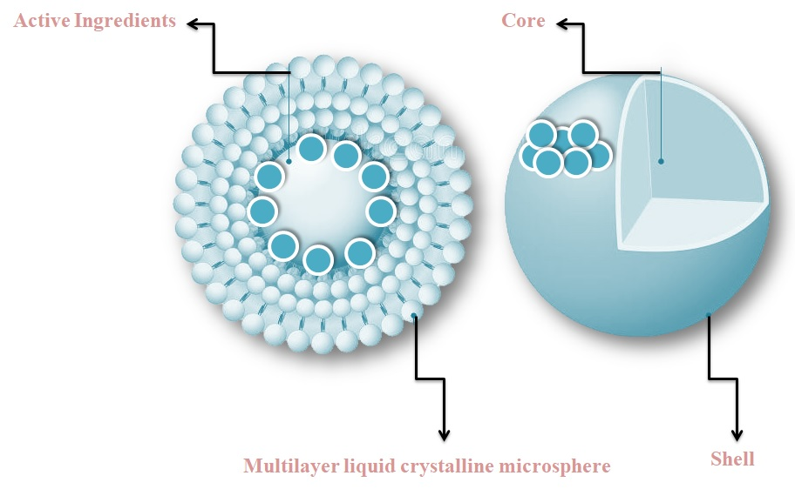
Figure 1: Components of a multiparticulate drug delivery system: Microencapsulation
The terminology used to describe formulations involving microparticles can be inconsistent and potentially confusing for those not well-versed in the field. In essence, the term "microparticle" denotes a particle with a diameter ranging from 1 to 1000 μm, regardless of its specific internal or external structure. Within the broader classification of microparticles, "microspheres" specifically denote spherical microparticles, and the subcategory "microcapsules" pertains to microparticles characterized by a core surrounded by a material distinctly different from that of the core. The core itself may be solid, liquid, or even gaseous (4–6). Despite the clear and rational subcategories, there is a common tendency among researchers to use the terms interchangeably, creating confusion for readers. Typically, when a formulation is labeled as a microsphere, it is understood to consist of a relatively uniform blend of polymer and active agent. In contrast, microcapsules are assumed to have at least one distinct region containing the active agent and, in some cases, more than one. Figure 1 illustrates some variations in microparticle structures. As the active agent domains and subdomains within microcapsules decrease in size, the microcapsules transition into microparticles (7–9). The term "microcapsule" is defined as a spherical particle ranging in size from 50 nm to 2 mm that contains a core substance. Microspheres, strictly speaking, are spherical particles that are empty. However, these terms, microcapsules and microspheres, are frequently used interchangeably. Additionally, some related terms are used alternately; for instance, "microbeads" and "beads" are interchangeable. The terms "sphere" and "spherical particles" are also employed, especially when referring to larger sizes and rigid morphologies. Given the appealing properties and extensive applications of microcapsules and microspheres, it is fitting to examine their applications in formulations for controlled drug release (1,6,7).
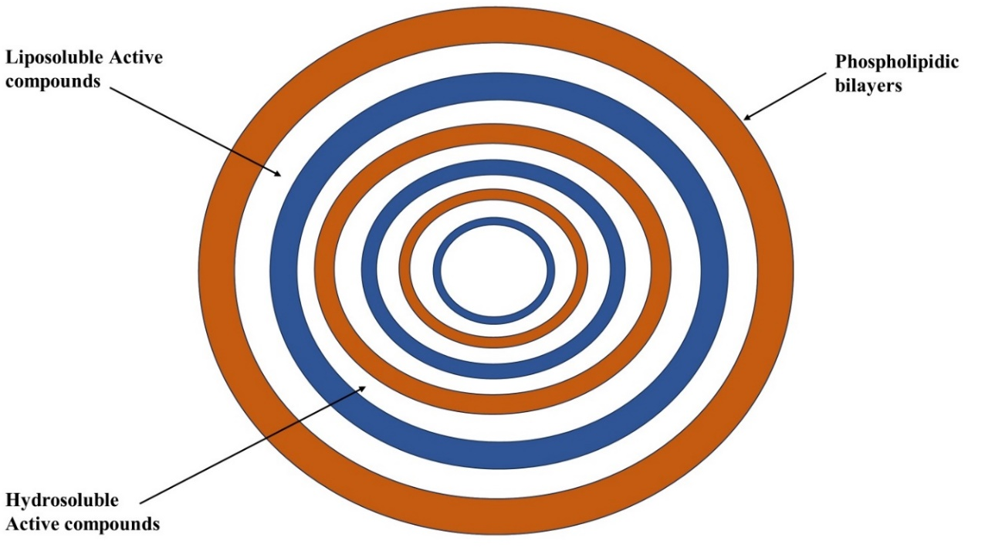
Figure 2: Microencapsulation process
While the term "capsule" suggests a structure with a core and shell, the term "microcapsules" encompasses not only particles or droplets enclosed by a membrane but also dispersion within a solid matrix without a distinct external wall phase, as well as intermediate types. Their size range, typically between 2 to 2000 μm, sets them apart from smaller nanoparticles or nanocapsules. Scanning electron microscopy (SEM) has revealed that the structural features of microcapsules are diverse and intricate. The walled prototype can be mononuclear, as depicted in Figure 2a, or may exhibit a multiple-core structure. Additionally, there may be double or multiple concentric coatings. Aggregated microcapsules exhibit significant variations in size and shape, as illustrated in Figure 2b, and may also have an additional external wall. Achieving perfect microcapsules is possible by utilizing liquid cores or forming the microcapsules as a liquid dispersed phase before solidification. While SEM can detect the microstructure of both the membrane and interior on surfaces or sections (Figure 2c), characterizing their physical qualities, including porosity, tortuosity, and crystallinity, is challenging to achieve quantitatively in microcapsules. Nonetheless, some progress has been made, and ongoing efforts aim to calculate permeability and porosity based on release data, dimensions, densities, and core/wall ratios. The influence of size and shape distribution has only recently become a subject of study (8–10).
Microcapsules are ultimately distributed in different forms of medication, including enteric-coated hard gelatin capsules, soft gelatin capsules, or liquid suspensions. These formulations enable the dispersion of individual microcapsules upon release. Microcapsules continue to be a subject of significant interest in controlled release, owing to the relatively straightforward design and formulation processes and the benefits associated with microparticulate delivery systems. These advantages encompass sustained release from each individual microcapsule, providing enhanced uniformity and reproducibility. Compared to monolithic systems with multiple doses, the use of microcapsules offers an additional safety factor in the event of a burst or defective unit in subdivided dosage forms. Lastly, it has been suggested that the distribution of multiple particle systems throughout the gastrointestinal tract can result in (a) decreased local concentrations, leading to reduced toxicity or irritancy, and (b) diminished variability in transit time and absorption rate (11–13).
- Microspheres
Introduction
Oral administration of drugs is widely preferred, yet the short circulating half-life and limited absorption within a specific segment of the intestine impose constraints on the therapeutic potential of many drugs. This pharmacokinetic limitation often necessitates frequent dosing to achieve the desired therapeutic effect [14, 15]. A rational strategy to enhance bioavailability and refine the pharmacokinetic and pharmacodynamic profiles involves releasing the drug in a controlled and site-specific manner. Microspheres, defined as small spherical particles with diameters ranging from 1 μm to 1000 μm, are free-flowing particles composed of biodegradable proteins or synthetic polymers. There are two types of microspheres: microcapsules, wherein the entrapped substance is distinctly surrounded by a capsule wall, and micromatrices, wherein the entrapped substance is dispersed throughout the matrix. Microspheres are sometimes referred to as microparticles [16, 17]. They can be manufactured from various natural and synthetic materials. Microspheres play a crucial role in enhancing the bioavailability of conventional drugs while minimizing side effects. The ideal characteristics of microspheres include [18, 19].
- The capacity to include moderately high concentrations of the drug.
- The stability of the formulation post-synthesis, maintaining a clinically acceptable shelf life.
- Regulated particle size and dispersibility in aqueous solutions for injection.
- The controlled release of the active agent with effective regulation across a broad time range.
- Compatibility with living organisms with manageable biodegradability.
- Vulnerability to chemical alteration.
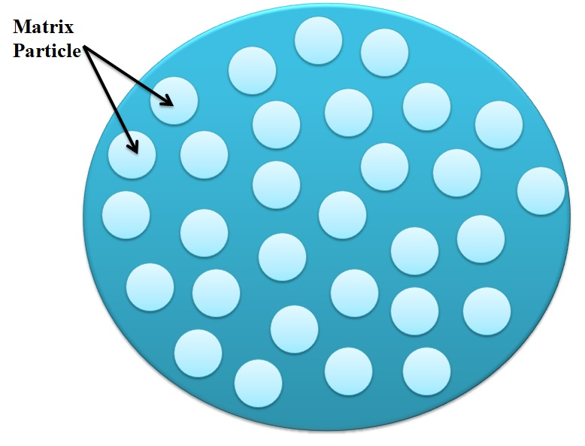
Figure 3: Microsphere
Advantages of microspheres: [19]
- Reduce particle size to enhance the solubility of poorly soluble drugs.
- Provide a consistent and prolonged therapeutic effect.
- Maintain a constant drug concentration in the blood to improve patient compliance.
- Decrease dosage and toxicity.
- Shield the drug from enzymatic and photolytic cleavage, making it particularly suitable for protein drug delivery.
- Reduce dosing frequency, thereby enhancing patient compliance.
- Improved drug utilization to enhance bioavailability and reduce the occurrence or severity of adverse effects.
- Microsphere morphology enables controlled variability in degradation and drug release.
- Transform liquid into a solid form and mask bitter taste.
- Shield the gastrointestinal tract from the irritant effects of the drug.
- Biodegradable microspheres have an advantage over large polymer implants, as they do not necessitate surgical procedures for implantation and removal.
- Controlled-release biodegradable microspheres are utilized to regulate drug release rates, diminishing toxic side effects, and eliminating the inconvenience of frequent injections.
Limitation: Some drawbacks were identified as follows [18]:
- The expenses associated with the materials and processing of controlled release preparations are considerably higher than those for standard formulations.
- The environmental impact of the polymer matrix and its consequences.
- The environmental impact of polymer additives such as plasticizers, stabilizers, antioxidants, and fillers.
- Less consistency in reproducibility.
- Process conditions, such as variations in temperature, pH, solvent addition, and evaporation/agitation, may affect the stability of core particles to be encapsulated.
- The environmental consequences of degradation products from the polymer matrix generated in response to factors like heat, hydrolysis, oxidation, solar radiation, or biological agents.
MATERIALS USED IN THE PREPARATION OF MICROSPHERE: [15, 21]
Typically, microspheres are composed of polymers and can be categorized into two types:
- Natural polymers are sourced from various origins such as carbohydrates and proteins, including chemically modified carbohydrates like agarose, carrageenan, chitosan, starch; proteins like albumin, collagen, and gelatin; and chemically modified carbohydrates such as polydextran and polystarch.
- Synthetic polymers are categorized into two types. Biodegradable polymers include lactides, glycolides, and their copolymers, as well as poly anhydrides and poly alkyl cyanoacrylates. Non-biodegradable polymers encompass poly methyl methacrylate (PMMA), glycidyl methacrylate, acrolein, and epoxy polymers.
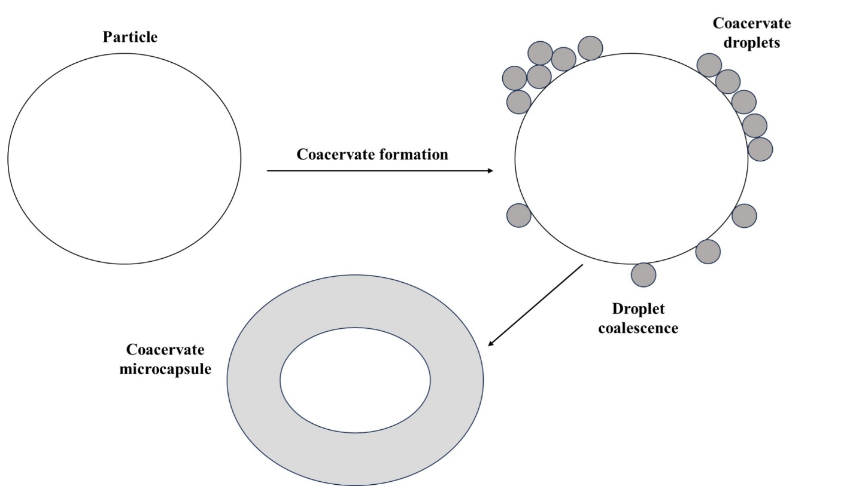
Figure 4: Illustrative depiction of the coacervate formation encircling a core material.
APPLICATION OF MICROSPHERES IN PHARMACEUTICAL INDUSTRY: [20,21,22]
- Ophthalmic Drug Delivery: Microspheres developed with polymers exhibit favorable biological characteristics such as bioadhesion, permeability-enhancing properties, and unique physico-chemical traits, making them suitable for designing ocular drug delivery vehicles. Examples include Chitosan, Alginate, and Gelatin.
- Oral Drug Delivery: Microspheres containing polymers, with the ability to form films, find application in formulating film dosage forms as an alternative to traditional pharmaceutical tablets. The pH sensitivity, along with the reactivity of primary amine groups, makes microspheres well-suited for oral drug delivery applications. Examples include Chitosan and Gelatin.
- Gene Delivery: Microspheres serve as potential oral gene carriers due to their adhesive and transport properties in the gastrointestinal tract. Examples include Chitosan, Gelatin, viral vectors, cationic liposomes, and polycation complexes.
- Nasal Drug Delivery: Polymer-based drug delivery systems, such as microspheres, liposomes, and gels, exhibit favorable bioadhesive characteristics and easy swelling upon contact with nasal mucosa, enhancing drug bioavailability and residence time in the nasal route. Examples include Starch, Dextran, Albumin, and a combination of Chitosan with Gelatin.
- Intratumoral and Local Drug Delivery: Polymer films are fabricated to deliver paclitaxel at the tumor site in therapeutically relevant concentrations. A mixture of drugs shows promise for controlled delivery in the oral cavity. Examples include Gelatin, PLGA, Chitosan, and PCL.
- Buccal Drug Delivery: Polymer, particularly Chitosan and Sodium Alginate, is an excellent choice for buccal delivery due to its muco/bioadhesive properties and its ability to act as an absorption enhancer.
- Gastrointestinal Drug Delivery: Polymer granules with internal cavities, prepared by deacidification, float in acidic and neutral media, providing controlled drug release. Examples include Eudragit, Ethyl cellulose + carbopol BSA, and Gelatin.
- Transdermal Drug Delivery: Polymers with good film-forming properties, such as Chitosan, Alginate, and PLGA, influence drug release from devices based on membrane thickness and film cross-linking.
- Colonic Drug Delivery: Chitosan is utilized for the specific delivery of insulin to the colon.
- Vaginal Drug Delivery: Polymers modified with the introduction of thioglycolic acid to primary amino groups, such as Chitosan, Gelatin, and PLGA, are widely used for treating mycotic infections of the genitourinary tract.
- Targeting Using Microparticulate Carriers: Pellets prepared with polymers, using extrusion/spheronization technology, serve as microparticulate carriers. Examples include Chitosan and Microcrystalline cellulose.
- Microencapsulation

INTRODUCTION
Microencapsulation represents a burgeoning technology designed to safeguard various food components or functional constituents from diverse processing conditions. This is achieved by encapsulating them within a polymeric or non-polymeric material, enabling controlled release under specific conditions. Moreover, this technology improves sensory attributes by concealing unpleasant tastes, aromas, and flavors. Additionally, it contributes to enhanced food safety by impeding the growth of microbes (23,24). Various bioactive compounds, including omega-3 and omega-6 fatty acids, vitamins, phenolic compounds, and carotenoids, are increasingly employed in the development of products with diverse functional properties to meet growing consumer demands. Nevertheless, these compounds are susceptible to instability when exposed to specific conditions such as light, temperature, pH, and oxygen. Consequently, microencapsulation serves as a method to shield these compounds from harsh conditions during food processing. Numerous encapsulated food constituents encompass flavoring agents, lipids, antioxidants, essential oils, pigments, probiotic bacteria, and vitamins (25). Various coating materials are chosen based on their rheological characteristics, capacity to disperse and stabilize the active compound, inertness toward the active compound, and their ability to effectively retain the active compound. Examples of coating materials encompass carbohydrates like starch, maltodextrin, modified starch, cyclodextrin, and cellulose; lipids such as wax, paraffin, beeswax, and diacylglycerols; gums like gum acacia, agar, and carrageenan; and proteins such as gluten, casein, and gelatine. Microencapsulation is a technological method employed as a means to safeguard delicate and valuable nutrients (26), by creating a protective barrier, enabling their release at specific locations, times, and conditions. For instance, as previously stated (27), In chewing gums, the encapsulated flavors are only released during chewing. Recently, the food industry has showcased intricate food formulations, such as incorporating specific volatile flavors in instant mixes and fatty acids in dairy products, which are particularly susceptible to auto-oxidation. In these cases, microencapsulation can provide a solution (28, 29). Numerous methods for microencapsulation exist, encompassing techniques like spray chilling, spray cooling, fluidized bed coating, liposome entrapment, extrusion, freeze drying, and coacervation.Based on the physical and chemical attributes of the core, the composition of the shell material, and the microencapsulation method applied, various types of capsules are produced. These include simple spheres encased in wall material, capsules with irregular cores, multiple distinct cores enveloped by a continuous coating of wall material, multiwalled microcapsules, and core particles embedded within the wall material matrix. The choice of coating material influences the techniques employed to generate microcapsules, leading to variations in capsule properties such as size, morphology, porosity, hygroscopicity, hydrophobicity, surface tension, and thermal behavior. Understanding these capsule properties is crucial for comprehending their behavior in any food system. These properties are closely linked to the controlled release of the encapsulated core, a critical aspect for the effectiveness of the microencapsulation process and its diverse applications. Key factors influencing core release include the nature of the core material, the core-to-encapsulant ratio, the characteristics of the encapsulant, and the interaction between the two. This review provides a critical analysis of essential microencapsulation concepts, encompassing the necessity of microencapsulation in food, the properties of coating materials, and the types of core materials they can be applied to. Additionally, it explores various microencapsulation techniques, delves into microcapsule properties such as physical, mechanical, thermal, and functional aspects, and elucidates different core release mechanisms. The review underscores the significance of microencapsulation technology in the realm of food industries.
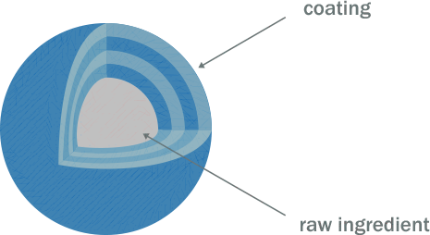
Figure 5: Microencapsulation
Advantages of Microencapsulation:
- Controlled Release: Microencapsulation enables the gradual and regulated release of the encapsulated substance, offering significant advantages in pharmaceuticals, especially for sustained drug delivery.
- Protection of Active Ingredients: It creates a protective shield around the core material, safeguarding it from external elements like light, oxygen, and moisture. This preservation mechanism aids in sustaining the stability and effectiveness of the encapsulated substance.
- Taste and Odor Masking: Microencapsulation finds application in concealing the taste or smell of specific substances, enhancing their palatability or acceptability in various products such as medications or nutritional supplements.
- Improved Stability: The encapsulation procedure can improve the stability of delicate or reactive materials, prolonging their shelf life and maintaining their overall quality.
- Targeted Delivery: Microencapsulation facilitates precise delivery of the encapsulated material to specific locations within the body, offering notable advantages, particularly in drug delivery systems.
- Ease of Handling: Handling and integrating microencapsulated materials into diverse formulations is typically more convenient, rendering them user-friendly across various industries.
Disadvantages of Microencapsulation:
- Cost: Engaging in the microencapsulation process can be financially demanding, involving specialized equipment and materials. This expense might restrict its widespread adoption, particularly in industries with financial constraints.
- Complexity Challenge: The microencapsulation process can be intricate, necessitating a comprehensive understanding of the involved materials and encapsulation techniques. This intricacy may present hurdles in large-scale production.
- Risk of Capsule Breakage: There exists a potential for capsule breakage during processing or handling, resulting in the premature release of the encapsulated material. This could adversely affect the overall efficacy of microencapsulation.
- Loading Capacity Limitation: Microcapsules may have a restricted capacity for loading certain materials, posing a limitation when attempting to encapsulate high concentrations of active ingredients.
- Uniformity Concerns: Attaining uniformity in the size and distribution of microcapsules can be challenging, and deviations in these parameters may impact the performance of the encapsulated material.
- Environmental Considerations: The materials utilized in microencapsulation, particularly the coatings, may raise environmental apprehensions. Some coating materials may not readily biodegrade, leading to potential environmental consequences.
TECHNIQUES TO MANUFACTURE MICROCAPSULES
1. Physical methods
1.1 Air-suspension coating involves coating particles with solutions or melts in a controlled and flexible manner. The particles are suspended in an upward-moving air stream, supported by a perforated plate with varying hole patterns inside and outside a cylindrical insert. Just enough air is allowed to rise through the outer annular space to fluidize the settling particles. The majority of the rising air, often heated, flows inside the cylinder, causing the particles to ascend rapidly. At the top, as the air stream diverges and slows, the particles settle back onto the outer bed, moving downward to repeat the cycle. This process allows particles to pass through the inner cylinder multiple times within a few minutes. The air suspension technique provides a diverse range of coating material options for microencapsulation. The process can apply coatings in the form of solvent solutions, aqueous solutions, emulsions, dispersions, or hot melts, with equipment capacities ranging from one pound to 990 pounds. While air suspension techniques are effective for encapsulating core materials composed of micron or submicron particles, it typically leads to particle agglomeration, resulting in a larger size [4].
1.2 Pan coating
The pan coating process, a long-standing method widely utilized in the pharmaceutical industry, is among the earliest industrial techniques for producing small, coated particles or tablets. During this process, particles are rotated or tumbled in a pan or similar device while the coating material is gradually applied. In the context of microencapsulation, it is generally deemed crucial for solid particles to be larger than 600 microns to ensure effective coating. This method has found extensive application in the preparation of controlled-release beads. Medications are typically coated onto various spherical substrates, such as nonpareil sugar seeds, followed by protective layers of different polymers. In practical terms, the coating is administered as a solution or as an atomized spray onto the desired solid core material in the coating pans. Typically, warm air is circulated over the coated materials during the application in the coating pans to eliminate the coating solvent. In some instances, the final removal of the solvent is achieved in a drying oven [2]. Airflow plays a crucial role in the drying process, influencing the evaporation rates and product temperatures within the dryer. This interaction occurs in three distinct modes:
1.3 Co-current: In this drying configuration, both the drying air and particles travel through the drying chamber in parallel, moving in the same direction. Upon discharge from the dryer, the product temperatures are lower than the exhaust air temperature. This mode is particularly suitable for drying heat-sensitive products. When utilizing a rotary atomizer, the air disperser generates significant air rotation, ensuring consistent temperatures across the drying chamber. However, in tower or FILTERMAT®-type spray dryers employing nozzle atomizers, an alternative non-rotating airflow is often employed with equal effectiveness.
1.4 In the counter-current drying configuration, both the drying air and particles traverse the drying chamber in opposing directions. This mode is well-suited for products that necessitate a certain level of heat treatment during the drying process. Typically, the temperature of the powder upon exiting the dryer is higher than the exhaust air temperature.
1.5 In the mixed-flow drying configuration, particle movement through the drying chamber involves a combination of both co-current and counter-current phases. This mode is appropriate for heat-stable products with coarse powder specifications, requiring the use of nozzle atomizers that spray upward into an incoming airflow. It is also suitable for heat-sensitive products, where the atomizer sprays droplets downward towards an integrated fluid bed, and the air inlet and outlet are positioned at the top of the drying chamber. An example of this application can be observed in the study on the microencapsulation of lycopene through spray drying [8].
2. Chemical process
2.1 Solvent Evaporation
This method has been employed by companies such as the NCR Company, Gavaert Photo - Production NV, and Fuji Photo Film Co., Ltd. to manufacture microcapsules. The processes take place in a liquid manufacturing medium. The microcapsule coating is dissolved in a volatile solvent that is immiscible with the liquid manufacturing medium phase. The core material intended for microencapsulation is dissolved or dispersed in the coating polymer solution. Through agitation, the mixture of core and coating material is dispersed in the liquid manufacturing medium phase to achieve the desired microcapsule size. The mixture is then heated, if necessary, to eliminate the solvent for the polymer. If the core material is dispersed in the polymer solution, the polymer contracts around the core. If the core material is dissolved in the coating polymer solution, a matrix-type microcapsule is formed. Once all the polymer solvent is evaporated, the temperature of the liquid medium is reduced to ambient temperature, if required, while agitation continues. At this stage, the microcapsules can be utilized in suspension form, coated onto substrates, or isolated as powders. The solvent evaporation technique for microcapsule production is versatile and applicable to a wide range of liquid and solid core materials, whether water-soluble or water-insoluble. Various film-forming polymers can be employed as coatings, as illustrated in the study titled "Evaluation of Sucrose Esters as Alternative Surfactants in Microencapsulation of Proteins by the Solvent Evaporation Method [9].
2.2. Polymerization
- Interfacial Polymerization: In interfacial polymerization, two reactants involved in a polycondensation reaction come together at an interface and react rapidly. This method is based on the classical Schotten Baumann reaction, where an acid chloride reacts with a compound containing an active hydrogen atom, such as an amine or alcohol, resulting in the formation of polyesters, polyurea, or polyurethane. Under appropriate conditions, thin and flexible walls are quickly formed at the interface. The process involves emulsifying a solution of the pesticide and a diacid chloride in water, followed by the addition of an aqueous solution containing an amine and a polyfunctional isocyanate. A base is present to neutralize the acid produced during the reaction, leading to the instantaneous formation of condensed polymer walls at the interface of the emulsion droplets.
- In-situ Polymerization: In some microencapsulation processes, direct polymerization of a single monomer occurs on the particle surface. For instance, cellulose fibers are encapsulated in polyethylene while immersed in dry toluene. Typical deposition rates are around 0.5 µm/min, and the coating thickness ranges from 0.2 to 75 µm. The coating is uniform, even over sharp projections.
- Matrix Polymer: In several processes, a core material is embedded in a polymeric matrix during the formation of the particles. One simple method is spray-drying, where the particle is formed by the evaporation of the solvent from the matrix material. Solidification of the matrix can also result from a chemical change. An example of this is demonstrated by Chang, who prepares microcapsules containing protein solutions by incorporating the protein in the aqueous diamine phase. This method has shown permselectivity, as evidenced by the ability to convert blood urea to ammonia, with the enzyme remaining within the microcapsules when incorporated into an extracorporeal shunt system. Many research groups are employing polymerization techniques for microencapsulation, including the National Lead Corporation and Eurand America. [4].
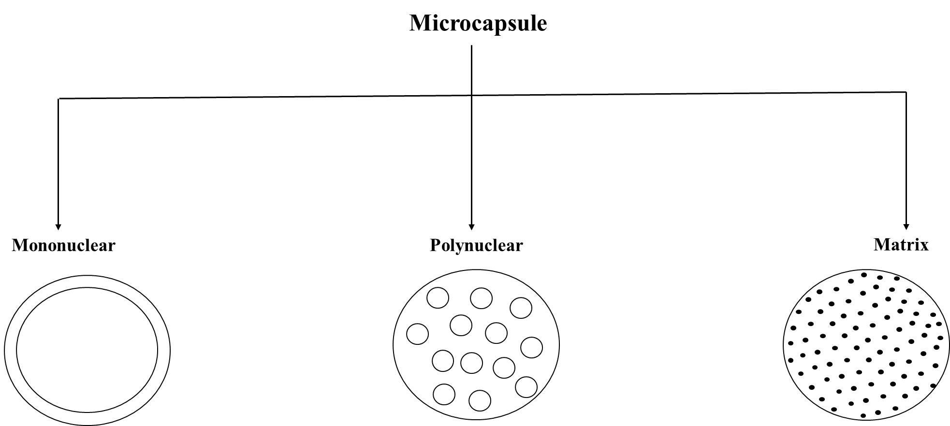
Figure 6: Types of microcapsules

APPLICATION [10-11]
- Immobilization of Cells: Utilized in plant cell cultures and the creation of bio-artificial organs from human tissue, especially in continuous fermentation processes.
- Manufacturing of Beverages
- Safeguarding Molecules from Interactions with Other Compounds
- Delivery of Pharmaceuticals: Employed in controlled-release delivery systems for drugs.
- Ensuring Quality and Safety in the Food, Agricultural, and Environmental Sectors
- Soil Inoculation
- Application in Textiles: Serving as a method to provide finishes.
- Safeguarding Liquid Crystals.
- Microparticles

INTRODUCTION
The utilization of technologies at micro- and nanoscales for the creation of innovative therapeutic options has significantly expanded in the pharmaceutical sector. Within these size scales, polymeric systems designed for controlled drug release can be formulated [37,38]. These systems exhibit structural distinctions based on their size, with microscale referring to particle diameters ranging from 1 to 1000 µm [39] and nanoscale ranging from 1 to 100 nm [40]. Apart from size differences, micro- and nanoparticles also vary in various properties such as crystallization, solubility, melting point, vitreous transition temperature, dissolution, etc., enabling their application in diverse contexts [41].

Figure 7: Illustration depicting the structure of polymeric microparticles produced through both single- and double-emulsion methods, along with the internal dispersion of drugs possessing diverse physicochemical characteristics.
Some advantages of microparticles compared to nanoparticles include their inability to cross the interstitium when transported by the lymph, resulting in a more potent local effect when their size exceeds 100 nm [39]. Additionally, microparticles exhibit a better retention profile in the skin [42]. Another advantage is observed in the pulmonary administration route, where particles with a diameter below 10 µm can reach the pulmonary alveolar region with high tissue permeability and gas exchange. Moreover, particles smaller than 20 µm, upon entering the bloodstream, can be phagocytosed by macrophages [43]. It's worth noting that due to anatomical differences, findings in animal models may not perfectly reflect human responses to these particles [44]
Advantages of Microparticles
Microcarriers offer an advantage over nanoparticles as they do not cross the interstitium at sizes exceeding 100 nm, allowing them to be transported by lymph and exert a local effect [45]. Additionally, toxic substances can be encapsulated in solid form within microcarriers, enhancing their stability and safety. Encapsulating drugs with polymers provides protection against enzymatic cleavage, especially in compatible drug delivery systems.
    - Administration of larger drug quantities can enhance patient performance.
    - Reduction in dose and associated risks.
    - Improved drug utilization can enhance bioavailability and decrease the occurrence or intensity of side effects.
    - Aids in shielding the gastrointestinal tract from opioid stimuli.
    - Shortening the dosing duration leads to higher patient survival rates.
    - Size reduction contributes to increased surface area and can enhance the solubility of challenging-to-dissolve materials.
    - Transformation of liquids into solids helps mask unpleasant tastes [46].
Disadvantages of Microparticles
The release rate of the controlled dose may vary based on factors like food intake and the extent of intestinal absorption. Fluctuations in flow rates can occur between different doses. As the release-administration formulation involves higher doses, any issues in drug release could pose challenges.
- This form of medication has the potential to be hazardous
- It should not be crushed or chewed [47].
Preparation of microparticles
Suspended microparticles containing active drugs were prepared by the emulsion solvent In the evaporation method, 1g of the drug was dispersed in a 10% w/v solution of cellulose acetate phthalate in a solvent mixture of acetone and ethanol (8:2). The resulting solution was stirred at 1000 rpm to ensure the dissolution of the mixture, and it was then slowly passed through a 250 ml beaker containing 100 ml of liquid paraffin at a constant rate. The system was stirred at room temperature for 4 hours to allow the solvent to evaporate, resulting in the formation of microparticles of Metronidazole. The prepared microparticles were collected by filtration, washed with cyclohexane to remove any residual liquid paraffin, and dried at room temperature. The dried microparticles were filtered, stored in a closed container, and the process was conducted following references [48, 49]
Types of microparticles
Magnetic microparticles
Magnetic microparticles are employed to target the delivery of the drug to the specific site affected by the disease. These microparticles, composed of polymers such as chitosan and dextran, exhibit a magnetic response, as depicted in Figure 2. The magnetic carrier harnesses the integrated material's magnetic properties and conveys it in response to a magnetic field. This innovative approach enables the substitution of substantial quantities of freely dispersed drugs with smaller amounts of drugs that are magnetically directed, offering enhanced precision in drug delivery [50,51].
Polymeric Microparticles
The polymer microparticles shown in Figure 3 are classified as follows:
Microparticles made from synthetic polymers have demonstrated safety and biocompatibility in various medical applications, including embolic particles, bulk agents, and drug carriers. However, a notable drawback associated with these microparticles is their tendency to migrate from the injection site, leading to heightened risks of embolism and tissue damage [52].
- Biodegradable Polymers: Biodegradable polymers like starch exhibit biodegradability, biocompatibility, and bioadhesiveness. These polymers, with a significant swelling capacity in aqueous environments, contribute to prolonged shelf life upon contact with mucosal surfaces and induce gel formation. The concentration of the polymer and the drug release profile can be modified to control the amount and rate of drug release. However, a challenge arises in loading drugs into biodegradable microparticles, posing difficulties in medical applications and affecting drug release efficiency [53].
- Bioadhesive micro particles possess the capability to adhere to a membrane by binding to a water-soluble polymer, known as adhesiveness. When the drug carrier adheres to mucous membranes like nasal, rectal, axillary, or buccal mucosa, it is termed bioadhesion. Illustrated in Figure 4, these microparticles exhibit prolonged residence at the application site, establishing close contact with the absorption site and enhancing pharmacological effectiveness [54, 55, 56].
- Floating micro particles, depicted in Figure 5, exhibit buoyancy in the stomach due to their lower density compared to gastric fluid. As the entire system moves along with the stomach contents, the gradual release of the drug occurs, contributing to enhanced gastric emptying and alterations in plasma concentration. This approach prolongs the therapeutic effect and diminishes the necessary dosage. In successive gastric emptying cycles, the absorbed particles disperse over a broader absorption area, elevating the probability of drug absorption and influencing the diffusion profile. Additionally, the division of each dose into multiple components minimizes the risk of dose slippage [57-59].
- Radiofrequency immobilization (RFI) is a therapeutic approach utilizing radio waves to immobilize patients. Microparticles ranging in diameter from 10 to 30 nm, upon reaching the capillary, interact with the capillary bed. The tumor receives an injection through an artery that provides oxygen and nutrients. In these instances, the radioactive microparticles illustrated in Figure 4 precisely administer targeted radiation doses to specific areas, avoiding harm to adjacent healthy tissue. Various types of radioactive microparticles are categorized as α emitters, β emitters, and γ emitters [60, 61].
Applications of microparticles
The delivery of vaccine microparticles is crucial to safeguard vaccines from bacteria or harmful agents. An ideal vaccine should possess qualities such as safety, user-friendliness, effectiveness, and affordability. Achieving a balance between safety and minimizing adverse reactions is challenging. The treatment strategy is closely tied to the induced antibody response and safety considerations. Biodegradable vaccine systems designed for parenteral immunization aim to address the drawbacks associated with conventional vaccines [62].
- Gene delivery through microparticles involves the use of viral vectors, nonionic liposomes, polycation complexes, and microcapsules to transport genetic drugs. Viral vectors are highly efficient for gene delivery due to their ability to target a diverse range of cells. However, their in vivo use can lead to immunological responses and adverse effects. To overcome these limitations, non-viral delivery methods for gene therapy have been explored. Non-viral approaches offer advantages such as easy preparation, cell/tissue targeting, immunosuppression, accommodation of unlimited plasmid size, and reproducible large-scale production. Polymers are employed as carriers for DNA in gene delivery applications [63-66].
- Targeted distribution, also referred to as targeted drug delivery, is an emerging concept that focuses on the precision of drug therapy. The success of drug treatment relies on the drug's capacity to reach and engage with specific target receptors. Utilizing transporter systems enhances drug activity by ensuring an efficient, reliable, and specific delivery to the intended target [67].
- Monoclonal antibodies designed to target microparticles are termed immune microparticles, employing a strategy aimed at specific site targeting. Monoclonal antibodies, despite their limited utility, play a crucial role in this approach. Bioactive substances encapsulated within microparticles can be precisely directed to specific locations using highly specific monoclonal antibodies (MAbs). MAbs can form a direct covalent attachment to microparticles, binding to amines, free aldehydes, or hydroxyl groups on the microparticle surface. The attachment of antibodies to microparticles can be achieved through various methods, including non-specific and non-selective adsorption, live coupling, and reagent coupling [67].
- Microparticles stand out as a highly promising avenue for delivering anticancer drugs. Their utilization is imperative in light of heightened vascular permeability and endocytic activity. Rendering soluble polyoxymethylene microparticles invisible is achieved through coating, and these microparticles, once secreted, accumulate in the Reticuloendothelial System (RES), presenting an alternative approach for cancer treatment [68, 69].
Microencapsulated pharmaceutical products available in the market encompass a range including progesterone, theophylline, aspirin and its derivatives, antihypertensive drugs, and potassium chloride for gastric issues. The use of microencapsulated potassium chloride is particularly employed to mitigate intestinal problems linked to its consumption. The microcapsule encapsulation and controlled ion release play a crucial role in reducing the risk of elevated saline concentrations, which can lead to complications such as perforation, ulceration, and bleeding. Furthermore, there have been proposals for injection and inhalation therapies incorporating microparticles. Despite the substantial research in this field, the number of commercially available products doesn't fully reflect the potential benefits of this technology. Cost considerations significantly influence the prevalence of microencapsulated drug products. While some processes, such as spray or drum coatings and spray dryers, are more accessible due to existing equipment, many microencapsulation methods are safeguarded by patents, adding complexity and value to the field [63].

CONCLUSION
In summary, the field of microencapsulation presents a promising avenue for advancing drug delivery systems, leveraging the encapsulation of substances within microspheres, microcapsules, or microparticles. Its advantages, including enhanced stability and prolonged release, offer solutions to conventional drug delivery challenges. While acknowledging complexities in formulation and potential drawbacks, a nuanced comprehension is essential for optimization. A comprehensive exploration of microencapsulation techniques, spanning from spray drying to coacervation, underscores the diverse methods crucial for tailoring drug formulations. This understanding is pivotal for researchers aiming to unlock the full potential of microencapsulation. The broad spectrum of microencapsulation applications, ranging from controlled drug delivery to taste masking, showcases its versatility in shaping drug development. Looking forward, anticipated advancements in targeted medicine, combination therapies, and smart materials present exciting prospects for more precise pharmaceutical interventions. The continuous refinement of microencapsulation techniques, coupled with emerging technologies, holds the promise of revolutionizing drug delivery. In essence, this study not only clarifies current definitions, benefits, drawbacks, methods, and applications but also lays the foundation for future innovations. By addressing challenges and optimizing methodologies, microencapsulation emerges as a cornerstone in the ongoing evolution of pharmaceutical science. Researchers and professionals are well-positioned to leverage these insights for enhanced therapeutic outcomes.

FUTURE SCOPE
- Targeted and Personalized Medicine:
    - Advancements in microencapsulation techniques to enable precise and targeted drug delivery, addressing individual patient characteristics and requirements.
    - Integration of personalized medicine principles to customize microsphere, microcapsule, and microparticle formulations for specific patient groups.
- Combination Therapies and Multi-Drug Delivery:
    - Continued exploration of microencapsulation for delivering combination therapies, allowing the simultaneous release of multiple drugs or therapeutic agents.
    - Development of sophisticated multi-drug delivery systems within a single microencapsulated platform for synergistic therapeutic effects.
- Incorporation of Smart Materials:
    - Integration of smart or responsive materials in microencapsulation for on-demand drug release triggered by specific physiological conditions.
    - Development of intelligent microcarriers capable of responding to disease markers or environmental stimuli for optimized therapeutic outcomes.
- Enhanced Bioavailability and Stability:
    - Ongoing efforts to enhance the bioavailability of poorly soluble drugs through advanced microencapsulation methods.
    - Research into novel materials and techniques to improve the stability of microencapsulated pharmaceuticals, ensuring efficacy throughout their shelf life.
- Biological and Biotechnological Applications:
    - Expansion of microencapsulation beyond traditional pharmaceuticals to include biological molecules, peptides, and proteins.
    - Application of microencapsulation in biotechnological processes, such as cell encapsulation for cell therapy and tissue engineering.
- 3D Printing and Microencapsulation Integration:
    - Further integration of 3D printing technologies with microencapsulation for creating complex, patient-specific drug delivery systems.
    - Advancements in 3D printing techniques to precisely control the architecture and composition of microencapsulated structures.
- Improved Analytical Techniques:
    - Continued development of high-resolution analytical techniques for characterizing microspheres, microcapsules, and microparticles.
    - Integration of advanced imaging, spectroscopy, and monitoring methods for real-time assessment of microencapsulated formulations.
- Environmental Sustainability:
    - Growing emphasis on environmentally sustainable microencapsulation materials and processes.
    - Exploration of green and biodegradable polymers to reduce the environmental impact of microencapsulated pharmaceuticals.
- Digitalization in Drug Development:
    - Integration of digital technologies and artificial intelligence in designing and optimizing microencapsulated drug formulations.
    - Use of computational modeling and simulation for rapid prototyping and predicting microencapsulation outcomes.
- Regulatory Framework Development:
    - Establishment of more comprehensive and tailored regulatory guidelines for approving microencapsulated pharmaceuticals.
    - Collaboration between researchers, industry, and regulatory bodies to address challenges and ensure the safe and efficient use of microencapsulation in drug development.

The upcoming developments in microencapsulation within the field of pharmaceutical science are anticipated to bring about groundbreaking solutions to current challenges, paving the way for the creation of innovative drug delivery systems. The active involvement of researchers and industry experts is expected to be instrumental in pushing the limits of microencapsulation technology, leading to progress in patient care and therapeutic interventions.

References

- Birnbaum, D. T., & Brannon-Peppas, L. (2004). Microparticle drug delivery systems. In Drug delivery systems in cancer therapy (pp. 117-135). Totowa, NJ: Humana Press.
- Singh, M. N., Hemant, K. S. Y., Ram, M., & Shivakumar, H. G. (2010). Microencapsulation: A promising technique for controlled drug delivery. Research in pharmaceutical sciences, 5(2), 65.
- Benita, S., & Donbrow, M. (1982). Effect of polyisobutylene on ethylcellulose-walled microcapsules: wall structure and thickness of salicylamide and theophylline microcapsules. Journal of pharmaceutical sciences, 71(2), 205-210.
- Berkland, C., Kipper, M. J., Narasimhan, B., Kim, K. K., & Pack, D. W. (2004). Microsphere size, precipitation kinetics and drug distribution control drug release from biodegradable polyanhydride microspheres. Journal of Controlled Release, 94(1), 129-141.
- Brazel, C. S., & Peppas, N. A. (2000). Modeling of drug release from swellable polymers. European journal of pharmaceutics and biopharmaceutics, 49(1), 47-58.
- Chemtob, C., Chaumeil, J. C., & N'Dongo, M. (1986). Tablets of metronidazole microcapsules: release characteristics. International journal of pharmaceutics, 29(1), 83-92.
- Chien, Y. W. (1992). Novel drug delivery systems. Drugs and the pharmaceutical sciences, 50.
- Connick, J. R., Walker, W. R., & Goynes Jr, W. R. (1983). Sustained release of mycoherbicides from granular formulations. 10th Int. In Symp. Controlled Release Bioactive Materials. San Francisco (Vol. 283).
- Costa, P., & Lobo, J. M. S. (2001). Modeling and comparison of dissolution profiles. European journal of pharmaceutical sciences, 13(2), 123-133.
- Davis, S. S., Hardy, J. G., Taylor, M. J., Whalley, D. R., & Wilson, C. G. (1984). A comparative study of the gastrointestinal transit of a pellet and tablet formulation. International journal of pharmaceutics, 21(2), 167-177.
- Deasy, P. B. (1984). Microencapsulation and related drug processes. Drugs and the pharmaceutical sciences, 20.
- Donbrow, M. (1987). Recent advances in microcapsule delivery systems. Topics in pharmaceutical sciences. Amsterdam: Elsevier Science, 33-45.
- Fravel, D. R., Marois, J. J., Lumsden, R. D., & Connick Jr, W. J. (1985). Encapsulation of potential biocontrol agents in an alginate-clay matrix. Phytopathology, 75(7), 774-777.
- Patel, N. R., Patel, D. A., Bharadia, P. D., Pandya, V., & Modi, D. (2011). Microsphere as a novel drug delivery. International Journal of Pharmacy & Life Sciences, 2(8).
- Singh, C., Purohit, S., Singh, M., & Pandey, B. L. (2013). Design and evaluation of microspheres: A Review. Journal of drug delivery research, 2(2), 18-27.
- Thota, S., Kusuma, B., Rarevati, M., Narendra, P., & Babu, S. M. (2021). Formulation and Evaluation of ethyl cellulose microspheres containing diclofenac sodium. International Journal of Research in Pharmaceutical Sciences and Technology, 2(4).
- Rina Parveen, H., Siva, P., & Reshma Fathima, K. (2017). Indian Journal of Pharmaceutical Science & Research. Indian Journal of Pharmaceutical Science & Research, 7(2), 54-59.
- Yogaraj, R., Kulkarni, G. S., Krishnababu, K., & Paarakh, P. M. (2023). Microspheres in Pharmaceutical Science. Journal of Multidisciplinary Cases (JMC) ISSN 2799-0990, 3(02), 1-9.
- Sahil, K., Akanksha, M., Premjeet, S., Bilandi, A., & Kapoor, B. (2011). Microsphere: A review. Int. J. Res. Pharm. Chem, 1(4), 1184-98.
- Kumar, B. P., Chandiran, I. S., Bhavya, B., & Sindhuri, M. (2011). Indian Journal of Pharmaceutical Science & Research. Indian Journal of Pharmaceutical Science & Research, 1(1), 19-37.
- Mali, D. S., Talele, S. G., Mogal, R., & Chaudhari, G. (2014). Review on nasal microspheres. Am. J. Pharm Tech Res, 4(1), 97-111.
- Hasanvand, E., Fathi, M., Bassiri, A., Javanmard, M., & Abbaszadeh, R. (2015). Novel starch based nanocarrier for vitamin D fortification of milk: Production and characterization. Food and Bioproducts Processing, 96, 264-277.
- Sengupta, A., Nielsen, K. E., Barinshteyn, G., & Li, K. (2001). U.S. Patent No. 6,248,364. Washington, DC: U.S. Patent and Trademark Office.
- Azeredo, H. M. C. (2005). Encapsulation: Applications to food technology. Alimentos e Nutrição, 16, 89-97.
- Meyer, A. S., Heinonen, M., & Frankel, E. N. (1998). Antioxidant interactions of catechin, cyanidin, caffeic acid, quercetin, and ellagic acid on human LDL oxidation. Food Chemistry, 61(1-2), 71-75.
- Kaushik, P., & Kaushik, D. (2019). Medicated chewing gums: Recent patents and patented technology platforms. Recent patents on drug delivery & formulation, 13(3), 184-191.
- Gharsallaoui, A., Saurel, R., Chambin, O., & Voilley, A. (2012). Pea (Pisum sativum, L.) protein isolate stabilized emulsions: a novel system for microencapsulation of lipophilic ingredients by spray drying. Food and Bioprocess Technology, 5, 2211-2221.
- Khan, S. A., Ahmad, M., Kousar, R., & Murtaza, G. (2011). Nimesulide-Serratiopeptidase Sustained Release Microparticles–Combined Formulation and In Vitro Characterization. Advances in Clinical and Experimental Medicine, 20(5), 605-611.
- Roberts, D. D., & Taylor, A. J. (2000). Flavor release: A rationale for its study.
- Jackson, L. S., & Lee, K. (1991). Microencapsulation and the food industry. Lebensm. Wiss. Technol, 24(4), 289-297.
- Lachman, L., Lieberman, H. A., & Kanig, J. L. (1976). The theory and practice of industrial pharmacy (pp. 210-212). Philadelphia: Lea & Febiger.
- http://www.niroinc.com
- Youan, B. C., Hussain, A., Nguyen, N.T., “AAPS Pharma Sci.”, 2003, 5(2).
- Garg, A., Chhipa, K., & Kumar, L. (2018). Microencapsulation techniques in pharmaceutical formulation. European Journal of Pharmaceutical and Medical Research, 5(3), 199-206.
- Tarai, M., Verma, M., & Saini, N. (2023). Microencapsulation in Textile Industry.
- Alexander, A., Patel, R. J., Saraf, S., & Saraf, S. (2016). Recent expansion of pharmaceutical nanotechnologies and targeting strategies in the field of phytopharmaceuticals for the delivery of herbal extracts and bioactives. Journal of controlled release, 241, 110-124.
- Frent, O. D., Vicas, L. G., Duteanu, N., Morgovan, C. M., Jurca, T., Pallag, A., ... & Marian, E. (2022). Sodium alginate—Natural microencapsulation material of polymeric microparticles. International Journal of Molecular Sciences, 23(20), 12108.
- Lengyel, M., Kállai-Szabó, N., Antal, V., Laki, A. J., & Antal, I. (2019). Microparticles, microspheres, and microcapsules for advanced drug delivery. Scientia Pharmaceutica, 87(3), 20.
- Zahin, N., Anwar, R., Tewari, D., Kabir, M. T., Sajid, A., Mathew, B., ... & Abdel-Daim, M. M. (2020). Nanoparticles and its biomedical applications in health and diseases: special focus on drug delivery. Environmental Science and Pollution Research, 27, 19151-19168.
- Otto, D. P., Otto, A., & De Villiers, M. M. (2015). Differences in physicochemical properties to consider in the design, evaluation and choice between microparticles and nanoparticles for drug delivery. Expert opinion on drug delivery, 12(5), 763-777.
- Dwipayanti, K. S., Azhar, M., Rahman, L., Pakki, E., Himawan, A., & Permana, A. D. (2022). Enhanced skin localization of metronidazole using solid lipid microparticles incorporated into polymeric hydrogels for potential improved of rosacea treatment: An ex vivo proof of concept investigation. International Journal of Pharmaceutics, 628, 122327.
- Gokce, E. H., Tanrıverdi, S. T., Eroglu, I., Tsapis, N., Gokce, G., Tekmen, I., ... & Ozer, O. (2017). Wound healing effects of collagen-laminin dermal matrix impregnated with resveratrol loaded hyaluronic acid-DPPC microparticles in diabetic rats. European Journal of Pharmaceutics and Biopharmaceutics, 119, 17-27.
- Fröhlich, E., & Salar-Behzadi, S. (2014). Toxicological assessment of inhaled nanoparticles: role of in vivo, ex vivo, in vitro, and in silico studies. International journal of molecular sciences, 15(3), 4795-4822.
- Wang, B. H., & Hu, L. (2016). TJS Drug Delivery to the Lymphatic System. Drug Delivery Principles and Applications; Wang, B., Longquin Hu, TJS, Eds, 509.
- Boyer, R. F. (1977). Transitions and relaxations. " Encyclopedia of Polymer Science and Technology", 2, 745-839.
- Prasad, B. S., Gupta, V. R., Devanna, N., & Jayasurya, K. (2014). Microspheres as drug delivery system-a review. J Glob Trends Pharm Sci, 5(3), 1961-72.
- Lamprecht, A., Torres, H. R., Schäfer, U., & Lehr, C. M. (2000). Biodegradable microparticles as a two-drug controlled release formulation: a potential treatment of inflammatory bowel disease. Journal of Controlled Release, 69(3), 445-454.
- Jameela, S. R., Suma, N., & Jayakrishnan, A. (1997). Protein release from poly (ε-caprolactone) microspheres prepared by melt encapsulation and solvent evaporation techniques: a comparative study. Journal of Biomaterials Science, Polymer Edition, 8(6), 457-466.
- Dutta, P., Sruti, J., Patra, C. N., & Rao, M. B. (2011). Floating Microsphere: Recent Trends in the Development of Gastro Retentive Floating Drug Delivery System. International Journal of Pharmaceutical Sciences and Nanotechnology, 4(1), 1296-1306.
- Mahale, M. M., & Saudagar, R. B. (2019). Microsphere: a review. Journal of drug delivery and therapeutics, 9(3-s), 854-856.
- Trivedi, P., Verma, A. M. L., & Garud, N. (2008). Preparation and characterization of aceclofenac microspheres. Asian Journal of Pharmaceutics (AJP), 2(2).
- Elagamy, H. (2022). Microspheres as a platform for drug delivery. Delta University Scientific Journal, 5(2), 122-126.
- Kumar, A., Mahajan, S., & Bhandari, N. (2017). Microspheres: a review. World J Pharm Pharm Sci, 14(6), 724-40.
- Meghna, K. S., Pillai, K., Giridas, S., Sreelakshmi, C., & Vijayakumar, B. (2017). Microsphere a drug delivery system–a review. International Journal of Novel Trends in Pharmaceutical Sciences, 7(4), 109-118.
- Khamanga, S. M., & Walker, R. B. (2012). In vitro dissolution kinetics of captopril from microspheres manufactured by solvent evaporation. Dissolution technologies, 19(1), 42-51.
- Desai, S., & Bolton, S. (1993). A floating controlled-release drug delivery system: in vitro-in vivo evaluation. Pharmaceutical research, 10, 1321-1325.
- Cameroni, R. (1998). Air compartment multiple-unit system for prolonged gastric residence. Part I. Formulation study. International Journal of Pharmaceutics, 1(174), 47-54.
- Shaji, J., & Shinde, A. (2012). Design and in vitro characterization of floating pulsatile microspheres of aceclofenac for rheumatoid arthritis. Int J Pharm Pharm Sci, 4, 374-9.
- Todea, M., Frentiu, B., Turcu, R. F. V., Berce, P., & Simon, S. (2012). Surface structure changes on aluminosilicate microspheres at the interface with simulated body fluid. Corrosion science, 54, 299-306.
- Vyas, S. P., & Khar, R. K. (2004). Targeted & controlled drug delivery: novel carrier systems. CBS publishers & distributors.
- Kawashima, Y., Niwa, T., Takeuchi, H., Hino, T., Itoh, Y., & Furuyama, S. (1991). Characterization of polymorphs of tranilast anhydrate and tranilast monohydrate when crystallized by two solvent change spherical crystallization techniques. Journal of pharmaceutical sciences, 80(5), 472-478.
- Katekar, V. A., Kothari, P. P., Nahar, A. A., Salve, P. A., Shendurkar, H. H., & Adhau, S. A. (2023). A review on recent advantages and evaluation of microparticles and their applications. GSC Biological and Pharmaceutical Sciences, 24(2), 297-307.
- Raj, H., Sharma, S., Sharma, A., Verma, K. K., & Chaudhary, A. (2021). A novel drug delivery system: Review on microspheres. Journal of Drug Delivery and Therapeutics, 11(2-S), 156-161.
- Hossain, K. M. Z., Patel, U., & Ahmed, I. (2015). Development of microspheres for biomedical applications: a review. Progress in biomaterials, 4, 1-19.
- Kedzierewicz, F., Thouvenot, P., Lemut, J., Etienne, A., Hoffman, M., & Maincent, P. (1999). Evaluation of peroral silicone dosage forms in humans by gamma-scintigraphy. Journal of controlled release, 58(2), 195-205.
- Nair, R., Reddy, B. H., Kumar, C. A., & Kumar, K. J. (2009). Application of chitosan microspheres as drug carriers: a review. Journal of pharmaceutical sciences and research, 1(2), 1.
- Kreuter, J., Nefzger, M., Liehl, E., & CzokR, V. R. (1983). Microspheres–A Novel Approach in Drug Delivery System. J Pharm sci, 72, 1146.
- Vyas, S. P., & Khar, R. K. (2004). Targeted & controlled drug delivery: novel carrier systems. CBS publishers & distributors.
- Prajapati, S. K., Tripathi, P., Ubaidulla, U., & Anand, V. (2008). Design and development of gliclazide mucoadhesive microcapsules: in vitro and in vivo evaluation. Aaps Pharmscitech, 9, 224-230.

