**Chapter 6 : Reducing Waste in Clinical Settings**

Mr. Mustafa Ngaja, Mr. Khush Jain 2 Shubham Gupta 2

1M.Sc. Research fellow Parul Institute of Paramedical and Health Sciences Parul university.

2Assistant Professor Parul Institute of Paramedical and Health Sciences Parul university.

(Email ID: [ngaja2525@gmail.com](mailto:ngaja2525@gmail.com) )

(Email ID; [Khushjain028@gmail.com](mailto:Khushjain028@gmail.com))

(Email ID: [shubham.gupta19175@paruluniversity.ac.in](mailto:shubham.gupta19175@paruluniversity.ac.in) )

**Abstract**

The healthcare sector generates millions of tonnes of waste annually, making it a substantial contributor to global waste generation. The environment, public health, and healthcare budgets are all adversely affected by this waste. The sources strongly support a multifaceted approach to waste reduction in clinical settings, which includes the adoption of "Lean" methodologies, appropriate segregation, recycling, and waste minimisation. Healthcare facilities can substantially reduce their environmental impact by instituting comprehensive recycling programs, reusing materials whenever feasible, and reducing unnecessary resource consumption. The sources emphasise the importance of staff education and training in attaining the objective of waste reduction, which is a critical aspect. Proper waste segregation at the source is a critical consideration. Additionally, the implementation of "Lean" principles, including process mapping and waste walks, can identify and eradicate inefficient activities, resulting in increased efficiency and cost savings.   
Minimising unused medical supplies, reducing the relaundering of underused linens, and ensuring the proper sorting of pharmaceutical and regulated medical waste are among the specific areas identified for waste reduction in clinical contexts. The sources also underscore the significance of addressing waste generated from specific procedures, such as the use of pre-packaged procedure packages, and promote the use of individual sterilised components instead. Healthcare facilities can reduce their environmental impact, improve operational efficiency, reduce costs, and contribute to a more responsible and sustainable healthcare system by adopting these strategies and cultivating a culture of sustainability.

# **Introduction and background**

The healthcare industry, by its very nature, generates a substantial amount of waste, broadly defined as any substance or object discarded by its holder(1). Within this broad spectrum lies **clinical waste**, a more specific category encompassing all waste generated during the diagnosis, treatment, or immunization of humans and animals(2). This includes waste produced during related research activities, or in the production and testing of biological materials(2). Examples of clinical waste include sharps, such as needles, blades, and scalpels; infectious waste, like blood-soaked bandages and cultures; and pharmaceutical waste, such as expired medications(3–5). The management of this waste, encompassing its proper handling, treatment, and disposal, plays a crucial role in safeguarding public and environmental health.

The **significance** of clinical waste reduction within medical settings cannot be overstated. Firstly, and perhaps most importantly, effective management of clinical waste is vital for protecting the health of patients, healthcare workers, and the general public. This is achieved by minimizing the risks associated with exposure to potentially hazardous materials(4,5). Improper disposal of sharps can lead to needlestick injuries, potentially transmitting bloodborne pathogens like HIV and Hepatitis B and C(3,6). Similarly, inadequate handling of infectious waste can facilitate the spread of contagious diseases like cholera, dysentery, and skin infections(7).

Furthermore, responsible clinical waste management aims to mitigate environmental pollution. This includes reducing the release of harmful substances into the air, water, and soil through proper treatment and disposal methods(3,6). For example, incineration, while effective for treating some types of clinical waste, can release harmful pollutants like dioxins and furans if not properly controlled(8,9). Landfilling, another common disposal method, poses the risk of leaching harmful substances into groundwater if waste is not properly treated and contained(9).

# **Categories of Waste in Clinical Environments**

The sources provide information on the types of waste generated in clinical settings and delve into the importance of proper segregation and disposal methods. It is expanded upon the three categories of waste you requested: **Biomedical Waste**, **Pharmaceutical Waste**, and **General Waste**.

**2.1. Biomedical Waste**

Biomedical waste refers to any waste generated during the processes of diagnosis, treatment, immunisation, or research involving humans or animals. This term also includes waste generated during the development and testing of biologicals, as well as in health camps. This waste category encompasses diverse materials, including sharps such as needles and scalpels, as well as objects tainted with blood or bodily fluids, such as bandages. The possible existence of infectious organisms (bacteria, viruses, parasites, fungus) renders this trash dangerous(2,4,8,10).

**Examples:**

* Used needles, syringes, lancets, and other sharps
* Soiled dressings, bandages, and swabs
* Blood and blood products, including blood bags
* Human and animal tissues, organs, body parts, and fetuses
* Laboratory cultures, specimens of microorganisms, and live or attenuated vaccines
* Discarded medicines and pharmaceutical products, particularly those contaminated with cytotoxic substances
* Waste from patients in isolation wards, including excreta, dressings, and heavily soiled clothing

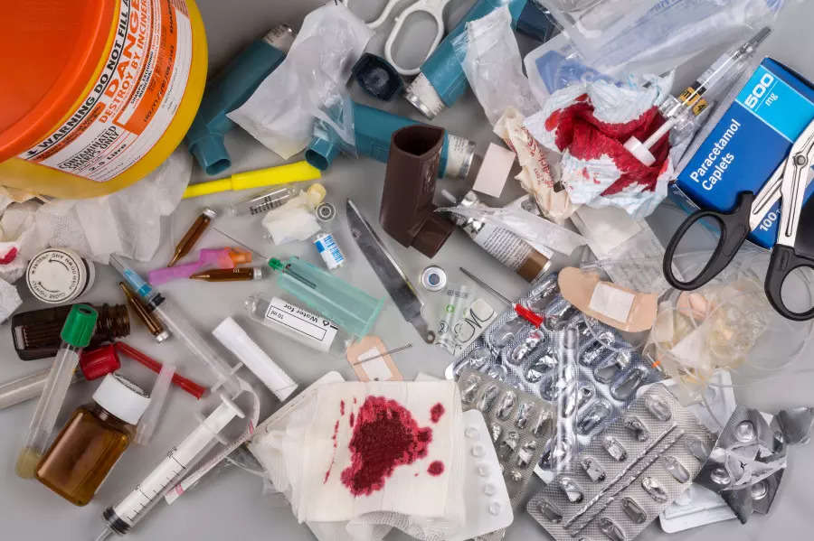

Fig 1: *Examples of* *Biomedical Waste*

**Methods of Segregation:**

The effective segregation of biomedical waste is crucial to safeguard healthcare workers, patients, and the environment(3). It is the first step in successful healthcare waste management(3). Color-coded containers and bins are widely used to achieve this, with different colors representing specific waste categories(4,11).

* **Yellow Containers:** Typically used for human and animal anatomical waste, soiled waste, expired medicines, chemical solid and liquid waste, discarded linen contaminated with blood or body fluids, and microbiology and biotechnology waste(12,13).
* **Red Containers:** Commonly used for contaminated recyclable waste such as tubing, bottles, syringes without needles, and other disposable items(12,13).
* **Blue Containers:** Used for broken or discarded contaminated glassware (except those contaminated with cytotoxic waste) and metallic implants(12,13).
* **White Containers:** Designated specifically for sharps, including needles, syringes with fixed needles, scalpels, blades, and any other sharp object that can cause punctures or cuts. These containers should be puncture-proof, leak-proof, and tamper-proof(11–13).

**Disposal Methods:**

* **Incineration:** One of the most widely used methods for biomedical waste disposal(3,4,9,12), involving burning waste at high temperatures (800-1100 °C) to convert it into ash and gases(9). While effective, it is expensive and can produce harmful emissions like dioxins(9). Strict emission controls are required to minimize environmental pollution(9).
* **Autoclaving:** Utilizes high-pressure steam to sterilize waste, making it safe for disposal(3,12,13). A more environmentally friendly option compared to incineration, but requires specific equipment and may not be suitable for all types of biomedical waste.
* **Microwaving:** Involves exposing waste to microwaves to generate heat and sterilize it(2,4). Can be a cost-effective alternative to autoclaving, but its effectiveness depends on the waste composition and the microwave system's specifications.
* **Deep Burial:** Used in certain situations where other disposal methods are not feasible(2). Waste is buried in a designated pit, usually lined with an impermeable material to prevent leaching of contaminants into the surrounding environment. Only suitable for small quantities of waste and requires careful site selection and monitoring to avoid groundwater contamination.
* **Chemical Disinfection:** Utilizes chemicals to kill or inactivate pathogens in the waste(2). Requires careful selection of disinfectants to ensure effectiveness against target microorganisms while minimizing environmental impacts.
* **Landfilling:** Waste is disposed of in a sanitary landfill, designed to isolate waste from the environment and control leachate(3,7). Not recommended for untreated biomedical waste due to the risk of releasing pathogens and contaminants into the environment.

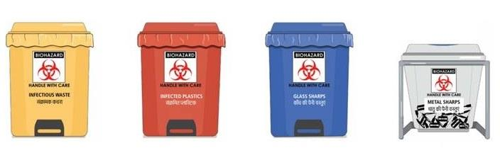

Fig 2: *Segregation of Solid Biomedical waste.*

**2.2. Pharmaceutical Waste**

Pharmaceutical waste includes discarded pharmaceutical products, vaccines, and sera, requiring specific disposal due to the potential for hazardous substances(1,5,9). It can range from unused tablets and capsules to vials of liquid medications and contaminated syringes. The hazards associated with pharmaceutical waste stem from the presence of active pharmaceutical ingredients, some of which can be toxic, persistent in the environment, or contribute to antimicrobial resistance(1).

**Examples:**

* Expired or unused medications, including tablets, capsules, liquids, and creams
* Partially used vials and ampoules
* Medicines contaminated with blood or body fluids
* Discarded syringes, needles, and other medical devices used to administer medications
* Cytotoxic drugs, which are used in cancer therapy and possess genotoxic properties
* Disinfectants, antiseptics, and cleaning agents containing pharmaceutical ingredients

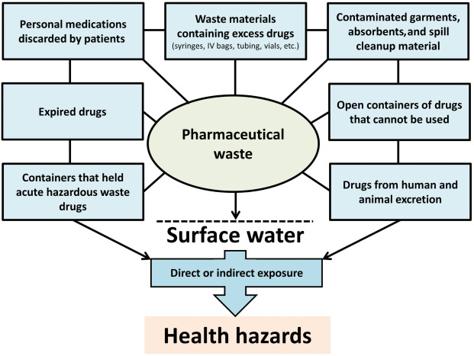  
**Fig 3: *Pharmaceutical Waste .***

**Methods of Segregation:**

* **Designated Containers:** Commonly brown containers specifically for pharmaceutical waste(14,15). These containers should be clearly labelled with the biohazard symbol and the words "Pharmaceutical Waste" to distinguish them from other waste streams. For cytotoxic waste, the label should indicate "Cytotoxic Waste" and the specific drug names if possible(4). These containers should be leak-proof, tamper-proof, and puncture-resistant to prevent spills and unauthorized access.
* **Segregation by Hazard Class:** Some institutions may further segregate pharmaceutical waste based on hazard class, such as those posing risks of acute toxicity, carcinogenicity, mutagenicity, teratogenicity, or environmental toxicity.
* **Return to Supplier:** In some cases, unused or expired pharmaceuticals can be returned to the supplier or manufacturer for proper disposal or credit. This option helps reduce the amount of pharmaceutical waste generated and minimizes disposal costs.

**Disposal Methods:**

* **Incineration:** A common method for disposing of pharmaceutical waste, particularly for cytotoxic waste and medications with hazardous properties(3,9). Incineration ensures the destruction of active pharmaceutical ingredients, reducing the risk of environmental contamination and accidental exposure. However, strict emission controls are necessary to mitigate the release of harmful by-products during the incineration process.
* **Encapsulation:** Involves mixing pharmaceutical waste with a solidifying agent, such as cement, to create a stable, solid block that can be safely landfilled(4). Encapsulation helps prevent the leaching of hazardous substances into the environment.
* **Chemical Neutralization:** Some pharmaceutical wastes can be neutralized through chemical reactions to render them less hazardous. For example, strong acids and bases can be neutralized using appropriate neutralizing agents before disposal.
* **Wastewater Treatment:** Liquid pharmaceutical waste, after appropriate pre-treatment, can be discharged into a wastewater treatment system designed to remove or degrade pharmaceutical residues.

**2.3. General Waste**

General waste, often referred to as non-hazardous waste or non-clinical waste, consists of waste materials that do not pose significant risks to human health or the environment(3,8,15). It constitutes a large portion of the waste generated in clinical settings, typically ranging from 75% to 90%(3–5,7,9). General waste can be safely disposed of through regular municipal waste management systems.

**Examples:**

* Packaging materials: Cardboard boxes, paper, plastic wrapping
* Office waste: Paper, envelopes, stationery, printer cartridges
* Food waste: Leftovers from kitchens and cafeterias, food packaging
* Uncontaminated disposable items: Gloves, masks, gowns, drapes
* Construction and demolition debris: Generated during renovations or building projects

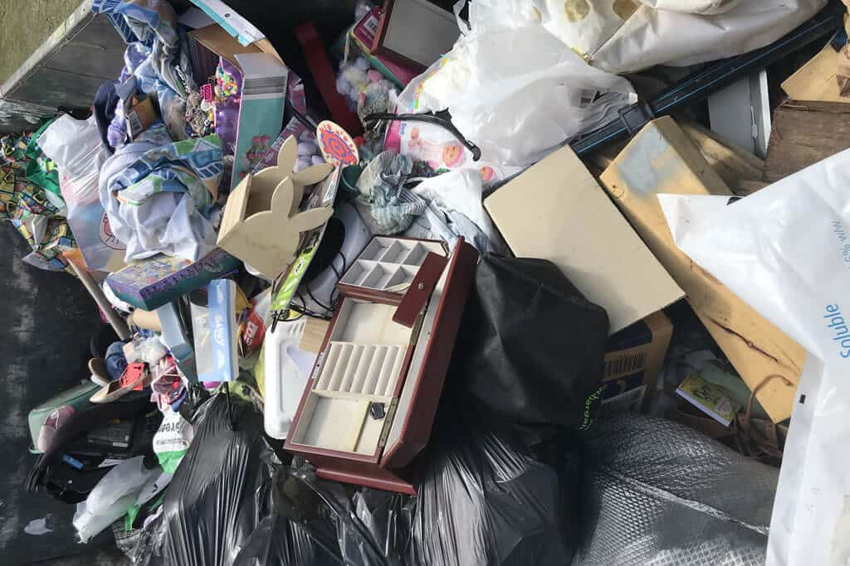  
Fig 4: ***General waste***

**Methods of Segregation:**

* **Black Containers or Bags:** They are typically used for general waste(1,14,15). Clear signage should be placed on or near these containers to indicate "General Waste" and to remind staff to only dispose of non-hazardous materials in these containers.
* **Waste Audits:** Regular waste audits are important to monitor segregation practices and identify areas for improvement(1,8). Audits can help reduce costs associated with the improper disposal of general waste as biomedical or pharmaceutical waste.

**Color Coding Systems:**

* **Standardization varies:** Color coding systems for waste segregation can differ between countries and even within a single healthcare facility.(4,5,16)
* **Common colors and categories:** Some commonly used colors and their corresponding waste categories include:
  + **Yellow:** Infectious waste, including sharps, and sometimes anatomical waste.(4,15,16)
  + **Black:** General waste, similar to household refuse.(4,15,16)
  + **Red:** Anatomical waste (in some systems) or contaminated waste.(11,16)
  + **White:** Waste sharps including metals (in some systems).(11,16)
  + **Blue:** Glassware and metallic body implants (in some systems). (11,16)

**Applying Principles to General Waste:**

While specific colors for paper, plastic, glass, and organic waste may vary depending on your location, you can apply the general principles of waste segregation to these materials:

* **Paper:** Use a dedicated container for paper waste, including newspapers, cardboard, and other paper products. Ensure the paper is clean and dry before disposal.
* **Plastic:** Collect different types of plastic separately if your local recycling program requires it. Clean and rinse plastic containers before disposal.
* **Glass:** Use a separate container for glass bottles and jars. Ensure the glass is clean and free of any food residue.
* **Organic:** Collect food scraps, yard waste, and other compostable materials in a designated container for composting or disposal according to local regulations.

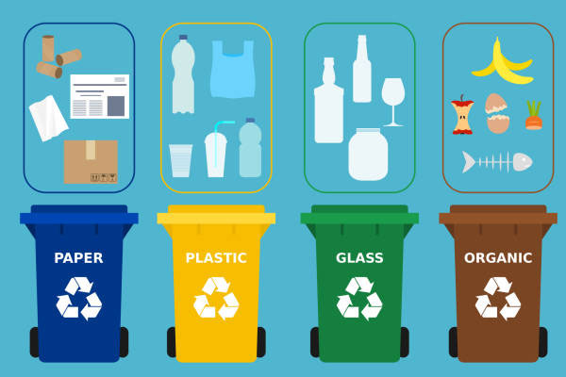

Fig5 : ***Color Coding System on General Waste***

**Disposal Methods:**

* **Landfilling:** The most common disposal method for general waste, where waste is deposited in a sanitary landfill designed to minimize environmental impacts(3,7).
* **Recycling:** Many components of general waste, such as paper, cardboard, plastics, and metals, can be recycled(4,14). Clinical settings should have designated recycling bins and implement procedures for collecting and sorting recyclable materials.
* **Composting:** Food waste and biodegradable materials can be composted to produce a valuable soil amendment. Some healthcare facilities may have onsite composting systems or partner with local composting facilities.

**Key Considerations for Waste Management in Clinical Settings:**

The sources emphasize the importance of a comprehensive and systematic approach to waste management in clinical settings(4). This includes:

* **Clear Waste Management Policies:** Healthcare facilities should have clear, written policies and procedures outlining waste management practices, responsibilities, training requirements, and emergency response plans.
* **Staff Training and Awareness:** All staff members should receive comprehensive training on waste management policies, procedures, and associated risks. Regular refresher training should be provided to ensure ongoing compliance.
* **Waste Minimization Strategies:** Implementing strategies to minimize waste generation, such as reducing the use of disposable items, promoting reusable alternatives, and optimizing inventory management practices, can significantly reduce waste volumes and associated costs.
* **Monitoring and Evaluation:** Regular monitoring and evaluation of waste management practices through waste audits, staff surveys, and data analysis can identify areas for improvement and ensure the effectiveness of implemented measures.

Effective waste management in clinical settings is a shared responsibility that requires the active participation and commitment of all staff members(4). It is crucial to prioritize proper waste segregation and disposal practices to protect human health, safeguard the environment, and ensure sustainable healthcare operations.

# **Current Challenges in Waste Management in Clinical Settings**

Clinical waste management is complicated due to the variety of waste and the health and environmental risks of inappropriate handling. To ensure safe and sustainable disposal, waste management involves stringent protocols, suitable infrastructure, and ongoing worker training. However, clinical environments often struggle with segregation, disposal, and health risks for patients and staff. This chapter discusses waste management's main challenges with examples.

## **Lack of Awareness and Training**

Healthcare professionals' lack of waste handling and disposal training is a major hurdle to clinical waste management. Many healthcare workers are unaware of the long-term health and environmental implications of incorrect waste disposal, which can include unintended exposure to hazardous items, inappropriate segregation, and higher waste management expenses (17).

The WHO and ICRC recommend training healthcare workers on waste management techniques to reduce occupational exposure and environmental damage. According to an ICRC report, unskilled staff in certain facilities combined biomedical waste with general waste, contaminating it and endangering waste handlers and the population (17).

Handling sharps or infectious debris improperly might injure healthcare personnel and cause waste disposal site cross-contamination. The dangers of processing biomedical and pharmaceutical waste are poorly understood, according to studies. Regular training can help healthcare staff follow proper segregation and disposal procedures, reducing exposure hazards (17).

### *Training and awareness programmes*

WHO recommends that healthcare facilities adopt comprehensive waste segregation, safe handling, and disposal training programs to address these challenges. Continuous training is needed to adapt to changing waste management protocols and technology. Regular workshops, visual guidelines, and posters at healthcare facilities have helped personnel practice good trash handling. Integrating these training programs into hospital operations promotes responsibility and lowers waste management errors (17).

## *Inadequate Waste Segregation Practices*

Segregating garbage reduces health concerns and ensures safe and efficient disposal. However, many healthcare facilities have poor waste segregation, which can cause cross-contamination, higher disposal costs, and environmental damage. Lack of labelling, colour-coded bins, and trash storage space often complicate waste segregation.

The WHO warns that poor segregation can classify the entire waste stream as hazardous, increasing disposal costs and environmental concerns. When packaging or paper is mixed with biological waste, the entire batch is considered hazardous and must be incinerated or disposed of. This increases expenses and environmental effect owing to hazardous waste treatment emissions (17).

WHO identified a hospital where colour-coded bins were inconsistently placed, confusing workers about garbage disposal. Sharps and infectious garbage were sometimes disposed of in normal waste bins, putting waste handlers and patients at danger. Such occurrences demonstrate the significance of consistent trash segregation for safe disposal (17).   
  
Solution: Waste Segregation Standards - WHO suggests standardised waste segregation systems with colour-coded containers for infectious, pharmaceutical, and sharps trash to solve these issues. Clear signs and frequent inspections can also assure waste segregation compliance. Training staff about the purpose of colour-coded bins and the hazards of each waste type encourages segregation, making trash management safer and cheaper.

## **Lack of Infrastructure and Resources**

Healthcare institutions, especially low-resource ones, have physical and resource constraints that make waste management difficult. Rural hospitals and tiny clinics may lack storage, waste containers, and incinerator or other disposal systems (17).

The ICRC's medical waste management standards emphasise the need for safe hazardous waste storage and disposal infrastructure. Low-resource healthcare facilities generally lack biomedical waste storage rooms, forcing personnel to store dangerous chemicals in temporary sites that increase contamination hazards. A clinic without a sharps waste storage room may keep used needles in normal waste containers, exposing cleaners and other staff (17).

Lack of incineration facilities might further complicate waste management. Healthcare facilities without high-temperature incineration may burn or dump biological waste, polluting the environment and spreading pathogens (17).

* + 1. *Resource allocation and mobile incinerators*

WHO advises strategic resource allocation to prioritise waste management infrastructure in resource-limited environments. If installing full incineration plants is financially or logistically impossible, mobile units are a reasonable alternative. These devices can handle hazardous waste on-site, reducing transportation emissions and risky disposal (17).

## **Regulatory and Policy Limitations**

Regional differences in medical waste management regulations and policies make disposal procedures inconsistent and compliance difficult. Some countries lack a national healthcare waste management strategy, leaving healthcare facilities without a hazardous waste framework. Sometimes regulations aren't enforced owing to lack of resources or oversight (17).

Healthcare facilities may have different waste management strategies due to regulatory inconsistencies. Hospitals in nations with strict regulations may have strict waste disposal protocols, whereas those in less regulated countries may struggle with basic segregation. This difference can harm public health since improperly managed trash pollutes water, soil, and air (17).

A WHO study found that nations lacking comprehensive waste regulations have greater rates of illicit dumping and open burning. These methods pollute the environment and expose local residents to viruses and toxins, highlighting the need for strong regulations (17).   
National and international policies and guidelines - The WHO recommends national healthcare waste management programs that follow international recommendations to overcome these restrictions. Hazardous waste segregation, storage, transport, and disposal should be outlined in such policies. International norms like the Basel Convention for hazardous waste transport help countries standardise waste management, especially in low-resource regions (17).

1. **Optimal Strategies for Waste Minimization**

## **Execution of Recycling Initiatives**

Establishing organized recycling initiatives in healthcare environments can markedly diminish waste production and ecological consequences. Hospitals and healthcare facilities get advantages from recycling initiatives that emphasize the segregation of non-hazardous waste from other categories, including plastics, metals, and paper, thereby facilitating safe recycling.

Carilion Roanoke Memorial Hospital in Virginia established a thorough waste reduction program, combining personnel training with recycling systems. This program promoted active participation in waste segregation among nursing personnel and environmental services. Through the implementation of designated recycling bins and the monitoring of departmental trash production, Carilion experienced a significant reduction in landfill waste, illustrating the beneficial effects of active engagement and awareness on environmental sustainability within healthcare environments (18,19).

The National Health Service (NHS) in the United Kingdom initiated a program to diminish single-use plastics within its facilities, targeting things such as disposable cutlery, straws, and containers. This program prioritizes collaboration with suppliers to procure biodegradable products and advocates for recycling among healthcare providers. This effort has effectively reduced plastic waste in NHS hospitals, underscoring the significance of sustainable practices in healthcare (19,20).

* 1. **Minimizing Packaging Waste**

Packaging trash constitutes a substantial portion of overall waste in the healthcare sector. Numerous medical products are separately wrapped to preserve sterility, leading to substantial quantities of throwaway packaging. Resolving this issue necessitates new procurement techniques and engagement with suppliers to reduce superfluous packing.

Mayo Clinic's Sustainable Packaging Initiative Mayo Clinic in the United States collaborated with medical suppliers to mitigate wasteful packaging by advocating for environmentally friendly, minimal packaging for commonly utilised commodes. This program minimised waste without sacrificing sterility or quality, illustrating how healthcare institutions can impact suppliers and procurement methods to attain environmental objectives while simultaneously reducing disposal costs (18,21).

Medline Industries Sustainable Packaging Medline Industries, a worldwide medical provider, provides hospitals with choices for recyclable and biodegradable packaging. In partnership with healthcare professionals, Medline has endeavoured to diminish plastic waste by utilising compostable or recyclable materials for a range of medical equipment. This project corresponds with overarching sustainability objectives in healthcare, emphasising the significance of collaborations between suppliers and hospitals in minimising waste (19,22).

# **Technological Innovations in Waste Management in Clinical Settings**

Modern technology has transformed healthcare, especially waste management. The latest techniques and software can improve clinical waste management, environmental impact, and operational efficiency. Technology helps healthcare institutions manage trash, complying with rules and reducing health and environmental dangers. Waste tracking software, automated waste sorting systems, and other waste management technologies are examined in this chapter.

**5.1. Use of Waste Tracking Software**

**Waste tracking software is designed to monitor the generation, movement, and disposal of waste, offering real-time visibility and valuable data for optimizing waste management processes.** Based on Sources, here are relevant examples that can be applied to this context.

* **Tracking Systems for Oily Waste:** The sources detail the application of RFID and GPS tracking devices for the management of oily waste in the oil and gas sector(23). These systems provide real-time data on the location and movement of waste containers, ensuring proper handling, preventing loss or misplacement, and facilitating efficient collection and disposal. **Imagine a similar system implemented in a hospital, where RFID tags are attached to containers of sharps, pharmaceutical waste, and biohazardous materials.** This would allow for real-time monitoring of their movement throughout the facility, from generation points to designated storage areas and ultimately to final disposal.
* **Software Solutions for Inventory Management and Tracking:** The sources highlight the use of **cloud-based inventory management systems, such as SAP Inventory Manager**,(23) for tracking oily waste in the oil and gas industry. This software provides real-time visibility into inventory levels, enabling efficient management of waste materials. **This concept can be readily applied to clinical waste management. A hospital could implement a similar system to track the inventory of different categories of clinical waste, such as sharps, pharmaceutical waste, and biohazardous materials.** This would ensure adequate supplies of waste containers, optimize storage space, and prevent shortages or overstocking.
* **Data Analysis and Reporting Software:** The sources mention the use of **software applications, such as SAP EHS**,(23) for data analysis and reporting in oily waste management. These applications can analyse large datasets to identify patterns, trends, and potential issues, enabling data-driven decisions for improving waste management processes. **In a clinical waste management context, similar software could be used to analyse data from waste tracking systems, identifying areas for improvement.** For instance, the software could pinpoint departments or procedures that generate higher volumes of certain waste categories, providing insights for targeted interventions to minimize waste at the source.

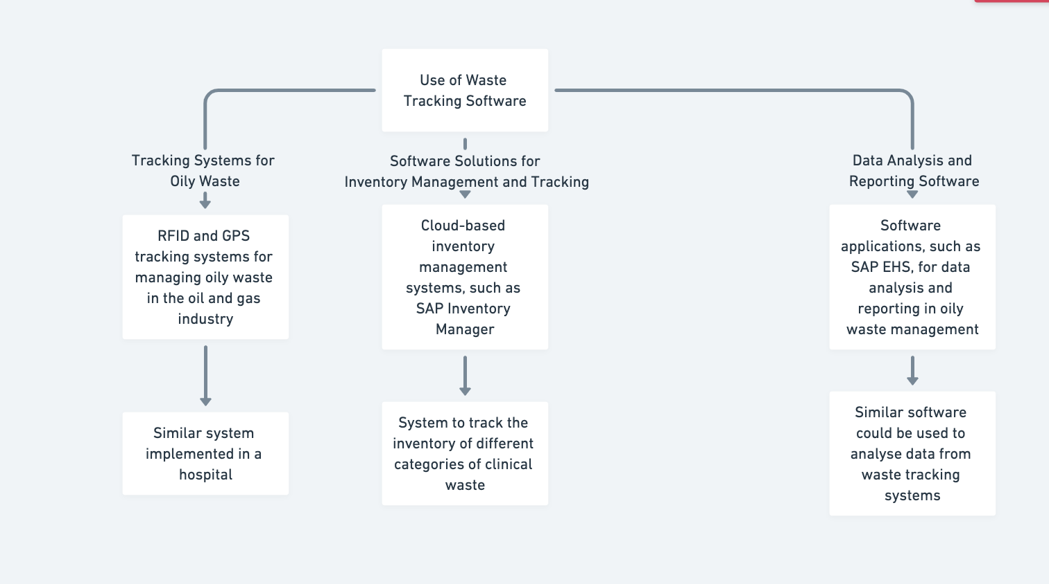  
**Fig 6**: ***Use of Waste Tracking Software***

**Adapting these waste-tracking principles to clinical waste management could lead to several benefits:**

* **Enhanced Compliance:** Tracking software would provide a comprehensive audit trail of waste movement and disposal, ensuring transparency and accountability for regulatory compliance.(24,25) This digital record-keeping could streamline audits and demonstrate adherence to protocols.
* **Data-Driven Optimization:** By tracking waste generation patterns, healthcare facilities could identify areas for improvement and implement targeted interventions to minimize waste generation and optimize resource utilization.(26)
* **Improved Risk Management:** Real-time tracking of clinical waste, especially hazardous materials, could minimize the risk of contamination and improper disposal, enhancing safety for healthcare staff and the environment.(24,26)

**5.2. Automated Waste Sorting Systems**

Automated trash sorting systems utilise modern technology, such as robots and artificial intelligence, to effectively and safely segregate various waste kinds, therefore diminishing the necessity for manual handling and mitigating dangers. According to sources, these are some instances applicable to this topic.

* **Robotic Systems for Waste Sorting:** The sources describe the use of **robotic systems equipped with sensors, cameras, and 3D laser scanners to identify and separate recyclable materials from mixed waste streams**.(27) **Envision a similar robotic system deployed in a hospital setting to sort clinical waste based on pre-programmed parameters.** It could identify and separate sharps from general waste, segregate different categories of biohazardous materials, and potentially identify recyclable materials within the waste stream.
* **Sensor-Based Sorting:** The sources mention the use of various sensors in automated sorting systems, including **metal detectors, inductive proximity sensors, IR sensors, and gas level sensors**.(28) These sensors can be incorporated into clinical waste sorting systems to identify different materials based on their properties. For example, **metal detectors could be used to identify sharps, while IR sensors could differentiate between different types of plastics in pharmaceutical waste containers.**
* **Deep Learning for Waste Recognition:** The sources emphasize the potential of **deep learning algorithms, such as YOLO, for accurate and efficient waste recognition**.(29,30) These algorithms can be trained on extensive datasets of clinical waste images to identify and categorize various types of waste. **Imagine a deep learning system integrated into a robotic sorting system in a hospital setting. As waste items move along a conveyor belt, the algorithm would analyze images in real time, guiding the robotic arm to pick up and place items into designated containers.**
* **Automated Lines for Sorting and Recycling:** The sources describe the use of **automated lines for sorting and recycling household waste**.(31) While these systems are designed for municipal waste, the principles can be adapted to handle clinical waste. **Imagine a similar system in a hospital, where a conveyor belt transports mixed clinical waste to a sorting area. Sensors and AI algorithms would identify and segregate different waste categories, directing them to appropriate containers for further processing or disposal.**

**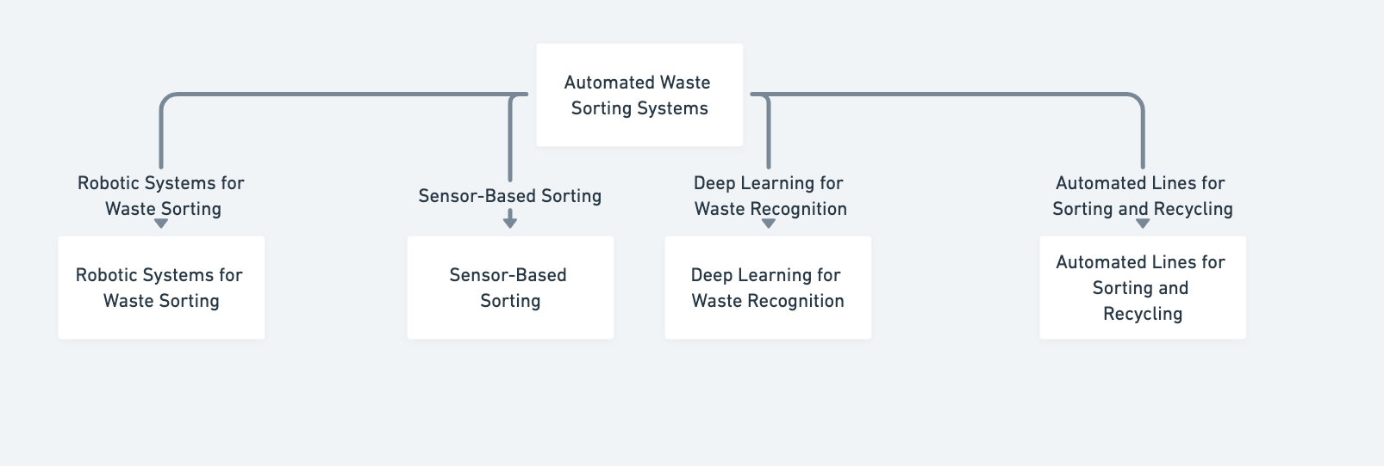  
Fig 7: *Automated Waste Sorting Systems***

**Adapting automated sorting systems for clinical waste offers numerous advantages:**

* **Enhanced Safety**: Automation would eliminate the need for manual handling of potentially infectious materials, significantly reducing the risk of needlestick injuries and exposure to biohazards.(28,32,33)
* **Increased Efficiency**: Robots and AI can sort waste faster and more accurately than humans, optimizing workflow and resource utilization.(23)
* **Improved Resource Recovery**: Advanced sorting systems can identify recyclable materials within clinical waste streams, contributing to sustainability efforts.(34)

**However, adapting these systems also presents challenges:**

* **Diversity and Complexity of Clinical Waste:** Sorting systems must be designed to handle a wide range of materials, accurately distinguishing between sharps, biohazardous materials, pharmaceutical waste, and general waste.(30,35,36)
* **Stringent Regulatory Compliance:** Systems must comply with strict regulations to prevent the spread of infection and protect public health, requiring features that track waste movement, maintain data integrity, and adhere to handling protocols.(36)

1. **Conclusion**

The healthcare industry's significant contribution to global waste generation presents a pressing need for comprehensive waste reduction strategies in clinical settings. As evidenced by the sources, this is not merely an economic concern but a critical step towards promoting environmental sustainability, safeguarding public health, and ensuring responsible resource management within the healthcare sector. **The sources collectively underscore that reducing waste requires a multifaceted approach involving waste minimization, proper segregation at the source, recycling, and the implementation of "Lean" methodologies to enhance efficiency.**

Numerous strategies can be implemented to effectively minimize waste in clinical settings. These include reducing unnecessary consumption of supplies, promoting the reuse of materials whenever feasible, and establishing comprehensive recycling programs for various materials. The sources particularly emphasize proper waste segregation at the source as a fundamental aspect of successful waste reduction initiatives, highlighting staff education and training as crucial components. **Moreover, applying "Lean" principles, such as waste walks and process mapping, can effectively identify and eliminate wasteful practices, ultimately leading to enhanced efficiency and cost savings.**.

Several specific areas within clinical settings have been identified as targets for waste reduction efforts. These include minimizing unused medical supplies, reducing the frequency of relaundering unused linens, and ensuring accurate sorting of pharmaceutical and regulated medical waste. **The sources also stress the importance of addressing waste generated from specific procedures, advocating for the use of individual sterile components instead of pre-packaged kits, which often contribute to significant waste.**. By implementing these targeted interventions, healthcare facilities can make substantial progress in reducing their overall waste generation.

**Embracing these strategies and fostering a culture of sustainability within healthcare institutions can yield significant benefits.**. These include mitigating environmental impact by reducing landfill usage and greenhouse gas emissions, decreasing costs associated with waste disposal and unnecessary purchases, and improving operational efficiency through streamlined processes and better resource utilization. Ultimately, by actively pursuing waste reduction, the healthcare industry can demonstrate its commitment to environmental responsibility, public health, and the creation of a more sustainable healthcare system.

# **References**

1. ▼ CLINICAL transporting clinical waste [Internet]. Available from: http://tinyurl.com/9kwqj69

2. Datta P, Mohi G, Chander J. Biomedical waste management in India: Critical appraisal. J Lab Physicians. 2018 Jan;10(01):006–14.

3. Ghali H, Cheikh A Ben, Bhiri S, Bouzgarrou L, Rejeb M Ben, Gargouri I, et al. Health and Environmental Impact of Hospital Wastes: Systematic Review. Vol. 6, Dubai Medical Journal. S. Karger AG; 2023. p. 67–80.

4. Chartier Yves. Safe management of wastes from health-care activities. World Health Organization; 2014. 308 p.

5. Reducing Clinical Waste in a Haemodialysis Clinic, Small Change Big Impact.

6. Taylor AL, Levin J, Chan J, Lee M, Kasitinon D, Miller E, et al. Improving environmental sustainability in outpatient clinics: Lessons from a waste audit. Journal of Climate Change and Health. 2021 Oct 1;4.

7. Hossain MS, Santhanam A, Nik Norulaini NA, Omar AKM. Clinical solid waste management practices and its impact on human health and environment - A review. Vol. 31, Waste Management. 2011. p. 754–66.

8. Johnson KM, González ML, Dueñas L, Gamero M, Relyea G, Luque LE, et al. Improving waste segregation while reducing costs in a tertiary-care hospital in a lower-middle-income country in Central America. Waste Management and Research. 2013 Jul;31(7):733–8.

9. Kenny C, Priyadarshini A. Review of current healthcare waste management methods and their effect on global health. Vol. 9, Healthcare (Switzerland). MDPI AG; 2021.

10. Bio-medical_Waste_Management_Rules_2016.

11. Saxena P, Pradhan IP, Kumar D. Redefining bio medical waste management during COVID- 19 in india: A way forward. Mater Today Proc. 2022 Jan 1;60:849–58.

12. PICTORIAL GUIDE ON BIOMEDICAL WASTE MANAGEMENT RULES 2016.

13. Guidelines for Management of Healthcare Waste as per Biomedical Waste Management Rules, 2016.

14. Reducing Waste in the Clinical Setting.

15. Icrc. MEDICAL WASTE MANAGEMENT [Internet]. Available from: www.icrc.org

16. Wyssusek KH, Keys MT, van Zundert AAJ. Operating room greening initiatives – the old, the new, and the way forward: A narrative review. Vol. 37, Waste Management and Research. SAGE Publications Ltd; 2019. p. 3–19.

17. Harding C, Van Loon J, Moons I, De Win G, Bois E Du. Design opportunities to reduce waste in operating rooms. Sustainability (Switzerland). 2021 Feb 2;13(4):1–14.

18. Ghali H, Cheikh A Ben, Bhiri S, Bouzgarrou L, Rejeb M Ben, Gargouri I, et al. Health and Environmental Impact of Hospital Wastes: Systematic Review. Vol. 6, Dubai Medical Journal. S. Karger AG; 2023. p. 67–80.

19. Reducing waste in the NHS: an overview of the literature and challenges for the nursing profession. 2015;

20. ▼ CLINICAL transporting clinical waste [Internet]. Available from: http://tinyurl.com/9kwqj69

21. Shipman SA, Sinsky CA. Expanding primary care capacity by reducing waste and improving the efficiency of care. Health Aff. 2013 Nov;32(11):1990–7.

22. Reducing Waste in the Clinical Setting.

23. Bayramov K. The role of software in reverse logistics and effect on oily waste management. Journal of Transport and Supply Chain Management. 2023;17.

24. Anderson RS, Green K. The Integrated Waste Tracking System (IWTS)-A Comprehensive Waste Management Tool The 10th International Conference On Environmental Remediation And Radioactive Waste Management, 2005. 2005.

25. Garcia JF, Seggerty BK. SOFTWARE FOR TRACKING CONTAINERIZED WASTE FROM CRADLE TO GRAVE.

26. Goossens Y, Leverenz D, Kuntscher M. Waste-tracking tools: A business case for more sustainable and resource efficient food services. Resources, Conservation and Recycling Advances. 2022 Nov 1;15.

27. Koskinopoulou M, Raptopoulos F, Papadopoulos G, Mavrakis N, Maniadakis M. Robotic Waste Sorting Technology: Toward a Vision-Based Categorization System for the Industrial Robotic Separation of Recyclable Waste. IEEE Robot Autom Mag. 2021 Jun 1;28(2):50–60.

28. Chahine K, Ghazal B. Automatic Sorting of Solid Wastes Using Sensor Fusion. International Journal of Engineering and Technology. 2017 Dec 31;9(6):4408–14.

29. Mahboob Ali M, Chvs H, Sai Teja G, Veera Jyothi B, Suresh Kumar L. Intelligent Waste Sorting System: Leveraging Arduino for Automated Trash Identification and Categorization. Vol. 16, International Journal of Computer Information Systems and Industrial Management Applications. 2024.

30. Ogrezeanu IA, Suciu C, Itu LM. Automated Waste Sorting: A Comprehensive Approach Using Deep Learning for Detection and Classification. In: 2024 32nd Mediterranean Conference on Control and Automation, MED 2024. Institute of Electrical and Electronics Engineers Inc.; 2024. p. 268–73.

31. Pîrvu R, Abdelnaser O, Ha H, Kaur H, Grabara J, Katsoni V, et al. The Impact of Megaprojects on Branding Ethiopia as an Appealing Tourist Destination Mulugeta GIRMA, Manjit SINGH Editorial Advisory Board. Journal of Environmental Management and Tourism [Internet]. Available from: http://dx.doi.org/10.14505/jemt

32. Gundupalli SP, Hait S, Thakur A. A review on automated sorting of source-separated municipal solid waste for recycling. Vol. 60, Waste Management. Elsevier Ltd; 2017. p. 56–74.

33. Paulraj SG, Thakur A, Hait S. AUTOMATED MUNICIPAL SOLID WASTE SORTING FOR RECYCLING USING A MOBILE MANIPULATOR. 2016.

34. Kocaleva Vitanova Zoran Zlatev M, Zlatanovska Lectoure Snezana Kirova B, Zlatanovska Mirjana Kocaleva Vitanova B. Editor in chief. Vol. 7, BALKAN JOURNAL OF APPLIED MATHEMATICS AND INFORMATICS (BJAMI).

35. Sereda TG, Kostarev SN. Development of automated control system for waste sorting. In: IOP Conference Series: Materials Science and Engineering. Institute of Physics Publishing; 2019.

36. Namen AA, Da Costa Brasil F, Abrunhosa JJG, Abrunhosa GGS, Tarré RM, Marques FJG. RFID technology for hazardous waste management and tracking. Waste Management and Research. 2014;32:59–66.

 37. <https://www.encstore.com/blog/5430-rfid-integration-with-oil-gas-industry>

38. https://www.gep.com/inventory-management-software