Paper Title*(Application of Graph Theory in Medical Field)

Abdur Rohman1

Department of Mathematical Sciences

Bodoland University

Kokrajhar, 783370, India

abdurrohman239@gmail.com

Birglai Basumatary2

Department of Mathematical Sciences

Bodoland University

Kokrajhar, 783370, India

birglaibasumatary@gmail.com

Surajit Kr. Nath3

Department of Mathematical Sciences

Bodoland University

Kokrajhar, 783370, India

surajitnathe9@gmail.com

ABSTRACT

Graph Theory is ultimately the study of relationships. Given a set of nodes and connections, which can abstract anything from city layouts to computer data, graph theory provides a helpful tool to quantify and simplify the many moving parts of dynamic system. Besides in medical field graph theory is very useful.

Investigating the patient wellbeing data is significant undertaking medical care area in light of the data got from patient. The doctor begins to give the treatment and furthermore this data become an imperative job to get ready for additional treatment of patient. The fundamental target of this work is to get clearness of data about persistent by plotting diagram.

Keywords—Graph Theory, Medical, Konigsberg bridge, Gene, Disease

# INTRODUCTION

In combinatorial research, Graph theory is a very natural and powerful tool. Some important research concerns such as inventory control problems can be solved with graph theory methodologies. It is possible to improve the operational military science and strategic decision making of healthcare inventory systems.

The article attempts to draw the attention of healthcare executives and inventories researchers to real world graph theory applications. Let us not go too far; we may use the current situation as an example. We’re all currently battling the life threatening corona virus: Aarogya Setu (also known as Cowin-20)

Is the name of the app, which is now being tested on both ions and android? It will track your location and notify you if come close to a covid-19 patient. Cowin-20 will use your location data and Bluetooth to determine if you have been in close proximity to a covid-19 infected person.

A graph is a way to store and represent “connected” data. For example- let’s consider a patient who visits a doctor and subsequently a pharmacy. This interaction can be represented in the form of a triangle, where the vertices (referred to as “nodes”) represent the patient doctor and pharmacy and each side (referred to as “edges”) represents a connection between the trio.

For modeling the interactions between objects, a graph is appropriate data structure. These methodologies in addition to graph database make the use of graphs in medical context particularly intriguing, such as modeling patient data in HER (Electronic Healthcare Record). Graphs and tables remain the most efficient and practical way to convey a large amount of information, especially comparative information and numbers. Visual presentations are powerful tools for concisely making points that are hard to put into words.

Some necessary research issues particularly inventory control problem that may be resolved using graphs. It suggests the chances that exist for improving the operational, military science and strategic decision making of health care inventory systems through the employment of graph theory approaches.

This work aims to boost the attention of health care managers and inventory researchers with relevance to realistic graph theory applications.

This research paper is based on all the application of Graph Theory in Medical Field in different ways and finding a solution with one source graph theory.

# Preliminaries

A**. Basics of Graph Theory**

A graph is an abstract representation of a set of objects where some pairs of the objects are connected by links. The interconnected objects are represented by mathematical abstractions called vertices, and the links that connect some pairs of vertices are called edges. Typically, a graph is depicted in diagrammatic form as set of dots for the vertices, joined by lines or curves for the edges.

Graph theory is a growing area in mathematical research and has a large specialized vocabulary. Graph theory can be said to have its beginning in 1736 when Euler considered the Konigsberg bridge problem.

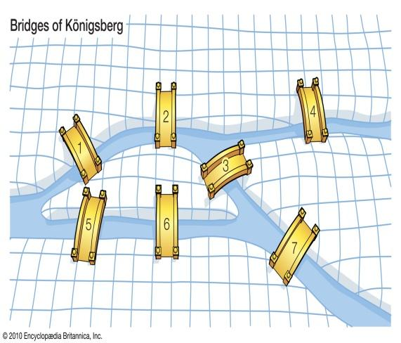



Figure 1: A park in Konigsberg, 1736 Figure 2: The graph of Konigsberg bridge problem

**Definition 1: Graph:** A graph G= (V, E) consist of a set of objects V=[v1,v2,……..] called vertices and another set E=[e1,e2………],whose elements are called edge.

**Definition 2: Connected Graph:** A graph (G) is called connected if there exist at least one path between every two vertices in a graph (G).

**Definition 3: Line graph:** A line graph is a graphical display of information that changes continuously over a time.

**Definition 4: Edge:** An Edge is a line joining pair of Vertices.

**Definition 5: Vertex:** A vertex is point. It is a fundamental unit from which graph are made. A vertex is also called a node.

**Definition 6: Directed graph:** A directed graph D consist of a finite nonempty set V of points together with a prescribed collection X of ordered pairs of distinct points.

**Definition 7: Undirected graph:** Where there is no distinction between the two nodes associated with each edges is called undirected graph.

**Definition 8: Bipartite graph:** G is a graph whose point set V can be partitioned into two subsets V1 and V2 such that every line of G joins V1 with V2.

**Definition 9: Eulerian graph:** A closed walk in a graph G containing all the edges of G is called an Euler line in G. A graph containing an Euler line is called an Euler graph.

**Definition 10: Hamiltonian Graph:** If graph G has a spanning cycle Z, then G is called a Hamiltonian graph.

**Definition 11: Sub graph:** A graph G is said to be a sub graph of a graph G if all the vertices and all the edges of g are in G, and each edge of g has the same end vertices in g as in G.

**Definition 12: Eulerian circuit:** An Eulerian circuit is a circuit that uses every edge of graph exactly once.

# Applications

## **Graph Theory in Gene regulatory networks**

In a GRN, vertices are mostly commonly considered to be genes, while edges contain some type of information about the regulatory interaction or transcriptional relationship between two genes. In a simplified and idealistic view, such regulatory interactions could resemble the action of transcription factors (TFs), which bind to target genes and influence their mRNA transcription. In such networks, vertices should thus be separated into genes that encode a TF and genes which do not. An interaction from a gene A to a gene B would then imply that the protein encoded by gene A acts as a TF and binds to a regulatory element, e.g. promoter of gene B ( which might be transcription factor encoding gene itself),thus influencing its transcriptional activity (Figure 3(A)). The regulatory mechanisms and interactions that involve transcription, translation and protein-DNA binding can then be abstracted as a simple network structure composed of TFs, target genes, and edges between them (Figure 3(B)). Yet, it is not always clear a-priori, which of the genes actually encode for TFs, and a clear separation of vertices into one of the two classes is thus not always feasible.

While the definition of a GRN as a model of TF-mediated transcriptional regulation of target genes appears commonly employed, transcription is influenced by a myriad of factors as well, including for instance non-coding RNAs, epigenetic factors, chromatin modifiers, posttranslational modifications, and translational co-regulators.

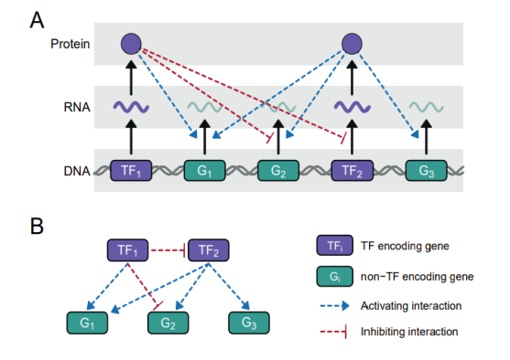

Figure 3

Thus GRNs can be represented as mathematical graphs, GRN=G (V,E),where the vertices(V) correspond to genes, or some variables that reflect a gene’s activity or expression, and the edges(E) indicate some type of transcriptional relationship between genes.

## **Application of Graph Theory in Disease**

**The granulomatous diseases Sarcoidosis and its pulmonary pathology**

Sarcoidosis is a desease in which abnormal collections of chronic inflammatory cells form a nodule (granulomas) in multiple organs. Sarcoidosis is present at various level of severity in all ethnic and racial groups and is mainly caused by environmental agents in people with higher genetic sensitivity. The disease is chronic inflammatory disease that primarily affects the lungs but can affect almost all organs of the body. Sarcoidosis is a complex disease displaying incorrect functionalities within immune cells, cytokines and antigenic reactions. Figure 4 shows a sub graph of the knowledge network compromising the concepts related with Sarcoidosis.

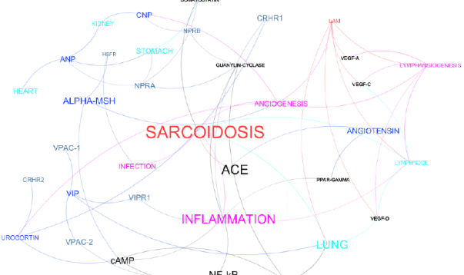

Figure 4

Here the Sarcoidosis is the Graph G where the nodules are the graph g which is in G i.e. Sarcoidosis. By which we can present the Sarcoidosis disease by the sub graph.

Here we can represent in Figure 5, the vertices v1,v2,v3,v4,v5 with the edges e1,e2....e5 as the disease Sarcoidosis and the vertices v6,v7....v10 with the edges e6,e7,….e10 as the infections, symptoms of the disease.



Figure 5

## **Application of Graph Theory in Medical Field**

1. **Line graph used by the Nurses**

In the medical field the nurses too use line graphs for showing trends or changes over a period of time. A line graph shows that relationship between two parameters. e.g. the change in the temperature during a day or week; the patient’s body weight related to time periods; the patient’s blood pressure during a day.

A nurse administers Tylenol to lower a patient’s fever. The graph below shows the decrease in the patient’s body temperature with respect to time. The horizontal axis expresses the time since the Tylenol was administered and the vertical axis expresses the patients’ temperature.

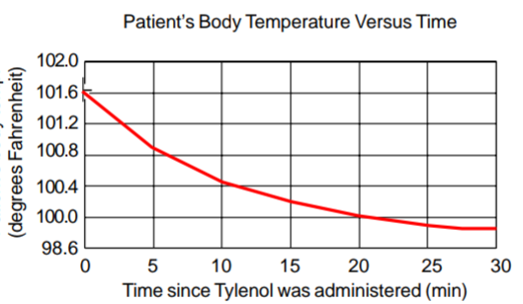

Table 1

1. **Connection between the trio:**

A graph is a way to store and represent “connected” data.

Let us consider a patient who visits a doctor and subsequently a pharmacy. This interaction can be represented in the form of a triangle, where the vertices represent the patient, doctor and pharmacy and each edges represents the connection between them.

Here vertices v1,v2,v3 are the patient, doctor and the edges e1,e2,e3 are the relation between them where v1,v2,v3 are connected to each other. Which creates a trio connection or else we can say a connected graph. This same interconnected structure can be used to represent data for hundreds of thousands of patients, doctors and pharmacies in a healthcare graph. Once data is represented in the form of a graph, it allows us to analyze and identify insights in ways that are not possible when the data is stored in other formats.



Figure 6

1. **Precision Medicine**

Graph networks are a topic of intense research in the area of precision medicine, where researchers try to understand disease-drug-gene-patient interactions. For example, multiple topic-specific networks could be constructed as follows using the figure given above:

1. A drug network, where each node represents a drug and the connection between nodes could be based on common compounds, similar diseases, reactions, etc.
2. A disease network, where each node represents a disease and connections are based on the similarity of symptoms
3. A gene network, where nodes represent individual genes and connections are based on proteins.
4. **Human Micro Cardiac Network System**

The circulation of blood in human cardiac system is itself a planned by the nature. So we have observed and studied planarity and the Hamiltonian or Eulerian graphs in cardiac network system. We modified the blood circulation system of heart with applications shown in Figure 7. We collected infrastructure connectivity graphs in human body with the blood circulation system in the heart and we called them as “Micro-Cardiac Network graphs”. Further we studied this concept in terms of network graphs. Our attempt is to show that there is a Hamiltonian or Eulerian path system in human heart functioning and we came to conclusion to give sketches of this system. Our investigation allows solving the problems of the thickly crowded dense micro cardiac network system which is shown in Figure 8. The extended edge connectivity may help the cardiac network system.

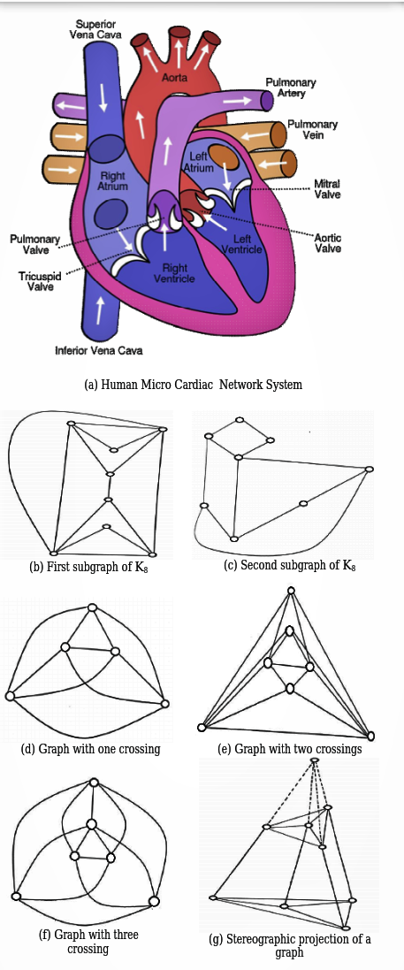

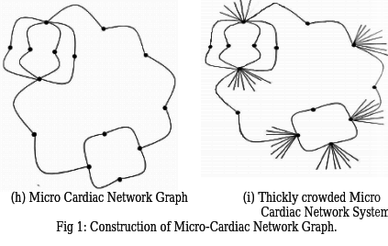

Figure 7 Figure 8

1. **Euler in Covid vaccine: Graph theory and gene sequencing**

Euler invented graph theory and graph theory makes gene sequencing possible and gene sequencing gives us the covid vaccine.

Gene sequencing helped create Covid vaccine. For the covid vaccine researchers obtain the gene sequence of the virus and based on that created a corresponding messenger mRNA. That mRNA instructs our body cells to create protein spikes like those on the corona virus. The presence of the spikes on the corona virus prompts out the immune system to create antibodies to fight those spikes. All these are possible because of gene sequencing, and graph theory makes gene sequencing possible. Hence graph theory helps make the covid vaccine.

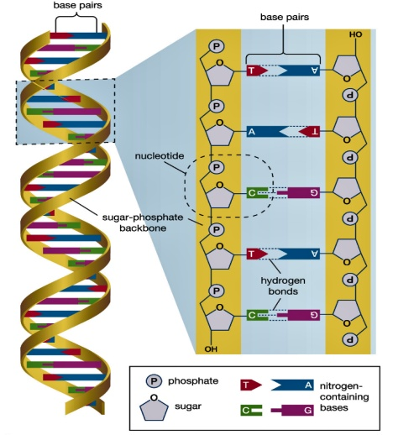

Figure 9

Gene sequencing means finding the exact listing of the nucleobases in the DNA or RNA.

Method of using graph in gene sequencing:

* The tail end of one read must overlap with the front end of another.
* Example:

-----------AC GC-----------

CU-----------

AC-----------

AC-----------

* The final combination that connects all the reads together, that’s a possible gene sequence.

Here we can say each reads is and edge and the sequence has to include all reads which is an Eulerian path. Let’s take one more example of method:

* Suppose RNA is known to be circular. The reads are:

AUC

AUA

CCG

CAU

CGC

CCA

GCC

UCC

UAU

Firstly let’s setup as a graph where all the prefixes and suffixes are nodes and the edges are the reads.

Now let us focus on an Eulerian circuit Graph and now write all the prefixes and suffixes as

Figure 10

AUC AU

AUA

CCG UC UA

CAU   
CGC CC CG

CCA

GCC CA GC

UCC

UAU

Next for each read, connect from its prefix to its suffix. Next let us use Euler’s Theorem to verify this digraph does have an Eulerian circuit.

In a directed graph, if at each vertex, number of incoming edges = number of outgoing edges, an Eulerian circuit exist.

Next find the Euler circuit and get the reads from the Eulerian circuit and combine the overlaps and we will get the gene sequence i.e. AUCCGCCAUAU. That’s how the graph theory helps the covid vaccine by providing a way to do gene sequencing.

# Conclusion

Graph theory is the study of lines and points. It is a subfield of mathematics which deals with graphs, diagrams that involve points and lines and which often pictorially represent mathematical truths. Graph theory is the study of the relationship between edges and vertices. One reason graph theory is such a rich area of study is that it deals with such a fundamental concept that any pair of objects can either be related or not related. What the objects are and what “related” means varies on context, and this leads to many applications of graph theory to science and other areas of math.

In this article, we introduced a study on application of graph theory in gene regulatory, diseases and in large scale of medical field with different types of tools and different types of ways. We also tried to figure it out how the graph is used for producing a vaccine.

##### REFERENCES

1. A. Maedche, S. Staab, “Ontology learning for the Semantic Web. Intillegent Sysytems”, IEEE 16(2), 2001, pp.72-79
2. B. E. Tropp, “Molecular Biology genes to protein”, Third edition.
3. D.R. Swanson, N.R. Smallheiser, “An interactive system for finding complementary literatures”, Artificial intelligence 91, 1997, pp.183-203
4. M. Klein, “Combining and relating ontologies: and analysis of problems and solutions”, IJCAI-2001
5. N. Deo, Eastern, “Graph Theory with applications to engeneering and computer Science”, Economy Edition.
6. T. Gruber, “Toward Principles for the design of Ontologies Used for knowledge Sharing”, International Journal of Human- Computer Studies 43 (5-6),1995, pp.907-928