Bartonella
Bartonella are highly fastidious, slow growing, gram negative bacteria. They have ability to invade mammalian cell and RBC.
It has several types:
Bartonella | Diseases | Reservoir | Transmission
B. henselae | - Cat scratch disease  - Bacteremia  - Endocarditis  - Bacillary peliosis  - Bacillary angiomatosis | Cats and felines | Exposure to cat & cat flies
B. quintana | - Trench fever  - Bacteremia  - Endocarditis  - Bacillary angiomatosis | Humans | Louse
B. bacilliformis | - Bartonellosis  - Oroya fever  - Verruga peruana | Humans | Sandfly

B. henselae
Transimitted by cat scratch or bite.
Cat flies (Ctenocephalides felis) and cat to cat transmission also occur.
Cat starch disease-it has two clinical forms:
- Atypical CSD- As hepatitis, retinitis & splenitis.

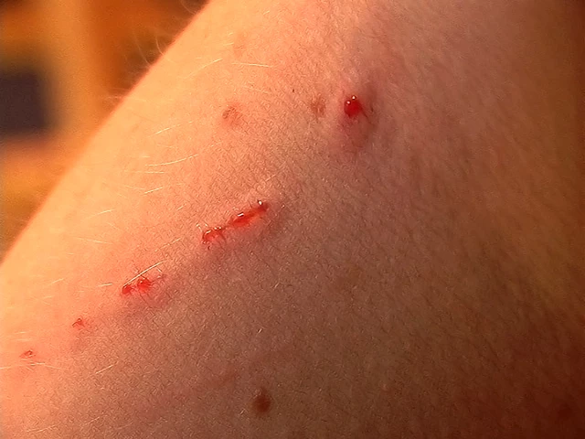
- Typical CSD- most common form. Subacute regional lymphadenopathy and painless erythematous papule develops at site of cat scratch.
Bacillary angiomatosis- angioproliferative disorder as nonvascular lesion involving skin and other organ. Associated with HIV & immunocompromised condition. Caused by both B. quintana (subcutaneous lesion) & B. henselae (hepatosplenic lesion)
Bacillary peliosis- angioproliferative disorder involving liver,spleen /7 lymph nodes
Bacteremia & Endocarditis
B. quintana
It is transmitted to humans by louse feces (autoinoculated into skin due to scratching). It causes Trench fever, chronic bacteremia, endocarditis & bacillary angiomatosis.
Trench fever
Trench fever/quintan fever has two forms:
1. Classical trench fever (5 days fever)
2. Re-emerged trench fever
B. bacilliformis
Transmitted by sandfly (Lutzomyia). Humans are only reservoir.it has two forms:
Oroya fever/Carrion’s disease- bacteremic, systemic illness with or without anemia.
Varruga peruana- cutaneous vascular lesion
Laboratory diagnosis
1.Specimen- blood, lymph node, skin biopsies
2.Microscopy- Imunofluorescence staining and Warthin-Starry silver nitrate staining
3.Culture- blood agar with 5% CO2 at 37°C (30°C for B. bacilliformis) incubated for 12-15 days (max 45 days).
4.Serological diagnosis
Antibody detection
- IFA
- EIA
5.Molecular diagnosis
- PCR
Treatment
Bartonellosis | Antiobiotics
Typical cat scratch disease | Azithromycin
Atypical cat scratch disease | Doxycycline
Trench fever, Endocarditis | Gentamycin
Bacillary angiomatosis & Bacillary peliosis | Erythromycin
Oroya fever | Chloramphenicol
Verruga peruana | Rifampin

