Chapter 3 –Dimorphic Fungi, Molds, and Mold-like Agents of Medical Importance

Objectives:

After finishing this chapter, you should be prepared to:

- Describe general characteristics and structures of the thermally dimorphic fungi at both room temperature and at 37ºC: Blastomyces, Coccidioides, Emergomyces, Histoplasmosis, Paracoccidioides, Talaromyces, and Sporothrix.
- Describe the general characteristics and structures of molds, both asexual and sexual.
- Describe the general characteristics of the mold-like bacteria Actinomyces and Nocardia.
- Define aseptate, coencytic, and septate hyphae.
- Define phaeoid, dematiaceous, and hyaline hyphae.
- List all of the asexual conidia and their associated structures and the sexual conidia and associated structures of fungi.
- Define sclerotic body and fungal granules.
- Plan a basic scheme to categorize the thermally dimorphic fungal pathogens and other molds by growth patterns, hyphae characteristics, and types of infections that they cause.
- Identify the major fungal infections (diseases) caused by the fungal agents in objectives #1-#3.
- Describe the importance of the immune system to protection from fungal disease.
- Discuss the conditions that make someone more vulnerable to serious fungal infection.
- Explain how fungi are involved in allergic disease and which ones are commonly involved.
- Discuss how fungi can cause toxicosis and which ones are commonly involved.
- Discuss the following different types of mycoses:
- Superficial
- Cutaneous
- Subcutaneous
- Opportunistic
- Invasive
- Disseminated/ Systemic
- Describe Maldi-Tof mass spectrophotometry and discuss its use in fungal identification.
- Describe the molecular methods that can be used to identify fungi more safely than the old conversion methods.
- Describe the key characteristics to identify of the pathogenic thermally dimorphic fungi: Blastomyces, Coccidioides, Emergomyces, Histoplasmosis, Paracoccidioides, Talaromyces, and Sporothrix.
- Describe the key characteristics to identify the aseptate or coenocytic mucormycetes.
- Describe the key characteristics to identify the septate opportunistic hyaline molds.
- Describe the key characteristics to identify the septate opportunistic phaeoid molds.
- Describe the key characteristics of superficial ectopic hair fungal diseases, black and white piedra.
- Describe the key characteristics of the superficial ectopic skin fungal diseases, tinea nigra and tinea versicolor.
- Describe the key characteristics to identify the septate hyaline dermatophyte molds.
- Compare and contrast chromoblastomycosis, mycetoma, and sporotrichosis and the agents associated with each.
- Describe the key characteristics to identify Actinomyces spp. and Nocardia spp.
- Discuss the blood serology tests that can be used to detect invasive Aspergillosis.
- Discuss the body sites and specimens that may be cultured to detect fungal infections and which fungi commonly infect which body sites.
- Discuss antifungal susceptibility testing for the organisms in this chapter.
Chapter 3 –Dimorphic Pathogenic Fungi, Molds, and Mold-like Agents of Medical Importance

Introduction to the thermally dimorphic fungi, molds, and mold-like agents of medical importance

This chapter deals with the pathogenic thermally dimorphic fungi (capable of living as a yeast at body temperatures and also as a mold at room temperatures), medically significant molds, and fungus-like (mold-like) bacteria, such as Norcardia spp.(aerobic) and Actinomyces spp.(anaerobic) that cause mycetoma and other pathology globally and their related pathology.
These fungi range from frank pathogens to typically benign fungi that can become opportunists. The dimorphs, particularly these endemic mycoses Blastomyces, Coccidioides, Paracoccidioides, and Talaromyces, are known for their pathogenic abilities and systemic disease. Yet, we must respect the disease-causing ability of some of the other invasive fungi, especially in the compromised host. Aspergillus fumigatus, for example, has enough pathogenic abilities to cause invasive aspergillosis worldwide and is currently #3 on the WHO fungal priorities pathogen list. Some feel it deserves to be moved to the highest rank on the prioritization scale. Beyond having worldwide distribution and concern over growing Aspergillus azole resistance, an invasive aspergillosis diagnosis is the leading mycosis in terms of mortality, followed by a diagnosis of pulmonary aspergillosis that is chronic. (1) Other fungi typically considered benign are seen increasingly as invasive in the compromised host because there are ever-increasing numbers of such patients as life is gradually extended. Most fungal infections arise in the immunocompromised, and many new fungal opportunists exist. However, the majority of fungal invasive infections are in these six categories: aspergillosis, candidiasis (candidosis), cryptococcus, mucormycosis, pneumocystis, and endemic thermal dimorph diseases. (2)

The interrelation of fungal disease and the immune system and progression of fungal disease

A healthy immune system does a lot to protect humans from invasive fungal diseases. If a patient is immune deficient, either temporarily or from a congenital condition, such as a deficit in neutrophils or interferon, it increases their vulnerability to infection. Also, if you have breaks in your skin or mucous membrane surfaces that provide innate protection, the ease of tissue invasion significantly increases. The typically effective immune defenses are why most human fungal infections are just on the outside layers of skin, nails, and hair, and the outside layers of the mucous membranes. Agents that grow primarily on top of the surface of the skin or hair are termed superficial fungi. Those that grow into the external layers of skin, nails, and hair are termed dermatophytes.
Suppose there is a break in the defenses, such as a puncture injury in chromoblastomycosis, mycetoma, sporotrichosis, a deep wound, or an IV-line access site with percutaneous (or through the skin) access. In that case, the fungus can get direct tissue access and invade. Or enough spores are inhaled to allow some to get through and land deep inside the respiratory tract. In that case, the host defenses may be compromised enough that the fungus can get a foothold and grow inside the patient's tissues and organs (it becomes invasive). Once the tissues or organs are infected, the fungi can also easily spread to nearby organs, the entire organ system (in which it has disseminated), or even eventually through multiple body systems and the whole body (it becomes systemic) via the circulatory system, the lymphatic system, and other body fluids. Similarly, a fungus growing in the cerebrospinal fluid around the brain and spinal cord can cause the swelling and infection of the meningeal membranes and can progress to invasive meningitis.
The Thermally Dimorphic Pathogenic Fungi
Blastomyces dermatitidis and Blastomyces gilchristi The genus Blastomyces has two dimorphic fungal species that cause blastomycosis (also known as North American blastomycosis or Gilchrist's disease). Those two species are B. dermatitidis and B. gilchristi. (1) Blastomyces lives in soil and is associated with decayed vegetation. The two species are morphologically identical but are distinguishable by ITS region sequence. (3) The chronic granulomatous disease, blastomycosis, has an initial pulmonary infection. In a little less than half of the pulmonary cases, this pulmonary phase is often followed by a dissemination of the yeast cells from the lungs to other body tissues, especially bone and skin, but also to other organs and tissues. (3, 4) Blastomycosis was long believed to be contained in North America. Recently, however, Blastomyces cases thought to be autochthonous (of local origin) have been reported in Africa, India, Asia, and rarely in Europe, although some of these were subsequently identified as other species of Blastomyces. (5, 6) Dogs can also get fatal blastomycosis from inhalation of spores in the environment.
Histopathology and direst testing: WARNING: This is an RG-3 microbe. B. dermatitidis represents a serious biohazard to laboratory professionals and must be handled only inside a BSCII. Tissue sections and histology smears with B. dermatitidis show large, round, unipolar, single-budding yeast-contained in like cells, with a very broad isthmus (neck where they bud), that vary from 8-15 µm up to even 30 µm in diameter (larger forms). (3) The refractile, thick hyaline cell walls of this yeast often have the appearance of having a space between the fungal cytoplasm and the patient’s tissue when observed from a hematoxylin and eosin stain (H&E). It is sometimes difficult to find and stain the yeast-like Blastomyces cells in H&E-stained preparations alone, so histology slides must also be stained using a Grocott's methenamine silver stain as a second method.
Colonial description: Colonies of Blastomyces growing under 30ᴼC have slightly variable appearances and growth rates. Some proliferate at a moderate rate, producing a fluffy white mycelium, while others grow more slowly (some take up to 4 weeks to grow) as waxy or glabrous, tan, nonsporulating colonies that develop a prickly center, followed by fluffy white or tan growth. Both sporulation and growth may be increased on yeast extract phosphate agar. Most strains have increasingly pleomorphic colonies with age. Colonies on Sabhi with blood 37ᴼC look wrinkled with folds, waxy or glabrous, cream to tan colored, and more yeast-like. It may take multiple subcultures for the thermal dimorphs to finally convert to yeast phase though. Now conversion is not felt to be necessary as these molds are dangerous to work with and molecular and exoantigen testing can easily and more safely identify them. Deaths have occurred among lab workers handling thermal dimorphic fungal pathogens.
Microscopically, the single-celled, hyaline, oval to pyriform, smooth conidia, (2-10 µm) on short lateral or terminal hyphal branches resemble those of Chrysosporium spp. (3) The organism produces the easily identifiable broad-based yeast stage seen in histology (see above) at body temperature, as B. dermatitidis is a thermal dimorphic fungus. Previously, conversion of the mold stage to the yeast stage was necessary to differentiate and identify this endemic pathogen from the non-pathogenic species Chrysosporium and Sepedonium. Exoantigen testing and molecular test methods is now preferred over culture identification to minimize the danger of working with dimorph fungi.
Molecular identification: A DNA probe to identify B. dermatitidis in clinical isolates is available commercially from Gen-Probe, Inc. (San Diego, CA). However, this probe is limited because it may only be used with a pure growth of B. dermatitidis (yeast or mold) from culture. PCR methods are available to identify B. dermatitidis directly from patient samples such as sputum or bronchial washings, and tissue. (7) A real-time PCR targeting the BAD1 gene has been designed to identify B. dermatitidis in tissue samples and from culture. (8) rDNA sequencing for identification from paraffin-embedded tissue has been developed by Morjaria et al. (2015). (9) The United States CDC has a helpful website of information about fungal molecular techniques. https://www.cdc.gov/fungal/hcp/laboratories/settings-for-dna-amplification.html

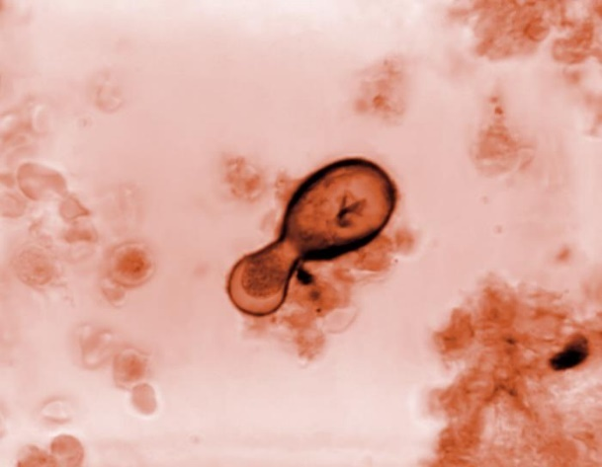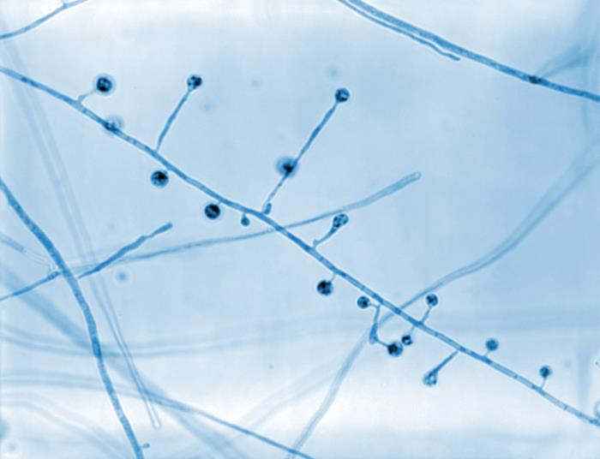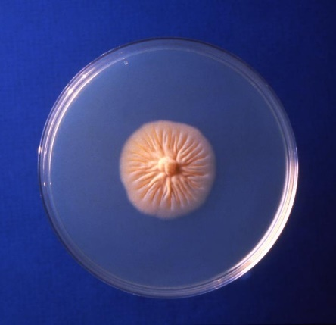
Figure 3-2. 20210 Caption: Under a magnification of 800X, this photomicrograph revealed ultrastructural morphology exhibited by the fungal organism Blastomyces dermatitidis. In this view you are able to see numbers of conidiophores. Note how each conidiophore sprouted directly from the filamentous hyphae in a perpendicular arrangement and that each was topped by a spherical-shaped conidium. CDC/ Dr. Libero Ajello, 1967. Public domain, PHIL library.
Figure 3-1. 20815 Caption: This photomicrograph of a Gridley-stained Congolese tissue sample, under a magnification of 1800X, revealed the presence of a Blastomyces dermatitidis fungal cell. In this view, you can see this yeast-form organism undergoing the asexual reproductive method known as budding, performing an extrusion of its cell wall and internal contents, thereby producing a new cell. CDC/ Dr. Libero Ajello, 1966. Public domain, PHIL library.
Figure 3-3. 17300 Caption: This culture plate contained a growth medium of Sabouraud dextrose agar (SDA), upon which a colony of Blastomyces dermatitidis fungal organisms had been cultured. The specimen from which this culture had been derived, had originated from Africa. CDC/ Dr. Arvind A. Padhye. 1979. Public domain, PHIL library.

Coccidioides immitis and Coccidioides posadasii cause the systemic disease coccidioidomycosis (San Joaquin Fever or Valley fever) and are thermally dimorphic fungi. They are morphologically indistinguishable but can be identified by genetic analysis or their growth rates in high osmotic salt solutions (C. posadasii grows more slowly). C. immitis was traditionally geographically restricted to California, especially California's San Joaquin Valley, and Mexico, whereas C. posadasii is found in Texas, California, Arizona, Mexico, and Latin America. (10, 11) The ranges of these fungi, however, especially C. immitis, are expanding currently due to climate change. These fungal organisms are inhaled as arthrospores (arthroconidia), and can cause acute coccidiomycosis with chills, fever, dyspnea, hemoptysis, and chest pain. Some patients that are infected with Coccidioides though develop a flu-like respiratory illness, while many remain asymptomatic. (9) Cavitation and consolidation are commonly seen on pulmonary imaging studies. In patients that have had previous infection, reactivation of infection and dissemination are possible whether or not they are immunodeficient. The histopathology of pulmonary coccidioidomycosis is suppurative, with many neutrophils seen, and granulomatous. The organisms appear as large, round, thick-walled spherules (sporangia) containing endospores (sporangiospores), that are visible on silver stains. The spherules are 30–100 microns in diameter, and the endospores released into the surrounding tissue mature to become new spherules. Lung cavitating lesions may have hyphae forming and may start to germinate as is also seen in histoplasmosis.

Histopathology and direct testing: WARNING:RG-3 organism. Coccidioides immitis/posadasii represent severe hazards to laboratory personnel and must be cautiously handled only under a BSCII. Coccidioides immitis tissue samples typically show the characteristic large endospore-filled spherules. Younger spherules are clear in the center with peripheral cytoplasm and have a very thick spherule wall. Endospore formation inside the spherule occurs later by repeated cleavage of cytoplasm. Rupturing the spherule disperses the mature endospores into the surrounding tissue, where they then restart the spherule development cycle and re-infect. (11)

Colonial description: This organism is a rapid grower (atypical for a thermal dimorph) and it can even grow as quickly as in 48 hours on blood agar and are often first seen on bacteriology blood or chocolate agar plates rather than in specialized and safer mycology laboratories. Managers and staff must all be trained about the danger of handling these pathogens, and precautions must be used to lessen the risk. There have been lab worker deaths associated with these dimorphs. C. immitis and C. posadasii colonies grown at temperatures under 30ºC may be moist or glabrous when young but rapidly become suede-like or downy, grey-white, cottony or wooly with a tan colony reverse. Great variability in growth rate and colony appearance is seen, however, and the colonies also tend to turn slightly more brown with age.

Microscopy shows unicellular, hyaline, rectangular to barrel-shaped, distinctly alternating arthroconidia, 2.5-4 x 3-6 µm in size, separated by a disjunctor cell containing no spore. (10) Other soil fungi also produce similar arthroconidia, but C. immitis is the only species within the primarily pathogenic fungi that develop this type of alternating arthroconidia Coccidioides immitis and C. posadasii are dimorphic fungi in tissue (at body temperature) they are spherules and endospores (instead of yeast) and in soil or culture at temperatures below 30C, they are mycelial and arthrospore forms. Despite its dimorphism, the spherule/endospore stage is not observed in routine lab culturing, and converting to this phase should not be attempted. Exoantigen testing or DNA sequencing is preferred to minimize risks of this fungal pathogen.

Molecular identification: A DNA probe to identify this species is available. Sequencing the rDNA internal transcribed spacer (ITS) region is reliable for species differentiation of these Coccidioides spp. (11)

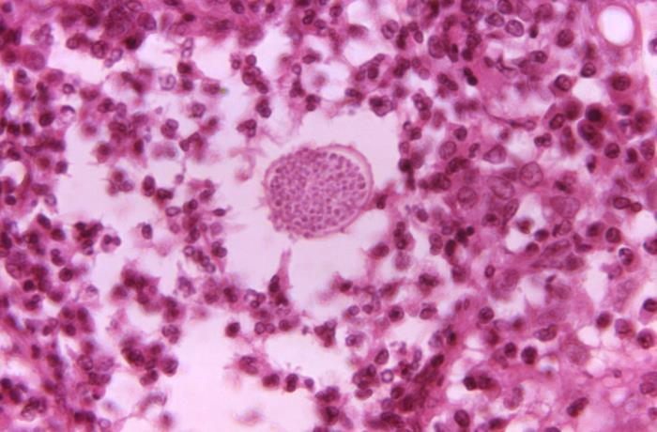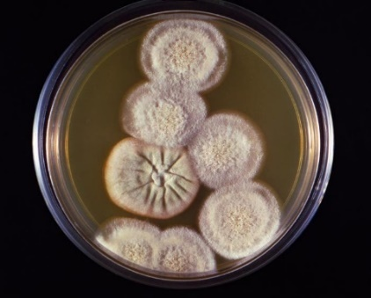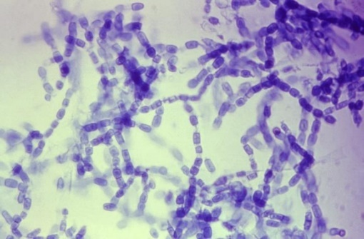
Figure 3-5. 20826 Caption: This culture plate contained an unknown growth medium, which was inoculated during a soil study and gave rise to these colonies of Coccidioides immitis fungal organisms. CDC/ Dr. Libero Ajello, 1966. Public domain, PHIL.
Figure 3-6. 16303 Caption: At 600X, this photo reveals Coccidioides immitis hyphae and arthroconidia. The average arthrospore is 3.0 x 4.5µm, barrel-shaped and they alternate with empty disjunctor cells (with no spores). CDC/ Dr. Brinkman, 1963. Public domain, PHIL.
Figure 3-4. 20526 Caption: At 500X, this photo shows histopathologic details exhibited by a tissue section from coccidioidomycosis case. A mature spherule is visible, which contains numerous endospores that would be released into the patient’s tissues, if the spherule ruptured. CDC/ Dr. Brodsky, 1966. Public domain, PHIL.

Emergomyces (formerly Emmonsia spp.) are dimorphic fungi that cause the systemic disease emergomycosis. These include Emergomyces africanus, Emergomyces canadensis, Emergomyces europaeus, Emergomyces orientalis, and Emergomyces pasteurianus. (12) Emmonsia parva is reclassified to Blastomyces parvus. Emergomyces crescens and Emergomyces sola do not cause disseminated disease but E. crescens is the etiologic agent of a granulomatous lung disease known as adiaspiromycosis. (12) Emergomycosis, a systemic fungal infection caused by the novel dimorphic fungus, Emergomyces species, is only in immune deficient patients. Emergomycosis has been found in immune compromised persons in Africa, Asia, Europe, and North America, and actually is the most commonly diagnosed endemic dimorphic mycete in South Africa. (12) It is assumed to be a global problem because of the number of HIV-positive patients. (12) The diagnosis of emergomycosis is difficult and should also be evaluated when diagnosing histoplasmosis and other dimorphs which are similar. The main infection route is believed to be inhalation of spores released from saprophytic hyphae in soil. In the body, these conidia grow into yeast-like cells that replicate and disseminate to organs other than the lungs. The vast majority of infected patients have advanced HIV/AIDS infection. Other underlying risk factors include neutropenia, hematological malignancies, organ transplantation, and immunosuppressive therapy. In a single case of the disease caused by E. orientalis, there was no immune deficiency except type 2 diabetes mellitus. Emergomycosis is a systemic disease that can involve skin, lungs, liver, spleen, blood, bone marrow, lymph nodes, brain, and cervix. Schwartz et al., in a study from South Africa, reported that 96% of patients with disseminated disease had cutaneous lesions; all of them had low helper T lymphocytes and had profound anemia. (12) Skin lesions with differing morphologies are reported in patients.

Histopathology and direct testing: The Emergomyces have a wide spectrum of microscopic morphologies in histological samples. The yeast phase of E. africanus and most Emergomyces looks like Histoplasma capsulatum with small, narrow-based yeast, while that of E. orientalis can look like Blastomyces dermatitidis. Histopathology can detect yeasts but cannot tell fungal agents apart. Therefore, it is important to identify these thermal dimorph fungi by other methods. Molecular techniques like sequencing are considered better identification tools. Serological tests of these organisms can cross-react with the Histoplasma galactomannan antigen. Inexpensive, accessible, and accurate tests are still needed. (13)

Colonial description: Emergomyces spp. grow readily on routine mycology media like Sabauraud’s dextrose agar, malt extract agar, or potato dextrose agar, incubated at 24–30°C. Colonies are slow growing, yellowish-white to tan, initially glabrous, becoming powdery, slightly raised and furrowed. The colony reverse is pale-yellow, ochre-buff to warm-buff peripherally. Upon subculture to malt extract agar or brain heart infusion agar with blood and incubation at 35°C., yellow-white or tan, pasty, cerebriform colonies appear after 2 or 3 weeks of incubation. (13)

Microscopic morphology of the mold phase in lactophenol aniline blue preparation exhibits slender conidiophores arising at right angles from thin-walled hyaline hyphae, slightly swollen at the tip, sometimes with short secondary conidiophores bearing small "florets" of single-celled oval to spherical conidia. (13) Gram-stained smears prepared from culture plates at 35ºC show small, oval yeast cells with narrow-based budding. However, becareful with identification by appearance, because the mold phase microscopic of E. africanus looks like Sporothrix schenckii in microscopy.

Molecular identification: Sequencing the rDNA ITS region is considered the identification gold standard.(2)
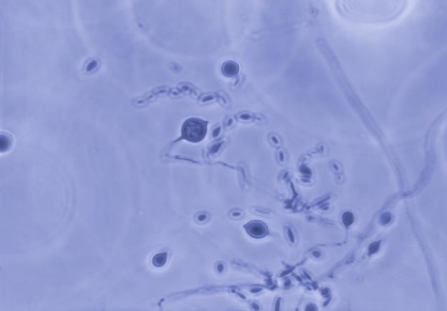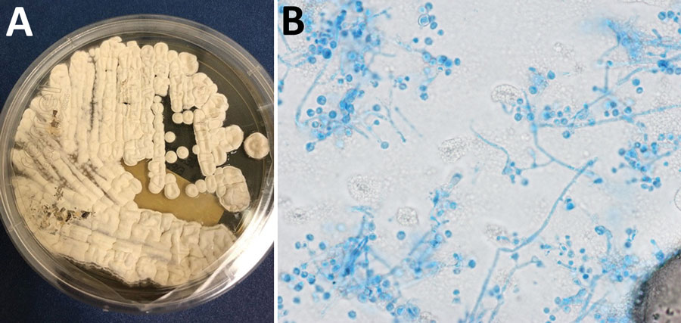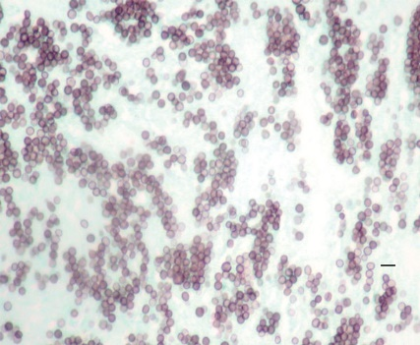
Figure 3-7. 23069 Caption: At 500X, this photo revealed the morphology of Emergomyces (Emmonsia) sp., labeled 45-883-64. Here, you are able to see the organism’s septate hyphae and numerous asexual adiaspores. CDC/ Dr. Libero Ajello, 1964. Public domain, PHIL.

Figure 3-9. Caption: Methenamine silver stain of a mediastinal lymph node biopsy, showing small round or oval yeasts in tissue. An Emergomyces canadensis case Saskatoon, Saskatchewan, Canada, 2003. Scale bar is 10 µm. CDC, Public domain. wwwnc.cdc.gov/eid/article/24/4/17-1765-f1.
Figure 3-8. Caption: Lung nodule biopsy and isolate of Emergomyces pasteurianus fungi in a patient from Liberia. A) Colony morphology at 14 days on Sabauraud’s dextrose agar. B) Lactophenol cotton blue tape prep; original magnification ×1,000. https://wwwnc.cdc.gov/eid/article/29/3/22-1683-f2. Public domain.

Histoplsma capsulatum
The Histoplasma capsulatum complex is a group of dimorphic fungal species that has a global distribution. Histoplasma capsulatum causes the systemic mycosis histoplasmosis (Darling's disease). The Mississippi-Ohio River Valley in America is recognized as its major endemic region. But sporadic cases have been reported as far away as Australia. The fungus has been isolated from soil enriched with bird and bat feces. Histoplasma capsulatum was recently divided into several subspecies that show extensive hybridization, which are difficult to distinguish. In South America, the Histoplasma capsulatum complex has tremendous diversity. Patients may be infected by several different genotypes. Histoplasmosis is a fungal intracellular reticuloendothelial system mycosis caused by inhaling conidia. Most histoplasmosis cases are inapparent or benign. The remaining cases may develop into chronic progressive lung disease, chronic cutaneous or disseminated disease involving multiple tissues and organs, or an acute rapidly progressive and fatal systemic disease. (14) All stages of this disease may look like a tuberculosis infection.
Histopathology and direct testing: WARNING: RG-3 organism. Histoplasma capsulatum represents a severe hazard to laboratory workers and must be only handled cautiously inside a BSCII. The characteristically small yeasts (2-4 microns in size) with narrow-based budding are grouped in clusters inside macrophages at 35-37ᴼC inside the tissues. (15)
Colonial description: Histoplasma capsulatum exhibits thermal dimorphism, growing inside the living host or in culture at 37ºC as a small budding yeast, and in the environment or in culture below 30ºC as a mold. Colonies below 30ºC are slow growing, white to buff-brown, suede-like to cottony or wooly, with a pale yellow-brown reverse. Other types are glabrous or verrucose. Colonies grown on BHI agar with blood at 37ºC are smooth, moist, cream to tan, and yeast-like. (14)

Microscopic morphology at temperatures under 30ᴼC shows the characteristically large, round, single-celled, tuberculate macroconidia (chlamydoconidia), 8-14 µm in diameter, formed on short, hyaline, undifferentiated conidiophores. (14) Small, round to pyriform microconidia, 2-4 µm in diameter, borne on short branches or directly attached to the sides of the hyphae may also be present. (14) Cultures may also only show macroconidia or only microconidia. Colonies grown at 35-37ᴼC have small round or oval budding yeast-like cells, 3-4 x 2-3 µm in size, that are observed microscopically. (14) Depending on the clinical disease, three varieties of Histoplasma capsulatum are recognized: var. capsulatum is the typical agent of histoplasmosis; var. duboisii is the African type; var. farciminosum causes lymphangitis in horses. (14) Histoplasma isolates also resemble Sepedonium and Chrysosporium. Traditionally, identification required converting the mold form to the yeast form by growth at 37ᴼC on enriched media; however, culture identification by either exoantigen test or DNA/RNA sequencing is now the expected technique for safety concerns. (14)

Molecular identification: A multiplex-PCR for identification from cultures has been developed by Eliaset et al. (2012). (14) A loop-mediated isothermal amplification (LAMP) assay for detection directly from clinical samples that is affordable and useful in resource-poor facilities was developed by Scheel et al. (2014). (14) Sequencing the rDNA ITS region may also be used for accurate identification. A MALDI-ToF mass spectrophotometry reference database to accurately and specifically identify Histoplasma capsulatum is also available. (14)
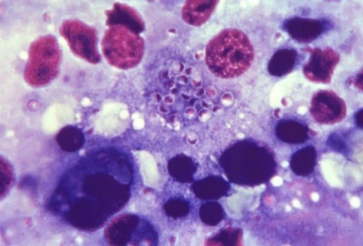 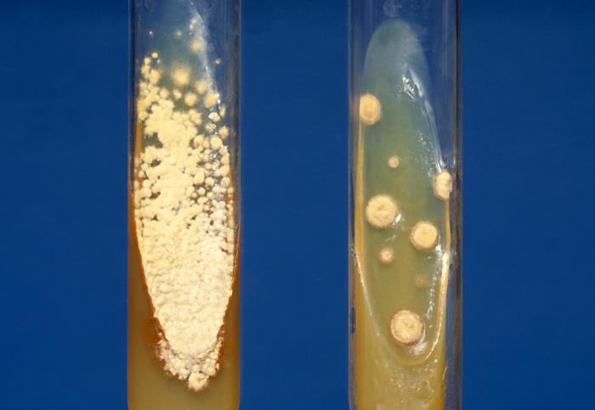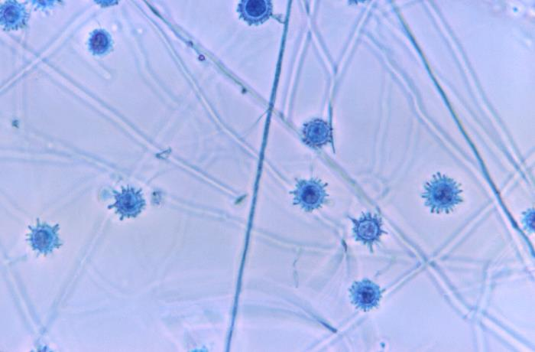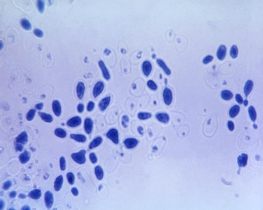shows
Figure 3-10. 22054 Caption: This photo of a liver tissue specimen revealed numerous Histoplasma capsulatum fungal organisms in the yeast stage of development. This was a case of disseminated histoplasmosis. These organisms were of a Tennessee strain, 106-D. CDC/Dr. Lucille K. Georg, 1964. Public domain, PHIL.
Figure 3-13. 20336 Caption: At 1200X and processed using the lactophenol cotton blue stain, this photo shows Histoplasma capsulatum extracted from a yeast phase culture. Note that some of these organisms were undergoing a budding. Public domain, PHIL. CDC/ Dr. Lucille K. Georg, 1967.
Figure 3-11. 4189 Caption: Both cultures were inoculated with Histoplasma capsulatum. The tube on the left contained Sabauraud’s agar, while the tube on the right contained a growth medium known as SABHI agar. CDC/ Dr. Lenore Haley, 1979. Public domain, PHIL
Figure 3-12. 20099 Caption: Under a magnification of 650X, this photo revealed ultrastructural details exhibited by a number of Histoplasma capsulatum tuberculated macroconidia. CDC/ Dr. Libero Ajello, 1966. Public domain, PHIL.
HOL

Paracoccidioides brasiliensis and P. lutzii Paracoccidioides brasiliensis is a thermal dimorphic fungus that causes the systemic disease paracoccidioidomycosis (Brazilian blastomycosis or South American blastomycosis). (16) P. brasiliensis has been subdivided into two species: P. brasiliensis and P. lutzii. P. brasiliensis/lutzii are located in Latin American areas. Both species are alike in appearance except that conidia of P. brasiliensis appearpear-shaped and P. lutzii’s conidia are slightly more elongated. Molecular identification is required for accurate speciation. (16)

Histopathology and direct testing: You can see large, thick-walled, multiple-yeasts in a ring. The yeast cells are narrow-based and budding yeast cells in a "Mariner's wheel" of P. brasiliensis. (3, 16)

Colonial description: Colonies grown below 30ºC are slow-growing and vary in appearnaces but are smooth at first and become folded or glabrous, suede-like or downy in texture, with white to brown aerial hyphae with a tan-brown or yellow-brown reverse. Colonies grown at 35-37ºC are waxy, wrinkled, and cream to tan colored. (3, 16)

Microscopic morphology: Various conidia may be seen microscopically at temperatures under 30ºC, including pyriform microconidia, chlamydospores, and arthroconidia but many times the hyphae are sterile. (1) None of these can identify the species. Often strains grow for lengthy periods producing no conidia. On blood agar at 37ºC, the mold converts into the yeast stage, and then the colonies are white to tan, moist, and glabrous, and become wrinkled, folded, and heaped. Many large, 20-60 μm, round, narrow based (narrow neck) budding yeast cells are present. (16) Single and multiple budding occurs; the latter are thick-walled cells that then form the classical "Mariner's wheel" or "Mickey Mouse" shapes that are classic and diagnostic for this dimorph, especially in methenamine silver-stained tissue. (1) Clinical history, tissue pathology, and culture identification with conversion to yeast phase at 37ºC were used for identification previously but molecular identification is now recommended instead of cultural conversion from the mold into the yeast phase because of safety concerns for lab personnel.

Molecular identification: Sequencing the rDNA of the ITS region is recommended now instead of the less safe practice of culturing for conversion to the yeast phase. (16)
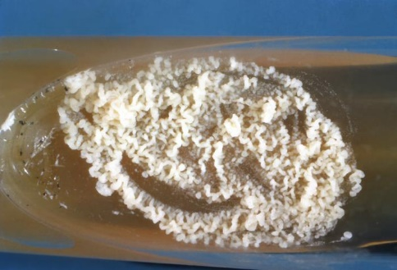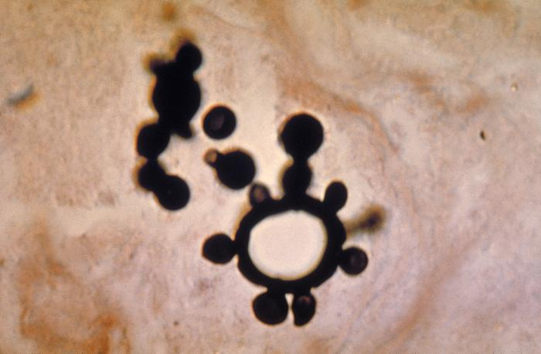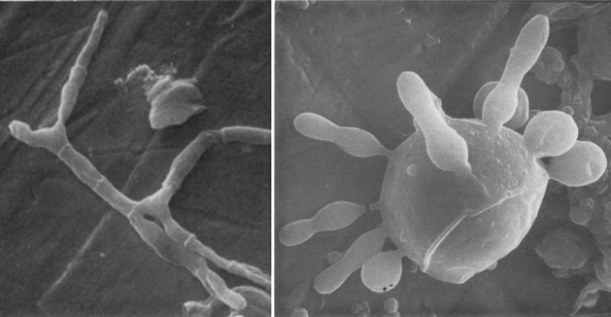
Figure 3-15. 527 Caption: This photo of a methenamine silver-stained tissue sample revealed the histopathology of a case of paracoccidioidomycosis. Note the many multiple buds projecting from one of the Paracoccidioides brasiliensis yeast cells. CDC/ Dr. Lucille K. Georg, 1963. Public domain, PHIL.
Figure 3-14. 4292 Caption: This photo depicts a slant culture of an unidentified growth medium with Paracoccidioides brasiliensis, having an unknown incubation period, gave rise to this yeast phase colony. CDC, 1963. Public domain, PHIL.
Figure 3-16. Paracoccidioides brasiliensis mycelium cells (left) and multibudding yeasts (right) using a scanning electron microscope. The magnifications are ×1,500 for the left image and ×3,000 for the right image. This image was adapted from Vieira e Silva et al. 1974. wwwnc.cdc.gov/eid/article/27/9/21-0461-f2 8/24/21

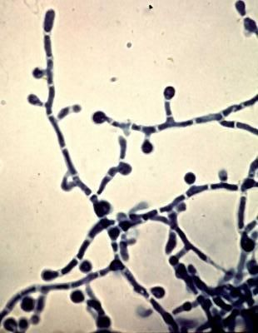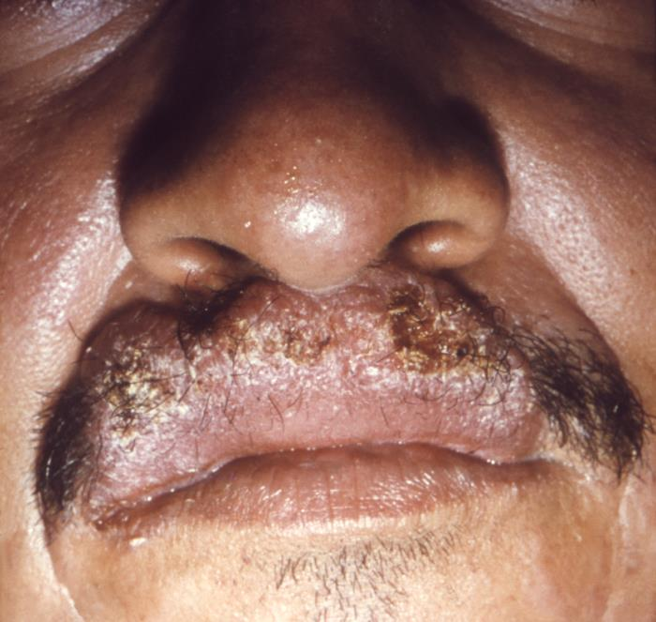
Figure 3-18. 12158 Caption: This image from 1965 depicted a close view of a Sao Paulo, Brazilian man’s face highlighting his nose and lips, and the cutaneous pathologic changes that had involved his upper lip, due of the mycotic infection, paracoccidioidomycosis. Also known as Brazilian blastomycosis, this disease is caused by the fungus, Paracoccidioides brasiliensis. CDC/ Dr. Martins Castro, San Paulo, Brazil; Dr. Lucille K. Georg, 1965. Public domain, PHIL.
Figure 3-76. At left: Paracoccidioides brasiliensis, cause of paracoccidioidomycosis, aka South American Blastomycosis, Brazilian Blastomycosis Tom Volk's
Fungus of the Month.
Paracoccidioides brasiliensis mycelium room temperature mold stage with classic “lollipop conidia” and arthroconidia visible. botit.botany.wisc.edu
https://www.pinterest.com/pin/407505466258594201/

The Sporothrix schenkii complex are dimorphic fungi that cause sporotrichosis (Rose Gardeners disease). It can remain local to the site of the skin puncture, or it can become systemic. It is now recognized that the S. schenckii complex is the five species: S. schenckii, S. brasiliensis, S. globosa, S. luriei, and S. mexicana. (3, 17) The Sporothrix schenckii complex are dimorphic fungi with a global presence, particularly found in both tropical and more temperate areas. Sporothrix is usually present in dirt and on vegetation. It is an established mycosis of humans and in many animals. Sporotrichosis (Rose Gardener's disease) is a chronic fungal cutaneous and subcutaneous tissue infection that also affect the adjacent lymphatics and is characterized by nodular ulcers that ulcerate and are filled with neutrophils. (17,18) Infections are caused by puncture, trauma or other injuries that implant conidia into the tissues through the skin or, uncommonly, by breathing in the conidia. (3,17) Further direct spread to articular surfaces, bone tissue, and muscle tissue are common. If the infection is not treated early, the mycosis can further spread into the central nervous system, respiratory system, genital area, or urinary system. (3, 17)

Histopathology and direct testing: An RG-2 organism. It is recommended to work in the BSCII, especially for any mold. In sporotrichosis, tissue samples often show epidermal hyperplasia on top of a marked inflammatory response. Careful examination of multiple areas of the slide is required to identify the causative organisms as they are often sparse and frequently missed on the direct examination. The organisms are yeast-like and elongated (resembling cigars), or rarely are hyphae in skin. Sporothrix asteroids (densely eosinophilic yeast shapes with a surrounding ray structure of eosinophilic material) may be seen on the H&E stain. Fluorescent antibody staining can increase the sensitivity of direct detection and may help to reveal these organisms, but it is not unusual for them to be missed on direct staining. (19)

Colonial description: Colonies at 25ºC are slow-growing, moist to leathery, or glabrous, with a wrinkled and folded surface. They are initially cream-colored but become dark brown to black with more incubation time as they are dematiaceous. This dark color is enhanced on potato dextrose or corn meal agar. Some strains may produce short aerial hyphae. Conidiophores arise from thin septate hyphae at right angles and are usually solitary, erect, and tapered toward their tips. Conidia are formed in clumps sympodially at the ends of the conidiophore. Their arrangement is often suggestive of a floweret. (3, 17) As the culture ages, conidia are formed singly along the sides of conidiophores and undifferentiated hyphae. Conidia are oval, elongated, 3-6 x 2-3 µm, hyaline, single-celled, and smooth-walled. In some strains, darkly pigmented, thick-walled, single-celled conidia may be observed along the hyphae. (17) This hyphomycete is characterized by thermal dimorphism and clusters of oval, denticulate conidia are produced sympodially on short conidiophores. On BHI agar containing blood at 37ᴼC, colonies are glabrous, white to grey or yellow colored, and yeast-like, containing round, oval, or cigar-shaped budding yeast cells. (3, 17)

Molecular identification: rDNA ITS, D1/D2, β-tubulin, calmodulin, or the chalcone synthase gene sequencing is recommended for species identification. (17) MALDI-TOF MS: A comprehensive reference database to identify Sporothrix species was developed by Oliveira et al. in 2015. (17)

See additional information and images in the Sporothrix schenkii case 1 in the previous chapter.

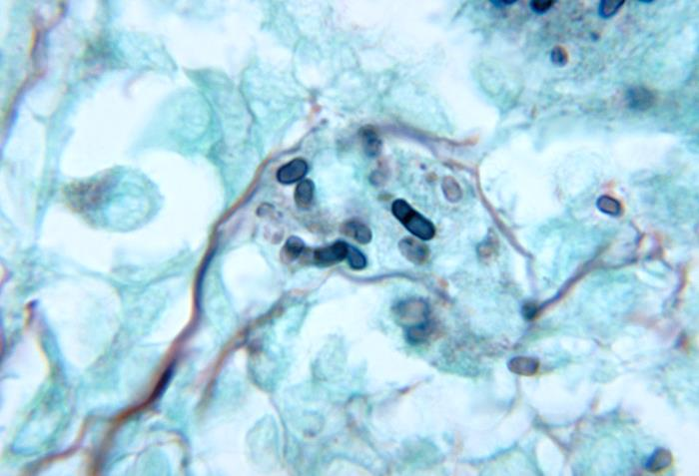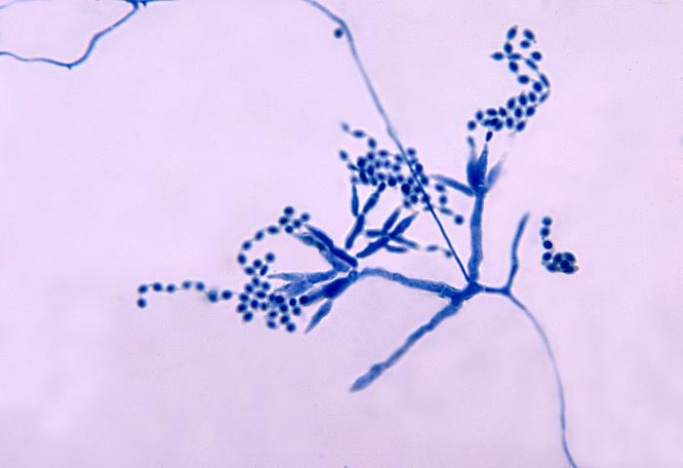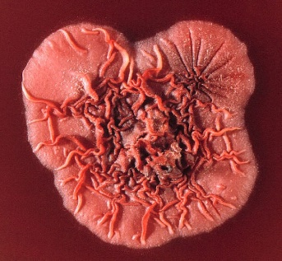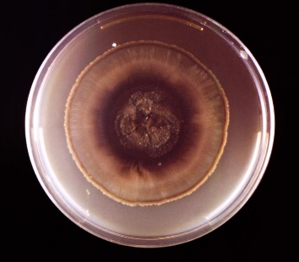
Figure 3-21. Talaromyces (Penicillium) marneffei colony.jpg
The top surface of a Talaromyces (Penicillium) marneffei colony.
James Gathany. Public domain. CDC
[[File:Penicillium marneffei colony.jpg|Penicillium_marneffei_colony]]
November 15, 2011, Obtained via Wikimedia Commons.
Figure 3-22. 19550 Caption: A culture plate that contained an unidentified growth medium, which had been inoculated with Sporothrix schenckii. Note that the colony was a dark brown in its central region, while transitioning into a yellowish-gray moving towards its periphery, and was primarily glabrous or flattened overall. CDC/ Dr. Hardin, 1966. Public domain, PHIL.
Figure 3-20. 4241 Caption: This is a photo revealing some of the ultrastructural morphology exhibited by the mold Talaromyces marneffei, formerly known as Penicillium marneffei, including chains of single-celled, teardrop-shaped conidia, each emanating from its respective, flask-shaped phialide. T marneffei is known to cause a disease known as talaromycosis, formerly referred to as penicilliosis. CDC/ Dr. LiberoAjello, 1972. Public domain, PHIL.
Figure 3-19. 4235 Caption: This is a photo of a mouse testicle tissue specimen, which was processed using methenamine silver stain, and revealed histopathologic changes indicative of an infection known as talaromycosis, formerly referred to as penicilliosis, caused by the mold, Talaromyces marneffei, formerly known as Penicillium marneffei, including globe-shaped yeast cells undergoing multiplication through fission.
Talaromyces (formerly Penicillium) marneffei is a dimorphic fungus that causes the systemic disease penicilliosis (now known as talaromycosis). Patients with impaired cellular immunity due to bone marrow or organ transplantation, steroid treatment, or HIV/AIDS that travel to endemic areas are at risk for Talaromyces marneffei and other endemic molds. (3,19) Talaromyces also occurs in immune competent hosts. T. marneffei is a recently recognized thermally dimorphic mold that has emerged as a common complication for individuals with HIV/AIDS in China, Southeast Asia, and also from Europe, Australia, and America that visit these areas.
T. marneffei is the only thermally dimorphic species in this genus. It is mycelial at room temperature and has a distinctive red diffusible pigment with age. In the hyphal state at 25ºC, the conidia from this mold in the environment are inhaled and then change to a longer yeast form in tissues and body fluids. (3,19) T. marneffei is a predominantly an intracellular pathogen that reproduces by binary fission, not budding, in tissues. Lung alveolar macrophages and blood may contain multiple yeast-like forms with the binary septate cells. The patient’s cell-mediated immunity plays a critical role in host defense, but cytokine-activated neutrophils also provide significant antifungal defense. Impaired activity of pulmonary phagocytes might explain the high talaromycosis rates in environmentally exposed HIV/AIDS hosts.
The bamboo rat has been blamed for the epidemiology of talaromycosis. The bamboo rat is host to and sometimes succumbs to T. marneffei. T. marneffei is found in both bamboo rats and infected humans, but this may be a coincidence. A case-control study revealed that patients with occupational and other exposure to soil, particularly in the rainy season, were more susceptible to T. marneffei infection, while a history of exposure to or eating bamboo rats (the only nonhuman host of T. marneffei), was not statistically a risk factor for infection. This study suggested an environmental soil source for talaromycosis rather than a zoonotic reservoir with both humans and rats as victims of this environmental fungus. (19)
Typical features of HIV/AIDS-associated T. marneffei infection in both adults and children include fever, lymphadenopathy, lung infiltrates, marked anemia, weight loss, hepatosplenomegaly, failure to thrive, and a papular skin rash similar to mollusca contagiosa. (19) Diagnosis of talaromycosisis is straightforward if the classic clinical features are present, and can be further reinforced with isolation of Talaromyces from blood cultures skin lesions, bone marrow, or lymph nodes. (3, 19)
Histopathology and direct testing: WARNING: RG-3 organism. Talaromyces marneffei is a biohazard to laboratory personnel and should be cautiously handled inside of a BSCII. Tissue samples demonstrate small, yeast-like cells, 3 µm in diameter, that are oval to ellipsoidal inside of macrophages or histiocytes or dispersed throughout the tissue. A few large, long, sausage or tube-like cells, up to 8 µm long, with distinctive septae may be seen and these cells divide by fission at the septum for reproduction in Talaromyces. A presumptive diagnosis can be made by these characteristic microscopic findings in stained smears of blood, skin lesions, bone marrow, or biopsy material. (19)
Colonial description: T. marneffei exhibits thermal dimorphism. Colonies at 25ᴼC are fast-growing, suede-like to downy, and white and develop yellowish-green conidia heads. Colonies become grey or pink to brown with age, producing a diffusible soluble red-brown to red-wine colored pigment. (3,19) Colonies are glabrous, tan-colored, and yeast-like on blood agar incubated at 35-37ºC. On the 35-37ºC plate, the colonies grow as yeasts and can be cerebriform, convoluted, or smooth. At 37ºC, there is a decreased production in pigment, and the colonies often appear cream or light tan or light pink in color.
In microscopic morphology, a stained touch smear often shows typical the septate yeast-like cells along with short hyphae, typical phialides, and conidia. (3, 19) Phialides are acerose (needle-shaped) to flask-shaped. Conidia are round, 2-3 µm in diameter, smooth-walled, and are produced in succession from the phialides. (19) Microscopically, yeast cells are spherical to elliptical, 2-6 µm in diameter. Numerous short hyphal elements are also often present. (19) Talaromyces marneffei is the only dimorphic species within the genus, which grows as a yeast-like stage at 37ºC.

Molecular identification: ITS sequencing and β-tubulin for a secondary molecular marker are recommended for identification.

The Opportunistic Molds

Mucormycetes (or zygomycetes) – fungi with aseptate or coenocytic hyphae
The opportunistic molds are a large and truly diverse group. These are molds that are particularly a problem for an immunocompromised patient. Emerging fungal infections arise in a complex mix of differing patients that may have immune deficits, changing climate conditions, and antifungal agent selective conditions. Those fungi that emerge as mycological pathogens are categorized as mycelial fungi (molds), dimorphs, or yeasts first. Filamentous fungal hyphae are also classified further as septate (divided inside by a septum or cross-wall), non-septate (aseptate), or scantily septate (coenocytic). Molds are then further classified as hyaline (transparent or minimal pigment) or dematiaceous (melanin-pigmented or dark). Those hyaline molds that are aseptate or coenocytic belong to the mucormycetes or the group previously known as the zygomycetes. This group is not a taxonomic group now but was formerly the group of fungi in the old division or phylum Zygomycota, which has been dropped. Recently, the taxonomy of this group of fungi has significantly changed, and they are now within the group of fungi termed Fungi incertae sedis (meaning fungi of uncertain taxonomic placement). Two phyla in the Fungi incertae sedis contain the fungi traditionally considered mucormycetes that are opportunistic human pathogens. The first phylum, Mucoromycota, contains most of the classic human opportunistic pathogens of the old mucormycetes: Lichtheimia (formerly Absidia) spp), Mucor, Rhizomucor, and Rhizopus, The second phylum, Zoopagomycota, includes the less common and less famous opportunistic pathogenic genera from the old mucormycetes, Basidiobolus and Conidiobolus. Basidiobolus spp. can cause subcutaneous infections and, less often, can cause intestinal and disseminated disease, and Conidiobolus spp. causes rhino-facial disease. These fungi all have similar aseptate or coenocytic, ribbon-like, broad, and polymorphic hyphae. Rhizopus spp. are the most common cause of mucormycosis (also called zygomycosis) in humans. Mucormycosis is relatively uncommon but can be serious and even often fatal. The Entomophthoromycotina fungal genera, Conidiobolus and Basidiobolus, are human pathogens that infect the nasal submucosa and subcutaneous tissues of the trunk and limbs (lobomycosis), respectively, mostly found in tropical areas. (21) They cause local and seldom cause invasive infections in immunocompetent hosts, and a few recent cases of dissemination and invasive disease in compromised patients have been reported, portending a new role for these organisms as opportunistic pathogens. (22)
Fungal opportunists are numerous and diverse, and the at-risk patient population is growing and continually changing with life-extending medicine, predicting a future with more opportunistic fungal infections. Deficiencies in the number or the functions of neutrophils and other phagocytic cells are associated with a wide variety of opportunistic fungi. (22) T-lymphocyte malfunctions are linked to dimorphic and to opportunistic molds in patients with graft-vs.-host disease or HIV/AIDS. Additional nonimmunological factors include environmental exposure to the fungal agent (ever changing with climate change), pre-existing tissue damage, colonization on mucocutaneous surfaces, indwelling vascular catheters, the use of broad-spectrum antibiotics and antifungals, and parenteral nutrition. Usually, however, it is yeast-like opportunistic pathogens that are seen with parenteral therapy and IVs. Emerging opportunistic molds that cause disease are often indistinguishable from those of Aspergillus spp. as all have airborne and parenteral routes of infection. In addition to infections of cutaneous and subcutaneous tissues, opportunistic molds also commonly affect the sinuses and bronchial tree and have a propensity to disseminate to the central nervous system. (22) Some hyaline molds, including Acremonium spp., Fusarium spp., and Paecilomyces spp. produce various small structures in infected tissues that aid their dissemination.
These various invasive emerging opportunist mold infections are associated with fatality rates that surpass those of the classic opportunists. The diagnosis depends on identifying the organism using culture-based methods because of the lack of medical, radiologic, and pathological features and the absence of laboratory testing. The antifungal therapy of most emerging fungal mycoses are not yet standardized and rely on use of amphotericin B at high doses, surgical measures, and restoring host defenses. (22) However, some organisms are inherently resistant to amphotericin B and require alternate therapies.
The Mucorales cause most cases of mycosis (mucormycosis and phycomycosis). The Mucorales cause severe, deeply invasive mycoses in compromised patients. Rhizopus spp. has been the most reported organism causing mucormycosis, but a rapidly growing list of additional mucormycetes has been reported more recently, such as: Cunninghamella, Apophysomyces, and Cokeromyces, Lichtheimia, Mucor, and Rhizomucor. (22) Cunninghamella bertholletiae was also associated with localized or disseminated infection in those receiving deferoxamine therapy and may also cause mycosis in neutropenic patients and in those receiving itraconazole therapy. (22) While Rhizopus oryzae, causes rhinocerebral mucormycosis in uncontrolled diabetic patients with developed ketoacidosis C. bertholletiae seldom does. (22)
In immune deficient or otherwise compromised hosts, mucormycetes have a high proclivity to invade blood vessels (angioinvasive), inducing a rapidly deteriorating pathology which is resistant to antimycotic agents and with increased mortality. Mucormycosis occurs in neutropenic patients, after transplantation, with steroid therapy, in burn patients, in patients with uncontrolled diabetic ketoacidosis, with deferoxamine therapy, in aluminum overload, in low-birth-weight infants, and in HIV/AIDS patients. (22)
The various tissue sites that these fungi infect are rhinocerebral, pulmonary, cutaneous, abdominal, GI tract, varied other sites, or they cause disseminated disease. (22) Lung, rhinocerebral, and disseminated mucormycosis are the most severe fungal infections and are also frequently seen globally. (22) Rhinocerebral mucormycosis begins as an ethmoid or maxillary sinus infection that expands to the ocular orbit and the cavernous sinus, and eventually invades the brain. Hemorrhagic necrosis due to blood vessel invasion with thrombosis is typical. A black eschar on the palate or the mucosa of the nose and a black eye discharge are expected manifestations of these mycoses. However, these features may also be observed in other mold infections and are not solely mucormycetes related. Other symptoms of rhinocerebral mucormycosis can be a eye irritations, periorbital swelling or numbness, headache on one side, vision changes, nasal blockage or congestion, and epistaxis. The onset of new eye complaints in a diabetic patient, a patient on deferoxamine, or a patient on steroids should prompt investigation for early rhinocerebral zygomycosis. Rhinocerebral mucormycosis progresses rapidly, resulting in death within days, or it may progress slowly. Computerized tomographic scans and magnetic resonance imaging are required to evaluate the degree of the rhinocerebral mucormycosis and to assist in surgical removal of fungal invaded tissue. (22)
Pulmonary mucormycosis with granulocytopenia resembles pulmonary aspergillosis with persistent fever, lung infiltrates, and resistance to treatment. The initial bronchopneumonia is followed by vascular invasion in the lungs and thrombosis, and subsequent blood vessel rupture, with potential dispersion to extrapulmonary sites and severe bleeding. (22) The sensitivity of respiratory cultures (especially sputum with many organisms) is low. The deeper, surgically obtained respiratory specimens are more sensitive and specific In a recent series of studies, a positive culture for mucormycetes was a typical lab finding just before death. (22) The control and normalization of the immunological or metabolic defects precipitating its development are crucial to curbing mucormycoses.
In this chapter, we will not be able to cover all the mucormycetes or related organisms, but the commonly isolated pathogenic mucormycetes will be described.
Lichtheimia corymbifera (formerly Absidia corymbifera)
The most significant species in this genus is Lichtheimia (Absidia) corymbifera. (23) L. corymbifera is the only recognized human pathogen in this genus. (24) Lichtheimia corymbifera is a fairly infrequent etiological agent of mucormycosis. This opportunistic mucormycosis manifests with lung, rhinocerebral, skin, subcutaneous, renal, GI tract, or meningeal, and possibly central nervous system invasion. Disseminated mucormycosis often arises from these infections as this organism is most often systemic, although also often localized in subcutaneous tissue. Mucormycosis is rarely observed in immunocompetent hosts. L. corymbifera is more frequently reported as a pathogen of animals but also causes human disease. (24) Thus, this page will discuss the essential features of L.corymbifera.
Lichtheimia spp. are ubiquitous and also frequent laboratory plate contaminants. Investigation of their significance in the patient when isolated. Growth of Lichtheimia from the medical specimens of patients with immune deficits or diabetes should be considered potentially significant. Finding the typical aseptate hyphae of the mucormycetes on direct microscopic examination of the sample, particularly if it is from a normally sterile body site, is significant even if the culture has no growth. (24)
Histopathology and direct testing: Broad, wide, hyaline, predominantly aseptate or coenocytic ribbon-like hyphae with thin walls are observed. The hyphae are usually not parallel to each other, and the branches occurring at a 90º angle from the hyphae. Fungal invasion of blood vessels is significant. Pyogenic inflammation and abscess formation with suppurative necrosis are seen.
Colonial description: Lichtheimia corymbifera grows rapidly, within four days. The initially flat colonies rise to fill the plate like fluffy cotton candy, with a coarse woolly or cottony texture, and are olive to gray in color. Potato dextrose agar may be used to assist with sporulation. From the top, the colony is grey. The colony reverse is clear or white, without pigmentation. L. corymbifera is thermophilic, and, unusually, grows better at 37°C than at room temperature. The highest temperature that it grows at is 48 to 52°C. L. corymbifera growth is optimal at 35-37°C though.
Microscopic identification from culture: Lichtheimia corymbifera has broad (6-15 µm), ribbon-like and generally aseptate hyphae. A rare septated hyphae might be found (coenocytic). Rhizoids are rare, but when they are seen, they are between the sporangiophores. The sporangiophores arise between the rhizoids on stolons, but on the opposite side of the rhizoids. The sporangiophores are branched and found in groups of 2-5 at these internodes. The sporangiophores may appear arched. Sporangiophores bear pear-shaped, 20-120 µm sporangia with a swelling below the columella (dome-shaped tip of the sporangiophore), known as apophysis (swelling of the sporangiophore just below the columella). (24) A septum is usually present just underneath the sporangium (on the sporangiophore). The columella, the structure at the base of the sporangium, is semicircular. A short collarette may be seen over the apophysis after dissolving the sporangial wall. The sporangiospores are single cells, hyaline to light black, round or oval in shape, smooth or rarely echinulate, and 3-4.5 µm. They are found inside the sporangium and released to the surroundings when it ruptures. (24)
Molecular identification: rDNA ITS sequencing is recommended for identification of the Mucormycetes from infected frozen tissues or cultures. (25)
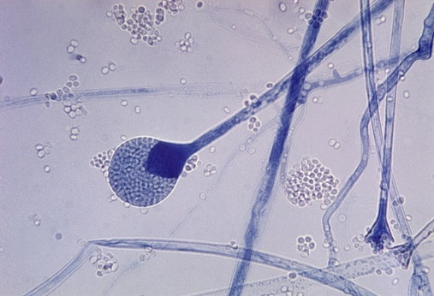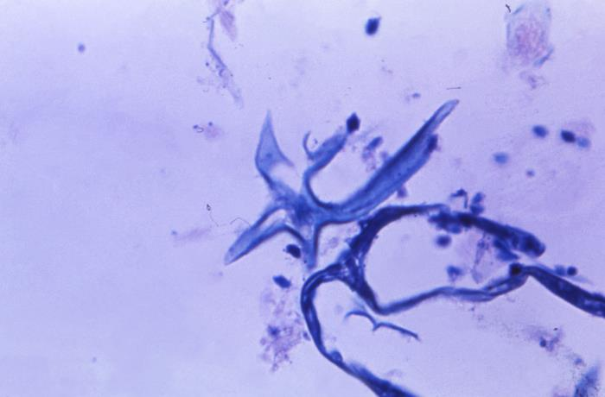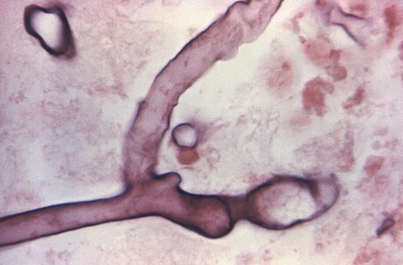
Figure 3-25. 14551 Caption: At 945X, this photo of a hematoxylin-eosin (H&E) stained stomach tissue sample, revealed the presence of a mycelium from an unknown fungal organism, harvested from a patient ill with mucormycosis, otherwise known as zygomycosis. CDC / Dr. Lucille K. Georg, 1964. public domain, PHIL.
Figure 3-24. Under a magnification of 600X, this Giemsa stained photomicrograph of a right ethmoid sinus tissue specimen, revealed ultrastructural morphology exhibited by a Mucor sp. fungal organism, in a case of zygomycosis. Here, you are able to see a number of filamentous hyphae, along with numbers of free-floating sporangiospores. CDC / Dr. Lucille K. Georg, 1964 Public domain, PHIL library.
Figure 3-23. This photo illustrates a mature sporangium of Lichthemia corymbifera (formerly an Absidia spp.) fungus. It is a common indoor mold and is one of the molds that cause the fungal infection known as zygomycosis. The infection typically involves the rhino-facial-cranial area, pulmonary, GI, skin, or, less frequently, other organ systems. CDC/Dr. Lucille K. Georg, 1955. This image is in the public domain. Wikimedia Commons.

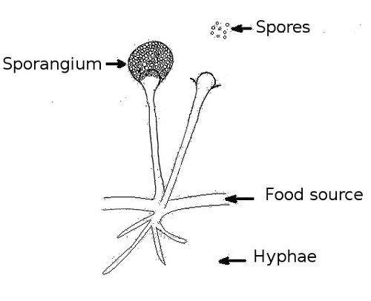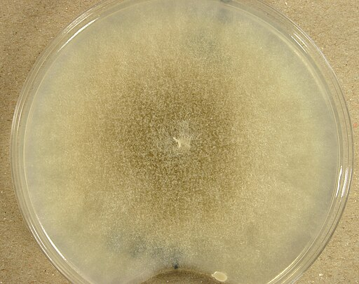
Figure 3-27. Mucor racemosus (UAMH 8346) on potato dextrose agar at 25 °C, grown for 10 days. November 19, 2009, 13:10:47, own work, Author: Medmyco. Creative Commons Attribution-Share Alike 4.0 International license. Obtained via Wikimedia Commons.
Rhizoid
Sporangiophore
Figure 3-26. To the right: The structures of Rhizopus spp. are drawn. For Rhizopus, the rhizoid (root-like structure at the bottom part of the hyphae) is directly under the sporangiophore that holds the sporangium. Sporangiophore and rhizoid added.
(Mucor has no rhizoid. Rhizomucor and Absidia have rhizoids that are between the sporangiophores). Drawing: DZadventiste
Source: https://commons.wikimedia.org/wiki/File:Structure_of_fungus.jpg
License: Public Domain.

Mucor spp.
Mucor is among the fungi that cause the characteristic infection called zygomycosis. However, the term mucormycosis is also used for this angioinvasive disease. Mucormycosis includes mucocutaneous and rhino-orbito-cerebral infections, septic joint disease, otomycosis, peritonitis from dialysis, kidney infections, stomach infections, and respiratory infections. (26) Immunodeficiencies and uncontrolled diabetic ketoacidosis predispose for mucormycosis. Renal failure, burns, deferoxamine treatment, and IV drug abuse may also predispose to development of mucormycosis. Angioinvasion causes tissue necrosis, and perineural invasion is characteristic of these fungal infections. The use of itraconazole therapy for prophyalxis in immune compromised patients may select for these fungi to cause infections. (26)
Histopathology and direct testing: Wide, ribbon-like, thin-walled, hyaline, aseptate or coenocytic hyphae are observed. The hyphae are typically not parallel, and the branches have wide (90º) angles from the hyphae. Blood vessel invasion is significant. Pyogenic inflammation, abscess formation, and suppurative necrosis are observed.
Colonial description: Colonies of Mucor grow quickly at 25-30°C and cover the surface of the agar. Its fluffy appearance, with several centimeters in height, resembles cotton candy (a characteristic of the mucormycetes). From the colony top, the color starts as white but becomes more grey or brown with time. From the colony's reverse side, it is white or pale buff. Rarely, a Mucor species may grow at temperatures as high as 40°C. However, Mucor racemosus and Mucor ramosissimus do not grow well at 35-37ºC and prefer room temperature. (26)
Microscopic identification from culture: Aseptate or coenocytic broad, ribbon-like (6-15 µm) hyphae with sporangia on sporangiophores, containig spores are seen. (26) Intercalary or terminal arthroconidia are located throughout the hyphae or at the tips of the hyphae; some species may also produce sparse chlamydospores. The apophysis, rhizoids, and stolons are absent or typically absent in Mucor species. Sporangiophores are shorter and may form shorter sympodial branches. Columella appear either hyaline or phaeoid. Sporangia are usually round, 50-300 µm, gray or black, and filled with spores. After the sporangia matures and bursts, sporangiospores spread quickly. Mucor sporangiospores are round (4-8 µm in diameter) or occasionally oval. (26)
Molecular identification: rDNA ITS sequencing is recommended to identify Mucormycetes from infected frozen tissues or from culture. (25)
Rhizomucor species
Rhizomucor spp. are among the fungi that cause mucormycosis (formerly zygomycosis), other names for this angioinvasive disease. Blood vessel invasion usually causes necrosis in surrounding tissues and perineural damage, which is characteristic for these mycoses. Mucormycosis is difficult to treat and often fatal.
Human infections due to Rhizomucor spp. are scarce. Skin, respiratory, rhino-orbito-cerebral, and disseminated mucormycosis caused by Rhizomucor pusillus has been identified from neutropenic patients with hematological malignancies and with diabetes. Rhizomucor variabilis has been isolated in cutaneous infections of immune competent people. While human infections with Rhizomucor are rare, infections in animals, particularly bovine mycotic abortion with Rhizomucor, are frequent (27).
Histopathology and direct testing: Wide, ribbon-like, thin-walled hyaline hyphae that are aseptate or coenocytic are visible in infected histology samples. The hyphae are typically at angles, with irregular branching at a 90º angle from the hyphae. Invasion of blood vessels is a significant finding in pathology.
Colonial description: Rhizomucor colonies grow rapidly, rising to fill the culture dish with cotton candy like growth, and mature in four days. The texture is typically fluffy, wooly or cottony. From the colony's top, the colony color is white initially and turns to grey-brown over time. The colony’s reverse side is white-pale buff. Rhizomucor spp., except Rhizomucor variabilis, show good growth at elevated temperatures (up to 54-55 °C) (thermophilic). (27, 28)
Microscopic Identification from culture: The appearance of Rhizomucor is between that of Rhizopus and that of Mucor. Nonseptate or sparsely septate broad ribbon-appearing hyphae, rhizoids that are rudimentary, branching sporangiophores with sporangia containing sporangiospores are seen. If the hyphae have rhizoids, they are scant, and are located between the sporangiophores, but on the opposite side. Sporangiophores are irregularly branched and end in sporangia at their tips. Sporangia (40-80 µm in diameter) are round and brown in color. Apophysis is not observed. Columellae are prominent and spherical to pyriform in shape. Sporangiospores (3-4 µm in diameter) are tiny, single cells, and round or occasionally ellipsoid. Zygospores, if present, are formed in the aerial rather than vegetative hyphae. Zygospores are round to slightly compressed and dark brown to a black-brown. (27)

Molecular identification: rDNA ITS sequencing is recommended to identify Mucormycetes from infected frozen tissues or from culture. (25)

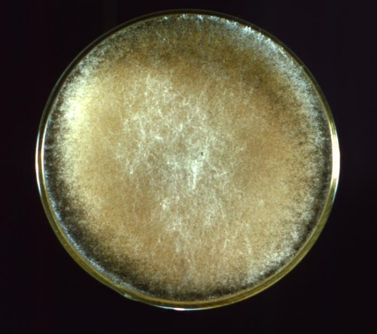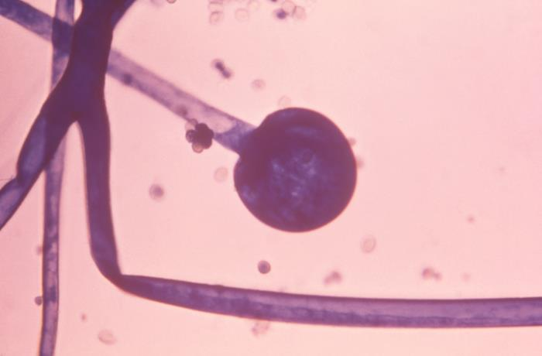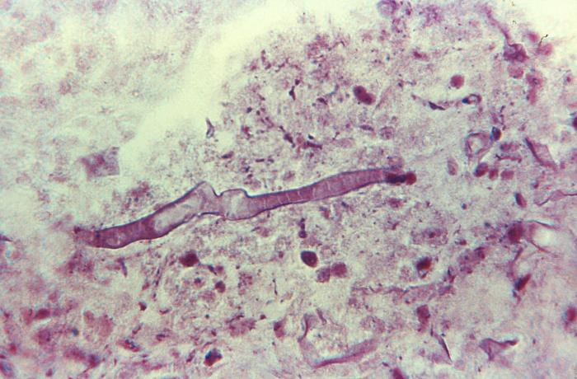
Figure 3-28. This photograph revealed morphology exhibited by a cultivated culture of the fungal organism, Rhizopus oryzae, also known as Rhizopus arrhizus var. delemar. The way in which this specimen filled the Petri dish is characteristic of this rapidly growing fungus. Also, characteristic is the colony’s cotton candy-like texture, and grayish yellow coloration.CDC/ Dr. Lucille K. Georg, 1964. Public domain. PHIL library.
Figure 3-30. Under a magnification of 610X, this photomicrograph of a Gram-stained specimen, revealed the presence of a filamentous mycelium from a Rhizopus sp. fungal organism. The specimen was harvested from a patient ill with mucormycosis, otherwise known as zygomycosis. CDC/ Dr. Lucille K. Georg, 1964. Public domain. PHIL library.

Figure 3-29. Caption: Under a magnification of 600X, this photomicrograph revealed ultrastructural morphology exhibited by an immature sporangium of the fungal organism, Rhizopus oryzae, also known as Rhizopus arrhizus var. delemar. The aseptate broad ribbon-like hyphae, the typical sporangium, and the dark conidia are all present. This specimen was isolated from a patient with a case of phycomycosis (mucormycosis), a form of zygomycosis. CDC/ Dr. Lucille K. Georg, 1968. Public domain. PHIL library.

Rhizopus spp.

Rhizopus spp. are extremely common saprotrophic fungi (classified in the Mucoromycotina and Mucoromycota) that are ubiquitous in soil, animal excrement, rotting plant material, and decaying fruits and vegetables in the refrigerator. Certain Rhizopus species can cause disease in animals, others cause human disease, and some are used as prototype organisms for research or to study biology. (29, 30) Rhizopus spp. are chief among the fungi causing the infections called mucormycosis. The older term zygomycosis is also used. The most frequent cause of mucormycosis is R. arrhizus and the second most common cause is R. microsporus. (30)
Mucormycosis includes mucocutaneous, rhino-orbito-cerebral, genitourinary, gastrointestinal, respiratory, and disseminated infections. (30) As with the other mucormycetes, diabetic ketoacidosis and immunosuppression are key predisposing factors. (29) Deferoxamine treatment, burns, kidney failure, trauma, and IV drug abuse also predispose to mucormycosis. (30) Rhizopus invasion of blood vessels causes necrosis and perineural invasion with tissue death, which are the most frightening complications of these mycoses. Mucormycosis is typically fatal. (30)
Histopathology and direct testing: Broad, ribbon-like, hyaline, often aseptate or coenocytic thin-walled hyphae are observed. The hyphae are typically at angles in histology preparations, and the branches are at 90º angles to the hyphae. Blood vessel invasion is a significant finding. Pyogenic inflammation, abscess formation, and suppurative necrosis are often observed.
Colonial description: Rhizopus colonies proliferate quickly, filling the culture dish with a cotton-candy like mycelium and growing rapidly in four days. The texture is typically cotton-candy-like and wooly or cottony. From the colony's top, the colony color is white initially and quickly turns grey or yellowish brown over time. The reverse side is white to buff. Pathogenic species of Rhizopus can grow well at 37°C.
Microscopic identification from culture: Aseptate or coenocytic, broad, ribbon-like hyphae (6-15 µm) with thin walls, sporangiophores, rhizoids (root-like hyphae), sporangia, and sporangiospores are present. Sporangiophores are brown and mostly unbranched. They are usually solitary but can form clusters. Rhizoids are located where the stolons and the sporangiophores meet, but on the opposite side of the stolon from the sporangiophores. Sporangia (40-350 µm in diameter) are round and are located at the sporangiophore terminus. No apophysis is seen, and there are semicircular columellae. Sporangiospores (4-11 µm in diameter) are single cells, round, smooth or striated, and hyaline to brown.
Molecular identification: rDNA ITS sequencing is recommended for the identification of Mucormycetes from infected frozen tissues or from culture. (25)
Septate hyaline opportunistic molds
Acremonium spp. Acremonium species are ubiquitous in nature and so are frequent lab contaminants. They are hyaline molds that resemble the early growth of Fusarium species when grown in culture. Acremonium produces small conidia on delicate phialides when observed in slide culture. (22) Further incubation does not reveal any macroconidia in Acremonium though, as does Fusarium spp.. (22) Like Fusarium and Paecilomyces spp., Acremonium spp. may produce phialoconidia during infection, facilitating dissemination and recovery from the bloodstream. (31) Acremonium causes a spectrum of infections, ranging from mycotic keratitis, nail infections, and mycetoma in immune competent hosts to fungemia and disseminated infection in the immunocompromised. The lungs and GI tract are the entry sites for infection. Cutaneous lesions may develop during a disseminated infection. (22) Acremonium spp. display little sensitivity to antifungal agents, with the most activity seen with amphotericin B. However, reported amphotericin B MIC values are comparatively high, suggesting resistance to typical doses. Acremonium causes a white-grain mycetoma. Rare cases of Acremonium keratitis, endophthalmitis, peritonitis, endocarditis, meningitis, onychomycosis (nail infection), and bone infection due to have also been reported. This fungus is known for opportunistic infections in immune deficient patients, such as transplant patients. Infections of implant devices with Acremonium spp. are also occasionally reported. (31)
Histopathology and direct testing: The mycetoma grains of Acremonium spp. are regular and oval or round in shape and about 500-2000µm in diameter. Poorly stained dense hyphal groups are seen when infected tissue is stained with H&E. (31)
Colonial description: Acremonium spp. has a moderately rapid growth rate and colonies mature within five days. (31) The texture of the colony is compact, flat, or folded, and the colony center may be raised. It is glabrous or felt-like at the beginning. (31) A powdery texture is soon observed. It then becomes overgrown with white, cottony hyphae. The color of the top of the colony is white, pale grey, pale yellow, or pale pink on its top surface. (31) The reverse side of the colony is either uncolored or has a pigment that is pink to rose-colored. (31) Because Acremonium is everywhere globally, they are most often encountered as lab plate contaminants. Thus, their isolation in culture requires interpretation.
Microscopic identification from culture: Acremonium spp. possess septate, hyaline hyphae, which are fine, delicate, and thin. Hyphae usually form hyphal rope-like forms. Unbranched, single phialides are seen on the tips, or the ropes of the hyphae, or both. The phialides taper towards their tips where the hyaline conidia 2-3×4-8µm in size are found. They usually appear in balls, clumps, or rarely as fragile chains. (31) A gelatinous matrix binds the conidia at the apices. The conidia may be unicellular or multicellular, resemble a small crescent, or cigar shapes with slight curving, (32) The properties of conidia vary for each species. Acremonium falciforme produces crescent shaped, aseptate conidia, composed of two or three cells. Acremonium kiliense has straight, short conidia, and the Acremonium recifei conidia are aseptate and crescent shaped. (31, 32)
Molecular identification: rDNA ITS and D1/D2 region sequencing is recommended to identify Acremonium species. (32)

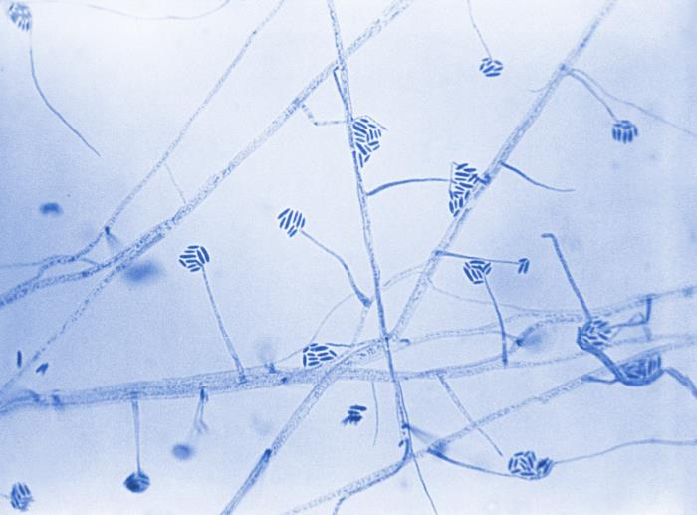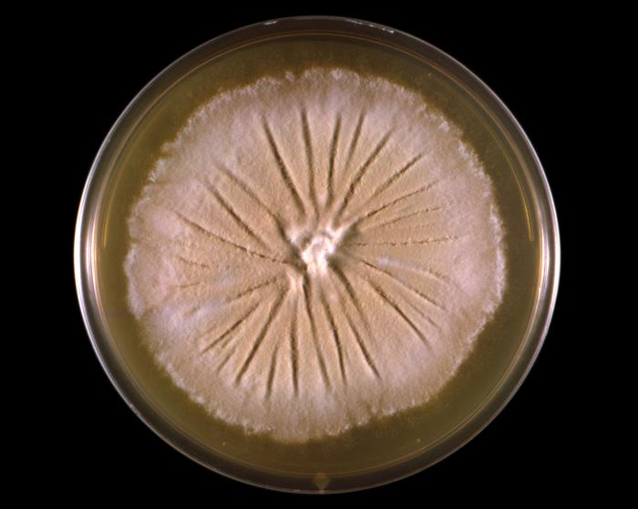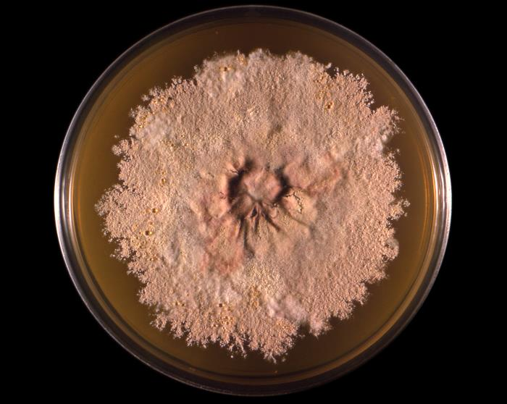
Figure 3-31. 23112 Caption: At 475X, this photorevealed some of the ultrastructural morphology exhibited by an Acremonium sp., formerly referred to as Cephalosporium. Note the organism’s septate, filamentous hyphae, long, slender phialides, each topped by a cluster of cigar-shaped conidia, bundled together by sticky mucous. CDC/ Dr. Hilliard F. Hardin; Dr. Lucille K. Georg,1965. Public domain, PHIL library.
Figure 3-33. 21444 Caption: This photograph depicts a top view of a culture plate with an unidentified growth medium inoculated with Chrysosporium georgiae, previously referred to as Trichophyton georgii. Note that this colony displayed its characteristic flat to powdery surface texture, and a tan to beige coloration. CDC/ Dr. Libero Ajello, 1966. Public domain, PHIL library.
Figure 3-32. 21443 Caption: This photo depicts a top view of a culture plate, with an unidentified growth medium that had been inoculated with an Acremonium spp., formerly referred to as Cephalosporium. In this case, the Acremonium sp. was labeled as the Easter Island-65 strain (EI-65). The colony that had developed exhibited its characteristic appearance, displaying a suede-like texture and gray-to-tan coloration. CDC/ Dr. Libero Ajello, 1966. Public domain, PHIL library.

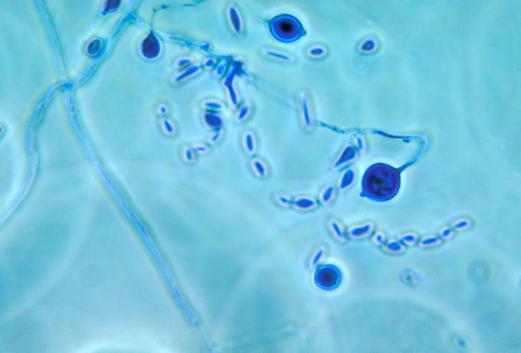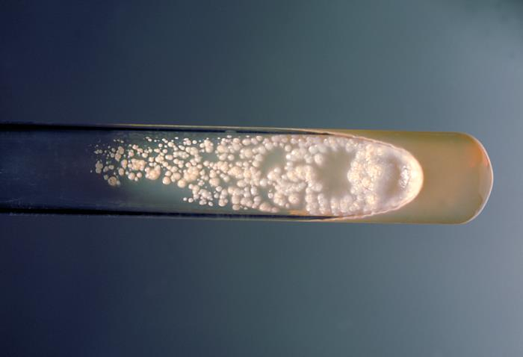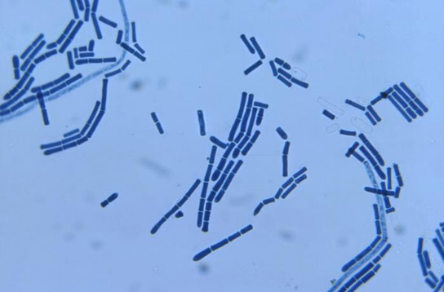
Figure 3-35. 207 Caption: This photograph depicts a slant culture test tube containing a growth medium of Sabouraud dextrose agar, which was inoculated with Geotrichum candidum and incubated for an unknown time at 37°C.
Figure 3-34. 3925 Caption: This photomicrograph depicts both fungal spores and larger adiaspores of what may have been a Chrysosporium spp. organism. CDC/ Dr. Libero Ajello, 1964. Public domain, PHIL.
Figure 3-36. 22967 Caption: At 400X, this was a photo of a slide culture specimen under bright field illumination with lactophenol cotton blue (LPCB). The ultrastructure morphology of Geotrichum candidum is highlighted. In this view, you are able to see both singular, and chains of arthroconidia. CDC/ Dr. William Kaplan, 1969. Public domain, PHIL library.

Aspergillus spp.

Aspergillus is an extensive genus with 250 species. (33) These are currently classified into seven subgenera, in several sections of related species. (33) Aspergillus spp. are ubiquitous molds in home and hospital environments. Aspergillus spp. are widespread in the environment, on plants, in decaying organic matter, in soil and dust, in air and aerosols, in animals, and in freshwater and marine environments. Aspergilli are also found indoors in buildings, in the air, in dust, on household appliances, on food, in refrigerators, and in drinking water. Upon isolation in laboratory culture all of these environmental molds must be evaluated as to their significance and whether it is actually present in the patient causing disease or whether it is a contaminant. Microbiology laboratories have relied on appearance-based identification methods to identify Aspergillus species. A number of species, however, have similar morphologies, which has allowed species to be misidentified. To avoid this, experts have clustered those species with identical appearances into species complexes so laboratories may more correctly use identification based on morphology. (33) Aspergillus spp. cause infections in both animals and humans.
Aspergillus spp. is associated with three different clinical conditions in humans: (i) infections (opportunistic) (ii) allergies and (iii) and toxicoses. Immune deficiency is the primary factor for the development of opportunistic infections. These infections may present in a diverse spectrum, varying from local conditions to dissemination as aspergillosis. Aspergillus is the most common mold isolated in invasive infections. Following the Candida species, it is the second most frequently recovered fungus of any type in opportunistic mycoses. It is the most lethal of the opportunistic mycoses globally. The most common species responsible for aspergillosis are A. fumigatus, Aspergillus flavus, and Aspergillus terreus. (32)
Almost any organ or system in the human body may be involved in aspergillosis. Onychomycosis, cutaneous aspergillosis, rhinosinusitis, cerebral aspergillosis, meningitis, myocarditis, otitis, keratitis, endocarditis, pulmonary aspergillosis, osteomyelitis, endophthalmitis, hepatosplenic aspergillosis, Aspergillus fungemia, and disseminated aspergillosis are seen in severe cases. Even nosocomial aspergillosis due to catheters and other devices is also a potential problem. Construction in hospital environments constitutes a risk for aspergillosis, particularly in neutropenic patients. Aspergillus spp. may also be local colonizers in previously developed lung cavities due to tuberculosis, sarcoidosis, bronchiectasis, pneumoconiosis, or neoplasms, and cause a distinct clinical syndrome called aspergilloma. Aspergilloma may also occur in the kidneys. (34)
Some Aspergillus antigens are allergens that initiate allergic pulmonary aspergillosis in atopic hosts. Aspergillus spp. produce various mycotoxins. These mycotoxins, have been proven to be carcinogenic, particularly in animals. Aflatoxin is a well-known cause of liver carcinoma. (33) Aspergillus flavus produces aflatoxin that contaminate foods, such as peanuts, for example. Ingestion of a large amount of aflatoxin may induce lethal effects in poultry that are fed toxin containing grain.
Histopathology and direct testing: On PAS-stain, Aspergillus spp. in patients with chronic granulomatous disease show 45º angle branching hyphae inside giant cells. Bulbous hyphal ends are sometimes found in the histology slides of Aspergillus spp. infections.
Direct serological galactomannan (GM) testing of bronchoalveolar lavage fluid (BAL) is valuable for earlier diagnosis of invasive pulmonary aspergillosis patients and is superior to GM serum testing. Testing for the beta-(1,3)-d-glucan (BG) molecule is a helpful direct test for Aspergillus infection. The beta-(1,3)-D-glucan (BDG) test is a serological blood test that detects a fungal cell wall component, specifically beta-(1,3)-D-glucan, which can be found in many fungi, including Aspergillus species. It's used to assist in diagnosing invasive fungal infections, especially aspergillosis.
Colonial description: Aspergillus spp. are hyaline molds that show characteristic conidial heads with flask-like phialides arranged in a circle or semicircle on a vesicle (enlarged structure at the end of a condiophore). Colonies are usually fast-growing, white, yellow, yellow-brown, brown to black, or most often shades of green on the top of the colony, mainly consisting of a dense felt of erect conidiophores. The colony reverse if buff colored. (33) For morphological identification, isolates grown on Czapek Dox agar, malt extract agar, or potato dextrose agar and incubated at 25C. Most species sporulate within seven days. Descriptions are primarily based on the colony pigmentation and the appearance of the conidial head. Microscopic mounts are best made using clear cellophane tape or slide culture preparations mounted in lactophenol cotton blue (LPCB). Adding a drop of alcohol to the LPCB prep is helpful to remove bubbles and excess conidia. Also, since Aspergillus spp. are ubiquitous, they are common laboratory contaminants and when isolated must be evaluated for significance.
Microscopic identification from culture: Conidiophores end in a swollen vesicle that has either a single layer of phialides (uniseriate) or a layer of cells (metulae) that bear small spirals of phialides (biseriate structure). The conidial head is formed by the vesicle, phialides, metulae (if present), and conidia. (34) The conidia are single-celled, smooth or rough, hyaline, or pigmented, and they are produced in long chains that are separate (radiate) or aggregated in compact columns (columnar).
Molecular identification: MALDI-TOF MS: Rreference spectra will accurately identify Aspergillus spp. even within their complexes. ITS rDNA sequencing is used to identify the species to the complex level only. For definitive identification, the inclusion of the β-tubulin, calmodulin, and actin genes are also required. (34)
Aspergillus fumigatus
Humans usually inhale the spore form of the fungi. Disease is generally seen in immunocompromised patients. The immune system plays an essential role in recognizing the foreign inhaled mold antigen/allergen, controlling its growth, and regulating the body's allergic and inflammatory responses to the infection. High mortality rates often accompany aspergillosis; therefore, early diagnosis and treatment of immune compromised patients is essential. The most frequent
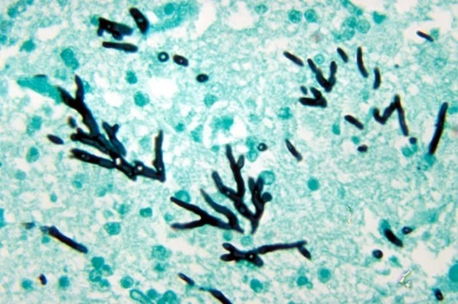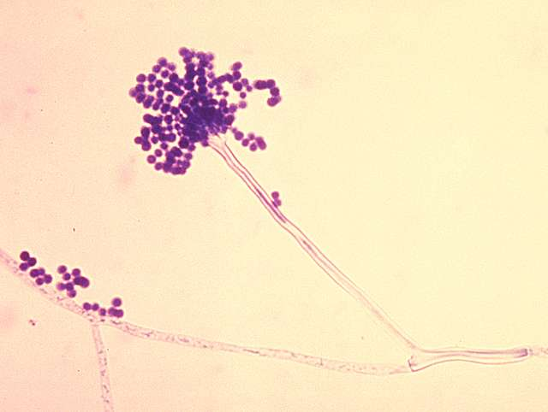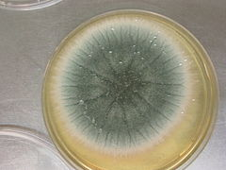
Figure 3-39. 070522-aspergillus 009.jpg
kolonie van Aspergillus fumigatus (macroscopie, schimmel) eigen werk
photo: Jankaan at Dutch Wikipedia
Creative Commons Attribution-Share Alike 3.0. 25 May 2007
[[File:070522-aspergillus 009.jpg|070522-aspergillus_009]] Obtained via Wikimedia Commons.
Figure 3-38. Summary: PHIL ID#: 300 Conidia: phialoconidia of Aspergillus fumigatus. Public domain, CDC 2016. Link: http://commons.wikimedia.org/ Obtained via Picryl Public Domain Media.

Figure 3-37. This is a photomicrograph of a methenamine silver stained turkey poult brain tissue sample, which revealed histopathologic changes in a case of aspergillosis, due to the fungal organism, Aspergillus fumigatus, including the presence of numerous, darkly stained hyphae showing acute angle (< 45°) or dichotomous branching and septate hyphae.. CDC/ Dr. Lucille K. Georg, 1972. Public domain, PHIL.

species responsible for aspergillosis is A. fumigatus. Its life cycle in nature depends primarily on asexual reproduction. Conidiophores create and hold the asexual conidia, that are later released into the air. Conidia are dispersed for fungal growth and for preserving the genome in a stressed environment. On average, humans inhale up to a few hundred conidia each day. Species prevalence has changed over the past decade. A. fumigatus was thought to be the culprit of 90% of aspergillosis previously, but in recent studies, the A. fumigatus species complex causes about 60% of aspergillosis, followed in frequency, respectively, by A. flavus, A. niger, and A. terreus. (33) This change may be because of improved laboratory identification techniques or due to a shift in the species of Aspergillus in the environment. Host defenses against inhaled conidia start with the mucous layer and the respiratory tract's innate ciliary system beating material out of the respiratory tract (this ciliary system is damaged in diseases such as cystic fibrosis and asthma). Macrophages are critical in fighting fungi and typically activate upon recognizing fungal cell wall components such as the beta-D-glucan, and secrete inflammatory cytokines to attract neutrophils and initiate both innate and cellular immunity to fight these fungi.
Aspergillus infections are common in the lungs, sinuses, and skin. The cardiovascular system and central nervous system may be involved by either direct adjacent or hematogenous spread of this fungus. Invasive pulmonary aspergillosis is usually found in patients with severe long term neutropenia, steroid use, inherited immunodeficiency, use of immunosuppressive medications, transplant patients, and HIV/AIDS patients. Aspergillosis is an infection with histopathological confirmation and a positive specimen result from a normally sterile site. Other types of Aspergillus disease, such as allergic bronchopulmonary aspergillosis (ABPA), and allergic sinusitis are important causes of morbidity but are seldom life-threatening. Many species of Aspergillus produce toxins (aflatoxins, mycotoxins 3-nitro propionic acid, and ochratoxin A), which inhibit macrophage and neutrophil phagocytosis as well as causing cancer.
The neutrophil dysfunction and neutropenia is directly proportional to the immune dysfunction and to the disease severity. Chronic steroid treatment also results in lack of macrophage and neutrophil function. The disease risk and type of disease are secondary to impaired phagocytosis, and other functions of phagocytes. Vascular invasion can also occur if fungal cell surface components bind to the blood vessel wall components, ultimately resulting in infarction or hemorrhage, followed by necrosis, and tissue death. Chronic necrotizing lung aspergillosis is characterized by alveoli filled with fluid or other material and granulomas (alveolar consolidation).
Histopathology and direct testing: Aspergillus in tissue shows acute angle (< 45°) (dichotomous) branching and septate hyphae, 2.5 - 4.5 µm in diameter on histology slides. Aspergillus has a genus-specific fruiting body that develops from mycelia in areas with a high oxygen tension (e.g., lung, sinus cavities) composed of a vesicle and either one (uniserate) or two layers (biserate) of phialides that produce conidia, depending on the species. It does not develop in tissue. Since histomorphology alone is not accurate for identification, definite classification should be based on microscopic culture appearance or molecular testing. Serological galactomannan and the beta-(1,3)-D-glucan (BG) test are rapid tests for invasive aspergillosis as above. Imaging studies are performed. Biopsies have the risk of bleeding, which is why noninvasive testing is usually the initial step. These include serum biomarkers and sputum analysis. If additional information is needed for diagnosis, then invasive techniques like a biopsy are warranted, bronchoscopy, BAL collection, or video-assisted thoracoscopy surgery.
Colonial description: RG-2 organism, please work under a BSCII for safety. On Czapek Dox agar, Aspergillus fumigatus colonies are usually blue-green with a suede-like surface of dense conidiophores. This color is strongly associated with this species.
Microscopic identification from culture: Conidial heads are columnar (up to 400 x 50 µm) but generally shorter and smaller, and the vesicle is uniseriate. Short, smooth conidiophores with a cone-shaped terminal vesicle and one row of phialides on the upper two-thirds of the vesicle that curve to be roughly parallel to each other are seen. Conidia are produced in succession, forming long chains, and are round (2.5-3.0 µm in diameter), green, and slightly rough. This species is thermotolerant with a maximum growth temperature of 55ᴼC.
Molecular identification: MALDI-TOF MS is accurate with an 'in-house' collection of sufficient reference spectra to allow identification of the Aspergillus spp., even those in the complexes, e.g., A. fumigatus. Sequencing of the rDNA ITS is recommended to identify to the species complex level only. To definitively identify this fungus, β-tubulin, calmodulin, and actin gene sequencing are also required.
Chrysosporium spp.
Chrysosporium spp. can cause cutaneous infections and nail infections in humans. Several species of Chrysosporium are keratinolytic, and some are thermotolerant. In addition, it has been frequently isolated from systemic infections of bone marrow recipients and patients with chronic granulomatous disease (35). Systemic Chrysosporium infections are noted for high mortality. (36) Species of Chrysosporium are cultured from skin and nail scrapings, especially from the feet and toes, but they are common soil microbes too, so they are often considered contaminants and require evaluation of significance when isolated. (33) The colonies may closely resemble Trichophyton spp. Other strains can resemble Histoplasma spp. or Blastomyces spp. (33)
Histopathology and direct testing: A biopsy of the lesions showed granulomatous tissue. In addition, histopathology slides show a few short and thick hyphae in the lesions.
Colonial description: The colony morphologies of Chrsosporium spp. vary greatly. Chrysosporium colonies grow moderately rapidly (mature at about 5 days) below 30°C. They may be cottony, wooly, or granular, with waxy areas, and flat or raised and folded in appearance. From the top, the typical colors are white, cream, yellow, or tan to beige, but they can also be pink, orange, or grey. The colony reverse side is white to tan.
Microscopic identification from culture: Chrysosporium hyphae are septate, and the conidia are hyaline, broad-based, one-celled, and smooth- or rough-walled. These conidia are broader than the vegetative hyphae and occur terminally on pedicels, along the sides of the hyphae, or in intercalary positions (within the hyphae). Arthroconidia are abundant and larger than their parent hyphae in diameter. Additionally, Chrysosporium parvum can form enlarged, thick-walled cells called adiaspores at 37-40°C, while some species cannot grow at 37ºC. Non-specialized conidiogenous cells produce hyaline, one-celled conidia directly on vegetative hyphae. Conidia are typically pear-shaped to club-shaped with truncated bases and are formed either from hyphae (as arthroconidia), laterally (often on pedicels), or terminally. Conidia are numerous, clavate to pyriform, smooth (6-7 x 3.5-4 µm), and have broad bases. The conidia are formed at the tips of the hyphae, on short or long lateral branches, or are sessile along the hyphae. No macroconidia or hyphal spirals are seen.
Molecular identification: ITS sequencing can assist in the identification of clinical isolates.

Fusarium spp.
The most common species in the genus Fusarium are Fusarium oxysporum, Fusarium solani, and Fusarium chlamydosporum. (36, 37) Fusarium spp., which was previously considered to cause only infections of the skin, nails, and cornea (keratitis), is now an emerging opportunistic hyaline molds that cause sinopulmonary and disseminated disease, particularly in granulocytopenic patients (such as undergoing antileukemic chemotherapy or stem cell transplantation). (36) Fusarium spp. has emerged as the second most common opportunist fungal pathogen after Aspergillus spp. in some cancer centers. (36) Fusarium spp. are common and are characterized by its distinctive large canoe-shaped macroconidia.
The major entry points for Fusarium spp. conidia are the lungs, paranasal sinuses, IV catheters, and breaks in the skin. (22) Humans' defenses depend upon pulmonary alveolar macrophages as a first line against fungal conidia and neutrophils for their defense against hyphae. (22) In immune compromised patients, neutropenia is the most critical risk factor, with corticosteroids further impairing and predisposing to invasive fusariosis. Similar to Aspergillus, Fusarium is highly invasive in blood vessels and leads to hemorrhagic infarction in pancytopenic hosts. (22) Fusarium spp. can produce lethal mycotoxins, especially in crops.
Invasive fusariosis presents with continual fever in profoundly neutropenic patients. Apart from sinusitis, established infections are characterized by lung infiltrates, skin lesions, and dissemination to multiple tissues and organs. As a result of adventitious sporulation in tissues as a mechanism for dissemination, Fusarium spp. can also be recovered in blood cultures. (34) Histopathological examination is often nonspecific, with only septate hyaline branching hyphae, so it is difficult to distinguish from other hyaline molds. Thus, definitive diagnosis still relies on culturing the organism from infected tissues or the bloodstream. (22) PCR techniques to detect Fusarium spp. earlier in blood cultures or bronchoalveolar lavage samples and simultaneously identify it are improving and should soon be available. (22, 34) Overall death rates with invasive Fusarium spp. are from 52 to 70% and are close to 100% in patients who do not recover from neutropenia. (34) Rapid recovery from neutropenia is necessary for survival so granulocyte colony stimulating drugs to support neutrophil production are critical. However, while recovery from neutropenia is necessary, it may not be sufficient for survival, as the fungal infection may continue progressing faster than the drugs stimulate neutrophils. In other cases, chronic disseminated infection may follow, similar to chronic disseminated candidiasis. (22) Newer neutrophil producing hormone therapies and antifungals offer some hope.
Histopathology and direct testing: Although definitive identification of these fungi requires culture, they often can be identified tentatively in tissue sections by a combination of histologic features, including hyaline septate hyphae and characteristic reproductive conidia and their related structures.
Colonial description: Fusarium spp. usually grow rapidly (within four days) on Sabdex agar below 30°C and produce woolly or cottony, flat, and spready growth. The one slow-growing species is Fusarium dimerum. On the colony top, the color may be white, cream, salmon, cinnamon, tan, yellow, red, violet, pink, or even purple. On the colony reverse side, it may be colorless, tan, red, or purple. (38) Colonial description: Colonies are usually fast-growing, pale or bright-colored (depending on the species) with or without the production of a cottony aerial mycelium.
Microscopic identification from culture: The species of Fusarium typically produce both macroconidia and microconidia on their phialides. The macroconidia are hyaline, two to several-celled, fusiform to sickle-shaped. The microconidia are one or two-celled, hyaline, smaller than macroconidia, pyriform, fusiform to ovoid, and straight or curved. Chlamydospores may or may not be present. (36) Fusarium spp. is often tricky to identify because of species variability (e.g., the conidia size or colony characteristics) and because not all required features are always well developed. (36) Sporulation may need to be induced on a sporulation media for some of the species. Critical characteristics used in the identification of Fusarium species are as follows: The colony growth diameter and pigmentation on potato dextrose agar, the size and shape of the macroconidia, the presence or absence of microconidia and their shape and type of formation, and the presence or absence of chlamydospores. The charactereistic hyaline septate hyphae, phialides, conidiophores, macroconidia, and microconidia are observed for microscopic identification. Chlamydospores are seen in Fusarium chlamydosporum, Fusarium napiforme, Fusarium oxysporum, Fusarium solani, and Fusarium sporotrichoides. Phialides are cylindrical, and either solitary or part of a branching system. (38) Phialides produce macroconidia (3-8 x 11-70 µm) on either unbranched or branched conidiophores. Macroconidia are made of two or more cells, and are thick-walled, smooth, and cylindrical, sickle, or canoe-shaped. Macroconidia have pointed ends and a recognizable basal foot cell. They usually accumulate in clumps or rafts. (38) The microconidia (2-4 x4-8 µm) are formed on long or short conidiophores. They are single-celled, smooth, hyaline, oval to cylindrical, and arranged in balls (occasionally in chains). Chlamydospores, if present, are sparse and are thick-walled, hyaline, intercalary, or terminal. (38)
Molecular identification: Species identification is currently based on multilocus sequencing data. FUSARIOID-ID (www.fusarium.org ) is an internet database to identify fusaria via ITS or multilocus nucleotide BLAST queries. It is available from the Westerdijk Fungal Biodiversity Institute. 28S rRNA gene sequencing is used to identify Fusarium at the species level more rapidly. (33)
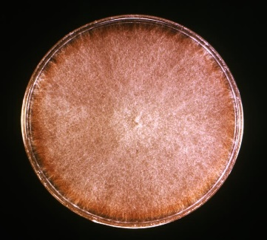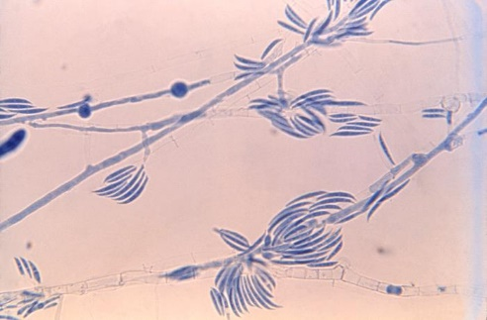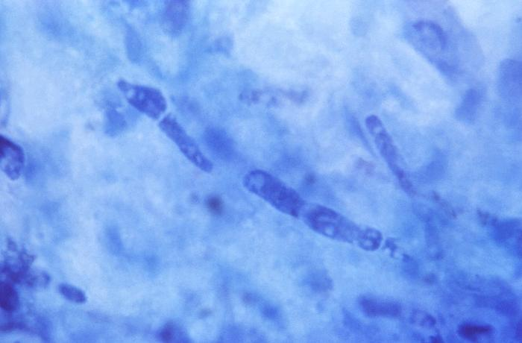
Figure 3-41. 23085 Caption: At 475X, this photo depicted clumps of elongated, sickle-shaped, multicellular macroconidia and hyaline septate hyphae exhibited by a Fusarium sp. fungal organism. CDC/ Dr. Hilliard F. Hardin, 1965. Public domain, PHIL.
Figure 3-42. 15468 Caption: This photo of a corneal tissue sample was harvested from a patient diagnosed with mycotic keratitis, also referred to as fungal keratitis, caused by Fusarium spp. Keratitis is infection caused by bacteria, viruses, amoebas, or fungi, as was the case here. CDC/ Dr. Lucille K. Georg, 1971. Public domain, PHIL.
Figure 3-40. 17974 Caption: Culture plate of Sabauraud’s dextrose agar, inoculated with Fusarium spp. After incubation, the media grew this pink-tan to brown, woolly textured, large colony. CDC/ Dr. Lucille K. Georg, 1972. Public domain, PHIL.

Figure 3-44. To the left. 21304 Caption: At 300X, this photo reveals the ultrastructures of Geotrichum candidum, which was grown on EMB agar. Note the branched, septate hyphae, some of which broke apart in order to release elongated arthroconidia that were, on average, 6-12µm x 3-6µm. CDC/ Dr. Hilliard F. Hardin, 1968. Public domain, PHIL.
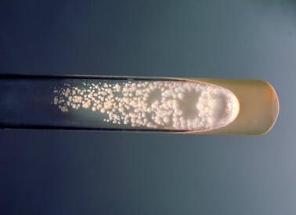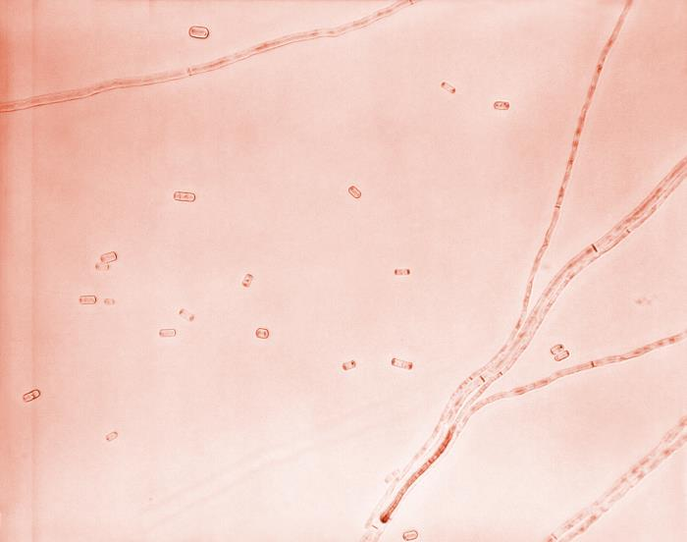
Figure 3-43. 3207 Caption: This photo is a culture tube of Sabouraud dextrose agar, inoculated with Geotrichum candidum, and at a temperature at 37°C. CDC/ Dr. William Kaplan, 1969. Public domain. PHIL.

Geotrichum spp.
Geotrichum spp. have recently undergone extensive a large taxonomic revision. The three species of interest to medical mycology are Geotrichum candidum, Magnusiomyces capitatus (previously known as Geotrichum capitatum), and Magnusiomyces clavatus (previously known as Saprochaete clavata or Geotrichum clavatum). (34) Geotrichum candidum is a common fungus that has global distribution. It is common in dirt, water, air, sewage, vegetation, and the GI tracts of humans and animals. Respiratory infection is the most common form of the disease in humans and animals, but oral, respiratory, cutaneous, vaginal, and GI infections are also seen. (38)
Histopathology and direct testing: RG-1 organism. The lesions of Geotrichum candidum consist of dense granulomatous inflammation. Some of the granulomas show neutrophilic micro-abscess formation. The fungal hyphae show marked fragmentation (arthroconidia), and no branching is seen. Periodic acid Schiff and Grocott-Gomori's Methenamine Silver stains show the arthroconidia.
Colonial description: Colonies are fast-growing, flat but thick, white to cream, appear dry on the top, and finely suede-like with no reverse pigment. Hyphae are septate, hyaline, branched, and they break into chains of hyaline, smooth, single-celled, cylindrical arthroconidia. Arthroconidia (6-12 x 3-6 µm) are released by separation of a double septum. (37)
Microscopic identification from culture: Blastoconidia production is not seen in this genus. Blastoconidia formation distinguish Geotrichum from Trichosporon, (Geotrichum does not produce blastoconidia, and Trichosporon does produce blastoconidia). (37)
Molecular identification: rDNA ITS sequencing is used for species identification.
Lomentospora prolificans (formerly Scedosporium prolificans)
Lomentospora (formerly Scedosporium) prolificans an increasingly recognized pathogen related to P. boydii. It can cause rare asymptomatic colonization and localized infections following penetrating trauma in immunocompetent individuals. L. prolificans also causes rapidly fatal disseminated infections in immunocompromised patients, particularly in those with neutropenia due to anticancer treatment or stem cell transplantation. Localized disease is managed successfully in immune competent patients with local surgical removal, while disseminated disease in immune suppressed patients is almost universally lethal. (22) Clinical hallmarks of disseminated L. prolificans infections are a high rate of positive blood cultures after the patient's death, disseminated skin lesions, and CNS invasion. (22) The respiratory tract appears to be the most frequent entry site, but a few cases indicate that L. prolificans may also enter the bloodstream through indwelling venous catheters. The geographic distribution of disseminated L. prolificans infections are more common in Spain and Australia. It is not known, however, whether there is an environmental reason for this pattern.
Histopathology and direct testing: RG-2 organism. Granule formation is typical in mycetoma. The granules are composed of septate and branching hyphae. Chlamydospores may be seen. In other body sites of infection with this fungus, granulomatous inflammation and necrosis associated with scattered hyphae are observed.
Colonial description: Hyphomycete with an initial grey-black pasty colony. Colonies are rapidly growing, flat, spready, olive-grey to black, with a suede-like or downy surface texture. Growth occurs at 45ºC. There is no growth in media with cycloheximide.
Microscopic identification from culture: Conidia are in small groups on distinctive flask-shaped conidiophores (swollen at the base), alone or in clusters along the hyphae. Conidia are clumped on slimy heads, they are unicellular, hyaline to tan, oval to pyriform, 3-7 x 2-5 µm, and with smooth, thick walls. (40) Conidiophores are seen with distinctly swollen bases and a conidial mass of aggregated conidia on their tops. (40)
Molecular identification: rDNA ITS and β-tubulin sequencing are used for identification.
Paecilomyces spp.
Paecilomyces spp. are septate, hyaline molds that are common in nature and are associated with keratitis and soft tissue infections in immunocompetent patients but may become the cause of deeper, invasive infections in immunocompromised patients. (22) The entry points for this organism are the respiratory tract, indwelling catheters, and the skin. Invasive Paecilomyces infections include fungemia, pneumonia, soft tissue infections, and disseminated disease. (22) As noted for Fusarium and Acremonium, Paecilomyces forms adventitious structures that resemble microconidia in infected tissue and that disseminate widely in the bloodstream. (35) Paecilomyces is an environmental mold found in compost, dirt, wood, and food. However, P. variotii is an emerging etiologic agent of mycotic keratitis and hyalohyphomycosis in compromised patients.
Histopathology and direct testing: RG-2 organism. The necrotic areas of tissues contain many intracellular and extracellular, negatively stained, non-pigmented, septate, acute angle branching hyphae, with parallel walls measuring 3–6μm, with bulbous swelling at the hyphae ends measuring 7–13μm. Occasionally, yeast-like cells measuring 7–15μm are present. Hyphae stain with Gomori methenamine-silver and Periodic acid-Schiff stains.
Cultural description: Colonies are fast-growing, powdery, tufted, and yellow-brown, grey-green, pink, violet, or sand-colored—key features: Yellow-brown or grey-green color, cylindrical phialides, and chlamydospores.
Microscopic identification from culture: Conidiophores with dense branches bearing phialides are seen. Phialides are cylindrical to ellipsoid, tapering abruptly into a long, cylindrical neck. Conidia are oval, ellipsoidal or fusiform, hyaline to yellow, smooth-walled, 3-5 x 2-4 µm, and are produced in long chains. Chlamydospores are usually present, singly or in short chains, 4-8 µm, thick-walled. P. variotii: Conidiophores, phialides, conidia, and terminal chlamydospores help to tentatively identify P. variotii. Paecilomyces somewhat resembles Penicillium, but is slightly different in colony color and the conidia are more oval in Paeciliomyces, but more round in Penicillium.

Molecular identification: rDNA ITS sequencing is recommended for identification.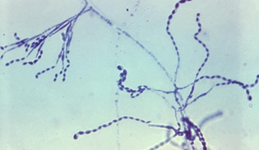 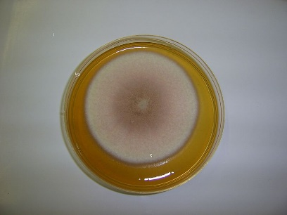 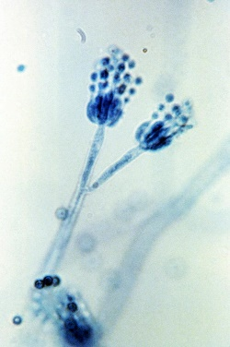 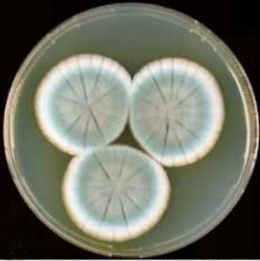
Figure 3-48. ‎Penicillium rubens NRRL 792. Colonies are 7 d old grown at 25 °C. A. CYA. B. MEA. C. YES. D–H. Bars =10 µm. 7 June 2011. Source: The penicillium strain of Fleming’s penicillin is P. rubens. IMA Fungus 2, 87–95 (2011). Photo: Houbraken, J., Frisvad, J.C. & Samson, R.A. Creative Commons Attribution-Share Alike 4.0 International license. Wikimedia Commons.
https://doi.org/10.5598/imafungus.2011.02.01.12.
Figure 3-47. 8398 Caption: At 1200x, this photo shows a bifurcated conidiophore of a Penicillium frequentans. The conidiophore’s distal end produces asexual conidia through budding. The round conidia are in chains extending from sterigma at the end of the conidiophores. (paint-brush appearance). CDC/ Lucille Georg, 1971. PHIL.
Figure 3-46. 14-day culture of the fungus Paecilomyces lilacinus 20 November 2005
Source: Own work
Author: Чхиквадзе Василий Мауглиевич. GNU Free Documentation License, Version 1.2. Wikimedia Commons.
Figure 3-45. 23113 Caption: At 475X, this photo shows the morphology of Paecilomyces. Branched conidiophores arising from hyaline, septate hyphae, topped with phialides, that produce a chain of oval, smooth conidia. CDC/ Dr. Lucille K. Georg; Dr. Hilliard F. Hardin, 1959. Public domain, PHIL.

Penicillium spp.
Penicillium is a ubiquitous genus with a huge number (354) of species. (38) Many species are common contaminants and are known as potential mycotoxin producers. Correct identification is therefore essential when investigating Penicillium contamination of food. Penicillium is among the top three most common indoor airborne fungi (along with Aspergillus ad Cladosporium). These three molds and Alternaria are most likely to cause allergy symptoms inhaling mold spores. Serious human pathogenic infections with Penicillium spp. are rare. However, opportunistic infections leading to ear, eye, and skin mycoses and endocarditis (following insertion of valve prosthesis) have been reported. (38) Penicillium spp. are hyaline saprophytic molds that often contaminate the clinical microbiology laboratory plates but rarely cause infection. When isolated they must be considered for their clinical significance.
Histopathology and direct testing: Histologic examination of tissue such as skin demonstrates invasive, septate, fungal hyphae with acute-angle branching, forming a nodule of organisms in the interstitial and deep dermis.
Colonial description: Penicillium colonies are rapidly growing, flat, filamentous, felt-like, woolly, or cottony in texture. They start as white and can become blue-green, gray-green, olive-gray, yellow, or pinkish over time. The plate reverse is usually a pale yellowish. (34)
Microscopic identification from culture: Septate, hyaline hyphae (1.5 to 5 µm), plain or branched conidiophores, metulae, phialides, and conidia are present. Metulae are secondary support branches that form on the conidiophores. The metulae then hold the flask-shaped phialides. The arrangement of the phialides at the tips of the conidiophores is characteristic. (34) They form a brush-like cluster, called a "penicillus" or plural "penicilli". The conidia (2.5-5µm in diameter) are distinctively round, single-celled, and are seen as unbranching chains at the tips of the phialides. (34) Penicillium differs from Paecilomyces by having flask-shaped phialides and globose conidia; from Gliocladium by making chains of conidia; and Scopulariopsis by having phialides. (34) Characteristic hyphomycete, flask-shaped phialides arranged in groups from branched metulae forming a Penicillus are helpful to recognize Penicillium.
Molecular identification: Sequencing of rDNA ITS and β-tubulin loci are recommended for identification.
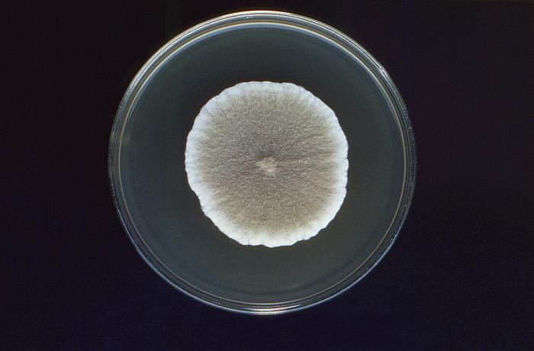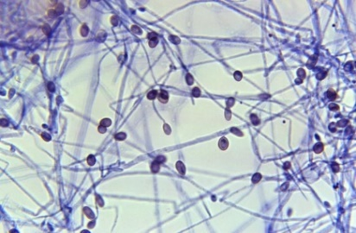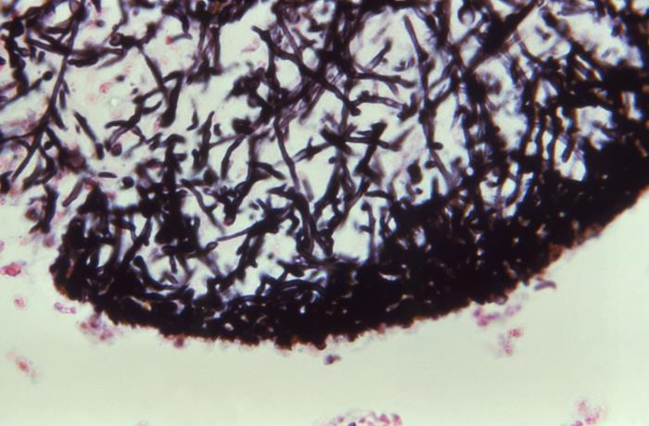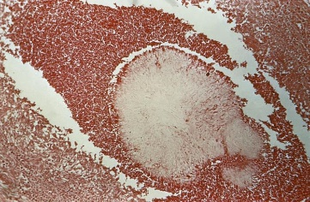
Figure 3-50. 21200 Caption: Under 500X, this photo of a culture specimen, revealed numerous, ovoid-shaped, brownish-tinted conidia, some were still attached to their respective hypha, by way of long, thin filamentous conidiophore, while others were attached directly to the hyphal strand, projecting laterally. This is Scedosporium (Pseudallescheria) boydii. CDC/ Dr. Hardin, 1968. Public domain, PHIL.

Figure 3-49. 15753 Caption: This culture plate contained Sabouraud dextrose agar inoculated with Scedosporium (Pseudallescheria) boydii. The colony shows key features, a cottony or wooly texture, and white color, which becomes darker gray to smoky or brown with age. CDC/ Dr. Libero Ajello, 1974. Public domain, PHIL.

Figure 3-51. 16648 Caption: At 400X, this photo of a Gömöri stained tissue sample, revealed histopathologic details of a maduromycotic mycetoma granule that had been caused by Scedosporium (Pseudallescheria) boydii. This view exposes some of the granule’s ultrastructure, including a matrix of numerous interwoven hyphae. CDC, no date given. Public domain, PHIL.
Figure 3-52. 15923 Caption: This photo of an hematoxylin and eosin (H&E)-stained unidentified tissue specimen, revealed the presence of a eumycotic mycetoma, and the histopathologic changes associated with this condition caused by Scedosporium (Pseudallescheria) boydii, an ascomycetous mold. CDC/ Dr. Lucille K. Georg, 1979. Public domain, PHIL.

Scopulariopsis spp.
Scopulariopsis brevicaulis is a saprophytic hyaline mold associated with onychomycosis, especially of the toenails, and, occasionally, localized infections following trauma or surgery. In immunocompromised patients, S. brevicaulis can cause invasive and disseminated infections with high mortality. Skin lesions, mycetoma, invasive sinusitis, keratitis, endophthalmitis, pulmonary diseases, endocarditis, brain abscesses, and disseminated infections due to Scopulariopsis spp. have been reported. Invasive Scopulariopsis infections are seen mainly in immunocompromised hosts. (45)
Histopathology and direct testing: While not diagnostic alone, the finding of narrow, branching septate hyaline hyphae on histopathology from a clinical specimen, along with other characteristics, can help diagnose the infection. (45)
Colonial description: Scopulariopsis colonies grow at a moderate to rapid rate and mature within five days. They are granular or powdery in texture. From the top, the color is white initially and becomes light brown or buff-tan in time. The colony reverse color is tan with a light brow center. Some species form darker colored colonies. (34)
Microscopic identification from culture: Septate hyphae, conidiophores, annellides, and conidia are seen. Chlamydospores may occasionally be seen. Conidiophores are hyphae-like and simple or branched. Annellides are solitary, in clusters, or they form a penicillus; they are slightly enlarged and are cylindrical. Conidia are single-celled, round to pear-shaped, rough, spiny, truncate, and in chains. (45)
Molecular identification: rDNA rDNA D1/D2 and EF-1α sequence analysis can identify the most common clinically species.
Scedosporium spp.
The taxonomy of this genus has been changed based on sequence data. Scedosporium apiospermum and Pseudallescheria boydii are currently separate species that, with S. aurantiacum, are the main human pathogens in this group. (44) Most infections with these fungi are mycetomas; the remainder include infections of the ear, eye, central nervous system, internal organs, and, more often, the lungs. S. prolificans was moved to the genus Lomentospora. L. prolificans is morphologically and phylogenetically distinct from the remaining Scedosporium species. (44)
Morphological identification of Scedosporium spp. is unreliable. Molecular identification techniques are now recommended. S. apiospermum and S. boydii are indistinguishable by appearance. S. aurantiacum exhibits similar conidial morphology, but most strains produce a yellow diffusible pigment on potato dextrose agar. (44) There is a long-running debate about whether Scedosporium are hyaline or dematiaceous. There is no pigment in the hyphae of Scedosporium spp. by histological staining and the nonpigmented grains in Scedosporium mycetoma are why they are generally thought to be hyaline. Yet the presence of the diffusible melanin-like pigment is observed in their colonies. It has been reported that this is because of conidia melanin.
Histopathology and direct testing: Septate hyphae may be observed in infected tissues. (44) Granule formation is typical in mycetoma. These granules are hyaline and are composed of septate and branching hyphae. Chlamydoconidia may be seen. In other body sites of infection with this fungus, granulomatous inflammation, necrosis, and scattered septate, hyaline fungal hyphae are observed. (44),
Colonial description: Colonies are rapid growing, white to grey, suede-like to downy, with a white colony reverse that becomes greyish-black over time. Although cultures often are grey, brown, or almost black due to pigments or the production of brown conidia, the fungus has a hyaline mycelium.
Microscopic identification from culture: Septate, hyaline hyphae with conidia producing cells (annellides), and conidia are present. Annellides arise directly from hyphae or are formed at the tips of the conidiophores. These annellides are flask-shaped with a swollen base and an elongated neck. Conidia (2-5 x 3-13 µm) are single-cellular, oval, olive to brown, with a slightly narrow, truncated base. They are formed in clumps at the apices of the annellides. In addition, some isolates may produce round, thick-walled conidia that arise directly on the hyphae. Some isolates do not display a sexual state even under appropriate growth conditions. (22) For such isolates, the designation Scedosporium apiospermum is used.
Molecular identification: Recommended for identification are rDNA ITS and β-tubulin. MALDI-TOF MS: A database of many reference spectra is needed for accurate identification.
Scedosporium (formerly Pseudallescheria) boydii
Scedosporium boydii may cause pneumonia, sinusitis, mycetomas, CNS infection, endocarditis, and disseminated disease with considerable morbidity and mortality. (22) In a review of thirty-one cases of invasive S. boydii infections, 61% died despite antifungal therapy and among eight patients with localized musculoskeletal soft tissue infection, seven required surgery, and three required amputations. (22) In immune suppressed patients, the usual entry point is the respiratory tract. Dissemination from the lungs may spread infection to other target organs. Cutaneous nodules may indicate dissemination to different organs and body systems, including the central nervous system. Diagnostic procedures and approaches are like those for invasive aspergillosis and other opportunists. (22)
Histopathology and direct testing: Hyaline, septate hyphae are seen in infected tissues. Scedosporium species cannot be differentiated in tissue sections. Granule formation is typical in mycetoma. The granules are composed of septate and branching hyphae. Chlamydospores may be seen. In other body sites of infection with this fungus, granulomatous inflammation, necrosis, and scattered fungal hyphae are observed.
Colonial description: Colonies are rapid growing, white to grey, suede-like to downy, with a white colony reverse that becomes greyish-black over time. Although cultures often are grey, brown, or almost black due to pigments or the production of brown conidia, the fungus has a colorless mycelium.
Microscopic identification from culture: Scedosporium boydii is a septate, hyaline mold characterized microbiologically by terminal annelloconidia and typical cleistothecia in the sexual state. Some isolates do not display a sexual state even under appropriate growth conditions. (22) For such isolates, the designation Scedosporium apiospermum is used.
Molecular identification: rDNA sequencing of ITS and β-tubulin is recommended for identification. MALDI-TOF MS: A database of many reference spectra allows for accurate identification of Scedosporium boydii.

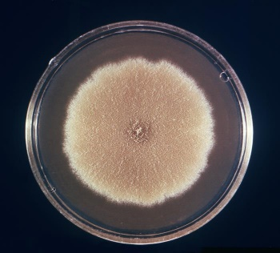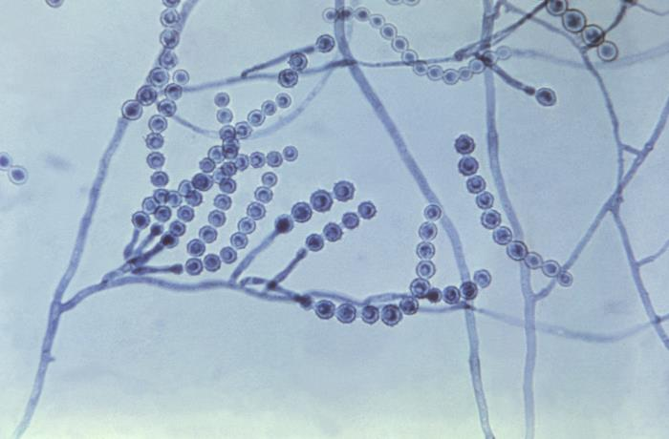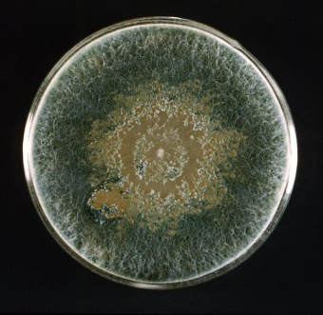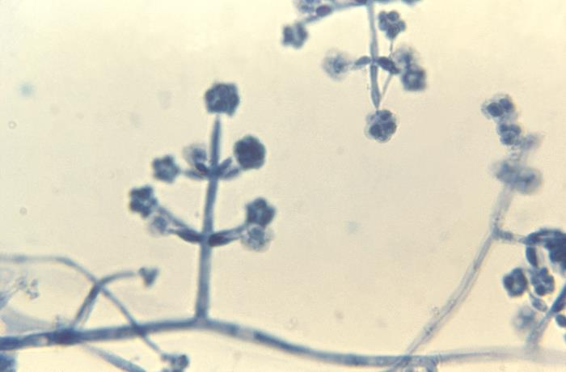
Figure 3-55. 23021 Caption: This culture plate, with Sabouraud dextrose agar was inoculated with Trichoderma. After an unidentified incubation period, the culture gave rise to this single, large, woolly colony, which displayed an overall dark green coloration, and a very compact, plaque-like central region, which had developed a brownish-green color. CDC/ Dr. Hilliard F. Hardin, 1965. Public domain, PHIL.
Figure 3-54. 23076 Caption: At 475X, this photomicrograph revealed some of the ultrastructural morphology exhibited by a Scopulariopsis sp. fungal organism. Here, you were able to see the organism’s septate, filamentous hyphae and many basipetal chains of rough-walled conidia, each emanating from a single annelide arranged in a cluster known as a penicillus. CDC/ Dr. Hilliard F. Hardin, 1965. Public domain, PHIL.

Figure 3-56. 23103 Caption: At 1200X, this photo shows the morphology of the genus Trichoderma. Note the septate, hyaline, filamentous hyphae, and conidiophores, from which flask-shaped phialides sprouted in a perpendicular fashion, which are topped by small clusters of globose conidia. CDC/ Dr. Hilliard F. Hardin, 1965. Public domain, PHIL.
Figure 3-53. 16418 Caption: This culture plate contains a growth medium of Sabouraud dextrose agar, upon which a single large colony of a species of the filamentous fungus Scopulariopsis had been cultivated. CDC/ Dr. Lucille K Georg., 1972. Public domain, PHIL

Trichoderma species

Previously thought to be an environmental organism with a low pathogenicity, several centers have recently reported infections caused principally by Trichoderma longibrachiatum. Although Trichoderma comprises numerous species, molecular analyses indicate that one species, T. longibrachiatum causes all human Trichoderma infections called trichodermatitits. (22) Trichoderma spp. has been reported to cause pulmonary, , rhino-orbital-cerebral mycosis, oral infection, otitis externa, sinusitis, brain abscess, stomatitis, mediastinitis and peritonitis, endocarditis, soft tissue, skin, keratitis, septic shock, and disseminated infections in immune suppressed patients, especially those with bone marrow or organ transplantation. (22, 46) Trichoderma spp. are often isolated from tumors. In tissues, the organisms appear as hyaline molds indistinguishable from each other. The lack of response of infections caused by these organisms to antifungal chemotherapy is consistent with elevated MICs of conventional antifungal agents in the few strains tested. (22) Like other opportunistic molds, high-dose amphotericin B is the initial treatment for invasive infections.

Histopathology and direct testing: RG-1 organism. Inflammation, angioinvasion, and tissue necrosis are seen in these infections. Immunohistochemistry shows positive Ki67, CD3, CD56, GZMB, and PRF markers. Periodic acid-Schiff staining, periodic acid-silver methenamine staining, and Calcofluor staining show fungal spores in the vascular lumen, walls, and surrounding the blood vessels.

Colonial description: Colonies are rapidly growing, at first white and downy, turning yellowish-green to deep green with age, growing compact tufts, often only in small groups or in concentric ringed zones on the agar surface. (46) The colony reverse is tan.

Microscopic identification from culture: Conidiophores are branched, irregularly arranged in whorls, with clusters of divergent, often irregularly bent, flask-like phialides. (46) Conidia are primarily green, sometimes hyaline, with smooth or rough walls. They are formed in slimy conidial heads clumped at the ends of the phialides. The typical appearance for identification is a hyaline, septate hyphae with branched conidiophores holding clumps of flask-like phialides and green conidia. (46)

Molecular identification: Species identification is based on multilocus sequencing of rDNA: ITS, EF-1α, Chi18-5, and actin genes.

Septate dematiaceous (phaeoid) opportunistic molds

The dematiaceous (dark melanin pigment in their cell walls, also called phaeoid) septate molds are a diverse group of dark brown or black fungal opportunistic pathogens. Among the most frequent agents of human infection are Bipolaris spp., Cladophialophora banana, Cladosporium lanthanum, Cladosporium trichoid, Altemaria spp., Exophiala spp., Phialophora spp., and Curvularia spp. (22) While the phaeoid molds are known to cause diseases in otherwise healthy hosts, such as localized skin lesions and subcutaneous tissue following a puncture injury, they are mostly opportunistic pathogens that are increasingly seen to cause sinusitis, pneumonia, and disseminated infections in immune deficient patients. (22) Research studies show that these phaeoid fungi also have a higher proclivity for infection of the central nervous system. (22)

Alternaria species

Alternaria is a ubiquitous genus of common saprophytes in soil, air, and vegetation. Alternaria infectoria is the most commonly encountered clinical species. (48) Alternaria alternata and A. infectoria, are recognized causative agents of subcutaneous phaeohyphomycosis and mycotic keratitis. (48) They are also a rare cause of onychomycosis, usually following nail trauma.

Histopathology and direct testing: RG-1 organism. Dark-colored filamentous hyphae are observed in sections of infected tissue stained with H&E. If the melanin formation is not apparent, the Fontana-Masson silver stain is helpful for melanin.

Cultural description: Colonies are rapid growing, black to olivaceous, black to greyish, and are suede-like to floccose. Microscopically, branched a chains of the distinctive multicellular conidia are produced sympodially from single or branched, short or elongated conidiophores. (48) Conidia are pear-shaped, occasionally oval or ellipsoid, with a short conical or cylindrical top. They are pale brown, smooth or verrucose. (48) Temperature: optimum 25-28ᴼC; maximum 31-32ᴼC.
Alternaria alternata show branched chains and multicellular conida that are thicker at the base with short conical beaks. Alternaria species may soon lose their ability to sporulate in culture. Potato dextrose agar and cornmeal agar are the most helpful media, and short incubation under ultra-violet light is also useful to maintain their sporulation. (48) Dematiaceous hyphae producing darkly pigmented, chains of oval to obclavate microconidia, often with short conical or cylindrical beak-like structures.
Molecular identification: Genotype studies have shown that nine genera and eight sections make up the Alternaria complex. (48) rDNA sequencing of the rDNA ITS is sufficient for genus and usually species-level identification and can differentiate A. alternata and A. infectoria. However, unknown sequences should be compared to well-characterized reference strains. (48)
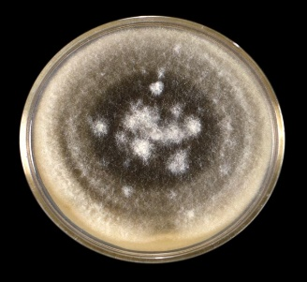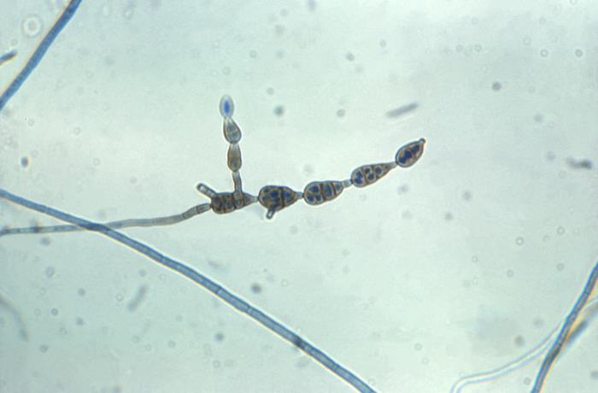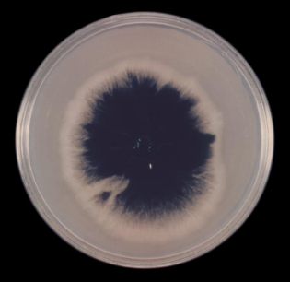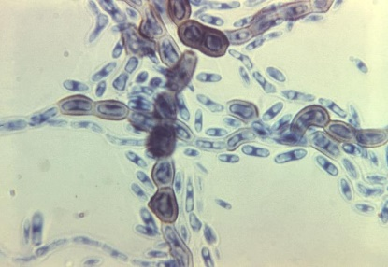
Figure 3-60. 16653 Caption: At 970X, the above photo of a lactophenol cotton blue wet prep stained specimen shows characteristics of the phaeoid Aureobasidium. CDC/ Dr. Hardin, 1965. Public domain, PHIL.

Figure 3-59. 23025 Caption:This image depicted a top view of a culture plate of Sabouraud dextrose agar inoculated with Aureobasidium. After a 16-day incubation period, the culture gave rise to this single, large colony, which displayed a central, darkly-colored region, surrounded by a beige periphery. CDC/ Dr. Hilliard F. Hardin, 1965.domain, PHIL.

Figure 3-58. 23084 Caption: At 400X, this photo depicts a chain of conidia from Alternaria spp. Alternaria sp. conidia are multicellular and phaeoid and are produced in straight or branching chains. The bottom of each conidium, on the conidiophore, is rounded, tapering distally towards its apex, imparting a beak-like appearance. This specimen had been prepared using LPCB staining. CDC/ Dr. Hilliard F. Hardin, 1965. Public domain, PHIL.

Figure 3-57. 23073 Caption: A culture with Sabouraud dextrose agar growing Alternaria. After 10 days, the culture grew this single, large colony with a characteristic wooly texture that was covered by short, gray-colored aerial hyphae. As the oldest colonial sector, its central region had begun to darken, displaying an olive-brown color. CDC/ Dr. Hilliard F. Hardin, 1965. Public domain, PHIL.

Aureobasidium spp.
Aureobasidium pullulans is ubiquitous in nature and is usually isolated as a plate contaminant. Because it is ubiquitous, its isolation in culture must be evaluated in light of other factors including clinical factors. It has also been reported as a rare causative agent of phaeohyphomycosis, mycotic keratitis, and peritonitis in patients on continuous ambulatory peritoneal dialysis. (49)
Histopathology and direct testing: RG-1 organism. Histopathology analysis of tissue shows a noncaseating granulomatous dermatitis. Direct examination of a sample in potassium hydroxide preparation reveals the presence of fungal hyphae. (48)
Colonial description: It is a phaeohyphomycete (also called a black yeast) that produces blastoconidia from hyphae, and form chains of darkly pigmented, thick-walled arthroconidia. The colonies are fast-growing, smooth, and soon covered with slimy clumps of conidia, cream to pink, with age becoming brown to black. (48)
Microscopic identification from the culture: Hyphae are hyaline, septate, but typically become dark brown with age. They form chains of one to two-celled, thick-walled, darkly pigmented arthroconidia. These arthroconidia of Aureobasidium are only of secondary importance in recognizing members of this genus. (48) Conidia are produced synchronously in dense groups from indistinct scars or short denticles on undifferentiated subhyaline hyphae. Conidia are smooth, single-celled, and ellipsoid but vary in size (8-12 x 4-6 µm) and shape, often with a hilum (i.e., scar at the point of attachment). (48) The optimum growth temperature is 25ºC; the maximum is 35-37ºC. (48) Aureobasidium pullulans cultures show black, slimy masses of conidia. Aureobasidium pullulans show one to two-celled, darkly pigmented arthroconidia and hyaline, single-celled, oval conidia produced on short denticles. (48)
Molecular identification: sequencing of rDNA ITS, EF-1α, and D1/D2 are recommended for identification.

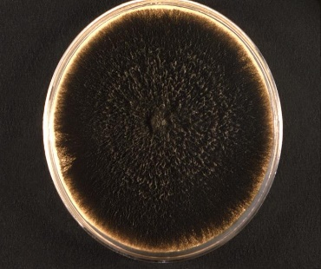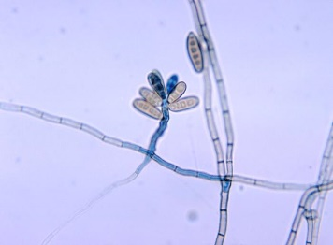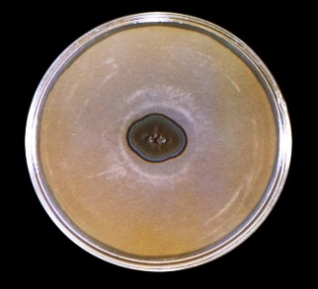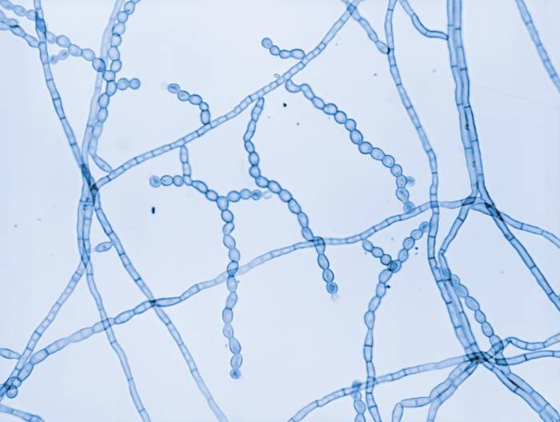
Figure 3-61. 10607 Caption: This image shows Bipolaris hawaiiensis. The colonial texture appears woolly. Normally, the reverse coloration appears as black, but is sometimes observed as brown, with areas becoming black increasingly with time. CDC, 1971. Public domain, PHIL.

Figure 3-63. 3059 Caption: This image depicts a top view of a culture plate containing an unidentified growth medium inoculated with the fungal organism Cladophialophora carrionii, formerly Cladosporium carrionii. After a 4-week incubation, the culture produced this olivaceous-colored colony. CDC/ Dr. Lucille K. Georg, 1963. Public domain, PHIL.

Figure 3-64. 20232 Caption: Under a magnification of 510X, this photomicrograph revealed ultrastructural details exhibited by the fungal organism Cladophialophora carrionii. Here, you see the characteristic, elongated conidiophores, giving rise to smooth-walled reproductive conidia chains ranging from limoniform (lemon-shaped) to fusiform (spindle-shaped). CDC/ Dr. Libero Ajello, 1967. Public domain, PHIL

Figure 3-62. 4318 Caption:This photo reveals the ultrastructural morphology of Bipolaris hawaiiensis, including its septate hyphae, septate, geniculate conidiophore, which was topped by a cluster of 3- to 6-celled conidia, referred to as poroconidia. B. hawaiiensis has been shown to be one of the causes for phaeohyphomycosis. CDC, 1971. Public domain, PHIL.

Bipolaris spp.

Bipolaris spp. is the most common cause of sinusitis caused by dematiaceous fungi. Bipolaris also causes pneumonia, fungemia, subcutaneous abscesses, and disseminated disease. (22) Bipolaris sinusitis is typically refractory to amphotericin B.

Histopathology and direct testing: RG-1 organisms. H&E staining shows inflammatory sinonasal polyps and clusters of eosinophilic granulocytes in the mucus. GMS staining showed septate fungal hyphae not only in the fungal balls but also within the mucus, where the hyphae seemed to be impacted or embedded within the clusters of eosinophils.

Colonial description: Colonies have a moderate to rapid growth rate, grey to black or brown, suede-like to floccose on the colony top, with a black colony reverse side. (50)

Microscopic identification from culture: Bipolaris shows the development of hyaline to deep olive pigmented, pseudoseptate conidia on a bent or zig-zagged main stem. (50) Macroconidia are primarily curved, fusoid, or rarely straight, with 2–14 pseudoseptae (usually more than 6), germinating only from the ends (bipolar). (50) The key features are dematiaceous hyphomycete hyphae producing pale brown, sympodial, pseudoseptate, straight, fusiform, or ellipsoidal macroconidia rounded at both ends. (50)

Molecular identification: ITS rDNA sequencing is used to identify clinical species, and GPDH the best single phylogenetic marker for Bipolaris species. (50)

Cladophilalophora species

Cladophialophora is a melanin-producing mold known to cause human brain abscesses. (51, 52) Cladophialophora bantiana (formerly Cladosporium bantianum) has a high proclivity for CNS infection which is frequently fatal. Notably, patients with CNS infections caused by Cladophialophora bantiana may have no apparent immunosuppression but still have high morbidity and mortality. (22) CNS infections may be best managed with surgical resection. The state of encapsulation and inflammation of the CNS lesion is critical in determining outcome, independent of antifungal chemotherapy. (22) Patients with encapsulated, granulomatous, solitary, and resectable lesions were associated with a favorable outcome. Those patients with poorly encapsulated, non-granulomatous, multiple lesions, and multifocal lesions, had an unfavorable and fatal outcome. (22)

Cladophialophora spp. also cause chromoblastomycosis, phaeohyphomycosis, and skin lesions. (51, 52) While Cladophialophora boppii and Cladophialophora carrioinii are both found in patients with chromoblastomycosis, Cladophialophora boppii also causes skin lesions. (51, 52) Trauma and exposure to soil are the main predisposing factors for acquiring infections due to Cladophialophora carrionii such as chromoblastomycosis. (52) Cladophialophora devriesii, on the other hand, has been reported to cause disseminated phaeohyphomycosis. (52)

Histopathology and direct testing: WARNING: RG-3 organism. C. bantiana cultures represent a severe danger to all personnel and must be handled cautiously solely within a class II Biological Safety Cabinet. Observe for sclerotic bodies in chromoblastomycosis and for septate dematiaceous hyphae in all tissues and histological slides.

Cultural morphology: Cladophialophora colonies are slow-growing, yeast-like, olive-grey, are powdery to woolly and spready or suede-like to floccose and grow with or without cycloheximide at temperatures up to 42-43ᴼC (except C. carronii). Typically, the color is olive-green to black on the colony top surface and black on the colony reverse side. (52) Cladophialophora boppi and Cladophialophora bantiana grow at a moderate rate at 25°C on potato dextrose agar. Growth of Cladophialophora carrionii is at a slow rate under the same conditions. (52) Cladophialophora bantiana can grow at temperatures up to 42°C, but Cladophialophora carrionii does not grow above 36°C. Cladophialophora bantiana also possesses enzyme activity on urease agar. (52)

Microscopic identification from culture: C. bantiana exhibits predominantly hyphal growth both in vivo and in culture, with a morphology of dark-colored, usually unbranched, wavy chains of conidia, 5–10 μm in length. (51, 52). Cladophialophora spp. produce septate, dark brown hyphae, and single-celled conidia. Cladophialophora bantiana and Cladophialophora boppi also may produce chlamydospores. (52) The conidiophores of Cladophialophora resemble
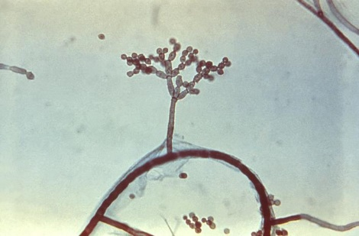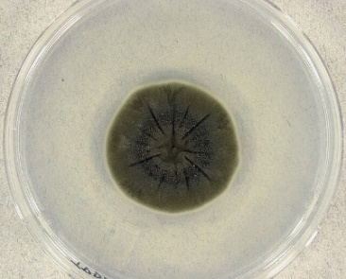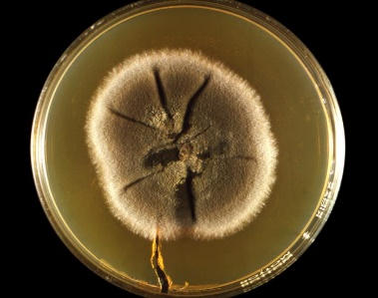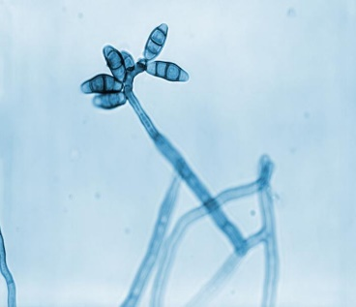
Figure 3-67. 20241 Caption: This culture plate gave rise to a colony of Curvularia geniculata. As you can see here, the colony’s front exhibited a suede-like or downy texture and a coloration that ranged from brown, as in this example, to black. CDC/ Dr. Libero Ajello, 1967. Public domain, PHIL

Figure 3-66. Cladosporium sphaerospermum colony.jpg Cladosporium sphaerospermum (UAMH 4745) on potato dextrose agar after incubation for 14 days at 25°C. Photo: Medmyco. Creative Commons Attribution-Share Alike 4.0. March 24, 2005. [[File:Cladosporium sphaerospermum colony.jpg|Cladosporium_sphaerospermum_colony]] Wikimedia Commons.
Figure 3-65. 15887 Caption: At 475X, this photo revealed some of the ultrastructural features exhibited by a species of dematiaceous mold, Cladosporium. Here, you can see chains of conidia, or spores, emanating from atop a brown-colored conidiophore, jutting perpendicularly from a darkly colored, septate hypha. CDC/ Dr. Hardin, 1965. Public domain, PHIL.
Figure 3-68. 20228 Caption: At a magnification of 710X, this photomicrograph revealed ultrastructural details exhibited by a solitary, Curvularia geniculata conidiophore, which was topped by a number of characteristic multiseptate conidia. CDC/ Dr. Libero Ajello, 1967. Public domain, PHIL.

the vegetative hyphae. The conidia are light to dark brown and frequently form chains of easily dislodged conidia. The conidia are released from the conidiophore with no attachment scars. (52) C. bantiana produces single-cellular, long chains of spindle-shaped conidia, 6-11×2.5-5 µm. (52) C. boppi produces unbranched, long, smooth, round conidia chains, 2-3×3-4 µm. (52) C. carrionii produces long, abundantly branching, single-celled, lemon-shaped conidia (4-6×2-3 µm), smooth or infrequently echinulate. (51, 52)

Molecular identification: rDNA ITS sequencing is recommended for identification. Maldi-tof is also available for identification. (51)

Cladosporium spp.

Cladosporium spp. are one of the most commonly distributed fungi globally. They are isolated from dirt, food, textiles, paint, and organic wastes. (53) Some are pathogens of plants, causing leaf spot or are secondary invaders of leaf lesions caused by other pathogenic fungi. (53) Studies of air pollution found Cladosporium spores in most homes tested in Canada, and another study in the America found Cladosporium conidia in 70% of homes tested. (53)
They can cause allergies and cause mycoses infrequently and mostly in immune compromised patients. Cladosporium causes chromoblastomycosis, skin lesions, onychomycosis, sinusitis, keratitis, and lung infections. (53) The main causative agents of chromoblastomycosis are members of these genera of dematiaceous fungi that inhabit the soil: Fonsecaea, Phialophora, and Cladosporium, Exophiala, and Rhinocladiella. (60) Phaeohyphomycoses caused by Cladosporium spp. include subcutaneous infections, onychomycosis, and keratomycosis. Cladosporium spores can also germinate in the lungs and develop into a fungal ball. The most frequently encountered condition caused by these fungi are allergies. C. herbarum is a common experimental fungi in allergystudies, followed by Aspergillus fumigatus and A. alternata. (53)

Histopathology and direct testing: Phaeoid hyphae may be found in tissue slides of infected hosts. The fungi causing chromoblastomycosis produce characteristic sclerotic bodies. Sclerotic bodies are thick-walled, spherical, or polyhedral brown structures with vertical and horizontal septa. (60) They may be found as solitary bodies, in clumps, or inside of giant cells. (60) Melanin, secreted in the sclerotic body's cell wall, gives the structure a dark brown color. These sclerotic bodies (also called copper penny bodies or muriform cells) divide by division along their septa and are found in the striatum corneum of the epidermis. (60) Phaeoid hyphae may also be observed in other tissue sites.

Colonial description: Cladosporium species belong to the group of organisms called phaeoid fungi, with darkly pigmented hyphae. (54) Cladosporium spp. colonies are usually 15–40 mm, velvety, and dark green but there is colonial variation. (54) Cladosporium colonies have a moderately slow growth rate on potato dextrose agar at a temperature below 30°C, and their texture is velvety or powdery. (54) Like the other dematiaceous fungi, the color is olivaceous green to black on the colony top and dark brown to black on the colony reverse. (54) Most Cladosporium spp. do not grow above 35°C. (54)

Microscopic identification from the culture: Cladosporium spp. have septate brown hyphae, pigmented conidiophores, and conidia. (54) Conidiophores bear intercalary and terminal swellings. Conidia are cylindrical or elliptical, brown, and have darker points of attachment called hila. The conidia are on branching chains and they easily detach. The conidial wall is smooth or echinate. The conidia are two- or four-celled. C. sphaerospermum produces septate, elongated shield cells, also known as ramoconidia. Their conidiophores (structures bearing asexual spores) are typically a deep olive-color, nearly straight, and branched. Conidia are globose to ellipsoid and olive and with rough surfaces.

Molecular identification: Genus-level identification is typically sufficient, and morphological identification can just be confirmed by rDNA ITS and D1/D2 sequence. Multilocus gene sequencing of the ITS, D1/D2, EF-1α, and actin genes is necessary for more precise species identification. (55)

Curvularia spp.

The Curvularia genus contains many species that live in the soil or on plants. It was shown that cultural morphology identification often did not correspond to the molecular identification. This required a recent phylogenetic analysis of the genera Bipolaris and Curvularia, with recategorization of many species. Bipolaris australiensis, B. hawaiiensis, and B. spicifera are clinical isolates that were transferred to Curvularia. Curvularia spp. is a cause of phaeohyphomycosis. Brain abscesses, brain inflammation, wound infections, mycetoma, onychomycosis, keratitis, pneumonia, endocarditis, peritonitis, disseminated mycosis, and allergic bronchopulmonary disease and allergic sinusitis, are caused by Curvularia spp. In this genus, Curvularia lunata is the most commonly isolated species. Infections can occur in immunocompetent patients. But Curvularia has recently emerged as another opportunistic dematiaceous pathogen infecting the immunocdeficient. (56) Up to now, Curvularia lunata has been the most often reported infectious species but different species, such as C. americana, C. brachyspora, C. chlamydospora, C. clavata, C. hominis, C. inaequalis, C. muehlenbeckiae, C. pseudolunata, C. senegalensis, and C. verruculosa have now also been increasingly reported from clinical cases so that the mix of species is changing or else identification methods have improved. (56)

Histopathology and direct testing: RG-1 organisms. Granule formation is typical in mycetoma. The granules of fungal mycetoma are composed of phaeoid septate and branching hyphae. Chlamydospores may be seen. In other body sites infected with this fungus, granulomatous inflammation, tissue necrosis, and scattered light-brown fungal hyphae are seen on histology preparations in the lab.

Colonial description: Curvularia has a moderate to rapid growth rate and woolly colonies on potato dextrose agar at temperatures under 30°C. (57) From the colony top, the color of the colony is initially white to pinkish or orange gray and then turns to olive brown or black as the colony matures. Colonies are suede-like to downy, and eventually brown to blackish brown with a black reverse on Sabauraud’s agar. (57)

Microscopic identification from culture: The hyphae are dark. Conidiophores erect, straight to bent-knee shaped in the hyphae, and septate. (56) The conidia are three to five celled poroconidia (holoblastic with new daughter conidia produced through a pore on the parent cell wall), ellipsoidal, usually curved or lunate, rounded at the ends or sometimes tapering slightly at the base, medium reddish brown to dark brown, with 3–10 (usually 3–5) septae and smooth to verrucose conidia. (56) The hilum (point of conidial attachment) is bulging in some species. (56) Key features: This is a phaeohyphomycete producing sympodial (conidia on alternating sides on the hyphae or condiophores), pale brown, cylindrical, or slightly curved conidia. (56,57)

Molecular identification: Genus level identification is usually sufficient, and morphological identification can be confirmed by rDNA ITS and D1/D2 sequence analysis. Multilocus gene sequence analysis of the ITS, D1/D2, EF-1α, and actin is necessary for accurate species identification in some cases. (56)

Exophiala species., including Exophiala (formerly Wangiella) dermatitidis
Several species of Exophiala, such as the E. jeanselmei complex and the E. spinier complex, are recognized human pathogens. (58) Mycetoma (especially for the E. jeanselmei complex), simple local cutaneous infections, endocarditis, central nervous system and various other disseminated infections are caused by Exophiala. Exophiala also causes phaeohyphomycosis in both immune competent and immune suppressed patients. (58, 59) Both mycetoma and chromoblastomycosis may be caused by Exophiala spp. These infections usually occur after a traumatic puncture and are associated with local or systemic immune suppression. (58) Infection and abscesses in subcutaneous tissue, vegetations on prosthetic valves, fungemia, and disseminated infections due to Exophiala spp. have also been reported. Exophila pisciphila infects the nervous systems of fish (thus its name) and humans. (58)

Exophiala (formerly Wangiella) dermatitidis is known as a black yeast; however, this organism is a non-thermal dimorph that develops hyphae in human tissue. E. dermatitidis causes a catheter-related fungemia and central nervous system infections. (59)

Histopathology and direct testing: Phaeoid (brown) hyphae and phaeoid yeast-like cells are seen in infected tissue preparations.

Colonial description: At first, Exophila spp. are yeast-like, moist, and brown to dark green and eventually black. The colony's texture then turns felt-like due to growth of aerial grey hyphae. The colony's top color is typically brown to olivaceous-black, and the colony reverse is black in mature colonies. (58)

Microscopic identification from culture: In new growth, round, yeast-like, budding cells are seen. These cells often form in long chains. As the culture matures, phaeoid septate hyphae, then bear conidiophore cells (annellides), eventually form. (58) The annellides are tube-like or rocket-like, and typically narrow to a long tip. The annellides produce ellipsoid conidia (1-3×3-6 µm). These conidia are usually unicellular in clumps at the tops or sides of the annellides. (58)

Molecular identification: rDNA ITS and D1/D2 sequencing are recommended for identifying this mold. (59) MALDI-ToF mass spectrophotometry is a promising identification tool with an extensive database for some species. (59)

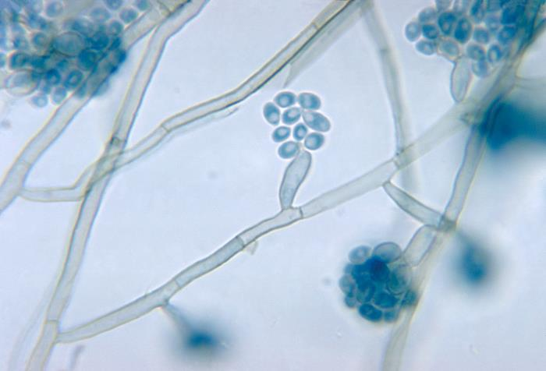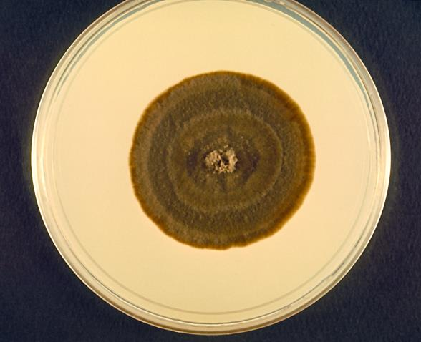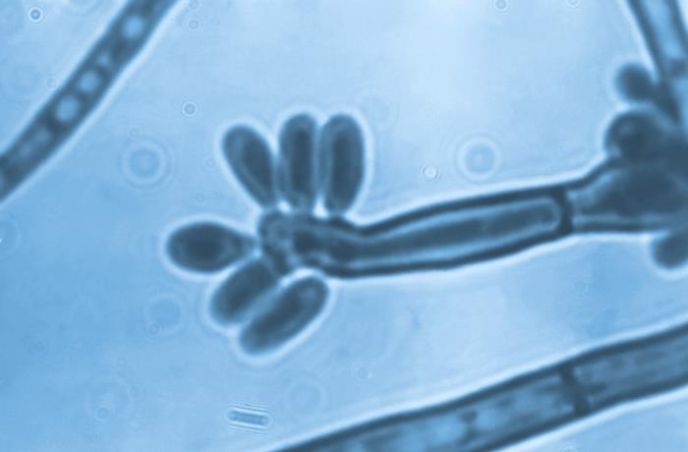
Figure 3-71. 22228 Caption: This photo shows morphology of Fonsecaea pedrosoi, formerly Hormodendrum pedrosoi. This view shows acrothecal-type spore formation, unique to the genus, with spores emanating both from the top, and the sides of a blunt-end conidiophore. CDC/ Dr. Lucille K. Georg, 1964. Public domain, PHIL.

Figure 3-69. 4332 Caption: This photo shows morphology of the genus Exophiala, including clusters of its ellipsoidal-shaped microconidia, which were borne from annelide, rocket-shaped conidiogenous cells spouting from the septate hyphae. CDC, 1971, Public domain, PHIL.
Figure 3-70. 4160 Caption: This is a top view of a culture plate, with an undisclosed growth meda inoculated with Exophiala salmonis. CDC, 1970. Public domain, PHIL.

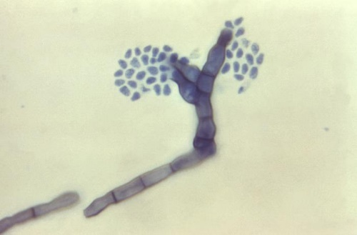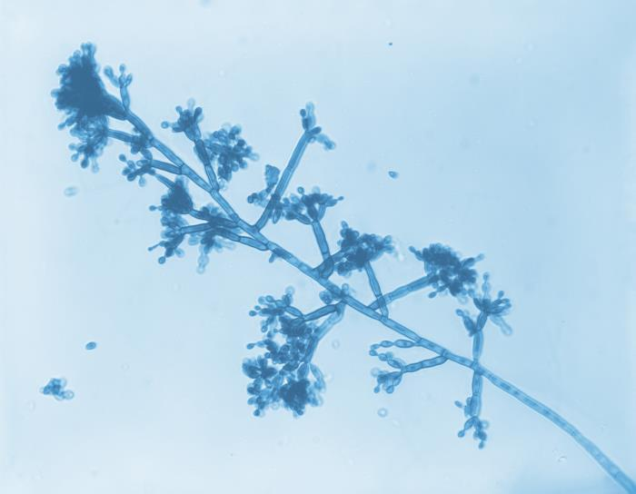
Figure 3-73.At the left: 2920 Caption: At 620X, this photo shows classic morphology of the dematiaceous Fonsecaea pedrosoi, raised in a slide culture. This image focuses on what is referred to as Cladosporium-type sporulation. CDC/ Dr. Lucille K. Georg, 1961, Public domain, PHIL.

Figure 3-72. At the right: 16442 Caption: At 1000X, this photo shows features of the dematiaceous, or dark-colored fungus, Fonsecaea compacta. Note the septate conidiophore, topped by three phialides, each with its own cluster of mostly barrel-shaped conidia. CDC/ Dr. Lucille K. Georg, 1961, Public domain, PHIL

Fonsecaea spp.

The genus was recently changed taxonomically based on rDNA ITS sequences. Fonsecaea is one of the important causative agent of the traumatic, chronic infection of chromoblastomycosis. Three pathogenic human species now included in the Fonsecaea genus are: F. monophora, F. pedrosoi, and F. nubica. They cannot be identified solely by appearance. (60, 61) All three strains are recognized as etiological agents of chromoblastomycosis, and they grow at 37ºC, but not 40ºC. Chromoblastomycosis presents with scaly plaque-like lesions and cauliflower-type lesions, most commonly on the lower extremities (61). Additionally, a primarily nasal chromoblastomycosis has been reported. The etiologic agents of the majority of cases of chromoblastomycosis are members of these three genera of dematiaceous fungi that inhabit the soil: Fonsecaea, Phialophora, and Cladosporium, though there are several others. Fonsecaea pedrosoi is an etiological agent of chromoblastomycosis in tropical areas, specifically in South America and Japan and Fonsecaea compacta is a rare cause of chromoblastomycosis in tropical Latin America. (61) Systemic invasion following chromoblastomycosis is rare. (61)

In addition to chromoblastomycosis, Fonsecaea causes other human infections, including paranasal sinusitis, keratitis, and fatal brain abscesses following dissemination through the blood. (61)

Histopathology and direct testing: RG-2 organism. Conduct all work with this mold under a BSCII safety cabinet. Fonsecaea that cause chromoblastomycosis produce a sclerotic body, a distinctive structure seen in chromoblastomycosis tissues. Sclerotic bodies (also known as copper penny bodies or muriform cells) are spherical or polyhedral, dark brown, thick-walled structures with horizontal and vertical septa. They may be found in clusters or within giant cells. Melanin produced in the sclerotic body's cell wall gives the structure a dark brown color. Unlike yeasts, sclerotic bodies mostly divide by separation along the septa. (61) Dematiaceous hyphae are also be observed in patient tissues.

Colonial description: Colonies have a slow rate of growth. Fonsecaea colonies are suede-like to downy, heaped and folded or flat, and olivaceous to black with a black colony reverse. Fonsecaea also produces velvety or cotton-like colonies on growth sporulation media at temperatures below 30°C. The colonies grow and mature in 14 days. On both the colony top and reverse sides, they are dark olive to brown or black. (60, 61)

Microscopic identification from culture: Conidia producing cells of a pale olive color are loosely arranged on branched hyphae on prominent or swollen denticle stalks. Conidia are club-shaped to ellipsoid, in short chains, subhyaline, smooth and 3.5-5 x 1.5-2 µm. Four types of conidia production are seen in Fonsecaea mold: (60)
(i) Cladosporium type: The conidiophore stalks give rise to primary shield-shaped conidia that then produce long, branching chains of oval, phaeoid conidia. These conidia have visible dark hila (attachment scars). (61) This type of conidiogenesis is primarily observed in Cladosporium but may also be present in Fonsecaea. (61)
(ii) Fonsecaea type: The septate, compactly sympodial conidiophores give rise to conidia that are single-celled and arise on swollen denticles at the condiophore ends. These give rise to single-celled, pale brown, secondary conidia. The secondary conidia often produce a tertiary series of conidia like those formed by the first conidia, resulting in a complex conidial structure. This type of conidia is primarily observed in the strains of Fonsecaea. (61)
(iii) Phialophora type: In this type of conidiogenesis, conidia are located at the ends of the flask or vase-shaped phialides with collarettes. This type of conidia production is primarily observed in Phialophora but may also rarely be present in Fonsecaea. (61)
(iv) Rhinocladiella type: Conidiophores are sympodial and have denticles with unicellular, pale brown conidia. The conidia are at the ends and sides of conidiophores. The formation of secondary conidia is variable. This type of conidia formation is mostly in Rhinocladiella and but may also be seen in Fonsecaea. (61)

Molecular identification: rDNA ITS sequencing is recommended for identification. (60)

Hortaea (formerly Cladosporium, Exophiala, or Phaeoannellomyces) werneckii

Hortaea werneckii is a common dematiaceous fungal saprobe found in dirt, wood, compost, and organic debris in the tropical and subtropical humid areas. It is also the etiologic agent of the superficial skin condition tinea nigra in humans.

Histopathology and direct testing: RG-1 organism. The epidermis and dermis of the skin infected with tinea nigra are largely unremarkable. Numerous short, segmented dematiaceous hyphae and spores are visible within the most superficial aspects of the stratum corneum. These organisms have a characteristic brown-yellow color on routine hematoxylin and eosin sections.

Colonial description: Hortaea colonies are slower-growing and yeast-like, initially mucoid, and shiny-black. Over time though, they develop many aerial mycelia and become dark olive in color and more felt-like.

Microscopic identification from culture: The dematiaceous growth consists of brown to dark olivaceous, septate hyphe and numerous pale brown, two-celled, cylindrical to spindle-shaped yeast-like cells that taper towards the ends to form a tube or vase shaped conidiophore (annellide). Most yeast-like cells also have prominent, darkly pigmented septa. Annellides may also arise from the hyphae sides. Conidia are one- to two-celled, cylindrical to spindle-shaped, and hyaline to pale brown, and occurring in aggregated clumps. Chlamydospores are also seen. The key feature of this phaeohyphomycete is the two-celled yeast-like cells that produce annelloconidia.

Molecular identification: rDNA ITS sequencing can identify these organisms. See the previous chapter for more information and images of this yeast-like organism.

Phialophora spp.

Phialophora contains over 40 species, most of which are found in nature from dirt or on decaying wood. (63) Some human pathogens with phialide-type conidia type production previously taxonomically in Phialophora have been moved to these other genera: Phaeoacremonium and Pleurostomophora. The potentially opportunistic pathogens Phialophora verrucosa, P. europaea, P. americana, P. bubakii, and P. reptans remain in the Phialophora genus. (63) P. americana and P. verrucosa both produce conidia from phialides with visible dark collarettes. Sequencing has demonstrated a close genetic match, suggesting that these last two species may actually be the same organism.

Phialophora are etiological agents of chromoblastomycosis and phaeohyphomycosis. (64) In tropical and subtropical areas, particularly for Japan and Latin America, P. verrucosa is the principal causative agent of chromoblastomycosis. Phaeohyphomycoses for Phialophora include cutaneous infections, subcutaneous cysts, osteomyelitis, arthritis, keratitis, endocarditis, brain infection with fatal hemorrhage, and disseminated disease.

Histopathology and direct testing: Sclerotic bodies may be seen with Phialophora chromblastomycosis. Granule formation is typical in Phialophora mycetoma. The granules are composed of phaeoid septate and branching hyphae. Chlamydoconidia may be seen. In other body sites of infection with this fungus, necrosis, granulomatous inflammation and a few light-brown fungal hyphae are typically observed.

Cultural description: Philalophora growth rate on Sabaroud’s dextrose agar is slow. Growth is phaeoid, initially heaped, but later becomes flat, suede-like or matted, and olivaceous to black on both colony sides.

Microscopic identification from culture: Phialides are notably vase or flask-shaped with darkly pigmented collarettes at the top. Conidia are ellipsoid, smooth, hyaline, 3.0-5.0 x 1.5-3.0 μm, and clumped in slime heads at the phialide tops. Key features: Classic vase or flask-shaped phialides with distinctive funnel-shaped, darkly pigmented collarettes.

Molecular identification: rDNA ITS sequencing is recommended. (63)
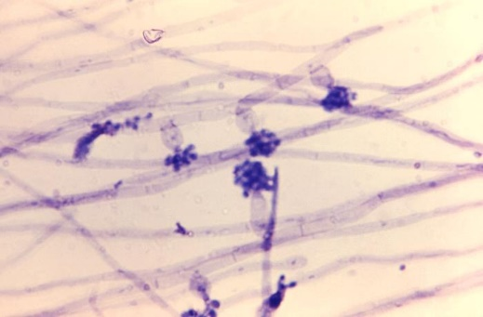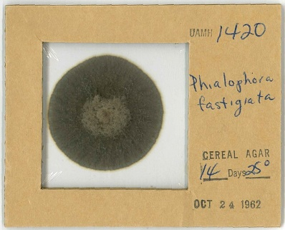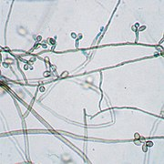
Figure 3-76. Rhinocladiella mackenziei
Slide culture of UAMH 9926, Rhinocladiella mackenzei Photo: Medmyco. Creative Commons Attribution-Share Alike 4.0
Rhinocladiella mackenziei UAMH 9926.jpg Copy
[[File:Rhinocladiella mackenziei UAMH 9926.jpg|Rhinocladiella_mackenziei_UAMH_9926]] 8/11/2017. Wikimedia Commons.
Figure 3-75. Phialophora fastigiata
Dried colony of Phialophora fastigiata on cellophane. Photo by: Medmyco. Creative Commons Attribution-Share Alike 4.0. [[File:Phialophora fastigiata colonyUAMH1420.jpg|Phialophora_fastigiata_colony_UAMH1420]] Wikimedia Commons. 10/24/1962.

Figure 3-74. 17356 Caption: At 1200X, this photo shows morphology of Phialophora verrucosa. Note the flask shaped phialides with darker collarettes projecting from the septate, hyaline hyphae, topped by a cluster of conidia. CDC/ Dr. Lucille K. Georg, 1969.

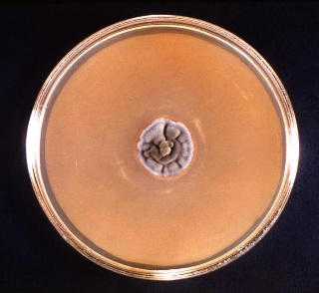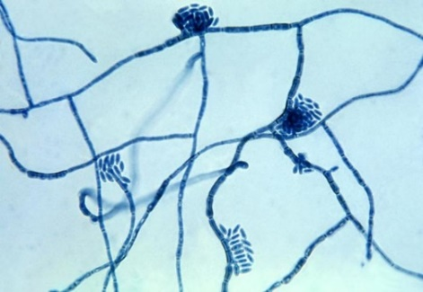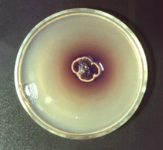
Figure 3-77. 3060 Caption: A culture plate of unidentified growth medium inoculated with Hortaea werneckii, which subsequently produced this ruffled, velvety gray fungal colony after a 4-weeks. Colonies of H. werneckii are initially yeast-like and felt-like and shiny black at maturity. It is the cause of tinea nigra, an ectopic skin infection affecting the stratum corneum in humans. CDC/ Dr. Lucille K. Georg, 1964, public domain, PHIL.
Figure 3-79. 3058 Caption: This culture plate, with an unidentified growth medium, was inoculated with Piedraia hortae and grew this predominantly brown, irregularly shaped colony, surrounded by a yellow tinted edge and a perimeter of a brownish-red halo. CDC/ Dr. Lucille K. Georg. 1964, public domain, PHIL

Figure 3-78. 3935 Hortaea-werneckii-fungus--causes-tinea-nigra.jpg: Photo of Hortaea werneckii, the etiologic agent of tinea nigra. CDC/Dr. Lucille K. Georg, 1964. Public domain. [[File:Hortaea-werneckii-fungus]]
Obtained via Wikimedia Commons.

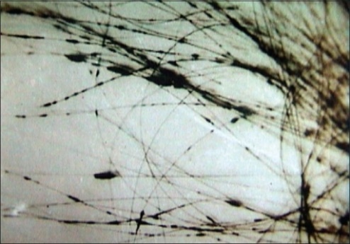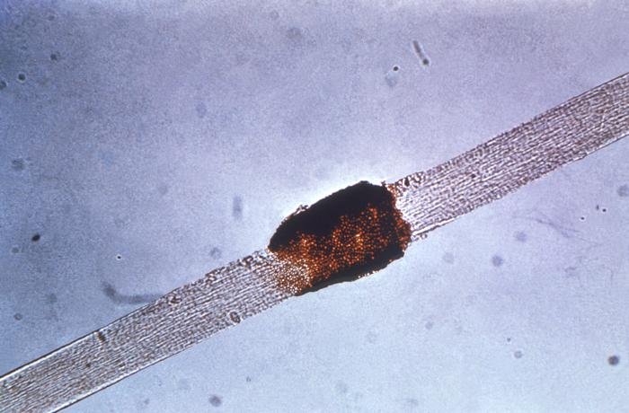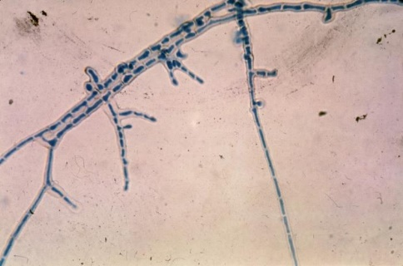
Figure 3-82. 3057Caption: At 475X, this photomicrograph reveals some characteristics exhibited by Piedraia hortae. P. hortae, the etiologic agent for black piedra, a superficial (ectopic) fungal infection of the hair shaft. Infections are usually localized to the scalp but may also be on hair from the beard or moustache and on pubic hair. CDC/ Dr. Lucille K. Georg, 1964. Public domain, PHIL.
Figure 3-80. Piedra Negra Micosis.png
Nódulos de Piedra negra en el cabello infectado por el hongo Piedraia hortae. https://openi.nlm.nih.gov. Creative Commons Attribution 2.0 [[File:Piedra Negra Micosis.png|Piedra_Negra_Micosis]]
December 4, 2017 Wkimedia Commons.
Figure 3-81. 3937 Caption: Under low power, this photo of a hair shows some of the pathologic effects on a hair shaft caused by black piedra due to Piedraia hortae. CDC/ Dr. Lucille K. Georg, 1964. Public domain, PHIL.

Piedraia hortae

Piedraia is a phaeoid mold found in the soil of regions that are tropical. The genus Piedraia contains two species: P. hortae and P. quintanilhae. One of the keratinolytic fungi, P. hortae, is the etologic agent of black piedra in man. (65) Conversely, P. quintanilhae was isolated from primates in Central Africa, but not much is known about it as a pathogen. We will only discuss Piedraia hortae. (65)

Black piedra causes brown to black nodules that attach frimly to the hair shaft. The nodules contain ascostromata (the fruiting body of this fungus with asci and ascospores). The scalp hair is most frequently infected, but other body hair can be affected. (65) Most cases are asymptomatic and may remain so for years. However, breaks due to hair shaft weakness may eventually occur in severe cases. (65) The infection mainly involves people in tropical regions (mostly South America) that use oily hair care products. Piedraia hortae and Trichosporon spp. coinfections may occur. (65)

Histopathology and direct testing: A direct KOH prep is most helpful to detect the dematiaceous hyphae wrapped around the hair shaft in brown or black nodules.

Colonial description: Piedraia hortae colonies of are small, slow-growing, folded, felt-like, and dark brown to black. They are glabrous or may become felt-like, covered with short aerial hyphae. (65) Piedraia hortae can make a red to brown diffusible pigment. On the reverse side, the colony is black. (65)

Microscopic identification from culture: Dematiaceous septate hyphae and ascostromata containing asci and ascospores are present. Hyphae are darkly pigmented and contain many also contain intercalary chlamydospore-like cells. (65) Ascostromata are structures that are round to irregular shape and black. Each contains one ascus. The asci are ellipsoid, single, or in clumps and they each hold eight ascospores. Ascospores can be hyaline to darkly pigmented. (65) They are single-celled, taper at both ends, or are curved, and form their distinctive whip-type projections. (65)

Rhinocladiella species and Rhinocladiella (formerly Ramichloridium) mackenziei

Rhinocladiella has undergone taxonomic revision and has gained the former Ramichloridium species. Rhinocladiella now contains six to eight species, five of which are clinically significant: R. aquaspersa, R. atrovirens, R. basitona, R. similis and R. mackenziei (formerly Ramichloridium mackenziei). (67) R. mackenziei is a fatal neurotropic organism and is mostly restricted to people from the Middle East. (22) R. aquaspersa is associated with chromoblastomycosis with scaly, crusted, flat, dull-red plaques or cauliflower lesions. R. mackenziei is a well-known fungal agent of sinusitis and CNS infection in the Middle Eastern nations. (67) This organism should always be considered as an etiological agent in patients from this region who manifest signs of either sinusitis or central nervous system infection. Globally, R. mackenziei is a fairly rare, neurotropic organism that causes fatal brain lesions, mainly in patients who are immune deficient or suffer from metabolic disease such as diabetes. (67) This species is generally confined to the arid area between Israel and Pakistan, with one autochthonous case reported in India. Cases in Ameria and Europe are in Middle Eastern patients. (67)
Histopathology and direct testing: Chronic inflammation of a granulomatous type with pseudoepitheliomatous hyperplasia and a mixed cell infiltrate consisting of lymphocytes, histiocytes, giant cells, neutrophils, and dark sclerotic bodies (muriform cells or copper penny bodies) are seen on the H&E stain. Further staining with PAS shows the presence of moderate to darkly pigmented septate hyphae with no yeast formation. (67)

Colonial description: Colonies are moderate to slow growing, velvety, and dark olive to brown in color with an olivaceous colony reverse side. They will grow with cycloheximide in the agar. (67)

Microscopic identification from culture: Dematiaceous, septate hyphae are seen. Conidiophores arise at a 90º right angle from the hyphae, they are erect, stout, thick-walled, brown, 3.0-4.5 µm wide, 10-25 µm long, with short cylinder-shaped denticles that generate conidia at their tips. Conidia are brown, ellipsoid to club-shaped, 8.5-12.0 × 4-5 µm, with an easily seen, wide base scar where the conidia had been attached during production. (67)

Molecular identification: rDNA ITS and D1/D2 sequencing is used for species identification. (67)

Fungal Infections of Human Mycoses by Body Site

Superficial Fungal Agents and Dermatophytes

These fungi cause infections of the skin, hair, nails, and mucous membranes, and are the largest and most widespread group of all of the mycoses. As discussed previously, your immune system generally does a lot to protect you from fungal agents being able to invade your sterile deep tissues and organs. For that reason, most fungal pathogens tend to only be able to get as far as infecting the outer parts of the human body in most fungal infections if you are immune competent. Various superficial fungal pathogens can affect your skin, hair, nails, and mucous membranes (such as mouth, throat, or vagina). (68) Some are ectopic (on top of), only on the very outside layers of the stratum corneum or the hair shaft and some penetrate the skin, nails, or hair and but do not go deeper into the tissues and are termed the dermatophytes.

Superficial ectopic infections of the skin

Tinea nigra. As covered above, tinea nigra is caused by Hortae werneckii. For more information, see above molds and also see the chapter on yeasts and yeast-like organisms. It causes dark patches on the superficial layers of the skin’s stratum corneum on the palms and on the soles of the feet. These patches are smooth, with brownish color, and painless.

Tinea versicolor. Malassezia spp. cause the skin infection and accompanying skin discoloration called tinea versicolor (also known as pityriasis versicolor). It causes scaly flat plaque-like patches of reddish-brown discoloration of the skin on white patients, and it causes whiter or lighter-color scaly patches of discoloration of darker skin. Skin patches infected with Malassezia may fluoresce under teh ultraviolet light of a Wood’s lamp used for screening for mycoses. See the chapter on yeasts and yeast-like organisms. In rare cases, it can cause fungemia or other mycoses, especially if receiving parenteral nutrition with high lipid content, or if the patient is immune compromised. It is also a very common agent of ear infections for dogs and is possibly connected to seborrheic dermatitis (SD). The increased presence or growth of Malassezia spp. stimulates skin inflammation and precipitates flares of SD for unknown reasons.

Superficial ectopic infections of the hair

Black piedra is a superficial ectopic (only on the external hair shaft) fungal infection of hair shafts that causes small nodules of hyphae to stick tightly onto the shaft and are sometimes called hard nodules. It is caused by Piedraia hortae and is characterized by these black-colored hyphal nodules. Black piedra is common in the tropics, especially in individuals that use oily hair products or have long oily hair or inadequate scalp hygiene.

White Piedra. The condition white piedra is most often caused by Trichosporon spp., such as T. cutaneum, T. ovoide, T. asahii, and T. inkin, but is also occasionally due to Acremonium species. White piedra causes soft nodules of hyphal masses to adhere to the external hair shaft. They are called soft nodules because they are less tightly packed and stick less tightly to the hair shaft and so dislodge more easily than those of black piedra. Only rarely, Trichosporon asahii (one of the Trichophyton spp. that can cause white piedra) also grows from the nails and may even be present in the lungs, causing onychomycosis and a hypersensitivity pneumonitis, respectively.

Candidiasis and yeast infections of mucosal surfaces and skin

Candidiasis (usually caused by Candida albicans and sometimes by other Candida species or other yeast) cause superficial skin and mucous membrane infections that are just some of all the infections known as candidiasis. These superficial yeast infections include some types of infant diaper rash, thrush (an oral yeast infection), esophageal candidiasis, candidal intertrigo (infection in the skin folds), and vulvovaginitis (a vaginal yeast infections). (68) These infections do occur more often in immnue compromised patients as they are opportunistic pathogens. They are typical for diabetic, HIV/AIDS patients, people on antibiotic therapy lacking their normal flora, and for newborns. For additional information, see the chapter on yeasts and yeast-like organisms.

The Dermatophytes – septate hyaline fungi that affect the skin, nails, and hair

The fungi that infect skin and nail cells and hair, are known as the dermatophytes and the mycoses they cause are the various types of ringworms (also called dermatophytosis or tineas). Ringworm is not a worm or parasite, but a fungus infection. It’s a skin, hair, or nail infection that’s caused by dermatophyte and superficial molds that live on the dead tissues of your skin, hair, nails, or on your scalp. The name ringworm comes from the fact that it leaves a circular rash with a reddened ring on the skin. Fungi tend to grow in a circle or ring (in nature, for example, in mushrooms and here in the skin) with the active new fungal growth on the outside so that as the fungus grows, the ring expands. They can infect your feet (called tinea pedis or athlete's foot), your fingernails or toenails or nail bed (tinea unguium or onychomycosis with discolored, thickened, cracked, and crumbly nails), your scalp (called tinea capitis), your groin and inner thighs (called tinea cruris or jock itch), your hands (called tinea manuum), your facial hair and area of skin surrounding it (called tinea barbae) and other parts of your body (called tinea corporis). See the dermatophyte profiles below here. (68)

Epidermophyton floccosum

Epidermophyton floccosum has global distribution and often causes superficial cutaneous and nail mycoses. (69) It is is an anthropophilic dermatophyte. (69) E. floccosum causes tinea corporis (ringworm), tinea pedis (athlete's foot), tinea unguium (infection of the nail bed, onychomycosis), and tinea cruris (jock itch). It has no specific growth requirements and is not known to invade the hair shaft. (69) Key: It infects skin and nails, but not hair.

Histopathology and direct testing: RG-2 organism. A KOH prep is useful as the skin or nail is dissolved to reveal septate hyaline hyphae.

Colonial description: Colonies are usually moderate to slow-growing, khaki-yellow or less often greenish-brown colored, with a suede-like surface, raised and folded in the center, with a flat periphery and a submerged growth fringe. (69) A deep yellow-brown pigment is usually present. (69) Colonies have a tan color reverse. Microscopic morphology shows characteristic club-shaped, smooth, thin-walled macroconidia with two to four cells that are produced in clusters directly from the hyphae. (69) Chlamydospores are typical in older cultures. Microconidia are not formed and so not seen. (69) These fungi grow in the presence of cycloheximide and chloramphenicol and will also grow on and turn dermatophyte test media (DTM) from yellow to red.

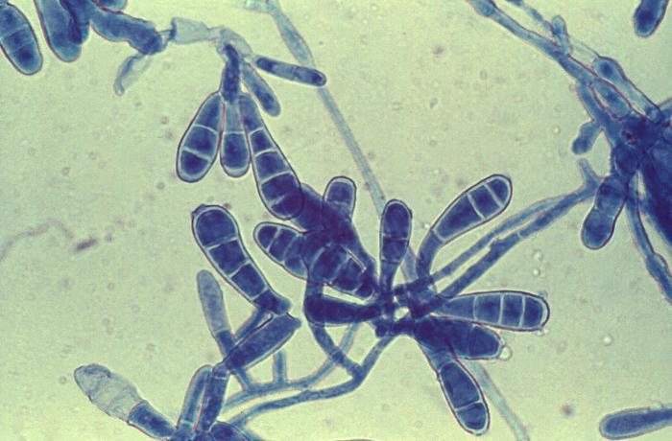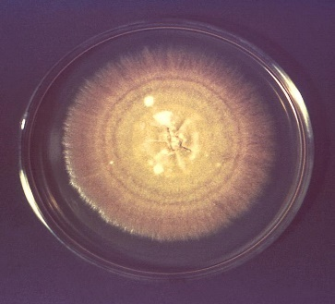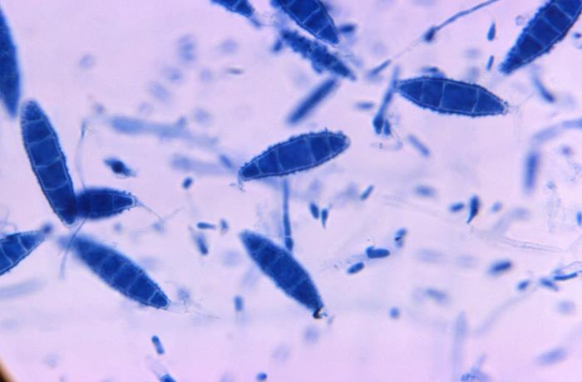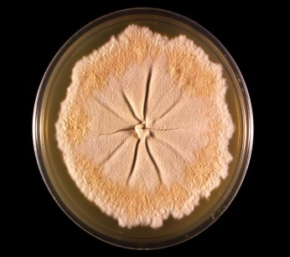
Figure 3-85. 21580 Caption: Under a magnification of 166X, this photomicrograph revealed a number of oblong-shaped macroconidia, of the dermatophytic fungal organism, Nannizzia gypsea, formerly known as Microsporum gypseum. This particular specimen was labeled as strain X-462. CDC/ Dr. Libero Ajello, 1966. Public domain, PHIL.
Figure 3-86. 21460 Caption: This photo depicted a culture plate top, with an unidentified growth medium with the dermatophytic fungal organism, Nannizzia gypsea, formerly known as Microsporum gypseum. Note its characteristic flat, granular surface and tawny-buff color. CDC/ Dr. Libero Ajello, 1966. Public domain, PHIL.

Figure 3-84. 14590 Caption: Sabouraud dextrose with Epidermophyton floccosum. E. floccosum colonies are slow growing, greenish-brown or khaki colored, with a suede-like surface. E. floccosum is a common cause of dermatophytosis that infects skin and nails. CDC/ Dr. Lucille K. Georg, 1968. Public domain, PHIL.
Figure 3-83. 14588 Caption: At 475X, this photo reveals a number of macroconidia of the dermatophytic fungus, Epidermophyton floccosum, as well as the organism’s filamentous hyphae. CDC/ Dr. Lucille K. Georg, 1964. Public domain, PHIL.

Nannizzia species
The genus Nannizzia now consists of 9 species. N. gypsea, N. fulva, N. nana, and N. persicolor were previously in the genus Microsporum. (70) N. gypsea is acommon soil-associated dermatophyte that has global range and causes infections in both animals and humans, especially in children and farmers, with warm and humid weather. (70) It usually produces a single lesion on the skin or scalp and is the most common of this genus. The ectothrix invaded hairs do not fluoresce under Wood's UV light. It is pathogenic for skin and hair and rarely nails. (70, 71) The other species rarely cause human diseases. (70)

Histopathology and direct testing: RG-1 organism. A KOH prep is helpful as the skin, nails, or hair is dissolved to reveal the hyaline hyphae.

Colonial description: Colonies grow rapidly and are mainly cottony to powdery, whitish to buff, yellow, cinnamon, buff-colored with violet or reddish hues. (70) These fungi grow in the presence of cycloheximide and chloramphenicol and will also grow on and turn dermatophyte test media (DTM) from yellow to red.

Microscopic identification from culture: Macroconidia are terminal to solitary, symmetrical, large, ellipsoid to fusiform, cylindrical, or club-shaped or cigar-shaped cylindrical, thick, four to six cells, hyaline, and rough walled. Microconidia are hyaline, single-celled, oval to pear-shaped to club shaped, and rough-walled. Most of the macroconidia's terminal or distal ends are rounded slightly, but the ends attached to the hyphae are truncated. Numerous clavate-shaped microconidia are also characteristic of this fungus, but these are not diagnostic.

Molecular identification: rDNA ITS sequencing can be used for identification.

Microsporum species

The genus Microsporum now has three species: M. canis, M. ferrugineum, and M. audouinii. Many species previously considered Microsporum have been moved to the genera Nannizzia, Paraphyton, and Lophophyton. Paraphyton and Lophophyton rarely cause human disease. Although they are not always present in cultures, Microsporum species form both macro- and microconidia, especially on sporulation media. (72) Microsporum spp. mainly infect the hair in ectothrix invasion style and infect skin, except M. persicolor that does not infect hair. Nail infections can occur less often but do occur in this genus. (71) Asymptomatic carriage may be observed. Immunocompromised patients and otherwise healthy hosts are both infected. (72) M. canis, M. audouinii, and M. ferrugineum all fluoresce under a quick Wood’s lamp screening of hair. M. canis is the most frequently seen species and may also be seen on dogs and cats.

Histopathology and direct testing: A KOH prep is helpful as the skin, nails, or hair is dissolved to reveal the hyaline hyphae.

Colonial description: Microsporum growth rate is variable but is generally slow to moderate. Microsporum colonies are glabrous, wooly, downy, or powdery. The growth on Sabdex at temperatures below 30°C may be slow to moderate, with the width of the colony usually between one and nine cm after seven to ten days of incubation. (72, 73) The colony color varies depending on its species. It may be white, yellow, beige, or cinnamon. On the colony reverse, it may be yellow or red to brown due to pigments or tan with no pigment. (72, 73) Strains of M. canis often do not sporulate to produce their characteristic macroconidia and microconidia on the primary culture media. Inoculation to polished rice grains or lacrimal agar or other sporulation media are recommended to stimulate sporulation. The nonsporulating strains of M. canis are often misidentified as M. audouinii. (72, 73) Laboratories have surprising difficulty in differentiating M. audouinii and M. canis. The hair perforation test, the ability to grow on rice grains, and the growth at 37°C provide helpful hints to differentiate the Microsporum spp. from each other. (72, 73) Microsporum fungi grow in the presence of cycloheximide and chloramphenicol and will also grow on and turn dermatophyte test media (DTM) from yellow to red.

Microscopic identification from culture: Microsporum spp. produce hyaline, septate hyphae, microconidia, and macroconidia. Conidiophores are hyphae-like. Microconidia are solitary single cells, hyaline, oval to clavate in shape, smooth, and thin-walled. (72) Macroconidia are hyaline, echinulate to rough, thick-walled, typically fusiform (spindle-shaped), and multicellular (6-15 cells) . They often have an annular frill. (72,73) Racquet -like hyphae, nodular bodies, and chlamydospores may be present. Inoculation onto specific sporulation media, such as potato dextrose agar supplemented with 5% sodium chloride or the above rice grains or lacrimal agar, may be helpful in stimulating macroconidia production of some strains. (72,73) As discussed on separate pages for each species, variations in the shape of macroconidia and the abundance of microconidia and other structures help in inter-species differentiation.

Molecular identification: rDNA ITS sequencing is recommended for identification. (73)

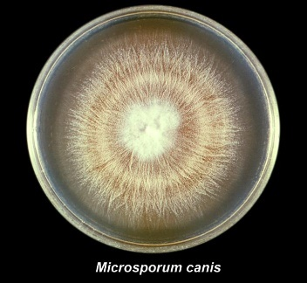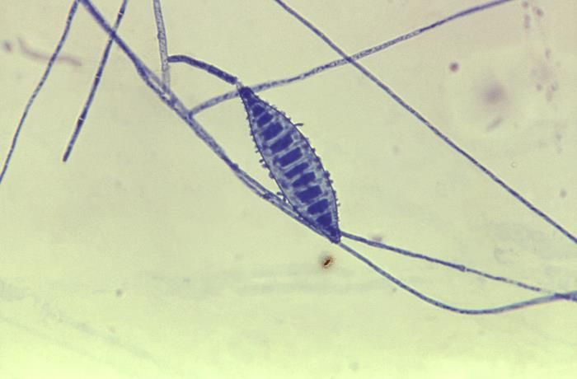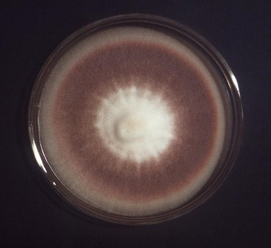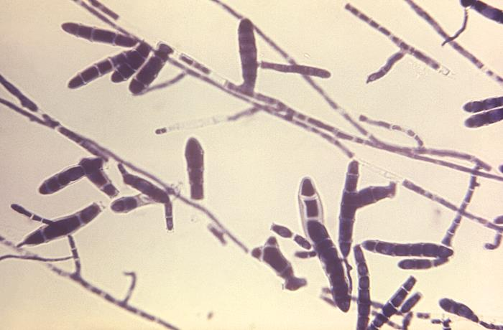
Figure 3-90. 16027 Caption: At 474X, this photomicrograph revealed some of the ultrastructural morphology exhibited by the dermatophytic fungal organism, Trichophyton rubrum, strain A-600. Of importance were the large, atypically swollen forms of the multicellular macroconidia. Referred to as mitospores, for these reproductive structures are born out of the process of mitosis, and are therefore, haploid when they reach maturity. CDC/ Dr. Lucille K. Georg, 1970, Public domain, PHIL.
Figure 3-87. 22030 Caption: This photo shows Microsporum canis, strain A-638, viewed from the top. It shows its characteristic, cream-colored surface that was streaked with numerous radial grooves emanating from the colony’s center. The colony had been cultivated on a growth medium of Sabouraud dextrose agar for a 3-week period. CDC/ Dr. Lucille K. Georg, 1964. Public domain, PHIL.
Figure 3-89. 16018 Caption: This photograph is a Sabouraud dextrose agar, with Trichophyton rubrum. The colony has a texture that is glabrous, though fuzzy. Its top coloration ranged from a white central region, to a brown, rust colored mid-region, to a beige periphery. CDC/ C. Papageorge, 1976. Public domain, PHIL.
Figure 3-88. 22255 Caption: At 475X, this photo revealed some of the ultrastructural morphology exhibited by a macroconidium of the fungus, Microsporum canis. Of note, was the spindle-shape of this reproductive structure, and its roughened surface. CDC/ Dr. Lucille K. Georg, 1964. Public domain, PHIL.

Trichophyton species

DNA sequences now delineate phylogenetic relationships, so the species in the genus Trichophyton have rearranged. Sixteen species are now classified as Trichophyton. (74) The most frequently cultured are T. mentagrophytes, T. rubrum, T. schoenleinii, T. tonsurans, T. verrucosum, and T. violaceum. (75) Trichophyton is one of the dermatophyte genera that inhabit the soil, humans, or animals. Trichophyton includes geophilic, zoophilic, and anthropophilic species. (75) Some species are worldwide, while some have a limited geographic range. T. concentricum, as an example, is endemic to the Pacific Islands, Southeast Asia, and Latin America. Trichophyton is a leading cause of skin, hair, and nail infections in humans. (75) Morphologic, biologic, and physiologic properties are used to differentiate and identify the Trichophyton species. They can infect the hair by ectothrix or endothrix invasion, skin, and nails. Like the other dermatophyte genera, Trichophyton is a keratinophilic mycelial fungus. The ability to invade keratinized tissue is the major virulence factor of these dermatophyte fungi. Trichophyton possesses several enzymes, such as acid proteinases, elastase, keratinases, and other proteinases to accomplish this superficial invasion into the outer layers and structures of the body.

Trichophyton rubrum is the most common cause of dermatophytoses globally and is quite common. (75) Some Trichophyton species can also cause serious invasive mycoses in immune deficient hosts and T. rubrum is one that does. It is named T. rubrum for its distinctive red pigment.

Histopathology and direct testing: A KOH prep is helpful as the skin, hair, or nail is dissolved to reveal the hyphae. Hyaline, septate, and branched hyphae with arthroconidia in chains are observed. (75)

Colonial description: The growth rate of Trichophyton colonies is slow to moderate. The texture is waxy, or glabrous to cottony. The color is white to bright yellow, beige, or reddish-violet from the colony top. The colony reverse is pale, yellowish, brown, or reddish-brown. (74, 75) These fungi grow in the presence of cycloheximide and chloramphenicol and will also grow on and turn dermatophyte test media (DTM) from yellow to red.

Microscopic identification from the culture: The genus Trichophyton is characterized morphologically by smooth-walled macro- and microconidia development. Specialized hyphae and chlamydocondia may be present by are of little help in identification. Macroconidia are borne directly on the hyphae or short pedicels laterally and are clavate or fusiform, and they range from 4-8 x 8-50 μm. Macroconidia are few or absent in many Trichophyton species. (74) Microconidia are round, pear or club shaped, or irregular in shape, ranging from 2-3 x 2-4 μm, although they also may be absent in some species. (74) The presence of microconidia helps to differentiate Trichophyton from E. floccosum, and the smooth-walled, mostly sessile macroconidia differentiates Trichophyton from Lophophyton, Microsporum, Nannizzia, and Paraphyton. In practice, two categories may be recognized with microscopy and culture:

i. Species that may produce microconidia. Macroconidia might or might not be present: T. rubrum, T. interdigitale, T. mentagrophytes, T. tonsurans, T. equinum, T. erinacei, and to a lesser extent T. verrucosum, which may occasionally produce conidia on some media. The macro- microconidia shape, size, and arrangements are the most helpful characteristics for identification. Culture and growth characteristics are also helpful.

ii. Species that do not produce any microconidia or macroconidia despite attempts to sporulate. Chlamydospores or other structures in the hyphae may be seen but are not helpful for identification: T. verrucosum, T. violaceum, T. schoenleinii, T. concentricum, and T. soudanense. Culture and growth rate results and some clinical information, such as the site, lesion appearance, location, travel history, animal contacts, and even occupation, may be helpful for identification. (74, 75)

Additional confirmatory tests and special media or sporulation media can help to differentiate between the Trichophyton species, especially isolates of T. rubrum, T. tonsurans, and T. mentagrophytes. Use of various types sporulation media, Sabouraud's agar with 5% Salt, bromocresol purple-dextrose agar (BCP), 1% peptone agar, urea, Trichophyton nutrient agars 1-5, and a hair perforation test can be helpful in identification.

Molecular identification: rDNA ITS and EF-1α sequences are used for speciation. MALDI-TOF MS methods require a good sequence database for identification. (75)

Fungal agents of keratitis

Fungal keratitis is infection of the cornea of the eye with a fungal organism. Fungal keratitis can develop quickly from an eye injury or incorrect contact lens use. If it is not treated, it can cause blindness. Sometimes, treatment cannot restore vision, and permanent vision impairment or blindness may result. Different fungi such as Fusarium, Aspergillus, or Candida can infect the cornea. Superficial keratitis involves the outer layer of the cornea. After this form of keratitis heals, the cornea usually has no scar. Deep keratitis affects the inner layers of the cornea, which can result in a scar on the cornea after healing, which may or may not affect your vision, depending on the scar's location.

Otomycosis

Fortunately, fungal ear mycoses occur only in your outer ear. Most often, just in your ear canal. This occurs when fungi like Aspergillus, some opportunistic molds, Candida, or other yeast grow and spread in your ear, often after swimming with fluid retention in your ear. Because fungi thrive in warmer temperatures, fungal ear infections are most common during hotter months. Seek a care giver as these infections typically don't go away without treatment.

Fungal Agents of the respiratory tract

Upper respiratory tract: The mouth and throat are affected mainly by Candida albicans for fungal infections.

Sinuses: Fungal rhinosinusitis is a sinus infection with a fungal cause. Different types of fungal sinus conditions have the same symptoms: nasal congestion or nasal blockage and pain in the cheeks, forehead, and between the eyes. Fungal sinus conditions involve a colonization or an overgrowth of fungi in the sinuses. Different fungal sinus conditions include fungus balls, allergic fungal sinusitis, saprophytic fungal sinusitis, and invasive fungal sinusitis. The symptoms of a fungal sinus mycoses include: nasal congestion or blockage, inflammation, nasal polyps, headache and facial pain, fever and chills, vision problems, and eye and face swelling. Invasive fungal sinusitis can be caused by Aspergillus spp., Candida spp., Rhizpus spp., or Rhinocladiella spp., Mucor spp. or other opportunist fungi. As you can read above a variety of molds can cause allergies and can infect the sinuses, both dematiaceous and hyaline. Some are fatal.

Most cases of sinusitis mycoses are treated with sinus resection surgery, and many also require additional antifungal therapy. However, some people with healthy immune systems may recover without antifungal therapy. People with conditions that compromise the immune system (such as leukemia, lymphoma, or diabetes) are much more likely to get a fungal sinus infection and have a much higher risk of serious complications. Some fungal sinusitis infections destroy the lining of the nose and the sub tissues and can then directly spread to the brain and even cause death.

Lower respiratory tract (Bronchial/ Lung): Pathogenic fungi, such as Cryptococcus neoformans, Aspergillus, Pneumocystis, endemic fungi, and Candida species cause pulmonary infection in humans. Fungi are prone to have many spores that if airborne are inhaled. Fungal pathogens’ spores can trigger the host’s innate or cellular immune reactions after breathing in spores, and the lungs are the primary infectious location. Aspergillus and Cryptococcus are the most significant fungal pathogens in pulmonary infections and in mortality globally.

Aspergillus is one of the most frequent fungi that sporulates in the lungs from airborne floating conidia. These spores in the air are tiny enough, at only 2 to 3 μm, to float and to get through the defenses of the airways and into the alveoli of the lung. There, they cause a spectrum of diseases that include lethal aspergillosis infection for primarily immune-deficient individuals and asthma allergies in atopic patients. In people with functional immune systems, the inhaled spores are usually phagocytized by macrophages in the alveoli and are destroyed in an oxidized-lytic fashion by phagocytosis. In immune compromised hosts, incomplete destruction of the inhaled spores results in their germination in lung tissue resulting in aspergillosis in the lung.

Cryptococcosis is caused by inhalation of the airborne ubiquitous yeast into the lung. As a species of Cryptococcus, C. neoformans has a global distribution, like Aspergillus, it is geophilic and in found in areas of bird or bat habitation. The most severe aspect of infection with Cryptococcal mycosis is cryptococcal meningitis. (77, 78) C. neoformans and Cryptococcus gattii can spread through the bloodstream via the lungs to invade the brain by crossing the blood-brain barrier. Fungi can directly penetrate the blood-brain barrier by using endothelial cells in the capillaries and vessels around the brain, using a method similar to transporting white blood cells across the vessel wall. (77, 78) Large-scale growth and tissue injury occur despite the host's best defense mechanisms.

Pneumocystis jirovecii pneumonia (PJP) is induced by fungal pathogens of the genus Pneumocystis, like Pneumocystis jirovecii. P. jirovecii is the most common AIDS-related and AIDS confirming disease. Now PJP is increasingly reported in non-AIDS patients with a specific immunity deficiency or in patients receiving a course of high-dose glucocorticoids. Research continues in the development of vaccines and other treatments for PCP, with the current therapeutic strategy being to give trimethoprim-sulfamethoxazole. However, is currently no vaccine in clinical trials to prevent PJP. There are significant obstacles to new therapies, such as the inability to culture Pneumocystis spp. in vitro.

Endemic dimorphic fungi that cause endemic dimorphic mycoses occur in specific geographical regions and can result in severe and fatal infections. These pathogens can infect both immune-competent hosts and immunocompromised hosts. In immunodeficient hosts, dimorphic pathogens elicit a more serious and disseminated course of disease, with concomitantly increased mortality. The increasing occurrence of endemic mycoses often correlates with an increasing population of elderly and immunodeficient patients, although even immune functional patients can get disseminated disease with these true pathogens. With these fungal diseases, mortality is also high even for immune competent hosts. In North America, the three primary endemic dimorph mycoses: blastomycosis, coccidioidomycosis, and histoplasmosis can resemble community-acquired pneumonia. For coccidioidomycosis, half of the patients that are infected are asymptomatic because an acute infection resembles the common symptoms of a cold or bronchitis. Only a few cases ever develop to become disseminated disease. Histoplasmosis, caused by the dimorphic pathogen Histoplasma capsulatum, is often misdiagnosed as a common community-acquired pneumonia. A difference is that histoplasmosis cases reveal a history of encountering dirt contaminated with bat or bird droppings. Most patients have pneumonia signs and symptoms first for histoplasmosis. Serious cases can disseminate or culminate in respiratory failure and death. Blastomycosis is less commonly seen than histoplasmosis and coccidioidomycosis. Additionally, paracoccidioidomycosis is geographically distributed mostly in Central and South America, with Brazil largely accounting for the bulk of the reported cases.

Fungal Agents of Urinary Tract Infections

Most fungal bladder and kidney infections result from Candida albicans, other Candida species, or other non-Candida yeasts. However, a variety of different fungi can rarely involve the kidney as a result of serious disseminated disease. (78) These UTI fungi include: the endemic dimorph mycoses, Aspergillus species, Trichosporon species, Acremonium species, Fusarium species, Mucorales (e.g., Rhizopus and Mucor species), Geotrichum species, Candida species, Cryptococcus spp., and a variety of dematiaceous molds.

Fungal Agents of Subcutaneous Mycoses, Bone and Joint Infections, Miscellaneous Sites

You can get a fungus into your skin and under the surface of your skin (subcutaneous) that causes a subcutaneous mycosis. This happens frequently when the fungus enters into a wound or cut, usually through a traumatic injury when working with plants or soil (such as a puncture from a barb or thorn). These infections cause lesions, rashes, and signs of skin infection. More of these mycoses are seen predominantly in tropical and subtropical areas where the fungal agents grow and form reservoirs for disease. Sporothrix shenckii and a few others also have sporadic cases in temperate regions because the fungus is present worldwide despite growing better in warmer tropical and subtropical locations. Examples of subcutaneous mycoses include:

Sporotrichosis (rose gardener's disease). Sporothrix is the etiologic agent of sporotrichosis. It is usually localized around the puncture site but can extend into subcutaneous areas and nerves, bone, and joints that are nearby. From there, it can disseminate through the blood and spread to other tissues and organs. You can also get a sporotrichosis pneumonia in your pulmonary system or Sporothrix in other tissues or organs, especially from disseminated infection with this fungus.

Chromoblastomycosis- Various fungi are able to cause chromoblastomycosis, which can cause long-lasting (chronic) deep cutaneous/subcutaneous infections and deformities. It forms reddened scaly plaques or cauliflower lesions on the external skin. It grows and produces sclerotic bodies in the tissues. It damages subcutaneous tissue, nerves, and nearby bone under the infected skin. It rarely disseminates to other tissues or organs of the body. The most common fungal agents are: Cladosporium carrionii, Phialophora verrucosa, and Fonsecaea pedrosoi. Less common agents: Fonsacea compactum, Rhinocladiella aquaspersa, Exophiala jeanselmei, and other Exophiala spp.

Mycetoma-Mycetoma is another chronic cutaneous and subcutaneous tissue infection that disfigures. It primarily affects the feet and legs but can also affect the hands, shoulders, abdomen, buttocks, and even the scalp. Mycetoma is a gradually progressive disease. After the initial infection, it may take a year to form the characteristic lesions. It then continues to grow and produces granules of compacted hyphae in the tissues. The lesions are localized, painless, hard subcutaneous nodes. The infection spreads and destroys surrounding tissues but does not affect the nerves or tendons. Mycetoma is also called Madura Foot or Maduramycosis. Mycetoma is classified based on causative agents, the color of grains (granules), and geographical location involved. In eumycetoma: This mycetoma is caused by various environmental fungi. Depending on the fungus involved, it is associated with both black granule and white granule mycetoma. In actinomycetoma: The mycetoma is caused by bacterial actinomycetes, either anaerobic Actinomycetes species or aerobic Nocardia species. Bacterial mycetomas generally cause white or pale-grain mycetoma.

Fungal agents of other deep infections of the body tissues/organs (wounds, abscesses, post-surgical wounds or fungemia)

Deep fungal infections are found in places other than the skin or mucous membranes like in the lungs, blood, kidney, and brain. Some are opportunistic infections, which usually cause disease in people with immune system deficits, but can affect patients with healthy immune functions. These infections can disseminate throughout the body via the blood and cause fungemia (fungus in the blood).

Deep or invasive fungal infections include:

- Histoplasmosis is commonly found in the river basin areas of the Ohio and Mississippi Rivers. The fungus Histoplasma causes histoplasmosis, which can infect the lungs, blood, bone marrow, brain, or other body parts. (76)

- Coccidioidomycosis (Valley fever) is endemic in the American Southwest. Caused by Coccidioides, a fungus that can infect the lungs and rarely spread to other body parts. It is most commonly seen in Arizona and California.

- Blastomyces, the etiologic fungus that causes blastomycosis, most commonly infects your skin, bones, and lungs. Rarely, it can also infect your central nervous system.

- Aspergillus, that causes aspergillosis, causes lung diseases, like allergic bronchopulmonary aspergillosis, chronic pulmonary aspergillosis, and invasive aspergillosis. It can also infect other body sites or form aspergillomas (fungus ball).

- Invasive candidiasis. Various Candida species, especially C. alibicans, cause invasive candidiasis. They can colonize intravenous lines and cause fungemia. These yeasts can also infect your heart, blood (candidemia, fungemia), brain, eyes (endophthalmitis), bones, or other body parts, as can some other yeast species.

- Pneumocystis jirovecii (previously species caronii) pneumonia (PJP-formerly PCP). This fungus, Pneumocystis jirovecii, can infect your lungs and cause Pneumocystis jirovecii pneumonia (PJP). It was an enormous problem for HIV-positive patients before treatment, but it can also infect non-HIV patients. Fungemia is very rare with PJP.

- A group of molds called mucormycetes, or Mucorales, known by the older name zygomycetes, cause mucormycosis. Mucormycetes can infect your nasal sinuses and spread to infect your eye orbit and brain (rhino-orbito-cerebral mucormycosis), lungs (pulmonary mucormycosis), skin (cutaneous mucormycosis), intestines (gastrointestinal mucormycosis), or many other body sites at the same time (disseminated mucormycosis).

- Cryptococcus neoformans and Cryptococcus gattii cause cryptococcosis. Cryptococcus usually infects your lungs but sometimes can disseminate and infect your brain and spinal cord and cause cryptococcal meningitis. (76, 77)

- Urinary tract infections with Candida species and other yeasts cause deep infections. Bacteria cause the vast majority of urinary tract infections (UTIs), but some are caused by yeasts, such as Candida species, especially C. albicans, and other yeasts and yeast-like organisms and less often, molds. (78)

Direct Tests that might help with earlier detection of the fungal agents causing deep invasive fungal disease include the (1-3)-β-d-Glucan (BDG) serum and the glucomannan test. BDG is found in cell walls of most fungi (e.g., Aspergillus, Candida, Fusarium, Pneumocystis jirovecii) with the notable exceptions of the Cryptococcus species, the Blastomyces species, and the Mucorales (e.g., Lichtheimia, Mucor, Rhizomucor, and Rhizopus), which either lack BDG or produce it in extremely low amounts. Elevated serum levels of BDG have been associated with a fungal infection with pathogens containing BDG, e.g., Aspergillus, Candida, Fusarium, Pneumocystis jirovecii. The BDG serum levels may be detected before the patient's symptoms and before isolation or identification of the fungus via routine lab methods. A positive glucomannan test result supports a diagnosis of invasive aspergillosis (IA). Positive results should be considered with other diagnostic procedures, such as culture, histological examination of biopsy specimens, and radiographic evidence.

Fungi found in cerebrospinal fluid

Cerebrospinal fluid should be concentrated before processing in the medical laboratory. It can be centrifuged and a direct India ink prep made to look for Cryptococcus spp. (76) If there is more than 5ml of the spinal fluid for culture, it can filtered through a 0.45 µm sterile filter and portions of the filter can then be cultured to increase the likelihood of finding a fungus by the concentration of the sample. Other body fluids can also be concentrated in this manner.

Fungal species associated with meningitis include Cryptococcus spp., the dimorphic fungi if they disseminate such as
Histoplasma, Blastomyces, Coccidioides, and Candida species. (76, 77) A variety of other molds such as Aspergillus spp., Fusarium spp., Scedosporium spp., and a variety of dematiaceous fungi such as Rhinocladiella spp., and Cladophialophora spp. and others are isolated in rare cases especially, but not exclusively, in the immunocompromised as discussed above. (76, 77)

 | Table 3-1 The Most frequent culture sites for the various mycoses of medical importance
Infection |  | Other tissues | Respiratory | Skin | Subcutaneous Tissue | Blood | Bone marrow | Bone | Urine tract | CSF | Other body systems
Blastomycosis |  |  | + | + |  | +/- |  | + |  | +
Coccidiomycosis |  |  | + | + ~15-67%⁷⁹ |  | +/- |  |  |  | +
Emergomycosis |  |  | + | + |  | +/-
Histoplasmosis |  |  | + | +/- ~5-10%⁸⁰ |  | + | + |  |  | +
Paracoccidiomycosis |  |  | + | + |  | +/-
Talaromycosis |  |  | + | + |  | +/-
Cryptococcosis |  |  | + | + ~10-15%⁸¹ |  | +/- |  |  | +/- | +
Invasive Aspergillosis |  |  | + | + ~5-10%⁸²
Invasive Candidiasis |  |  | + | + ~10%⁸¹ |  | + ~70% of fungemia, higher with other yeasts⁸¹ |  |  | + | +
Mucormycosis |  | 1. rhino-cerebralsinuses, eye orbit, eye, and to brain | + 2. lung | +  3. skin | +  with skin |  |  |  |  | +  esp. with 1. brain | 4.  stomach  GI tract
Sporotrichosis |  |  |  | + | + |  |  | +/-
Chromoblastomycosis |  |  |  | + | +
Eumycotic mycetoma |  |  |  | + | +
Actinomycetoma |  |  |  | + | +
Phaeohyphomycosis |  |  |  | + | +
Key: + = This site is frequently involved in this mycosis and cultured. +/- = This site is involved in a small/ moderate percent of these mycoses
and is cultured fairly often
Remember, other sites, even if not marked can sporadically be involved in these mycoses and may need to be cultured. These are all rough estimates and to give you an idea of what you are likely to see.

Susceptibility testing of molds and dimorphs

The Clinical Laboratory Standards Institute (CLSI) USA) and the European Committee on Antimicrobial Susceptibility Testing (EUCAST) both have guidelines for acceptable susceptibility testing protocols. Acceptable methods for both agencies include: 1) Broth microdilution methods that give MIC values, 2) Gradient diffusion methods (performed on agar like the commercial E-test and gives MIC values), 3) the traditional disk diffusion on agar (reported in sensitive, intermediate, and resistant interpretive categories which can be correlated to MICs for many organisms, but not all), 4) approved commercial methods like Yeast One (Thermo Scientific) and Vitek-2 (bioMerieux), and 5) agar screening for Aspergillus azole resistance. These are standardized to give reliable results. The biggest problem for many of them is whether or not there are established breakpoint interpretations for determining drug susceptibility and resistance for the species that you are testing so you can interpret the results and choose the proper antifungal dosage. Such interpretive guidelines are established for many yeasts and for some commonly isolated molds, but unfortunately, for many fungal species that cause infections, and even serious invasive infections, clinical breakpoints have not yet been established. Thus, interpretations of susceptible or resistant cannot be provided by clinical laboratories, and this is especially true for many molds capable of causing severe mycoses.

Disk diffusion testing is inexpensive, reproducible, and easy to perform and is well established and used especially in resource-limited settings. It is commonly used for yeasts but does not give MIC results without interpretative guidelines. Disk diffusion is useful for >90% of Candida isolates that fall within the five species for which established breakpoint interpretations are avialble, but this method is not useful for emerging species or for newly developed antifungals because there is no way to interpret the results. It is less useful for mold isolates because of the same problem. Microdilution broth testing or commercial products are used more often for dimorphs and mold antifungal testing. Antifungal testing cannot always be performed. For example, it is not necessary or useful to test molds against an antifungal to which it has intrinsic resistance. Also, for example, Aspergillus terreus does not have intrinsic resistance to amphotericin B but susceptibility testing is still not recommended for this bug for amphotericin B because many studies have shown poor outcomes with amphotericin B in A. terreus. So standardized antifungal testing is not always recommended or always available because of interpretive issues but is useful if it is available. Some labs send all their susceptibility testing for fungi to reference labs.

Some things your lab should do if you perform this testing: 1) you should purchase the CLSI or EUCAST standard publications for this testing, 2) familiarize yourself with the methods and 3) consult with the public health lab and other experts about testing issues if they arise. Reading the references given at the end of this chapter will also increase your knowledge of these issues and methods. (86, 87)

Mold-like Bacteria of Medical Importance

Actinomyces species

Actinomycosis bacterial infection is rare and causes pus-filled areas (abscesses) surrounded by tissue and thus a lumpy appearance. It is also sometimes called lumpy jaw because it often infects the neck and head of the infected host or animal. You get it from infection with the anaerobic gram-positive bacteria of the Actinomyces genus. Actinomyces are normal flora residents of your body in non-sterile areas without harming you, such as in the mucous membranes of your mouth and GI tract. But surgery, injury, dental surgery, or dental disease can allow them to get entry into deeper tissues. Then they grow in that normally sterile area, where they don't belong, without even any competition. (83) Actinomycosis invades gradually into surrounding tissues, creating a persisting, tunnel tract (an opening leading underneath your skin). The tract is filled with yellowish pus exudates containing sulfur granules. Sulfur granules are dense clumps that are made of dead immune cells and dead bacteria. The name comes from the yellow color, not from actual sulfur. Actinomycosis can take several weeks or even months to cause symptoms after initial infection. Actinomyces usually infect areas around your mouth and face. But you can also get actinomycosis in other parts of your body. Physicians refer to the type of actinomycosis by which part of the body is infected. Cervicofacial actinomycosis (lumpy jaw) affects the face, mouth, nose, neck, and jaw. Pulmonary actinomycosis affects your lungs or chest. Abdominal actinomycosis affects your GI tract or other abdominal organs. Pelvic actinomycosis affects your reproductive organs and pelvis cavity. (83)

Symptoms of actinomycosis depend on where your infection is located. They include fever, weight loss, bumpy nodules, pain when you chew or severe jaw tightness with an infection in your mouth or jaw. chest pain with an infections in your lungs or chest, abdominal pain with a GI tract or abdominal infection, vaginal bleeding, pus, discharge, or pain with a pelvic infection. (83) Actinomyces israelii bacteria are the most common cause of actinomycosis. But many other Actinomyces spp. can also cause it, including A. naeslundii, A. odontolyticus, A. viscosus, and others. Most of the time, Actinomyces live symbiotically without incident in specific mucous membranes, like your mouth, GI tract, and vagina, but not in inner sterile sites. They are among millions of bacteria that live on or in your body without usually harming you. But if they get into sterile tissues, they start reproducing and cause infection. (83) You get actinomycosis when Actinomyces bacteria get into parts of your body where they don't belong. For instance, surgery, dental work, injury, dental or other diseases can cause a break in a mucous membrane that allows bacteria to infect a sterile part of your body. Foreign objects in mucous membranes can also allow bacteria to grow. Bleeding gum disease or various dental procedures or conditions are the most common ways to get actinomycosis (lumpy jaw). Other causes include intrauterine devices (IUDs) or pelvic surgery (pelvic infection), or getting food, liquids, or a foreign object into your lungs (aspiration and pulmonary infection), abdominal diseases like appendicitis, diverticulitis, or peptic ulcer disease, gallbladder removal (cholecystectomy), bowel resection, or another surgery in your abdominal cavity (abdominal infection). (83) Actinomycosis is an infection with anaerobic Actinomyces bacteria. It is a gram-positive rod that is thin, branching, fragmented, and sometimes coccobacillary in form, with no spores. It can be grown in anaerobic culture from patient specimens and identified with traditional bacteriological techniques, nucleic acid methods, or Maldi-Tof mass spectrophotometry. It causes pus-filled wounds in the face and mouth and in other surrounding tissues that it spreads to. Physicians often must treat it with antibiotics at high doses over many months. (83)

Nocardia species

Nocardiosis is the name of the disease caused by the aerobic bacteria, Nocardia spp., which is usually found in the environment in standing water, soil, and decaying plants. Nocardia are considered opportunistic pathogens. They infect people and animals under the right conditions. They can cause severe infections in people with weak immune systems who have difficulty fighting off infections. (84) If someone breathes in dust that contains the bacteria, soil, or water containing Nocardia, or if Nocardia gets into the skin through a cut, or a hospitalized patient gets the bacteria in their surgical wound, the patient can acquire nocardiosis. (84) Nocardiosis usually first appears as a skin or lung infection. It can also occur as an infection that spreads throughout the body (disseminated). In America, Nocardiosis most often manifests as a lung infection. Nocardiosis must be treated to prevent its spread to other body sites such as the spinal cord and brain. (84) About 4 of 10 patients with nocardiosis die from the infection. (84) The brain is the most common site of disseminated infection. More than eight in ten patients that develop nocardiosis involving the brain or spinal cord, die from it. The risk of death is even higher for patients with fragile immune systems. (84) With nocardiosis in the lungs you can experience these symptoms: cough, chest pain, pneumonia, fever, night sweats, and weight loss. With a lung infection from nocardia, the infection can spread to your brain. If your central nervous system (brain and spinal cord) are infected, you can experience: confusion, weakness, headache, seizures, nocardiosis and skin infections. You also can get a skin infection if soil containing Nocardia gets into open wounds or cuts when farming or gardening with no protective apparel (which increases the risk of cuts, thorn pricks, or other injuries). If skin is invaded, you can develop: skin ulcers, shallow sores, or nodules under the skin surface. These nodes drain when the bacteria invade your lymph nodes. A physician consultation is recommended with an lesion or injury that doesn't heal or with nocardiosis symptoms. Obtaining a patient’s history of how they were wounded is important. The doctor can determine nocardiosis by performing tests for these bacteria. Nocardia are branching, filamentous, gram-positive rods on gram stain. They may exhibit a beaded appearance due to irregular staining. A key test for identification is finding these partially acid-fast branching, filamentous rods in a Modified Kinyoun's stain. Nocardia can be identified more conclusively with additional bacteriological techniques, nucleic acid methods, or Maldi-Tof mass spectrophotometry. Your healthcare provider may need to take samples from an infected site, such as your lungs, mucus from the lower airways, skin, or even the brain. (84)
Invasive pulmonary aspergillosis (IPA) in a neutropenic patient- A Case Study
Case: This is an invasive pulmonary aspergillosis (IPA) case in an immunodeficient patient, with their physical exam and diagnostic findings that include laboratory blood Aspergillus marker tests, computed tomography imaging, and bronchoalveolar lavage specimen testing and culture. The patient had recently been diagnosed with chronic lymphocytic leukemia and was treated with Chlorambucil-based therapy.
A 72-year-old male patient, now non-compliant with the physician’s therapy orders, presented to the hospital emergency room with nonspecific symptoms of productive cough, hemoptysis, fever, chills, malaise, but the patient denied having any chest pain. He reported also visiting a local health clinic before and, importantly, was told he had a community acquired pneumonia, but was not diagnosed with aspergilloma. During this emergency room visit with subsequent hospitalization, his low-grade fever was resistant to the antibiotic therapy started empirically in the emergency room. He had marked neutropenia with a WBC count of 3,000/µL and an absolute neutrophil count of 445/µL. Pulmonary imaging studies were ordered which revealed a cavitary type mass with a thick wall at the right lung tip with centrilobular nodes. This resembled aspergilloma, and ground-glass-like opacities were around the alveoli of the lungs, consistent with the "Halo Sign" seen in invasive pulmonary aspergillosis. (85) The halo sign in chest imaging is a finding on lung window computed tomography settings that shows ground glass opacities surrounding a pulmonary mass or nodule and that represents recent hemorrhage. (85) This sign is typically seen in angioinvasive aspergillosis. If you see this sign in radiological imaging, it is essential to evaluate the possibility of invasive pulmonary aspergillosis. (85) This sign is seen in immunocompromised patients. (85) Tuberculosis was ruled out. Serum βDG and both BAL and serum galactomannan testing are recommended in immune compromised patients. Bronchoscopy was performed, and a bronchoalveolar lavage collected revealed a brown to black fluid with suspended black particles, and the BAL fluid analysis revealed positive Aspergillus serology with elevated titer and BAL histology smears revealed acute angle dichotomous branching and septate hyphae. The serum Aspergillus β-D-glucan and the BAL and serum galactomannan tests were all positive with high titers. Microbiology cultures grew Aspergillus fumigatus from the BAL fluid specimen. The patient decided, however, to refuse antifungal treatment with voriconazole and Neupogen and left the emergency department against medical advice. In later attempts to call this patient, emergency room personnel learned that the patient expired twelve days after leaving against medical advice.
Summary: Making a diagnosis of invasive aspergillosis has some requirements. It requires culturing Aspergillus spp. from a normally sterile site and demonstration of fungal hyphae invasion in histology tissue samples. The diagnostic approach for patients with initial findings suspicious for aspergillosis first involves testing that is non-invasive, such as fungal serum testing, imaging scans, and mycology cultures, if needed followed by more invasive surgical procedures, such as bronchoscopy, BAL collection, and, for some patients, biopsy.
Advances in combatting neutropenia through neutrophil stimulation drugs such as Neupogen and other similar biological products can help these neutropenic patients, but if the patient is non-compliant, nothing can be done. To successfully treat such cases the root immune deficiency (neutropenia in this case) should be mitigated as much as possible. Nonspecific pulmonary symptoms in immunodeficient patients should trigger suspicion for aspergillosis, especially considering the high risk of death from aspergillosis. Physicians must be alert to the possibility of invasive fungal infections in at risk patients such as this and should initiate antifungal treatment and treatment to correct the immunodeficiencies as soon as possible for a favorable resolution.
References:
- Riina Rautemaa-Richardson, Malcolm D. Richardson, Systemic fungal infections. Medicine, Volume 45, Issue 12, 2017, Pages 757-762. ISSN 1357-3039. https://doi.org/10.1016/j.mpmed.2017.09.007.
(https://www.sciencedirect.com/science/article/pii/S1357303917302475)
- Firacative C. Invasive fungal disease in humans: are we aware of the real impact? Mem Inst Oswaldo Cruz. 2020 Oct 9;115:e200430. doi: 10.1590/0074-02760200430. PMID: 33053052; PMCID: PMC7546207.
- Sarah Kidd, Catriona Halliday, Helen Alexiou. DESCRIPTIONS OF MEDICAL FUNGI – third edition, revised November 2017. PDF Free Download. http://healthdocbox.com/Allergies/84244870-Descriptions-of-medical-fungi.html
- Unknown 8 | Mycology | University of Adelaide. https://www.adelaide.edu.au/mycology/mould-identification-a-virtual-self-assessment/unknown-8
- Zerbato V, Di Bella S, Pol R, D'Aleo F, Angheben A, Farina C, Conte M, Luzzaro F; Gianluigi Lombardi on behalf of the AMCLI Mycology Committee; Luzzati R, Principe L. Endemic Systemic Mycoses in Italy: A Systematic Review of Literature and a Practical Update. Mycopathologia. 2023 Aug;188(4):307-334. doi: 10.1007/s11046-023-00735-z. Epub 2023 Jun 9. PMID: 37294504; PMCID: PMC10386973.
- Randhawa HS, Chowdhary A, Kathuria S, Roy P, Misra DS, Jain S, Chugh TD. Blastomycosis in India: a case report and current status. Med Mycol. S1;2012: 185-192.doi: 10.3109/13693786.2012.68596
- Kaplan M, Zhu Y, Kus JV, McTaggart L, Chaturvedi V, Chaturvedi S. Development of a Duplex Real-Time PCR Assay for the Differentiation of Blastomyces dermatitidis and Blastomyces gilchristii and a Retrospective Analysis of Culture and Primary Specimens from Blastomycosis Cases from New York (2005 to 2019). J Clin Microbiol. 2021 Feb 18;59(3):e02078-20. doi: 10.1128/JCM.02078-20. PMID: 33298609; PMCID: PMC8106702.
- Sidamonidze K, Peck MK, Perez M, Baumgardner D, Smith G, Chaturvedi V, Chaturvedi S. Real-time PCR assay for identification of Blastomyces dermatitidis in culture and in tissue. J Clin Microbiol. 2012 May;50(5):1783-6. doi: 10.1128/JCM.00310-12. Epub 2012 Mar 7. PID: 22403418; PMCID: PMC3347106.
- Morjaria S, Otto C, Moreira A, Chung R, Hatzoglou V, Pillai M, Banaei N, Tang YW, Figueroa CJ. Ribosomal RNA gene sequencing for early diagnosis of Blastomyces dermatitidis infection. Int J Infect Dis. 2015 Aug;37:122-4. doi: 10.1016/j.ijid.2015.06.017. Epub 2015 Jun 28. PMID: 26129971.
- Unknown 34 | Mycology | University of Adelaide. https://www.adelaide.edu.au/mycology/mould-identification-a-virtual-self-assessment/unknown-34
- https://www.adelaide.edu.au/mycology/mycoses/dimorphic-systemic-mycoses#coccidioidomycosis
- Samaddar, A., & Sharma, A. (2021). Emergomycosis, an Emerging Systemic Mycosis in Immunocompromised Patients: Current Trends and Future Prospects. Frontiers in Medicine. https://doi.org/10.3389/fmed.2021.670731
- Emergomyces | Mycology | University of Adelaide
- https://www.adelaide.edu.au/mycology/fungal-descriptions-and-antifungal-susceptibility/dimorphic-fungal-pathogens#histoplasma-capsulatum
- Guarner J, Brandt ME. Histopathologic diagnosis of fungal infections in the 21st century. Clin Microbiol Rev. 2011 Apr;24(2):247-80. doi: 10.1128/CMR.00053-10. PMID: 21482725; PMCID: PMC3122495.
- https://www.adelaide.edu.au/mycology/fungal-descriptions-and-antifungal-susceptibility/dimorphic-fungal-pathogens#paracoccidioides-brasiliensislutzii-
- Unknown 33 | Mycology | University of Adelaide. https://www.adelaide.edu.au/mycology/mould-identification-a-virtual-self-assessment/unknown-33 (Sporothrix)
- Subcutaneous Mycoses | Mycology | University of Adelaide. https://www.adelaide.edu.au/mycology/mycoses/subcutaneous-mycoses
- Patrick Emanuel. Sporotrichosis pathology, 2013. DermNet. https://dermnetnz.org/topics/sporotrichosis-pathology
- Talaromyces marneffei | Mycology | University of Adelaide. https://www.adelaide.edu.au/mycology/fungal-descriptions-and-antifungal-susceptibility/hyphomycetes-conidial-moulds/talaromyces
- Vilela R, Mendoza L2018.Human Pathogenic Entomophthorales. Clin Microbiol Rev 31:10.1128/cmr.00014-18.https://doi.org/10.1128/cmr.00014-18
- Groll AH, Walsh TJ. Uncommon opportunistic fungi: new nosocomial threats. Clin Microbiol Infect. 2001;7 Suppl 2:8-24. doi: 10.1111/j.1469-0691.2001.tb00005.x. PMID: 11525222.
- Knowledge Base Archive - Page 19 of 19 - Doctor Fungus. https://drfungus.org/knowledge-base/page/19/
- Absidia Species - Doctor Fungus. https://drfungus.org/knowledge-base/absidia-species/
- Schwarz P, Bretagne S, Gantier JC, Garcia-Hermoso D, Lortholary O, Dromer F, Dannaoui E. Molecular identification of mucormycetes from culture and experimentally infected tissues. J Clin Microbiol. 2006 Feb;44(2):340-9. doi: 10.1128/JCM.44.2.340-349.2006. PMID: 16455881; PMCID: PMC1392659.
- https://drfungus.org/knowledge-base/mucor-species/
- https://drfungus.org/knowledge-base/rhizomucor-species/ .
- Barbara J. Howard. Clinical and Pathogenic Microbiology, 2nd Ed., 1994. Mosby, p. 552
- Kern, M. and Blevins, K. Medical Mycology, 2nd ed. 1997. Module 3. F.A. Davis.
- https://drfungus.org/knowledge-base/rhizopus-species/
- https://drfungus.org/knowledge-base/acremonium-species/
- https://www.adelaide.edu.au/mycology/fungal-descriptions-and-antifungal-susceptibility/hyphomycetes-conidial-moulds/acremonium
- https://www.adelaide.edu.au/mycology/fungal-descriptions-and-antifungal-susceptibility/hyphomycetes-conidial-moulds/aspergillus
- Mohammed, S. (2007). Isolation and Identification of Mycelial Fungi Associated with Human Ear Infections. https://core.ac.uk/download/pdf/71670588.pdf
- https://www.adelaide.edu.au/mycology/fungal-descriptions-and-antifungal-susceptibility/hyphomycetes/chrysosporium
- Chrysosporium Species - Doctor Fungus. https://drfungus.org/knowledge-base/chrysosporium-species/
- https://www.adelaide.edu.au/mycology/fungal-descriptions-and-antifungal-susceptibility/hyphomycetes-conidial-moulds/fusarium
- https://drfungus.org/knowledge-base/fusarium-species/
- https://www.adelaide.edu.au/mycology/fungal-descriptions-and-antifungal-susceptibility/hyphomycetes-conidial-moulds/geotrichum-candidum
- https://www.adelaide.edu.au/mycology/fungal-descriptions-and-antifungal-susceptibility/hyphomycetes-conidial-moulds/lomentospora
- https://www.adelaide.edu.au/mycology/fungal-descriptions-and-antifungal-susceptibility/hyphomycetes-conidial-moulds/paecilomyces
- https://www.adelaide.edu.au/mycology/fungal-descriptions-and-antifungal-susceptibility/hyphomycetes-conidial-moulds/penicillium
- George Manuselis Jr., Connie R. Mahon, Donald C. Lehman, et al. Textbook of Diagnostic Microbiology, Fifth Edition. ISBN:0323089895, ISBN13:9780323089890, March 2014, Saunders, Ch. 27.
- https://www.adelaide.edu.au/mycology/fungal-descriptions-and-antifungal-susceptibility/hyphomycetes-conidial-moulds/scedosporium
- https://drfungus.org/knowledge-base/scopulariopsis-species/#:~:text=Scopulariopsis%20is%20a%20filamentous%20fungus%20that%20inhabits%20soil%2C,teleomorphs%20which%20are%20classified%20in%20the%20genus%20Microascus.
- https://www.adelaide.edu.au/mycology/fungal-descriptions-and-antifungal-susceptibility/hyphomycetes-conidial-moulds/trichoderma
- https://drfungus.org/knowledge-base/alternaria-species/#:~:text=Description%20and%20Natural%20Habitats%20Alternaria%20is%20a%20cosmopolitan,Its%20teleomorphic%20genera%20are%20called%20Clathrospora%20and%20Leptosphaeria.
- Alternaria | Mycology | University of Adelaide. https://www.adelaide.edu.au/mycology/fungal-descriptions-and-antifungal-susceptibility/hyphomycetes-conidial-moulds/alternaria
- https://www.adelaide.edu.au/mycology/fungal-descriptions-and-antifungal-susceptibility/hyphomycetes-conidial-moulds/aureobasidium (34)
- https://www.adelaide.edu.au/mycology/fungal-descriptions-and-antifungal-susceptibility/hyphomycetes-conidial-moulds/bipolaris (57)
- https://www.adelaide.edu.au/mycology/fungal-descriptions-and-antifungal-susceptibility/hyphomycetes-conidial-moulds/cladophialophora
- Cladophialophora Species - Doctor Fungus. https://drfungus.org/knowledge-base/cladophialophora-species/
- Cladosporium Mold: Allergy, Health Symptoms, Treatment & Removal. https://library.bustmold.com/cladosporium/
- https://drfungus.org/knowledge-base/cladosporium-species/
- Cladosporium | Mycology | University of Adelaide. https://www.adelaide.edu.au/mycology/fungal-descriptions-and-antifungal-susceptibility/hyphomycetes-conidial-moulds/cladosporium
- https://www.adelaide.edu.au/mycology/fungal-descriptions-and-antifungal-susceptibility/hyphomycetes-conidial-moulds/curvularia
- Curvularia Species - Doctor Fungus. https://drfungus.org/knowledge-base/curvularia-species/
- https://drfungus.org/knowledge-base/exophiala-species/#:~:text=Exophiala%20is%20a%20dematiaceous%20fungus%20widely%20distributed%20in,various%20human%20infections%20%5B%20531%2C%201295%2C%202202%20%5D.
- https://www.adelaide.edu.au/mycology/fungal-descriptions-and-antifungal-susceptibility/hyphomycetes-conidial-moulds/exophiala
- https://www.adelaide.edu.au/mycology/fungal-descriptions-and-antifungal-susceptibility/hyphomycetes-conidial-moulds/fonsecaea-complex
- https://drfungus.org/knowledge-base/fonsecaea-species/

- https://www.adelaide.edu.au/mycology/fungal-descriptions-and-antifungal-susceptibility/hyphomycetes-conidial-moulds/hortaea-werneckii
- Phialophora verrucosa | Mycology | University of Adelaide. https://www.adelaide.edu.au/mycology/fungal-descriptions-and-antifungal-susceptibility/hyphomycetes/phialophora-verrucosa
- https://drfungus.org/knowledge-base/phialophora-species/#:~:text=Phialophora%20is%20a%20dematiaceous%20filamentous%20fungus%20that%20inhabits,are%20the%20causative%20agents%20of%20some%20human%20infections.
- Piedraia Species - Doctor Fungus. https://drfungus.org/knowledge-base/piedraia-species/
- Sarah E Kidd, Alireza Abdolrasouli, Ferry Hagen, Fungal Nomenclature: Managing Change is the Name of the
Game, Open Forum Infectious Diseases, Volume 10, Issue 1, January 2023,
ofac559, https://doi.org/10.1093/ofid/ofac559
- https://www.adelaide.edu.au/mycology/fungal-descriptions-and-antifungal-susceptibility/hyphomycetes-conidial-moulds/rhinocladiella
- Fungal Infection (Mycosis): Types, Causes & Treatments. https://my.clevelandclinic.org/health/diseases/24401-fungal-infections-mycosis
- https://www.adelaide.edu.au/mycology/fungal-descriptions-and-antifungal-susceptibility/dermatophytes/epidermophyton
- https://www.adelaide.edu.au/mycology/fungal-descriptions-and-antifungal-susceptibility/dermatophytes/nannizzia
- Martínez E, Ameen M, Tejada D, Arenas R. Microsporum spp. onychomycosis: disease presentation, risk factors and treatment responses in an urban population. Braz J Infect Dis. 2014 Mar-Apr;18(2):181-6. doi: 10.1016/j.bjid.2013.08.005. Epub 2013 Nov 22. PMID: 24275374; PMCID: PMC9427520.
- https://drfungus.org/knowledge-base/microsporum-species/#:~:text=Microsporum%20is%20one%20of%20the%20three%20genera%20that,on%20skin%20and%20its%20appandages%20and%20remains%20noninvasive.
- https://www.adelaide.edu.au/mycology/fungal-descriptions-and-antifungal-susceptibility/dermatophytes/microsporum
- https://www.adelaide.edu.au/mycology/fungal-descriptions-and-antifungal-susceptibility/dermatophytes/trichophyton
- May Trichophyton Species - Doctor Fungus. https://drfungus.org/knowledge-base/trichophyton-species/
- www.cdc.gov/meningitis/fungal.html
- Neuroimmune Toxicity Recovery Programs - Dr. Ernesto J. Fernandez. https://ernestojfernandez.com/neuroimmune-toxicity-recovery-programs/
- Kibbler, Christopher C., and others, 'Fungal infections of the kidney and those associated with renal failure, dialysis, and renal transplantation', in Christopher C. Kibble https://www.adelaide.edu.au/mycology/fungal-descriptions-and-antifungal-susceptibility/dermatophytes/microsporumr, and others (eds), Oxford Textbook of Medical Mycology (Oxford, 2018; online edn, Oxford Academic, 1 Dec. 2017), https://doi.org/10.1093/med/9780198755388.003.0029, accessed 18 May 2024.
- Garcia Garcia SC, Salas Alanis JC, Flores MG, Gonzalez Gonzalez SE, Vera Cabrera L, Ocampo Candiani J. Coccidioidomycosis and the skin: a comprehensive review. An Bras Dermatol. 2015 Sep-Oct;90(5):610-9. doi: 10.1590/abd1806-4841.20153805. PMID: 26560205; PMCID: PMC4631225
- DermNet. https://dermnetnz.org/topics/histoplasmosis
- Lass-Flörl, C., Kanj, S.S., Govender, N.P. et al. Invasive candidiasis. Nat Rev Dis Primers 10, 20 (2024). https://doi.org/10.1038/s41572-024-00503-3
- DermNet.https://dermnetnz.org/topics/aspergillosis#:~:text=Skin%20changes%20are%20most%20commonly%20a%20consequence%20of,of%20patients%20with%20invasive%20aspergillosis%20develop%20skin%20lesions.
- https://my.clevelandclinic.org/health/diseases/24981-actinomycosis#What%20Causes%20Actinomycosis?
- https://www.cdc.gov/nocardiosis/about/index.html
- Denning DW. Invasive aspergillosis. Clin Infect Dis. 1998 Apr;26(4):781-803; quiz 804-5. doi: 10.1086/513943. PMID: 9564455.
- Wiederhold NP. Antifungal Susceptibility Testing: A Primer for Clinicians. Open Forum Infect Dis. 2021 Sep 9;8(11):ofab444. doi: 10.1093/ofid/ofab444. PMID: 34778489; PMCID: PMC8579947.
- Berkow EL, Lockhart SR, Ostrosky-Zeichner L. Antifungal Susceptibility Testing: Current Approaches. Clin Microbiol Rev. 2020 Apr 29;33(3):e00069-19. doi: 10.1128/CMR.00069-19. PMID: 32349998; PMCID: PMC7194854.

