**STAKEHOLDER ENGAGEMENT AND ACTIVISM FOR SUSTAINABILITY OF BUSINESS**

***Eedula Navya Reddy, MBA (1st year), University College for Women (Telangana Mahila Vishwavidyalayam), Koti, Hyderabad, Telangana, India.***

***Abstract:***

*This chapter explains about stakeholders' engagement and activism and their impact on sustainability of business. It focuses on components and factors influence the sustainability of business. Advantages and disadvantages of stakeholders' engagement and activism for sustainability of business are also discussed in this chapter. For every business, sustainability is not an option, it is a necessity. Stakeholder engagement and activism makes long term development for businesses. It is a strategy to be used. In this chapter we can also know about the role, importance and how to engage the stakeholders for sustainability of business. Stakeholder engagement is the principle of corporate social responsibility. Involving stakeholders helps in raising awareness about sustainability.*

***Keywords:***

*Activism, Business, Engagement, Stakeholders, Strategy, Sustainability*

**Introduction**

**Stakeholder Engagement:**

Stakeholder engagement refers to interaction with and involving stakeholders in a company's activities, decision making and goals. Stakeholders are those who have vested interest in the company. They are employees, customers, suppliers, investors, activists, non-governmental organizations, media etc. Stakeholder engagement involves collaboration with them i.e., exchanging information and feedback, taking input and ideas, collaborating goals etc. Effective stakeholder engagement leads to innovation, brand loyalty, long-term development, trust, proper risk management, etc. It helps in maintaining good relationships and leads to better future.

**Stakeholder Activism:**

Stakeholders' activism is the actions taken by stakeholders to influence a company's operations and decisions. It can take many forms. Stakeholder activism takes place when stakeholders want to change the behavior of their company. This can be done through petitions, protests, social media etc. Main aim of stakeholders' activism is to make companies more responsible and accountable. It can lead to changes in the policies of a company.

**Sustainability of business**:

The term “sustainability” is derived from the Latin word “Sustinere” which means “to sustain or to maintain”. Sustainability in business refers to its ability to maintain its operations, products and services. It is important to contribute to a better future. Sustainability of business means making sure that a company can succeed in future. Business sustainability is also known as corporate sustainability. It helps in mitigating economic, social and environmental challenges. Business sustainability also improves goodwill.



**Business sustainability**

**Review of Literature:**

**The role of stakeholders in sustainable development *by Monika Sady, August 2023***

According to her in a book “Organizing Sustainable Development”, there are three types of sustainable developments. They are economic sustainability, environmental sustainability and social sustainability. She concluded that innovation and sustainable development go hand in hand. There is no unique framework for stakeholder engagement, but numerous models are there. For sustainable development multiple stakeholder's engagement is required. Frequently businesses are faced with complex sustainability concerns. As managing various stakeholders is different, successful planning, development and implementation are necessary for their engagement.

**Engaging stakeholders for sustainable development *by Walter Leal Filho and Luciana Brandly, January 2016***

According to their research, stakeholder engagement is important for sustainable development. Problems like conflict of interests, insufficient capabilities, too many different stakeholders, later stage of stakeholder engagement, risks for government etc. may arise during engagement of stakeholders for sustainable development. Dimensions to identify stakeholders are by responsibility, influence, dependency, representation etc. Clarity on goals, scope, context, roles, responsibilities, timelines, rules etc. are the areas where participants must be clear for well-worked collaboration.

**Components of stakeholders' engagement and activism for sustainability of business**

**1) Stakeholder Identification:**

Identify the stakeholders and analyze their interests and expectations. Stakeholders include employees, customers, suppliers, investors, activists, non-governable organizations, media, etc. Identifying stakeholders is the crucial step for further process. Business analyst is responsible for identifying the stakeholders. An organized documentation is prepared to identify the key players in a project which is called the stakeholders list.

**2) Stakeholder Engagement:**

Communicate goals with stakeholders and seek input through various channels. It enhances transparency and trust. Stakeholders' engagement is a benefit to both the stakeholders and organization. Through engagement, strong relationships will be maintained between the organization and stakeholders. It involves communicating, listening and responding. By engaging stakeholders, business will come to know about what and how they need.

**3) Stakeholder Activism:**

Engage and address the concerns of stakeholders. Then collaborate the company's goals with their concerns. Stakeholders' activism is the action done by stakeholders to change the behavior of business. Each stakeholder will have their own type of activism. The goal of stakeholders' activism is to drive positive change. Stakeholders' activism will improve the relationship between businesses and their stakeholders.

**4) Identification of sustainability issues:**

Identify the problems and reasons for those issues. So that a company can easily overcome those problems. Common sustainability issues are economic, environmental and social. To identify sustainability issues, a business must engage with its stakeholders. Sustainability is very important for future development. Identifying sustainability issues will decrease depletion of future resources. It is very important as sustainability is the major driver of climate change. Inefficient use of resources is the main cause of sustainability.

**5) Sustainability strategy development:**

Primarily set the objectives and goals wanted to reach. Then start developing initiatives. Finally establish the metrics. Proper sustainability strategies will improve innovations, manage the risks and crisis, etc. A proper plan is mandatory to implement strategies. The first step in this is to know the reason why the company is in business. Every organization should have its mission, vision and some values. And strategies should be prepared according to those values. Being clear about those values will help in preparing proper strategies.

**6) Feedback from Stakeholders:**

Get feedback regularly from stakeholders. Engage communication transparently. Address their concerns and criticisms. Getting feedback from stakeholders is essential to know their concerns and needs. It helps in preparing strategies, accordingly, making decisions, to know the area where development is needed. Feedback can be gotten through verbal, writing or online. Getting feedback and responding to that will lead to effective performance of business and long-term success.

**7) Monitor the performance of sustainability:**

Always keep tracking the performance. Identify the areas where improvement is required and implement strategies accordingly. Economic metrics are key for measuring performance of sustainability. To analyze the performance, first we must set the goals. Then compare the present performance and goals to be reached. From that lagging point in performance will be known. From this, we can also know the area where costs can be reduced. It also helps in showing progress to stakeholders, which enhances the trust in them.

**8) Reporting:**

Prepare and publish sustainability reports. Share achievements and progress derived. Mention challenges faced in those reports. Sustainability reports will disclose the performance and progress to reach its goals. Key aspects of sustainability reporting are transparency, accountability and stakeholder engagement. Types of reporting are annual, online, integrated, and sector specific. Reporting is the process of showing information to specific persons in a required structure.

**9) Continuous improvement:**

Continuously make improvements by assessing and reviewing. Refine initiatives and strategies to be implemented. So that we can see the improvement in sustainability. It is a continuous process to enhance performance and progress towards goals. Four stages of Continuous improvement cycle are plan, do, check and act. It is also known as continual improvement which means ongoing improvements. It is an important tool to achieve better results. From this, we can find the weak areas.

**10) Stakeholder collaboration and partnerships:**

Make collaborations and partnerships which improve sustainability. It also leads to better strategies. It involves working with various groups, which enhances knowledge. There are two types of stakeholders. One is internal and the other is external. Effective collaboration and partnerships require proper communication.

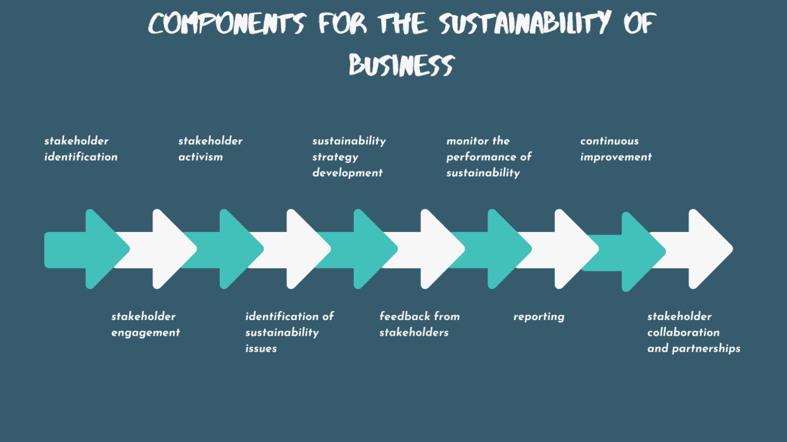

**Factors that influence stakeholder engagement and activism for sustainability of business:**

**1) Economic Values:** Financial aspects (costs and values) influence the stakeholders' engagement and activism for sustainability of business.

**2) Social Values:** It includes ethics and morals.

**3) Environmental concerns:** Business operations impact the natural environment.

**4) Reputation and brand:** Perceived leadership and responsibility in sustainability practices.

**5) Industry norms:** Industry standards and peer pressure for sustainability performance.

**6) Organizational culture:** Company mission and vision supports sustainability.

**7) Innovation and technology:** Adoption of innovative solutions and techniques.

**8) Globalization:** Global sustainability standards.

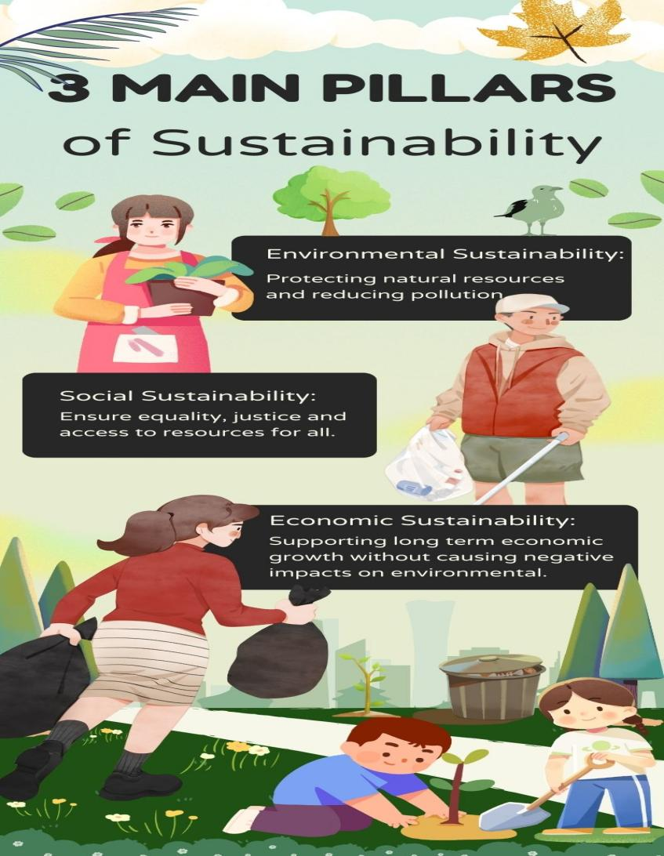

**Advantages of stakeholders' engagement and activism for sustainability of business:**

1. Improves brand loyalty.
2. Enhances reputation.
3. Improves stakeholders' trust.
4. Helps in solving business problems.
5. Helps in decision making.
6. Increases accountability.
7. Increases transparency of business.
8. Supports more access for investment and capital.
9. Enhances top talent.
10. Helps in managing risks and opportunities.
11. Increases growth which drives innovations.

**Disadvantages of stakeholders' engagement and activism for sustainability for business:**

1. Higher expectations may arise from stakeholders.
2. Pleasing all stakeholders is difficult.
3. Increases resources allocation and costs.
4. It consumes more time.
5. Conflicting demands and expectations may arise.

**Conclusion:**

Stakeholders' engagement and activism helps for sustainability of business through enhancing innovations, competitions, increasing capital and investments, collaborations and partnerships, managing risks and crisis, seeking inputs and feedback, ideas, etc. It is concluded that a firm should create values to all its stakeholders, not only for its shareholders. Aligning business objectives and goals with its stakeholders improves long term development.

**References:**

* <https://www.tractivity.co.uk>
* <https://aworld.org>
* <https://www.smestrategy.net/>
* <https://www.apm.org.uk/>
* <https://www.indiainfoline.com/>