**Bacteriophage**

Bacteriophages, discovered by Frederick Twort in England and Felix d'Herelle at the Pasteur Institute in France in the early 20th century, are viruses that infect bacteria. The term "bacteriophage" was coined by d'Herelle, reflecting their ability to "eat" bacteria by causing complete lysis of susceptible bacterial cultures. The term "bacteriophage" originates from "bacteria" and "phagein," meaning "to devour," reflecting their predatory nature.Phages, as they are commonly known, are obligate intracellular parasites that replicate inside bacteria using the host's biosynthetic machinery. They are ubiquitous and can be easily isolated from feces and sewage. There are at least 12 distinct groups of bacteriophages, exhibiting significant structural and genetic diversity.

**Types of bacteriophages:**

**T4 Phage-** T4 bacteriophages are widely used in research and discovered in 1944 by Delbruck and colleagues, providing models for studying phage community mechanisms. It is part of the Escherichia coliphages, discovered in 1944 by Delbruck and colleagues, providing models for studying phage community mechanisms. Belonging to the Caudovirales order of the Myoviridae family, T4 features a non-enveloped head and contractile tail. Its structure comprises a protein capsid, or head, housing a linear double-stranded DNA molecule. The contractile tail, measuring 925 Å long and 520 Å in diameter, attaches to a special portal at the head's base. Six short tail fibers on the baseplate recognize host surface receptor molecules. T4 bacteriophages, part of the T-even virus group, are extensively studied and share similarities among themselves. With around 300 different genes, they represent one of the largest and most complex groups of bacterial viruses.

**Lambda Phage-** Lambda phage, also known as coliphage λ, infects bacteria of the Escherichia coli species. Discovered by Esther Lederberg in 1951 during her studies on E. coli under ultraviolet irradiation, lambda phage belongs to the Siphoviridae family within the Caudovirales order. Characterized by the absence of an envelope, a non-contractile tail, and a linear double-stranded DNA molecule, lambda viruses have been extensively studied to understand viral lifestyles and serve as model viruses for research. With a temperate life cycle, lambda phage can enter either the lytic phase or reside within the host's genome via lysogeny. The phage particle comprises a protein head or capsid, a non-contractile tail, and tail fibers housing the viral genome. Due to its non-contractile tail, lambda phage relies on existing pathways to invade host cells rather than forcing entry. The virus is composed of 12-14 different types of proteins, totaling over 1000 protein molecules, and a single DNA molecule within the phage head.

**M13 Phage-** The M13 bacteriophage, often referred to simply as M13 phage, is a filamentous virus that infects Escherichia coli bacteria. It is characterized by a single-stranded DNA genome and is commonly used in molecular biology research, particularly in phage display techniques for protein engineering and selection. M13 phage is known for its long, cylindrical shape and ability to replicate without causing lysis of the host cell. It has a simple structure consisting of a protein coat surrounding the DNA genome. M13 phage has been widely utilized as a genetic tool due to its ease of manipulation and ability to display foreign peptides or proteins on its surface.

**T7 Phage-** T7 bacteriophages infect E. Coli, have a short replication cycle and ability to efficiently lyse host cells. They have a complex structure with an icosahedral head and a tail, similar to T4 phages. Its genome is composed of double-stranded DNA. They have been extensively studied and used in molecular biology research, particularly for their role in genetic engineering and recombinant DNA technology.

**P1 Phage-** P1 bacteriophages (temperate phage) infect several species of bacteria, including E. coli and Salmonella. It was first identified in 1951 by Joshua Lederberg and Norton Zinder during their studies on bacterial genetics. P1 phage belongs to the family Myoviridae within the order Caudovirales. It has a complex structure consisting of an icosahedral head and a contractile tail, typical of tailed bacteriophages. The genome of P1 phage is composed of linear double-stranded DNA. Unlike lytic bacteriophages, P1 phage can undergo both lytic and lysogenic cycles. In the lysogenic cycle, the phage integrates its DNA into the host bacterial chromosome, where it replicates along with the host genome. P1 phage has been extensively studied and used as a genetic tool in molecular biology research, particularly in studies involving bacterial genetics, phage biology, and genetic engineering.

**Morphology of bacteriophage:**

Bacteriophages (Figure 30) typically range in size from 24-200 nm in length. Among them, T4 is one of the largest, measuring approximately 200 nm long and 80-100 nm wide

**Head/Capsid-** All phages possess a head structure, varying in size and shape, with some adopting an icosahedral configuration (20 sides) while others are filamentous (M13 phage).The head serves to enclose the nucleic acid, providing protective covering. Certain phages (Caudovirales) feature tails attached to the head, which are hollow tubes facilitating the passage of nucleic acid during infection (T4 phage).

**Tail-** Many bacteriophages have a tail structure that extends from the head. The tail is involved in host recognition and attachment, as well as the injection of genetic material into the bacterial cell during infection. Some phages (Myoviridae) have long contractile tails (T4 phage), some have long, non-contractile tails, such as lambda phage (Siphoviridae) and few phage have short tails, often resembling a hexagonal or icosahedral head attached directly to the tail (Podoviridae).

**Tail Fibers-** Proteinaceous appendages attached to the tail that aid in host recognition and attachment. Tail fibers are essential for the initial binding of the phage to specific receptor sites on the bacterial cell surface.

**Base Plate-** Located at the end of the tail and serves as the attachment point for tail fibers. It plays a crucial role in phage binding to the bacterial cell surface and facilitating the insertion of genetic material into the host cell.

**Sheath-** In T4 phage, the tail is surrounded by a contractile sheath. During the infection process, the sheath contracts, driving the insertion of the phage genetic material into the bacterial cell.

**Genetic material-** The genetic material of the phage, which can be either DNA or RNA, is contained within the head or capsid. This genetic material carries the instructions necessary for the replication and assembly of new phage particles inside the host cell.

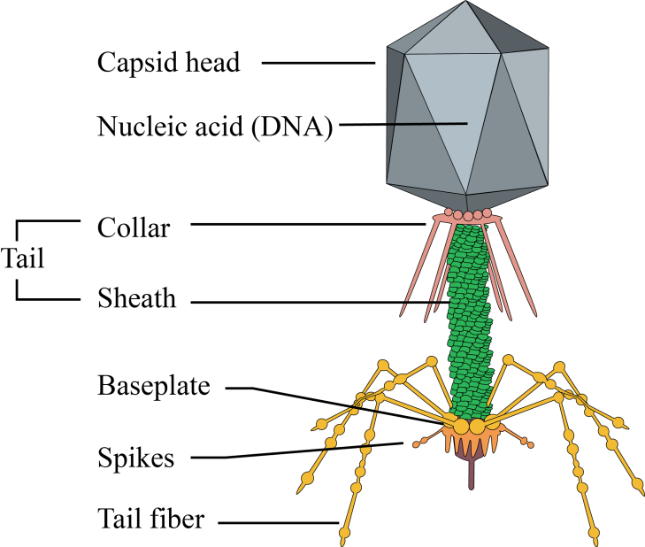

**Figure 30: Structure of bacteriophage**

**Replication of bacteriophages:**

**Adsorption-** Adsorption marks the initial stage of phage infection, wherein the phage attaches to specific receptors on the bacterial cell surface via tail fibers or similar structures. This attachment is reversible initially but becomes irreversible through base plate components

**Penetration-** Following adsorption, the bacteriophage's genetic material penetrates the bacterial cell akin to a syringe injection. Penetration occurs, involving sheath contraction (if present) and insertion of the hollow tail fiber into the bacterial envelope. The base plate and tail fibers firmly attach to the cell, allowing the hollow core to breach the cell wall. The tail sheath contracts, powered by a small amount of adenosine triphosphate, facilitating DNA injection into the bacterial body. This process may be aided by lysozyme on the phage tail, creating a hole in the bacterial wall. The intricate phage structure is solely required for DNA injection; subsequent daughter phage synthesis relies solely on the phage DNA. After penetration, the phage's empty head and tail remain outside as a shell or "ghost." When bacteria are exposed to numerous phages, multiple holes in the cell lead to leakage of cell contents, resulting in bacterial lysis without viral replication, known as "lysis from without."

**Synthesis:** Following phage nucleic acid penetration, synthesis of phage components begins. Early proteins, essential for building phage-specific molecules, are produced first, followed by late proteins, including those for the phage head and tail. During this phase, bacterial protein, DNA, and RNA synthesis halts.

**Maturation:** Phage DNA, head protein, and tail protein are synthesized separately within the bacterial cell. The DNA is condensed and packaged into the head, while tail structures are added. This process, assembling phage components into mature infectious particles, is termed maturation.

**Release:** Phages follow either lytic or lysogenic cycles, with lytic phages causing cell death post-synthesis, assembly, maturation, and release.

**Lytic cycle-**

* Lytic or virulent phages (Figure 32) are bacteriophages that replicate within bacterial cells, ultimately leading to cell lysis and death.
* Upon injection of the phage nucleic acid into the host cell, an eclipse period ensues, during which no infectious phage particles are detectable. This phase marks the synthesis and assembly of phage components into mature virions.
* Phage-specific mRNA and proteins are synthesized, sometimes causing degradation of the host chromosome.
* Structural proteins and lysis factors are produced separately, followed by assembly into mature phage particles, known as maturation.This phase triggers bacterial cell lysis due to the accumulation of phage lysis proteins, releasing intracellular phage particles into the environment.

The period between the entry of phage nucleic acid into the bacterial cell and the appearance of the first infectious intracellular phage particle is called the eclipse phase. It signifies the time required for phage component synthesis and assembly into mature phage particles. The time from bacterial cell infection to the initial release of infectious phage particles is termed the latent period. Following this, the number of released phage particles increases until the maximum is reached, marking the rise period. The average yield of progeny phages per infected bacterial cell, known as burst size, is determined through experiments measuring the release of infected phage particles over time. These results form a one-step growth curve when plotted on a graph (Figure 31).

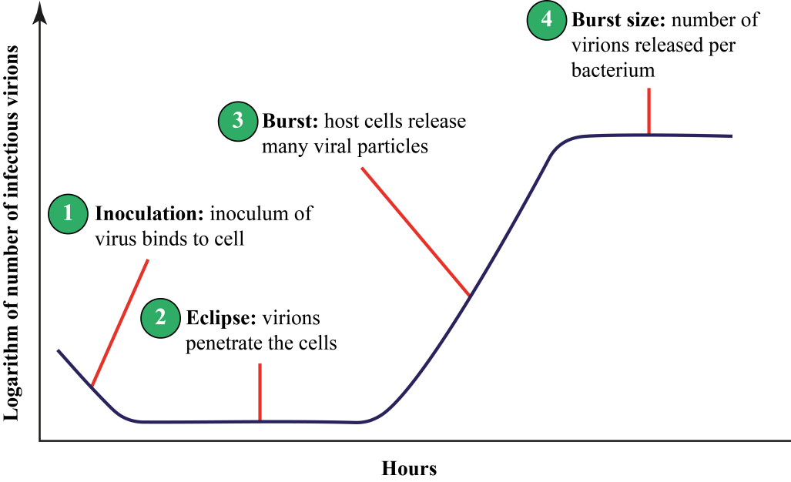

**Figure 31: One step growth curve of bacteriophage**

**Lysogenic cycle-**

* Temperate or lysogenic phages (Figure 32) are capable of adopting two modes of replication: either through the lytic cycle or by entering a dormant phase within the host cell.
* Typically, the phage DNA integrates into the host chromosome and replicates alongside it, being transmitted to subsequent generations of daughter cells.
* This integrated form of phage DNA is termed a prophage, and the bacteria containing it are referred to as lysogenic bacteria.
* The presence of prophage genes can introduce novel characteristics to the bacteria, as occasionally, additional phage genes are expressed, altering the properties of the bacterial cell—a phenomenon known as lysogenic conversion or phage conversion.

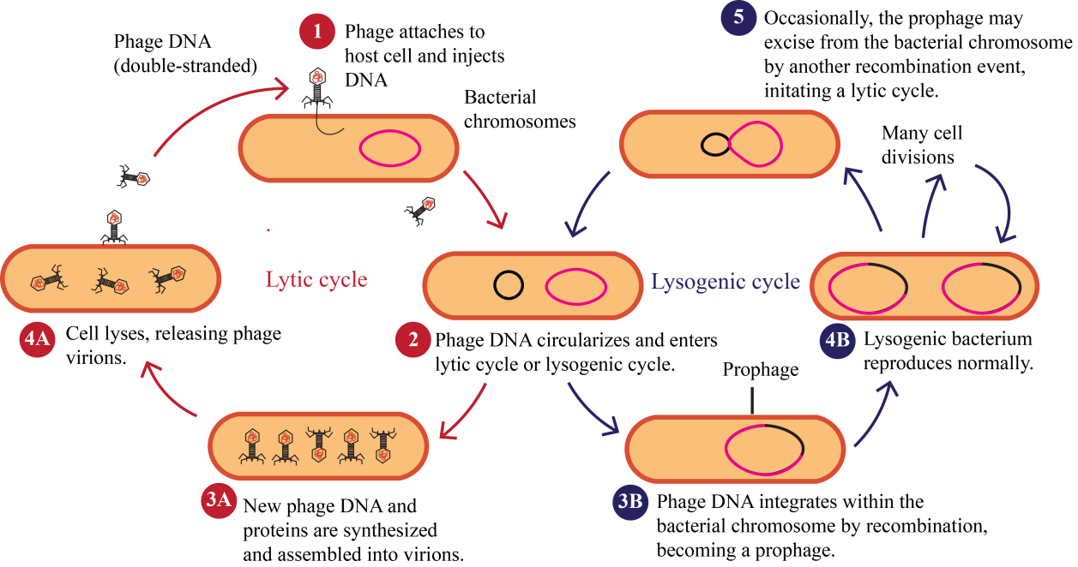

**Figure 32: Life cycle of bacteriophage**

**Phage genetics**:

The transfer of genetic material between bacteria occurs through transduction. This may occur as generalized or specialized transduction.

**a. Generalized transduction-** During generalized transduction (Figure 33) within the bacteriophage lytic cycle, bacterial DNA segments can be accidentally enclosed within newly formed viral particles. Consequently, upon the lysis of the infected bacterial cell and the release of the phages, some phages contain fragments of bacterial DNA. Upon infecting new bacterial cells, this transferred DNA can integrate into the recipient cell's genome through homologous recombination. This process can facilitate genetic exchange, potentially altering the characteristics of the recipient cell.

**b. Specialized transduction-** Specialized transduction (Figure 33) involves the selective packaging of bacterial DNA segments near the prophage into viral particles during prophage excision from the bacterial genome. This occurs when the prophage is erroneously removed during the shift from lysogenic to lytic cycle. Occasionally, adjacent bacterial DNA may also be incorporated into the newly formed phage particles during excision. Upon infecting new bacterial cells, these specialized transducing phages can transfer the bacterial DNA segments to the recipient cell's genome via homologous recombination. Unlike generalized transduction, specialized transduction specifically transfers bacterial genes near the prophage integration site rather than random DNA segments.

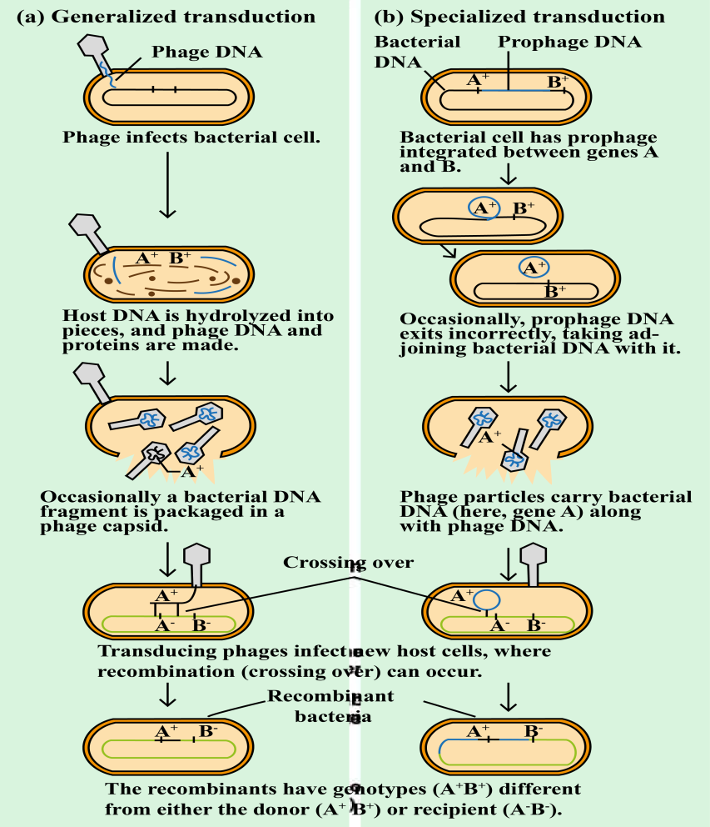

**Figure 33: Phage transduction**

**Phage typing:**

Phage typing (Figure 34), a method for bacterial identification, utilizes bacteriophages that infect bacteria, to classify and recognize bacterial strains based on their susceptibility to specific phages. By exposing bacterial cultures to various phages and noting which ones cause bacterial lysis, researchers can establish susceptibility patterns. This technique aids in epidemiological studies, facilitating the identification and tracking of bacterial strains, especially during outbreak investigations or monitoring antibiotic resistance. Phage typing assigns a number or "phage type" to bacterial strains based on their lysis patterns. This method has long been employed for Salmonella Typhimurium and Staphylococci, aiding in epidemiological surveillance and outbreak control.

**Phage typing procedure-**

The bacterial strain to be typed is isolated and cultured on a suitable growth medium.

A panel of different bacteriophages, each with specific host ranges, is prepared. These phages are selected based on their ability to infect and lyse the target bacterial species or strains.

The isolated bacterial cultures are exposed to the panel of phages. Each bacterial culture is inoculated with one phage at a time.

The cultures are monitored for bacterial lysis, which indicates susceptibility to the phage. This can be visually observed as clear zones or plaques in the bacterial lawn where lysis has occurred.

Patterns of susceptibility across the phage panel are analyzed to determine the phage type of the bacterial strain.

Based on that pattern, the bacterial strain is assigned a phage type, which helps in identifying and characterizing the strain for epidemiological purposes.

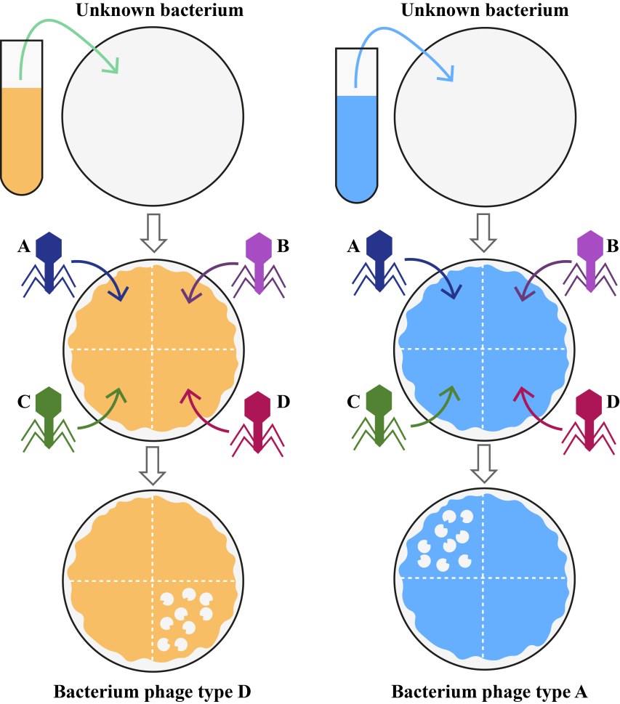

**Figure 34: Phage typing**

**Significance of phage:** Bacteriophages, or phages, hold significant importance in various fields:

1. **Medicine:** Phages are extensively studied for their potential in phage therapy, which involves using them to combat bacterial infections, including antibiotic-resistant strains.
2. **Biotechnology:** Phages are used in biotechnological applications like phage display for protein engineering and as vectors in gene therapy.
3. **Molecular Biology Research:** Phages serve as valuable tools in molecular biology research, aiding in the study of bacterial genetics, gene regulation, and mechanisms of viral infection. They're used in techniques like transduction, where they transfer bacterial DNA between cells.
4. **Evolutionary Studies:** Phages are crucial in understanding the co-evolutionary dynamics between bacteria and viruses, shedding light on the evolution of both host defense mechanisms and viral strategies for infection.
5. **Environmental Impact:**  Phages play a vital role in regulating bacterial populations in various ecosystems, impacting nutrient cycling, microbial diversity, and ecological balance. They're also being explored for their potential in mitigating bacterial contamination in food and water sources.
6. **Bioremediation:** Certain phages can infect and kill bacterial species involved in environmental pollution, offering potential applications in bioremediation efforts to clean up contaminated sites.

**References:**

Belnap, D.M., 2020. Detection of Bacteriophages: Electron Microscopy and Visualisation, in: Harper, D.R., Abedon, S.T., Burrowes, B.H., McConville, M.L. (Eds.), Bacteriophages: Biology, Technology, Therapy. Springer International Publishing, Cham, pp. 1–61. https://doi.org/10.1007/978-3-319-40598-8_18-2

Kasman, L.M., Porter, L.D., 2024. Bacteriophages, in: StatPearls. StatPearls Publishing, Treasure Island (FL).

Ye, M., Sun, M., Huang, D., Zhang, Z., Zhang, H., Zhang, S., Hu, F., Jiang, X., Jiao, W., 2019. A review of bacteriophage therapy for pathogenic bacteria inactivation in the soil environment. Environment International 129, 488–496. https://doi.org/10.1016/j.envint.2019.05.062