Bacterial-host interactions
Bacterial translocation (BT)
It can be defined as:
The passage of viable bacteria through the intestinal barrier to the mesenteric lymph nodes, with the possibility that from there they can spread to other systems.

Although the intestine provides a functional barrier between the microorganisms of the intestinal microbiota and the host, BT is not an uncommon event among healthy people but is more evident in people with underlying diseases.
Recent findings indicate that the concept of BT could be expanded to include the presence of bacterial products (bacterial DNA and endotoxin) in mesenteric lymph nodes and other territories.
Both bacterial DNA and endotoxin cause sustained activation of the immune system, with the release of pro-inflammatory cytokines and effectors, such as nitric oxide, which can aggravate the hemodynamic alterations present, for example, in patients with cirrhosis.
How the bacteria can leave the intestine and reach other organs has remained largely unexplored. However, researchers have observed that there may be different variables or populations of the same species of bacteria, as occurs with Enterococcus faecalis. These populations behave differently, which would explain why not all of them translocate.
The location of BT has never been well studied and may depend on both the experimental model used and the cause. In endotoxemia, it appears that mucosal damage is greater in the ileus and cecum than in the jejunum.

The mechanisms that influence the pathogenesis of TB are fundamentally three:
A-intestinal bacterial overgrowth (IBS),
B-local and systemic immunological alterations
C-increased intestinal permeability
A-Intestinal bacterial overgrowth
It may be due to an overgrowth of the entire microbiota as well as that of a particular species. These alterations are due to multiple factors ranging from the type of diet, presence of an underlying disease that requires medication that influences the microbiota, use of antimicrobials that are eliminated through the intestine, and metabolic or hormonal alterations^{1, 2}.
B-Local and systemic immunological alterations
The intestine has endocrine and immunological functions, in addition to the usual digestion, metabolism and absorption of nutrients.

Figure 1. Intestinal barrier and immune system
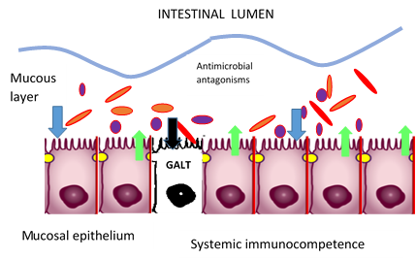

It is estimated that 25% of the intestinal mucosa is lymphoid tissue and that between 70%-80% of the immunosecretory cells are located in the intestine.
The collection of immune cells is called gut-associated lymphoid tissue (GALT).
- Peyer's patches: are analogous to lymph nodes. Specialized epithelial cells, M cells, line Peyer's patches and act as afferent lymphatics.
- Lymphoid cells of the lamina propria: They include T and B lymphocytes, plasma cells, eosinophilic macrophages, and mast cells.
- Intraepithelial lymphocytes. They are located within the lamina propria in a proportion of one lymphocyte for every 6 epithelial cells.

Three factors intervene in the alteration of the immune system:
1-cellular hypoxia
2-tissue injury induced by mediators, such as oxygen free radicals, NO, cytokines and other molecules
3-the toxic effect of some bacteria on the intestinal lumen.
The final result is the appearance of episodes of ischemia, reperfusion and changes in flows in different intestinal areas.
This results in: edema and peeling of the enterocytes, interruption of the lamina propria with hemorrhagic foci and ulcerations and, occasionally, the presence of bacteria crossing the mucosa.

C-Increased intestinal permeability
The intestinal barrier is mainly formed by a mucin component secreted by the intestinal epithelium. This is actually a layer of cells with intercellular junctions (tight junctions, among other intercellular components), which allows the selective passage of substances.
Figure 2. Union of epithelial cells of the intestinal mucosa and types of translocation (adapted from ³)
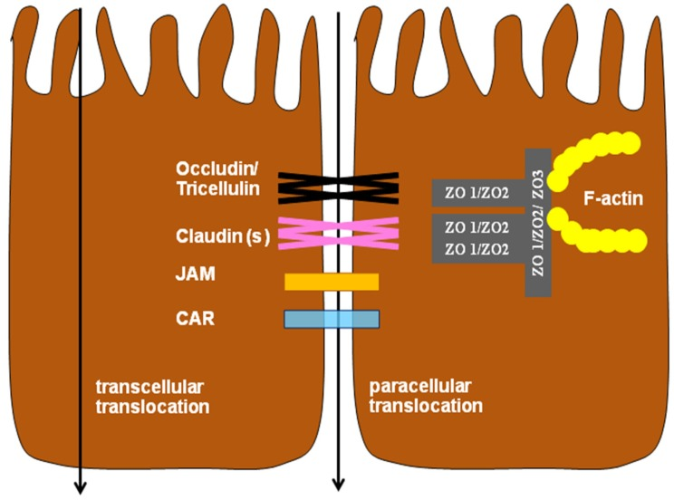

JAM = Junctional adhesion molecule; CAR = Coxsackie virus and adenovirus receptor, ZO = Zonula occludens.
How do pathogens influence?
The interaction between different unusual microorganisms and the intestinal barrier produces a different degree of virulence. The most common form of violation and subsequent penetration is through the union of epithelial cells, due to a decrease in their resistance; such is the case of Escherichia coli, Salmonella or Bacteroides.
In tables 1, 2, 3 and 4 you can see the interaction of relevant pathogens with the structures that bind the cells of the intestinal mucosa.

Table 1. Interaction of EPEC with intestinal mucosal cell junctions (adapted from³)
Pathogen/Mechanism | In Vivo/In Vitro | Effects | References
EPEC dephosphorylates and dissociates occludin | in vitro | periadhesion actmyosin contraction that increases paracellular permeability and disturbs the barrier | Simonovic et al. ⁴
EPEC redistributes occludin | in vivo | disruption of ion transport and disturbs the barrier | Shifflet et al.⁵
EPEC induces redistribution of ZO-1 and occludin  ECEP alters the distribution of the TJ protein ZO-1 | in vivo  in vitro | increases in paracellular translocation and changes the junctional structure  alteration of barrier and transport functions | Zhang et al.⁶  Philpott et al.⁷

Table 2. Interaction of Salmonella with the junctions of the cells of the intestinal mucosa (adapted from ³)
Pathogen/Mechanism | In Vivo/In Vitro | Effects | References
Salmonella enteritidis compromises the intestinal epithelial barrier | in vitro | depression of transepithelial ion transport | Awad et al.⁸
Salmonella Typhimurium depresses the production of claudin-1, claudin-4, and the mRNA that allows the expression of occludin | in vivo | disruption of epithelial function | Shao et al.⁹
Salmonella Typhimurium disruption of epithelial function | in vivo | alteration of the barrier function of the intestinal mucosa | Zhang et al.¹⁰
Salmonella Typhimurium depresses ZO-1 and occludin mRNA expression, causes redistribution of TJ epithelial proteins claudin-1 and ZO-2 | in vitro | damage to the intestinal barrier, facilitates the translocation of pathogenic and non-pathogenic microorganisms | Koehler et al.11

Table 3. Interaction of Clostridium perfringens with the junctions of the cells of the intestinal mucosa (adapted from ³)
Pathogen/Mechanism | In Vivo/In Vitro | Effects | References
C. perfringens type C causes redistribution of the epithelial TJ proteins, occludin and claudin-3 | in vitro | depresses transepithelial electrical resistance | Nava and Vidal¹²
C. perfringens disrupts the TJ barrier through phospholipase activation | in vivo | perturbation of TJ by increasing intestinal permeability | Otamiri ¹³
C. perfringens decreases claudin-1 and occludin mRNA expression | in vivo | alteration of the intestinal barrier by increasing intestinal permeability | Collier et al.¹⁴

Pathogen/Mechanism | In Vivo/In Vitro | Effects | References
C. jejuni (NCTC 12744) disrupts epithelial barrier function | in vivo | TJ perturbation by increasing permeability | Awad et al.¹⁵
C. jejuni 81116 induces occludin redistribution | in vitro | decrease in transepithelial electrical resistance | Dodson¹⁶
C. jejuni 81–176 induces the translocation of commensal bacteria through a transcellular process mediated by lipid transporters | in vivo | promotes the translocation of non-invasive bacteria through the intestinal epithelium | Kalischuk et al.¹⁷
C. jejuni RM1221 alters claudin-4 distribution | in vitro | Increases transepithelial permeability | Lamb-Rosteski et al.¹⁸
C. jejuni (NCTC 12744) interferes with intracellular Ca2+ signaling | in vivo | alteration of the barrier and transport and facilitates the translocation of E.coli | Awad et al.¹⁹
Table 4. Interaction of Campylobacter with the junctions of the cells of the intestinal mucosa (adapted from ¹⁵)

Figure 3. Pathophysiology of Campylobacter in chickens: translocation via transcellular (a) and paracellular (b) pathways
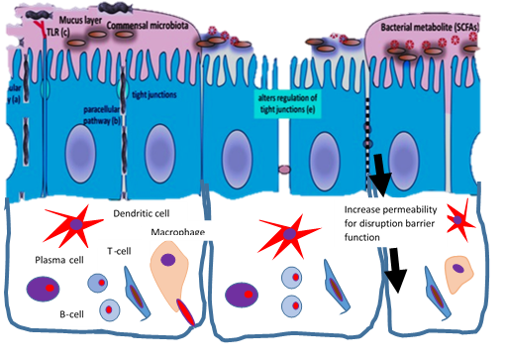
a
b

Figure 3b: Paracellular transmigration of C. jejuni through tight junctions and adherens junctions of intestinal epithelial cells (adapted from ²⁰)
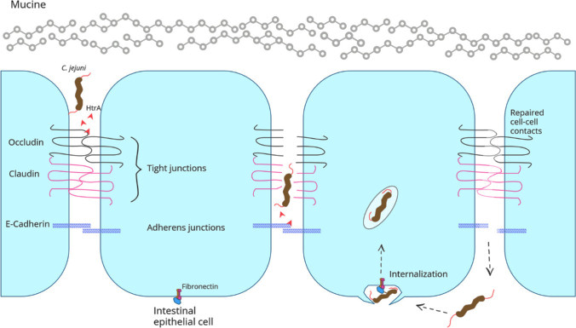

In experimental studies, BT has been widely reproduced, but results in clinical studies have been very limited. Evidence of mesenteric lymphatic contamination (and the role of IL-2) may be important for the demonstration of BT according to some authors¹⁵, and inconclusive for others, since it represents a normal immune response in serious situations²¹.
It has been seen that increased intestinal permeability causes a higher incidence of multi-organ failure (MOF).
Intestinal permeability and episodes of infection are two situations related to the severity of the injuries in the critically ill patient, but not consequential.
The set of measures aimed at reducing the intensity and duration of the injury, such as reducing periods of hemodynamic instability, the early use of vasoactive medication and the early administration of substrates, can reduce episodes of hypoperfusion (ischemia/repercussion), which in turn would decrease the extent of intestinal permeability and the time for its repair ²².
Some immune-based therapies have been designed to reduce intestinal inflammation and subsequent systemic immune activation in mice.
Such immune activations were associated with reduced microbial translocation and enhanced expression of intestinal junctional genes.
There are several studies that have focused on anti-inflammatory therapy that could block pro-inflammatory pathways. Some showed that a flavonoid exerted significant anti-inflammatory effects through downregulation of inducible nitric oxide synthase (iNOS) and cyclooxygenase 2 (COX-2) expressions in vivo in rats and cell cultures (BV-2 or Caco-2)^{23, 24}.
The concept that BT contributes to morbidity remains an attractive line of research.
In particular, the role of the liver and lung in modulating the inflammatory response must be further investigated. Studies should also be carried out on changes or modifications in colonic permeability, in the lymphatic pathway of TB and in the release of inflammatory mediators by the mesenteric lymph nodes²².
That is, the intestinal barrier must be reestablished to limit the translocation of microorganisms capable of causing distant infections, sepsis or aggravating existing clinical problems with secondary infections.
Let us remember that there are different types of secretion in bacteria. Some use the type III secretion apparatus to inject virulence proteins (effectors) into the host cell and thus counteract innate immunity. The ribosomal protein S3 (RPS3) guides NF-κB subunits to specific κB sites and plays an important role in the innate response to bacterial infection²⁵.

What happens in other mucous membranes?
The epithelium of the vaginal mucosa acts as a physical barrier and as an immunological mediator, providing the first defense against possible infections.
Mucosal epithelia generally comprise multiple layers of rarely keratinized stratified squamous epithelium resting on a lamina propria where the upper apical layers lack tight junctions, that is, they do not have the junctional system that we describe in the epithelial cells of the intestinal mucosa. .
These layers are permeable to water, soluble proteins, viruses, and penetrable by the vaginal microbiota, as well as by cellular (e.g., CD4+ T cells and macrophages) and molecular mediators of the immune system (e.g., cytokines)
This is permeability and the question: is it a translocation? If it constitutes a translocation, systemic pathologies should be observed from this mucosa.
However, the vagina and endocervix provide immunological defenses by conferring tolerance to microbes, maintaining epithelial integrity, and recruiting and supporting immune cells.
As the first line of immune defense, epithelial cells express pattern recognition receptors (PRRs), including Toll-like receptors (TLRs), which respond to microbes or pathogen-associated molecular patterns (MAMPs/PAMPs) by secreting cytokines and chemokines, antimicrobial peptides and other molecules.
The proinflammatory response elicited by pathogens is normally required to control infections.
However, inflammation of the vaginal mucosa can promote the transmission of viral STIs, such as HIV, by compromising the integrity of the epithelium and by recruiting and activating HIV target cells.
Epithelial cell-derived immune mediators have critical roles in cell recruitment, immune regulation, and tissue repair
Given the intimate contact of the microbiota and its acid metabolites with the vaginal epithelium, it is important to study how these interactions modulate the immunity of these mucous membranes and whether this is enough to avoid a true translocation²⁶.
The stability of the vaginal microbiota depends on several factors and we know that the bacteria of the vaginal microbiota, which normally maintain a pH <4.5, have the opportunity to migrate towards the uterus through the cervix since they are adjacent. However, the communication of microorganisms between these two sites is still unclear and the mechanisms underlying the modulation of the microbiota in the uterus and the induction of diseases when vaginal bacteria move to the upper reproductive system remains obscure²⁷.
It can be assumed that, in addition to the canalicular route, there may be a true translocation through the tissues of the genital tract.

Translocation across the outer membrane of Gram-negative bacteria
Until now we have talked about bacterial translocation through epithelia, but there is another translocation and it is the one that occurs in Gram-negative bacteria through their external membrane²⁸.
Clinical importance of bacterial translocation in the intestine in the initiation of sepsis and multiorgan failure (MOF)
As we have already expressed, the intestinal mucosa provides a functional barrier between the microbiota microorganisms and the host. When this is altered, the passage of microorganisms to the lymph nodes and from there to the bloodstream can occur and systemic dissemination appears. Let us remember that sepsis is a potentially fatal organ dysfunction and is one of the main causes of MOF in critically ill patients²⁹.
Both microorganisms and host factors can contribute to bacterial translocation and trigger sepsis.
Figure 4. Contribution of BT to sepsis and multiorganic failure
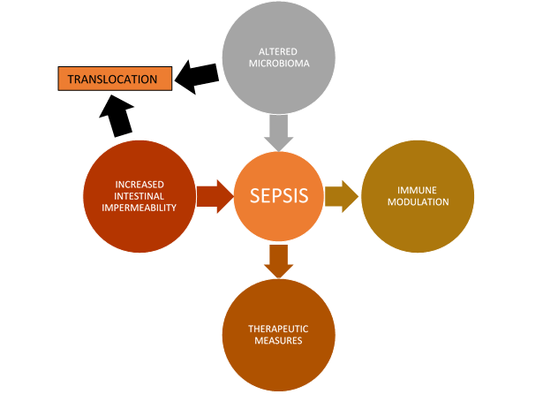
The figure 4 shows how the alteration of the microbiome caused by multiple factors such as the use of antimicrobials, unbalanced diet, immune alterations and other causes, can contribute to the increase in intestinal permeability that will allow microbial passage.
Shimizu K et al.³⁰ demonstrated that patients in the early stages of sepsis had a decrease in Bifidobacterium and Lactobacillus, species usually protective of the intestinal microbiota, and an increase in Staphylococcus spp and Pseudomonas aeruginosa.
Antibiotics in sepsis have a double function that can be risky. On the one hand, they contribute to eliminating the causative microorganisms, but they also accentuate the intestinal imbalance that increases intestinal permeability.
Azithromycin has been studied as an antibiotic that regulates the activity of the microbiota by reducing protein synthesis and biofilm formation.
In chronic inflammatory disorders, it exerts an immunomodulatory effect on epithelial cells and cells of the immune component through modulatory activity on the NF-κB inflammatory pathway, mucin release, expression of surface receptors, macrophages and autophagy³¹.
In summary we can say that in the pathogenesis of systemic processes such as sepsis, microorganisms and their virulence factors are as important as those dependent on the host. These findings provide new challenges and new targets for therapeutic management since treatment has not changed drastically in recent years and other strategies are required to reduce the morbidity and mortality caused by this pathology.

Bibliography

1. Berg RD, Garlington AW. Translocation of certain indigenous bacteria from the gastrointestinal tract to the mesenteric lymph nodes and other organs in a gnotobiotic mouse model. Infect Immun. 1979; 23:403-11.

2. García-Tsao G, Lee FY, Barden GE, Cartun R, West AB. Bacterial translocation to mesenteric lymph nodes is increased in cirrhotic rats with ascites. Gastroenterology. 995; 108: 1835-41.
3. Wageha A. Awad, Claudia Hess, and Michael Hess.l Enteric Pathogens and Their Toxin-Induced Disruption of the Intestinal Barrier through Alteration of Tight Junctions in Chickens Toxins (Basel) 2017; 9 : 60 Published online 2017 doi: 10.3390/toxins9020060
4. Simonovic, I.; Rosenberg, J.; Koutsouris, A.; Hecht, G. Enteropathogenic Escherichia coli dephosphorylates and dissociates occludin from intestinal epithelial tight junctions. Cell. Microbiol. 2000, 2, 305–315.
5. Shifﬂett, D.E.; Clayburgh, D.R.; Koutsouris, A.; Turner, J.R.; Hecht, G.A. Enteropathogenic E. coli disrupts tight junction barrier function and structure in vivo. Lab. Investig. 2005, 85, 1308–1324.
6. Zhang, Q.; Li, Q.R.; Wang, C.Y.; Liu, X.X.; Li, N.; Li, J.S. Enteropathogenic Escherichia coli changes distribution of occludin and ZO-1 in tight junction membrane microdomains in vivo. Microb. Pathog. 2010, 48, 28–34.
7. Philpott, D.J.; McKay, D.M.; Sherman, P.M.; Perdue, M.H. Infection of T84 cells with enteropathogenic Escherichia coli alters barrier and transport functions. Am. J. Physiol. 1996, 270, G634–G645.
8. Awad, W.A.; Aschenbach, J.R.; Khayal, B.; Hess, C.; Hess, M. Intestinal epithelial responses to Salmonella enterica serovar enteritidis: Effects on the intestinal permeability and ion transport. Poult. Sci. 2012, 91, 2949–2957.

9. Shao, Y.; Guo, Y.; Wang, Z. Beta-1,3/1,6-glucan alleviated intestinal mucosal barrier impairment of broiler chickens challenged with Salmonella enterica serotype typhimurium. Poult. Sci. 2013, 92, 1764–1773.
10. Zhang, B.; Shao, Y.; Liu, D.; Yin, P.; Guo, Y.; Yuan, J. Zinc prevents Salmonella enterica serovar typhimurium-induced loss of intestinal mucosal barrier function in broiler chickens. Avian Pathol. 2012, 41, 361–367.
11. Koehler, H.; Sakaguchi, T.; Hurley, B.P.; Kase, B.A.; Reinecker, H.C.; McCormick, B.A. Salmonella enterica serovar typhimurium regulates intercellular junction proteins and facilitates transepithelial neutrophil and bacterial passage. Am. J. Physiol. Gastrointest. Liver Physiol. 2007, 293, G178–G187.
12. Nava, P.; Vidal, J.E. The CpAL system regulates changes of the trans-epithelial resistance of human enterocytes during Clostridium perfringens type C infection. Anaerobe 2016, 39, 143–149.
13. Otamiri, T. Phosopholipase C-mediated intestinal mucosal damage is ameliorated by quinacrine. Food Chem. Toxicol. 1989, 27, 399–402.
14. Collier, C.T.; van der Klis, J.D.; Deplancke, B.; Anderson, D.B.; Gaskins, H.R. The effects of tylosin on bacterial mucolysis, Clostridium perfringens colonization, and intestinal barrier function in a chick model of necrotic enteritis. Antimicrob. Agents Chemother. 2003, 47, 3311–3317.
15. Awad, W.A.; Molnár, A.; Aschenbach, J.R.; Ghareeb, K.; Khayal, B.; Hess, C.; Liebhart, D.; Dublecz, K.; Hess, M. Campylobacter infection in chickens modulates the intestinal epithelial barrier function. Innate Immun. 2015, 21, 151–160.
16. Dodson, A. Host Factors Affecting the Virulence of Campylobacter. Ph.D. Thesis, University of Bristol, Bristol, UK, 2010
17. Kalischuk, L.D.; Inglis, G.D.; Buret, A.G. Campylobacter jejuni induces transcellular translocation of commensal bacteria via lipid rafts. Gut Pathog. 2009, 1, 2.
18. Lamb-Rosteski, J.; Kalischuk, L.; Douglas Inglis, G.; Buret, G. Epidermal growth factor inhibits Campylobacter jejuni-induced claudin-4 disruption, loss of epithelial barrier function, and Escherichia coli translocation. Infect. Immun. 2008, 76, 3390–3398.
19. Awad, W.A.; Smorodchenko, A.; Hess, C.; Aschenbach, J.R.; Molnár, A.; Dublecz, K.; Khayal, B.; Pohl, E.E.; Hess, M. Increased intracellular calcium level and impaired nutrient absorption are important pathogenicity traits in the chicken intestinal epithelium during Campylobacter jejuni colonization. Appl. Microbiol. Biotechnol. 2015, 99, 6431–6441
20. Kemper L, Hensel A. Campylobacter jejuni: targeting host cells, adhesion, invasion, and survival. Appl Microbiol Biotechnol. 2023; 107: 2725-2754. doi: 10.1007/s00253-023-12456-w. Epub 2023 Mar 21. PMID: 36941439; PMCID: PMC10027602.

21. Wazna E, Gorski A. Bacterial translocation and its clinical significance. Postepy Hig Med Dosw (Online). 2005; 59:267-275.
22. García de Lorenzo y Mateos, A., Acosta Escribano, J., & Rodríguez Montes, J. A.. (2007). Importancia clínica de la translocación bacteriana. Nutrición Hospitalaria, 22 (Supl. 2), 50-55. http://scielo.isciii.es/scielo.php?script=sci_arttext&pid=S0212-16112007000500007&lng=es&tlng=es
23. Cui Y., Wu J., Jung S.C., Park D.B., Maeng Y.H., Hong J.Y., Kim S.J., Lee S.R., Kim S.J., Kim S.J., et al. Anti-neuroinflammatory activity of nobiletin on suppression of microglial activation. Biol. Pharm. Bull. 2010; 33: 1814–1821. doi: 10.1248/bpb.33.1814.

24. Xiong Y., Chen D., Yu C., Lv B., Peng J., Wang J., Lin Y. Citrus nobiletin ameliorates experimental colitis by reducing inflammation and restoring impaired intestinal barrier function. Mol. Nutr. Food Res. 2015; 59:829–842. doi: 10.1002/mnfr.201400614.

25. Wu, M.; El Qaidi, S.; Hardwidge, P.R. SseL Deubiquitinates RPS3 to Inhibit Its Nuclear Translocation. Pathogens 2018, 7, 86. https://doi.org/10.3390/pathogens7040086
26. Aldunate M, Srbinovski D, Hearps AC, Latham CF, Ramsland PA, Gugasyan R, Cone RA and Tachedjian G (2015) Antimicrobial and immune modulatory effects of lactic acid and short chain fatty acids produced by vaginal microbiota associated with eubiosis and bacterial vaginosis. Front. Physiol. 6:164. doi: 10.3389/fphys.2015.00164
27. Wang J, Li Z, Ma X, Du L, Jia Z, Cui X, Yu L, Yang J, Xiao L, Zhang B, Fan H, Zhao F. Translocation of vaginal microbiota is involved in impairment and protection of uterine health. Nat Commun. 2021 Jul 7;12(1):4191. doi: 10.1038/s41467-021-24516-8. PMID: 34234149; PMCID: PMC8263591.
28. Vergalli, J., Bodrenko, I.V., Masi, M. et al. Porins and small-molecule translocation across the outer membrane of Gram-negative bacteria. Nat Rev Microbiol 2020; 18, 164–176. https://doi.org/10.1038/s41579-019-0294-2
29. Potruch A, Schwartz A, Ilan Y. The role of bacterial translocation in sepsis: a new target for therapy. Therap Adv Gastroenterol. 2022; 9;15:17562848221094214. doi: 10.1177/17562848221094214. PMID: 35574428; PMCID: PMC9092582.
30. Shimizu K, Ogura H, Goto M, et al. Altered gut flora and environment in patients with severe SIRS. J Trauma 2006; 60: 126–133.
31. Parnham MJ, Erakovic Haber V, Giamarellos-Bourboulis EJ, et al. Azithromycin: mechanisms of action and their relevance for clinical applications. Pharmacol Ther 2014; 143: 225–245.

