MAINTENANCE OF FRESHWATER FISHES IN AQUARIUM

Name: Mrs. Albina Subba
Designation: Assistant Professor,
Department of Zoology
St. Joseph’s College,
North Point, Darjeeling.
West Bengal-734105
Phone number: 9733218417/7001543050
Email id: subbaalbina@gmail.com

Abstract:

Freshwater aquariums at home offer a unique and engaging way to explore aquatic ecosystems, providing both aesthetic pleasure and educational value. The study examines the key aspects of maintaining a healthy freshwater aquarium, including water quality management, species selection and routine care practices. Proper water quality is achieved through regular testing and adjustments of parameters such as pH, ammonia, nitrites and nitrates. Routine care involves daily feeding, temperature monitoring and observation of fish behaviour as well as regular cleaning of the aquarium. The study also explores the benefits of creating a well-balanced aquatic environment, which include enhanced fish health, stable ecological conditions and reduced incidence of disease. By adhering to these guidelines, one can successfully manage freshwater aquariums, fostering a sustainable and vibrant aquatic habitat that promotes the well-being of its inhabitants and enriches the home environment.

Keywords: Freshwater Aquarium, Water Quality, Routine Care, Aquatic Habitat,

- INTRODUCTION:

An aquarium is a facility or a glass container designed to house and display aquatic animals and plants in a simulated natural environment, typically featuring transparent walls for viewing. Aquarium comes from Latin word ‘aqua’ which means water and ‘arium which means ‘a place for relating to’. It is a specially designed device that acts as an artificial habitat for water-dwelling animals.
The practice of keeping ornamental fishes as pets has a long and fascinating history, dating back thousands of years. The Sumerians, Assarians and Egyptians have all kept fish in ponds. By the end of the 17th century gold fish was introduced in several countries and became popular in England and Scotland. The opening of the fish house in London Regent Park during the spring of 1853 is the world’s first aquarium. Aquarium fish keeping is only next to the most favoured hobby, photography in the world (Das et al. 2005). The fishes can be reared in aquariums, plastic tanks and garden ponds for the recreation and leisure (Mukherjee et. al. 2000).

- TYPES OF AQUARIUM:

On the basis of water regime they contain, the aquarium may be of two types:
a. Freshwater aquarium- Freshwater aquariums are used for freshwater fishes that are found in rivers and creeks. It comes in both cold and warm water varieties. For a tropical fish aquarium, the temperature needs to be set between 24.5 and 26.7 degree celcius in freshwater aquarium.
b. Marine water aquarium- Marine aquariums are used for saltwater fishes. The water needs to be highly filtered to maintain fish life. For a tropical fish aquarium, temperature should be maintained between 26.7 and 27.8 degrees Celsius for marine water aquariums.
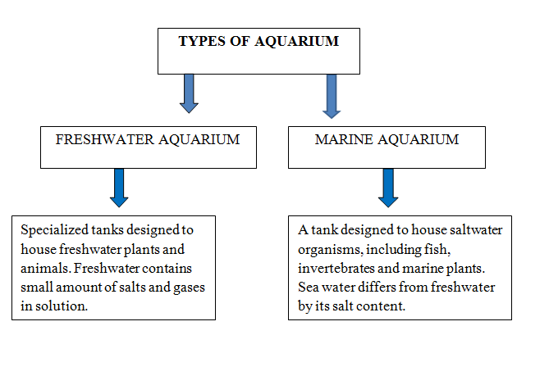

- COMPATIBLE GROUP OF FISHES FOR HOME AQUARIUM:

There are many fishes suitable for freshwater aquariums, each with unique characteristics and care requirements.
- Tetras- Neon Tetras (Paracheirodon innesi) and Cardinal Tetras (Paracheirodon axelrodi) are known for vibrant blue and red colouring and are peaceful and best aquarium fishes to be kept in schools.
- Guppies (Poecilia reticulata) are small, colourful and hardy fishes making them ideal for beginners.
- Mollies (Poecilia sphenops) are hardy, live-bearing fish available in a variety of colours.
- Angelfish (Pterophyllum scalare) are elegant long-finned fish that add graceful presence to the tank.
- Corydoras Catfish are peaceful bottom dwellers that help keep the tank clean by scavenging for leftover food.
- Goldfish (Carassius auratus) are very popular and come in many varieties. They are peaceful and slow swimming fishes.
- Zebra Danios (Danio rerio) are small hardy fishes with distinctive horizontal stripes. They are very active and can tolerate a wide range of water conditions.
- Rainbowfish are known for their bright iridescent colours. They prefer a spacious tank with good water quality.
- Loaches are diverse group of freshwater fishes known for their unique behaviours, bottom dwelling habits and interesting appearances. They are popular in aquariums for their ability to keep the tank clean by scavenging and their generally peaceful nature.

- PLANTS THAT CAN GROW IN AQUARIUM:

• Rooted submerged plants- a.) Vallisneria sp. b.) Sagittaria sp. C.) Hydrilla sp., d) Najas sp., e.) Potamogeton sp., f.) Cryptocoryne sp.
• Rootless submerged plants – a.) Fanwort sp. b.) Hygrophila sp. c.) Limnophila sp. d.) Ceratophyllum sp., e.) Myriophyllum sp., f.) Nitella sp.
• Free floating plants - a.) Lemna b.) Riccia c.) Salvinia d.) Azolla pinnata (mosquito fern) e) Eichhornia.

- SETTING UP OF A FRESHWATER AQUARIUM:

Setting up and maintaining a freshwater aquarium can be rewarding and enjoyable hobby. It involves key steps to create a healthy and aesthetically pleasing environment for fish and plants. Here is a detailed guide on how to set up a freshwater aquarium.

- Site Selection for setting the Aquarium:

The ideal site for setting up an aquarium is a stable and accessible location that ensures the health and well being of the aquatic inhabitants while providing aesthetic enjoyment. It should be placed in a sturdy stand to support the weight of the filled aquarium.
Aquarium tank should be kept away from direct or excess sunlight to prevent overheating and excessive algal growth in the aquarium tank. A ventilated area helps manage humidity levels. For safety, the aquarium should be situated away from high traffic areas, doors and windows to minimize disturbances. Additionally, positioning it in a visible yet secure spot protects it from interference by children and pets, making it an attractive and stable focal point in the room.
After selection of a suitable site, it must be ensured that the supporting place has a plain and even surface. Uneven surface produces stress on glass and may prove disastrous when aquarium is filled with water. We could solve this problem by placing thermocol cushion beneath the tank.

- Fish Selection:

Selecting the right fish for the aquarium involves careful consideration of their habitat and feeding behaviour. It should be ensured that all fishes have compatible dietary requirements. Slow and steady eaters will not get any food if their tank mates are fast swimming and greedy ones. Wrong information or any error may be catastrophic for the fishes. Fishes will suffer if they are exposed in wrong environment in a wrong way. By researching and planning the tank setup, a harmonious and thriving community can be created that brings beauty and enjoyment to our space. An aquarist should know everything properly and rightly.

- Size and nature of the fish:
For a healthy aquarium, size and nature of the fish are just as important as compatibility. Fish grow to various sizes and it is essential to account for their adult dimensions to avoid overcrowding, which can lead to stress and health issues. Similarly the nature of fish, ranging from peaceful to aggressive, affects the compatibility with tank mates. Peaceful fishes like Neon Tetras and Guppies can easily coexist in community tanks, while semi-aggressive fishes like Angelfish require more cautious tank mate selection. Aggressive fishes such as Betta fish often needs solitary setups or carefully chosen companions to prevent conflict. Understanding and balancing these aspects ensure a stable, thriving aquarium where all inhabitants can flourish.

- Equipments needed:

- Aquarium tank:

The most important equipment for setting up of an aquarium is the aquarium tank. While selecting the tank, its shape, size and material used should be taken into consideration.
Tanks may be of several kinds:
- Tank with metal frame: Aquarium tanks with metal frames are typically constructed using glass panels held together by a metal frame around the edges. It is a very common type of tank with a metal frame work, usually made of enamelled iron, a light alloy or stainless steel and glass walls sealed with putty.
- Acrylic tank: It is also known as plexi-glass tank made up of high quality plexi-glass, not particularly hard. It is light in weight, provides excellent clarity and better thermal insulation. However, it is more prone to scratching compared to glasses and tends to lose its clarity. Over time it can yellow or become cloudy.
- Glass tank: It is built entirely of glass. Glass tanks offer excellent clarity and do not yellow over time, ensuring the clear view of the aquatic life. The heavier weight of the glass provides stability, reducing the risk of tank tipping over.

Size: Choosing an ideal size of a tank depends on the preferences, experience level and the specific needs of the fish that we wish to keep. For starters, a smaller tank with a capacity of 10-20 gallons is good to learn the basics of aquarium care. For experienced aquarists, a medium-sized tank (e.g., 20-40 gallons) provides versatility and room for a wider range of fish and plants. Larger tanks of about 40 gallons and above are suitable for expecienced aquarists looking to create intricate aquascapes or house larger fish species.

Bottom: The base of an aquarium is known as bottom which contains gravel, sand, and plant specific substrates. The bottom is prepared to make the fish feel more comfortable and to provide a growing medium for aquatic plants. The composition of the bed is mostly depends on the needs of the aquarium plants.

Stand: Aquarium stand is a sturdy wooden or metallic structure on which aquarium is placed. It provides support and elevates the tank to a comfortable viewing height.

Hood or lid: Hood is the top most covering of an aquarium to keep the fishes confined in the tank, thereby protecting the fishes against intruders. It also minimizes water loss by evaporation. Some hoods include built-in lighting fixtures for convenience.

- Aquarium filters:

The harmful metabolic products of fish like ammonia and nitrates are regularly produced which keep on accumulating in the aquarium water. At times, they may exceed the carrying capacity of aquarium water and cross the lethal limits and eventually poison the fish. Therefore proper arrangements should be made to remove those harmful substances so that we get clear water in aquarium. Aquarium filters are the devices used to remove those harmful substances from the aquarium which is achieved by the process of filtration.
Aquarium filters are crucial for maintaining a healthy environment in the tank. They help remove physical debris, convert harmful chemicals and provide oxygenation.

Types of Aquarium filters:

- Mechanical Filters: These filters physically trap particles and debris from the water. They usually consist of a sponge, filter pad, or floss that catches solid waste passes through. (e.g. Sponge filter)
- Biological Filters: These filters promote the growth of beneficial bacteria that break down ammonia and nitrite into less toxic nitrate. Common biological filtration methods include bio-wheels, bio-balls, and porous ceramic media.
- Chemical Filters: These filters use chemical media such as activated carbon or resins to remove impurities, odors and discoloration from the water. Chemical filtration is often used to remove medication residues or pollutants that other filters might miss.
- UV Sterilizers: UV sterilizers use ultraviolet light to kill algae, parasites and harmful bacteria in the water, reducing the risk of diseases and improving water clarity.
- Internal Filters: Internal filters are placed inside the aquarium and use suction cups to attach to the glass. These filters are suitable for small to medium tanks. E.g.-Submersible filters
- External Filters: External filters are usually mounted outside the tank. They use hoses and siphon to draw water in and out of the filter chamber. E.g.- Hang-on-back (HOB filter) and Canister filters. Canister filters are known for filtration capacity and are often preferred for large aquariums.

Selecting the right filter for freshwater aquarium depends on the tank size, the types of fish and plants and the maintenance preferences. Proper filtration is the key to a healthy and thriving aquarium, ensuring a clean and stable environment for the aquatic life.

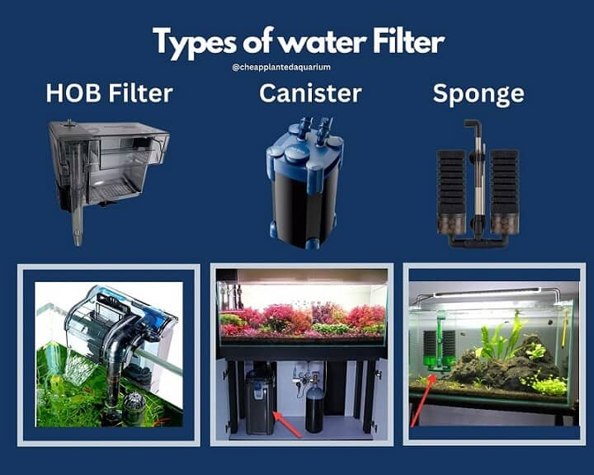

Fig 1: Types of aquarium filters (Source- Cheap Planted Aquarium)

- Heating and Temperature Control:

Maintaining proper temperature in the aquarium is crucial for the health and well being of its inhabitants. Fish tank heater is the important equipment for temperature maintenance. The temperature range suitable for each kind of fish to survive and flourish varies. The aquarium heater helps to maintain a suitable temperature important for tropical fish. A heater is chosen according to the size of the tank.
Another important tool in aquarium setup is the thermometer. It helps in monitoring the temperature and thereby helps maintain the aquarium temperature. Stick-on or floating thermometers can be used. Aquarium heater controller can also be used to control the water temperature. If the temperature drops too low, the heater will start heating the water and if the temperature becomes too high, the heater will stop working and the controller will be on fan.

- Thermometer:
Fishes require specific temperature ranges for their health and growth. Maintaining these optimal temperatures helps prevent stress, ailments and mortality. A thermometer made up of transparent glass or perpex is fixed on the glass surface inside the aquarium using a magnet. The temperature is monitored regularly.

- Aerator:
An aerator is an essential component of a healthy aquarium. It consists of a regulator, power source and small joints. Aerators are used in aquarium to ensure adequate oxygen levels and proper water circulation. Better circulation and oxygenation can help deter the growth of algae by reducing nutrient build-up and preventing stagnant areas.

- Substrate:
A substrate layer of sand or gravel at the bottom of the aquarium tank provides a base for plants and supports their growth. It helps in creating s simulated natural environment. A medium sized (2-3 cm) sand or gravel is ideal for the purpose. It provides a medium for beneficial bacteria to colonize contributing to biological filtration. It also supports natural behaviour of fish such as foraging and spawning, by offering a suitable texture and environment. The choice of the substrate, whether it is gravel for easy maintenance, sand for a natural look, or nutrient-rich substrate for plant growth, should be based on the specific needs of the aquarium inhabitants and the desired aesthetic. The substrate should be rinsed thoroughly before adding to the tank to remove dust and debris.

- WATER QUALITY MAINTENANCE:

Maintaining water quality in an aquarium is crucial for fish health. Key parameters include pH, ammonia, nitrite, nitrate, hardness and temperature. Regular testing ensures these parameters remain within safe levels, promoting a stable environment. Ammonia and nitrite, toxic byproducts of fish waste and decaying matter should be undetectable in a healthy aquarium, while nitrate levels must be kept low through routine water changes and the use of live plants. The pH should be stable and appropriate for the specific species housed, and water hardness must be managed to suit the fish and plants. Adequate filtration, both mechanical and biological plays a vital role in maintaining water clarity and quality. Properly maintained water quality not only enhances the appearance of the aquarium but also ensures the long-term health and vitality of its aquatic life.

- DECORATION OF AQUARIUM:

Decorating an aquarium involves creating an aesthetically pleasing environment that also meets the needs of its inhabitants. Here are some key elements for effectively decorating an aquarium:
  - A substrate should be chosen that complements the type of aquarium and the needs of the fish and plants. Gravel, sand, crushed coral are the substrates that can be used in an aquarium.
  - Another thing to be kept in mind is the background of the aquarium as it enhances the visual depth of tank and hides the equipments. Various shades of blue or pictures with coral reefs can be used as background. Other options are painted backgrounds, printed backgrounds or naturalistic 3D backgrounds.
  - Attractive and large water plants can be used which provides agreeable and clean living climate. The plants produce oxygen, reduce nitrates and create natural hiding spots for the fishes. Java fern, Anubias, Amazon sword and Java moss are some examples of live aquarium plants.
  - Caves, crevices and ledges can be created with the help of slate, granite, lava rock and aquarium-safe rocks. Live rocks are often used in freshwater aquariums which are packed with bacteria, micro- and macro- organisms. These help to clean water through natural bio-organic filtering processes.
  - Proper lighting enhances the appearance of the aquarium and supports plant growth. Appropriate light intensity and spectrum based on the needs of plants and fish has to be used.
  - Enough space should be given for plant growth and swimming of fishes.

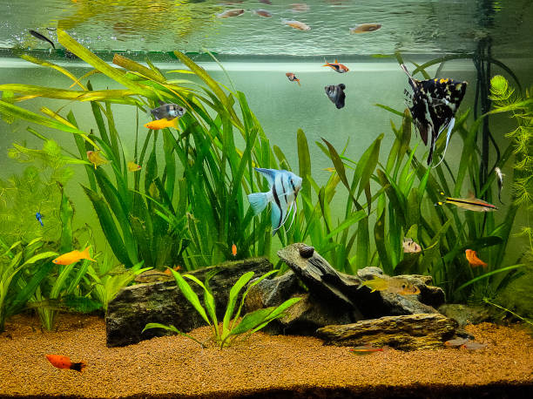

Fig 2. A decorated aquarium with fishes and plants (Source- iStock)

- MAINTENANCE OF AQUARIUM:

- Fishes that are healthy, swimming upright and move active with well defined colour patterns on them should be selected.
- Fishes with deformed bodies, broken fins, white spot or open wounds on the body, showing ungraceful movement should be avoided. Dead fishes should be removed immediately.
- New fish should be quarantined in a separate tank for 2-4 weekks to monitor for diseases before introducing them in the main tank.
- Water must be changed regularly (20-30% every two or four weeks)
- Algal scum must be cleaned from the glass, decorations and plants at regular intervals using an algae scraper.
- Thorough gravel vacuum must be done every week to remove the dirt and accumulated wastes.
- Aquarium water must be changed once it turns cloudy.
- Fishes should be given food once or twice a day with appropriate amount and type of food. Over feeding of fishes should be avoided which can spoil the quality of water resulting in death of fishes.
- Plants should be pruned at regular intervals to promote healthy growth
- All equipments need to be checked regularly to ensure they are functioning regularly.

- CONCLUSION:

Keeping aquarium fish as a hobby is a rewarding and educational pastime that brings the beauty and tranquillity to our homes. This hobby involves creating and maintaining a balanced aquatic environment where fish and plants can thrive. Aquarists must learn about water chemistry, fish species compatibility and proper tank maintenance. Regular tasks such as feeding, water testing and cleaning the tank help maintain optimal water quality and fish health. Additionally, watching fish swim gracefully can be a relaxing and stress-relieving experience. This hobby not only enhances home decor but also provides valuable lessons in Biology and Ecology, making it both enjoyable and enriching.

References:

- Ahilan B and Waikhom G (2007): Some prime marine ornamental fishes of India. Fishing Chimes 27: 50-53.
- Anna Mercy TV, Gopalakrishnan A, Kapoor D and Lakra WS (2007): Ornamental fishes of the western ghats of India. National Bureau of Fish Genetic Resources, Kochi. ISBN 81-902951-8-7.
- Das M, Sarma S and Das AK (2005): Status of ornamental fishes of Assam. Fishing Chimes 25(3): 13–15.
- David E. Boruchowitz: “The Simple guide to freshwater aquariums”
- Gupta SK and Gupta PC (2006): General and Applied Ichthyology. Schand Publishers, New Delhi
- Mary B and Gina S: “The complete Fishkeeper”
- Maurice K and Tony W (1996): “Freshwater biodiversity in Asia with special reference to fish”, World Bank Technical Paper no. 343
- Mukherjee M, Chattopadyay M, Datta SK and Biswas S (2000): Problems and prospects of aquarium fish trade in West Bengal. Fishing Chimes 20(1): 90–93
- Shree Charana R, Nikith Kumar K, Shariq Mohammed Khan, Girish M,: “Arduino based aquarium monitoring system”, International Research Journal of Engineering and Technology (IRJET), eISSN: 2395-0056 Volume: 06 Issue: 06 June 2019
- Swain SK (2003): Aquarium care and maintenance, ATIC (NATP) bulletin series-1, 28 .
- T. Salim, T. Haiyunnisa and H. Alam,: “Design and Implementation of Water Quality Monitoring for Eel Fish Aquaculture An Examination of Microbubble Aeration,” 2016 International Symposium on Electronics and Smart Devices (ISESD) November 29-30, 2016.
- Trivedi S.P.: “Aquarium fish and their maintenance (e-contents), University of Lucknow)
- Venugopalan K.N: Aquarium Making and Maintenance, Central Marine Fisheries Research Institute,Kochi

