The effects of melatonin on stomach ulcers caused by non-steroidal anti-inflammatory drugs: Effect on extracellular matrix remodeling and angiogenesis

Krishnendu Ganguly ^{1*}, Ria Sarkar ², Krishnendu Adhikary ¹

¹Department of Medical Lab Technology, Paramedical College Durgapur, West Bengal 713212, India
² Infectious Diseases and Immunology Division, CSIR's Indian Institute of Chemical Biology;, Kolkata,West Bengal 713212, India

Running Title: Melatonin's Gatroprotective Effects

*Corresponding mail: gangkrish1977@gmail.com

Abbreviations:

AP-1 activator protein-1; BM basement membrane; bp base pair; CAM chick chorioallantoic membrane; cDNA complementary deoxyribonucleic acid; CMA corneal micropocket assay; DNA deoxyribonucleic acid; ECM extracellular matrix; EDTA ethylenediamine tetra-acetic acid; ERK extracellular signal regulated kinase; GI gastrointestinal; GAPDH glyceraldehyde-3-phosphate dehydrogenase; H2O2 hydrogen peroxide; IL interleukin; JNK c-Jun N-terminal kinase; kDa kilodalton; MAPK mitogen activated protein kinase; MMP matrix metalloproteinase; MPO myeloperoxidase; mRNA messenger ribonucleic acid; MT-MMP membrane-type matrix metalloproteinase; NF-ƙB nuclear factor kappa beta; NSAID nonsteroidal anti-inflammatory drug; O2.- superoxide radical; OH. hydroxyl radical; PAGE polyacrylamide gel electrophoresis; PBS phosphate buffer saline; PCR polymerase chain reaction; PG prostaglandin; RNA ribonucleic acid; ROS reactive oxygen species; RT-PCR reverse transcritase polymerase chain reaction; SOD superoxide dismutase; TEMED n’, n’, n’, n’-tetramethylethylenediamine; TIMP tissue inhibitor of metalloproteinase; TNF tumour necrosis factor; Tx triton-X-100; TBST tris-buffered saline with 0.02% Tween 20; VEGF vascular endothelial growth factor

Abstract

The widespread occurrence of hyperacidity and ulcers is seen as a universal human misery by both industrialised and emerging nations. People who had it not only endured terrible, never-ending agony, but also ran the danger of potentially deadly gastrointestinal haemorrhage or ulcers. An increasing number of cases over the last two decades means that 10% of the world's population may have this disease at some point (Cullen et al., 1997; Kunturek et al., 2005). The most prevalent cause of gastric ulcers, according to Koelz et al. (1978), is the excessive secretion of hydrochloric acid into the gastrointestinal lumen by the proton-pumping H+-K+-ATPase enzyme located in the parietal cells of the stomach mucosa. According to research by Konturek et al. (1994) and Yoshikawa and Naito (2000), gastric ulcers may develop in two different locations: the epithelial border and the granulation tissues. The granulation tissues include fibroblasts, macrophages, and proliferating endothelial cells. Prior studies (Konturek et al., 1994; Maity et al., 2003) found that stress, careless use of nonsteroidal anti-inflammatory drugs (NSAIDs), heavy smoking, and alcohol use were the main contributors to stomach ulcers. Since its discovery, the spiral-shaped bacterium Helicobacter pylori has been acknowledged as the main culprit responsible for over 60% of gastritis, stomach ulcers, and gastric cancer cases. One theory as to why NSAIDs are responsible for around 26% of stomach ulcers is because natural killer cells inhibit cyclooxygenase (COX), which in turn reduces prostaglandin (PG) production (Wallace, 1997). In many forms of gastric ulcers, acid and reactive oxygen species (ROS), particularly hydroxyl radical, have been shown to induce mucosal oxidative damage (Brzozowski et al., 2006; Naito & Yoshikawa, 2006). Western countries are seeing a decline in H. pylori-induced ulceration due to improved medical treatment. However, elderly populations experiencing pain syndromes and arthritis are using nonsteroidal anti-inflammatory drugs (NSAIDs), which is contributing to an increase in stomach ulcers (Bombardier et al., 2000). Gastric ulcers may also develop as a result of the stress caused by medical diseases or traumas, such as burns, pneumonia, or an infection with Helicobacter pylori (Konturek & Konturek, 1994). Heavy alcohol use, cigarette smoking, and other long-held beliefs about ulcer triggers have been shown to have no effect on the onset of peptic ulcers in recent decades. In addition to regulating cell proliferation, migration, apoptosis, and differentiation, the extracellular matrix (ECM) is crucial for the structural integrity of gastric tissues and for the healing of gastric ulcers (Ernst et al., 1995; Gillessen and Domschke, 1994). According to research (Ernst et al., 1995; Gillessen & Domschke, 1994), matrix metalloproteinases (MMPs) play an important role in controlling several ECM components that support the healthy operation of stomach tissues. According to Jones et al. (1999), the process of stomach ulcer healing involves three steps: first, the regeneration of blood vessels within the granulation tissue surrounds the ulcer; second, the proliferation of epithelial cells surrounding the ulcer; and lastly, the restoration of glandular architecture. To restate, a web of interdependent chemicals, including growth factors, transcription factors, and cytokines, regulates the healing process by either promoting or inhibiting angiogenesis (Tarnawski, 2005; Tarnawski et al., 2001). Matrix remodelling is the primary process that occurs during ulcer healing. The exact function of matrix metalloproteinases (MMPs) during the stomach's repair and damage processes brought on by NSAIDs is unclear (Swarnakar et al., 2005; Ganguly et al., 2006). According to Altun and Ugur-Altun (2007), there is a lot of research on the effects of the pineal gland's principal hormone, melatonin (N-acetyl-5-hydroxytryptamine), on the immune system, on prevention of cancer, on the timing of reproduction, on the body's natural rhythms, on jet lag, and antioxidant capabilities. Various organs contribute to homeostasis during the day, including eneterochromaffin cells of the gastrointestinal system, the liver, and the eyes, which produce additional pineal melatonin (Maestroni, 2001; Konturek et al., 2007).

Stomach
At action in the digestive system during the second phase of digestion is the muscular-hollow organ shaped like a J. Gastric acid is discharged into the atmosphere, making it very acidic. Species, food, time of day, and medicine use are among the variables that influence the luminal pH, which may range from 1 to 2 (Anthea, 1993; Anne & Moore, 2007). The combination of these factors with digestive enzymes has the potential to finally decrease the size of big molecules to an absorbable form for the small intestine. Chief cells secrete the enzyme pepsinogen into the bloodstream, which is converted into pepsin at low pH levels; this enzyme is essential for protein digestion (Anthea, 1993; Anne & Moore, 2007). On its journey from the small intestine to the rest of the body, vitamin B12 must be conjugated with intrinsic factor, a glycoprotein generated by the parietal cells of the stomach, in order for it to be absorbed. While water, electrolytes, and food are absorbed relatively slowly by the stomach, fat-soluble compounds like alcohol and iron are absorbed in large amounts.
Nestled between the oesophagus and the duodenum—the first segment of the small intestine—on the left side of the abdomen is the stomach. Two smooth muscular valves called sphincters retain the stomach's contents in their proper places. Anthea (1993) cites two such examples: the esophageal sphincter and the pyloric sphincter, both of which are located near the heart and divide the oesophagus and the digestive tract. Figure 1 from Anthea (1993) shows that the human stomach is divided into four sections: the lower, funnel-shaped antrum, the upper, more expanded fundus, the narrowing pylorus at the point where the small intestine meets the stomach, and the cardiac opening, which is the opening from the stomach into the oesophagus. Small gastric glands situated closely over the thick mucous membrane of the walls release hydrochloric acid and enzymes, which partially break down lipids and proteins. At regular intervals, the muscles in the digestive system contract to break down food into chyme, a semifluid mixture that is then transported into the small intestine and pylorus by regular peristaltic waves. The vagus nerve and the sympathetic nervous system regulate the secretions and motions of the stomach (Anne & Moore, 2007).
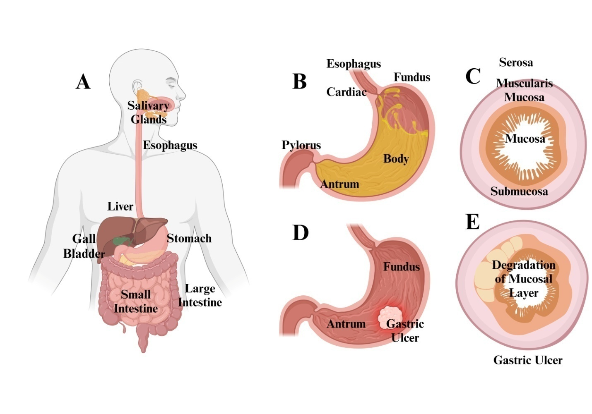
Figure 1. The anatomy of the human stomach in the illustration. The fundus, body, antrum, and pylorus are the four distinct sections that make up a human stomach. The pyloric sphincter allows food to pass from the duodenum to the stomach. The three-layer muscular structure of the stomach—an inner oblique layer, a middle circular layer, and an external longitudinal layer—supports the peristaltic action that occurs during digestion. Jointly, these levels function. The muscularis mucosa, submucosa, mucosa, and serosa are the four layers that make up each inner lining. The gastric glands are densely packed on the mucosa and contain the cells that produce hydrochloric acid, digestive enzymes, and mucus (Encyclopaedia Britannica, Inc., 2003).

Evaluation of surgical procedures
The stomach walls (Figure 1), like the rest of the gastrointestinal tract, are made up of the following layers arranged in a specific order: The mucosa is the thickest layer, and it is composed of the muscularis mucosae, a thin layer of smooth muscle, and the lamina propria, the underlying layer. The submucosa is a layer of fibrous connective tissue that lies underneath the mucosa and serves to divide it from the layer below. The Meissner's plexus may be seen in this layer. Three layers of smooth muscle lie underneath the submucosa of the stomach, distinguishing it from other gastrointestinal organs. Physical food breakdown occurs during churning in the inner oblique layer. This is one of the most distinctive components of the digestive tract. The antrum differs from the fundus in that it has thicker skin cell walls and stronger contractions. The pylorus is surrounded by a robust muscular wall in the middle. The pylorus is able to migrate into the duodenum under control of a tonically constricted wall, which acts as a functional sphincter despite its lack of visible distinction. In the space between the outer longitudinal and middle circular layers is where you'll find Auerbach's plexus. The serosa is a continuous layer of connective tissue that sits underneath the muscularis externa and makes up the peritoneum (Anthea, 1993; Anne & Moore, 2007).

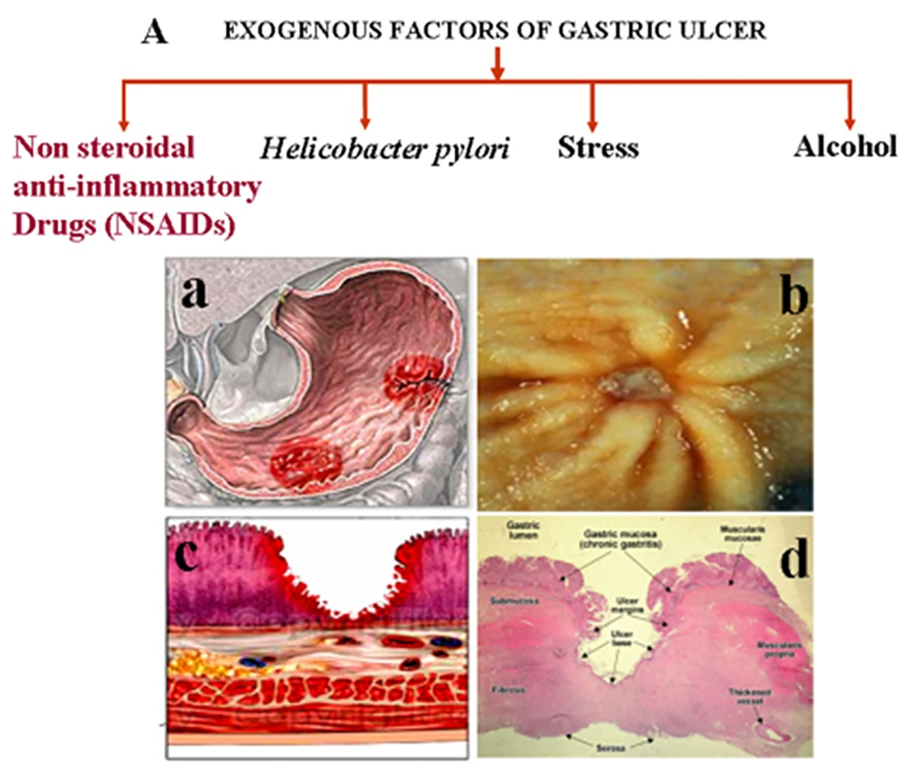

Figure 2: Factors connected to gastric ulceration. Gastric ulcers (A) are most often caused by alcohol use, psychological stress, Helicobacter pylori infection, and indiscriminate use of nonsteroidal anti-inflammatory drugs (NSAIDs). Both the light and dark microscopical views of a human stomach ulcer (B). Ulcers often form at the fundus-antrum junction (Ba). A person's stomach ulcer, as seen via an endoscope (Bb). A necrotic lesion grows throughout the thickness of the stomach mucosa and even into the muscularis mucosa (Bc) when an ulcer forms. Gastric ulcers, caused by acid-pepsin aggressiveness, are mucosal defects that penetrate the muscularis mucosae and muscularis propria. The perpendicular ulcer borders show that gastritis is still present. Febrinoid necrosis, granulation tissue, fibrous tissue, and inflammatory exudate are the four main components seen at the base of an ulcer. The fibrous ulcer base could have thick-walled veins or thrombosis (Bd).

Cell types
Various cell types are present throughout the glands' many layers: Mucous cells may be found all throughout the stomach and around the isthmus of the gland. Because of their neutral stain and mucus layer secretion, they protect the stomach from erosion. Oxyntic parietal cells are found in the stomach, close to the gland's neck. Their acidophilic nature enables them to produce endogenous chemicals that promote digestion in addition to creating stomach acid. Only in the fundic area, towards the base of the gland, are chief (zymogenic) cells found. They help with digestion since they are basophilic and release pepsinogen and rennin. All the way down the base of the stomach's glands are cells that create enteroendocrine hormones. They manufacture hormones like somatostatin and regulate the paracrine and autocrine systems.
Anne and Moore (2007) provide the following criteria for a gastric ulcer: a lesion or wound on the stomach wall that extends half a centimetre or more into the stomach's muscularis mucosae or the whole thickness of the mucosa (Figure 2). Up to 60% of stomach ulcers are caused by an H. pylori infection (Konturek & Konturek, 1994). The ulcers that form in chronic gastritis usually have perpendicular margins. During the active phase of an ulcer, four zones may be seen at the base: fibrous tissue, granulation tissue, fibrinoid necrosis, and inflammatory exudate (Arista-Nasr, 2005). At the base of a fibrous ulcer, you could see veins that are thickened or thrombosed. Cancerous tumours are the underlying cause of around 4% of stomach ulcers. The primary feature of stomach ulcers is containment.
Consistent risk factors for stomach ulcers (Figure 3): Consumption of alcohol, mental stress, infection with Helicobacter pylori, and the improper use of nonsteroidal anti-inflammatory drugs (NSAIDs) are the leading causes of stomach ulcers (A). Both the light and dark microscopical views of a human stomach ulcer (B). Ulcers may form at the junction of the fundus and antrum (Ba). An endoscopic view of a patient's stomach ulcer (Bb). If a necrotic ulcer lesion were to penetrate the whole thickness of the stomach's mucosal lining, it would eventually reach the muscularis mucosa (Bc). The acid-pepsin vicious cycle may lead to the rupture of the stomach mucosal lining, which is known as a gastric ulcer. Perpendicular ulcer margins are a hallmark of chronic gastritis. At the base of the ulcer, one may see four distinct zones: fibrinoid necrosis, inflammatory exudate, fibrous tissue, and granulation tissue. Chronic peptic ulcers are defined by elevated edges and an inflammatory milieu, while acute ulcers are regular in appearance. Scarring in the parietal region may induce radial folds to appear on the surrounding mucosa (Arista-Nasr, 2005). The majority of gastric ulcers occur in the little curved area of the stomach.
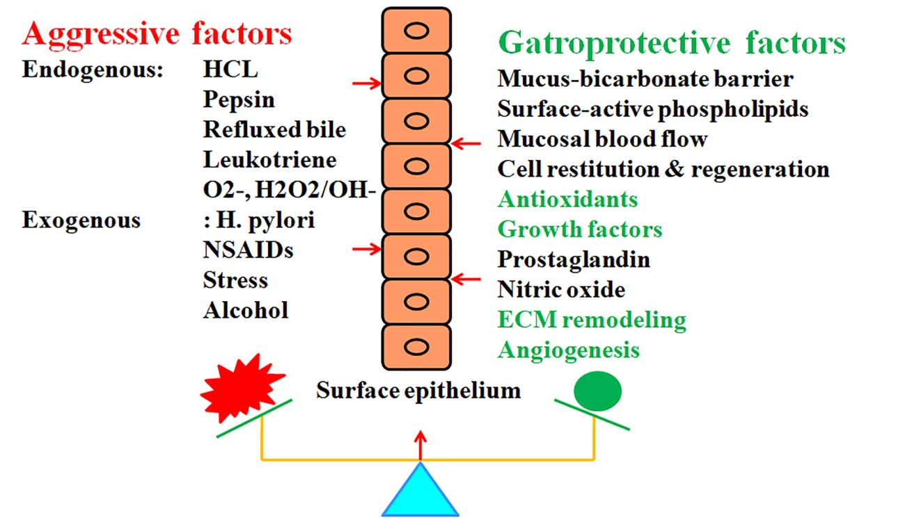

Figure 3: During stomach ulceration, aggressive and defensive factors are crucial. The underlying cause of stomach ulcers is the imbalance between aggressive and gastroprotective forces. The aggressive elements could have origins either inside or outside the organisation. Among the main endogenous components are hydrochloric acid, pepsin, reflusked bile, leukotrienes, and reactive oxygen species (ROS). Things like psychological stress, long-term alcohol usage, H. pylori infection, and NSAID use are factors that are outside of one's control. Enzymes and cellular antioxidants, the mucus-bicarbonate barrier, surface active phospholipids, mucosal blood flow, cell restitution and regeneration, prostaglandins, growth factors, nitric oxide, prostaglandins, angiogenesis, and remodelling of the extracellular matrix (ECM) all contribute to gastroprotection against these dangerous factors.
The signs of Gastric Ulcer:
Some of the symptoms of a gastric ulcer include an upset stomach, vomiting excessively, not wanting to eat, or producing a lot of saliva to wash down the throat after regurgitation. The function of aggressive and defensive factors in gastric ulceration (Figure 3): When the aggressive and gastroprotective components interact in an imbalanced way, the result is gastrectomy. There are two major types of aggressive factors: exogenous forces and endogenous forces. Pepsin, hydrochloric acid, leukotrienes, reflusked bile, and reactive oxygen species (ROS) are mostly endogenous substances. Examples of external variables include heavy alcohol use over an extended period of time, psychological stress, Helicobacter pylori infections, and the use of nonsteroidal anti-inflammatory drugs (NSAIDs). The mucus-bicarbonate barrier, surface active phospholipids, mucosal blood flow, cell restitution and regeneration, prostaglandins, nitric oxide, some growth factors, antioxidant enzymes and antioxidants within cells, extracellular matrix (ECM) remodelling, angiogenesis, and other mucosal defence mechanisms offer gastroprotection against these harmful factors. Perforation of the stomach by ulcers is very unusual. Because of how painful it is, surgery needs to be done right away. On the other hand, individuals with advanced stomach cancer are three to six times more likely to develop H. pylori-induced ulcers (Arista-Nasr, 2005; Konturek & Konturek, 1994).
Mechanism of gastric ulcer
Many different things may lead to stomach ulcers. Gastric ulcers may develop if there is an unbalanced presence of aggressive and gastroprotective components. Aggressive impacts may be either exogenous or endogenous. The use of nonsteroidal anti-inflammatory drugs (NSAIDs), chronic alcoholism, psychological stress, and certain medical problems (such as an H. pylori infection) are all instances of external causes. The main internal factors that contribute include hydrochloric acid, pepsin, refluxed bile, leukotrienes, and reactive oxygen species (ROS) such O2, H2O2, and •OH, as stated by Wallace (1997) and Konturek et al. (2005). Mucosal defences provide gastroprotection against these hostile elements; a list of them is included in Figure 3; Maity et al., 2003; and Massarrat, 2008. The mucus-bicarbonate barrier, active phospholipids on the surface of cells, blood flow across the mucosa, cell regeneration and restoration, prostaglandins, nitric oxide, certain growth factors, antioxidant enzymes and antioxidants inside cells, remodelling of the extracellular matrix, and angiogenesis are all components of these defences. Cullen et al. (1997) found that Helicobacter pylori is the most common cause of chronic inflammation. It is in the antral mucosa that these bacteria call home. Nonsteroidal anti-inflammatory medication (NSAID) carelessness is also a component (Wallace, 1997). When prostaglandins function properly in the stomach mucosa, blood flow and mucus production are maintained consistently. In order to prevent prostaglandin syntesis, NSAIDs work by inhibiting the function of COX-1. Psychiatric distress due to head trauma or burns may have a role in the development of peptic ulcers. According to Konturek & Konturek (1994), smoking accelerates the development of ischemic ulcers by causing atherosclerosis and vascular spasms. Overuse of laxatives has also been associated with peptic ulcers. Blood type O seems to run in families and is associated with duodenal ulcers. Ulcer repair difficulties may arise from rare gastrinomas, also known as Zollinger Ellison syndrome, which are tumours that release gastrin. People who experience chronic stress and struggle to maintain a regular eating schedule are at an increased risk of developing stomach ulcers, as shown by study (Cullen et al., 1997; Konturek & Konturek, 1994). This inflammatory response to NSAIDs relies on these few critical regulators.
Stress, NSAIDs, and Helicobacter pylori infection are factors that increase the production of inflammatory cytokines (Konturek et al., 2005). Cytokines may therefore be a common element that leads to ulcer recurrence. Monocytes and macrophages are the principal producers of inflammatory cytokines, which enhance leukocyte activation and upregulate the expression of adhesion molecules. Langman et al. (1991) states that neutrophil adhesion to the vascular endothelium is a critical stage in the progression of NSAID-induced stomach damage. Cytokines are believed to be required for the development of gastritis and stomach ulcers linked to NSAIDs. Cytokines are important in the aetiology of inflammation of the mucosa (Langman et al., 1991). Time and dose were the two main factors that enhanced the amount of stomach mucosal erosion when different NSAIDs were given. According to research (Wallace, 1997), this caused TNF-levels to rise while prostaglandin E2 levels fell. Another feature of gastric ulcers is the release of increased inflammatory cytokines from the mucosa, such as LT B4, IL-1, IL-2, IL-6, IL-7, and IL-8.
The impact of NSAIDs on gastric ulcer formation and prostaglandin synthesis (Figure 4): The bioactive molecules known as prostaglandins have a role in both normal and abnormal physiological and pathological processes via their effects on paracrine and autocrine communication. Arachidonic acid, a product of membrane phospholipids, is the primary raw material for these, and two rate-limiting enzymes, phospholipases and cyclooxigenases (COXs), are used in their production. Arachidonic acid may be converted into prostaglandins, which can irritate or protect cells, or even leukotrienes by two enzymes, COX-1 and COX-2. Gastric ulcers are caused by prostaglandins, which are inhibited by cyclooxygenases (COXs), an enzyme that NSAIDs work by blocking. When inflammatory cytokines (IL-1β and TNF-α) and anti-inflammatory cytokines (IL-10), when generated, cause ulcer healing to fail. Nonsteroidal anti-inflammatory medicines (NSAIDs) have been shown to suppress the action of two COX virus isoforms, COX-1 and COX-2. Gastric mucosa protection against cytoprotection, regulation of renal blood flow, prevention of platelet aggregation, and maintenance of kidney perfusion are some of the "housekeeping" tasks mediated by the PGs generated by COX-1 (Gudis & Sakamoto, 2005; Vane & Botting, 1998; Fiorucci & Antonelli, 2001). In contrast, COX-2 is absent from the majority of healthy tissues. However, mitogenic and inflammatory stimuli swiftly promote COX-2 expression, which in turn increases prostaglandin (PG) production in inflammatory tissues.
In aerobic organisms, reactive oxygen species (ROS) are mainly produced by the release of activated oxygen radical from mitochondria during regular oxidative respiration (Seis & Cadenas, 1985; Stadman, 1992). Keeping the production and consumption of reactive oxygen in check is critical for proper cellular homeostasis, as stated by Shiva et al. (2004) and Stadtman (1992). Reactive oxygen species (ROS) are significant during the inflammatory phase of gastric ulceration. Activation of several cell types occurs in inflammatory illnesses. These include resident macrophages, epithelial cells, neutrophils, and lymphocytes. Inflammatory cells release superoxide (O2) when they get active. Superoxide dismutase (SOD) rapidly changes this O2 to H2O2 or hydroxyl radical (.OH) by means of the Fenton reaction and the superoxide-driven Haber-Weiss reaction (Shiva et al., 2004). Superoxides are also produced by combining oxygen with NADPH oxidase. Extra enzymes that may generate superoxide include xanthine oxidase and cytochromes P450, according to Imlay (2003) and McCord and Fridovich (1969). Researchers have paid little attention to enzymatic antioxidants like sulfiredoxin and the peroxiredoxins. Among the enzymes that Seis and Cadenas (1985) listed as possessing antioxidant capacities were paraoxonase, aldehyde dehydrogenases, and glutathione-S transferases. Scientists have discovered that stomach ulcers caused by reactive oxygen species (ROS) may cause a loss of glutathione, oxidation of proteins, and peroxidation of membrane lipids. Some reactive oxygen species (ROS), such as superoxide anion (H2O2), may remain within cells for long periods of time at relatively high concentrations and function as messengers for signal transduction, according to recent study. This is in response to different physiological conditions.
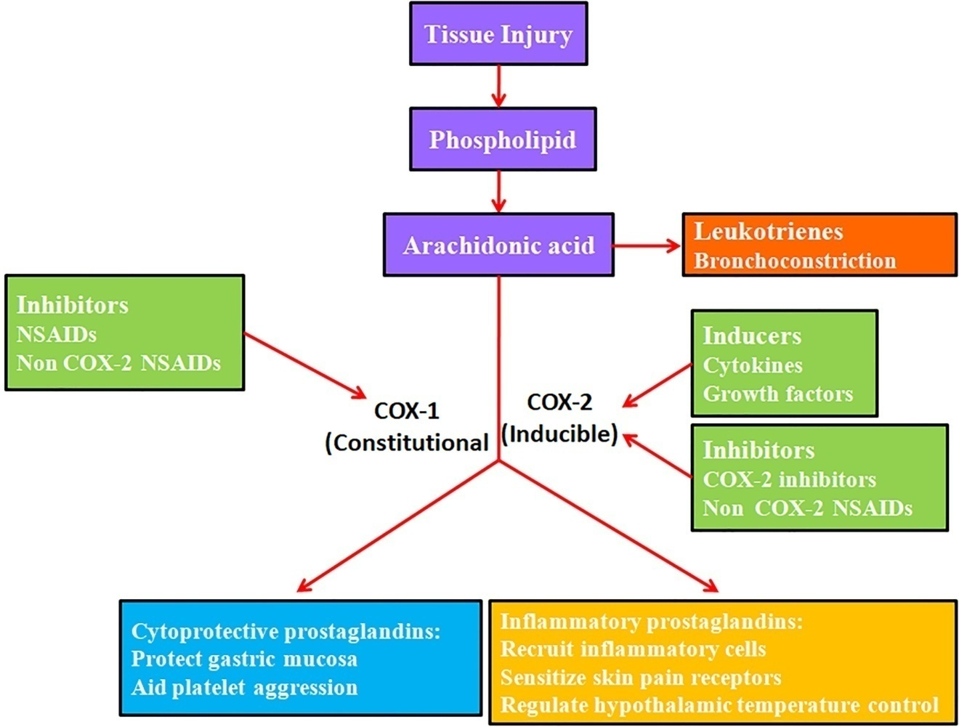

Figure 4: Gastric Ulcer Development and Prostaglandin Biosynthesis as Influenced by Nonsteroidal Anti-Inflammatory Drugs Autocrine and paracrine communication is mediated by prostaglandins in several physiological and pathological processes. Like hormones, these bioactive compounds have an effect on the body. Arachidonic acid is mostly isolated from membrane phospholipids by two rate-limiting enzymes: phospholipases and cyclooxigenases (COXs). When COX-1 and COX-2 enzymes are present, arachidonic acid has the potential to undergo a number of transformations, including the production of leukotrienes, inflammatory prostaglandins, and cytoprotective prostaglandins. The mechanism by which NSAIDs induce gastric ulcers is by their inhibition of cyclooxygenases (COXs), leading to a decrease in prostaglandin production.

1.4. NON-STEROIDAL ANTI-INFLAMMATORY DRUG
Nonsteroidal anti-inflammatory medications (NSAIDs) are among the most widely used classes of pharmaceuticals for the treatment of pain, inflammation, and fever. Wallace states that nonsteroidal anti-inflammatory drugs (NSAIDs) are used to treat a wide range of inflammatory conditions, including but not limited to: rheumatoid arthritis, osteoarthritis, acute gout, headaches, dysmenorrhea, migraines, pain after surgery, back pain, sciatica, sprains, strains, rheumatism, tooth pain, kidney stone pain, fever, and many more painful conditions (1997). Among the many functions of nonsteroidal anti-inflammatory drugs (NSAIDs) is the prevention of cardiovascular events like heart attacks and strokes in high-risk individuals by reducing blood coagulation. Research by Wallace (1997), Yoshikawa and Naito (2000), and Konturek et al. (1994) suggest that these medications are effective in treating certain types of neuropathic pain when combined with other analgesics.
1.4. Pharmaceuticals that do not include NSAIDs
Nonsteroidal anti-inflammatory medications (NSAIDs) are shown below with a few instances.
Alpha alkaloids include the following medications: aspirin, amoxiprin, benorilate, faislamine, methyl salicylate, magnesium salicylate, choline salicylate, diflunisal, and salicyl salicylate. As an example of an arylalkanoic acid, consider Acemetacin, Diclofenac, Acelofenac, Etodolac, Indomethacin, Nabumetone, Sulindaca, or Tolmetin. Some examples of arylpropionoic acid, generally known as a profen, include ibuprofen, carprofen, fenbufen, fenoprofen, fluurbiprofen, ketoprofen, ketorolac, oxiprosin, tiaprofenic acid, and suprofen. Mefenamic acid and meclofenamic acid are the two types of fenamic acid that are accessible. Fenamic acid is also called N-arynalthranicic acid. Some examples of pyrazolidine derivatives include sulphynpyrazone, phenylbutazone, azapropazone, metamizole, and oxyphenbutazone. There are others. Piroxycam, lornoxicam, meloxicam, and tenoxicam are all oxicams. As COX-2 inhibitors, Celecoxib, Etoricoxib, Lumiracoxib, Parecoxib, Rofecoxib, and Valdecoxib are among the medications that are available. The nimesulide species are members of the sulphonanilide class. (Work by Patterson et al., 2008): Added to this are licofelone and omega-3 fatty acids.
1.4.1. Process of Action
Prostaglandins (PG) are hormone-like bioactive molecules that cause inflammation and pain; nonsteroidal anti-inflammatory medications (NSAIDs) inhibit their synthesis (Figure 4). Bioactive compounds that mimic hormones, PGs serve several physiological and pathological purposes. They facilitate the short-distance transmission of autocrine and paracrine signals (Green, 2001). Arachidonic acid is the principal source of PGs (PLA2), and its release from cell membranes is caused by A2 phospholipase. Lipooxygenase, cytochrome p-450 monooxygenase, and PGG/H synthase, sometimes known as cyclooxygenase, are enzymes that may break down free intracellular arachidonic acid when it is released from phospholipids. The COX enzyme is a crucial yet time-consuming component in the PG synthesis process, as stated by Vane (2000), Green (2001), and Vane and Botting (1998). So far, scientists have identified two distinct COX isoforms. According to Vane (2000) and Green (2001), it may be used by different cell types to aid in the conversion of arachidonic acid into PGG2, PGH2, thromboxane A2 (TXA2), and other similar compounds. It was shown in the 1970s that inflammation generates a large quantity of primary prostanoids, including thromboxane A2, prostaglandin D2 (PGD2), prostaglandin E2, prostaglandin F2, and prostaglandin I2. Works cited include those of Moncada et al. (1973) and Velo et al. (1973). Acetylsalicylic acid, an aspirin-like anti-inflammatory medicine, has been on the market since 1899 and has inhibited the production of these prostanoids (Figure 4; Collier & Flower, 1971; Vane & Botting, 1998; Vane, 2000). Acetylsalicylic acid has been in use for the longest period of time compared to other NSAIDs. It irreversibly and covalently deactivates COX-2 in a specific manner (Kalgutkar et al., 1998). Domethasone is a well-known NSAID that selectively inhibits cyclooxygenase-1 and -2 with delayed reversibility and high efficacy (Mitchell et al., 1993). In addition to the fact that indomethacin and bile both disrupt the mucosal barrier, some of its adverse effects may be unrelated to COX-inhibition, and the medicine may have an ulcerogenic effect (Lichtenberger, 2001).

Nonsteroidal anti-inflammatory drugs (NSAIDs) deal a double punch by inhibiting COX-1, which reduces amounts of pro-inflammatory prostaglandins, and acidic substances irritate the stomach mucosa right away. Consequences include stomach problems. Common gastrointestinal problems were enumerated by Anthera (1993) and Anne and Moore (2007), and they include things like stomach discomfort, nausea, vomiting, diarrhoea, dyspepsia, lack of appetite, gastric ulcers, and bleeding. Longer treatments and greater dosages increase the likelihood of ulceration. Not to mention that the likelihood of gastrointestinal side effects from various medications varies. According to research by Konturek and Konturek (1994), ibuprofen, diclofenac, and aspirin had fewer incidences of stomach problems than piroxicam and indomethacin.
1.5. Gastric Ulcers Caused by NSAIDs
According to Shahin et al. (1997), several NSAIDs, including ibuprofen, indomethacin, pyroxicam, and aspirin, cause functional, morphologic, and ultrastructural alterations in the gastrointestinal tract. Studies on mucosal damage produced by NSAIDs have been conducted using a variety of animals, including rats, mice, rabbits, hamsters, gerbils, dogs, and cats (Okabe & Amagase, 2003). Acute gastric ulcer models and chronic gastric ulcer models are the main categories of ulcer models, which are determined by the length of the trials and the dose of NSAIDs. This response might be immediate or chronic, depending on how long the stimulation lasts. These stages have several commonalities but also exhibit notable distinctions with respect to cellular activation and the production of inflammatory mediators.
1.5.1. Acute stomach ulcer models
In the aftermath of a harmful and destructive attack, the body launches an inflammatory reaction in an attempt to repair damaged tissue, restore the integrity of the stomach lining, and expedite the healing process. Chemical or mechanical damage, very high or low temperatures, oxygen deprivation, dietary deficiencies, microorganisms, and many other harmful stimuli may set off an inflammatory response. All vascularized tissues often exhibit the same pattern in their first, intrinsic reaction to an outside stimulation. Factors such as plasma complement, coagulation system activation, kallikrein-kinin cascades, and cytokine production by active, wounded, or dying inflammatory or tissue cells attract phagocytizing cells to the site of inflammation. In response to different chemotactic signals, neutrophil granulocytes fortify the vascular wall, acting as an initial barrier against infections and other chemicals that cause infections. By causing the postcapillary venules to enlarge and become more permeable, local inflammatory mediators facilitate neutrophil emigration and inflammatory edoema, which in turn generate heat and hyperemia. In order to defend themselves, activated phagocytes secrete cytokines, lipid mediators, and chemotactic chemicals; they also release a great deal of reactive oxygen and nitrogen species; and they use proteolytic enzymes like elastase and bactericidal agents like hypochlorous acid from myeloperoxidase. Acute inflammation exhibits the traditional signs of inflammation, including reddening, swelling, heat, discomfort, and functional impairment. Tissue cells may initiate an endogenous anti-inflammatory response by releasing substances that block the action of oxygen radicals, proteases, and cytokines that promote inflammation. Some of the mediators in this category include cytokines (like IL-4 and IL-10), enzymes (such antiproteases and superoxide dismutases), and cytokine antagonists (like soluble TNF-α receptor and IL-1 receptor antagonist). At the conclusion of the reaction, things look up: the innate inflammatory response goes down, foreign material is flushed out, and healing happens via fibrosis or regeneration. According to Okabe and Amagase (2003) and Arista-Nasr (2005), it might develop into an abscess or persistent inflammation.
Past studies on NSAID-induced gastric ulcers have mostly employed rodents like rats and mice as the study subjects. Male Sprague-Dawley or Whister rats (180-220g) or Balb/c mice (50-55 g) are kept in a controlled environment with a temperature range of 22 ± 1°C, humidity levels ranging from 65 to 70%, and a light/dark cycle of 12:12. Their basic laboratory diet and access to potable water make up the bulk of their upbringing. A variety of nonsteroidal anti-inflammatory drugs (NSAIDs) (40-60 mg/kg body weight) are administered orally or intraperitoneally to rats after they had fasted for 24 hours and have unrestricted access to water in order to cause acute damage inside the gastrointestinal system. To induce acute stomach ulcers, mice are given 70-80 mg/kg b.w. of NSAIDs orally after a six-hour fast. The animals are killed after four hours. A measurement of the ulcers on the stomach's fundic mucosa is then converted into an ulcer index (Okabe & Amagase, 2003).
1.5.2. Chronic stomach ulcer models:
When the acute phase of inflammation finishes, the body enters a chronic phase to make sure the original stimulation is still present. When the acute response has set the stage, monocytes and macrophages infiltrate and activate at a higher rate to counteract the neutrophil-granulocyte dominance of acute inflammation. An extended inflammatory response, launched by the adaptive immune system—sometimes referred to as the "second line" of defense—is often more precisely focused against components of the first attack than the acute response. For this level of specificity to be achieved, it is necessary to clonally expand a subset of cells that can identify the foreign antigen and set off a cascade of events that includes cytotoxic, immunomodulatory, or antibody secretory responses. Although phagocytic cells activate immunological effector functions, neutrophils decrease throughout the chronic phase. Their activities are controlled by B-cells, which release antibodies, and cytokines, respectively, by T-helper cells. In contrast to inhibitory cytokines like transforming growth factor beta, activating cytokines like IL-1, IL-6, or TNF-α enhance several cell-mediated immunological activities. In a perfect world, persistent inflammation would lead to repair via regeneration or scarring. Granulomatous inflammation, or a swarm of lymphocytes around a group of active macrophages, is a hallmark of many inflammatory diseases that last for a long time (Arista-Nasr, 2005; Okabe & Amagase, 2003). In a study conducted by Ganguly et al. (2006), rats were given 24 mg/kg b.w. of indomethacin orally twice daily, with a 12-hour gap between doses, in order to cause chronic stomach ulcers. The oral administration of 10 mg/kg b.w. for five consecutive days resulted in the development of a chronic ulcer in BALB/c mice (Yamagiwa et. al., 2001). Domethacin, a powerful nonsteroidal anti-inflammatory drug (NSAID), slowed the recovery of experimental stomach ulcers in mice, as shown by Szelenyi et al. (1982). Doses of 1–3 mg/kg once day or 1 mg/kg twice daily for 2–4 weeks of indomethacin consistently postponed the healing of acetic acid ulcers, according to Okabe and Amagase (2003). Aspirin, similar to indomethacin, may harm the stomach mucosa and slow the healing of ulcers in humans and animals, according to research by Odabore and Amagase (2003).

1.6. REMODELING OF EXTRACELLULAR MATRIX (ECM):
The extracellular matrix (ECM) consists of glycoproteins, proteoglycans, and glycosaminoglycans, as stated by Aumailley and Gayraud (1998) and Zagris (2001). It is a highly organised fibrillar meshwork that cells may attach to and move through. The extracellular matrix (ECM) also serves as a barrier, stopping cells from relocating, protecting tissues, and regulating chemical and stimulus transmission. The ever-changing cellular environment caused by ECM must also be understood in order to comprehend cellular behaviour (Boudreau & Bissell, 1998; Streuli, 1999). The extracellular matrix not only forms the backbone of tissues, but it also controls cell migration, proliferation, death, and differentiation. According to Zagris (2001) and Sternlicht and Werb (2001), proteinases are involved in several ECM-dependent processes, including ovulation, implantation, angiogenesis, tissue morphogenesis and development, bone remodelling, wound healing, and involution of tissues. Sternlicht and Werb (2001) and Birkedal-Hansen (1995) found that inadequate or excessive proteolysis is associated with several clinical diseases, such as scleroderma, arthritis, periodontitis, and chronic wounds. Proteases are classified as endo- or exo-peptidases, according on whether the target proteins possess an internal or terminal cleavage site (Woessner, 1998). The sequence of amino acids and the presence of cofactors determine the catalytic activity and the function of endopeptidases. Serine, cysteine, aspartic, and metalloproteinases are the main categories of these enzymes. Metzincins are metalloproteinases that belong to the subfamily known as matrix metalloproteinases (MMPs). Several clinical problems have been associated with these subfamilies, such as inflammation, RA, and tumour growth overall (Aumailley & Gayraud, 1998).
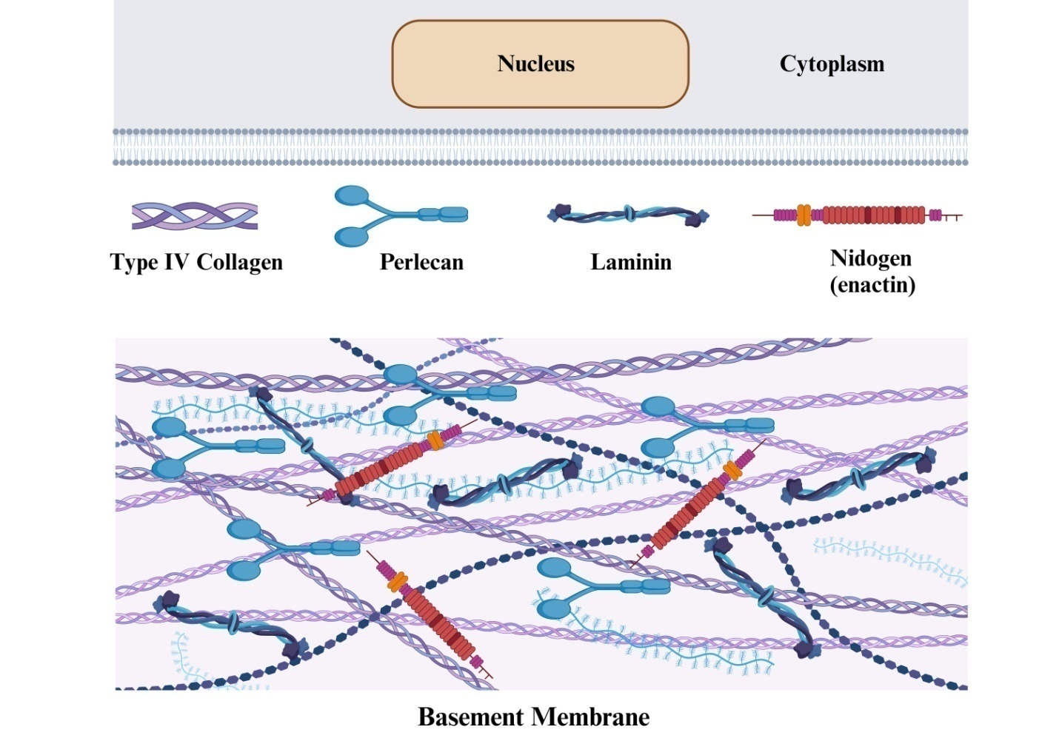

Figure 5: A schematic drawing shows a basement membrane (BM) structure outside of the cell: The great majority of cells, with the exception of immune cells, create basement membranes (BM). (a) As functional units of bone morphogenetic protein (BM), the cell assembles and secretes nidogen/entactin, perlecan, type IV collagen promoters, and laminin trimers. (b) The BM scaffold is believed to begin building around the basolateral surface of cells by laminin polymerization. Receptor proteins such as integrins and dystroglycans attach it to cells. (C) Affixation of the type IV collagen network occurs with the deposition of this polymer. A link between the laminin polymer and the type IV collagen network is provided by nidogen/entactin, but there is evidence that the two may interact directly. The other components of the basolateral BM interact with the laminin polymer and the type IV collagen network to create a functional BM (Tryggvason, 1987; Kalluri, 2003).
1.6.1. Membrane between cells:
Cells of connective tissue, such as macrophages, chondrocytes, fibroblasts, and osteoblasts, compose and surround the interstitial matrix. According to Aumailley and Gayraud (1998), it consists of a web of protein fibres that contain an amorphous glycosaminoglycan/proteoclycan substance. Different tissues have different molecular structures and matrix compositions. Such tissues include the dermis, tendons, ligaments, bone, and stroma of parenchymal organs. Both Prockop and Kivirikko (1995) and Aumailley and Gayraud (1998) state that the interstitial extracellular matrix (ECM) in all tissues is mostly composed of collagens. Multitudes of fibrillar collagens, including types I, II, III, V, and XI, contribute to the tissues' mechanical strength. Collagen is very resistant to proteolysis because to its triple-helical structure. This polymer is made up of three consecutive α-chains with Gly-X-Y triplet sequences. When two very thin collagen molecules (only a nanometer thick) join, fibrils are created. These fibrils may be further combined to form fibres with the assistance of covalent crosslinking, which stabilises them. Type I collagen, which is present in several tissues as collagen fibrils, is primarily a heterotrimer made up of two β1(I) and one γ2(I) chain chains. One component of cartilage, type II collagen, is mostly made up of homotypy 1(II)3. The class of non-fibrollar collagens is quite diverse, as pointed out by both Prockop and Kivirikko (1995) and Aumailley and Gayraud (1998). Type I collagen forms heterotypic fibrils in soft connective tissues with types III [μ1(III)3] and V. Collagen fibrils join proteins of the FACIT and other fibril-associated types that have broken triple-helices. The microfibril production in most stromal connective tissues is attributed to type VI collagen. Some tissues, such the dermis, lungs, and major blood arteries, are thought to be elastic because of elastic fibres (Aumailley & Gayraud, 1998). The main protein in elastic fibres, elastin, is hydrophobic, highly crosslinked, and resistant to most proteinases and harsh physical treatments. Microfibrils made of proteoglycans, various glycoproteins, and fibrillins interact with elastic fibres, according to Debelle and Tamburro (1999). Protein: Proteins are extracellular matrix (ECM) components. Plasma contains two structural glycoproteins of the extracellular matrix (ECM) that help cells adhere to the matrix (Tryggvason et al., 1987). The high-molecular-weight glycoproteins known as fibronectins form fibrillar structures and dimers connected by disulfides. On cell surfaces, integrin receptors are linked to fibronectins. They also bind to fibrin, proteoglycans, and collagen, among many other matrix components. According to research conducted by Tryggvason et al. (1987) and Vartio et al. (1983), fibronectins at the cell surface and ECM are downregulated during cell transformation due to reduced production and accelerated proteolytic destruction. Thrombospondins, tenascins, and SPARC may mediate adhesive and non-adhesive contacts and aid in the disassembly of focal contact structures (Murphy-Ullrich, 2001). Proteoglycans (PGs) and glycosaminoglycans (GAGs) make up the fibrous part of the interstitial extracellular matrix (ECM). The O-linked glycosaminoglycan (GAG) chains that comprise PGs are attached to serine and threonine residues; these chains may be composed of chondroitin sulphate, keratan, heparan, or dermatan (Iozzo, 1998). PGs work on matrix organisations and construct structural frameworks. Essential for maintaining tissue volume and water retention, their hydrophilic nature makes them indispensable. Many biological processes are affected by PGs, including adhesion, invasion, and cell proliferation (Iozzo, 1998). According to Lu (2000), heparan sulphate proteoglycans are bound to by many ECM-associated growth factors, including members of the VEFG and FGF families. Decorin and fibromodulin are small, leucine-rich proteoglycans that help regulate collagen fibrillogenesis and matrix architecture by binding to components of the extracellular matrix (ECM).
1.6.2. Basement Membrane: According to Tryggvason et al. (1987; Yurchenco & O'Rear, 1994), specialised sheets of extracellular matrix called basement membranes (BMs) separate the layers of epithelium and endothelial cells from the collagenous stroma cells. Their creation and assembly are carried out by cells distributed on each side of the BM. Heparan, chondroitin sulphate, entactin/nidogen, and type IV collagen are the principal proteoglycans discovered in bone marrow. The presence of proteoglycans in all BM structures raises the possibility that they are involved in charge-dependent molecular sieving and immobilisation, since growth hormones such as VEFG and FGF-2 have been shown to bind to perlecan, the principal BM heparan sulphate proteoglycan (Yurchenco & O'Rear, 1994; Iozzo, 1998). Multiplexin collagen types XV and XVIII, fibulin, and secreted SPARC are among the components linked by the evidence.
Matrix metalloproteases (1.7): Researchers found that 25,000–30,000 human genes included more than 2% proteases or protease inhibitors when the Human Genome Project was completed. According to Pozo et al. (2005), controlled breakdown of macromolecules is crucial in many biological processes, such as development, reproduction, host defence, inflammatory diseases, neurological disorders, and cancer. The family of 23 endopeptidases known as matrix metalloproteinases (MMPs) has the ability to break down all twenty-one components of the extracellular matrix (ECM), and the list of non-ECM substrates that MMPs may degrade is constantly growing (Lopez-Otin & Overall, 2002). Matrix metalloproteinases (MMPs) are involved in ECM breakdown and remodelling, but they are also crucial in regulating the activities of many physiologically active substances, including growth factors, chemokines, proinflammatory cytokines, and inhibitors of serine proteinase (Vu & Werb, 2000). Inflammation, immunity, chronic wounds, arthritis, periodontitis, cancer, and cardiovascular disease are just a few of the many physiological and pathological processes that include matrix metalloproteinases (MMPs) (Parks & Mecham, 1998; Vu and Werb, 2000; Stamenkovic, 2003). Matrix metalloproteinases (MMPs) are present in almost all cell types in culture and in every repair and remodelling process, but they are seldom seen in healthy, normal tissue (Parks & Mecham, 1998). Matrix metalloproteinases (MMPs) are present in almost all cell types in culture and in every repair and remodelling process, but they are seldom seen in healthy, normal tissue (Parks & Mecham, 1998). Naturally occurring tissue inhibitors of metalloproteinases (TIMPs) are the most critical regulators of precise proteolysis in normal tissue remodelling. The activity of matrix metalloproteinase (MMP) is regulated by many mechanisms; these processes include gene transcription, messenger RNA stability, enzyme secretion and binding, zymogen activation, and endogenous inhibitor inhibition (Nagase & Woestner, 1999). Substrate targeting, shedding, oligomerization, cellular absorption and internalisation, autolysis, mRNA stability, translational efficiency, and enzyme compartmentalization and secretion are among the several potential processes that modulate MMP activity. These techniques, when combined, limit MMP expression and activity to the specified areas.
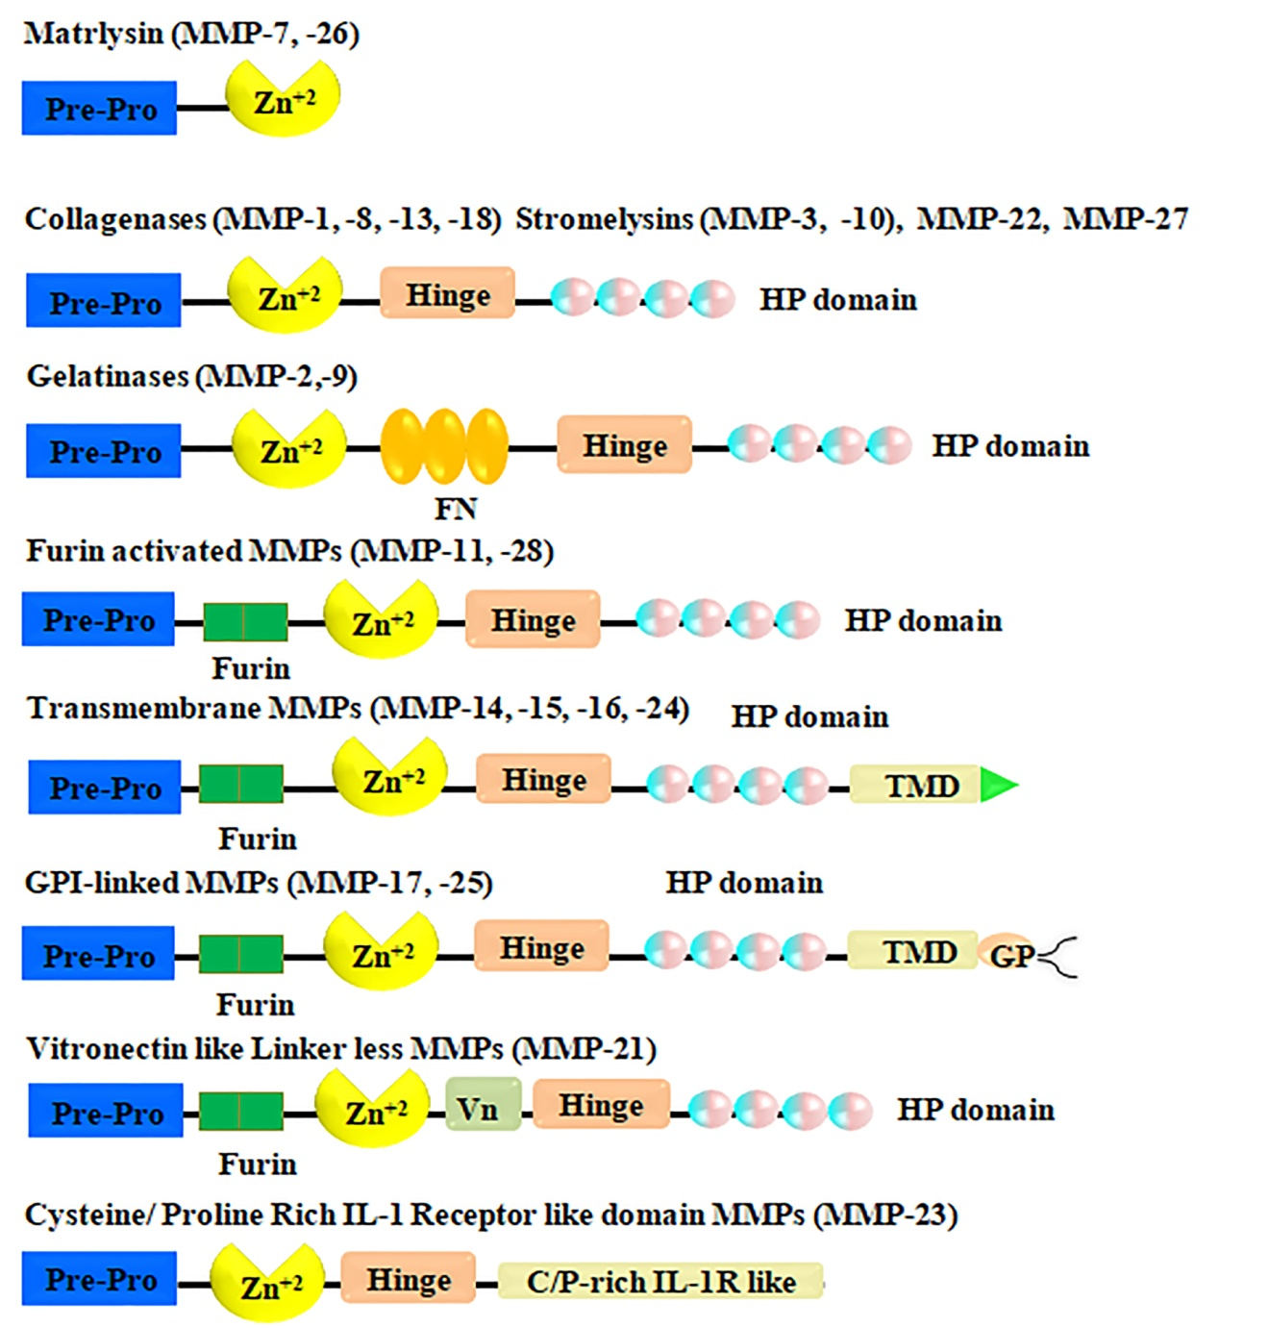

Figure 6. Metalloproteinases with a matrix structure. There are eight structural subgroups of matrix metalloproteinases (MMPs), five of which are secreted and three of which are MT-MMPs. A zinc-binding site (Zn) in the catalytic domain, an amino-terminal signal sequence (Pre), and a propeptide (Pro) that interacts with zinc via a thiol (SH) group are all features of minimal-domain matrix metalloproteinases (MMPs). Simple matrix metalloproteinases (MMPs) that include hemopexin interact with cell surface molecules, proteolytic substrates, and tissue inhibitors of metalloproteinases (TIMPs) via a hinge (H) that links the hemopexin-like domain to the catalytic domain. The first and last of the four repeats in the hemopexin-like domains are connected by a disulfide bond (S-S). Inserts in certain matrix metalloproteinases (MMPs) resemble fibronectin type II repeats (Fi), which bind gelatinous proteins. To activate the secreted matrix metalloproteinases (MMPs) that have been furinactivated, intracellular furin-like serine proteinases (Fu) may use a recognition motif between the propeptide and catalytic domains of the involved proteins. Both membrane-type and vitronectin-like insert matrix metalloproteinases (MT-MMPs) exhibit this pattern. For instance, there are multi-functional matrix metalloproteinases (MMPs) such as glycosylphosphatidylinositol (GPI)-anchored (MT-MMPs) and transmembrane (TM-)MMPs that have a short Cy domain and a carboxy-terminal (TM) span. Attached to cellular membranes, MMP-23 is another sort of matrix metalloproteinase. It connects to the cell membrane via an N-terminal signal anchor (SA), which classifies it as a type II transmembrane matrix metalloproteinase. Other characteristics of MMP-23 include its unique Cysteine array (CA) and immunoglobulin (Ig)-like domains (Egeblad & Werb, 2002).

1.7.1.1. Organisation
According to Birkedal-Hansen (1993) and Nagase and Woessner (1999), all matrix metalloproteinases (MMPs) have the same basic domain structure. This structure includes a signal peptide that directs secretion, a propeptide with a cysteine residue that maintains latent state by binding the catalytic zinc ion, and a catalytic domain with the zinc binding site. The majority of matrix metalloproteinases (MMPs) include the carboxy-terminal hemopexin-like domain and hinge region, while MMP-7, -23, and -26 do not. In addition, different subgroups of matrix metalloproteinases have distinctive domains, including the gelatin-binding domains found in the catalytic domain of MMP-2 and MMP-9 gelatinases. The presence of repetitions of the fibronectin motif in these domains facilitates enzyme binding to gelatin. As a result, four of the six MT-MMPs—MMP-14, -15, -16, and -24—contain the transmembrane domain. Activation and regulation of matrix metalloproteinase (MMP) on various level: Regulatory signals may activate matrix metalloproteinases (MMPs) by attaching to particular receptors on cell surfaces. These signals might originate from soluble substances, the extracellular matrix (ECM), or cell-cell contacts. These matrix metalloproteinases have two potential secretion sites: outside of cells (proMMP) and on cell surfaces (MT-MMPs). There are a lot of circumstances that might trigger proMMP activation. In addition to their involvement in cell proliferation, invasion, and angiogenesis, activated matrix metalloproteinases (MMPs) may inhibit the induction of cell death and the host immune response to tumours, all of which contribute to the promotion of cancer. It is also feasible to use MMP autolysis or inhibitors to prevent these cellular effects from starting.
1. 7. 2. Matrix metalloproteinase Categories
Based on their structural properties and substrate specificity, MMPs are classified into six subgroups: membrane type MMP (MT-MMP)s (MMP-14, MMP-15, MMP-16, MMP-17, MMP-24, MMP-25), other MMPs (MMP-12, MMP-19, MMP-20, MMP-21, MMP-23, MMP-27, MMP-28), collagenases (MMP-1, MMP-8, and MMP-13), gelatinases (MMP-2 and MMP-9), stromelysins (MMP-3, MMP-10, and MMP-11), matrilysins (MMP-7 and MMP-26), and other MMPs (MMP-12, MMP-19, MMP-20, MMP-21, MMP-23, MMP-27, MMP-28) (Birkedal-Hansen, 1993; Nagase & Woessner, 1999) (Figure. 8). When collagenase has its C-terminal region removed, it loses its ability to hydrolyze native collagen (Nagase & Woessner, 1999). According to Velasco et al. (1999), the recently cloned MMP-23 differs from other MMPs in terms of its domain structure, prodomain length, lack of hemopexin-like repeats in the Cterminal domain, and mysterious signal sequence. However, it does have significant sequence similarities with other MMPs.
Matrix metalloproteinase-1 (collagenase-1), matrix metalloproteinase-8 (neutrophil collagenase-2), and matrix metalloproteinase-13 (collagenase-3), as specified by Stolow et al. (1996), constitute the subfamily of collagenases. The ¾- and ¼-fragments are formed when the native fibrillar collagen types I-III are cleaved by collagenases. The cleavage happens precisely at the glysine-isoleusine (Gly-Ile) and glysine-leu (Gly-Leu) residues of the α1 and α2 chains, resulting in the creation of three helical segments that, upon denaturement at body temperature, provide randomly coiled gelatin. According to Birkedal-Hansen (1993) and Sternlicht and Werb (2001), gelatinases and proteinases further break down the smaller pieces. In terms of substrate specificity and functional relevance, collagenases vary between themselves. According to Birkedal-Hansen (1993), Figure 8, and Knauper et al. (1996), matrix metalloproteinase MMP-1 has a preference for breaking down collagen III, while matrix metalloproteinase MMP-8 favours type I collagen.
Figure 8 shows that the two enzymes that make up the gelatinase group, gelatinase-A (MMP-2) and gelatinase-B (MMP-9), have identical structural features and substrate selectivity. The catalytic domain of gelatinases must have three head-to-tail cysteine-rich repetitions in order for the enzyme to bind and cleave, particularly denatured collagen and elastin. These repetitions are similar to the type II repeats found in fibronectin, which bind collagen. When collagenases have broken down a protein, either gelatinase or collagenase II may dissolve partly denatured collagens of any genetic type (Nagase & Woessner, 1999). A potent enzyme that destroyed type IV collagen was discovered by researchers to be matrix metalloproteinase-2 (MMP-2) in the basement membrane of a malignant melanoma tumour in mice (Salo et al., 1991). The 72 kDa latent MMP-2 is released and conforms to a 59-62 kDa version when activated. Matrix metalloproteinase-2 cleaves a wide variety of proteins, including collagen types I, II, IV, V, VII, X, and XI, components of bone marrow and gelatins (Aimes & Quigley, 1995; Takagi et al., 1998; Sternlicht & Werb, 2001). Similar to collagenases, the hemopexin domain is required for the early cleavage of type I collagen's triple helical structure; however, it has no effect on MMP-2 binding to collagen (Takagi, 1998). As to Sternlicht and Werb (2001), this is so. This 72-kDa secreted form is mostly activated. Upon binding to cell surfaces, a molecular complex consisting of matrix metalloproteinase-1 (MT1-MMP), tissue inhibitor of metalloproteinase-2 (TIMP-2), and matrix metalloproteinase-2 (MMP-2) activates MMP-2. In order to convert ProMMP-2 into its 64-kD intermediate form, MMP-14 cleaves it while it is in its active, proximal state. Murphy-Ullrich (2001) states that this intermediate form is transformed into the fully active 62-kD variety by autoproteolytic cleavage at a second location. Cancer cells that overexpress MMP-2 are more likely to invade surrounding tissues and spread to other parts of the body. Sternlicht & Werb (2001), Nagase & Woessner (1999), and Liotta & Stetler-Stevenson (1990) all state that MMP-2 is involved in several processes that need remodelling of the extracellular matrix.
Although human macrophages were initially thought to be the source of matrix metalloproteinase-9 (Nagase & Woessner, 1999), it has since been discovered that many other types of cells can produce this enzyme. These include plasma cells, fibroblasts, vascular smooth muscle cells, osteoclasts, macrophages, PMNs, migrating keratinocytes, T-lymphocytes, monocytes, and macrophages (Leppert et al., 1995; Wucherpfennig et al., 1994; Parks & Mecham, 1998). In addition to forming a 200-kD homodimer, MMP-9 is expelled from cells as 92-kD proMMP-9 when it forms a substantial complex with TIMP-1 (Parks & Mecham, 1998). Parks and Mecham (1998) found that as a result, a portion of the released MMP-9 attaches to the cell surface, making it very resistant to the inhibition of TIMP-1. Usually moderate and contained in healthy tissues, an upregulation of MMP-9 expression may occur during inflammation, wound healing, or cancer invasion. The amount to which MMP-9 degrades type I-III collagens is lower than that of MMP-2, despite the fact that both enzymes have comparable substrate selectivity. In the process of bone remodelling and development, MMP-9 plays a crucial role in facilitating collagen resorption, as noted by Sternlicht and Werb (2001) and Parks and Mecham (1998). Its overexpression has also been linked to inflammatory responses in periodontal disorders and lung conditions. Research by Liotta and Stetler-Stevenson (1990) and Parks and Mecham (1998) suggests a connection between MMP-9 and tumour cells, their metastasis potential, and mobile invasion. Chronic wounds have a higher amount of MMP-9, as stated by Parks and Mecham (1998).
Membrane matrix metalloproteinases (MMPs) 3, 10, and 11, often called stromelysin-1, -2, and -3, are members of the stromelysin family. Stromelysins and collagenases have structural similarities in their domains. However, fibrillar collagens seen in nature cannot be broken. Nagase and Woessner (1999) and McCawley and Materisian (2001) found that tryptase, chymase, plasmin, and kallikrein are among the enzymes that activate MMP-3, along with ProMMPs-1, -3, -7, -8, -9, and -13. Parks and Mecham (1998) and Liotta and Stetler-Stevenson (1990) both state that stromelysin-3 can cleave insulin-like growth factor binding protein, proteinase inhibitors, β2-magroglobulin, and β1-PI, although it does not interact with numerous ECM components. Its proprotein convertase recognition region is located between its pro- and catalytic domains, setting it apart from other secreted matrix metalloproteinases. Fibroblasts, keratinocytes, and epithelial cells are the ones that produce it, says Birkedal-Hansen (1993). According to Parks and Mecham (1998), proteoglycans are one of numerous ECM-related proteins that MMP-3 may be able to break down. It has been shown that plasmin, elastase, and cathepsin G activate MMP-10, which in turn activates proMMPs-1, -2, -7, -8, and -9 (Parks and Mecham, 2004; Nagase and Woessner, 1999). Laminin1, fibronectin, proteoglycans, globular type IV and IX collagens, and many other molecules are broken down by it (McCawley & Materisian, 2001). Parks and Mecham (1998) found that keratinocytes express MMP-10 in both living organisms and laboratory environments. Its proprotein convertase recognition region is located between its pro- and catalytic domains, setting it apart from other secreted matrix metalloproteinases.
1.7.4. Transcription control:
In response to their requirement, matrix metalloproteinases (MMPs) may be quickly synthesised and activated, despite their generally modest expression rate. Additionally, MMP transcriptional activators are able to exert their effects via a wide variety of signal-transduction pathways. For instance, MMP production may be increased or decreased in several cell types by the p38 mitogen-activated protein kinase (MAPK) (ERK1, ERK2). A number of extracellular signals and signal-transduction pathways culminate in the transcription factor AP1, which is bound to the promoter region of most MMP genes (Figure 7; Overall & Lopez-Otin, 2002). Members of the FOS and JUN family of oncoproteins in AP1 may contribute to the upregulation of matrix metalloproteinase (MMP) expression in cancerous tumours. The results of studies conducted by Parks and Mecham (1998) and Lopez-Otin (2002) suggest that different types of tumour cells may respond differently to the same inducible chemical, or that different agents may work in different ways. Extra nuclear factors that control MMP expression are probably responsible for this diversity. These include the ETS family of oncoproteins, which bind PEA3 sites that are present in MMP gene promoters26; nuclear factor of ƙB (NF-ƙB), which induces MMP-1, 3, 9, 13 and 14 (Overall & Lopez-Otin, 2002; Parks & Mecham, 1998); signal transducers and activators of transcription (STATs), which mediate the effects of interferons (IFNs) on MMP gene expression; T-cell factor 4 (TCF4) and CAS-associated zinc-finger protein (CIZ), which activate the expression of MMP-1, 3 and 7 (Overall & Lopez-Otin, 2002; Parks & Mecham, 1998); p53,which modulates the transcription of MMP-1, 2 and 13 (Overall & Lopez-Otin, 2002); and core-binding factor A1 (CBFA1),which forms part of a regulatory cascade that controls MMP expression in both normal and tumour cells. Other than the AG-rich element (AGRE) and the TGF-β inhibitory element (TIE), the promoters of other MMP genes also include negative regulatory elements, as shown in Figure 9. A1 (CBFA1), which controls the production of matrix metalloproteinase (MMP) in both healthy and malignant cells. The promoters of other MMP genes have also had negative regulatory elements, such the AG-rich element (AGRE) and the TGF-β inhibitory element (TIE), as shown in Figure 10. Interactions between cells, growth factors, cytokines, oncogenes, hormones, and components of the extracellular matrix all play a role in transcriptional regulation of matrix metalloproteinase (MMP) production.
Figure 9 shows the components that control the expression of human matrix metalloproteinase genes. These components include the transcription start sites (shown by the bent arrow), the 5'-3' promoters, and the areas inside the boxes that bind transcription factors. Here are a few examples of places where transcription factors can be found: AG-rich element (AGRE), activator proteins (AP)-1 and -2, core-binding factor 1 (CBFA1), cyclic AMP response-element binding protein (CREB), early growth response-1 (EGR1), immortalization-sensitive elements (ISE)-1 and -2, keratinocyte differentiation factor responsive element (KRE), nuclear factor of ƙB (NF-ƙB) site, polyomavirus enhancer-A binding-protein-3 (PEA3) site, retinoic-acid response element (RARE), retinoblastoma control element (RCE), stromelysin-1 platelet-derived growth factor-responsive element (SPRE), and signal transducer and activator of transcription (STAT). Parks and Mecham (1998) state that a TGF-β inhibitory element (TIE) present in several MMP genes is the manner by which TGF-β influences transcription. Different cell types and matrix metalloproteinase genes may react differently to different environmental stressors. The inducible MMP production (MMP-1, MMP-3, MMP-7, MMP-8, MMP-9, MMP-13, and MMP-14) is increased in different cell lines by a variety of cytokines, such as IL-1 and TNF-α, whereas TGF-β, glucocorticoids, IFN-ά, and retinoid acid mostly have suppressive effects. According to Overall and Lopez-Otin (2002), TGF-β enhances MMP-2, MMP-9, and MMP-13 formation in keratinocytes, whereas it inhibits MMP-1 and MMP-3 growth in fibroblasts. In glioma cells, it regulates the generation of MMP-7. The factors TGF-β, IL-1α, and epidermal growth factor (EGF) generate high amounts. The formation and release of matrix metalloproteinases (MMPs) may be facilitated by hormones, certain extracellular matrix (ECM) proteins, bacterial cells and products, and cell-to-cell adhesion proteins (Saarialho-Kere et al., 1996). Matrix metalloproteinase 2 and 14 synthesis are somewhat impacted by transcriptional regulation (Birkedal-Hansen, 1995; Saarialho-Kere et al., 1996). Matrix metalloproteinase (MMP) production regulation is an intricate process that involves transcription factors' trans-activating activity, degradation, and synthesis, in addition to cellular MMP production.
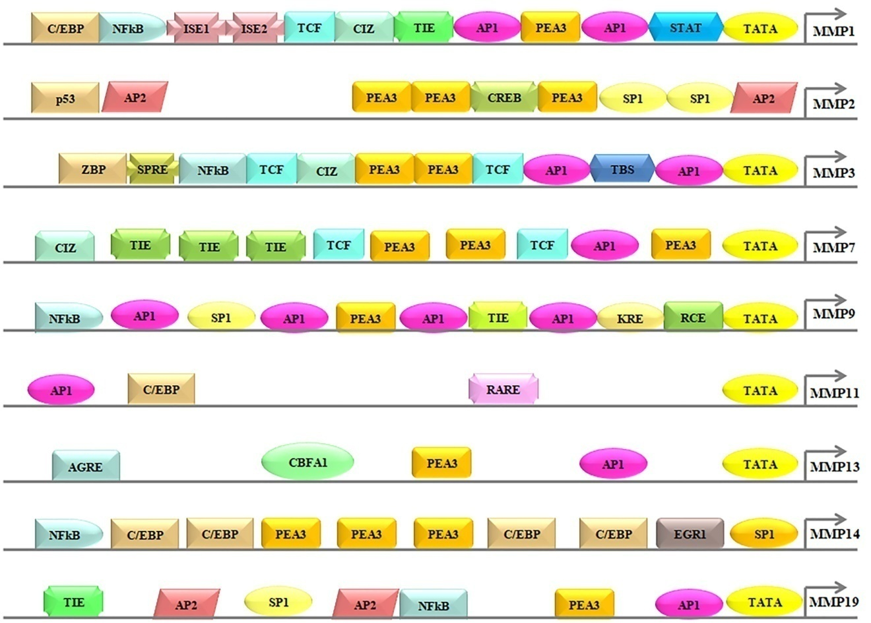

Figure 7: Regulatory elements are located in the promoter regions of human MMP genes. The transcription factor binding sites, the 5'-3' promoters, and the transcription start sites indicated by the bent arrow. Transcription-factor-binding sites include: the AG-rich element (AGRE), the activator proteins (AP)-1 and -2 site, the core-binding factor 1 (CBFA1) site, the CCAAT/ enhancer-binding protein (C/EBP) site, the CAS-interacting zinc-finger protein (CIZ) site, the cyclic AMP response-element binding protein (CREB) site, the early growth response-1 (EGR1) site, the immortalization-sensitive elements (ISE)-1, and -2, the keratinocyte differentiationfactor responsive element (KRE), the nuclear factor of κB (NF-κB) site, the polyomavirus enhancer- A binding-protein-3 (PEA3) site, the retinoic-acid response element (RARE), the retinoblastoma control element (RCE), the stromelysin-1 platelet-derived growth factor-β responsive element (SPRE), the signal transducer and activator of transcription (STAT) site, the TATA-box (TATA), the TEL (translocation-ETS-leukaemia) binding site (TBS), the T-cell factor (TCF) site, the transforming growth factor-β inhibitory element (TIE) site, and the binding site for 89-kDa zinc-binding protein (ZBP-89) (Overall & Lopez-Otin, 2002).

A family of proteins known as NF-əəB is a transcription factor. In response to stress, cytokines, free radicals, UV radiation, and bacterial or viral antigens, almost all animal cells contain NFə-əB, as stated by Gilmore (2006). According to Collistar and Albensi (2005), synaptic plasticity and memory processes are linked to NF-ƙB. The activation of the NF-ƙB cytoplasmic site occurs with stimulation of an inflammatory response (Bussolino et al., 1996). Dimer NF-ƙB is formed by the assembly of the five mammalian Rel proteins, p65, c-Rel, p50/NF-B1, p52/NF-əB2, and RelB, in almost any arrangement. Dormant cells establish a compound with NF-B when a kind of cytoplasmic inhibitor called inhibitors of NF-̫B (IkB's) is present. In response to certain intracellular stimuli, signalling pathways are activated, leading to the IkB kinase complex's (IKK complex) activation. Two functionally redundant kinases, IKKa (IKK1) and IKKb (IKK2), plus a scaffold protein, IKKg (NEMO), make up the IKK complex. The functional IKK complex phosphorylates the IkBs at a specific amino acid.
In many cases, the cascade of cytokines and growth factors that stimulate matrix metalloproteinase (MMP) formation involves the activation protein-1 (AP-1) pathway. Extracellular signals trigger AP-1 transcription factor complexes, which bind to the MMP gene's AP-1-binding site and enhance MMP production. Figure 11 from Angel and Karin (1991) shows that AP-1 transcription factors oversee not just proliferation, differentiation, and development, but also genes related to inflammation, tumour formation, and stress responses. Examples of homo- and hetero-dimers in AP-1 complexes include members of the proto-oncogene families Fos (c-Fos, FosB, Fra-1, and Fra-2), Jun (c-Jun, JunB, and JunD), and ATF (ATF2, ATF3/LRF1, and B-ATF). The basic region leucine zipper is the inspiration for the name "bZIPs" given to these DNA-binding proteins. A number of environmental cues, including cytokines, growth hormones, and indicators of cellular stress, quickly reawaken the proteins from their slumber in dormant cells (Whitmarsh & Davis, 1996; Angel & Karin, 1991). Additionally, neoplastic transformation may occur in cells when the expression of the Fos and Jun proteins is abnormal, uncontrolled, or overexpressed (Angel & Karin, 1991). Expression of both c-fos and c-jun at the same time speeds up tumour growth. Research conducted by Saez et al. (Saez et al., 1995) indicates that c-Fos plays a crucial role in the progression of skin tumours to a malignant state. Figure 11 shows c-Fos, a "master switch" involved in cell proliferation and differentiation. Both during and after transcription, MAP kinase pathways control AP-1 activity (Whitmarsh & Davis, 1996). The activation of several genes, including MMPs, is triggered when the AP-1 complex binds to the TRE motif (an abbreviation for TPA responsive element). Polyomavirus complementer The AP-1 binding site is often found with a binding protein 3 (PEA-3) sequence. According to Gutman and Wasylyk (1990), the majority of MMP genes activate the PEA binding site via oncogene, growth factor, and phorphol ester-responsible components. According to Whitmarsh and Davis (1996), MMP control in tumour development occurs when MMP-genes are activated at the same time via the AP-1 and PEA sites. New evidence suggests that AP-1 activation is an important pathophysiological component of NSAID-induced gastric ulceration.
1.8. How the Gastric Ulcer Heals
Whenever an ulcer heals or repairs, the submucosal and mucosal tissues undergo their inherent regeneration process. In order to repair the damage, a complex series of metabolic processes occurs, which in turn causes ulceration. Stadelmann et al. (1998) and Qin and Benveniste (1999) found that while these processes actually happen concurrently, they may be arbitrarily split into three stages: inflammation, proliferation, and maturation/remodeling.
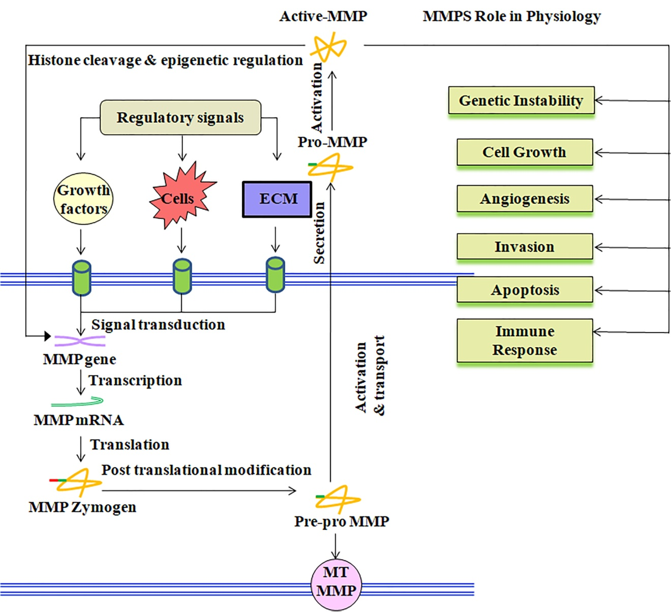
Figure 8: Control of matrix metalloproteinase expression and activity Certain receptors on cell surfaces are bound by various regulatory signals, such as soluble substances, interactions with the extracellular matrix (ECM), or cell-cell contacts. This triggers a cascade of reactions that ultimately leads to the synthesis of functional matrix metalloproteinases (MMPs), which may be either exported to the extracellular space (proMMP) or confined to the surface of the cell (MT-MMPs). When ProMMPs are activated, it's because of a variety of factors. Matrix metalloproteinases (MMPs) are active proteins that have several roles in cancer growth, as shown by the red boxes. Improving genetic instability, cell proliferation, angiogenesis, and invasion are all mechanisms that fall into this category. Inducing cell death and the host immune response to tumours are both thwarted by these chemicals. Inhibitors or autolysis of matrix metalloproteinases (MMPs) might impede the initiation of these biological effects. The orange boxes represent different levels of MMP regulation that could be targeted by therapeutic interventions. These levels include cell responses to regulatory cues, signal transduction, transcription induction, post-transcriptional processing, MMP activation and transport, and secretion (Overall & Lopez-Otin, 2002).

1.8.1: Inflammation
In order to achieve hemostasis, blood must coagulate, which sets off a cascade of events that attract phagocytic cells. The proliferative phase of ulcer healing begins when these cells devour debris and wounded tissues. Because of their role in releasing fibrin-fibronectin plugs, platelets play a disproportionately large role in this context. These plugs facilitate protein and particle aggregation, glycoprotein expression on cell membranes, and the induction of various factors, including growth factors, prostacyclins, serotonin, bradykinin, prostaglandins, histamine, and prostacyclins. This block was replaced as it disintegrated by granulation tissue and, later, collagen. Thanks to histamine's role in vasodilation and thromboxanes' and prostaglandins' roles in vasoconstrictin, inflammatory cells like macrophases and leukocytes (polymorphonuclear neutrophils, PMNs) may discover the ulcerated area more readily. Neutrophils engulf dead cells and damaged tissues by releasing radicals and proteases. Macrophages and helper T cells are examples of leukocytes that secrete cytokines that promote T cell proliferation, vasodilation, and increased permeability of blood vessels. Macrophages are activated by the low oxygen tension in the ulcerated area, and they secrete chemicals that encourage the formation of new blood vessels. Furthermore, they stimulate cell reepithelialization, granulation tissue production, and extracellular matrix formation. According to Martin and Leibovich (2005), these chemicals are secreted by macrophages, which are essential for the advancement of wound healing.
1.8.2. Life Cycle Phase
Even before the inflammatory phase concludes, fibroblasts start to enter the ulcerated area two or three days after stomach wounds form, marking the beginning of the proliferative phase. The inflammatory and proliferative stages do not occur in a strict chronological order, but rather coexist for a while. During the proliferative phase, the ulcer wound contracts, lialization occurs, granulation tissue develops, collagen deposition occurs, and angiogenesis occurs (Lorenz & Longaker, 2003). As seen in Figure 12, the physiological process of angiogenesis involves the creation of new blood vessels from preexisting ones. A structure with a thin wall lined with endothelium is formed during angiogenesis by the muscular smooth muscle wall and pericytes. The regulation of angiogenesis is regulated by a balanced interaction of signals from different cell types inside the stomach mucosa, some of which release substances that promote angiogenesis and others that inhibit it. The ulcer heals by laying the groundwork for future tissue growth—granulation tissue—in the ulcerated area. Epithelium and connective tissue (collagen) make up this tissue, which develops into blood vessels in due time. Endothelial cells can't migrate without plasminogen activator and collagenases, which degrade the extracellular matrix and the clot. Here, matrix metalloproteinases (MMPs) break down the basement membrane and extracellular matrix (ECM), paving the way for cell proliferation and angiogenesis. The fibrin scab's fibronectin and other cells' growth factors entice endothelial cells to the wound location. Macrophages and platelets secrete angiogenic chemicals that endothelial cells chemotactically seek for in low-oxygen conditions (Stadelmann et al., 1998; Midwood et al., 2004). Proteases, especially matrix metalloproteinases (MMPs), include vascular endothelial growth factor (VEFG), transforming growth factor (TGF), fibroblast growth factor (FGF), collagen, and other growth factors. While ulcers heal in animals and people alike, little is known about how growth factors and matrix metalloproteinases (MMPs) are regulated (Shahin et al., 2001; Baragi et al., 1997). As an ulcer heals, a network of microvessels and capillaries is finally formed as endothelial cells proliferate in response to the positive effects of VEFG and TGFβ. There is mounting evidence that VEFG is critically involved in angiogenesis, the process by which the capillary density of a network grows. Goto et al. (1993) discovered that bovine capillary endothelial cells were induced to proliferate and produce tube structures by vascular endothelial growth factor (VEFG) and basic fibroblast growth factor (bFGF). In vitro studies shown that VEFG is a potent activator of angiogenesis (Chang et al., 2004; Prior et al., 2003) because it causes endothelial cells to migrate and proliferate, resulting in the creation of tube structures that resemble capillaries. The exposure of endothelial cells to VEFG triggers a massive signalling cascade.
During the healing process, damaged or inflamed cells release angiogenic growth factors into nearby tissues. Two examples of these factors are basic fibroblast growth factor (bFGF) and blood vessel endothelial growth factor (VEFG). These growth agents bind to certain endothelial cell (EC) receptors. The nucleus receives signals that activate endothelial cells. The basement membrane encasing the blood vessels might acquire minute holes due to the secretion of new growth hormones and enzymes such matrix metalloproteinases (MMPs). Endothelial cells proliferate and migrate to the injured area to start the process. Integrins are specialised adhesion molecules that help the newly sprouting blood artery progress. With the aid of matrix metalloproteinases, the tissue is distributed along the route of the growing artery. Ultimately, endothelial cells proliferate to form the blood vessel tube. Blood vessels may form loops when they connect with one another. The newly formed blood vessels are structurally supported by pericytes and certain muscle cells. A tyrosine kinase signalling cascade is activated once blood flows to VEFG receptor-2 (VEGFR-2). This series of events triggers the synthesis of factors that promote several stages of blood vessel maturation, such as permeability, proliferation, migration, and differentiation. Ma et al. (2001) found that endostatin levels decreased while VEFG levels increased in blood samples from patients with artificially produced stomach ulcers. The process of VEFG-induced angiogenesis begins with the migration of endothelial cells and culminates in the sprouting of blood vessels. Endothelial cell migration and mitosis are both aided by VEFG, as stated by Brown et al. (1992). Additionally, it stimulates angiogenesis by increasing microvascular hyperpermeability, which in turn causes the formation of an extracellular matrix rich in fibrin. Angiogenesis and VEFG are vital in the management of gastric ulcers. Giving rats VEFG helps them recover from experimental duodenal ulcers more quickly (Tarnawski et al., 2001). The following angiogenic factors, as reported by Veikkola and Alitalo (1999) and Pepper (2001): interleukin (IL-01), platelet derive growth factor (PDGF), tumour necrosis factor (TNF), transforming growth factor beta (TGF-alpha), and epidermal growth factor (EGF). According to Dai et al. (2005), PGE2 has the ability to promote VEFG gene expression in rat microvascular endothelial cells. Among the many members of the FGF family are nineteen distinct polypeptide growth factors. As stomach ulcers heal, the expression of bFGF and its receptors increases, which triggers the angiogenic response (Tarnawski et al., 2001). The rats' ulcer healing quality is negatively affected and the healing process is extended because plasminogen activator is removed when an antibody against bFGF is delivered intravenously or intraperitoneally (Tarnawski et al., 2001). Acid stable recombinant bFGF improves angiogenesis and wound healing in rats. According to Ernst et al. (2001), sucralfate aids in the healing of ulcers by causing the stomach mucosa to release matrix-bound fibroblast growth factor.
Two to five days after ulceration, the inflammatory phase concludes, and fibroblasts start to gather at the site of the ulcer. Angiogenesis, granulation tissue growth, and fibroplasia all happen at the same time, and their numbers reach a high one to two weeks after an ulcer has healed. Within the first two days after an injury, fibroblasts create the main collagen matrix at the location of the wound by migration and proliferation. When the inflammatory phase begins, fibroblasts connect to fibronectin after passing over the fibrin scab. Before migrating, fibroblasts spread ground material and collagen into the ulcer bed. Fibroblasts use extracellular matrix components such proteoglycans, glycoproteins, elastin, and fibronectin to help them move through wounds (Cohen et al., 2006). Granulation tissue is necessary to seal up a large, exposed cut that goes through the basement membrane. Ulcers often begin to take shape and cover the ulcer bed two to five days after they first appear. The tissue is composed of new blood vessels, myofibroblasts, endothelial cells, fibroblasts, inflammatory cells, and a temporary extracellular matrix (ECM). Although they change in composition from normal tissue ECM, glycosaminoglycans, proteoglycans, fibronectin, and collagen are all components of the extracellular matrix that are present during the provisional phase. The main ingredients, hyaluronan and fibronectin, work together to create a hydrated matrix that facilitates cell movement. This intermediate matrix will be replaced by an ECM later on that is more akin to the one in healthy tissue. Fibronectin and growth factors (PDGF, TGF-β) stimulate fibroblast proliferation, migration to the wound bed, and ECM molecule production (Stadelmann et al., 1998).
1.8.3. The Phase of Development and Renovation: When the amounts of collagen produced and broken down are equal, the healing process reaches its mature stage. A year or more may elapse during the maturation phase, depending on the extent of the wound and whether it was initially closed or left open. According to Eichler and Carlson (2006) and Mulvaney and Harrington (1994), stronger type I collagen gradually replaces the more prevalent type III collagen throughout maturation. Type III collagen is present during proliferation. A process of reorganisation, cross-linking, and alignment along tension lines is used to restore order to the collagen fibres. At this point, the ulcer wound's tensile strength is increasing; three months after injury, it's close to half of normal tissue strength, and it may reach 80% later on. Apoptosis reduces activity at the wound site and scar reddening by eliminating blood vessels that are no longer needed. Predictable and rapid wound healing is common, according to research by Mulvaney and Harrington (1994) and Eichler and Carlson (2006). Nonetheless, if this isn't the case, a persistent ulcer wound could form as a result of improper healing. Matrix metalloproteinases (MMPs) are crucial in the dysregulation of extracellular matrix remodelling throughout the healing phases of gastric ulcers (Parks & Mecham, 1998). The role of matrix metalloproteinases (MMPs) in the repair of NSAID-induced acute gastric ulcers remains unclear. Little is known about the involvement of matrix metalloproteinases (MMPs) and tumour inhibitors of metalloproteinases (TIMPs) in stomach ulcers caused by nonsteroidal anti-inflammatory drugs (NSAIDs), as stated by Menges et al. (2000), Lempinen et al. (2000), and Shahin et al. (2001). Several studies have shown that indomethacin-induced gastric ulcers include matrix metalloproteinases (MMPs)-1, -2, and -9, which are involved in extracellular matrix remodelling (Menges et al., 2000; Lempinen et al., 2000; Shahin, et al., 2001). According to Lempinen et al. (2000), matrix metalloproteinases-9 and -2 are differentially regulated in acute and chronic ulceration in rats. Researchers Menges et al. (2000) found that MMP-1 concentrations were much higher in H. pylori ulcers compared to ulcers generated by nonsteroidal anti-inflammatory medications. In the early phases of indomethacin-induced chronic gastric ulcers, MMP-9 may have a substantial impact, whereas MMP-2 may be engaged in the natural turnover of the gastric ECM (Lempinen et al., 2000). Collagen expression has an important structural and functional role in the healing of stomach ulcers, as shown by Shahin et al. (2001). Activated ulceration and remodelling of the extracellular matrix seem to need MMP-2.
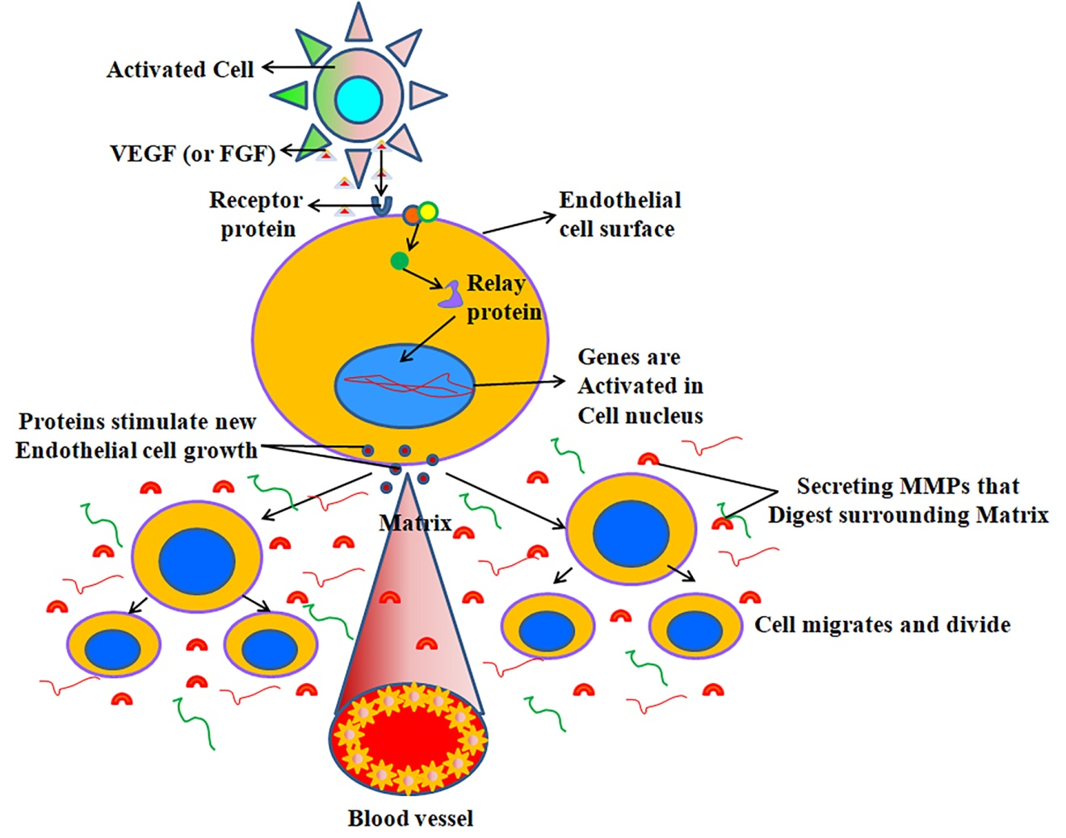

Figure 9. The creation of new blood vessels during an ulcer's healing process: During the healing process, damaged or inflamed cells release angiogenic growth factors into nearby tissues. Two examples of these factors are basic fibroblast growth factor (bFGF) and blood vessel endothelial growth factor (VEFG). Specific receptors on endothelial cells (EC) allow these growth factors to bind. The nucleus receives signals that activate endothelial cells. The basement membrane encasing the blood vessels might acquire minute holes due to the secretion of new growth hormones and enzymes such matrix metalloproteinases (MMPs). Endothelial cells proliferate and migrate to the damage site with the help of certain adhesion molecules called 'integrins,' which propel the newly sprouting blood artery forward. As the artery widens, matrix metalloproteinases (MMPs) aid in spreading the tissue outward. Ultimately, endothelial cells proliferate to form the blood vessel tube. Blood vessels may form loops when they connect with one another. Pericytes and other specialised muscle cells also help the newly formed blood vessels stand on their own. Blood then begins to circulate.

1.9. MEDICAL CARE
Taking omeprazole or misoprostol, two proton pump inhibitors and prostaglandin analogues, together may reduce acid production and therefore the severity of gastrointestinal adverse effects. When younger people show signs that are comparable to ulcers, antacids are often recommended to them. Bismuth compounds might be useful as disinfectants or antimicrobials. As a precaution against peptic ulcers, physicians may prescribe prostaglandin analogues such as misoprostol to patients using nonsteroidal anti-inflammatory medications (NSAIDs). The best treatments for H. tend to be combinations of two antibiotics (such clarithromycin, amoxicillin, tetracycline, or metronidazole) and one proton pump inhibitor (PPI), sometimes in addition to a bismuth molecule. H. pylori germs. Medication that directly suppresses the formation of stomach acid speeds up the healing process of peptic ulcers, regardless of their source. Four to eight weeks is the usual time frame for treatment. While it's not true that bland meals speed healing or stop ulcers from coming back, they may help reduce acid levels. It is fair, nevertheless, for people to avoid things that make gas and pain worse. Stay away from things like alcohol, nicotine, and nonsteroidal anti-inflammatory medicines (NSAIDs) as they might irritate the stomach (Laine et al., 2008; Ramakrishnan & Salinas, 2007).
1.10. Melatonin is;
One such hormone found in nature is melatonin, formally known as N-acetyl-5-methoxytryptamine. the vast majority of creatures, including humans, and even some other kinds of life, such algae, in 2003, Caniato et al. Its content in the circulation fluctuates regularly, and its correct regulation of circadian rhythms is dependent on it (Reiter, 1993; Redman et al., 1983). Many melatonin receptors must be activated before melatonin can exert its biological effects. On the other hand, others believe it is because of its role as an antioxidant that protects DNA in mitochondria and the nucleus (Altun & Ugur-See Altun (2007) and Reiter et al., 2001). According to Redman et al. (1983), pharmaceutical melatonin has the potential to control circadian rhythms and environmental cycles, making it a potential treatment for insomnia. Its therapeutic effect can be minimal. due to its comparatively high concentration, short biological half-life, and poor absorption. According to Reiter et al. (1994), the main reason to use melatonin supplements is that they may help with sleep naturally. There may be a domino effect of beneficial effects on health and wellbeing due to Melatonin's antioxidant qualities and other benefits. The immunological system and the endocrine system are both stimulated by it. Supplemental melatonin pills included three to ten times the amount needed to provide the ideal physiologic melatonin blood level throughout the night to enhance sleep quality, according to research out of the United States' Massachusetts Institute of Technology. The doses increase melatonin levels for a short period of time. On the other hand, there is evidence that suggests that smaller doses (such as 0.3 mg) are just as effective as larger ones (such as 3 mg) in enhancing the quality of one's sleep.
1.10.1. Generating with living organisms
The pineal gland is responsible for producing melatonin in humans and other higher animals. Other locations where it is found include the gastrointestinal system, the lens, and the retina (in the brain), among others. (Dawson and Encel, 1993; Bubenik et al., 1977). A very active enzyme, O-methyltransferase, is derived from the 5-hydroxyindole-amino acid tryptophan, which is produced naturally as serotonin. An input from the retina about the daily light-dark cycle reaches the hypothalamic suprachiasmatic nucleus (SCN), which in turn influences melatonin production by the pineal gland. Rhythmicity and melatonin production are impacted by the two SCN Non-image-forming light signals. A short time ago, this was found via the retinohypothalamic tract (RHT). A signal is sent from the retinal photosensitive neurons to the SCN when it is bright or dark. pictures are formed by cells other than ganglion cells, which are intrinsically photosensitive photoreceptors. Melanopsin is sensitive to substances that mimic vitamins. light-sensitive vitamin A photopigment that peakes at 484 nanometers in the blue spectrum (Reiter, 1993). The release of certain endocrine and neuronal signals generated by "dark" and "light" regulates behaviour and the body's inherent sleep-wake cycles, since this light signal initiates the sleep-wake cycle. Cells located in the peripheral, such as those in the bone marrow, lymphocytes, and epithelial cells, have the ability to produce melatonin. There seems to be no control on the amount of melatonin in these cells by the photoperiod, and their levels are typically much higher than blood levels (Karasek, 2003).
Version 1.10.3. Application Areas
A wide variety of organisms make use of melatonin, the production of which fluctuates with both time and quantity. in the same manner as time passes by on a clock. Melatonin secretion and synthesis profiles are altered. simply because summer evenings are often shorter than winter ones. Photoperiodic seasonal processes, including as reproduction, behaviour, and camouflage coloration, are dependent on daylength and are biologically triggered by the change secretion time. Because the melatonin signal controls seasonal changes in sexual physiology, seasonal breeders mate during longer periods of daylight and have shorter gestation periods. In animals that undergo mating during the day, progesterone (melatonin) may decrease libido by inhibiting the secretion of luteinizing hormone (LH) and follicle-stimulating hormone (FSH) by the anterior pituitary gland. Replicating Melatonin prevents both short-day and long-day breeders from having offspring. Melatonin is a stimulant for breeders, according to Maharaj et al. (2007) and Reiter et al. (2007). While melatonin does play a role in controlling the circadian cycle by chemically triggering a decrease in core temperature and lethargy, the vast majority of the transmission of endocrine and paracrine components actually occurs in the neurological system, specifically the suprachiasmatic nucleus (Karasek, 1999).
Version 1.10.3. Application in healthcare
Melatonin, cardiovascular disease, cancer, and immunological issues have all been investigated. impairments, depression, seasonal affective disorder (SAD), irregular sleep schedule, and impotence are all possible symptoms. Early research suggests that melatonin may have a significant role in modulating the pharmacological effects of drugs like cocaine. Light therapy for delayed sleep phase syndrome is usually given upon rising, and melatonin, a chronobiotic, is given topically when swallowed in the late afternoon or early evening, as well as for other circadian rhythm disorders. linked to irregular sleep-wake cycles as measured in hours. According to Reiter et al. (2007), it has shown promise in treating various circadian rhythm sleep disorders, such as jet lag and problems encountered by individuals whose jobs include alternating between day and night shifts. Jet lag, which occurs when you travel long distances, may disrupt your sleep habits. quickly from one time zone to another. Sleep disturbances, decreased hunger, decreased psychomotor efficiency, and generalised lethargy are some of the symptoms that could develop. Alterations to sleep patterns have alleviated the problem for aircrews operating longer schedules. It is feasible to alternate between shorter periods of sleep and longer ones. Environmental factors known as "zeitgebers" (time givers) help animals stay healthy and in sync with their life cycles. Interrupting the usual pattern is the rapid passage across many time zones. Circadian rhythms need around one day to adapt when travelling between time zones. A five-hour time difference, for instance, would need around five days of adjustment. (From Reiter et al., 2007). An oral dose of melatonin is all that's needed to treat jet lag. Time lag is a common issue for aeroplane crews after many trips abroad. Because it aids with jet lag, mood, and patients' lethargy, a 5-milligram oral dose of melatonin is recommended for travels lasting five days or more. Additionally, shift workers may be prescribed 5 mg of melatonin before bed, regardless of how alert they seem when on the clock. There may be a physiological function for melatonin production throughout the night in initiation of sleep, and synthetic melatonin may be useful in treating insomnia. Between the hours of 6 and 8, just about when most people start to feel the onset of sleep due to the body's natural production of melatonin. Research has shown that melatonin (5 mg daily for 30 days) may effectively alleviate delayed sleep phase syndrome (Reiter et al., 2007).
When it comes to relieving pain and inflammation, nonsteroidal anti-inflammatory medicines (NSAIDs) are among the most often recommended medications. Gastric hyperacidity and ulceration are recognised side effects of this medicine when used over an extended period of time. For example, NSAIDs may lead to gastrointestinal erosions by reducing cell regeneration, producing reactive oxygen species (ROS), inhibiting prostaglandin synthesis, suppressing both cyclooxygenase activities, and decreasing mucosal blood flow at the ulcer boundary (Konturek et al., 1994; Wallace, 1997). The arylalkanoic acid family of nonsteroidal anti-inflammatory drugs (NSAIDs) includes indomethacin, which was FDA-approved in 1965 after its discovery in 1963 (Hart & Boardman, 1963). People with pain syndromes and arthritis, who are mostly older people, take NSAIDs more often, which increases the risk of stomach ulcers (Bombardier et al., 2000). Dozethacin, ibuprofen, naproxen, aspirin, and celocoxib were among the nonsteroidal anti-inflammatory drugs (NSAIDs) and acetic acid that were used to create an animal model of gastric ulcer. pylori infection that superficially resembles a human stomach ulcer.
During gastric ulceration and repair, ECM regulates cell proliferation, apoptosis, migration, and differentiation; it also provides structural integrity for gastric tissues (Gillessen & Domschke, 1994; Sahin et al., 2001; Ernst et al., 1995). The correct functioning of gastric tissues is supported by reports indicating matrix metalloproteinases (MMPs) play an important role in modulating several kinds of extracellular matrix (ECM) components (Gillessen & Domschke, 1994; Sahin et al., 2001). Egeblad and Werb (2002) and Parks and Mecham (1998) found that matrix metalloproteinases (MMPs) are a family of zinc-dependent endopeptidases that modify or selectively destroy the majority of the extracellular matrix (ECM) components of gastric mucosa, including collagen and other structural molecules. Gelatinases (MMP-2, 72 kDa and -9, 92 kDa) and stromilysin-1 (MMP-3, 56 kDa) are two distinct members of the matrix metalloproteinase (MMP) family; they may cleave a variety of proteins, including collagen type I, IV, V, VII, and XI, as well as elastin, fibronectin, and laminin (Parks & Mecham, 1998). Tissue inhibitors of metalloproteases (TIMPs) block matrix metalloproteinases (MMPs), which are in turn controlled at several levels, including the activation of latent zymogens, the stimulation of gene expression, and other mechanisms (Parks & Mecham, 1998). The constitutive expression of MMP-2 (72 kd gelatinase) and its activation are linked to the balance between MT1-MMP and TIMP-2, making it unique among the MMPs (Parks & Mecham, 1998). According to Parks and Mecham (1998), the primary function of activated matrix metalloproteinases is to regulate the extracellular matrix. Gastric ulcer healing also involves re-establishment of glandular architecture, replication of epithelial cells at ulcer margins, and angiogenesis in the granulation tissue at ulcer base (Szabo & Vincze, 2000; Jones et al., 1999; Takahashi et al., 1998). When it comes to mending stomach ulcers, whether they are acute or chronic, matrix remodelling is the most crucial step. Few studies have examined the impact of matrix metalloproteinases (MMPs) on endothelial cell (ECM) remodelling and angiogenesis in the context of NSAID-induced
gastrointestinal damage and the stages of healing (Ganguly et al., 2006, Swarankar et al., 2005; Lempinen et al., 1999).
Understanding the control of matrix metalloproteinases (MMPs) in gastric tissues throughout the acute and chronic stages of NSAID-induced gastric ulceration, as well as investigating the underlying processes in terms of inflammation and molecular signalling, was the primary goal of this study. The findings demonstrate that total proteolytic activity, MMP-9, -3, and MT1-MMP expression were all upregulated during acute and chronic stomach ulceration caused by NSAIDs. Our results show that active MMP-3 is abundant at the beginning (days 1-5) and significantly activates MMP-9 in the later stages (days 6-9) of chronic gastric ulceration, which may indicate that active MMP-3 is responsible for the activation of pro-MMP-9 molecules in the latter stages (days 6-9). The immunofluorescence and biochemical evidences demonstrate, for the first time, that MMP-9 and -3 were localised to gastric mucosal cells at damaged areas during the development of ulceration. As the stomach ulcer progressed, their synthesis and secretion were promoted. We also discovered that MMP-9 synthesis, which is increasing as the illness progresses and eventually leads to a deadly state, is mediated by inflammatory cells in the submucosa. During both the acute and chronic phases of gastric ulceration, we observed an upregulation of proinflammatory molecules such as TNF-α, IL-1β, and IL-8, together with an increase in MPO activity. Acute and chronic stages of ulceration both included the NF-κB and AP-1 signalling pathways. At transcriptional levels, there was a notable increase in the expression of MMP-9 and -3 target genes throughout the chronic stage because the AP-1 nuclear translocation is prolonged after the NF-κB translocation.
Although omeprazole, ranitidine, and famotidine are popular medications for treating hyperacidity and ulceration, there is evidence that their long-term usage may be harmful to the system (Wallace, 2001). Researchers are therefore seeking a safe and effective treatment drug that may stop gastropathy and ulceration in their tracks. It is well-established that melatonin has antioxidant characteristics (Beyer et al., 1998; Allegra et al., 2003; Reiter et al., 1994). There is a lack of data on how melatonin affects the breakdown and remodelling of extracellular matrix (ECM) during ulceration and how to avoid it, despite the fact that it is well-established that melatonin protects against stomach ulcers by scavenging different ROS (Pieri et al., 1995; Beyer et al., 1998). Here, we investigate how melatonin controls matrix metalloproteinases (MMPs), particularly MMP-9 and -3, while stomach ulcers caused by nonsteroidal anti-inflammatory drugs (NSAIDs) heal. In this case, melatonin prevents acute and chronic stomach ulcers caused by indomethacin by reducing inflammation and oxidative stress and by significantly lowering the expression of matrix metalloproteinases (MMPs-9, -2, and -3). In this study, we discovered that when stomach inflammation develops, phosphorylation of ERK-1/2 and JNK activates both NF- κB and AP-1. This process occurs in tandem with the overproduction of ROS, TNF-α, IL-1β, and IL-8. During the pretreatment with melatonin, these circumstances were turned around.
Additionally, we investigated the molecular signalling of MMP-2 mediated by redox in the context of acute and chronic stomach ulcers generated by indomethacin. Melatonin and other antioxidants have also been studied for their effects on this. In general, reactive oxygen species (ROS) alter matrix metalloproteinase (MMP) activity in one of two ways: indirectly, by modifying MMP structure, or directly, via redox-dependent regulation of MMP gene transcription (Nelson, and Melendez, 2004). It has not been well investigated, however, how ROS directly relate to the control of MMPs in stomach ulceration. In order to understand how H2O2 mediates the inhibition of MMP-2 gene transcription and secretory and synthesis-level MMP-2 activity in acute gastric ulcers, we conducted research into these processes. In this study, we investigated if there was a connection between the expression of MMP-2 and the levels of MT1-MMP and TIMP-2 in the event of acute stomach injury. Using nuclear extracts from both acute and chronic stomach ulcerated tissues, we conducted an EMSA test to examine the potential impact of H2O2 on MMP-2 transcription. In acute gastric ulceration, the activation and nuclear translocation of the AP-2α transcription factor were decreased, but in chronic gastric ulceration, they were dramatically elevated. Figure 2; Ganguly et al., 2006; Nelson & Melendez, 2004 all point to H2O2 buildup in gastric mucosa as a potential regulator of MMP signalling, including MMP-9 expression and activity, which may play a role in the start of ulceration.
During the repair of indomethacin-induced stomach ulcers, we also spoke about how melatonin acts as an angiogenic modulator. Melatonin speeds up the development of new blood vessels during the healing of acute stomach ulcers caused by nonsteroidal anti-inflammatory drugs (NSAIDs), according to histological and immunofluorescence investigations. Furthermore, unlike gastric ulceration caused by NSAIDs, it increased stomach mucosal expression of VEFG and eNOS. Importantly, melatonin's significant proangiogenic capabilities during stomach ulcer healing were linked to high expression of VEFG and MMP-2 activity, indicating its potential as a therapeutic agent. Melatonin may facilitate basement membrane disintegration and cell invasion of the surrounding matrix by upregulating matrix metalloproteinase-2, according to the data. We further postulate that melatonin's angiogenic and antioxidant properties give it a preventative role. When used in conjunction with nonsteroidal anti-inflammatory drugs (NSAIDS), melatonin's ability to induce proangiogenic factors might be therapeutically used in patients at a greater risk. According to Ganguly et al. (2010), melatonin aided healing by increasing angiogenesis and inducing collagenolysis by repressing TIMP-2 expression and upregulating VEFG, eNOS, and MMP-2.
In the forty years after Gross and Lapiere's (1962) first description of a collagenolytic activity associated with tadpole tail resorption, the significance of matrix metalloproteinases (MMPs) in human health and illness has been well recognised. The new generation of molecularly targeted therapies for various diseases, including gastric ulceration, should include MMP-inhibition strategies, which have been developed from extensive research on these enzymes over the years.

REFERENCES:

1. Cullen, D. J.; Hawkey, G. M.; Greenwood, D. C.; Humphreys, H.; Shepherd, V.; Logan, R. F. and Hawkey, C. J. “Peptic Ulcer Bleeding in the Elderly: Relative Roles of Helicobacter Pylori and Non- Steroidal Anti-Inflammatory Drugs.” Gut, 1997, 41(4), pp. 459-62.

2. Konturek, S. J.; Konturek, P. C.; Brzozowski, T.; Konturek, J. W. and Pawlik, W. W. “From Nerves and Hormones to Bacteria in the Stomach; Nobel Prize for Achievements in Gastrology During Last Century.” J Physiol Pharmacol, 2005, 56(4), pp. 507-30.

3. Koelz, H. R.; Fischer, J. A.; Sachs, G. and Blum, A. L. “Specific Effect of Acetylsalicylic Acid on Cation Transport of Isolated Gastric Mucosal Cells.” Am J Physiol, 1978, 235(1), pp. E16-21.

4. Konturek, P. C. and Konturek, S. J. “Role of Helicobacter Pylori Infection in Gastro-Duodenal Secretion and in Pathogenesis of Peptic Ulcer and Gastritis.” J Physiol Pharmacol, 1994, 45(3), pp. 333-50.

5. Yoshikawa, T. and Naito, Y. “The Role of Neutrophils and Inflammation in Gastric Mucosal Injury.” Free Radic Res, 2000, 33(6), pp. 785-94.

6. Maity, P.; Biswas, K.; Roy, S.; Banerjee, R. K. and Bandyopadhyay, U. “Smoking and the Pathogenesis of Gastroduodenal Ulcer—Recent Mechanistic Update.” Mol Cell Biochem, 2003, 253(1-2), pp. 329-38.

7. Wallace, J. L. “Nonsteroidal Anti-Inflammatory Drugs and Gastroenteropathy: The Second Hundred Years.” Gastroenterology, 1997, 112(3), pp. 1000-16.

8. Brzozowski, T.; Konturek, P. C.; Sliwowski, Z.; Kwiecien, S.; Drozdowicz, D.; Pawlik, M.; Mach, K.; Konturek, S. J. and Pawlik, W. W. “Interaction of Nonsteroidal Anti Inflammatory Drugs (NSAID) with Helicobacter Pylori in the Stomach of Humans and Experimental Animals.” J Physiol Pharmacol, 2006, 57(Suppl 3), pp. 67-79.

9. Brzozowski, T.; Kwiecien, S.; Konturek, P. C.; Konturek, S. J.; Mitis-Musiol, M.; Duda, A.; Bielanski, W. and Hahn, E. G. “Comparison of Nitric Oxide-Releasing Nsaid and Vitamin C with Classic NSAID in Healing of Chronic Gastric Ulcers; Involvement of Reactive Oxygen Species.”Med Sci Monit, 2001, 7(4), pp. 592-9.

10. Naito, Y. and Yoshikawa, T. “Oxidative Stress Involvement and Gene Expression in Indomethacin-Induced Gastropathy.” Redox Rep, 2006, 11(6), pp. 243-53.

11. Bombardier, C.; Laine, L.; Reicin, A.; Shapiro, D.; Burgos-Vargas, R.; Davis, B.; Day, R.; Ferraz, M. B.; Hawkey, C. J.; Hochberg, M. C., et al. “Comparison of Upper Gastrointestinal Toxicity of Rofecoxib and Naproxen in Patients with Rheumatoid Arthritis. Vigor Study Group.” N Engl J Med, 2000, 343(21), pp. 1520-8.

12. Konturek, S. J.; Brzozowski, T.; Stachura, J.; Dembinski, A. and Majka, J. “Role of Gastric Blood Flow, Neutrophil Infiltration, and Mucosal Cell Proliferation in Gastric Adaptation to Aspirin in the Rat.” Gut, 1994, 35(9), pp. 1189-96.

13. Ernst, H.; Grunert, S.; Schneider, H. T.; Beck, W. S.; Brune, K. and Hahn, E. G. “Distribution of Extracellular Matrix Proteins in Indomethacin-Induced Lesions in the Rat Stomach.” Scand J Gastroenterol, 1995, 30(9), pp. 847-53.

14. Gillessen, A. and Domschke, W. “The Significance of Cytokines and Extracellular Matrix for Stomach Ulcer Healing.” Z Gastroenterol, 1994, 32(12), pp. 691-3.

15. Jones, M. K.; Tomikawa, M.; Mohajer, B. and Tarnawski, A. S. “Gastrointestinal Mucosal Regeneration: Role of Growth Factors.” Front Biosci, 1999, 4, pp. D303-9.

16. Tarnawski, A. S. “Cellular and Molecular Mechanisms of Gastrointestinal Ulcer Healing.” Dig Dis Sci, 2005, 50(Suppl 1), pp. S24-33.

17. Tarnawski, A.; Szabo, I. L.; Husain, S. S. and Soreghan, B. “Regeneration of Gastric Mucosa during Ulcer Healing Is Triggered by Growth Factors and Signal Transduction Pathways.” J Physiol Paris, 2001, 95(1-6), pp. 337-44.

18. Swarnakar, S., Ganguly, K., Kundu, P., Banerjee, A., Maity, P., and Sharma, A., V. Curcumin regulates expression and activity of matrix metalloproteinases-9 and -2 during prevention and healing of indomethacin- induced gastric ulcer J. Biol. Chem, 2005 280, pp. 9409-9415.

19. Ganguly, K.; Maity, P.; Reiter, R. J. and Swarnakar, S. “Effect of Melatonin on Secreted and Induced Matrix Metalloproteinase-9 and -2 Activity During Prevention of Indomethacin-Induced Gastric Ulcer.” J Pineal Res, 2005, 39(3), pp. 307-15.

20. Altun, A. and Ugur-Altun, B. “Melatonin: Therapeutic and Clinical Utilization.” Int J Clin Pract, 2007, 61(5), pp. 835-45.

21. Maestroni, G. J. “The Immunotherapeutic Potential of Melatonin.” Expert Opin Investig Drugs, 2001, 10(3), pp. 467-76.

22. Anthea, M. Human Biology and Health. Englewood Cliffs, New Jersey, USA: Prentice Hall, 1993.

23. Anne, M. R.A. and Moore, Keith L. Essential Clinical Anatomy. Hagerstown, MD: Lippincott Williams & Wilkins, 2007.

24. Arista-Nasr, J. “Gastropathies, Acute and Chronic Gastritis and Peptic Ulcer.” Rev Gastroenterol Mex, 2005, 70(Suppl 3), pp. 21-3.

25. Massarrat, S. “Smoking and Gut.” Arch Iran Med, 2008, 11(3), pp. 293-305.
26. Cullen, D. J.; Hawkey, G. M.; Greenwood, D. C.; Humphreys, H.; Shepherd, V.; Logan, R. F. and Hawkey, C. J. “Peptic Ulcer Bleeding in the Elderly: Relative Roles of Helicobacter Pylori and Non- Steroidal Anti-Inflammatory Drugs.” Gut, 1997, 41(4), pp. 459-62.

27. Langman, M. J.; Brooks, P.; Hawkey, C. J.; Silverstein, F. and Yeomans, N. “Non-Steroid Anti- Inflammatory Drug Associated Ulcer: Epidemiology, Causation and Treatment.” J Gastroenterol Hepatol, 1991, 6(5), pp. 442-9.

28. Gudis, K. and Sakamoto, C. “The Role of Cyclooxygenase in Gastric Mucosal Protection.” Dig Dis Sci, 2005, 50(Suppl 1), pp. S16-23.

29. Vane, J. R. and Botting, R. M. “Anti-Inflammatory Drugs and Their Mechanism of Action.” Inflamm Res, 1998, 47(Suppl 2), pp. S78-87.

30. Fiorucci, S. and Antonelli, E. “Cyclo-Oxygenase Isoenzymes. Structural Basis for Selective Inhibition of Cyclo-Oxygenases by Anti-Inflammatory Agents.” Dig Liver Dis, 2001, 33(Suppl 2), pp. S2-7.

31. Sies, H. and Cadenas, E. “Oxidative Stress: Damage to Intact Cells and Organs.” Philos Trans R Soc Lond B Biol Sci, 1985, 311(1152), pp. 617-31.

32. Stadtman, E. R. “Protein Oxidation and Aging.” Science, 1992, 257(5074), pp. 1220-4.

33. Shiva, S.; Moellering, D.; Ramachandran, A.; Levonen, A. L.; Landar, A.; Venkatraman, A.; Ceaser, E.; Ulasova, E.; Crawford, J. H.; Brookes, P. S., et al. “Redox Signalling: From Nitric Oxide to Oxidized Lipids.” Biochem Soc Symp, 2004, (71), pp. 107-20.

34. Stadtman, E. R. “Protein Oxidation and Aging.” Science, 1992, 257(5074), pp. 1220-4.

35. Imlay, J. A. “Pathways of Oxidative Damage.” Annu Rev Microbiol, 2003, 57, pp. 395-418.

36. McCord, J. M. and Fridovich, I. “Superoxide Dismutase. An Enzymic Function for Erythrocuprein (Hemocuprein).” J Biol Chem, 1969, 244(22), pp. 6049-55.

37. Sies, H. and Cadenas, E. “Oxidative Stress: Damage to Intact Cells and Organs.” Philos Trans R Soc Lond B Biol Sci, 1985, 311(1152), pp. 617-31.

38. Yoshikawa, T. and Naito, Y. “The Role of Neutrophils and Inflammation in Gastric Mucosal Injury.” Free Radic Res, 2000, 33(6), pp. 785-94.

39. Patterson, M. K.; Castellsague, J. and Walker, A. M. “Hospitalization for Peptic Ulcer and Bleeding in Users of Selective COX-2 Inhibitors and Nonselective Nsaids with Special Reference to Celecoxib.” Pharmacoepidemiol Drug Saf, 2008, 17(10), pp. 982-988.

40. Green, G. A. “Understanding Nsaids: From Aspirin to COX-2.” Clin Cornerstone, 2001, 3(5), pp. 50-60.
41. Vane, J. R. “The Fight against Rheumatism: From Willow Bark to COX-1 Sparing Drugs.” J Physiol Pharmacol, 2000, 51(4 Pt 1), pp. 573-86.

42. Vane, J. R. and Botting, R. M. “Anti-Inflammatory Drugs and Their Mechanism of Action.” Inflamm Res, 1998, 47(Suppl 2), pp. S78-87.

43. Moncada, S.; Ferreira, S. H. and Vane, J. R. “Prostaglandins, Aspirin-Like Drugs and the Oedema of Inflammation.” Nature, 1973, 246(5430), pp. 217-9.

44. Velo, G. P.; Dunn, C. J.; Giroud, J. P.; Timsit, J. and Willoughby, D. A. “Distribution of Prostaglandins in Inflammatory Exudate.” J Pathol, 1973, 111(3), pp. 149-58.

45. Collier, J. G. and Flower, R. J. “Effect of Aspirin on Human Seminal Prostaglandins.” Lancet, 1971, 2(7729), pp. 852-3.

46. Kalgutkar, A. S.; Crews, B. C.; Rowlinson, S. W.; Garner, C.; Seibert, K. and Marnett, L. J. “Aspirin- Like Molecules That Covalently Inactivate Cyclooxygenase-2.” Science, 1998, 280(5367), pp. 1268-70.

47. Mitchell, J. A.; Akarasereenont, P.; Thiemermann, C.; Flower, R. J. and Vane, J. R. “Selectivity of Nonsteroidal Antiinflammatory Drugs as Inhibitors of Constitutive and Inducible Cyclooxygenase.” Proc Natl Acad Sci U S A, 1993, 90(24), pp. 11693-7.

48. Lichtenberger, L. M. “Where Is the Evidence That Cyclooxygenase Inhibition Is the Primary Cause of Nonsteroidal Anti-Inflammatory Drug (Nsaid)-Induced Gastrointestinal Injury? Topical Injury Revisited.” Biochem Pharmacol, 2001, 61(6), pp. 631-7.

49. Anthea, M. Human Biology and Health. Englewood Cliffs, New Jersey, USA: Prentice Hall, 1993.

50. Shahin, M.; Gillessen, A.; Pohle, T.; Weber, C.; Schuppan, D.; Herbst, H. and Domschke, W. “Gastric Ulcer Healing in the Rat: Kinetics and Localisation of De Novo Procollagen Synthesis.” Gut., 1997, 41(2), pp. 187-94.

51. Okabe, S. and Amagase, K. “An Overview of Acetic Acid Ulcer Models and Their Utility for Drug Screening.” Nippon Yakurigaku Zasshi, 2003, 122(1), pp. 73-92.

52. Okabe, S. and Amagase, K. “An Overview of Acetic Acid Ulcer Models and Their Utility for Drug Screening.” Nippon Yakurigaku Zasshi, 2003, 122(1), pp. 73-92.

53. Yamagiwa, S.; Yoshida, Y.; Halder, R. C.; Weerasinghe, A.; Sugahara, S.; Asakura, H. and Abo, T. “Mechanisms Involved in Enteropathy Induced by Administration of Nonsteroidal Antiinflammatory Drugs (NSAIDs).” Dig Dis Sci, 2001, 46(1), pp. 192-9.

54. Szelenyi, I.; Engler, H.; Herzog, P.; Postius, S.; Vergin, H. and Holtermuller, K. H. “Influence of Nonsteroidal Anti-Inflammatory Compounds on Healing of Chronic Gastric Ulcers in Rats.” Agents Actions, 1982, 12(1-2), pp. 180-2.

55. Aumailley, M. and Gayraud, B. “Structure and Biological Activity of the Extracellular Matrix.” J Mol Med, 1998, 76(3-4), pp. 253-65.

56. Zagris, N. “Extracellular Matrix in Development of the Early Embryo.” Micron, 2001, 32(4), pp. 427-38.

57. Boudreau, N. and Bissell, M. J. “Extracellular Matrix Signaling: Integration of Form and Function in Normal and Malignant Cells.” Curr Opin Cell Biol, 1998, 10(5), pp. 640-6.

58. Sternlicht, M. D. and Werb, Z. “How Matrix Metalloproteinases Regulate Cell Behavior.” Annu Rev Cell Dev Biol, 2001, 17, pp. 463-516.

59. Birkedal-Hansen, H. “Proteolytic Remodeling of Extracellular Matrix.” Curr Opin Cell Biol, 1995, 7(5), pp. 728-35.

60. Woessner, J. F., Jr. “Role of Matrix Proteases in Processing Enamel Proteins.” Connect Tissue Res, 1998, 39(1-3), pp. 69-73; discussion 141-9.

61. Aumailley, M. and Gayraud, B. “Structure and Biological Activity of the Extracellular Matrix.” J Mol Med, 1998, 76(3-4), pp. 253-65.

62. Prockop, D. J. and Kivirikko, K. I. “Collagens: Molecular Biology, Diseases, and Potentials for Therapy.” Annu Rev Biochem, 1995, 64, pp. 403-34.

63. Debelle, L. and Tamburro, A. M. “Elastin: Molecular Description and Function.” Int J Biochem Cell Biol, 1999, 31(2), pp. 261-72.

64. Tryggvason, K.; Hoyhtya, M. and Salo, T. “Proteolytic Degradation of Extracellular Matrix in Tumor Invasion.” Biochim Biophys Acta, 1987, 907(3), pp. 191-217.

65. Vartio, T. “Fibronectin: Multiple Interactions Assigned to Structural Domains.” Med Biol, 1983, 61(6), pp. 283-95.

66. Murphy-Ullrich, J. E. “The De-Adhesive Activity of Matricellular Proteins: Is Intermediate Cell Adhesion an Adaptive State?” J Clin Invest, 2001, 107(7), pp. 785-90.

67. Iozzo, R.V. “Matrix Proteoglycans: From Molecular Design to Cellular Function.” Annu Rev Biochem, 1998, 67, pp. 609-52.

68. Lu, L.; Gunja-Smith, Z.; Woessner, J. F.; Ursell, P. C.; Nissen, T.; Galardy, R. E.; Xu, Y.; Zhu, P. and Schwartz, G. G. “Matrix Metalloproteinases and Collagen Ultrastructure in Moderate Myocardial Ischemia and Reperfusion in Vivo.” Am J Physiol Heart Circ Physiol, 2000, 279(2), pp. H601-9.

69. Yurchenco, P. D. and O’Rear, J. J. “Basement Membrane Assembly.” Methods Enzymol, 1994, 245, pp. 489-518.

70. Pozo, P.; Valenzuela, M. A.; Melej, C.; Zaldivar, M.; Puente, J.; Martinez, B. and Gamonal, J. “Longitudinal Analysis of Metalloproteinases, Tissue Inhibitors of Metalloproteinases and Clinical Parameters in Gingival Crevicular Fluid from Periodontitis-Affected Patients.” J Periodontal Res, 2005, 40(3), pp. 199-207.

71. Lopez-Otin, C. and Overall, C. M. “Protease Degradomics: A New Challenge for Proteomics.” Nat Rev Mol Cell Biol, 2002, 3(7), pp. 509-19.

72. Vu, T. H. and Werb, Z. “Matrix Metalloproteinases: Effectors of Development and Normal Physiology.” Genes Dev, 2000, 14(17), pp. 2123-33.

73. Parks, W. C. and Mecham, R. P. Matrix Metalloproteinases. New York: Academic Press, 1998.

74. Stamenkovic, I. “Matrix Metalloproteinases in Tumor Invasion and Metastasis.” Semin Cancer Biol, 2000, 10(6), pp. 415-33.

75. Nagase, H. and Woessner, J. F., Jr. “Matrix Metalloproteinases.” J Biol Chem, 1999, 274(31), pp.21491-4.

76. Velasco, G.; Pendas, A. M.; Fueyo, A.; Knauper, V.; Murphy, G. and Lopez-Otin, C. “Cloning and Characterization of Human MMP-23, a New Matrix Metalloproteinase Predominantly Expressed in Reproductive Tissues and Lacking Conserved Domains in Other Family Members.” J Biol Chem, 1999, 274(8), pp. 4570-6.

77. Stolow, M. A.; Bauzon, D. D.; Li, J.; Sedgwick, T.; Liang, V. C.; Sang, Q. A. and Shi, Y. B. “Identification and Characterization of a Novel Collagenase in Xenopus Laevis: Possible Roles During Frog Development.” Mol Biol Cell, 1996, 7(10), pp. 1471-83.

78. Birkedal-Hansen, H. “Role of Cytokines and Inflammatory Mediators in Tissue Destruction.” J Periodontal Res, 1993, 28(6 Pt 2), pp. 500-10.

79. Knauper, V.; Lopez-Otin, C.; Smith, B.; Knight, G. and Murphy, G. “Biochemical Characterization of Human Collagenase-3.” J Biol Chem, 1996, 271(3), pp. 1544-50.

80. Salo, T.; Lyons, J. G.; Rahemtulla, F.; Birkedal-Hansen, H. and Larjava, H. “Transforming Growth Factor-Beta 1 up-Regulates Type Iv Collagenase Expression in Cultured Human Keratinocytes.” J Biol Chem, 1991, 266(18), pp. 11436-41.

81. Aimes, R. T. and Quigley, J. P. “Matrix Metalloproteinase-2 Is an Interstitial Collagenase. Inhibitor- Free Enzyme Catalyzes the Cleavage of Collagen Fibrils and Soluble Native Type I Collage Generating the Specific 3/4- and 1/4-Length Fragments.” J Biol Chem, 1995, 270(11), pp. 5872-6.

82. Takagi, M.; Santavirta, S.; Ida, H.; Ishii, M.; Akimoto, K.; Saotome, K. and Konttinen, Y. T. “The Membrane-Type-Matrix Metalloproteinase/Matrix Metalloproteinase-2/Tissue Inhibitor of Metalloproteinase-2 System in Periprosthetic Connective-Tissue Remodeling in Loose Total-Hip Prostheses.” Lab Invest, 1998, 78(6), pp. 735-42.

83. Sternlicht, M. D. and Werb, Z. “How Matrix Metalloproteinases Regulate Cell Behavior.” Annu Rev Cell Dev Biol, 2001, 17, pp. 463-516.

84. Murphy-Ullrich, J. E. “The De-Adhesive Activity of Matricellular Proteins: Is Intermediate Cell Adhesion an Adaptive State?” J Clin Invest, 2001, 107(7), pp. 785-90.

85. Liotta, L. A. and Stetler-Stevenson, W. G. “Metalloproteinases and Cancer Invasion.” Semin Cancer Biol, 1990, 1(2), pp. 99-106.

86. Leppert, D.; Hauser, S. L.; Kishiyama, J. L.; An, S.; Zeng, L. and Goetzl, E. J. “Stimulation of Matrix Metalloproteinase-Dependent Migration of T Cells by Eicosanoids.” FASEB J, 1995, 9(14), pp. 1473-81.

87. Wucherpfennig, A. L.; Li, Y. P.; Stetler-Stevenson, W. G.; Rosenberg, A. E. and Stashenko, P. “Expression of 92 Kd Type Iv Collagenase/Gelatinase B in Human Osteoclasts.” J Bone Miner Res, 1994, 9(4), pp. 549-56.

88. McCawley, L. J. and Matrisian, L. M. “Tumor Progression: Defining the Soil Round the Tumor Seed.” Curr Biol, 2001, 11(1), pp. R25-7.

89. Overall, C. M. and Lopez-Otin, C. “Strategies for Mmp Inhibition in Cancer: Innovations for the Post-Trial Era.” Nat Rev Cancer, 2002, 2(9), pp. 657-72.

90. Saarialho-Kere, U. K.; Vaalamo, M.; Puolakkainen, P.; Airola, K.; Parks, W. C. and Karjalainen- Lindsberg, M. L. “Enhanced Expression of Matrilysin, Collagenase, and Stromelysin-1 in Gastrointestinal Ulcers.” Am J Pathol, 1996, 148(2), pp. 519-26.

91. Gilmore, T. D. “Introduction to NF-KappaB: Players, Pathways, Perspectives.” Oncogene, 2006, 25(51), pp. 6680-4.

92. Collister, K. A. and Albensi, B. C. “Potential Therapeutic Targets in the NF-KappaB Pathway for Alzheimer’s Disease.” Drug News Perspect, 2005, 18(10), pp. 623-9.

93. Bussolino, F.; Albini, A.; Camussi, G.; Presta, M.; Viglietto, G.; Ziche, M. and Persico, G. “Role of Soluble Mediators in Angiogenesis.” Eur J Cancer, 1996, 32A(14), pp. 2401-12.

94. Angel, P. and Karin, M. “The Role of Jun, Fos and the AP-1 Complex in Cell-Proliferation and Transformation.” Biochim Biophys Acta, 1991, 1072(2-3), pp. 129-57.

95. Whitmarsh, A. J. and Davis, R. J. “Transcription Factor AP-1 Regulation by Mitogen-Activated Protein Kinase Signal Transduction Pathways.” J Mol Med, 1996, 74(10), pp. 589-607.

96. Saez, E.; Rutberg, S. E.; Mueller, E.; Oppenheim, H.; Smoluk, J.; Yuspa, S. H. and Spiegelman, B. M. “C-Fos Is Required for Malignant Progression of Skin Tumors.” Cell, 1995, 82(5), pp. 721-32.

97. Gutman, A. and Wasylyk, B. “The Collagenase Gene Promoter Contains a Tpa and Oncogene- Responsive Unit Encompassing the PEA3 and AP-1 Binding Sites.” EMBO J, 1990, 9(7), pp. 2241- 6.

98. Stadelmann, W. K.; Digenis, A. G. and Tobin, G. R. “Physiology and Healing Dynamics of Chronic Cutaneous Wounds.” Am J Surg, 1998, 176(2A Suppl), pp. 26S-38S.

99. Qin, H.; Sun, Y. and Benveniste, E. N. “The Transcription Factors SP1, SP3, and AP-2 Are Required for Constitutive Matrix Metalloproteinase-2 Gene Expression in Astroglioma Cells.” J Biol Chem, 1999, 274(41), pp. 29130-7.

100. Martin, P. and Leibovich, S. J. “Inflammatory Cells During Wound Repair: The Good, the Bad and the Ugly.” Trends Cell Biol, 2005, 15(11), pp. 599-607.

101. Lorenz, H. P. and Longaker, M. T. “In Utero Surgery for Cleft Lip/Palate: Minimizing the “Ripple Effect” of Scarring.” J Craniofac Surg, 2003, 14(4), pp. 504-11.

102. Midwood, K. S.; Williams, L. V. and Schwarzbauer, J. E. “Tissue Repair and the Dynamics of the Extracellular Matrix.” Int J Biochem Cell Biol, 2004, 36(6), pp. 1031-7.

103. Shahin, M.; Konturek, J. W.; Pohle, T.; Schuppan, D.; Herbst, H. and Domschke, W. “Remodeling of Extracellular Matrix in Gastric Ulceration.” Microsc Res Tech, 2001, 53(6), pp. 396-408.

104. Baragi, V. M.; Qiu, L.; Gunja-Smith, Z.; Woessner, J. F., Jr.; Lesch, C. A. and Guglietta, A. “Role of Metalloproteinases in the Development and Healing of Acetic Acid-Induced Gastric Ulcer in Rats.” Scand J Gastroenterol, 1997, 32(5), pp. 419-26.

105. Goto, F.; Goto, K.; Weindel, K. and Folkman, J. “Synergistic Effects of Vascular Endothelial Growth Factor and Basic Fibroblast Growth Factor on the Proliferation and Cord Formation of Bovine Capillary Endothelial Cells within Collagen Gels.” Lab Invest, 1993, 69(5), pp. 508-17.

106. Chang, H. Y.; Sneddon, J. B.; Alizadeh, A. A.; Sood, R.; West, R. B.; Montgomery, K.; Chi, J. T.; van de Rijn, M.; Botstein, D. and Brown, P. O. “Gene Expression Signature of Fibroblast Serum Response Predicts Human Cancer Progression: Similarities between Tumors and Wounds.” PLoS Biol, 2004, 2(2), pp. E7.

107. Prior, B. M.; Lloyd, P. G.; Yang, H. T. and Terjung, R. L. “Exercise-Induced Vascular Remodeling.” Exerc Sport Sci Rev, 2003, 31(1), pp. 26-33.

108. Ma, X.; Zhang, L.; Ma, H. and Yu, R. “Association of Vascular Endothelial Growth Factor Expression with Angiogenesis and Tumor Cell Proliferation in Human Lung Cancer.” Zhonghua Nei Ke Za Zhi, 2001, 40(1), pp. 32-5.

109. Brown, L. F.; Yeo, K. T.; Berse, B.; Yeo, T. K.; Senger, D. R.; Dvorak, H. F. and van de Water, L. “Expression of Vascular Permeability Factor (Vascular Endothelial Growth Factor) by Epidermal Keratinocytes During Wound Healing.” J Exp Med, 1992, 176(5), pp. 1375-9.

110. Tarnawski, A.; Szabo, I. L.; Husain, S. S. and Soreghan, B. “Regeneration of Gastric Mucosa During Ulcer Healing Is Triggered by Growth Factors and Signal Transduction Pathways.” J Physiol Paris, 2001, 95(1-6), pp. 337-44.

111. Veikkola, T. and Alitalo, K. “VEGFs, Receptors and Angiogenesis.” Semin Cancer Biol, 1999, 9(3), pp. 211-20.

112. Pepper, M. S. “Role of the Matrix Metalloproteinase and Plasminogen Activator-Plasmin Systems in Angiogenesis.” Arterioscler Thromb Vasc Biol., 2001, 21(7), pp. 1104-17.

113. Ernst, H.; Grunert, S.; Schneider, H. T.; Beck, W. S.; Brune, K. and Hahn, E. G. “Distribution of Extracellular Matrix Proteins in Indomethacin-Induced Lesions in the Rat Stomach.” Scand J Gastroenterol, 1995, 30(9), pp. 847-53.

114. Cohen, D. B.; Kawamura, S.; Ehteshami, J. R. and Rodeo, S. A. “Indomethacin and Celecoxib Impair Rotator Cuff Tendon-to-Bone Healing.” Am J Sports Med, 2006, 34(3), pp. 362-9.

115. Mulvaney, M. and Harrington, A. Cutaneous Trauma and Its Treatment. 1994.

116. Eichler, M. J. and Carlson, M. A. “Modeling Dermal Granulation Tissue with the Linear Fibroblast- Populated Collagen Matrix: A Comparison with the Round Matrix Model.” J Dermatol Sci, 2006, 41(2), pp. 97-108.

117. Menges, M.; Chan, C. C.; Zeitz, M. and Stallmach, A. “Higher Concentration of Matrix- Metalloproteinase 1 (Interstitial Collagenase) in H. Pylori-Compared to NSAID-Induced Gastric Ulcers.” Z Gastroenterol, 2000, 38(11), pp. 887-91.

118. Lempinen, M.; Inkinen, K.; Wolff, H. and Ahonen, J. “Matrix Metalloproteinases 2 and 9 in Indomethacin-Induced Rat Gastric Ulcer.” Eur Surg Res, 2000, 32(3), pp. 169-76.

119. Shahin, M.; Konturek, J. W.; Pohle, T.; Schuppan, D.; Herbst, H. and Domschke, W. “Remodeling of Extracellular Matrix in Gastric Ulceration.” Microsc Res Tech, 2001, 53(6), pp. 396-408.

120. Laine, L.; Takeuchi, K. and Tarnawski, A. “Gastric Mucosal Defense and Cytoprotection: Bench to Bedside.” Gastroenterology, 2008, 135(1), pp. 41-60.

121. Ramakrishnan, K. and Salinas, R. C. “Peptic Ulcer Disease.” Am Fam Physician, 2007, 76(7), pp. 1005-12.

122. Caniato, R.; Filippini, R.; Piovan, A.; Puricelli, L.; Borsarini, A. and Cappelletti, E. M. “Melatonin in Plants.” Adv Exp Med Biol, 2003, 527, pp. 593-7.

123. Reiter, R. J. “The Melatonin Rhythm: Both a Clock and a Calendar.” Experientia, 1993, 49(8), pp. 654-64.

124. Redman, J.; Armstrong, S. and Ng, K. T. “Free-Running Activity Rhythms in the Rat: Entrainment by Melatonin.” Science, 1983, 219(4588), pp. 1089-91.

125. Altun, A. and Ugur-Altun, B. “Melatonin: Therapeutic and Clinical Utilization.” Int J Clin Pract, 2007, 61(5), pp. 835-45.

126. Reiter, R. J.; Acuna-Castroviejo, D.; Tan, D. X. and Burkhardt, S. “Free Radical-Mediated Molecular Damage. Mechanisms for the Protective Actions of Melatonin in the Central Nervous System.” Ann N Y Acad Sci, 2001, 939, pp. 200-15.

127. Reiter, R. J.; Tan, D. X.; Poeggeler, B.; Menendez-Pelaez, A.; Chen, L. D. and Saarela, S. “Melatonin as a Free Radical Scavenger: Implications for Aging and Age-Related Diseases.” Ann N Y Acad Sci, 1994, 719, pp. 1-12.

128. Dawson, D. and Encel, N. “Melatonin and Sleep in Humans.” J Pineal Res, 1993, 15(1), pp. 1-12.

129. Karasek, M. “Melatonin in Humans-Where We Are 40 Years after Its Discovery.” Neuro Endocrinol Lett, 1999, 20(3-4), pp. 179-88.

130. Maharaj, D. S.; Glass, B. D. and Daya, S. “Melatonin: New Places in Therapy.” Biosci Rep, 2007, 27(6), pp. 299-320.

131. Reiter, R. J.; Tan, D. X.; Terron, M. P.; Flores, L. J. and Czarnocki, Z. “Melatonin and Its Metabolites: New Findings Regarding Their Production and Their Radical Scavenging Actions.” Acta Biochim Pol, 2007, 54(1), pp. 1-9.

132. Hart, F. D. and Boardman, P. L. “Indomethacin: A New Non-Steroid Anti-Inflammatory Agent.” Br Med J, 1963, 2(5363), pp. 965-70.

133. Bombardier, C.; Laine, L.; Reicin, A.; Shapiro, D.; Burgos-Vargas, R.; Davis, B.; Day, R.; Ferraz, M. B.; Hawkey, C. J.; Hochberg, M. C., et al. “Comparison of Upper Gastrointestinal Toxicity of Rofecoxib and Naproxen in Patients with Rheumatoid Arthritis. Vigor Study Group.” N Engl J Med, 2000, 343(21), pp. 1520-8.

134. Shahin, M.; Konturek, J. W.; Pohle, T.; Schuppan, D.; Herbst, H. and Domschke, W. “Remodeling of Extracellular Matrix in Gastric Ulceration.” Microsc Res Tech, 2001, 53(6), pp. 396-408.

135. Ernst, H.; Grunert, S.; Schneider, H. T.; Beck, W. S.; Brune, K. and Hahn, E. G. “Distribution of Extracellular Matrix Proteins in Indomethacin-Induced Lesions in the Rat Stomach.” Scand J Gastroenterol, 1995, 30(9), pp. 847-53.

136. Gillessen, A. and Domschke, W. “The Significance of Cytokines and Extracellular Matrix for Stomach Ulcer Healing.” Z Gastroenterol, 1994, 32(12), pp. 691-3.

137. Egeblad, M. and Werb, Z. “New Functions for the Matrix Metalloproteinases in Cancer Progression.” Nat Rev Cancer, 2002, 2(3), pp. 161-74.

138. Szabo, S. and Vincze, A. “Growth Factors in Ulcer Healing: Lessons from Recent Studies.” J Physiol Paris, 2000, 94(2), pp. 77-81.

139. Jones, M. K.; Tomikawa, M.; Mohajer, B. and Tarnawski, A. S. “Gastrointestinal Mucosal Regeneration: Role of Growth Factors.” Front Biosci, 1999, 4, pp. D303-9.

140. Takahashi, C.; Sheng, Z.; Horan, T. P.; Kitayama, H.; Maki, M.; Hitomi, K.; Kitaura, Y.; Takai, S.; Sasahara, R. M.; Horimoto, A., et al. “Regulation of Matrix Metalloproteinase-9 and Inhibition of Tumor Invasion by the Membrane-Anchored Glycoprotein RECK.” Proc Natl Acad Sci U S A, 1998,95(22), pp. 13221-6.

141. Swarnakar, S.; Ganguly, K.; Kundu, P.; Banerjee, A.; Maity, P. and Sharma, A. V. “Curcumin Regulates Expression and Activity of Matrix Metalloproteinases 9 and 2 During Prevention and Healing of Indomethacin-Induced Gastric Ulcer.” J Biol Chem, 2005, 280(10), pp. 9409-15.

142. Lempinen, M.; Inkinen, K.; Wolff, H. and Ahonen, J. “Matrix Metalloproteinases 2 and 9 in Indomethacin-Induced Rat Gastric Ulcer.” Eur Surg Res, 2000, 32(3), pp. 169-76.

143. Ganguly, K., Maity, P., Reiter, R., J., and Swarnakar, S. Effect of melatonin on secreted and induced matrix metalloproteinase-9 and -2 activity during prevention of indomethacin induced gastric ulcer J. Pineal. Research. (2005): 39, PP307-315.

144. Beyer, C. E.; Steketee, J. D. and Saphier, D. “Antioxidant Properties of Melatonin—an Emerging Mystery.” Biochem Pharmacol, 1998, 56(10), pp. 1265-72.

145. Ganguly, K., Kundu, P., Banerjee, A., Reiter, R.J. and Swarnakar, S. Hydrogen peroxide mediated down regulation of matrix metalloprotease-2 in indomethacin-induced acute gastric ulceration is blocked by melatonin and other antioxidants. Free Rad. Biol. Med. 2006; 41; pp 911-925.

146. Ganguly, K., Sharma, A.V., Reiter, R.J., Swarnakar, S. Melatonin promotes angiogenesis during protection and healing of indomethacin-induced gastric ulcer: role of matrix metaloproteinase-2. J Pineal Res. 2010. 49(2); pp130-140.

