Predicting Ethereum Price Fluctuations Using Artificial Neural Networks

¹ Tharmalingam Gunasekar,
Department of Mathematics,
Vel Tech Rangarajan Dr. Sagunthala R&D Institute of Science and Technology,
Chennai, Tamil Nadu, India.
tguna84@gmail.com.

³ M. L. Suresh,
Department of Mathematics,
Vel Tech Rangarajan Dr. Sagunthala R&D Institute of Science and Technology,
Chennai, Tamil Nadu, India.
mukunthusuresh@gmail.com

² Prabakaran Raghavendran,
Department of Mathematics,
Vel Tech Rangarajan Dr. Sagunthala R&D Institute of Science and Technology,
Chennai, Tamil Nadu, India.
rockypraba55@gmail.com.

⁴ J S S Allwin Ebinesar,
Department of Biotechnology,
Vel Tech Rangarajan Dr. Sagunthala R&D Institute of Science and Technology,
Chennai, Tamil Nadu, India.
drallwin@veltech.edu.in

ABSTRACT
This research investigates the growing demand from investors, traders, and government entities for accurate forecasting of ethereum prices. As one of the pioneering crypto currencies, ethereum has gained traction, in part, due to its promise of freedom from centralized government control. Our methodology employs cutting-edge artificial neural networks (ANN) to forecast ethereum prices. The key advantage lies in the adaptability of these networks to capture the dynamic and often unpredictable patterns inherent in crypto currency markets. To enhance forecast accuracy and timeliness, we explore various lag configurations within specific time intervals, demonstrating the model's effectiveness through the resulting outcomes. Our predictions undergo thorough validation, with a focus on assessing the root mean square error as a critical performance metric. Consistently, the outcomes from our proposed artificial neural network model outperform traditional prediction methods, providing valuable insights for individuals, industries, and governmental bodies navigating the complex landscape of crypto currencies.

Keywords— Artificial Neural Network, Ethereum Price, Prediction Model, Optimal Lag

INTRODUCTION

In recent years, the cryptocurrency market has transformed into a dynamic and profitable arena, attracting investors, researchers, and enthusiasts alike. Given its volatility and complexity, robust forecasting methods are essential for guiding investment decisions. Artificial Neural Networks have emerged as potent tools for predicting cryptocurrency prices, leveraging their capacity to discern intricate data patterns. This study explores the application of artificial neural networks, drawing upon a substantial body of research dedicated to financial forecasting.

Ethereum, as a pioneering cryptocurrency, has become a focal point in financial forecasting due to its significant influence and market dominance. Being the first decentralized digital currency, ethereum has garnered global attention and sparked widespread interest among investors, traders, and researchers alike. Its decentralized nature, limited supply, and underlying blockchain technology have led to unparalleled volatility and price fluctuations, presenting both challenges and opportunities for forecasters.

A survey by Charandabi and Kamyar [3] provides an extensive overview of literature on predicting cryptocurrency price indices using Artificial Neural Networks, emphasizing their prevalence and importance in this domain. Moreover, Struga and Qirici [4] specifically delve into Ethereum price prediction using neural networks, enriching the understanding of these models' applicability to specific cryptocurrencies.

Expanding upon prior studies, this research broadens its focus to encompass the broader realm of time series prediction. Wang et al. [5] introduce a novel approach that combines singular spectrum analysis with support vector machine regression to forecast failure time series, adding an extra dimension to the explored methodologies.

Additionally, pioneering research by Kiran and Ravi [6] in software reliability prediction utilizing soft computing techniques, along with influential publications by Haykin [7] on neural networks, lays the theoretical groundwork for the application of artificial neural network methodologies. Lakshmanan and Ramasamy [8] significantly contribute by implementing an artificial neural-network-based approach to model software reliability growth, highlighting the versatility of artificial neural networks across various domains.

Furthermore, Haykin's enduring contributions to the field of Neural Networks [9] provide a comprehensive reference for understanding the underlying principles and applications. Finally, Dhiman and Kumar [10] propose an innovative approach employing the Spotted Hyena Optimizer to address complex engineering problems, showcasing the dynamic and evolving landscape of optimization techniques.

Almeida and Gonçalves' study in 2023 [11] conducts a systematic literature review on investor behavior within cryptocurrency markets, offering insights into this dynamic area. Additionally, in 2023, [12] Zheng et al. analyze the relationship between cryptocurrency transaction behavior and electricity consumption, shedding light on the environmental implications of cryptocurrencies. Filippou, Rapach, and Thimsen's research in 2023 [13] employs machine learning to explore the predictability of cryptocurrency returns, providing valuable insights for investors and financial analysts.

This study aims to synthesize and extend the current body of knowledge on ethereum prediction, leveraging the collective insights of these diverse methodologies. By harnessing the adaptability and learning capabilities of artificial neural networks, we aim to contribute to the ongoing discourse on effective forecasting strategies in this dynamic and evolving market.

METHODOLOGY FOR PROPOSED MODEL

Artificial neural networks, also known as connectionist systems, are computational systems inspired by biological neural networks found in the human body, although they are not exact replicas. Unlike rule-based programming, these networks learn from examples, aiming to generate an output pattern in response to an input pattern. Their distinctive feature lies in their parallel and distributed architecture, consisting of numerous units (neurons) and interactions [9].
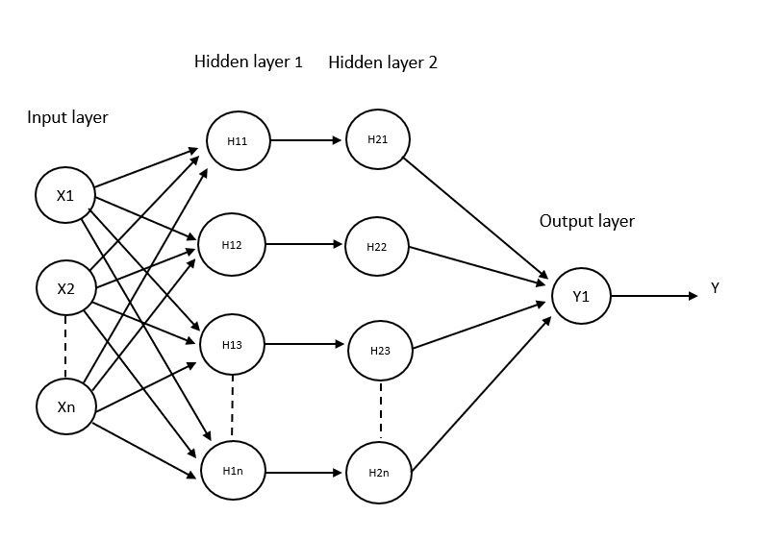
Fig. 1. Design of the Artificial Neural Network Structure

We employ the back-propagation learning technique, which entails propagating the error signal backward through the network. This process involves iteratively refining and adjusting the network's weights to improve its efficiency until it can produce the desired responses [8].

The steps involved in developing the artificial neural network model for our prediction are as follows:
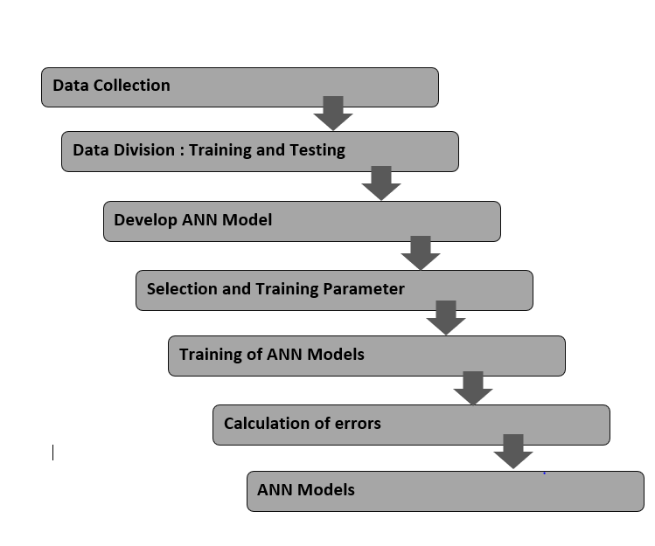
Fig. 2. Diagram of Model Development

In the proposed model, our focus lies on a single dependent variable: the closing price of Ethereum. Since this variable represents a time series, we have followed a traditional time series forecasting model for our experiments, outlined as follows [10]:
$K_{t}=h(x^{'})$
The set $\left\{x_{t-1},x_{t-2},…,x_{t-p}\right\}$represents a series of delayed variables, illustrated in Figure 1 as the input parameters. The primary objective is to approximate the function [10]. This approximation is achieved through an iterative process that includes modifying the weights during the modeling process. The visual representation of the suggested model can be located in Figure 2.

To clarify the development of our proposed predictive model, we've segmented the process into four distinct phases:
(a) Data Collection: We gathered Ethereum price data from investing.com, spanning a period of 4 years, totaling approximately 2500 records. Specifically, we collected data on the open, high, and low prices of Ethereum.

(b) Data Normalization: Prior to commencing the training process, we conducted data normalization. The closing price was scaled to fit within the range of [0.01, 0.05] using the following equation:
$$A^{'}=\frac{l-Min}{Max-Min}\left(m-n\right)+n$$

In this context, $A'$ stands for the normalized value, $l$ denotes the value undergoing normalization, $min$ signifies the minimum value within the series subject to normalization, $max$ represents the maximum value within the series being normalized, $n$ indicates the minimum value of the target range, and $m$ signifies the maximum value of the target range [10].

(c) Activation Function: The activation function, also known as the transfer function, establishes the relationship between input nodes and output nodes in a neural network. In our model, we utilized the sigmoid function, defined as:

$$h(x)=\frac{1}{1+e^{-x}}$$

(d) The training process of a neural network is a intricate task, involving a sophisticated form of unconstrained nonlinear optimization. It entails continuously adjusting the network's weights to minimize the mean squared error between the intended and observed output values for all input patterns. To accomplish this, we utilized the Back-Propagation (BP) algorithm, which employs the steepest descent gradient approach. This algorithm was applied to train the model and minimize errors. The error function, denoted as E, is defined as:

$$E=\frac{1}{2N}\sum_{l=1}^{n}{{(k_{l}-{k_{l}}^{d})}^{2}}$$
In this context, $k_{l}$ represents the network's output, while ${k_{l}}^{d}$ stands for the desired output for the $l^{th}$ input pattern. We employ the steepest descent gradient methodology, and the partial derivatives are calculated using the chain rule. The updated rules for adjusting the weights and biases of this model are determined using the following equations:

$${w_{j}}^{new}={w_{j}}^{old}+ ∆w_{j}$$
$${g_{j}}^{new}={g_{j}}^{old}+ ∆g_{j}$$
Where $∆w_{j}=-ζ\frac{dE}{dw_{j}}$
$$=-ζ\frac{1}{n}\sum_{l=1}^{n}{(\left(k_{l}-{k_{l}}^{d}\right){ k}_{l}(}1-k_{l})\frac{y}{w_{j} x_{j}+g_{j}} x_{j})$$
$$∆b_{j}=-ζ\frac{dE}{db_{j}}$$
$$=-ζ\frac{1}{n}\sum_{l=1}^{n}{(\left(k_{l}-{k_{l}}^{d}\right){ k}_{l}(}1-k_{l})\frac{y}{w_{j} x_{j}+g_{j}} x_{j})$$
Here, $ζ$ serves as the learning parameter, controlling the convergence speed of the model.

RESULTS AND DISCUSSIONS

The proposed model’s assessment focuses on predicting the price of ethereum specifically the closing prices. The effectiveness of the proposed model is assessed using the Root Mean Square Error (RMSE) measure, defined in the subsequent manner:
$$RMSE=\sqrt{\frac{1}{n}{\left(k_{j}-\hat{k_{j}}\right)}^{2}}$$
In this equation, $k_{j}$ represents the actual open price, $\hat{k_{j}}$ denotes the predicted price, and $n$ is the total number of observations [10]. This evaluation method offers valuable insights into the model's predictive accuracy for crypto currency prices.

Table 1: The following presents RMSE values associated with various delay (lag) settings.

LAG | RMSE VALUE
2 | 8409.23
3 | 3253.62
4 | 8642.51
5 | 3284.75

The dataset has been partitioned into two sets, with 70% allocated for instructional training and 30% reserved for testing. The training set is utilized to ascertain the most effective lag value for our proposed model. Through a systematic adjustment of the lag value, we extract outcomes and pinpoint the lag value that results in the lowest RMSE values. Table 1 displays the RMSE values corresponding to lag values 2, 3, 4, and 5. Noteworthy is the observation that the RMSE reaches its nadir at a lag value of 4, which subsequently forms the foundation for our prediction.

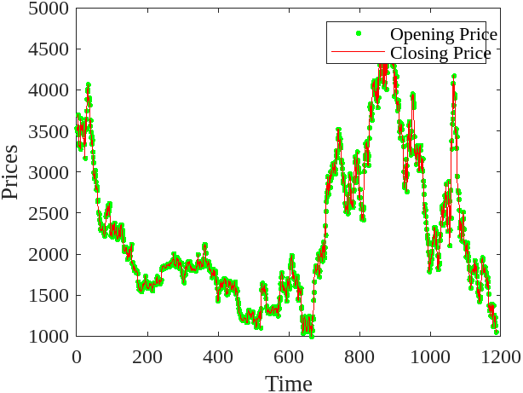

Fig. 3. Actual and Forecasted Closing Prices Over Time

CONCLUSION

This study has underscored the effectiveness of artificial neural network models in predicting ethereum price trends, particularly in identifying optimal lag configurations. The neural network model exhibits robust performance in providing accurate short-term forecasts, offering valuable insights for investors in their decision-making processes. It's essential to recognize the inherent unpredictability of ethereum in crypto currency markets, influenced by numerous known and unknown factors. While our research has primarily focused on closing prices, it's evident that Ethereum values are susceptible to various elements, including shifts in supply and demand, economic variables, and media-driven events. The adaptability of our approach to evolving price patterns is a notable advantage. In future endeavors, integrating fundamental indicators and market trends into the model holds potential for improving its performance and relevance in the ever-changing landscape of Ethereum in crypto currency markets.

REFERENCES

- Kang, C.Y., Lee, C.P., & Lim, K.M. (2022). Cryptocurrency Price Prediction with Convolutional Neural Network and Stacked Gated Recurrent Unit. Data, 7(11), 149.
- Biswas, S., Pawar, M., Badole, S., Galande, N., & Rathod, S. (2021, March). Cryptocurrency price prediction using neural networks and deep learning. In 2021 7th international conference on advanced computing and communication systems (ICACCS) (Vol. 1, pp. 408-413). IEEE.
- Charandabi, S.E., & Kamyar, K. (2021). Prediction of cryptocurrency price index using artificial neural networks: a survey of the literature. European Journal of Business and Management Research, 6(6), 17-20.
- Struga, K., & Qirici, O. (2018, November). Ethereum Price Prediction with Neural Networks. In RTA-CSIT (pp. 41-49).
- Wang, X., Wu, J., Liu, C., Wang, S., & Niu, W. (2016). A hybrid model based on singular spectrum analysis and support vector machines regression for failure time series prediction. Quality and Reliability Engineering International, 32(8), 2717-2738.
- Kiran, N.R., & Ravi, V. (2008). Software reliability prediction by soft computing techniques. Journal of Systems and Software, 81(4), 576-583.
- Haykin, S. (2009). Neural networks and learning machines (3rd ed.). Pearson Education India.
- Lakshmanan, I., & Ramasamy, S. (2015). An artificial neural-network approach to software reliability growth modeling. Procedia Computer Science, 57, 695-702.
- Haykin, S. (1999). Neural Networks. Tom Robbins.
- Dhiman, G., & Kumar, V. (2019). Spotted hyena optimizer for solving complex and non-linear constrained engineering problems. In Harmony Search and Nature Inspired Optimization Algorithms: Theory and Applications, ICHSA 2018 (pp. 857-867). Springer Singapore.
- Almeida, J., & Gonçalves, T. C. (2023). A systematic literature review of investor behavior in the cryptocurrency markets. Journal of Behavioral and Experimental Finance, 100785.
- Zheng, M., Feng, G. F., Zhao, X., & Chang, C. P. (2023). The transaction behavior of cryptocurrency and electricity consumption. Financial Innovation, 9(1), 1-18.
- Filippou, I., Rapach, D., & Thimsen, C. (2023). Cryptocurrency Return Predictability: A Machine-Learning Analysis. In Cryptocurrency Return Predictability: A Machine-Learning Analysis: Filippou, Ilias| uRapach, David| uThimsen, Christoffer. [Sl]: SSRN.

