**The Urgency of Sustainability in Clinical Medicine**

**Pratap Singh**1

M.Sc. Research Fellow

Department of Radiological Imaging Technique

College of Paramedical Sciences, Teerthanker Mahaveer University, Moradabad (U.P)

E-mail:

[pratap.053078@tmu.ac.in](mailto:pratap.053078@tmu.ac.in)

**Mamta Verma**2

Assistant professor

Department of Radiological and Imaging Techniques,

College of Paramedical Sciences, Teerthanker Mahaveer University,

Moradabad (U.P)

E-mail: [mamtav.paramedical@tmu.ac.in](mailto:mamtav.paramedical@tmu.ac.in)

**Raushan Kumar**3

Assistant professor

Department of Radiological and Imaging Techniques,

College of Paramedical Sciences, Teerthanker Mahaveer University,

Moradabad (U.P)

E-mail: [raushank.paramedical@tmu.ac.in](mailto:raushank.paramedical@tmu.ac.in)

**ABSTRACT**

The global healthcare sector significantly contributes to environmental degradation, waste production, and inefficient resource use. Worldwide, healthcare systems struggle to balance dwindling resources with increasing demands while maintaining high-quality, equitable, and accessible care. In the medical field, sustainability has become a pressing issue due to the environmental impact of medical practices, resource consumption, and waste generation, which have substantial implications for both human health and planetary well-being. This study identified four primary categories of sustainable practices in hospital operations: environmental, customer-focused, employee-oriented, and community-centered. Integrating sustainability into healthcare workers' professional mindset can encourage sustainable practices within organizations, generate practical knowledge, and promote sustainability thinking among medical professionals. Additionally, this paper examines the adverse ecological effects of the healthcare industry and various factors influencing the demand for sustainability.

Keywords: Healthcare facilities; Sustainability; Environment; Public health; Waste management; Clinical medicine

1. **INTRODUCTION**

**Definition of sustainability in clinical medicine**

The term sustainability is defined as using resources to meet the needs of the present without compromising the ability of future generations to meet their own needs. According to sustainable approaches and sustainable agriculture, two of the most frequently used definitions of sustainability from an environmental point of view are 1) "of, relating to, or being a method of harvesting or using a resource so that the resource is not depleted or permanently damaged." 2) being "of or relating to a lifestyle involving the use of sustainable methods" [a sustainable society] **(1)**.

Healthcare facilities aim to enhance and maintain public health, but their environmental footprint can adversely impact the well-being of humans and other living organisms. Consequently, ensuring the sustainability of hospitals and medical institutions is crucial for promoting human health and overall welfare. Sustainability in healthcare extends beyond environmental considerations, encompassing a holistic approach that also addresses the social aspects of the industry. Specifically, the social component of sustainability within healthcare emphasizes considerations such as equity, empowerment, accessibility, participation, cultural identity, and institutional stability, all of which are crucial in ensuring the long-term well-being of individuals and communities. **(2)**.

Sustainability in healthcare is not merely a matter of justifying the current rate of spending. Rather, it requires a comprehensive and strategic approach that takes into account the various aspects of sustainability, including social, environmental, and economic (organizational) factors [Figure 1] **(3)**. These factors are used as evaluation criteria for checking the sustainability practices in a particular healthcare system. Healthcare managers and leaders play a vital role in developing strategies aligning with the organization's vision, values, and mission while ensuring the system's long-term viability.

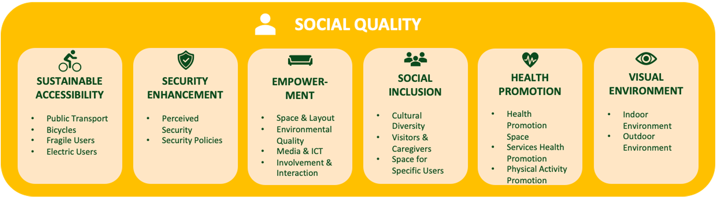

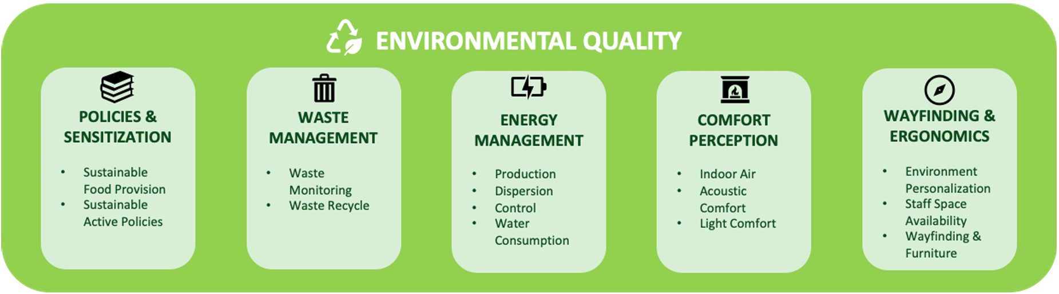

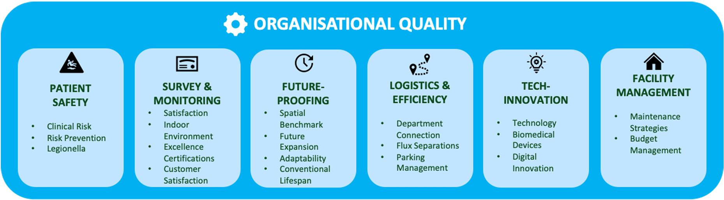

**Figure 1: Sustainability measurement criteria for a healthcare system (3)**

1. **Why sustainability is an urgent issue in modern healthcare**

Sustainability has become an increasingly pressing concern in the healthcare industry, as the environmental impact of medical practices, the consumption of resources, and the generation of waste have significant implications for both human health and the overall well-being of our planet. Healthcare systems around the world face the challenge of balancing diminishing resources with growing demands, all while ensuring the provision of high-quality, equitable, and accessible care. **(4)**. The healthcare sector's significant contribution to environmental degradation and climate change is a primary driver behind the urgent need for sustainability. **(5)**.

1. **The Environmental Impact of Healthcare**

The healthcare sector significantly contributes to environmental pollution, which adversely affects human health. Pollution is a primary cause of morbidity and mortality, accounting for 16% of all fatalities worldwide in 2015, equivalent to 9 million premature deaths. Air pollution is currently associated with the majority of these environment-related deaths, causing 1 in 8 deaths globally. Fossil fuel combustion is the principal source of both air pollution and climate change, with the latter being identified as the most critical public health challenge of the 21st century. Annually, an estimated 150,000 deaths occur worldwide due to health hazards associated with climate change, including extreme weather events, deteriorating air quality, food and waterborne diseases, vector-borne illnesses, food and water insecurity, and social instability **(6)**. Between 2030-2050, an additional 250,000 lives per year are projected to be lost due to climate change, and vital earth systems will face further disruption unless urgent action is taken to reduce emissions **(7)**.

Paradoxically, the modern healthcare industry itself is a significant source of environmental pollutants that are detrimental to human health. In 2001, the Institute of Medicine outlined specific goals for improving healthcare quality in "Crossing the Quality Chasm," which included preventing patient injuries from intended care, enhancing efficiency, and eliminating waste. Despite this, the United States healthcare sector alone is responsible for 9% of criteria air pollutants and 9-10% of greenhouse gas emissions nationally, as well as other toxic emissions, resulting in an annual loss of 614,000 Disability-Adjusted Life Years (DALYs) **(8)**. Figure 2 represents the pollution pathway of natural or environmental sinks by different byproducts of various healthcare industries. **(9)**.

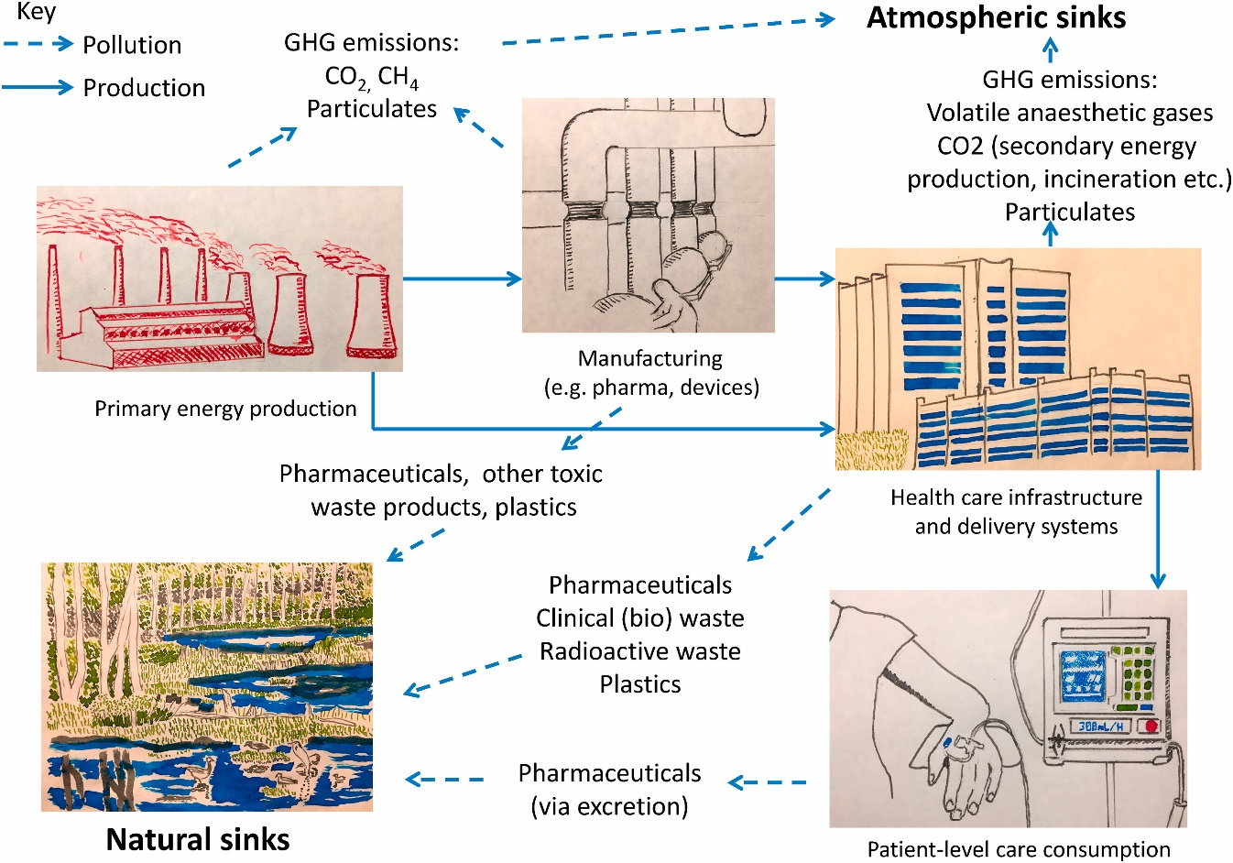

**Figure 2: Pollution pathway of healthcare system (9)**

1. **Energy consumption, waste generation, and resource depletion in clinical settings**

The healthcare industry ranks among the world's most resource-intensive sectors, significantly impacting energy utilization, waste generation, and resource consumption. Medical facilities such as hospitals and clinics consume substantial amounts of energy to operate sophisticated equipment, regulate indoor environments, and maintain life-support systems.

Indeed, the energy consumption of intensive care units alone can be comparable to that of small residential areas. Moreover, the sector's extensive use of disposable medical items, sterilization processes, and packaging materials contributes to a mounting waste crisis, generating millions of tons of refuse annually. The environmental challenges are further exacerbated by the disposal of hazardous materials, including sharp objects and pharmaceuticals. Improper management of these substances can result in soil and water contamination.

Furthermore, the extraction of natural resources for manufacturing and transporting medical supplies underscores the pressing need for sustainable procurement strategies and circular economy principles in healthcare. These measures are crucial for mitigating the industry's environmental impact while maintaining high standards of patient care. **(10)**.

Example: Clinical laboratories, in contrast, are significant consumers of energy, water, and hazardous chemicals, and are known to utilize 5 to 10 times more energy per square meter than a typical office. The large and small electrical appliances, such as centrifuges, ultra-low temperature freezers, auto analyzers, laboratory/hospital information systems, multiple computer systems, air conditioners, water treatment plants, vacuum systems, lights, and exhaust fans operating continuously, contribute to the production of a substantial amount of greenhouse gases (GHG), resulting in high plug loads and increased carbon footprints. The necessity of controlling temperature and humidity, as well as implementing processes to meet the required air circulation per hour by laboratory safety requirements, further compromises sustainability. **(11)**.

1. **The evolving concept of sustainability in clinical medicine**

In recent years, the notion of sustainability in clinical medicine has expanded significantly, moving beyond environmental concerns to encompass a wider range of healthcare delivery aspects. While initially centered on reducing the ecological footprint of medical practices, sustainability now includes economic feasibility, social accountability, and enduring health outcomes. This holistic approach seeks to create healthcare systems that are not only environmentally responsible but also financially viable and equitable in their service delivery. Healthcare practitioners are increasingly recognizing the need to consider resource distribution, waste minimization, and the enduring effects of medical interventions on both individuals and larger populations. This shift in mindset has prompted a reassessment of conventional medical practices and the creation of innovative healthcare delivery methods. For example, telemedicine and remote patient monitoring have emerged as sustainable alternatives to traditional in-person visits, decreasing travel-related emissions and enhancing care accessibility for underserved communities.

The incorporation of sustainability principles into clinical medicine has also sparked a renewed emphasis on preventive care and health promotion. By prioritizing early intervention and lifestyle changes, healthcare providers aim to lessen the impact of chronic diseases and reduce the need for resource-intensive treatments. This proactive strategy not only enhances patient outcomes but also contributes to the overall sustainability of healthcare systems by decreasing long-term expenses and resource usage. Moreover, the concept of sustainability in clinical medicine extends to medical research and innovation.

Scientists are increasingly evaluating the environmental and social impacts of new medical technologies and treatments throughout their entire lifecycle, from development to disposal. This comprehensive approach ensures that advancements in medical science positively contribute to both human health and environmental well-being. Sustainable clinical practices now highlight preventive care, patient education, and the prudent use of medical resources to maximize health outcomes while minimizing unnecessary expenses and environmental damage. This involves implementing evidence-based guidelines, reducing overdiagnosis and overtreatment, and fostering shared decision-making between healthcare providers and patients. By empowering patients with knowledge and involving them in their care decisions, medical professionals can promote a more sustainable and patient-centered approach to medicine. The pursuit of sustainability in clinical medicine also requires collaboration across various sectors of the healthcare industry.

Hospitals, pharmaceutical companies, medical device manufacturers, and healthcare policymakers must cooperate to develop and implement sustainable practices throughout the entire healthcare value chain. This collaborative effort can result in more efficient supply chains, reduced waste generation, and the development of eco-friendly medical products and technologies. Furthermore, the concept of sustainability in clinical medicine is increasingly being integrated into medical education and training programs. Future healthcare professionals are being equipped with the knowledge and skills necessary to practice medicine sustainably, ensuring that sustainability principles become deeply ingrained in medical culture.

This evolving concept challenges healthcare professionals to balance immediate patient needs with the broader goal of maintaining a resilient and effective healthcare system for future generations. It necessitates a paradigm shift in how medical care is conceptualized, delivered, and evaluated, with a focus on long-term outcomes rather than short-term interventions alone.

1. **Aspects of Sustainable Practices in Healthcare**

Research suggests that incorporating sustainability into healthcare operations can lead to improvements in both financial performance and quality of care. To maximize the advantages of sustainable practices within an organization, it is crucial to comprehend sustainability-based strategies. By examining existing literature on sustainability in the healthcare sector, this research identified four main categories of sustainable practices in hospital operations: environmental, customer-focused, employee-oriented, and community-centered. These categories form an approach to achieving sustainability objectives for the ongoing enhancement of quality and financial outcomes. Figure 3 illustrates this expanded sustainability framework.

1. *Environmentally-Focused Sustainability*

The healthcare industry is recognized for its environmental sustainability efforts, which aim not only to reduce environmental pollution by decreasing waste (e.g., water recycling and minimizing hazardous chemical usage) in operations but also to cut operational costs. Some environmental sustainability initiatives in healthcare include mercury elimination, healthcare waste toxicity reduction, and minimizing hazardous chemical use Additionally, recycling has been introduced to address increasing quantities and treatment expenses. In recent years, the scope of environmental sustainability has expanded to include sustainable design and construction techniques to create genuine healing environments **(1,12,13)**.

1. *Customer-Centered Sustainability*

Healthcare providers have also recognized the significance of delivering high-quality service to patients and strive to balance resource allocation with patient needs as part of their sustainability practices. **(14)**. Beyond the advanced use of technology in healthcare to provide effective treatment and services to customers, many healthcare organizations have now developed health information or e-health strategies. Information technology plays a crucial role in guiding health organizations towards sustainability by enhancing efficiency, creating sustainability tools, and transforming products into services (e.g., integrating systems and lifestyles through vaccination reminder services) **(15)**. Patient satisfaction is considered a key indicator of healthcare sustainability, closely linked to service quality improvement, reduced medical costs, and meeting customer expectations. **(1)**.

1. *Sustainability focused on employees.*

In healthcare, sustainability extends beyond patient care to include creating a healthier workplace for employees. Occupational sustainability in healthcare involves adapting to changing operations without compromising the well-being of medical practitioners. Establishing a healthy work environment is crucial for enhancing staff job satisfaction. Integrating sustainability into the professional mindset of healthcare workers can foster sustainability practices within the organization, generating practical knowledge and promoting sustainability thinking among health professionals. Some healthcare organizations also focus on addressing outdated practices and behaviors among healthcare professionals. **(1,16)** As part of their ongoing efforts to enhance the quality of service medical practitioners provide. Studies have also highlighted the significance of spatial design, equipment, and supplies in boosting nurses' job efficiency and satisfaction. **(16)**.

1. *Sustainability oriented towards the community.*

Regarding community-focused sustainability, some research has explored healthcare delivery through 'home-based healthcare' programs as a sustainable initiative. This approach addresses limited access, medical errors, and negligence in rural areas. Community-based sustainable services have been enhanced with technology, such as tele-monitoring and patient monitoring systems, evolving from initial health information exchange systems. Additionally, in responding to public concerns, the healthcare industry has taken steps toward resource conservation and pollution reduction. Many healthcare organizations have adopted the principle of "first do not harm" in their professional practice.

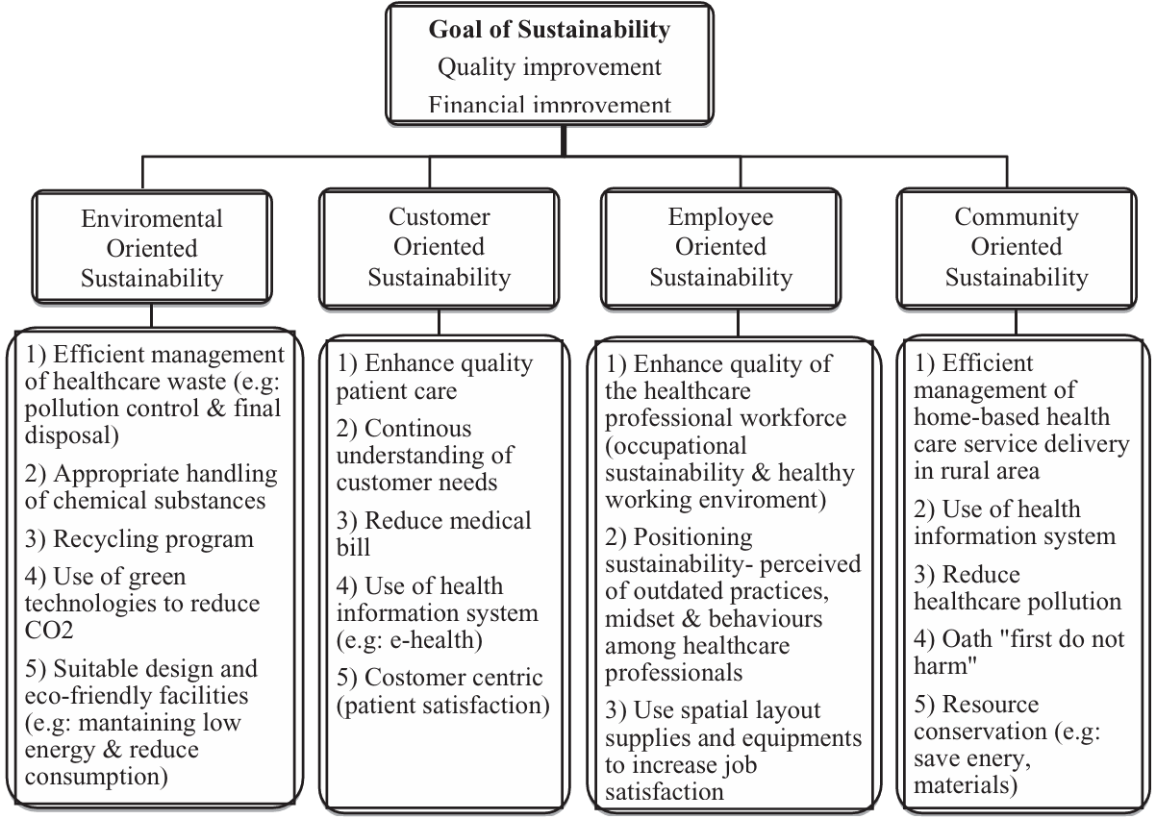

**Figure 3: Goals of sustainability (1)**

1. **How unsustainable practices affect patient health**

The intersection of environmental sustainability and patient health in clinical medicine highlights the unintended consequences of unsustainable healthcare practices. These effects are multifaceted, involving direct health impacts from pollution and waste mismanagement, exacerbated climate-related health crises, and the deepening of global health inequities.

1. **Pollution from Healthcare Activities**

Healthcare systems are significant contributors to global greenhouse gas (GHG) emissions, accounting for approximately 4.4% of the total. Activities such as energy use in hospitals, transport, and resource-intensive procedures release substantial amounts of pollutants, including carbon dioxide, particulate matter (PM), and nitrogen oxides. These pollutants directly affect human health by exacerbating respiratory and cardiovascular conditions, particularly in vulnerable populations, such as children, the elderly, and individuals with preexisting conditions.

For example:

* Respiratory Illnesses: Exposure to air pollution linked to healthcare emissions can lead to increased hospitalizations for asthma, chronic obstructive pulmonary disease (COPD), and lung infections.
* Cardiovascular Risks: Fine particulate matter (PM2.5) has been associated with higher incidences of heart attacks and strokes.

1. **Hazardous Waste Mismanagement**

The improper handling and disposal of medical waste, including plastics, sharps, and e-waste, pose severe health risks. Only about 20% of e-waste is formally recycled, while the remainder often ends up in landfills or informal recycling sectors in low-income regions. This mismanagement leads to:

* Toxic Exposures: Communities near waste dumpsites face exposure to heavy metals such as lead, mercury, and cadmium, resulting in neurological damage, cancers, and kidney dysfunctions.
* Child Health Hazards: In many regions, children are involved in informal e-waste recycling, exposing them to hazardous chemicals. This leads to developmental issues and cognitive impairments.

Unregulated methods such as open burning of medical waste further exacerbate air pollution and release carcinogenic compounds, endangering both local populations and healthcare workers involved in disposal.

1. **Climate Change and Health Crises**

Healthcare systems' unsustainable operations contribute to climate change, creating a feedback loop where environmental degradation directly worsens patient health.

Key climate-related health impacts include:

* Heat-Related Illnesses: Rising global temperatures increase instances of heat strokes and dehydration, and exacerbate chronic conditions such as cardiovascular and renal diseases. Vulnerable populations, including the elderly and those in urban heat islands, are disproportionately affected.
* Infectious Disease Outbreaks: Shifts in climate patterns expand the range of vector-borne diseases such as malaria and dengue fever. Increased flooding also amplifies waterborne infections, including cholera and typhoid.
* Mental Health Effects: Natural disasters such as floods and wildfires disrupt lives, leading to post-traumatic stress disorder (PTSD), depression, and anxiety.

1. **Exacerbating Health Inequalities**

Unsustainable practices disproportionately affect low- and middle-income countries (LMICs), which bear the brunt of climate change impacts despite contributing minimally to global emissions. Examples include:

* Food and Water Insecurity: Climate change exacerbates droughts and extreme weather events, threatening food supplies and leading to malnutrition. Those in LMICs are particularly vulnerable to these crises, with long-term impacts on child development and chronic disease prevalence.
* Healthcare Disruptions: Damage to healthcare infrastructure during extreme weather events disproportionately affects rural and underserved communities **(17,18)**.

1. **Economic Urgency: Rising Healthcare Costs and Sustainability**

The economic burden of unsustainable healthcare practices has become a growing concern, as the global healthcare system continues to face significant challenges in terms of environmental impact, waste, and inefficient resource utilization. The healthcare industry, which accounts for a significant portion of economic activity, has a responsibility to address these issues and implement sustainable practices to mitigate environmental and financial costs. **(1,19)**.

The discussion on sustainability in healthcare has gained momentum in recent years, with scholars and healthcare professionals recognizing the need for a more holistic approach to managing the industry's environmental impact. **(1)**. Healthcare facilities consume a significant amount of resources, including energy, materials, and water, and inevitably generate waste that can have detrimental effects on the environment. **(20)**. The increasing reliance on technology-based and expensive treatments, coupled with the growing burden of long-term conditions that are often dependent on lifestyle and environmental factors, has further exacerbated the problem. **(19)**.

Addressing the environmental impacts of healthcare practices can not only create considerable benefits for the environment but also contribute to cost savings and improve the public image of healthcare organizations. Sustainable practices, such as reducing energy consumption, optimizing waste management, and adopting environmentally friendly materials, can lead to significant financial savings for healthcare providers. **(21)**.

Additionally, the integration of sustainability principles into medical education has been identified as a key strategy for promoting sustainable healthcare practices. Educating future healthcare professionals on the importance of sustainable practices and equipping them with the necessary knowledge and skills can contribute to the long-term sustainability of the healthcare industry. **(1,19)**.

1. **Financial benefits of adopting sustainable practices in clinical medicine**
2. **Cost Savings through Waste Reduction**

Waste management is a considerable expenditure in clinical settings, particularly with medical waste disposal, which requires specialized treatment due to its hazardous nature. By adopting sustainable practices such as source segregation, recycling programs, and the reuse of materials when safe, hospitals can significantly reduce waste disposal costs. For example, proper segregation of general waste from biohazardous waste can lower the volume of high-cost medical waste processing. A study demonstrated that introducing comprehensive waste management systems reduced hospital waste costs by 30%, translating into substantial annual savings for large institutions **(22)**.

1. **Energy Efficiency and Reduced Utility Costs**

Healthcare facilities are among the most energy-intensive institutions, with 24/7 operations and the use of advanced medical equipment. Implementing energy-efficient technologies, such as LED lighting, high-efficiency HVAC systems (Heat, Ventilation, and Air Conditioning ), and renewable energy sources, can drastically cut utility bills. For instance, retrofitting an average-sized hospital with energy-efficient systems was shown to reduce annual energy costs by 20%–40%, saving hundreds of thousands of dollars annually.

Additionally, incorporating smart energy management systems can optimize energy usage by identifying peak consumption periods and redistributing load effectively, further enhancing savings. **(21)**.

1. **Savings through Sustainable Procurement**

Sustainable procurement practices, including purchasing reusable surgical instruments and biodegradable packaging materials, can lower operational costs. Though the initial investment may be higher, the long-term savings outweigh the upfront costs. For instance, transitioning to reusable surgical gowns and drapes has been shown to reduce procurement costs by 30% while decreasing environmental impact. **(23)**.

1. **Financial Incentives and Grants**

Healthcare institutions that adopt sustainable practices often qualify for government grants, tax incentives, and funding from environmental organizations. These financial supports reduce the overall cost burden of implementing green initiatives and make sustainable healthcare financially viable.

1. **Enhanced Patient Volume and Reputation**

Patients increasingly value environmentally conscious healthcare providers. Hospitals with green certifications or sustainability initiatives attract more patients, boosting revenue through increased patient volume. Moreover, sustainability practices enhance staff morale, leading to higher retention rates and reducing costs associated with turnover and training. **(21–23)**.

The incorporation of sustainable practices in clinical medicine offers a significant opportunity for cost savings and financial benefits. As healthcare systems worldwide face increasing financial pressures, adopting environmentally conscious strategies can yield both ecological and economic gains. The following are the financial advantages of waste reduction, energy efficiency, and other sustainable interventions.

1. **Factors Affecting Healthcare Sustainability**

The healthcare sector integrates sustainability into its operations based on social responsibility and responsiveness. A survey of the literature on sustainability in healthcare indicates that there are several helping to expand the use of sustainable healthcare methods, as Figure X illustrates. Among the variables that contribute are:

* Governments throughout the world are becoming more concerned about sustainability in healthcare; for example, to conserve energy and protect the environment, many healthcare institutions have been forced to include sustainability in their operations.
* Environmental changes like pollution, global warming, and the depletion of natural resources (including water and energy) eventually push the healthcare sector to figure out how to integrate sustainability-based strategies into its operations.
* Healthcare is under pressure to implement sustainability-based methods into its operations as a result of education and public awareness campaigns about how businesses use natural resources and how their operations lead to pollution and limited resources.
* In many healthcare companies, corporate sustainability is becoming more and more important. The integration of sustainability in healthcare is naturally influenced by several factors, including employee development, workplace atmosphere, creativity, social responsibility, and ethical conduct.
* Many nations have been forced to prioritize sustainability as a way to lower operational expenses due to the increasing expenses related to healthcare.

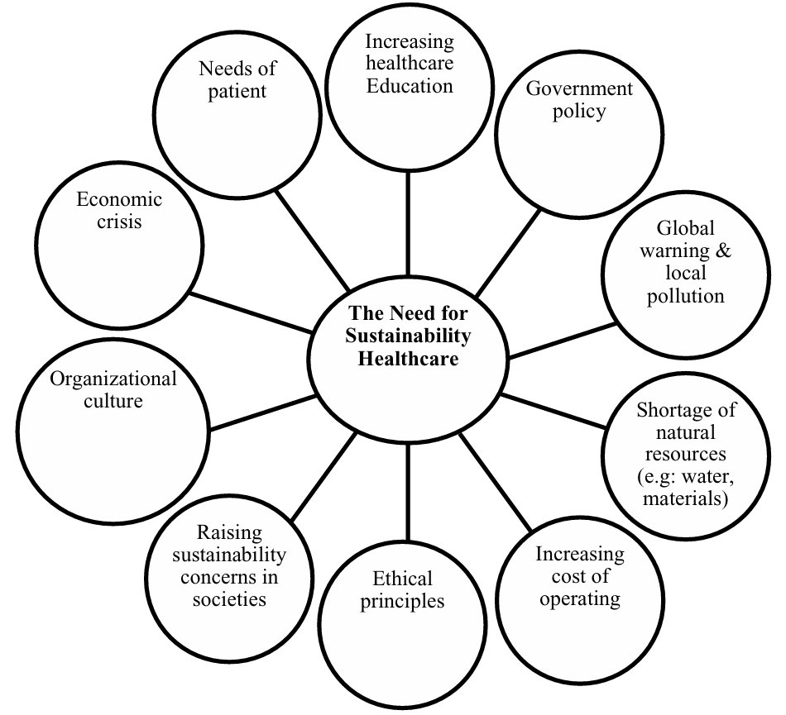

**Figure 4: Factors influencing the urgency of sustainability (1)**

1. **Strategies for effective sustainability implementation in healthcare**

Increasing resource costs, climate change, public awareness, and evolving lifestyles are likely to drive healthcare organizations toward implementing sustainable operations. To establish an enduring culture of sustainability in healthcare organizations, the following strategies and recommendations are proposed:

* Develop sustainability leadership to devise specific strategies and continuously monitor implementation.
* Increase staff involvement in steering committees and conduct staff learning assessments. Promoting a healthy environment reflects the sustainability of employee leadership in continuously improving service quality.
* To maintain and enhance sustainability practices in healthcare, it is crucial to boost awareness and encourage staff participation. Ongoing efforts should focus on expanding programs that include motivation, training, and creating educational resources.
* Greater emphasis should be placed on advancing innovations that promote healthcare sustainability across all aspects of sustainable practices.
* Research in social and psychological fields should be conducted among healthcare professionals to gain insights into the behaviors, attitudes, and cultural factors necessary for improving hospital sustainability.
* Enhanced collaboration between various medical specialties and non-medical experts, such as engineers and architects, is essential to help healthcare organizations address sustainability challenges.
* Furthermore, healthcare institutions should broaden their partnerships with relevant associations and non-governmental organizations **(1)**.

**Conclusion**

This chapter presents the initial results of existing literature on the sustainability of the healthcare sector focused on improving the quality of life of patients since service excellence in the healthcare setting refers to the provider's ability to fulfill and regulate the demands of patients consistently. It also explores the negative ecological effects of healthcare industries and different factors influencing the demand for sustainability. Different studies identify a gap in the integration of sustainability measures into healthcare management. According to this existing study, the meaning of sustainability is not only concerning the environment but also to the consumers, staff, and public. The rise of sustainability in healthcare entails striking a balance between four important aspects of its operations: patient, employee, and community demands as well as environmental considerations to continually enhance quality and save costs. Due to the harmful effects of unsustainability practices and financial benefits, leaders and organizations need to adopt and implement sustainability measures to meet current needs and future needs as well.

**References**

1. Marimuthu M, Paulose H. Emergence of Sustainability Based Approaches in Healthcare: Expanding Research and Practice. Procedia - Soc Behav Sci. 2016 Jun 15;224:554–61.

2. Faezipour M, Ferreira S. A System Dynamics Perspective of Patient Satisfaction in Healthcare. Procedia Comput Sci. 2013 Jan 1;16:148–56.

3. Brambilla A, Apel JM, Schmidt-Ross I, Buffoli M, Capolongo S. Testing of a Multiple Criteria Assessment Tool for Healthcare Facilities Quality and Sustainability: The Case of German Hospitals. Sustainability. 2022 Jan;14(24):16742.

4. Faezipour M, Ferreira S. A System Dynamics Perspective of Patient Satisfaction in Healthcare. Procedia Comput Sci. 2013 Jan 1;16:148–56.

5. Biermann F. Scientific evidence on the political impact of the Sustainable Development Goals | Nature Sustainability [Internet]. [cited 2024 Nov 16]. Available from: https://www.nature.com/articles/s41893-022-00909-5

6. Sherman JD, Thiel C, MacNeill A, Eckelman MJ, Dubrow R, Hopf H, et al. The Green Print: Advancement of Environmental Sustainability in Healthcare. Resour Conserv Recycl. 2020 Oct 1;161:104882.

7. Organization WH. Global Health Risks: Mortality and Burden of Disease Attributable to Selected Major Risks. World Health Organization; 2009. 71 p.

8. Eckelman MJ, Sherman JD, MacNeill AJ. Life cycle environmental emissions and health damages from the Canadian healthcare system: An economic-environmental-epidemiological analysis. PLOS Med. 2018 Jul 31;15(7):e1002623.

9. Hensher M, Canny B, Zimitat C, Campbell J, Palmer A. Health care, overconsumption, and uneconomic growth: A conceptual framework. Soc Sci Med. 2020 Dec 1;266:113420.

10. De Waele JJ, Hunfeld N, Baid H, Ferrer R, Iliopoulou K, Ioan AM, et al. Environmental sustainability in intensive care: the path forward. An ESICM Green Paper. Intensive Care Med. 2024 Nov 1;50(11):1729–39.

11. Thakur A, Mukhopadhyay T, Ahirwar AK. Approaching sustainability in Laboratory Medicine. Clin Chem Lab Med CCLM. 2024 Aug 1;62(9):1787–94.

12. Yang C, Peijun L, Lupi C, Yangzhao S, Diandou X, Qian F, et al. Sustainable management measures for healthcare waste in China. Waste Manag. 2009 Jan 20;29(6):1996.

13. Kim S, Osmond P. Analyzing green building rating tools for healthcare buildings from the building user’s perspective. Indoor Built Environ. 2014 Aug 1;23(5):757–66.

14. Faezipour M, Ferreira S. A System Dynamics Perspective of Patient Satisfaction in Healthcare. Procedia Comput Sci. 2013 Jan 1;16:148–56.

15. Coiera E, Hovenga EJS. Building a sustainable health system. Yearb Med Inform. 2007;11–8.

16. Pinzone M, Lettieri E, Masella C. Sustainability in Healthcare: Combining Organizational and Architectural Levers. Int J Eng Bus Manag. 2012 Jan 1;4:38.

17. Environmental Impacts of the U.S. Health Care System and Effects on Public Health - PubMed [Internet]. [cited 2024 Nov 16]. Available from: https://pubmed.ncbi.nlm.nih.gov/27280706/

18. Romanello M, McGushin A, Di Napoli C, Drummond P, Hughes N, Jamart L, et al. The 2021 report of the Lancet Countdown on health and climate change: code red for a healthy future. Lancet Lond Engl. 2021 Oct 30;398(10311):1619–62.

19. Tun S. Fulfilling a new obligation: Teaching and learning of sustainable healthcare in the medical education curriculum. Med Teach. 2019 Oct;41(10):1168–77.

20. Alharbi NS, Alhaji JH, Qattan MY. Toward Sustainable Environmental Management of Healthcare Waste: A Holistic Perspective. Sustainability. 2021 Jan;13(9):5280.

21. Eckelman MJ, Sherman J. Environmental Impacts of the U.S. Health Care System and Effects on Public Health. PloS One. 2016;11(6):e0157014.

22. Chung JW, Meltzer DO. Estimate of the carbon footprint of the US health care sector. JAMA. 2009 Nov 11;302(18):1970–2.

23. McGain F, Story D, Hendel S. An audit of intensive care unit recyclable waste. Anesthesia. 2009 Dec;64(12):1299–302.