Leveraging Blockchain-Enabled Smart Grids for Sustainable Development

Bannishikha Banerjee1[[0000-0003-4848-8749](https://orcid.org/0000-0003-4848-8749)], Sanjana Shaw1, Indraneel Mukhopadhyay1[0000-0001-9121-6250]

1Amity Institute of Information Technology, Amity University Kolkata

**ABSTRACT**

The idea of a "smart grid" was presented in order to incorporate renewable and green energy sources into conventional power infrastructures. In order to build a sustainable civilization in the quantum era, the "Internet of Energy" is becoming a viable means of delivering energy information at any time and from any location. Decentralized smart grids are becoming more popular as a result of the old centralized grid's inability to handle expanding connections. Blockchain is a viable answer for smart grid systems, especially in the quantum era, because to its security and transparency. With an emphasis on security concerns, this paper examines blockchain's function in smart grids. It talks about recent studies, real-world uses, and the difficulties in implementing blockchain technology to increase smart grid security.

**Keywords**: Blockchain; Smart Grid; Security; Quantum Computing.

1. **INTRODUCTION**

The demand for power has increased as a result of technological improvements and the growth of Internet of Things (IoT) devices. A global assessment of numerous small- and large-scale power generation and distribution options has been spurred by this demand. Furthermore, the need for flexible power generating techniques is being driven by the expanding need for renewable and sustainable energy across a range of industries. Three key tenets—decentralization, digitalization, and decarbonization—direct the needs of the future energy system [1]. The Energy Union Package proposed by the European Commission is based on these ideas [2]. The development of low-voltage power generating and distribution systems has given rise to the idea of the Internet of Energy (IoE) [3]. Among the many advantages of the Internet of Energy (IoE) is the improvement of energy production, distribution, and consumption by means of automated and intelligent technologies that enable safe data sharing between different stakeholders [4]. All energy sources are given equal weight in the inclusive network that is the Internet of Everything [5]. In the context of smart grids, according to the National Institute of Standards and Technology (NIST) [6], a “smart grid domain” is a higher-level category that includes companies, structures, people, systems, devices, or other entities that have the common goal of sharing, storing, processing, and managing the data needed for the smart grid. Generation, transmission, distribution, consumption, operation, service delivery, and market elements are all included in these categories. Examining the interactions between several smart grid sectors produced from [6], we discover that the generation domain is responsible for generating energy using a variety of methods. In the meantime, service providers play a crucial role in controlling the flow of energy and overseeing its distribution, trading, and operations. According to [7], the term “customers” refers to a broad range of elements, such as automation stations, demand response systems, smart appliances, sensors, connected devices, supervisory control and data acquisition (SCADA) systems, advanced metering infrastructures (AMI), electric vehicles, and home energy management solutions. Together, these components support the smart grid's overall efficacy and usefulness.

The AMI facilitates the collection, tracking, and analysis of energy usage data by establishing two-way communication between utility suppliers and consumers. The three primary components of AMI are the communication network, the AMI center, and smart meters. Smart meters track and record electricity use and provide real-time data to the AMI center. The AMI center serves as a server responsible for managing data systems. To enable communication between smart meters, the AMI center, and home appliances, several communication protocols are used [8]. The SCADA system is essential to the operation of energy systems since it monitors, controls, and manages the power grid. The AMI facilitates the collection, tracking, and analysis of energy usage data by establishing two-way communication between utility suppliers and consumers. The three primary components of AMI are the communication network, the AMI center, and smart meters. Smart meters track and record electricity use and provide real-time data to the AMI center. The AMI center serves as a server responsible for managing data systems. To enable communication between smart meters, the AMI center, and home appliances, several communication protocols are used [8]. The SCADA system is essential to the operation of energy systems since it monitors, controls, and manages the power grid. Additionally, setting local market prices and promoting energy generation in nearby microgrids are made possible via an economic exchange marketplace. Additionally, the monitoring and rectification of voltage fluctuations offers the possibility of delivering high-quality power. The optimization of operations is then guaranteed by technological and operational standards. Finally, to guarantee resistance against a range of potential attackers, vulnerability protection is crucial. The smart grid's development and uptake have greatly improved the efficiency of managing, controlling, and supervising the electrical grid. These advancements have also facilitated the integration of electric cars, renewable energy sources, two-way communication, and consumer-engaging automated and self-sustaining systems [10].

The old method of centrally controlled intelligent grid management, control, and operation is no longer viable and difficult to apply due to the current trend in microgrid development and expansion. A number of variables, including weather, the availability of energy sources, geographic locations, pre-existing infrastructure, and energy demand, can affect the production and distribution of fossil fuel-free energy. These differences, together with the energy system's decentralization, need for modern, flexible operating and management technologies as well as creative energy storage options [11]. Understanding the skill of balancing electricity generation and distribution in response to seasonal variations in demand is also essential. The length of power transmission lines has a major impact on the amount of energy lost. These energy losses can be significantly reduced and environmental preservation can be promoted by integrating microgrid and renewable infrastructure into energy generating and delivery [12]. In order to increase generating revenues and lower consumption costs at the same time, the implementation of an electrical market could be a catalyst for the growth of microgrid production [13]. Establishing coordinated and methodically automated controls for the creation and distribution of these microgrids is the main obstacle, especially as the number of prosumers keeps growing. Current energy sector innovations and technology are not well adapted to the special needs of microgrids. As a result, many energy industry players are promoting the application of blockchain technology [14] to power transactions in microgrids. Peer-to-peer (P2P) power trading, decentralized grid management, and local distributed generation (DG) use are the objectives of this initiative [13].

1. **Smart Grids**

Current energy sector innovations and technology are not well adapted to the special needs of microgrids. As a result, many energy industry players are promoting the application of blockchain technology [14] to power transactions in microgrids. Peer-to-peer (P2P) power trading, decentralized grid management, and local distributed generation (DG) use are the objectives of this initiative [13].

Connecting small-scale generators, such community-based wind farms or residential solar panels, to the traditional electrical grid is becoming more and more popular in the modern landscape. Large-scale, centralized systems that mostly rely on hydropower or fossil fuels like coal and natural gas have historically controlled the production of energy. It is usually difficult for smaller firms to enter the energy market because these energy sources need large investments at the state or corporate level. Recent technology advancements, however, have made it possible for small businesses, private companies, and even people to generate low-voltage renewable electricity. The energy landscape is changing as a result of this change, which also makes it possible for more people to participate in the production and use of renewable energy and helps the energy system become decentralized [14].

The trend toward localized renewable energy generation is best illustrated by the example of Sweden. Compared to other years, the nation's renewable energy capacity increased significantly in 2020 with the installation of 4,333 wind turbines and 65,819 solar panels. With an annual increase of almost 40% in the production of renewable energy between 2016 and 2020, this rise is remarkable. The significance of renewable energy in Sweden's energy strategy—which aims to achieve 100% reliance on renewable energy by 2040—is highlighted by such advancements. The government's resolve to cut carbon emissions, lessen dependency on fossil fuels, and support alternative energy sources is reflected in this aggressive goal [15].

The movement to expand renewable energy is gaining steam on a global scale. A total of 721 gigawatts of new renewable capacity, mostly from wind, solar, and other non-hydro renewable technologies, were to be introduced by 2030, according to targets established by 87 governments worldwide in 2020. These goals show how the world is moving toward a cleaner, more sustainable energy future and how renewable energy is becoming more widely acknowledged as a crucial part of efforts to mitigate climate change. Systems that can integrate and coordinate the many energy sources to maintain stability and reliability are becoming more and more necessary as the globe works toward these lofty renewable energy targets.

The intricacy of coordinating the different sources and efficiently managing their output is a difficulty for the integration of decentralized renewable energy sources into current energy networks. Conventional energy systems have defined rules for energy distribution and are heavily controlled and regulated. However, there are difficulties in regulating variations in power generation, maintaining grid stability, and balancing supply and demand when small-scale, intermittent renewable sources like solar and wind are included into these systems. Furthermore, in order for renewable energy sources to be successfully integrated into and coordinated with the central grid, varying degrees of infrastructure and technology are frequently needed [16].

Integration of microgrids, which are localized energy systems that can function alone or in tandem with the main grid, is one possible way to address these issues. Microgrids are made to produce, store, and distribute renewable energy in a particular region, such a community or neighborhood. Numerous distributed generation (DG) devices, including as solar panels, wind turbines, biomass, fuel cells, and even more conventional power sources like coal or natural gas, can be incorporated into these systems. Microgrids lessen the need for centralized systems, which are susceptible to interruptions like blackouts or natural disasters, by offering localized energy generation and storage [17].

The operational difficulties of microgrid systems have been brought to light by research, especially with regard to attaining power balance and guaranteeing efficient communication between the several dispersed generating units. For instance, variations in solar and wind energy production can lead to supply and demand mismatches that need to be fixed to keep the grid stable. Furthermore, advanced control systems and communication technologies are needed to coordinate various energy sources, from conventional fossil fuel-based generators to renewable technologies like wind and solar [18]. To guarantee their operational integrity and effectiveness, many of these systems still need to be further refined as they are still in the early stages of development.

Communication and data sharing with the central grid are essential for a successful microgrid integration. A more cohesive and effective energy system that can take advantage of the advantages of both centralized and decentralized energy generation can be achieved by integrating microgrids with the wider grid. For instance, excess energy from microgrids can be routed back into the central grid to assist stabilize the overall energy supply when local demand is low and renewable energy generation is high. In a similar vein, microgrids can use the central grid to supply local demand when renewable energy production is low. A more adaptable and robust energy system that can better react to changes in supply and demand is produced by this integration.

Integration of microgrids with the wider energy grid will be made easier with the development of sophisticated automation and data exchange systems. Real-time monitoring and control of energy production, distribution, and consumption will be possible with these systems, facilitating more effective decision-making and guaranteeing the stability of the central grid as well as the microgrid [19]. More specifically, improved coordination and optimization of energy flows across various sources will be made possible by the deployment of smart grid technology, including sensors, communication networks, and advanced analytics. This will guarantee that energy is delivered in the most economical and efficient way possible by addressing problems like power imbalances, energy losses, and system inefficiencies.

Decentralized renewable energy systems have great advantages, but there are still a number of obstacles preventing their broad use. The regulatory and legislative environment, which can differ greatly between locations, is one major obstacle. The regulatory environment in some nations might not be strong enough to facilitate the integration of distributed energy systems and microgrids into the main grid. Utility firms, for instance, might not have many incentives to invest in the infrastructure required to link decentralized energy sources to the grid in many areas since they might not immediately profit from such expenditures. Furthermore, modifications and investments in new technologies are crucial because the grid infrastructure may not be built to handle the variations in energy generation linked to renewable sources [20].

The expense of putting in place decentralized renewable energy solutions, like microgrids, is another obstacle. Even though the cost of renewable energy technology has dropped dramatically in recent years, some towns and businesses may still find the initial expenditure needed to build microgrid systems to be unaffordable. Making these systems more available to a wider range of stakeholders will require increased support from governments and financial institutions in the form of incentives, subsidies, or financing mechanisms in order to solve this issue [21].

In order to combat the effects of climate change and lessen reliance on fossil fuels, there is an increasing need for decentralized renewable energy sources. Integration of microgrids and distributed energy generation into the broader grid will become more crucial as technology continues to lower the cost and increase the accessibility of renewable energy systems. But in order to accomplish this, considerable work will be needed to remove the financial, legal, and technical obstacles that presently prevent these systems from being widely used. A more robust and sustainable energy system that can satisfy the demands of both the present and the future generations can be developed with sustained research, innovation, and policy assistance.

1. **Blockchain Embedded Smart Grids**

Blockchain technology, known for its secure and decentralized framework, is increasingly gaining attention in the energy sector. Its potential to revolutionize data exchange, monitoring, and security aligns with the industry's need for transparency, efficiency, and resilience. Though still in its early stages, blockchain's applications in energy management, particularly in smart grids and distributed energy resources, are rapidly expanding [22].

Traditionally, energy systems rely on central authorities, often leading to inefficiencies and vulnerabilities. Blockchain addresses these challenges by enabling secure, decentralized transactions. It records, verifies, and shares data on energy generation, distribution, and consumption without intermediaries.

A key use case is microgrid energy trading, where blockchain facilitates peer-to-peer energy exchanges. Smart contracts enable secure, transparent transactions within microgrids, empowering consumers to manage their energy production and usage. Several blockchain frameworks already demonstrate practical applications in this domain [23].

Beyond microgrids, blockchain supports decentralized energy markets, automating pricing and distribution through smart contracts. Research has explored Ethereum-based energy trading systems, enabling communication between smart meters and distribution system operators (DSOs). This creates a decentralized mechanism for monitoring energy usage, adjusting pricing in real-time, and ensuring efficient grid distribution [24].

Integrating blockchain with technologies like IoT and wireless sensor networks (WSNs) enhances data collection and analysis, optimizing energy systems. These technologies provide real-time insights into grid operations, enabling smarter energy management and consumption [25]. Blockchain’s tamper-proof records and secure data exchange further improve grid performance by addressing challenges such as privacy, security, and scalability.

Smart grids require reliable communication among components, especially as they integrate renewable energy and distributed generation. Blockchain ensures secure, transparent data exchange, fostering collaboration among producers, consumers, and regulators. It also addresses grid imbalances through real-time monitoring and automated smart contract actions, improving efficiency and stability [26].

Despite its promise, implementing blockchain in energy systems faces challenges such as scalability, regulatory hurdles, and integration with existing infrastructure. However, its ability to enhance security, transparency, and stakeholder collaboration underscores its transformative potential. Continued research and development will be crucial in unlocking blockchain's role in creating sustainable, decentralized energy systems [27, 28, 29].

**Table 1: Existing Smart Grid vs Blockchain Smart Grid**

|  |  |  |
| --- | --- | --- |
| Aspect of Smart Grid | Existing Smart Grid | Blockchain Smart Grid |
| Transition in Power Sources | Transitioned to use sustainable sources and grid integration | Moving towards a decentralized framework by coordinating distributed energy resources |
| Focus | Initially focused on integrating innovative detection and control into the traditional grid | Emphasizes ongoing monitoring, automated control, and optimization |
| Intermediation and Markets | Depended on intermediaries and integrated markets | Supports multiple users in generating and sharing energy through distributions |
| Communication Technologies | Relied on advanced communication technologies | Predominantly utilizes the Energy Internet for seamless energy and data sharing |
| Communication Direction | Bi-directional communications | Supports advanced plug-and-play functionalities |
| Computational and Communication Costs | Faced heavy computational and communication costs | Costs are distributed among network entities |
| Network Expansion Options | Limited options for network expansion | Offers the flexibility to expand rapidly with numerous availabilities |
| Vulnerability to Single Points of Failure | Vulnerable to single points of failure | Demonstrates resilience against single points of failure |
| Integration with Energy Networks | Primarily integrated with electric energy networks | Integrated with various energy networks |
| Dependency on Regional Grid Control | Dependent on regional grid control | Facilitates smooth access to extensive distributed energy resources |

1. **Blockchain in Quantum Era**

Quantum computing is one of the most transformative technologies of the 21st century, with the potential to solve problems beyond the reach of classical systems. It is expected to revolutionize fields like cryptography, materials science, and artificial intelligence. While quantum mechanics has been studied for decades, applying its principles to computation began only in the late 20th century [29].

The origins of quantum computing can be traced to Paul Benioff’s work in the late 1970s, where he introduced a quantum mechanical model for computation. This foundational research was followed by significant contributions from figures like Richard Feynman, who emphasized the limitations of classical systems in simulating quantum processes, and David Deutsch, who proposed the concept of a universal quantum computer. Peter Shor’s algorithm in the 1990s highlighted quantum computing's potential in areas like cryptography by enabling efficient integer factorization, demonstrating clear advantages over classical systems [30][31][32].

Major technology companies, including IBM, Google, and Microsoft, are driving advancements in quantum computing. Google achieved a milestone in 2019 by demonstrating quantum supremacy, solving a problem classical computers could not complete efficiently. IBM and Microsoft are exploring frameworks and alternative models like topological quantum computing to overcome challenges such as error correction and qubit stability [33].

Quantum computing also poses risks, particularly to cybersecurity. Blockchain systems, which rely on classical cryptography, may become vulnerable to quantum attacks that could break encryption protocols like RSA and elliptic curve cryptography. This could compromise the security of cryptocurrencies, digital identity systems, and other blockchain applications [34].

To address this, researchers are developing quantum-resistant algorithms, with initiatives like NIST’s post-quantum cryptography standardization efforts. These are essential to safeguarding blockchain systems against future threats. On the flip side, quantum computing could enhance blockchain by optimizing consensus mechanisms and enabling secure quantum cryptographic methods such as quantum key distribution (QKD) [35][36].

In summary, quantum computing holds immense promise for advancing technology but also poses challenges to existing systems like blockchain. Ensuring the coexistence of these technologies will require innovations in quantum resistance and synergy between quantum and classical systems, potentially reshaping industries like cybersecurity and finance [37].

1. **CHALLENGES FOR MANAGEMENT, CONTROL AND OPERATIONS ON SMART GRID**

Quantum computing has emerged as a transformative technology with the potential to redefine industries by solving complex problems beyond classical systems. Although quantum mechanics has been studied for over a century, its application in computing gained traction in the late 20th century. Paul Benioff's concept of a quantum Turing machine in 1979 laid the foundation for this revolutionary field [38].

Quantum computers leverage principles like superposition and entanglement. Unlike classical bits, qubits can represent both 0 and 1 simultaneously, enabling quantum systems to process vast data sets exponentially faster for specific tasks. Entanglement allows qubits to work together efficiently, even across large distances, unlocking unprecedented computational power.

Leading companies like IBM, Google, and Microsoft are advancing quantum computing. IBM’s Quantum Experience platform enables users to experiment with quantum algorithms, while Google’s Sycamore processor demonstrated quantum supremacy in 2019 by solving a problem far beyond classical capabilities. These milestones indicate rapid progress toward practical applications [39].

However, quantum computing poses challenges, especially in cybersecurity. Cryptographic systems, including blockchain, rely on computational difficulty, which quantum computers could overcome. This threatens blockchain's role in secure and transparent transactions, raising concerns across industries.

Efforts to mitigate these risks include quantum-resistant cryptography. Organizations like NIST are developing standards for algorithms that can withstand quantum attacks. Simultaneously, quantum technologies could enhance blockchain by improving consensus algorithms and enabling ultra-secure communication through quantum cryptography [40].

*Addressing Smart Grid Challenges*

The integration of smart grids presents complex challenges requiring coordinated efforts across stakeholders. Effective collaboration is essential to balance energy generation, distribution, and consumption. Factors like population growth, environmental shifts, and increasing microgrid adoption introduce uncertainties, causing inefficiencies and outages. Modern data exchange systems can address these issues by storing surplus energy locally without affecting main grid infrastructure [41].

Grid imbalances arise from technical faults, environmental factors, and disruptions like reverse power flow (RPF) from renewable sources. Maintaining control of power supply and adapting to active and reactive power regulation are vital for stability. Advanced voltage control strategies, as explored in [25], and synchronization improvements are essential [9].

Data management in smart grids faces challenges like data quality, security, and scalability. Systems like Advanced Metering Infrastructure amplify data analysis workloads significantly. Automated, secure technologies can enhance grid operations by providing accurate, real-time insights [26][38].

Decentralized grid management empowers local control through automation technologies like SCADA, PMUs, and smart meters. Research into distributed automation strategies highlights the benefits and challenges of integrating decentralized energy resources [10]. Effective coordination between centralized and decentralized systems is crucial for success [27][39].

*Security and Privacy Concerns*

While decentralization improves efficiency, it introduces cybersecurity vulnerabilities. SCADA systems in smart grids, often transmitting data in plain text, are susceptible to attacks. Methods like jabbing, puppet, and stack-smashing attacks compromise data integrity, while experimental attacks expose systems to Denial of Service (DoS) risks [7][18][19]. A comprehensive approach to threat detection and countermeasures is essential for secure smart grid operations [30].

1. **BLOCKCHAIN FOR SMART GRID MANAGEMENT, CONTROL AND OPERATION**

Blockchain offers a novel solution to challenges in the energy sector by simplifying data management, fostering equitable incentive systems, reducing regulatory expenses, addressing technical issues, lowering transaction costs in decentralized networks, improving resource allocation speed, and mitigating price adjustment challenges. It also enhances stakeholder transparency, ensures data security and confidentiality, streamlines energy supply chains, and minimizes distribution losses. These advantages have made blockchain a promising area of research and development in the energy sector [43].

Although many applications remain in the pilot phase, notable projects demonstrate its potential. The Brooklyn Microgrid [21] facilitates local solar energy users to exchange data via blockchain, while the Electron Project in the UK [22] utilizes a blockchain-based platform for grid operators, local energy markets, and distributed energy resources, enabling grid optimization across diverse energy assets. Such initiatives underscore global interest in blockchain’s transformative potential for the energy industry. A detailed list of blockchain-related energy projects can be found in [44].

Traditionally, energy generation and distribution were dominated by large corporations. The adoption of Advanced Metering Infrastructures (AMI) has enabled bidirectional communication among generators, distributors, retailers, and consumers, fostering the transition to smart grids. Technologies like Wireless Sensor Networks (WSNs), the Internet of Things (IoT), and Virtual Power Plants (VPPs) further optimize power generation and consumption. These advancements collectively enhance grid intelligence, efficiency, and automation [20][24].

Figures [1, 2, and 3] illustrate the block structure, chain structure, and asset transfer mechanism. Within a smart grid, blockchain facilitates the secure transfer of monetary assets in exchange for power, showcasing its critical role in modernizing the energy infrastructure.

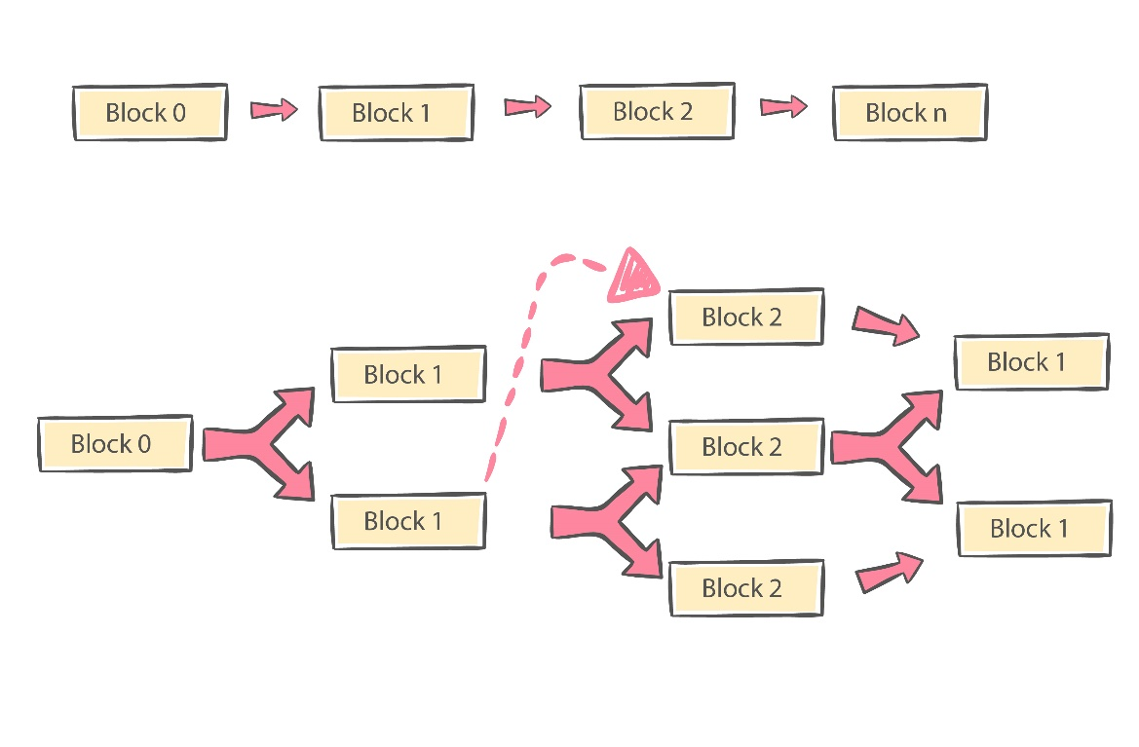

**Figure 1: Block Structure**

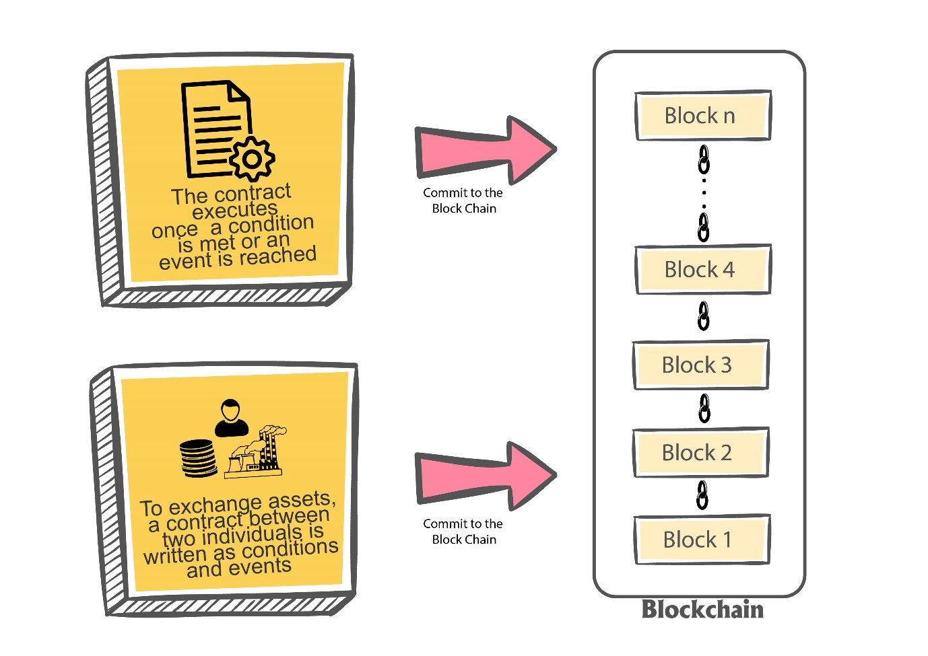

**Figure 2: Blockchain**

**Figure 3: Asset exchange between parties**

Traditional smart grid systems have predominantly relied on centralized control and management, which, while effective in some contexts, are prone to vulnerabilities such as cyberattacks, data breaches, and operational failures. A single point of failure in these systems can disrupt the entire grid. Moreover, the complexity of modern energy networks, combined with increased demands for data management, access control, and security, has led to operational bottlenecks that impede real-time data processing and the safeguarding of sensitive information [45].

The integration of blockchain technology into smart grid systems offers a promising alternative to overcome these challenges. Blockchain’s decentralized framework provides significant advantages, including secure, transparent, and tamper-proof data exchange between stakeholders such as utilities, consumers, and third-party service providers. By employing consensus mechanisms like proof of work or proof of stake, blockchain enhances the grid's resilience against cyber threats and ensures data integrity [46].

A decentralized, blockchain-powered smart grid distributes decision-making across diverse stakeholders, eliminating the reliance on a single controlling entity. This enhances adaptability and responsiveness, enabling energy producers, consumers, and grid operators to collaboratively manage and optimize the grid. Table 2 compares the advantages of decentralized blockchain grids with traditional centralized systems, highlighting benefits such as improved security and operational efficiency.

Blockchain also facilitates seamless coordination between stakeholders, allowing for secure data sharing related to energy production, consumption, and grid conditions. This improves decision-making and supports the integration of diverse energy sources, including renewables, which often face challenges in centralized grid frameworks [47].

Moreover, blockchain ensures transparency in energy transactions, allowing consumers to trace energy flow from production to consumption. This promotes fair pricing and supports sustainable energy practices. The immutable nature of blockchain records prevents fraud and ensures the reliability of transaction data.

The transition to a blockchain-powered decentralized smart grid offers enhanced security, improved data management, and stronger stakeholder collaboration. By distributing control and fostering transparency, blockchain helps create a resilient, efficient, and equitable energy grid, addressing key limitations of traditional systems.

**Table 2: Blockchain based solutions to address the challenges of smart grids.**

|  |  |  |
| --- | --- | --- |
| Blockchain Application Areas | Blockchain-Based Solutions to Address the Challenges | Ref. |
| Collaboration between stakeholders | * Fosters trust and transparency between stakeholders and the public. * Automates monitoring and maintenance of the smart grid. * Enables resource allocation and tracking of environmental indicators. * Enhances the efficiency of renewable energy sources. * Advances the digitalization of the grid and sanctions new applications for the power system. * Empowers microgrid prosumers to play a significant role in the management and operation of the smart grid. | [15] |
| Controlling Grid Imbalance | * Regulating voltage and ensuring equitable production distribution among distributed generation units. * Facilitating a temperature-safe system to safeguard customer data collected and transmitted to the smart grid. | [16, 17] |
| Data—Analysis and Management | * Safeguarding the authenticity and accuracy of aggregated data. * Developing unalterable data structures resistant to modification, featuring high scalability, and accommodating microtransactions. * Elevating the architecture of the power management system for real-time monitoring of power consumption. * Implementing secure data aggregation through encryption. * Enabling a multi-dimensional data aggregation control mechanism for the smart grid. * Establishing a decentralized aggregation mechanism to manage transactions among various smart meters. | [22,24] |
| Decentralizing grid management and operations | * Strengthening authentication and non-repudiation measures. * Enabling power management processes without relying on a trusted intermediary. * Involvement in distributed computing to alleviate the computational burden on Virtual Power Plants (VPPs). * Promoting decentralization. * Amplifying transparency, digitizing the grid, and facilitating novel applications for the power system. * Assisting advanced metering infrastructure control systems to enhance operational efficiency, optimal planning, and efficient trading. * Enabling traceable energy management on the smart grid. | [25,26,29] |
| Security and privacy | * Creating rigid data structures that cannot be modified. * Improving cybersecurity and privacy in smart grid systems. * Enhancing security, privacy, information security, and access control. * Addressing localization and provenance concerns. * Resolving issues related to real-time performance, elevated transaction expenses, and information security. * Promptly identifying adversarial nodes. | [30, 31] |

Blockchain technology offers a decentralized platform that enables equitable information sharing among participants, eliminating the need for trust among them [30]. Its integration into the energy sector provides significant advantages, including support for decentralized low-voltage energy production and distribution systems [24].

Blockchain facilitates streamlined multi-tier communication among energy producers, distribution system operators, transmission system operators, and consumers, improving operational efficiency [5]. When combined with smart contracts, it enhances the management of smart grids by automating processes based on pre-defined consensus rules. These contracts broadcast signals across all nodes, ensuring transaction validity and precise control over energy storage, ultimately balancing supply and demand [28, 29].

Additionally, blockchain securely records, archives, and distributes all energy transactions, ensuring decentralized security for energy flows and business operations [5].

1. **CONCLUSION AND FUTURE WORK**

Blockchain-driven smart grid systems operate autonomously, leveraging predefined consensus mechanisms without requiring human intervention, intermediaries, or centralized control. They also provide robust data aggregation methods to address grid privacy and security challenges. This study explores the application of blockchain solutions in managing, regulating, and operating smart grid systems, with a focus on non-financial use cases within the energy sector. Key challenges are categorized into five domains: stakeholder collaboration, grid imbalance resolution, data management refinement, decentralization of operations, and security and privacy enhancement. By analyzing existing literature, this study identifies additional challenges and outlines future research opportunities within these domains. Blockchain's flexibility is evident in its ability to adapt various architectures to specific applications, showcasing its potential for smart grid management. However, practical implementations remain limited to certain regions, highlighting the lack of comprehensive, systematic solutions for grid management and operations. Overcoming this limitation requires rethinking current grid frameworks and developing blockchain applications tailored to smart grid infrastructure. Designing a reliable, scalable, and durable blockchain system necessitates a thorough understanding of the existing grid’s structure, technical management, and future business and technological trends. Accurate predictions about smart grid developments are essential to creating blockchain systems that can support long-term, efficient grid operations.