Chapter 2 – Yeasts and Yeast-like Organisms of Medical Importance
Objectives:
After finishing this chapter, you should be prepared to:
- Describe the colonial characteristics and structures of yeast and yeast-like organisms.
- Describe risk factors for diseases caused by yeast.
- Discuss candidiasis, cryptococcosis, a disease caused by opportunistic and unusual yeasts, infection with Geotrichum candidum, Pneumocystis jirovecii infection, protothecosis, infection with Nakaseomyces glabrata, tinea nigra, tinea versicolor, and trichosporonosis.
- Identify the clinical media and culturing techniques used to process specimens from patients with suspected yeast infections (refer to the previous chapter).
- Identify the various direct tests, direct stains, media, biochemical tests, and the molecular techniques used to identify each yeast or yeast-like organism.
- Describe microscopic appearances of each of the types of yeasts on corn meal-Tween, Sabdex, and CHROMagar Candida agar.
- Identify the key characteristics and crucial test results to identify and diagnose the clinically significant yeasts.
- Create a laboratory plan to identify clinically significant yeast.

Chapter 2 – Yeasts and Yeast-like Organisms of Medical Importance
Medically significant yeast and yeast-like organisms
Yeasts are ubiquitous and will be present in various types of patient specimens and patient populations. This chapter includes the most common yeasts that cause human disease and also yeast-like fungal organisms that may cause human disease. Examination of yeast preparations will show round to oval budding cells (blastoconidia). Some cells may be elongated, forming pseudohyphae, and a few species will show actual arthroconidia and true hyphae (Geotrichum and Trichosporon). Cryptococcus spp. or Rhodotorula spp. may produce capsules. Yeasts are best grown at 25 to 30ᴼC on Sabauraud's dextrose or Sabhi agar and often grow on primary bacteriological media without inhibitors. The addition of cycloheximide will inhibit many yeast strains. Yeast typically grows as cream-colored but may also be white, yellow, tan, orange, red, or dematiaceous (brown or black pigment). The two most medically common and significant yeasts are Candida albicans and Cryptococcus neoformans. Candida auris is now a top concern for hospitalized patients due to its excellent resistance to antifungal medications.
Yeasts are associated with many different fungal infections in various body sites. They cause skin, hair, and nail infections, mucous membrane infections, upper and lower respiratory infections, kidney and urinary tract infections, wounds, abscesses, disseminated fungemia, meningitis, and more. Their ubiquitous nature is a big part of why they make up three of the four top critical priorities of the 2022 first-ever fungal pathogens priority list of the WHO. (1)
Candida albicans and candidiasis
Candida albicans is global and the most frequent yeast that causes candidiasis. This gave it a critical ranking in significance in the recent WHO fungal pathogens list (#4). Generally, candidiasis is well-known to be related to milder topical skin, nail, or mucous membrane infections. But this yeast is also capable of causing severe, even life-threatening, invasive disease, as well as disseminated disease, including hematogenous route spread, candidemia, or meningitis. The most common cause of invasive fungal disease currently globally is the yeast, C. albicans. (1, 2) This is more common in immunocompromised and elderly hosts. In these cases, antifungal therapy must be initiated immediately to save lives. This necessitates speedy detection and identification.
On Sabaraud's Dextrose agar, C. albicans has cream-colored, smooth, waxy colonies on culture with narrow-based budding spherical to ovoid budding blastoconidia, pseudohyphae, and true hyphae. CHOMagar Candida is a commercial culture media that facilitates the isolation, differentiation, and the presumptive identification of C. albicans and other common clinically significant yeast species. Colonies of C. albicans and C. dubliniensis can even be tentatively differentiated on this media, as they appear light and dark green, respectively, on CHROMagar Candida. Once this yeast is first isolated, a test for germ tube formation is performed. If the yeast forms germ tubes, (a positive test), some laboratories stop there and call the yeast Candida albicans, but to differentiate it from C. dubliensis, which is also germ tube positive, include a test for growth at 42ᴼC. C. albicans grows at 42ᴼC, and C.dubliensis does not. Both yeasts are also chlamydospore formers on corn meal/tween agar. Alternatively, molecular testing can differentiate them in significant cases of yeast infection.
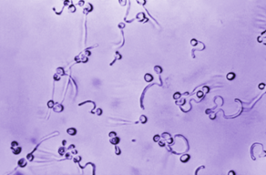
Figure 2-1. Caption: Germ tubes. This photomicrograph revealed Candida albicans fungal spores that had been suspended in animal serum specimens and allowed to grow, giving rise to filamentous germ tubes. The specimen was unstained. PHIL image library, public domain. Image: CDC/ Dr. Lucille K. Georg 1967.

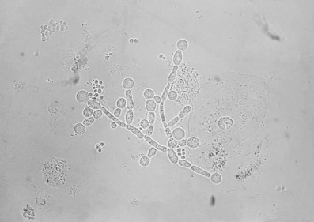
Figure 2-2. Summary: ID#9812This photomicrograph depicts Candida albicans chlamydospores present in a sputum specimen. Chlamydospores are the round terminal asexual conidia. C. albicans is a yeast that is the etiologic agent responsible for "Candidiasis." The clinical features of candidiasis depend upon whether the condition is oropharyngeal, vulvovaginal, or systemic. 2016. CDC. www.cdc.gov.

Candida auris
Candida auris infections are challenging to get under control and eradicate because of the multi-resistance of this organism. It is monitored in intensive care units worldwide because of this significant resistance problem. (2) It is a global pathogen despite just arriving on the scene when first recognized in 2009. This accounts for its critical ranking significance (#2) in the recent WHO fungal pathogens list despite the relatively low number of patient deaths currently.(2)
C. auris is difficult to identify with phenotypic and biochemical tests or commercial biochemical identification kits. On most traditional and chromogenic media, C. auris colonies usually appear as white or slightly pink, but some colonies may even look red or purple. New chromogenic media have been formulated that can further assist in detecting C. auris. This yeast is a pale cream color with a distinctive blue halo that diffuses into the surrounding agar. on CHROMagar Candida. C. auris can grow on blood agar or chocolate agar, so mycology media are not necessary if the laboratory does not have them. The appearance and color of C. auris colonies in culture may aid in this species identification but cannot be used as the sole method for the identification of C. auris. This yeast can only be distinguished from other more common species of Candida by using other molecular methods as described below. Also, the CDC and some state health laboratories can assist in C. auris identification. C. auris is able to grow at 40–42ºC unlike most other yeast species. C. auris is an oval to round budding yeast that rarely forms short pseudohyphae and does not form germ tubes. Some strains form aggregates of cells, but others do not.
Currently, the way to identify C. auris is to use a matrix-assisted laser desorption/ionization time-of-flight (MALDI-TOF) instrument that is capable of differentiating C. auris from other yeast species or by using a nucleic acid method. Be aware that not all of the reference databases included with MALDI-TOF devices allow for the detection of C. auris, so verify that yours does if using this method. Nucleic acid methods based on sequencing the D1-D2 region of the 28s rDNA or the Internal Transcribed Region (ITS) of rDNA can also be used for the identification of C. auris. The BioFire FilmArray BCID2 and the GenMark ePlex Blood Culture Identification Fungal Pathogen (BCID-FP) Panel have been FDA-approved as molecular tests suitable for the identification of C. auris in fungemia. (3)
All Candida auris isolates should undergo sensitivity testing according to current CLSI anti-fungal susceptibility testing guidelines. Although C. auris is usually multidrug-resistant, levels of antifungal resistance can vary widely across isolates. There are currently no established C. auris susceptibility breakpoints, and breakpoints are defined based on those established for closely related Candida species and on the opinions of experts. See the CDC website for additional information. (4)

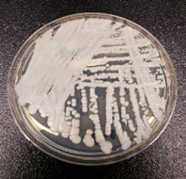
Figure 2-3. Caption: A top view of a culture plate containing an unknown medium with a strain of Candida auris yeast growing. CDC/ NCEZID; DFWED; MDB. 2016. Shawn Lockhart. PHIL image library, public domain image.

Candida dubliensis

Candida dubliensis is similar to C. albicans and can also be germ-tube-positive. It is more temperature sensitive, though, and cannot grow at 42ᴼC, while C. albicans can grow at this higher temperature. On CHROMagar Candida, the growth of C. dubliensis and C. albicans appear darker and lighter green, correspondingly. C. dubliensis has been seen in oral candidiasis (thrush) in AIDS patients, and it has been associated with invasive disease recently. (5)

Pichia kudriavzeveii (formerly Candida kruseii)

Pichia kudriavzeveii is clinically significant as the fifth most common cause of candidemia. However, it is more well known for its innate resistance to fluconazole and somewhat reduced sensitivity to other drugs. (1, 2) Pichia kudriavzeveii (formerly Candida krusei) belongs to the group of candidiasis-type etiological agents, although it is not currently in the genus Candida. It is not as common as the other Candida species, but the infections caused by this organism are particularly relevant in the health setting because of its intrinsic fluconazole resistance. It is a yeast that commonly resides in the mucosal membranes of healthy individuals. Still, this yeast causes life-threatening infections in compromised patients, particularly in those patients with a hematologic malignancy and those using prolonged azole treatment. The risk factors for fungemia due to P. kudriavzeveii include having artificial implants, a recent surgery (< 30 days), neutropenia, splenectomy, the presence of oncological conditions such as solid tumors, leukemia, or a lymphoma as an underlying disease, or having bone marrow or stem cell transplantation.
Because of its strong biofilm-forming capability, P. kudriavzeveii forms a pellicle on the surface of liquid cultures that are stationary. On agar media, the colonies often appear cream to tan color and are wrinkled and flat. Physiologically, P. kudriavzeveii can grow on vitamin-free media and differs from other Candida spp. in many characteristics. On CHROMagar Candida, colonies of P. kudriavzeveii appear pink and have a dry, rougher texture with a light border. Corn meal/tween media reveals conidia that typically elongate, reaching 20-25 µm in length, and are said to take on a "match-stick" like appearance. It also is capable of forming true hyphae. (6)
Candida parapsilosis
Candida parapsilosis is a significant cause of serious and severe candidemia in high-risk individuals, such as premature neonates and ICU patients. It is found in younger populations as well as the elderly. The number of cases of infections with this organism is growing each year. (1, 6) Many strains of this pathogen, but not all, have strong biofilm-forming capabilities, which often give it increased tolerance to echinocandins. A significant concern with this yeast is the progressing spread of fluconazole resistance. These resistant strains can cause outbreaks in hospitals with elevated mortality rates. The prevalence of fluconazole-resistance varies greatly world-wide, with higher rates in South Africa, Latin America, and southern Europe, where the rates of fluconazole-resistance for C. parapsilosis exceed 20%. (2) It has a high ranking and significance in the recent WHO fungal pathogens list because of its growing global prevalence especially in underdeveloped nations (#11). Candidemia is one of the most severe systemic infections caused by different Candida species. This yeast can cause candidiasis in various body sites. The main clinical forms of candidiasis disease are cutaneous, mucosal, and disseminated (which is also known as invasive or systemic candidiasis). This severe fungal condition can infect the blood, brain, eyes, kidneys and liver and cause disseminated disease. Immuno-compromised patients are susceptible to these infections.
Colonies of this yeast vary in appearance but are creamy, moist, shiny, or wrinkled, concentric, crepe-like and invading the agar on Sabauraud’s dextrose medium. It turns a characteristic rust color with age at the colony edges. C. parapsilosis colonies appear white to pale pink on CHROMagar Candida. Corn meal/tween agar produces blastospores that are typically single or in short chains at the distal end of cells at 25°C after 72 hours; the pseudohyphae are elongated and curved and are sometimes thin or sometimes larger and thicker called "giant cells." (6) The strains with more pseudohyphae are those that invade the agar and are also the ones more associated with biofilm production and possibly thus to greater antibiotic resistance in lower glucose environments. (7)
Candida tropicalis
Candida tropicalis is a yeast that can cause serious and severe infections in people with defective immune systems. It is also known to cause infections when the normal microbiota in the human host has been compromised by antibiotic therapy or when the blood sugar levels are high in the patient. Candida tropicalis is known to be pathogenic in neutropenic hosts in whom it disseminates through the bloodstream (hematogenous route) to the peripheral organs. (8) It is similar to Candida albicans in pathogenicity and in its clinical presentation. It is a common systemic fungus in patients with compromised defenses. Candida tropicalis has been obtained from marine fish, seawater, sea sediment, marine plants, algae, and shellfish. It is widely distributed in many tropical and subtropical marine environments. It is also found in the human gut, on fruit surfaces, and in soil. C. tropicalis is a common Candida species associated with disease in tropical countries. Echinocandins or Amphotericin B are recommended for treatment, with extended spectrum triazoles being acceptable alternatives for candidemia and invasive candidiasis. (8) The frequency of invasive disease with C. tropicalis varies by geographical location, causing 3-66% of all candidemia, depending on where you are. (9) Candida tropicalis is seen in cancer patients and leukemia patients with significant granulocytopenia. C. tropicalis is particularly virulent and deadly in neutropenic hosts. Hematogenous spread to multiple peripheral organs is fairly common, with dissemination and eventual fungemia. C. tropicalis infection shows the worst clinical outcome among non-albicans candidemia. (8, 9, 10) It has a high ranking in significance (#10 on the list) in the recent WHO fungal pathogens because of its severity and prevalence.
On Sabauraud’s dextrose media, C. tropicalis are white, or cream-colored, dull, and dry, with a mycelium fringe border edge. On CHROMagar Candida, C. tropicalis colonies appear as dark blue to a metallic shiny blue. On corn meal/tween agar, oval blastospores are seen in small numbers along the hyphae in irregular clumps at 25°C after 72 hours of incubation. C. tropicalis can produce true hyphae. Chlamydosphores are extremely rare.
Other Candida species and other yeasts of medical importance
This chapter is in no way a comprehensive list of all the yeasts reported to be associated with candidiasis or other yeast infections. Many other Candida species, in particular, and other yeast species have been reported in mucocutaneous infections, candidiasis, and even serious invasive infections. This points to the value of speciating the yeasts you isolate in these cases to monitor medical and epidemiological trends. Generally, the methods covered here for identification can also identify these other yeasts.
Cryptococcus species
Cryptococcus neoformans causes cryptococcosis and has considerable pathology. That accounts for its critical ranking and significance in the recent WHO fungal pathogens list (#1). (1) This global pathogen is found in pigeons or other bird droppings and throughout nature. These yeasts are frequently inhaled and may cause a mold, subclinical primary pulmonary infection. People with chronic lung diseases like bronchitis or bronchiectasis may become asymptomatic carriers of Cryptococcus spp. Patients with symptomatic disease manifest with cough, fever, and single or multiple nodules in the mid-to-lower-lung fields on chest radiographs. (2,10) Many patients have dense infiltrate in single lung segments. About 18% of untreated patients develop dissemination in immune-competent patients, with the remainder demonstrating healed or "walled-off" granulomas. In patients with compromised immunity, other underlying disease, or under systemic steroid therapy, the infection disseminates more often. Meningitis is a complication in 40 to 80% of these disseminated cases, and symptoms develop rapidly in immunosuppressed patients. (2) Symptoms include a dull headache, confusion, stupor, nausea, vomiting, stiff neck, loss of balance, fever, decreased visual acuity, possible swelling of the optic nerve, and hydrocephalus. (2) CSF is clear with increased protein and decreased glucose, and typically, lymphocytes predominate, but occasional polymorphonuclear predominance happens. Dissemination can also involve hepatosplenic infection, osteomyelitis, subcutaneous infection, skin nodules, and prostatitis. The average survival of AIDS patients after a Cryptococcus diagnosis is only six months. (2)
The two main cryptococcal pathogens are the species Cryptococcus neoformans and Cryptococcus gattii. Both are significant pathogens, and C. gattii has a high ranking as a priority in the recent WHO fungal pathogens list (#16) (C. neoformans is rated a critical priority #1). (1) In people living with HIV, C. gattii infection has an estimated mortality rate of 10-43%, and C. neoformans has a mortality rate of 20-61%. C. neoformans infection has a mortality rate of 8-50% in patients without HIV. C. gattii, however, has a greater incidence of neurological sequelae and reconstitution inflammatory syndrome post-infection. (2)
On Sabauraud’s dextrose agar, colonies are generally mucoid or slimy in appearance. Younger colonies are usually non-pigmented and appear cream colored. However, yellow, orange, red, pigments may be produced by older cultures. Bird seed agar (or Niger seed or caffeic acid) plates can distinguish the brown colonies of Cryptococcus from the white colonies of Candida species or other yeast. Cryptococcus is characterized by globose to oval yeast cells or blastoconidia that reproduce by narrow-necked budding. Pseudohyphae are usually absent or rudimentary. Most species are encapsulated, and the thickness of capsule formation depends on the medium. Adding 1% peptone to the media enhances capsule formation. (10) Laboratory testing for Cryptococcus spp. includes many rapid tests, as starting treatment rapidly is crucial. These include serodiagnostic cryptococcal antigen tests. A direct mount of the specimen in India Ink may show the classic capsules of Cryptococcus spp. Many labs include caffeic or bird seed (Niger) agar in the direct specimen setup to save time in identifying Cryptococcus spp. as dark colonies on this media. A rapid urease test on the initial growth may also be helpful. Traditional or commercial biochemical testing products, MALDI-TOF, and molecular methods like PCR are available for identification.
Figure 2-5. Summary: This photo depicts Cryptococcus neoformans using a light India ink staining preparation. Life-threatening infections caused by the encapsulated fungal pathogen Cryptococcus neoformans have been increasing steadily HIV/AIDS, and the expanded use of immunosuppressive drugs. Русский: Cryptococcus neoformans под микроскопом.1969. Public domain. Link: http://commons.wikimedia.org/. Obtained via Picryl.

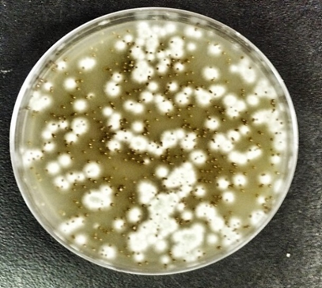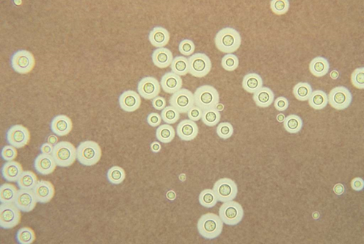
Figure 2-4. Pigmented (melanized) yeast colonies of Cryptococcus gattii (dark smaller colonies) and an unidentified mold (white) on Niger seed agar. Photo: Djspring. Creative Commons Attribution-Share Alike 3.0 license. 31 December 1969. [[File:Cryptococcus gattiiselection.jpg|Cryptococcus_gattii_selection]] Obtained from Wikimedia Commons.

Geotrichum candidum

Yeast-like Geotrichum candidum occasionally causes vaginal, oral, bronchial, and rarely fungemia and systemic disease, mainly in the immune deficient. Direct preparations of Geotrichum candidum reveal fragmented hyphae with continuous, non-alternating rectangular arthroconidia with rounded edges. (Note: To differentiate, Coccidioides immitis has alternating arthroconidia.) (10) It looks like yeast but lacks blastoconidia and is often grouped with the molds.
Hortaea wernecki (formerly Phaeoannellomyces wernecki or Exophilala wernecki)
Hortaea wernecki is a dematiaceous (black) yeast found in halophilic (salt-containing) environments. H. wernecki is the etiological agent of tinea nigra, a human and animal superficial cutaneous mycosis involving either the palms of the hands or the soles of the feet. Oval yeast and branching and septate hyphae are seen in the superficial layers of the stratum corneum. It tends to infect children, and young adults, predominantly young females. It is found in those living in warm climates or those who have visited the tropics or the subtropics of Latin America, Asia, and Africa. It can cause serious infections in the immunocompromised. (11)
The colonies are olivaceous to black and smooth, slimy, and yeast-like. Hyphae, conidia, and chlamydospores can be seen in wet preps. (11)

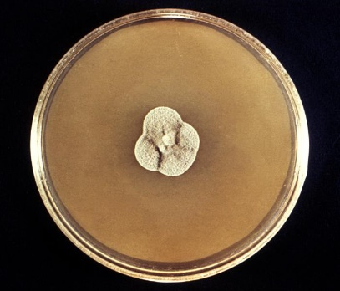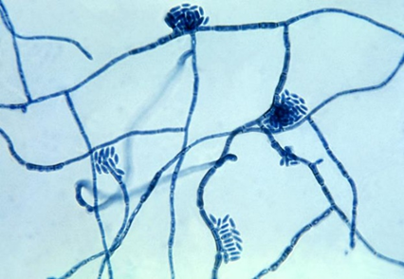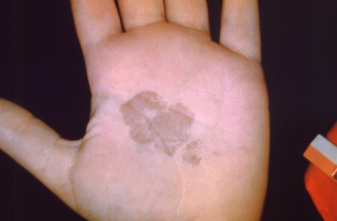
Figure 2-6. Caption: Sabouraud dextrose agar with a colony of H. werneckii. H. werneckii are slow-growing, initially mucoid, yeast-like, and shiny black at maturity. This causes tinea nigra, a superficial skin infection affecting the stratum corneum in humans. CDC/ Dr. Lucille K. Georg, 1969. PHIL image library, public domain.
Figure 2-8. Caption: The palm of this patient’s left hand shows a brown discolored, irregularly-shaped patch of skin, which was diagnosed as tinea nigra. This was caused by the fungus, H. werneckii. This condition, a form of ringworm or dermatophytosis, usually affects the superficial layers of skin on the palms and soles of the feet. These patches are smooth, with brownish coloration, and painless. CDC/ Dr. Lucille K. Georg, 1965. PHIL image library, public domain.

Figure 2-7.Caption: Under magnification of 475X, this photomicrograph of a slide culture specimen revealed some of the ultrastructural morphology exhibited by the fungal organism, Hortaea werneckii, the causative agent of tinea nigra. CDC/ Dr. Lucille K. Georg, 1964. PHIL image library, public domain.

Malassezia species

Malassezia species are lipid-loving yeasts that infect the skin and cause tinea versicolor. Tinea versicolor is a superficial skin infection that produces patchy lesions or scaling of skin with varying pigmentation changes. In light skin, the patches look a little darker, and in dark skin, they look lighter. These tinea versicolor lesions may be on the face, chest, trunk, and abdomen. See Figures 2-9, 2-10, and 2-11) Tinea versicolor infections may be related to squamous cell turnover rates as there is a higher incidence among people receiving corticosteroid therapy, decreasing the squamous cell turnover rate. Others have reported that genetic factors, hygiene, or excess sweating may also contribute to this condition. M. furfur has been implicated in disseminated infections in patients receiving lipid replacement therapy and those who are immune deficient. Malassezia also is a common endogenous skin colonizer. It has the greatest presence worldwide in hot, humid, and tropical regions. (12)
This organism requires lipids in the media to grow. Agar plates are covered with sterile olive oil. Colonies are cream-colored, moist, and smooth. Malessezia spp. can be identified in tinea versicolor lesions by its classic "spaghetti and meatballs" appearance on direct KOH wet mount preparation or by observing the golden yellow fluorescence of the lesions under the Woods lamp during a screening examination. The fungus appears as round budding yeast and short, septate, sometimes branched hyphae in the direct KOH wet mount.
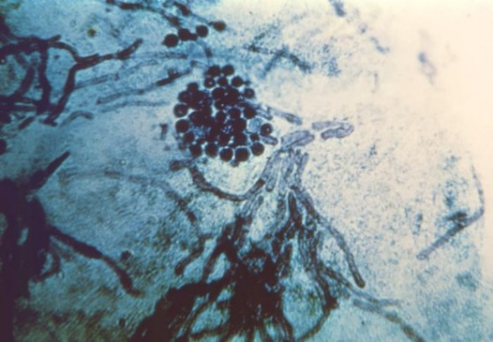
Figure 2-9. Caption: This photomicrograph revealed the histopathology exhibited by a skin scraping sample, which had been affected by a dermatophytic fungal organism, causing a condition known as tinea versicolor, also known as dermatomycosis furfuracea, or tinea flava. Note the round, yeast-like cells and short hyphae. (“Spaghetti and meatballs” appearance). Usually, tinea versicolor is caused by Malassezia spp. including M. globosa, M. furfur, and other Malessezia spp. CDC/ Dr. Lucille K. Georg 1964. PHIL library image, public domain.
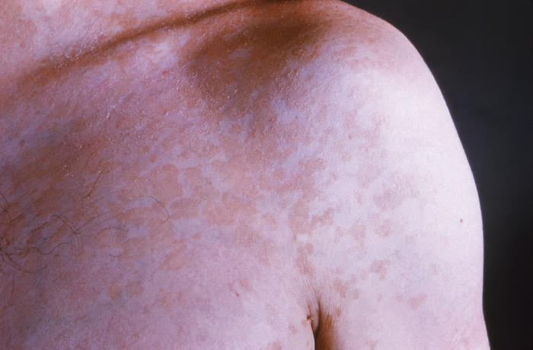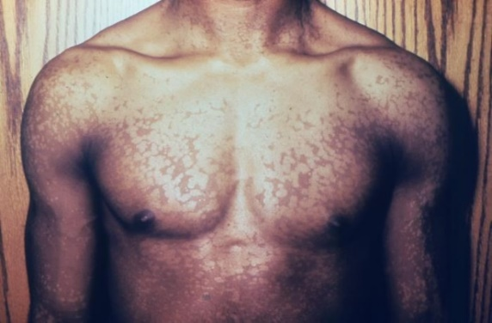
Figure 2-11. Caption: The chest of this male patient displayed a mosaic pigmentation pattern, which had been caused by a dermatophytic fungal organism, and is known as tinea versicolor. In this case, the specific dermatophyte was not disclosed, but the pattern covered his chest, upper arms, and upper abdominal regions. CDC/ Dr. Gavin Hart. PHIL image library, public domain.
.
Figure 2-10. Caption: This is an anterior view of a patient’s left shoulder, revealing a plaque-like, erythematous rash. It was diagnosed as a case of tinea versicolor, caused by the fungal organism, Malassezia furfur, formerly Pityrosporum ovale. CDC/ Dr. Lucille K. Georg. 1964. PHIL image, public domain.

It is usually cultured if found in blood cultures and more serious infections. It can be identified using special media, PCR, some strains with Maldi-Tof mass spectrophotometry, and other molecular techniques. The best media to initially grow Malassezia spp. is Dixon agar. M. pachydermatis is the only species that can grow on lipid-free Sabdex agar. Additional media that help to speciate the Malessezia spp. are CHROMagar Malassezia medium, EL slants with castor oil, and TE slants with tween 60 and esculin for esculin hydrolysis; the catalase test is also used for speciation. (12)

Nakaseomyces glabrata (formerly Candida glabrata, before that Torrulopsis glabrata)
Nakaseomyces glabrata is a global opportunistic fungus that usually affects the debilitated. It has a high ranking and significance in the recent WHO fungal pathogens list because of its global prevalence. (#5) N. glabrata may be the second or third most common Candida strain, with its prevalence growing more recently, especially in developed nations. Although it is no longer in the genus Candida, it is still a yeast that causes candidemia. N. glabrata infections are most likely to affect the urinary tract, from the urethra to the bladder and the kidneys. It also infects the genitals, the mouth, and even the bloodstream, in the case of specific at-risk groups. This yeast usually infects the lungs and the kidneys, although it can disseminate through the blood and cause fungemia and septic shock. It is the second or third most commonly isolated yeast from blood cultures worldwide, depending on the geography studied. In one study done in Sweden, the following percentages for yeasts causing candidemia were seen: 19% for N. glabrata, versus 65% for Candida albicans, 7% for Candida parapsilosis, 4% for Candida dubliniensis, 3% for Candida tropicalis, and 2% for Pichia kudriavzevii and other yeasts. (13) Another concern with N. glabrata is its increasingly reduced susceptibility to fluconazole and echinocandins. It also is increasingly prevalent in developed countries and the immunocompromised and the elderly. (13)
N. glabrata colonies on Sabouraud dextrose agar at 25°C are whitish to cream colored, smooth, glossy or glistening. On CHROMagar Candida, C. glabrata produces colonies that appear pink to purple. It can grow at 42ºC. The addition of cycloheximide to the media inhibits its growth. Microscopically, it does not form pseudohyphae or hyphae. Only blastoconidia are observed on corn meal/tween agar after 72 hours of incubation at 25°C. Its yeast cells are tiny, ranging from 2.5-4.0 x 3.0-6.0 μm as compared to C. albicans, which is 3.5-6.0 x 4.0-8.0 μm. (14) Direct preparations and histology stains of lung tissue may show many budding yeast cells inside of macrophages resembling Histoplasma capsulatum. The isthmus between the budding yeast cells of N. glabrata is wider than in Histoplasma spp. N. glabrata, however, is not a dimorph.
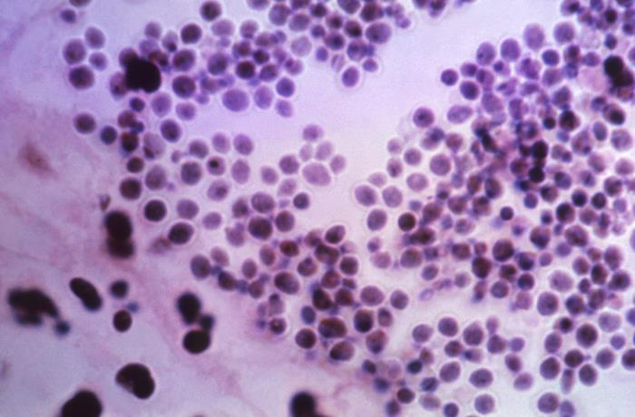
Figure 2-12. Caption: This photomicrograph of a hematoxylin-eosin (H&E)-stained sample of human kidney tissue, revealed the presence of clusters of classic yeast cells of the fungus, Nakaseomyces glabrata, (formerly Candida glabrata, and before that, Torulopsis glabrata). N. glabrata are a bit smaller than Candida spp., CDC/ Dr. Lucille K. Georg, 1967. PHIL library, public domain.

Pneumocystis jirovecii (formerly Pneumocystis carinii)

HIV-positive patients were significantly affected by Pneumocystis jirovecii. Immunofluorescent staining using monoclonal antibodies to Pneumocystis jirovecii has the highest sensitivity and specificity of the stains available. (14, 15) Sensitivity ranges from 48% to 100%, and specificity from 82% to 100% for immunofluorescent staining for P. jirovecii. (15) In the past, P. jirovecii was a tremendous burden for HIV/AIDS patients but effective treatment has alleviated this situation. In the last few years, P. jirovecii pneumonia has become an important opportunistic pathogen in the immunosuppressed, especially among kidney transplant recipients and those with vasculitis. P. jirovecii pneumonia causes more than 500,000 cases annually, with 175,000 deaths. (1) P. jirovecii was ranked as a medium-priority fungal pathogen in the recent WHO report (#18). Some feel this pathogen should be moved up in the WHO list due to its disease burden, and evolving epidemiological shift to other immunosuppressed patients, and its treatment challenges. (1, 2)

Pneumocystis jirovecii is challenging to culture in vitro, so the diagnosis has traditionally relied upon clinical symptoms, radiographic findings, and observing the organisms on staining of lung specimens such as bronchoalveolar lavage fluid or induced sputum. However, histological staining methods have been shown to have poor sensitivity for detecting Pneumocystis pneumonia. Immunofluorescent stains via monoclonal antibodies to Pneumocystis jirovecii have a higher sensitivity and specificity than conventional stains and can be used with flow cytometry. Sensitivity ranges from 48% to 100%, and specificity from 82% to 100%. (15) New molecular methods, including polymerase chain reaction (PCR), loop-mediated isothermal amplification (LAMP), and antibody-antigen testing on less invasive samples, have been developed for the diagnosis of Pneumocystis pneumonia and show an improved sensitivity or specificity. The influence of genetic variation on molecular diagnosis because of genetic polymorphisms of the organism may result in particular molecular methods, such as either PCR or LAMP, being less effective for detection in pstients in certain geographic areas. The impact of genetic variation on molecular diagnosis has yet to be demonstrated in the literature and needs to be further researched. (15)

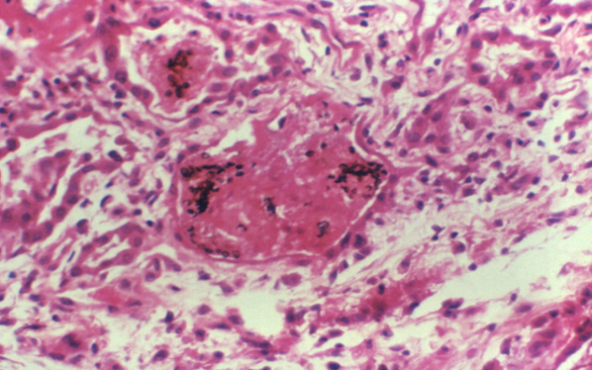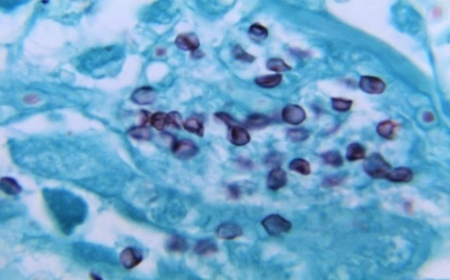
Figure 2-14. Caption: Under magnification of 1150X, this photo of a silver stained human lung tissue specimen, reveals typical histopathology encountered due to a case of Pneumocystis pneumonia (PCP), caused by the fungus Pneumocystis jirovecii, formerly known as P. carinii. Numerous darkly-stained cysts are present, while the intracellular bodies are not seen. CDC/ Lois Norman, M.S., 1968. PHIL image library, public domain.
Figure 2-13. Caption: This human lung tissue specimen was processed using a combination of histologic stains, (hematoxylin-eosin (H&E) with Grocott's methenamine silver (GMS)). The human lung tissue was extracted from a patient ill with pulmonary pneumocystosis. This photo revealed the presence Pneumocystis jirovecii, formerly Pneumocystis carinii, fungal organisms within the intra-alveolar spaces. CDC/ Dr. Francis Chandler. 1976. PHIL image library, public domain.

Prototheca species (yeast-like algae that can infect people)

Prototheca species are unique spherical unicellular organisms that are green algae that have lost their chloroplasts but resemble yeast when grown on agar plates. They are not yeasts or even fungi. The few Prototheca species capable of invading animals and humans and causing disease (protothecosis) are Prototheca zopfii and Prototheca wickerhamii. Most human infections are caused by Prototheca wickerhamii. (16) They cause skin infections and bursitis. In immunocompromised patients, they can disseminate to cause more severe disease. They grow yeast-like colonies on Sabdex and mold inhibitory agar. The characteristic "spoke-and-wheel" sporangia can be seen on direct wet slide prep with lactophenol cotton blue stain and wet mount with calcofluor white or FA stain. MALDI-TOF mass spectrometry or molecular techniques such as DNA sequencing of the ribosomal internal transcribed spacer, D2 targets of the large-subunit ribosomal DNA, or 16S ribosomal RNA gene are the preferred methods of identification. (16) Identification by sequencing of mitochondrial DNA ctyb gene has been proposed to be the "new gold standard" in diagnosis of protothecal infections. (16) Prototheca spp. stain well with Gridley fungus stain, Grocott's modification of Gomori methenamine silver. Histopathology is also used to help diagnose protothecosis. Necrotizing granulomatous inflammation with organisms morphologically consistent with Prototheca are seen on histological specimens. Periodic acid-Schiff stains them well, but hematoxylin and eosin–stained smears may not. (16)

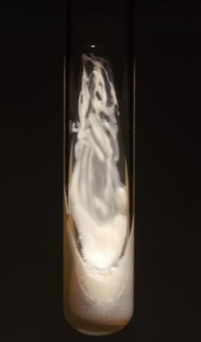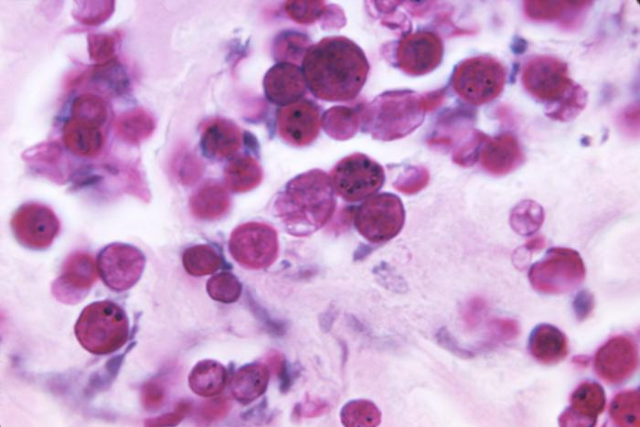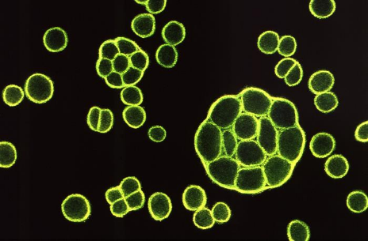
Figure 2-16. Caption: At 1850X magnification, this photo of a periodic acid-Schiff (PAS)-stained tissue sample, reveals the histopathology in a protothecosis case, caused by a green algae of the genus Prototheca. Though taxonomically an alga, Prototheca lack chlorophyll, and are saprophytes, consuming organic matter. Prototheca spp. resemble yeast , but are algae. CDC/Dr. Kaplan, 1971. PHIL, public domain.
Figure 2-15. Caption: This image is a Sabouraud’s dextrose agar (SDA) slant with a colony of achlorophilic Prototheca stagnora algal organisms. This algae lacks plastids, and is therefore, achlorophyllous. CDC, 1971. PHIL library, public domain.
Figure 2-17. Caption: This illustration depicts how use of the fluorescent antibody (FA) staining technique, used upon a tissue sample, revealed the presence of the achlorophyllic algal organism, Prototheca wickerhamii. CDC/ M. Sudman, 1972. PHIL library, public domain.

Rhodotorula species
Rhodotorula species are known for their bright salmon-pink color. They are urea-positive and have a capsule. They are not common disease agents but have been known to cause opportunistic infection rarely and can be plate contaminants.
Saccharomyces species
Saccharomyces is a genus that includes many yeast species. Saccharomyces species are not common agents of disease. However, they have been associated with pulmonary infections, oropharyngeal infections, endocarditis, fungemia, pneumonia, peritonitis, vaginitis, urinary tract infections, skin infections, and esophagitis, especially in the immunocompromised. It is now considered an opportunistic pathogen. A small number of invasive Saccharomyces infection cases have been reported. Risk factors for invasive disease with Saccharomyces are similar to those for invasive candidiasis, with intravascular catheters and antibiotic therapy being the most prominent risk factors. Blood was the most frequent specimen of isolation in invasive cases. S. boulardii accounted for just above half of Saccharomyces fungemia cases and the yeast was only isolated from blood cultures. (17) Patients that are infected with S. boulardii were most often immunocompetent with a generally good prognosis. A very small number of cases have been associated with S. boulardii probiotic use. Simply removing intravenous lines or doing some diligence in changing these lines is helpful for prevention. Invasive Saccharomyces infection is indistinguishable from an invasive candidiasis case by clinical signs and symptoms and is detected through laboratory testing. (17)
On Sabaroud dextrose agar, Saccharomyces colonies are flattened or dome-shaped, moist, smooth, dull or glistening, and cream colored. The Saccharomyces produce ascospores, especially when grown on ascospore agar or V-8 media. Ascospores are round spheres inside the asci. These asci contain 1–4 ascospores. Asci don’t burst when mature but remain intact. Ascospores can be stained with Gram stain, and the ascospores are gram-negative and other vegetative cells are gram-positive. (10, 17) Saccharomyces do not use nitrate, but the fermentation of various carbohydrates is a typical characteristic of Saccharomyces. Yeast and blastoconidia (cell buds) are observed. The yeast are single celled, round or ellipsoid to elongated in shape. Multipolar budding with multiple buds is common in Saccharomyces. (17) If pseudohyphae are present at all, which is very unusual, they are small and rudimentary. Hyphae are absent.
Trichosporon species (now some species are in two new genera, Apiotricum species and Cutaneotrichsporon species)
This group of yeasts is known for superficial skin conditions, infecting the skin and causing allergic reactions. Still, a few strains also can cause life-threatening invasive fungal disease and fungemia. Trichosporon species are capable, pathogenic yeasts that colonize and proliferate in different sites in the patient, including the gastrointestinal tract, skin, and the respiratory tract. (18) Invasive Trichosporon mycosis is almost exclusively in compromised patients, especially in those with hematological malignancies. (18) Invasive trichosporonosis is difficult to diagnose as well as to treat. The world-wide incidence of trichosporonosis is increasing. This genus of fungi has had many new reclassifications, which can confuse the reader in the literature. The first Trichospron spp. reported was T. beigelli (now T. asahii), which is one of the causes the superficial white piedra on external hair shafts. Scientists realized that several species were being identified as T. beigelli, and they felt that many similar fungal species could also cause white piedra. The most common strains causing white piedra now are Trichosporon inkin, Trichosporon ovoides, Trichosporon asahii, Trichosporon asteroides, Trichosporon mucoides, and Trichosporon cutaneum. (18) T. asahii and other Trichosporon species can also cause invasive disease in the immunocompromised.
The colonies are usually raised and have a wax-like appearance, which develops irregular folds with radial furrows. (10) Most are urease-positive. These yeasts are characterized by the unique development of septate, hyaline true hyphae that often fragment into rectangular or oval arthroconidia and they also have pseudohyphae. Blastoconidia are also usually seen. (10)

Exophiala dermatitidis (formerly Wangiella dermatitidis)

Exophiala (formerly Wangiella) dermatitidis is a pathogen of humans that causes a disease known as phaeohyphomycosis that typically infects the skin and subcutaneous tissues. (10, 11) Phaeohyphomycosis can be caused by many phaeoid (dematiaceous) fungi, including Bipolaris, Cladosporium, Cladophialophora, Exophiala, Fonsecaea, Ochronosis, Phialophora, and Rhinocladiella. Most of these organisms have been recognized as opportunists, though some are frank pathogens. Dematiaceous fungi rarely cause fatal mycoses in patients with healthy host defenses, although some cause fatal brain abscesses in immunocompetent patients. Cases of severe disseminated infection almost always occur in patients that are compromised. Clinical infections and conditions seen with Exophiala include invasive sinusitis (sometimes with bone necrosis), abscesses, keratitis, skin, subcutaneous nodules, a lung mass, lung hypersensitivity, bone, mycotic joint infections, endocarditis, brain and other abscesses, and disseminated infection. (11) Although typically referred to as black yeast, this fungus is, in fact, also a conidiogenic mold in the Ascomycota. (10, 11) This is actually a type of dimorphic fungi with an ability to switch between these forms based on environmental factors (temperature, pH, and nutrient availability). Often in medical mycology, the dimorphs are divided into thermal and non-thermal dimorphs, with the most famous human pathogens being the thermal dimorphs that are a yeast at body temperature and a mold at room temperature. Exophiala is a non-thermal dimorph that reproduces in the yeast phase.

The yeast phases of the thermal dimorphic fungi

The yeast phases of the thermal dimorphic systemic fungi will be considered along with the dimorphic fungi in the subsequent chapter.

Yeast species culture, identification, and susceptibility testing

Yeast are round to oval and appear as budding cells (asexually producing blastoconidia). Some yeast form yeast blastoconidia only, and some (Candida spp.) will form cells that are elongated, forming pseudohyphae, and a few species will show actual arthroconidia and true hyphae (Geotrichum and Trichosporon spp.). Yeasts are best grown at 25 to 30ᴼC on Sabauraud's dextrose or Sabhi agar and often grow on primary bacteriological media without inhibitors. Cycloheximide will inhibit many yeast strains. Malassezia requires an agar overlay of sterile olive oil or special media. Yeast typically grows as cream-colored but may be white, yellow, tan, orange, red, violet, or dematiaceous (brown or black pigment). First, the fungus is recognized as yeast or mold by microscopy and appearance. Yeast are unicellular organisms with no capability or minimal capability of mycelial growth. Yeasts reproduce asexually by blastoconidia formation (budding). Then, look at the other structures. The germ tube test can help to differentiate Candida albicans and Candida dubliensis, which form germ tubes when incubated in serum or anticoagulated rabbit plasma at 37ºC. Cryptococcus spp. or Rhodotorula spp. usually produce capsules, which helps in their rapid identification. Both of these yeasts are also urease positive. Cryptococcus spp. grows on birdseed or caffeic agar and turns black. Rhodotorula spp. usually has a salmon-pink color on fungal media, so their appearance helps with initial identification. As Cryptococcus spp. can potentially cause serious infections such as meningitis, direct antigen detection, and serological tests are available to assist in rapid identification. (10)
Malassezia spp. can be recognized easily if the patient's skin has the typical tinea versicolor lesions and the direct KOH prep shows the classic "spaghetti and meatballs" appearance. (See figure 2-9). These lesions also fluoresce under a Woods lamp upon patient examination. For further identification of the other yeasts, CHROMagar Candida and biochemical testing can help speciate the Candida spp. Biochemical testing (See Table 2-1) can also help in their identification. Maldi-tof mass spectrophotometry, PCR, fluorescent antibody stains, and serological exoantigen testing can rapidly and more accurately identify yeast species in significant cases. Please see Figure 2-1 for a standard preliminary fungal identification flowchart.
Antifungal Susceptibility Testing
The Clinical Laboratory Standards Institute (CLSI) has released four publications with accepted methods for standardized fungal yeast and mold susceptibility testing and testing results for clinical laboratories. A standardized inoculum of your fungus suspension is made per recommended procedures and swabbed uniformly onto a susceptibility agar media. Mueller-Hinton agar is used. Antifungal-impregnated Kirby-Bauer disks are tamped on the media surface aseptically, and then the plate is allowed to grow. After growth is present, any zone of inhibition by the antibiotic is measured and evaluated by its identified species to establish susceptibility and resistance to the desired antifungal agent. Please refer to these published guidelines and to the CDC website to ensure standardized results.
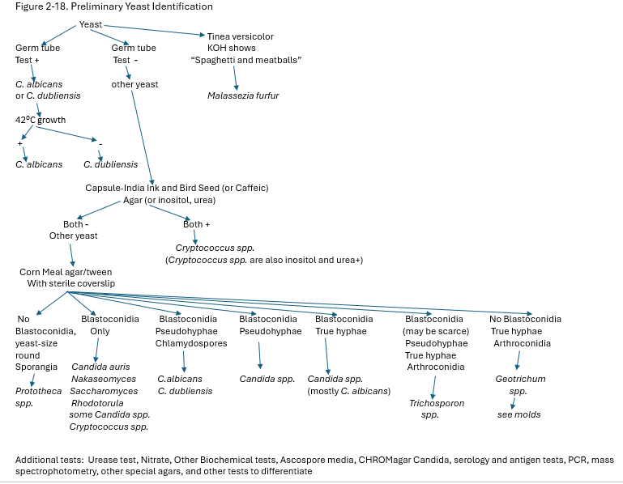

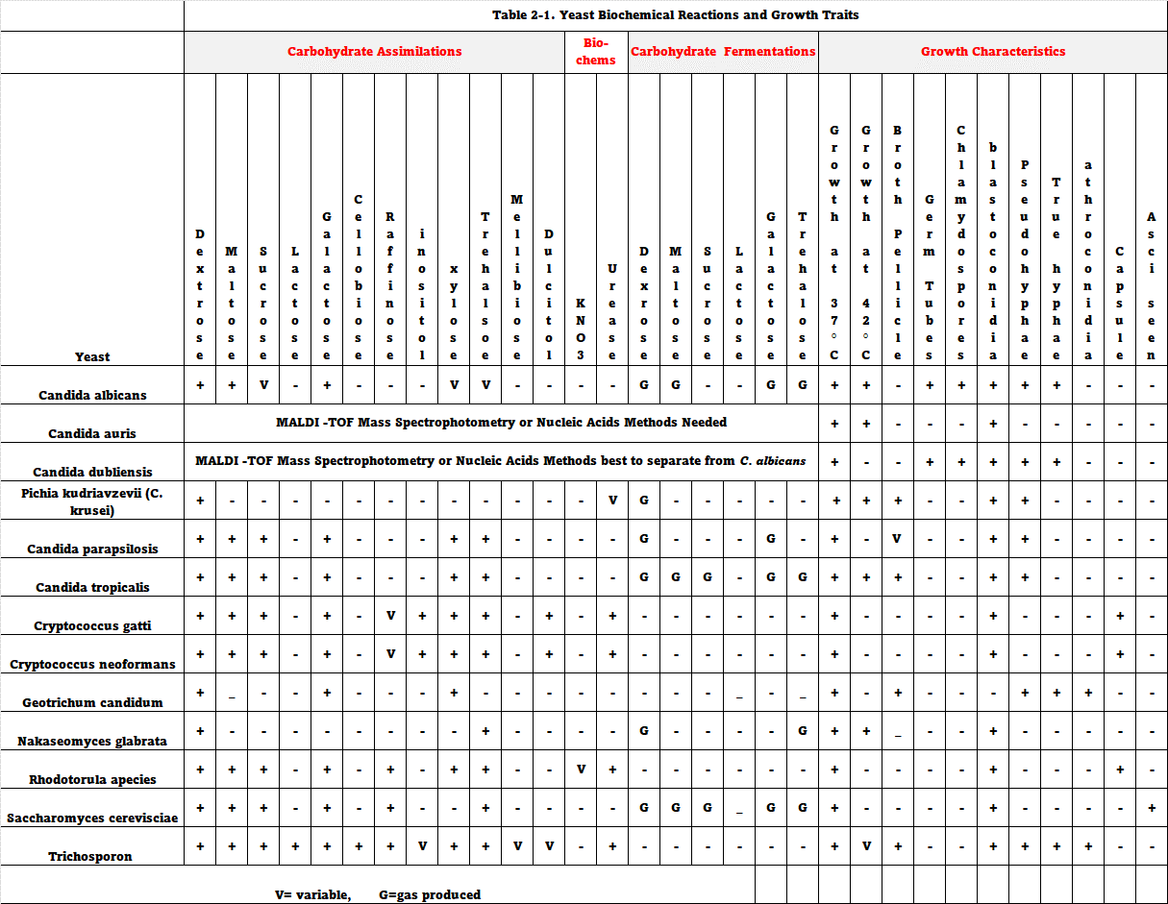
Case Study 2-1- Invasive Candidiasis with Candida albicans

A 61-year-old woman with end-stage renal disease was taken to the emergency room with chills, fever, malaise, and a rash on her wrists. She came with her blood culture report already indicating yeast growth the day before this emergency room visit. The patient stated that she had a progressively increasing cough producing white sputum without blood for the last two weeks, shortness of breath, fever, and chills. She also reported pain in her lower back and with urination. She stated that she had difficulty and pain when swallowing and some heartburn after eating. Her co-morbidities were diabetes and hypertension. The patient was routinely getting dialysis therapy through an arteriovenous shunt graft in her arm. The dialysis center had decided to send this patient to the emergency department after getting the initial preliminary lab report of yeast in her blood. The yeast growing in her blood culture bottles was subsequently identified further as Candida albicans in the final lab report later in the day.

The initial physical examination showed an obese female who was alert and communicative. She was febrile (at 101 °F), blood pressure readings were elevated (at 162/88 mmHg), and her oxygen saturation was satisfactory (97%) in room air. Further skin examination revealed approximately 1 to 2-mm macular lesions in the skin on the ventral surfaces of both of her wrists. Crackles were heard upon respiration, and she had normal heart sounds. The arteriovenous graft had good blood flow, although it had some slight swelling surrounding it. A urine sample was collected for culture, and it later grew >100,000 colonies/ml of C. albicans. An upper endoscopy was ordered, and it revealed esophagitis. Lung lesions and lung cavitary nodules were observed on a pulmonary computerized tomography (CT). An ultrasound image revealed a collection of fluid around the patent’s arteriovenous shunt. Using ultrasound guidance, a fine needle aspiration was performed, and the resulting fluid culture grew Candida albicans. The infected arteriovenous graft was excised, and a temporary catheter inserted for hemodialysis use. Later, after recovery and the patient’s blood cultures returning to negative, the patient had a permacath implanted for dialysis. A bronchoscopy fluid with white mucous, a transbronchial biopsy, and her esophageal sample all grew out Candida albicans. Aspergillosis was ruled out due to a negative test for Aspergillus fumigatus and Aspergillus niger precipitins, a negative serum beta-D-glucan assay, and a negative bronchoalveolar lavage galactomannan test.

The infectious disease consultant recommended that the patient be started on fluconazole. After two days, repeat blood cultures are negative. The patient was discharged from the hospital with instructions to complete six weeks of fluconazole therapy during her dialysis treatment visits. The patient subsequently completed antifungal treatment and is still being monitored in the dialysis center. She is currently without symptoms. Candidiasis usually first presents as colonization, not infection. Risk factors for developing a candidiasis infection include immunosuppression, neutropenia, diabetes, hematologic malignancy, long-term antibiotic use, sepsis, and total parenteral nutrition. Candidemia is the fourth most common cause of hospital-acquired bloodstream infections in the United States. (19, 20) Invasive candidiasis has a high mortality rate in adults, especially in the elderly. Invasive candidiasis occurs when C. albicans or a different Candida species enters the bloodstream and spreads to other body sites. Risk factors for invasive candidiasis are prolonged central venous catheter placement, renal failure, surgical procedures, neutropenia, immunosuppression, hematologic malignancy, sepsis, long-term use of antibiotic therapy, and total parenteral nutrition. (19, 20) Radiologic presentation varies from pneumonia, nodules, micro-abscesses, miliary patterns, ground-glass opacity, pleural effusion, thickening of the bronchial wall, and rarely cavitary lesions in Candida infections in the lung.

This case was diagnosed as disseminated, invasive candidiasis because C. albicans grew in the patient's blood cultures, arteriovenous graft fluid, skin lesions, esophagus, and urinary tract, and because of chest CT findings. The negative precipitin test, which looks for IgG, IgE, and IgM antibodies in the patient’s serum, and negative galactomannan and βD-Glucan tests ruled out a coexisting Aspergillus infection. (20) Delayed initiation of treatment for invasive candidiasis would have corresponded in a significantly higher risk for death. This prompt diagnosis of disseminated and invasive candidiasis and prompt initiation of appropriate antifungal treatment is crucial to clear this infection and was successful for this patient.

Figure 2-19. Under a low magnification of 125X, this photomicrograph of a Grocott-Gömöri’s (or Gömöri) methenamine silver (GMS)-stained lung tissue sample revealed the histopathology caused by the Candida albicans fungal organisms. A specimen harvested from a pulmonary candidiasis. CDC/Dr. Hicklin,1964. Public domain, Phil image library.

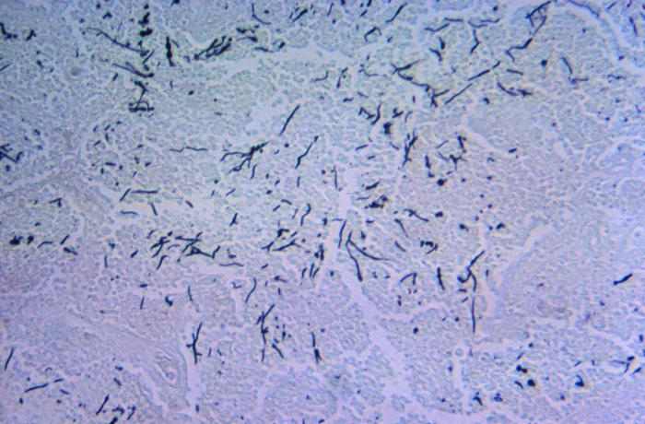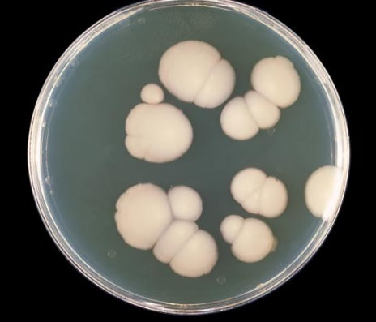
Figure 2-20. Caption: This photo depicts a top view of a SabHI agar, which had been inoculated with Candida albicans, and incubated for an unknown time, at a temperature of 20°C. These round colonies grew on the medium surface. CDC/ Dr. William Kaplan. Public domain, Phil image library.

References:
- Shahin Ali, PhD, Rebecca Bradford, MBA, MS, PMP, and Victoria Knight-Connoni, PhD. WHO Releases Priority Fungal Pathogens List, A first-of-its-kind report to drive research on fungal pathogens. November 16, 2022. https://www.atcc.org/blogs/2022/who-releases-priority-fungal-pathogens-list
- Giacomo Casalini, Andrea Giacomelli, Spinello Antinori. The WHO fungal priority pathogens list: a crucial reappraisal to review the prioritization. The Lancet Microbe. Open AccessPublished:April 09, 2024DOI:https://doi.org/10.1016/S2666-5247(24)00042-9.
- https://www.cdc.gov/fungal/candida-auris/fact-sheets/fact-sheet-lab-staff.html
- https://www.cdc.gov/fungal/candida-auris/c-auris-antifungal.html
- Gutiérrez J, Morales P, González MA, Quindós G. Candida dubliniensis, a new fungal pathogen. J Basic Microbiol. 2002;42(3):207-27. doi: 10.1002/1521-4028(200206)42:3<207::AID-JOBM207>3.0.CO;2-C. PMID: 12111748.
- Cletus P. Kurtzman, Jack W. Fell and Teun Boekhout, eds.. The Yeast, Fifth Edition. 2011. The Yeasts (Fifth Edition) Shahin Ali, PhD, Rebecca Bradford, MBA, MS, PMP, and Victoria Knight-Connoni, PhD. WHO Releases Priority Fungal Pathogens List, A first-of-its-kind report to drive research on fungal pathogens. November 16, 2022.2011, Pages 9-19. Elsevier Science. ISBN 978-0-444-52149-1. Yeasts Pathogenic to Humans - ScienceDirect.
- Gómez-Molero E, De-la-Pinta I, Fernández-Pereira J, Groß U, Weig M, Quindós G, de Groot PWJ, Bader O. Candida parapsilosis Colony Morphotype Forecasts Biofilm Formation of Clinical Isolates. J Fungi (Basel). 2021 Jan 7;7(1):33. doi: 10.3390/jof7010033. PMID: 33430377; PMCID: PMC7827155.
- Chai LY, Denning DW, Warn P. Candida tropicalis in human disease. Crit Rev Microbiol. 2010 Nov;36(4):282-98. doi: 10.3109/1040841X.2010.489506. PMID: 20883082.
- Zuza-Alves DL, Silva-Rocha WP, Chaves GM. An Update on Candida tropicalis Based on Basic and Clinical Approaches. Front Microbiol. 2017 Oct 13;8:1927. doi: 10.3389/fmicb.2017.01927. PMID: 29081766; PMCID: PMC5645804.
- Kern, M. and Blevins, K. Medical Mycology, 2nd ed. 1997. F.A. Davis.
- Deanna A. Sutton, Michael G. Rinaldi, Stephen E. Sanche, CHAPTER 14 - Dematiaceous fungi, Editor(s): Elias J. Anaissie, Michael R. McGinnis, Michael A. Pfaller, Clinical Mycology (Second Edition), Churchill Livingstone, 2009, Pages 329-354, ISBN 9781416056805, https://doi.org/10.1016/B978-1-4160-5680-5.00014-1. (https://www.sciencedirect.com/science/article/pii/B9781416056805000141)
- Kaneko T, Makimura K, Abe M, Shiota R, Nakamura Y, Kano R, Hasegawa A, Sugita T, Shibuya S, Watanabe S, Yamaguchi H, Abe S, Okamura N. Revised culture-based system for identification of Malassezia species. J Clin Microbiol. 2007 Nov;45(11):3737-42. doi: 10.1128/JCM.01243-07. Epub 2007 Sep 19. PMID: 17881545; PMCID: PMC2168522.
- Lindberg E, Hammarström H, Ataollahy N, Kondori N. Species distribution and antifungal drug susceptibilities of yeasts isolated from the blood samples of patients with candidemia. Sci Rep. 2019 Mar 7;9(1):3838. doi: 10.1038/s41598-019-40280-8. PMID: 30846717; PMCID: PMC6405987.
- Koehler, A. P., Chu, K.-C., Houang, E. T. S., & Cheng, A. F. B. (1999). Simple, reliable, and cost-effective yeast identification scheme for the clinical laboratory. Journal of Clinical Microbiology, 37(2), 422–426.
- Bateman M, Oladele R, Kolls JK. Diagnosing Pneumocystis jirovecii pneumonia: A review of current methods and novel approaches. Med Mycol. 2020 Nov 10;58(8):1015-1028. doi: 10.1093/mmy/myaa024. PMID: 32400869; PMCID: PMC7657095.
- Cullen GD, Yetmar ZA, Fida M, Abu Saleh OM. Prototheca Infection: A Descriptive Study. Open Forum Infect Dis. 2023 Jun 6;10(6):ofad294. doi: 10.1093/ofid/ofad294. PMID: 37389225; PMCID: PMC10300632.
- Adela Enache-Angoulvant, Christophe Hennequin, Invasive Saccharomyces Infection: A Comprehensive Review, Clinical Infectious Diseases, Volume 41, Issue 11, 1 December 2005, Pages 1559–1568, https://doi.org/10.1086/497832
- Gaurav V, Grover C, Das S, Rai G. White Piedra: An Uncommon Superficial Fungal Infection of Hair. Skin Appendage Disord. 2022 Jan;8(1):34-37. doi: 10.1159/000517807. Epub 2021 Aug 5. PMID: 35118127; PMCID: PMC8787612.
- O'Donnell, L. E., Robertson, D., & Ramage, G. (2015). Candida virulence factors. https://doi.org/10.1007/978-3-662-47194-4_2
- Arshad, H., Garcia, S., & Khaja, M. (2017). Case report of invasive, disseminated candidiasis with peripheral nodular cavitary lesions in the lung. https://doi.org/10.1016/j.rmcr.2016.11.003

