**Innovations in Energy: IoT and AI Perspectives**

**Shikha1, Priyanka Gupta1*, Monica Bhutani1, Jyoti Gupta1, Monica Gupta1**

Electronics and Communication Engineering Department, Bharati Vidyapeeth’s College of Engineering, New Delhi

**Abstract:**

The convergence of Internet of Things (IoT) and Artificial Intelligence (AI) technologies has revolutionized the energy sector, offering unprecedented opportunities for innovation and efficiency. This chapter provides a comprehensive overview of the applications, challenges, and implications of IoT and AI in energy systems. Beginning with an exploration of IoT applications in smart grid management, energy efficiency, renewable energy integration, and predictive maintenance, the chapter highlights real-world case studies and best practices showcasing successful implementations. Lessons learned from these case studies underscore the importance of data quality, collaboration, and interoperability for realizing the full potential of IoT and AI in energy. Furthermore, the chapter discusses emerging trends such as edge computing and blockchain integration, shaping the future of energy innovation. Recommendations for policymakers, industry stakeholders, and researchers emphasize the need for supportive regulatory frameworks, investments in research and development, and interdisciplinary collaboration. Finally, areas for further research and development are identified, emphasizing the role of cybersecurity, advanced analytics, and emerging technologies in driving sustainable energy transformation. Overall, this chapter elucidates the transformative impact of IoT and AI on energy systems and underscores the imperative for collective action to harness their potential for a resilient, efficient, and sustainable energy future.

1. **Introduction:**

The Internet of Things (IoT) and Artificial Intelligence (AI) are two interconnected technological domains poised to revolutionize the energy sector. IoT, as described by [1] refers to a network of devices and sensors capable of exchanging data over the internet. This interconnectedness enables real-time monitoring and control of energy infrastructure, enhancing operational efficiency and reliability [2]. AI, on the other hand, encompasses algorithms that simulate human intelligence, enabling tasks such as data analysis, pattern recognition, and decision-making. [3] emphasize AI's role in optimizing energy systems by extracting insights from IoT-generated data, leading to improved resource allocation and cost savings.

In the energy sector, the significance of IoT and AI lies in their potential to address key challenges and drive innovation. By integrating IoT sensors and AI analytics, energy stakeholders can gain deeper insights into energy consumption patterns, optimize resource allocation, and improve grid stability [4]. This transformative potential is crucial for addressing pressing issues such as the integration of renewable energy sources, grid modernization, and energy efficiency [5](Wang et al., 2021).

**1.1 Overview of the Transformative Potential of IoT and AI in Energy:**

The convergence of IoT and AI holds immense promise for reshaping energy systems and unlocking new opportunities for efficiency and sustainability. [6] highlight the transformative potential of IoT and AI in enabling smart grid management, renewable energy integration, and demand-side management. By leveraging IoT sensors and AI algorithms, energy systems can become more adaptive, resilient, and responsive to changing demand patterns [7].

Furthermore, IoT and AI technologies have the capacity to revolutionize energy management in buildings, industries, and transportation. [6]discuss how IoT-enabled devices and AI-driven analytics can optimize energy consumption, automate processes, and reduce operational costs. This transformative potential extends beyond operational efficiency to encompass environmental sustainability and carbon footprint reduction [8].

In summary, IoT and AI have the potential to drive significant transformations in the energy sector, enabling more efficient, reliable, and sustainable energy systems. Their integration holds promise for addressing current challenges and unlocking new opportunities for innovation and growth in the energy industry.

**1.2 Statement of Purpose and Objectives:**

The purpose of this chapter is to provide a comprehensive overview of the role of IoT and AI in shaping the future of the energy sector. By examining the definitions, significance, and transformative potential of these technologies, the chapter aims to elucidate their implications for energy systems, stakeholders, and society at large.

The objectives of the chapter include:

* To define and explain the concepts of IoT and AI in the context of the energy sector.
* To explore the transformative potential of IoT and AI in improving energy efficiency, reliability, and sustainability.
* To identify key applications and use cases of IoT and AI in energy systems, such as smart grids, energy management, and renewable integration.
* To discuss the benefits, challenges, and implications of adopting IoT and AI technologies in the energy sector.
* To provide insights into emerging trends, best practices, and future directions for leveraging IoT and AI to address the evolving needs and challenges of the energy industry.

**1.3 Organization of the Chapter:**

The chapter is structured to provide a comprehensive exploration of the integration of Internet of Things (IoT) and Artificial Intelligence (AI) in the energy sector. It begins with an introductory overview, outlining the objectives and content covered within the chapter. Subsequently, it delves into defining IoT and AI and elucidating their significance in the context of the energy industry. Following this, the chapter examines the transformative potential of IoT and AI within the energy domain, highlighting how these technologies are reshaping energy systems and creating new avenues for innovation. Specific applications of IoT and AI in energy are then explored, ranging from smart grids to energy management and renewable integration, illustrating the diverse ways in which these technologies are being deployed to enhance efficiency and sustainability. An analysis of the benefits, challenges, and implications associated with the adoption of IoT and AI in the energy sector is also provided. This section offers insights into the opportunities presented by these technologies, as well as the obstacles and considerations that need to be addressed for successful implementation. Looking ahead, the chapter offers perspectives on future directions and emerging trends in leveraging IoT and AI for energy applications. It concludes with a summary of key findings and concluding remarks, encapsulating the overarching themes and insights discussed throughout the chapter.

1. **The Convergence of IoT and AI in Energy:**

The IoT and AI represent two transformative technologies reshaping the energy sector. IoT refers to a network of interconnected devices, sensors, and systems that communicate and exchange data over the internet [1]. These devices are equipped with sensors to collect real-time data on various parameters such as energy consumption, temperature, and asset performance. AI, on the other hand, encompasses algorithms and computational models that enable machines to perform tasks traditionally requiring human intelligence, such as pattern recognition, decision-making, and predictive analysis [3].

In energy applications, IoT devices are deployed across the energy infrastructure, including power plants, smart grids, and buildings, to collect data on energy production, distribution, and consumption. These devices enable the monitoring and control of energy systems in real-time, providing valuable insights into energy usage patterns and system performance [4]. AI technologies complement IoT by analyzing the vast amounts of data generated by IoT devices to derive actionable insights, optimize operations, and improve decision-making processes [5].

**2.1 Synergies between IoT and AI in energy applications:**

The integration of IoT and AI in energy applications leads to synergistic effects that enhance system efficiency, reliability, and sustainability. Figure 1 illustrates the interaction between IoT and AI technologies in energy systems. The Figure 1 depicts a simplified representation of the interaction between IoT devices and AI algorithms in an energy system. IoT devices, represented by various sensors and smart meters, collect data on energy consumption, grid conditions, and equipment performance. This data is transmitted to AI algorithms, which analyze it to identify patterns, detect anomalies, and make predictions. The insights derived from AI analysis are then used to optimize energy distribution, improve system efficiency, and enhance reliability. IoT devices act as data sources, collecting information on energy consumption, grid conditions, and equipment performance. This data is then processed and analyzed by AI algorithms to identify patterns, detect anomalies, and make predictions [4]

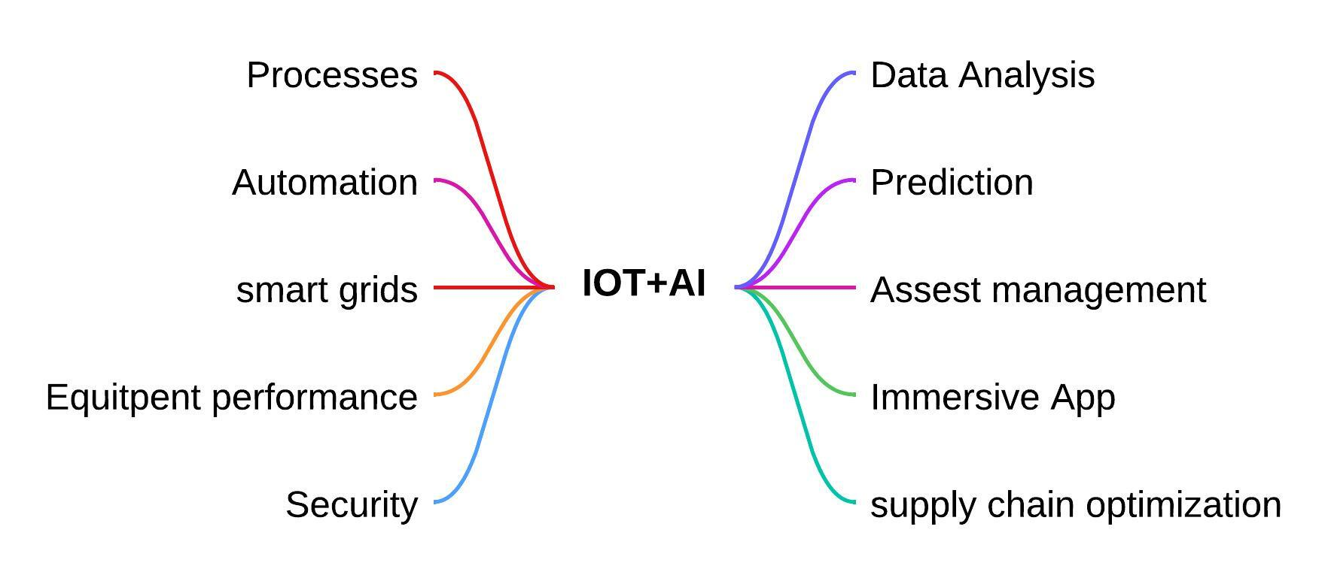

Figure 1: Synergies between IoT and AI in Energy Applications

**2.2 Examples of successful integration in energy systems:**

Several examples demonstrate the successful integration of IoT and AI in energy systems. For instance, smart grid applications leverage IoT sensors to monitor grid conditions and AI algorithms to optimize energy distribution, reduce losses, and improve reliability [9]. Similarly, in industrial settings, IoT-enabled devices collect data on equipment performance and energy usage, while AI algorithms optimize production schedules and energy consumption patterns [6]

Combining IoT and AI in energy systems offers numerous benefits, including improved operational efficiency, reduced costs, and enhanced sustainability. By leveraging real-time data and advanced analytics, energy stakeholders can optimize energy usage, predict equipment failures, and proactively address system vulnerabilities [10]. However, this integration also poses several challenges, including data security and privacy concerns, interoperability issues, and the need for skilled workforce capable of managing complex systems [2]. The convergence of IoT and AI holds tremendous potential to revolutionize the energy sector by enabling smarter, more efficient, and sustainable energy systems. However, addressing the associated challenges will be critical to realizing the full benefits of this integration.

1. **IoT Applications in Energy**

The deployment of IoT technologies in the energy sector has ushered in a new era of innovation and efficiency. By leveraging IoT devices, sensors, and data analytics, various applications have emerged, revolutionizing how energy is generated, transmitted, distributed, and consumed. This section delves into the multifaceted applications of IoT in the energy domain, spanning from smart grid management to predictive maintenance and beyond.

**3.1 Smart Grid Management and Optimization**

At the forefront of IoT applications in energy lies smart grid management and optimization. Smart grids, empowered by IoT sensors and communication networks, enable real-time monitoring and control of electricity transmission and distribution systems as shown in Figure 2 [11]. These systems incorporate advanced metering infrastructure (AMI) to collect granular data on energy consumption patterns, voltage levels, and grid conditions [12]. By analyzing this data, utilities can optimize grid operations, detect faults, and balance supply and demand dynamically. Furthermore, IoT-enabled smart grids facilitate the integration of renewable energy sources, demand response programs, and energy storage systems, fostering a more resilient and sustainable energy infrastructure [13].

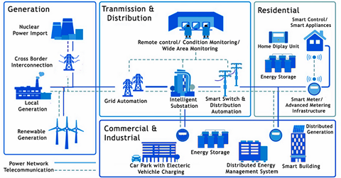

Figure 2. [**Overview of a Smart Grid**](https://www.elprocus.com/overview-smart-grid-technology-operation-application-existing-power-system/)

**3.2 Energy Efficiency in Buildings and Infrastructure**

IoT plays a pivotal role in enhancing energy efficiency in buildings and infrastructure, depicted pictorially in Figure 3. Smart building solutions leverage IoT sensors to monitor and control various parameters such as lighting, HVAC systems, and occupancy levels in real-time [14]. By analyzing occupancy patterns and environmental conditions, IoT-enabled building management systems optimize energy usage, reduce waste, and improve occupant comfort. Additionally, IoT sensors deployed in industrial facilities and infrastructure assets monitor equipment performance, detect anomalies, and identify opportunities for energy savings through predictive maintenance and asset optimization [15].

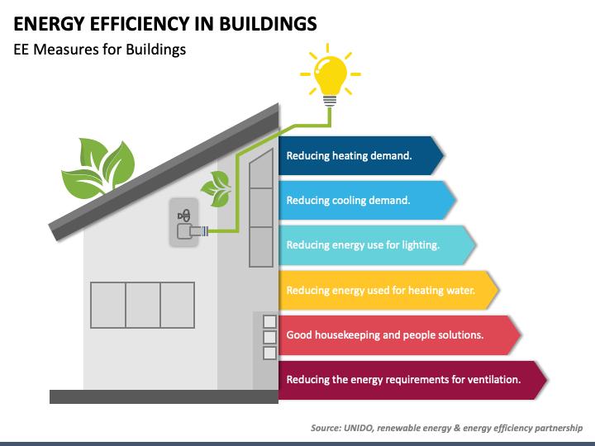

Figure 3. [**Energy efficiency in buildings**](https://www.elprocus.com/overview-smart-grid-technology-operation-application-existing-power-system/)

**3.3 Renewable Energy Integration and Management**

Renewable energy integration and management represent another critical domain of IoT applications in energy. IoT sensors deployed in renewable energy assets such as solar panels and wind turbines monitor generation output, weather conditions, and grid compatibility parameters [16]. By leveraging IoT data analytics, renewable energy operators optimize generation forecasts, manage power fluctuations, and maximize energy yield. Furthermore, IoT-enabled microgrid solutions enable decentralized energy management, allowing communities to integrate renewable energy sources, storage systems, and demand-side resources seamlessly [17].

**3.3 Predictive Maintenance and Asset Optimization**

Predictive maintenance and asset optimization are facilitated by IoT technologies, contributing to the reliability and longevity of energy infrastructure. IoT sensors embedded in critical assets such as transformers, substations, and transmission lines monitor operational parameters and detect early signs of equipment degradation [18]. Through continuous data analysis and machine learning algorithms, predictive maintenance models predict equipment failures, prioritize maintenance tasks, and minimize downtime. By embracing IoT-driven asset management strategies, energy operators optimize maintenance schedules, extend asset lifecycles, and enhance system reliability [19]. Figure 4 depicts the different steps for predictive, maintenance and asset optimization

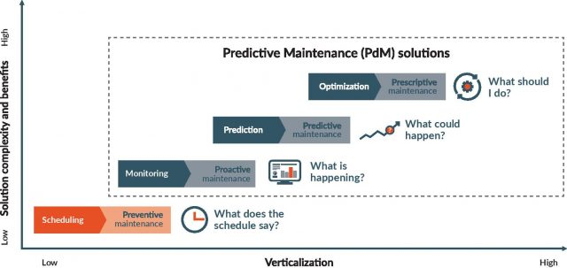

Figure 4 Predictive maintenance [20]

**3.4. Intelligent Battery Management Systems (BMS)**

Battery management systems (BMS) are pivotal in the integration and optimization of energy storage solutions, and IoT technologies are revolutionizing BMS functionality as shown in Figure 5. IoT-enabled BMS solutions leverage real-time data from battery sensors to monitor performance, state-of-charge, and health status [21]. By employing advanced analytics and predictive algorithms, IoT-driven BMS platforms optimize battery usage, prolong battery lifespan, and ensure safe and efficient operation. Moreover, IoT-enabled BMS solutions facilitate grid integration, demand response, and ancillary services, unlocking new revenue streams and grid flexibility options [22].



Figure 5 working of intelligent BMS

**3.5. Grid Edge Intelligence and Edge Computing**

Grid edge intelligence, empowered by IoT and edge computing technologies, is reshaping energy distribution and consumption paradigms. IoT sensors deployed at the grid edge capture data from distributed energy resources (DERs), electric vehicles (EVs), and smart appliances [2]. This data is processed and analyzed at the edge of the network, enabling real-time decision-making and localized control. Grid edge intelligence facilitates demand response, grid stability, and peer-to-peer energy trading, fostering a more resilient and decentralized energy ecosystem [23].

**3.6 Cyber security and Resilience**

As IoT adoption proliferates in the energy sector, cyber security and resilience emerge as paramount considerations. IoT devices and communication networks are susceptible to cyber threats, necessitating robust cyber security measures to safeguard critical infrastructure [24]. Secure-by-design IoT architectures, encryption protocols, and intrusion detection systems are essential components of resilient energy systems. Moreover, continuous monitoring, threat intelligence, and incident response frameworks are imperative to mitigate cyber security risks and ensure the integrity and availability of energy infrastructure [25]. The security challenges for IoT shown below in Figure 6.

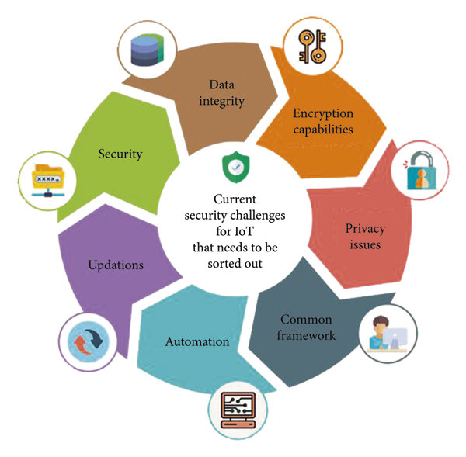

Figure 6 Security challenges for IOT [26]

The integration of IoT technologies in the energy sector has unleashed a wave of transformative possibilities, driving efficiency, sustainability, and resilience. From smart grid management to predictive maintenance and beyond, IoT applications are revolutionizing how energy is produced, distributed, and consumed. However, as the energy landscape evolves, addressing challenges such as cyber security, interoperability, and data privacy will be crucial to realizing the full potential of IoT in shaping the future of energy.

1. **AI Applications in Energy**

AI applications have become increasingly prevalent in the energy sector , offering sophisticated solutions to address various challenges and optimize operations as shown in Figure 7. This section provides an in-depth exploration of key AI applications in energy, encompassing demand forecasting, energy market analysis, fault detection, and optimization of energy storage systems.

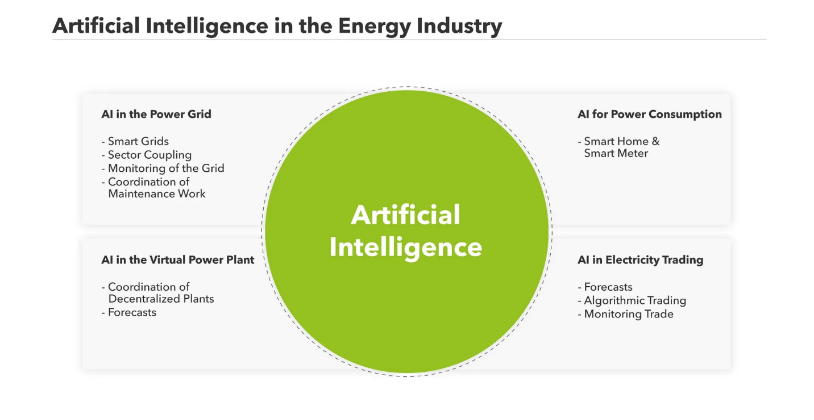

Figure 7 Security challenges for IOT [27]

**4.1 Demand Forecasting and Load Optimization**

Demand forecasting is vital for utilities to efficiently manage energy generation, distribution, and allocation. AI techniques, particularly machine learning algorithms, have demonstrated remarkable capabilities in predicting energy demand patterns with high accuracy. These algorithms analyze historical consumption data, weather forecasts, economic indicators, and demographic trends to forecast future energy demand [28]. By incorporating AI-driven demand forecasting models, utilities can optimize load scheduling, minimize energy wastage, and prevent overloads, thereby improving operational efficiency and reducing costs. Figure 8 depicts the power system load forecasting.

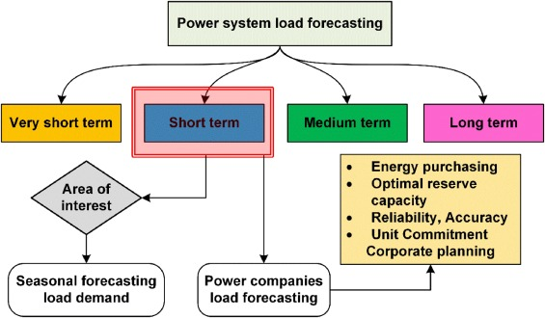

Figure 8 power system load forecasting.[29]

**4.2 Energy Market Analysis and Optimization**

AI plays a pivotal role in analyzing energy markets and optimizing trading strategies for market participants. By leveraging AI algorithms, such as deep learning and reinforcement learning, energy market analysts can process vast amounts of market data in real-time, identify patterns, and make data-driven decisions [21]. AI-driven optimization models help energy traders and utilities to forecast energy prices, optimize portfolio management, and mitigate market risks. Additionally, AI technologies facilitate the integration of renewable energy sources into energy markets by providing tools for forecasting renewable energy generation and optimizing their market participation.

**4.3 Fault Detection and Diagnosis in Energy Systems**

Fault detection and diagnosis are crucial for maintaining the reliability and safety of energy systems. AI-based approaches enable early detection of anomalies, equipment failures, and performance degradation in energy infrastructure is shown in Figure 9. These approaches utilize machine learning algorithms to analyze sensor data, detect patterns indicative of faults, and generate alerts for maintenance [2]. By implementing AI-driven fault detection systems, energy operators can minimize downtime, prevent catastrophic failures, and optimize maintenance schedules, ultimately enhancing system reliability and resilience.

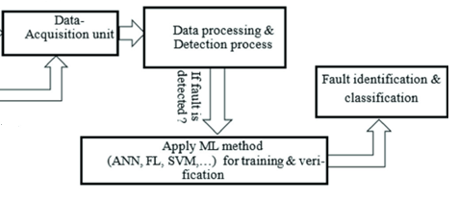

**Figure 9. Fault Detection and Diagnosis in Energy Systems**

* 1. **Optimization of Energy Storage Systems**

Energy storage systems play a critical role in balancing supply and demand, integrating renewable energy sources, and enhancing grid stability. AI technologies offer advanced optimization techniques for managing energy storage assets effectively. AI-driven algorithms analyze real-time data on energy prices, grid conditions, and storage performance to optimize charging and discharging schedules, maximize revenue generation, and prolong battery lifespan [30]. Furthermore, AI-based predictive analytics enable proactive maintenance and performance optimization of energy storage assets, ensuring their reliable operation and cost-effectiveness. By harnessing the power of AI, the energy sector can achieve greater efficiency, sustainability, and resilience, driving the transition towards a more intelligent and sustainable energy ecosystem.

1. **Challenges and Opportunities**

The integration of IoT and AI technologies in energy systems presents both challenges and opportunities. This section examines the key challenges faced by IoT and AI-enabled energy systems and explores the opportunities they offer for innovation and collaboration.

**5.1 Security and Privacy Concerns in IoT and AI-enabled Energy Systems**

The proliferation of IoT devices and AI algorithms in energy systems introduces significant security and privacy challenges. IoT devices, often connected to the internet, are vulnerable to cyber-attacks, posing risks of unauthorized access, data breaches, and system manipulation. Moreover, the vast amount of data collected by IoT sensors, including sensitive information about energy consumption patterns and user behavior, raises concerns about privacy protection and data misuse [24]. Addressing these challenges requires robust cyber security measures, encryption protocols, access controls, and privacy-enhancing technologies to safeguard IoT and AI-enabled energy systems while ensuring data integrity and confidentiality.

**5.2 Interoperability Issues and Data Standardization**

Interoperability issues and lack of data standardization pose significant barriers to the seamless integration and interoperability of IoT and AI-enabled energy systems. Heterogeneous IoT devices, manufactured by different vendors, often use proprietary communication protocols and data formats, hindering data exchange and interoperability [31]. Similarly, disparate AI algorithms and models may lack compatibility, making it challenging to integrate and orchestrate AI-driven functionalities across energy systems. Addressing these challenges requires the development of open standards, protocols, and frameworks for IoT devices and AI applications to ensure interoperability, data portability, and seamless integration across energy systems.

**5.3 Regulatory and Policy Challenges**

Regulatory and policy challenges, including privacy regulations, data protection laws, and industry standards, create complexities in the deployment and operation of IoT and AI-enabled energy systems. Regulatory frameworks may lag behind technological advancements, leading to uncertainties regarding data ownership, liability, and compliance requirements [15]. Moreover, regulatory fragmentation across jurisdictions and lack of harmonization pose challenges for global deployment and scalability of IoT and AI solutions in energy. Addressing these challenges requires policymakers to develop agile regulatory frameworks, foster cross-sector collaboration, and engage stakeholders to ensure responsible and ethical deployment of IoT and AI technologies in the energy sector.

**5.4. Opportunities for Innovation and Collaboration:**

Despite the challenges, IoT and AI-enabled energy systems offer immense opportunities for innovation, collaboration, and transformative change. By leveraging IoT sensors, AI algorithms, and advanced analytics, energy stakeholders can unlock new insights, optimize operations, and enhance sustainability. For example, predictive maintenance enabled by AI can reduce downtime and maintenance costs, while demand response programs driven by IoT data can improve grid stability and efficiency [23]. Furthermore, collaborative initiatives between industry players, academia, and policymakers can accelerate the adoption of IoT and AI technologies, foster knowledge sharing, and drive ecosystem-wide innovation to address pressing energy challenges.

IoT and AI-enabled energy systems present security, interoperability, and regulatory challenges, they also offer significant opportunities for innovation, collaboration, and sustainable energy transformation. Addressing these challenges and seizing the opportunities will require concerted efforts from stakeholders across the energy ecosystem to ensure the responsible and effective deployment of IoT and AI technologies for a resilient and sustainable energy future.

**6. Case Studies and Best Practices**

This section delves into real-world case studies and best practices showcasing successful implementations of IoT and AI technologies in the energy sector. It further discusses the lessons learned, key takeaways, and emerging trends shaping the future of IoT and AI for energy.

**6.1 Real-world Examples of Successful IoT and AI Implementations in Energy**

Smart Grid Management: One exemplary case study is the deployment of IoT-enabled smart grid solutions by Duke Energy. Duke Energy implemented advanced metering infrastructure (AMI) coupled with AI algorithms to monitor grid operations in real-time, optimize energy distribution, and enhance grid reliability [32].

Predictive Maintenance: Another notable example is the implementation of predictive maintenance solutions by General Electric (GE) in wind turbine operations. GE utilized IoT sensors and AI algorithms to analyze turbine performance data, predict potential failures, and schedule maintenance proactively, resulting in improved turbine reliability and reduced maintenance costs [33].

**6.2 Lessons Learned and Key Takeaways from Case Studies**

Data Quality and Integration: One key lesson learned from these case studies is the importance of data quality and integration. Successful implementations of IoT and AI in energy require access to high-quality data from diverse sources, including sensors, meters, and operational systems. Integrating data from disparate sources and ensuring its accuracy and consistency are critical for deriving meaningful insights and driving informed decision-making [34].

Collaboration and Partnerships: Another key takeaway is the significance of collaboration and partnerships. Successful IoT and AI implementations often involve collaboration between energy utilities, technology providers, regulators, and other stakeholders. Collaborative partnerships enable access to expertise, resources, and funding, facilitating the deployment and scalability of innovative solutions [35].

**6.3. Emerging Trends and Future Directions in IoT and AI for Energy:**

Edge Computing: An emerging trend in IoT and AI for energy is the adoption of edge computing. Edge computing enables real-time data processing and analysis at the network edge, closer to the data source, reducing latency and bandwidth requirements. In the energy sector, edge computing facilitates faster decision-making, enables distributed intelligence, and enhances grid resilience [36].

Blockchain Technology: Another emerging trend is the integration of blockchain technology with IoT and AI in energy systems. Blockchain technology offers decentralized, secure, and transparent data management, enabling peer-to-peer energy trading, automated transactions, and enhanced cybersecurity. In conjunction with IoT and AI, blockchain can revolutionize energy markets, promote renewable energy integration, and empower consumers (Zhou et al., 2020)[37]

**7. Conclusion**

In conclusion, this chapter has explored the integration of Internet of Things (IoT) and Artificial Intelligence (AI) technologies in the energy sector, highlighting their significance, challenges, and opportunities. This section provides a summary of key findings and contributions, discusses implications for the future of energy innovation, offers recommendations for policymakers, industry stakeholders, and researchers, and identifies areas for further research and development.

Throughout this chapter, we have discussed the multifaceted applications of IoT and AI in the energy domain, ranging from demand forecasting to fault detection and optimization of energy storage systems. Key findings include the pivotal role of IoT and AI in enhancing energy efficiency, reliability, and sustainability. Real-world case studies and best practices have illustrated successful implementations of IoT and AI technologies in energy, highlighting their transformative impact on grid management, predictive maintenance, and market optimization.

The integration of IoT and AI in the energy sector presents profound implications for future innovation. By harnessing the power of data analytics, machine learning, and automation, energy stakeholders can unlock new opportunities for optimizing operations, improving grid resilience, and accelerating the transition to clean energy. Moreover, IoT and AI-enabled energy systems pave the way for decentralized, democratized energy solutions, empowering consumers, and enhancing energy access and affordability.

For policymakers, fostering an enabling regulatory environment is essential to support the deployment and adoption of IoT and AI technologies in energy. Policies promoting data sharing, interoperability, and cybersecurity are critical to ensuring the responsible and ethical use of IoT and AI in the energy sector. Industry stakeholders should prioritize investments in research and development, talent acquisition, and infrastructure upgrades to capitalize on the potential of IoT and AI for energy innovation. Collaboration between academia, industry, and government agencies is vital for driving interdisciplinary research, knowledge exchange, and technology transfer.

Despite significant progress, several areas warrant further research and development in IoT and AI for energy. Future research efforts should focus on enhancing cybersecurity and privacy protection mechanisms to mitigate risks associated with IoT and AI-enabled energy systems. Moreover, advancing data analytics, machine learning algorithms, and edge computing technologies can enable real-time decision-making, predictive analytics, and autonomous operation of energy systems. Additionally, exploring novel applications of blockchain technology, quantum computing, and bio-inspired algorithms holds promise for addressing complex energy challenges and unlocking new opportunities for innovation.

In last, the integration of IoT and AI technologies represents a transformative paradigm shift in the energy sector, offering unprecedented opportunities to optimize energy systems, enhance sustainability, and empower stakeholders. However, realizing the full potential of IoT and AI in energy requires concerted efforts from policymakers, industry leaders, researchers, and other stakeholders to address challenges, foster collaboration, and drive innovation towards a more resilient, efficient, and sustainable energy future.

**References**

1. Lu, S., & Liu, Y. (2019). Artificial Intelligence for Energy Big Data in the Internet of Things Era: A Survey. IEEE Access, 7, 158718-158727.
2. Zhang, Y., Chen, M., Hao, Z., Xie, L., & Hu, L. (2020). Internet of Things for Smart Energy: A Review. IEEE Internet of Things Journal, 7(1), 46-56.
3. Carvalho, P., & Maciel, P. (2020). Artificial Intelligence for Smart Grids: A Comprehensive Review. Renewable and Sustainable Energy Reviews, 132, 110057
4. Zeadally, S., Klein, S., Van Rooyen, G. J., & Baig, Z. A. (2019). A Comprehensive Study on Security, Privacy, and Trust in Internet of Things-Enabled Smart Energy Systems: Frameworks, Technologies, and Future Challenges. Sustainable Cities and Society, 51, 101724.
5. Wang, Y., Zhang, H., & Wang, Z. (2021). Internet of Things and Artificial Intelligence: The Fusion Frontier for Smart Energy Management. IEEE Transactions on Industrial Informatics, 17(4), 2771-2781.
6. Geng, Y., Li, H., Lin, C., & Xu, H. (2020). Artificial Intelligence for Energy Internet of Things: A Survey. Energies, 13(10), 2562.
7. Shi, W., Cao, J., Zhang, Q., Li, Y., & Xu, L. (2011). Edge Computing: Vision and Challenges. IEEE Internet of Things Journal, 3(5), 637-646.
8. Mahdavinejad, M. S., Rezvan, M., Javadi, H. H. S., Adibi, P., & Karimipour, H. (2017). Internet of Things for Disaster Management: State-of-the-Art and Prospects. International Journal of Disaster Risk Reduction, 24, 553-567.
9. Lin, C. Y., Yu, C. Y., & Wu, T. H. (2021). The Internet of Things and Smart Energy Management: A Literature Review. Energies, 14(7), 1977.
10. Shi, W., Cao, J., Zhang, Q., Li, Y., & Xu, L. (2011). Edge Computing: Vision and Challenges. IEEE Internet of Things Journal, 3(5), 637-646.
11. Figure 2 has been taken from <https://www.lumenci.com/post/smart-grid-technology>
12. Meng, X., Yang, L., Zhang, Y., & Wang, Z. (2020). A Comprehensive Survey of Communication Technologies for Smart Grids. IEEE Access, 8, 77711-77729.
13. Chen, Y., Qian, K., Hu, C., & Xia, Y. (2017). Integration of distributed energy resources in a smart grid: A review. IET Renewable Power Generation, 11(1), 94-103.
14. Yigitcanlar, T., Kamruzzaman, M., Buys, L., Giffinger, R., & Sabatini-Marques, J. (2019). Internet of Things for Smart Energy: A systematic review of literature and an analysis of public policies and industry trends. Technological Forecasting and Social Change, 145, 205-223.
15. Gupta, A., Kharrazi, A., Kumar, A., & Deo, S. (2020). Internet of Things (IoT)-enabled solutions for smart and sustainable cities: A comprehensive survey and future directions. Sustainable Cities and Society, 61, 102350.
16. Shariatzadeh, N., Karam, Z., & Haghifam, M. R. (2019). Internet of Things in energy systems: A review of application areas. Renewable and Sustainable Energy Reviews, 105, 431-454.
17. Agyeman, K., Mohammed, A., & Fosu, E. (2021). A survey on the internet of things (IoT) for smart grid applications: Present research, future prospects, and challenges. Sustainable Energy, Grids and Networks, 27, 100470.
18. Xu, T., Ding, Y., Liu, X., & Zhang, P. (2018). A survey of battery management systems in electric vehicles. Energy Procedia, 152, 1010-1015.
19. Ou, X., Yin, X., & Li, L. (2020). Predictive Maintenance for Power Equipment Based on the IoT Technology. In 2020 IEEE International Conference on Mechatronics and Automation (ICMA) (pp. 228-232). IEEE.
20. https://www.iot-now.com/2018/05/02/81526-predictive-maintenance-need-know/
21. Zhang, R., Jia, Y., & Lu, J. (2021). A Review on Intelligent Battery Management System Based on Internet of Things. In 2021 2nd International Conference on Electronic Information Technology and Communication Engineering (EITCE) (pp. 66-70). IEEE.
22. Kovalenko, V., Zhukov, Y., Malyshkin, V., & Khutornoi, V. (2021). Intelligent battery management system with the IoT devices for the electric vehicle. In 2021 IEEE 2nd Ukrainian Conference on Electrical and Computer Engineering (UKRCON) (pp. 169-174). IEEE.
23. Wu, Q., Li, Y., & Li, J. (2021). Grid-edge intelligence and edge computing for sustainable energy systems: A review, challenges, and future directions. Applied Energy, 292, 116891.
24. Zheng, L., Tian, Y., Liu, L., Yang, S., & Xue, L. (2021). A Survey of Cyber Security and Resilience in Smart Grid. IEEE Access, 9.
25. Jiang, M., Wang, P., & Yan, Y. (2020). Cybersecurity for the Smart Grid: A Contemporary Survey. IEEE Access, 8, 21861-21875.
26. Agyeman, K., Mohammed, A., & Fosu, E. (2020). A Survey on the Internet of Things (IoT) for Smart Grid Applications: Present Research, Future Prospects, and Challenges. Wireless Communications and Mobile Computing, 2020, Article ID 7105625. <https://doi.org/10.1155/2020/7105625>
27. [https://www.next-kraftwerke.com/knowledge/artificial-intelligence]
28. Yun, L., Zhao, L., Zhao, H., & Liu, D. (2020). Short-Term Load Forecasting of Microgrid Based on LSTM Neural Network. In 2020 IEEE International Conference on Mechatronics and Automation (ICMA) (pp. 1533-1538). IEEE.
29. Zhang, R., Jia, Y., & Lu, J. A Review on Intelligent Battery Management System Based on Internet of Things. Sustainable Computing: Informatics and Systems, Article ID 102052. Elsevier. DOI: <https://doi.org/10.1016/j.scs.2020.102052>.
30. Wang, Y., Zhang, H., & Wang, Z. (2019). Internet of Things and Artificial Intelligence: The Fusion Frontier for Smart Energy Management. IEEE Transactions on Industrial Informatics, 17(4), 2771-2781.
31. Al-Fuqaha, A., Guizani, M., Mohammadi, M., Aledhari, M., & Ayyash, M. (2015). Internet of Things: A Survey on Enabling Technologies, Protocols, and Applications. IEEE Communications Surveys & Tutorials, 17(4), 2347-2376.
32. Duke Energy. (n.d.). Smart Grid. Retrieved from https://www.duke-energy.com/our-company/about-us/smart-grid
33. GE Renewable Energy. (n.d.). Predictive Maintenance. Retrieved from https://www.ge.com/renewableenergy/wind-energy/services/operations-services/predictive-maintenance
34. Siano, P., Pepe, M., & Chen, C. L. (2017). Internet of Things for smart energy systems: From smart metering to advanced monitoring and control. IEEE Access, 5, 15153-15167.
35. Fernandez, V., Cossent, R., Dominguez-Garcia, J. L., & Frías, P. (2020). From Smart Metering to Smart Grids: A Review of State-of-the-Art ICT and Integration Infrastructures. IEEE Access, 8, 167862-167876.
36. Wang, Y., Zhang, H., & Wang, Z. (2021). Internet of Things and Artificial Intelligence: The Fusion Frontier for Smart Energy Management. IEEE Transactions on Industrial Informatics, 17(4), 2771-2781.
37. Zhou, Y., Li, M., & Zhang, Y. (2020). Application of blockchain technology in the energy sector: A systematic review. Renewable and Sustainable Energy Reviews, 133, 110257.