**A comparative study of D-region ionospheric disturbances associated with Bulbul, Amphan and Yaas over the Bay of Bengal**

**Jyotirmay Pandit**

Department of Physics, JIS School of Polytechnic, Kalyani 741235, West Bengal, India

*jyotirmoy_pandit@rediffmail.com*

**Bipasa Raha**

Department of Physics, D. S. College, Katihar 854105, Bihar, India

*bipasa.raha@gmail.com*

**Debojyoti Halder\***

Department of Physics, R. B. C. Evening College, Naihati 743165, West Bengal, India

*debojyoti829@gmail.com*

* Corresponding Author

ABSTRACT

Here in this paper, we have done a combinatorial observation and a comparative study of D-region ionospheric disturbances associated with Very Severe Cyclonic Strom Bulbul happened in 2019, Super Cyclonic Strom Amphan in 2020 and Very Severe Cyclonic Storm Yash in 2021 over the Bay of Bengal. Also, the analysis of VIIRS High-Resolution IR Images of these three Cyclonic Storms in three consecutive years have been done to investigate the characteristics of the three tropical cyclones. To investigate the D-region ionospheric disturbances, 40 kHz atmospherics data as recorded over Kalyani (22.98°N, 88.46°E), West Bengal and analysed.

**Keywords –** Amphan, Bulbul, Yash, Tropical Cyclone, Ionospheric Disturbances.

# INTRODUCTION

India, a country surrounded by the Arabian sea in the West, the Indian Ocean in the South and the Bay of Bengal in the East, is most vulnerable to get hit by tropical cyclones in the basin, from the east or from the west. On an average, 2 or 3 tropical cyclones make landfall in India each year, with one being a severe tropical cyclone or greater. A tropical cyclone is a rapid rotating storm originating over tropical oceans from where it draws the energy to develop. It has a low-pressure centre and clouds spiralling towards the eyewall surrounding the "eye", the central part of the system where the weather is normally calm and free of clouds. Its diameter is typically around 200 to 500 km, but can reach 1000 km. A tropical cyclone brings very violent winds, torrential rain, high waves and, in some cases, very destructive storm surges and coastal flooding. In the Bay of Bengal and Arabian Sea, they are called "cyclone", in western South Pacific and southeast Indian Ocean, called “severe tropical cyclone” and in the southwest Indian Ocean, “tropical cyclone”. Depending on the maximum wind speed, tropical cyclones will be designated as follows:

(i) Tropical depression is when the maximum sustained wind speed is less than 63 km/h.

(ii) Tropical storm is when the maximum sustained wind speed is more than 63 km/h.

(iii) Hurricane, typhoon, tropical cyclone, very severe cyclonic storm - depending on the basin - when the maximum sustained wind speed exceeds 116 km/h.

In table 1, some classifications of tropical cyclones have been shown. In Figure 1, the plots for average seasonal cycles of tropical cyclones over the north Atlantic Ocean, eastern and central north Pacific Ocean, north and southwest Indian Ocean are shown. The abscissa spans the 13 months, December through January of the following year; the ordinate is the number of storms per hundred years. For each day, the graph shows the number of years that a cyclone was present (normalized per 100 years). The blue line represents all tropical cyclones (surface winds greater than 17 m s-1 or 34 knots); shading represents tropical cyclones of hurricane strength (surface winds greater than 33 m s-1 or 64 knots).

**Table 1. classification of tropical cyclones (https://public.wmo.int/)** 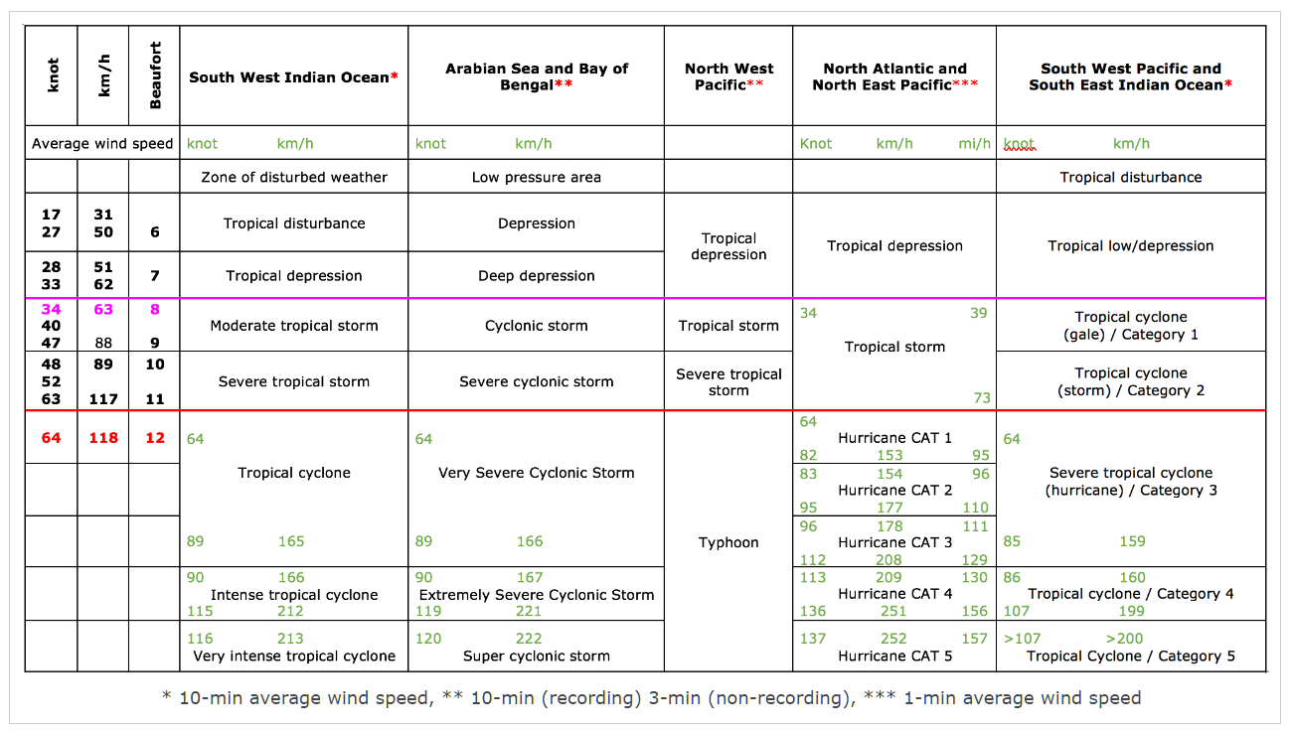

Very Severe Cyclonic Strom Bulbul, Super Cyclonic Strom Amphan and Very Severe Cyclonic Storm Yash in the last couple of years, all landfall in coastal area of Bay of Bengal and wreaked havoc in West Bengal, an eastern state in India [1-3].

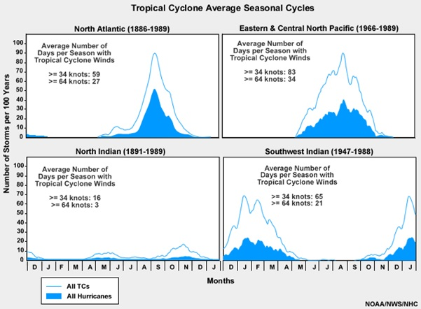

**Fig 1. Average annual cycle of tropical cyclone occurrence for each ocean basin (Image: NOAA Archive)**

1. **ORIGIN AND STRUCTURE OF TROPICAL CYCLONES**

The cloud greenhouse effect accelerates tropical cyclone development. Schematic depiction (Fig. 2) of how the trapping of infrared radiation by deep convective clouds leads to locally increased warming, and how this warming promotes the thermally direct transverse circulation of the tropical cyclone [4]. (a) An incipient storm, characterized by a weak, broad primary circulation. (b) An intensifying storm characterized by a well-defined eye and a strong primary circulation.

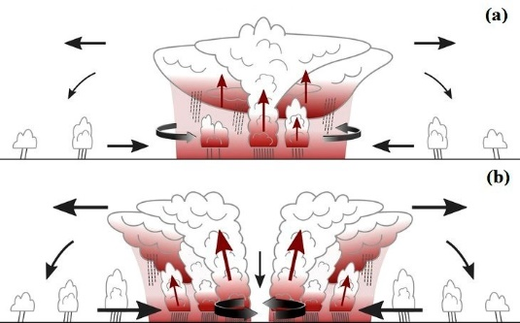

**Fig. 2 (a) An incipient storm, characterized by a weak, broad primary circulation. (b) An intensifying storm characterized by a well-defined eye and a strong primary circulation (Image: James h. Ruppert Jr. / Penn state news, May 24, 2021)**

Tropical Cyclones are warm core low pressure systems having a large vortex in the atmosphere, which is maintained by the release of latent heat by convective clouds that form over warm oceans. In the northern hemisphere, the winds in a cyclone blow anticlockwise in the lower troposphere and clockwise in the upper troposphere. However, in the southern hemisphere, the winds of the cyclone blow in the opposite direction i.e., clockwise in the lower levels and anticlockwise in the upper levels. A full-grown cyclone is a violent whirl in the atmosphere with 150 to 1000 km diameter and 10 to 15 km height. Gale winds of 150 to 250 kmph or more spiral around the centre of the low-pressure system with 30 to 100 hPa below the normal sea level pressure. In a fully developed cyclonic storm, there are four major components of horizontal structure viz. Eye, Wall cloud region, Rain/Spiral bands and Outer storm area. A schematic diagram is given in Fig 3.

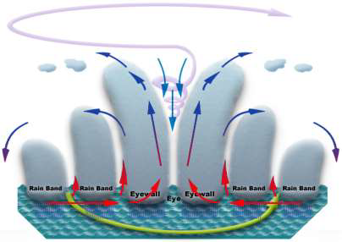

**Fig. 3. A schematic diagram of Eye, Wall cloud region, Rain/Spiral bands and Outer storm area**

**A. Cyclonic Eye**

The most spectacular part of a matured cyclonic storm is its 'eye', which forms at the centre of the storm inside a Central Dense Overcast region. The eye has a diameter of about 10 to 50 km, which is generally cloud free and is surrounded by thick wall clouds around it. It resembles an 'eye' when viewed in a satellite picture. It is a calm region with practically no rain. It is warmer than the surrounding region. The eye is generally seen when the storm is severe and the surface pressure falls below 980 hPa in the Indian Ocean areas. Sometimes, a double eye wall structure can also be seen when the storm becomes very intense.

**B. Wall cloud region or eye wall**

The eye is surrounded by a 10-15 km thick wall of convective clouds where the maximum winds occur. This is the most dangerous part of a cyclonic storm. The height of the wall goes up to 10 to 15 km. The intense convection in this wall cloud region produces torrential rain.

**C. Rain or spiral bands**

Beyond the eye wall region, the major convective clouds in a cyclonic storm, responsible for heavy rains, have a spirally banded structure. These spiral bands are sometimes hundreds of kilometres long and a few kilometres wide. The spiral bands are easily identifiable in radar and satellite pictures, as a number of thunderstorm cells are embedded in them that produce heavy rainfall. These spirals also continuously change places and orientation with respect to the centre and rotate around it.

1. **COMPARISON OF THE CHARACTERISTICS OF THE TROPICAL CYCLONES**

The three tropical cyclones have distinct features. They vary in their classifications but somehow some features are similar as they have occurred around the same time in three consecutive years around the same region. The dominant features of the three tropical cyclones are given in Table 2.

**Table 2 Dominant features of the tropical cyclones Bulbul, Amphan and Yaas**

|  |  |  |  |  |
| --- | --- | --- | --- | --- |
| **Name** | **Dates active** | **Peak classifi-cation** | **Date and time of severe cyclonic storm intensified** | **Dominant features** |
| BULBUL | 05 to 11 November, 2019 | Very Severe Cyclonic  Storm | Severe cyclonic storm intensified into a very severe cyclonic storm on 8 November 2019 at 05:30 IST | Crossed West Bengal Coast close to the Sunderban forest in West Bengal near 21.55°N/ 88.5°E during 20:30 IST to 23:30 IST with maximum sustained surface wind speed of 110-120 kmph gusting to 135 kmph on 9th November 2019 |
| AMPHAN | 16 to 21 May, 2020 | Super Cyclonic Storm | Severe cyclonic storm intensified into a very severe cyclonic storm on 17 May, 2020 at 14:30 IST, then intensified into an extremely severe cyclonic storm 18 May, 2020 at 02:30 IST, then intensified into a super cyclonic storm on 18th May, 2020 at 11:30 IST | Crossed West Bengal – Bangladesh coasts across Sundarbans, near lat. 21.65°N/ long. 88.3°E during 15:30 IST to 17:30 IST with maximum sustained surface wind speed of 155-165 kmph gusting to 180 kmph on May 20 2020. |
| YAAS | 23 to 27 May 2021 | Very Severe Cyclonic  Storm | Severe cyclonic storm intensified into very severe cyclonic storm on 25 May 2021 at 11:30 IST | Crossed in between Digha, West Bengal and North Odisha coastal area near Latitude 21.35°N and Longitude 86.95°E, about 20 km to the south of Balasore during 10:30 IST to 11:30 IST with maximum sustained surface wind speed of 130 -140 kmph, gusting to 155 kmph on May 26 2021. |

On May 24, 2021, the Moderate Resolution Imaging Spectroradiometer (MODIS) on board NASA’s Terra satellite acquired a true-colour image of Tropical Cyclone Yaas spinning in the Bay of Bengal heading towards landfall as a very severe cyclonic storm (Fig. 4a). MODIS on board NASA’s Aqua satellite also acquired true-colour image of Tropical Cyclone Amphan on May 16, 2020 (Fig. 4b) and Matmo, known locally as Bulbul on November 8, 2019 (Fig 4c) and at the time when they gathering strength in the Bay of Bengal as it was taking aim at India and Bangladesh. These three very large storms stretched across much of the Bay of Bengal, sporting a rounded shape with convective bands spiralling into a distinct circular eye and all features of a very strong system [5]. In our laboratory at Kalyani, West Bengal, we are operating round-the-clock sferics instrument at 40 kHz. The records of the instrument noted very interesting similar variations in the level during the whole jour-ney of all the three severe tropical cyclones. Also, The Visible Infrared Imaging Radiometer Suite (VIIRS) instrument captured a high-resolution infrared image of the three cyclones, indicating the storm's eye very prominently. VIIRS could only observe the cyclones twice a day. However, VIIRS produced in-frared imagery at 375-meter resolution.

|  |  |  |
| --- | --- | --- |
| Tropical Cyclone Yaas | amphan modi.jpg | bulbul modi.jpg |
| **Fig. 4a: NASA’s Terra satellite acquired a true-colour image of Tropical Cyclone Yaas over the Bay of Bengal on May 25, 2021** | **Fig. 4b: NASA’s Terra satellite acquired a true-colour image of Tropical Cyclone Amphan over the Bay of Bengal on May 16, 2020** | **Fig. 4c: NASA’s Terra satellite acquired a true-colour image of Tropical Cyclone Bulbul over the Bay of Bengal on November 8, 2019** |

1. **VISIBLE INFRARED IMAGING RADIOMETER SUITE (VIIRS) HIGH RESOLUTION IR IMAGES**

Most tropical cyclones form over remote ocean areas and are detected on satellite imagery. Local wind and/or surface pressure data are needed to estimate the damaging potential of cyclones. One technique, known as the Dvorak technique, uses digital infrared images. The upwelling IR radiation is a measure of the temperature of the cloud top, or, in the absence of clouds, the temperature of the Earth's surface and measure of atmospheric humidity. The more intense tropical cyclones is, the better-defined, clear, and dry the eye is due to subsidence and also the higher the cloud tops above the eyewall. So, more intense tropical cyclones have a higher IR 'blackbody' temperature in the eye, and a lower one over the eyewall [6-8]. Meteorological Satellite Centre of JMA, HIMAWARI Real-Time satellite imagery on November 8, 2019 at 15:30 IST reveal and impressive upper-level outflow pattern of very severe cyclonic storm Bulbul across the NW, SW and SE quadrants. While some drier air is present across the NE quadrant, the improving deep convection could also boost the intensity if this quadrant outflow develops a better pattern. 50kt radii expand 50-65 miles around the centre in all quadrants (Fig. 5a). Cooperative Institute for Meteorological Satellite Studies (CIMSS) satellite loop shows very severe cyclonic storm Bulbul nearing landfall in India on, Saturday Nov. 9, 2019 shown in Fig 5b.

|  |  |
| --- | --- |
|  | ir bulbul.png |
| **Fig. 5a: HIMAWARI Real-Time Satellite imagery on shows very severe cyclonic storm Bulbul on November 8, 2019** | **Fig. 5b: CIMSS satellite loop shows very severe cyclonic storm Bulbul on Nov. 9, 2019** |

When NASA-NOAA’s Suomi NPP satellite passed over tropical cyclonic storm Amphan on May 18 at 02:00 IST, infrared imagery revealed very cold cloud top temperatures and an obscured eye (Fig. 6a). The higher the cloud top, the colder it is, and the stronger the storm. The VIIRS instrument found several areas within where cloud top temperatures were as cold as minus 80 degrees Fahrenheit (minus 62.2 Celsius), indicating powerful storms. Storms with cloud tops that could have been found to generate heavy rainfall. Satellite imagery also revealed that the eyewall is open on the eastern side of the eye, indicative of the easterly vertical shear and mid-level dry air moving into the tropical cyclone. NOAA-20 VIIRS True Color Red-Green-Blue (RGB) and Infrared Window (11.45 µm) images as viewed on 18 May, 2020 at 12:30 IST (Fig. 6b) provided a more detailed view of tropical cyclonic storm Amphan shortly before the time of its peak intensity. CIMSS satellite loop Meteosat-8 Infrared Window (10.8 µm) images (Fig. 6c) showed super cyclonic storm Amphan during the period when it was rapidly intensifying to a Category 5 storm by 17:30 IST on 18 May 2020. In fact, Amphan became the strongest tropical cyclone on record in the Bay of Bengal basin.

|  |  |
| --- | --- |
| ir Amphan2.jpg | amphan ir final.png |
| **Fig. 6a: NASA-NOAA’s Suomi NPP satellite VIIRS instrument aboard captured cloud top temperatures using infrared light of super cyclonic storm Amphan on May 18 at 02:00 IST** | **Fig. 6b: NOAA-20 VIIRS True Colour RGB and Infrared Window*(11.45 µm)* image of super cyclonic storm Amphan as obtained on 18 May, 2020 at 12:30 IST** |
|  |  |
| ir Amphan.gif | |
| **Fig. 6c: Meteosat-8 Infrared Window*(10.8 µm)* images of super cyclonic storm Amphan as obtained on May 18, 2020 at 17:30 IST** | |

The Regional and Mesoscale Meteorology Branch (CIRA/RAMMB) of NOAA/NESDIS satellite captured imagery of very severe cyclonic storm Yaas in the Bay of Bengal on May 24, 2021 depicts a consolidating but broad, partly exposed low-level circulation with a wide swath of deep convective banding over the western semicircle of the system. The initial position is based on the broad but defined centre in the satellite imagery (Fig. 7a) and the initial intensity is based on the Dvorak estimate of T2.5 and 35 knots. A constellation of sub-meter resolution Earth observation satellites, SkySat captured sub-meter resolution imagery on 25 May 2021 of very severe cyclone, Yaas given in Fig. 7b. Meteorological Satellite Center of JMA, HIMAWARI Real-Time Satellite imagery, Cooperative Institute for Meteorological Satellite Studies (CIMSS) satellite loop, NASA-NOAA’s Suomi NPP satellite, The Regional and Mesoscale Meteorology Branch (CIRA/RAMMB) of NOAA/NESDIS satellite, Moderate Resolution Imaging Spectroradiometer (MODIS) on board NASA’s Terra satellite all captured imagery of the tropical cyclonic storms storm Bulbul, Amphan and Yaas with a view to investigate the characteristics of the cyclone in the Indian Ocean.

|  |  |
| --- | --- |
| yaas RAMBB.png | yaas skysat.jpg |
| **Fig. 7a: NOAA/NESDIS satellite imagery of very severe cyclone, Yaas in the Bay of Bengal on May 24, 2021** | **Fig. 7b: SkySat satellite imagery of very severe cyclone, Yaas in the Bay of Bengal on May 25, 2021** |

1. **TROPICAL CYCLONIC STORMS IN RELATION TO 40 KHZ ATMOSPHERICS**

In association with the three cyclones, we have analysed the effect on VLF atmospherics at 40 kHz to observe the characteristic variation in the atmospherics record during the whole journey of the of the three tropical cyclones showing that even when the severe cyclone was approaching from a sufficiently remote location towards West Bengal [8]. In our records, the intense swash and the associated variations in the atmospherics levels for the three tropical cyclones have observed are highly striking which appears to be linked with the concerned tropical cyclones and suggesting that the severe disturbances may be responsible to influence the D-layer of the ionosphere and thus may cause temporary problem in radio communication [10-12]. Atmospherics recorded at 40 kHz on 8 November 2019 when severe cyclonic storm Bulbul intensified into a very severe cyclonic storm (Fig. 8a), on 18th May, 2020 when extremely severe cyclonic storm Amphan intensified into a super cyclonic storm (Fig. 8b) and on 25 May 2021 when severe cyclonic storm Yaas intensified into very severe cyclonic storm (Fig. 8c).

|  |  |
| --- | --- |
| bulbul VLF.png | Amphan VLF.png |
| **(a)** | **(b)** |
| yaas vlf.png | |
| **(c)** | |

**Fig. 8: Variation of 40 kHz atmospherics recorded (a) on 8 November 2019 when severe cyclonic storm Bulbul intensified into a very severe cyclonic storm, (b) on 18th May, 2020 when extremely severe cyclonic storm Amphan intensified into a super cyclonic storm and (c) on 25 May 2021 when severe cyclonic storm Yaas intensified into very severe cyclonic storm.**

When the variations of sferics levels are examined, it appears that there are random fluctuations of the noise voltages with occasional sudden enhancement and rapid fall. This nature of constant fluctuations in the signal levels seems to be associated with the random changes of the electrical properties of the associated cyclones [13-15]. In the record we have demonstrated the pattern formed in the atmospherics level for a period of 1-1.5 hours only. In our round-the-clock record a similar pattern of rapid fluctuation with very occasional sudden enhancement was noticed almost throughout the whole journey of all the three severe tropical cyclones.

1. **CONCLUSION**

All the three tropical cyclones appeared and grew into powerful form which finally made landfall in coastal area of West Bengal. The satellite’s spatial resolution affects the observed brightness temperature, along with certain other factors. It has been seen that a warm eye is related to a lack of clouds in or covering up the eyes. As under the situation, the eyes are large enough to see all the way to the surface at the viewing angle of satellites, the satellites having large spatial resolution for identifying pixels that does not contain cloud and the underlying sea surface temperature. Powerful, slow-moving storms may churn the waters sufficiently for mixing cooler water from the thermocline up into the surface layer and thus reducing the sea surface temperature. The sea surface temperature may also be lowered by heavy rains and cloud cover from the storms. The warm water was deep enough to not mix too much cool water from below by a well-known process called upwelling. In association with the cyclones, VLF atmospherics at 40 kHz represents the characteristic variation in the atmospherics record at Kalyani, West Bengal. The record shows a typical pattern during the whole period after an initial sudden enhancement. Under this continued disturbed condition of the atmosphere, the level of the atmospheric noise fluctuates and the duration of the fluctuations varies from small to large values [16-18]. This indicates that the severe disturbances causing the cyclones may be responsible to influence lower ionospheric layers and thus may cause temporary problem in radio communication. The intense swash and the associated variations in the atmospherics levels for the three tropical cyclones have observed are highly striking which appears to be linked with the concerned tropical cyclones and to be associated with the random changes of the electrical properties of the associated cyclones.

**ACKNOWLEDGEMENTS**

The Regional and Mesoscale Meteorology Branch (CIRA/RAMMB) of NOAA/NESDIS satellite imagery, Moderate Resolution Imaging Spectroradiometer (MODIS) on board NASA’s Terra satellite, all captured imagery has been utilized partly in the present study. Acknowledgement is also due to India Meteorological Department for using some of their data, reports, bulletin available in the IMD web.

**REFERENCES**

1. Super Cyclonic Storm “AMPHAN” over the southeast Bay of Bengal (16th – 21st May 2020): Summary, Regional Specialized Meteorological Centre tropical Cyclones, New Delhi, India Meteorological Department.
2. Very Severe Cyclonic Storm “BULBUL” over the Bay of Bengal (05th – 11th November 2019): Summary, Regional Specialized Meteorological Centre tropical Cyclones, New Delhi, India Meteorological Department.
3. The Cyclonic Storm “Yaas‟ over East-central Bay of Bengal has intensified into a Severe Cyclonic Storm, India Meteorological Department BULLETIN, Dated 25/05/2021, Ministry of Earth Sciences.
4. T. L. Olander and C. S. Velden, “The Advanced Dvorak Technique (ADT) for Estimating Tropical Cyclone Intensity: Update and New Capabilities. Wea. Forecasting”, vol. 34, pp. 905–922, 2019.
5. Cyclone warning in India, “standard operation procedure”, India meteorological department, Ministry of earth sciences, Government of India, March 2021.
6. A. B. Bhattacharya, J. Pandit and R. Bhattacharya, “Rare Super Cyclone Phailin in the Indian Ocean: Analysis of VIIRS High-Resolution IR Images and 40 kHz Spherics Data,” Earth, Moon, and Planets, vol. 113, pp. 43–51, 2014.
7. C. E. Barnes, and G. M. Barnes., “Eye and eyewall traits as determined with the NOAA wp-3d lower-fuselage radar”, Mon. Wea. Rev., vol. 142, pp. 3393–3417, 2014.
8. S. R. Kalsi, “Use of Satellite imagery in tropical cyclone intensity analysis and forecasting”, Meteorological Monograph, cyclone warning division No.1/2002, India Meteorological Department, New Delhi-110003, India, 2002.
9. R. Bhattacharya, “Characteristics of Tropical Cyclonic Storm Phailin as Derived from Satellite and Atmospherics Observations”, International Journal of Electronics & Communication Technology, vol. 5, pp. 56, 2014.
10. J. Callaghan, and R. K. Smith, “The relationship between maximum surface wind speeds and central pressure in tropical cyclones”, Aust. Meteor. Mag. Vol. 47, pp. 191-202, 1998.
11. A. K. Sen, S. K. Sarkar, and A. B. Bhattacharya, “Fading of VLF atmospherics associated with torrential rain due to monsoon depression”, Mausam, vol. 23, pp.51, 1982.
12. A. B. Bhattacharya, and J. Pandit, “The Ionosphere and its Transient Variations”, LAP Lambert Academic Publishing, 2013.
13. R. R. Chen, D. L. Boyer, D.L., and L. Tao, “Laboratory Simulation of Atmospheric Motions in the Vicinity of Antarctica”, Journal of the Atmospheric Sciences, vol. 50, pp. 4058, 1993.
14. D. Hanley, J. Molinari, and D. Keyser, “A Composite Study of the Interactions between Tropical Cyclones and Upper-Tropospheric Troughs”, Monthly Weather Review (American Meteorological Society), vol. 129, pp. 2570, 2001.
15. R. Hart, and J. Evans, “Synoptic Composites of the Extratropical Transition Lifecycle of North Atlantic TCs as Defined Within Cyclone Phase Space”, American Meteorological Society, 2003.
16. I. Samiljanic, “A case study of SuCS, AMPHAN using Meteosat-8 & Himawari-8 data”, 2020.
17. C. Lang, and J. D. Ryder, “The Effect of Tropical Cyclones on Climate Change Engagement”, Climatic Change, vol. 135(3), pp.625-638, 2016.
18. C. Yassine, “Indian Ocean Tropical Cyclones and Climate Change”, Springer, 2010.