Harnessing Artificial Intelligence and Machine Learning for Sustainable Agriculture Transformation

**Abhishek Upadhyay1\***

Ph.D. Scholar, Department of Farm Machinery and Power Engineering,

ICAR – Central Institute of Agricultural Engineering,

Bhopal, Madhya Pradesh, India.

Email: [abhiupadhyay7798@gmail.com](mailto:abhiupadhyay7798@gmail.com)

**Prem Veer Gautam 2\***

Scientist, Agricultural Engineering and Renewable Energy Division,

ICAR – Central Arid Zone Research Institute,

Jodhpur, Rajasthan, India.

Email: [veerpremgautam@gmail.com](mailto:veerpremgautam@gmail.com)

**Prabhakar Shukla 3**

Research Associate, AICRP on EAAI,

ICAR – Central Institute of Agricultural Engineering,

Bhopal, Madhya Pradesh, India.

**Ravi Kumar Sahu 4**

Ph.D. Scholar, Department of Farm Machinery and Power Engineering,

ICAR – Central Institute of Agricultural Engineering,

Bhopal, Madhya Pradesh, India.

**Aman Kumar 5**

Ph.D. Scholar, Department of Agricultural Processing and Food Engineering,

ICAR – Central Institute of Agricultural Engineering,

Bhopal, Madhya Pradesh, India.

**Umashanker 6**

Ph.D. Scholar, Department of Soil and Water Conservation Engineering,

ICAR – Central Institute of Agricultural Engineering,

Bhopal, Madhya Pradesh, India.

**Bhupendra Ghritalahre 7**

Ph.D. Scholar, Department of Farm Machinery and Power Engineering,

ICAR – Central Institute of Agricultural Engineering,

Bhopal, Madhya Pradesh.

**Amit Prasad 8**

Ph.D. Scholar, Department of Soil and Water Conservation Engineering,

ICAR – Central Institute of Agricultural Engineering,

Bhopal, Madhya Pradesh, India.

**Sheikh Mukhtar Mansuri 9**

Scientist, Agricultural Engineering and Renewable Energy Division,

ICAR – Central Arid Zone Research Institute,

Jodhpur, Rajasthan, India.

**ABSTRACT**

Computers that are frequently configured to think and behave like people are considered to be Artificial Intelligence (AI) simulations of human intelligence. Computer programming and sophisticated software for mobile devices that is appropriate for agricultural user behaviour are also included. Agricultural activities in the future will be heavily reliant on artificial intelligence. Agricultural methods will become more automated as a result, and self-learning algorithms will be developed. AI-based apps will handle several important agricultural tasks, such as preparing the seedbed, sowing and transplanting, weeding, spraying, harvesting, threshing, and transporting. Currently, in its infancy, this technology will automate all of the aforementioned farm procedures with time and capital investment, resulting in lower manufacturing costs and more efficient input utilization. Similar to how other fields are developing, the Internet of Things (IoT) in agriculture is also changing due to advancements in robotics, computer-based imaging systems, Global Positioning System (GPS) and Remote Sensing (RS) technologies, and Unmanned Agricultural Vehicles (UAVs). The agricultural industry has now been affected by the AI and machine learning (ML) revolution that has changed many other industries. Many technologies are being developed by businesses to facilitate farmers' crop and soil health monitoring. The two most advanced AI-based technologies that can guarantee crop health are computer vision-based imaging and robotics. These AI-driven solutions gather more accurate and comprehensive data on crop health for study.

**Keywords-**Artificial Intelligence, Internet of Things, Machine Learning, Sustainable Agriculture, Agricultural Robotics.

**I. INTRODUCTION**

In the modern era, agriculture stands at the intersection of tradition and innovation, facing the dual challenges of feeding a burgeoning global population while simultaneously confronting environmental sustainability concerns. The advent of Artificial Intelligence (AI) and Machine Learning (ML) technologies has emerged as a beacon of hope for the agricultural sector, offering unprecedented opportunities to revolutionize traditional practices, enhance efficiency, and foster sustainability [1]. In recent years, the fusion of ML with AI in agriculture has garnered significant attention as a potential game-changer for the industry. This convergence of cutting-edge technologies offers unprecedented opportunities to address the myriad challenges facing modern agriculture, ranging from climate change and resource scarcity to food security and sustainability [2]. By leveraging AI and ML algorithms, farmers and agricultural stakeholders can glean extensive data to provide insightful conclusions, optimize production processes, and make informed decisions that enhance productivity, profitability, and environmental stewardship [3].

The concept of precision agriculture lies at the heart of this technological revolution, wherein AI-driven algorithms meticulously analyze an array of data inputs – ranging from satellite imagery and drone surveillance to soil sensors and weather forecasts. These insights enable farmers to make informed decisions in real time, optimizing resource allocation, minimizing waste, and maximizing yields [4]. By transcending the limitations of human perception, AI empowers farmers to detect subtle patterns, predict trends, and take proactive measures to resolve possible problems before they worsen – thereby enhancing productivity while reducing environmental impact [5]. Moreover, AI and ML technologies hold immense potential in the realm of crop management and protection. Advanced algorithms can identify and classify crop diseases, nutrient deficiencies, and pest infestations with unparalleled accuracy, enabling targeted interventions and minimizing the need for broad-spectrum pesticides [6]. Through the deployment of AI-powered drones and robotic systems, farmers can undertake precise, site-specific applications of agrochemicals, conserving resources and mitigating the ecological footprint of agriculture [7]. Furthermore, the predictive capabilities of AI and ML are reshaping the agricultural landscape by enabling stakeholders to anticipate market trends, forecast yields, and optimize supply chain logistics [8]. By leveraging historical data, climate models, and consumer preferences, these technologies empower farmers to make strategic decisions regarding planting schedules, crop selection, and distribution channels – thereby enhancing profitability and resilience in an ever-evolving market environment [9].

This chapter examines how AI and ML are changing farming practices and creating a more sustainable and resilient agricultural future. From precision agriculture and crop monitoring to predictive analytics and robotic farming, the possibilities presented by AI and ML are as diverse as they are transformative.

**II. FOUNDATIONS OF ARTIFICIAL INTELLIGENCE (AI) AND MACHINE LEARNING (ML)**

A paradigm change in the execution and administration of agricultural operations is brought about by AI and ML. This section serves as a foundational exploration of these technologies, delving into their theoretical underpinnings, fundamental concepts, and their evolution within the agricultural domain [10].

**A. Theoretical underpinnings of AI and ML:**

At its core, AI describes how computers may mimic human intellectual functions as perception, learning, reasoning, problem-solving, and natural language comprehension. As a branch of artificial intelligence, machine learning entails creating algorithms that let computers analyze, interpret, and anticipate data in order to make judgements.

The theoretical foundations of AI and ML encompass various disciplines, including mathematics, statistics, computer science, and cognitive psychology. ML algorithms are composed of fundamental ideas including Bayesian inference, decision trees, neural networks, and support vector machines. Understanding these concepts is crucial for developing and deploying AI-based solutions in agriculture [11].

**B. Agricultural AI and ML evolution**

Technological breakthroughs have fueled a slow but steady process of integrating AI and ML into agriculture, the availability of data, and the need to address the industry's complex challenges. Initially, AI and ML applications in agriculture focused on simple tasks such as yield prediction and pest monitoring. However, with the proliferation of sensor technologies, drones, and satellite imagery, the scope and sophistication of AI-driven solutions in agriculture have expanded significantly [12].

Today, AI and ML are being used across various domains within agriculture, including precision agriculture, crop monitoring, predictive analytics, and robotic farming. With the potential to completely transform farming practices, these technologies could result in higher productivity, sustainability, and efficiency.

**C. Key Concepts, Algorithms, and Techniques**

Within the realm of AI and ML, there exist numerous algorithms and techniques that are particularly relevant to agriculture. Supervised learning algorithms, such as linear regression and random forests, are frequently employed for yield prediction and crop classification operation. Unsupervised learning algorithms, such as clustering and dimensionality reduction, are employed for anomaly detection and pattern recognition in agricultural data.

Image identification, natural language processing, and time-series forecasting are popular agricultural applications of deep learning, a subset of ML that uses neural networks with numerous layers. Convolutional Neural Networks (CNN) are ideal for crop health monitoring and pest detection using satellite and drone images. Reinforcement learning, another branch of ML, has the potential to revolutionize autonomous agricultural systems by enabling machines to learn optimal decision-making strategies through trial and error [13].

**III. PRECISION AGRICULTURE: REVOLUTIONIZING CROP MANAGEMENT**

Precision agriculture leverages AI and ML to optimize resource use, agricultural production, and environmental effect. This section delves into the transformative role of precision agriculture in revolutionizing crop management and explores how AI and ML are being harnessed to drive efficiency and sustainability in agricultural operations [14].

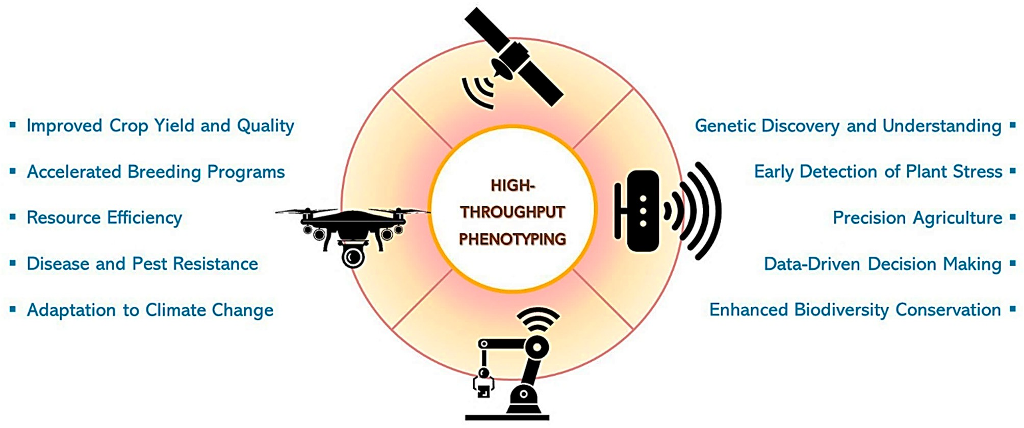

**Figure 1: Agricultural importance of high throughput phenotyping [15].**

**A. Role of precision agriculture in optimizing resource utilization**

Traditional farming methods apply water, fertilizers, and pesticides blanketly, resulting in inefficiency and environmental devastation. Precision agriculture, on the other hand, involves the precise application of inputs based on real-time data and analysis, tailored to the specific needs of individual plants or sections of the field. By optimizing resource utilization, precision agriculture helps farmers reduce input costs, minimize environmental pollution, and improve overall farm profitability. AI and ML play a crucial role in this process by analyzing data from various sources, including sensors, drones, satellites, and weather stations, to provide actionable insights for decision-making [16].

**B. Integration of sensor technologies, drones, and satellites for data collection**

Decision-making in precision agriculture is mostly dependent on data collection and interpretation. Sensor technologies embedded in the soil, plants, and equipment give current information on crop health, nutritional levels, and soil moisture, and machinery performance. High-resolution images of fields are being captured by drones fitted with cameras and sensors, which enables farmers to keep an eye on crop health, identify pests and diseases, and evaluate how well irrigation and fertilization techniques are working [17]. A macroscopic perspective of a whole farm area can be obtained by satellite imaging, allowing farmers to track crop development, identify irregularities, and identify areas of interest for further investigation [18]. The integration of these data sources into AI and ML algorithms facilitates the generation of actionable insights for precision agriculture applications.

Smart farming, based on the Internet of Things (IoT), enables farmers to employ intelligent technology in their fields to reduce energy waste and boost productivity. It renders conventional farming methods obsolete and provides farmers more autonomy. Business Insider estimated in 2015 that there will be 30 million IoT devices in use in agriculture, and by 2050, there will be 4.1 million daily IoT-connected farm-generated data sets. Farmers may use real-time data from IoT to make better decisions about crop production. In difficult-to-reach areas, a drone used for pesticide spraying reduces labour expenses, and soil monitoring boosts output. Smart farming includes modern IoT-based irrigation, automation, pest control, crop development monitoring and management, and insect population control. This farming gathers, keeps track of, and manages agricultural data. data produced by machines via satellites, unmanned aerial vehicles, or remote sensing. Many farm tasks may be measured and recorded with the use of sensors and other smart technology [19]. For computer processing, the data can be used as IoT presently. The trust that consumers have in agricultural products is increased via a traceability system. Smart farming has sensors built in to collect eco-data. Dairy smart technologies include daily health maintenance, milking, feeding, and management automation. Seedlings, water levels, and soil plots are all monitored via IoT in precision farming. IoT and advanced technical analysis can make use of images, sounds, graphical patterns, and wavelengths [14].

**C. Applications of AI and ML in Precision Agriculture**

AI and ML algorithms are deployed across a range of precision agriculture applications as shown in Fig. 2, including:

* Yield prediction: Machine learning models examine past agricultural yield data, weather conditions, soil properties, and management practices to predict future yields and optimize production strategies.
* Variable rate application: AI algorithms generate prescription maps that guide the variable use of inputs based on geographic heterogeneity within fields, such as water, herbicides, and fertilizers.
* Crop health monitoring: ML models analyze imagery from drones and satellites to find indications in crops of disease, stress, or nutrient deficits, enabling early intervention and targeted treatments.
* Weed and pest management: AI-powered systems identify and classify weeds and pests in fields, enabling targeted spraying or mechanical removal, thereby minimizing the use of chemical inputs.

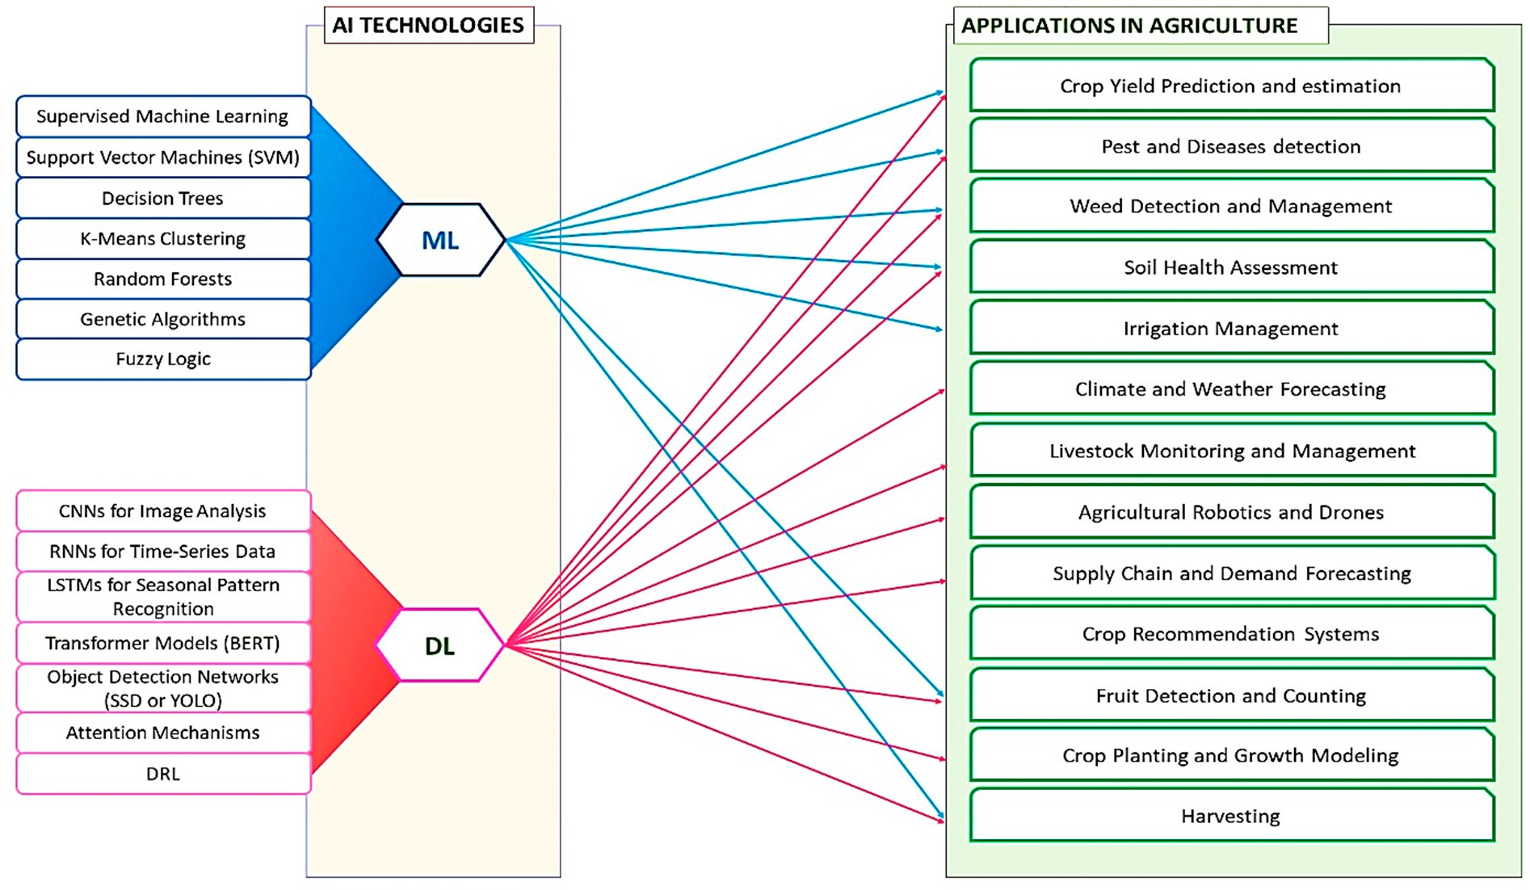

**Figure 2: Application of AI in precision Agriculture [20].**

**IV. CROP MONITORING AND MANAGEMENT: ENHANCING YIELD AND QUALITY**

Crop monitoring and management are fundamental aspects of agricultural operations, crucial for ensuring optimal yields, crop health, and quality. This section discusses how AI and ML are changing crop monitoring and management, allowing farmers to make data-driven decisions and optimize yield.

**A. Importance of early detection and intervention in crop health management**

Early identification and action are critical for mitigating the impact of pests, diseases, and nutrient deficiencies on crop health and yield. Traditional methods of crop monitoring often rely on visual inspection, which may not be timely or accurate enough to detect subtle signs of stress or disease [21]. AI and ML technologies offer a more proactive approach by examining information from many sources, such as satellite images, drones, and sensors, to identify potential threats early on. Farmers can use AI and ML systems to identify changes in crop health indicators such as chlorophyll levels, leaf coloration, and growth patterns, enabling timely intervention to mitigate the spread of pests or diseases and prevent yield losses [22]. Additionally, ML models can analyze historical data to identify patterns and trends indicative of specific pest or disease outbreaks, providing valuable insights for preventive measures.

**B. AI-driven systems for disease and pest detection**

Machine learning techniques are employed by AI-driven systems for the identification of diseases and pests to evaluate sensor data and pictures for signs of stress, damage, or infestation in crops [23]. Large datasets of crop photos can be used to train Convolutional Neural Networks (CNN) to identify patterns linked to certain pests or diseases, allowing for automatic detection and categorization [24].

Farmers can more effectively tailor treatments when they detect areas of concern at an earlier stage. They can work at scale, analyzing large volumes of data collected from drones, satellites, and ground-based sensors to deliver immediate information about the health condition of crops. These systems are driven by artificial intelligence. This reduces the need for broad-band pesticide applications and minimizes the impact on the environment [25].



**Figure 3: AI driven management system for advanced agriculture [26].**

**C. Monitoring soil conditions and nutrient levels using ML algorithms**

In addition to monitoring crop health, ML algorithms can analyze soil data to assess nutrient levels, pH balance, and other soil properties that influence plant growth and development. Soil sensors and probes provide real-time measurements of soil parameters, which are then fed into ML models to generate recommendations for fertilization and soil amendment strategies [27]. By optimizing nutrient management practices, farmers can improve crop yields, enhance nutrient uptake efficiency, and reduce fertilizer runoff and leaching. ML-based soil fertility mapping techniques can also identify areas of the field with nutrient deficiencies or excesses, enabling targeted application of fertilizers to address specific crop requirements [28].

Numerous real-world examples demonstrate the efficacy of AI and ML-based crop monitoring and management solutions in improving production outcomes and farm profitability. In a study by authors [28], Based on past data, environmental variables, and crop requirements, a machine learning model was created to forecast soil nutrient levels. The great accuracy of the model in forecasting nutrient excesses and shortfalls allowed for timely adjustments to fertilizer application rates. Researchers [29] proposed a system that uses three machine learning techniques—Random Forest (RF), Support Vector Machine (SVM), and Multiple Linear Regression (MLR)—to forecast the three critical components of soil fertility (OM, K2O, and P2O5). They gather 400 soils from the Moroccan centre of Doukala. Texture, carbonates, and cation exchange capacity were shown to be the main parameters that had a substantial impact on the prediction of OM, P2O5, and K2O. A model for recommending fertilizer was also suggested by them.

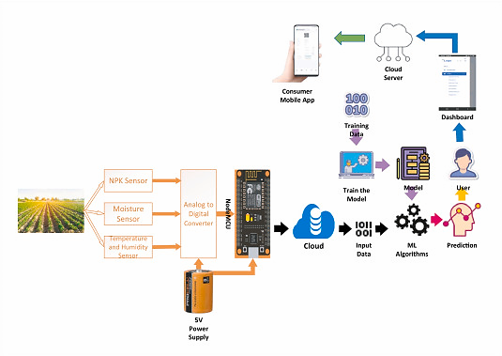

**Figure 4:  An inventive ML-enabled Internet of Things device for tracking soil nutrients [27].**

**V. PREDICTIVE ANALYTICS: FORECASTING YIELDS AND MARKET TRENDS**

Predictive analytics represents a powerful tool for farmers and agricultural stakeholders, enabling them to forecast crop yields, anticipate market trends, and make informed decisions that optimize production and maximize profitability. This section discusses how ML and AI developments are transforming agriculture and the revolutionary role that predictive analytics plays in it for yield prediction, demand forecasting, and inventory management.

**A. Leveraging historical data for yield prediction**

Yield prediction is a critical aspect of agricultural planning, allowing farmers to estimate future production levels and make knowledgeable choices about marketing tactics, resource allocation, and crop management techniques [30]. Time-series forecasting, regression analysis, machine learning algorithms, and other predictive analytics techniques use past information on crop yields, weather, soil characteristics, and management strategies to produce precise forecasts of future yields [31].

Machine learning algorithms excel at evaluating huge and complicated datasets to find patterns and relationships that statistical methods may miss. SVM, RF, and Neural Networks (NN) may be trained on past yield data to create forecasting models that incorporate crop growth and development trends and dynamics [32]. Weather stations, satellite imaging, and IoT sensors can be used in predictive analytics models to account for temperature, precipitation, soil moisture, and nutrient levels, which affect crop yields. The holistic approach to yield prediction helps farmers foresee difficulties and opportunities and change their management strategies.

**B. AI and ML models for inventory control and demand forecasting**

Demand forecasting is another critical aspect of agricultural planning, enabling farmers and agribusinesses to anticipate market trends, plan production schedules, and optimize inventory management [33]. Long Short-Term Memory (LSTM) network, Recurrent Neural Network (RNN), and Gradient Boosting Machine (GBM) can capture complicated features and dependencies in time-series data, making them ideal for demand forecasting. ML models can estimate agricultural demand and supply by training on past sales data and adding external factors like economic indicators, weather, and marketing activities [34].

Predictive analytics models can also optimize inventory control by offering perceptions into stock levels, stockouts, and replenishment strategies. By forecasting future demand and identifying potential supply chain bottlenecks, predictive analytics models enable farmers and agribusinesses to reduce carrying costs, maximize inventory levels, and guarantee prompt product delivery to customers [35].

**C. Impact of predictive analytics on farm profitability and sustainability**

The adoption of predictive analytics in agriculture has profound implications for farm profitability and sustainability. By providing accurate forecasts of crop yields and market demand, predictive analytics enables farmers to optimize production schedules, allocate resources efficiently, and minimize waste. By anticipating potential challenges such as weather fluctuations, pest outbreaks, and market volatility, predictive analytics models enable farmers to implement proactive measures to mitigate risks and maximize returns [36].

Moreover, predictive analytics can enhance sustainability by promoting more efficient use of resources and reducing environmental impact. By optimizing irrigation schedules, fertilization practices, and pesticide applications, predictive analytics models enable farmers to minimize inputs while maximizing yields, leading to more sustainable farming practices. By optimizing inventory management and supply chain logistics, predictive analytics models reduce waste and minimize the carbon footprint of agricultural operations [37].

Numerous case studies exemplify the transformative impact of predictive analytics on farm profitability and sustainability. For example, researchers [38] in 2021 examined how AI manages agricultural supply chain risks. AI and Supply Chain Risk Mitigation (SCRM) in Indian agro-industries are the subject of their work. According to the Technology, Organization, And Environment (TOE) framework, process factors, information sharing, and supply chain integration strongly influence AI adoption. AI's positive impact on SCRM is evident, showcasing its potential in mitigating supply chain disruptions. This study underscores the importance of AI in enhancing the resilience and adaptability of agricultural supply chains in the face of global challenges. Similarly, authors [39] discuss the way in which digitization has affected the supply chain, emphasizing the function of technical instruments like blockchain, cloud computing, IoT, AI, and big data. Streamlining routes, anticipating demand, tracking shipments, and quickly adapting to changes are all benefits of these digital advances that are increasing supply chain efficiency.

**VI. WEED AND PEST CONTROL: TARGETED INTERVENTIONS FOR SUSTAINABLE PEST MANAGEMENT**

Weeds and pests pose significant challenges to agricultural productivity, causing yield losses, reducing crop quality, and increasing production costs. Conventional weed and pest control techniques frequently apply chemical pesticides and herbicides widely, which might have unfavorable consequences on human health, environmental quality, and ecosystem integrity [40]. This section explores the ways that developments in ML and artificial intelligence AI are drastically changing weed and pest control practices, enabling farmers to implement targeted interventions that minimize chemical usage and promote sustainable pest management strategies.

**A. Challenges associated with weed and pest control in agriculture**

Weeds and pests represent major threats to crop production worldwide, competing with crops for nutrients, sunlight, and water, and transmitting diseases that can devastate entire harvests. Traditional methods of weed and pest control, such as mechanical cultivation and chemical spraying, are often labor-intensive, costly, and environmentally damaging [41]. Moreover, the widespread use of chemical pesticides and herbicides has led to the development of pesticide-resistant weeds and pests, further exacerbating the problem [42]. In response to these challenges, farmers are increasingly turning to alternative weed and pest control methods that minimize chemical usage and promote ecological balance. Integrated pest management (IPM) strategies integrate mechanical, cultural, and biological control techniques with targeted chemical interventions, have gained traction as sustainable alternatives to conventional pest control practices.

In order to mitigate these negative consequences and ensure the continued success of agriculture, effective weed management tactics that are supported by artificial intelligence and cutting-edge technologies are essential. By increasing their effectiveness, using less chemicals, and leaving fewer residues behind, the application of AI technology to weed control aims to mitigate the environmental effects of herbicides [43].

**B. AI-powered drones and robots for weed detection and eradication**

AI-powered drones and robots represent promising tools for weed detection and eradication in agriculture, enabling farmers to identify and remove weeds with precision and efficiency. Large tracts of farmland can be swiftly and precisely surveyed by drones fitted with high-resolution cameras and sensors, capturing detailed imagery of crop fields and identifying weeds based on their shape, color, and size [44]. Machine learning algorithms trained on large datasets of weed images can classify weeds with high accuracy, enabling drones to distinguish between weeds and crops and target weeds for removal. Once weeds are identified, drones can deploy targeted interventions such as mechanical weeding, thermal treatments, or precision herbicide application, minimizing chemical usage and reducing environmental impact [45].

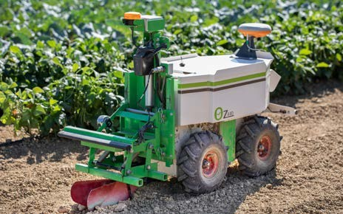Similarly, AI-powered robots with mechanical arms, cameras, and sensors can efficiently and precisely maneuver around agricultural fields and pull weeds. These robots use machine learning techniques to recognize weeds in real-time and apply targeted interventions, such as mechanical weeding or precision herbicide application, to suppress weed populations and promote crop health [46].

**Figure 5: AI-powered small weeding robot [47].**

**C. ML algorithms for predicting pest outbreaks and recommending preventive measures**

The importance of ML algorithms in predicting pest outbreaks and recommending preventive measures, enabling farmers to implement proactive pest management strategies that minimize crop damage and reduce reliance on chemical pesticides. By examining past information on pest populations, weather conditions, crop phenology, and agronomic practices, ML models can identify patterns and trends indicative of impending pest outbreaks and generate early warning alerts for farmers [48].

Moreover, ML algorithms can analyze complex relationships between environmental factors, pest populations, and crop susceptibility to identify risk factors and recommend preventive measures. For example, ML models can predict the likelihood of pest infestations based on weather forecasts, soil moisture levels, and crop phenology, enabling farmers to implement targeted interventions such as crop rotation, trap cropping, or biological control measures to mitigate pest pressure [49].

Numerous studies exemplify the efficacy of Integrated Pest Management (IPM) strategies leveraging AI and ML technologies in agriculture. For example, a study conducted by researchers [50] demonstrated the effectiveness of AI-powered drones for weed detection and eradication in vineyards. By deploying drones equipped with high-resolution cameras and machine learning algorithms, farmers were able to identify and remove weeds with precision, reducing herbicide usage and improving crop health and yield.

Similarly, other researchers [51] implemented an AI-driven pest monitoring system that analyzes data from weather stations, traps, and sensors to predict pest outbreaks and recommend preventive measures. By leveraging ML algorithms to analyze historical data on pest populations, weather conditions, and crop phenology, the system was able to accurately predict pest outbreaks with accuracy, enabling farmers to implement targeted interventions and minimize crop damage.

**VII.** **ARTIFICIAL INTELLIGENCE APPLICATIONS IN BIOENERGY SYSTEMS**

Demand for fossil fuel-derived energy has increased over the past several decades as a result of global population expansion, urbanization, and industrialization [52]. As a result, the formation of substantial amounts of Greenhouse Gases (GHG) has accelerated global warming and climate change. Thus, the development and utilization of renewable energy resources is currently emphasized in sustainable global energy policy as a means of limiting the usage of fossil fuels. The wide availability and easy access of biomass make it a major source of renewable energy. Notably, agricultural residues emerge as the primary contributors to bioenergy production. In India, biomass production plays a significant role, with agricultural crop residues contributing substantially to the overall biomass. Annually, a total of 869.11 MT of gross residue is generated, of which 288.14 MT (33.15%) constitutes surplus residue [53].

The conversion of biomass feedstock into bioenergy products has been studied using a variety of processes. These products include solids like biochar, liquids like biodiesel, bioethanol, and bio-oil, and gaseous outputs like biogas, syngas, and hydrogen [54]. Additionally, issues of handling many different types of biomasses, supply chain utilization and process control are increasingly coming to light. In order to solve these difficulties, detailed research has been done on supply chain and process optimization, in recent research. In this scenario, artificial intelligence (AI) has been effectively utilized in bioenergy production processes. AI encompasses the mechanical capacity to execute tasks that emulate human intelligence classified artificial intelligence (AI) into four categories: heuristics, hybrids & others, machine learning (ML), and symbolic AI [52]. Depending on the data format and learning style, author [55] suggested supervised and unsupervised approaches. The author outlined three key areas where AI has found prominent applications, comprising:

* Prediction of biomass characteristics
* Forecasting performance in biomass conversion processes, and
* Predicting biofuel characteristics and assessing end-use systems for bioenergy.

**A. Prediction of biomass characteristics**

The properties of biomass directly influence both the operational efficiency of biomass conversion processes and the quality of bio-based products. This study reviews AI applications for predicting biomass feedstock properties, aiming to integrate them with both AI-based and standard process models for the conversion of biomass. AI provides a promising option to streamline biomass characterization processes, replacing traditional methods like the oxygen bomb calorimeter (ASTM standard D5865-13) for Higher Heating Value (HHV), Thermogravimetric Analysis (TGA) and proximate analysis (ASTM standard D7582-15) for ash/moisture content, and an ultimate analysis of the hydrogen and carbon contents determination. Conventional analytical methods are both time-consuming and costly. Numerous studies have turned to AI to forecast features of biomass using alternative properties that are simpler to measure [52].

**B. Forecasting performance in biomass conversion processes**

Pyrolysis and gasification stand as two well-established thermochemical conversion methods. While both processes involve the thermal degradation of biomass under inert conditions, they differ in temperature ranges (400–700°C for pyrolysis and >700°C for gasification) and residence times (1 second to 30 minutes for pyrolysis and 10 to 20 seconds for gasification) [54]. AI exhibits a special capacity to assist conventional pyrolysis modelling techniques. Process-based simulations (e.g., using Aspen Plus) depend on input data, which includes product yields and attributes that are often collected from experiments, at the process level [56]. The majority of AI research on gasification concentrate on predicting the composition of syngas, with H2 concentration being the most commonly utilized output variable. Some studies utilized TGA data to train AI models, aiming to decrease the time and cost associated with conducting TGA.

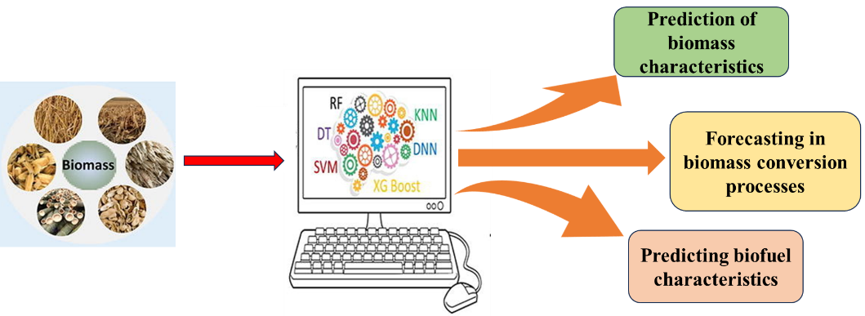

**Figure 6: AI and ML based bioenergy prediction and assessment.**

**C. Predicting biofuel characteristics and assessing end-use systems for bioenergy**

Biofuel holds significant potential for mitigating GHG and other air emissions within the transportation sector [57]. Several AI studies have focused on predicting the cetane number, a crucial indicator of a fuel's ignition characteristics [54]. Biodiesel's physicochemical properties, such as viscosity, density, and iodine value, can be determined by FAME content, chemical structure information (such as double bonds, carbon, and hydrogen atoms), and fuel blending ratio, especially when blended with diesel fuel. Integrating trained cetane number models with production models can optimize AI models for biomass conversion to biodiesel to produce high-quality biofuel. This is because the models' output variables for biomass conversion to biodiesel are the FAME content and yield.

**VIII. ROBOTIC FARMING: AUTOMATING TASKS FOR INCREASED EFFICIENCY**

Agricultural robotics and automation represent a paradigm shift in farming practices, enabling farmers to automate labor-intensive tasks, optimize resource utilization, and improve productivity and efficiency. This section explores the transformative role of robotics and automation in agriculture and examines how the fields of AI and machine learning ML are transforming agricultural practices, encompassing everything from planting and harvesting to pest management and observation.

**A. The evolution of agricultural robotics**

The use of robotics in agriculture has a long history, dating back to the development of simple mechanical devices for tasks such as planting, weeding, and harvesting. However, recent advancements in robotics technology, coupled with innovations in AI and ML, have led to a new generation of agricultural robots that are capable of performing complex tasks with precision and efficiency [58]. Early agricultural robots were primarily designed for repetitive and labor-intensive tasks, such as weed removal and fruit picking, where manual labor was costly and inefficient. These robots often relied on predefined algorithms and sensor feedback to navigate and interact with the environment, limiting their flexibility and adaptability to changing conditions [59].

Today, agricultural robots are becoming increasingly sophisticated, incorporating advanced sensors, actuators, and control systems that enable them to perform a wide range of tasks autonomously. AI and ML algorithms are also playing a crucial role in enhancing the capabilities of agricultural robots, enabling them to learn from experience, adapt to new environments, and make intelligent decisions in real-time [60].

**B. Importance of robotics and automation in agriculture**

Agriculture is facing unprecedented challenges, including labor shortages, rising production costs, and environmental concerns, necessitating the adoption of innovative technologies to enhance efficiency, sustainability, and profitability. Robotics and automation offer promising solutions to these challenges, enabling farmers to streamline operations, reduce labor costs, and improve overall farm productivity. Traditional farming methods often rely on manual labor for tasks such as planting, weeding, and harvesting, which can be time-consuming, labor-intensive, and costly. Moreover, the scarcity of skilled agricultural workers, coupled with increasing labor costs, poses significant challenges to farm profitability and competitiveness [61].

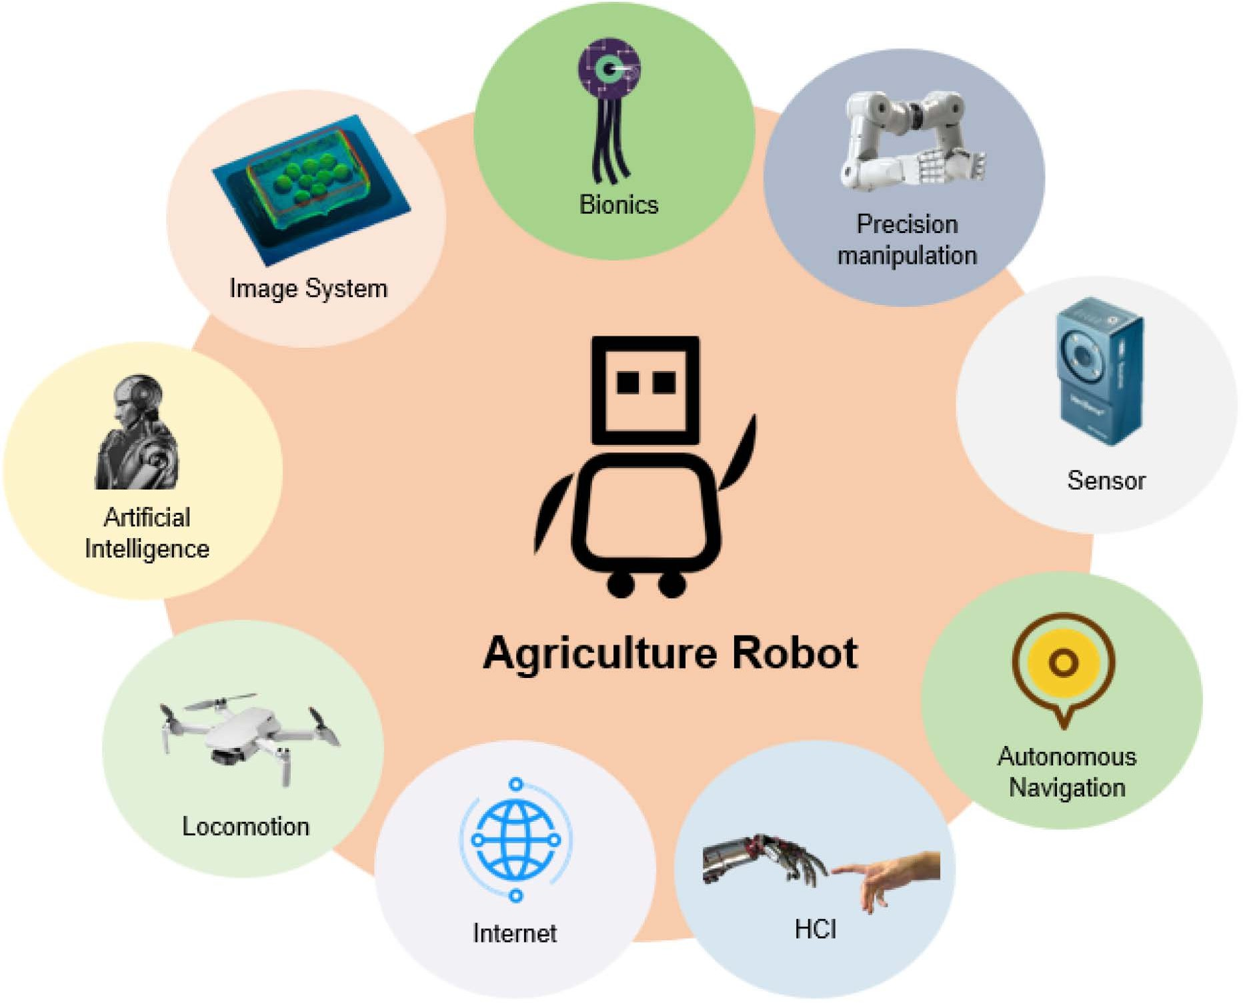

**Figure 7: Components involved in agricultural robots [62].**

Robotics and automation technologies enable farmers to automate repetitive tasks, optimize resource utilization, and increase operational efficiency, freeing up labor resources for more value-added activities. By leveraging robotics and automation, farmers can reduce production costs, improve crop quality, and enhance overall farm profitability [63]. Agricultural robotics are being used across various domains within agriculture, revolutionizing the way farming operations are conducted and managed. Some key applications of agricultural robotics include:

1. Planting and Seeding: Agricultural robots equipped with precision planting systems can accurately sow seeds at optimal spacing and depth, reducing seed wastage and improving crop establishment. These autonomous navigation robots can precisely place seeds in fields by utilizing sensor input and GPS.
2. Weeding and Pest Control: With the use of cameras and artificial intelligence (AI) algorithms, robotic weeders can precisely locate and eradicate weeds, cutting down on the need for chemical pesticides and their negative effects on the environment. Similarly, robotic pest control systems can target specific pests with minimal collateral damage, reducing reliance on chemical pesticides.
3. Harvesting and Fruit Picking: Agricultural robots equipped with robotic arms and computer vision systems can harvest crops such as fruits and vegetables with precision and efficiency. These robots can identify ripe produce, grasp it gently without causing damage, and place it into collection bins, reducing labor costs and increasing harvesting efficiency.
4. Monitoring and Maintenance: Crop health and soil moisture levels can be tracked by autonomous drones and ground-based robots fitted with sensors and cameras, and environmental conditions in real-time. These robots can collect data on plant growth, pest infestations, and disease outbreaks, enabling growers to make knowledgeable choices on pest control, fertilization, and irrigation.

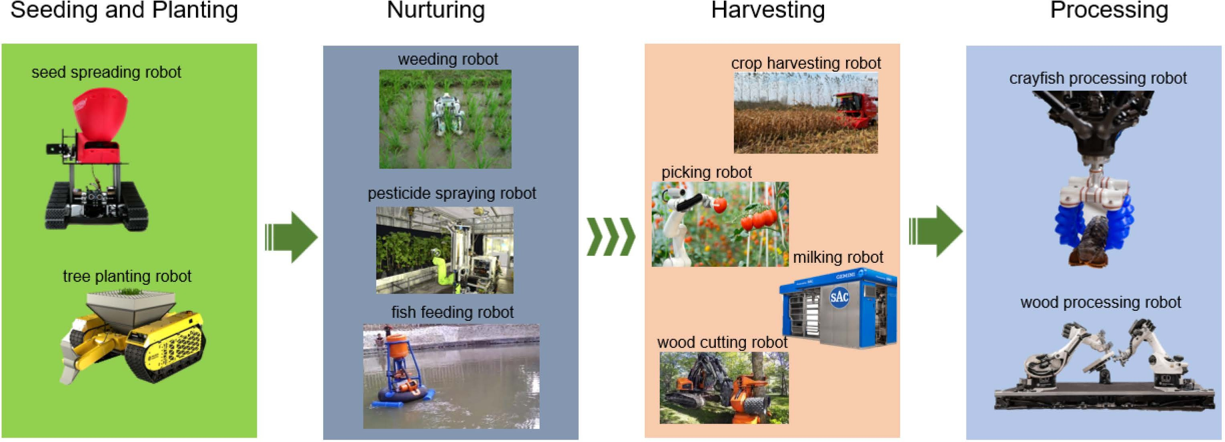

**Figure 8: Key applications of agricultural robots [64-66].**

**C. Challenges and opportunities in agricultural robotics**

While agricultural robotics hold great promise for improving farm efficiency and productivity, there are also significant challenges that need to be addressed. The expense of robotics technology, which can be unaffordable for small and medium-sized farmers, is one of the primary obstacles [67]. Additionally, there are technical challenges related to the design and development of robots that can operate effectively in dynamic and diverse farming situations [68].

However, there are also significant opportunities for innovation and collaboration in the field of agricultural robotics. Advances in AI and ML algorithms are enabling robots to pick up knowledge from experience and modify to new tasks and environments, increasing their versatility and effectiveness. Moreover, ongoing research in areas such as soft robotics, swarm robotics, and human-robot interaction is opening up new possibilities for robotics technology in agriculture [62].

**D. Advancements in agricultural robotics and automation technologies**

Advancements in robotics and automation technologies have transformed the way farming operations are conducted, enabling farmers to automate a wide range of tasks, from field preparation and planting to harvesting and post-harvest handling. Robotic systems equipped with sensors, actuators, and AI algorithms can perform tasks such as weeding, planting, spraying, and harvesting with efficiency and precision [69, 70]. For example, autonomous tractors and robotic planters can navigate fields and plant crops with high accuracy, optimizing seed placement and spacing to maximize yields.

Likewise, precision and efficiency in the harvesting of fruits and vegetables can be achieved by robotic harvesters fitted with sensors and vision systems, which also minimize crop damage and personnel expenses [71]. Post-harvest handling systems, such as robotic sorting and packing machines, can automate tasks such as grading, sorting, and packaging, improving product quality and reducing post-harvest losses [66].

**E. Applications of AI and ML in agricultural automation and robotics**

The use of AI and ML technologies is essential in enhancing the capabilities of agricultural robots and automation systems, enabling them to perceive, reason, and act in complex and dynamic environments. In order to make decisions in real time and adjust to changing circumstances, machine learning algorithms can examine sensor data, images, and environmental variables. in the field [72].

For example, computer vision algorithms can analyze imagery from cameras mounted on agricultural robots to identify crops, weeds, and other objects in the field, enabling robots to perform tasks such as planting, weeding, and harvesting with precision [73]. Reinforcement learning algorithms can enable robots to learn optimal control policies for navigating fields, avoiding obstacles, and performing tasks efficiently [74]. Moreover, AI and ML algorithms can optimize robotic operations and resource utilization, enabling robots to make intelligent decisions about task prioritization, path planning, and resource allocation for enhanced farm productivity and efficiency [75].

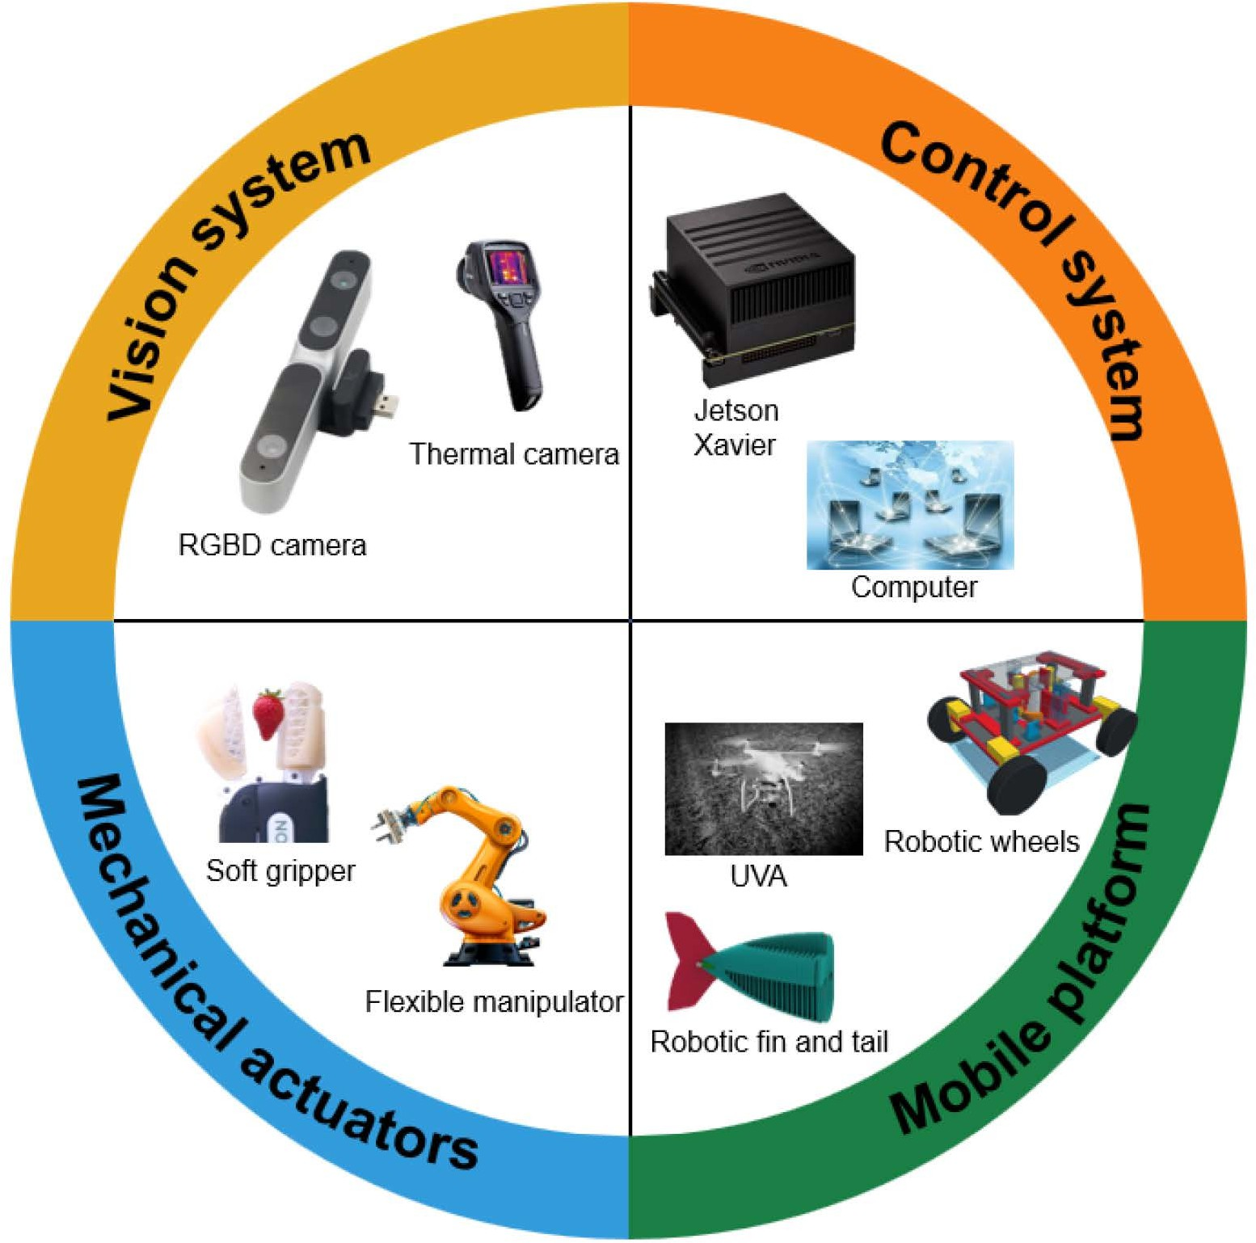

**Figure 9: Components of advanced agricultural robots [76, 77].**

Numerous case studies exemplify the transformative impact of agricultural robotics and automation, highlighting the benefits of AI and ML technologies in improving farm productivity, efficiency, and sustainability. For example, Sori and other [64] developed an autonomous weeding system for wet rice culture, leveraging robotic weeders equipped with computer vision and AI algorithms to remove weeds with precision. By automating the weeding process, the author was able to reduce labor costs, minimize herbicide usage, and improve overall farm productivity. Similarly, Lehnert and other [78] developed an autonomous harvesting system for sweet peppers, leveraging robotic harvesters equipped with sensors and vision systems to harvest sweet peppers with precision and efficiency.

**IX. THE ROLE OF ARTIFICIAL INTELLIGENCE IN FOOD PROCESSING AND STORAGE**

The food industry is one of many sectors that have seen a change in recent years due to the incorporation of AI technologies. From improving food safety to optimizing storage and processing methods, AI has become an invaluable tool for enhancing efficiency, reducing waste, and ensuring the quality of food products. This chapter explores the diverse applications of AI in food storage, processing, and related areas, highlighting key advancements and their impact on the industry.

**A. Enhancing Food Safety**

Ensuring the safety of food products is paramount in the food industry. AI plays a crucial role in enhancing food safety by enabling rapid and accurate detection of contaminants, pathogens, and other potential hazards. By identifying potential contaminants, or adulterants, AI helps ensure compliance with regulatory standards and protect public health. Large volumes of data from sensors, cameras, and other sources can be analyzed by machine learning algorithms to quickly spot anomalies and possible threats. For instance, AI-powered systems can detect foreign objects in food processing lines, such as metal fragments or plastic pieces, preventing contaminated products from reaching consumers [79].

**B. Quality Control and Inspection**

Maintaining consistent quality standards is essential for food manufacturers. AI technologies enable automated quality control and inspection processes, minimizing human error and improving efficiency. Computer vision systems equipped with AI algorithms can analyze visual data to assess the quality of food products in real time based on parameters such as color, size, shape, and texture. This enables manufacturers to identify defects or deviations from desired specifications, ensuring that only high-quality products reach consumers [80]. AI technologies allow for the real-time monitoring and management of several parameters, including temperature, humidity, and air quality in food storage facilities. By providing continuous insights into environmental conditions, AI helps maintain product freshness, extend shelf life, and prevent spoilage [81].

**C. Predictive Maintenance**

Efficient maintenance of food storage and processing equipment is critical for preventing costly breakdowns and minimizing downtime. AI-powered predictive maintenance systems predict equipment failures by utilizing sensor and Internet of Things data before they occur. By analyzing patterns and trends in equipment performance, AI algorithms can identify early signs of potential issues and schedule maintenance tasks proactively. This proactive approach helps to optimize equipment reliability and reduce the risk of unexpected disruptions in food production operations [82].

**D. Supply Chain & Process Optimization**

AI technologies play a vital role in optimizing the food supply chain, from farm to fork. By analyzing data related to inventory levels, demand forecasts, transportation routes, and storage conditions, AI algorithms can optimize logistics and distribution processes to minimize costs and reduce food waste. By predicting demand fluctuations and supply chain disruptions, AI reduces inventory holding costs, minimizes stockouts, and boosts productivity. For example, AI-powered demand forecasting models can predict consumer demand with greater accuracy, enabling more efficient inventory management and production planning [83]. AI algorithms optimize food processing workflows by analyzing production data and identifying opportunities for efficiency improvements. By automating repetitive tasks and optimizing process parameters, AI enhances productivity, reduces labor costs, and ensures consistent product quality [84].

**X. AI-ENABLED WATER MANAGEMENT SYSTEMS**

To ensure the sustainability of many sectors, such as agriculture, public health, and environmental conservation, and to solve the issues posed by water shortages, efficient water management is essential [85]. Effective water management is crucial for crop productivity in agriculture since irrigation requires huge amounts of water. Sustainable water management is even more important to fulfill the world's rising food demand as a result of shifting climatic trends and population growth. Precision farming and drip irrigation are two examples of sustainable irrigation practices that maximize agricultural yield by optimizing water usage. In addition to decreasing the stress on freshwater ecosystems and fostering environmental sustainability, effective water management in agriculture helps conserve water supplies.

The water shortage is a major issue in many regions of the globe. The water demand has increased due to increasing populations, urbanization, and climate change, and natural water sources are under growing stress. Because of this scarcity, sustainable methods of managing water resources must be developed, emphasizing efficiency, conservation, and the utilization of alternative water sources like desalination and wastewater reuse. However, implementing such strategies would require significant financial outlays, technological breakthroughs, and a shift in public perceptions about water use [86,87].

The application of AI holds great promise for resolving the difficulties and complexities related to water management. AI can improve infrastructure operations, encourage sustainable practices, and manage water scarcity. Artificial intelligence can help manage water scarcity by evaluating huge amounts of data and offering precise forecasts and insights. In order to predict instances of water scarcity, machine learning algorithms can examine past data on water availability, usage trends, and meteorological conditions. Using this information, water resources can be allocated more effectively through proactive planning and the execution of water conservation initiatives. AI is particularly useful for real-time water system monitoring, which reduces water loss by enabling the early discovery of anomalies or leaks. AI can also help optimize operations and maintenance tasks for aged infrastructure. AI can continuously monitor water infrastructure and identify potential problems or inefficiencies by integrating sensors and IoT devices. To predict infrastructure breakdowns and prioritize maintenance interventions, predictive maintenance algorithms can examine data from various sources, including sensor readings, previous maintenance records, and weather conditions. By being proactive, we can increase the dependability of water systems, decrease downtime, and prolong the life of infrastructure. The application of AI to water conservation concerns is the main topic of this chapter, which looks at four important areas:

* Water management and distribution
* Smart irrigation systems
* Water quality monitoring
* Drought prediction and early warning systems

**A. Management and Distribution of Water**

Because of its capacity to evaluate enormous amounts of data from many sources, AI has become an effective technique for improving water management. Artificial Intelligence can offer significant insights into water management procedures by combining data from sensor networks, satellite images, and weather conditions. Accurately predicting water consumption is one of the main advantages of AI in this area. AI systems can produce projections that assist water authorities in effectively planning and allocating resources by evaluating past data and taking into account variables like population growth, weather, and seasonal fluctuations. By being proactive, we can avoid water shortages or overallocation and better prepare for times of peak demand. AI can also be very helpful in identifying leaks in water infrastructure. AI algorithms are capable of analyzing data gathered from strategically positioned sensors across the water distribution network by utilizing machine learning techniques. These algorithms can identify trends and abnormalities that point to leaks or unusual water flow. In order to avoid water loss, infrastructure damage, and the related financial and environmental implications, early leak identification is essential. Rapid leak location allows maintenance teams to react fast, reducing the time needed to fix the problem and conserve water.

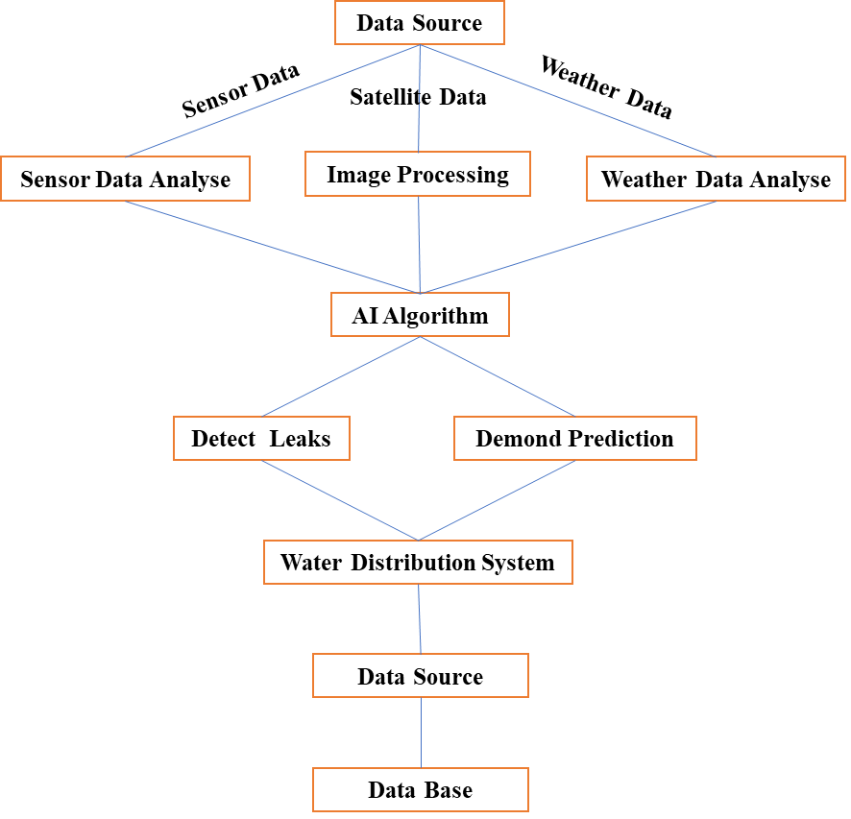

**Figure 10: Components of an AI-enabled Water Management and Distribution systems management system.**

**B. Smart irrigation system**

AI-powered technology integration in agriculture has enormous potential to maximize water use and raise agricultural productivity. Monitoring soil temperature, moisture content, and water requirements is one of the main areas where artificial intelligence can have a big impact [88]. AI algorithms can analyse satellite imagery and other sensor data using remote sensing and IoT approaches to deliver real-time information about the moisture content of the soil. With the use of this information, farmers can prevent under- or overwatering their crops by determining the ideal timing and volume of irrigation [89]. Additionally, AI algorithms are capable of analyzing a wide range of data sources, including as historical records, weather data, and satellite imagery, in order to evaluate crop health and identify early indicators of disease or water stress. Artificial Intelligence can detect possible problems before they are noticeable to the human eye by keeping an eye on vegetation indices, leaf temperatures, and other indicators. Early detection enables farmers to minimize crop losses and reduce water waste associated with inadequate irrigation practices by delivering targeted irrigation or deploying appropriate treatments [90].

Furthermore, by taking into account a variety of variables, including crop type, weather patterns, evapotranspiration rates, and soil characteristics, AI can assist farmers in making well-informed decisions about irrigation scheduling and water management strategies. By analyzing past data, machine learning algorithms are able to find patterns and relationships among the different variables. AI systems may generate customised irrigation schedules that optimise crop production and water use. This increases the sustainability of agricultural activities by saving water and lowering the energy used by irrigation systems [91].

**C. Water Quality Monitoring**

Water quality analysis was traditionally done via labour-intensive, time-consuming procedures that required human professionals to manually review and analyze the results. However, this procedure may be greatly expedited and automated with AI, producing outcomes that are more precise and efficient. Artificial intelligence algorithms can identify patterns and irregularities in data, hence facilitating the identification of diverse compounds that may provide a health concern to humans [92]. Water treatment plants can respond quickly and put the right procedures in place to guarantee the security of the drinking water supply through to this quick detection. AI can also help in the early identification of possible waterborne illnesses. Artificial intelligence models can detect patterns and connections between specific pollutants and disease incidence by examining past data on water quality. Public health organizations can put preventive measures into place and reduce risks before outbreaks spread widely thanks to this proactive strategy. AI offers a more fast and effective solution for disease surveillance than traditional methods, which mostly rely on retrospective analysis and manual data interpretation [93, 94]. AI may also be used to improve the upkeep and monitoring of water treatment facilities. AI systems can identify anomalies or departures from typical operating circumstances by analyzing sensor data in real time. This helps operators minimize downtime and guarantee ongoing water quality monitoring by enabling them to quickly identify and address problems, such as equipment malfunctions or system breakdowns. On the other hand, manual checks and periodic inspections are frequently used in traditional approaches, which may not be as efficient in quickly identifying issues [97].

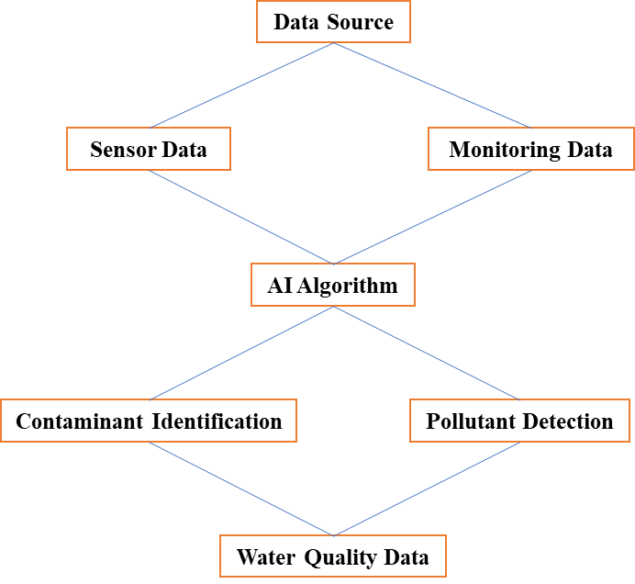

**Figure 11: Components of an AI-enabled Water Quality Monitoring systems.**

**D. Drought Prediction and Early Warning Systems**

Artificial intelligence algorithms have revolutionized the field of climate forecasting by effectively predicting and assessing drought situations by utilizing historical climate data, satellite imagery, and meteorological information. AI algorithms are capable of identifying important signs and trends linked to drought events by analyzing huge amounts of historical weather data. In order to predict future drought conditions, these algorithms are able to identify tiny correlations between factors including temperature, precipitation, humidity, and soil moisture levels. Using AI algorithms to forecast droughts more accurately is made possible in large part by satellite photography. The health of the vegetation, the amount of land cover, and the surface temperature may all be determined from high-resolution photographs of the Earth's surface taken by satellites fitted with cutting-edge sensors. Drought indicators, including diminished vegetative vigour or rising surface temperature anomalies, can be detected by AI systems through the analysis of these satellite photos. Artificial Intelligence systems can generate complete drought forecasts that consider both local and regional aspects, leading to more accurate predictions, by merging this satellite data with other meteorological information. Governments and communities may manage water scarcity with great advantage when artificial intelligence is used in drought early warning systems. Early warning systems are capable of processing real-time data and producing timely alerts about possible drought conditions by employing artificial intelligence algorithms. In order to help local communities, government agencies, and organizations responsible for managing water resources take preventative action against droughts, these alerts can be disseminated to the appropriate parties. To promote judicious water use, for example, governments should enact laws requiring water conservation, provide funding to impacted regions, and launch public awareness campaigns. Water-saving measures, improved irrigation methods, and a variety of water sources can help communities become ready. All things considered, AI-driven early warning systems enable decision-makers to make knowledgeable decisions and create all-encompassing plans to immediately address water scarcity.

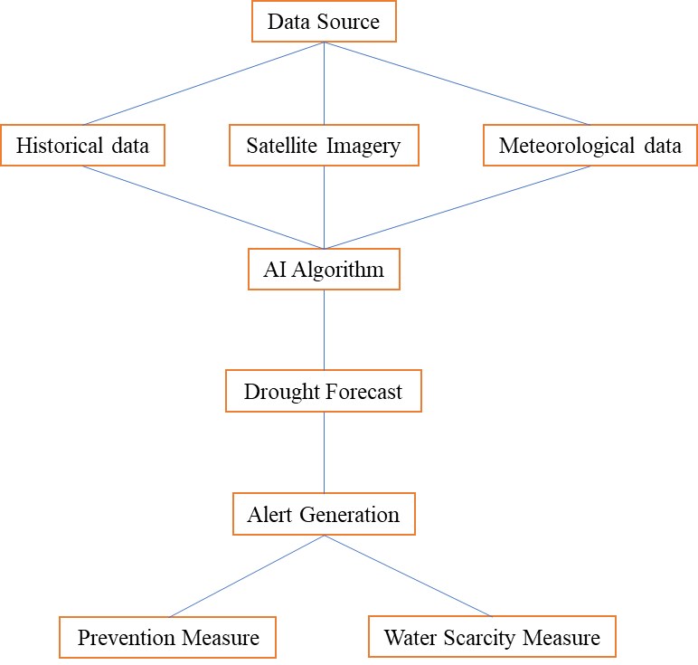

**Figure 12: Components of an AI-enabled Drought Prediction and Early Warning Systems.**

**XI. CHALLENGES AND OPPORTUNITIES OF AI AND ML IN AGRICULTURE**

Technology can transform agriculture, but farmers lack the technical ability to operate technology-led gear, creating an ecological dilemma. Planning systems with farmers in mind is the best method to handle this. Digital product designers must focus on the user interface and provide solutions in local languages [96]. Small-scale farmers worry about device and sensor quality and cost while adopting modern technology. In IoT solutions, system dependability is crucial. Decision support systems directly affect farm operations, therefore any threats to operation or component failure will cause reliability difficulties [97]. As a network of small, widely scattered items, IoT systems have limited processing and storage resources for data management and security. Making the most of resource-constrained networks requires proper data management. Despite the tremendous potential of AI and ML in agriculture, several challenges and opportunities lie ahead. These include:

* Accessibility and Affordability: Making AI and ML accessible and affordable to smallholder farmers and agricultural communities in developing countries remains a significant challenge. bridging the digital gap and offering guidance and assistance for technology adoption are essential for realizing the full benefits of these technologies.
* Data Quality and Privacy: Models for AI and ML depend on high-quality data for training and validation, yet data collection and management practices in agriculture can be inconsistent and fragmented. Ensuring data quality, integrity, and privacy are crucial for building trust and confidence in AI and ML solutions.
* Regulatory and Ethical Considerations: As AI and ML applications in agriculture become more prevalent, policymakers and regulators must address ethical and legal issues related to data ownership, algorithmic bias, and accountability. Establishing clear guidelines and standards for AI and ML deployment in agriculture is essential for promoting responsible innovation and protecting farmers' interests.
* Interdisciplinary Collaboration: Addressing complex agricultural challenges requires interdisciplinary collaboration and partnership between researchers, policymakers, industry stakeholders, and farmers. By fostering collaboration and knowledge exchange, stakeholders can leverage the collective expertise and resources needed to develop and implement effective solutions.

**XII. CONCLUSION**

In conclusion, this comprehensive exploration of various facets of technological advancements, particularly focusing on AI and ML applications in agriculture, highlights the transformative potential of these technologies in shaping the future of farming. The following sections provide a recap of key insights and findings, discuss the implications of AI and ML for the future of agriculture, outline the challenges and opportunities on the horizon, and offer recommendations for policymakers, researchers, and practitioners.

The food business is being revolutionized by the integration of AI technologies, from enhancing food safety and quality control to optimizing supply chain operations and personalized nutrition services. By harnessing the power of AI, food manufacturers can improve efficiency, reduce waste, and meet the evolving needs of consumers in an increasingly complex and competitive market landscape. However, realizing the full potential of AI in the food sector requires careful consideration of ethical, regulatory, and societal implications to ensure that these technologies benefit society. In essence, the convergence of AI and ML with agriculture heralds a new era of sustainable, data-driven farming practices – where precision, efficiency, and environmental stewardship converge to meet the demands of a rapidly evolving world. As we embark on this transformative journey, it is imperative to harness the full potential of these technologies while ensuring equitable access, ethical considerations, and holistic sustainability principles guide our path forward.

**REFERENCES**

[1] Xu, X., Li, J., Zhu, Z., Zhao, L., Wang, H., Song, C., Chen, Y., Zhao, Q., & Pei, Y. (2024). A Comprehensive Review on Synergy of Multi-Modal Data and AI Technologies in Medical Diagnosis. *Bioengineering*, *11*(3), 219. <https://doi.org/10.3390/bioengineering11030219>

[2] Ahmad, L., & Nabi, F. (2021). *Agriculture 5.0: Artificial intelligence, IoT and machine learning*. CRC Press. DOI: [10.1201/9781003125433](http://dx.doi.org/10.1201/9781003125433)

[3] Ragazou, K., Garefalakis, A., Zafeiriou, E., & Passas, I. (2022). Agriculture 5.0: A new strategic management mode for a cut cost and an energy efficient agriculture sector. Energies, 15(9), 3113. <https://doi.org/10.3390/en15093113>

[4] Klerkx, L., & Rose, D. (2020). Dealing with the game-changing technologies of Agriculture 4.0: How do we manage diversity and responsibility in food system transition pathways?. *Global Food Security*, *24*, 100347.

[6] Yuan, Y., Chen, L., Wu, H., & Li, L. (2022). Advanced agricultural disease image recognition technologies: A review. *Information Processing in Agriculture*, *9*(1), 48-59. <https://doi.org/10.1016/j.inpa.2021.01.003>

[5] Van Klompenburg, T., Kassahun, A., & Catal, C. (2020). Crop yield prediction using machine learning: A systematic literature review. *Computers and Electronics in Agriculture*, *177*, 105709. <https://doi.org/10.1016/j.compag.2020.105709>

[7] Singh, P. K., & Sharma, A. (2022). An intelligent WSN-UAV-based IoT framework for precision agriculture application. *Computers and Electrical Engineering*, *100*, 107912. <https://doi.org/10.1016/j.compeleceng.2022.107912>

[8] Elavarasan, D., Vincent, D. R., Sharma, V., Zomaya, A. Y., & Srinivasan, K. (2018). Forecasting yield by integrating agrarian factors and machine learning models: A survey. *Computers and electronics in agriculture*, *155*, 257-282. <https://doi.org/10.1016/j.compag.2018.10.024>

[9] Lezoche, M., Hernandez, J. E., Díaz, M. D. M. E. A., Panetto, H., & Kacprzyk, J. (2020). Agri-food 4.0: A survey of the supply chains and technologies for the future agriculture. *Computers in industry*, *117*, 103187. <https://doi.org/10.1016/j.compind.2020.103187>

[10] Früh, A., & Haux, D. (2022). Foundations of Artificial Intelligence and Machine Learning. Berlin: Weizenbaum Institute for the Networked Society - The German Internet Institute. https://doi.org/10.34669/ WI.WS/29.

[11] Wang, Y., Hou, M., Plataniotis, K. N., Kwong, S., Leung, H., Tunstel, E., Rudas I. J., and Trajkovic L. (2020). Towards a theoretical framework of autonomous systems underpinned by intelligence and systems sciences. *IEEE/CAA Journal of Automatica Sinica*, *8*(1), 52-63.

[12] Dawn, N., Ghosh, T., Ghosh, S., Saha, A., Mukherjee, P., Sarkar, S., Guha S., & Sanyal, T. (2023). Implementation of Artificial Intelligence, Machine Learning, and Internet of Things (IoT) in revolutionizing Agriculture: A review on recent trends and challenges. *Int. J. Exp. Res. Rev*, *30*, 190-218. <https://doi.org/10.52756/ijerr.2023.v30.018>

[13] Choi, R. Y., Coyner, A. S., Kalpathy-Cramer, J., Chiang, M. F., & Campbell, J. P. (2020). Introduction to machine learning, neural networks, and deep learning. *Translational vision science & technology*, *9*(2), 14-14.

[14] Gautam, P. V., Mansuri, S. M., Prakash, O., Pramendra, Patel, A., Shukla, P., & kushwaha, H. L. (2023). Agricultural Mechanization for Efficient Utilization of Input Resources to Improve Crop Production in Arid Region. (pp. 689-716). Singapore: Springer Nature Singapore. DOI: [10.1007/978-981-19-9159-2_34](http://dx.doi.org/10.1007/978-981-19-9159-2_34).

[15] Zhang, X., Huang, C., Wu, D., Qiao, F., Li, W., Duan, L., Wang, K., Xiao, Y., Chen, G. & Yan, J. (2017). High-throughput phenotyping and QTL mapping reveals the genetic architecture of maize plant growth. *Plant physiology*, *173*(3), 1554-1564.

[16] Mohanty, S., & Singh, D. (2022). Optimal Resource Utilization in precision agriculture. *In*: 2022 2nd International Conference on Advance Computing and Innovative Technologies in Engineering (ICACITE) (pp. 1608-1612). IEEE. doi: 10.1109/ICACITE53722.2022.9823820.

[17] Mohamed, E. S., Belal, A. A., Abd-Elmabod, S. K., El-Shirbeny, M. A., Gad, A., & Zahran, M. B. (2021). Smart farming for improving agricultural management. *The Egyptian Journal of Remote Sensing and Space Science*, *24*(3), 971-981. <https://doi.org/10.1016/j.ejrs.2021.08.007>

[18] Kumar, S., Singh, M., Mirzakhaninafchi, H., Rajesh, U. M., Ali, M., Bhardwaj, M., & Soni, R. (2018). Practical and affordable technologies for precision agriculture in small fields: present status and scope in India. In *14th International Conference on Precision Agriculture Montreal, Quebec, Canada* (pp. 24-27).

[19] Bhat, S. A., & Huang, N. F. (2021). Big data and ai revolution in precision agriculture: Survey and challenges. *Ieee Access*, *9*, 110209-110222. **DOI:**[10.1109/ACCESS.2021.3102227](https://doi.org/10.1109/ACCESS.2021.3102227)

[20] Karunathilake, E. M. B. M., Le, A. T., Heo, S., Chung, Y. S., & Mansoor, S. (2023). The path to smart farming: Innovations and opportunities in precision agriculture. *Agriculture*, *13*(8), 1593. <https://doi.org/10.3390/agriculture13081593>

[21] Siddiqua, A., Kabir, M. A., Ferdous, T., Ali, I. B., & Weston, L. A. (2022). Evaluating plant disease detection mobile applications: Quality and limitations. *Agronomy*, *12*(8), 1869. <https://doi.org/10.3390/agronomy12081869>

[22] Ayoub Shaikh, T., Rasool, T., & Rasheed Lone, F. (2022). Towards leveraging the role of machine learning and artificial intelligence in precision agriculture and smart farming. *Computers and Electronics in Agriculture*, *198*, 107119. <https://doi.org/10.1016/j.compag.2022.107119>.

[23] Javaid, M., Haleem, A., Khan, I. H., & Suman, R. (2023). Understanding the potential applications of Artificial Intelligence in Agriculture Sector. *Advanced Agrochem*, *2*(1), 15-30. <https://doi.org/10.1016/j.aac.2022.10.001>

[24] Upadhyay, A., Chandel, N.S., & Chakraborty, S.K. (2024). Disease Control Measures Using Vision-Enabled Agricultural Robotics. *In:* Chouhan, S.S., Singh, U.P., Jain, S. (eds) Applications of Computer Vision and Drone Technology in Agriculture 4.0. Springer, Singapore. https://doi.org/10.1007/978-981-99-8684-2_10

[25] Balaska, V., Adamidou, Z., Vryzas, Z., & Gasteratos, A. (2023). Sustainable Crop Protection via Robotics and Artificial Intelligence Solutions. *Machines*, *11*(8), 774. <https://doi.org/10.3390/machines11080774>

[26] Saiz-Rubio, V., & Rovira-Más, F. (2020). From smart farming towards agriculture 5.0: A review on crop data management. *Agronomy*, *10*(2), 207. <https://doi.org/10.3390/agronomy10020207>

[27] Islam, M. R., Oliullah, K., Kabir, M. M., Alom, M., & Mridha, M. (2023). Machine learning enabled IoT system for soil nutrients monitoring and crop recommendation. *Journal of Agriculture and Food Research*, *14*, 100880. <https://doi.org/10.1016/j.jafr.2023.100880>

[28] Blesslin Sheeba, T., Anand, L. D., Manohar, G., Selvan, S., Wilfred, C. B., Muthukumar, K., Padmavathy, S., Raamesh Kumar, P., & Asfaw, B. T. (2022). Machine learning algorithm for soil analysis and classification of micronutrients in IoT-enabled automated farms. *Journal of Nanomaterials*, *2022*. <https://doi.org/10.1155/2022/5343965>

[29] Al Masmoudi, Y., Bouslihim, Y., Doumali, K., Hssaini, L., & Ibno Namr, K. (2022). Use of machine learning in Moroccan soil fertility prediction as an alternative to laborious analyses. *Modeling Earth Systems and Environment*, *8*(3), 3707-3717. <https://doi.org/10.1007/s40808-021-01329-8>

[30] Ahish, N., Shashikala, H. K., & Bharath, N. (2019). Automated modular data analysis and visualization system with predictive analytics using machine learning for agriculture field. *International Journal of Research in Science*, *5*(1), 1-3. DOI: 10.24178/IJRS.2019.5.1.01.

[31] Chandraprabha, M., & Dhanaraj, R. K. (2021). Soil Based Prediction for Crop Yield using Predictive Analytics. 2021 3rd International Conference on Advances in Computing, Communication Control and Networking (ICAC3N), Greater Noida, India, 2021, pp. 265-270, doi: 10.1109/ICAC3N53548.2021.9725758.

[32] Terrada, L., El Khaili, M., & Ouajji, H. (2022). Demand Forecasting Model using Deep Learning Methods for Supply Chain Management 4.0. *International Journal of Advanced Computer Science and Applications, 13*(5), 704-711. DOI: 10.14569/ijacsa.2022.0130581

[33] Xu, G., Piao, S., & Song, Z. (2015). Demand Forecasting of Agricultural Products Logistics in Community. American Journal of Industrial and Business Management. 05. 507-517. 10.4236/ajibm.2015.57050.

[34] Chelliah, B. J., Latchoumi, T. P., & Senthilselvi, A. (2022). Analysis of demand forecasting of agriculture using machine learning algorithm. *Environment, Development and Sustainability, 26*, 1731-1747. DOI: 10.1007/s10668-022-02783-9.

[35] Katiyar, S., & Farhana, A. (2021). Smart agriculture: The future of agriculture using AI and IoT. *Journal of Computational Science, 17*(10), 984-999. DOI: 10.3844/jcssp.2021.984.999.

[36] Pal, S. (2023). Advancements in AI-Enhanced Just-In-Time Inventory: Elevating Demand Forecasting Accuracy. *International Journal for Research in Applied Science & Engineering Technology, 11*, 282-289. DOI: 10.22214/ijraset.2023.56503

[37] Ryan, M., Isakhanyan, G., & Tekinerdogan, B. (2023). An interdisciplinary approach to artificial intelligence in agriculture. *NJAS: Impact in Agricultural and Life Sciences, 95*(1), 2168568.DOI: 10.1080/27685241.2023.2168568.

[38] Nayal, K., Raut, R., Priyadarshinee, P., Narkhede, B. E., Kazancoglu, Y., & Narwane, V. (2022). Exploring the role of artificial intelligence in managing agricultural supply chain risk to counter the impacts of the COVID-19 pandemic. *The International Journal of Logistics Management, 33*(3), 744-772. DOI: 10.1108/ijlm-12-2020-0493.

[39] Aarasse, S., & Idelhakkar, B. (2023). Technological tools and the impact of digitalisation on the supply chain. *European Journal of Economic and Financial Research, 7*(4), 53-66. DOI: 10.46827/ejefr.v7i4.1569.

[40] Modi, R.U., Kancheti, M., Subeesh, A., Raj, C., Singh, A.K., Chandel, N.S., Dhimate, A.S., Singh, M.K., Singh, S., (2023). An automated weed identification framework for sugarcane crop: a deep learning approach. Crop Protect. 173, 106360 https://doi. org/10.1016/j.cropro.2023.106360.

[41] Molinari, F. A., Blanco, A. M., Vigna, M. R., & Chantre, G. R. (2020). Towards an integrated weed management decision support system: A simulation model for weed-crop competition and control. *Computers and Electronics in Agriculture*, *175*, 105597. <https://doi.org/10.1016/j.compag.2020.105597>

[42] Chu, L., Liu, H., Zhang, Z., Zhan, Y., Wang, K., Yang, D., ... & Yu, J. (2022). Evaluation of wood vinegar as an herbicide for weed control. *Agronomy*, *12*(12), 3120. <https://doi.org/10.3390/agronomy12123120>

[43] Hakme, E., Herrmann, S., S., E. Poulsen, M., (2020). Data processing approach for the screening and quantification of pesticide residues in food matrices for early-generation GC-TOFMS. *Brazilian J. Anal. Chem.* 7 https://doi.org/10.30744/ brjac.2179-3425.AR-36-2019.c

[44] Olsen, A., Konovalov, D.A., Philippa, B., Ridd, P., Wood, J.C., Johns, J., Banks, W., Girgenti, B., Kenny, O., Whinney, J., Calvert, B., Azghadi, M.R., White, R.D., (2019). DeepWeeds: a multiclass weed species image dataset for deep learning. *Sci. Rep.* 9, 2058. <https://doi.org/10.1038/s41598-018-38343-3>.

[45] Farooq, U., Rehman, A., Khanam, T., Amtullah, A., Bou-Rabee, M. A., & Tariq, M. (2022, June). Lightweight deep learning model for weed detection for IoT devices. In *2022 2nd International Conference on Emerging Frontiers in Electrical and Electronic Technologies (ICEFEET)* (pp. 1-5). IEEE. https://doi.org/10.1109/ ICEFEET51821.2022.9847812.

[46] Jin, X., Liu, T., Yang, Z., Xie, J., Bagavathiannan, M., Hong, X., Xu, Z., Chen, X., & Chen, Y. (2023). Precision weed control using a smart sprayer in dormant bermudagrass turf. *Crop Protection*, *172*, 106302. https://doi.org/10.1016/j. cropro.2023.106302

[47] Naio Technologies. (2016). Autonomous Oz Weeding Robot. Available online: <https://www.naio-technologies.com/en/oz/>

[48] Domingues, T., Brandão, T., & Ferreira, J. C. (2022). Machine Learning for Detection and Prediction of Crop Diseases and Pests: A Comprehensive Survey. *Agriculture*, *12*(9), 1350. <https://doi.org/10.3390/agriculture12091350>

[49] Kaur, I., Sandhu, A.K. & Kumar, Y. (2022). Artificial Intelligence Techniques for Predictive Modeling of Vector-Borne Diseases and its Pathogens: A Systematic Review. *Arch Computat Methods Eng* 29, 3741–3771. <https://doi.org/10.1007/s11831-022-09724-9>

[50] Bah, M., Hafiane, A., Canals, R., (2018). Deep learning with unsupervised data labeling for weed detection in line crops in UAV images. *Remote Sens (Basel)* 10, 1690. https:// doi.org/10.3390/rs10111690.

[51] Sladojevic, S., Arsenovic, M., Anderla, A., Culibrk, D., & Stefanovic, D. (2016). Deep neural networks based recognition of plant diseases by leaf image classification. *Computational intelligence and neuroscience*, *2016*.

[52] Liao, M., & Yao, Y. (2021). Applications of artificial intelligence-based modeling for bioenergy systems: A review. *GCB Bioenergy*, *13*(5), 774–802. https://doi.org/10.1111/gcbb.12816

[53] Deka, T. J., Osman, A. I., Baruah, D. C., & Rooney, D. W. (2023). Assessment of bioenergy and syngas generation in India based on estimation of agricultural residues. *Energy Reports*, *9*, 3771–3786. <https://doi.org/10.1016/j.egyr.2023.02.054>

[54] Sahu, R. K., Gangil, S., Bhargav, V. K., Sahu, P., & Ghritalahre, B. (2023). Synthesizing biomass into nano carbon for use in high-performance supercapacitors - A brief critical review. *Journal of Energy Storage*, *72*(PB), 108348.

[55] Pedregosa, et al. (2019). Scikit-learn Machine Learning in Python. *Environmental Health Perspectives*, *127*(9), 2825–2830. https://doi.org/10.1289/EHP4713

[56] Lan, K., & Yao, Y. (2019). Integrating Life Cycle Assessment and Agent-Based Modeling: A Dynamic Modeling Framework for Sustainable Agricultural Systems. *Journal of Cleaner Production*, *238*, 117853. https://doi.org/10.1016/j.jclepro.2019.117853

[57] Liew, W. H., Hassim, M. H., & Ng, D. K. S. (2014). Review of evolution, technology and sustainability assessments of biofuel production. *Journal of Cleaner Production*, *71*, 11–29. https://doi.org/10.1016/j.jclepro.2014.01.006

[58] Oliveira, L. F., Moreira, A. P., & Silva, M. F. (2021). Advances in Agriculture Robotics: A State-of-the-Art Review and Challenges Ahead. *Robotics*, *10*(2), 52. <https://doi.org/10.3390/robotics10020052>

[59] Fountas, S., Mylonas, N., Malounas, I., Rodias, E., Hellmann Santos, C., & Pekkeriet, E. (2019). Agricultural Robotics for Field Operations. *Sensors*, *20*(9), 2672. <https://doi.org/10.3390/s20092672>.

[60] Nair, A.S., Nof, S.Y., Bechar, A. (2021). Emerging Directions of Precision Agriculture and Agricultural Robotics. *In*: Bechar, A. (eds) Innovation in Agricultural Robotics for Precision Agriculture. Progress in Precision Agriculture. Springer, Cham.<https://doi.org/10.1007/978-3-030-77036-5_8>.

[61] Bechar, A., & Vigneault, C. (2016). Agricultural robots for field operations: Concepts and components. *Biosystems Engineering*, *149*, 94-111. <https://doi.org/10.1016/j.biosystemseng.2016.06.014>

[62] Cheng, C., Fu, J., Su, H., & Ren, L. (2023). Recent advancements in agriculture robots: Benefits and challenges. *Machines*, *11*(1), 48. <https://doi.org/10.3390/machines11010048>

[63] Jyoti, B., Chandel, N. S., & Agrawal, K. N. (2020, June). Application of robotics in agriculture: an indian perspective. In *Proceedings of the 8th Asian-Australasian Conference on Precision Agriculture*. Punjab Agricultural University (PAU), Ludhiana 14–17 October 2019.

[64] Sori, H., Inoue, H., Hatta, H., & Ando, Y. (2018). Effect for a paddy weeding robot in wet rice culture. *Journal of Robotics and Mechatronics*, *30*(2), 198-205.

[65] Wagner, H. J., Alvarez, M., Kyjanek, O., Bhiri, Z., Buck, M., & Menges, A. (2020). Flexible and transportable robotic timber construction platform–TIM. *Automation in Construction*, *120*, 103400.

[66] Geng, A., Hu, X., Liu, J., Mei, Z., Zhang, Z., & Yu, W. (2022). Development and Testing of Automatic Row Alignment System for Corn Harvesters. *Applied Sciences*, *12*(12), 6221. <https://doi.org/10.3390/app12126221>

[67] Vasconez, J. P., Carvajal, D., & Cheein, F. A. (2019). On the design of a human–robot interaction strategy for commercial vehicle driving based on human cognitive parameters. *Advances in Mechanical Engineering*, *11*(7), 1687814019862715. <https://doi.org/10.1177/1687814019862715>

[68] Strisciuglio, N., Tylecek, R., Blaich, M., Petkov, N., Biber, P., Hemming, J., van Henten, E., Sattler, T., Pollefeys, M., Gevers, T. & Fisher, R. B. (2018, June). Trimbot2020: an outdoor robot for automatic gardening. In *ISR 2018; 50th International Symposium on Robotics* (pp. 1-6). VDE.

[69] Bhimanpallewar, R.N.; Narasingarao, M.R. (2020).  AgriRobot: Implementation and evaluation of an automatic robot for seeding and fertiliser microdosing in precision agriculture. *Int. J. Agric. Resour. Gov. Ecol.*  *16*, 33–50.

[70] Williams, H. A., Jones, M. H., Nejati, M., Seabright, M. J., Bell, J., Penhall, N. D., Barnett, J.J., Duke, M.D., Scarfe, A.J., Ahn, H.S., & MacDonald, B. A. (2019). Robotic kiwifruit harvesting using machine vision, convolutional neural networks, and robotic arms. *biosystems engineering*, *181*, 140-156.

[71] Li, B., Yang, Y., Qin, C., Bai, X., & Wang, L. (2020). Improved random sampling consensus algorithm for vision navigation of intelligent harvester robot. *Industrial Robot: the international journal of robotics research and application*, *47*(6), 881-887.

[72] Sharma, A., Jain, A., Gupta, P., & Chowdary, V. (2020). Machine learning applications for precision agriculture: A comprehensive review. *IEEE Access*, *9*, 4843-4873.

[73] Araújo, S. O., Peres, R. S., Barata, J., Lidon, F., & Ramalho, J. C. (2021). Characterising the agriculture 4.0 landscape—emerging trends, challenges and opportunities. *Agronomy*, *11*(4), 667.

[74] Yang, J., Ni, J., Li, Y., Wen, J., and Chen, D. (2022). The intelligent path planning system of agricultural robot via reinforcement learning. *Sensors* 22, 1–19. doi: 10.3390/s22124316.

[75] Fernando, D., Salcedo, J. V., D., P., & Sanchis, J. (2023). Mobile robotics in smart farming: Current trends and applications. *Frontiers in Artificial Intelligence*, *6*, 1213330. <https://doi.org/10.3389/frai.2023.1213330>.

[76] Katzschmann, R. K., DelPreto, J., MacCurdy, R., & Rus, D. (2018). Exploration of underwater life with an acoustically controlled soft robotic fish. *Science Robotics*, *3*(16), eaar3449.

[77] Raj, R., Aravind, A., Akshay, V. S., Chandy, M., & Sharun, N. D. (2019). A seed planting robot with two control variables. *In*: 2019 3rd International Conference on Trends in Electronics and Informatics (ICOEI) (pp. 1025-1028). IEEE.

[78] Lehnert, C., English, A., McCool, C., Tow, A. W., & Perez, T. (2017). Autonomous sweet pepper harvesting for protected cropping systems. *IEEE Robotics and Automation Letters*, *2*(2), 872-879.

[79] Radanliev, P., De Roure, D., Van Kleek, M., Santos, O., & Ani, U. (2021). Artificial intelligence in cyber physical systems. *AI & society*, *36*, 783-796.

[80] Wieme, J., Mollazade, K., Malounas, I., Zude-Sasse, M., Zhao, M., Gowen, A., Argyropoulos, D., Fountas, S., & Van Beek, J. (2022). Application of hyperspectral imaging systems and artificial intelligence for quality assessment of fruit, vegetables and mushrooms: A review. *Biosystems Engineering*, *222*, 156-176. https://doi.org/10.1016/j.biosystemseng.2022.07.013

[81] Dadhaneeya, H., Nema, P. K., & Arora, V. K. (2023). Internet of Things in food processing and its potential in Industry 4.0 era: A review. *Trends in Food Science & Technology*, *139*, 104109. https://doi.org/10.1016/j.tifs.2023.07.006

[82] Bousdekis, A., Lepenioti, K., Apostolou, D., & Mentzas, G. (2020). A Review of Data-Driven Decision-Making Methods for Industry 4.0 Maintenance Applications. *Electronics*, *10*(7), 828. https://doi.org/10.3390/electronics10070828

[83] Tang, Y. M., Chau, K. Y., Lau, Y., & Zheng, Z. (2022). Data-Intensive Inventory Forecasting with Artificial Intelligence Models for Cross-Border E-Commerce Service Automation. *Applied Sciences*, *13*(5), 3051. <https://doi.org/10.3390/app13053051>

[84] Mondal, P. P., Galodha, A., Verma, V. K., Singh, V., Show, P. L., Awasthi, M. K., Lall, B., Anees, S., Pollmann, K., & Jain, R. (2023). Review on machine learning-based bioprocess optimization, monitoring, and control systems. *Bioresource Technology*, *370*, 128523. <https://doi.org/10.1016/j.biortech.2022.128523>

[85] Gregory, K. B., Vidic, R. D., & Dzombak, D. A. (2011). Water management challenges associated with the production of shale gas by hydraulic fracturing. *Elements*, *7*(3), 181-186. <https://doi.org/10.2113/gselements.7.3.181>

[86] Lubin, D. A., & Esty, D. C. (2010). The sustainability imperative. *Harvard business review*, *88*(5), 42-50.

[87] Gleick, P. H. (1998). Water in crisis: paths to sustainable water use. *Ecological applications*, *8*(3), 571-579.  [https://doi.org/10.1890/1051-0761(1998)008[0571:WICPTS]2.0.CO;2](https://doi.org/10.1890/1051-0761(1998)008%5b0571:WICPTS%5d2.0.CO;2)

[88] Stafford, J. V. (2000). Implementing precision agriculture in the 21st century. *Journal of agricultural engineering research*, *76*(3), 267-275. <https://doi.org/10.1006/jaer.2000.0577>

[89] Pierce, F. J., & Nowak, P. (1999). Aspects of precision agriculture. *Advances in agronomy*, *67*, 1-85. <https://doi.org/10.1016/S0065-2113(08)60513-1>

[90] Umamaheswar, S., Kathawate, L. G., Shirsath, W. B., Gadde, S., & Saradha, P. (2022). Recent turmeric plants agronomy analysis and methodology using Artificial intelligence. *International Journal of Botany Studies*, *7*(2), 233-236.

[91] Gebbers, R., & Adamchuk, V. I. (2010). Precision agriculture and food security.  *Science*, *327*(5967), 828-831. [DOI: 10.1126/science.1183899](https://doi.org/10.1126/science.1183899)

[92] Strobl, R. O., & Robillard, P. D. (2008). Network design for water quality monitoring of surface freshwaters: A review. *Journal of environmental management*, *87*(4), 639-648. <https://doi.org/10.1016/j.jenvman.2007.03.001>

[93] Bartram, J., & Ballance, R. (1996). *Water quality monitoring: a practical guide to the design and implementation of freshwater quality studies and monitoring programmes*. CRC Press. <https://doi.org/10.4324/9780203476796>

[94] Smith, R. A., Schwarz, G. E., & Alexander, R. B. (1997). Regional interpretation of water‐quality monitoring data. *Water resources research*, *33*(12), 2781-2798. <https://doi.org/10.1029/97WR02171>

[95] Behmel, S., Damour, M., Ludwig, R., & Rodriguez, M. J. (2016). Water quality monitoring strategies—A review and future perspectives. *Science of the Total Environment*, *571*, 1312-1329.. <https://doi.org/10.1016/j.scitotenv.2016.06.235>

[96] Doran, D., Schulz, S., & Besold, T. R. (2017). What does explainable AI really mean? A new conceptualization of perspectives. *arXiv preprint arXiv:1710.00794*.

[97] Thoma, J. (2022). Risk imposition by artificial agents: The moral proxy problem. In S. Voeneky, P. Kellmeyer, O. Mueller, & W. Burgard (Eds.), (2022). The Cambridge handbook of responsible artificial intelligence: Interdisciplinary perspectives (pp. 50–66). Cambridge University Press.