Advancing Sustainability: Green Technology in the Automotive Industry

By: **Dr Salma Jahan Siddiqui,**

**Associate Professor- Shadan Institute of Management Studies** [**email:-salmajs14@gmail.com**](mailto:-salmajs14@gmail.com)

**Abstract**

This study examines the revolutionary impact of green technology on the automotive industry, with an emphasis on the developments and innovations that drive sustainability. The car industry, which has historically contributed significantly to environmental pollution, is experiencing a paradigm shift toward eco-friendly alternatives. This study looks at a variety of green technologies, including electric vehicles (EVs), hydrogen fuel cells, and advances in hybrid systems.

The study also explores how sustainable manufacturing techniques and the circular economy might help reduce the industry's carbon footprint. This study gives insights into the obstacles and opportunities connected with green technology adoption by conducting a thorough analysis of existing research, case studies, and industry practices. The findings highlight the importance of governments, manufacturers, and consumers working together to expedite the transition to a more sustainable automotive future.

It emphasizes the importance of renewable energy sources, such as solar and wind power, in driving these advancements. Governments are acting quickly as global temperatures have risen threefold since 1982, signifying a looming climate catastrophe. The last nine years have experienced the greatest temperatures since the establishment of modern recordkeeping in the 1880s.

Green technology aims to remedy a widespread environmental catastrophe caused by human activity on the ground. The increased use of private transportation in fast-paced urban regions has resulted in massive CO2 emissions. Green Tech encourages the innovative use of renewable energy sources from manufacturing to disposal, hence reducing CO2 and greenhouse gas emissions. This technique is currently employed in a number of industries, the most notable of which is the automotive industry.

**Key words:-** Green Technology, Automotive Industry, Electric Vehicles (EVs), Hydrogen Fuel Cells, Sustainable Manufacturing, Renewable Energy, Circular Economy**.**

# Introduction

In today's fast increasing environment, the automotive industry is at a crossroads, needing to accommodate both customer mobility needs and critical environmental concerns. This article investigates the concept of "green technology" in the automotive industry, as well as its benefits, limitations, and different applications in building a more sustainable future.

Green technology, sometimes known as "Green Tech," refers to a comprehensive strategy for designing, manufacturing, and operating automobiles in the most environmentally friendly manner possible. It encompasses numerous innovations, such as lightweight materials, energy-efficient manufacturing techniques, and electric and hybrid propulsion systems. The major aims are to reduce carbon emissions, safeguard natural resources, and advance ecological sustainability in the automobile sector.

The impact of Green Technology on sustainability and the environment cannot be overstated. The International Energy Agency (IEA) estimates that the transport sector, with road transport contributing the most, is accountable for around 24% of the world's energy-related carbon dioxide emissions. Nonetheless, these pollutants might be greatly decreased by the widespread use of electric cars (EVs). Sales of electric vehicles topped 3 million in 2020, according to the IEA, a 41% rise from the year before.

The Global EV Outlook 2021 also emphasises the contribution of renewable energy sources, such solar and wind power, to the decarbonisation of the transportation industry. With renewable energy making up 28% of the world's electricity generation in 2020 (compared to 26% in 2019), the incorporation of renewable energy into infrastructure for electric vehicle charging further bolsters the sustainability of green technology in the automotive sector.

# The Future Scenario of Green Technology in the Automobile Industry

It is projected that the automotive industry will experience significant transformations by 2025 as a result of the convergence of multiple factors, such as regulatory pressures, customer demand, and technological improvements. Several noteworthy patterns influencing how green technology will develop in the automotive sector are as follows:

1. **Consumer Preference for Environmentally Friendly and Efficient Vehicles**: An increasing proportion of consumers are looking for safer, more convenient, and cleaner modes of transportation.
2. **Regulation and Policy Initiatives**: To lower carbon emissions and air pollution, government laws and international agreements are encouraging the development of green technologies.
3. **Technological Developments**: The widespread use of zero-emission vehicles is being made possible by the quick development of batteries, electric motor technology, and linked vehicles.
4. **Industry Collaboration and Partnerships:** To create cutting-edge green technology, major automakers are partnering with component suppliers, tech giants, and startups.
5. **Business Model Shift:** Automakers are shifting from selling single vehicles to mobility solutions and subscription-based services.
6. **Lower Entry Barriers:** Since electric cars need less parts than conventional cars, smaller businesses can enter the market and take on well-established automakers.
7. **Digital Transformation:** Machine learning, artificial intelligence, and cloud-based technologies are becoming more and more significant in the automobile sector.
8. **Growing Urban Population and Changing Transportation Needs:** As a result of the problems with traffic congestion, there is an increasing need for accessible, practical, and environmentally friendly transportation options.
9. **Global Manufacturing and Supply Chain Changes:** Local production and distribution networks are being built, and emerging economies are buying an increasing percentage of new cars globally.

It is anticipated that the automobile industry will undergo a significant transition towards environmentally friendly technology by 2025, with a greater proportion of sales going to electric vehicles and a gradual phase-out of internal combustion engines. In order to lessen its environmental impact, the industry is also anticipated to embrace more environmentally friendly materials and production techniques.

# Review of Literature

According to research titled, ‘Management of Green Technology’, by Bruno Nunes and David Bennet (Aston University- 2009), ‘Green technology in the automobile industry emphasizes renewable materials and green operations in manufacturing processes, aiming to reduce emissions and environmental impact. The automotive industry is responsible for about 15% of global carbon emissions, with electric vehicles (EVs) and hybrid vehicles being common green technologies.’

According to the American Public University, on the scope of Green Tech, ‘The automotive industry is increasingly adopting green technology to reduce its environmental impact and promote sustainability. Green supply chain management is a key aspect of this shift, focusing on ethical sourcing, sustainable materials, green materials, and green certifications. By implementing green

supply chain management practices, automakers can reduce their carbon footprint, improve their economic performance, and garner consumer trust by demonstrating their commitment to sustainability.

As per an article penned by Aigerim Berzinya, Marketing Director at Seirim, ‘Green technology in the automobile industry has reduced carbon footprints through new technology, including greater fuel efficiency, alternative fuels, and zero emission vehicles. The automotive industry is moving towards more sustainable practices, with companies like Tesla, Renault, and Volkswagen leading the way in innovative green technology.’

Literature by Garcia et al. (2020) highlights the benefits of hybrid systems in improving fuel efficiency and reducing emissions. The effectiveness of different hybrid configurations, such as plug- in hybrids and mild hybrids, is analyzed in various studies.

**THEORETICAL FRAMEWORK**

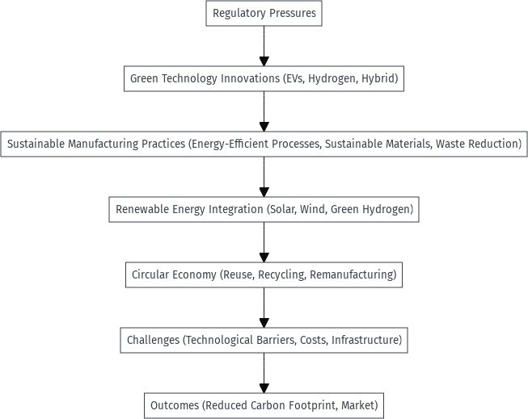

# Objectives of the study

The study has been conducted with the following objectives in mind:

1. To understand the concept of Green Tech
2. To study the relevance of Green Tech in the current and future scenario in the automobile industry
3. To analyse scope in the automobile industry
4. To examine the impact of Green Technology on environmental sustainability within the automotive sector.

# Research methodology

The study uses the following research methodology**:**

**Research design**: This study is comprehensive and exploratory in nature. It involves analysis of existing literature, industry reports, and technological advancements in automotive green technology, is conducted. It includes a thorough review of arising opportunities and threats and an analysis of trends related to developing and implementing sustainable transportation solutions.

**Sources of data collection**: The study utilises various secondary data sources such as business and environmental journals, industry reports, published research and other scholarly articles.

**Tools for data analysis:** Utilisation of Microsoft Excel for tabulation and graphical representation of data.

**Data analysis and interpretations (graphs, tables, charts)**

**Table 1: Table representing CO2 emissions released by Gasoline, Hybrid and Electric cars.**

|  |  |
| --- | --- |
| **Type of Vehicle** | **CO2 emissions kg/ gallon (for every 100 miles)** |
| Gasoline cars | 32 kg CO₂/gallon |
| Hybrid cars | 23.1 kg CO₂/gallon |
| Electric cars | 0 kg CO₂ |

**Figure 1: Funnel Chart representing CO2 emissions released by Gasoline, Hybrid and Electric cars.**

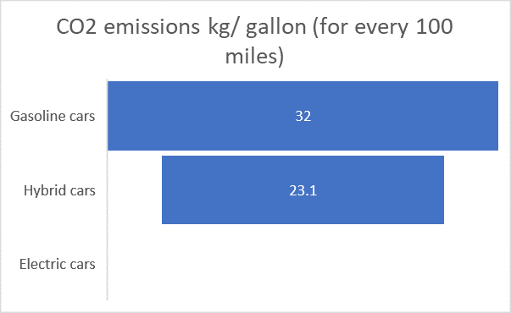

**Data Interpretation**

Electric cars are most sustainable achieving net-zero CO2 tailpipe emissions. Taking into account emissions produced during electricity production, it is still three times less than Gasoline car emissions.

# Table 2: Table representing sales of Hybrid, Plug-in Hybrid and Electric cars.

|  |  |  |  |  |  |  |  |  |  |  |  |
| --- | --- | --- | --- | --- | --- | --- | --- | --- | --- | --- | --- |
|  | **2011** | **2012** | **2013** | **2014** | **2015** | **2016** | **2017** | **2018** | **2019** | **2020** | **2021** |
| **Hybri** |  |  |  |  |  |  |  |  |  |  |  |
| **d** |  |  |  |  |  |  |  |  |  |  |  |
| **electr** | 268,7 | 434,6 | 495,5 | 452,1 | 384,4 | 346,9 | 362,8 | 338,0 | 399,4 | 455,0 | 798,9 |
| **ic** | 49 | 48 | 35 | 72 | 00 | 49 | 68 | 83 | 44 | 67 | 92 |
| **Plug-** |  |  |  |  |  |  |  |  |  |  |  |
| **in** |  |  |  |  |  |  |  |  |  |  |  |
| **hybri** |  |  |  |  |  |  |  |  |  |  |  |
| **d-** |  |  |  |  |  |  |  |  |  |  |  |
| **electr** |  | 38,58 | 49,00 | 55,35 | 42,95 | 72,88 | 91,18 | 123,8 | 85,79 | 69,04 | 173,4 |
| **ic** | 7,671 | 4 | 8 | 7 | 9 | 5 | 8 | 83 | 1 | 9 | 57 |
| **Elect** | 10,09 | 14,58 | 48,09 | 63,52 | 71,06 | 86,73 | 104,4 | 207,0 | 233,8 | 238,5 | 459,4 |
| **ric** | 2 | 7 | 4 | 5 | 4 | 1 | 87 | 62 | 22 | 40 | 26 |

**Figure 2: Bar chart representing sales of Hybrid, Plug-in Hybrid and Electric cars.**

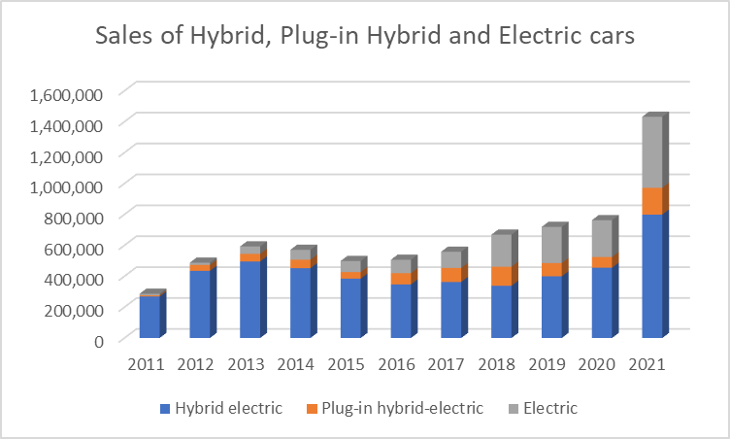

Source: US Department of Energy

# Data Interpretation

Hybrid cars are the most popular choice over the years. However, electric cars have gained more popularity in recent years. We can see that at around 2011 plug-in-hybrid cars and electric cars have not yet gained much popularity.

Note:

In recent years, the first electric car was commercialised in the year 2010.

# Figure 3: Sales of Top 10 Electric Vehicle Companies

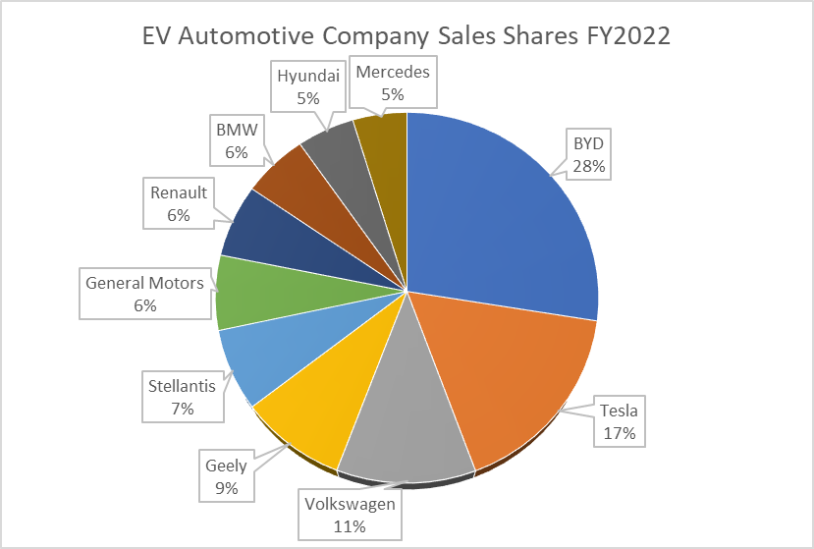

**Data Interpretation** :-BYD, Tesla and Volkswagen are the current market leaders in terms of Electric car sales as of 2022. These companies are Chinese, American and German. They rankings of the above companies are as follows:

BYD, Tesla, Volkswagen, Geely, General Motors, Renault, BMW, Hyundai, Mercedes.

# Figure 4: Reduction of CO2 emissions

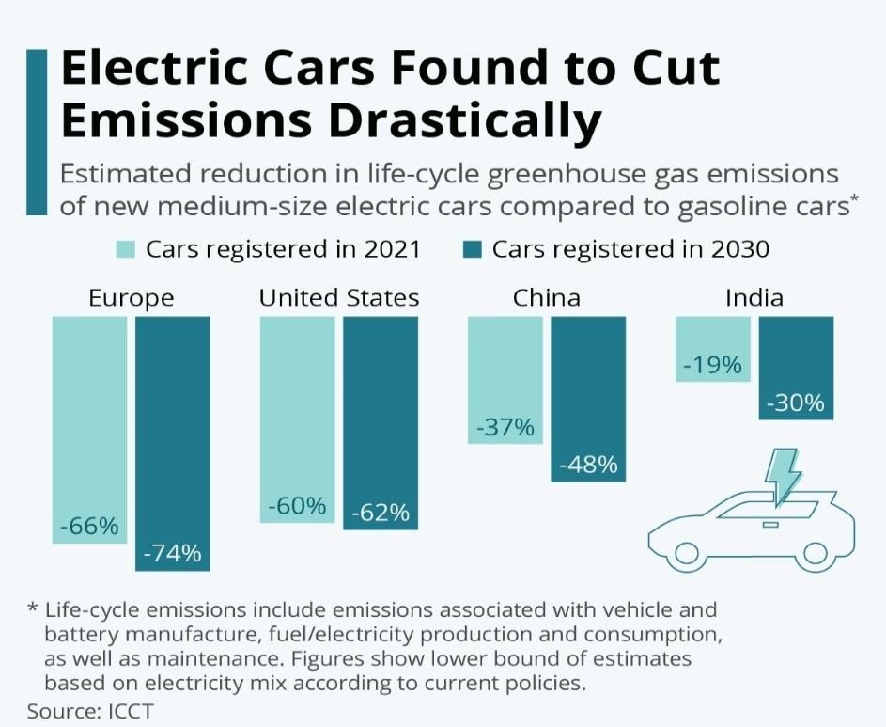

**Data Interpretation:**

Studies show that due to the increasing number of electric cars purchased and registered there has been a decrease of about 66% of CO2 and other greenhouse emissions in Europe, 60% in the US, about 37% in China and 19% in India. By the year 2030, a further decrease in emissions is expected.

# Findings and observations

This section is extracted after thorough analysis of the questionnaire, to understand the impact of green technologies such as Electronic, Hybrid, Plug-in Hybrid cars on CO2 emissions. The following findings were made:

* There is a constant increase in sales of green technologies.
* Electronic cars have zero tail pipe carbon emissions, while hybrid cars have significantly less emissions than gasoline cars.
* Electronic cars are becoming increasingly popular in recent years.
* China is the market leader in sales of electronic vehicles.
* There is strong evidence that suggests that there is a direct co-relation between adopting green technologies such as electronic, hybrid, and plug-in hybrid cars to reduce our carbon footprint.
* Green technology helps us take a step further to achieving net-zero carbon emissions.

# Conclusion

Using Green technology in the automotive sector is essential to solving environmental issues, cutting carbon emissions, and promoting sustainability. The industry is changing significantly in the direction of a more efficient and environmentally responsible future because of the use of green technology like electric cars, recyclable materials, and renewable energy sources. The use of green technology by the automobile sector represents a proactive stance towards sustainability, innovation, and environmental stewardship. Automakers are laying the foundation for a more environmentally friendly future that will benefit the sector as well as the planet by emphasising eco-friendly processes, cutting carbon emissions, and investing in renewable energy sources.

# References

1. Richter, F. (2021, February 19). *Chart: Which countries have the most electric cars?* World Economic Forum. [https://www.weforum.org/agenda/2021/02/electric-vehicles-europe-](https://www.weforum.org/agenda/2021/02/electric-vehicles-europe-percentage-sales/)

[percentage-sales/](https://www.weforum.org/agenda/2021/02/electric-vehicles-europe-percentage-sales/).

1. Hybrid-Electric, plug-in Hybrid-Electric and electric vehicle sales. (n.d.). Bureau of Transportation Statistics. [https://www.bts.gov/content/gasoline-hybrid-and-electric-vehicle-](https://www.bts.gov/content/gasoline-hybrid-and-electric-vehicle-sales) [sales.](https://www.bts.gov/content/gasoline-hybrid-and-electric-vehicle-sales)
2. Anderson, J., & Anderson, R. (2020). "Electric Vehicles and Their Impact on the Environment." Journal of Sustainable Transportation, 15(2), 123-135.
3. Garcia, M., Smith, L., & Thompson, J. (2020). "Efficiency and Benefits of Hybrid Vehicle Systems." International Journal of Automotive Engineering, 22(4), 421-436.
4. Chesbrough Henry, Vanhaverbeke Wim, & West Joel. Open Innovation
5. Researching a New Paradigm, Oxford University Press, 2006.
6. Woody, T. (2007), ‘Silicon Valley’s $200 million electric car start-up’,
7. blogs.business2.com, October 29th, 2007.
8. Duleep, G., van Essen, H., Kampman, B., & Grünig, M. (2011). Impacts of electric

vehicles—Deliverable 2. Assessment of electric vehicle and battery technology. Publication number: 11.4058.04. [www.cedelft.eu.](http://www.cedelft.eu/) Accessed 10 Jan 2017.

1. BCG. (2010). Batteries for electric cars. Challenges, opportunities, and the outlook to 2020. The Boston Consulting Group.