COMPUTER TECHNOLOGY 💻
MOIN RAZA
UG Student, Department of Biotechnology, GD Rungta College of Science and Technology, Bhilai,Chhattisgarh
^{Corresponding author-} ^{moinrzpathan2@gmail.com}

INTRODUCTION

In the ever-evolving landscape of the 21st century, the symbiotic relationship between humans and technology has become increasingly inseparable, reshaping the way we live, work, and communicate. At the forefront of this transformative journey is the ubiquitous presence of computers and technology. These powerful tools have revolutionized every aspect of our lives, acting as catalysts for innovation, connectivity, and progress.

The computer, a marvel of human ingenuity, has evolved from its humble beginnings as room-sized machines to sleek, portable devices that fit in the palm of our hands. As we navigate through the digital age, the capabilities of computers have expanded exponentially, enabling us to process vast amounts of information, simulate complex scenarios, and connect with people across the globe in an instant.

Technology, the driving force behind this digital revolution, encompasses a vast array of innovations that extend far beyond the confines of traditional computing. From artificial intelligence and machine learning to the Internet of Things (IoT) and blockchain, technology continues to push the boundaries of what is possible. It has become an integral part of industries such as healthcare, finance, education, and entertainment, shaping the way we approach challenges and opportunities in our interconnected world.

This introduction sets the stage for a deeper exploration into the dynamic realm of computers and technology, where the fusion of human creativity and technological prowess opens doors to unprecedented possibilities. Join us on this journey as we unravel the intricacies of the digital landscape, examining the impact of these technological marvels on our society, economy, and the very fabric of our daily lives.

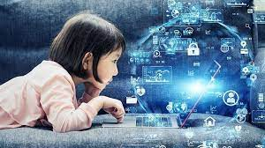
DEFINITION
Computer technology refers to the practical application of computer systems, hardware, and software to solve real-world problems and enhance various aspects of human life. It encompasses a broad range of technologies and techniques that enable the effective use, development, and maintenance of computer systems. Computer technology is a dynamic field that continually evolves as new hardware components, software applications, and methodologies are developed.

At its core, computer technology involves the study, design, and implementation of computer systems, networks, and software applications to perform specific tasks or functions. This includes understanding the architecture of computers, the development of software programs, the design of computer networks, and the integration of various technologies to create efficient and effective computing solutions.

HISTORY OF COMPUTER TECHNOLOGY
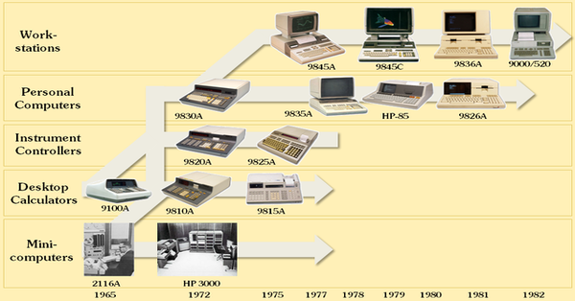
The history of computer technology is a fascinating journey marked by numerous milestones and breakthroughs that have shaped the modern digital landscape. Here is a concise overview of key developments:

- Pre-20th Century: Precursors to Computing

Early concepts of computation date back to ancient civilizations, with devices like the abacus being used for arithmetic calculations.
The 17th-century invention of the mechanical calculator by Blaise Pascal and later, the Pascaline, by Gottfried Wilhelm Leibniz, marked early attempts at automating mathematical processes.

- 19th Century: Analytical Engine Concept

Charles Babbage, often regarded as the "father of the computer," conceptualized the Analytical Engine in the 1830s. Although it was never built during his lifetime, his designs laid the groundwork for modern computing principles.

- 1930s-1940s: Early Electronic Computers

The 1930s saw the development of electro-mechanical computers like the Atanasoff-Berry Computer (ABC) and the Harvard Mark I.
The 1940s witnessed the advent of electronic computers, with notable machines including the ENIAC (Electronic Numerical Integrator and Computer) and the EDVAC (Electronic Discrete Variable Automatic Computer).

- 1950s: Mainframes and Early Programming Languages

The 1950s marked the rise of mainframe computers, which were large, centralized systems. UNIVAC I, delivered in 1951, became the first commercially produced computer.
The development of programming languages like Fortran (1957) and LISP (1958) facilitated software creation and made computers more accessible.

- 1960s: Miniaturization and Integrated Circuits

Advancements in miniaturization and the invention of integrated circuits paved the way for smaller and more powerful computers.
IBM's System/360 (1964) introduced a family of compatible computers, providing flexibility in system configurations.

- 1970s: Personal Computers Emerge

The 1970s witnessed the birth of the microprocessor, with the Intel 4004 (1971) being the first commercially available microprocessor.
The development of the Altair 8800 (1974) and the subsequent release of the Apple I (1976) and Apple II (1977) marked the emergence of personal computers.

- 1980s-1990s: Rise of the Personal Computer Industry

IBM PC (1981) and the introduction of MS-DOS by Microsoft established the PC standard.
Graphical User Interfaces (GUIs) gained popularity with the release of the Apple Macintosh (1984) and Microsoft Windows (1985).
The World Wide Web was born in 1989, revolutionizing communication and information access.

- 2000s-2020s: Mobile Computing and Cloud Technology

The 2000s saw the proliferation of mobile computing with the rise of smartphones and tablets.
Cloud computing became a dominant paradigm, enabling remote data storage and processing.
Advances in artificial intelligence, machine learning, and quantum computing have been prominent in recent years.
The history of computer technology is an ongoing narrative of innovation, with each era building upon the achievements of its predecessors. As technology continues to evolve, the future promises further advancements, pushing the boundaries of what computers can achieve.
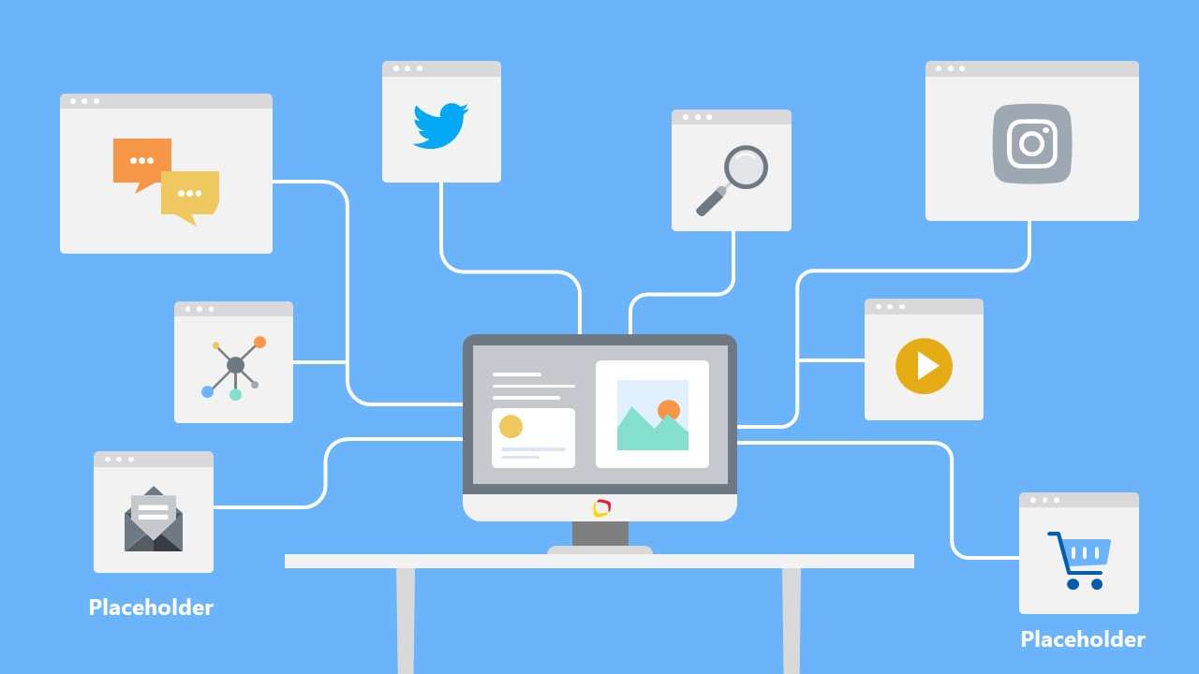

APPLICATION OF COMPUTER TECHNOLOGY
Computer technology is pervasive across numerous industries, influencing the way we work, communicate, and live. Here are some key applications of computer technology:

- Business and Finance:

- Data Analysis: Computers enable businesses to analyze large datasets to gain insights, make informed decisions, and identify trends.
- Financial Modeling: Complex financial models and simulations are created using computer technology for risk assessment, investment analysis, and strategic planning.
- Electronic Transactions: Online banking, e-commerce, and digital payment systems rely on computer technology for secure and efficient transactions.

- Healthcare:

- Medical Imaging: Computers process and analyze medical images from technologies such as MRI, CT scans, and X-rays, aiding in diagnostics and treatment planning.
- Electronic Health Records (EHR): Computer systems manage patient records, ensuring accurate and accessible information for healthcare professionals.
- Drug Discovery: Computational methods assist in simulating and analyzing molecular interactions, accelerating the drug discovery process.

- Education:

- Online Learning: Computers facilitate distance education, providing access to educational resources and interactive learning materials.
- Educational Software: Applications for simulations, tutorials, and educational games enhance the learning experience for students of all ages.
- Administrative Systems: Institutions use computer technology for managing student records, scheduling, and other administrative tasks.

- Communication:

- Internet and Email: The backbone of modern communication, allowing instant global communication and information sharing.
- Social Media: Platforms leverage computer technology for user interactions, content delivery, and personalized experiences.
- VoIP (Voice over Internet Protocol): Computer-based communication systems enable voice and video calls over the internet.

- Entertainment:

- Gaming: Computer technology powers video games, virtual reality (VR), and augmented reality (AR) experiences.
- Streaming Services: Digital content delivery, including music, movies, and TV shows, relies heavily on computer technology.
- Digital Art and Animation: Creative industries use computers for digital art creation, animation, and special effects in movies.

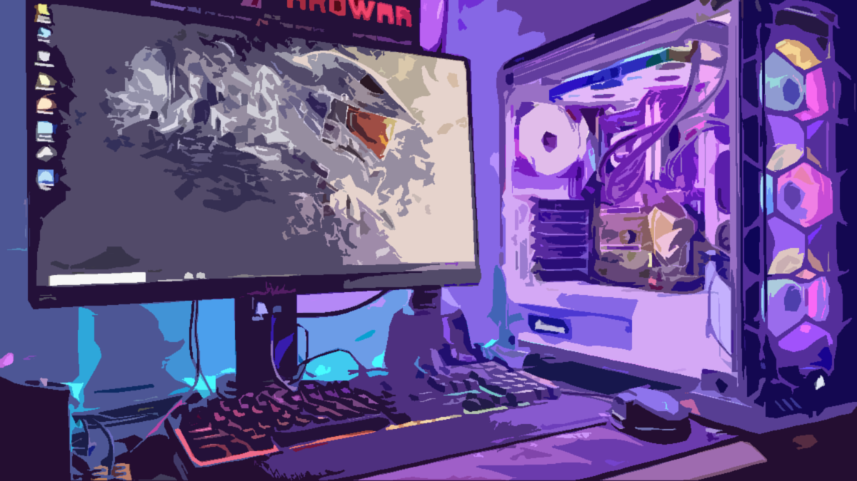

CONCLUSION

In conclusion, the trajectory of computer technology has been a remarkable journey marked by continuous innovation and transformative impact across diverse facets of human existence. From the conceptual designs of pioneers like Charles Babbage to the era of ubiquitous computing and beyond, computers have evolved from room-sized machines to pocket-sized devices, becoming integral to our daily lives.

The applications of computer technology are vast and influential, permeating industries such as business, healthcare, education, communication, entertainment, manufacturing, transportation, research, and security. The ability of computers to process vast amounts of data, automate complex tasks, and connect people globally has revolutionized the way we work, learn, communicate, and conduct business.

REFERENCES

- Weiser, M. (1999). The computer for the 21st century. ACM SIGMOBILE mobile computing and communications review, 3(3), 3-11.
- García, C. R., Caballero-Gil, P., Burmester, M., & Quesada-Arencibia, A. (Eds.). (2016). Ubiquitous Computing and Ambient Intelligence: 10th International Conference, UCAmI 2016, San Bartolomé de Tirajana, Gran Canaria, Spain, November 29–December 2, 2016, Proceedings, Part I (Vol. 10069). Springer.

- Corchado Rodríguez, J. M., Rodríguez González, S., Llinas, J., & Molina, J. M. (2009). International symposium on distributed computing and artificial intelligence 2008 (DCAI 2008). Springer Berlin Heidelberg.

- Rodríguez, J. M. C., Rodriguez, S., Llinas, J., & Molina, J. M. (Eds.). (2008). International Symposium on Distributed Computing and Artificial Intelligence 2008 (DCAI ́08) (Vol. 50). Springer Science & Business Media.

- Sandoval, F., Prieto, A., Cabestany, J., & Graña, M. (Eds.). (2007). Computational and Ambient Intelligence: 9th International Work-Conference on Artificial Neural Networks, IWANN 2007, San Sebastián, Spain, June 20-22, 2007, Proceedings (Vol. 4507). Springer.

- Cho, Y., & Bianchi-Berthouze, N. (2019). Physiological and affective computing through thermal imaging: A survey. arXiv preprint arXiv:1908.10307.

- Castro, J. E., Fowler, B., & Gomes, L. (Eds.). (2018). Time, Science and the Critique of Technological Reason: Essays in Honour of Hermínio Martins. Springer.

- Reynolds-Cuéllar, P., Wong-Villacres, M., Badillo-Urquiola, K., Barrera Machuca, M. D., Cibrian, F. L., Ciolfi Felice, M., ... & Lemus, O. A. (2023, April). Para Cima y Pa’Abajo: Building Bridges Between HCI Research in Latin America and in the Global North. In Proceedings of the 2023 CHI Conference on Human Factors in Computing Systems (pp. 1-19).

- Martínez-Santos, J. C. (Ed.). (2018). Advances in Computing: 13th Colombian Conference, CCC 2018, Cartagena, Colombia, September 26–28, 2018, Proceedings (Vol. 885). Springer.

- Panyan, M. V. (1984). Computer technology for autistic students. Journal of Autism and Developmental Disorders, 14(4), 375-382.

Introduction of writer

The topic Computer Technology is written by Moin Raza from bsc 2nd year biotechnology i chose this topic due to increase our daily life dependencies on Computer .The topic like to explain u the importance of Computers In our daily life and why should we have proper knowledge of computer technology in 21st century. I hope my research will help u to more about computers and its importance.

