**Hematinics, Coagulants and Anticoagulants**

**Hematinics:** These are substances required in the formation of blood, and are used for treatment of anemias.

* Essential haematinics: Iron, vitamin B 12, folic acid.

Etiology:

* Anemia occurs when:

(a) Blood loss (acute or chronic)

(b) Impaired red cell formation due to:

Deficiency of essential factors, i.e. iron, vitamin B-12, folic acid.

Bone marrow depression, erythropoietin deficiency.

(c) Increased destruction of RBCs

**Anemia**

Anemia is a decrease in the RBC count, hemoglobin, or hematocrit values resulting in a lower ability for the blood to carry oxygen to body tissues.

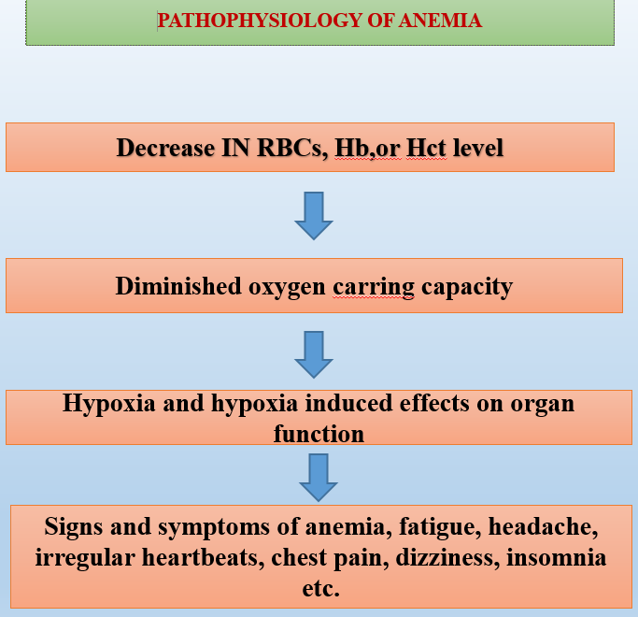

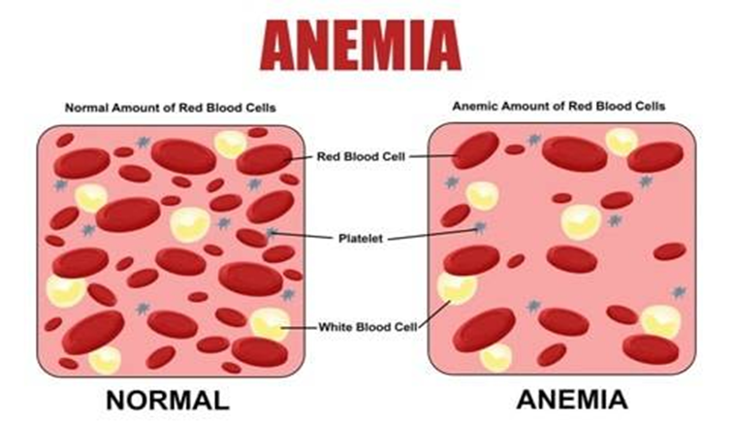

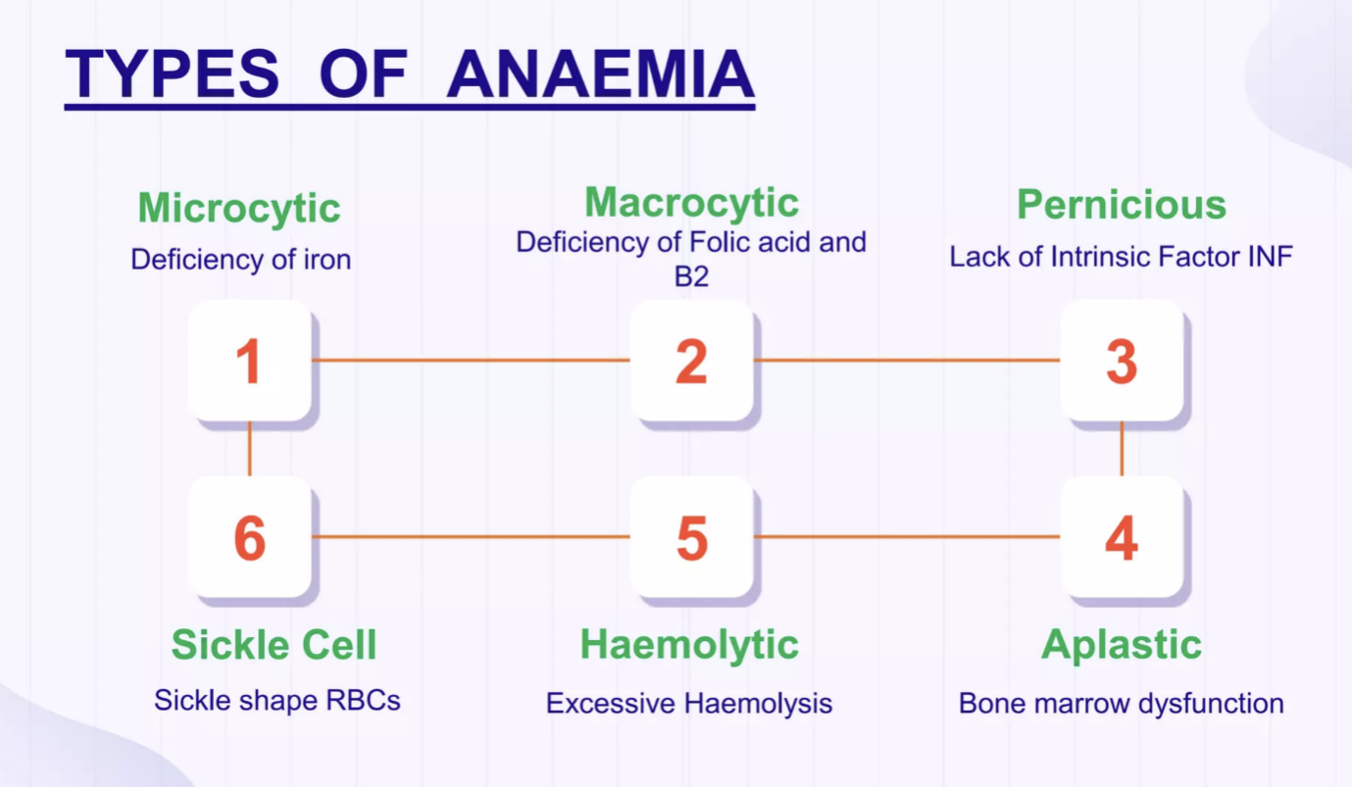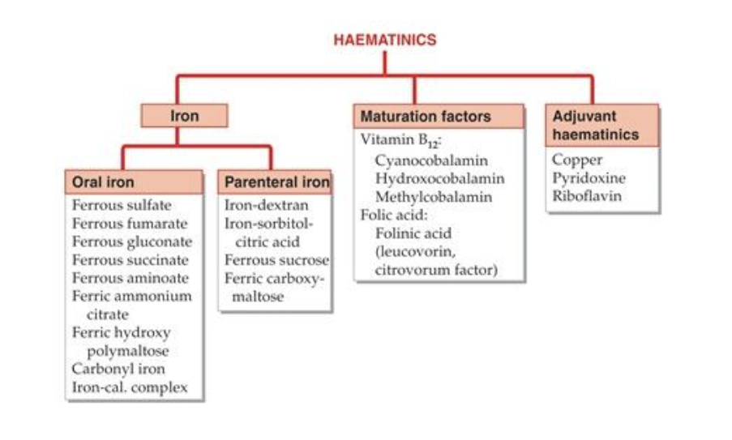

**Iron**

Distribution of iron in body

* Hemoglobin (Hb). 66%
* Iron stores as ferritin and hemosiderinn. 25%
* Myoglobin (in muscles). 7%
* Enzymes (cytochromes etc.) 6%

**Daily Iron requirement**

* Adult male: 0.5-1 mg
* Adult female: 1-2 mg (menstruating)
* Children: 25 micro gm /kg
* Pregnancy: 3-5 mg

**Dietary sources of iron rich**

* Liver, egg yolk, dry fruits, wheat, spinach, Meat, chicken, fish, banana, apple.
* Two different iron transporters in the intestinal mucosal cells to carryout iron uptake.
* **divalent metal transporter 1** (DMTI) carries ferrous iron into the mucosal cell
* **ferroprotein** are bound with ferrous iron & pass-through mucosal cell directly into the blood stream

**Mechanism of Iron absorption, transportation, utilization & storage**

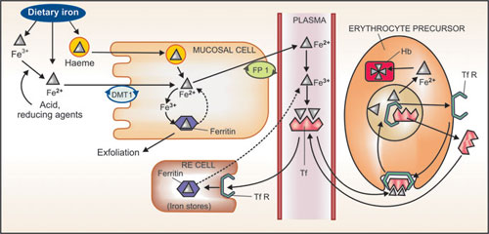

**Mechanism**

* On entering plasma Ferrous is immediately converted to the ferric form and form complex with a glycoprotein transferrin (Tf) which has two binding sites for ferric ions.
* Iron is transported into erythropoietic and other cells through attachment of transferrin to specific membrane bound transferrin receptors (TfRs).
* The complex is engulfed by receptor through endocytosis. Iron detaches from complex at the acidic pH of the intracellular vesicles.
* Released iron used for Hb synthesis.
* Tf & TfR comes back to cell surface to carry another.

**Storage**

Liver, (spleen, bone marrow) as well as in hepatocytes and myocytes as ferritin and hemosiderin.

**Excretion**

* In adult male is 0.5- to 1mg, mainly as exfoliated i.e, mucosa cells, some rbcs and in bile (lost in feaces)
* In menstruating women- monthly loss of – 0.5-1mg per day
* Other routes – skin (urine and sweat)

**Therapeutic uses**

* Pregnancy
* Iron deficient anemia
* Premature babies
* Blood loss
* Malabsorption syndrome
* GI bleeding due to-ulcers.

**Iron preparations & brand names**

* Oral preparations- ferrous sulfate (feosol)
* Parenteral preparations- iron dextran (imferon)

**Folic acid**

Pteroyl glutamic acid (PGA) (pteridine + Para aminobenzoic acid (PABA) + glutamic acid.)

• Dietary sources: Liver, green leafy vegetables (spinach), Yeast, egg, milk.

• Present in food as poly-glutamates

• Absorption: in the duodenum and jejunum

• Transported in the blood as methyl-THFA by active and passive transport.

• Stored in cells as polyglutamate, Liver takes up a large part and secretes methyl-THFA in bile.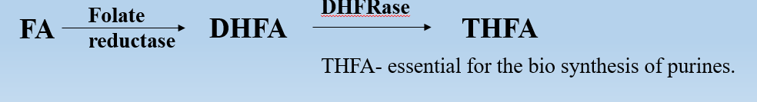

**Therapeutic Uses of Folic Acid**

Megaloblastic anemia

Folic acid deficiency

Protect epithelial cell

Growth in infants

In pregnancy

**Preparations and dose:**

* Folic acid: -liquid oral, Injectable
* Folinic acid: -CALCIUM LEUCOVORIN 3 mg/ml inj.

**Diurnal demand:** 0.2 mg per day (0.8 mg in gestation & lactation mothers)

**Vitamin B12 (Cyanocobalamin)**

Complex cobalt containing compounds Cyanocobalamin and hydroxocobalamin

• synthesized by microorganisms, plants and animals acquire it from them.

**Dietary sources**: Fish Liver, salt water fish, eggs, chicken, meat, cheese.

Two active coenzyme forms of B12 are deoxyadenosyl-cobalamin (DAB12) and methyl-cobalamin (methyl B12).

**Functions**

* Vit. B12 act as cofactor in following reactions -
* Conversion of homocysteine to methionine - methionine is methyl group donor in metabolic reactions.
* Purine and pyrimidine synthesis - needed for DNA synthesis
* Malonic acid DAB12 Succinic acid important for propionic acid metabolism (Carbohydrate and lipid metabolism)
* for cell growth and multiplication

**Dosage and Uses of Vitamin B12**

* Vit B12 is well absorbed after i.m. or deep s.c. injection
* Cyanocobalamin: 35 micro gm/5 ml liq.,
* Hydroxocobalamin: 500 mg. 1000 mg

**Therapeutic Uses**: Treatment of Vitamin B12 deficiency

1. Megaloblastic anaemia: defects in the metabolism of vitamin B12 or folic acid.
2. Pernicious anaemia: body isn't able to absorb orally vitamin B12 due to a lack of intrinsic factor so given parenterally IM or SC
3. Prophylaxis: 3-10 micro gm daily
4. Neurological condition like: Neuropathies, trigeminal neuralgia, Multiple sclerosis, psychiatric disorders.

**COAGULANTS**

**Introduction**:

Haemostasias- stoppage of bleeding from damaged blood vessel.

3 basic mechanism which prevent blood loss:

1. Initially vasospasm of small capillaries- Vasoconstriction
2. 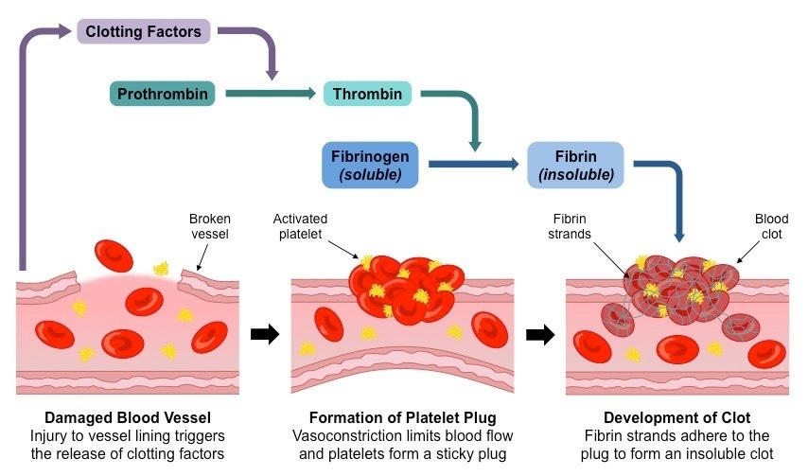Platelet plug formation

**Blood clotting:**

**Coagulation** is the process by which a liquid, particularly blood, changes into a semi-solid or solid state. In the context of blood, coagulation is part of hemostasis, the body's mechanism to prevent excessive bleeding after an injury. It involves transformation of blood from liquid to gel, forming a clot.

Disorders of coagulation can lead to an increased risk of bleeding or clotting (thrombosis).

**3 stages of coagulation:**

* Intrinsic/extrinsic
* Thrombin formation
* Fibrin Formation

**Coagulants**

Coagulants are drugs that promote coagulation and control bleeding.

Coagulants are also called as hemostatics.

* Systemically
* locally (styptics)

In Hemorrhagic states - Hemophilia, Von Willebrand’s disease

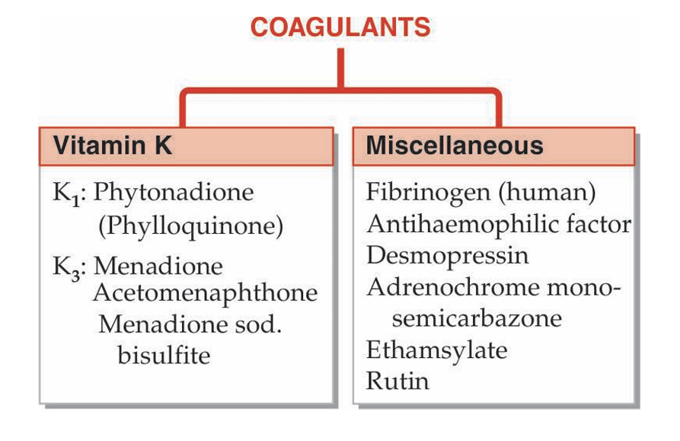Fresh whole blood or plasma - best therapy provide all factors needed for coagulation Act immediately.

**Vitamin K (**Phytonadione and Menadione)

**Mechanism of Action:**

Vit K acts as a cofactor at a late stage in the synthesis of coagulation proteins - prothrombin (II). VII, IX and X by liver. The vit K dependent changes, ability to bind Ca2+ and to get bound to phospholipids and properties essential for participation in the coagulation cascade.

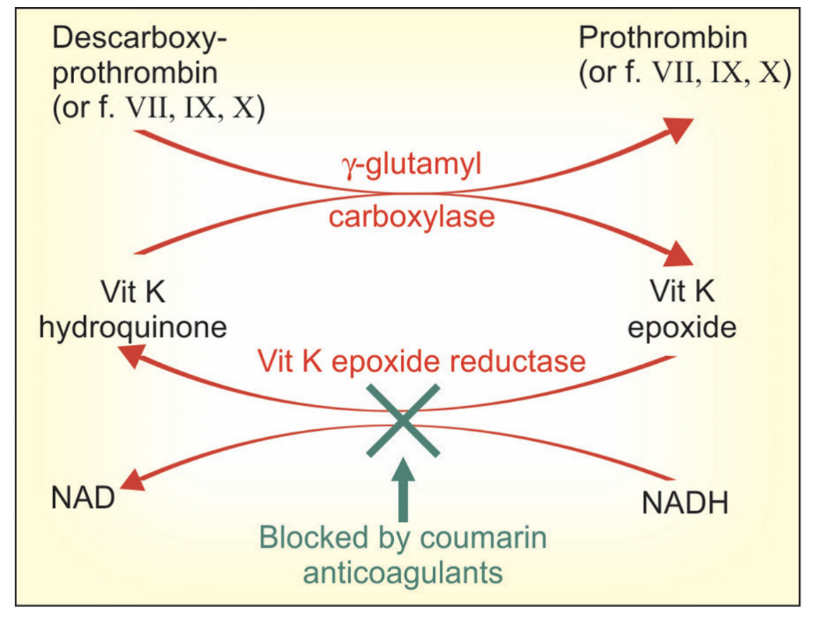

**Therapeutic uses:**

* Dietary deficiency
* Liver disease
* Malabsorption
* Long term antimicrobial therapy
* Newborn babies lack intestinal flora and have low level of clotting factors:
* Overdose of oral anticoagulants

**Adverse effects:**

* Allergic reactions are very rare.
* Dizziness
* Rapid and Weak Pulse
* Profuse Sweating
* Brief Hypotension
* Pain, Swelling, and Tenderness at the Injection Site

**Contraindications:**

* Severe anaphylaxis reactions can occur on i.v. inj of emulsion; this route should not be used.
* During Surgeries.
* Vitamin K may interfere with the effectiveness of anticoagulants, such as **warfarin.**

**Dosages and brand names:**

* Phytonadione: VITAMIN-K, KVI, K-WIN 10 mg/ml for i.m. injection.
* Acetonaphthone: ACETOMENADIONE 5, 10 mg tab; KAPILIN 10 mg tab.

**Anti-Coagulants**

* The drugs that are used to reduce the coagulability of blood are known as anti-coagulants

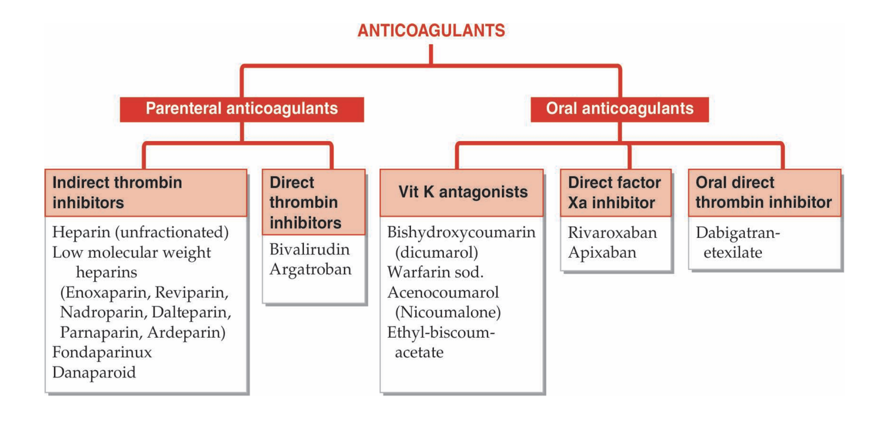**Heparin**

* McLean, a medical student discovered that liver contains a powerful anticoagulant, in 1916.
* Howell and Holt named it HEPARIN obtained from liver Mixture of mucopolysaccharides with MW 10,000 to 20,000 (D-glucosamine-L-iduronic acid & D-glucosamine - D-glucuronic acid)
* Strongest organic acid present in the body.
* Found in the mast cells of lung, liver and intestinal mucosa Commercially obtained from-ox lung and pig intestinal mucosa.

**Heparin mechanism of action:**

**HEPARIN**

26

**Binds and activates plasma antithrombin III**

**heparin-AT III complex binds to clotting factors of the intrinsic and common plasma pathways (Xa, IIa, IXa, antithrombin XIa, XIla and XIlIa) and inactivates them**

**inhibition of factor Xa as well as thrombin (IIa) mediated conversion of Anticoagulation Effect fibrinogen to fibrin**

**Anticoagulation effect**

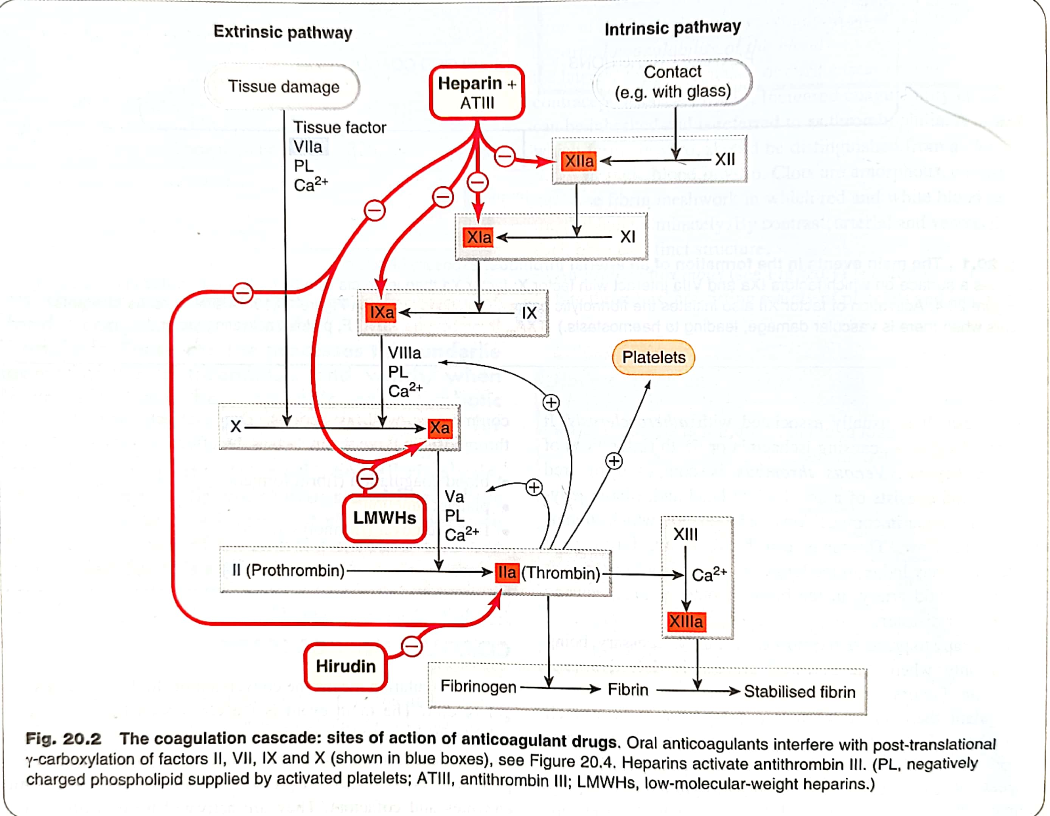

**Pharmacological actions:**

* **On Blood:**

**Anticoagulation**: Heparin prevents blood clot formation by binding to antithrombin III (ATIII) and accelerating its inactivation of coagulation enzymes, including thrombin (factor IIa) and factor Xa

**Thromboprophylaxis:** Heparin is indicated for prophylaxis.

* **On Platelets:**

**Inhibits** platelets aggregation and **increases** the bleeding time.

* **On Cardiovascular System**:

**Prevents embolisms** in patients with atrial fibrillation and also used as an adjunct antithrombin therapy in patients with unstable angina and acute coronary artery syndrome.

* **Respiratory System**:

**Pulmonary Embolism**: Heparin reduces thrombosis associated with pulmonary embolism**.**

* **Renal System**:

**Kidney Dialysis**: Heparin prevents blood clotting during kidney dialysis.

**Pharmacokinetics**

* Large MW, highly ionized molecule: therefore not absorbed orally.
* If injected i.v - acts instantaneously. After s.c injection anticoagulant effect develops after ~ 60 min
* Does not cross blood-brain barrier or placenta.
* Safe in pregnancy
* Metabolized in liver by heparinase

**Adverse Effects:**

• Bleeding due to overdose -serious complication- hematuria (Ist sign)

• Thrombocytopenia

• Transient and reversible alopecia

• Osteoporosis - On long-term use

• Hypersensitivity reactions

**Contraindications**

* Bleeding disorders
* Heparin induced thrombocytopenia
* Endocarditis
* Ulcers in gut
* Severe hypertension (risk of cerebral hemorrhage)
* large malignancies (risk of bleeding in the central necro sed area of the tumor)