**REDUCING WASTE IN CLINICAL SETTING**

**Priyanka Singh1**

**Ph.D. Scholar, Teerthanker Mahaveer University Moradabad**

**Email-** [**priyankasingh.nov.26@gmail.com**](mailto:priyankasingh.nov.26@gmail.com)

**Mamta Verma2**

**Assistant Professor, Teerthanker Mahaveer University Moradabad**

**Email- mv926431**[**@gmail.com**](mailto:priyankasingh.nov.26@gmail.com)

**Abstract-** Improving patient outcomes, sustainability, and healthcare efficiency all depend on reducing waste in clinical settings. Waste in healthcare includes excessive material use, ineffective procedures, needless resource use, and preventable patient problems. Adopting technology to improve workflows, embracing lean management concepts, and putting evidence-based strategies into practice are some ways to tackle this issue. Reduced usage of single-use plastics, improved inventory control, improved care coordination, and internet integration to cut down on unused trips are important strategies. Fostering a sustainable culture requires the involvement and education of healthcare workers. Carefully reducing waste can help healthcare companies save costs, improve the quality of care they offer, and lessen their environmental effect. This abstract highlights the importance of a multidisciplinary approach in achieving waste reduction and its implications for a more sustainable healthcare future.

**Keywords-** Environmental Health and Safety, clinical waste, sustainable, Waste Resources Action Programme.

* 1. **Introduction of waste material**

The term "clinical waste" relates to trash generated by medical procedures and related activities that could be dangerous or provide an infection risk, such as bandages, dressings, swabs, etc. Waste in clinical settings is any material or substance left behind after medical operations or treatments that is no longer needed or useful. The possible threats that clinical waste causes to the environment and public health are taken into consideration while classifying it. To avoid contamination, infection, or harm, roper handling and disposal are essential.

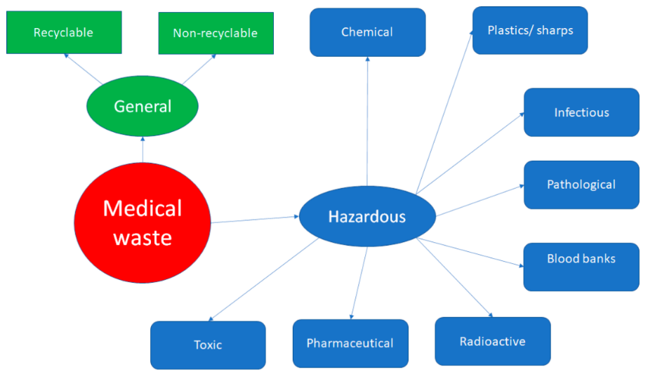

**Figure- 1 various types of clinical waste**

* 1. **Definition**

There are several definitions that describe the clinical waste but first defined by **Toyota**, this framework consists of seven categories of non-value-adding activities: **(Figure 1 & 2)**

* 1. **Overproducing**- creating goods in excess of what is necessary before a legitimate order is received;
  2. **Over processing**- longer or more sophisticated processes than necessary;
  3. **Excessive waiting**- extended cycle times that decrease agility;
  4. **Unnecessary transportation**- material moved between locations needlessly;
  5. **Unneeded movement**—inefficient workspace; layout adding to workload;
  6. Accumulation of work-in-process or raw materials;
  7. **Poor quality**- too many flaws, including excessive rework and low process quality.**[1]**

**Figure-2 Healthcare waste classification**

* 1. **Introduction of clinical waste reduction-** Hospital waste reduction has drawn attention from biomedical companies since it is one of the waste management categories with the greatest social and economic significance. Adopting the **reducing, reusing**, and **recycling** concepts in healthcare has major societal advantages in addition to improving hospital's exterior brand. Hospitals may show that they are managing their facilities responsibly by putting in place initiatives that reduce medical waste and encourage sustainability.

Financially speaking, cutting clinical waste can result in a large reduction in operating expenses. Recycling also lessens the financial burden of disposal by recovering expenditures from squandered resources.

* **Prevention-** Prevention is the process of utilizing less material, reusing items, and avoiding unnecessary consumption in order to reduce waste generation.
* **Reuse**- The process of giving goods or materials new uses without undergoing further processing. Donating, fixing, and reusing are all included in this.
* **Recycling** is converting waste materials into new goods while lowering the demand for virgin resources.
* **Recovery**- The process of turning non-recyclable garbage into energy using techniques including anaerobic digestion, gasification, and incineration with energy recovery.
* **Disposal**- The process of disposing of waste by burning and landfilling without recovering energy. Only in situations where garbage cannot be avoided, reused, repurposed, or recovered can this least desirable alternative be employed.**[2]**
  1. **Waste management and classification based on World Health Organization (WHO) guidelines**

**4.1 Infectious waste**- Excreta and other materials that have come into contact with patients in isolation wards who have highly infectious diseases, as well as waste and waste water contaminated with bodily fluids like blood, including highly infectious waste like microbiological stocks and laboratory cultures, are examples of waste that is known or suspected to contain pathogens and pose a risk of disease transmission.

**Accountability for the secure treatment and elimination of infectious waste-**

The person who generates the infectious waste holds the primary duty for its safe handling and disposal. Even when there are other people processing the waste, this obligation continues all the way to the point of disposal. Even while garbage haulers and owners of treatment facilities are equally concerned with managing infectious waste, the generator should perform inspections or take other steps to guarantee that the waste is being treated and disposed of appropriately. Additionally, there can be municipal, state, or federal laws governing the disposal of medical waste and documentation that need to be followed. **[3] (Figure3)**

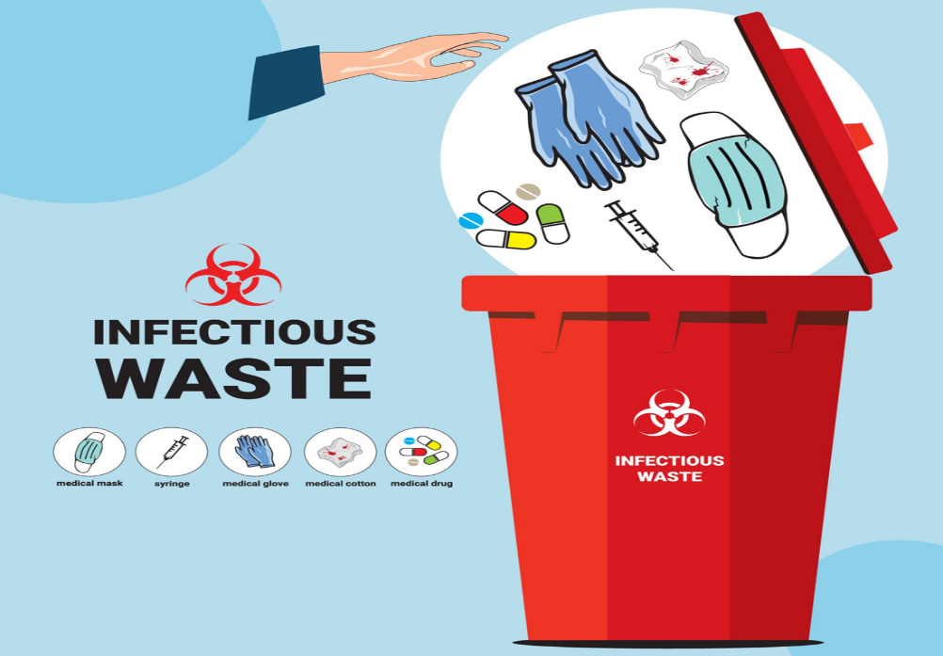

**Figure-3 Clinical infectious waste stock**

* 1. **Pathological waste**- Understandable **human-derived tissue**, organs, and body parts that have to be disposed of via funeral or burning are considered human pathological waste. Body fluids removed via surgery, autopsy, or other medical operations; specimens of bodily fluids and their containers; teeth and surrounding bone and gum structures; and discarded materials saturated with bodily fluids other than urine are not included in this. **(Figure4)**  
     Investigate Organs, dead bodies, body parts, and tissue produced from vertebrates that need to be burned are all considered animal pathological waste.   
     Solid, non-sharp medical waste tainted with biological material is considered standard regulated medical waste, or "Red Bag" trash. This type of garbage needs to be autoclaved and dumped in a landfill.

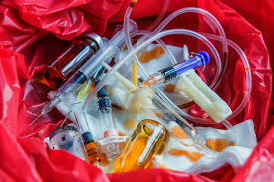

**Figure-4 Different types of pathological clinical wastes**

**Responsibility- Waste Generators:** Those who produce pathological waste from animals and humans, such as students, instructors, staff, and visitors, are required to make sure that all related wastes are handled, stored, managed, and disposed of in accordance with this update. Employees who pack, ship, or sign Medical Waste Tracking Forms for shipments of pathological waste are required to finish **Environmental Health and Safety (EHS)** Regulated Medical Waste Shipper Training. Staff can get technical support and direction on pathological waste management from Environmental Health and Safety (EHS).EHS offers Shipper Training for Regulated Medical Waste and Pathological Waste, which covers how to properly package, handle, and transport pathological waste. Please refer to the Waste Disposal Procedures for any more questions on the disposal of biological waste. "Red Bag" is the standard term for regulated medical waste. Solid, non-sharp garbage that has been tainted with biological material is considered waste and needs to be autoclaved before being dumped in a dump. **[4]**

**4.3 Sharps waste** - Things used to pierce or cut body parts are referred to as "sharps." Sharps can pierce, cut, and perhaps expose waste handlers in a waste container. As a result, before being disposed of, all sharps waste needs to be decontaminated and put in sharps containers. Needles for intravenous, hypodermic, or other operations; auto-disposable syringes; syringes with needles attached; infusion sets; scalpels; pipettes; knives; blades; and shattered glass are examples of sharps waste. **(Figure5)**

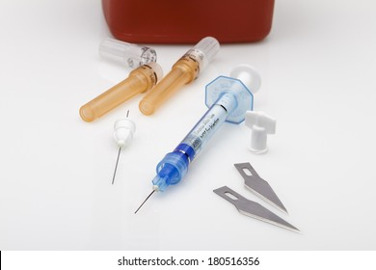

**Figure-5 Hospital sharp waste examples**

**Management**- Dispose of sharps trash in red plastic bins marked "biohazard." Don't use a container that is too big; instead, pick one that fits your workspace. Close the lid and cover the sides and lid with autoclave tape, making that the vent holes are not blocked, once the container is no more than two-thirds full. Put the room number and name of the Principal Investigator (PI) on the label. Sharps containers can be purchased from lab/medical providers.**[5]** **(Figure6)**

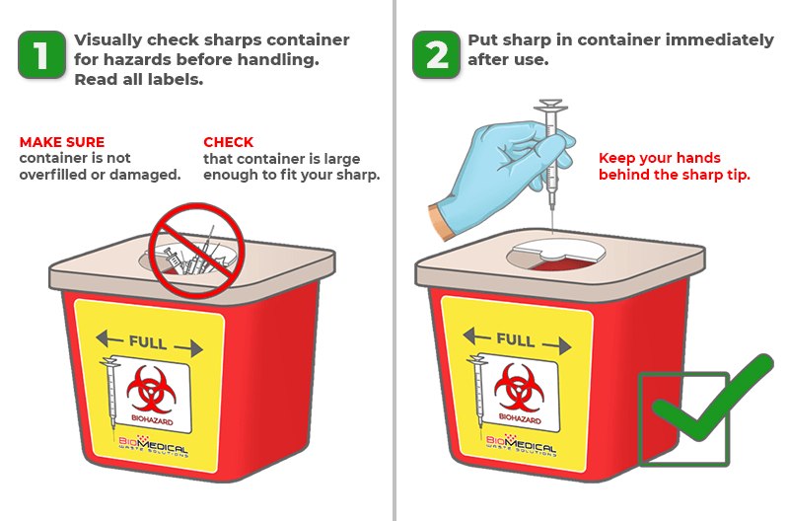

**Figure-6 Management of clinical sharp waste**

**4.4 Offensive/Hygiene waste-**Anything that is unpleasant, that is, because it smells, and has the potential to "offend" the senses is considered offensive waste. This category of waste, which includes items like **sanitary protection, diapers, and incontinence pads**, is not categorized as clinical or hazardous waste. Such types of trash can be aesthetically repulsive and cause discomfort because of its look or odor, but it does not directly endanger health or safety. In industries including healthcare, cosmetics, and some industries, the control of unpleasant waste is essential to maintaining a clean atmosphere, adhering to rules, and ensuring public hygiene.

**Management-**To reduce the dangers of cross-contamination or improper handling, it is crucial to maintain hygiene when dealing irritating hygiene waste. Despite not being contagious, disagreeable waste can produce unpleasant odors, draw bugs, or expose people to potentially dangerous compounds by accident if it is handled improperly. Respecting strict waste laws is essential to ensuring that objectionable garbage is handled sustainably and appropriately.**[6]**

* 1. **Pharmaceutical waste-**Syringes are one of several possible sources of pharmaceutical waste in the healthcare system; they are not just produced during intravenous (IV) preparation.   
     **Typically, pharmaceutical waste might consist of**: **(Figure7)**
* Expired drugs

• Patients' personal drugs that were thrown away

• Waste items (syringes, IV bags, tubing, vials, etc.) that contain surplus medications

• Waste products with traces of chemotherapeutic drugs

• Drug vials that are open and unusable

• Containers for acute hazardous waste medications

• Drugs that are discarded

• Contaminated garments, absorbents and spill cleanup material.**[7]**

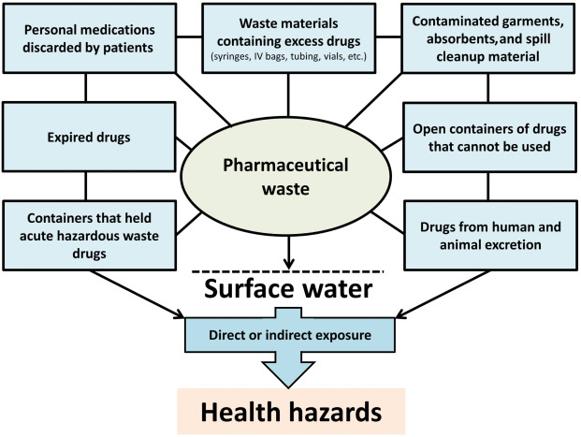

**Figure-7 Pharmaceutical waste and their exposure**

* 1. **Radioactive Waste-** Radioactive waste is produced by various nuclear fuel cycle processes, as well as the manufacture and utilization of radionuclides for various social purposes. Mining and processing uranium ore, creating nuclear fuel, generating electricity in nuclear reactors, processing spent nuclear fuel, managing radioactive waste, creating and utilizing radionuclides for a range of industrial and medical applications, conducting research on radioactive material, and other activities all contribute to the production of the different types of radioactive waste**.** It can have different levels of radioactivity and might be solid, liquid, or gas. Radioactivity from the trash may last for a few hours, many months, or possibly hundreds of thousands of years. Radioactive wastes are separated into three groups according to their nature and level: high level waste, low and intermediate level waste, and exempt waste. Their toxicity or danger potential does not change over time and remains constant until it is converted into another suitable form, which distinguishes them from conventional chemicals or industrial waste.It’s radioactive danger potential lowers with time based on the half lifetimes of radionuclides present in the trash," is the most important.**[8]** **(Figure8)**

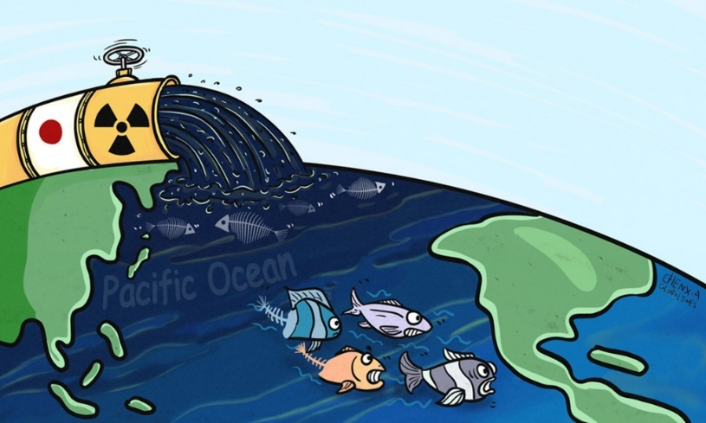

**Figure-8 Oceans as a radioactive waste a dump**

#### **Cytotoxic and cytostatic waste-Basically there are two types of cytotoxic and cytostatic waste-**

* Drugs that are poisonous, mutagenic, carcinogenic, or harmful to reproduction. Cancer and related diseases are treated using these medications. Tablets, liquids, and creams containing leftover or expired medication may be considered this type of trash. Because the medications in these products are made to either kill or block cell growth, improper disposal can make them very harmful.**(Figure9)**
* Garbage that has been contaminated. Any objects or goods that come into touch with cytotoxic and cytostatic medications are likewise considered cytotoxic and cytostatic waste because of the risks involved. For instance, a medical professional's gloves or clothing may be used to handle such drugs.**[9]**

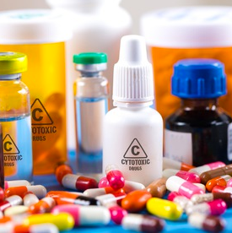

# **Figure-9 Cytotoxic Drugs or Cytotoxic Contaminated Materials**

* 1. **Recyclables-**Since many of the goods used in hospitals are classified as hazardous or clinical waste, they cannot be recycled. According to certain organizations, hospitals do not recycle nearly enough of their garbage; only 7% of healthcare plastic waste gets recycled, according to the garbage and **Waste Resources Action Programme** (**WRAP**).

However, the quantity of recycling bins for appropriate materials especially cardboard and plastic packaging is growing. Hospitals can recycle paper waste, even if it contains sensitive information, because of specialized shredders.**(Figure10)**

A large portion of the general public is also ignorant about recycling programs, such as the recycling of used asthma inhalers. These can be recycled at pharmacies and contain recyclable aluminum and plastic.**[10]**

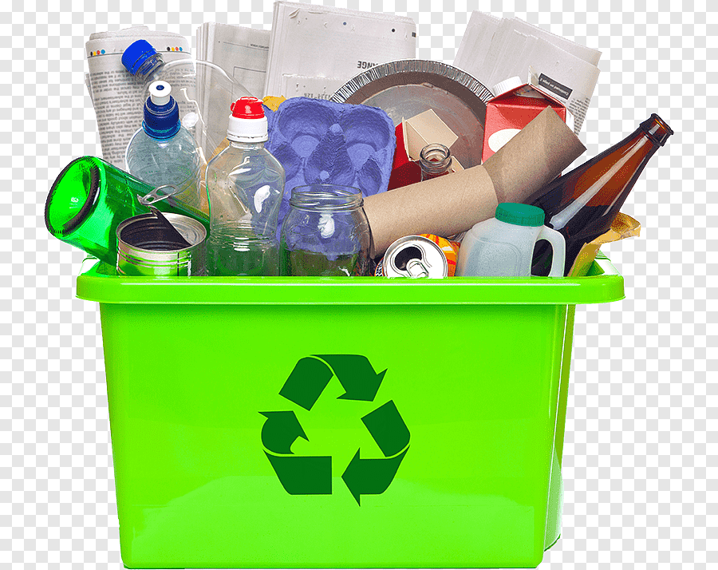

**Figure-10 Biodegradable garbage Reusing Decomposition Recycling, biodegradable trash, and waste management**

**4.9 E Waste-** One of the solid waste sources with the quickest rate of growth worldwide is e-waste. Lead is frequently released into the environment during the recycling, storage, or disposal of e-waste through unofficial methods, such as open burning.  
Informal recycling of e-waste can have a number of harmful health implications. Women who are pregnant and children are more at risk.   
Millions of women and children who labor in the unorganized recycling industry worldwide may be exposed to dangerous levels of e-waste, according to WHO estimates.

Electrical or electronic devices that are loosely abandoned, surplus, outdated, or broken are referred to as e-waste, or **Waste Electrical and Electronic Equipment (WEEE)**.Due to a lack of knowledge about proper disposal, the majority of trash electronic equipment in India are kept in households. This constantly expanding trash is not only incredibly complicated in nature, but it is also a rich source of metals, such as copper, silver, and gold, that may be collected and reintroduced into the manufacturing cycle.**[11]** **(Figure11)**

**Table 1.** **The components of different e-waste sources and their effects on health[12]**

|  |  |  |
| --- | --- | --- |
| **Sources** | **Constituents** | **Health effect** |
| Solder in computer screen gaskets, glass panels, and printed circuit boards. | Lead | - Harm to the kidneys, blood systems, and central and peripheral nerve systems  - Adverse effects on children's brain development; damages the kidneys and circulatory system |
| Chip resistors and semi-conductors | Cadmium | * + - Toxic irreversible effect     - Accumulates kidney and liver     - Neural damage |
| Computer housing and cabling | PVC and Plastic | Dioxin, which is produced during burning, interferes with development and reproduction. |
| Front panels of CRT | Heavy metals and phosphor | Weaken muscles and harm the spleen, liver, and heart. |
| Printed circuit board rails and copper wires. | Copper | Wilson's disease, liver damage, nausea, or cramping in the stomach |
| Rechargeable nickel-cadmium batteries. | Nickel | Asthma is brought on by a nickel allergy of the lungs, while dermatitis is brought on by a nickel allergy of the skin. |

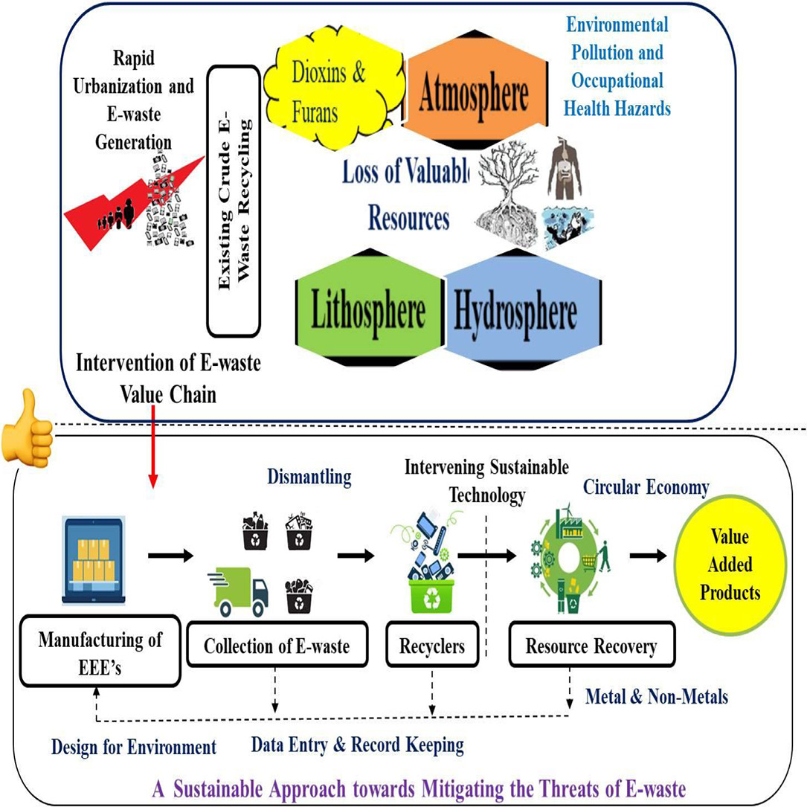

**Figure 11- E-waste's impact on human health**

**Table 2. Summary of clinical wastes and its management[13]**

|  |  |  |  |
| --- | --- | --- | --- |
| **CATEGORY** | **TYPE OF WASTE** | **TYPE OF BAG OR CONTAINER TO BE USED** | **TREATMENT AND DISPOSAL OPTION** |
| **Yellow**  **Yellow** | Human organs, tissues, body parts, and fetuses that are not yet viable (as defined by the Medical Termination of Pregnancy Act 1971, as amended regularly). | Yellow colored non-chlorinated plastic bags | Deep burial, plasma pyrolysis, or incineration |
| Animal carcasses, organs, tissues, and other waste products from animals employed in tests or research in veterinary clinics, universities, or animal shelters are all considered animal anatomical waste. |
| Bandages, plaster casts, cotton swabs, bags with leftover or wasted blood, and blood components are examples of products that can be contaminated with blood. | Burning, deep burial, or plasma pyrolysis.  If the mentioned amenities are not available, shredding, mutilation, autoclaving, microwaving, or hydroclaving, or a combination of shredding and sterilization, may be used. Waste should be submitted for energy recovery after treatment. |
| **Expired or Discarded Medicines:** Pharmaceutical trash, such as glass or plastic ampoules, vials, and other materials contaminated with cytotoxic medications, including antibiotics. | Yellow colored non-chlorinated plastic bags or containers | Items containing cytotoxic drugs that have expired or are contaminated with them should be returned to the manufacturer or supplier for incineration at a temperature of more than 1200oC, or they can be encapsulated or undergo plasma pyrolysis at a temperature of more than 1200oC.  Any other medications that are discarded need to be burnt or sent back to the manufacturer. |
| **Chemical Waste:** Utilized or wasted chemicals used in the manufacturing of biological disinfectants. | Containers with a yellow hue or non-chlorinated plastic bags | Destroyed by packaging, plasma pyrolysis, or incinerated in a facility that handles, stores, and disposes of hazardous waste. |
| **Chemical Liquid Waste:** Aspirated bodily fluids, infected secretions, laboratory liquid, floor washings, cleaning, housekeeping, and disinfection operations, silver X-ray film developing liquid, discarded Formalin, used or discarded disinfectants, and biological waste are all included in this category. | Separate collection system that leads to a system for treating wastewater | After resource recovery, the chemical liquid waste needs to be pre-treated before being mixed with other wastes. |
| Microbiology, biotechnology, and other clinical laboratory waste include things like blood bags, lab cultures, stocks or specimens of microorganisms, live or attenuated vaccines, human and animal cell cultures used in research, industrial laboratories, biological production, residual toxins, dishes, and culture equipment. | Autoclave safe plastic bags or containers | As directed by the World Health Organization or the National AIDS Control Organization, pre-treat to sterilize on-site using non-chlorinated chemicals before incineration. |
| **Red** | Wastes produced by disposable products such tubing, bottles, intravenous tubes and sets, catheters, urine bags, syringes (both fixed and needleless), vaccutainers with their needles snipped, and gloves are classified as contaminated waste (recyclable). | Red colored non-chlorinated plastic bags or containers | Sterilization and shredding, autoclaving, micro-waving, hydroclaving, and then shredding or mutilation. Waste that has been treated should be transferred to approved or registered recyclers, energy recovery facilities, or, if feasible, to be converted into fuel oil, diesel, or roads. It is not appropriate to dispose of plastic garbage in landfills. |
| **White (Translucent)** | Throw away sharp objects, such as Metals: Needles, fixed-needle syringes, burner or needle tip cutter needles, scalpels, blades, or any other potentially piercing or cutting sharp object that is infected. This includes used, discarded, and contaminated metal sharps. | Tamper-proof, leak-proof, and puncture-proof containers | Dry heat sterilization, shredding, mutilation, autoclaving, encapsulation in cement concrete or metal containers, autoclaving and shredding together, and then being sent to appropriate concrete waste sharp pits, sanitary landfills, or iron foundries (with permission to operate from the State Pollution Control Boards or Pollution Control Committees). |
| **Blue** | Glassware: Any damaged, broken, or thrown-away glass, including medication vials and ampoules, with the exception of those tainted with cytotoxic wastes | Boxes of cardboard with blue markings | Glass waste can be disinfected by soaking it in detergent and sodium hypochlorite treatment, or it can be autoclaved, microwaved, or hydroclaved before being shipped for recycling. |

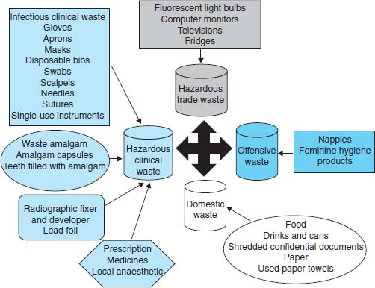

**Figure-12 Healthcare waste management**

* 1. **Reduction process of clinical waste in hospitals-**

Decreasing material inflow is an appropriate way for minimizing hospital waste discharge. This involves understanding what you purchase, how you use it, and how much of it you usually discard away. It also entails modifying your ordering procedures to reduce the waste that results in healthcare.

To prevent overspending, you could, for instance, buy cleaning supplies and equipment in set amounts for each department or switch to washable pitchers, plates, glasses, cups, and cutlery from disposable ones.

* 1. **Audits of Hospital Waste**

Audits are an essential aspect of the toolkit for figuring out how much garbage has been generated, what kind of waste it is, and where it is being disposed of. More analysis and a reduction in hospital waste are made possible by the specialized department-level (as compared to facility-level) information that an audit can provide.

By auditing surgical packs, for example, you can find out which things aren't utilized often enough to be included in each and every one of them.

* 1. **Cutting Down on Paper and Cardboard Waste in Healthcare**

According to WHO estimates, 85% of hospital waste is of the general type, with paper and cardboard accounting for 54% of this total. Fortunately, common-sense efforts to "reduce, reuse, and recycle" can help cut down on a large portion of this paper and cardboard waste.

Some examples are present here-

* Using washable diapers, surgical/nursing gowns, and linens rather than paper ones in the clinical setting.
* Utilizing both sides of paper, promoting email and message over paper-and-pencil correspondence, subscribing to online magazines rather than their paper counterparts, and keeping recycling bins close at hand are all administrative practices.
* Regarding upkeep and cleaning, use electronic hand dryers instead of paper towels and sorting cardboard, office paper, and newspapers for recycling.
* Using reusable plates, glasses, and cups instead of paper ones while serving food

In terms of cardboard specifically, you can reduce the amount of cardboard waste by using reusable medical waste containers, arranging for suppliers to replace cardboard containers with backhaul able reusable (plastic or metal) ones, and buying in bulk rather than in tiny, individual packages.

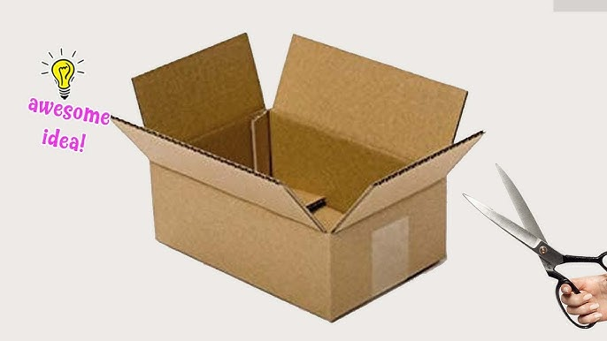

**Figure-13 Paper or cardboard cutting for waste reduction**

* 1. **Waste reduction in healthcare: Plastics**

Reusable containers for medical waste are one of the finest solutions to reduce the amount of plastic waste generated. As rather than ones manufactured from single-use plastics.   
With that, one of the problems with recycling plastics is that hospitals usually don't make enough recyclable plastic on their own to attract a local plastics recycler.

One way to reach a critical mass is for local hospitals to combine their recyclable plastics. Concentrating on recycling plastic wastes that are desirable to recyclers and produced in the greatest numbers is another, more practical choice.

**Examples-**

* "**Blue wrap**," commonly referred to as sterilization wrap, is a non-woven polypropylene
* Bottles with polypropylene as irrigation
* Durable plastic containers, trays, and basins composed of **Polyester terephthalate (PET), polystyrene (PS), high-density polyethylene (HDPE), or polyethylene terephthalate glycol (PETG)** Plastic bags **(Private Equity PE)**, stretch film, and shrink wrap are readily recyclable in large quantities at arriving dock regions.
* Reducing medical waste experts advise beginning small. An example would be to start a mixed-plastics recycling program in a single hospital area or a small number of rooms, then spread it to other areas.

Starting with a high-impact location (like an operating room), identifying which plastics are easily collected and recycled, and then starting a trial program there is one strategy. Another option is to start with a medical department that produces a lot of recyclable plastics, ideally one where the employees have demonstrated a sufficient level of dedication to recycling. For instance, a standard staffing group, clean or antiseptic spaces, and smaller places with repetitious low-pressure tasks.

Sterile areas in primary and ambulatory surgical departments, interventional radiology rooms, and catheter labs are a few obvious choices. Take into account hygienic spaces in prep areas, anesthesia rooms, and pharmacies. **[14]**

* 1. **Reducing Hospitals' Regulated Medical Waste (RMW)**

One frequent but avoidable cause of excess regulated medical waste (RMW) is the improper disposal of normal waste materials into bio hazardous waste receptacles. The quantity of garbage that is intended to be treated as hazardous is unnecessarily increased by improperly classifying medical waste. Costs rise as a result, with no financial or environmental advantages.

Controlling the distribution of RMW (Regulated Medical Waste) containers to hospital rooms and locations where RMW is commonly created or present can help address this problem. Make sure these containers are appropriately color-coded and have clear labels for simple identification.

**Examples of Hospital Waste Reduction Strategies**

* Applying reusable containers for waste streams related to chemotherapy, medications, sharps, and pharmaceuticals
* Working with medical waste management companies that can do waste audits, train your employees, and increase productivity
* Patients or staff are less likely to use smaller RMW containers as trash cans in patient rooms because they are more difficult to use.
* Patients are far more likely than personnel to put trash in the incorrect container, so when possible, only staff should have access to RMW containers.
* RMW containers should not be placed next to ordinary trash containers since this makes it too simple for waste to fall into the incorrect container.**[15]**
  1. **Creating a Medical Waste Reduction Plan and Making the Hospital "Greener"**

Creating an official waste management strategy for the entire hospital that outlines your objectives, creates protocols, and informs your employees of them is well worth the effort. To help healthcare institutions create a more sustainable program that lowers overall waste volumes and environmental impacts, a waste plan is essential.

In order to determine whether paper, plastics, cardboard, and RMW are being disposed of appropriately, the hospital waste reduction plan should incorporate waste audits as well as recurring spot checks. Employees should be informed of the results, and in cases where shortcomings in healthcare waste management are found, retraining should be given.**[16]**

* 1. **Clinical waste reduction through education and training for staff**

Only about 10% of a facility's garbage should be Regulated Medical garbage (RMW), provided that it is properly segregated. However, it frequently accounts for half of the volume of waste, demonstrating a lack of understanding regarding appropriate segmentation and lowering medical waste.

Health professionals can save a great deal of money, time, and effort by receiving thorough education and training. Daniels Health, your hospital waste reduction partner, provides professional training to clinical and non-clinical staff in every facility we work with. This covers online courses as well as educational resources like disposal point placards and posters.**[17]**

## The Waste Management Hierarchy

The waste management hierarchy is a paradigm that encourages a more sustainable approach to waste handling by ranking waste management solutions according to their environmental impact, from most to least encouraged. Businesses and communities can gain greatly from the environmental and financial advantages of incorporating this framework into their waste management system. The following is a summary of the hierarchy's main ideas:

**6.1 Segregation-** Segregation is a useful technique for managing and treating waste. When done properly, it can prevent biomedical waste from being mixed with other waste, particularly municipal waste, and it also lowers the amount of waste produced. Segregation will prevent some biomedical waste, such as spent needles, syringes, and other plastics, from being reused. Certain materials, such as plastics, can be recycled and used again for non-food items after being properly cleaned. **Figure 14** shows the color coding which is used to segregate the different kinds of clinical waste.

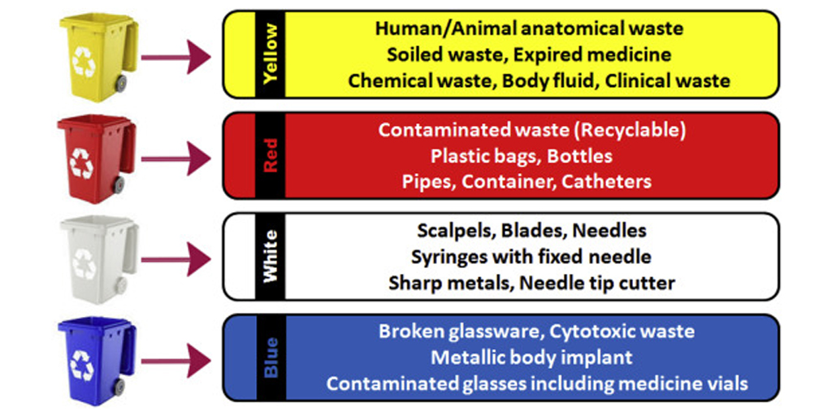

**Figure-14 Different color code of container for waste disposal**

**6.2** **Collection and storage-** Installing various color-coded containers for biomedical wastes originating from various sources is part of the biomedical waste collection process. The bins and containers should be positioned to ensure complete collection. The type of garbage is represented by the bins and bags with the biohazard emblem in **Figure 15**. Generally speaking, the symbols in biomedical waste management serve as a reminder to exercise caution when handling those compounds. The Dow Chemical Company created the biohazard emblem for their containment products in 1966.

Keep garbage in the right location, label containers with the ward or room they are kept in, and don't keep it for longer than 8 to 10 hours in large hospitals or 24 hours in residential care facilities.

Following collection, the biomedical waste is kept in designated containers and in the appropriate location. In large hospitals with more than 250 beds, storage should not last longer than 8 to 10 hours, and in assisted living facilities, it should last 24 hours. The location must be prominently displayed on the label of every container. Tracing the trash at its source is the goal of labeling. A warning notice and a clear storage space are required.

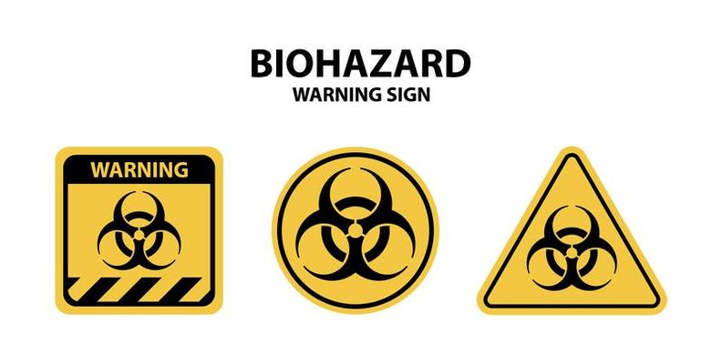

**Figure 15 Biohazards symbols**

**6.3** **Transportation-** After collection, the garbage is moved for treatment in enclosed wheelbarrows or carts. Manual loading should be avoided by the operator. Before being transported for treatment, biomedical waste bags and containers need to be knotted or covered. Transporting vehicles should be designed to prevent direct interaction with the public, scavengers, and the operator. It must be properly enclosed when the containers are being transported. In addition to training the driver on what to do in the event of an unintentional spill, the design should take into account the consequences of traffic accidents. Additionally, make sure to give the containers' interiors a good clean.

**6.4 Treatment and disposal-** Biomedical waste needs to be sterilized before being disposed of Deep burial is one method of disposing of anatomical waste. At the point of generation, syringes must be cut (with hub cutters) and chemically cleansed with a 1% bleaching powder solution before being disposed of in a sharps pit. Plastics that are diseased should be autoclaved or chemically treated, then shredded, recycled, and finally dumped in municipal landfills. Following are some treatment methods of waste-[18]

* **Incineration**
* **Autoclaving of Biomedical Waste**
* **Biomedical Liquid Waste**
* **Microwave Treatment**
* **Deep Burial**
* **Inertization**
  1. **Benefits of waste reduction in clinical practice**

**7.1 Benefits for Public Health-** There are numerous advantages for public health when healthcare waste is managed properly. In the first place, it helps **stop infections from spreading**. The population's health is protected when clinical waste is collected and treated properly because it **lowers the possibility of contamination and infectious disease transmission**.

Furthermore, it's very likely that these **wastes include dangerous chemicals like radioactive materials** or expired medications. By ensuring that these compounds are disposed of safely, their appropriate management lowers the risk of exposure and any potential negative health impacts.   
Lastly, biological waste disposal **protects the health of healthcare professionals**. When handling this garbage, health personnel run the risk of becoming cut by sharp objects or coming into contact with hazardous materials. Medical personnel' health is protected and the danger of accidents is decreased with effective management, which includes staff training and the use of personal protective equipment.

**7.2 Benefits for environment-** Medical waste can contain hazardous chemicals that, if improperly disposed of, contaminate the environment. Second, some biomedical waste, such as organic waste, can be anaerobically digested or composted to create biogas or compost, which reduces greenhouse gas emissions and aids in the fight against climate change. Lastly, some biomedical waste can be recycled or recovered to produce new resources, which encourages sustainability and opens up new opportunities for the circular economy. In conclusion, proper management of medical waste has numerous environmental benefits.

**7.3 Economic benefits-** The handling of biomedical waste has financial advantages as well. For instance, using sterilizing equipment saves a lot of money since it eliminates the burdensome chore of disposing of trash by contracting with other businesses with the necessary expertise. This results in substantial operating cost reductions because the entire procedure can be managed effectively and affordably internally.[19]

**Conclusion-** The reduction of waste in healthcare necessitates a multidisciplinary, cooperative strategy that incorporates sustainable practices, technology, and the active involvement of medical personnel. Healthcare businesses may improve patient outcomes, lower costs, and provide the sector a more sustainable future by emphasizing efficiency, education, and evidence-based practices. In summary, enhancing patient care, lowering expenses, and advancing environmental sustainability all depend on the healthcare industry minimizing clinical waste. Organizations can drastically reduce waste by putting evidence-based methods into practice, making the best use of their resources, embracing sustainable technologies, and encouraging a culture of accountability among healthcare workers. These initiatives not only improve operational effectiveness but also open the door to a more sustainable and healthy healthcare future.

**References:**

1. Rutala, W. A., and Mayhall, C. G. (1992). Medical waste. Infection Control and Hospital Epidemiology, 13(1), 38- 48.
2. Hamoda, H. M., El.Tomi, H. N., and Bahman, Q. Y. (2005). Variations in hospital waste quantities and generation rates. Journal of Environmental Science and Health, 40(2), 467–476.
3. Pike, R. M. Laboratory-associated Infections: Incidence, Fatali-ties, Causes, and Prevention. Ann Rev Microbial, 33:41-66,1979
4. G LaGrega, M. D., Buckingham, P. L. and J. C. Evans, “Hazardous Waste Management,” 2nd Edition, Mc-Graw Hill, 2001
5. Blenkharn JI, Odd C (2008). Sharps Injuries in Healthcare Waste Handlers. Ann. Occup. Hyg. 52(4):281-286.
6. Mallik, Ujjwal, et al. "Clinical and Offensive Waste Disposal Management Scenario in Faridpur Town." *the Proceedings of the WasteSafe* (2017).
7. Kadam, Atul, et al. "Pharmaceutical waste management an overview." *Indian Journal of Pharmacy Practice* 9.1 (2016).
8. Pigford, T. H., The National Research Council study of the isolation system for geologic disposal of radioactive wastes, in Scientific Basis for Nuclear Waste Management VII, p. 461, Elsevier, New York, 1984.
9. VON GRUENIGEN, Sandrine. "Handling of cytotoxic drugs and related waste in low and middle-income countries: A toolkit to promote safe handling practices." PhD diss., Université de Genève, 2022.
10. Bui, Tat-Dat, et al. "Opportunities and challenges for solid waste reuse and recycling in emerging economies: A hybrid analysis." *Resources, Conservation and Recycling* 177 (2022): 105968.
11. Shittu, Olanrewaju S., Ian D. Williams, and Peter J. Shaw. "Global E-waste management: Can WEEE make a difference? A review of e-waste trends, legislation, contemporary issues and future challenges." *Waste Management* 120 (2021): 549-563.
12. Rautela, Rahul, et al. "E-waste management and its effects on the environment and human health." *Science of the total environment* 773 (2021): 145623.
13. Chisholm, Jade Megan, et al. "Sustainable waste management of medical waste in African developing countries: A narrative review." *Waste Management & Research* 39.9 (2021): 1149-1163.
14. Rajalakshmi, S., K. Amzad Basha, and G. A. Asif Jamal. "A Manual on Waste Management Audit." *Laser Park Publish House, Coimbatore, Tamil Nadu, India. 163p* (2023).
15. Subramanian, Aravind Kumar, et al. "Biomedical waste management in dental practice and its significant environmental impact: A perspective." *Environmental Technology & Innovation* 24 (2021): 101807.
16. Anam, Hajera, et al. "A Study on Waste Disposal Management and Recommendation for Safe Disposal." *E3S Web of Conferences*. Vol. 491. EDP Sciences, 2024.
17. Debrah, Justice Kofi, Diogo Guedes Vidal, and Maria Alzira Pimenta Dinis. "Raising awareness on solid waste management through formal education for sustainability: A developing countries evidence review." *Recycling* 6.1 (2021): 6.
18. Hegde, Veda, Raghavendra D. Kulkarni, and G. S. Ajantha. "Biomedical waste management." *Journal of Oral and Maxillofacial Pathology* 11.1 (2007): 5-9.
19. Adhikari, Shiva R., and Siripen Supakankunit. "Benefits and costs of alternative healthcare waste management: an example of the largest hospital of Nepal." *WHO South-East Asia journal of public health* 3.2 (2014): 171-178.