HARMONISING HR WITH KNOWLEDGE MANAGEMENT: THE GREEN HRM APPROACH
V. Sarada ¹, K. Mamatha ²
Associate Professor, Anurag Engineering College, Ananthagiri (V&M), Kodad, Suryapet (Dist.), Telangana, India
Associate Professor, School of Management, Anurag University, Hyderabad, Telangana, India
ABSTRACT:
Environmental concerns and sustainability are central to corporate strategies in the contemporary world. The amalgamation of Green HRM (Green Human Resource Management) with Knowledge Management (KM) and Knowledge Management Systems (KMS) is one of the prominent brewing strategies for attaining sustainability. Green HRM converges on entrenching environmental sensitivities into human resource (HR) practices to foster a sustainability culture and reduce ecological impact. Concurrently, Knowledge Management ensures that valuable organisational knowledge is effectively captured, shared, and utilised to enhance decision-making and operational efficiency. Knowledge Management Systems, as technological enablers, provide tools for knowledge storage, retrieval, and dissemination of the KM process. This chapter explores the synergy between Green HRM and KM/KMS, emphasising how the alignment of these domains can drive sustainable business practices. By leveraging KM and KMS, organisations can support Green HRM initiatives, such as green training, employee engagement in sustainability, and eco-friendly policies, thus creating a robust framework for environmental stewardship. Implementing these integrated strategies effectively promotes organisational sustainability and enhances overall performance and competitive advantage.
KEYWORDS: Green HRM, Knowledge Management, Knowledge Management Systems, Sustainability.
- INTRODUCTION:
Incorporating knowledge management (KM) and green human resource management (GHRM) is crucial for accomplishing organisational and environmental objectives as businesses increasingly realise the value of sustainable practices in their core business operations.
Green HRM aims to promote environmentally conscious behaviour among employees and incorporate ecological factors into HR policies. This strategy cultivates an environmental responsibility culture within the workforce and strengthens the company's commitment to sustainability. Knowledge management enables staff members to make meaningful contributions to environmentally friendly projects by allowing the exchange and use of knowledge about sustainable practices. Organisations can attain a synergistic impact that fosters innovation in sustainable practices, increases employee engagement, and improves organisational performance by aligning HR and KM via the lens of GHRM. Due to this integration, the workforce can become more informed and motivated to adopt sustainable practices. The workforce will also be more aware of environmental challenges. This strategy highlights how crucial it is to match knowledge management systems with human resource strategies to develop a sustainable organisational culture and address the urgent environmental issues businesses face.

- SUSTAINABILITY:
Sustainability is a procedure that considers ecological balance and environmental conservation while tying together economic and social dimensions. This concept lies without disturbing future demands and fulfilling the present requirements of a country's social, financial, and environmental growth. Organisational sustainability is applied at several levels, including organisational, regional, and national. Sustainability is perceived as "a competitive strategy that embodies an organisation's philosophy and strategy" [1]. The UN Brundtland Commission sparked a conversation on sustainability. The Brundtland Commission adopted a broad definition of sustainable development that was long-term, global, and considered a range of stakeholders [2]. The three pedestal sustainability points are 3 Cs: communal, commercial, and climate. The following are different theories which give their broader views towards sustainability.
- Brundtland Theory: Brundtland's business sustainability theory considers both external and internal impacts on stakeholders, focusing on short—and long-term sustainability [3].
- Stakeholder Theory: The stakeholder theory of sustainability is guided by an open-systems framework, recognising the interconnectedness of various stakeholders, organisational systems, social systems, and the environment [4].
- Responsibility Theory: The responsibility-oriented theory of sustainability, based on the open systems model, emphasises responsibility to various stakeholders for their own sake rather than focusing on the economic interests of the organisation's owners. It assesses performance through metrics like employee and community well-being [2].
- Substance Theory: The substance-oriented sustainability theory focuses on maintaining organisational resources, particularly HRs, to ensure future survival through resource consumption and reproduction. [2].
- Open System Theory: According to open system theory, social, economic, and political issues all impact an organisation's operations and performance.
The literature on sustainable HRM addresses the dynamic nature of HRM, its interdependence with internal, external, and individual factors, and its economic, social, and ecological effects on stakeholders [4]. Three distinct conceptual approaches may be used to identify the sustainability of HRM: sustainable work systems, sustainable resource management, and sustainable HRM. Sustainable resource management aims to make the relationship between an organisation and the environment more transparent and suggest solutions for the resource shortage. Work systems emphasise the social component of sustainability and seek to broaden public understanding of the processes leading to the deployment and enhancement of human resources [5]. In addition to job security and health promotion, flexible work arrangements, participative leadership, a value-added economy, self-reliance, and work-life balance, sustainable HRM also helps to build an influential organisational culture [6].
Socially Responsible HRM (SRHRM), Green HRM (GHRM), Triple Bottom line HRM (TBLHRM), and Common Good HRM (CGHRM) are different types of sustainability [7].
SRHRM involves HR procedures that integrate worker needs with business requirements. It aims to improve job experiences and satisfy personal and societal expectations using contemporary strategies and technologies. In SRHRM, the organisational perspective is inside-out, and the goal is to lower business risks [8].
TBLHRM focuses on economic, social, and environmental goals, enabling financial advantages through social responsibility and ecological sustainability. It redefines success assessment for organisations by implementing ESG (Environmental and Social Governance) and guiding business goals. TBLHRM aims to achieve financial, environmental, and societal goals from an inside-out organisational approach. [9].
The concept of CGHRM, which aligns business demands with environmental and societal needs, is being studied in academic settings. It involves elevating the community and positively influencing its surroundings. Although promising, it's still a long way from being implemented.
The concept GHRM of human resource management involves eco-friendly projects, cost reduction, and improved staff engagement, with HR technology offering paperless processes like digital onboarding and robotic interviewing. In GHRM, the organisational perspective is inside-out, and the goal is to fulfil environmental and financial objectives. Additionally, opinions differ about how well GHRM approaches address stakeholder concerns and have an excellent environmental impact [10]. According to a common good approach, businesses have a primary duty to "make an effective contribution to resolving the sustainability challenges we are collectively facing"[11], and their long-term self-interest is in ensuring our shared means of subsistence [12]. As a result, Common Good HRM prioritises group interests over, or more accurately, on par with, the needs, wants, and wishes of individuals [13].
Green HRM (GHRM): "Adopting HRM strategies and practices that enable the achievement of financial, social, and ecological goals, with an impact inside and outside of the organisation and over a long-term time horizon while controlling for unintended side effects and negative feedback" is the definition of "green human resources management"[6]. The term "green human resources management" (GHRM) refers to a collection of procedures, processes, and policies that encourage environmentally conscious, resource-conscious, and socially conscious behaviour among workers in a corporation [14]. Through the use of HRM linkages for recruiting, selection, adjustments, reorganisations, trade union creation, and distribution, GHRM can directly enhance the ability of green employees to comprehend, inform, and practice green work and sustain its green aims. GHRM adopts an ecological perspective and seeks to provide a green workplace that motivates employees to carry out their duties in the most ecologically friendly way possible [15]. Green innovation and GHRM practices are crucial for improving environmental performance in environmentally conscious sectors. HR managers can set goals and implement exemplary measures to reduce waste and pollution. Green campaigns can motivate employees to adopt sustainable practices. GHRM can be a visible aspect of a company's responsibilities and CSR measures, ensuring the success of any organisation [15].

2.1 Need for the transformation of HRM:
Organisations must reform their human resources (HRM) to promote operational excellence, generate higher value, and adjust to the shifting business landscape. The following are some of the leading causes of the need for HRM transformation:
Talent Management (TM) also aims to develop and deploy the right people at the right job at the right time and provide them with the right environment to showcase their abilities in the best possible way for the organisation. Organisations should be able to recognise the people and capabilities that may create value and deliver a competitive advantage [16].
Businesses must optimise their HR procedures and strategies in light of their growing financial problems [17].
The increasing importance of knowledge, originality, critical thinking, and problem-solving skills in today's knowledge-based, digitally-driven employment environment necessitates focusing on change for Human Resource Management (HRM) [18].
As enterprises' influence on society becomes increasingly apparent, HR plays a critical role in environmental management by including workers in decision-making to limit economic activity and ecological harm [19].
To organise environmental programs successfully, it is necessary to apply eco-friendly HRM policies.
- MOVING TOWARDS GREEN HRM
Moving towards Green means organisational development by preserving knowledge capital and ecological protection. HRM policies to encourage inclusive HR practices and the organisation's sustainability from an economic, social, and environmental perspective are known as "GHRM." The goal is to adhere to the rules and procedures that encourage the organisation's staff to adopt and pursue initiatives advantageous to the organisation and the people, society, business, and environment [20]. GHRM encourages employees to use their best efforts to accomplish the work more quickly and responsibly. GHRM practices, such as flexible work schedules, electronic filing, car-sharing, job-sharing, teleconferencing, virtual interviews, recycling, telecommuting, online training, energy-efficient office space, etc., help organisations reduce employee carbon footprints by incorporating environmentally friendly HR practices for sustainable resource use that result in more efficiencies, less waste, improved job-related attitudes, improved work/private life, lower costs, and improved employee performance and retention [21]. Evidence suggests that an organisation's financial success can be positively impacted by its environmental performance, a concept known as the "Green pays" argument [22].
3.1 Green HRM Practices (GHRMP):
GHRM is a set of practices that creates a sustainable and environmentally friendly work environment. It focuses on integrating environmental concerns into traditional HR processes, such as recruiting, training, compensation, and performance management. GHRM practices can lead to several benefits, including improved employee engagement, reduced environmental impact, and enhanced organisational reputation. Some critical aspects of GHRM include [15, 23, 24]:
Green job design: Creating positions incorporating environmentally friendly responsibilities and contributing to the organisation's sustainability goals.
Green recruitment and selection: Attracting and hiring employees with green awareness and promoting environmentally responsible behaviours.
Green education and development: Providing training and development opportunities that focus on green skills and sustainability.
Green performance appraisal: Evaluating individual and team performance based on their contributions to environmental sustainability and the organisation's green goals.
Green compensation and reward: Implementing incentives and reward systems that encourage employees to engage in environmentally responsible behaviours and contribute to the organisation's sustainability efforts.
Green training and development: Educating employees about environmental issues and providing opportunities for skill development in green areas.
Centralize document storage and use paperless office supplies: This will reduce paper use and promote the use of electronic documents and communication.
Green measures: Implementing energy-saving measures, such as adjusting the temperature and using energy-efficient equipment.
Sustainable practice Promotion: Encouraging employees to adopt sustainable practices in their work and personal lives.
- KNOWLEDGE MANAGEMENT
In the late 20th century, the organisations are struggling to gather business knowledge buried in information silos. The top management is a dearth of expertise dormant in the silos. The information silos are mostly disorganised and unable to provide any form of information at short time. Many person-hours are spent on extracting, organising, compiling, and presenting the knowledge extracted. Sometimes, the extracted knowledge becomes obsolete, and the managers are running behind information extraction from capacious silos. The majority of organisations are losing commercial advantage due to vibrant market changes. Top management is tumbling to make apt decisions with scant information. Even managers or employees cannot meet their information requirements to make decisions.
According to a McKinsey report (2012), one out of five employees hired is engaged in information gathering and searching without any potential work done. This is a scary situation in organisations [25].
Employee knowledge exchange is an essential procedure, but it's not what usually occurs [26].
Top management of traditional organisations observed that new organisations are growing faster than conventional organisations. Moreover, traditional organisations are boundary-based, whereas new organisations are boundaryless. Old-fashioned organisations are inflexible and stubborn, but modern firms are distinguished by their capacity to adapt and change. In contrast to conventional establishments, contemporary organisations exhibit higher agility, possessing an array of business tactics and an increased readiness to undertake measured risks in response to evolving circumstances. For their internal and international work, they heavily rely on networking, information and communication technology, and flexibility. They also emphasise cooperation heavily. Conversely, conventional companies are centralised, hierarchical, risk-averse, and have fixed, unchangeable corporate strategies and processes. They have a lower chance of succeeding with innovation and change. These companies adjust to new business procedures and technology more slowly than others and lose competitive advantage. It is discerned that the success or failure of an organisation is determined by its ability to gather, store, disseminate, and efficiently handle its collective knowledge to achieve its objectives [26]. When knowledge is readily available, the employees are more productive as individuals and as teams. The concept of knowledge is shown in Fig 2. On the other hand, deliberate and efficient knowledge availability enables teams to promptly retrieve all relevant data and follow up with internal specialists for further inquiries [27]. It is apparent that in contemporary epistemology and philosophy, knowledge is viewed as a framework or tool that facilitates effective behaviour [28].
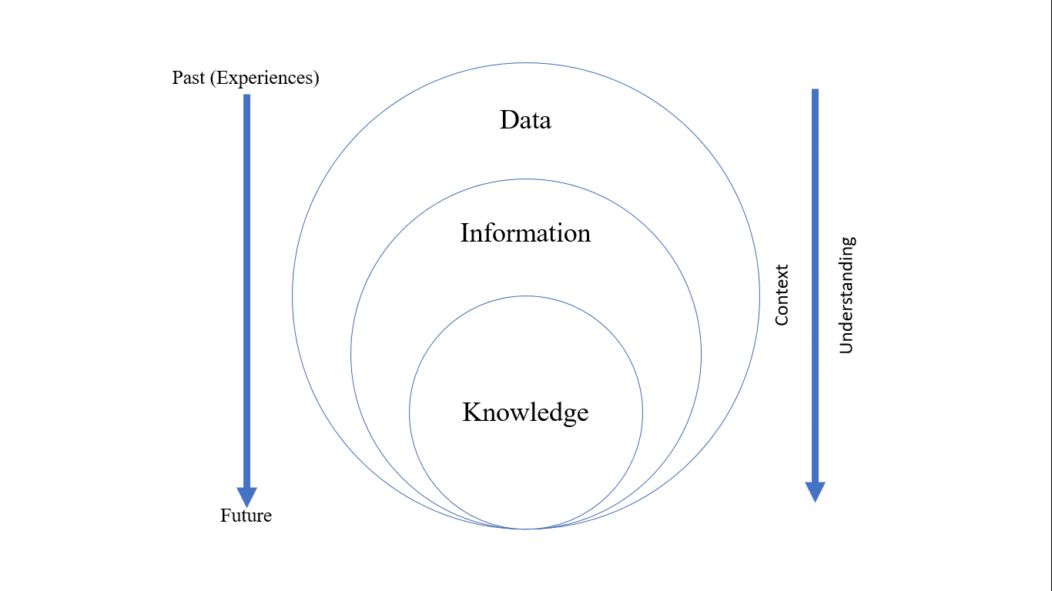
Fig. 1 Data – Information – Knowledge Relationship

Knowledge management (KM) has existed for many years in one form or another. In the early 1980s, as the internet gained popularity and exposure, management consulting organisations promptly assessed and recognised the potential of intranets [29]. Peter Drucker is credited with coining the phrase in the 1980s. KM gained scholarly recognition in the 1990s. It may be argued that KM has existed for millennia in gathering, preserving, and disseminating knowledge. However, KM gained popularity in the late 1980s [30].
KM is organising, producing, applying, and disseminating collective information inside an organisation. Keeping information accessible is a necessary component of effective KM [31].
Organisational knowledge mobilisation for business objectives is KM's responsibility. It can be enabled with KM Systems. Aino et al. studied an employee's job satisfaction, which is positively affected by KM [32]. All that occurs within your company depends on knowledge, information, and data. KM integrates information, process, practice, improvement, people, insights, advice, and technology [33].
4.1 Importance and need of KM:
KM's importance and needs include increased staff growth and development, better business process efficiency, faster problem-solving, faster decision-making, shorter information retrieval times, increased innovation, total time savings, enhanced workplace collaboration and trust, increased employee satisfaction, effective risk management, stakeholder satisfaction, and more organisational agility [34].
KM is integral to modern companies, as knowledge is varied and complex, encompassing explicit and tacit competence. Making thoughtful decisions and original ideas requires addressing this complexity well. Businesses may minimise operational costs and increase worker productivity using KM. A key element of effective knowledge management is storing data in a place that facilitates easy access, sharing, and updating business knowledge. An organisation's capacity to solve issues and make decisions more swiftly and successfully may be enhanced by KM. It is essential for continuous learning and growth inside the organisation. One additional benefit of KM is knowledge retention [34].
KM transforms raw data and scattered information – files, note files, documents, spreadsheets, books, repositories, logs, messages, social media, processes, circulars, notices, etc.- into a treasured and valuable asset [35].
4.2 Types of Knowledge:
The types of knowledge can be categorized as follows [36 – 38], and Fig. 2 shows this.
- Explicit Knowledge: This is structured information, such as reports and performance metrics, that is easy to document, share, and learn.
- Implicit Knowledge: The application of learned (explicit) knowledge.
- Tacit Knowledge: This is personal, context-specific, and harder to formalise, and it is not easily documented or shared.
- Declarative Knowledge: It refers to factual knowledge that can be explicitly stated.
- Procedural Knowledge: This type of knowledge is about how to do something, including processes and methods.
4.3 Explicit Knowledge:
Explicit knowledge can be documented, disseminated, and learned by others. The information is arranged and readily shared. Exact information may be found in several locations, such as standard operating procedures (SOPs), product specifications, and reports. Some key characteristics of explicit knowledge include [36, 37, 39]:
- Ease of documentation: Explicit knowledge can be smoothly recorded and stored in a structured format, such as a document or a database.
- Ease of sharing: This knowledge can be easily transmitted and shared among team members or across the organisation.
- Learnability: Explicit knowledge can be learned by others, making it easier for individuals to acquire new skills and knowledge.
- Structured format: Explicit knowledge is typically organised in a structured manner, such as in a knowledge base or a document management system.
Performance measurements, product standards, and standard operating procedures are a few instances of explicit knowledge. Gathering, organising, and disseminating explicit knowledge improves decision-making, problem-solving, and overall organisational performance.

4.4 Implicit Knowledge:
Implicit knowledge is the application of learned (explicit) knowledge, which is structured and can be easily shared. It is personal, context-specific, and harder to formalise than explicit knowledge. Implicit knowledge is often gained through experience and practical application of explicit knowledge. The critical characteristics of implicit knowledge include:
- Context-specific: Implicit knowledge is tied to a particular context or situation, making it harder to transfer and share than explicit knowledge.
- Experience-based: The type of information is obtained from instruction, independent study, real-world application, firsthand experience, and mistakes.
- Unspoken: Implicit knowledge is considered tacit, as it is not easily documented or shared formally.
- Application of explicit knowledge: Implicit knowledge involves applying explicit knowledge, which is structured and can be easily shared.
Technical proficiency, problem-solving techniques, and industry or organisation best practices are a few instances of implicit knowledge. Organisations may enhance decision-making, problem-solving, and efficiency by developing methods to collect, organise, and communicate explicit and implicit information. This can be achieved by recognising the distinctions between the two forms of knowledge.
4.5 Tacit Knowledge:
The knowledge that is difficult to articulate or extract is known as Tacit knowledge, and it is frequently acquired through insight, intuition, and firsthand experience. Comparatively speaking, it is more challenging to convey and exchange than explicit knowledge since it is subjective, informal, and context-specific. Hands-on engagement in a particular setting is frequently the method of acquiring implicit information firmly embedded in personal experiences. Leadership, language, humour, and intuition are a few areas of tacit knowledge. Because it is hard for rivals to imitate and provides access to insightful information that might boost productivity at work, tacit knowledge is crucial to having a competitive advantage. Organisations can enhance their ability to make decisions, solve problems, and operate more efficiently by recognising the traits of tacit knowledge and creating plans to gather, arrange, and disseminate it effectively.
Tacit Knowledge is also known by other names such as Experiential Knowledge, Tribal Knowledge and know-how knowledge. Tacit knowledge base enhances the business with a competitive advantage. It is irreplaceable [40].
Examples of tacit knowledge include artistic skills, professional expertise, cultural understanding, motor skills, etc.
4.6 Declarative Knowledge:
Explicit information concerning concepts, ideas, themes, histories, principles, and facts is declarative knowledge. Theory knowledge, descriptive knowledge, and propositional knowledge are some other names for it. Declarative knowledge is often obtained via education, experience, and observation. It may be represented verbally and in writing using declarative phrases. The essential characteristics of this knowledge include ease of documentation, ease of sharing, learnability, and structural format. This knowledge is easily recordable and stored in a well-defined format, such as documents or databases. The teams that share can quickly acquire this knowledge. The learning curve of this knowledge is low [41]. Factual information on a subject, such as the elements in the periodic table or the capital of France, is an example of declarative knowledge. Declarative knowledge serves as the cornerstone for curriculum design and establishes learning objectives, making it crucial for creating a solid foundation for learning and growth [42].
4.7 Procedural Knowledge:
Knowledge of processes, techniques, or equipment operation is procedural knowledge. It is understanding how to carry out a specific skill or task. Procedural knowledge is intricate and complex to express clearly since it is frequently acquired by practice, experience, and hands-on engagement. The characteristics are practical knowledge, goal orientation, difficulty expressing, and learning through experience [43].
Technical expertise, problem-solving strategies, and organisational best practices are also part of procedural knowledge at work. Organisations can enhance their ability to make decisions, resolve problems, and run more efficiently when they understand the characteristics of procedural knowledge and develop efficient methods for collecting, organising, and disseminating both types of information [44].
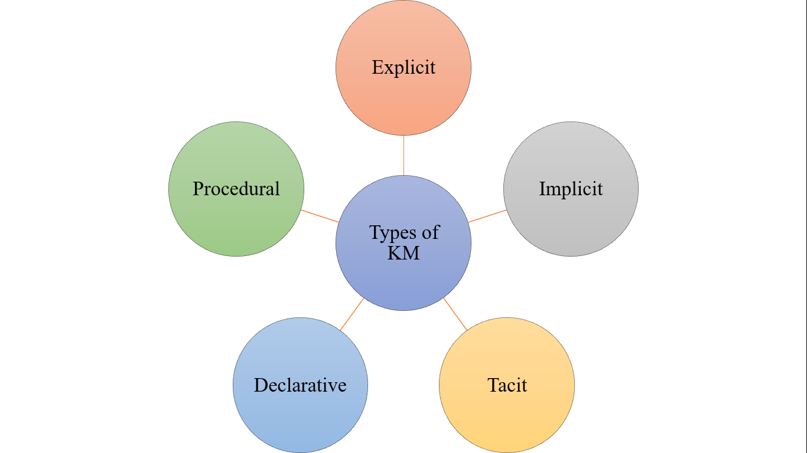
Fig. 2 Types of Knowledge Management

4.8 Principles of Knowledge Management:
According to T. H. Devenport, the KM principles [45] are as follows:

KM is expensive:
KM costs may encompass the price of technology, such as knowledge management systems, and the labour and supplies needed for efficient information control [46]. Better decision-making, innovation, and overall performance are the only advantages of efficient knowledge management that could offset the expenses [47].
An effective KM requires hybrid solutions of people and technology:
A balance between technology and mankind is an absolute necessity for KM. Though KM is predominantly the responsibility of individuals in an organization, it can be effectively used to collect, organise, and disseminate knowledge through technology such as Knowledge Management Systems (KMS). Organisations may increase productivity and save costs by utilising a strong KMS, which facilitates timely access to pertinent information, supports correct decision-making, and fosters creativity and teamwork [33].
KM is highly political.
KM is indeed highly political, especially in the context of policy impact and the public sector. The political nature of KM is evident in the need for knowledge brokers to consider the political context when presenting information to policymakers [48].
KM requires knowledge managers.
The role of knowledge managers is highlighted in the context of aligning the tone for a culture of knowledge storage and sharing, ensuring that the righteous knowledge reaches the right people without information overload [33].
KM benefits more from maps than models, more from markets than from hierarchies:
Knowledge maps serve as indispensable tools, offering distinct advantages like precise gap identification, Efficient Knowledge Asset Location, Holistic Knowledge Asset Linking, Strategic Decision Enhancement, and Optimized Knowledge-Centered Support [49]. Knowledge maps play a pivotal role in precise KM. They offer a focused approach to gap identification, streamlined access to knowledge assets, and a visually cohesive representation, ultimately enhancing strategic decision-making and optimising knowledge-centred support within the organisation [50].
Sharing and using knowledge are often unnatural acts:
Numerous sources bolster the assertion. Sharing information can be perceived as unnatural as people may be reluctant to impart their expertise to others. A rigid corporate culture and structure may make sharing knowledge even more problematic [51]. A lack of incentive to share knowledge may also result from someone believing that doing so may jeopardise their job. Motivating people to perform such labour is difficult since transferring information into a system and learning from others can be intimidating and time-consuming. However, overcoming these challenges and encouraging information exchange is essential, as doing so may improve output, inventiveness, and judgement [52]. Consequently, among many others, it is critical to promote a knowledge-oriented culture that supports knowledge creation and sharing, assigns clear accountability for knowledge management, and effectively uses technology to capture and disseminate knowledge. It encourages knowledge sharing and utilisation within an organisation. This is due to the possibility that using and disseminating information would look odd [53].
KM means improving the knowledge work process:
KM is organising, producing, using, and exchanging knowledge within a company. This means providing information in a format that offers seamless access to all organisation members. KM seeks to increase organisational effectiveness and preserve information in a readily available format. This is achieved by capturing and organising knowledge in a knowledge management system, sharing knowledge with other beneficiaries, and improving processes and technology to provide easy access to knowledge. KM also improves knowledge of work processes, reduces business operation costs, and increases employee productivity. This discipline encourages the identification, capture, assessment, retrieval, and sharing of all information assets within an organisation in an integrated manner. Since enhancing knowledge work processes is a core objective of knowledge management, the statement "KM means improving knowledge work processes" is true [33] [54]
Knowledge access is only the beginning:
The first step in efficiently utilising knowledge inside an organisation is gaining access. Through KM, people may foster the creativity and cultural shifts required to advance the company and adapt to shifting market demands. KM facilitates quick and easy access to the organisational knowledge base, fosters the development of a standard organisational memory, and encourages more informed decision-making. Furthermore, KM fosters teamwork, enables workers to be more effective and productive, and offers a central location to keep corporate data accessible to all staff members. Thus, while knowledge availability is essential, knowledge application and utilisation strategies are just as critical to accomplishing organisational objectives, fostering innovation, and arriving at well-informed decisions [55 – 58].
KM never ends:
KM is a continuous process. KM involves developing, capturing, distributing, and utilising knowledge within an organisation. It is a cyclical process that continuously refines information, encourages a culture of learning and adaptation, and requires routine assessment, adjustment, and improvement [27]. Effective KM is a continuous process that evolves as knowledge changes and new information is generated. It involves various stages, such as knowledge creation, sharing, structuring, using, and auditing, and is a dynamic activity that must be integrated into the corporate culture. Therefore, KM accurately captures knowledge's perpetual and evolving nature [59].
KM requires a knowledge contract:
A knowledge contract is an agreement that outlines the expectations and responsibilities of knowledge management participants, ensuring a mutual understanding of the process. It is an essential component of effective knowledge management. The concept of a knowledge contract is emphasised in the context of successful knowledge management strategies and developing efficient and effective knowledge management solutions for government and commercial agencies. The existence of a knowledge contract is considered fundamental for the successful implementation of knowledge management within an organisation [33] [41] [60][61].
- KNOWLEDGE MANAGEMENT SYSTEMS
An organisation's ability to manage and use knowledge efficiently depends on its knowledge management systems or KMS. Knowledge is gathered, stored, arranged, and distributed within an organisation using KMS tools and software. The creation of a knowledge-oriented culture, the assignment of specific responsibilities, the use of technology for knowledge capture and sharing, and the understanding that knowledge management is a political process requiring a knowledge contract are all crucial parts of their role in the knowledge management process. KMS helps organisations maintain information that is easily accessible and actionable for everyone, improving efficiency and productivity and facilitating better decision-making. KMSs are an integral component of KM, enabling organisations to manage, share, and utilise their knowledge resources [61]. The KMS architecture is shown in Fig 3.
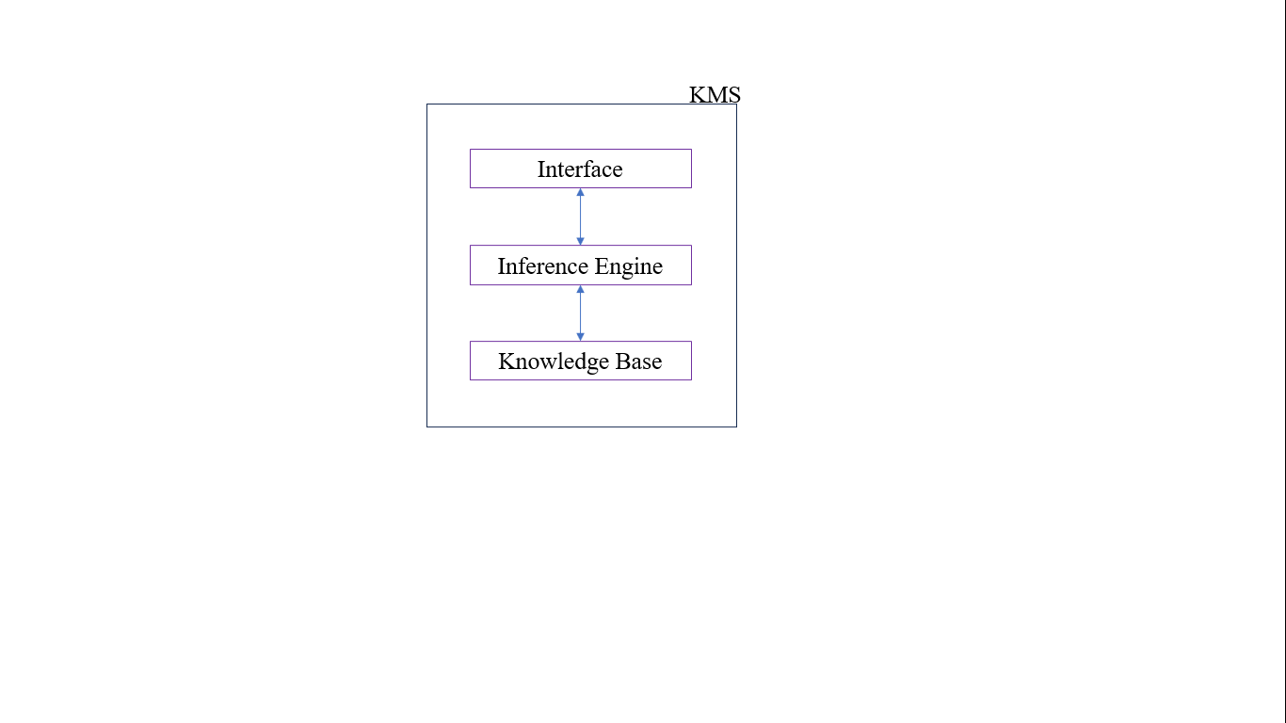
Fig 3. KMS Architecture

KMS is an IT system that includes content, search, guidance, and insight, and it is used to organise documentation, frequently asked questions, and other information into easily accessible resources. KMS can exist within organisations or teams and can also be used to centre a knowledge base for users or customers. The system stores and retrieves knowledge to improve understanding, collaboration, and process alignment. The KMS is crucial to the success of businesses because it helps improve efficiency, productivity, and customer service. It includes various components such as content, search, guidance, insight, process, practices, people, and culture. Implementing a KMS involves capturing, organising, updating, and analysing knowledge to ensure it is easily accessible and beneficial for the organisation and its customers. Furthermore, KMS should be regularly updated and integrated with analytics to track its success and impact. Challenges such as obsolete technology and lack of employee buy-in are essential for successfully implementing a KMS [61].
5.1 Knowledge Management and its Components (KMC)
The components of the KM include People, Process, Content /IT and Strategy
People: People are the key to knowledge creation and sharing. They lead, support, and encourage knowledge sharing within the organisation. In addition to creating, gathering, and sharing information, people must mentor and advise their coworkers.
Processes: Well-defined processes are required to regulate and measure information flows. They are in a position to produce, gather, and share information and offer advice and experience to their colleagues.
Content/IT: Information content and IT resources are essential for connecting people to the proper knowledge. This entails producing, preserving, overseeing knowledge assets and offering platforms and tools for information access and exchange.
Strategy: A clear strategy is necessary for utilising KM to fulfil the organisation's goals and objectives. The strategy outlines how KM will be implemented, managed, and measured, ensuring it aligns with the organisation's objectives.
Green Knowledge Management:
Green Knowledge Management (GKM) is a framework that integrates environmental sustainability into knowledge management practices. The innovative idea of "green knowledge management" (GKM) aims to include environmental or green factors in every facet of knowledge management. The environmental issues have led to a considerable growth in the need for green expertise. Recently, there has been much discussion concerning ecological concerns [62]. Ecologists deserve praise for their tenacious efforts to educate the public about the loss of natural resources and the damage that comes to the environment from businesses throughout the world using resources too quickly [63].
Businesses have begun to focus more on sustainable development with the release of the Brundtland Commission report by the United Nations. They are trying to integrate the knowledge about nature and society into new concepts and theories. Green knowledge is not solely about information about a natural condition; it has a broad spectrum of how we should react to that situation and consider following a more sustainable environmental, social, and economic development path [64].
It involves systematically creating, sharing, and applying green knowledge within organisations. GKM aims to promote sustainable practices, reduce the environmental impact of human activities, and enhance organisational green performance and innovation. The components of GKM include green job design, recruitment and selection, education and development, performance appraisal, compensation and reward, training, and sustainable practices. GKM is essential for organisations to enhance their green performance, achieve sustainable development, and capitalise on green innovation. GKM is gaining momentum, and there is a growing need to measure and integrate green or environmental aspects into all dimensions of knowledge management. The development and validation of scales for measuring GKM reflect the increasing importance of integrating environmental concerns into traditional knowledge management processes [65].
The businesses may analyse and gauge the effectiveness of their Green Knowledge Management (GKM) procedures by creating and assessing a GKM scale. With this scale, organizations may determine their adherence to GKM standards and pinpoint areas needing development [66]. Furthermore, companies can gauge how GKM affects environmental performance metrics like waste reduction and carbon footprint. In addition, they may monitor staff involvement and GKM activities, such as how many staff members attend green training sessions or how many green ideas they come up with [67]. Organisations may also evaluate how well GKM practices work by looking at how they affect performance and innovation, for example, how many green patents are submitted or how much money is saved by using green practices. Organisations can identify areas for development and maximise their GKM framework to meet their sustainability objectives by evaluating the efficacy of their GKM activities [68][69].
- CONFLUENCE OF GHRMP AND KMC FOR SUSTAINABILITY:
Integrating GHRM techniques with knowledge management has produced several advantages.
1. Improved cooperation and openness about environmental projects: We aim to foster collaboration on various ecological issues, from biodiversity conservation and sustainable resource management to environmental protection.
2. Enhanced staff knowledge exchange and access to best practices: Technology can help transfer knowledge within an organisation in various ways. First, a centralised knowledge management system makes information, documents, and best practices easily accessible and shared among staff members. Wikis, collaboration platforms, and intranets can all be used for this.
3. Making decisions based on data to maximise environmental initiatives: Analysing data gives environmental intelligence the information it needs to make sustainable decisions. Organisations may pinpoint areas for improvement and put plans in place to reduce their adverse environmental effects by examining data like energy use, emissions, and resource consumption.
4. Creation of a sustainable culture via involvement and ongoing education: Organisations might try to involve staff members in sustainability efforts by forming cross-functional teams devoted to eco-friendly projects. This can be accomplished by asking staff members for their ideas and providing a forum for them to share their knowledge.
References:
[1]. Samant, S. M., & Sangle, S. A selected literature review on the changing role of stakeholders as value creators. World Journal of Science, Technology and Sustainable Development, 13(2), 100–119.(2016), https://doi.org/10.1108/WJSTSD-01-2016-0002.
[2]. Robin Kramar, Beyond strategic human resource management: is sustainable human resource management the following approach, The International Journal of Human Resource Management,oct-2013 DOI:10.1080/09585192.2013.816863; http://dx.doi.org/10.1080/09585192.2013.816863
[3]. Elkington, J., Cannibals With Forks: The Triple Bottom Line of the 21st Century, (1997), Oxford: Capstone.
[4]. Benn, S., and Bolton, D., Key Concepts in Corporate Social Responsibility, London: Sage. (2011)
[5]. Mohiuddin M, Hosseini E, Faradonbeh SB, Sabokro M. Achieving Human Resource Management Sustainability in Universities. Int J Environ Res Public Health. 2022 Jan 14;19(2):928. Doi: 10.3390/ijerph19020928. PMID: 35055753; PMCID: PMC8775848.
[6]. Ehnert I. Sustainability and human resource management: Reasoning and applications on corporate websites. Eur. J. Int. Manag. 2009;3:419–438. doi: 10.1504/EJIM.2009.028848.
[7].Anjali, “What are the 4 Types of Sustainable HRM?,” ZingHR, Aug. 17, 2022. https://www.zinghr.com/human-resource-software/what-are-the-4-types-of-sustainable-hrm/
[8]. Aust, B. Matthews, and M. Muller-Camen, ‘Common Good HRM: A paradigm shift in Sustainable HRM?’, Human Resource Management Review, vol. 30, no. 3, p. 100705, 2020.
[9]. N. Thom and R. J. Zaugg, ‘Nachhaltiges und innovatives Personalmanagement’, in Nachhaltiges Innovationsmanagement, E. J. Schwarz, Ed. Wiesbaden: Gabler Verlag, 2004, pp. 215–245.
[10]. Jackson, S. E., Renwick, D. W. S., Jabbour, C. J. C., & Muller-Camen, M.. State-of-the-Art and Future Directions for Green Human Resource Management:Introduction to the Special Issue. German Journal of Human Resource Management, 25(2), 99-116.2011 https://doi.org/10.1177/239700221102500203.
[11]. Dyllick, T., & Muff, K. ,Clarifying the Meaning of Sustainable Business: Introducing a Typology From Business-as-Usual to True Business Sustainability. Organization & Environment, 29(2), 2016. 156-174. https://doi.org/10.1177/1086026615575176.
[12]. Ehnert, Ina and Ehnert, Ina, sustainable, Sustainable human resource management, Springer,2009
[13]. Daly, H. E., For the common good: Redirecting the economy toward community, the environment, and a sustainable future (No. 73). Beacon Press.1994
[14]. Green human resources management - meaning and definition [2021],”Accessed: 07 January 2024” You matter. Available at: https://youmatter.world/en/definition/green-human-resources-management-meaning-definition/.
[15] Y.-K. Kuo, T. I. Khan, S. U. Islam, F. Z. Abdullah, M. Pradana, and R. Kaewsaeng-on, “Impact of Green HRM Practices on Environmental Performance: The Mediating Role of Green Innovation,” Frontiers in Psychology, vol. 13, Jun. 2022, doi: https://doi.org/10.3389/fpsyg.2022.916723.
[16] F. Rabbi, N. Ahad, T. Kousar, and T. Ali, “TALENT MANAGEMENT AS A SOURCE OF COMPETITIVE ADVANTAGE,” Journal of Asian Business Strategy, vol. 5, no. 9, pp. 208–214, 2015, doi: https://doi.org/10.18488/journal.1006/2015.5.9/1006.9.208.214.
[17] Gartner, “What Is HR Transformation — and What Does It Achieve?,” Accessed: Jan. 7, 2024. (online) Available: Gartner. https://www.gartner.com/en/human-resources/topics/hr-transformation.
[18] Liliya Babynina, “Transformation Of Approaches To Human Resources Management In The New Reality,” The European Proceedings of Social and Behavioural Sciences, Apr. 2021, doi: https://doi.org/10.15405/epsbs.2021.04.02.89.
[19] T. Marditama, Mohd Yusoff Yusliza, Latifah Abdul Ghani, Jumadil Saputra, and Z. Muhammad, “Green Human Resource Management and Sustainable Organization Literature: A Mini-Review Approach,” Mar. 2021, doi: https://doi.org/10.46254/an11.20210712.
[20] Saxena, Ritu & Pachauri, Vivek.. Innovation on HR Practices: Heading towards Green HRM. (2020) doi: 10.13140/RG.2.2.36347.44320.
[21] Marhatta, S., & Adhikari, S. (2013). Green HRM and sustainability. International eJournal of Ongoing Research in Management & IT. www.asmgroup.edu.in/incon/publication/incon13-hr-006pdf
[22] Ambec, S. and Lanoie, P. Does it pay to be green? A systematic overview. Academy of Management Perspectives, (2008), 43, pp. 45–62.
[23]. Baykal E and Bayraktar O Green human resources management: A novel tool to boost work engagement. Front. Psychol. (2022), 13:951963. doi: 10.3389/fpsyg.2022.951963
[24] Green HRM, https://hrmi.org/green-hrm/,
[25] Michael Chui, James Manyika, Jacques Bughin, Richard Dobbs, Charles Roxburgh, Hugo Sarrazin, Geoffrey Sands, and Magdalena Westergren, The social economy: Unlocking value and productivity through social technologies, https://www.mckinsey.com/industries/technology-media-and-telecommunications/our-insights/the-social-economy, Last Accessed on 13.01.2024
[26] N. Boer, Knowledge sharing within organizations. 2005
[27] Starmind, What Is Knowledge Management and Why Is It So Important?, https://www.starmind.ai/resources/what-is-knowledge-management-and-why-is-it-so-important, Last Accessed on 13.01.2024
[28] Kamal, P. N. M., & Buniyamin, N. (2018). Knowledge Management System in Industries. 2018 4th International Conference on Electrical, Electronics and System Engineering (ICEESE). doi:10.1109/iceese.2018.8703552
[29] Indeed Editorial Team, What Is Knowledge Management and Why Is It Important?, https://www.indeed.com/career-advice/career-development/what-is-knowledge-management, last accessed on 13.01.2024.
[30] Team Capacity, Who created the term knowledge management?, https://capacity.com/knowledge-management/faqs/who-created-the-term-knowledge-management/#:~:text=Knowledge%20management%20has%20been%20around,%2C%20storing%2C%20and%20distributing%20knowledge, last accessed on 13.01.2024.
[31] KMS lighthouse, Integrate Knowledge Management With Your Business Processes, https://kmslh.com/blog/integrate-knowledge-management-with-your-business-processes/m
[32] P. K. Aino, V. Mika, and Heilmann, “The Impact of Knowledge Management on Job Satisfaction,” J. Knowl. Manag., vol. 20, no. 4, pp. 621–636, 2016.
[33] Glossary, Knowledge Management, https://www.getguru.com/reference/what-is-knowledge-management, last accessed on 13.01.2024.
[34] Garima Behal, Importance of knowledge management in organizations | Benefits & Examples, https://www.oslash.com/blog/importance-of-knowledge-management-in-organizations-benefits-examples, last accessed on 13.01.2024.
[35] Eric Harris, The Relevance of Knowledge Management to Organizations, https://www.kminstitute.org/blog/relevance-knowledge-management-organizations, last accessed on 13.01.2024.
[36] Harry Wray, What is knowledge management? Definition, types, and benefits, https://www.zendesk.com/in/blog/knowledge-management-system/#georedirect, last accessed on 13.01.2024.
[37] Disha Gupta, 7 Types of Knowledge: Explicit, Implicit, Tacit, & More, https://whatfix.com/blog/types-of-knowledge/, last accessed on 13.01.2024.
[38] The Complete Guide to Knowledge Management, https://document360.com/knowledge-management/, last accessed on 13.01.2024.
[39] Jesse Wilkins, Tacit Knowledge Vs. Explicit Knowledge, https://info.aiim.org/aiim-blog/tacit-knowledge-vs-explicit-knowledge, last accessed on 13.01.2024.
[40] What is Tacit Knowledge? Examples, Benefits & Importance, https://betterdocs.co/what-is-tacit-knowledge/, Last Accessed on 14.01.2024.
[41] Emilija Angelovska, Declarative knowledge, https://www.edapp.com/blog/declarative-knowledge/, Last Accessed on 14.01.2024.
[42] Shelf, The 9 Different Types of Knowledge: What They Are and Why They Matter, https://shelf.io/blog/9-different-types-of-knowledge/, Last Accessed on 14.01.2024.
[43] Raluca Brebeanu, What is procedural knowledge and how you can make the most of it?, https://elium.com/blog/what-is-procedural-knowledge-and-how-you-can-make-the-most-of-it/, Last accessed on 15.01.2024.
[44] Riddhi Patel, What is Procedural Knowledge and How to Use It?, https://www.thecloudtutorial.com/procedural-knowledge/, Last accessed on 15.01.2024.
[45] Davenport, T. H. (1997). Ten principles of knowledge management and four case studies. Knowledge and Process Management, 4(3), 187–208. doi:10.1002/(sici)1099-1441(199709)4:3<187::aid-kpm99>3.0.co;2-a
[46] Dhanya, Knowledge management: Challenges and solutions, https://www.zoho.com/learn/focalpoint/knowledge-management-challenges-and-solutions.html, Last accessed on 15.01.2024.
[47] Jacobson and Laurence Prusak, The Cost of Knowledge, https://hbr.org/2006/11/the-cost-of-knowledge, Last accessed on 15.01.2024.
[48] Topp, L., Mair, D., Smillie, L. et al. Knowledge management for policy impact: the European Commission’s Joint Research Centre case. Palgrave Commun 4, 87 (2018). https://doi.org/10.1057/s41599-018-01433
[49] Nick Milton, Benefits mapping in Knowledge Management, https://www.nickmilton.com/2017/01/benefits-mapping-in-knowledge-management.html, Last accessed on 15.01.2024.
[50] Rees Morrison, Ten principles of knowledge management, by Thomas Davenport, https://www.lawdepartmentmanagementblog.com/ten-principles-of-knowledge-management-by-thomas-davenport/, Last accessed on 15.01.2024.
[51] Eva Semertzaki, 2 - Knowledge management, Editor(s): Eva Semertzaki, In Chandos Information Professional Series, Special Libraries as Knowledge Management Centres, Chandos Publishing, 2011, Pages 57-119, ISBN 9781843346135, https://doi.org/10.1016/B978-1-84334-613-5.50002-9.
[52] s Rechberg, I. and Syed, J. (2013), "Ethical issues in knowledge management: conflictof knowledge ownership", Journal of Knowledge Management, Vol. 17 No. 6, pp. 828-847. https://doi.org/10.1108/JKM-06-2013-0232
[53] Thomas H. Davenport, Some Principles of Knowledge Management, https://www.strategy-business.com/article/8776, Last accessed on 15.01.2024.
[54] Michael E.D. Koeni, What is KM? Knowledge Management Explained, https://www.kmworld.com/About/What_is_Knowledge_Management, Last accessed on 15.01.2024.
[55] Law, K.K., Chan, A. (2016). Knowledge Utilization in Organizations. In: Farazmand, A. (eds) Global Encyclopedia of Public Administration, Public Policy, and Governance. Springer, Cham. https://doi.org/10.1007/978-3-319-31816-5_152-1
[56] Halil Zaim, Shahnawaz Muhammed & Merve Tarim (2019) Relationship between knowledge management processes and performance: critical role of knowledge utilization in organizations, Knowledge Management Research & Practice, 17:1, 24-38, DOI: 10.1080/14778238.2018.1538669
[57] Matteo Colombi, Top 5 Reasons Why Knowledge Management is Necessary, https://broadvision.com/blog/top-5-reasons-knowledge-management-necessary/, Last accessed on 15.01.2024.
[58] Chakravarthy, Anil S. et al. “Utilization and Evaluation of Knowledge Management Tools in Information Technology Industry.”, IOSR Journal of Business and Management (IOSR-JBM),e-ISSN: 2278-487X, p-ISSN: 2319-7668. Volume 17, Issue 2.Ver. II, Feb. 2015, PP 41-52.
[59] Hanisch, B., Lindner, F., Müller, A., & Wald, A. (2008). Project knowledge management: status quo, organizational design, and success factors. Paper presented at PMI® Research Conference: Defining the Future of Project Management, Warsaw, Poland. Newtown Square, PA: Project Management Institute.
[60] Clifton L. Smith, David J. Brooks, Chapter 8 - Knowledge Management,Editor(s): Clifton L. Smith, David J. Brooks, Security Science, Butterworth-Heinemann, 2013,Pages 177-198, ISBN 9780123944368, https://doi.org/10.1016/B978-0-12-394436-8.00008-4.
[61] V. Ribière, F.A. Calabrese, Chapter 2 - Why are companies still struggling to implement Knowledge management? Answers from 34 experts in the field, Editor(s): Jay Liebowitz,Successes and Failures of Knowledge Management, Morgan Kaufmann, 2016, Pages 13-34, ISBN 9780128051870, https://doi.org/10.1016/B978-0-12-805187-0.00002-4.
[62] Sourabh Kumar, Mukesh Kumar Barua, A modeling framework of green practices to explore their interrelations as a conduit to policy, Journal of Cleaner Production, Volume 335, 2022,130301, ISSN 0959-6526, https://doi.org/10.1016/j.jclepro.2021.130301.
[63] Cathérine Lehmann, Olivier Delbard, Steffen Lange, Green growth, a-growth or degrowth? Investigating the attitudes of environmental protection specialists at the German Environment Agency, Journal of Cleaner Production, Volume 336, 2022, 130306, ISSN 0959-6526, https://doi.org/10.1016/j.jclepro.2021.130306.
[64] Abbas, J. and Khan, S.M. (2023), "Green knowledge management and organizational green culture: an interaction for organizational green innovation and green performance", Journal of Knowledge Management, Vol. 27 No. 7, pp. 1852-1870. https://doi.org/10.1108/JKM-03-2022-0156
[65] Song M, Yang MX, Zeng KJ, Feng W. Green Knowledge Sharing, Stakeholder Pressure, Absorptive Capacity, and Green Innovation: Evidence from Chinese Manufacturing Firms. Bus Strat Env. 2020; 29: 1517–1531. https://doi.org/10.1002/bse.2450
[66] Siming Yu, Jawad Abbas, Susana Álvarez-Otero, Jacob Cherian, Green knowledge management: Scale development and validation, Journal of Innovation & Knowledge, Volume 7, Issue 4, 2022,100244, ISSN 2444-569X, https://doi.org/10.1016/j.jik.2022.100244.
[67] Shouwen Wang, Jawad Abbas, Muhammad Safdar Sial, Susana Álvarez-Otero, Lucian-Ionel Cioca,
Achieving green innovation and sustainable development goals through green knowledge management: Moderating role of organizational green culture, Journal of Innovation & Knowledge,Volume 7, Issue 4, 2022, 100272, ISSN 2444-569X, https://doi.org/10.1016/j.jik.2022.100272.
[68] Abeer Hmoud Al-Faouri, Green knowledge management and technology for organizational sustainability: The mediating role of knowledge-based leadership, Cogent Business & Management, (2023), 10:3, DOI: 10.1080/23311975.2023.2262694
[69] Ahmad, Farooq, Md Billal Hossain, Khurram Mustafa, Faisal Ejaz, Kausar Fiaz Khawaja, and Anna Dunay. 2023. "Green HRM Practices and Knowledge Sharing Improve Environmental Performance by Raising Employee Commitment to the Environment" Sustainability 15, no. 6: 5040. https://doi.org/10.3390/su15065040

