**Hematinics, Coagulants and Anticoagulants**

**Hematinics:** These are substances required within the arrangement of blood, and are utilized for treatment of anemias.

• Fundamental hematinic: Iron, vitamin B12, acid.

Etiology:

• Iron deficiency happens when:

(a) Blood misfortune (Loss or incessant)

(b) Disabled red cell arrangement due to:

Insufficiency of fundamental variables, i.e. press, vitamin B-12, folic corrosive.

Bone marrow misery, erythropoietin lack.

(c) Expanded annihilation of RBCs

Anemia

Frailty could be a diminish within the RBC tally, hemoglobin, or hematocrit values coming about in a lower capacity for the blood to carry oxygen to body tissues.

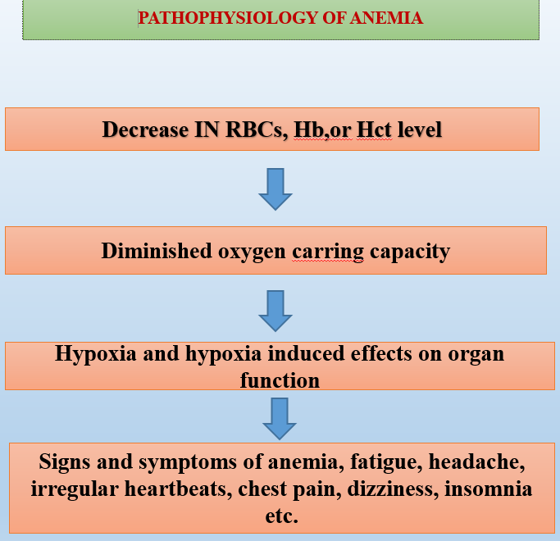

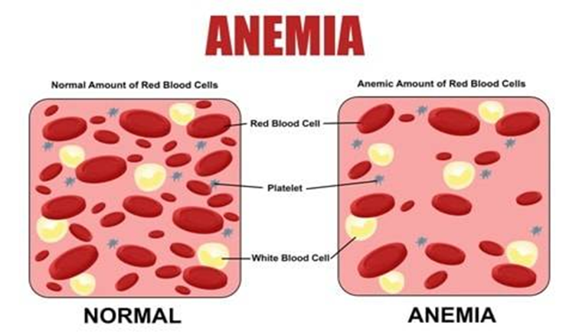

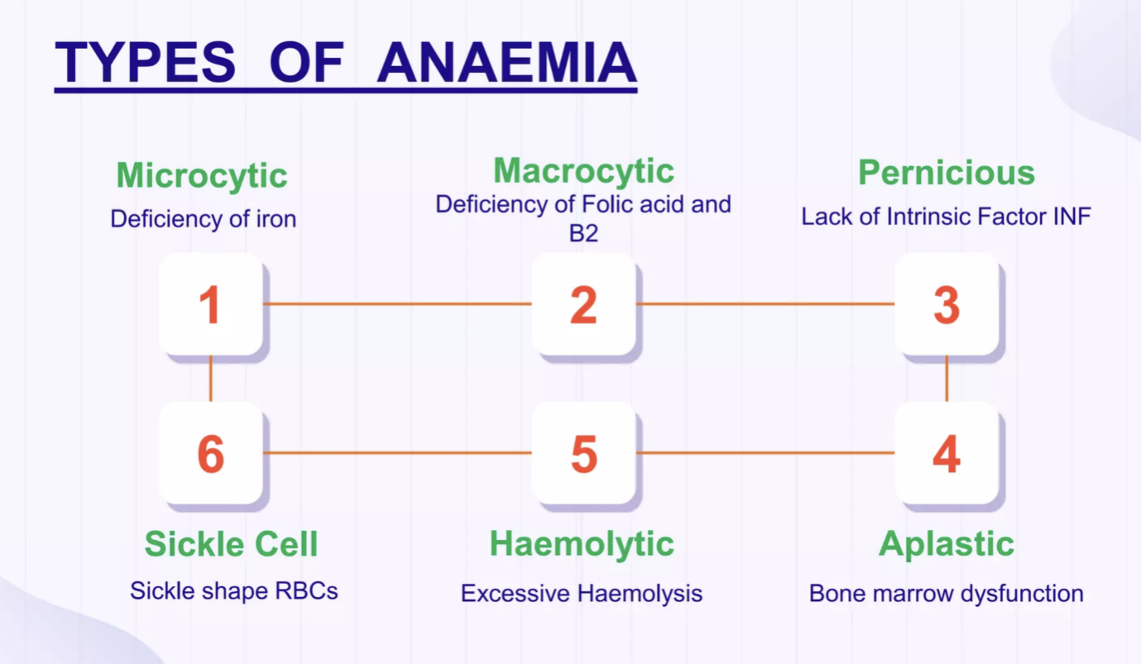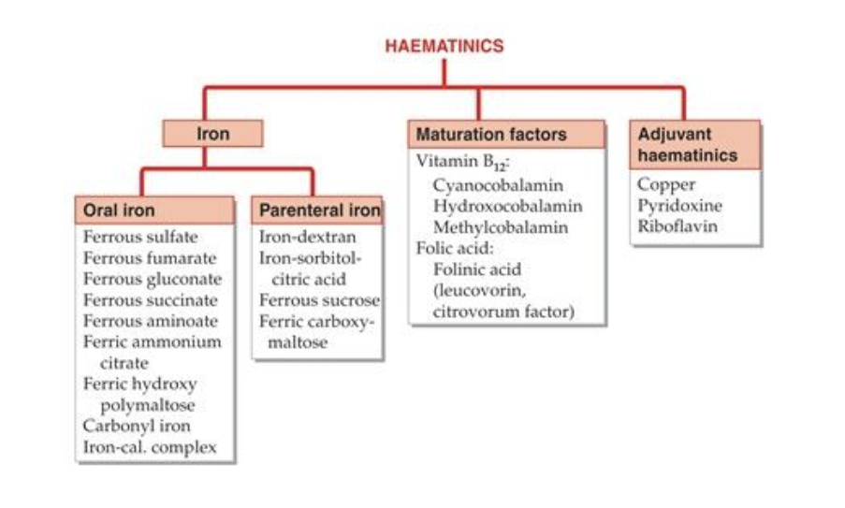

**Iron**

Distribution of iron in body

* Hemoglobin (Hb). 66%
* Iron stores as ferritin and hemosiderinn. 25%
* Myoglobin (in muscles). 7%
* Enzymes (cytochromes etc.) 6%

**Everyday Iron requirement (prerequisite)**

* Adult male : 0.5-1 mg
* Adult female : 1-2 mg (menstruating)
* Children: 25 micro gm /kg
* Pregnancy: 3 - 5 mg

**Dietary sources of iron-rich**

* Liver, egg yolk, dry Natural products, wheat, spinach, Meat, chicken, fish, banana, apple.
* Two distinctive iron transporters within the intestinal mucosal cells carry out iron uptake.
* **divalent metal transporter-1** (DMTI) carries ferrous iron within the mucosal cell
* **ferroprotein** are bound with ferrous iron & pass through mucosal cells directly into the bloodstream

**Mechanism of Iron absorption, transportation, utilization & storage**

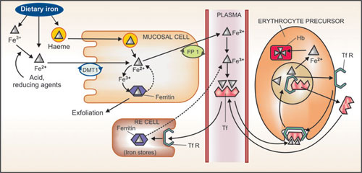

**Mechanism**

Upon entering the plasma, iron is immediately converted to ferrous form and forms a complex with the glycoprotein, transferrin (Tf), which has two binding sites for ferric ions.

• Iron is transported into erythrocytes and other cells by binding of transferrin to specific membrane-bound transferrin receptors (TfRs).

• The complex is engulfed by the receptor by endocytosis.

Iron dissociates from the complex at the acidic pH of the intracellular vesicle.

• The released iron is used for Hb synthesis.

• Tf and TfR return to the cell surface to transport other substances.

**Storage**

Liver (spleen, bone marrow) as well as in hepatocytes and muscle cells as ferritin and hemosiderin.

**Excretion**

* In adults, this amount is 0.5 to 1 mg, mainly in the exfoliated form, i.e.in mucous cells, in some red blood cells and in bile (lost in the stool)
* In menstruating women- monthly loss of – 0.5-1mg per day
* Other routes – skin (urine and sweat)

**Therapeutic uses**

* Pregnancy
* Iron deficient anemia
* Premature babies
* Blood loss
* Malabsorption syndrome
* GI bleeding due to-ulcers.

**Iron preparations & brand names**

* Oral preparations- ferrous sulfate (feosol)
* Parenteral preparations- iron dextran (inferno)

**Folic acid**

Pteroyl glutamic acid (PGA) (pteridine + para-aminobenzoic acid (PABA) + glutamic acid.

* Food sources: Liver, green leafy vegetables (spinach), yeast, eggs, milk.
* Present in food as poly-glutamates
* Absorption: in the duodenum and jejunum
* Transported in the blood as methyl-THFA by active and passive transport.
* Stored in cells as polyglutamate, Liver takes up a large part and secretes methyl-THFA in bile.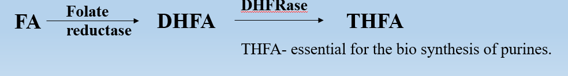

**Therapeutic Uses of Folic Acid**

* Megaloblastic anemia
* Folic acid deficiency
* Protect epithelial cell
* Growth in infants
* In pregnancy

**Preparations and dose:**

* Folic acid: -liquid oral, Injectable
* Folinic acid : - CALCIUM LEUCOVORIN 3 mg/ml inj.

**Diurnal demand:** 0.2 mg per day (0.8 mg in gestation & lactation mothers)

**Vitamin B12 (Cyanocobalamin)**

Complex cobalt-containing compounds Cyanocobalamin and hydroxocobalamin

* + These are synthesized by a microorganism, and plants, and animals acquire them from them.

**Dietary sources** : Fish - Liver, saltwater fish, eggs, chicken, meat, and cheese.

Two active coenzyme forms of B12 are deoxy adenosyl-cobalamin (DAB12) and methyl-cobalamin (methyl B12).

**Functions**

* Vitamin B12 act as cofactor in following reactions -
* Conversion of homocysteine to methionine - methionine is methyl group donor in the metabolic reactions.
* Purine and a pyrimidine synthesis - needed for a DNA synthesis.
* Malonic acid DAB12 Succinic acid important for propionic acid metabolism (Carbohydrate and lipid metabolism)
* for cell growth and multiplication

**Dosage and Uses of Vitamin B12**

* Vitamin B12 is well absorbed after i.m. (Intramuscular) or deep s.c(Subcutaneous). injection
* Cyanocobalamin: 35 micro gm / 5 ml liquid.,
* Hydroxocobalamin: 500 mg. 1000 mg

**Therapeutic Uses**: The Treatment of Vitamin B12 deficiency.

1. Megaloblastic anemia: defects in the metabolism of vitamin B12 or folic acid.
2. Pernicious anaemia: body isn't able to absorb orally vitamin B12 due to a lack of intrinsic factor so given parenterally IM or SC
3. Prophylaxis: 3-10 micro gm daily
4. Neurological condition like: Neuropathies, trigeminal neuralgia, Multiple sclerosis, psychiatric disorders.

**COAGULANTS**

**Introduction**:

Haemostasias- stoppage of bleeding from damaged blood vessel.

3 basic mechanism which prevent blood loss:

1. The Initially vasospasm of a small capillaries- Vasoconstriction
2. 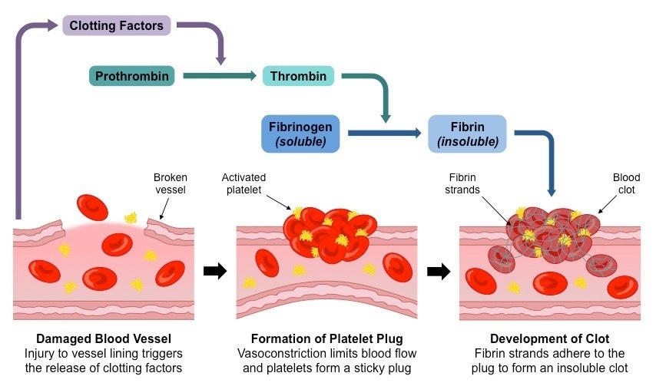Platelet - plug formation

**Blood clotting:**

**Coagulation** is the Procedure by which a liquid, particularly blood, changes into a semi-solid or solid state. In the context of blood, coagulation is part of hemostasis, the body's mechanism to prevent excessive bleeding after an injury. It involves transformation of blood from liquid to gel, forming a clot.

Disorders of coagulation can lead to an increased risk of bleeding and clotting (thrombosis).

**3 stages of coagulation:**

* Intrinsic or extrinsic
* Thrombin formation
* Fibrin Formation

**Coagulants**

Coagulants are the drugs that promote coagulation and control a bleeding.

Coagulants are also known as hemostatics.

* Systemically
* locally (styptics)

The Hemorrhagic states : Hemophilia, Von-Willebrand’s disease

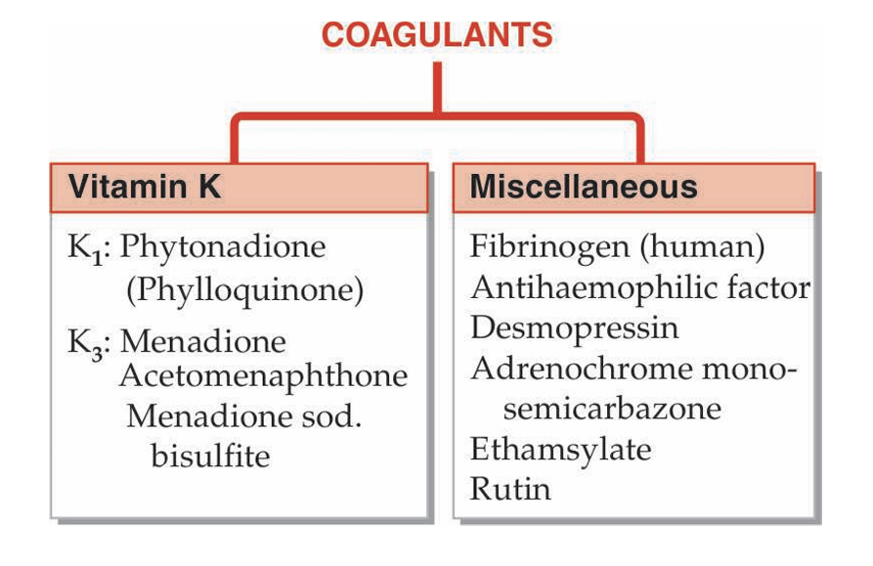Fresh whole blood or plasma: The best therapy can provide all factors needed for coagulation Act immediately.

**Vitamin K (**Phytonadione and Menadione)

**Mechanism of action:**

Vitamin K acts as a cofactor in the final stage of the synthesis of the liver's coagulation proteins - prothrombin (II), VII, IX and X.

Vitamin K-dependent changes, Ca2+ binding and phospholipid binding, and properties necessary for participation in the coagulation process.

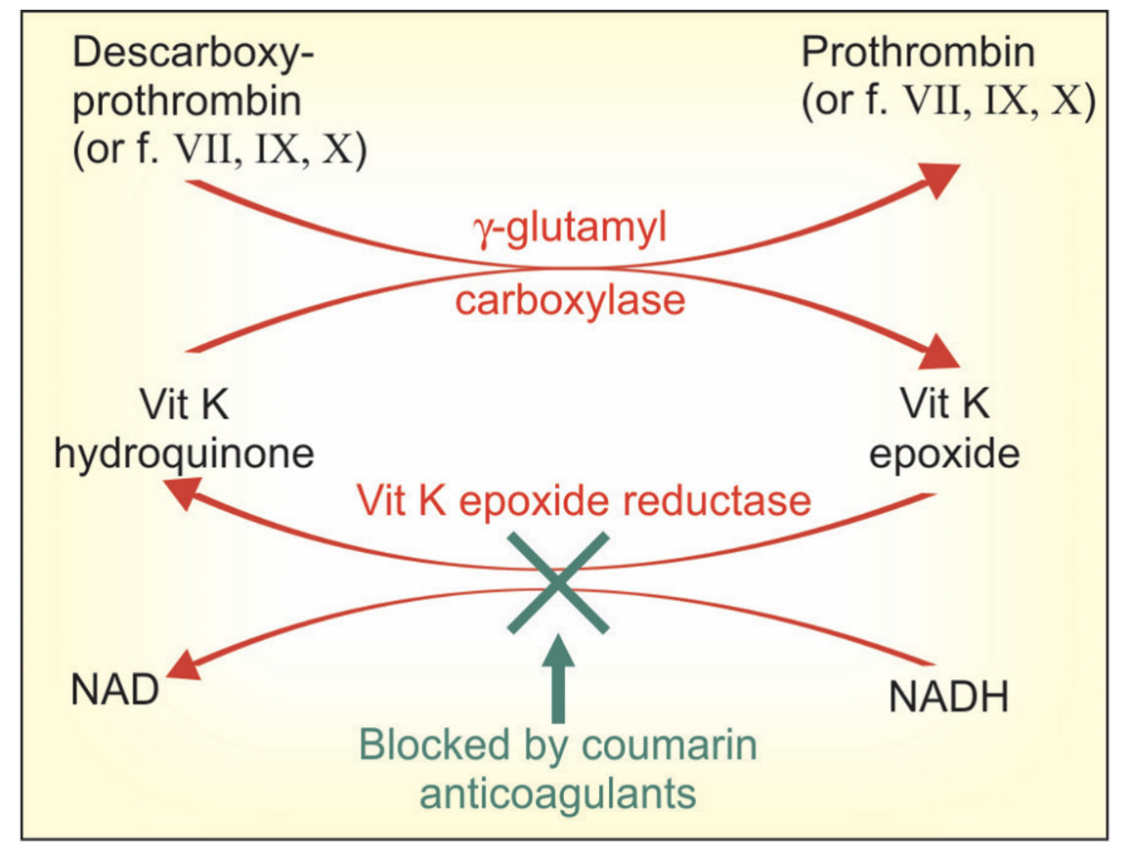

**Therapeutic uses:**

* Dietary deficiency
* Liver disease
* Malabsorption
* Long term antimicrobial therapy
* The Newborn babies are having lack intestinal flora and have low level of clotting factors:
* Overdose oral anticoagulants

**Adverse effects:**

* Allergic reactions are very rare.
* Pain, Swelling, and Tenderness at the Injection Site
* Dizziness
* Rapid and Weak Pulse
* Profuse Sweating
* Brief Hypotension

**Contraindications:**

* Severe anaphylaxis reactions can occur on i.v. inj of emulsion; this route should not be used.
* During Surgeries.
* Vitamin K may interfere with the effectiveness of anticoagulants, such as **warfarin.**

**Dosages and brand names:**

* Phytonadione: VITAMIN-K, KVI, K-WIN 10 mg/ml for i.m. injection.
* Acetonaphthone: ACETOMENADIONE 5, 10 mg tab; KAPILIN 10 mg tab.

**Anti-Coagulants**

* The drugs that are used to reduce the coagulability of blood are known as anti-coagulants

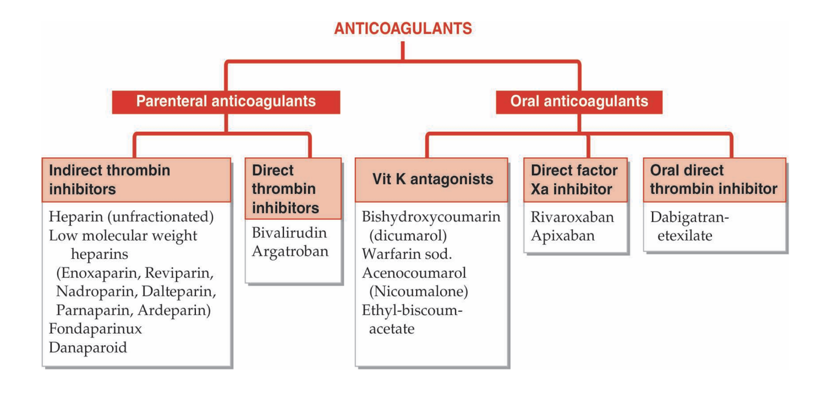**Heparin**

* + McLean, a medical student, discovered that liver contained a powerful anticoagulant in 1916.
* Howell and Holt called it HEPARIN obtained from liver A mixture of mucopolysaccharides with molecular weights ranging from 10,000 to 20,000 (D-glucosamine-L-iduronic acid and D-glucosamine acid - D-glucuronic acid) • The most powerful organic acid found in the body.
  + Present in mast cells of the lungs, liver and intestinal mucosa.
* Obtained commercially from the lining of bovine lungs and porcine intestines.

**Heparin mechanism of action:**

**HEPARIN**

26

**Binds and activates plasma antithrombin III**

**heparin-AT III complex binds to clotting factors of the intrinsic and common plasma pathways (Xa, IIa, IXa, antithrombin XIa, XIla and XIlIa) and inactivates them**

**inhibition of factor of Xa as well as thrombin (IIa) mediated conversion of Anticoagulation Effect fibrinogen to a fibrin**

**Anticoagulation effect**

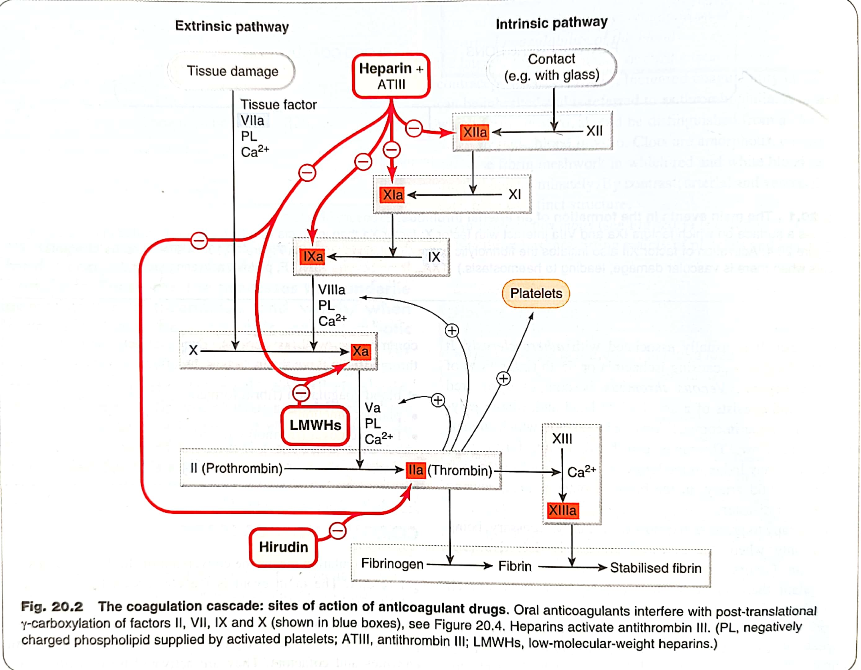

**Pharmacological actions:**

* **On Blood:**

**Anticoagulation**: Heparin prevents blood clot formation by binding to antithrombin III (ATIII) and accelerating its inactivation of a coagulation enzymes, including thrombin (factor IIa) and factor Xa

**Thromboprophylaxis:** Heparin indicated for prophylaxis.

* **On Platelets:**

**Inhibits** platelet aggregation and **increases** the bleeding time.

* **On Cardiovascular System**:

**Prevents embolisms** in patients with atrial fibrillation and is also used as adjunctive antithrombotic therapy in patients with unstable angina and acute coronary syndromes.

* **Respiratory System**:

**Pulmonary Embolism**: Heparin reduces thrombosis associated with pulmonary embolism**.**

* **Renal System**:

**Kidney Dialysis**: Heparin prevents blood clotting during kidney dialysis.

**Pharmacokinetics**

* Large MW, highly ionized molecule: therefore not absorbed orally.
* If injected i.v.- immediate effect.
* After sc injection, anticoagulant effect develops after about 60 minutes.
* Does not cross the blood-brain barrier or placenta.
* Safe during pregnancy • Metabolized in the liver by heparinase Side effects: • Overdose bleeding - serious complication - hematuria (sign 1) • Thrombocytopenia • Transient and reversible alopecia
* Osteoporosis - On long-term use
* Hypersensitivity reactions

**Contraindications**

* Bleeding disorders
* Heparin induced thrombocytopenia
* Endocarditis
* Ulcers in gut
* Severe hypertension (risk of cerebral hemorrhage)
* Large malignant tumor (risk of bleeding in the necrotic center of the tumor)