**Harnessing the Power of Sports for Sustainable Business Development: A Holistic Approach**

***Mrs. Yeshoda Madugula, M. Com, MA (Sociology), Hyderabad, Telangana, India.***

***Ms. Nanditha Veerlapally, Student, B. Com (Computers) IIIrd year, Villa Marie College for Women, Hyderabad, Telangana, India.***

**Abstracts**

*The role of sport in sustainable business development is increasingly recognized due to its significant contribution to physical well-being, social cohesion, and economic opportunity. Sustainable business development in the sports industry involves the integration of environmental, social, and economic factors into business strategies and operations. This holistic approach ensures that sports organizations and their associated businesses thrive while minimizing environmental impact, enhancing social equity, and achieving long-term economic benefits. This chapter throws light on a conceptual framework for understanding the contribution of sport to sustainable business development. This chapter delves on how sports are contributing to sustainable business development and also breakthrough innovation with key requirements. This chapter also highlights CSR initiatives in sport to help businesses and the role of CSR in sports.*

***Keywords:*** *Economic benefits, environmental impact, social equity, sport, sustainable business development.*

**Introduction**

“*Sustainable development is defined as development that satisfies the needs of the present without compromising the ability of future generation to satisfy theirs.”*

***-MS Harlem Brundtland***

The contribution of sport to sustainable business development has received significant attention in recent years. As a multi-faceted industry, sport not only promotes physical well-being and social cohesion, but also provides significant economic opportunities. Sustainable business development in sport involves the integration of environmental, social, and economic factors into business strategies and operations. This holistic approach ensures that sports organizations and their associated businesses thrive while minimizing environmental impact, enhancing social equity, and achieving long-term economic benefits.

Sports play an important role in long-term company development because they promote economic growth, social integration, and environmental stewardship. Sports have a significant influence on long-term business growth by creating jobs and stimulating the economy. Major athletic events, such as the Olympics and the World Cup, generate significant expenditures in infrastructure, tourism, and local companies. These events generate countless job possibilities, ranging from construction and hospitality to event administration and marketing, promoting economic stability and growth in host regions. Sport represents a broad range of opportunities to promote environmental awareness, capacity building, and far-reaching actions for environmental, social, and economic development across society.

**Review of Literature**

**Ricardo Roseira Cayolla et al., (2021) in** the paper titled **Sustainable Initiatives in Sports Organizations—Analysis of a Group of Stakeholders in Pandemic Times** stated the importance of environmentally sustainable initiatives in sport (ESIS) for stakeholders in pandemic times. The topics such as climate changes and energy consumption, environmental effect of sporting events, and health and well-being were studied and analyzed under three sustainable forms: organizational, community, and individual. The data collection method happened during epidemic periods, when every form of collective athletic event was suspended to the general population. The descriptive analysis of the data is offered, and the findings suggested that health and well-being is the most valorized issue by members and workers, in a sustainable individual form. On the other hand, sponsors demonstrated their interest largely in a sustainable organizational and community forms.

**Conceptual Framework**

The conceptual framework for understanding the contribution of sport to sustainable business development can be presented in three main areas:

* **Environmental Sustainability:** It focuses on reducing the environmental impact of sporting events and facilities. This includes initiatives such as green stadiums, waste reduction programs and promoting sustainable transport.
* **Social Sustainability:** It highlights the role of sport in promoting social cohesion, inclusion and community well-being. This includes creating accessible sports programs, promoting diversity and engaging with local communities.
* **Economic Sustainability:** It involves creating economic value through sustainable practices. This can be achieved by generating revenue from environmentally friendly sporting events, creating jobs and stimulating the local economy.

Sports also help to promote healthy lives and improve public health, which contribute to long-term company growth. Companies that engage in sports-related activities, such as corporate wellness initiatives or community sports sponsorships, benefit their workers' well-being while simultaneously lowering healthcare expenses and increasing productivity. A healthy workforce may reduce absenteeism and promote employee engagement, thereby improving a company's overall performance and sustainability. It is also important to note that social inclusion and community development are essential parts of the ways in which sports help to the development of sustainable businesses. Participating in sporting activities brings together individuals from a wide range of backgrounds, which helps to cultivate a sense of community and social cohesion. Businesses that show their commitment to social responsibility by providing financial assistance to community sports programs or local sports teams are able to significantly improve their reputation and cultivate a sense of loyalty among both their employees and their consumers. The inclusion of this setting contributes to the formation of a stable social environment, which is necessary for the sustained success of a firm.

**Sports is Contributing for Sustainable Business Development in the Following Ways:**

* Economic stability in the country
* Incorporating Social inclusion
* Creation of Job opportunities
* Stakeholder involvement in decision making
* Community engagement
* Long-term viability of resources
* Environmental stewardship
* Improved and increased health initiatives
* Increased corporate responsibility
* Upgradation of technological integration
* Eco-friendly practices and products
* Brand loyalty of customers
* Increased and improved global cooperation

**Breakthrough Innovation with Key Requirements**

Disruptive innovation in the sports industry involves the introduction of new approaches and technologies that significantly change the way sports are consumed, experienced and managed. Key requirements for successful disruptive innovation include:

* **Technological Advancements:** Adopting new technologies such as wearable technology, virtual reality and data analytics to enhance the sports experience and operational efficiency.
* **Stakeholder Engagement:** Involving all stakeholders, including fans, athletes, sponsors and local communities, in the innovation process to ensure broad support and relevance.
* **Integrating Sustainability:** Ensuring new innovations align with sustainability goals such as reducing environmental impact and promoting social justice.
* **Scalability:** Developing innovations that can be scaled and adapted to different contexts and markets, ensuring long-term viability and widespread impact.

**Corporate Social Responsibility (CSR)**

The enhancement of brand visibility and the creation of marketing possibilities are two additional ways in which corporate sponsorship and partnerships in sports contribute to the growth of sustainable businesses. By using these ties, businesses whoever sponsor sports teams or events have the opportunity to reach a wider audience, establish brand loyalty, and market their products and services. Both the businesses and the sports organizations enjoy the benefits of this mutually beneficial connection. The businesses benefit from improved exposure and customer involvement, while the sports groups benefit from financial assistance.

**Contribution to Business Sustainability in Several Ways:**

* **Brand Image and Reputation:** By supporting sports and sports infrastructure projects, corporations strengthen their brand image as a socially responsible organization. This enhances their reputation among consumers, potential employees, and investors, resulting in increased customer loyalty and a positive impact on the company's bottom line.
* **Employee Engagement and Well-Being:** Involving employees in sports-related CSR initiatives promotes teamwork, improves morale, and promotes a healthy and active lifestyle among employees. This can lead to increased productivity and reduced absenteeism.
* **Marketing and Advertising:** Sports projects financed through CSR offer extensive marketing and advertising opportunities. Corporations can use sponsorships and promotions to increase brand awareness and media coverage, reaching a wider audience. Employee engagement and well-being. Involving employees in sports-related CSR initiatives promotes teamwork, improves morale, and promotes a healthy and active lifestyle among employees. This can lead to increased productivity and reduced absenteeism.
* **Long-Term Business Benefits:** A strong sports ecosystem benefits the country as a whole, resulting in more talented athletes, higher levels of competition, and potential future clients, partners, and corporate brand ambassadors.

CSR initiatives in sports can help businesses build a positive reputation, attract their employees, and attract new customers, thereby contributing to the long-term sustainability of the business.

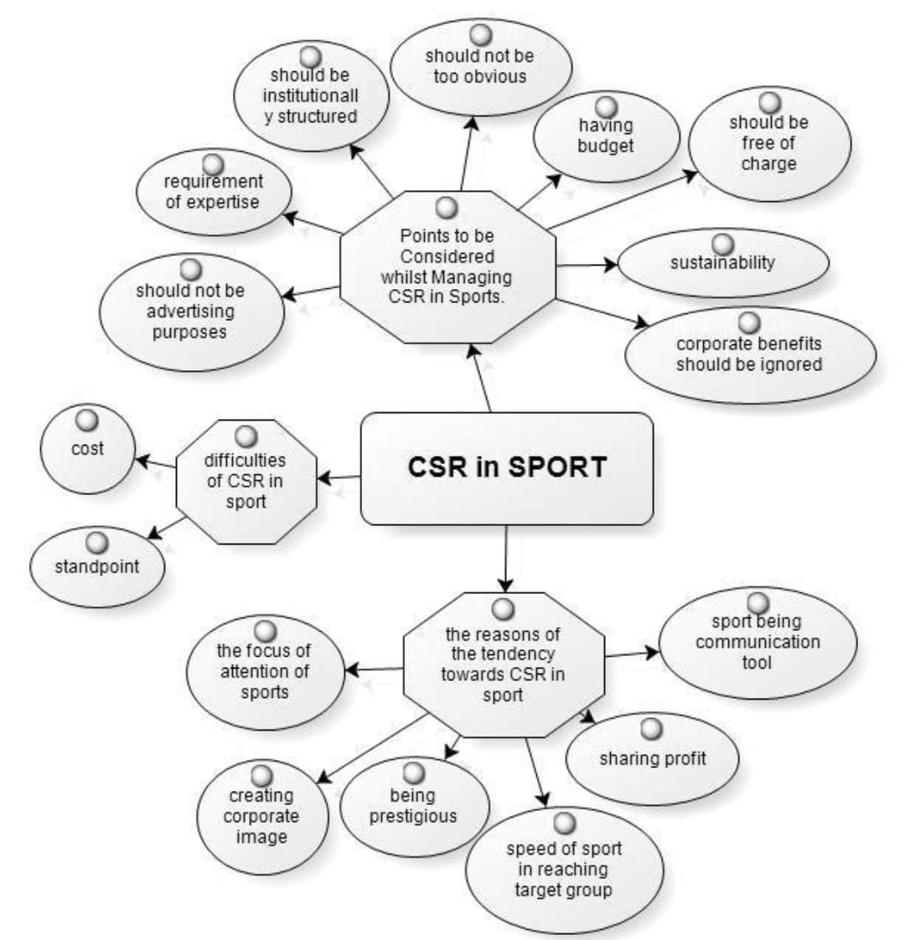

**Examples**

* **Eco-friendly stadiums:** The Mercedes-Benz Stadium in Atlanta, USA, is a prime example of an environmentally friendly sports venue. It features a retractable roof, rainwater harvesting system, and energy-efficient lighting, demonstrating how sports venues can minimize their environmental impact.
* **Inclusion Programs:** The International Paralympic Committee (IPC) promotes inclusion in sport by organizing events for athletes with disabilities. This initiative has increased awareness and support for adaptive sports while promoting social sustainability.
* **Wearable Technology:** Companies like Fitbit and Garmin have revolutionized sports and fitness by introducing wearable devices that track fitness and health metrics. This technology empowers people to take charge of their health, promoting both personal and societal well-being.

In addition, sports stimulate technical innovation and advancement, both of which are critical for long-term company growth. The need for improved performance and an improved viewing experience in sports has prompted the creation of cutting-edge technology, including innovative broadcasting methods, wearable fitness trackers, and environmentally friendly materials for sporting goods. Investing in sports-related technology may give businesses a competitive advantage and advance sustainable practices in the sector as a whole.

To inspire corporate values and support sustainability sports is one the potential to inspire in today’s era. For long term sustainability, it is important to promote these values, and businesses can foster a positive work environment and ethical business practices. Sporting events provide multiple opportunities for cultural diplomacy and global networking, enabling firms to increase their reach and collaborate on international projects. This global connectivity supports innovation, cultural understanding, and shared accountability for sustainable development goals, benefiting businesses and society globally.

**Companies Spending their CSR funds on Sports**

* **Jindal Sports Hostel:** The Jindal Steel & Power (JSP) Foundation is the organization behind the innovative Jindal Sports Hostel. Located in Soyabali, Keonjhar District, the hostel offers first-rate residential facilities to sixty specially chosen children with the goal of developing rural athletes. The facility is a part of an effort to uplift impoverished children by encouraging teamwork and discipline while fostering their academic and athletic potential. The goal is to mould them into future leaders and champions of India.
* **Tata Steel’s Commitment to sports:** Tata Steel has constructed academies for football, archery, athletics, hockey, and sport climbing, making it one of the leading corporate sponsors of Indian sports. Through its academies and grassroots feeder centres, the firm has continuously contributed to the development and upbringing of professional athletes.
* **Reliance Foundation’s Young Champs Programme:** The Reliance Foundation Young Champs initiative was created in 2015 with the goal of supplying elite football talent in the country aged 12 to 16 years old. It is a platform for growth and development. The players were discovered through the Indian Super League's (ISL) grassroots programs.
* **Hindustan Zinc’s Zinc Football Programme:** Hindustan Zinc has launched a large program aimed at promoting grassroots growth and excellence in football in Rajasthan.   
  The corporation has established ZF schools, which employ football as a social development tool and provide a platform for young children to express themselves via football. ZF has established 12 community football centres where 350+ boys and girls receive football training from certified coaches, with the belief that "every child should have the opportunity to play".

**Businesses Can Use Various Sustainability Kpis to Measure the Impact of Their Sports-Inspired Initiatives, Including:**

**1. Carbon Footprint Reduction:** Carbon footprint reduction is one of the measures to check total greenhouse gas emissions (CO2e) before and after implementing initiatives.

**2. Energy Consumption:** Track total energy usage (in kWh) and the percentage of energy sourced from renewable sources. Energy consumption is important to be tracked to understand the consumption level and to take measures accordingly.

**3. Sustainable Product Sales:** To promote sustainability, it is critical to track sales of sustainable products or services launched through new initiatives. Tracking these data allows businesses to measure market acceptability and discover effective initiatives. Promoting these sustainable alternatives effectively can increase consumer interest and acceptance. This, in turn, improves overall sustainability objectives and promotes a more environmentally friendly market.

4. **Engagement Metrics:** Its aim is to monitor and record the quantity of community events and programs that are sponsored or take part in, with a specific emphasis on sustainability themes and activities. This tracking will help to evaluate the engagement and impact in promoting sustainable practices within our community. The main goal is to enhance transparency and measure the effectiveness of our sustainability efforts.

5. **Public Awareness and Perception:** Conducting surveys and using the survey data to gauge public awareness of sustainability initiatives and their impact on brand perception. This data helps us understand our audience’s views and measure the effectiveness of our sustainability communication. Insights gained will guide improvements in sustainability strategies.

6. **Sponsorship Impact:** Evaluate the effectiveness of partnerships with sports organizations by measuring joint initiatives' reach and engagement. This evaluation helps to understand the impact of these partnerships on objectives and community involvement. Analyzing these metrics enables to refine the strategies and strengthen future collaborations.

7. **Investment in Sustainable Technologies:**  Keep tabs on the money spent on environmentally friendly products or services. In the green energy sector, wind, solar, and hydropower are promising technologies.

By establishing and monitoring these KPIs, businesses can effectively evaluate the impact of their sports-inspired sustainability initiatives and make informed decisions for future improvements.

**Conclusion**

The sports industry has the potential to become a powerful driver of sustainable business development. By integrating environmental, social, and economic sustainability into their operations, sports organizations can achieve long-term success and make a positive contribution to society. The most important steps along this path are the introduction of disruptive innovations and the involvement of stakeholders. As the industry continues to evolve, a commitment to sustainability will play a key role in shaping its future. It is important for businesses and sports to focus on environmental, social, and economic sustainability. The contribution of sports to sustainable business development is complex and spanning economic. By investing in sports and embracing the principles and opportunities they offer, businesses can promote sustainable growth, increase their corporate responsibility, and contribute to a more sustainable future for all. In terms of the social, economic, and environmental spheres, sports support sustainability. Sports groups achieve environmental sustainability by cutting back on energy and waste in their facilities. Through a range of outreach initiatives and activities, they foster community involvement and inclusion on a social level. From an economic point of view, sports create jobs, boost local economies, and invest in environmentally friendly practices and infrastructure. In general, sports that incorporate sustainability have a greater positive influence on the environment and society.

**References**

* <https://www.researchgate.net/publication/361030625_Sport_for_Development_Programs_Contributing_to_Sustainable_Development_Goal_5_A_Review>
* <https://www.taylorfrancis.com/chapters/oa-edit/10.4324/9781003314295-1/events-sustainability-making-events-sustainable-enough-judith-mair-andrew-smith>
* <https://www.icsspe.org/es/system/files/McCullough%20Pfahl%20%20Nguyen%20-%20The%20green%20waves%20of%20environmental%20sustainability%20in%20sport.pdf>
* <https://www.icsspe.org/es/system/files/McCullough%20Pfahl%20%20Nguyen%20-%20The%20green%20waves%20of%20environmental%20sustainability%20in%20sport.pdf>
* <https://doi.org/10.3390/su13169122>
* <https://thecsrjournal.in/top-csr-projects-for-sports-in-india/>