Gasification of Biomass for Sustainable Energy: Process, Technologies, and Applications
Mallamolla Pradeep ^{1*}, N.L. Panwar ¹, Sachin Channappa Hallad ¹
¹Department of Renewable Energy Engineering, College of Technology and Engineering,
MPUAT, Udaipur, Rajasthan
*Corresponding author: pradeepyadav1737@gmail.com
Abstract
Gasification is one of the thermo-chemical conversion technologies of biomass energy. It is the process of conversion of solid biomass into gaseous fuel (syngas). This chapter gives a brief information about the gasification process, reaction chemistry, different types of gasification technologies (fixed bed & fluidized bed) and producer gas. Various advantages and disadvantages of the different gasifiers and their applications were discussed in this chapter & concludes with the brief about producer gas and its application.
Keywords: Gasification, pyrolysis, producer gas, biomass, gasifier
1.Introduction
Concerns about climate change and global warming lead to efforts that promote more renewable energy sources and improve energy efficiency in order to lower CO₂ greenhouse gas emissions. In addition to solar and wind power, one of the primary sustainable energy sources is biomass. When wind and solar energy supplies are limited, biomass energy may be employed as an adjustable, controllable energy source that will be given in greater quantities. This is possible with the renewable energy combination that includes solar, wind, and biomass energy (Heidenreich, S., & Foscolo, P. U. 2015). Biomass energy is one among the developing renewable energy resources that has become most emerging fuel resource because of its wide availability and characteristics (Li, Y et al., 2020).
Biomass is referred as the biodegradable portion of biologically derived products, wastes, and residues from industries like forestry, fisheries, aquaculture, agriculture (including plant and animal materials), and the biodegradable portion of municipal and industrial wastes (Cortazar, M et al., 2023). The major conversion technologies used for biomass conversion are 1. Physical conversion, 2. Bio-chemical and 3. Thermo-chemical conversion (Adams, P. et al., 2023). Thermochemical conversion is a remarkable and the most important pathway for biofuel production, due to various benefits such as less reaction time, efficient nutrient recovery, small footprint and ability to handle several kinds of blends. Combustion, gasification, pyrolysis & torrefaction are the major thermo-chemical conversion technologies (Zhang, J., and Zhang, X. 2019). Among the thermochemical conversion processes, gasification has gained significant attention due to its superior combustion efficiency (Pandey, B. et al., 2019).
2.Gasification
Gasification is the conversion of solid raw material into fuel gas otherwise called as syngas, which can be upgraded to liquid fuels. The process of "biomass gasification" involves the conversion of carbonaceous biomass into combustible gases (such as H₂, CO, CO₂, and CH₄) at particular heating values in presence of limited supply of oxygen (Bhaskar, T. et al., 2011). Gasification is similar to combustion when air or oxygen is supplied, however it is known as a partial combustion process because combustion mainly focuses on heat generation whereas, the goal of gasification is to produce valuable gaseous products that may be stored for later use or utilised immediately for burning. Moreover, because gasification releases less harmful gases into the atmosphere and makes better use of the solid leftovers, it is seen to be a more environmentally friendly process (Rezaiyan, J., & Cheremisinoff, N. P. 2005).
Gasification is a form of pyrolysis carried out in the presence of a limited supply of air or oxygen at high temperatures in order to increase the gas production. The gas produced is referred as the producer gas. Producer gas mainly a combination of carbon monoxide, hydrogen and methane, together with carbon dioxide and nitrogen. Compared to the original solid biomass, the producer gas is more flexible as it can either be burnt to create steam and process heat or utilised in gas turbines to generate power (Demirbas, A. 2009). Comparatively with other thermochemical processes, gasification offers greater potential for direct commercial use. The major advantages of gasification over direct combustion are: improved energy application flexibility, improved cost-effectiveness, thermodynamic efficiency at smaller scales, and even reduced environmental impact when integrated with gas cleaning and refining technologies
3.Gasification process and reaction chemistry
The four major stages of the gasification process are Drying (endothermic stage), Pyrolysis (endothermic stage), Oxidation (exothermic stage) and Reduction (endothermic stage).
3.1Drying
The biomass feed used for the gasification is usually sun dried and having moisture content 10-15%. Sometimes partially dried biomass is also used having moisture content up to 25%. Drying is the process of removal of moisture content of biomass feedstock completely to bone-dry. The temperature of the drying stage ranges from 100 -180 ℃. There will be no thermal decomposition of biomass in this stage.
3.2Pyrolysis
In this stage the biomass is heated at a high temperature ranging between 250 - 700 ℃ in the absence of air. This stage consists of thermochemical decomposition of the carbonaceous structural components especially, breakdown of chemical bonds and formation of smaller molecular weight molecules (Molino, A. et al., 2016). The biomass is thermally decomposed and converted into solid, liquid and gaseous fuel. The pyrolysis stage can be defined with the following reaction (Atnaw, S. M. et al., 2017) (Thakkar, M. et al., 2018):
Biomass ↔ H2 + CO + CO₂ + CH₄ + H₂O (water vapour) + Tar+ Char (Endothermic)
3.3Oxidation
Desired air for the partial combustion of biomass will be introduced in this stage. The temperature of this stage varies between 700-1500 ℃. Various thermal reactions take place between the air and carbon produced in the pyrolysis zone. Most thermal reactions are exothermic in nature. Carbon reacts with the air to produce carbon dioxide and on the other hand heat reacts with hydrogen produces water vapour. The main reactions that take place during the oxidation stage are given below (Rubinsin, N. J. et al., 2023):
C + O₂ → CO₂ (Char combustion reaction)
C + 1/2O₂ → CO (Partial oxidation reaction)
H₂ + 1/2O₂ → H₂O (Hydrogen combustion reaction)
3.4Reduction
In this stage all the thermo-chemical reactions will takes place in the absence of air. The reduction stage involves all the products of the previous stages of pyrolysis and oxidation; the gas mixture and the char react with each other resulting in the formation of the final syngas. The reduction temperature is a significant aspect of the whole process, influencing the characteristics of the solid residue and syngas. The main reactions take place in this stage are given below (Thakkar, M. et al., 2018) (Molino, A. et al., 2016):
C + CO₂ ↔ 2CO (Boudouard reaction)
C + H₂O ↔ CO + H₂ (Reforming of char reaction)
CO + H₂O ↔ CO₂ + H₂ (Water gas shift reaction)
C + 2H₂ ↔ CH₄ (Methanation reaction)
4.Classification of various Gasification technologies
The gasification technology can be applied in a wide range of industrial applications, and numerous gasifier variants have been designed and tested. Many different configurations have been used in the construction and operation of gasifiers as shown in the figure.
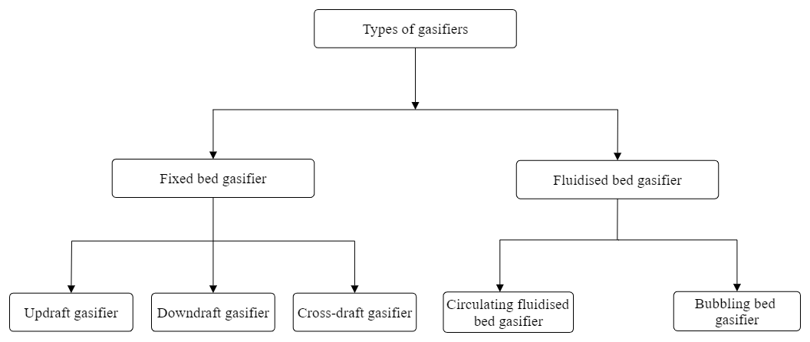

Fig.1: Classification of Gasifiers
4.1 Fixed bed gasifiers

The three main types of gasifiers for fixed beds are the cross-draft, downdraft, and updraft models. Based on the fuel and air flow directions within the gasifier, these designations were assigned. Fixed bed gasifiers can operate on a small scale of up to 10 MW. For this reason, the majority of fixed bed gasifiers are utilised in decentralised biomass power production systems (Loha, C. et al., 2018).
4.1.1 Updraft gasifier
The schematic view of the updraft gasifier is shown in figure 2. In the updraft gasifier the gasifying agent such as air or steam are introduced at the bottom section of the gasifier to interact with biomass which is fed from the top of the reactor. The generated fuel after gasification exists from the top side of the gasifier. Hence updraft gasifier is also known as the counter current type of gasifier (Loha, C. et al., 2018). These gasifiers have the highest thermal efficiency because of the low temperature of gases exiting the gasifier unit (Sansaniwal, S. K. et al., 2017). Apart from the high thermal efficiency these gasifiers have other advantages such as high methane content in producer gas, simple & low-cost process, low pressure drop and slight tendency to slag formation (Basu, P. 2018) (Loha, C. et al., 2018). However counter current type has some disadvantages such as low gas production, sensitivity to tar and moisture content of biomass, long startup time and poor reaction capability of the system (Mishra, S., & Upadhyay, R. K. 2021).

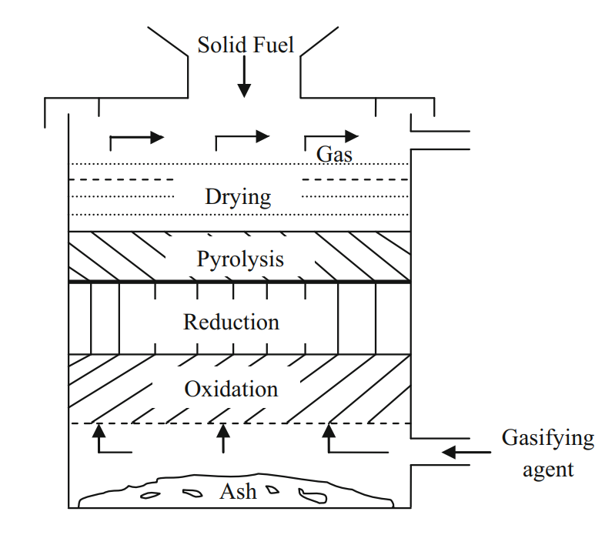
Fig 2: schematic view of updraft gasifier (Loha, C. et al., 2018)
4.1.2 Downdraft gasifier
The schematic view of the downdraft gasifier is shown in figure 3. In these gasifiers the gasifying agent air or steam interacts with the biomass feedstock in the downward direction and the generated producer gas also flow downwards in the co-current direction and exits from the bottom side of the reactor. Hence the downdraft gasifier is also known as a co-current type gasifier (Pang, S. 2016). The end products of the pyrolysis and drying zones are forced to pass through the oxidation zone of the reactor for thermal cracking which implies less tar yield in the final product. This gasifier is suitable for small scale decentralize power generation because of low tar and moisture content in the final product. However, downdraft gasifier has some drawbacks such as low thermal efficiency and high particulate matter (Thomson, R.et al., 2020).
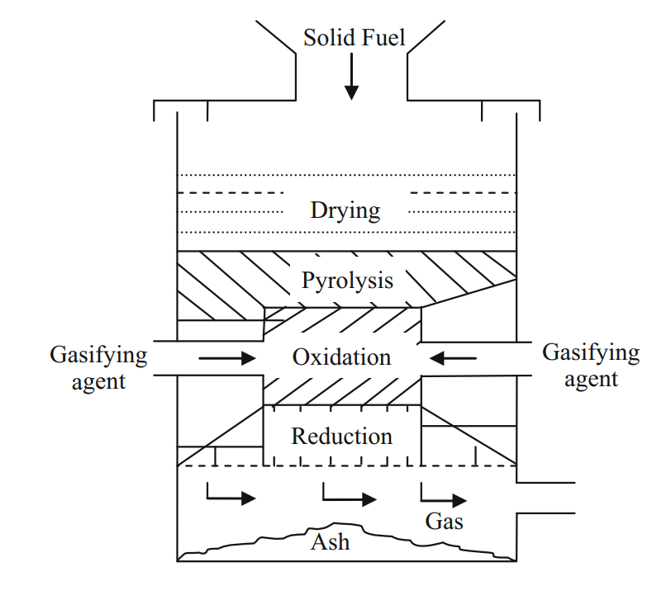
Fig 3: schematic view of downdraft gasifier (Loha, C. et al., 2018).
4.1.3 Cross-draft gasifier
The schematic view of the cross-draft gasifier is shown in figure 4. It is one of the simplest types of gasifier design in which the biomass feedstock enters the reactor from the top and air is provided from the side of the reactor (Loha, C. et al., 2018). It has various advantages when compared to the other fixed bed gasifiers but it is not the ideal type. Less start time, compatible with dry air blast, flexible syngas production and fast response to the biomass fed into the reactor are some of the major advantages of the cross-draft gasifier. However, it has some drawbacks such as inability to handle high tar and ash contents, suitable only for small scale industries (Mishra, S., & Upadhyay, R. K. 2021).
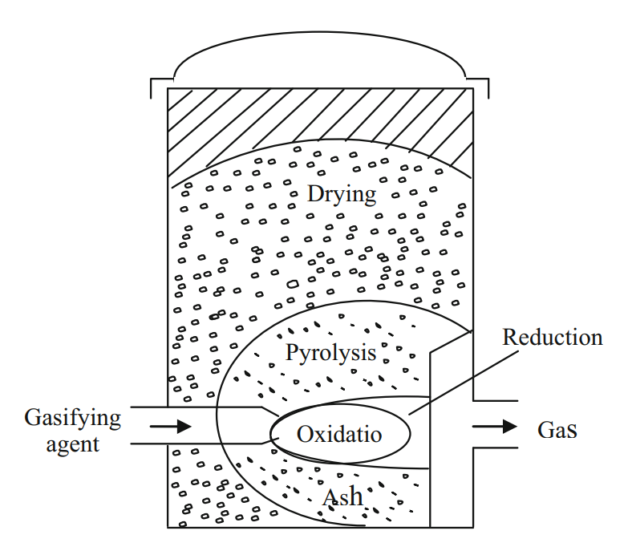
Fig 4: schematic view of cross-draft gasifier (Loha, C. et al., 2018).
4.2 Fluidized bed gasifier
The operation of both updraft and downdraft gasifiers in influenced by the morpho graphical, physical and chemical properties of the fuel. Lack of bunker flow, slagging and extreme pressure drop over the reactor are some common problems faced in these gasifiers. To overcome the above-mentioned problems fluidized bed gasifier is used. Unlike fixed bed gasifiers, drying, pyrolysis, oxidation, and reduction zones of fluidized bed gasifiers are not apparent at any particular location within the gasifier. In this type of gasifiers, the biomass feed stock is kept in suspended state by providing air velocity using a blower. This system requires the feedstock to be finely ground into small particles and fed into the reactor (Loha, C. et al., 2018). The bed is externally and after the sufficient temperature is acquired the biomass is introduced. The feedstock is introduced at the bottom of the gasifier, and heated up to the bed temperature very quickly. Hence the treatment of fuel is very Fastly pyrolyzed as a result the component mix with a large amount of gaseous material. The distinct advantages of these type gasifiers are less tar production, greater carbon conversion rate, uniform & adjustable temperature and flexibility in terms of use of different types of fuel, feed rate, particle size, and moisture content (Siedlecki, M. et al., 2011) (Loha, C. et al., 2018). Fluidized bed gasifiers are applicable for small to medium scale. Based on the gasification medium fluidised bed gasifiers are divided into two types discussed below.
4.2.1 Bubbling fluidized bed gasifier
The schematic view of the bubbling fluidized bed gasifier is shown in figure 5. It is the oldest fluidized bed gasifier (Wheeldon, J. M., & Thimsen, D. 2013). The beds are usually made up of inert materials such sand, dolomite, silica etc and high-pressure fluidizing medium such as air, oxygen or steam being used. These types of gasifiers operate at low velocity of medium less than 1m/s. A cyclone separator is used at the end to collect the solid particles transported along with the gases. These gasifiers can operate at very high temperatures resulting in higher thermal cracking of feedstock to improve the production of syngas. Carbon conversion efficiency of this type of gasifiers is less compared to Circulating fluidized bed gasifiers.
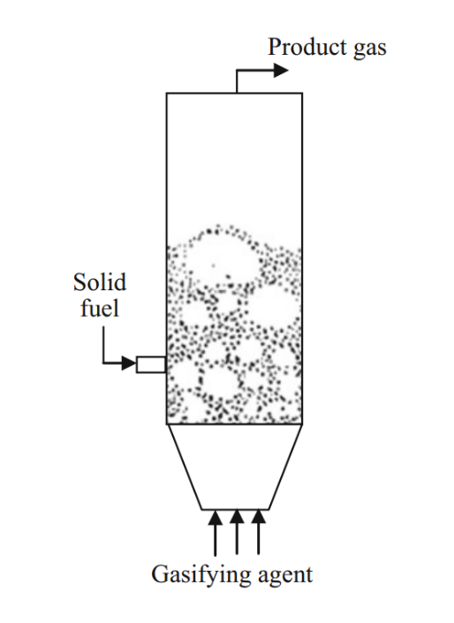
Fig 5: schematic view of Bubbling fluidized bed gasifier (Loha, C. et al., 2018).
4.2.3 Circulating fluidized bed gasifier
The schematic view of the Circulating fluidized bed gasifier is shown in figure 6. Circulating fluidized bed is advanced and emerging technology as compared to fixed bed type of gasifiers. In this gasifier, the solid fuel flow outside the reactor and are recycled back into the reactor as a result the carbon conversion efficiency is increased. The fluidizing medium in this gasifier is high ranging from 3 m/s to 10 m/s (Sansaniwal, S. K. et al., 2017). The gas generated using circulating fluidized bed gasifier have low tar, ash and moderate gas temperature, finally reduced gas cooling load and improved overall conversion efficiency Circulating bed gasifier are mainly used in paper industry, cement kiln, boiler and power generation etc.

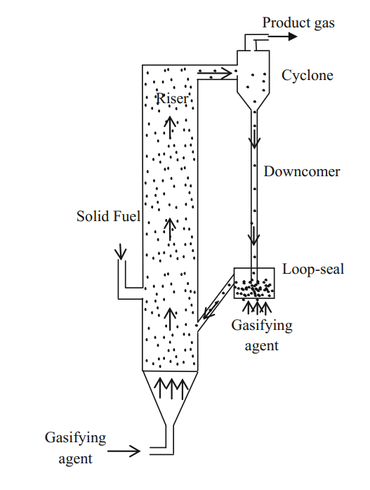
Fig 6: schematic view of circulating fluidized bed gasifier (Loha, C. et al., 2018).
5. Producer gas and its application
The main end product of the gasification process is producer gas. Producer gas is the mixture of combustible and non-combustible gases. The nitrogen in the air remains same and dilutes the gas, so producer gas has a lower heating value 5800 KJ/m3. After the ash and sulphur compounds are removed, it is used near its source. Producer gas is generally used to power gas turbines which are suited to low calorific value (Grammelis, P. et al., 2016). The quality and quantity of the producer gas highly depends on various parameters such as type of feed stock, gasification temperature, pressure, bed material, residence time and equivalence ratio. The various constituents of the producer gas are given in the table below.
Nitrogen (N₂) | 45-60%
Carbon-monoxide (CO) | 15-30%
Hydrogen (H₂) | 10-20%
Carbon-dioxide (CO₂) | 5-15%
Water vapour (H₂O) | 6-8%
Methane (CH₄) | 2-4%
Calorific value | 4.5-6 MJ/m³
Table 1: Constituents of producer gas
Producer gas was used primarily as an industrial fuel for iron and steel manufacturing, such as firing coke ovens and blast furnaces, electricity generation, cement and ceramic kilns, or for mechanical power through gas engines.
6. Conclusion
In the above chapter, gasification process and various gasification technologies were discussed. Gasification is the process of conversion of solid biomass into gaseous fuels. The gasification process is completed in different reaction zones such as drying, pyrolysis, oxidation and reduction. It is observed that the construction of fixed bed gasifiers is simple and they are easy to operate. Fixed bed gasifiers consist of separate zones for different reaction zones. Updraft gasifier is generally used for thermal application whereas downdraft gasifier is used for both thermal application & power generation due to less tar production. To overcome the problems faced in fixed bed gasifiers such as lack of bunker flow, slagging and extreme pressure drop over the reactor fluidized bed gasifiers are used. However fluidized gasifier has its own advantages and drawbacks. Bubbling fluidized bed gasifier is simple in construction but its carbon conversion efficiency is low whereas, the solid biomass is re-introduced into the reactor in circulating fluidized bed gasifier to increase the carbon conversion efficiency. Fluidized bed gasifiers used for large scale industrial purposes. There are no common criteria for selecting gasifiers. The main factors that go into identifying a gasifier are the type and availability of biomass, the downstream use of produced gas, and the required application level. Other elements, such as social acceptance, capital investment, and environmental restrictions, could also be very important.

References
Heidenreich, S., & Foscolo, P. U. (2015). New concepts in biomass gasification. Progress in energy and combustion science, 46, 72-95.
Li, Y., Ahmed, A., Watson, I., & You, S. (2020). Waste-to-biofuel and carbon footprints. In Waste Biorefinery (pp. 579-597). Elsevier.
Cortazar, M., Santamaria, L., Lopez, G., Alvarez, J., Zhang, L., Wang, R., ... & Olazar, M. (2023). A comprehensive review of primary strategies for tar removal in biomass gasification. Energy Conversion and management, 276, 116496.
Adams, P., Bridgwater, T., Lea-Langton, A., Ross, A., & Watson, I. (2018). Biomass conversion technologies. In Greenhouse gas balances of bioenergy systems (pp. 107-139). Academic Press.
Zhang, J., & Zhang, X. (2019). The thermochemical conversion of biomass into biofuels. In Biomass, biopolymer-based materials, and bioenergy (pp. 327-368). Woodhead Publishing.
Pandey, B., Prajapati, Y. K., & Sheth, P. N. (2019). Recent progress in thermochemical techniques to produce hydrogen gas from biomass: A state of the art review. International Journal of Hydrogen Energy, 44(47), 25384-25415.
Bhaskar, T., Bhavya, B., Singh, R., Naik, D. V., Kumar, A., & Goyal, H. B. (2011). Thermochemical conversion of biomass to biofuels. In Biofuels (pp. 51-77). Academic Press.
Rezaiyan, J., & Cheremisinoff, N. P. (2005). Gasification technologies: a primer for engineers and scientists. CRC press.
Demirbas, A. (2009). Thermochemical conversion processes. Biofuels: Securing the Planet’s Future Energy Needs, 261-304.
Molino, A., Chianese, S., & Musmarra, D. (2016). Biomass gasification technology: The state of the art overview. Journal of Energy Chemistry, 25(1), 10-25.
Atnaw, S. M., Sulaiman, S. A., & Yusup, S. (2017). Biomass gasification. Waste Biomass Management–A Holistic Approach, 159-185.
Thakkar, M., Mohanty, P., Shah, M., & Singh, V. (2018). An Overview of Biomass Gasification. Recent Advancements in Biofuels and Bioenergy Utilization, 147-176.
Rubinsin, N. J., Karim, N. A., Timmiati, S. N., Lim, K. L., Isahak, W. N. R. W., & Pudukudy, M. (2023). An overview of the enhanced biomass gasification for hydrogen production. International Journal of Hydrogen Energy.
Loha, C., Karmakar, M. K., De, S., & Chatterjee, P. K. (2018). Gasifiers: types, operational principles, and commercial forms. Coal and Biomass Gasification: Recent Advances and Future Challenges, 63-91.
Sansaniwal, S. K., Pal, K., Rosen, M. A., & Tyagi, S. K. (2017). Recent advances in the development of biomass gasification technology: A comprehensive review. Renewable and sustainable energy reviews, 72, 363-384.
Basu, P. (2018). Biomass gasification, pyrolysis and torrefaction: practical design and theory. Academic press.
Mishra, S., & Upadhyay, R. K. (2021). Review on biomass gasification: Gasifiers, gasifying mediums, and operational parameters. Materials Science for Energy Technologies, 4, 329-340.
Pang, S. (2016). Fuel flexible gas production: Biomass, coal and bio-solid wastes. In Fuel flexible energy generation (pp. 241-269). Woodhead Publishing.
Thomson, R., Kwong, P., Ahmad, E., & Nigam, K. D. P. (2020). Clean syngas from small commercial biomass gasifiers; a review of gasifier development, recent advances and performance evaluation. international journal of hydrogen energy, 45(41), 21087-21111.
Siedlecki, M., De Jong, W., & Verkooijen, A. H. (2011). Fluidized bed gasification as a mature and reliable technology for the production of bio-syngas and applied in the production of liquid transportation fuels—a review. Energies, 4(3), 389-434.
Wheeldon, J. M., & Thimsen, D. (2013). Economic evaluation of circulating fluidized bed combustion (CFBC) power generation plants. In Fluidized Bed Technologies for Near-Zero Emission Combustion and Gasification (pp. 620-638). Woodhead Publishing.
Grammelis, P., Margaritis, N., & Karampinis, E. (2016). Solid fuel types for energy generation: Coal and fossil carbon-derivative solid fuels. In Fuel flexible energy generation (pp. 29-58). Woodhead Publishing.

