Numerical computation of heat and mass transfer in micropolar Casson fluid flow over non-linearly porous stretching sheet with heat generation
Pravendra Kumar^{1,*}, Bhupander Singh², Seema Goyal³, Kapil Kumar⁴, Rahul kumar⁵
1-Research Scholar, Department of Mathematics, Meerut College, Meerut email: pkumar0106@gmail.com
2-Professor, Department of Mathematics, Meerut College, Meerut email: bhupandersingh1969@yahoo.com
3-Professor, Department of Mathematics, Meerut College, Meerut email: seemagoyal19@gmail.com
4-Research Scholar, Department of Mathematics, Meerut College, Meerut email: kapiltomadia071993@gmail.com
5-Research Scholar, Department of Mathematics, Meerut College, Meerut email: rahulkumargkp95@gmail.com
Abstract
In the present study we investigation the numerical solution of heat and mass transfer in micropolar Casson fluid flow over non-linearly stretching sheet with heat generation effect in porous medium.The controlling partial differential equations are transformed into nonlinear ordinary differential equations by applying the proper similarity transformations. The aforementioned transformed nonlinear ordinary differential equations are numerically solved with the application of MATLAB software. Concentration, fluid velocity, micro-rotation, and temperature are provided graphically along with an analysis and discussion of the effects of various relevant factors such as the Casson fluid parameter, porosity parameter, micro-inertia density parameter, heat generation parameter, buoyancy parameter, diffusion parameter, spin gradient viscosity parameter, Schmidt number, etc. on the velocity, micro-rotation, concentration, and temperature profiles. The generated data's graphical representations are explained in depth.
Keywords Micropolar fluid; Heat and mass; Heat generation; Casson fluid; Porous medium; non-linearly stretching sheet;
Introduction
Magneto hydrodynamics, or MHD, investigates the behavior of fluids within electrically conducting environments. Alfven laid the groundwork for this field, which later saw researchers delving into its mathematical underpinnings and applying these models to various mechanical scenarios [1]. MHD's relevance extends to metallurgical and metalworking processes, where understanding the flow of electrically conducting fluids is crucial. It is especially valuable in situations where heat transfer is a critical factor. Moreover, micropolar fluid theory, introduced by Erigen, has captivated researchers for decades. Nazar explored micropolar fluid flow at stagnation points on stretching surfaces, while Chiam investigated the flow of micropolar fluids induced by stretchy surfaces. These fluids, characterized by non-Newtonian behavior, consist of colloidal elements such as large dumbbell molecules suspended in smaller fluid bodies. They are valuable for characterizing the flow behavior of suspension solutions, specialized lubricants, plyometric fluids, paints, animal blood, and liquid crystals, demonstrating their versatility across diverse fields.
Eringen [2] pioneered the thought of microstructure fluids, which integrate microscale elements connecting the overall velocity vector field with particle rotation. These fluids comprise solid particles dispersed within a fluid medium and elucidate the behaviour of colloidal fluids, liquid crystals, and biological systems. Effective cooling systems are crucial for product manufacturing due to the importance of cooling speed. Thermal radiation, a well-understood phenomenon, simplifies handling extreme heat in various industrial activities like nuclear reactors and spacecraft. Radiant heat energy from a heated surface is proportional to the fourth power of its absolute temperature, influencing the thermal change inenergy equation. The fluid characterization of non-Newtonian fluids, which is not described by Navier-Stokes equations, has prompted the exploration of different non-Newtonian model types. Some fluids are discussed by Hayat and Mustafa [3], Hayat and Obaidat [4], Nadeem and Fang [5], Turkyilmazoglu and Pop [6], and Qasim [7]). Non-Newtonian liquids, such as Jeffrey fluid, exhibit unique properties like linear viscoelastic behavior, finding applications in industries like polymer production. Jeffrey fluid, including its forms like diluted polymer solution, is often utilized in fluid models due to its simplicity and representation of retardation and relaxation times. Numerous studies, including those by Sharma et al. [8], Nallapu and Radhakrishnamacharya [8], and Vandna et al. [9], have explored the effects of magnetic fields, flow in porous media, and heat transfer in MHD micropolar Jeffrey fluid flow. Other investigations by researchers such as Ellahi et al. [11], Khan et al. [12], and Vaidya et al. [13] have delved into different aspects of the Jeffrey model, including radiative flow and thermal radiation effects [14]. Studies like those by Vandna et al. [15] and Dhermendar et al. [16] have examined MHD fluid flow over various geometries and mediums, analysing parameters like curvature and porosity on temperature gradients. Mahabaleshwar et al. [17] have numerically investigated magnetohydrodynamics fluid flow and heat transfer over elastic or non-elastic sheets in the presence of heat sources/sinks and thermal effects.
The influence of carbon nanotubes (CNTs) on radiation effects has been investigated, revealing that the magnetic field profile ofthe upper branch solutionsexhibits greater analytical stability compared to the lower branch solutions. Researchers, such as Panday et al. [18], have explored the relationship betweenConvection combined with thermal radiation in the flow of a Newtonian fluid is a nonlinear stretching sheet, demonstrating that an increase in the linear convection parameter leads to higher stream velocity near the surface and lower velocitydifferent from it. Megahed and colleagues [19] explored the investigation of magnetohydrodynamics flow close to an unstable elastic sheet under conditions of changing fluid properties, thermal emission, and heat flow. In a separate study, Krishna [20] investigated the MHD unsteady free convective rotating flow of Jeffrey fluid with a gradually increasing wall temperature, examining ion slip and Hall effects. Khader et al. [21] presented numerical solutions for MHD unsteady micropolar fluid flow induced by either an elastic or non-elastic surface, while considering the effects of thermal radiation and heat source. Numerous research investigations utilize Magnetohydrodynamics (MHD) flow coupled with heat and mass transfer due to the predominant influence of the magnetic field[22],[23],[24],[25].Magnetohydrodynamics (MHD), the study of electrically conducting fluid motion under magnetic field influence, holds significant importance across a range of applications including MHD generators, nuclear reactors, and biometric pumps. Adegbie et al. [26] and Malik et al. [27] examined the varied characteristics of MHD non-Newtonian fluid flow over a stretching surface, highlighting the impact of changing thermal conductivity on fluid temperature. The analysis and numerical exploration of electrically conductive fluids are of great importance in both engineering and scientific fields, with applications ranging from MHD generators and nuclear reactors to technological innovations such as intelligent system of lubrication and equipment segregation. Within the domain of biological fluids, many scholars [28], [29], [30] have been conducted magnetohydrodynamics studies. Additionally, the investigation of convective heat transfer within porous media saturated with fluid has garnered significant attention due to its broad industrial applications, including geothermal energy recovery, food processing, and various chemical industry processes. Ahmed and colleagues [31] investigated the influence of radiation on convective heat transport in the MHD boundary layer of a porous medium in small pressure gradient. Similarly, Butt et al. [32] examined the consequence of heat production of the flow of magnetohydrodynamics Jeffrey fluids through porous media.
Mathematical formulation
We consider a two dimensional boundary layer flow of incompressible micropolar Casson fluid towards a non-linear porous stretching surface at y=o. According to the plane x-axis taken along the surface and the y-axis perpendicular to it, fluid flow is confined in the positive y region towards a surface which is shown in fig. 1. Furthermore In is accepted that power-low surface velocity distribution $u_{w}=ax^{n}$ for the positive value of a. physically $n>1$ indicates non-linear stretching case. Temperature at the plate is regulated by heated fluid of temperature $T_{f}$ below the surface of the wall and heat transfer coefficient is${ h}_{f}$. The concentration of species at the surface kept constant$C_{w}$. The concentration and temperature beyond the boundary layer are${ C}_{∞}$ and${ T}_{∞}$ respectively.
The rheological equation of state for an isotropic and incompressible flow of a Casson fluid is given by:
$τ_{ij}=\left\{\begin{aligned}2\left(μ_{B}+{P_{y}}/{\sqrt{2π}}\right)e_{ij}, π>π_{c}, \\ 2\left(μ_{B}+{P_{y}}/{\sqrt{2π_{c}}}\right)e_{ij}, π>π_{c},\end{aligned}\right.$
Where $μ_{B}$ plastic dynamic viscosity, $π=e_{ij}e_{ij}$ and $e_{ij}$ is the $({i,j)}^{th}$component of deformation rate,$π$ denotes deformation rate, $π_{c}$is a critical value of non Newtoniam model, $P_{y}$is the yield stress of fluid. Under these assumptions, the governing equations are
$\frac{∂u}{∂x}+\frac{∂v}{∂y}=0$ (1)
$u\frac{∂u}{∂x}+v\frac{∂u}{∂y}=ν\left(1+\frac{1}{β}\right)\frac{∂^{2}u}{∂y^{2}}+\frac{κ}{ρ}\left(\frac{∂N}{∂y}\right)+gβ_{T}\left(T-T_{∞}\right)+gβ_{C}\left(C-C_{∞}\right)+\frac{μ}{ρk^{*}}u$ (2)
$u\frac{∂N}{∂x}+v\frac{∂N}{∂y}=\frac{γ}{ρ}\left(\frac{∂^{2}N}{∂y^{2}}\right)-\frac{κ}{ρ}\left(2N+\frac{∂u}{∂y}\right)$ (3)
$u\frac{∂T}{∂x}+v\frac{∂T}{∂y}=∝\left(\frac{∂^{2}T}{∂y^{2}}\right)+\frac{Q}{ρC_{P}}\left(T-T_{∞}\right)$ (4)
$u\frac{∂C}{∂x}+v\frac{∂C}{∂y}=D_{B}\left(\frac{∂^{2}C}{∂y^{2}}\right)+\frac{D_{T}}{D_{w}}\left(\frac{∂^{2}T}{∂y^{2}}\right)-k_{2}\left(C-C_{∞}\right)$ (5)
Where u and v are the velocity components in the x-and y-direction,$β$ is the Casson fluid parameter,$ρ$ is the density of the fluid, $ν$ are the kinematic viscosity,$β_{C}$,$β_{T}$ and $k_{2}$ are the coefficient of mass expansion, the coefficient of thermal expansion and the reaction rate of the solute, respectively, g is acceleration due to gravity and D is the diffusion coefficient.
Boundary conditions
$\left.\begin{aligned}u=u_{w}=ax^{n}, v=0, N=-m_{0}\frac{∂u}{∂y} , -k_{2}\frac{∂T}{∂y}=h_{f}\left(T_{f}-T\right), C=C_{w} , as y→0 \\ u→0, N→0, T→T_{∞}, C→C_{∞}, as y→∞\end{aligned}\right\}$ (6)
Now consider the non-dimensional variables given below.
$$η=\sqrt{\frac{a\left(n+1\right)}{2υ}}x^{\frac{n-1}{2}}y , N=ax^{n}\sqrt{\frac{a\left(n+1\right)}{2υ}}x^{\frac{n-1}{2}}G\left(η\right) , ϕ\left(η\right)=\frac{C-C_{∞}}{C_{w}-C_{∞}} ,θ\left(η\right)=\frac{T-T_{∞}}{T_{w}-T_{∞}} ,$$
$$u=ax^{n}F^{'}\left(η\right) , v=-υ\sqrt{\frac{a\left(n+1\right)}{2υ}}x^{\frac{n-1}{2}} \left[F\left(η\right)+\frac{n-1}{n+1}ηF^{'}\left(η\right)\right]$$
Substitute similarity variable into equation (1), (2), (3), (4) and (5), the transformed equation are
$\left(1+\frac{1}{β}\right)F^{'''}\left(η\right)+F\left(η\right)F^{''}\left(η\right)-\frac{2}{n+1}\left[n{F^{'}\left(η\right)}^{2}-λ^{*}θ\left(η\right)-λϕ\left(η\right)+KpF^{'}\left(η\right)\right]+KG^{'}\left(η\right)=0$ (7)
$λ_{0}G^{''}\left(η\right)+F\left(η\right)G^{'}\left(η\right)-\left(\frac{3n-1}{n+1}\right)G\left(η\right)F^{'}\left(η\right)-\frac{2}{\left(n+1\right)}.KB\left[2G\left(η\right)+F^{''}\left(η\right)\right]=0$ (8)
$θ^{''}\left(η\right)+Prθ^{'}\left(η\right)F\left(η\right)+\left(\frac{2}{n+1}\right)Pr ε θ\left(η\right)=0$ (9)
$ϕ^{''}\left(η\right)+Sc.F\left(η\right)ϕ^{'}\left(η\right)+ScSrθ^{''}\left(η\right)-\frac{2}{n+1}Sc.Kr.ϕ\left(η\right)=0$ (10)
Boundary condition after using similarity variable
$\left.\begin{aligned}F\left(η\right)=0,F^{'}\left(η\right)=1,G\left(η\right)=-m_{0}F^{''}\left(η\right),ϕ\left(η\right)=-γ\left(1-θ\left(η\right)\right) at y=0 \\ F^{'}\left(η\right)→0,G\left(η\right)→0,ϕ\left(η\right)→0,θ\left(η\right)→0 at y→∞\end{aligned}\right\}$ (11)
$$λ^{*}=\frac{G_{r}}{R_{e}^{2}} , λ=\frac{G_{c}}{R_{e}^{2}} , Kp=\frac{ν}{ak^{*}x^{n-1} } , K=\frac{κ}{ρυ} , λ_{0}=\frac{γ}{ρjυ} , B=\frac{v}{jax^{n-1}} , Pr=\frac{υ}{∝} , ε= \frac{Q}{ax^{n-1}ρC_{P}} , Kr=\frac{k_{2}}{ax^{n-1}} , Sc=\frac{υ}{D_{B}} , Sr=\frac{D_{T}}{{υD}_{w}}\left(\frac{T_{w}-T_{∞}}{C_{w}-C_{∞}}\right) , γ=\frac{{-h}_{f}}{k_{2}}\sqrt{\frac{2ν}{a(1+n)}}x^{-\left(\frac{n-1}{2}\right)}$$
Where the primes denotes differentiation with respect to$η, λ^{*}=\frac{G_{r}}{R_{e}^{2}} buoyancy parameter , λ=\frac{G_{c}}{R_{e}^{2}} diffusion parameter , Kp=\frac{ν}{ak^{*}x^{n-1}} porosity parameter, K=\frac{κ}{ρυ}$ micropolar parameter $λ_{0}=\frac{γ}{ρjυ}$spin gradient viscosity parameter,$B=\frac{v}{jax^{n-1}} micro inertia density parameter$ $Pr=\frac{υ}{∝}$ Prandtl number, $ε= \frac{Q}{ax^{n-1}ρC_{P}}$ heat generation/absorption parameter, $Kr=\frac{k_{2}}{ax^{n-1}}$ chemical reaction parameter, $Sc=\frac{υ}{D_{B}}$ Schmidt number, $Sr=\frac{D_{T}}{{υD}_{w}}\left(\frac{T_{w}-T_{∞}}{C_{w}-C_{∞}}\right)$ Soret number and $γ=\frac{{-h}_{f}}{k_{2}}\sqrt{\frac{2ν}{a\left(1+n\right)}}x^{-\left(\frac{n-1}{2}\right)}$ Biot number.
The physical quantities of interest are skin friction coefficients$C_{f}$ , local Nusselt number $Nu_{x}$ and Sherwood number $Sh_{x}$ which are defined as
$C_{f}=\frac{τ_{w}}{ρu_{w}^{2}} , Nu_{x}=\frac{xq_{w}}{k\left(T_{w}-T_{∞}\right)},$ ${ Sh}_{x}=\frac{xq_{m}}{D_{B}(C_{w}-C_{∞})}$ (12)
Where the wall friction$τ_{w}$, heat and mass transfer at wall $q_{w}$ and $q_{m}$ are expressed as
$τ_{w}={\left[κN+\left(μ+{P_{y}}/{\sqrt{2π}}+κ\right)\frac{∂u}{∂y}+\right]}_{y=0}$, $q_{w}=-k{\left(\frac{∂u}{∂y}\right)}_{y=0}$ and $q_{m}=-D_{B}{\left(\frac{∂C}{∂y}\right)}_{y=0}$ (13)
Skin friction coefficients
${ C}_{f}\sqrt{{ Re}_{x}}=\sqrt{\frac{n+1}{2}}\left(1+\frac{1}{β}+K(1-n)\right)F^{''}\left(0\right)$ (14)
Local Nusselt number
${{ { Nu}_{x}Re}_{x}}^{-1/2}=-\sqrt{\frac{n+1}{2}}θ^{'}(0)$ (15)
And Sherwood number
${{ { Sh}_{x}Re}_{x}}^{-1/2}=-ϕ^{'}(0)$ (16)
Where ${ Re}_{x}=\frac{U_{w}x}{v}$ is the local Reynolds number?
Solution Algorithm
In order to address the boundary value problems (7)-(10) which are accompanied in (11), we employed the bvp4c function, a pre-existing solver, within the MATLAB software package. The basis of the algorithm is established on a methodology equation (7)-(10) in conjunction with the boundary condition (11) via a process of diminution, resulting in a system of first order nonlinear differential equation as presented below.
$F=y_{1},F^{'}=y_{2},F^{''}=y_{3}, G=y_{4}, G^{'}=y_{5}, θ=y_{6}, θ^{'}=y_{7}, ϕ=y_{8}, ϕ^{'}=y_{9}$ (17)
By means of similarity transformation, equation (7), (8), (9) and (10) can be reduced to first- order ordinary differential equations.
$y_{1}^{'}=F^{'}=y_{2}$ (18)
$y_{2}^{'}=F^{''}=y_{3}$ (19)
$y_{3}^{'}=\frac{1}{\left(1+\frac{1}{β}\right)}\left[\frac{2}{n+1}\left(ny_{2}^{2}-λ^{*}y_{6}-λy_{8}+Kpy_{2}\right)-Ky_{5}-y_{1}y_{3}\right]$ (20)
$y_{4}^{'}=G^{'}=y_{5}$ (21)
$y_{5}^{'}=\frac{1}{λ_{0}}\left\lfloor \left(\frac{3n-1}{n+1}\right)y_{2}y_{4}+\frac{2}{\left(n+1\right)}KB\left(2y_{4}+y_{3}\right)-y_{1}y_{5}\right\rfloor$ (22)
$y_{6}^{'}=θ^{'}=y_{7}$ (23)
$y_{7}^{'}=-\left[Pry_{1}y_{7}+\frac{2}{\left(n+1\right)}Pr∈y_{6}\right]$ (24)
$y_{8}^{'}=ϕ^{'}=y_{9}$ (25)
$y_{9}^{'}=\frac{2}{\left(n+1\right)}Sc.Kr.y_{8}+Sc.Sr\left[Pry_{1}y_{7}+\frac{2}{\left(n+1\right)}Pr∈y_{6}\right]-Sc.y_{1}y_{9}$ (26)
Result and discussion
The equation (7), (8), (9) and (10), following their transformation were subjected to numerical, solutions through the bvp4c routine in MATLAB, along with due consideration of the boundary conditions (11). The result thus obtained were subsequently analyzed and presented in the form of graphs, which demonstrate the behavior of non-dimensional parameters such as $λ^{*}, λ , Kp, K, λ_{0}$,$B,Pr$, $ε$, $Kr$, $Sc$ and $Sr$, in relation to the simulated fluid velocity, along with temperature , concentration and micro rotation profiles. These graphs are vividly depicted in figure 1-19.
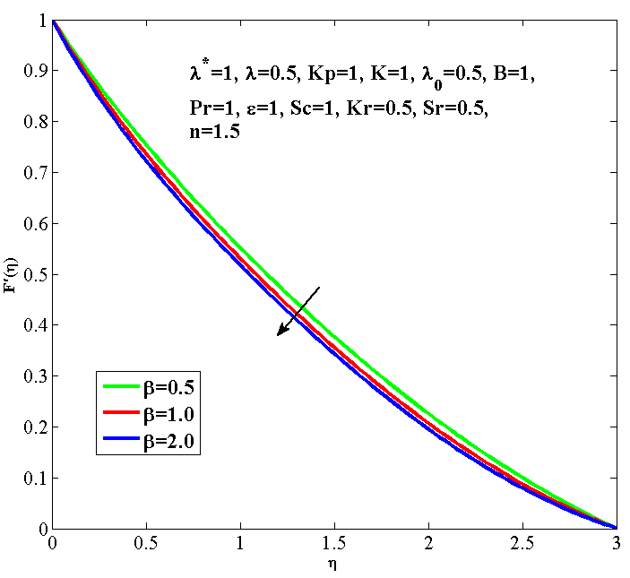
Fig.1 Casson fluid parameter with velocity profile
Figure1. Show that effect of Casson fluid parameter on fluid velocity. We can see that increase in Casson fluid parameter, the velocity profile decreases.

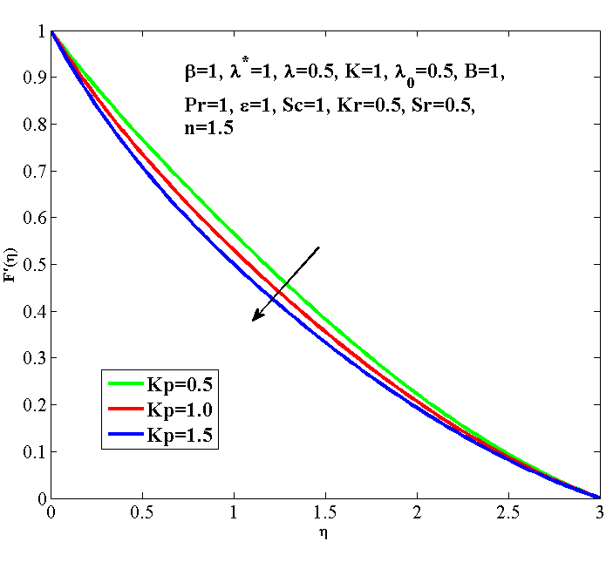
Fig.2 porosity parameter with velocity profile
Figure 2 is drafted to the variation in porosity parameter with respect to velocity profile. For raising the values of porosity parameter when found that velocity profile increased.
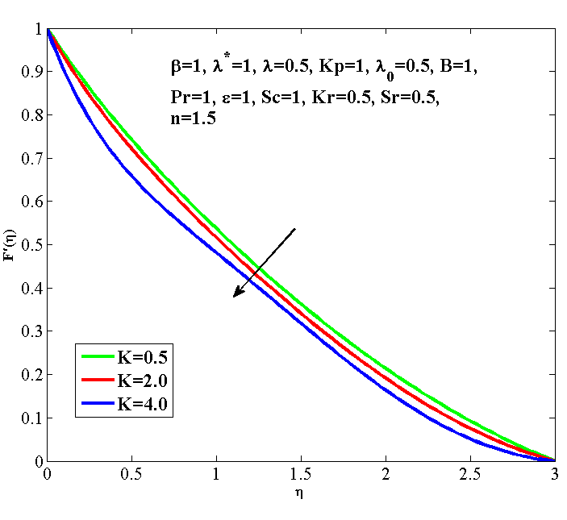
Fig.3 $K on f^{'}$
Figure 3 represent the effect of Micropolar parameter in velocity profile. It is seen from this graph that fluid velocity decrease for raising values of Micropolar parameter.
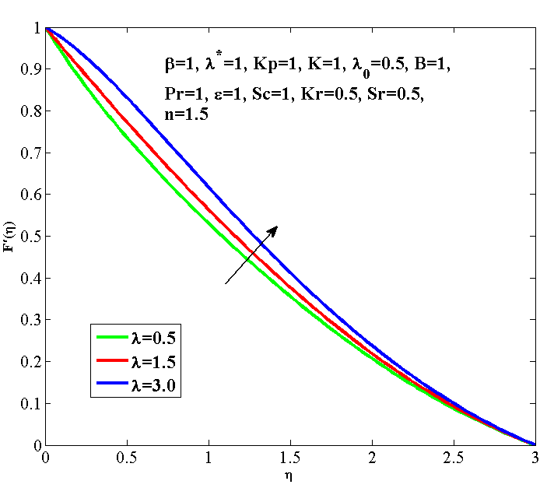
Fig.4 $λ on f^{'}$
Figure 4 is designed to show how the diffusion parameter affects the velocity. It can be identified that velocity profile is rising for enhances the value diffusion parameter.
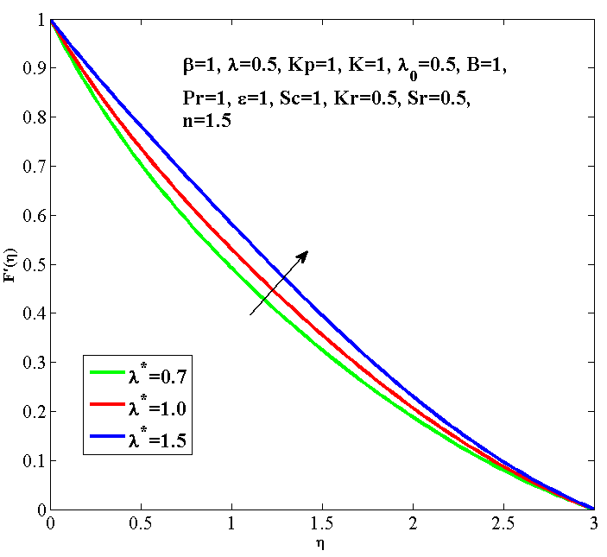
Fig.5 $λ^{*} on f^{'}$
Figure 5 describes the behavior of buoyancy parameter on velocity profile. It is seen that, velocity increases near to the surface with increase in buoyancy parameter.
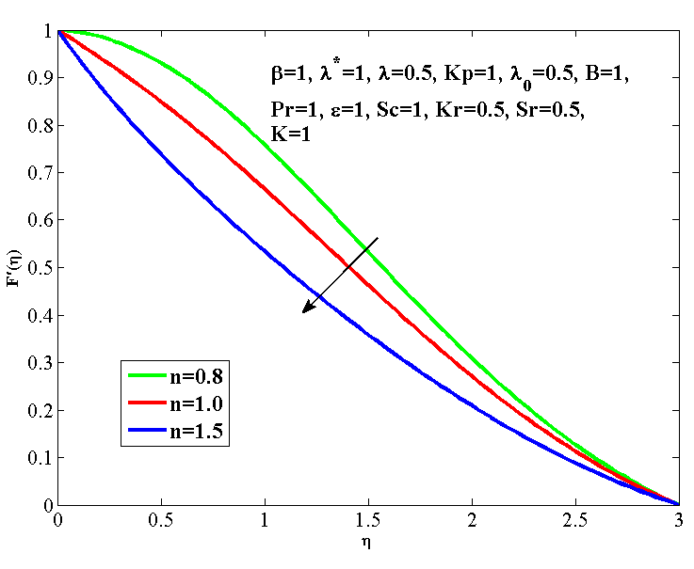
Fig.6 $n on f^{'}$
Figure 6 shows effect of power index on velocity. Due to the raising the value of power index parameter, velocity of the fluid is decrease.
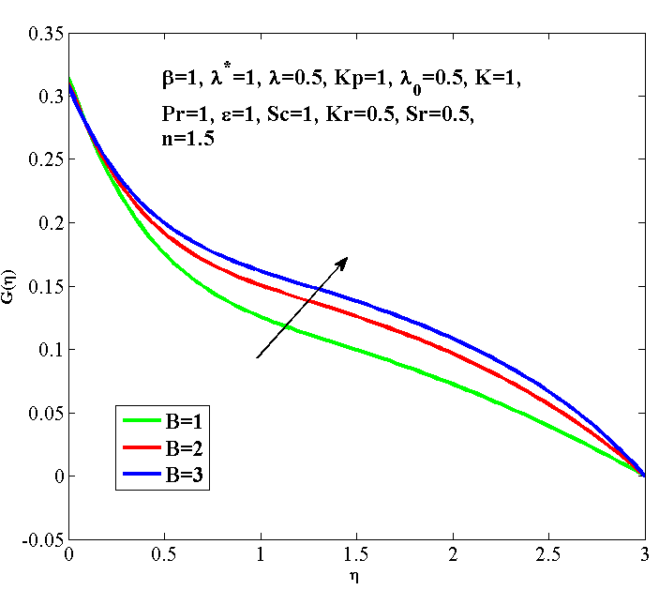
Fig.7 $B on micro rotation parameter$
Figure 7 shows effect of micro inertia density parameter B on micro-rotation profile. For higher values of micro inertia density parameter, it is seen that increases the value of micro-rotation profile.
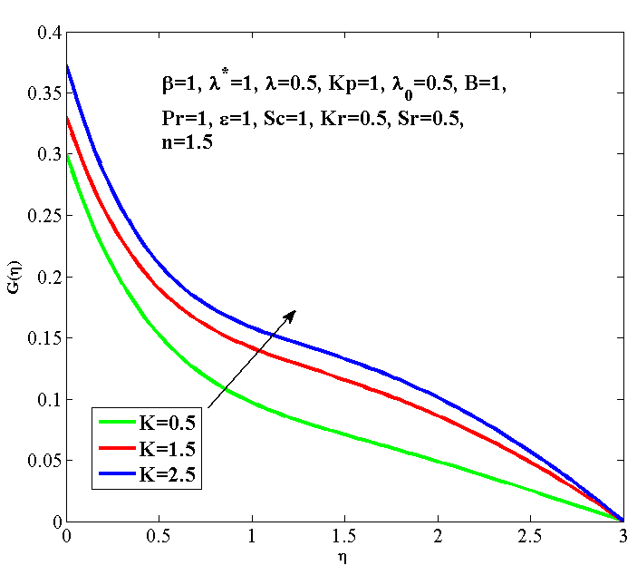
Fig.8 $K on micro rotation parameter$
From fig.8 it is clear that for higher values of micropolar parameter, the micro-rotation parameter also increase.
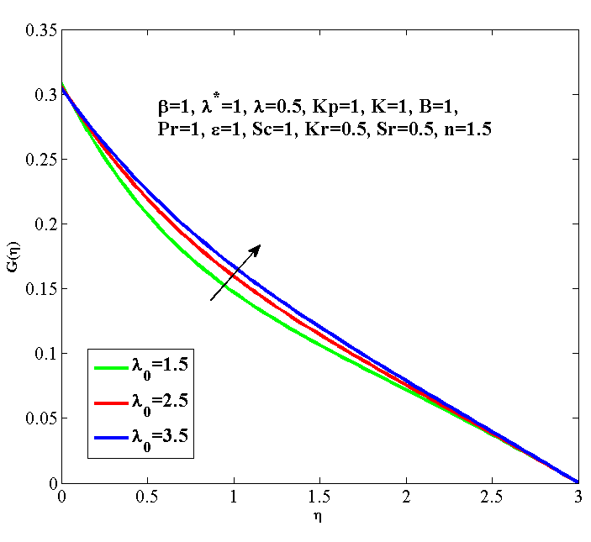
Fig.9 effect $λ_{0} on G\left(η\right)$
Figure 9 effect of Spin gradient viscosity parameter on microrotation parameter. It can b realized from the figure that the microrotation parameter turns up for rise in spin gradient viscosity parameter.
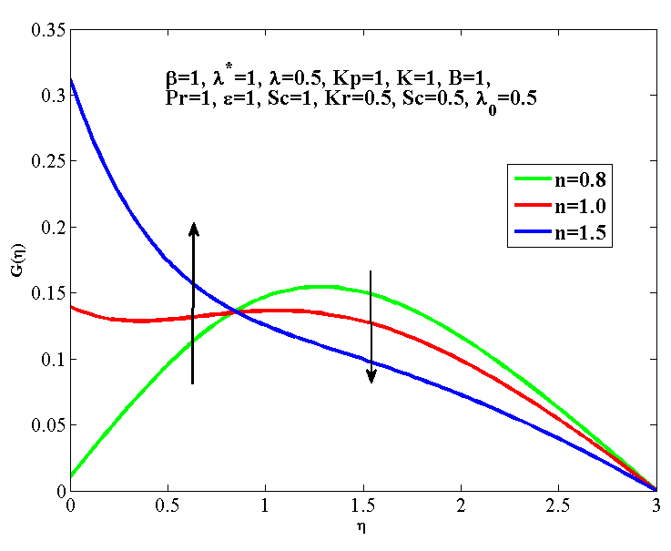
Fig.10 effect $n on G\left(η\right)$
From figure 10 shows that effect of power index parameter on micro-rotation parameter. It is seen that micro-rotation improve with increase in power index near the surface, whereas reverse effects on throughout the flow field.
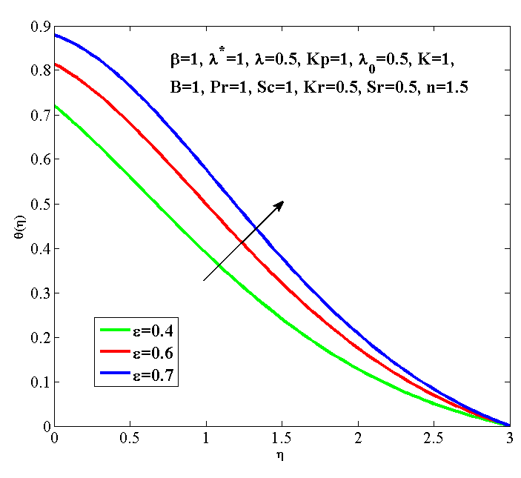
Fig.11 effect $ε on θ\left(η\right)$
Figure 11 specify the temperature profile have been plotted for various values of heat generation/absorption parameter by keeping other parameter fixed. Physically when we increase the values of heat generation/absorption parameter, temperature of the fluid is also increase.
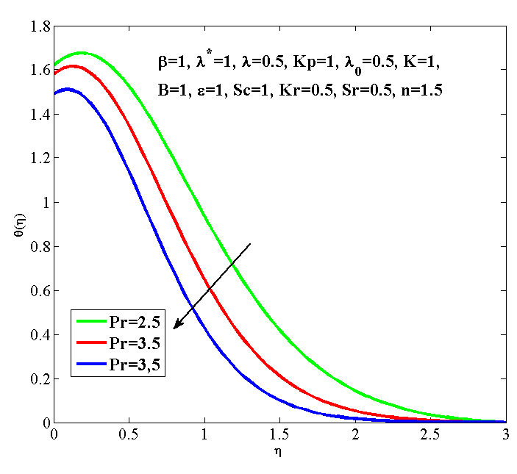
Fig.12 effect $Pr on θ\left(η\right)$
Figure 12 shows the effect of Prandtl number on temperature profile. Physically, when the amount of Prandtl number parameter increases, the values of temperature profile will decrease.
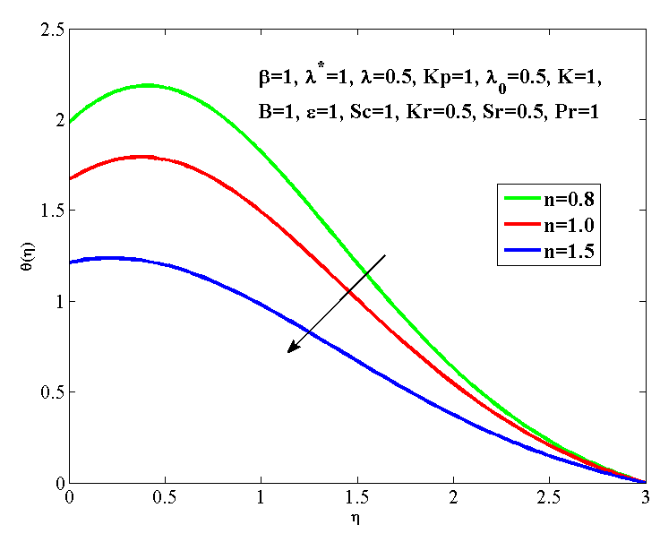
Fig.13 effect $n on θ\left(η\right)$
Figure 13 determine the effect of power index on temperature profile. Show that as the power index increases, the temperature profile decreases gradually.
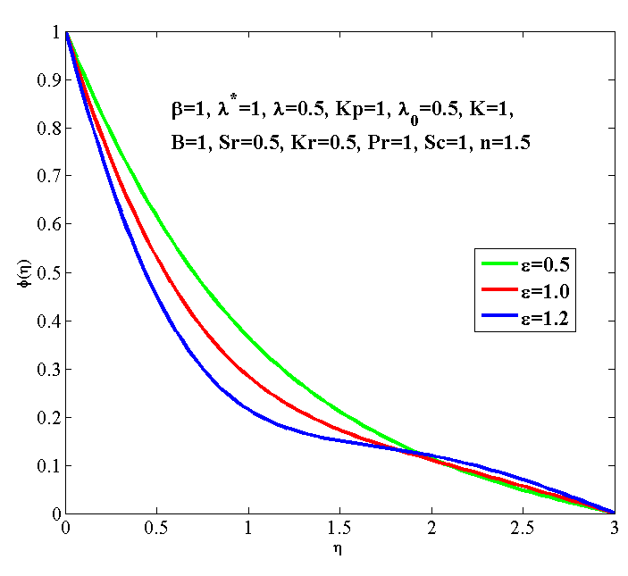
Fig.14 effect $ε on ϕ\left(η\right)$
Figure 14 exhibits the concentration profiles for different values of heat generation/absorption parameter. It I observed that concentration profiles oscillate with increase in heat generation/absorption parameter.
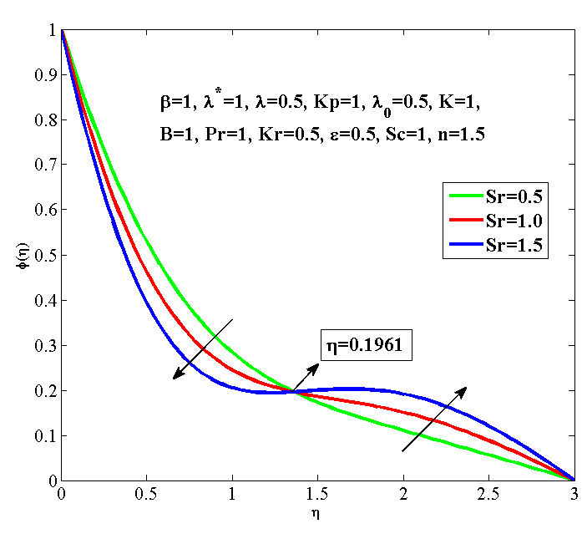
Fig.15 effect $Sr on ϕ\left(η\right)$
Figure 15 shows that concentration profile decreases near the boundary and after$η=0.1961$ sometime we observe the opposite action it means concentration increases with increases in the Soret number.
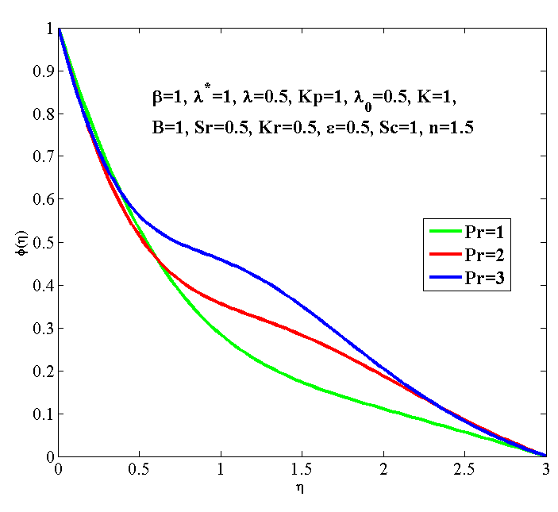
Fig.16 effect $Pr on ϕ\left(η\right)$
Figure 16 impact of various value of Prandtl number on concentration profile. It can be realized from the picture that the concentration profiles oscillate for increasing the value of Prandtl number.
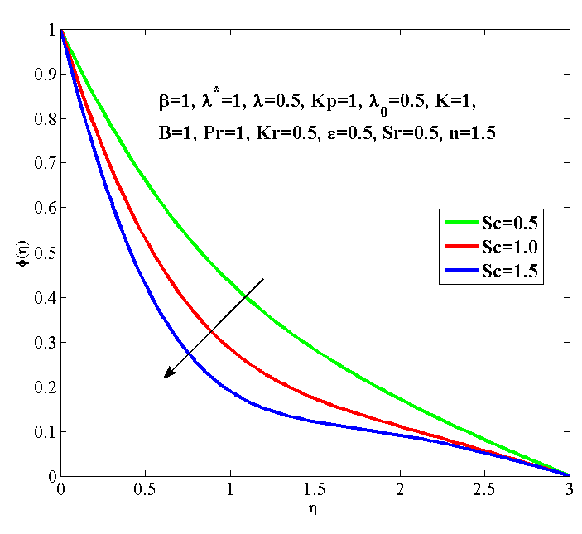
Fig.17 effect $Sc on ϕ\left(η\right)$
From figure 17 Soret number defines the effects of the concentration profile. We found fall in concentration parameter when Soret number value increasing.
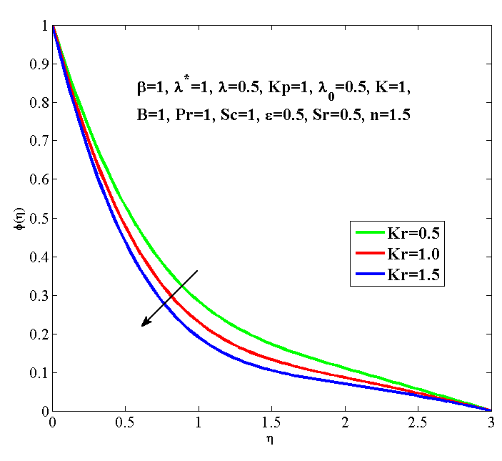
Fig.18 effect $Kr on ϕ\left(η\right)$
Figure 18 is plotted in order to check the effect of chemical reaction parameter on concentration profile. When we increase the value of chemical reaction parameter there is concentration profile decreasing.
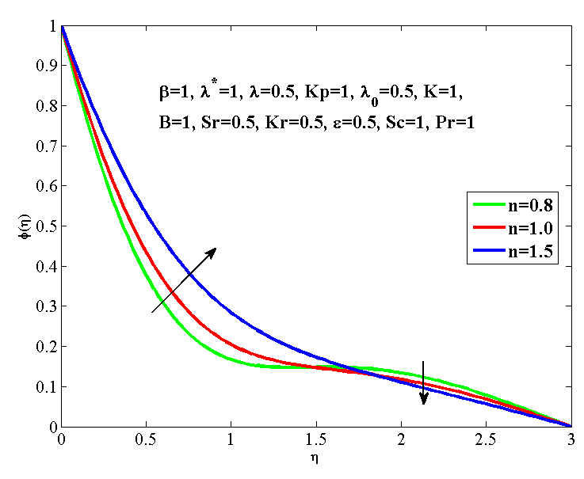
Fig.19 effect $n on ϕ\left(η\right)$
Figure 19 illustrates the effect of the power index on concentration profile. When we increase the values of power index parameter there is initial raise and then fall in the concentration profile.
Table 1: Effect of various parameters on$C_{f}$
$$β$$ | $$λ^{*}$$ | $$λ$$ | $$K_{p}$$ | K | n | $$f^{''}(0)$$ | $$\sqrt{\left(\frac{n+1}{2}\right)} \left(1+\frac{1}{β}+K(1-n)\right)f^{''}\left(0\right)$$
0.5 | 1 | 0.5 | 1 | 1 | 1.5 | -0.4227 | -1.1835
1.0 | 1 | 0.5 | 1 | 1 | 1.5 | -0.4413 | -0.7413
2.0 | 1 | 0.5 | 1 | 1 | 1.5 | -0.4507 | -0.5047
1 | 0.7 | 0.5 | 1 | 1 | 1.5 | -0.5518 | -0.9270
1 | 1.0 | 0.5 | 1 | 1 | 1.5 | -0.4413 | -0.7413
1 | 1.5 | 0.5 | 1 | 1 | 1.5 | -0.2854 | -0.4794
1 | 1 | 0.5 | 1 | 1 | 1.5 | -0.4413 | -0.7413
1 | 1 | 1.5 | 1 | 1 | 1.5 | -0.3083 | -0.5179
1 | 1 | 3.5 | 1 | 1 | 1.5 | -0.0110 | -0.0184
1 | 1 | 0.5 | 0.5 | 1 | 1.5 | -0.3506 | -0.5890
1 | 1 | 0.5 | 1.0 | 1 | 1.5 | -0.4413 | -0.7413
1 | 1 | 0.5 | 1.5 | 1 | 1.5 | -0.5232 | -0.8789
1 | 1 | 0.5 | 1 | 0.5 | 1.5 | -0.4295 | -0.8418
1 | 1 | 0.5 | 1 | 2.0 | 1.5 | -0.4614 | -0.5167
1 | 1 | 0.5 | 1 | 4.0 | 1.5 | -0.5265 | 0.0000
1 | 1 | 0.5 | 1 | 1 | 1.2 | -0.1612 | 0.0338
1 | 1 | 0.5 | 1 | 1 | 1.5 | -0.4413 | 0.2466
1 | 1 | 0.5 | 1 | 1 | 1.8 | -0.6124 | 0.5796

Table 2: Effects of various parameters on Sherwood number and Nusselt number
$$β$$ | $$λ^{*}$$ | K | n | $$λ$$ | $$K_{p}$$ | $$ε$$ | Pr | B | $$λ_{0}$$ | $${ S}_{r}$$ | $$S_{c}$$ | $$K_{r}$$ | $$-\sqrt{\frac{n+1}{2}}θ^{'}(0)$$ | $$-ϕ^{'}(0)$$
0.5 | 1 | 1 | 1.5 | 0.5 | 1 | 1.2 | 1 | 1 | 0.5 | 0.5 | 1 | 0.5 | -0.6928 | 1.4165
1.0 | 1 | 1 | 1.5 | 0.5 | 1 | 1.2 | 1 | 1 | 0.5 | 0.5 | 1 | 0.5 | -0.7316 | 1.4339
2.0 | 1 | 1 | 1.5 | 0.5 | 1 | 1.2 | 1 | 1 | 0.5 | 0.5 | 1 | 0.5 | -0.7570 | 1.4454
1 | 0.7 | 1 | 1.5 | 0.5 | 1 | 1.2 | 1 | 1 | 0.5 | 0.5 | 1 | 0.5 | -0.9852 | 1.5479
1 | 1.0 | 1 | 1.5 | 0.5 | 1 | 1.2 | 1 | 1 | 0.5 | 0.5 | 1 | 0.5 | -0.7316 | 1.4339
1 | 1.5 | 1 | 1.5 | 0.5 | 1 | 1.2 | 1 | 1 | 0.5 | 0.5 | 1 | 0.5 | -0.4989 | 1.3336
1 | 1 | 0.5 | 1.5 | 0.5 | 1 | 1.2 | 1 | 1 | 0.5 | 0.5 | 1 | 0.5 | -0.7130 | 1.4256
1 | 1 | 2.0 | 1.5 | 0.5 | 1 | 1.2 | 1 | 1 | 0.5 | 0.5 | 1 | 0.5 | -0.7620 | 1.4507
1 | 1 | 4.0 | 1.5 | 0.5 | 1 | 1.2 | 1 | 1 | 0.5 | 0.5 | 1 | 0.5 | -0.8627 | 1.4936
1 | 1 | 1 | 1.2 | 0.5 | 1 | 1.2 | 1 | 1 | 0.5 | 0.5 | 1 | 0.5 | -1.2180 | 1.7078
1 | 1 | 1 | 1.5 | 0.5 | 1 | 1.2 | 1 | 1 | 0.5 | 0.5 | 1 | 0.5 | -0.7316 | 1.4339
1 | 1 | 1 | 1.8 | 0.5 | 1 | 1.2 | 1 | 1 | 0.5 | 0.5 | 1 | 0.5 | -0.4194 | 1.2497
1 | 1 | 1 | 1.5 | 0.5 | 1 | 1.2 | 1 | 1 | 0.5 | 0.5 | 1 | 0.5 | -0.7316 | 1.4339
1 | 1 | 1 | 1.5 | 1.5 | 1 | 1.2 | 1 | 1 | 0.5 | 0.5 | 1 | 0.5 | -0.6015 | 1.3780
1 | 1 | 1 | 1.5 | 3.5 | 1 | 1.2 | 1 | 1 | 0.5 | 0.5 | 1 | 0.5 | -0.3671 | 1.2817
1 | 1 | 1 | 1.5 | 0.5 | 0.5 | 1.2 | 1 | 1 | 0.5 | 0.5 | 1 | 0.5 | -0.5950 | 1.3745
1 | 1 | 1 | 1.5 | 0.5 | 1.0 | 1.2 | 1 | 1 | 0.5 | 0.5 | 1 | 0.5 | -0.7316 | 1.4339
1 | 1 | 1 | 1.5 | 0.5 | 1.5 | 1.2 | 1 | 1 | 0.5 | 0.5 | 1 | 0.5 | -0.8738 | 1.4971
1 | 1 | 1 | 1.5 | 0.5 | 1 | 0.4 | 1 | 1 | 0.5 | 0.5 | 1 | 0.5 | -0.3124 | 0.8943
1 | 1 | 1 | 1.5 | 0.5 | 1 | 0.6 | 1 | 1 | 0.5 | 0.5 | 1 | 0.5 | -0.2027 | 0.9468
1 | 1 | 1 | 1.5 | 0.5 | 1 | 0.7 | 1 | 1 | 0.5 | 0.5 | 1 | 0.5 | -0.1346 | 0.9820
1 | 1 | 1 | 1.5 | 0.5 | 1 | 1.2 | 2.5 | 1 | 0.5 | 0.5 | 1 | 0.5 | -0.8347 | 0.5865
1 | 1 | 1 | 1.5 | 0.5 | 1 | 1.2 | 3.5 | 1 | 0.5 | 0.5 | 1 | 0.5 | -0.8282 | 0.5634
1 | 1 | 1 | 1.5 | 0.5 | 1 | 1.2 | 4.5 | 1 | 0.5 | 0.5 | 1 | 0.5 | -0.8243 | 0.4684
1 | 1 | 1 | 1.5 | 0.5 | 1 | 1.2 | 1 | 1 | 0.5 | 0.5 | 1 | 0.5 | -0.7316 | 1.4339
1 | 1 | 1 | 1.5 | 0.5 | 1 | 1.2 | 1 | 2 | 0.5 | 0.5 | 1 | 0.5 | -0.7280 | 1.4325
1 | 1 | 1 | 1.5 | 0.5 | 1 | 1.2 | 1 | 3 | 0.5 | 0.5 | 1 | 0.5 | -0.7258 | 1.4316
1 | 1 | 1 | 1.5 | 0.5 | 1 | 1.2 | 1 | 1 | 1.5 | 0.5 | 1 | 0.5 | -0.7373 | 1.4316
1 | 1 | 1 | 1.5 | 0.5 | 1 | 1.2 | 1 | 1 | 2.5 | 0.5 | 1 | 0.5 | -0.7392 | 1.4375
1 | 1 | 1 | 1.5 | 0.5 | 1 | 1.2 | 1 | 1 | 3.5 | 0.5 | 1 | 0.5 | -0.7402 | 1.4379
1 | 1 | 1 | 1.5 | 0.5 | 1 | 1.2 | 1 | 1 | 0.5 | 0.5 | 1 | 0.5 | -0.7316 | 1.4339
1 | 1 | 1 | 1.5 | 0.5 | 1 | 1.2 | 1 | 1 | 0.5 | 1.0 | 1 | 0.5 | -0.7411 | 1.9373
1 | 1 | 1 | 1.5 | 0.5 | 1 | 1.2 | 1 | 1 | 0.5 | 1.5 | 1 | 0.5 | -0.7514 | 2.4511
1 | 1 | 1 | 1.5 | 0.5 | 1 | 1.2 | 1 | 1 | 0.5 | 0.5 | 0.5 | 0.5 | -0.7019 | 0.9331
1 | 1 | 1 | 1.5 | 0.5 | 1 | 1.2 | 1 | 1 | 0.5 | 0.5 | 1.0 | 0.5 | -0.7316 | 1.4339
1 | 1 | 1 | 1.5 | 0.5 | 1 | 1.2 | 1 | 1 | 0.5 | 0.5 | 1.5 | 0.5 | -0.7479 | 1.8646
1 | 1 | 1 | 1.5 | 0.5 | 1 | 1.2 | 1 | 1 | 0.5 | 0.5 | 1 | 0.5 | -0.7316 | 1.4339
1 | 1 | 1 | 1.5 | 0.5 | 1 | 1.2 | 1 | 1 | 0.5 | 0.5 | 1 | 1.0 | -0.7409 | 1.6029
1 | 1 | 1 | 1.5 | 0.5 | 1 | 1.2 | 1 | 1 | 0.5 | 0.5 | 1 | 1.5 | -0.7474 | 1.7475

Table 1 show that the varying parameters' effects including the $β,$ K,$Kp$, $λ$, $, n$ and$λ^{*}$on the skin friction coefficient. Specifically, Table 1 demonstrates that a raise in the$β,$ K,$λ$, $n$ and$λ^{*}$leads to a corresponding increase skin friction coefficient. Conversely, rise in value of the $Kp$results in a decrease in the skin friction coefficient.
Table 2 illustrates the varying parameters' effects including the $β,$ K,$Kp$, Sc, Sr,$Kr,$ $ε, λ^{*}$,$λ$, Pr,$B, n$ and$λ_{0}$on the Nusselt number. Specifically, Table 2 demonstrates that a raise in the$λ^{*}$,$λ$, Pr,$B and n$ leads to a corresponding increase in the Nusselt number. Conversely, a raise in values of the $β,$ K,$Kp$, Sc, Sr,$Kr,$ $ε$ and $λ_{0}$ results in a decrease in the Nusselt number
We observe that table 2 effects of different parameters likes $β,$ K,$Kp,$ Sc, Sr,$Kr,ε, λ^{*}, λ$ Pr,$B, n$ and$λ_{0}$ on Sherwood number. We noticed that increases the value $β,$ K,$Kp$, Sc, Sr,$Kr,$ $ε$ and$λ_{0}$ respectably, also increases the value of Sherwood number. We investigate increases the value of${ λ}^{*}$,$λ$, Pr,$B and n$ the Sherwood number decrease.
Conclusions
- The velocity of the sheet decreases when increase the values of Casson parameter, Porosity parameter, Micropolar parameter and Power index parameter respectively.
- On raising the value of Diffusion parameter and Buoyancy parameter, value of fluid velocity increase.
- On increasing the value of Micro inertia density parameter, Micropolar parameter and Spin gradient viscosity parameter, Micro-rotation of the fluid is increase.
- It is seen that Micro-rotation improves with increase in Power index near the surface, whereas reverse effects on throughout the flow field.
- As the value of heat generation and Prandtl number parameter rises, temperature of fluid increases with heat generation and inverse effect of Prandtl number.
- On Schmidt number and chemical reaction parameter are increasing, concentration parameter is decreasing.
- Concentration parameter of the fluid is oscillating when increasing the value of heat generation and Prandtl number.
- Shows that concentration profile decreases near the boundary and after$η=0.1961$ sometime we observe the opposite action it means concentration increases with increases in the Soret number.
- When we increase the values of power index parameter there is initial raise and then fall in the concentration profile.
- Skin friction shows same effect to$β,$ K,$λ$, $n$ $λ^{*}$and opposite effect to$Kp$.
- Nusselt number shows same effect to$λ^{*}$,$λ$, Pr,$B, n$ and inverse effect to$β, K, Kp, Sc, Sr, Kr, ε λ_{0}$.
- Sherwood number shows same effect to$β,$ K,$Kp$, Sc, Sr,$Kr,$ $ε$ $λ_{0}$ and inverse effect to${ λ}^{*}$,$λ$, Pr,$B n$.

References
- F.P. Bowden, D. Tabor.(1942). Nature Publishing Group, Nat. Publ.
- Eringen, A. C. (1966). Theory of micropolar fluids. Journal of Mathematics and Mechanics, 1-18.
- Hayat, T., & Mustafa, M. (2010). Influence of thermal radiation on the unsteady mixed convection flow of a Jeffrey fluid over astretching sheet. Zeitschrift für Naturforschung A, 65(8-9), 711-719.
- Hayat, T., Shehzad, S. A., Qasim, M., & Obaidat, S. (2012). Radiative flow of Jeffery fluid in a porous medium with power lawheat flux and heat source. Nuclear Engineering and Design, 243, 15-19.
- Nadeem, S., Zaheer, S., & Fang, T. (2011). Effects of thermal radiation on the boundary layer flow of a Jeffrey fluid over anexponentially stretching surface. Numerical Algorithms, 57(2), 187-205.
- Turkyilmazoglu, M., & Pop, I. (2013). Exact analytical solutions for the flow and heat transfer near the stagnation point on astretching/shrinking sheet in a Jeffrey fluid. International Journal of Heat and Mass Transfer, 57(1), 82-88.
- Qasim, M. (2013). Heat and mass transfer in a Jeffrey fluid over a stretching sheet with heat source/sink. Alexandria EngineeringJournal, 52(4), 571-575.
- Sharma, B. D., Yadav, P. K., & Filippov, A. (2017). A Jeffrey-fluid model of blood flow in tubes with stenosis. ColloidJournal, 79(6), 849-856.
- Nallapu, S., &Radhakrishnamacharya, G. (2014). Jeffrey fluid flow through porous medium in the presence of magnetic field innarrow tubes. International Journal of Engineering Mathematics, 2014.
- Agarwal, V., Singh, B., & Nisar, K. S. (2022). Numerical analysis of heat transfer in magnetohydrodynamic micropolar jeffery fluidflow through porous medium over a stretching sheet with thermal radiation. Journal of Thermal Analysis and Calorimetry, 1-23.
- Ellahi, R., Rahman, S. U., & Nadeem, S. (2014). Blood flow of Jeffrey fluid in a catherized tapered artery with the suspension ofnanoparticles. Physics Letters A, 378(40), 2973-2980.
- Khan, A., Zaman, G., &Algahtani, O. (2018). Unsteady Magnetohydrodynamic Flow of Jeffrey Fluid through a Porous OscillatingRectangular Duct. Porosity Process. Technol. Appl, 125-128.
- Vaidya, H., Rajashekhar, C., Divya, B. B., Manjunatha, G., Prasad, K. V., &Animasaun, I. L. (2020). Influence of transportproperties on the peristaltic MHD Jeffrey fluid flow through a porous asymmetric tapered channel. Results in Physics, 18, 103295.
- Das, K., Acharya, N., & Kundu, P. K. (2015). Radiative flow of MHD Jeffrey fluid past a stretching sheet with surface slip andmelting heat transfer. Alexandria Engineering Journal, 54(4), 815-821.
- Agarwal, V., Singh, B., Kumari, A., Jamshed, W., Nisar, K. S., Almaliki, A. H., & Zahran, H. Y. (2021). SteadyMagnetohydrodynamic Micropolar Fluid Flow and Heat and Mass Transfer in Permeable Channel with ThermalRadiation. Coatings, 12(1), 11.
- Reddy, Y. D., Goud, B. S., Nisar, K. S., Alshahrani, B., Mahmoud, M., & Park, C. (2023). Heat absorption/generation effect onMHD heat transfer fluid flow along a stretching cylinder with a porous medium. Alexandria Engineering Journal, 64, 659-666.
- Mahabaleshwar, U. S., Sneha, K. N., Chan, A., & Zeidan, D. (2022). An effect of MHD fluid flow heat transfer using CNTs withthermal radiation and heat source/sink across a stretching/shrinking sheet. International Communications in Heat and MassTransfer,135, 106080.
- Pandey, A. K., Bhattacharyya, K., Gautam, A. K., Rajput, S., Mandal, M., Chamkha, A. J., & Yadav, D. (2022). Insight into therelationship between non-linear mixed convection and thermal radiation: the case of Newtonian fluid flow due to non-linear
stretching. Propulsion and Power Research.
- Megahed, A. M., Reddy, M. G., & Abbas, W. (2021). Modeling of MHD fluid flow over an unsteady stretching sheet with thermalradiation, variable fluid properties and heat flux. Mathematics and Computers in Simulation, 185, 583-593.
- Krishna, M. V. (2020). Hall and ion slip impacts on unsteady MHD free convective rotating flow of Jeffreys fluid with ramped wall temperature. International Communications in Heat and Mass Transfer, 119, 104927.
- Khader, M. M., & Sharma, R. P. (2021). Evaluating the unsteady MHD micropolar fluid flow past stretching/shirking sheet with heat source and thermal radiation: Implementing fourth order predictor–corrector FDM. Mathematics and Computers in Simulation, 181, 333-350.
- Pop, I., & Na, T. Y. (1998). A note on MHD flow over a stretching permeable surface. Mechanics ResearchCommunications, 25(3), 263-269.
- Mbeledogu, I. U., Amakiri, A. R. C., &Ogulu, A. (2007). Unsteady MHD free convective flow of a compressible fluid past amoving vertical plate in the presence of radiative heat transfer. International journal of heat and mass transfer, 50(9-10), 1668-1674.
- Muthucumaraswamy, R., & Sivakumar, P. (2016). MHD flow past a parabolic flow past an infinite isothermal vertical plate in thepresence of thermal radiation and chemical reaction. International Journal of Applied Mechanics and Engineering, 21(1).
- Raju, R. S., Reddy, G. J., Rao, J. A., Rashidi, M. M., & Gorla, R. S. R. (2016). RETRACTED: Analytical and numerical study ofunsteady MHD free convection flow over an exponentially moving vertical plate with Heat Absorption.
- Adegbie, S. K., Kọrikọ, O. K., &Animasaun, I. L. (2016). Melting heat transfer effects on stagnation point flow of micropolar fluidwith variable dynamic viscosity and thermal conductivity at constant vortex viscosity. Journal of the Nigerian Mathematical
Society, 35(1), 34-47.
- Malik, M. Y., Bibi, M., Khan, F., & Salahuddin, T. (2016). Numerical solution of Williamson fluid flow past a stretching cylinderand heat transfer with variable thermal conductivity and heat generation/absorption. AIP Advances, 6(3), 035101.
- Misra, J. C., Sinha, A., & Shit, G. C. (2011). Mathematical modeling of blood flow in a porous vessel having double stenoses in thepresence of an external magnetic field. International Journal of Biomathematics, 4(02), 207-225.
- Eldabe, N., Agoor, B. M., & Alame, H. (2014). Peristaltic motion of non-Newtonian fluid with heat and mass transfer through aporous medium in channel under uniform magnetic field. Journal of Fluids, 2014.
- Cheng, J., Liao, S., & Pop, I. (2005). Analytic series solution for unsteady mixed convection boundary layer flow near thestagnation point on a vertical surface in a porous medium. Transport in porous media, 61(3), 365-379.
- Ahmed, M. A. M., Mohammed, M. E., & Khidir, A. A. (2015). On linearization method to MHD boundary layer convective heattransfer with low pressure gradient. Propulsion and Power Research, 4(2), 105-113.
- Butt, A. R., Abdullah, M., Raza, N., & Imran, M. A. (2017). Influence of non-integer order parameter and Hartmann number on theheat and mass transfer flow of a Jeffery fluid over an oscillating vertical plate via Caputo-Fabrizio time fractional derivatives. TheEuropean Physical Journal Plus, 132(10).

