**Environmental Impacts of Healthcare Practices**

Mr. Mustafa Ngaja, Mr. Khush Jain 2 Shubham Gupta 2

1M.Sc. Research fellow Parul Institute of Paramedical and Health Sciences Parul university.

2Assistant Professor Parul Institute of Paramedical and Health Sciences Parul university.

(Email ID: [ngaja2525@gmail.com](mailto:ngaja2525@gmail.com) )

(Email ID; [Khushjain028@gmail.com](mailto:Khushjain028@gmail.com))

(Email ID: [shubham.gupta19175@paruluniversity.ac.in](mailto:shubham.gupta19175@paruluniversity.ac.in) )

**Abstract**

The healthcare industry, crucial for human welfare, substantially contributes to environmental deterioration through its diverse operations. Healthcare operations are resource-intensive and produce significant waste and emissions, resulting in contamination of air, water, and land. The frequently neglected environmental repercussions jeopardise human health and intensify climate change. The sector significantly contributes to greenhouse gas (GHG) emissions, with estimates suggesting it represents 4-5% of worldwide emissions. These emissions originate from multiple sources, including energy usage in healthcare facilities, transportation, and the manufacturing and disposal of medical equipment and drugs. The healthcare sector's interrelation with industrial operations renders it a significant contributor to pollution.

Assessing the environmental impact of healthcare is essential for formulating effective mitigation solutions. Life cycle assessments (LCA) evaluate the environmental impact of healthcare activities by accounting for both direct and indirect emissions as well as resource utilisation. These evaluations indicate that the predominant emissions frequently arise in the supply chain and ancillary operations of healthcare. Research has examined the environmental impacts of particular healthcare practices and domains, including surgery, imaging, and medication consumption. The results underscore the necessity of addressing both direct and indirect environmental effects to attain significant reductions. The incorporation of environmental impact variables in healthcare facilitates the assessment of the environmental pressures exerted by healthcare activities, utilising diverse criteria contingent upon the healthcare context, measurement scope, and nature of environmental impact.

To mitigate the environmental impact of healthcare, it is imperative to adopt sustainable methods and minimise waste and emissions. A variety of initiatives, including waste reduction, enhancements in energy efficiency, and the adoption of less-polluting alternatives, have been recognised to mitigate the sector's environmental impact. Moreover, measures and tactics at the organisational level designed to diminish the demand and necessity for healthcare are crucial. Moreover, healthcare practitioners and policymakers have an ethical obligation to prioritise and reform healthcare to adopt ecologically sustainable methods. The adoption of these sustainable practices not only reduces environmental consequences but may also yield cost savings and enhance public health.

**1. Introduction**

***1.1 Overview of Healthcare Practices***

Environmental impacts refer to the effects of human activities on the environment, and these impacts significantly affect health care practices. (1,2)The health care sector is interconnected with industrial activities that emit pollution to air, water, and soils.(2,3) These emissions include greenhouse gases (GHGs) as well as other pollutants such as particulate matter, sulfur and nitrogen oxides, persistent organic pollutants, and toxic metals. (1,2) Both direct emissions from healthcare facilities and indirect emissions from the production of electricity and materials used by those facilities contribute to environmental degradation. (1,2) This pollution has a direct impact on public health. (2,3)

It is a vast and complex system, encompassing a wide array of activities from traditional healing to innovative, high-technology treatments.(4) It is a major economic driver and employer, consuming substantial resources.(4–6) Healthcare practices are resource-intensive, requiring continuous operation and significant energy consumption for heating, ventilation, cooling, and lighting.(5–7) They also involve the use of a wide variety of materials and the generation of substantial waste, including medical supplies, pharmaceuticals, and packaging.(5) The healthcare sector relies on a complex supply chain that includes the manufacture and transport of medical supplies and pharmaceuticals, and it has numerous direct impacts on the environment as well as indirect impacts through its influence on other economic sectors.(4,5,8) In addition, healthcare facilities also have functions such as laundry services, facility heating and cooling, and transportation that contribute to the sector's environmental footprint.(4,5)

***1.2 Importance of Studying Environmental Impacts***

Studying the environmental impacts of healthcare is crucial due to the sector's significant contribution to pollution, resource depletion, and overall environmental degradation.(1,5,6,9) Healthcare activities result in a wide range of pollutants, including greenhouse gases, particulate matter, and other harmful substances, which affect air, water, and soil quality. (3,10,11)The healthcare sector's contribution to global greenhouse gas emissions is substantial, ranging from 1% to 5% of total global emissions, and even higher for some national impacts.(1,6,10) The sector also generates significant amounts of waste, including hazardous medical waste, which poses risks to both human and environmental health.(5,7,12) Understanding these impacts is essential for developing strategies to mitigate the sector's negative effects, reduce its carbon footprint, and improve public health.

Moreover, the healthcare sector's environmental footprint has a feedback effect by creating adverse health outcomes which then require additional health care services, perpetuating a cycle of negative impacts. (10,13)This highlights the need for a more sustainable approach to healthcare delivery, which includes evaluating the full life cycle of medical products and practices, and addressing supply chain impacts, energy use, and emissions.(5,8) Examining the environmental impacts of healthcare can lead to more efficient resource management, reductions in waste and energy consumption, and the selection of less harmful materials. This can also lead to the development of environmentally preferred alternatives, and best practices that minimize emissions.(5) By addressing these environmental impacts, the healthcare sector can better fulfil its mission of improving health while also protecting the environment.(10,11,14)

**2. Sources of Environmental Impacts in Healthcare**

***2.1 Medical Waste Management***

Medical waste management is a significant source of environmental impact within the healthcare sector.(8) Healthcare activities generate substantial amounts of waste, including hazardous and infectious materials.(6,14,15) Much of this waste is plastic, including single-use items, such as syringes and blood bags. (14)Improper disposal of this waste leads to environmental contamination and can release methane, a major greenhouse gas, when organic waste decomposes.(15)

* **Waste Generation:** A large proportion of healthcare's environmental impact comes from the sheer volume of waste produced.(9,11) This includes not only medical supplies but also packaging and other materials.(2,8)
* **Waste Treatment:** The most common methods for treating healthcare waste, such as incineration, can create severe environmental contamination that contributes to climate change.(13) Incinerators are significant sources of air emissions, including dioxins and mercury. (4)Autoclaves, often used to sterilize waste, are usually equipped with shredders to reduce the volume of waste going to landfills, which still contributes to landfill issues such as leachate and methane production.(13)
* **Specific Waste Types:** Some types of medical waste, like pharmaceuticals, pose unique challenges.(8) A significant percentage of oral drug doses are released into the environment through urine, and hospital wastewater, a major source of micropollutants, is not always adequately treated to remove these components.(16) Additionally, some medical devices contain mercury, which can be released during incineration, and can contribute to environmental pollution.(4)
* **Circular Economy:** The healthcare sector has largely followed a linear economic model where products are designed for single use and disposal.(15) This contributes to waste and resource depletion, while a transition to a circular model of production would focus on reducing waste and reusing materials. (15)

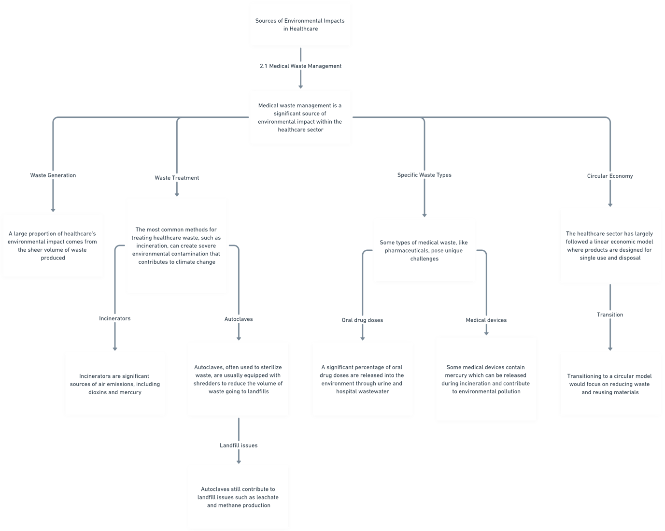 ***fig 1 : Medical Waste Management***

***2.2 Energy Consumption in Healthcare Facilities***

Healthcare facilities are energy-intensive, and their energy consumption is another major source of environmental impact.(6,7) Hospitals, in particular, require a continuous supply of energy for heating, cooling, ventilation, lighting, machinery, and healthcare treatments.(6,16)

* **High Energy Demand:** Hospitals are among the most energy-intensive building types.(5) They use significant amounts of electricity for various functions. (7)For example, heating, ventilation, and air conditioning (HVAC) systems account for the largest share of energy consumption in surgical suites.(17)
* **Sources of Energy Use:** A substantial portion of the healthcare sector's energy-related emissions comes from the generation of electricity.(2,3,18) In the US, power generation is the largest source of GHG emissions associated with healthcare.(2,3)
* **Operational Energy Use:** Beyond direct energy use, there is significant "upstream" energy consumption involved in the manufacturing of consumables used in healthcare.(7)
* **Impact of Medical Decisions:** Medical decisions can influence energy consumption. (7) Choices about procedures, pharmaceuticals, and equipment use all have an impact on a facility's energy footprint. (7)
* **Life Cycle Perspective:** It is important to consider the full life cycle of energy use, including the energy required for the production of energy and the manufacturing of consumables. (7)
* **Other Considerations** In addition to energy, water consumption in healthcare facilities contributes to GHG emissions because of the energy required for water treatment and sanitation. (15)

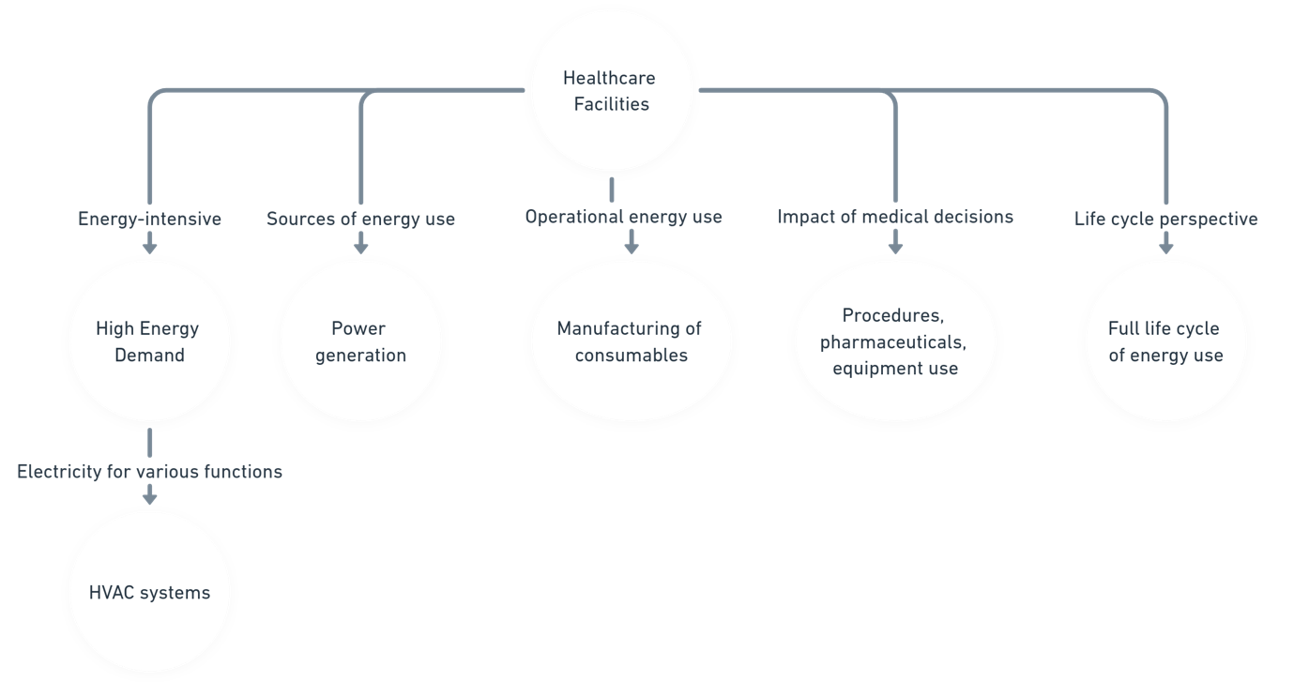

***fig 2: Energy Consumption in Healthcare Facilities***

***2.3 Water Usage in Healthcare***

Water usage in healthcare is a significant environmental concern due to both the quantity of water consumed and the potential for water contamination. Healthcare facilities use substantial amounts of water for a variety of purposes, which can strain local water resources and contribute to pollution if not properly managed.(1,10,19)

* **High Consumption Areas**: Major areas of water consumption in hospitals include:
  + Wash basins, sinks, and showers.(19)
  + Toilets. (19)
  + Laboratories, cooling towers, macerators, and sterilizers. (19)
  + Food preparation. (19)
  + Dialysis treatments. (19,20) Dialysis can consume 120 to 800 litres of fresh water per treatment, much of which is discarded as reject water.(20)
  + Hydrotherapy.(21)
  + Steam generation. (21)
  + Surgical scrubbing.(20)
  + Pharmaceutical preparations. (21)
  + Patient-care equipment like ventilators. (21)
  + Automated endoscope reprocessors. (21)
  + Dental unit water lines. (21)
* **Water Intensity and Expenditure**: As healthcare expenditure increases, the water footprint also increases.(1,10) This is particularly true in higher expenditure brackets, where the water footprint increases at a greater rate than per-capita healthcare expenditure.(1) Even with technological innovations that have reduced water intensity in healthcare, the overall per-capita water footprint has increased. (1,10)
* **Waterborne Diseases**: Healthcare facilities can be reservoirs for waterborne pathogens like *Legionella* spp. and *Pseudomonas aeruginosa*, leading to infections. (21)Water systems, including cooling towers, potable water supplies, and hydrotherapy equipment, can harbor these organisms, posing risks to patients, especially those who are immunocompromised.(21)
* **Water Quality**: The quality of water used in healthcare settings is critical.(21,22) This is particularly true in applications like hemodialysis where water must be treated to remove chemical and biological contaminants that could cause harm to patients.(21)
* **Water Conservation**: Water conservation strategies such as auditing water usage, checking for leaks, applying flow restrictors on hand basins, installing dual-flush toilets, and reclaiming water from dialysis units can reduce water usage by 10–25%. (19)Additionally, recycling reject water from dialysis can reduce costs compared to generating fresh water through reverse osmosis of sea water.(20) The use of water-saving devices, such as automatic tap timers, can reduce water consumption for surgical hand scrubbing.(19)

***2.4 Pharmaceutical and Chemical Pollution***

Pharmaceutical and chemical pollution from healthcare activities is another critical area of environmental impact. These pollutants enter the environment through various pathways, including wastewater and improper disposal, and can have significant consequences for ecosystems and human health.(16,23)

* **Pharmaceutical Waste**: A significant portion of orally administered drugs is released into the environment through urine. These pharmaceutical residues, including antibiotics, can contaminate surface and ground water, potentially leading to antibiotic resistance and other ecological impacts. Hospital wastewater, a major source of micropollutants, often is not adequately treated to remove these compounds. Expired or unused medications, if improperly disposed of, also contribute to pharmaceutical pollution.(16)

  
***fig3: Pharmaceutical Waste****(24)*

* **Chemicals in Healthcare**: Various chemicals are used in healthcare for cleaning, disinfection, and sterilization.(4,13,16) Some of these chemicals, like mercury, can be released during waste incineration, contributing to environmental pollution.(4) Standard cleansers used in healthcare can contain mercury. (4) Other chemicals, like glutaraldehyde, are also of concern.(25)



***Fig 4 : toxic mercury from contaminated water supply****(26)*

* **Disinfection By-products**: Chemicals used for disinfecting medical equipment and healthcare settings, such as sodium hypochlorite (NaClO) and hydrogen peroxide (H2O2), do not sterilize but disinfect.(13)
* **Occupational Hazards:** Some chemicals used in medical equipment sterilization can pose occupational hazards due to their toxicity.(4) Healthcare workers can be exposed to chemicals such as antineoplastic drugs, creating additional occupational health (8)risks.

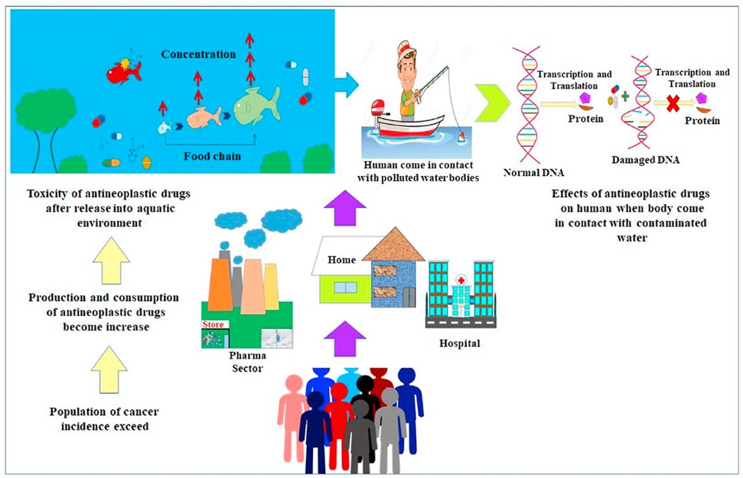

***Fig 5: antineoplastic drugs****(27)*

* **Sources of Chemical Waste**: Chemical pollutants can also come from other areas including dental fillings, X-ray diagnosis, and nuclear medicine.(4)
* **Need for Safer Alternatives:** There is a need to substitute harmful chemicals with safer alternatives, including replacing mercury-based thermometers and seeking alternatives to chemicals like PVC and BPA.(25)

**3. Types of Healthcare-Related Pollution**

***3.1 Air Pollution***

The healthcare sector is a significant contributor to air pollution through various direct and indirect emissions. These emissions include **greenhouse gases (GHGs)**, criteria air pollutants, and other harmful substances that impact both environmental and human health.(3)

* **Greenhouse Gas Emissions**:
  + The healthcare sector is a substantial source of GHG emissions, with a significant portion coming from indirect sources related to the supply chain, including the manufacturing of pharmaceuticals and medical supplies.(1,3,6,17) In the U.S. the healthcare sector's GHG emissions reached 655 million metric tons of CO2 equivalents (Mt CO2-e) in 2013, representing 9.8% of the national total. If it were a country, the U.S. healthcare sector would rank 13th in the world for GHG emissions.(2,3)
  + **Direct emissions** from healthcare facilities, such as on-site boilers and vehicles, account for a smaller portion of the total.(2,3,6,17)
  + **Indirect emissions**, such as those from the production of electricity and materials used by healthcare facilities, contribute the most to the sector's GHG footprint. Specifically, power generation is a large contributor to GHG emissions via the use of electricity in healthcare facilities and their supply chains.(2,3)
  + **Specific contributors** to GHG emissions include: hospital care, physician and clinical services, and prescription drugs. (2,3)
* **Criteria Air Pollutants**:
  + Healthcare activities release significant amounts of criteria air pollutants, including particulate matter (PM), sulfurdioxide (SO2), and nitrogen oxides (NOx). In 2013, the U.S. healthcare sector was responsible for 12% of national acid rain, 10% of smog formation, and 9% of respiratory disease related to particulate matter. (2,3)
  + **Fine particulate matter** is a leading cause of air pollution-related diseases. (2,3)
* **Other Air Pollutants:**
  + Anesthetic gases are potent greenhouse gases.(1,28,29)
  + The use of halocarbon solvents, refrigerants, and propellants in the manufacturing of surgical and medical instruments and pharmaceutical preparations contributes to ozone depletion.(2,3)
  + Waste management activities, such as incineration, emit carcinogenic and non-carcinogenic air toxics. (2,3) Medical waste incinerators are a major source of air emissions, including dioxin and mercury.(4,21)
  + Volatile organic compounds (VOCs) are emitted by healthcare facilities and contribute to the formation of smog.(28)
* **Health Impacts**:
  + Air pollution from healthcare activities results in significant health burdens, including respiratory diseases and lost disability-adjusted life years (DALYs).(2,3,6,28) For example, in 2013, health damages from air pollutants related to the U.S. healthcare sector were estimated at 470,000 DALYs lost. The majority of DALYs from non-GHG pollutants are due to respiratory diseases from PM exposure.(28)
  + Exposure to toxic air pollutants can also lead to other health issues including asthma and other respiratory problems. (2,3)

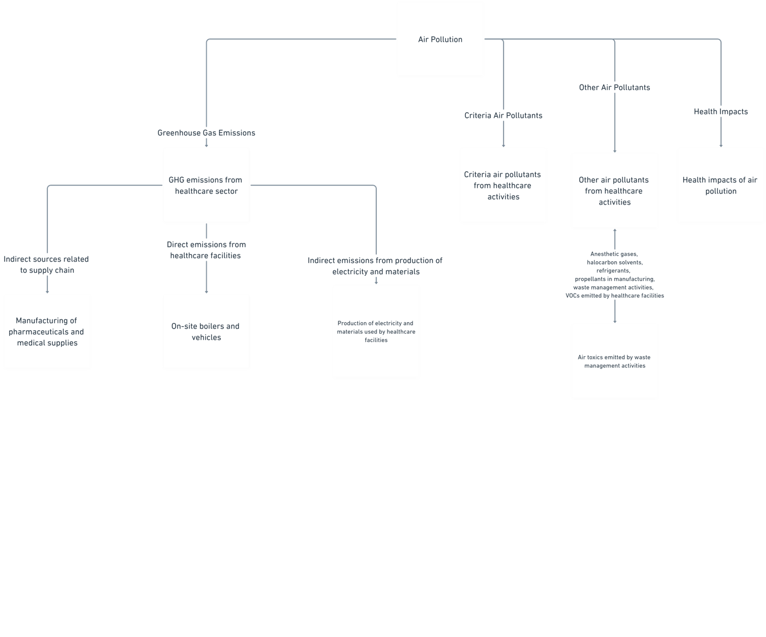

***Fig 6:******Air Pollution***

***3.2 Water Pollution***

Healthcare activities also contribute to water pollution through various pathways, impacting both human health and ecosystems.(1)

* **Sources of Water Pollution**:
  + **Pharmaceuticals**: A large percentage of oral drugs are excreted through urine and enter the environment, contaminating surface and ground water.(6,16)
  + **Chemicals**: Disinfectants, sterilants, and other chemicals used in healthcare facilities can contaminate water sources.(4,21) Some of these chemicals can be persistent and harmful to aquatic life and human health.(16)
  + **Radioactive wastes** from medical procedures can pose risks if they contaminate water.(4,21)
  + **Hospital wastewater**, a significant source of micropollutants, often is not adequately treated to remove specific components present in the discharges.(16)

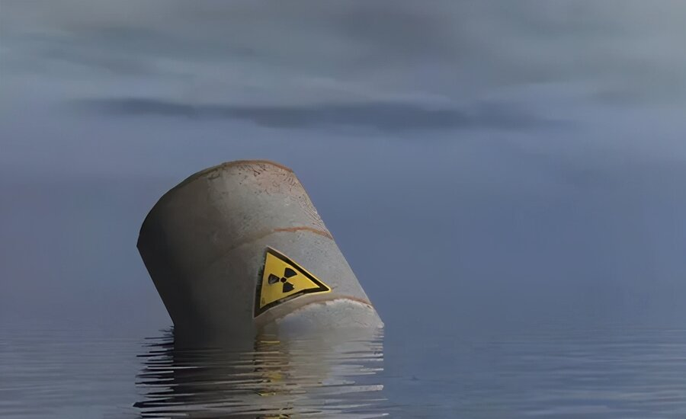

***Fig 7 :******Radioactive wastes water pollution****(30)*

* **Specific Pollutants**:
  + **Antibiotics** and other pharmaceutical residues in water can contribute to antibiotic resistance.(1,16)
  + **Mercury** from medical devices and dental fillings can contaminate water through improper disposal and incineration. (4,21)Standard cleansers used in healthcare can contain mercury.(4)
  + **Formaldehyde** from dialysis membrane disinfection is another chemical pollutant.(4,21)
  + **Disinfection by-products** result from the use of chemicals like sodium hypochlorite (NaClO) and hydrogen peroxide (H2O2) for disinfection.(21)
* **Health Impacts**:
  + Water contamination can lead to various diseases, including cholera, diarrhea, and typhoid fever.(1,10)
  + Exposure to chemical pollutants in water can cause a variety of health problems depending on the specific chemical and concentration.(1,21)
  + Microbial contamination of water can cause infections, including legionellosis.(21)
* **Water Scarcity**:
  + Healthcare's heavy water usage contributes to water scarcity, which impacts the availability of clean water and can result in disease. (1,10,15)Water consumption in healthcare is also linked to GHG emissions due to the energy required for water treatment and sanitation.(15)



***Fig 8 :******Water Scarcity****(31)*

***3.3 Soil Contamination***

Soil contamination in the healthcare sector is a significant concern due to the potential for **long-term environmental and health impacts** from the improper disposal of medical waste and other contaminants.(13)

* **Sources of Soil Contamination**:
  + **Improper Waste Disposal**: Healthcare facilities generate various types of waste, including hazardous materials, pharmaceuticals, and infectious substances. If not managed correctly, these wastes can leach into the soil.(13)
  + **Landfilling of Medical Waste**: Landfilling of untreated medical waste can contaminate soil with pathogens, heavy metals, and chemicals. Leachate from landfills can also contaminate the soil. (13)

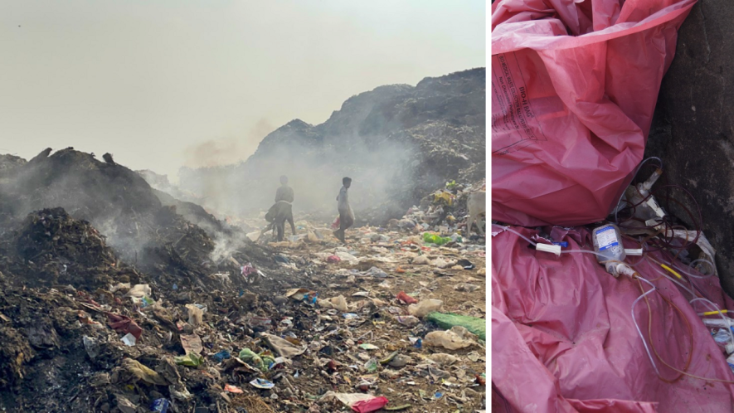

***Fig 9 : Landfilling of Medical Waste****(32)*

* + **Incinerator Ash**: Ash from medical waste incinerators, if not properly managed, can contaminate soil with heavy metals and dioxins. (13)

  
***fig 10: Incinerator Ash****(33)*

* + **Wastewater Irrigation**: The use of untreated wastewater for irrigation can contaminate soil with pathogens, pharmaceuticals, and other chemicals. (13)
* **Specific Contaminants**:
  + **Pathogens**: Infectious agents like bacteria and viruses from medical waste can persist in soil, posing risks to human and animal health. (13)
  + **Heavy Metals**: Medical devices, dental amalgams, and certain (13) pharmaceuticals contain heavy metals like mercury, cadmium, and lead, which can accumulate in the soil.(8)
  + **Pharmaceuticals**: Improperly discarded medications and their metabolites can contaminate soil, potentially affecting soil organisms and entering the food chain.(13)
  + **Chemicals**: Disinfectants, solvents, and other chemicals used in healthcare can leach into the soil, causing contamination. (13)
  + **Dioxins and PCBs**: These persistent organic pollutants, often emitted from incinerators, can contaminate soil. (13)
* **Health and Environmental Impacts**:
  + **Direct Exposure**: Direct contact with contaminated soil can lead to skin infections and other health problems.
  + **Food Chain Contamination**: Contaminants can be absorbed by plants and animals, entering the food chain and potentially impacting human health.
  + **Water Contamination**: Soil contamination can lead to the contamination of groundwater, further impacting water quality and human health. (13)
  + **Ecological Damage**: Soil contamination can disrupt ecosystems, impacting soil organisms and plant growth.

***3.4 Noise Pollution***

Noise pollution in healthcare settings can impact both patients and staff, and is an important environmental factor to consider. While the sources primarily exist within healthcare facilities, they can also impact the surrounding communities.(22)

* **Sources of Noise Pollution**:
  + **Medical Equipment**: Equipment such as ventilators, alarms, and diagnostic machines can contribute to high noise levels. (22)
  + **Construction and Renovation**: Construction and renovation activities within and around healthcare facilities can generate significant noise. (22)
  + **Traffic**: Noise from vehicles and other traffic around healthcare facilities can be a major source of disturbance. (22)
  + **Human Activity**: Conversations, staff movement, and other human activities can also contribute to noise pollution. (22)
  + **Waste Management**: Waste collection and disposal can generate noise. (22)
  + **Helicopters**: Medical transport helicopters can create significant noise, especially in densely populated areas. (22)
* **Health Impacts**:
  + **Patient Discomfort**: High noise levels can lead to patient discomfort, sleep disturbances, and increased stress. (22)
  + **Staff Stress**: Constant exposure to noise can cause stress, fatigue, and decreased job satisfaction among healthcare staff. (22)
  + **Hearing Loss**: Prolonged exposure to high noise levels can cause hearing loss, especially for healthcare staff.(22,34)
  + **Interference with Communication**: Noise can interfere with communication between staff and patients, potentially leading to medical errors.(22)
  + **Reduced Community Contacts**: Noise can contribute to reduced community contacts and constraints on child development.(34)
* **Mitigation Measures**:
  + **Noise Reduction Technology**: Employing quieter medical equipment, using sound-absorbing materials, and implementing noise dampening measures. (34)
  + **Operational Changes**: Scheduling noisy activities during less sensitive periods and managing traffic flow can help reduce noise. (34)
  + **Facility Design**: Designing healthcare facilities with noise reduction in mind, such as separating noisy areas from patient areas. (34)

  
*Fig 11 : Sources Of Noise Pollution*

**4. Environmental Impact of Specific Medical Practices**

***4.1 Radiology and Imaging***

Radiology and imaging are essential for diagnosis and treatment, but they also contribute to healthcare's environmental footprint through energy consumption, resource use, and waste generation.(7)

* **Energy Consumption**:
  + MRI (Magnetic Resonance Imaging) has been identified as having the largest per-scan environmental footprint across multiple impact categories, followed by CT (Computed Tomography) or single-photon emission tomography, and then ultrasound.(35) MRI requires significant energy for its operation, including the generation of magnetic fields and image processing.(7) The energy required for image creation is a small portion of in-hospital electricity consumption; however, the full energy needs of a patient who receives an MRI expand beyond this direct active energy to much more significant in-hospital energy consumption, including standby, idle, and ancillary devices. (7)
* CT scans also consume considerable energy, though less than MRI. (7)
* X-rays, while generally less energy-intensive than MRI or CT, still contribute to overall energy consumption. (7)
* The energy consumption for imaging includes not only the direct use of the machines but also the energy lost in the generation and transmission of electricity, along with the manufacturing of consumables. (7)
* One study found that the greatest opportunity to reduce energy consumption in medical imaging lies within cardiac imaging.(36)
* **Resource Use**:
  + **Contrast agents** used in imaging procedures can have environmental impacts during their production and disposal.(7,35)
  + **Consumables**, such as films, printing materials, and disposable equipment, contribute to resource consumption and waste. (7,35)
* **Waste Generation**:
  + **Chemical wastes** from processing imaging films and solutions, although less prevalent with the shift to digital imaging, can contribute to water and soil contamination. (7,35)
  + **Radioactive waste** from procedures involving radioactive materials must be managed properly to avoid environmental contamination. (7,35)
  + **Electronic waste (e-waste)** from outdated equipment also presents an environmental challenge.(7)
* **Specific Modalities**:
  + **Ultrasound** is generally considered to have a lower environmental impact compared to other imaging modalities. (7,35)
  + **Cardiac imaging** is a significant contributor to the environmental impact of imaging, and there are opportunities to reduce this impact by choosing lower-energy alternatives such as echocardiography as the first-line test.(36)
* **Environmental Impact Reduction**:
  + **Choosing lower-energy alternatives** where appropriate can reduce the environmental impact of radiology.
  + **Implementing quality improvement programs** aimed at cutting unnecessary test ordering can realize environmental benefits and reduce costs.(36)
  + **Telehealth screening** and standardized pre-operative testing guidelines can reduce emissions associated with patient travel.(36)
  + **"Eco Radiology"** initiatives are aimed at reducing wasted energy in radiology departments.(9)
  + The environmental impact of MRI has been quantified, emphasizing the importance of reducing the use of unnecessary scans.(7)

***4.2 Surgery and Anesthesia***

Surgical procedures and anesthesia are resource-intensive and generate significant environmental impacts through energy use, material consumption, and waste production.(5)

* **Energy Consumption**:
  + Operating rooms (ORs) are among the most energy-intensive areas in a hospital.(5) The energy is primarily used for heating, ventilation, and air conditioning (HVAC).(35)
  + The required electrical energy for image creation is a small portion of in-hospital electricity consumption, whereas the full energy needs of the patient expand beyond this direct active energy to much more significant in-hospital energy consumption (standby, idle, ancillary devices, etc)(7)
  + **Surgical equipment** also contributes to energy consumption. (35)
* **Material Consumption**:
  + Single-use surgical instruments and supplies constitute a major source of environmental impact due to the energy and resources required for their production.(35)
  + The use of disposable surgical equipment is a significant contributor to greenhouse gas emissions in surgery.(35)
  + The majority of environmental impacts from single-use materials result from their production.(5)
  + Minimally invasive surgery, while having other benefits, tends to drive up the amount of pollution generated within the OR. (5)
  + Customized surgical packs contribute to a large volume of waste.(37)
* **Waste Generation**:
  + Surgical procedures generate considerable medical waste, including single-use instruments, packaging, and other supplies.(35)
  + The carbon footprint of surgical procedures ranges widely (5.9–1000 kg CO2e per procedure), and the waste produced is a major factor.(35)
  + **Improper waste management** can contribute to soil and water contamination.(8)
* **Anesthetic Gases**:
  + **Anesthetic gases** are potent greenhouse gases that contribute significantly to the carbon footprint of surgical procedures.(35)
  + The global warming potential (GWP) of different anesthetic gases varies considerably. Desflurane has a much higher GWP compared to sevoflurane and isoflurane.(20)
  + The use of anesthetic gases is a primary greenhouse gas emission hotspot. (20)
  + Studies have shown that **sevoflurane** has the lowest CO2 equivalent emissions at a constant fresh gas flow rate. (35)
* **Specific Surgical Procedures**:
  + **Hysterectomy** procedures have been studied in detail, with different surgical approaches (vaginal, abdominal, laparoscopic, robotic) having varying environmental impacts.(5,35) Minimally invasive hysterectomies use more disposable equipment, thus increasing their environmental impact.(35)
  + **Cataract surgery** has been identified as having a significant carbon footprint, with variability related to methodological, contextual, and procedural differences.(35)
  + **Orthopedic surgeries** including joint replacements and carpal tunnel releases have also been assessed for their environmental impacts, with additive manufacturing showing more sustainability than conventional methods.(37)
  + **Cardiac surgeries** are also associated with substantial emissions.(36)
  + **Dental interventions** also have a measurable carbon footprint, with variations across different procedures.(35)
* **Environmental Impact Reduction**:
  + **Choosing environmentally preferred anesthetics** and avoiding excessive fresh gas flow rates can reduce emissions. (5)
  + **Reprocessing single-use medical devices** can reduce the environmental impact of surgical devices. (5)
  + **Transitioning to reusable instruments** and equipment when possible is a key strategy.(5)
  + **Implementing green protocols and practices** in operating rooms can reduce waste and energy consumption.(17)
  + **Rinsing bypass circuits** after cardiac surgery can reduce medical waste.(36)
  + **Reducing unnecessary surgical procedures** is an important way to minimize the overall impact.(4)
  + **Standardizing surgical supply packs** to use fewer items and less waste can be effective.(37)

***4.3 Pharmaceutical Manufacturing and Use***

The pharmaceutical industry has a substantial environmental impact throughout the life cycle of its products, from manufacturing to patient use and disposal.(15)

* **Manufacturing:**
  + **Pharmaceutical production** is an energy-intensive process that consumes significant amounts of raw materials and generates greenhouse gas emissions.(35)
  + The manufacturing process for active pharmaceutical ingredients (APIs) contributes significantly to their overall environmental impact.(21,35)
  + The production of packaging for pharmaceuticals also contributes to environmental impacts.(38)
  + Pharmaceutical companies are being urged to adopt more sustainable practices, including carbon transparency reporting.(15)
  + Some pharmaceutical companies have joined initiatives such as the Sustainable Medicines Partnership (SMP) and the Sustainable Markets Initiative (SMI).(39)
* **Medication Use:**
  + Inhalers are a major contributor to the carbon footprint of pharmaceuticals due to the use of hydrofluorocarbon (HFC) propellants, which are potent greenhouse gases. (17,38)
    - The use stage of HFC inhalers causes the majority of their carbon footprint.(38)
    - Switching to lower-carbon propellants like HFC-152a can greatly reduce the global warming and ozone depletion potentials of inhalers. (38)
    - Dry powder inhalers (DPIs) have a much lower global warming potential (GWP) compared to HFC inhalers. (17,38)
    - Metered-dose inhalers (MDIs), which contain potent GHGs to deliver medication to the lungs, are a significant contributor to global warming. (38)
    - Different inhalers have different emissions: tetrafluoroethane inhalers emit less than 10 kg-CO2e per inhaler, reliever inhalers (e.g., Ventolin) emit about 25 kgCO2e, and heptafluoropropane inhalers emit over 36 kgCO2e per inhaler. (38)
    - Replacing HFA inhalers with dry powder inhalers could reduce GHG emissions by approximately 1.2 Mt CO2 eq./y in the UK alone.(38)
    - Recycling partially used HFA inhalers to recover and reuse HFA should be implemented more widely.
  + Anesthetic gases also contribute significantly to greenhouse gas emissions.
  + Medication prescribing practices also contribute to environmental impacts, and optimizing prescribing standards is key to reducing emissions.
    - Reducing the unnecessary prescribing of antibiotics is also important.(15,16)
    - Low-carbon prescribing refers to optimizing prescribing, dispensing, compliance, and waste management.(39)
* **Pharmaceutical Waste:**
  + A significant amount of pharmaceutical waste is generated through expired or unused medications.(16,17)
  + Up to 45% of pharmaceuticals remain unused after cataract surgery.(17)
  + Improper disposal of pharmaceutical waste can lead to environmental contamination, particularly in aquatic environments. (17)
  + A large portion of liquid drugs may be improperly disposed of down the drain. (17)
  + Wastewater treatment is a strategy for mitigating pharmaceutical pollution. (17)
  + Unused medications contribute to unnecessary air and water pollution. (17)
* **Reducing Pharmaceutical Impacts**:
  + Returning unused medications to pharmacies for safe disposal can reduce pharmaceutical waste.(17,39)
  + Extending medication shelf life, adjusting package sizes, and optimizing stock management can reduce pharmaceutical waste.(25)
  + The development of more efficient medication delivery systems should be supported by pharmaceutical companies. (25)
  + Prescribers, healthcare professionals, and patients have a role to play in optimizing prescribing, dispensing, compliance, and waste management.(39)
  + The use of dry powder inhalers in place of metered dose inhalers is a significant opportunity to reduce the carbon footprint of medication use.(17)
  + Efforts to change clinical behavior away from reliance on low-value care could result in multiple co-benefits, including reduced inpatient hospital stays, outpatient visits, catering costs, laundering, and avoided GHG emissions linked to patient admissions, among others.(15)

***4.4 Disposal of Single-Use Medical Supplies***

Single-use medical supplies contribute substantially to healthcare waste, and their disposal poses significant environmental challenges.(38,40)

* **Waste Volume and Composition**:
  + The healthcare industry generates a large amount of waste, including a significant proportion of single-use items.(4,15,25,40)
  + Single-use medical devices (MDs) account for approximately 90% of the waste generated by the healthcare industry.(15)
  + Most medical products are designed to be disposed of after a single use.(40)
  + Approximately 85% of medical waste in the USA is non-hazardous, and about 15% of that is recyclable. (15)
  + Custom packs for surgical and medical procedures contribute a significant amount of waste.(37,38)
  + The use of single-use items has increased due to concerns about contamination risk.(40)
  + Plastic is a major component of single-use medical supplies.(4,6)
* **Disposal Methods and Impacts:**
  + Medical waste is often incinerated, which can lead to air pollution, including dioxin and mercury emissions.(4,17)
  + Incineration is the third-largest direct and fourth-largest supply chain source of GHG emissions in the health and hygiene sector.(17)
  + Some medical waste is landfilled, which can also have negative environmental impacts.(4,38)
  + Pathological waste, including human tissues and body parts, is also often incinerated.(13)
  + Sharps waste, including needles and syringes, requires special handling and disposal.(13,21)
  + Some liquid and gaseous chemicals used in medical equipment sterilization can pose occupational hazards due to their toxicity.(4)
* **Alternatives to Single-Use Items**:
  + Reusable medical devices have been shown to have lower environmental impacts compared to single-use versions.(6,40,41)
  + Reprocessing single-use medical devices can reduce waste and environmental impacts.(5,15,19,40)
  + The reprocessing industry is valued at roughly $400 million, demonstrating its potential to reduce waste.(5)
  + The move towards single-use items has been driven by factors beyond infection control, such as cost, ease of use, and marketing.(19)
  + Considering dematerialization and end-of-life strategies at the design stage of medical devices can reduce environmental burdens.(38)
* **Circular Economy Principles:**
  + The transition from a linear to a circular economic model is critical to reducing GHG emissions and other pollutants linked to healthcare waste.(15)
  + This approach seeks to reduce the need for extraction of further resources and to create new value chains.(6)
* **Waste Management Improvements**:
  + Waste reduction programs are important for minimizing the environmental impact of healthcare facilities.(25)
  + Improved waste segregation and recycling programs can help reduce the volume of waste sent to landfills and incinerators. (25)
  + Composting can further reduce the amount of waste going to landfills. (25)
* Recycling of medical supplies, like IV bags and tubing, is possible but is not always practiced due to lack of clear guidelines.(8)
* Facilities should clearly indicate which materials are considered medical waste.(25)
* Waste management committees can help create more sustainable processes. (25)
* There are opportunities to reduce waste from hospital food services and kitchens through better management and recycling.(17)

**5. Sustainability Challenges in Healthcare**

The healthcare sector faces significant sustainability challenges, particularly regarding its carbon footprint, medical waste, and environmental justice.

***5.1 Carbon Footprint of Hospitals***

* The healthcare sector is a major contributor to greenhouse gas emissions.(6) If global healthcare were a country, it would be the fifth-largest emitter of carbon dioxide. Healthcare accounts for 4-5% of global greenhouse gas emissions.(36)
* The US healthcare system contributes approximately 8.5% of the nation's total greenhouse gas emissions, while the UK's NHS accounts for 3% of the nation’s CO2 emissions, and the healthcare sector in Australia is also a significant contributor.(6,19)
* **Hospitals are a significant source of emissions** due to their energy-intensive nature and consumption of resources. A substantial portion of a hospital's carbon footprint comes from direct energy use, staff and patient travel, and the production of procured goods such as pharmaceuticals and medical equipment. (6,19)
* **Major sources of environmental emissions** include the production of disposable materials and single-use surgical devices, energy used for heating, ventilation, and air conditioning (HVAC) and anesthetic gases.(5)
* The majority of healthcare emissions come from indirect sources, also known as **Scope 3 emissions**, which include the supply chain, medical products, and materials. Scope 3 emissions account for approximately 71% of the healthcare sector's global footprint.(6,15)
* **Strategies to reduce the carbon footprint** include transitioning to renewable energy sources and improving energy efficiency in healthcare facilities, using low-energy heating, ventilation and air conditioning (HVAC) systems, and utilizing solar energy, choosing alternative medical interventions with a smaller carbon footprint, and implementing circular economy principles.(6,7,15)
* **Specific areas for intervention** include reducing energy consumption, improving waste management, implementing sustainable procurement practices, reducing low-value care, and optimizing transportation.(15)
* **Life Cycle Assessment (LCA)** can help measure the environmental impact of medical practices and identify areas for improvement.(7)

***5.2 Challenges in Recycling Medical Waste***

* The healthcare industry is a massive generator of waste, much of which is plastic.(15) In the US, hospitals generate 3.4 billion pounds of solid waste annually.(5)
* **A large proportion of medical products are single-use** and designed to be disposed of after use. This practice results in a significant amount of waste that is often toxic to human health and the environment.(15)
* **Healthcare waste management** contributes to climate change due to the energy required for treatment and the pollution it creates. Common waste treatment technologies, such as incineration, do not completely eliminate waste and can create other environmental problems such as leachate and methane gas.(13)
* **Recycling and reusing opportunities are often limited** in many clinical areas. Waste disposal can have a large impact on a facility’s carbon footprint, and waste segregation may help avoid unnecessary high-carbon waste treatment.(17,42)
* **Strategies for improving waste management** include implementing circular economy principles, reducing the use of single-use plastics, using bio-based plastics, and designing waste out of the system.(6,15)

***5.3 Environmental Justice Issues in Healthcare Access***

* Climate change, to which the healthcare sector contributes, has direct health consequences from heat waves, hurricanes, flooding, drought, and wildfires.(6)
* **The healthcare sector's contribution to global warming is counter to its mission of improving health**. (6)
* Environmental justice concerns are evident in the healthcare sector, where vulnerable populations are often disproportionately affected by environmental hazards and have limited access to care.
* A focus on sustainability can improve environmental health, as well as access to clean water, transport, and waste disposal.(14)
* **The transition to sustainable healthcare requires addressing environmental injustice** and promoting equitable access to healthcare services and resources.(6,14)

**6. Case Studies and Global Perspectives**

The sources provide insights into case studies and global perspectives on sustainable healthcare, highlighting differences between developed and developing nations, successful initiatives, and lessons from environmental policies.

***6.1 Developed vs. Developing Nations***

* **Developed nations** generally have a larger healthcare carbon footprint compared to developing countries. For example, the United States contributes a disproportionately large amount of global healthcare emissions. Healthcare emissions per capita vary greatly, with the United States having the highest and India having the lowest among OECD countries plus India and China.(6,9,11)
* **Healthcare systems in developed countries** are often more resource-intensive, with higher rates of consumption of disposable materials, energy, and pharmaceuticals. (6,9,11)
* **Developing countries** have the opportunity to implement sustainable practices while building and retrofitting their healthcare infrastructure.(6)
* **Data limitations** are a significant challenge in low-income countries, making it difficult to assess their environmental footprints.(1,10)
* **Environmental impact assessments (EIAs)** are not always prioritized in developing economies that face other non-environmental challenges.(22)
* **Some developing countries** have implemented successful initiatives, such as using solar panels for lighting and eliminating coal and oil-fired boilers in hospitals, but these are less well documented than initiatives in the developed world.(6)
* **Multilateral financial institutions** play a role in promoting EIA in developing and transitional economies. (22)

***6.2 Successful Green Healthcare Initiatives***

* **The UK's National Health Service (NHS)** is a leader in sustainable healthcare, with a dedicated Sustainable Development Unit established in 2007. The NHS has developed metrics to track progress in decarbonizing the healthcare system and has implemented a Sustainable Health Dashboard for performance monitoring of providers.(6)
* **The NHS promotes sustainable practices** such as reducing meat in food service, sourcing food locally, reducing energy consumption, travel planning, and sustainable procurement. (6)
* **A hospital in the Western Cape of South Africa** reduced water consumption by 19 million litres and decreased CO2 emissions by over 550 metric tons through efficiency improvements in its laundry facilities. (6)
* **Some hospitals have implemented a comprehensive environmental protocol** that identifies emission sources, such as materials, energy, transport, food, water, and laundry, and provides steps for reducing emissions in each domain. This has resulted in reductions of up to 40% in CO2e emissions per patient.(17)
* **Various interventions** such as the reduction of single-use materials, improved waste management, recycling, the use of less-polluting anesthetic gases, and transitions to cleaner energy sources have been shown to improve the sustainability of surgical activities.(17)
* **Telehealth** has been shown to significantly reduce CO2 emissions related to patient travel.(25)
* **Other successful initiatives** include purchasing and serving sustainably grown, healthy food, using a room service model to avoid food waste, redistributing unused food, and creating food gardens in hospitals.(25)

***6.3 Lessons from Global Environmental Policies***

* **The 1969 US National Environmental Policy Act (NEPA)** has had a significant international impact on the development and practice of environmental impact assessment (EIA).(22)
* **The UN Economic Commission for Europe's Espoo Convention** recognizes the importance of dealing with transboundary environmental impacts. (22)
* **The European Green Deal** set the objective of climate neutrality in Europe by 2050, pushing for integration of environmental objectives into health policies.(17)
* **The WHO's Geneva chart for well-being** integrated environmental objectives, highlighting the need for socially and environmentally responsible health policies. (17)
* **The EU Resilience Fund** supports efforts to create more sustainable healthcare systems, requiring health sector transformation with objectives of environmental performance. (17)
* **The Paris Agreement** and countries’ Nationally Determined Contributions (NDCs) provide a framework for national and sub-national climate action plans that include the healthcare sector.(29)
* **Environmental policies and drug innovation** should be combined with public health measures to reduce pharmaceuticals in wastewaters.(17)
* **International programs** are strengthening collaboration on sustainable healthcare between jurisdictions, allowing for resource and best practice sharing.(25)
* **A “Health in All Policies” approach** that includes strategic assessments, rather than only individual projects, and has a direct influence on policy is needed. (43)
* **Cross-sectoral collaboration** among governmental institutions, non-governmental organizations, research institutions, health care providers, and industry is important.(17,43)
* **Many countries** have set health-based air quality targets and implemented policies to achieve them, demonstrating that it's possible to reduce pollution significantly by involving relevant sectors.(43)
* **The Global Reporting Initiative and the Carbon Disclosure Project** are widely used to promote sustainability reporting by large healthcare organizations.(6)

**7. Mitigating Environmental Impacts of Healthcare**

The healthcare sector, essential for human welfare, considerably contributes to environmental deterioration through substantial energy use, waste production, and pollution.(1,5–7,10,11,13,16,36) The worldwide healthcare sector significantly adversely affects the Earth's ecology, particularly in wealthy nations.The worldwide healthcare sector significantly adversely affects the Earth's ecology, particularly in wealthy nations.(9,11,36) If global healthcare were a country, it would be the fifth largest emitter of carbon dioxide equivalent (CO2e) emissions. This environmental footprint undermines the healthcare sector's primary mission, necessitating the implementation of strategies to mitigate these impacts. (9,36)Addressing these environmental problems necessitates a comprehensive strategy, incorporating principles such as sustainable healthcare facilities and the incorporation of renewable energy sources.(15)

***7.1 Green Hospitals: Concepts and Practices***

**Green hospitals** aim to minimize the environmental impact of healthcare facilities through sustainable practices.(2,3,23) The Healthier Hospitals Initiative (HHI) in the U.S., launched in 2012, is a national campaign to improve environmental health and sustainability in the healthcare sector, engaging over 1,200 hospitals. The HHI offers tools and resources, developed from the Green Guide for Healthcare, to help hospitals transition to more sustainable operations. The American Hospitals Association also provides a Sustainability Roadmap with recommendations to improve the environmental footprint of key areas. These include cleaner and more efficient energy use, water conservation, waste reduction, environmentally preferable supply chain management, safer cleaning chemicals, and healthier foods. (2,3) A systems-based approach is crucial for effective mitigation of environmental impacts caused by healthcare. This approach brings together voluntary initiatives from governmental and non-governmental organizations, peer support, and the adaptation of programs designed for environmental education purposes. Effective programs should be action and reward based.(23)

Key areas that define a green hospital are:

* **Energy Efficiency:** Employing energy-efficient architectural designs, including low-energy heating, ventilation, and air conditioning (HVAC) systems, installing double-glazed windows, and utilising efficient lighting and solar energy. Enhancing energy efficiency in healthcare institutions is a vital component of decarbonisation.(15)
* **Waste Management**: Concentrating on the reduction, treatment, and secure disposal of healthcare waste. This include recycling, reusing, and reprocessing materials. The selection of waste treatment methods can greatly influence the carbon footprint, making trash segregation to prevent superfluous high-carbon treatment essential. Research indicated that the carbon footprint of joint replacements might be diminished by 75% by the separation and recycling of debris rather than incineration.(17,25,37)
* **Water Conservation**: Executing water conservation measures, assessing water consumption, repairing leaks, installing flow restrictors, and recovering water from dialysis machines and sterilisers.(17)
* **Sustainable Supply Chain**: Ecologically advantageous supply chain management and the utilisation of safer cleaning agents. The Coalition for Sustainable Pharmaceutical and Medical Devices is developing production standards and enhancing reporting openness, informed by life cycle assessment..(2,3)
* **Food Sourcing**: Purchasing and serving sustainably grown, healthy food.(25)
* **Transportation**: Improving transportation strategies for both patients and staff. (25)
* **Reducing reliance on single-use medical devices** and substituting them with reusable devices can significantly reduce the amount of waste produced.(17)

***7.2 Renewable Energy in Healthcare***

**Renewable energy in healthcare** is another critical component of mitigating the sector's environmental impact. The World Health Organization (WHO) emphasizes that the health sector can benefit from the adoption of mitigation strategies that improve access to renewable energy. The use of clean and renewable energy is part of a larger effort toward greater sustainability. Transitioning to renewable energy sources is crucial for decarbonizing the healthcare sector and reducing greenhouse gas emissions. In addition to transitioning to renewable energy sources, improving energy efficiency in healthcare facilities is also a crucial aspect of decarbonization. Hospitals can reduce their reliance on fossil fuels and minimize their carbon footprint by using renewable energy sources. (2,3,15)

**The healthcare sector must adopt a holistic, comprehensive systems approach to sustainability**. This includes combining different environmental interventions, organizational changes, and innovations. There is an emerging consensus that holistic approaches are needed, including primary care providers and public health strategies. This also means addressing barriers for change, such as a lack of interest, information, and resources, as well as organizational and geographic challenges. The framework for action should address both the direct and indirect sources of pollution in the healthcare sector.(15,17,23)

Many healthcare facilities are integrating their quality management systems (QMSs) and environmental management systems (EMSs). This approach can provide a framework for measuring the quality of hospital services in terms of their environmental impact. The process of life cycle assessment (LCA) helps evaluate the environmental profiles of medical practices by integrating both hospital energy and upstream energy used to manufacture consumables. LCA studies have quantified environmental impacts in various services, including nephrology, anesthesiology, radiology, obstetrics, and hysterectomy. Such studies emphasize that more environmentally friendly treatment options can have the same patient outcomes.(7)

A range of interventions can successfully reduce the environmental impact of healthcare. Many studies focus on micro-level interventions that can reduce environmental impact in limited aspects of care.(17) These include:

* **Telemedicine** can reduce patient travel-related emissions. It has been shown to save time, travel costs, and environmental pollutants.(17,18)
* **Switching from single-use to reusable equipment** in operating rooms.(17)
* **Improved hospital waste management and recycling**. Waste segregation, recycling, reuse, and reprocessing are important.(17)
* **Reducing the use of the most polluting anesthetic gases**.(6,17)

***7.3 Sustainable Medical Waste Management Techniques***

**Sustainable medical waste management** is essential for minimizing the healthcare industry's environmental impact. This involves a comprehensive approach that includes reducing waste generation, improving waste segregation, implementing recycling programs, and adopting alternative waste treatment methods. The healthcare sector is a significant contributor to waste, with the Italian healthcare system alone producing about 792,827 tons of waste in 2017, 75% of which was classified as hazardous. In the United States, hospitals generate an average of 5500 tons of waste daily. Approximately 20% of all hospital waste comes from the operating room.(6,16,19) Therefore, implementing effective waste management strategies is crucial.

**Waste reduction** should be the priority, focusing on avoiding unnecessary procedures and reducing the use of disposable items. This can be achieved by transitioning from a linear to a circular economic model, where materials are reused, repurposed, and recycled.(6,15,19) Strategies for waste reduction include:

* **Minimizing unnecessary devices and packaging**: This involves using less packaging and opting for reusable medical devices instead of single-use options.(15,25)
* **Optimizing the use of medical supplies**: Reducing the amount of unused supplies stocked in patient rooms.(25)
* **Implementing waste segregation**: Properly separating waste into different categories is essential for effective recycling and treatment. Color-coding of waste receptacles can help.(13,25,37)
* **Improving waste management processes**: This includes moving through the waste hierarchy, from discarding to avoiding the creation of waste materials.(19)
* **Promoting manufacturer take-back programs**: This involves working with medical supply manufacturers to take back certain types of medical supplies for proper recycling and repurposing.(15)
* **Using customized surgical kits**: Tailoring operating kits to the needs of different hospitals and types of surgery can reduce sterile packaging waste.(37)

**Recycling** is also a key element of sustainable medical waste management.(19,25) Studies indicate that 20-30% of operating room waste is recyclable,(25) and approximately 30% of all hospital waste is paper/cardboard and another 30% is plastic, which means there is a high recycling potential.(19) However, manual sorting of waste within the operating room is often not feasible due to time and cost constraints.(5) Still, research shows that recycling rates could be increased by 45-60% by weight for each hysterectomy type, significantly reducing the amount of municipal solid waste (MSW).(5) To improve recycling, appropriate education is necessary, as is a shift in attitudes to embrace sustainable practices.(25) It has been shown that hospitals can increase recycling by 19% and reduce waste by 50% through improving waste segregation.(25)

**Alternative waste treatment methods** are important for sustainable medical waste management, and can include:

* **Microwaving infectious waste** as a preferable alternative to autoclaving, lime or incineration.(13,19)
* **Photo-biological and ethanol fermentation** can treat unrecycled medical waste, making it a potential carbon-neutral energy source.(6)
* **Waste segregation** is an important factor that can help avoid unnecessary high-carbon waste treatment.(37)

***7.4 Reducing Plastic Use in Medical Facilities***

**Reducing plastic use** is another crucial step in making healthcare more environmentally sustainable. The healthcare sector uses approximately 3 million pounds of plastic medical products each year. Polyvinyl chloride (PVC) is a primary component in 25% of all medical products, and over 750 million pounds of it are used annually. The heavy use of these plastics contributes to environmental pollution, and reducing it is a priority.(4,6) Strategies to reduce plastic use include:

* **Transitioning to bio-based plastics**: Replacing petroleum-based plastics with biopolymers can significantly reduce the environmental impact of medical devices.(6,40)
* **Replacing single-use plastics with reusable alternatives**: For example, replacing disposable vaginal specula with reusable stainless steel specula could reduce life cycle GHG emissions by up to 75%.(5,6)
* **Using alternatives to PVC**: Many medical products use PVC, which has been the focus of environmental campaigns due to concerns about the health and environmental impacts of toxic chemicals used in its production.(4)
* **Reducing packaging**: Medical products often have excessive packaging that can be reduced.(25,37)
* **Promoting sustainable procurement practices**: This involves encouraging the purchase of products with minimal packaging, recyclable materials, and reusable options. A sustainability scorecard for medical products can help with this.(15,19,25,44)
* **Implementing ‘green’ purchasing policies**: Healthcare facilities can move towards environmentally friendly alternatives, purchase in bulk to lower costs and reduce packaging.(7)

**8. Role of Stakeholders in Sustainable Healthcare**

Stakeholders play a crucial role in the transition towards sustainable healthcare, and their involvement is essential for achieving meaningful and lasting change. The following sections outline the roles of healthcare professionals, policymakers, government bodies, and the public in promoting sustainable healthcare practices.

***8.1 Role of Healthcare Professionals***

Healthcare professionals, including doctors, nurses, and other clinical staff, are at the forefront of healthcare delivery and have a significant impact on the sustainability of the system.(45,46) Their roles in sustainable healthcare can be categorized as follows:

* **Implementing Sustainable Practices:** Healthcare professionals can implement sustainable practices in their daily routines, such as reducing waste, using resources efficiently, and promoting preventative care. They can also champion the adoption of green technologies and innovations within their workplaces.(47,48)
* **Patient Education:** They have a vital role in educating patients about the importance of sustainable healthcare and encouraging them to actively participate in their care. This can include promoting self-care practices, disease prevention, and responsible use of healthcare resources.(46,47)
* **Advocacy and Leadership**: Healthcare professionals can advocate for sustainable practices within their organizations and at policy levels, becoming role models for the whole health sector. (46,47) They can take leadership roles in promoting environmental stewardship and ethical practices within their professional communities.(49)
* **Interdisciplinary Collaboration**: Working with diverse teams, health professionals can foster collaboration across disciplines to address complex issues related to sustainable healthcare. They can promote an integrated approach to care that considers environmental, social, and economic factors.(47)
* **Research and Innovation:** Healthcare professionals can participate in research to identify new sustainable healthcare solutions and evaluate the effectiveness of existing practices. They can use their knowledge to develop innovative approaches that improve both patient outcomes and environmental sustainability.(47,50)

***8.2 Policy Makers and Government Bodies***

Policy makers and government bodies have the authority to create and enforce regulations that promote sustainable healthcare practices.(46,47) Their roles can be described as follows:

* **Developing and Implementing Policies:** They can develop policies and regulations that encourage the adoption of sustainable practices across the healthcare sector. This could include setting environmental standards for healthcare organizations, promoting green procurement practices, and supporting research into sustainable healthcare solutions.(46,47)
* **Providing Funding and Incentives:** Governments can provide funding for sustainable healthcare initiatives and offer incentives to organizations and individuals who adopt environmentally friendly practices. This can encourage the adoption of sustainable technologies and practices that may be costly upfront. (46,47)
* **Setting National Standards**: They can establish national standards for sustainable healthcare and promote consistency across different regions.(47) This can help to ensure that sustainable practices are implemented equitably and effectively.
* **Facilitating Collaboration:** Governments can create platforms for collaboration between different stakeholders to develop joint strategies for sustainable healthcare.(47,51) This can help to ensure that all stakeholders are working towards common goals.
* **Public Health Initiatives:** Policy makers can develop public health initiatives that promote sustainable lifestyles and reduce the demand for healthcare services. This can include encouraging healthy eating, physical activity, and preventative care.(47,52)
* **Monitoring and Evaluation:** Governments can monitor the progress of sustainable healthcare initiatives and evaluate their effectiveness, making adjustments as needed. (47)This can help ensure that policies and programs are achieving their intended goals.

***8.3 Public Awareness and Participation***

Public awareness and participation are crucial for the success of sustainable healthcare initiatives.(46,47) The public's role can be summarized as follows:

* **Increased Awareness**: The public should be educated about the environmental impacts of healthcare and the need for sustainable practices. This can be achieved through public awareness campaigns, community outreach programs, and education in schools.(46,47,50)
* **Patient Empowerment:** Patients should be empowered to take an active role in their healthcare, making informed decisions that promote both their health and environmental sustainability. This includes seeking preventative care, adopting healthy lifestyles, and using healthcare resources responsibly.(46,47)
* **Demand for Sustainable Healthcare:** The public can express their demand for sustainable healthcare by choosing providers and services that prioritize environmental responsibility. This can create a market incentive for healthcare organizations to adopt sustainable practices.(46,47)
* **Community Engagement:** Community groups can play an important role in promoting sustainable healthcare at the local level by organizing events, sharing information, and advocating for changes in policy and practice.(47) This can create a sense of collective responsibility and support for sustainable healthcare initiatives.
* **Co-creation:** The public, in their role as patients, can act as co-creators of their own healthcare, through the choices and actions they make. Their engagement can influence treatment needs and, therefore, environmental impacts.(46)
* **Feedback and Accountability:** The public can provide valuable feedback on healthcare services and hold providers accountable for their environmental performance. (53)This can help to ensure that healthcare organizations are responsive to the needs of their communities.

**Additional Considerations**

* **Collaboration is Key:** A collaborative approach involving all stakeholders is vital for the success of sustainable healthcare initiatives. This requires a shared understanding of the issues and a commitment to working together towards common goals.(46,47)
* **Long-Term Commitment:** The transition to sustainable healthcare is a long-term process that requires sustained effort and commitment from all stakeholders. It is essential to have a clear vision for the future and to work towards that vision consistently.(47)
* **Addressing Inequalities:** Sustainable healthcare initiatives should prioritize equity and accessibility, ensuring that all members of society have access to high-quality, environmentally responsible care.(46,47)
* **Leveraging Technology:** Digital technologies can play a crucial role in promoting sustainable healthcare, by improving communication, enabling remote monitoring, and facilitating the delivery of care.(47,50,51)

**9. Future Directions and Innovations**

***9.1 Technological Advancements for Sustainable Healthcare***

The healthcare industry is a significant contributor to environmental issues, and there is a growing need for sustainable practices. Technological advancements are crucial for reducing the healthcare sector's environmental footprint. **The integration of "Healthcare 4.0" technologies, which encompass the use of the Internet, telecommunications, and artificial intelligence, is changing how medical care, diagnosis, treatment, and service are provided**. These technologies offer opportunities to enhance efficiency and reduce environmental impacts. The use of telemedicine, for instance, has been shown to reduce patient travel-related emissions.(9,13,15,17,41,48,51) In addition, digital technologies such as wearable devices and the Internet of Medical Things (IoMT) are also seen as solutions that can impact healthcare practices.(51)

**A key area of innovation is in the development of new medical treatments and health therapies, including the use of 3D-printed surgical implants**.(51) Additive manufacturing can significantly reduce the environmental impact compared to conventional methods.(37) For example, one study showed that additive manufacturing of orthopaedic parts resulted in 143.22 MJ per part compared to 314.52 MJ per part for conventional manufacturing.(37) Furthermore, technological advancements in diagnostic imaging are also being explored, with life cycle assessments (LCAs) conducted on modalities like computed tomography (CT) and x-ray. However, research is still needed, for instance, an LCA study for magnetic resonance imaging (MRI) has not yet been found. In the case of MRI, the energy footprint extends beyond in-hospital consumption to include energy used in the generation and transmission of electricity, as well as the manufacturing of consumables.(7)

**The design of healthcare facilities is also undergoing a technological transformation, with a focus on incorporating renewable energy sources**. Building design using a collaborative approach can ensure the decarbonization of the healthcare sector. The implementation of energy-saving policies, smart community infrastructure, and Healthcare 4.0 technologies will improve energy consumption in healthcare buildings. **The principles of a circular economy, which emphasize waste reduction and resource reuse, are also being explored, particularly in relation to single-use plastics and medical waste**. This involves shifting from a linear "take-make-waste" model to a circular approach that reduces the need for resource extraction.(6,41)

**Telemedicine and remote diagnostics are increasingly important technologies, and offer the potential to reduce patient travel and the environmental impact of healthcare**. Teleconsultation, for instance, is an activity associated with a reduced environmental impact. These strategies must be implemented with attention to primary care and preventive medicine, which can reduce the need for hospitalizations, procedures, and pharmaceuticals. In addition, **digital interventions are showing potential to improve health outcomes while reducing costs and environmental impact**.(6,7,11,19,39,51,54)

***9.2 Integrating Environmental Studies into Medical Education***

There is a growing recognition of the need to integrate environmental sustainability into medical education. Healthcare workers are often undertrained and uninformed about the environmental impact of their practices. **Environmental education for healthcare practitioners can create a ripple effect, influencing the hospital, the wider healthcare system, and ultimately society**. It is essential to ensure that healthcare workers understand how unpolluted environments support patient safety. By including environmental topics in curricula and providing training opportunities for healthcare professionals, hospitals can promote environmentally sustainable health care practices.(16,23)

**One approach is to educate practitioners on the links between health and environment, highlighting the health risks associated with environmental degradation**. This can be done through formal education programs, continuing professional development, and providing staff with clear information on best practices. **Environmental competencies should also be developed for healthcare educators and trainees**. By emphasizing the preventive dimensions of healthcare, medical professionals can focus on reducing hospitalizations and its global burden.(13,16,17,39)

**Teaching hospitals can serve as key areas for fostering environmental education**. As graduates move to other healthcare facilities, countries, or into private practice, they can carry their knowledge and influence to advocate for change, impacting clinical guidelines. Providing environmental training that counts toward continuing professional development can incentivize healthcare workers to engage in sustainability efforts.(15,23)

**Furthermore, the integration of environmental studies into medical education should also address the broader systemic issues, such as the impact of the healthcare supply chain, pharmaceutical waste, and energy consumption in hospitals**. This can help to develop environmentally conscious professionals who can drive change and advocate for sustainability within their respective fields.(6,15,23)

***9.3 Predicting Future Trends in Healthcare and Environment***

Several trends and research priorities can help to predict the future of healthcare and the environment. **One of the key trends is the move toward a more holistic, systems-based approach to healthcare, recognizing the interconnectedness of human and environmental health**.(6,15,17) This includes a greater focus on preventive care and public health strategies, reducing the need for healthcare interventions.(6,16,17) **It also requires a greater emphasis on environmental sustainability at organizational and sectoral levels**.(17)

**Another trend is the increasing use of life cycle assessments (LCAs) to quantify the environmental impact of healthcare products, processes, and services**.(5,7) LCA provides crucial information on the source of environmental impacts, enabling healthcare decision-makers to prioritize interventions.(5,6) The development of comprehensive databases that detail material and energy flows is also needed to enhance the accuracy of these assessments. Such analysis can identify areas where the most impact is forced on the environment. The application of LCAs has been proven in quantifying the environmental impacts of different medical services, including nephrology, anesthesiology, radiology, and obstetrics.(7,9,35)

**Research priorities include expanding existing lifecycle inventory databases to include detailed material and energy flows for common healthcare items**. It's important to incorporate non-GWP environmental indicators within future assessments and to prioritize under-researched geographical areas. Improving the standardization of health-care LCA studies is vital, as well as developing consensus-based approaches and reporting frameworks for future health-care LCAs conducted at different scales.(35)

**The healthcare sector is increasingly expected to take a leading role in climate mitigation, given the increasing impact of climate change on people's lives**. This means taking responsibility for reducing its carbon footprint and promoting both planetary and human health. It is crucial for healthcare providers to proactively adopt mitigation, adaptation, and resilience strategies to meet future challenges. By unifying its voice and leveraging its purchasing power, the healthcare sector can promote more sustainable solutions.(15,25)

**Finally, research must focus on standardizing environmental impact factors to allow for cross-organization comparisons and developing tools for selecting measurable indicators for use in quality management**. Future research could also explore environmental impact in healthcare settings other than hospitals, such as facilities for the elderly and pharmacies.(9,11)

**10.Conclusion**

*10.1 Key Findings*

The healthcare sector substantially contributes to global warming by its energy use, transportation requirements, and utilised products. A significant percentage of this impact arises from the utilisation and disposal phases of products, shaped by both product design and consumer behaviour. The environmental impact of healthcare is intricate and can be quantified in several manners, necessitating standardised definitions and assessment methodologies. Research indicates that reusable medical equipment typically exhibit reduced environmental impacts and economic benefits compared to disposable alternatives, while recycling and the utilisation of biopolymers can further mitigate these effects. The sustainability of initiatives necessitates meticulous preparation and consideration. Moreover, healthcare professionals frequently lack enough training and knowledge regarding the environmental consequences of their activities. A comprehensive global database of environmental impact evaluations in healthcare has been established to provide a resource of evidence for healthcare practitioners, sustainability researchers, and policymakers.

*10.2 Recommendations for Sustainable Practices*

To alleviate the ecological consequences of healthcare, various measures may be employed. This encompasses the adoption of low-carbon technology, the promotion of telemedicine, an emphasis on renewable energy sources, and the utilisation of Healthcare 4.0 technologies. Integrating planetary health principles into medical curriculum and providing environmental training for healthcare professionals is essential. The application of circular economy ideas, environmentally preferable procurement, and sustainable architectural design is also essential. Healthcare systems ought to establish climate resilience initiatives and adopt climate-smart cooling solutions. A systematic strategy to waste reduction, encompassing measures to diminish waste generation, tracking progress over time, and guaranteeing stakeholder engagement, is vital. Ultimately, new care models that integrate environmental, social, and economical aspects into decision-making should be implemented.

Numerous fundamental issues are crucial for promoting sustainability in healthcare. This encompasses the necessity for a comprehensive framework aimed at minimising the environmental impact of the healthcare system, taking into account both operational elements and the supply chain. The emphasis is on significant research and the education of all supply chain sectors, while recognising both individual and collective obligations to reduce environmental impact and enhance product quality and healthcare. Moreover, it is essential to collaborate actively to attain ecologically sustainable solutions, including the promotion of material reuse and reprocessing, as well as the adoption of environmentally preferable purchasing practices. Investing in environmental sustainability ultimately yields advantages in health protection, financial savings, and enhanced care efficiency.

***References***

1. Lenzen M, Malik A, Li M, Fry J, Weisz H, Pichler PP, et al. 04.PIIS2542519620301212. Lancet Planet Health. 2020 Jul 1;4(7):e271–9.

2. Eckelman MJ, Sherman J. 38._file. PLoS One. 2016 Jun 1;11(6).

3. Eckelman MJ, Sherman J. 01._file. PLoS One. 2016 Jun 1;11(6).

4. Davies T, Lowe AI. 12.dp000001. 1999.

5. Thiel CL, Eckelman M, Guido R, Huddleston M, Landis AE, Sherman J, et al. 10.thiel-et-al-2015-environmental-impacts-of-surgical-procedures-life-cycle-assessment-of-hysterectomy-in-the-united-states. Environ Sci Technol. 2015 Feb 3;49(3):1779–86.

6. Hu H, Cohen G, Sharma B, Yin H, Mcconnell R. 44.annurev-environ-112320-095157. 2024;53:5. Available from: https://doi.org/10.1146/annurev-environ-112320-

7. Esmaeili A, McGuire C, Overcash M, Ali K, Soltani S, Twomey J. 08._10213560. Int J Health Care Qual Assur. 2018 Oct 8;31(8):910–22.

8. Vatovec C, Senier L, Bell M. 23.Vatovec_2013_EcoHealth. Ecohealth. 2013 Sep;10(3):257–67.

9. Sijm-Eeken M, Jaspers M, Peute L. 30.Identifying_Environmental_Impact_Factors_for_Susta. Vol. 20, International Journal of Environmental Research and Public Health. Multidisciplinary Digital Publishing Institute (MDPI); 2023.

10. Lenzen M, Malik A, Li M, Fry J, Weisz H, Pichler PP, et al. 31.PIIS2542519620301212. Lancet Planet Health. 2020 Jul 1;4(7):e271–9.

11. Sijm-Eeken M, Jaspers M, Peute L. 33.ijerph-20-06747. Vol. 20, International Journal of Environmental Research and Public Health. Multidisciplinary Digital Publishing Institute (MDPI); 2023.

12. Steenmeijer MA, Waaijers-van der Loop SL, Zijp MC, consultants L, Steenmeijer M, Steenmeijer MA, et al. 11._1-s2.0-S2542519622002443-main [Internet]. Vol. 6, Articles Lancet Planet Health. 2022. Available from: www.thelancet.com/

13. Zikhathile T, Atagana H, Bwapwa J, Sawtell D. 20.ijerph-19-11967. Vol. 19, International Journal of Environmental Research and Public Health. MDPI; 2022.

14. Samuel G. 36.S12910-023-00973-2. BMC Med Ethics. 2023 Dec 1;24(1).

15. Leal Filho W, Luetz JM, Thanekar UD, Dinis MAP, Forrester M. 39.S11625-024-01487-5. Vol. 19, Sustainability Science. Springer; 2024. p. 1103–9.

16. Piscitelli P, Karaj S, Miani A, Kyriakides TC, Greco E, Colicino E, et al. 37.epidemiologia-04-00043. Vol. 4, Epidemiologia. Multidisciplinary Digital Publishing Institute (MDPI); 2023. p. 521–4.

17. Seppänen AV. 34._586-the-environmental-sustainability-of-health-care-systems [Internet]. 2023. Available from: www.irdes.fr

18. Williams JTW, Bell KJL, Morton RL, Dieng M. 41._1-s2.0-S1098301524000925-main. Vol. 27, Value in Health. Elsevier Ltd; 2024. p. 794–804.

19. McGain F, Naylor C. 27.mcgain2014. J Health Serv Res Policy. 2014 Jan 1;19(4):245–52.

20. Brown LH, Buettner PG, Canyon D V. 09.brown-et-al-2012-the-energy-burden-and-environmental-impact-of-health-services. Vol. 102, American Journal of Public Health. 2012.

21. Department of Health US, Services H, for Disease Control C. 43.Guideline-Environmental-H. 2019.

22. Petts J. 28.Handbook of Environmental Impact Assessment, Vol. 2_ Environmental Impact Assessment in Pracice_ Impact and Limitations.

23. Ryan-Fogarty Y, O’regan B, Moles R. 24.Ryan_Fogarty_2016_greening [Internet]. Vol. 126, Published in Journal of Cleaner Production. 2016. Available from: https://hdl.handle.net/10344/5511

24. fig3: Pharmaceutical Waste [Internet]. [cited 2024 Dec 26]. Available from: https://www.linkedin.com/pulse/what-considered-pharmaceutical-waste-daniels-health-pty-ltd

25. Wyns A, Alliance H, Bragge P. 45.A_review_of_sustainable_healthcare_-_june_2022 [Internet]. 2022. Available from: www.safetyandquality.gov.au

26. Fig 4 : toxic mercury from contaminated water supply [Internet]. [cited 2024 Dec 26]. Available from: https://www.healtheuropa.com/removing-toxic-mercury-contaminated-water-supply/89079/

27. Yadav A, Rene ER, Mandal MK, Dubey KK. Fig 5: antineoplastic drugs. Chemosphere. 2021 Jan 1;263:128285.

28. Eckelman MJ, Sherman JD, MacNeill AJ. 13._file. PLoS Med. 2018 Jul 1;15(7).

29. Karliner J, Slotterback S, Boyd R, Ashby B, Steele K. 40.HealthCaresClimateFootprint_092319. 2019.

30. Fig 7 : Radioactive wastes water pollution [Internet]. [cited 2024 Dec 26]. Available from: https://maritimeindia.org/the-fukushima-conundrum-ocean-disposal-of-nuclear-waste/

31. Fig 8 : Water Scarcity [Internet]. [cited 2024 Dec 26]. Available from: https://sgkplanet.com/en/what-is-water-scarcity/

32. Kumari S, Kiran U V. Fig 9 : Landfilling of Medical Waste. Human Factors in Healthcare [Internet]. 2022 Dec 1 [cited 2024 Dec 26];2. Available from: https://www.newsclick.in/madhya-pradesh-medical-waste-dangerous-we-dont-know-diseases-it-can-cause-ii

33. fig 10: Incinerator Ash [Internet]. [cited 2024 Dec 26]. Available from: https://www.socotec.co.uk/our-services/environmental-science/incinerator-bottom-ash-preparation-testing-and-monitoring

34. 32.kiev_chapt_12.pdf.crdownload.

35. Drew J, Christie SD, Rainham D, Rizan C. 03.PIIS2542519622002571. Vol. 6, The Lancet Planetary Health. Elsevier B.V.; 2022. p. e1000–12.

36. Barratt AL, Li Y, Gooroovadoo I, Todd A, Dou Y, McAlister S, et al. 06.e002279.full. Open Heart. 2023 May 2;10(1).

37. McKenzie BJ, Haas R, Ferreira GE, Maher CG, Buchbinder R. 05.journal.pone.0276685. PLoS One. 2022 Nov 1;17(11 November).

38. Jeswani HK, Azapagic A. 02._1-s2.0-S0959652619347304-main. J Clean Prod. 2020 Apr 20;253.

39. 35._reducing-environmental-impact-medicines-sustainability-toolkit.

40. Sousa AC, Veiga A, Maurício AC, Lopes MA, Santos JD, Neto B. 17.Assessment_of_the_environmental_impacts. Vol. 23, Environment, Development and Sustainability. Springer Science and Business Media B.V.; 2021. p. 9641–66.

41. García-Sanz-Calcedo J, Al-Kassir A, Yusaf T. 07.applsci-08-00440. Applied Sciences (Switzerland). 2018 Mar 15;8(3).

42. Breth-Petersen M, Bell K, Pickles K, McGain F, McAlister S, Barratt A. 22.e056997.full. BMJ Open. 2022 Aug 23;12(8).

43. 42._9789240000377-eng. World Health Organization; 2020.

44. Polisena J, De Angelis G, Kaunelis D, Gutierrez-Ibarluzea I, Shaheen M. 16.div-class-title-environmental-impact-assessment-of-a-health-technology-a-scoping-review-div. Int J Technol Assess Health Care. 2018;34(5):536–536.

45. Panda A, Mohapatra S. 15.Panda-mohapatra-2021-online-healthcare-practices-and-associated-stakeholders-review-of-literature-for-future-research. Vikalpa. 2021 Jun 1;46(2):71–85.

46. Martin N, Mulligan S, Shellard IJ, Hatton P V. 17._9781912482443. Consensus on Environmentally Sustainable Oral Healthcare A Joint Stakeholder Statement. White Rose University Press; 2022.

47. Pereno A, Eriksson D. 01.main. Futures. 2020 Sep 1;122.

48. Lee PC, Huang CY, Huang MH, Hsu MJ. 18.Sustainability-15-04521-v2. Sustainability (Switzerland). 2023 Mar 1;15(5).

49. Shaw E, Walpole S, McLean M, Alvarez-Nieto C, Barna S, Bazin K, et al. 13.AM_AMEE_Consensus_Statement_title. Med Teach. 2021;43(3):272–86.

50. Martin N, England R, Mulligan S. 09._1-s2.0-S0020653922000338-main. Vol. 72, International Dental Journal. Elsevier Inc.; 2022. p. 261–5.

51. Laurisz N, Ćwiklicki M, Żabiński M, Canestrino R, Magliocca P. 12.ijerph-20-02416-v2. Int J Environ Res Public Health. 2023 Feb 1;20(3).

52. Tun MS. 04.Fulfilling a new obligation  Teaching and learning of sustainable healthcare in the medical education curriculum. Med Teach. 2019 Oct 3;41(10):1168–77.

53. Hussain M, Ajmal MM, Gunasekaran A, Khan M. 06.Exploration_of_social_sustainability_in. J Clean Prod. 2018 Dec 1;203:977–89.

54. Nipa NS, Alam M, Haque MS. 08.nipa_et_al_identifying_relevant_stakeholders. In: Communications in Computer and Information Science. Springer Science and Business Media Deutschland GmbH; 2021. p. 349–57.