**SILICA NANOPARTICLES IN MEDICINE: A COMPREHENSIVE REVIEW OF THEIR DIAGNOSTIC AND THERAPEUTIC POTENTIAL**

Dr. Ankita L. Chaudhary

Assistant Professor, Chemistry Department, R.R. Mehta College of Sci. & C. L. Parikh College of Commerce, Palanpur-Gujarat, India

E Mail: ankitagol9610@gmail.com

Corresponding Author: Dr. Ankita L. Chaudhary

**Abstract**

Silica nanoparticles (SiNPs), derived from silicon dioxide—an essential component and the most abundant element in the Earth's crust—have gained significant attention in recent years for their versatile applications across a wide range of industries. These nanoparticles are particularly noted for their tunable sizes, high surface area, and remarkable biocompatibility, which make them suitable for a variety of applications, including food technology, the synthesis of advanced materials, medical imaging, and drug delivery systems. One of the key features that makes SiNPs so attractive is their ability to be tailored in terms of particle size, which can be finely controlled during synthesis, enabling precise targeting and functionality in biological systems.

In addition to their adjustable size, the large surface area of SiNPs provides ample space for surface modifications, allowing for the attachment of various functional groups or molecules that can enhance their stability, biocompatibility, and targeting ability. This characteristic has made SiNPs a promising candidate for use in drug delivery and therapy. By modifying the surface chemistry of SiNPs, researchers can design systems that deliver therapeutic agents such as chemotherapy drugs, RNA-based therapies, or proteins directly to specific cells or tissues, reducing the potential for side effects and improving treatment efficacy. Furthermore, SiNPs have also shown potential in imaging techniques, particularly in medical diagnostics, where they can be used as contrast agents in imaging modalities like MRI or CT scans.

The rapid evolution of SiNP synthesis techniques has made the production of these nanoparticles more accessible and cost-effective, opening the door for their widespread use in biomedical applications. These advancements have been particularly important in the context of targeted cancer therapies, where SiNPs are being developed to carry drug payloads specifically to tumor cells, sparing healthy tissues from the toxic effects of chemotherapy. In addition to cancer treatment, SiNPs are also being explored for their potential in other therapeutic areas, including cardiovascular diseases, respiratory conditions, and neurological disorders. Researchers are continuing to innovate, designing SiNPs with enhanced properties such as controlled release mechanisms, multi-functionalization, and the ability to cross biological barriers, such as the blood-brain barrier.

Despite these exciting developments, the increasing use of SiNPs in clinical settings raises important concerns regarding their safety and potential toxicity. While SiNPs have shown great promise in preclinical studies, their long-term effects on human health remain largely uncharacterized. Research into the toxicity of SiNPs has highlighted the need for more comprehensive studies that explore their effects on various organ systems, including the liver, kidneys, lungs, and nervous system. These studies are crucial for understanding how SiNPs interact with the body over extended periods of time and at various concentrations, as well as their potential for bioaccumulation.

Moreover, the methods by which SiNPs are synthesized, their size, surface charge, and functionalization all play a significant role in determining their biocompatibility and toxicity. As a result, the safety profiles of SiNPs can vary widely depending on these factors. For instance, surface modifications intended to enhance targeting can also influence the nanoparticles' ability to interact with immune cells, potentially leading to unwanted immune responses. Thus, establishing standardized protocols for evaluating the safety of SiNPs is essential to ensure their safe use in clinical environments.

This review aims to provide a comprehensive overview of the current state of research on SiNPs, with a particular focus on their role in drug delivery and diagnostic applications. It examines the progress made in improving the biocompatibility and functionality of SiNPs, discusses their potential therapeutic uses across various diseases and conditions, and explores the ongoing challenges related to their safety and toxicity. The goal is to offer insights into the promising future applications of SiNPs in medicine, while also addressing the critical need for further research to establish their safety for human use.

By consolidating the latest findings, this review hopes to contribute to a more nuanced understanding of SiNPs, their potential benefits in healthcare, and the critical steps needed to advance their clinical applications. With continued research and technological advancements, SiNPs have the potential to revolutionize the fields of drug delivery, diagnostics, and therapeutic interventions, offering new avenues for personalized medicine and more effective treatments for a wide range of diseases.

**Introduction**

Silica, a prevalent element within the Earth’s crust, is abundantly present in silicate minerals and widely distributed across various plants and grains (1). Representing a significant part of natural compounds, silica is a versatile inorganic material, and in nanoparticle form (SiNPs), it possesses distinct properties that are highly valuable for biomedical applications. Key features include uniform pore sizes, flexible particle size control, and a high surface area that can be further enhanced by modifiable surfaces. The presence of silanol (Si–OH) groups on their surfaces enables these nanoparticles to undergo chemical modifications, making SiNPs adaptable for diverse functionalization strategies. These properties not only improve their compatibility with biological systems but also provide a stable inorganic framework, making them resilient under challenging conditions such as fluctuations in temperature, exposure to organic solvents, and acidic environments (2). This robustness offers a notable advantage over many conventional drug delivery systems, which may degrade under similar conditions, limiting their application range. Due to such beneficial characteristics, silica nanoparticles are now the second most widely produced nanomaterial globally, after carbon-based nanostructures.

This article presents a comprehensive review of recent advancements in the development and application of silica nanoparticles, specifically addressing their synthesis methodologies, biomedical uses, and toxicity assessments. The discussion begins with an exploration of both traditional and innovative synthesis methods, detailing the key processes used to produce the two primary types of SiNPs, namely non-porous and mesoporous forms. Following this, the article delves into the latest biomedical applications of SiNPs, highlighting their role as drug delivery vehicles and diagnostic tools. Emphasis is placed on the effectiveness of SiNPs in transporting therapeutic agents across various human biological systems, including the respiratory, nervous, digestive, and circulatory systems, where they have demonstrated potential for targeted treatment and improved bioavailability of drugs. For each system, the unique advantages of SiNPs as drug carriers are discussed, with a focus on their ability to navigate biological barriers and release therapeutic compounds at desired sites (3).

Furthermore, the article examines the diagnostic applications of silica nanoparticles, where they serve as imaging and contrast agents due to their tunable optical and magnetic properties. The review concludes with an assessment of SiNP toxicity based on current in vivo (animal model) and in vitro (cell culture) studies, providing insights into the potential adverse effects on various organs and systems within the body. This section evaluates the impact of SiNP exposure on cellular integrity, immune responses, and organ function, emphasizing the importance of continued research to ensure safe and effective biomedical applications of silica nanoparticles.

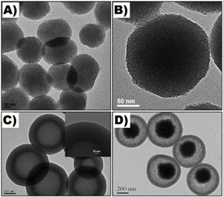

Figure 1 presents TEM images displaying various types of mesoporous silica nanoparticles (MSNs): bare MSNs (A, B), hollow MSNs (C), and MSNs with a magnetic nanoparticle core (D). Images (A), (B), (C), and (D) are reproduced with permission from sources [4, 5, 6], respectively.

**2. Common Types and Synthesis Methods of Silica Nanoparticles (SiNPs)**

**2.1 Non-Porous Silica Nanoparticles (N-SiNPs) or Silica Microspheres**

Non-porous silica nanoparticles (N-SiNPs) are a form of amorphous silica characterized by their lack of defined internal structure or specific pore formation. Despite this absence of structural porosity, N-SiNPs possess excellent biocompatibility, which has contributed to their broad application across various biomedical and pharmaceutical fields. Their stability and non-toxic nature make them ideal candidates for use in drug delivery systems, where they facilitate the transport of therapeutic agents to targeted locations within the body (7) (8) (9). Additionally, N-SiNPs are extensively utilized in medical imaging, acting as contrast agents to improve the visualization of tissues and structures. Their adaptability extends to enzyme encapsulation, allowing for the stabilization and protection of enzymes in different environments, as well as their function as stabilizers within therapeutic formulations, enhancing the overall effectiveness and shelf-life of pharmaceutical products.

Two main synthetic approaches are predominantly employed in the production of N-SiNPs. These methods allow for control over particle size and surface characteristics, thereby optimizing N-SiNPs for specific applications in drug delivery, imaging, and other therapeutic areas. Through these synthesis processes, researchers can tailor the properties of N-SiNPs to meet the unique requirements of different biomedical applications, further expanding their versatility and utility in modern medical technology (10).

**2.1.1 Pyrolysis Method**

Non-porous silica nanoparticles (N-SiNPs) synthesized through thermal processing are frequently referred to as pyrogenic or fumed silica due to the high-temperature combustion method employed. This technique involves the controlled combustion of silicon tetrachloride (SiCl₄) within a flame rich in both oxygen and hydrogen, reaching temperatures well above 1000°C. Under these extreme conditions, silicon tetrachloride reacts to form fine silica (SiO₂) particles, with sizes typically falling in the range of 5 to 50 nanometers. This precise size control makes pyrogenic silica highly valuable in various applications, particularly where uniform particle size and specific chemical properties are required [7].

Known as the aerosol route, this synthesis method [11], [12] utilizes an atomizer to produce fine aerosolized droplets, which then pass through a high-temperature zone where silica particles are generated. As the aerosolized silica travels through a cooling system, the particles start to agglomerate, leading to clusters that can be collected for further processing. The cooling step is essential, as it allows for the efficient separation of solid silica particles from by-products in the off-gas, specifically hydrochloric acid (HCl). A deacidification process follows to eliminate residual HCl from the particle surfaces, enhancing the purity and stability of the final N-SiNPs.

An advantage of this method lies in its flexibility; by adjusting the reaction parameters, such as the composition of the flame and the type or concentration of feedstock, scientists can fine-tune the physical and chemical properties of N-SiNPs to suit specific end uses. Modifications in flame temperature, fuel ratio, and silicon tetrachloride feed rate allow for precise control over particle characteristics, enabling the production of N-SiNPs with tailored features for applications in areas like drug delivery, coatings, and fillers, where particle uniformity and stability are critical [13].

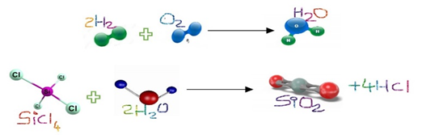

**2.1.2 Wet Method**

Unlike the high-temperature pyrolysis approach, the wet synthesis method for producing non-porous silica nanoparticles (N-SiNPs) typically yields colloidal or hydrated forms of silica as initial products. This method, which is often preferred for synthesizing nitrogen-doped N-SiNPs, utilizes more moderate reaction conditions, relying on solutions rather than flames. As a result, it avoids the extreme temperatures required in pyrolysis, offering a gentler, more flexible route to nanoparticle production.

The wet synthesis process involves the use of silica precursors, like tetraethyl orthosilicate (TEOS), which undergoes hydrolysis and condensation reactions in aqueous or alcoholic media to form silica nanoparticles. These reactions are typically catalyzed by either acidic or basic conditions, allowing for adjustments to be made to control the particle size and structure. By fine-tuning the pH level, temperature, and concentration of reactants, researchers can produce a range of particle sizes and properties tailored for specific applications.

An additional advantage of wet synthesis is its versatility in incorporating dopants, such as nitrogen, into the silica structure. Nitrogen-doped silica nanoparticles are of particular interest due to their enhanced functionality, especially in applications like catalysis, imaging, and drug delivery. The nitrogen doping can be achieved by introducing nitrogen-containing reagents during the reaction, allowing for modifications to the surface chemistry that improve the reactivity and biocompatibility of the nanoparticles.

Due to its adaptability and relative simplicity, the wet synthesis method has become one of the most widely used approaches for creating silica nanoparticles. It allows for controlled production of N-SiNPs with specific characteristics, without the need for complex and costly equipment associated with high-temperature methods, making it a practical choice for large-scale synthesis as well.

**2.1.2.1 Co-Precipitation Method**

The wet synthesis method typically involves treating an alkali metal silicate solution—often sodium silicate—with a dilute acid, such as hydrochloric or sulfuric acid. This reaction produces a gelatinous silica precipitate. Following this initial formation, the silica gel is carefully filtered and repeatedly washed to remove any residual salts or impurities that may have formed during the reaction.

Once thoroughly purified, the gel undergoes a controlled dehydration process to remove excess water, which helps in achieving the desired microporous structure. After dehydration, the material is finely ground, resulting in colorless silica particles with consistent microporosity. These microporous silica particles have a high surface area and are well-suited for various applications, including adsorption, catalysis, and biomedical uses, due to their stable structure and compatibility in various chemical environments.

This systematic approach not only yields high-quality silica particles but also allows for adjustments in particle size and pore distribution by modifying factors such as the concentration of the acid, the type of alkali metal silicate used, and the duration of the dehydration step. As a result, the wet synthesis technique remains a widely utilized and flexible method for producing microporous silica nanoparticles for a range of scientific and industrial applications if further refinement or expansion is needed (10),(13).

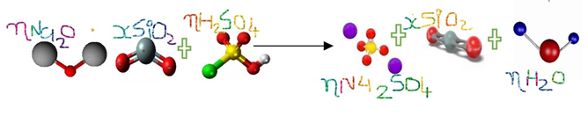

**2.1.2.2 Sol-Gel Synthesis**

The sol-gel synthesis method is a highly popular approach for fabricating silica nanoparticles (SiNPs), valued for its simplicity, scalability, and precise control over particle properties. This process starts with a hydrosol phase, in which tiny colloidal particles are suspended in a solution containing a mixture of alkoxide precursors—typically tetraethyl orthosilicate (TEOS)—and water. Through hydrolysis and condensation reactions, these precursors interact, leading to the gradual formation of a porous and amorphous silica gel.

As the reactions proceed, the solution begins to thicken, signifying the transition from a liquid to a gel state. This phase shift is characterized by an increase in viscosity and the aggregation of silica particles, which slowly interconnect, creating a network that forms the solid framework of the gel. Over time, the gel achieves a stable, solid form, often molded into a cubic or spherical structure, depending on the conditions of the process.

The sol-gel method is particularly advantageous because it allows for fine control over the particle size, porosity, and surface characteristics of SiNPs by simply adjusting variables such as the concentration of precursors, the pH of the solution, and the reaction temperature. This versatility makes sol-gel synthesis a foundational technique for producing SiNPs in various sizes and structures, suitable for applications ranging from drug delivery to catalysis.

**Acid Precipitation**

The acid precipitation method is a widely utilized technique for synthesizing silica nanoparticles (SiNPs), particularly when derived from silicon-rich biomass sources such as bamboo leaves (14), sugarcane bagasse (15), and paddy straw (16). This method begins with the incineration of the selected biomass to produce ash, which serves as a source of silica. The ash is then treated with a 2.5 N sodium hydroxide (NaOH) solution at approximately 100°C for several hours, a process that converts the silica into sodium silicate. This conversion is a crucial step in unlocking the silica for further processing.

Following this, concentrated sulfuric acid (H₂SO₄) is added to the sodium silicate solution, which lowers the pH and induces the precipitation of silica as solid particles. These silica precipitates are then carefully collected, filtered, and dried at controlled temperatures to obtain the desired SiNPs. The properties of the final nanoparticles, such as size, morphology, and purity, can be finely tuned by adjusting several process parameters, including the concentration of NaOH, pH levels, calcination temperature, and drying conditions. Through these modifications, researchers can optimize the characteristics of the silica nanoparticles to suit specific applications in areas such as drug delivery, water treatment, and catalysis.

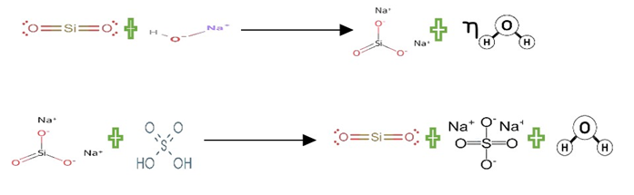

Azlina et al. [17] employed an acid precipitation method to synthesize nitrogen-doped SiNPs (N-SiNPs) using tetraethyl orthosilicate (TEOS) as the primary material. In this approach, acetic acid acts as a catalyst, and distilled water serves as the hydrolyzing agent. By carefully controlling reaction duration and calcination temperature, they successfully synthesized non-porous silica nanoparticles (N-SiNPs). The reaction period affects nanoparticle formation and size, while calcination temperature is crucial for improving crystallinity and removing residual materials.

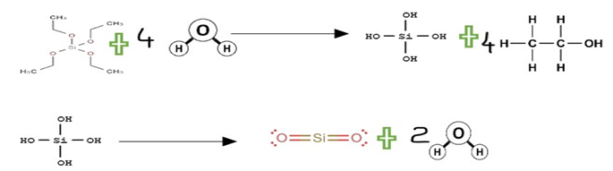

**Stöber Synthesis**

The Stöber method, first developed by W. A. Stöber in 1968, is a widely recognized and effective approach for synthesizing silica nanoparticles (SiNPs) with highly controlled size and uniformity. This versatile technique utilizes a physicochemical process to generate monodisperse silica particles, which are particles of a uniform size distribution. The method involves hydrolysis and condensation reactions, where alcohol or other organometallic silicon precursors are added to a solution containing silicon alkoxides, typically tetraethyl orthosilicate (TEOS).

In addition to its ability to produce uniform silica nanoparticles, the Stöber method is also capable of generating a variety of sol-gels from metallic salts and metal alkoxides. By carefully controlling reaction conditions, including the concentration of reactants, pH levels, and the choice of solvent, the Stöber process can be adapted to synthesize nanoparticles with specific surface properties, particle sizes, and shapes. This method's ability to tailor the characteristics of silica nanoparticles makes it a valuable tool for a range of applications, including drug delivery, biosensing, and catalytic processes.

**Reaction Mixture Preparation:**

* A mixture of ethanol, water, and ammonia creates a basic medium.
* TEOS is added as the silica precursor.

**Hydrolysis and Condensation:**

* TEOS undergoes hydrolysis to form silanol (Si–OH) groups.
* These silanol groups then condense, forming silica nanoparticles.

**Growth and Aging:**

* Adjusting the concentration of TEOS, water, and reaction time helps control nanoparticle size.
* Particles continue to grow as additional silanol groups condense.

**Separation and Purification:**

* Once the target particle size is achieved, nanoparticles are separated, usually by centrifugation or filtration.
* The nanoparticles are washed to remove reactants and impurities.

**Drying and Storage:**

* The purified silica nanoparticles are dried and stored for future use.

**Advantages**:

* Uniform Size: The Stöber method is highly effective for producing nanoparticles with a consistent and narrow size range.
* Versatility: It enables the addition of various dopants or functional groups to adjust the silica's properties.
* Scalability: This method can be scaled for industrial applications while retaining precise control over particle attributes.

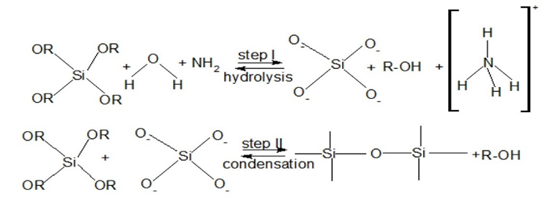

**Microemulsion Synthesis**

Microemulsion synthesis is a flexible and effective technique that offers precise control over the size and morphology of silica nanoparticles (SiNPs). This method is typically carried out within a water-in-oil (w/o) microemulsion system, which is a thermodynamically stable mixture of oil, water, and surfactant. This system acts as a nano-reactor, providing an ideal environment for the hydrolysis and condensation reactions of silica precursors. The reaction rate, particularly the hydrolysis process, is significantly influenced by the pH of the system (18).

Acidic conditions tend to accelerate the hydrolysis of silica precursors, facilitating the formation of silica nanoparticles. On the other hand, alkaline conditions promote condensation, favoring the growth of a silica network and controlling particle size. Base catalysis not only supports the formation of the silica structure but also enhances both condensation and dissolution, which plays a crucial role in determining the final particle size and uniformity. Conversely, acid catalysis tends to speed up the hydrolysis process while inhibiting condensation and dissolution, which can result in less defined or irregularly shaped nanoparticles.

Thus, precise regulation of pH is a critical factor in controlling the overall synthesis process and ensuring that the silica nanoparticles exhibit the desired characteristics, such as uniform size, shape, and surface properties.

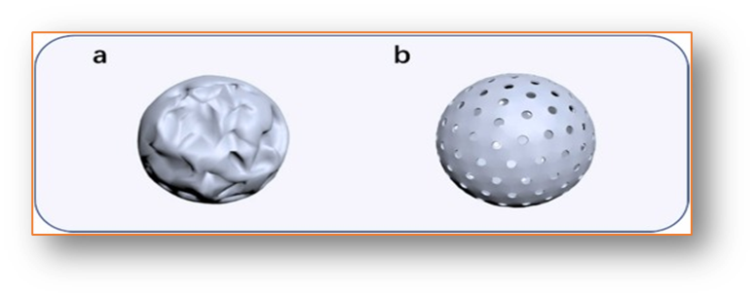

Figure 2 shows two widely recognized types of silica nanoparticles (SiNPs): (a) non-porous silica nanoparticles (N-SiNPs) and (b) mesoporous silica nanoparticles (M-SiNPs) [32].

Silicon nanoparticles (SiNPs) were synthesized using a sol-gel method in combination with a reverse micelle microemulsion process. In this technique, tetraethyl orthosilicate (TEOS) acts as the primary silica precursor, while Triton X-100 functions as the surfactant, methanol serves as the co-surfactant, and cyclohexane is used as the oil phase. The reverse micelle microemulsion method is known for its ability to offer precise control over the size and distribution of the nanoparticles, contributing to its high efficiency. However, despite its effectiveness, this method depends on organic solvents and costly surfactants, along with requiring additional purification and recovery steps. These factors create challenges for scaling up the process for large-scale production.

On the other hand, the Stöber synthesis method is more widely utilized in industry due to its practicality and scalability. This approach allows for better control over the size and morphology of SiNPs and is more cost-effective compared to microemulsion-based methods. Furthermore, the Stöber method holds considerable potential for further optimization, making it a preferred choice for large-scale production of silica nanoparticles.

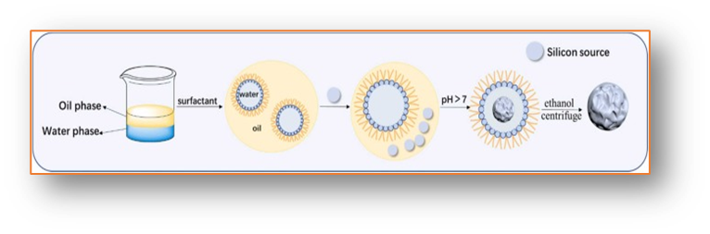

Figure 3 illustrates the microemulsion synthesis method for non-porous silica nanoparticles (N-SiNPs) [32].

**2.2 Mesoporous Silica Nanoparticles**

Mesoporous silica nanoparticles (M-SiNPs) are renowned for their unique structural characteristics and exceptional physicochemical properties (19). These include a high surface area, customizable porosity, outstanding thermal stability, and remarkable biocompatibility. These traits make M-SiNPs highly desirable for a variety of applications, including bioimaging, targeted drug delivery, and catalytic processes. The porosity and pore size of M-SiNPs can be meticulously adjusted to selectively retain molecules, enhancing their versatility in various fields. Additionally, M-SiNPs are often used as a fundamental material for the development of other advanced nanomaterials, broadening their scope of use in cutting-edge technologies.

There are several synthesis approaches for producing M-SiNPs, each with its own set of advantages. Some of the most commonly used methods include the improved Stöber synthesis, liquid crystal template-assisted synthesis, evaporation-induced self-assembly (EISA), and one-pot synthesis techniques. The template-assisted method is particularly popular due to its well-understood reaction mechanism, ease of controlling synthesis conditions, and adaptability to laboratory-scale production. By using various types of templates, researchers can synthesize a diverse range of M-SiNPs with tailored properties (22).

On the other hand, EISA, which relies on solvent evaporation to drive nanoparticle formation, is more suited for large-scale industrial production. Despite its scalability, this method has not yet been widely adopted due to certain limitations in its application. As M-SiNPs continue to gain traction in bioimaging and drug delivery, the demand for larger and more functionalized nanoparticles is on the rise. This has spurred researchers to explore more efficient and practical synthesis methods to meet these demands. One-pot synthesis, though still not fully understood in terms of its mechanistic details, holds significant promise for future advancements and is an area of active research.

**2.2.1 Liquid Crystal-Assisted Synthesis**

The template synthesis method, also referred to as liquid crystal-assisted synthesis, begins with the dissolution of a surfactant in a polar solvent, which results in the formation of liquid crystal suspensions. When the surfactant concentration exceeds the critical micelle concentration (CMC), micelles begin to form and can self-organize into various structures, such as cubic or lamellar arrangements. These micelles serve as templates, guiding the creation of pores within the final nanoparticle structure. Once the liquid crystal aggregates are formed, tetraethyl orthosilicate (TEOS) is introduced into the system to initiate sol-gel reactions that ultimately lead to the formation of mesoporous silica nanoparticles (M-SiNPs).

Following the formation of the mesoporous silica nanoparticles, the surfactant is removed through chemical or thermal degradation processes. These may involve methods such as refluxing the material in acidified alcohol, treating it with ammonium nitrate, or performing calcination, each of which helps to eliminate the surfactant while preserving the integrity of the mesoporous structure.

The mechanism behind this process is often referred to as the "swelling–shrinking" model, which involves several distinct stages. First, the surfactant molecules, such as cetyltrimethylammonium bromide (CTAB), self-assemble into micelles. Next, TEOS is solubilized within the hydrophobic cores of the micelles, which causes changes in the size and shape of the micelles. Following this, the TEOS undergoes hydrolysis, converting it into a hydrophilic form that can gradually release into the surrounding aqueous environment. Finally, the hydrolysis and condensation of silica occur, leading to the formation of silica monomers, which migrate from the micelle cores and create silica shells around them, resulting in the formation of mesoporous silica nanoparticles.

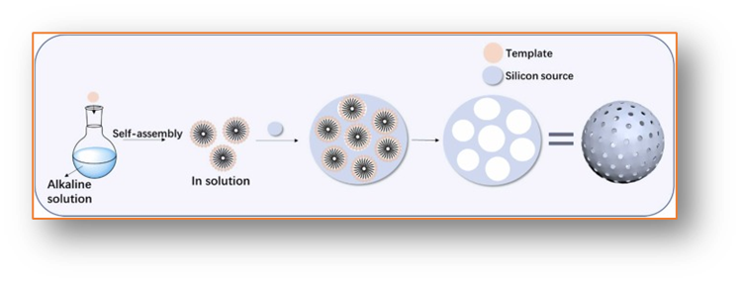

Figure 4 depicts the surfactant-assisted synthesis process for mesoporous silica nanoparticles (M-SiNPs) [32].

**3. Therapeutic and Diagnostic Applications of SiNPs**

**3.1 Drug Delivery and Therapeutic Approaches**

**3.1.1 Respiratory Tract**

Respiratory conditions, including serious diseases such as lung cancer, acute lung injury, and various infections like pneumonia and viral illnesses, continue to present significant health challenges globally (23). Recent advancements in nanotechnology have provided new opportunities for therapeutic interventions, particularly with the use of silicon nanoparticles (SiNPs). Among these, mesoporous silica nanoparticles (M-SiNPs) have emerged as promising candidates for drug delivery applications, particularly in the respiratory system. M-SiNPs are being developed to form inhalable, water-based aerosol formulations that allow for efficient and targeted delivery of therapeutic agents directly to the respiratory tract (24),(25).

In one notable study, researchers investigated the potential of M-SiNPs for treating airway inflammation in mice. The study showed that inhaled dexamethasone-loaded M-SiNPs, which were coated with polyethylene glycol–polyethylene imine (PEG–PEI), facilitated effective drug delivery to the lungs, resulting in improved therapeutic outcomes. This demonstrates the efficacy of M-SiNPs in overcoming the physiological barriers of the respiratory system and delivering drugs precisely where needed.

In the realm of lung disease treatment, various strategies have been explored to enhance the targeting and effectiveness of SiNP-based drug carriers. For instance, Van et al. designed avidin-coated M-SiNPs, which are customizable, biocompatible, and capable of carrying various therapeutic agents for precise delivery to lung tissues. Another research effort led by Fischer et al. involved the creation of cylindrical M-SiNP systems loaded with negatively charged small interfering RNA (siRNA) molecules aimed at targeting alveolar macrophages, key cells involved in lung inflammation and immune responses. Furthermore, Wang et al. focused on the treatment of acute lung injury associated with mitochondrial dysfunction. They employed selenium-doped porous SiNPs with antioxidant properties, designed to specifically target mitochondria and reduce oxidative stress, thus improving cellular function in damaged lung tissue.

Lung cancer, a disease with a survival rate of approximately 14% over six years, presents another challenging area where SiNP-based therapies are being developed. Non-small cell lung cancer (NSCLC) constitutes around 86% of lung cancer cases, and targeted therapies are crucial for improving patient outcomes. One innovative approach involves the use of myricetin-loaded M-SiNPs conjugated with multidrug-resistant protein 1 (MRP1) siRNA and folic acid. This formulation has shown potential in preclinical studies to inhibit tumor growth by selectively targeting cancer cells while overcoming drug resistance mechanisms (26). Additionally, Zhou et al. developed erlotinib-loaded hollowed-out M-SiNPs, which are designed to form a gel at body temperature. This gelation property allows for prolonged, localized release of the drug, offering sustained treatment for NSCLC.

In another promising strategy, doxorubicin, a widely used chemotherapy drug, has been co-encapsulated with cyclosporin within photoluminescent, carbon-based quantum dots embedded in M-SiNPs. This combination targets lung cancer DNA with high precision, enhancing the therapeutic efficacy while minimizing off-target effects. Madajewski et al. also proposed a novel formulation of ultrasmall core-shell SiNPs (less than 8 nm in size) linked with gefitinib–dipeptide drug conjugates. This approach enhances the drug delivery capability of the nanoparticles while reducing associated toxicity. Finally, an innovative method to overcome drug resistance involves coating SiNPs with cancer cell membranes. This allows for the co-delivery of miR495, a microRNA that targets P-glycoprotein, along with doxorubicin, providing an effective strategy to combat multidrug resistance in lung cancer treatment.

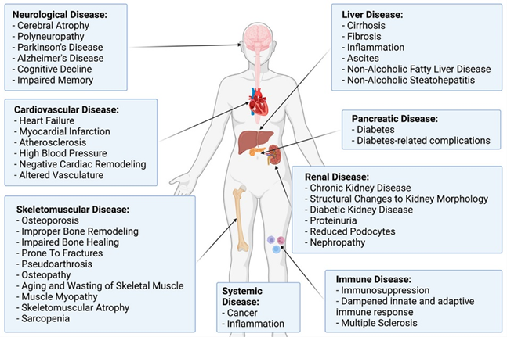

Fig. 5. SiNPs as Drug Carriers for Treating Diseases in the Human System [31].

**3.1.2 Digestive System Organs**

Silicon nanoparticles (SiNPs) with sizes larger than 7 nm tend to accumulate in the liver, particularly in hepatocytes. This is because liver cells play a key role in eliminating foreign particles through enzymatic degradation or excretion in bile. Research has demonstrated that SiNPs with sizes of 10 nm and 100 nm can be used safely as carriers for drugs and genes, making them promising tools for medical applications (27). Furthermore, SiNPs that are specifically engineered to target liver cells have the potential to improve the delivery of therapeutic agents for liver diseases, such as hepatitis, liver cancer, and fatty liver disease, by ensuring targeted and efficient treatment delivery.

For example, mesoporous silica nanoparticles (M-SiNPs) loaded with miR-33 antagomirs are being developed to specifically target liver tissue. These SiNPs aim to treat lipid metabolism disorders by delivering antagomirs directly to hepatocytes. miR-33 is a microRNA involved in regulating lipid metabolism, and by inhibiting its activity, these M-SiNPs help normalize lipid profiles and enhance metabolic function in the liver. This targeted approach shows promise for treating conditions like non-alcoholic fatty liver disease (NAFLD) and other related metabolic disorders (28).

**3.1.3 Vascular System**

Cardiovascular diseases, which remain the leading cause of death and disability globally (29), encompass a wide range of conditions such as myocardial ischemia-reperfusion injury, heart attacks, and heart failure. These diseases pose significant challenges to public health and medical management worldwide.

Silicon nanoparticles (SiNPs) can be strategically engineered to target endothelial cells within blood vessels, offering a promising approach for the localized treatment of various vascular conditions, including atherosclerosis and vascular inflammation. These nanoparticles are capable of carrying therapeutic agents such as anti-inflammatory drugs or gene therapies to the affected sites, thereby reducing plaque buildup and enhancing endothelial function, which is vital for managing diseases affecting coronary and peripheral arteries. SiNPs designed to release their payloads in a controlled manner can provide long-lasting therapeutic effects, reducing the need for frequent dosing, particularly in the treatment of chronic cardiovascular conditions.

Moreover, SiNPs have applications in medical imaging, serving as contrast agents for techniques like MRI and ultrasound. This enhances the visualization of cardiovascular structures, aiding in more accurate diagnostics and disease monitoring. Additionally, SiNPs can deliver antioxidants directly to the heart tissue, helping to counteract oxidative stress and protect heart cells from damage. In the aftermath of heart attacks, SiNPs can also facilitate the targeted delivery of stem cells or growth factors, promoting tissue repair and supporting functional recovery of the heart muscle.

**Conclusion**

The widespread utilization and production of silicon nanoparticles (SiNPs) are largely due to their remarkable physical and chemical properties, which make them ideal candidates for a range of applications. Consequently, it is crucial to thoroughly examine the principal synthesis techniques employed in their production to fully understand their capabilities and potential.

Among these synthesis methods, the sol-gel process—particularly the Stöber method—has seen substantial progress over time. These advancements have led to improved stability, functionality, and biocompatibility of SiNPs, particularly in biomedical fields. Today, SiNPs are widely used in drug delivery, therapeutic interventions, and medical diagnostics, functioning as both carriers and reagents. By modifying their surface chemistry or incorporating specific functional groups, SiNPs can be tailored to target particular organs or tissues, enabling efficient and targeted delivery of drugs, gene therapies, or proteins. Although cancer treatment remains a focal point of current SiNP research (30), their potential spans a wide array of diseases affecting various human systems.

In the context of medical diagnostics, SiNPs are categorized based on five distinct types of imaging reactions. Recent breakthroughs in SiNP research have highlighted their versatility and potential as a powerful platform for both treatment and diagnosis. Despite these advancements, further work is needed to develop standardized, unified protocols for evaluating nanoplatforms in biological environments. Achieving this will be essential for ensuring the safety, reliability, and effectiveness of SiNPs in clinical and commercial applications.

**References**

1.R. Diab, N. Canilho, I.A. Pavel, F.B. Haffner, M. Girardon, A. Pasc, Silica-based systems for oral delivery of drugs, macromolecules and cell, Adv. Colloid Interface Sci., 249 (2017), pp. 346-362.  
 2.J. Florek, R. Caillard, F. Kleitz,Evaluation of mesoporous silica nanoparticles for oral drug delivery - current status and perspective of MSNs drug carriers, Nanoscale, 9 (40) (2017), pp. 15252-15277.

3.S.Y. Hsu, R. Morris, F. Cheng, Signaling pathways regulated by silica nanoparticles, Molecules, 26 (5) (2021), [10.3390/molecules26051398](https://doi.org/10.3390/molecules26051398).

4. H. Xu, et al. A facile route for rapid synthesis of hollow mesoporous silica nanoparticles as pH-responsive delivery carrier, J. Colloid Interface Sci., 451 (2015), pp. 101-107.

5.Q. Zhang, et al., Multifunctional mesoporous silica nanoparticles for cancer-targeted and controlled drug delivery, Adv. Funct. Mater., 22 (2012), pp. 5144-5156.

6. X. Chen, et al., Transferrin gated mesoporous silica nanoparticles for redox-responsive and targeted drug delivery, Colloids Surf. B: Biointerfaces, 152 (2017), pp. 77-84.

7.S. Rangaraj, R. Venkatachalam, In vitro and in vivo characteristics of biogenic high surface silica nanoparticles in A549 lung cancer cell lines and Danio rerio model systems for inorganic biomaterials development, Artif. Cells Nanomed. Biotechnol., 46 (7) (2018), pp. 1415-1424,

8.O. Okoturo,Evans, A. Dybowska, E. Valsami,Jones, J. Cupitt, M. Gierula, A.R. Boobis, R.J. Edwards, Elucidation of toxicity pathways in lung epithelial cells induced by silicon dioxide nanoparticles, PLoS One, 8 (9) (2013).

9. C. Mochizuki, J. Nakamura, M. Nakamura, Development of non-porous silica nanoparticles towards cancer photo-theranostics, Biomedicines, 9 (1) (2021),

10.E.P.O.F. Additives, F. NutrientSourcesaddedto, M. Younes, P. Aggett, F. Aguilar, R. Crebelli, B. Dusemund, M. Filipic, M.J. Frutos, P. Galtier, D. Gott, U. GundertRemy, G.G. Kuhnle, J.C. Leblanc, I.T. Lillegaard, P. Moldeus, A. Mortensen, A. Oskarsson, I. Stankovic, I. WaalkensBerendsen, R.A. Woutersen, M. Wright, P. Boon, D. Chrysafidis, R. Gurtler, P. Mosesso, D. Parent,Massin, P. Tobback, N. Kovalkovicova, A.M. Rincon, A. Tard, C. Lambre, Re-evaluation of silicon dioxide (E 551) as a food additive, EFSA J., 16 (1) (2018).

11.A. Panas, A. Comouth, H. Saathoff, T. Leisner, M. AlRawi, M. Simon, G. Seemann, O. Dossel, S. Mulhopt, H.R. Paur, S. Fritsch-Decker, C. Weiss, S., Diabate Silica nanoparticles are less toxic to human lung cells when deposited at the air-liquid interface compared to conventional submerged exposure Beilstein J. Nanotechnol., 5 (2014), pp. 1590-1602.

12.A.M. Mebert, C.J. Baglole, M.F. Desimone, D. Maysinger, Nanoengineered silica: properties, applications and toxicity Food Chem. Toxicol., 109 (Pt 1) (2017), pp. 753-770.

13. K. Rasmussen, A. Mech, J. Mast, P. Temmerman, N. Waegeneers, F.V. Steen, J.C. Pizzolon, L.D. Temmerman, E.V. Doren, K.A. Jensen, Synthetic Amorphous Silicon Dioxide (NM-200, NM-201, NM-202, NM-203, NM-204): Characterisation and Physico-Chemical Properties JRC Repository: NM-series of Representative Manufactured Nanomaterials, 2013.

14. S. Rangaraj, R. Venkatachalam, A lucrative chemical processing of bamboo leaf biomass to synthesize biocompatible amorphous silica nanoparticles of biomedical importance, Appl. Nanosci., 7 (5) (2017), pp. 145-153.

15.J. Athinarayanan, V.S. Periasamy, M. Alhazmi, A.A. Alshatwi, Synthesis and biocompatibility assessment of sugarcane bagasse-derived biogenic silica nanoparticles for biomedical applications, J. Biomed. Mater. Res B Appl. Biomater., 105 (2) (2017), pp. 340-349.

16..M.N.A. Uda, S.C.B. Gopinath, U. Hashim, N.H. Halim, N.A. Parmin, M.N. Afnan Uda, P. Anbu, Production and characterization of silica nanoparticles from fly ash: conversion of agro-waste into resource, Prep. Biochem Biotechnol., 51 (1) (2021), pp. 86-95.

17. Top of Form.

Bottom of Form

H.N. Azlina, J.N. Hasnidawani, H. Norita, S.N. Surip, Synthesis of SiO2nanostructures using Sol-Gel method, Acta Phys. Pol. A, 129 (4) (2016), pp. 842-844.

18.K.S. Finnie, J.R. Bartlett, C.J. Barbé, L. Kong, Formation of silica nanoparticles in microemulsions, Langmuir, 23 (6) (2007), pp. 3017-3024.

19. M. Gisbert-Garzaran, D. Lozano, M. Vallet-Regi, Mesoporous silica nanoparticles for targeting subcellular organelles, Int J. Mol. Sci., 21 (24) (2020).

20. J. Liu, T. Liu, J. Pan, S. Liu, G.Q.M. Lu, Advances in multicompartment mesoporous silica micro/nanoparticles for theranostic applications, Annu Rev. Chem. Biomol. Eng., 9 (2018), pp. 389-411.

21. J. Lu, M. Liong, J.I. Zink, F. Tamanoi, Mesoporous silica nanoparticles as a delivery system for hydrophobic anticancer drugs, Small, 3 (8) (2007), pp. 1341-1346.

22. D. Ren, J. Xu, N. Chen, Z. Ye, X. Li, Q. Chen, S. Ma, Controlled synthesis of mesoporous silica nanoparticles with tunable architectures via oil-water microemulsion assembly process, Colloids Surf. A: Physicochem. Eng. Asp., 611 (2021).

23. A. Garcia-Fernandez, F. Sancenon, R. Martinez-Manez, Mesoporous silica nanoparticles for pulmonary drug delivery, Adv. Drug Deliv. Rev., 177 (2021).

24.X. Li, M. Xue, O.G. Raabe, H.L. Aaron, E.A. Eisen, J.E. Evans, F.A. Hayes, S. Inaga, A. Tagmount, M. Takeuchi, C. Vulpe, J.I. Zink, S.H. Risbud, K.E. Pinkerton, Aerosol droplet delivery of mesoporous silica nanoparticles: a strategy for respiratory-based therapeutics, Nanomedicine, 11 (6) (2015), pp. 1377-1385.

25. T. Gulin-Sarfraz, S. Jonasson, E. Wigenstam, E. von Haartman, A. Bucht, J.M. Rosenholm, Feasibility study of mesoporous silica particles for pulmonary drug delivery: therapeutic treatment with dexamethasone in a mouse model of airway inflammation, Pharmaceutics, 11 (4) (2019).  
26.Y. Song, B. Zhou, X. Du, Y. Wang, J. Zhang, Y. Ai, Z. Xia, G. Zhao, Folic acid (FA)-conjugated mesoporous silica nanoparticles combined with MRP-1 siRNA improves the suppressive effects of myricetin on non-small cell lung cancer (NSCLC), Biomed. Pharm., 125 (2020).

27. O. Tuncel, E. Kahraman, G. Bagci, N. Atabey, S. Ozcelik, Engineered silica nanoparticles are biologically safe vehicles to deliver drugs or genes to liver cells, Mater. Sci. Eng. C Mater. Biol. Appl., 119 (2021),

28.Y. Tao, S. Xu, J. Wang, L. Xu, C. Zhang, K. Chen, Z. Lian, J. Zhou, H. Xie, S. Zheng, X. Xu, Delivery of microRNA-33 antagomirs by mesoporous silica nanoparticles to ameliorate lipid metabolic disorders, Front Pharm., 11 (2020), p. 921.

29. C.J. Liu, L. Yao, Y.M. Hu, B.T. Zhao, Effect of quercetin-loaded mesoporous silica nanoparticles on myocardial ischemia-reperfusion injury in rats and its mechanism, Int. J. Nanomed., 16 (2021), pp. 741-752.

30.T. Li, S. Shi, S. Goel, X. Shen, X. Xie, Z. Chen, H. Zhang, S. Li, X. Qin, H. Yang, C. Wu, Y. Liu, Recent advancements in mesoporous silica nanoparticles towards therapeutic applications for cancer, Acta Biomater., 89 (2019), pp. 1-13.

31. I. Ponton, A. Marti Del Rio, M. Gomez Gomez, D. Sanchez-Garcia, Preparation and applications of organo-silica hybrid mesoporous silica nanoparticles for the Co-delivery of drugs and nucleic acids, Nanomaterials, 10 (12) (2020).

32.Yanmei Huang, Peng Li, Ruikang Zhao, Laien Zhao, Jia Liu, Shengjun Peng, Xiaoxuan Fu, Xiaojie Wang, Rongrui Luo, Rong Wang, Zhuhong Zhang, Silica nanoparticles: Biomedical applications and toxicity, Biomedicine & Pharmacotherapy, 151(2022), 113053.