“THE IMPACT OF HEALTHCARE SUPPLY CHAIN ON PATIENTS”
Prakash. A ¹ , Harun Pothu ²

Authors:
1 Prof. Prakash A, Professor, MBA Department, Krupanidhi College of Management, Krupanidhi Group of Institutions, Bengaluru, India
2. Harun Pothu, PGDM 2022 batch, KSM, Krupanidhi Group of Institutions Bengaluru, India

Abstract:
Heathcare Supply Chain Management (HSCM), is a fragmented and complicated process. Healthcare supply chain involves the delivery of goods and services by obtaining the resources and manufacturing the required product to all hospitals for the public healthcare of all communities. However, increasing the efficiency of HSCM sector may reduce the substantial cost across their organizations.
HSCM, involves procurement, operations management, transportation logistics and sales channels: The raw materials could be converted into useable products and delivered to the end users, customers. HSCM is a systematic management of flow of goods, finances, information and data of products or services from sourcing of raw-materials to handover of products to the end-users.
HSCM activities links procurement, manufacturing, operations management, transportation logistics and sales channels i.e., Supply Chain planning inventory and maintenance of enterprise assets and manufacturing plant/s, logistics transportation and sales order management. HSCM could extend to global trade such as management of global suppliers and multiple production practices.
This study is to recognize the importance of HSCM to achieve organizational goals. The issues faced by the customers / patients, unavailability of particular medicine, lack of time management for the appropriate supplies at the appropriate time. In-time availability of inventory of medicines and enhancing administrative work flow. The organizations may face many problems due to their inefficiency and improper organization in HSCM. Also respondents understanding of HSCM system being functioning at healthcare organizations and inventory management.

Key Words:
Heathcare-Supply-Chain-Management (HSCM), Healthcare, Supply Chain Management (SCM), Inefficiency, Inventory Management, Radio Frequency Identification (RFID), Workflow.

INTRODUCTION
Heathcare Supply Chain Management (HSCM) in the hospitals have operational functions such as inventory management and supply of healthcare products to the healthcare organizations. The problem faced by majority of the healthcare organizations are the issue of distribution and storage of the healthcare products which would highly impact on the reputation and the top quality patient care service of the organization. HSCM necessitate the process of handling healthcare products like medical equipment, surgical products, sterilized items, clothes, hygienic food, etc. and information flows from the origin to their delivery at specific healthcare locations as planned. According to the reports, the costs of supplying the products are highest in terms of expenses in hospitals, next to human resources costs. The HSCM need to fulfill progressive results and higher productivity. The HSCM team need to find the probabilities to improve the HSCM activities to reduce the costs, improve the quality of patient care service. A good understanding of the HSCM activities are required for the betterment of HSCM activities. The proper routine analysis of performance is important to find out the weakness in the activities, and also it would be insights for the organization’s decision making processes.
The HSCM in healthcare organizations are characterized by its challenges in operations, such as lifesaving medicines, costly medical instruments and equipment utilized in operation theatres, tracking of inventory because of the urgent treatments and volatile requirements for medical supplies. Various medical equipments may be in storage facilities in the laboratories, hospitals and operational processes results in achieving top quality healthcare service of the organization. Therefore, it is good to have effective supply chain practices in healthcare organizations for proper managing and distribution of the supplies to particular units. In the past few years, the supply chain operations cost has increased. The main reason for the cost increment is due to the wastes in healthcare supply chain activities. Particularly the operation theatre turned into a crucial cost pushing element for a hospital. 40 percent to 60 percent of the hospital supply chain expenses are used for medical equipment and different other supplies in the operation theatre. Managing these supplies in an effective and productive way have been a challenge for so long. Unavailability of any of the medical equipment may postpone a surgical process and it may result as trouble for patient’s health. Whereas, overstocking and hiding the supplies in the storage facilities would increase the supply chain cost as well as leads to inefficient logistics processes.
HSCM is the information, data of materials and funds concerning procurement, transportation of finished products, services from the manufacturers to the patients / customers to rise clinical effects, also calculating and regulating costs. The HSCM activities requires proper coordination and interaction to achieve the commitments of the supply chain processes such as distribution, storage and inventory activities. Good cooperation and coordination contributes in a positive manner to the healthcare supply chain performance. The prime challenge for operational researchers is to make sure the top quality patient care service with the minimal resource available like operation theatres, healthcare equipment and other supplies, healthcare personals etc. The topmost priority is to enhance an efficient and high quality system for delivering the services at right place at right time.
The primary emphasis of this study is on internal HSCM processes, challenges, how to figure it out in a cost effective way. Delivering top quality patient care service is the topmost priority for any HSCM organization. In order to achieve that, solving such challenges faced in healthcare supply chain would be a mandatory element for the management.

CHALLENGES IN HEALTHCARE SUPPLY CHAIN
HSCM is distinctive from supply chain in every other industry, even though it involves movement of goods from manufacturing place to end user patients, as these goods supplied can be a reason for life and death of the patients. Also managing and coordinating healthcare supply chain creates more expenses for the suppliers. The biggest challenges faced in healthcare supply chain are:
Shortage of drugs: The variation that comes with the healthcare industry makes deficiencies seem certain. The healthcare supply chain can be impacted by this. This may result in procuring alternatives at higher prices.
Instant shipping: In the medical sector, unforeseen events could occur, and healthcare facilities are obligated to deal with them, regardless of the financial burden. The suppliers may incur more expenses leading to losses. Suppliers can totally eliminate their first instant / overnight shipping costs with better stock arrangements.
Item shipping expenses: Another challenge healthcare services suppliers face is the hidden expenses of each item. The majority of suppliers recently examined the item and shipping costs. Complete landed supply costs may require suppliers to strategize their financial plan. The unavoidable part of lapsed items and surplus supplies should be known to them. Items standards and price tag change are to be considered. Quality healthcare services scheduling comes to the forefront here. This implies item use, uncommon conveyances, internal distribution, and such other things.
Data and Information Flow: Data and information flow from input sources, through various processes, and finally to output destinations. The HSCM data and information are used to analyze processes to visualize and understand the data flow and processes within a Company and its supply chain system.

HEALTHCARE MANAGEMENT
Healthcare is not a new term that has originated; in fact, it has always been a part of history. People have been continuously devising ways to improve their healthcare status from pre-historic times to date. The World Health Organization (WHO) has made a significant contribution to transforming global healthcare. WHO is the guiding and managing authority for global health.

HEATHCARE SCM
HSCM activities consists of demand forecasting, raw material sourcing, manufacturing, inventory management, storage, transportation logistics and return of surplus, damaged or faulty products. These processes needs to enhance the movement of materials, flow of information and financial transactions.
Every supplier, manufacturer and distribution channel depend on inventory management, storage, transportation and speed of delivery with collaborative communication between these partners.
HSCM sustainability comprises of environmental, social, and legal issues. These companies have follow statutory regulations and also impact of social well-being and environment.

REVIEW OF LITERATURE
HSCM is the operations followed by the manufacturers to transfer the products or services to end users. HSCM activities comprise of procurement of raw materials from the suppliers to finished goods or services through its sales distribution channels and transportation companies. Similarly the return of unsold goods or defective goods by the end user customers.
Application of Just-in-Time (JIT) technique adopted by HSCM has shown that a cost reduction on the medical supplies and also reengineering, outsourcing has in effect become cost-efficient utilizing information technologies (IT) by identifying suppliers has been advantageous for cost reduction.
HSCM requires to emphasize on cure and care of patients by many healthcare products /services suppliers in order to improve the HSCM by taking the inputs from multiple medical service providers. The lead-time of supplier/s and unification of Internet of Things (IoT) practices have been the focus of HSCM efforts.
Use of RFID (Radio Frequency Identification) in HSCM: The RFID enables the visibility of products / services movements to managers about the items to be tracked. It would also reduce on labor costs, shrinkage reduction and inventory visibility.
In Hospitals sector supply chain, value and profitability is related to flow of information, services and operational costs generate costs within the HSCM. Hence, appropriate management of these flows is the key to supply chain success, therefore a success to motivate a hospital – provide best healthcare. The HSCM in a hospital involves the management of flows of their health care products and services between and among stages to maximize total profitability and at the same time provide best healthcare using technology.

Effective HSCM operates in following areas:
Procedural development of product management including maintenance, compliance, clinical engagement standardization and demand-matching.
Raw material sourcing: Vendor selection and partnerships, Group Purchasing, product portfolio management, pricing, coordination and contracting.
Purchasing of commodities, centralized purchasing systems, payment cycle - settlement of receipts and account auditing.
Inventory and distribution management: Ordering, stock taking, monitoring stocks, locating the right vendors, replenishing cycle and managing stocks.
HSCM Logistics is the process of strategically achieving the sourcing, transporting, warehousing of materials by the companies and its sales channels systematically that the present and upcoming supply flow optimization to fulfill the orders cost effectively.
Hospitals deal with items majority of it are perishable in nature which includes medicines and other biological products. The medicines such as lifesaving drugs are very expensive hence heavy loss of money is incurred if they are not used before expiry dates. They have to be stored, issued, used and ordered in very efficient way. Logistics department have to take care of this as Fist in First out (FIFO) policy and HSCM may adopt Just-in-Time (JIT) process. Use of technology such as Barcode, Radio Frequency Identification (RFID), and QR code are identified in terms of costs and operating procedures.
Operating expenses at hospitals is a major issue of concern. Major part of expenses goes to supplies, drugs and consumables. Streamlining the workflow, product standardization, informed purchasing, inventory management, information management are few of the performance measures of HSCM which help to control the operating expenses. A small reduction in inventory management expenses may impact on hospital working capital savings.
Amini et.al (2007) applied Radio Frequency Identification to trace patients in the hospital. RFID enhanced tracing the patients time to about 80 percent from 25 percent in the trauma centre. The patients spent more time i.e. 10 - 12 hours for treatment. RFID enabled to gather the data in a inactive way avoiding any obstructions with medical procedures such as process cycle time, patient’s responsive level, data collection, machinery and utilization of people.
Wasingtu Gosaye Bekele, et. al. (2022) The global market is volatile, competition in any business has led the managers to relook at their practices, operations and business models to emerge as a success.
Anusha Thakur (2022) the digitalization in business using Artificial Intelligence in Industrial Automation and Automated Guided Vehicles gaining traction, may lead to fulfill the demand and supply in the future.
Shivam Kamat, Avadesh Dalpati (2021) Internet of Things as technology has network of devices and machines that can interact among themselves which has revolutionized as to utilize the network of devices and sensors such as RFID tags, sensors, to collect data, process them and helps in decision making for inventory control, customer management, business analytics and such other activities.
Aronsson, Abrahamsson and Spens (2011) believe that the HSCM in healthcare industry, established the practice of HSCM could be lean and agile.
Objectives
- The study is to understand the importance of HSCM to achieve organizational goals.
- The issues faced by the customers / patients, unavailability of particular medicine, lack of time management for the correct supplies at the correct time.
- Also understanding of the supply chain system being functioning at healthcare organizations and inventory management. In-time availability of inventory of medicines and enhancing administrative work flow.

RESEARCH METHODOLOGY
This section covers research design and apparatuses for analysis.
Research Design
The survey design used is Primary source of data collection using the structured questionnaire.
The technique used to collect questionnaire was Random sampling. The data collection was conducted from 128 respondents comprising of 61 male and 67 female respondents respectively. The survey covered all levels of healthcare services with respect to Information Technology, Health care and Retails of pharmacy. Tools used for analyze the data are correlation analysis, descriptive statistics.
The data analyzed using descriptive statistics and inference statistics.
DATA ANALYSIS 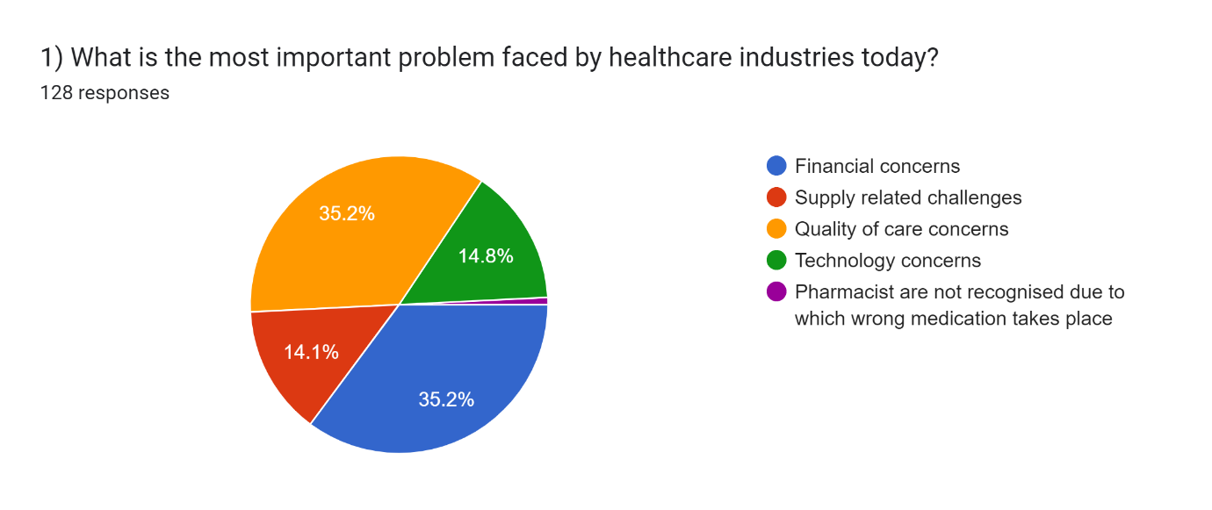
Chart 1

Analyzed that, the most important problem faced by the healthcare industry today is financial concerns, which accounted for 35.2% of the responses. This is followed by quality-of-care concerns and supply-related challenges, each accounting for 35.2% and 14.1% of the responses, respectively. Technology concerns also received significant attention at 14.8%. Additionally, a small percentage of respondents (0.8%) highlighted the issue of pharmacists not being recognized, leading to wrong medication.
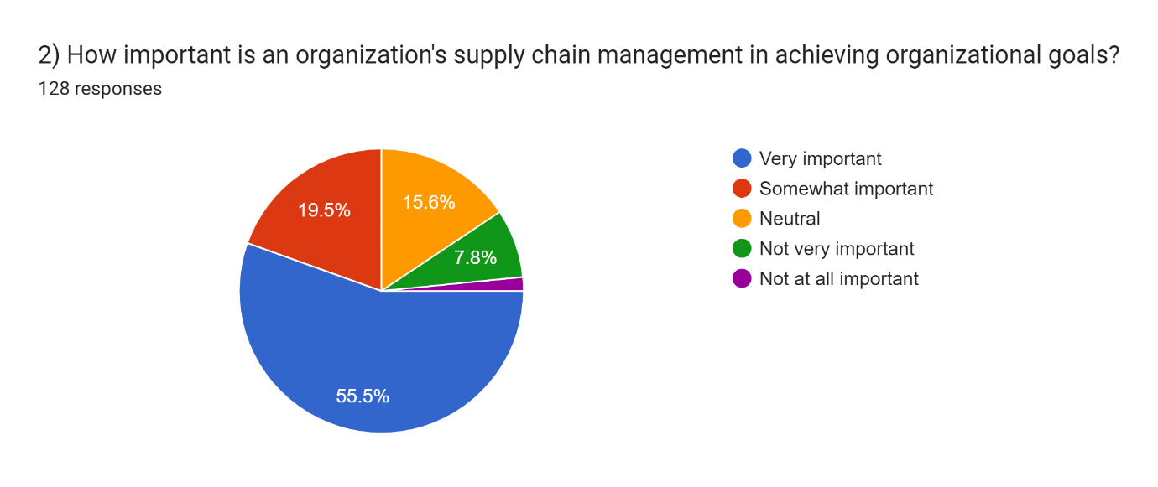
Chart 2

Majority of the respondents (55.5%) consider an organization's supply chain management to be very important in achieving organizational goals. This suggests that efficient and effective management of the HSCM is seen as success. Additionally, 19.5% of the respondents believe it is somewhat important, reinforcing the overall significance of HSCM in organizational performance.
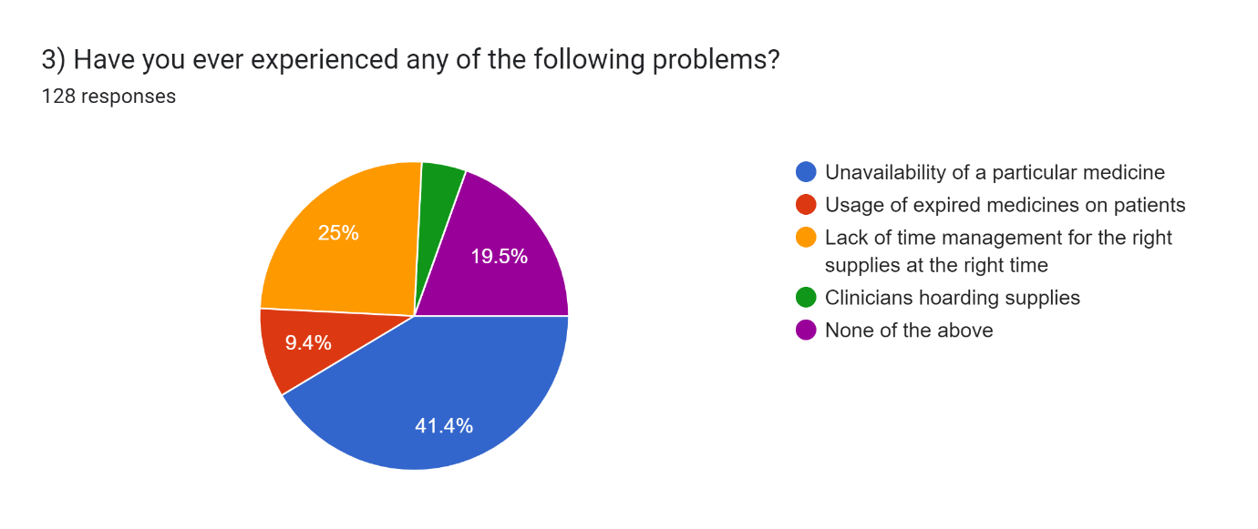
Chart 3

Particulars | Age Group | Respondents
Clinicians hoarding supplies | 18-25 | 1
Clinicians hoarding supplies | 26-35 | 1
Clinicians hoarding supplies | 36-45 | 4
Clinicians hoarding supplies | 45 & above
Lack of time management for the correct supplies at the correct time | 18-25 | 19
Lack of time management for the correct supplies at the correct time | 26-35 | 10
Lack of time management for the correct supplies at the correct time | 36-45 | 3
Lack of time management for the correct supplies at the correct time | 45 & above
None of the above | 18-25 | 24
None of the above | 26-35
None of the above | 36-45 | 1
None of the above | 45 & above
Unavailability of a particular medicine | 18-25 | 40
Unavailability of a particular medicine | 26-35 | 8
Unavailability of a particular medicine | 36-45 | 3
Unavailability of a particular medicine | 45 & above | 2
Usage of expired medicines on patients | 18-25 | 7
Usage of expired medicines on patients | 26-35 | 4
Usage of expired medicines on patients | 36-45 | 1
Usage of expired medicines on patients | 45 & above
No association between different age groups and the problems faced in most cases.
Only in the case of clinicians hoarding supplies we see that there's a significant association
Top 2 features based on chi square
a) Clinicians hoarding supplies
b) Unavailability of a particular medicine
Table 1

According to the most common problem experienced by respondents is the unavailability of a particular medicine, accounting for 41.4% of the responses. Another significant issue is the usage of expired medicines on patients, which was reported by 9.4% of the respondents. Additionally, 25% of the participants mentioned a lack of time management for the right supplies at the right time, while 4.7% reported clinicians hoarding supplies as a problem. These findings highlight the challenges faced in ensuring medication availability and proper supply management in healthcare settings.
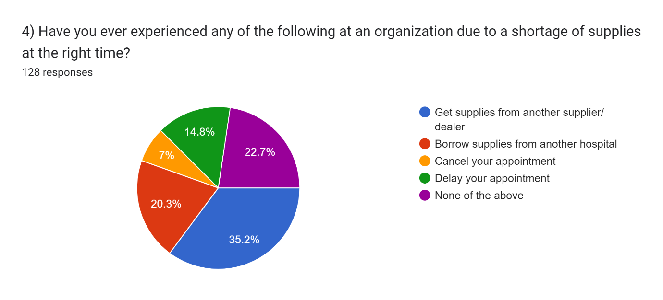
Chart 4

When organizations face a shortage of supplies at the right time, the most common solution is to get supplies from another supplier or dealer, which accounts for 35.2% of the responses. Another approach is to borrow supplies from another hospital, reported by 20.3% of the respondents. In some cases, individuals may have had to cancel their appointments (7%) or experience appointment delays (14.8%) due to the shortage. These findings indicate the various strategies employed to address supply shortages and minimize disruptions in healthcare services.
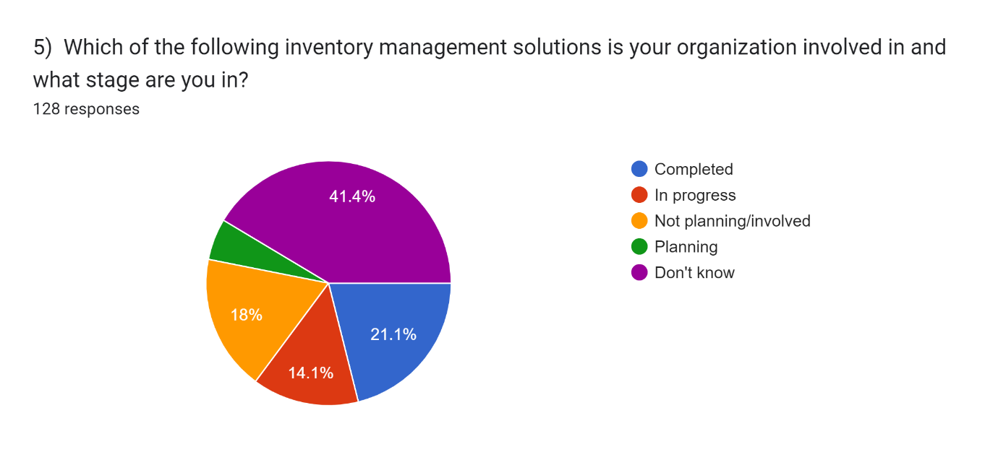
Chart 5

Accordingly that 21.1% of organizations have completed implementing an inventory management solution. 14.1% are currently in progress with their implementation, while 18% are not planning or involved in any inventory management solutions. Additionally, 5.5% of organizations are in the planning stage of implementing such a solution. These findings suggest that a significant portion of organizations have recognized the importance of inventory management and are either in progress or have completed implementing solutions, while a notable percentage has yet to engage in such initiatives.

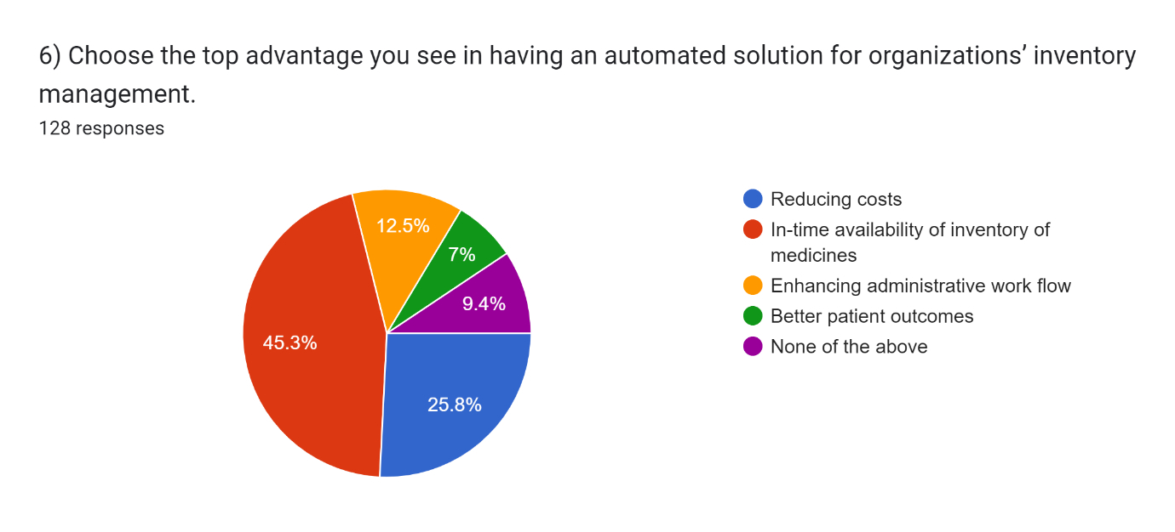
Chart 6

The top advantage noticed in supply management is the timely availability of inventory of medicines, accounting for 45.3% of the responses. This is followed by reducing costs, which was selected by 25.8% of the participants. Other perceived advantages include enhancing administrative workflow (12.5%) and achieving better patient outcomes (7%). These findings highlight the importance of timely inventory availability and cost reduction as key benefits of implementing automated inventory management systems in healthcare organizations.

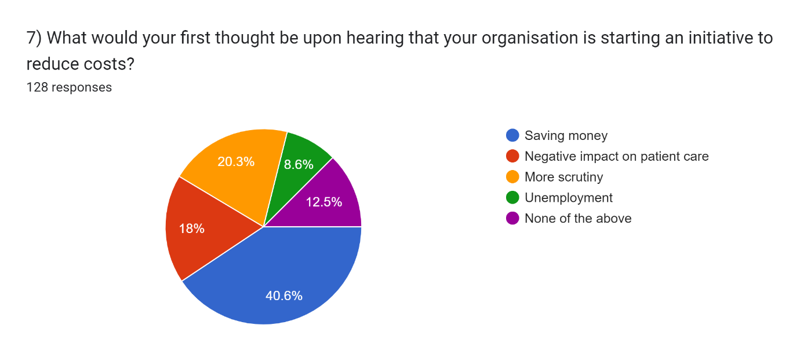
Chart 7

Analyzed that the majority of individuals (40.6%) would perceive the initiative to reduce costs as a means of saving money for the organization. However, a notable concern is that 18% of respondents worry about a potential negative impact on patient care. Additionally, 20.3% anticipate increased scrutiny on expenses, while 8.6% express concerns about the possibility of unemployment. These findings indicate a mix of positive and negative expectations associated with cost reduction initiatives, with a focus on balancing financial savings while ensuring quality patient care.
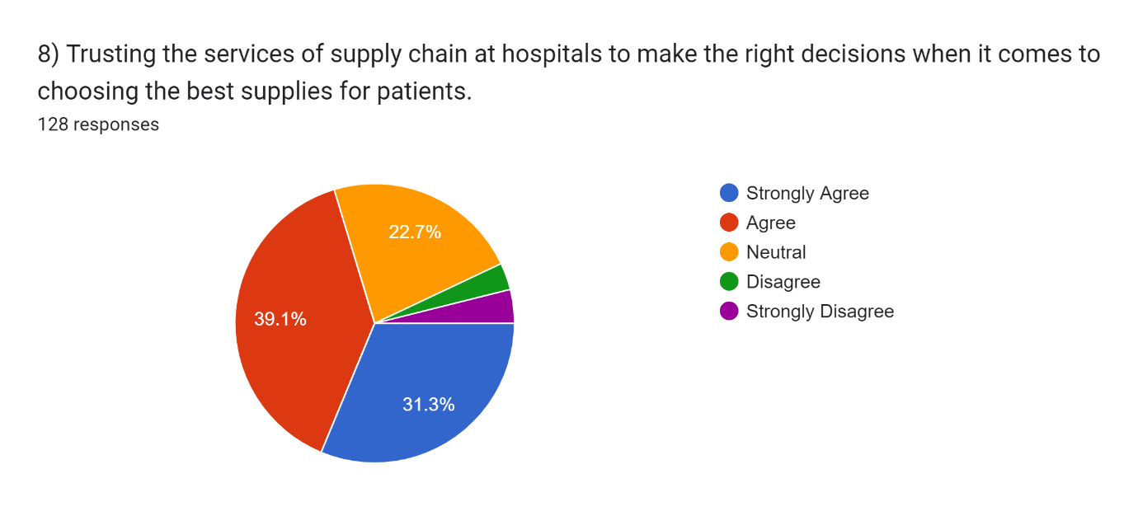
Chart 8

A significant percentage of respondents (70.4%) either strongly agree or agree that they trust the services of the HSCM at hospitals to make the correct decision while choosing the best medicinal goods, services for patients. However, a notable percentage (6.9%) expressed either disagreement or strong disagreement with this statement. These findings suggest that there is a generally positive level of trust in the HSCM decision-making, although there is still room for improvement and addressing the concerns of those who have reservations.

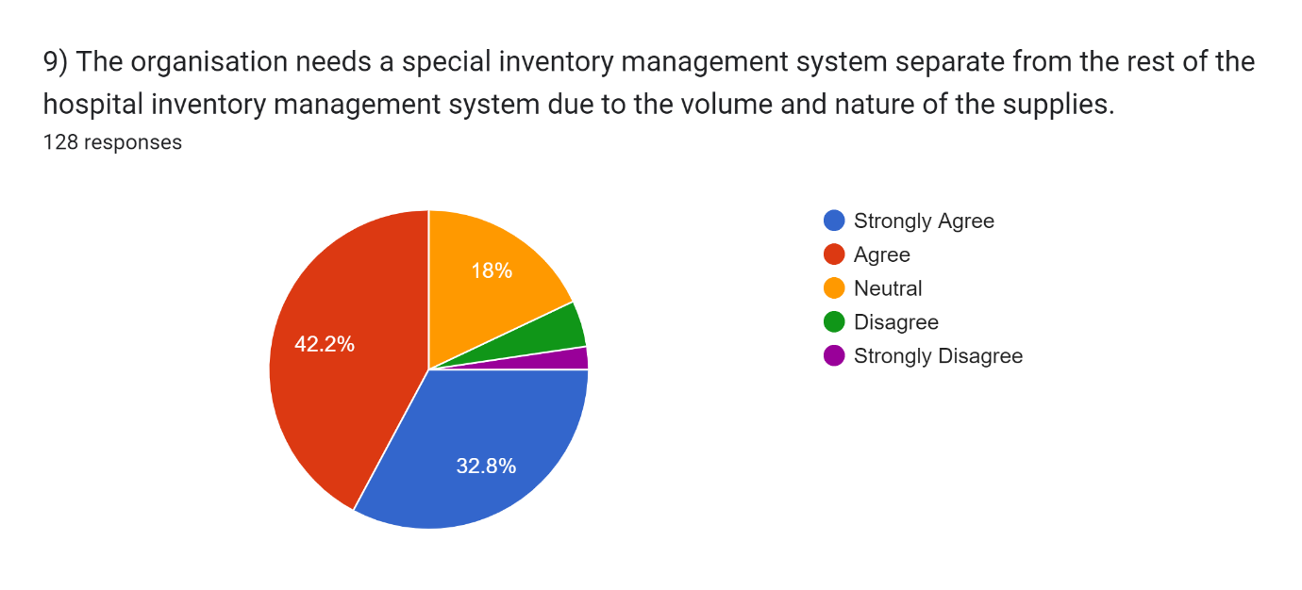
Chart 9

Majority of respondents (75%) either strongly agree or agree that the organization requires a specific stock management system away from the rest of the hospital stock management system because of the bulk and type of the supplies. A smaller proportion (22.7%) expressed neutrality or disagreement with this statement. These findings indicate that a majority of individuals recognize the requirement of dedicated stock management arrangement for specialized supplies, acknowledging the unique requirements and challenges associated with their volume and nature.

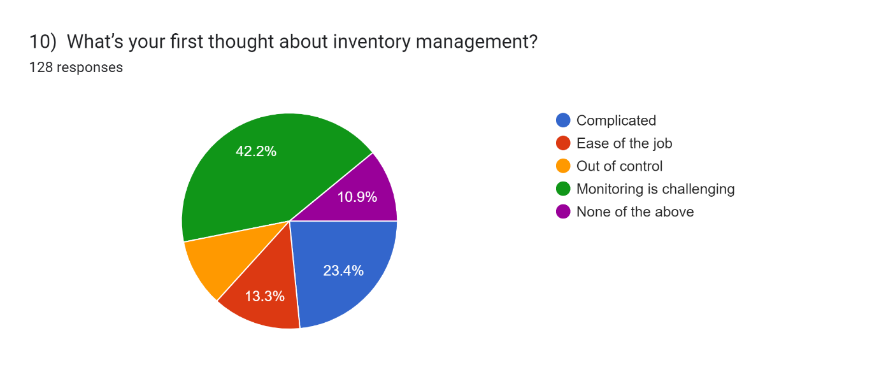

Chart 10

The first thought about inventory management varies among individuals. While a significant proportion (42.2%) finds monitoring inventory challenging, a notable percentage (23.4%) considers it complicated. On the other hand, a smaller portion (13.3%) perceives it as an ease of the job. Additionally, a minority (10.2%) feels that inventory management is out of control. These findings suggest that inventory management is seen as a complex and challenging task, requiring careful monitoring and control to ensure efficient operations.
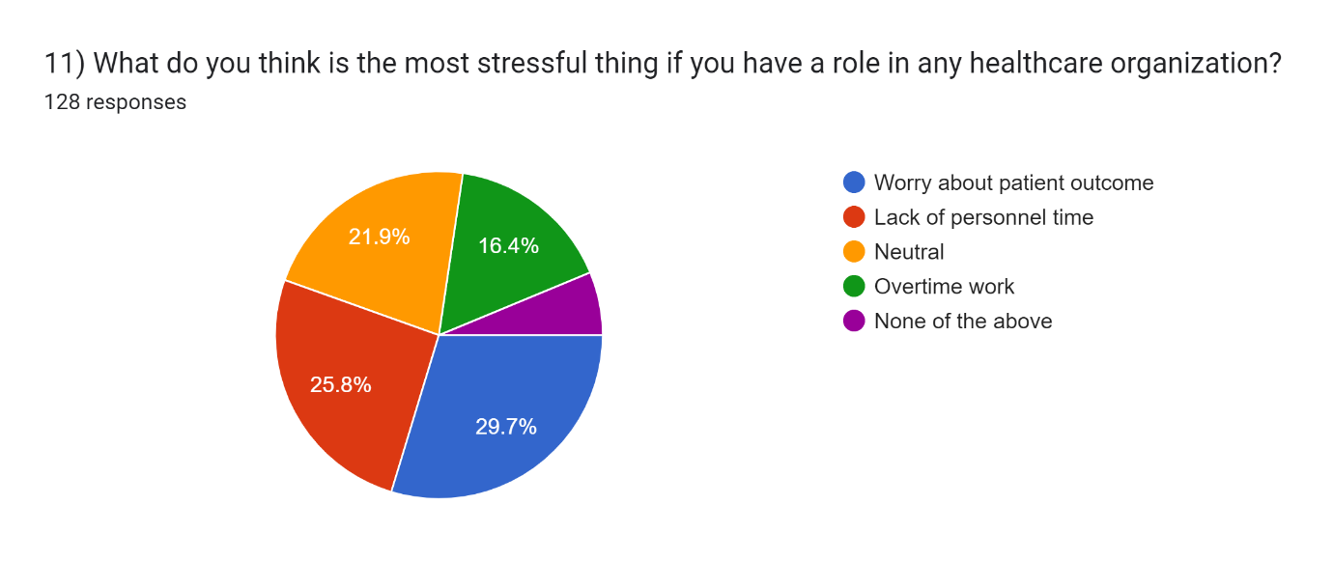
Chart 11

The most stressful thing for individuals with a role in any healthcare organization is worrying about patient outcomes, which accounted for 29.7% of the responses. The second highest stress factor is the lack of personnel time, reported by 25.8% of the participants. Additionally, 16.4% mentioned overtime work as a significant source of stress. These findings highlight the importance of patient outcomes and the strain that time constraints and excessive work hours can place on healthcare professionals, emphasizing the need for support and resources to manage these stressors effectively.
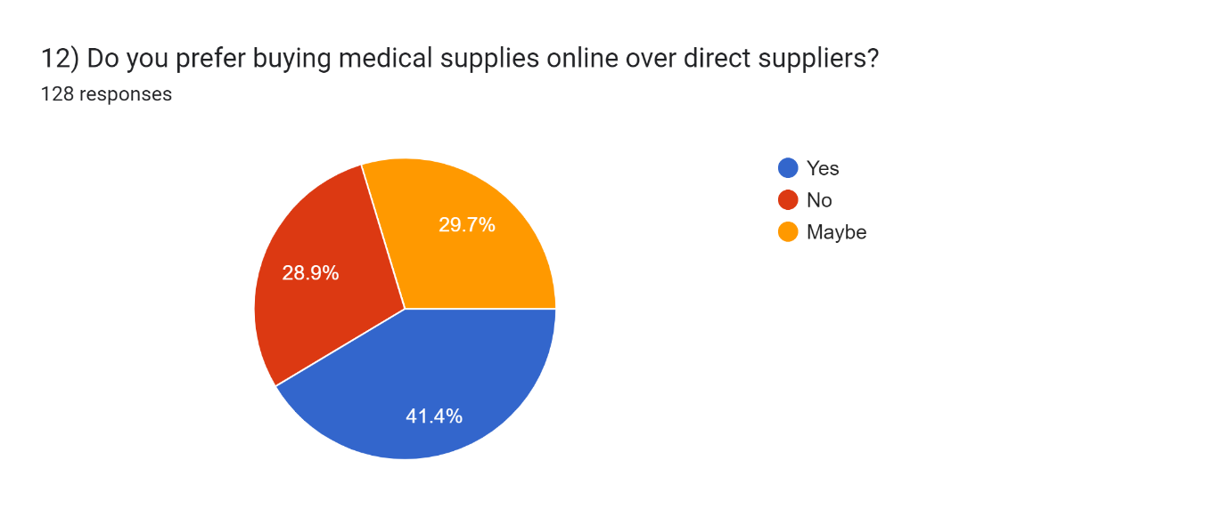
Chart 12

A significant proportion of respondents (41.4%) prefer buying medical supplies online over direct suppliers. However, a notable percentage (28.9%) indicated a preference for direct suppliers, while a sizeable portion (29.7%) expressed uncertainty or a neutral stance. These findings suggest that there is a preference for online purchasing of medical supplies among some individuals, possibly due to factors such as convenience, accessibility, and potentially cost-effectiveness. However, a considerable number still prefer the traditional approach of sourcing supplies directly from suppliers. The "maybe" responses indicate the need for further considerations and evaluation of factors influencing procurement decisions.

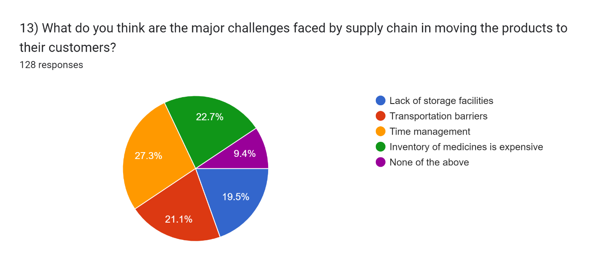
Chart 13

Analyzed that the major challenges faced by supply chains in moving products to their customers include transportation barriers (21.1%), time management (27.3%), and the expense associated with inventory of medicines (22.7%). Additionally, a notable percentage (19.5%) identified the lack of storage facilities as a significant challenge. These findings highlight the complexities involved in ensuring efficient and timely product delivery, including logistical hurdles, resource allocation, and cost considerations. Addressing these challenges is crucial for improving supply chain operations and meeting customer demands effectively.

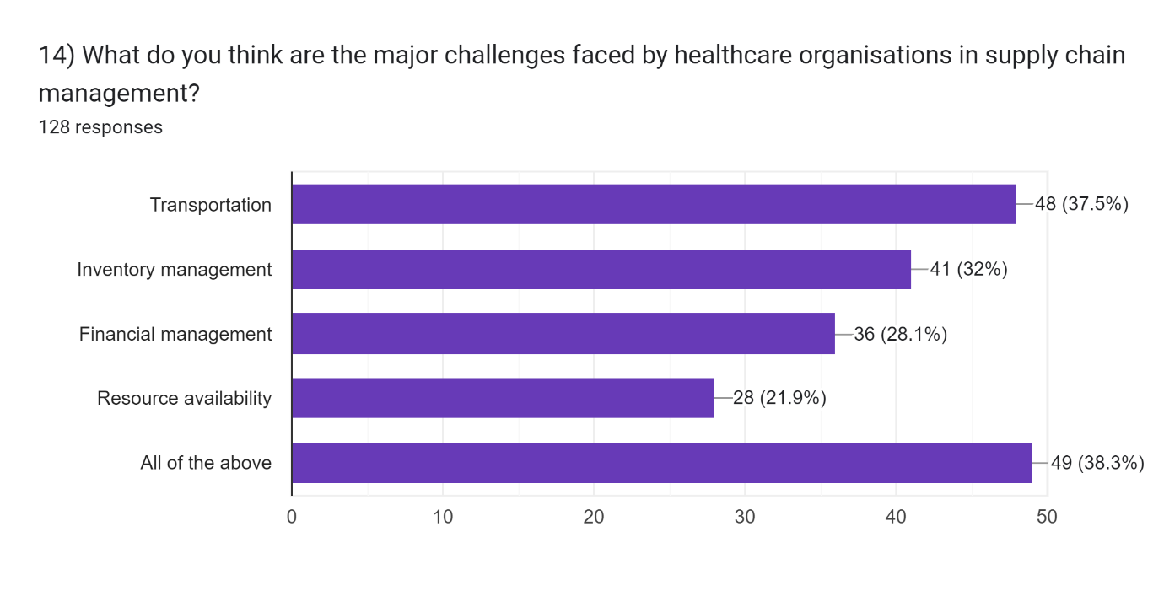

Chart 14
Chi – Square Analysis
Particulars | Respondents
Financial management | Female | 3
Financial management | Male | 3
Financial management, Resource availability | Female | 1
Financial management, Resource availability | Male | 1
Inventory management | Female | 9
Inventory management | Male | 3
Inventory management, All of the above | Female | 1
Inventory management, All of the above | Male | 2
Inventory management, Financial management | Female | 2
Inventory management, Financial management | Male | 1
Inventory management, Financial management, Resource availability | Female
Inventory management, Financial management, Resource availability | Male | 3
Resource availability | Female | 5
Resource availability | Male | 4
Transportation | Female | 13
Transportation | Male | 4
Transportation, Financial management | Female | 2
Transportation, Financial management | Male | 3
Transportation, Financial management, Resource availability | Female | 2
Transportation, Financial management, Resource availability | Male | 1
Transportation, Inventory management | Female | 1
Transportation, Inventory management | Male | 4
Transportation, Inventory management, Financial management | Female | 1
Transportation, Inventory management, Financial management | Male | 6
Transportation, Inventory management, Financial management, Resource availability | Female | 1
Transportation, Inventory management, Financial management, Resource availability | Male | 2
Transportation, Inventory management, Financial management, Resource availability, All of the above | Female | 1
Transportation, Inventory management, Financial management, Resource availability, All of the above | Male | 3
Transportation, Inventory management, Resource availability | Female
Transportation, Inventory management, Resource availability | Male | 1
Transportation, Resource availability | Female | 2
Transportation, Resource availability | Male | 1
No association between gender and any of the stated problems
Purely from feature importance stand point the top 2 features based on chi square are
a) Transportation
b) Inventory management
Table 2

Analyzed that the major challenges faced by healthcare organizations in supply chain management include transportation (37.5%), inventory management (32%), financial management (28.1%), and resource availability (21.9%). Interestingly, a significant portion of respondents (38.3%) identified that all of the mentioned challenges are major concerns. These findings highlight the multifaceted nature of supply chain management in healthcare organizations and the need to address issues related to transportation, inventory, finances, and resource availability comprehensively to ensure efficient and effective supply chain operations.

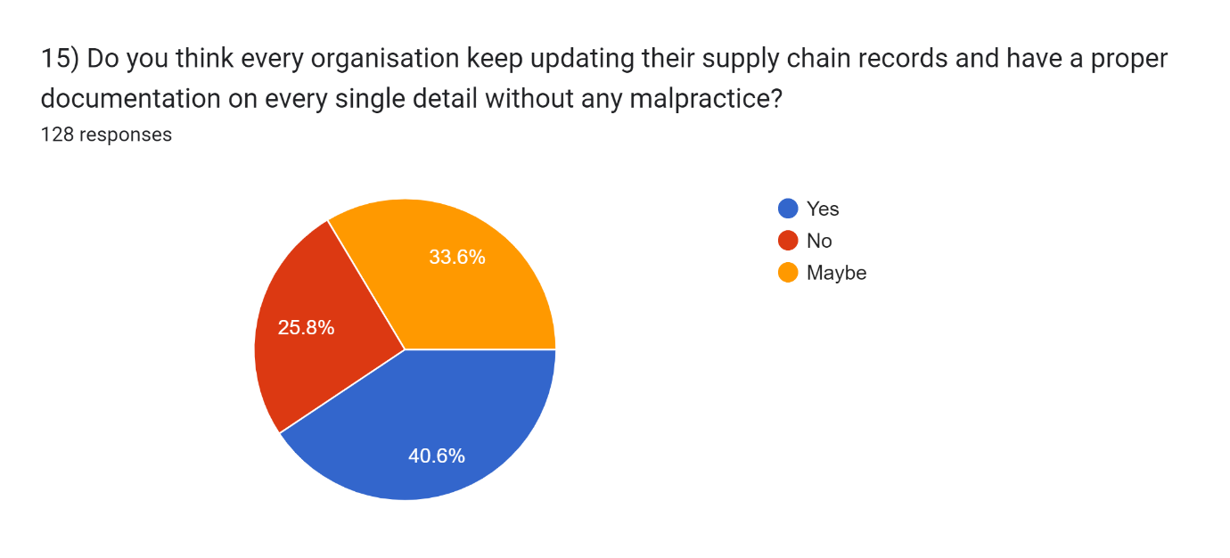
Chart 15

A significant proportion of respondents (40.6%) believe that every organization keeps updating their supply chain records and maintains proper documentation without any malpractice. However, a notable percentage (25.8%) disagrees with this notion. A considerable portion (33.6%) expressed uncertainty or a neutral stance. These findings suggest that there may be doubts about the consistency and integrity of supply chain records and documentation practices within organizations, indicating a need for greater transparency, accountability, and adherence to best practices in supply chain management.

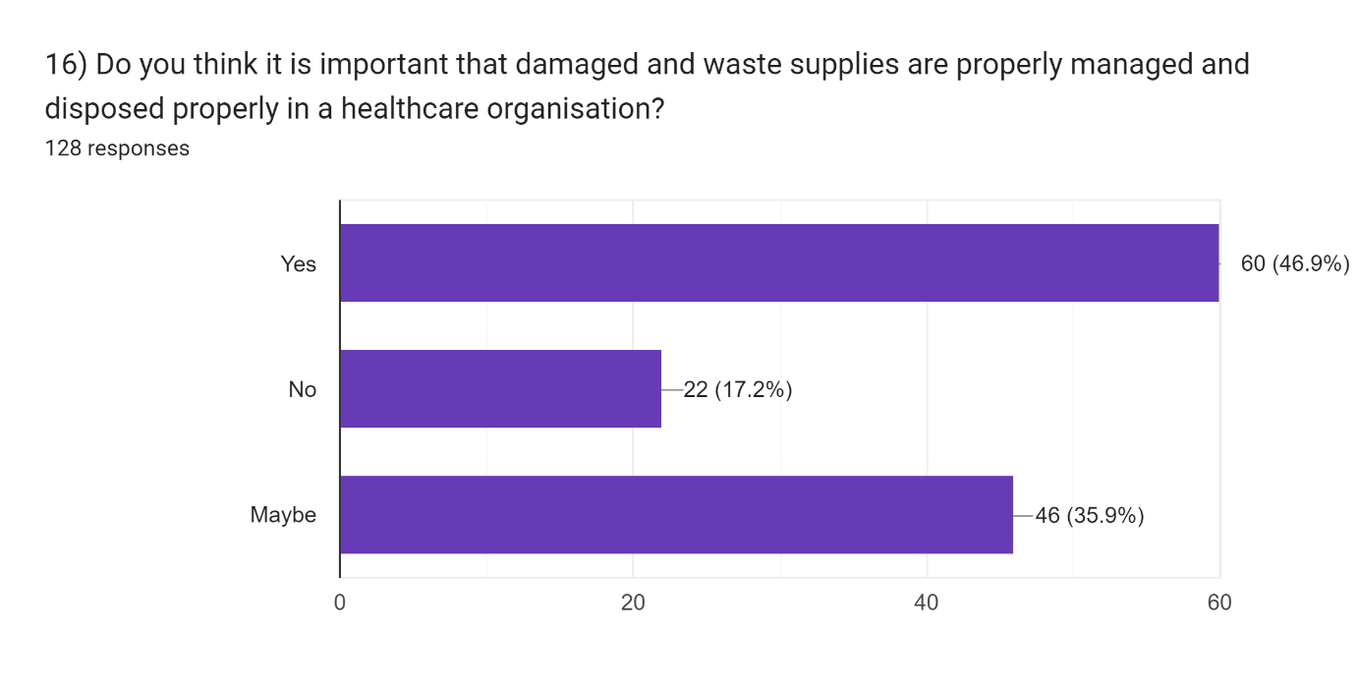
Chart 16

According to the data, a majority of respondents (46.9%) believe that it is important for healthcare organizations to properly manage and dispose of damaged and waste supplies. However, a notable portion (17.2%) disagreed with this notion. A significant number of respondents (35.9%) expressed uncertainty or a neutral stance. These findings suggest that there may be differing opinions on the importance of proper management and disposal of damaged and waste supplies within healthcare organizations. Addressing this issue is crucial to ensure safe and environmentally responsible practices while minimizing potential risks and inefficiencies associated with improper disposal.

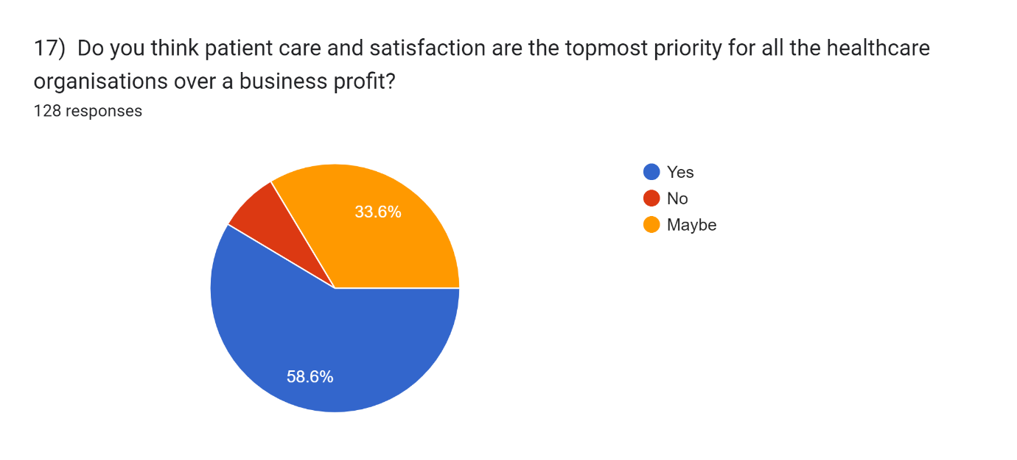
Chart 17

A majority of respondents (58.6%) believe that patient care and satisfaction are the topmost priority for all healthcare organizations over business profit. However, a small percentage (7.8%) disagrees with this notion. A significant number of respondents (33.6%) expressed uncertainty or a neutral stance. These findings suggest that while a majority recognizes the importance of prioritizing patient care and satisfaction, there may be differing perspectives on the balance between patient-centric goals and business profitability within healthcare organizations. Striking the right balance is crucial to ensure ethical, patient-centered care while maintaining financial sustainability.

FINDINGS
Financial concerns: Financial challenges are a significant problem faced by healthcare industries today, with a notable percentage of respondents expressing concerns about costs and financial management.
Supply management: There are various challenges in supply management, including the unavailability of specific medicines, usage of expired medicines, and difficulties in time management and allocation of supplies.
Trust in supply chain decision-making: A majority of respondents express trust in the services of the supply chain to make the correct decisions while selecting the supplies for patients/customers signifying confidence in their expertise and decision-making capabilities.
Stress factors in healthcare organizations: Worry about patient outcomes, lack of personnel time, and overtime work are identified as major stressors for individuals working in healthcare organizations.
Preference for online purchasing: A significant proportion of respondents prefer buying medical supplies online, highlighting the convenience and accessibility of online platforms.
Challenges in supply chain management: Major challenges faced by healthcare organizations in supply chain management include transportation barriers, inventory management, financial management, and resource availability.
Importance of documentation and proper disposal: Respondents emphasize the importance of updating supply chain records and proper management and disposal of damaged and waste supplies in healthcare organizations.
Patient care and satisfaction as a priority: The majority of respondents consider patient care and satisfaction to be the topmost priority for healthcare organizations, prioritizing them over business profit.

RECOMMENDATION
Improve financial management: Considering the anxieties raised regarding financial challenges and the importance of patient care, healthcare organizations should focus on improving financial management practices. This can include implementing cost-saving measures, conducting regular financial audits, exploring alternative funding sources, and ensuring transparency and accountability in financial decision-making.
Enhance Healthcare supply chain management: Addressing the challenges identified in supply chain management is crucial for efficient operations. Organizations should invest in robust inventory management systems to optimize stock levels, improve transportation logistics, and ensure timely availability of supplies. Additionally, proper documentation and disposal of damaged and waste supplies should be prioritized to ensure safety and environmental responsibility.
Foster a culture of continuous improvement: The data reflects varying opinions and uncertainties on certain topics, indicating the need for continuous improvement and addressing identified challenges. Organizations should foster a culture of learning and adaptability, encourage employee engagement and feedback, and regularly evaluate and refine processes to enhance efficiency and quality of care.
Embrace technology and automation: To address challenges in inventory management, financial management, and overall operational efficiency, healthcare organizations should embrace technology and automation solutions. This includes implementing electronic health records (EHRs), adopting automated inventory management systems, leveraging data analytics for decision-making, and utilizing telehealth and digital platforms for patient care.

BIBLIOGRAPHY
- Choudhury, T T., Paul S K, Kaisar S, & Moktadir M A (2021) Covid 19 pandemic related supply chain studies : A systematic review. Transportation Research Part E : Logistics and Transportation Review, 148 (August 2020), 102271 https://doi.org/10.1016/j.tre.2021.102271
- Supply Chain Disruption & How to Respond Accenture (n.d.) Retrieved April 15, 2022 from https://www.accenture.com/us-en/insights/consulting/coronavirus-supply-chain-disruption
- Paul S K, Choudhury P, Moktadir M A, & Lau K H, (2021). Supply chain recovery challenges in the wake of COVID 19 pandemic. Journal of Business Research, 136, (December 2020), 316-329 https://doi.org/10.1016/j.jburses.2021.07.056
- Choudhury, T., Paul S K, Rahman H F, Jia, Z & Shukla N, (2020). A Systematic literature review on the service supply chain : Research agenda and future research directions. Production Planning and Control, 31 (16), 1363 – 1384 https://doi.org/10.1080/09537287.2019.1709132
- Kumar M S, Raut D R D, Narwane D V S & Narkhede D B E (2020) Applications of Industry 4.0 to overcome the COVID 19 operational challenges. Diabetes and Metabolic Syndrome : Clinical Research and Reviews 14(5), 1283-1289 https://doi.org/10.1016/j.dsx.2020.07.010
- Ivanov D B (2021) Supply Chain resilience and its interplay with digital technologies : Making innovations work in emergency situations. International Journal of Physical Distribution & Logistics Management.
- Berhane T. (2017) Assessment on implementation status of integrated pharmaceutical logistic system for the management of health commodities : The case of public health centers in Addis Ababa Ethiopia. Journal of Pharmaceutical Care & Health Systems 3(2)
- Christopher kilger. (2014). supply chain management and advanced planning: concepts, models software and case studies.
- Jonathan Emanuele and Laura Koetter. (2007). Workflow opportunities and challenges in healthcare.
- Karen Moons, Geert Waeyenberg and Lileane Pintelon. (2018). Measuring the logistics performance of internal hospital supply chains – A literature study.
- Amini, M., R. F. Otondo, B. D. Janz, M. G. Pitts. 2007. Simulation modeling and analysis: A collateral application and exposition of RFID technology. Production and Operations Management 16(5) 586-598
- Leena V Gangolli, Ravi Duggal and Abhay Shukla. (2002). Review of healthcare in India.
- Tugce Beldel, Aziz Kemal Konyalioglu and Hatice Camgoz Akdag. (2019). Supply chain management in healthcare: A literature review.
- Kathleen E. Mckone sweet, Paul Hamilton, Susan B. Willis. (2005). The Ailing Healthcare Supply Chain: A Prescription for Change.
- Rahimnia, F. and Moghadasian, M. (2010), "Supply chain legality in professional services: how to apply decoupling point concept in healthcare delivery system".
- Moons. (2019). Measuring the logistics performance of internal hospital supply chains – A literature study.

