Innovative Solutions for Modeling and Analyzing Ebola Virus Dynamics
Neha Kalyan^{1,*}
ABSTRACT. In the relentless pursuit of combating the Ebola virus, mathematical modeling stands as a powerful tool for understanding its dynamics and devising effective control strategies. This paper presents a novel approach to solve the Ebola virus model by integrating the Laplace transform method with a newly developed iterative technique. The proposed methodology offers a robust and efficient framework for analyzing the intricate dynamics of the virus spread and the efficacy of various intervention strategies.
KEYWORDS: Ebola virus model; Laplace Transform; Iterative technique; Epidemic dynamics.
- Introduction
Fractional calculus [1], a branch of mathematics with roots tracing back centuries to luminaries like Leibniz and Euler, has become increasingly relevant in modern science and engineering. Initially conceived to extend traditional calculus to non-integer orders, fractional calculus has found applications in various fields, offering new insights and tools for understanding complex systems. Alongside this, advancements in computational techniques have transformed how we tackle mathematical problems. These numerical methods, powered by computers, provide efficient ways to approximate solutions to equations, making it easier to analyze dynamic systems and simulate real-world scenarios. The advent of computers and computational techniques has revolutionized the field of numerical methods, enabling researchers to tackle previously intractable problems in mathematics and science. Numerical methods play a pivotal role in approximating solutions to differential equations, offering efficient and accurate approaches for analyzing dynamical systems and simulating real-world phenomena. In recent years, there has been growing interest in leveraging numerical methods to solve fractional differential equations, capitalizing on their flexibility and computational power to address a wide range of applications, for details see [2–11].
The Ebola virus disease (EVD), characterized by its high mortality rate and potential for rapid spread, remains a significant global health concern. Since its discovery in 1976, numerous outbreaks have occurred, causing devastating impacts on affected communities and posing challenges for healthcare systems worldwide. Mathematical modeling has emerged as a valuable tool for understanding the dynamics of EVD transmission and assessing the effectiveness of intervention strategies aimed at controlling its spread [12–19].
In this paper, we present a novel approach to solving the Ebola virus model by integrating the Laplace transform method with a newly developed iterative technique. Our motivation stems from the need for more efficient and accurate methods to analyze the complex dynamics of EVD transmission and evaluate the impact of various control measures. The Laplace transform method offers an alternative approach by transforming the differential equations into algebraic equations,

*Corresponding author: Tel. +91-9729764214
E-mail address: uietphd2025nehakalyan@kuk.ac.in (N. Kalyan)

thereby simplifying the problem-solving process. By combining the strengths of the Laplace transform with innovative iterative techniques, we aim to address the challenges posed by nonlinearities and dynamic changes inherent in epidemic models. However, the application of the Laplace transform to epidemic models encounters challenges due to the presence of nonlinearities and non-constant coefficients [20–22]. To overcome these limitations, we introduce a new iterative technique tailored to address the specific characteristics of the Ebola virus model. This iterative approach iteratively refines the solution obtained through the Laplace transform method, enhancing accuracy and convergence properties.
This paper is organized in various sections as follows: In Section 1, we present the introduction. In the second Section, description of the model used in this study is given. important definitions that are used in this paper are given in section 3. In Section 4, description of the technique is given. In Section 5, application of the technique to the proposed model is given. In Section 6, numerical simulation and discussion is presented. Finally, Section 7 contains the conclusion.

- Description of the model
The Ebola virus model represents a system of nonlinear differential equations that describe the interactions between susceptible, infected, and recovered individuals within a population. The Ebola virus model (EVD) is written as [12]:
$$\begin{aligned}{{}_{0}^{C}D}_{t}^{α}S\left(t\right)=-iS\left(t\right)I\left(t\right)+sR\left(t\right)-aN, \\ {{}_{0}^{C}D}_{t}^{α}I\left(t\right)=iS\left(t\right)I\left(t\right)-\left(d+r\right)I\left(t\right), \\ {{}_{0}^{C}D}_{t}^{α}R\left(t\right)=rI\left(t\right)-sR\left(t\right), \\ {{}_{0}^{C}D}_{t}^{α}D\left(t\right)=dI\left(t\right)+aN,\end{aligned}$$
with the initial conditions $S\left(0\right)=S_{0}, I\left(0\right)=I_{0}, R\left(0\right)=R_{0}, D\left(0\right)=D_{0},$and $0<α≤1$ is the order of the derivative.
Where N be the total population, S be the susceptible, I be the infected, R be the number of recovery and D be the number of disease induced deaths due to EVD. The description of the parameters is given in table 1.

- Mathematical preliminaries
This section presents the basic definitions of Caputo fractional derivatives, Laplace transform and their properties that are used throughout the paper.
Definition 2.1. The Caputo fractional derivative of $u\left(t\right)$is presented as [23]:
${{}_{a}^{C}D}_{t}^{α}\left[u\left(t\right)\right]=\frac{1}{Γ\left(α-m\right)}\int_{0}^{t}{{\left(t-τ\right)}^{m-α-1}}u^{m}\left(τ\right)dτ$,
where$m-1<α<m,$ $m∈N.$
Definition 2.2. The Laplace transform (LT) of a function $u\left(t\right)$ is defined as [23]:
$$U\left(s\right)=L\left[u\left(t\right)\right]=\int_{0}^{∞}{e^{-st}}u\left(t\right)dt,$$
and the Inverse Laplace transform of $U\left(s\right)$ is defined as:
$$u\left(t\right)=L^{-1}\left[U\left(s\right)\right]=\frac{1}{2πi}\int_{a-i∞}^{a+i∞}{e^{st}}U\left(s\right)ds.$$
Definition 2.3. The Laplace transform of the Caputo derivative is defined as [23]:
$$L\left[{{}_{0}^{C}D}_{t}^{α}\left[u\left(t\right)\right]\right]=s^{α}U\left(s\right)-\sum_{k=0}^{n-1}{s^{α-k-1}u^{k}}\left(0\right)$$
where$n-1<α≤n,$ $n∈N.$
- Description of the technique
In this section, we describe the proposed technique to solve the Ebola virus model. For this, we consider the fractional initial value problem with Caputo fractional derivative as:
${{}_{}^{C}D}_{t}^{α}f\left(x,t\right)=L\left(f\left(x,t\right)\right)+N\left(f\left(x,t\right)\right)+g\left(x,t\right),$(1)
with the initial condition as:
$$f\left(x,0\right)=φ\left(x\right), x∈\left(a,b\right), t∈\left(0,∞\right),$$
where $L$ and $N$ represents the linear and non-linear operators respectively, and $g$is any given function.
Now, apply Laplace transform on both sides, we get
$$L\left[f\left(x,t\right)\right]-\frac{φ\left(x\right)}{s}=\frac{1}{s^{α}}L\left[L\left(f\left(x,t\right)\right)+N\left(f\left(x,t\right)\right)+g\left(x,t\right)\right].$$
Taking Inverse Laplace transform on both sides, we obtain
$$f\left(x,t\right)=φ\left(x\right)+L^{-1}\left[\frac{1}{s^{α}}L\left[g\left(x,t\right)\right]\right]+L^{-1}\left[\frac{1}{s^{α}}L\left[L\left(f\left(x,t\right)\right)+N\left(f\left(x,t\right)\right)\right]\right],$$
which is of the form of eq. (1).
Now, by solving the above equation using new iterative technique described in [24], we have the solution of eq. (1) in the form of infinite series as:
$$f\left(x,t\right)=\sum_{i=0}^{∞}{f_{i}\left(x,t\right)},$$
where
$$\left\{\begin{aligned}\begin{aligned}f_{0}=φ\left(x\right)+L^{-1}\left[\frac{1}{s^{α}}L\left[g\left(x,t\right)\right]\right], \\ f_{1}=L^{-1}\left[\frac{1}{s^{α}}L\left[L\left(f_{0}\left(x,t\right)\right)+N\left(f_{0}\left(x,t\right)\right)\right]\right], \\ .\end{aligned} \\ . \\ . \\ f_{m+1}=L^{-1}\left[\frac{1}{s^{α}}L\left[L\left(f_{m}\left(x,t\right)\right)\right]\right]+L^{-1}\left[\frac{1}{s^{α}}L\left[N\left(\sum_{j=0}^{m}{f_{j}}\right)-N\left(\sum_{j=0}^{m-1}{f_{j}}\right)\right]\right].\end{aligned}\right.$$
- Application
In this section, we implemented the proposed technique on fractional Ebola virus model given by:
$$\begin{aligned}{{}_{0}^{C}D}_{t}^{α}S\left(t\right)=-iS\left(t\right)I\left(t\right)+sR\left(t\right)-aN, \\ {{}_{0}^{C}D}_{t}^{α}I\left(t\right)=iS\left(t\right)I\left(t\right)-\left(d+r\right)I\left(t\right), \\ {{}_{0}^{C}D}_{t}^{α}R\left(t\right)=rI\left(t\right)-sR\left(t\right), \\ {{}_{0}^{C}D}_{t}^{α}D\left(t\right)=dI\left(t\right)+aN,\end{aligned}$$
with the initial conditions $S\left(0\right)=d_{1}, I\left(0\right)=d_{2}, R\left(0\right)=d_{3}, D\left(0\right)=d_{4},$and $0<α≤1$ is the order of the derivative.
After applying the technique described in section 3, we get the solution of the above equation in the form of series as:
$$S\left(t\right)=\sum_{i=0}^{∞}{S_{i}\left(t\right)}, I\left(t\right)=\sum_{i=0}^{∞}{I_{i}\left(t\right)}, R\left(t\right)=\sum_{i=0}^{∞}{R_{i}\left(t\right)}, D\left(t\right)=\sum_{i=0}^{∞}{D_{i}\left(t\right),}$$
where $S_{0}=d_{1}$, $I_{0}=d_{2}$, $R_{0}=d_{3}$, ${ D}_{0}=d_{4}$,
$$S_{1}=γ_{1}\frac{t^{α}}{Γ\left(α+1\right)}, γ_{1}=-iS_{0}\left(t\right) I_{0}\left(t\right)+s R_{0}\left(t\right)-aN,$$
$$I_{1}=γ_{2}\frac{t^{α}}{Γ\left(α+1\right)}, γ_{2}=iS_{0}\left(t\right) I_{0}\left(t\right)-\left(d+r\right)I_{0}\left(t\right),$$
$$R_{1}=γ_{3}\frac{t^{α}}{Γ\left(α+1\right)}, γ_{3}=rI_{0}\left(t\right)-sR_{0}\left(t\right),$$
$$D_{1}=γ_{4}\frac{t^{α}}{Γ\left(α+1\right)}, γ_{4}=dI_{0}\left(t\right)+aN,$$
$$S_{2}=-aN\frac{t^{α}}{Γ\left(α+1\right)}+\left(sγ_{3}-iγ_{2}S_{0}-iγ_{1}I_{0}\right)\frac{t^{2α}}{Γ\left(2α+1\right)}-iγ_{1}γ_{2}\frac{t^{3α}Γ\left(2α+1\right)}{Γ\left(3α+1\right){Γ\left(α+1\right)}^{2}},$$
$$I_{2}=\left(iγ_{2}S_{0}+iγ_{1}I_{0}-\left(d+r\right)γ_{2}\right)\frac{t^{2α}}{Γ\left(2α+1\right)}+iγ_{1}γ_{2}\frac{t^{3α}Γ\left(2α+1\right)}{Γ\left(3α+1\right){Γ\left(α+1\right)}^{2}},$$
$$R_{2}=\left(rγ_{2}-sγ_{3}\right)\frac{t^{2α}}{Γ\left(2α+1\right)},$$
$$D_{2}=aN\frac{t^{α}}{Γ\left(α+1\right)}+{dγ}_{2}\frac{t^{2α}}{Γ\left(2α+1\right)},$$
and so on. So, we get the approximate solution of EVM with three iterations as:
$$S\left(t\right)=\sum_{i=0}^{2}{S_{i}\left(t\right)}, I\left(t\right)=\sum_{i=0}^{2}{I_{i}\left(t\right)}, R\left(t\right)=\sum_{i=0}^{2}{R_{i}\left(t\right)}, D\left(t\right)=\sum_{i=0}^{2}{D_{i}\left(t\right).}$$

- Simulation and discussion
Numerical simulations are obtained for $S,I,R$ and $D$ at distinct values of order of derivative $α$ using Matlab software and values of parameter are given in table 1. Fig. 1a represents the behavior of susceptible with time for different values of order of derivative. It shows that the number of susceptible decreases as the order of derivative decreases. Fig. 1b represents the behavior of infected with time for different values of order of derivative which shows that the number of infected increases with decrease in order of derivative. Similar behavior is seen from fig. 1c and 1d, which represents the behavior of recovered and deaths respectively, with time for different values of order of derivative. Both recovered and number of deaths are increasing with decreasing of order of derivative.

Table 1. Description and values of parameters [25].
Parameters | Description | Values
$$i$$ | Rate of Infection | 0.01
$$s$$ | Rate of Susceptible | 0.02
$$d$$ | Death rate due to disease | 0.6
$$a$$ | Death rate due to other reason | 0.01
$$r$$ | Rate of Recovery | 0.4
$$N$$ | Total population | 1000
$$S_{0}$$ | Number of susceptible at $t=0$ | 900
$$I_{0}$$ | Number of infected at $t=0$ | 10
$$R_{0}$$ | Number of recovered at $t=0$ | 0
$$D_{0}$$ | Number of deaths at $t=0$ | 0
Table 1. Description of the parameters.

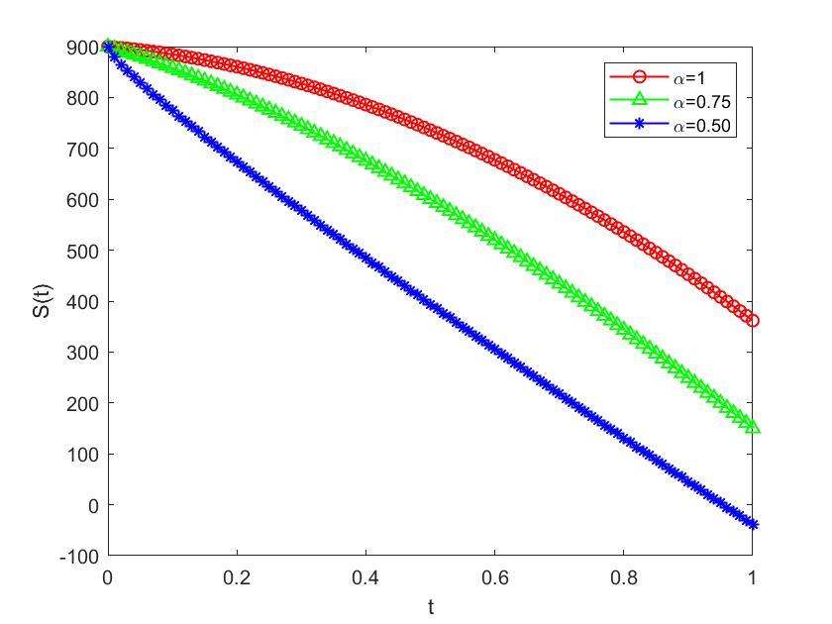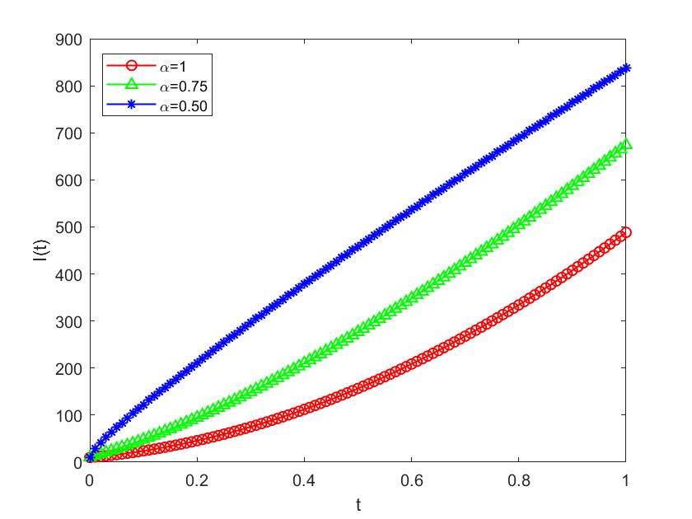 (a) (b)

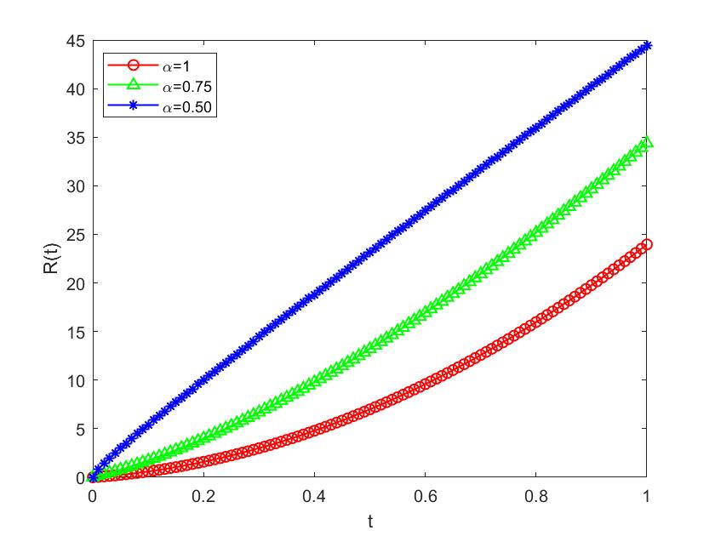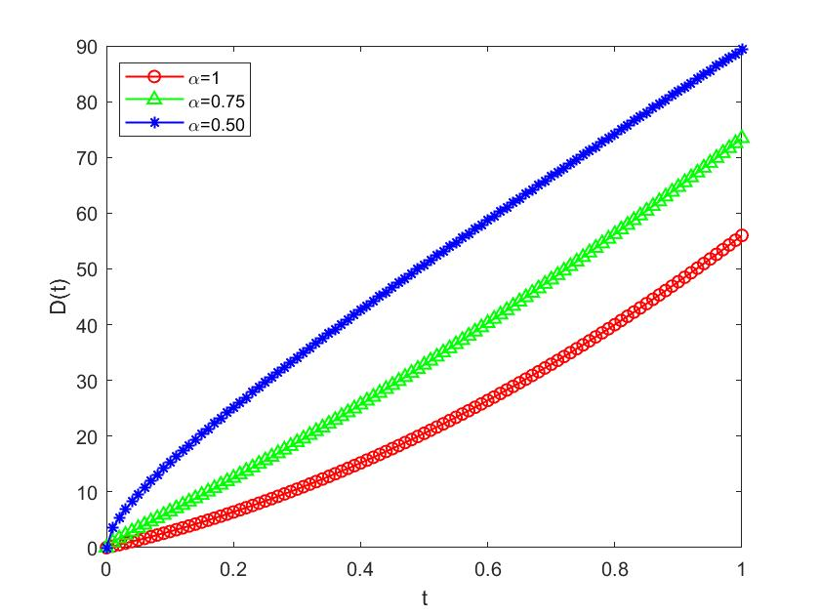(c) (d)
Figure 1. Behavior of (a) Susceptibles, (b) Infected, (c) Recovered and (d) Deaths with time at distinct values of $α$.

- Conclusion
In this article, the application of a hybrid technique on the Ebola virus model is given. the combination of fractional calculus, numerical methods, and mathematical modeling offers a potent approach for understanding and controlling the transmission dynamics of infectious diseases like Ebola virus disease. Through innovative techniques such as the integration of the Laplace transform and iterative methods, we can improve the accuracy and efficiency of modeling efforts, ultimately leading to more effective strategies for disease prevention and control. Continued research and collaboration in this interdisciplinary field hold promise for mitigating the impact of epidemics on public health and society.

References
[1] Hilfer R. Applications of fractional calculus in physics. World scientific; 2000.
[2] Sales Teodoro G, Tenreiro Machado JA, Capelas de Oliveira E. A review of definitions of fractional derivatives and other operators. J Comput Phys 2019;388:195–208. https://doi.org/10.1016/j.jcp.2019.03.008.
[3] Prakash A, Rahul. Analysis and Numerical Simulation of Fractional Biological Population Model With Singular and Non-Singular Kernels. Proc Inst Math Mech 2022;48:178–93. https://doi.org/10.30546/2409-4994.48.2022.178193.
[4] Barros LC de, Lopes MM, Pedro FS, Esmi E, Santos JPC dos, Sánchez DE. The memory effect on fractional calculus: an application in the spread of COVID-19. Comput Appl Math 2021;40:1–21. https://doi.org/10.1007/s40314-021-01456-z.
[5] Losada J, Nieto JJ. Properties of a new fractional derivative without singular kernel. Prog Fract Differ Appl 2015;1:87–92. https://doi.org/10.12785/pfda/010202.
[6] Sherief HH, El-Sayed AMA, Abd El-Latief AM. Fractional order theory of thermoelasticity. Int J Solids Struct 2010;47:269–75. https://doi.org/10.1016/j.ijsolstr.2009.09.034.
[7] Ebenezer B. On Fractional Order Influenza A Epidemic Model. Appl Comput Math 2015;4:77. https://doi.org/10.11648/j.acm.20150402.17.
[8] Access O, Saxena H. ON LITERATURE AND TOOLS IN FRACTIONAL CALCULUS AND 2021:1014–9.
[9] Lazarević MP, Rapaić MR, Šekara TB, Mladenov V, Mastorakis N. Introduction to fractional calculus with brief historical background. Chapter Book“Advanced Top Appl Fract Calc Control Probl Syst Stab Model 2014:3–16.
[10] Ie S. Fractional Calculus and Fractional Differential Equations with SCILAB 2010.
[11] Zheng Z, Zhao W, Dai H. A new definition of fractional derivative. Int J Non Linear Mech 2019;108:1–6. https://doi.org/10.1016/j.ijnonlinmec.2018.10.001.
[12] Singh H. Analysis for fractional dynamics of Ebola virus model. Chaos, Solitons and Fractals 2020;138:1–8. https://doi.org/10.1016/j.chaos.2020.109992.
[13] Farman M, Akgül A, Abdeljawad T, Naik PA, Bukhari N, Ahmad A. Modeling and analysis of fractional order Ebola virus model with Mittag-Leffler kernel. Alexandria Eng J 2022;61:2062–73. https://doi.org/10.1016/j.aej.2021.07.040.
[14] Rachah A, Torres DFM. Mathematical modelling, simulation, and optimal control of the 2014 ebola outbreak in West Africa. Discret Dyn Nat Soc 2015;2015. https://doi.org/10.1155/2015/842792.
[15] Derakhshan MH. The stability analysis and numerical simulation based on Sinc Legendre collocation method for solving a fractional epidemiological model of the Ebola virus. Partial Differ Equations Appl Math 2021;3:100037. https://doi.org/10.1016/j.padiff.2021.100037.
[16] Altaf KM, Atangana A. Dynamics of ebola disease in the framework of different fractional derivatives. Entropy 2019;21:1–32. https://doi.org/10.3390/e21030303.
[17] Science N, Phenomena C, Ali M, Dutta H. Chaos , Solitons and Fractals A fractional order model for Ebola Virus with the new Caputo fractional derivative without singular kernel. Chaos, Solitons Fractals Interdiscip J Nonlinear Sci Nonequilibrium Complex Phenom 2020;134:109717. https://doi.org/10.1016/j.chaos.2020.109717.
[18] Area I, Batarfi H, Losada J, Nieto JJ, Shammakh W, Torres Á. On a fractional order Ebola epidemic model. Adv Differ Equations 2015;2015. https://doi.org/10.1186/s13662-015-0613-5.
[19] Latha VP, Rihan FA, Rakkiyappan R, Velmurugan G. A fractional-order model for Ebola virus infection with delayed immune response on heterogeneous complex networks. J Comput Appl Math 2018;339:134–46. https://doi.org/10.1016/j.cam.2017.11.032.
[20] Haq F, Shah K, ur Rahman G, Shahzad M. Numerical solution of fractional order smoking model via laplace Adomian decomposition method. Alexandria Eng J 2018;57:1061–9. https://doi.org/10.1016/j.aej.2017.02.015.
[21] Klcman A, Gadain HE. On the applications of Laplace and Sumudu transforms. J Franklin Inst 2010;347:848–62. https://doi.org/10.1016/j.jfranklin.2010.03.008.
[22] Baleanu D, Aydogn SM, Mohammadi H, Rezapour S. On modelling of epidemic childhood diseases with the Caputo-Fabrizio derivative by using the Laplace Adomian decomposition method. Alexandria Eng J 2020;59:3029–39. https://doi.org/10.1016/j.aej.2020.05.007.
[23] Kumar D, Singh J, Baleanu D, Sushila. Analysis of regularized long-wave equation associated with a new fractional operator with Mittag-Leffler type kernel. Phys A Stat Mech Its Appl 2018;492:155–67. https://doi.org/10.1016/j.physa.2017.10.002.
[24] Daftardar-Gejji V, Jafari H. An iterative method for solving nonlinear functional equations. J Math Anal Appl 2006;316:753–63. https://doi.org/10.1016/j.jmaa.2005.05.009.
[25] Kumar V, Manish B. A Reliable Solution of Nonlinear Time Dependent Fractional Model of Ebola Virus Disease with Arbitrary Order Derivative in Liouville – Caputo Sense. Int J Appl Comput Math 2021;7:1–16. https://doi.org/10.1007/s40819-021-01200-5.

