linguistic perspective on technology evolution
Zamzam Rehman
UG student, Department of Biotechnology, GD Rungta College of Science and Technology, Bhilai, Chhattisgarh, India
Corresponding Author - zamzamrehman65759@gmail.com
INTRODUCTION
Language is something which cannot be ignored at all. Even when you talk about language you still need a “language” to talk in. For a short introduction “language is a system of conventional spoken, manual (signed) or written symbols by means of which human beings as members of social group and participants in a culture, express themselves.” Likewise, technology is also a thing which runs along with you side by side. The more you grow, the more you will find it complexly enhancing.
Now the question is how does they both corelate? Language grows and adapts continuously, evolving as we come up with better words that reflects our culture and society. It mirrors the unexpected interwining of our lives with technology.
Language is ever changing, adapting and evolving to the needs of its users. As long as the needs of the language users change, so will the language. Language changes very slowly as the new words are coined and naturalized in the process. Technology has had a meteoric impact on the English language and it has changed the modes of communication. New products, technology and experiences require new words to refer to them clearly and efficient. People tend to think that older forms of English are more elegant, logical or correct than the modern forms, but it’s not true. The fact that language is ever changing doesn’t mean it’s getting worse, it’s just different. Language will never cease to change it will continue to respond to the needs of the people who use it. So, whenever we hear a new phrase or a word that grates on our ears, we should assume like everything else in nature, the English language is also a work in progress. With the immense population growth new technological advancements would be required to support and sustain us. The new generation is exposed to audio, video, images and interactive features which they could never learn in a book. We have to teach them to become cautious consumers and learn how to use these tools to reach to their fullest potential. This study makes an attempt to discuss how modern technology has contributed to the coinage of new words in English Language. Key Words – English, Language, Technology, Change, Digital
HISTORY
Talking about history of language, some scholars think its relationship with human evolution, and its consequences have been subjects of study for centuries. Scholars wish to study language origination must draw some inferences from fossil records, archaeological evidences, studies of language acquisition, and to compare human language and communication system of other animals.
When communication is developing to this extend why would the technology be slow then? The history of technology is history of invention of tools and techniques. The term technology actually comes from the Greek word “techne” meaning art and craft and the word “logos” means word or speech but this word technology used to describe the advancements or changes that affects the environment around us.
THEORIES THAT RELATE THEM
A controversy related to language and technology has something to do with the appropriate theoretical grounding for the field.
- Chapelle, in her groundbreaking article in 1997 which is titled as “Call in the year 2000: Still in Search of Research Paradigms?” argues that fields like computational linguistics, psychology will lack the specificity needed to design the pedagogy of CALL.
- Writing 8 years later Chapelle cites a substantial body of CALL Research in the interactionalist tradition.
Intrinsically, English and language ‘s role is for communication. Due to the advancement of technology, the communication modes have changed dramatically. The new forms of communication have also changed the English language to suit and fit with technology for efficiency and effectiveness.

Printing Press – The printing press is an early example of how technology put a huge impact in changing of English language and the way people communicate. Due to the nature of printing press being able to create mass quantity of the same text in the identical form, it helped to create a standardized version of English. Even, the availability and quantity of texts helped to improve the literacy rates throughout Europe during its time and now in the third world countries.

Cell Phone Texting – Cellular phone texting started in the late 80‟s with the first rudimentary text message being sent from a beeper with upside down numbers to spell out words. Even in the mid 90‟s when text messaging from cell phones was available, it wasn’t widely used. Now a majority of cell phone users utilize the ability to text for its convenience and discreetness. It allows people to communicate instantaneously through text. It is also arguably the earliest cause of modern day abbreviations alongside the computer and the internet.
Internet – The Internet is the latest huge advancement in the way people communicate and exchange information. It is capable of integrating and sharing audio and visuals into one package and connects anyone that has its service available regardless of its distance. It is capable of allowing users to exchange and share a plethora of information. It is the largest step towards globalization thus far and has played a unique role in shaping the dynamics of English language.

HOW TECHNOLOGY DRIVES EVOLUTION OF LANGUAGE?
- WHEN WORDS GET NEW MEANINGS
Words do not get into our language in their final state but it evolves with time, which hereby changes our understanding and perception of term.
For example, the label ‘nerd’ was earlier used to insult the people who were secluded, socially awkward or any outsider. In contrary to this now it is being used as a title of honour.
‘NERDISM’ today means ‘reliable expertise’, which acknowledge the shift in a=the age of evolution.
This change is due to the economic success of Silicon Valley pioneers such as Steve jobs and Bill Gates whose company earns billions today.
- WORDS APPROACH IN DICTIONARY
While the generation prior to us may have seen the dictionaries as custodians and defenders of “correct” language- that is no longer the case.

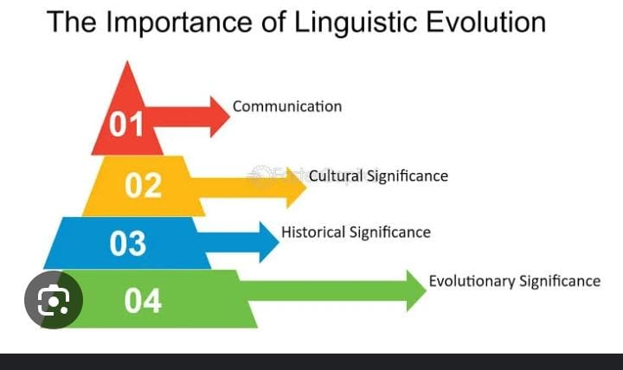

Figure:

Back in 2007, the Oxford English Dictionary removed the words like acorn, dandelion, pasture etc. which described the nature but now they replaced those words with ‘blog’, ‘chatroom’.

- INTERNET LITERACY
The language spoken by young generation and technology can sometimes be difficult to decipher, but it’s also the key to understand the evolution of language around us.

GRAPH THAT SHOWS THE IMPACT FACTOR OF TEXT ,SPEECH AND LANGUAGE TECHNOLOGY

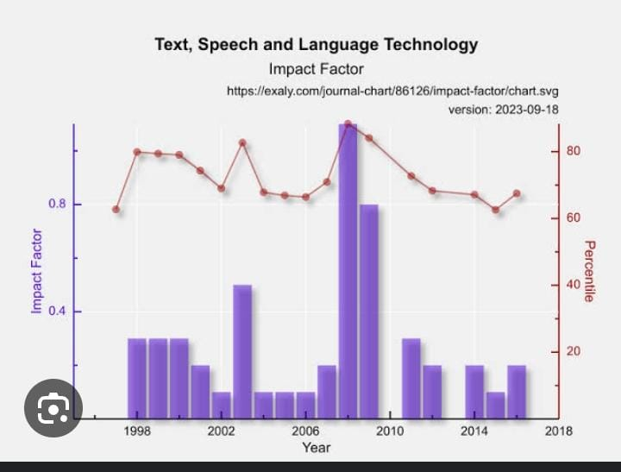
Figure:

COMPUTER LANGUAGES

While relating technology and language, how could we forget talking about computer languages. Yes, you heard it right “language of computers.”
“A computer language is a formal language used to communicate with a computer.”
It is based on binary system.
All humans and animals have their ways of communicating with each other. Humans have different languages such as Hindi, English, Telugu, etc whereas animals communicate through their sounds and signals. We have been working on computers for decades now but have you ever wondered how do we communicate with them? Isn’t it kind of inquisitive?

Well, computers certainly cannot understand human languages so we cannot directly communicate with them. Hence, with time, we developed several languages which help us to convey our messages to computers and make them do our work. In this article, we have discussed all these computer languages and their types.

What are Computer Languages
A group of instructions that are used to create computer programs are known as computer languages. The main aim of these languages is to make human-computer interaction possible and easy. We, humans, have invented these computer languages to make our work easier by making our tasks done by the computer.

Types of Computer Languages
In this section, we will be learning about the types of Computer Language. 4 types of machine languages are known to us and the same have been discussed below for your reference.

Low-Level Language
A Low-level computer language consists of only 1’s and 0’s. First and Second generation computers were first built using this language. This type of language is easily understood by a computer but it is very difficult for humans to understand this. These Low-level languages are specifically designed to interact with the computer hardware and are categorized into two types- Machine level language and Assembly level language.

Machine Level Language
Machine level language is a type of Low-level language. This language is believed to be the oldest computer language. Computers tend to understand only the language of Digital Electronics which deals with the presence and absence of voltages. 2 logics can play their role within the computer which are-

Positive Logic: In this, the presence of voltage is denoted by 1 and the absence of voltage is denoted by 0.
Negative Logic: Here, the presence of voltage is denoted by 0 while the absence of voltage is denoted by 1.
Computers can follow one of the logics at a time and not both simultaneously. A program can be written using only 0s and 1s to make the computer understand and data can also be represented using only 0s and 1s. Such a program is called a Machine Language program. A computer can directly understand a program written in the machine language hence, a machine language program does not require any translator to convert from one form to another.

Assembly Level Language
Assembly level language was introduced with the advancement of Machine Level Language. This computer language uses symbols, which are popularly known as mnemonics in computer terminology to write the instructions. Hence, writing a program in Assembly Level Language is more understandable to humans rather than machine-level language. In this language, symbolic names are used to denote addresses and data. The Assembly language code gets converted into a Machine language code with the help of an Assembler for the computer to understand the binary-converted Assembly Language.

High-Level Language
High-Level Languages are the advanced development languages in the evolution of computer languages. The main goal of these languages is to make programming easier and less error-free. These high-level languages use words and commands along with symbols and numbers. High-Level Programming languages are created to be more user-friendly and easier for humans to understand than Low-level languages. They use keywords similar to English words, making coding more intuitive. Here are some examples of High-Level Programming languages are-

C
C++
Java
Java Script
Python
C#
PHP
Difference between High Level and Low-Level Language
High-Level languages and low-level languages are different from each other in many aspects. High-level languages are human friendly whereas low-level languages are programmer friendly. High-level languages take longer to execute the programs while program execution time is less in low-level languages.

- 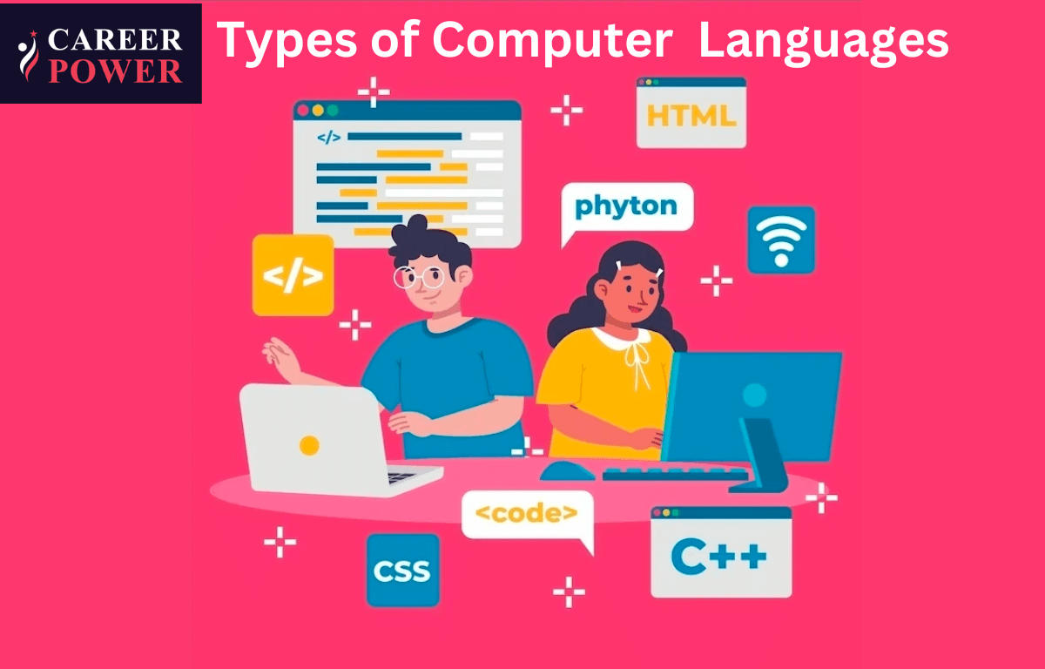

Opportunities in their blending

The following is the list given below that offers an overview of the affordances of technology for language education:
- It reduces anxiety of language learning and increase motivation through game-based activities, creative ideas like mashups and digital storytelling etc.
- It enables multiple modes of language activities in which reading, learning, writing, speaking, and listening skills are all integrated which thereby enhances the strength and interest of different learners.
- Learners find a new platform to make a new social identity.
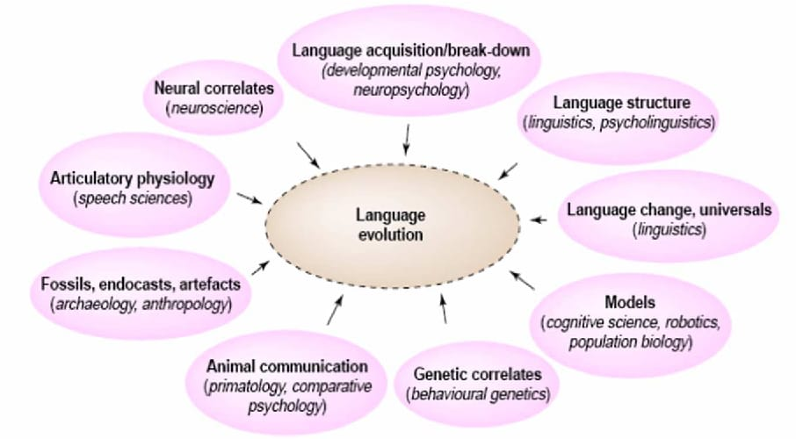
- It facilitates individual learning experiences.

Figure:

CONCLUSION

Computer technology has enjoyed decades of use in the field of second and foreign language education, but efforts to integrate technology have at times presented various challenges to educators due to rapid advances in technology and occasional changes in teaching method of language. The greatest challenges with technology use in language education appear to relate to a lack of studies. In this era of automation, language teachers need not to fear being replaced by technology.
As Technology has advanced, it has contributed in changing the way people write. The new generation has got many more opportunities to write and express themselves than the old generation on the social media. The social media offers an open platform to all people. It has also been observed that in order to express various emotions, techno users resort to pictorial expression of emotion than describing it. It shows regressive tendency to go back to the past when pictorial alphabet was used. Moreover, the cognitive development of human mind had not been so advanced to express abstract ideas in words. It is to be understood that the fascination of techno users for the minimum usage of words, in the long run, is sure to retard cognitive and imaginative capability of mind to express subtle and abstract emotions and ideas elaborately through the medium of language.

REFERENCES
- Gong, T., Shuai, L., & Comrie, B. (2014). Evolutionary linguistics: theory of language in an interdisciplinary space. Language Sciences, 41, 243-253.
- Dediu, D., & Christiansen, M. H. (2016). Language evolution: constraints and opportunities from modern genetics. Topics in Cognitive Science, 8(2), 361-370.
- Kinsella, A. R. (2009). Language evolution and syntactic theory (Vol. 1). Cambridge University Press.
- Számadó, S., & Szathmáry, E. (2006). Selective scenarios for the emergence of natural language. Trends in Ecology & Evolution, 21(10), 555-561.
- Bernabeu, P., & Vogt, P. (2015). Language evolution: Current status and future directions. In 10th Language at the University of Essex Postgraduate Conference (LangUE) (pp. 1-27).
- Dor, D., & Jablonka, E. (2001). How language changed the genes: toward an explicit account of the evolution of language. New essays on the origin of language, 133, 151-175.
- Pleyer, M., Hartmann, S., Winters, J., & Zlatev, J. (2017). Interaction and iconicity in the evolution of language: Introduction to the
- Fujita, H., & Fujita, K. (2022). Human language evolution: a view from theoretical linguistics on how syntax and the lexicon first came into being. Primates, 63(5), 403-415.
- Christiansen, M. H., & Kirby, S. (2003). Language evolution: Consensus and controversies. Trends in cognitive sciences, 7(7), 300-307.
- Wacewicz, S., Zywiczynski, P., Hartmann, S., Pleyer, M., & Benítez-Burraco, A. (2020). Language in Language Evolution Research. Biolinguistics, 14, 59-101.
- Gontier, N. (2012). Selectionist approaches in evolutionary linguistics: an epistemological analysis. International Studies in the Philosophy of Science, 26(1), 67-95.
- Botha, R., & Everaert, M. (Eds.). (2013). The evolutionary emergence of language: Evidence and inference (Vol. 17). Oxford Studies in the Evolutio.
- Steels, L. (2017). Do languages evolve or merely change?. Journal of Neurolinguistics, 43, 199-203.
- Kirby, S. (1999). Function, selection, and innateness: The emergence of language universals. OUP Oxford.
- McMahon, A., & McMahon, R. (2012). Evolutionary linguistics (Vol. 223). Cambridge University Press.

