Knowledge Representation

Husnara khan
Gyan Ganga College of Technology
E-mail -husnarakhan@ggct.co.in

Daljeet Kaur
Gyan Ganga College of Technology
E-mail -daljeetkaur@ggct.co.in

Abstract— The demand for effective Knowledge Representation has surged alongside the rise of smart technologies. This process encompasses gathering data, conveying information, and accessing accurate knowledge. It's evident that a straightforward and lucid representation model is crucial for efficient data capture and retrieval. There's now a pressing need for enhanced knowledge representation models to align with contemporary needs. This research delves into the evolution of representation models throughout history. Its primary aim is to synthesize the advancements made in knowledge representation models and explore various methodologies and approaches utilized in this field.
In the realms of artificial intelligence and natural language processing, knowledge representation stands as a pivotal element. Its symbiotic relationship with automated reasoning underscores its significance, as effective representation facilitates coherent reasoning. Scholars in the domain of knowledge representation and reasoning have devised techniques and methodologies that serve as cornerstone advancements in computer science. These innovations have fostered substantial progress across a spectrum of practical domains, from natural language processing to robotics and software engineering. Yet, there remains a call for further inquiry to empower a more proactive role in steering the reasoning process through the framework of knowledge representation. This discourse has explored the intricacies of knowledge representation and reasoning, scrutinizing the key challenges and emergent opportunities that novel research in this realm has engendered.

Keywords- Knowledge Acquisition, Semantic Webs, Knowledge representation and reasoning, , Declarative representations, Formal logic

I. Introduction

Knowledge Representation in AI refers to how knowledge is expressed and structured for automated reasoning. It involves studying how an intelligent agent's beliefs, intentions, and judgments can be suitably articulated. One of its main objectives is to model intelligent behavior in agents. Knowledge Representation and Reasoning (KR, KRR) entails encoding real-world information in a format that a computer can comprehend and use to solve complex problems, such as natural language communication with humans. Unlike mere data storage, Knowledge Representation enables machines to learn from this knowledge and exhibit intelligent behavior to human beings.

There are five types of knowledge, including:
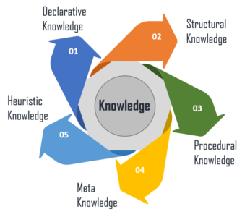

Declarative Knowledge: Encompasses concepts, facts, and objects, and is conveyed through declarative sentences.
Structural Knowledge: Basic problem-solving knowledge that outlines the relationships between concepts and objects.
Procedural Knowledge: Pertains to knowing how to perform tasks and includes rules, strategies, and procedures.
Meta Knowledge: Knowledge about other types of knowledge.
Heuristic Knowledge: Represents expert knowledge in a specific field or subject.

Artificial Intelligence systems typically comprise several components to exhibit intelligent behavior. These components include:
Perception, Learning, Knowledge Representation & Reasoning, Planning, Execution.
Here is an example to illustrate the different components of the system and their functioning:
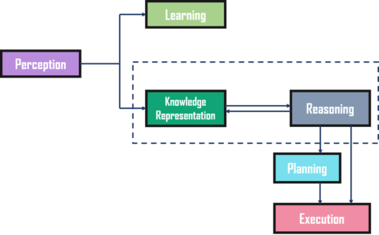

The diagram above illustrates how an AI system interacts with the real world and highlights the components that contribute to its intelligent behavior:

Perception: This component gathers data or information from the environment. It helps the system detect sources of noise, assess any damage to the AI, and determine appropriate responses to sensory inputs.
Learning: The learning component processes the data captured by the perception component. Its aim is to enable computers to be taught rather than manually programmed, emphasizing self-improvement. This involves acquiring knowledge, making inferences, learning heuristics, and conducting faster searches.
Knowledge Representation and Reasoning: This is the core component that imparts human-like intelligence to machines. Knowledge representation focuses on understanding and modeling intelligent behavior from a top-down approach, determining what an agent needs to know to act intelligently. Automated reasoning makes this knowledge usable as needed.
Planning and Execution: These components rely on the analysis provided by knowledge representation and reasoning. Planning involves identifying initial states, preconditions, effects, and a sequence of actions to achieve a desired goal state. Execution is the final stage, where the planned actions are carried out.

This interaction and integration of components enable the AI system to function intelligently and effectively.
Representation Requirements can be described as a robust knowledge representation system should possess the following characteristics:
Representational Accuracy: It should accurately represent all necessary types of knowledge.
Inferential Adequacy: It should be capable of manipulating the representational structures to generate new knowledge that aligns with the existing framework.
Inferential Efficiency: It should efficiently direct the inferential process towards the most productive paths by storing relevant guides.
Acquisitional Efficiency: It should be able to easily acquire new knowledge through automated methods.

In the AI community, scholars have long viewed human brain knowledge and intelligent information processing systems as interconnected networks of nodes. These nodes' organization, relationships, and information retrieval efficiency vary greatly between human brain networks and artificial intelligence systems. The connections within the human brain network exhibit diverse characteristics influencing the speed of information retrieval. Consequently, there's a pressing need to devise intelligent knowledge representation systems that enable autonomous nodes to ascertain appropriate connectivity. Moreover, communication among nodes extends beyond mere linear relationships, encompassing network intelligence. In the contemporary landscape, knowledge assumes a pivotal role, driving cutting-edge decision-making methodologies in artificial intelligence. It manifests as the intelligent behaviours of AI agents or systems, enabling them to act appropriately based on input awareness or experience. The crux of artificial intelligence lies in knowledge representation and reasoning, aiming to understand intelligence and cognition to a degree where computers can emulate human capabilities effectively.

The discussion surrounding knowledge representation holds a central position within the realm of artificial intelligence. Not only do suitable knowledge representations play a crucial role in shaping the design and efficacy of commercially viable software programs, but our selection of knowledge representation systems also reveals implicit theories regarding the essence of machine and human intelligence. For instance, advocates of rule-based representations and proponents of semantic nets may harbor slightly divergent perspectives on the organizational structure of knowledge in human minds. While some AI practitioners focus solely on crafting software systems tailored to specific tasks, the broader field of cognitive science delves into inquiries regarding the nature of knowledge and its arrangement in both humans and machines. In this context, knowledge representation systems serve as a means to articulate and examine theoretical assertions and hypotheses.

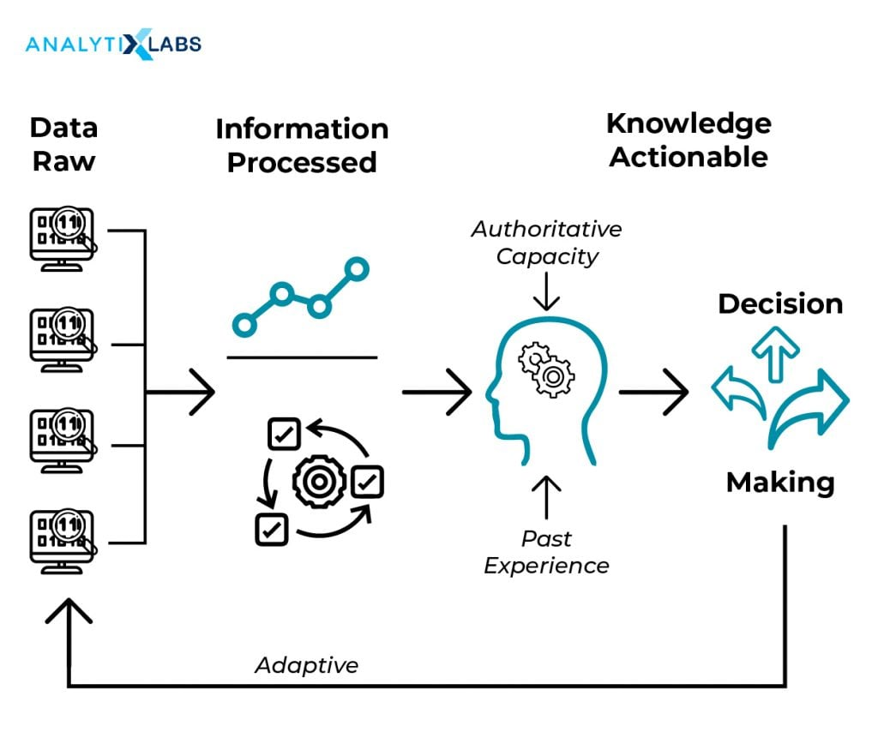Knowledge Representation in AI

II. LITERATURE SURVEY
In the ever-progressing realm of artificial intelligence (AI), knowledge representation assumes a foundational role, empowering machines to comprehend and rationalize the complexities of the world. Today, we delve into the significance of knowledge representation in AI, its profound influence on the evolution of intelligent systems, and its applicability across diverse domains.

Significance of Knowledge Representation in AI Systems
Knowledge representation entails structuring information in a manner comprehensible and actionable for AI systems. It serves as the bedrock upon which intelligent machines decipher the abundance of data and information they encounter. Here are key rationales underscoring the paramount importance of knowledge representation in AI:

1. Facilitating Understanding and Reasoning: Knowledge representation empowers AI systems to encode and interpret information about the world, fostering comprehension of concepts, relationships, and context. This capability underpins reasoning and problem-solving, enabling AI to derive insights and make informed decisions.

2. Embracing Flexibility: Varied AI applications necessitate diverse forms of knowledge representation, spanning structured data, natural language texts, images, and sensor data. Such versatility is indispensable for accommodating the multifaceted information sources with which AI systems engage.

3. Enabling Inference and Decision-Making: AI systems frequently engage in inferential reasoning, predictive analytics, and decision-making based on their understanding of the environment. Effective knowledge representation facilitates these processes, empowering AI to navigate complex and uncertain scenarios adeptly.

4. Facilitating Human Interaction: AI systems often interact with humans, be it through chatbots, virtual assistants, or customer service platforms. Knowledge representation is pivotal for comprehending user queries and delivering meaningful responses, bridging the gap between human language and machine comprehension.

5. Supporting Learning and Adaptation: AI is dynamic and should continually learn and adapt. Proficient knowledge representation facilitates the acquisition of new information, updating of existing knowledge, and ongoing enhancement of performance over time.

6. Fostering Cross-Domain Integration: Real-world applications frequently demand AI systems to integrate knowledge from diverse domains, such as healthcare, finance, or robotics. Knowledge representation enables the synthesis of information from disparate sources, fostering a holistic problem-solving approach.

7. Ensuring Scalability: As data volumes surge, AI systems must scale their knowledge representation capabilities efficiently. Robust methods for organizing and accessing knowledge are indispensable for managing large datasets while sustaining performance levels.

III. RESEARCH METHODOLOGY

Essentials of Knowledge Representation
1. Understanding Knowledge Representation in AI: Knowledge representation in artificial intelligence involves organizing and encoding information to facilitate comprehension, manipulation, and reasoning for computers and AI systems. It encompasses modeling and storing data about the world, including concepts, facts, relationships, and rules, in a format usable by machines for tasks such as problem-solving, decision-making, and communication.

2. Significance in Empowering Intelligent Decision-Making:
Knowledge representation stands as a vital component in AI systems, pivotal for enabling intelligent decision-making. Its contributions to this process include:
a. Organizing Information: Knowledge representation allows AI to structure vast data sets into a comprehensible format, laying the groundwork for understanding the world and contextual decision-making.
b. Inference and Logic: By representing facts and relationships, AI systems can engage in logical reasoning, drawing conclusions, making predictions, and generating new insights.
c. Contextual Understanding: Effective knowledge representation facilitates AI's comprehension of contextual nuances, essential for accurate decision-making across various domains like healthcare.
d. Adaptability: Flexible knowledge representation methods cater to different AI applications, enhancing systems' ability to make informed decisions.
e. Learning and Adaptation: Dynamic knowledge representation enables AI to continuously acquire new information, updating its knowledge base and improving performance over time.
f. Human Interaction: Knowledge representation bridges the gap between human language and machine comprehension, facilitating meaningful interactions and decision support.

3. Common Methods of Knowledge Representation in AI:
Various techniques exist for knowledge representation, each suited to specific application requirements:
a. Semantic Networks: Represent concepts and relationships using nodes and links, ideal for structured knowledge and reasoning tasks.
b. Frames: Organize knowledge around objects or concepts and their properties.
c. Predicate Logic: Utilizes symbols and rules for formal, logical representation, beneficial for complex relationships and deductive reasoning.
d. Ontologies: Define standardized vocabularies for specific domains, capturing concepts, attributes, and relationships.
e. Neural Networks: Implicitly represent knowledge through connection weights, excelling in pattern recognition and data-driven decision-making.
f. Rule-Based Systems: Employ conditional statements and rules for knowledge representation, common in expert systems and decision support applications.

Each method possesses unique strengths and weaknesses, influencing its suitability for diverse AI tasks and domains. The choice of knowledge representation approach significantly impacts the efficacy of AI systems in making intelligent decisions.

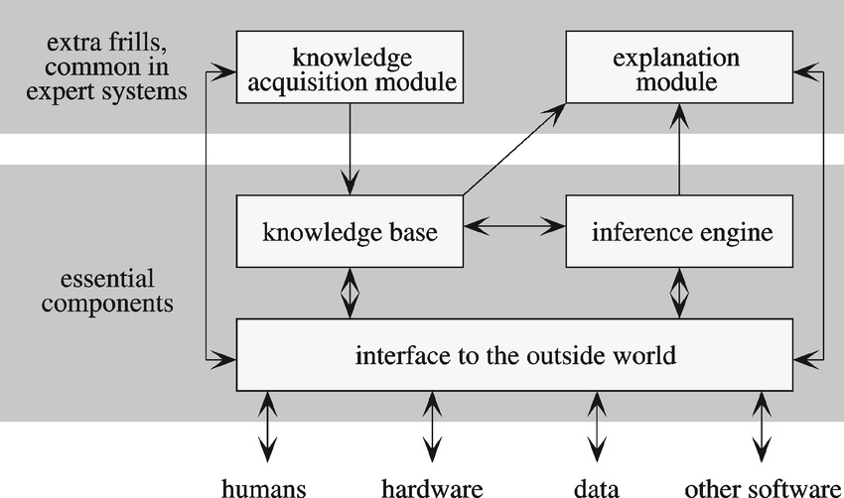
The fundamental elements of a system based on
knowledge.

Techniques and Attributes of Knowledge Representation in AI

Techniques of Knowledge Representation in AI:
1. First-Order Logic: Utilizes predicate logic for expressive knowledge representation.
2. Procedural Knowledge: Encodes task performance methods alongside declarative knowledge.
3. Knowledge Bases: Structured repositories storing facts, rules, and relationships.
4. Bayesian Networks: Probabilistic models facilitating reasoning under uncertainty.

Attributes of Knowledge Representation in AI:

1. Expressiveness: Ability to capture complex relationships and facts.
2. Inferential Capabilities: Support for logical and probabilistic reasoning.
3. Efficiency: Quick retrieval and reasoning with knowledge.
4. Scalability: Ability to handle large knowledge bases and complex domains.
5. Modularity: Structured representation enabling easy updates and maintenance.
6. Interoperability: Integration of knowledge from diverse sources and formats.
7. Consistency: Maintenance of internal coherence and avoidance of contradictions.
8. Abstraction and Granularity: Capture of high-level concepts and fine-grained details.

Effective knowledge representation is critical for AI systems' success, impacting their understanding, learning, and decision-making across various applications. The choice of approach depends on specific problem domains and requirements.
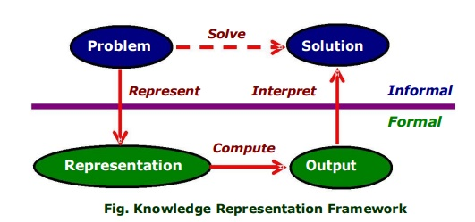

KR and Machine Learning
The advancements in machine learning, particularly with the rise of deep neural networks, have led to a new direction in research where machine learning is combined with symbolic or knowledge-based methods. This integration aims to leverage the strengths of both approaches. On one side, researchers anticipate that knowledge representation (KR) methods can assist in addressing challenges within machine learning. Conversely, machine learning techniques are expected to help overcome limitations within KR systems.

KR for ML: Despite the success of deep learning, doubts persist regarding neural networks' capacity for systematic reasoning and generalization. This skepticism has spurred the development of neuro-symbolic approaches, which blend deep learning architectures with explicit symbolic reasoning processes. For example, DeepProbLog utilizes probabilistic logic programs to reason about deep learning model predictions. Similarly, combinations of neural networks with Answer Set Programming and Markov Logic Networks have been proposed. Symbolic reasoning's utility in machine learning has been explored in contexts like Inductive Logic Programming and more recently, under Statistical Relational Learning. Integrating reasoning components into machine learning models can enhance generalization and bridge the gap between available training data and the ideal data for individual component training. For instance, DeepProbLog demonstrates the ability to train a neural network to recognize hand-written digits when only provided with examples specifying the sum of two hand-written digits.

Aside from reasoning, machine learning models can benefit from symbolic knowledge in various ways. Knowledge injection methods utilize rules and constraints to regularize neural network models, discouraging predictions inconsistent with specified rules. Rules also serve as weak supervision to address limited labeled training examples. Understanding relevant concepts within a domain is crucial; Concept Bottleneck Models utilize this knowledge to ensure neural network representation spaces are semantically meaningful and somewhat interpretable. Other approaches aim to discover meaningful concepts by designing models that learn interpretable vectors resembling concept prototypes, which can then be used for explanations.
Explainability and interpretability have emerged as significant concerns within the realm of machine learning. Explanations can manifest in various forms, such as sets of input features, linear combinations of features, or generated natural language sentences. Given that transparency is a fundamental characteristic of knowledge representation (KR) systems, it's unsurprising that KR concepts often feature prominently in this domain. For example, generating explanations using language models can sometimes result in explanations that lack fidelity. One potential solution involves constructing models that deduce answers by incrementally building something akin to a proof tree. Similarly, large language models can generate step-by-step derivations for reasoning-based answers, known as chains of thought, by extrapolating from a few example derivations. However, these models' implicit proof strategies tend to be basic, suggesting that incorporating KR methods could enhance their capabilities. Specific KR frameworks, like computational argumentation, have long been utilized for modeling explanations. Additionally, when explaining entire models rather than individual predictions, default rules often provide much more concise explanations than decision trees or traditional rules. Another potential application of KR methods lies in formally verifying properties of ML models, such as their resilience against adversarial attacks.

Regarding ML for KR, the bottleneck of knowledge acquisition is a primary challenge in KR systems. These systems require access to structured knowledge, typically encoded in a formalism, which can be scarce and costly to obtain for most domains. ML techniques offer several avenues to mitigate this challenge. For instance, ML models can identify and leverage statistical regularities within existing knowledge bases, leading to strategies for automatically expanding knowledge graphs with plausible triples and identifying missing subsumptions in ontologies. Numerous methods have been devised to convert textual knowledge into a structured format, with recent emphasis on extracting knowledge directly from large language models. The success of language models in knowledge acquisition extends beyond knowledge graphs, encompassing tasks like capturing social commonsense knowledge and inducing script knowledge. ML methods have also been proposed to enhance reasoners or even serve as alternatives to classical reasoners. Some efforts aim to approximate the entire reasoning process using neural networks, enabling efficient and inconsistency-tolerant reasoning with ontologies or heuristic solution searching for computationally intractable problems. Another approach involves integrating ML methods within traditional reasoners, such as learning suitable heuristics for improved performance.

Knowledge Representation (KR) and Robotics
Robots, as physical entities, execute tasks by interacting with their environment through sensors and effectors. Examples include vacuum robots, warehouse robots, and autonomous vehicles in urban settings. Given their need for domain and general knowledge to solve problems like planning and reasoning, robotics appears to be an ideal domain for KR application. For instance, the pioneering robot Shakey, in the late 1960s, employed explicit knowledge representations to plan actions like moving objects between rooms. Although Shakey's reasoning techniques have been surpassed by more advanced methods, the planning language STRIPS, stemming from the Shakey project, remains in use today. Despite the early success of Shakey, KR had minimal influence on robotics for some time, as immediate challenges like safe navigation in unfamiliar environments took precedence. A breakthrough occurred in the mid-1990s with the advent of probabilistic robotics, leading to notable achievements such as museum tour guide robots like Rhino and Minerva and a resurgence of KR techniques like the action language Golog, which controlled Rhino's high-level behavior.

Simultaneously, Ray Reiter and colleagues pioneered Cognitive Robotics, where KR assumes a central role. Cognitive Robotics aims to equip robots or software agents with higher-level cognitive functions, including reasoning about goals, perception, actions, mental states of other agents, and collaborative task execution. While Cognitive Robotics has made strides, fully realizing the vision of integrating KR into robotics remains a work in progress.

Nevertheless, KR significantly influences the high-level behavior control of many modern robotic systems. Notably, the KnowRob system, developed by Tenorth and Beetz, combines rich ontologies with specialized reasoners such as temporal and qualitative spatial reasoners. Planning techniques also play a crucial role, transitioning from domain-dependent planners like IxTeT and TAL to domain-independent PDDL planners like FF, TFD, and ROSPlan. The action language Golog, initially used to control Rhino, has been integrated with PDDL planners. Additionally, goal reasoning has found application in robotics, as demonstrated by scenarios like production logistics, where robots must juggle multiple goals concurrently, prioritizing and sometimes abandoning them due to timing constraints or failures.
A compelling avenue within robotics involves integrating task and motion planners to generate more resilient plans, particularly in scenarios involving object manipulation. Extending this concept to conditional planning enables handling incomplete information and partial observability .

Once a robot has determined its course of action, constant monitoring of their execution becomes crucial. Early approaches to execution monitoring, particularly within Golog programs. More recent advancements in continual planning not only tightly integrate planning and execution monitoring but also allow for postponing plan refinement until sufficient information is gathered at runtime [52, 174]. In terms of failure diagnosis, model-based techniques rooted in strong KR principles have been developed. While execution failures are inevitable in general, efforts are underway to enhance robot safety, resilience, and trustworthiness. Verification, closely tied to KR, plays a pivotal role in this endeavor, as evidenced by its numerous connections to KR in the context of verifying robotic systems.

Undoubtedly, numerous challenges persist in realizing the vision of KR-based cognitive robots. A comprehensive list of these challenges can be found in the Dagstuhl report on cognitive robotics.
KR's role in Information Systems
Ontologies and knowledge graphs stand as pivotal contributions of KR to information systems research and practice. Additionally, ontology-mediated data access tackles fundamental database research queries by leveraging advanced KR techniques. Its logical underpinnings primarily involve variants of datalog, description logics, and existential rules. Declarative approaches to data exchange and integration closely align with ontology-mediated data access in terms of techniques and objectives. Description logics have been proposed as a logical basis for standard database design formalisms like ER and UML diagrams. The optimization of description logic reasoners is utilized to verify their consistency and logical implications. Recently, KR methods, particularly in non-monotonic reasoning and description logics, have been instrumental in further advancing the W3C standard SHACL for enhancing semantic and technical interoperability by validating graph-based data against sets of constraints.

These applications of KR methods in information systems and databases predominantly address the structural and static aspects of information. However, incorporating KR methods to address the dynamic behavior of information systems is a recent development. Despite its recognition as a major challenge in business process management (BPM) and information systems engineering, the integration of structural and behavioral aspects has seen limited KR application. Research communities addressing this challenge, such as AI4BPM and PM4AI workshops, emphasize three critical aspects of BPM: the business process lifecycle, varying complexity and predictability, and modeling patterns.

In the field of BPM, KR applications are evolving. Integrated modeling of processes and data results in infinite-state relational transition systems with first-order interpretations for each state. Analysis, ranging from standard properties like reachability and safety to more intricate properties expressed in variants of first-order temporal logics, has been explored under complete and incomplete information scenarios. Relevant KR techniques encompass reasoning about action and planning. Moreover, KR methods find applicability in analyzing knowledge-intensive processes, where flexibility is paramount, leveraging approaches developed in decidable first-order temporal logic and temporal conceptual modeling. Furthermore, KR approaches are pertinent in declarative process modeling, management, and mining. They should also be utilized to address emerging reasoning challenges in process mining, formalizing tasks, exploring decidability and complexity, and employing automated reasoning techniques instead of ad-hoc algorithms. Notable examples include logic-based techniques like planning.

KR and Logic/Philosophy

Classical first-order logic initially emerged as an endeavor to formalize the foundations of mathematics, notably exemplified by the monumental work of Russell and Whitehead. Later developments delved into philosophical concepts such as strict versus material implication, necessity versus contingency, and issues surrounding naming and reference. This marked a significant departure in the application of logic, whether propositional, first-order, modal, or relevance, to represent and reason about real-world domains. The KR Hypothesis, asserting that a knowledge-based approach is indispensable for constructing any genuinely intelligent agent, intimately links logic and KR by advocating semantically meaningful declarative structures in such agents.

The relationship between KR, philosophy, and logic has been mutually enriching. Both sides have reaped numerous benefits. For instance, belief revision, initially a philosophical concept, found application and further development within KR. Broadly speaking, KR, and AI more broadly, have introduced novel problems and challenges to logic, while real-world applications have honed these issues. In turn, formal logic has equipped researchers with tools and methodologies to tackle these challenges. Much formal work in KR involves the development and refinement of new and existing logical frameworks.

Illustrative examples highlight the fruitful exchange between KR and logic. Notable reasoning problems like the frame, qualification, and ramification problems have been identified and addressed, with roots in philosophical inquiries. Areas like belief revision and deontic reasoning have benefited from progress made within the KR community. Additionally, modal logic research, driven by KR and computer science, has spurred advancements in non-monotonic reasoning, particularly through fixed-point semantics and preferential structures proposed by Shoham and extended by others. Furthermore, research in description logics has yielded comprehensive analyses of useful fragments of first-order logic and their associated complexity properties. Conversely, recognizing that many description logics align with syntactic variants of modal logics has allowed the description logic community to leverage theoretical and technical insights developed for modal logics over the years.

Various disciplines approach the concept of knowledge differently, reflecting the complexity and diversity of its forms and definitions. These distinct approaches are outlined below:

1.Philosophy: Epistemology is the branch of philosophy that delves into the nature of knowledge, tracing its historical development through various theses and theories.

2. Linguistics: Linguistics explores the knowledge system inherent in human language, encompassing a spectrum of complex abilities including speech, emotions, thoughts, desires, and expression. Its subfields include phonetics, phonology, morphology, syntax, semantics, and pragmatics.

3. System Analysis: This problem-solving process integrates knowledge and methods from modern science and technology with goal-oriented concepts to identify essentials and devise a robust framework for overcoming uncertainties. It encompasses eight major areas: organizational structure, behavior, politics, functional requirements, systems development, information technology, individual behavior, and corporate characteristics.

4. Artificial Intelligence: AI focuses on representing and reasoning with real-world information in a format understandable to computers, enabling them to address various situations.

5. Connectionist Theories: These theories elucidate the process by which human knowledge is acquired and represented, offering insights into the theory of mind.

6. Constructivist Theories: These theories posit that knowledge and meaning are constructed by individuals through experiences and ideas.

7. Educational Psychology: This discipline defines knowledge as awareness of something and understanding its significance, acquired through experience or learning.

8. Cognitive Science: An interdisciplinary field combining psychology, linguistics, philosophy, and computer modeling, Cognitive Science develops theories about human thinking, perception, and learning.

Methods of Knowledge Representation take various forms, including:

1. List (Hierarchical) Scheme: This method organizes knowledge sequentially, with each step or action stored in a repository called the Knowledge Base. As new instances are encountered, the Knowledge Base is updated accordingly.

2. Procedure (Functions/Control Flow) Scheme: This approach involves a set of instructions or procedures to be followed for problem-solving, representing processed information.

3. Network (Trees/Graphs) Scheme: Using nodes to represent concepts or objects and edges to denote their relationships, this scheme employs data structures such as decision trees and semantic networks to facilitate storage and manipulation of resources.

4. Structured (Stereotype) Schemes: These schemes extend network representation with complex data structures for each node. Frames and Scripts, containing additional procedures within nodes, aid in achieving specific goals.

5. Rule-Based Representation (Special Problem-Solving Contexts): This method employs inference rules and predictions encoded as production rules, defining conditions and corresponding actions (If-Then pairs) based on initial and goal states, legal operators, and operator restrictions.

6. Logic-Based Representation: Utilizing mathematical notations and symbols, this scheme expresses problems in a manner understandable by both computers and humans. With accurately defined syntax and semantics, outputs are unambiguous. Types of reasoning include Propositional Logic (Boolean), Predicate Calculus (additional information), and Certainty Measures (certainty factors) for tasks like Diagnosis, Expert Estimation, and Statistical Analysis.

7. Ontology Scheme: Domain-based representation utilizing formal semantics, making knowledge explicitly accessible to machines, easily shareable, and field-specific.

8. Hybrid Scheme: A combination of different methods, offering flexibility and adaptability to various problem-solving contexts.
Challenges and Solutions

1. Addressing Incompleteness and Uncertainty:AI employs fuzzy logic and probabilistic reasoning to handle incomplete or uncertain information effectively.
2. Tackling Representation Bias: Semantic web and ontology engineering promote standardization and transparency, mitigating bias by fostering structured representations.
3. Achieving Scalable Knowledge Representation:
Knowledge graphs and embeddings facilitate scalable representation, efficiently handling large datasets and complex relationships.
4. Managing Context and Context-Dependent Knowledge:
AI systems use context-aware techniques to ensure accurate decision-making in contextually rich environments.
5. Overcoming the Symbol-Grounding Problem:
Sensor fusion techniques in robotics connect abstract symbols to real-world entities, enhancing natural language understanding and image recognition.
6. Addressing Ontology Development and Maintenance Challenges:
Automated tools aid in ontology development and maintenance, ensuring consistency and coherence in evolving knowledge bases.

Successful AI applications, from virtual assistants to healthcare decision support systems, demonstrate effective knowledge representation in addressing real-world challenges. Overcoming these challenges requires a combination of techniques tailored to specific application contexts, ensuring AI systems' responsible and ethical use.
The objective of research in knowledge representation should revolve around comprehending and portraying the complexity of the world. However, much of the research identified as fundamental to knowledge representation has predominantly focused on a narrower scope, particularly concerning taxonomic and default reasoning. We contend that it is not coincidental that valuable insights, such as discovering optimal temporal abstractions, have emerged from a thorough examination of practical tasks within real-world domains. This reinforces our belief, which is shared by others that endeavors to portray the richness of the natural world should be the primary driving force behind knowledge representation research.

Our assertion extends to both terminology and methodology. Firstly, works like those of Hamscher and Lenat should be acknowledged by the knowledge representation community as integral to knowledge representation research, rather than being pigeonholed into categories such as diagnosis or qualitative physics and deemed unrelated. Secondly, insights akin to those obtained from studies originate from exploring the world itself, rather than solely scrutinizing linguistic frameworks. We argue that individuals identifying as knowledge representation researchers should develop theories and technologies that support projects like these. Conversely, those engaged in such projects are undertaking a crucial form of knowledge representation research.

While tools and methodologies hold significance, the field should encompass a broader scope, reflecting the vast intricacies of the world. We advocate for the central focus of the field to be understanding and depicting this complexity.

IV. FUTURE SCOPE OF ARTIFICIAL INTELLIGENCE
Knowledge representation is pivotal for AI systems, empowering them to comprehend, rationalize, and make well-founded decisions. Challenges in this domain encompass incompleteness, uncertainty, scalability, representation bias, contextual nuances, and the symbol-grounding dilemma. Solutions like fuzzy logic and probabilistic reasoning tackle uncertainty, while endeavors such as the Semantic Web and ontology engineering address representation bias. Scalability concerns are mitigated through the utilization of knowledge graphs and embeddings. Real-world applications such as virtual assistants, healthcare systems, recommendation engines, autonomous vehicles, and search engines adeptly navigate these challenges. Practical solutions encompass probabilistic reasoning, distributed databases, fairness-aware machine learning, context awareness, sensor fusion, and automated ontology development. AI continually evolves, augmenting its capacity to confront intricate knowledge representation issues in artificial intelligence, thus rendering it a formidable instrument for discerning decision-making.
VII. Conclusion
Knowledge representation serves as the bedrock for AI to comprehend and engage with the world in significant ways. It is vital for facilitating machine learning, reasoning, and informed decision-making, thus constituting a core element in the advancement of intelligent AI systems. In this conversation, we'll explore different facets of knowledge representation and its real-world utility in artificial intelligence.

In the domain of artificial intelligence, knowledge representation serves as a fundamental cornerstone, enabling machines to grasp concepts, engage in reasoning, and execute informed decisions. Yet, it presents various hurdles, spanning from managing uncertainty to mitigating bias and ensuring scalability. These challenges underscore the necessity for inventive strategies and solutions in knowledge representation. Nonetheless, with advancements in areas like fuzzy logic, semantic web technologies, and knowledge graphs, AI is witnessing significant progress in tackling these obstacles, facilitating successful applications across diverse fields. As AI evolves further, knowledge representation retains its pivotal role as a critical frontier in the quest for developing more intelligent and ethically responsible machines.
We contended that a knowledge representation fulfills five distinct functions, each significant in shaping the essence of representation and its fundamental responsibilities. These functions generate numerous, occasionally conflicting requirements, necessitating discerning and astute compromises among the desired attributes. Additionally, these five functions assist in clearly delineating the essence of the representations and the technologies used in representation development.
This perspective carries implications for both research and practical applications within the field. In terms of research, it advocates for a broader conceptualization of representation compared to the often-used definition, emphasizing that all five aspects are crucial components of representation issues. It asserts that the ontological commitment provided by a representation is among its most significant contributions, thus highlighting the importance of ensuring this commitment is both substantial and thoughtfully selected. Furthermore, it posits that the primary objective of representation is to describe the natural world, suggesting that the field would make the greatest strides by adopting this viewpoint as its central focus.

Regarding the practical application of knowledge representation work, this perspective suggests that the task of combining representations should be guided by insights into how to integrate their theories of intelligent reasoning, rather than focusing solely on their implementation mechanisms. It also encourages a deeper understanding and appreciation of the fundamental essence of representations. We propose that representation technologies should not be perceived as adversaries to be overcome, compelled to conform to a specific manner of behavior. Instead, they should be comprehended on their own terms and utilized in ways that leverage the insights that originally inspired them and imbued them with power.

REFERENCES

[1] Brachman, R., and Levesque, H. eds. 1985. Readings in Knowledge Representation. San Mateo, Calif.: Morgan Kaufmann. Brachman, R., and Schmolze, J. 1985.
[2] An Overview of the KL-ONE Knowledge Representation System. Cognitive Science 9(2): 171–216. Davis, R. 1991.
[3] A Tale of Two Knowledge Servers. AI Magazine 12(3): 118–120. Davis, R., and Shrobe, H. 1983.
[4] Representing Structure and Behavior of Digital Hardware. IEEE Computer (Special Issue on Knowledge Representation) 16(10): 75–82. Davis, R.; Shrobe, H.; and Szolovits, P. 1993.
[5] What Is a Knowledge Representation? Memo, AI Laboratory, Massachusetts Institute of Technology. Doyle, J. 1992.
[6] Rationality and Its Roles in Reasoning. Computational Intelligence 8:376–409. Doyle, J., and Patil, R. 1991.
[7] Two Theses of Knowledge Representation: Language Restrictions, Taxonomic Classification, and the Utility of Representation Services. Artificial Intelligence 48(3): 261–297. Doyle. J., and Patil, R. 1989.
[8] Two Dogmas of Knowledge Representation, Technical Memo, 387B, Laboratory for Computer Science, Massachusetts Institute of Technology. Fahlman. S.; Touretsky, D.; and van Roggen, W. 1981.
[9] Cancellation in a Parallel Semantic Network. In Proceedings of the Seventh International Joint Conference on Artificial Intelligence, 257–263. Menlo Park, Calif.: International Joint Conferences on Artificial Intelligence. Hamscher, W. 1991.
[10] Modeling Digital Circuits for Troubleshooting. Artificial Intelligence 51:223–272. Hayes, P. 1979.
[11 ] https://www.sciencedirect.com/topics/socialsciences/knowledge-representation
[12] https://www.edureka.co/blog/knowledge-representation-in-ai/

