Title:- Overview of Intestinal Coccidian Parasites in Human Beings
Introduction
Intestinal Coccidian parasites are a group of protozoan parasites belong to the phylum Apicomplexa ,class coccidea , family Eimeriidae. [Table-1]
Some of the common intestinal coccidian parasites that infect humans include Cryptosporidium spp., Cyclospora cayetanensis, and Isospora spp. The importance of intestinal coccidian parasites in immunocompromised patients lies in the increased risk of severe disease and the potential for opportunistic infections. In immunocompetent individuals, infection with intestinal coccidian parasites may cause self-limiting symptoms such as diarrhoea, pain abdomen, nausea, and vomiting. However, in immunocompromised patients, such as those with HIV/AIDS, organ transplants, or undergoing chemotherapy, these infections can lead to severe and potentially life-threatening complications. Immunocompromised individuals are more susceptible to developing chronic and disseminated infections with intestinal coccidian parasites. The parasites can cause prolonged diarrhea, malabsorption, weight loss, dehydration, and electrolyte imbalances in these patients. Additionally, coccidian parasites may lead to extra-intestinal manifestations, such as biliary tract involvement or systemic dissemination, leads to significant morbidity and mortality in immunocompromised individuals. Monitoring and managing coccidian parasite infections in immunocompromised patients are crucial to prevent complications and improve clinical outcomes. Strategies for prevention, early detection, and treatment of coccidian parasite infections are essential in this vulnerable patient population.
Table 1: classification of phylum Apicomplexa
Kingdom | Subkingdom | Phylum | Class | Order | Genus
Protozoa | Neozoa | Apicomplexa (Sporozoa ) | Coccidea | Eimeriida | Eimeria  Toxoplasma  Cryptosporidium  Cyclospora  Isospora  Sarcocystis
 |  |  |  | Haemosporida | Plasmodium
 |  |  |  | Piroplasmida | Babesia

Epidemiology:
The burden of intestinal coccidian parasitic infections is significant, with estimates suggesting that millions of cases occur annually worldwide. These infections disproportionately affect susceptible individuals, like children, the elderly, and persons with relatively weak immunity. The epidemiology of intestinal coccidian parasites is influenced by factors such as poor sanitation, overcrowding, inadequate healthcare infrastructure, and socioeconomic disparities. The lack of comprehensive surveillance data and the limited availability of diagnostic tools pose challenges in assessing the true burden of these infections in the country.
- Cryptosporidium spp.: Cryptosporidiosis is a leading cause of diarrheal illness worldwide, particularly in low- and middle-income countries with poor sanitation and water quality. Outbreaks of Cryptosporidium infection have been reported in settings such as childcare facilities, healthcare institutions, and recreational water sources.
- Cyclospora cayetanensis: Cyclosporiasis is more commonly reported in tropical and subtropical regions with inadequate sanitation and water treatment systems. Outbreaks of Cyclospora infection have been associated with the ingestion of contaminated fresh product, including berries and leafy vegetables.
- Isospora spp.: Infection with Isospora parasites is also prevalent in areas with poor sanitation and hygiene practices. The transmission of Isospora oocysts occurs through the ingestion of contaminated food or water, leading to symptomatic infections, especially in immunocompromised individuals.

Lifecycle
The life cycle of intestinal coccidian parasites, such as Cryptosporidium spp., Cyclospora cayetanensis, and Isospora (Cystoisospora) spp., involves complex stages of development within the host's gastrointestinal tract. Overviews of the typical life cycle of these coccidian parasites are as follows
- Oocyst Stage: The infective stage of coccidian parasites is the oocyst, a thick-walled structure that contains sporulated sporozoites. Oocysts are excreted in the feces of infected hosts and may contaminate the environment, including food and water sources.

- Ingestion and Excystation: The host usually ingests oocysts through contaminated food or water. Within the host's gastrointestinal tract, oocysts undergo excystation, releasing sporozoites from the oocyst wall.

- Invasion and Replication: The released sporozoites invade the host's intestinal epithelial cells, where they undergo asexual replication (merogony). This process involves the formation of merozoites, which further invade and multiply within adjacent cells, leading to the development of schizonts or meronts.
- Formation of Gametocytes: Some parasites differentiate into sexual stages, the male (microgametocytes) and female (macrogametocytes) gametocytes. Fertilization occurs when microgametocytes release microgametes that fertilize macrogametes, forming zygotes.
- Oocyst Formation and Shedding: Zygotes develop into oocysts, which undergo sporogony, leading to the formation of sporulated oocysts containing infective sporozoites. These sporulated oocysts are shed in the host's feces, completing the life cycle and providing a source of transmission to other hosts.
- Environmental Contamination: Shed oocysts contaminate the environment, including water sources, soil, and food. This contamination can lead to the ingestion of oocysts by susceptible hosts, perpetuating the cycle of infection.
- Cycles of Infection: In the case of Cryptosporidium spp., the life cycle involves both asexual and sexual reproduction stages within the host's intestinal epithelium. The rapid replication of the parasites and the production of large numbers of oocysts contribute to the persistence of infection and the potential for environmental contamination. Fig1- 3 showing life cycle of coccidian parasites

Figure-1 : Showing life cycle of Cryptosporidium species (source- CDC)

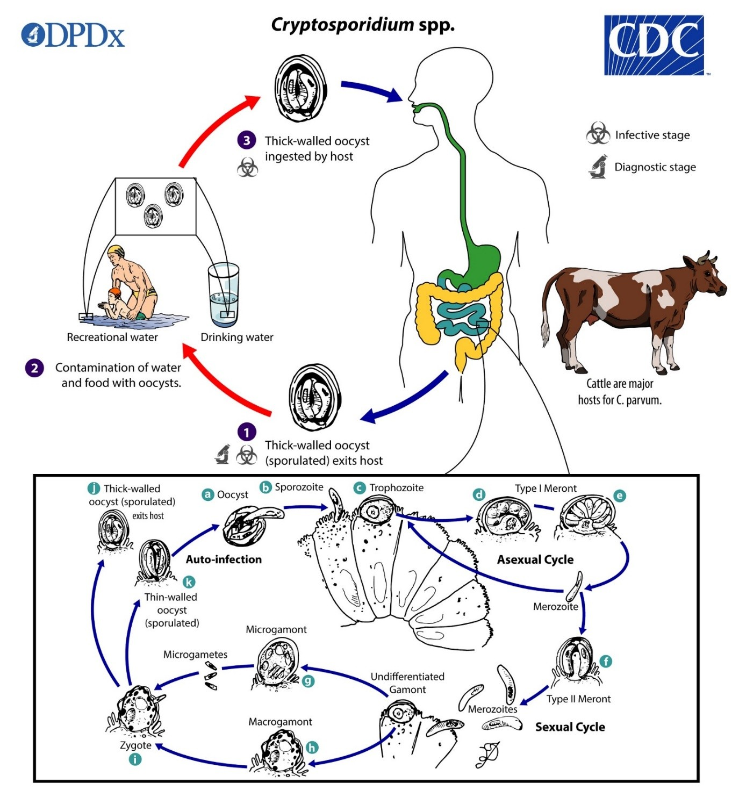

- The infected host excretes sporulated oocysts through faeces, which contain four sporozoites
- Majority of Cryptosporidium spp. are spread by direct contact with sick people or animals, or by ingestion food or water that has been contaminated by faeces .
- Excystation happens after ingesting by an appropriate host. After being released, the sporozoites parasitize the gastrointestinal tract's epithelial cells ( , ). Parasites reproduce asexually (schizogony or merogony) , , in intestinal epithelial cells, typically within the brush border, and subsequently sexually (gametogony), generating microgamonts (male) and macrogamonts (female) . Zygote developed after fertilization of the macrogametes by the microgametes ( ) which sporulate in the infected host. Zygotes produce two different types of oocysts (thick-walled and thin-walled). Thick-walled oocysts are excreted from the host into the environment , whereas thin-walled oocysts are involved in the internal autoinfective cycle and are not present in stools . Oocysts are infectious upon faecal excretion, thus enabling direct and immediate fecal-oral transmission. Extracellular stages have been reported, but their relevance in the overall life cycle is unclear.

Figure-2 : Showing life cycle of Cystoisospora species (source- CDC)

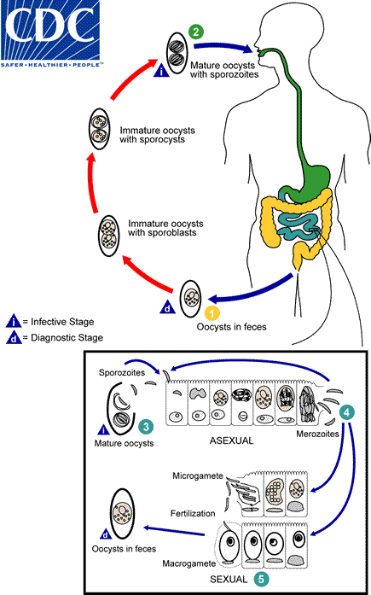

1. The immature oocyst typically contains one sporoblast during excretion (very rarely, two). Following excretion, the sporoblast divides in two during further maturation (the oocyst now has two sporoblasts); the sporoblasts then secrete a cyst wall to become sporocysts, which divide twice to create four sporozoites
2. Ingestion of oocysts carrying sporocysts leads to infection. In the small intestine, the sporocysts excyst and release their sporozoites, which infiltrate the epithelial cells and initiate schizogony.
3. The merozoites are released when the schizonts burst, infiltrate fresh epithelial cells, and carry on the asexual multiplication cycle.
4. Trophozoites grow to become schizonts, which are made up of several merozoites. Gametocyte development for both male and female begins the sexual stage after at least one week.
5. After fertilization, oocysts develop and are excreted in the stool.

Figure-3 : Showing life cycle of species (source- CDC)
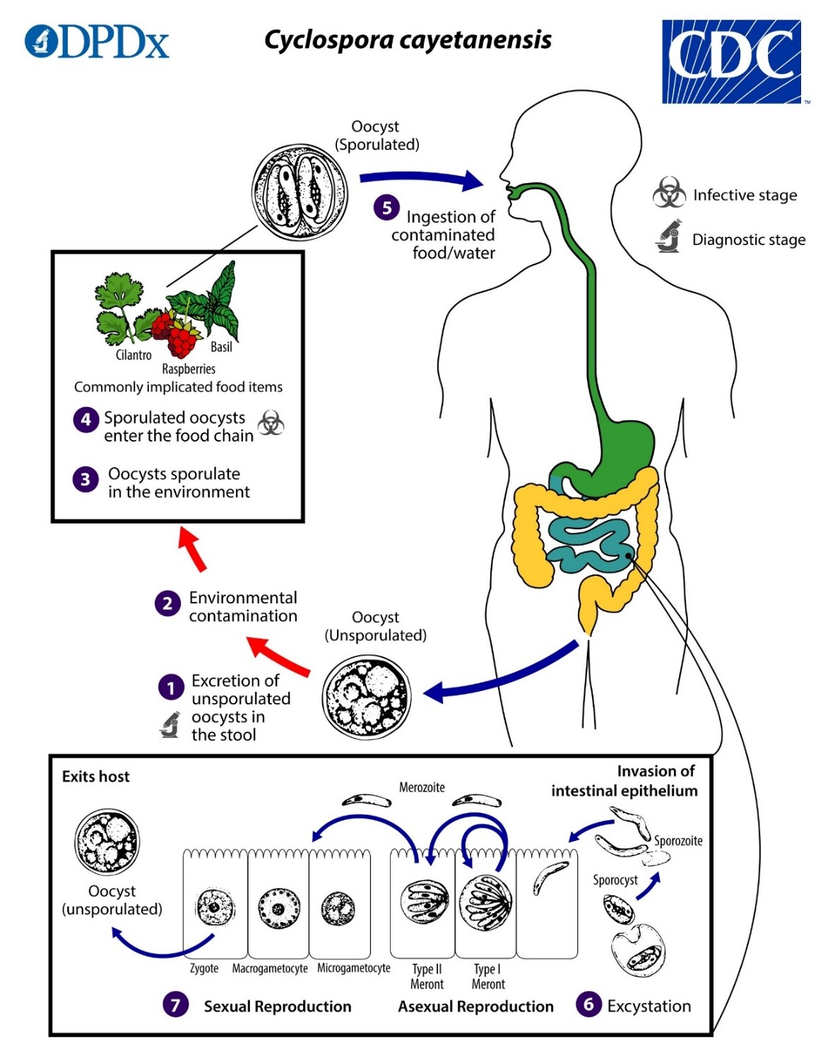

1. Freshly passed stool containing oocysts is not infective, which means that there may be no direct fecal-oral transmission, this differentiates Cyclospora from another important coccidian parasite, Cryptosporidium).
2 & 3. In the environment, sporulation takes place at temperatures between 22°C and 32°C over the course of several days or weeks. This division produces two sporocysts, which has two elongated sporozoites.
4 and 5. Sporadic oocysts have the potential to contaminate water or infiltrate the food chain, where they can be consumed. The sporulated oocysts have the potential to contaminate water/or enter in food chain.
6. In the gastrointestinal system, the oocysts excyst, releasing the sporozoites that infiltrate the small intestine's epithelial cells.

7. inside the intestinal epithelial cells ,they divide into type I and type II meronts through asexual means. Merozoites from Type I meront most likely remain in the asexual cycle, but merozoites from type II meront grow sexually and leads to development of macrogametocytes and microgametocyte’s. zygotes formed after fertilization,which further developed into oocyst , which is excreted in the stool.

Pathogenesis
The pathogenesis of these parasites involves several key factors that contribute to their ability to cause disease in vulnerable hosts:
- Infectivity and Replication: Opportunistic coccidian parasites have a unique life cycle, includes both asexual and sexual reproduction stages. Upon ingestion of infectious oocysts through contaminated food and/or water, sporozoites are released and infiltrate the intestinal epithelial cells. These parasites replicate asexually within the host cells, leading to the production of numerous merozoites and ultimately more oocysts. This continuous cycle of invasion and replication contributes to the parasite's ability to establish and maintain infection in the host.

- Host-Parasite Interaction: The interaction between opportunistic coccidian parasites and the host immune system is critical in determining the outcome of infection. Immunocompromised people, such as those receiving immunosuppressive therapy or living with HIV/AIDS, have compromised immune systems, which makes it difficult to effectively regulate the growth of parasites. This allows the parasites to proliferate unchecked in the intestinal epithelium, leading to severe and chronic infections.

- Intestinal Damage and Malabsorption: Opportunistic coccidian parasites, particularly Cryptosporidium spp., are known to cause significant damage to the intestinal epithelium. Parasite attachment and invasion of enterocytes result in villous blunting, inflammation, and disruption of the mucosal barrier. This can lead to malabsorption of nutrients, electrolyte imbalances, and impaired intestinal function, contributing to symptoms such as diarrhea, weight loss, and dehydration.
- Extra-intestinal Manifestations: In addition to intestinal pathology, opportunistic coccidian parasites can disseminate beyond the gastrointestinal tract in immunocompromised patients. This extra-intestinal spread can involve organs such as the biliary tract, respiratory system, liver, and gallbladder, leading to complications such as cholecystitis, pneumonia, and hepatitis. Disseminated infections are associated with increased morbidity and mortality in susceptible individuals.
- Chronic Infection and Immune Evasion: Opportunistic coccidian parasites have developed strategies to evade host immune responses and establish chronic infections in immunocompromised hosts. Factors such as antigenic variation, intracellular survival mechanisms, and inhibition of immune signaling pathways contribute to the persistence of infection and the difficulty in eradicating the parasites.
Understanding the pathogenesis of opportunistic coccidian parasites is essential for developing effective prevention strategies, diagnostic approaches, and treatment interventions to mitigate the impact of these infections on immunocompromised individuals. Targeting key aspects of parasite infectivity, host-parasite interactions, and disease progression can help improve clinical outcomes and reduce the burden of infection in vulnerable populations.

CLINICAL SIGNIFICANCE

Symptoms such as diarrhea, malaise, fatigue, and loss of appetite are commonly associated with various gastrointestinal pathogens, including those causing cyclosporiasis in developed nations. In endemic regions, clinical infections typically affect children aged 4–10 years. Approximately half of these children experience diarrhea and other gastrointestinal discomforts such as malaise, bloating, and reduced appetite. In some cases, infections may resolve spontaneously, suggesting a potential role of immunity in clearing the infection. In instances of human isosporiasis, severe symptoms are often observed in individuals with conditions like AIDS or other forms of immune suppression. Clinical presentations frequently include fever, malaise, chronic and persistent diarrhea, steatorrhea (excessive fat in stools), and weight loss. In severe cases, the infection can lead to fatal outcomes.

Diagnosis
Diagnostic methods for detecting intestinal coccidian parasites in immunocompromised patients play a crucial role in early identification, treatment, and management of infections. Several laboratory techniques are available for diagnosing these parasites. Here are some of the common diagnostic methods used:
- Stool Examination: Microscopic examination of stool samples is a primary and widely used method for detecting coccidian parasites. Routine stool examination by using saline wetmount and Specific staining techniques, such as modified acid-fast stains (e.g., Ziehl-Neelsen stain), can help visualize oocyst of Cryptosporidium spp., Cystoisospora spp and Cyclospora cayetanensis. The presence of oocysts, sporulated oocysts, or other parasite stages in stool samples confirms the infection. (Figure 1a-3a & 1b-3b)
- Direct Fluorescent Antibody (DFA) Test: DFA testing is a sensitive and specific method for detecting Cryptosporidium spp. and other coccidian parasites in stool samples. The procedure involves using specific fluorescent-labeled antibodies that bind to the parasites, allowing visualization under a fluorescent microscope.
- Polymerase Chain Reaction (PCR): PCR-based assays are highly sensitive molecular methods used for detection and identification of coccidian parasites in clinical samples. Targeting specific genetic markers, PCR can provide rapid and accurate diagnosis, even in low parasite concentrations. It also allows for species identification and differentiation.
- Enzyme-Linked Immunosorbent Assay (ELISA): ELISA tests can be used for detection of parasite-specific antigens in stool samples. Considered as a rapid and sensitive method for diagnosing infections caused by coccidian parasites like Cryptosporidium. ELISA kits are commercially available and offer high throughput for diagnostic laboratories.
- Microscopy of Duodenal Biopsy Samples: In cases where other diagnostic methods are inconclusive or when assessing extra-intestinal involvement, duodenal biopsy samples may be examined microscopically for the presence of coccidian parasites in intestinal mucosa.
- Immunofluorescence Assay (IFA): IFA can be used to detect specific antibodies against coccidian parasites in patient serum samples, indicating recent or past infections. Serological testing is not usually used for primary diagnosis but can be helpful in epidemiological studies or surveillance.
- Antigen Detection Assay: Rapid immunochromatographic test (ICT) based on lateral flow assays for antigen detections are available for diagnosing Cryptosporidium infections in stool samples. These tests provide quick results without the need for sophisticated laboratory equipment.

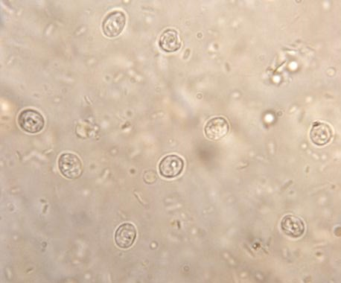  1a | 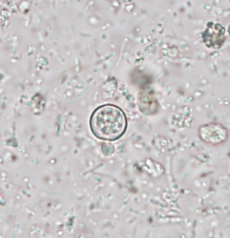  2a | 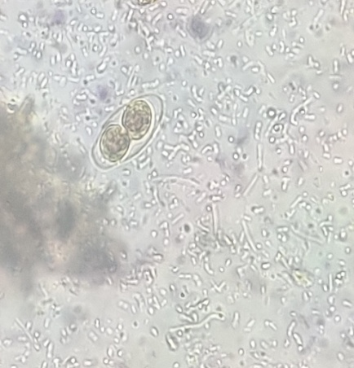  3a
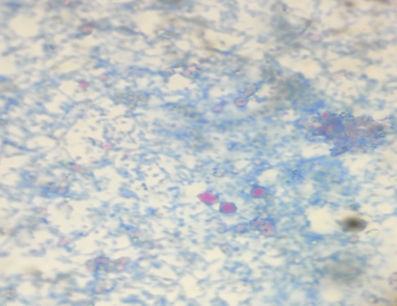  1b | 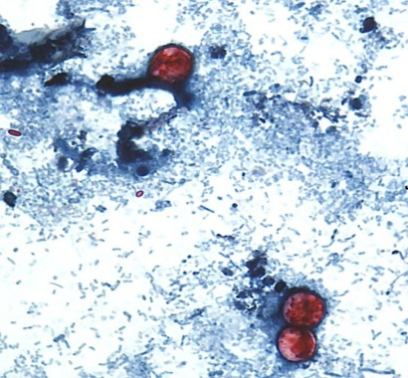  2b | 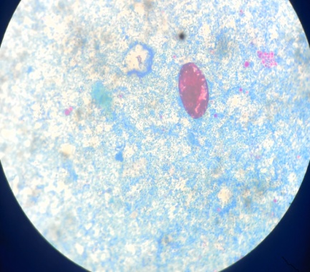  3b
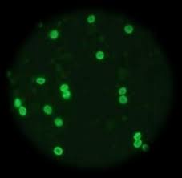  1c | 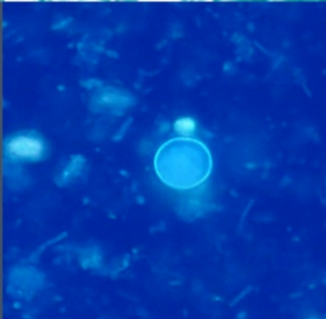  2c | 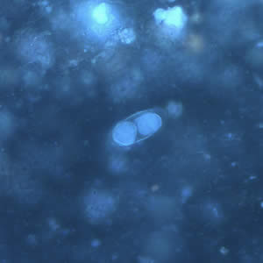  3c

Figure 1a to 1c: Cryptosporidium species
(1a). Round oocyst (4-6µm) in saline wet mount
(1b). Modified Ziehl-Neelsen stain shows red color round oocyst against blue background.
(1c). Direct fluorescent antibody staining shows brilliant green fluroscent oocysts
Figure 2a to 2c: Cyclospora species
(2a). Round unsporulated oocyst (08-10µm) in saline wet mount)
(2b). Modified Ziehl-Neelsen stain shows red color round oocyst against blue background.
(2c). UV fluorescence microscopy shows oocyst wall is autofluorescent
Figure 3a to 3c: Cystoisospora species
(3a). Oval sporulated oocyst (25-35µm) in saline wet mount
(3b). Modified Ziehl-Neelsen stain shows red color oval unsporulated oocyst
(3c). UV fluorescence microscopy shows fluorescent oocyst

Treatment
The treatment of coccidian parasites, such as Cryptosporidium spp., Cyclospora cayetanensis, and Isospora (Cystoisospora) spp., typically involves the use of specific medications aimed at controlling the infection. It is significant to remember that treatment options may change according to the specific parasite implicated, the patient's immunity status, and the severity of infection. Followings are some commonly used drugs for treating coccidian parasitic infections:
- Nitazoxanide: Nitazoxanide is the first-line treatment for Cryptosporidium infection in both immunocompetent and immunocompromised individuals. It can also be effective against Cyclospora and Isospora infections. Nitazoxanide disrupts parasite metabolism and replication, helping to alleviate symptoms and clear the infection. It is available in both pediatric and adult formulations.
- Trimethoprim-sulfamethoxazole (TMP-SMX): TMP-SMX is another medication commonly used to treat coccidian parasitic infections. It has shown efficacy against Isospora infections in particular. TMP-SMX works by inhibiting the parasite's folic acid synthesis, preventing replication and controlling the infection. However, its use in immunocompromised patients with severe infections may be limited due to the risk of adverse effects and the potential for developing drug resistance.
- Spiramycin: Spiramycin is an antibiotic used to treat certain parasitic infections, including Cryptosporidium infections in immunocompetent individuals. While it may not be as effective in immunocompromised patients, it can be considered as a treatment option in selected cases.
- Supportive Care: In addition to specific antiparasitic medications, supportive care is important to manage symptoms and prevent complications associated with coccidian parasitic infections. This may include oral rehydration solutions, electrolyte replacement, nutritional support, and management of associated gastrointestinal symptoms.
It is crucial to consult with a healthcare professional or infectious disease specialist for accurate diagnosis and appropriate management of coccidian parasitic infections. The specific treatment regimen will depend on factors like the parasite species, the severity of the infection, the immune status of the patient, and any associated medical conditions.

Comprehensive approach to preventing Coccidian Parasite Infections:
There are various approach to prevent infection from Coccidian parasites which includes personal hygiene practices, regular hand washing, Ensuring safe drinking water for communities by implementing proper filtration and disinfection, Practicing good food hygiene, including thorough cooking and washing of fruits and vegetables. Livestock and pets must be kept under improved sanitation facilities, consistent deworming at regular interval and proper veterinary care to minimize the transmission of coccidian parasites among animal populations and to the humans. These practices play a vital role in reducing the risk of coccidian parasite infections.

