Bacterial Aspect of Sexually Transmitted Infections
Author: Dr. Aditya Rana
Senior Resident, Department of Microbiology at Dr. R. P. Govt. Medical College, Kangra at Tanda(Himachal Pradesh)

Bacterial agents causing sexually transmitted diseases (STDs) are of significant concern in developed and developing countries. The main concerns are Chlamydia trachomatis (LGV), Neisseria gonorrhoeae (gonorrhea), Treponema pallidum (syphilis), Klebsiella granulomatis ( granuloma inguinale or donovanosis), and Haemophilus ducreyi (chancroid).
Sexually transmitted diseases (STDs) are still carrying a larger burden. World Health Organization (WHO), in its estimation in 2020 highlighted that there were 374 million fresh infections of four common STIs, which means nearly 1 million new STIs every day. The most common STI is Chlamydia, with 129 million new infections each year. Gonorrhea follows with 82 million new infections annually, and syphilis with 42 million new infections per year.
Sexually transmitted bacterial infections can appear in various forms, ranging from serious or potentially life-threatening illnesses like syphilis to incapacitating conditions with enduring effects, including pelvic inflammatory disease(PID), endometritis, ectopic pregnancy, and infertility. Additionally, milder manifestations like self-limiting urethritis with cervicitis are linked to bacterial sexually transmitted infections.
Typically, the progression of bacterial sexually transmitted diseases (STDs) is influenced by both microbial virulence and the host's immune responses to the pathogen. Certain shared features of bacterial STDs include a greater occurrence among adolescents in contrast to older populations, implying a potential reinforcement of immune resistance as individuals age.
When detected early, these infections are treatable with effective antimicrobials but may lead to irreversible consequences. Bacterial STDs can also increase the risk of acquiring infection of human immunodeficiency virus (HIV).
This chapter provides briefs on the significance of infection, causative agents, clinical presentation, pathogenesis (involving both microbial and host contributions to disease onset and progression), diagnosis, and treatment.

H. ducreyi(Chancroid)

Ducrey (1890) demonstrated the presence of this bacterium in chancroid lesions and successfully transmitted the lesion through several generations by inoculating it into the skin on the forearm.

Introduction:
Haemophilus ducreyi causes chancroid (or soft chancre), an STI associated with painful genital ulcers. These ulcers easily bleed in touch. The surrounding skin has no inflammation, but enlarged, tender inguinal lymph nodes (bubo) are common.

After infection, there's an incubation period of around one week. Following this, individuals may experience the development of painful, reddish bumps on the external genitalia, progressing into pustules and eventually eroding into non-indurated, hemorrhagic ulcers(fig.1). These lesions often multiply, appearing on adjacent skin surfaces like the thigh or scrotum in males and the labia, vagina, and perianal region in females. Suppurative inguinal lymphadenopathy, occasionally forming fluctuant buboes, is also typical. There's no acquired immunity post-infection, though hypersensitivity might develop.
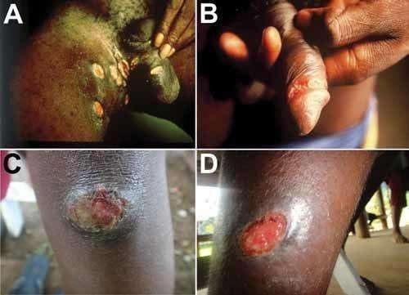

Fig. 1: Ulcers in Haemophilus ducreyi. A, B) Genital ulcers(Source: David Mabey). C,D) Skin ulcers (Source: Oriol Mitjà).

Haemophilus ducreyi release a potent 'cytolethal distending toxin' that somehow contributes to ulcer formation and delays in their healing process.
The histological analysis of chancroid genital ulcers reveals perivascular along with interstitial infiltrations of macrophages, CD4+, and CD8+ T cells, indicative of a type IV hypersensitivity, cell-mediated immune response. The significance of CD4+ T cells and macrophages in the clinical presentation may partly explain the increased assistance of HIV infection in chancroid patients.

Epidemiology:
In developing countries, genital ulcers by Chancroid is a major concern. It is primarily transmitted heterosexually, with a ratio of 3:1 to 25:1 in male-to-female infection. Chancroid can increase both the transmission efficiency and susceptibility of acquiring HIV infection.

Laboratory Diagnosis:
Specimens obtained from ulcer exudate or the ulcer edge and lymph node aspirates are useful for diagnosis.
Gram Staining:
H. ducreyi appears as a gram-negative coccobacillus which is pleomorphic maximally, often arranged in groups or parallelly. It commonly exhibits bipolar staining, described as resembling a 'school of fish' or a 'railroad track’ appearance.(fig.2).
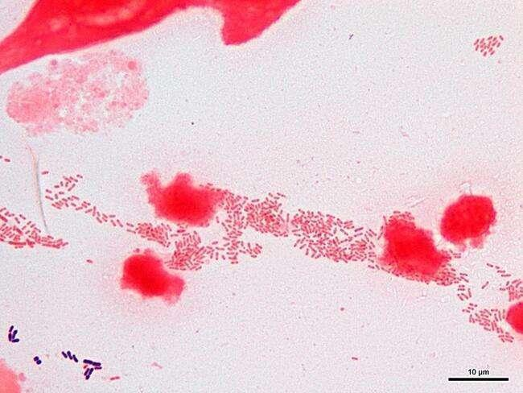
Fig. 2: H. ducreyi gram stain(School of fish) Source(hit-micrscopewb)
Culture:
H. ducreyi requires only factor X (hemin) for growth. Primary isolation is challenging and requires specific conditions such as growth on blood agar(rabbit) or with 1% isovitalex and made selective by adding vancomycin in chocolate agar.
Alternatively, it may grow on the chorioallantoic membrane of the chick embryo. Required growth conditions include 10% CO2, high humidity, and incubation at 35°C for 2 to 8 days. The growth surrounding the X disk can aid in presumptive diagnosis.(fig. 3)
Fig. 3: H. ducreyi around X and XV factor disc. Source(Universe84a)

Colony Morphology:
Colonies are typically small, grey, translucent, and measure 1-2 mm in size within 2-3 days. H. ducreyi displays biochemical inertness.

Slide Agglutination Test:
H. ducreyi is antigenically homogeneous, and cultures can be confirmed through agglutination with antiserum.

Treatment: The recommended treatment options for bacterial infections by CDC are as follows: Single oral dose of 1 gm Azithromycin. Alternatively, Ceftriaxone is administered through an intramuscular injection with a single dose of 250 mg.
Alternate regime is Ciprofloxacin orally, at a dosage of 500 mg, twice a day for a duration of 3 days. Lastly, Erythromycin base can be taken orally, with a dosage of 500 mg, three times a day, for 7 days.

Lymphogranuloma venereum(LGV)

Introduction:
LGV is a sexually transmitted infection caused by L1, L2, L2b & L3 serovar strains of C. trachomatis. Acute LGV typically involves a temporary the genital lesion primarily, followed by multiple suppurative regional lymphadenopathy.

Epidemiology:
LGV is relatively rare in North America but more common in regions such as Africa, Asia, and South America continents. Its prevalence is increasing in Europe, particularly among homosexual males. The major incidence of LGV is seen during the second and third decades of life, correlating with peak sexual activity.

Clinical Presentation:
Infected women are asymptomatic and can serve as a reservoir for transmission.
First Stage:
Initially in the infection it starts with a painless papule, ulcer, or vesicle which may appear on the penis or vulva, usually 3 days to 6 weeks after exposure. (fig. 4)
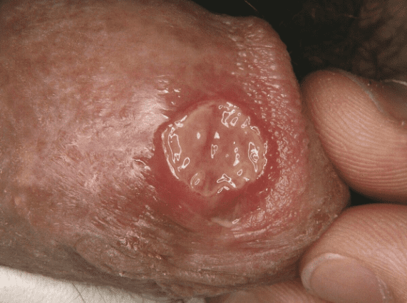
Fig. 4: LGV Ulcer. Source(Altmeyer Encyclopedia)

Second Stage:
Enlargement, tenderness, and softness of the inguinal lymph nodes (referred to as buboes) occur. Fistulae may form and discharge externally, leading to chronic fistulae. Systemic symptoms like fever, headache, and myalgia may also manifest.(fig. 5)
Fig. 5: Buboes in the second stage of LGV. Source(Springer Atlas of STD)

Third Stage:
Untreated cases, especially in females and homosexual men, may result in complications such as stricture in rectum, and rectovaginal fistulae or rectal fistulae. Edematous granulomatous hypertrophy of the vulva, scrotum, or penis (known as 'esthiomene') might occur.(fig. 6)
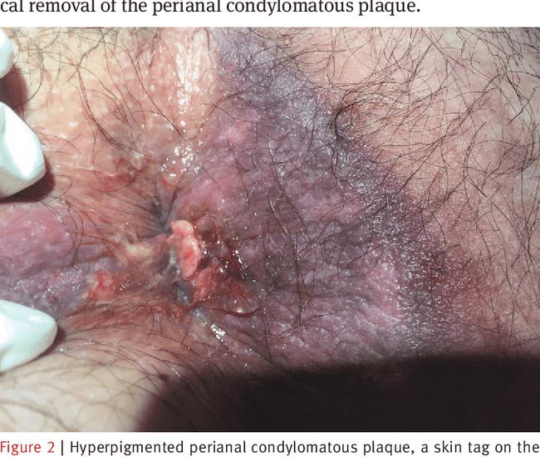
Fig. 6: Rectal fistulae in the third stage of LGV. Source(B. Mlakar)
Laboratory Diagnosis:
Diagnostic methods include scraping samples from the ulcer base, lymph node aspirates, direct detection (EIA and DIF), and culture.
While EIA is sensitive and quick, it lacks specificity and often needs confirmation via NAAT or DIF.
Gram staining poorly stains chlamydiae; alternative stains like Castaneda, Machiavello, or Gimenez methods are more effective.
Microscopic diagnosis has low sensitivity for detecting Miyagawa’s granulocorpuscles in LGV.(fig. 7)
Fig. 7: Miyagawa’s granulocorpuscles in LGV. Source (Medizzy)
Chlamydia isolation via intracerebral inoculation has been replaced by cell cultures, with various recommended cell lines for C. trachomatis.
Cell line cultures are species specefic: C. trachomatis recommended cell lines are McCoy, HeLa 229, buffalo, green monkey, and baby hamster kidney (BHK-21) cell lines
Serology:
Serologic tests include complement fixation using LPS antigen (group-specific but not species-specific), ELISA with recombinant LPS antigen, and Microimmunofluorescence (MIF) with species and serovar-specific MOMP antigen. MIF can detect IgM and IgG separately but is technically demanding.
High titer of 1:512 is a diagnostic feature of infection but more significantly fourfold rise in titers over 2-3 weeks is diagnostic.
Histology
Histologically, infected nodes initially show minute stellate abscesses encircled by histiocytes, which then coalesce into large, necrotic, suppurative foci.

Treatment:
Doxycycline 100mg bd PO is treatment of choice, alternatly erythromycin 500mg qds PO for 21 days is also the recommended treatment for LGV.

Granuloma inguinale (donovanosis)

Introduction:
Donovanosis is a chronic, progressive bacterial infection primarily transmitted through sexual contact.Donovanosis is also termed as granuloma inguinale or granuloma venereum. It is caused by Klebsiella granulomatis, earlier named Calymmatobacterium granulomatis. Polymerase chain reaction (PCR) studies show a close relationship between its phoE gene and genes found in Klebsiella pneumoniae and its related species.

Epidemiology:
The disease was initially documented in Calcutta by McLeod in 1882, and the characteristic pathological "Donovan bodies" in genital lesions were identified by Charles Donovan in Madras in 1905. Donovanosis is prevalent in regions like India, Brazil, Papua New Guinea, and parts of South Africa, and is linked to risk factors such as poor hygiene, lower socioeconomic status, and multiple sexual partners. Despite a global decrease, it remains a notable cause of genital ulcers in certain areas.
While primarily sexually transmitted, other modes of transmission might exist. Its infectivity is thought to be low since sexual partners of infected individuals often don't contract the infection immediately or may require multiple exposures to become infected. Transmission can occur through non-sexual contact, leading to extragenital skin lesions or even autoinoculation in infants born to infected mothers.

Clinical Features:
The period of incubation ranges from 1-3 months, possibly extending to 6 months. The disease progresses slowly, with painless papules evolving into beefy red ulcers that bleed easily upon contact(fig. 8). Genital involvement is common, affecting specific regions like the prepuce, frenum, glans in males, and the labia minora in females. Lymph node involvement is rare, though pseudobuboes can sometimes appear in the inguinal region due to subcutaneous abscess.
Fig. 8: Beefy Red Ulcer in Donovanosis. Source(Medscape)

Laboratory Diagnosis:
Specimen collection involves swabbing ulcerated areas or using granulation tissue for examination. Microscopic examination using stains like Giemsa or Wright's can reveal Donovan bodies—large, cyst-like macrophages filled with encapsulated bacilli displaying a safety-pin (bipolar) appearance.(fig. 9)
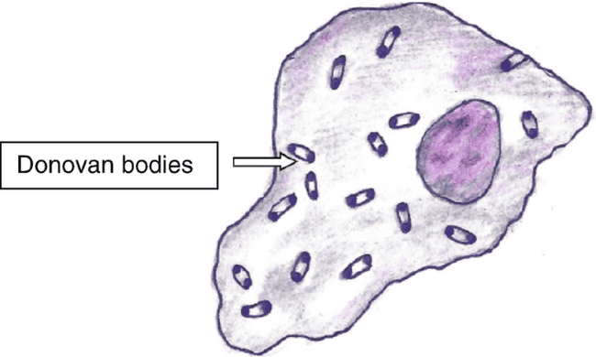
Fig. 9: Bipolar(Safety Pin Appearance)Wright’s staining. Source(Springer nature)
On gram staining they are encapsulated, and gram-negative bacilli.
Culture methods like on egg yolk medium and HEp-2 cell lines are done and molecular techniques like PCR aid in identifying the specific bacteria involved.

Treatment:
Antibiotics such as azithromycin, doxycycline, erythromycin, or ciprofloxacin are recommended least for period of 3 weeks or until ulcers heal.
Various antibiotic regimens, including aminoglycosides, might be necessary for patients not responding to initial therapy, particularly in HIV-positive individuals, as recommended by the CDC guidelines.

Syphilis(Treponema Pallidum)

Schaudinn and Hoffmann (1905) discovered the causative agent of Treponema pallidum in the chancres and inguinal lymph nodes of patients. The name "Pallidum" means pale on staining.
Epidemiology
Syphilis is primarily acquired through sexual exposure involving infective lesions i.e. chancres, mucous patches, and rashes on the skin(condylomata lata). Further, less common modes of infectivity include nonsexual personal contact such as vertical transmission(mother to fetus)in utero, blood or blood products transfusion, and organ transplantation.
Venereal syphilis presents a complex and varied clinical picture, often resembling various other diseases. It's categorized into stages: incubating, primary, secondary, early nonprimary nonsecondary syphilis, late syphilis, and tertiary syphilis.
Pathogenesis
Syphilis has been recognized as a prehistoric sexually transmitted infection since the fifteenth century. The nomenclature originated from a renowned poem in 1530 recounting the story of Syphilus, a sheep rearer boy who suffered from the disease. As stated earlier its transmission occurs primarily through sexual contact, but also by non-venereal modes like direct contact, blood transfusion, or transplacental transmission
T. pallidum, swiftly penetrates minute skin or mucosal abrasions. Within hours, it enters the lymphatic system and bloodstream, causing systemic infection and spreading to distant sites much faster than the appearance of primary lesions. Blood remains a potent source of infection during the incubation period or early stages of syphilis. The period of incubation ranges from 9 to 90 days, inversely related to bacterial load. The average incubation period in humans is around 3 weeks(21 days), correlating with an average bacterial infective dose of 500-1000 organisms.
Clinically
Primary syphilis typically manifests after 14 days to 3 months of incubation with the development of a painless, reddened papule. This evolves into a painless, 'punched-out' ulcer known as a chancre, mainly found on the genital region (seldomly in mouth and hands, or anus), often accompanied by local lymph node swelling.(fig. 10) Multiple chancres might arise, in HIV-infected individuals. Ulcers are highly infective and typically heal up on their own within 1–2 months.
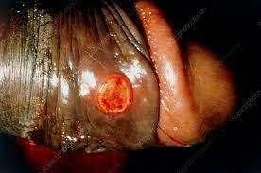
Fig. 10: Painless penile Ulcer in primary syphilis. Source(Science Photo Library)

Secondary syphilis emerges 1–6 months later as the infectious organisms disseminate from the chancre. Symptoms may include a rash—appearing as localized or diffuse skin lesions that can be macular, papular, pustular, or a mix thereof—spanning the trunk, limbs, palms, and soles. Mucosal ulcers might develop. Condylomata lata, highly infectious lesions, can appear in warm, moist areas (e.g., skin folds).(fig. 11) Early neurosyphilis, more common in HIV-positive individuals, may present with varied symptoms such as syphilitic meningitis, meningovascular syphilis, headache, limb paralysis, stroke, and various other features like fever, sore throat, mouth ulcers, lymph node swelling, malaise, hepatitis, periostitis, iritis, arthritis, and glomerulonephritis.
Fig. 11: Mucoculatenous patch on tongue, Condylomata lata & Rashes on hand in Secondary Syphillis. Source (CDC)

Latent syphilis follows the resolution of secondary symptoms and can span from 3 to 12 weeks. Patients are asymptomatic during this latent phase with low infectivity. However, up to 25% of patients may experience a recurrence of the disease. Early latent syphilis occurs within 2 years of the primary syphillis, while late latent syphilis manifests beyond this period.

Late or tertiary syphilis, although rare, emerges after a period of 2–20 years of infection. It is marked by chronic inflammation and can present in various forms such as gummatous syphili with lesions on skin, mucous membranes, bone, or organs. Cardiovascular syphilis involving endarteritis of the aorta, potentially causing aortic regurgitation or aneurysm formation. Late neurosyphilis—which can manifest as general paresis of the insane or tabes dorsalis.(symptoms like confusion, hallucinations, cognitive impairment, ataxia, sensory loss, and more)

Congenital syphilis can occur in two stages: Early congenital syphilis which occurs within 2 years of birth, presenting with various symptoms including rash, condylomata lata, mucous patches.
Late congenital syphilis occurring after a span of 2 years, characterized by distinct features like interstitial keratitis, Hutchinson's teeth, mullbery deafness, along with neurological or gummatous involvement.(fig. 12)
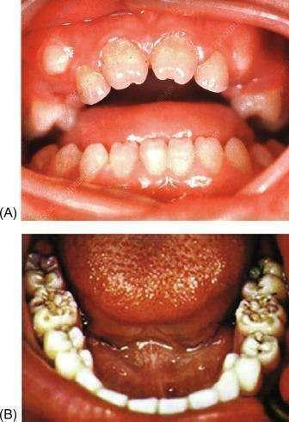
Fig. 12: a.) Hutchinson’s teeth b.) Mullbery deafness . Source(Science Direct)
Laboratory Diagnosis
Collecting samples for syphilis testing requires careful attention to prevent contamination and ensure accurate results:
Ulcers: Samples from ulcers must be devoid of blood, normalflora, or cellular debris. Cleans the ulcer with sterile gauze moistened with normal saline. Place the sample on a clean glass slide and cover it with clean coverslip.
PCR Samples: Dacron or cotton swab are used and place it in a cryotube with nucleic acid transport medium or universal transport medium.
Serum and Plasma: Serum is the preferred specimen for serology, but plasma can be used in some tests. Perform testing on plasma within 24 hours to prevent false-positive results. Capillary draws of whole blood, serum, or plasma are suitable for rapid syphilis tests.
Maternal and Infant Serum: Maternal serum can be used for screening congenital syphilis. For IgM-specific tests, use infants' serum to avoid contamination from maternal blood in cord blood specimens.

Storage Guidelines: Maintain serum, plasma, and cerebrospinal fluid (CSF) at 4°C if testing is delayed up to 4 hours. For delays exceeding 4 hours, store at -20°C. Samples intended for PCR, like unfixed tissue, ulcer exudate, CSF, or whole blood in EDTA, should be stored at -80°C if testing is delayed.

Diagnosis
Syphilis diagnosis involves various methods:
Microscopy: Spiral bacterias are seen under Dark-field microscopy and immunofluorescence microscopy from chancre exudates.(fig. 13)
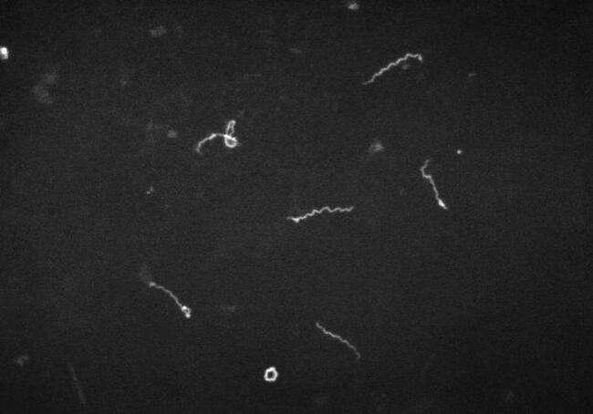
Fig. 13: Dark ground microscopy of Treponema Pallidum. Source(CDC)

Molecular test by PCR: Confirm diagnosis or test samples from oral lesions, which might have commensal spirochaetes, like Treponema macrodentium and Treponema microdentium.
Serology: Two types of tests, specific treponemal and non-treponemal/cardiolipin tests, are used. Specific tests like treponemal EIAs, TPHA, TPPA, and FTA-ABS detect IgM and IgG, typically positive in secondary and early latent syphilis. Non-treponemal tests like VDRL/RPR aid in staging and treatment monitoring.(fig. 14)
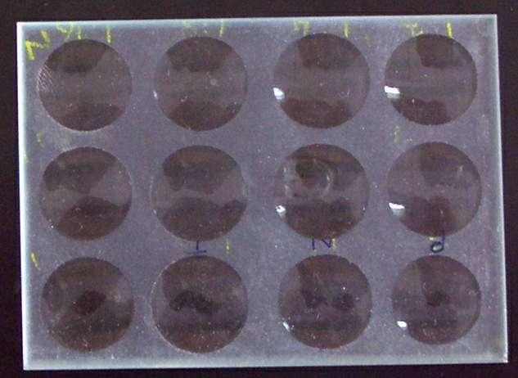
Fig. 14: VDRL Plate. Source(Wikipedia)
CSF: In neurosyphilis, asymptomatic cases there is pleocytosis in cytology, low glucose, raised protein biochemically, and positive VDRL microbiologically (might be negative in HIV). Symptomatic individuals show severe CSF changes in cytology & biochemically, with VDRL almost always positive.

Syphilis Stages and Tests:
Primary Syphilis: Dark-field microscopy, PCR-based tests, VDRL (75% positive), TPHA (90% positive).
Secondary Syphilis: VDRL (almost 100% positive), TPHA (100% positive), usually positive CSF-VDRL in early neurosyphilis.
Latent Infection: The VDRL test may show a decrease over time, but it does not necessarily rule out infection. Despite a declining VDRL result, the TPHA (Treponema pallidum hemagglutination) test shows a positive reaction.
Tertiary Syphilis: Gummas syphilis shows positive VDRL and TPHA test, syphilitic aortitis and late neurosyphilis might have weakly positive or negative VDRL but positive TPHA.
Congenital Syphilis: Neonatal serum's IgM presence confirms congenital syphilis, distinguishing it from passively transferred maternal antibodies. Various tests detect IgM; parallel maternal and neonatal tests or serial testing help confirm the diagnosis.
Diagnostic Procedures: Perform a chest X-ray in late latent syphilis or if aortic disease signs are present. Neurological imaging is recommended for individuals with neurological symptoms or signs

Treatment
In managing syphilis:
Screening: Testing all patients for other sexually transmitted infections is important along with HIV.
Early Syphilis Treatment:
Administer Benzathine benzylpenicillin: 2.4 million IU intramuscularly stat, divided into two separate injections or Doxycycline: 100mg twice daily for 14 days or Erythromycin: 500mg four times a day for 14 days.
Late Syphilis Treatment:
Benzathine benzylpenicillin: 2.4 million IU dose is given by IM route twice weekly for 3 weeks, or Doxycycline is given 100mg twice a day orally for 28 days.
Neurosyphilis Treatment:
Benzylpenicillin: 3–4 million IU intravenously is given 4 hourly for 14 days, or Procaine benzylpenicillin G is given 2.4 million IU intramuscularly daily with probenecid 500mg orally four times a day for 14 days, or Ceftriaxone 2g IV is given once a day for 14 days, or Doxycycline 200mg orally twice a day for 28 days.
Congenital Syphilis Diagnosis:
IgM in newborn serum signifies congenital syphilis, distinguishing it from maternal antibody transfer. Various techniques like FTA-ABS, TPHA, EIA, and VDRL tests help detect IgM. When specific tests aren't available, parallel processing of maternal and neonatal sera or serial testing aids in confirming congenital syphilis. The VDRL comes negative within three months due to the rapid decrease in passively transferred antibody titers.
Treatment Monitoring:
Assess treatment success based on symptoms and repeat VDRL. In neurosyphilis, perform a serial lumbar puncture in 3–6 months and then every 3 months until CSF findings come to be normal and CSF VDRL results non-reactive positive serology testing for 2 years requires retreatment.

Vulvovaginitis
Inflammation of the vaginal mucosa is called vaginitis, and the external genitalia, the vulva, is known as vulvitis. It stands as the major genital tract infection in females.
Females typically experience symptoms, including abnormal discharge with or without a foul odor and itching.
The three major causes of vaginitis in premenopausal females are associated with trichomoniasis, bacterial vaginosis, and vaginal candidiasis.
Bacterial Vaginosis
Introduction
Bacterial vaginosis (BV) leads to vaginal discharge in less than 50% of symptomatic females, this symptom is also seen in vulvovaginal candidiasis and trichomoniasis. Instead of being attributed to a single organism, BV results from intricate alterations in the composition of the microbial flora within the vaginal environment.
Epidemiology
Globally, the prevalence of bacterial vaginosis (BV) ranges from 11% to 48% among females of reproductive age.
Contributing factors to its addition include having multiple sexual partners & practicing vaginal douching. Notably, BV can develop in females who have never engaged in vaginal intercourse.
Pathophysiology
This condition involves an imbalance in the typical vaginal flora, characterized by:
- Lactobacilli play a crucial role by producing hydrogen peroxide (H2O2), which helps maintain a lower pH in the vagina. When these organisms decrease, the pH rises, leading to an overgrowth of anaerobic bacteria in the vaginal environment. These anaerobes produce enzymes that break down vaginal peptides, resulting in the formation of malodorous substances. Additionally, they contribute to increased discharge and shedding of the epithelial layers.

- This imbalance involves a decrease in the concentration of lactobacilli and rise in other organisms such as Gardnerella vaginalis, Prevotella species, Porphyromonas species, Bacteroides species, Peptostreptococcus species, Mycoplasma hominis, Ureaplasma urealyticum, and Mobiluncus species.
Clinical Features
Around 50 to 75% of cases exhibit no symptoms.
Symptoms, when present, include white-colored, fishy odor discharge thin in consistency. It might coincide with cervicitis, which can occur with or without concurrent chlamydial or gonococcal infections.
Pain during intercourse or irritation of the vulva is rare.
Complications associated with BV include a higher risk of preterm delivery in pregnant women. Additionally, it's linked to conditions like endometritis, post-partum fever, and infections post-gynecological surgeries. BV serves as a risk factor for acquiring and transmitting HIV, as well as for acquiring HSV-2, Chlamydia, and gonorrhea.
Diagnosis
A diagnosis of bacterial vaginosis includes at least three of the following four criteria that are met according to Amsel's criteria:
- Presence of profuse thin (low viscous), white vaginal discharge uniformly coating the lateral vaginal wall.
- pH of the vagina exceeds 4.5.
- Fishy odor (arising from volatile amines like trimethylamine) immediately upon mixing secretions with a 10% solution of potassium hydroxide (Whiff test).
- Clue cells identification: These are epithelial cells of the vagina, covered with coccobacilli, presenting a granular appearance and having blurred edges when observed on a wet mount.(fig. 15)
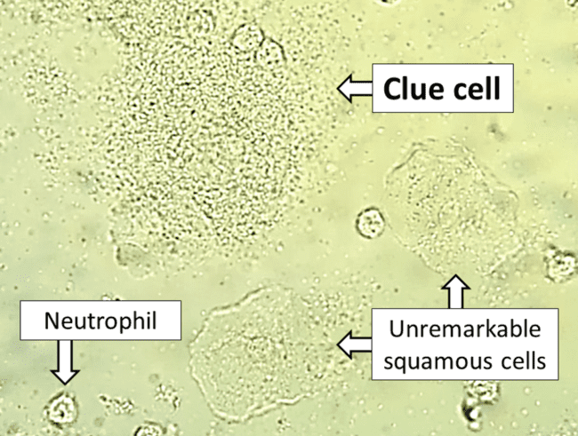
Fig. 15: Clue cell(epithelial cell covered with bacteria) in bacterial vaginosis. Source(CDC)

Laboratory Diagnosis
Nugent's score is a way to diagnose bacterial vaginosis (BV) by looking at a stained sample of vaginal discharge. It counts different types of bacteria present. If the total score is 7 or more, it indicates bacterial vaginosis.

Culture
G. vaginalis necessitates enriched media like chocolate agar or BHI broth with serum for culture. This gram-negative (appearing gram-variable in smears), nonmotile, small pleomorphic rod showcases metachromatic granules. It forms small hemolytic colonies when incubated aerobically under 5% CO2 on blood agar for 24-48 hours.

Identification can be performed using biochemical tests conventionally or automated systems like MALDI-TOF or VITEK based on the colonies formed.
For identification through broad-range PCR amplification of 16S rRNA in vaginal fluid, subsequent methods are employed to pinpoint specific bacterial species.
Treatment
In about one-third of cases, bacterial vaginosis resolves on its own without treatment. Treating the infection might decrease the risk of acquiring other sexually transmitted diseases.
Here are guidelines for treatment:
Who to treat:
Symptomatic females should receive treatment. Treatment is considered safe during pregnancy without any side effects.
Asymptomatic women undergoing abortion or hysterectomy benefit from treatment, lowering the risk of post-operative infection.
Asymptomatic pregnant females with a history of preterm delivery might also benefit from treatment. While studies haven't significantly proven that treating BV reduces preterm birth rates, it's associated with fewer cases of preterm prelabour rupture of membranes(PROM) and low-birthweight in babies these women. Screening women with a history of preterm labor for BV might be considered.
Treatment regimens:
Metronidazole: 500mg is taken two times a daily orally for 7 days or 5g of 0.75% metronidazole gel is used intravaginally once daily for 5 days. Metronidazole shows high early cure rates (>90%) and 80% cure rates at 4 weeks.
Clindamycin: 300mg twice daily orally for 7 days or 100mg clindamycin ovules intravaginally once daily for 3 days. However, clindamycin usage might be linked to acquiring clindamycin-resistant anaerobes. Metronidazole has not shown resistance.
Other agents like tinidazole, secnidazole, and probiotics have been utilized.
Recurrence:
Around 30% of females experience a recurrence within 12 weeks. Prolonged or alternative treatment courses might be necessary for these patients. Some individuals experiencing multiple relapses may benefit from long-term treatment, like twice-weekly intravaginal metronidazole gel. Clindamycin isn't recommended for long-term maintenance.
Treating partners hasn't shown consistent effectiveness in reducing recurrence. Sexual intercourse seems to influence disease activity. Some studies suggest decreased recurrence rates when male sexual partners consistently use condoms or when women remain abstinent.

Trichomonas Vaginalis
Trichomoniasis is a highly prevalent parasitic sexually transmitted infection (STI) caused by a flagellated parasite known as Trichomonas vaginalis. This parasite solely exists in the trophozoite stage, lacking a cyst stage. Within this stage, two forms are observed:
Flagellated trophozoite: This form is both infective and diagnostic in identifying the infection.
Amoeboid trophozoite: It represents the actively replicating form, encountered during the tissue feeding stage of the life cycle
Epidemiology
Trichomoniasis is primarily transmitted through sexual contact, with higher incidence rates seen in females with multiple sexual partners or those already infected with other sexually transmitted infections like HIV. There's a possibility of vertical transmission during childbirth.
While rare, non-sexual transmission, such as through contact with contaminated linens in institutional settings, can occur but is infrequent.
Lifecycle
Asymptomatic females act as reservoirs for trichomoniasis. When humans contract this infection through sexual activity, flagellated trophozoites enter the body and transform into amoeboid forms. These amoeboid forms then multiply within the genital tract, causing infection. Later, they revert to the flagellated trophozoite form, which is then discharged in vaginal or urethral secretions, contributing to the spread of the infection
Clinically
In trichomoniasis, about 25-50% of individuals remain asymptomatic but can still harbor the trophozoites, capable of transmitting the infection. Others may develop symptoms after 4-28 days of incubation.
Acute Infection (Vulvovaginitis): Facilitated with adhesin proteins in attachment to the vaginal epithelium. Females predominantly experience vulvovaginitis, marked by a thin, profuse, foul odor, and purulent vaginal discharge.
The discharge might be frothy (seen in 10% of cases) with a yellowish-green hue, mixed with pus cells.
A "strawberry" appearance (Colpitis macularis) on the vaginal mucosa occurs in about 2% of patients comes with small hemorrhagic spots on the vaginal and cervical mucosa.
Additional symptoms include dysuria and lower abdominal pain.
In males, features are non-gonococcal urethritis and, less frequently, epididymitis, prostatitis, and penile ulcerations.
Chronic Infection: During the chronic stage, the disease tends to be milder, with symptoms such as itching and discomfort during intercourse. Vaginal discharge is typically scanty and mixed with mucus
Trichomoniasis can lead to rare complications, including conditions like pyosalpinx (pus in the fallopian tubes), endometritis (inflammation of the inner lining of the uterus), infertility, low birth weight in newborns, and cervical erosions. Moreover, it heightens the risk of transmitting HIV and HSV-2 infections.
Lab Diagnosis
For diagnosing trichomoniasis in the laboratory, various sample types like vaginal and urethral discharge, urine sediment, and prostatic secretions in males can be examined.
Direct Microscopy: A wet (saline) mount of freshly collected samples needs to be examined within 10-20 minutes of collection. This method demonstrates the characteristic jerky, motile trophozoites of the parasite along with pus cells.(fig. 16) Sensitivity ranges from 40-80%, while specificity can reach up to 100%.
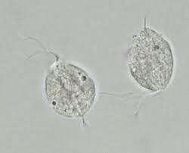
Fig. 16: Wet mount of Trichomonas Vaginalis. Source(University of California, San Francisco – Department of Laboratory Medicine)
Other Staining Methods: Additional staining techniques include permanent stains like Giemsa and Papanicolaou stains, acridine orange fluorescent stain, and the direct fluorescent antibody test (DFA).(fig. 17) The DFA test exhibits higher sensitivity (70-90%) compared to wet-mount examination.
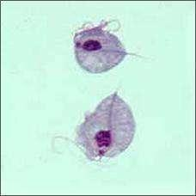
Fig. 17: Trichomonas Vaginalis in Giemsa staining. Source(CDC)
To diagnose trichomoniasis, immediate processing of specimens into media like Lash’s cysteine hydrolysate serum media is recommended. Specific containers for sample collection and culture are done in "InPouch TV".
Culture: Specimens should be cultured and incubated for 3-7 days. The culture fluid is then examined to demonstrate the presence of trophozoites.
Antigen Detection in Vaginal Secretions: Antigen detection methods, like rapid ICT (Immunochromatographic Test) and ELISA, are more sensitive than microscopy and provide indications of recent infection. They utilize monoclonal antibodies.
Antibody Detection: ELISA techniques using whole-cell antigen preparations or aqueous antigenic extracts detect antitrichomonal antibodies in serum and vaginal secretions. However, these antibodies persist over time, making it difficult to correlate between current and past infections.
Molecular Methods: Highly sensitive molecular techniques targeting specific genes of T. vaginalis, such as the beta-tubulin gene, have replaced culture techniques.

Other Diagnostic Tests:
Elevated vaginal pH (>4.5) is observed, but it's not specific as it can also be elevated in bacterial vaginosis. pH remains normal in vaginal candidiasis.
Positive "whiff test": A fishy smell intensifies when 10% KOH is added to vaginal discharge due to the production of amines. This test is positive in over 75% of trichomoniasis infections and is also in bacterial vaginosis.
Increased pus cells on wet mount examination are seen in over 75% of trichomoniasis cases.

Treatment
Metronidazole or tinidazole serves as the primary drug for treating trichomoniasis.
Standard Therapy: A single 2g dose is typically effective. This dosage is considered the standard treatment.
Treatment of Both Partners: It's crucial to treat both sexual partners simultaneously to prevent reinfection, especially considering that males may be asymptomatic carriers.
Resistance and Treatment Failure: Resistance to metronidazole is rare but reported in some cases (2.5-10%). If standard therapy fails, a repeated treatment course, typically lasting 5 days, might be considered.

Gonococcal Urethritis
Neisseria gonorrhoeae is a gram-negative bacterium, often observed in kidney-shaped pairs (diplococci). It causes gonorrhea, a sexually transmitted infection (STI). Gonorrhea commonly presents with manifestations like cervicitis, urethritis, and conjunctivitis.
Epidemiology
Neisseria gonorrhoeae infection is prevalent worldwide. In developing countries, perinatal transmission and neonatal eye infections are significant concerns.
A higher incidence of infection is seen in 20-24 years of males and females 16–19 years of age. Men who have sex with men (MSM) show a higher incidence.
Recent increases in its incidence and the rise of antimicrobial resistance have elevated it to a major public health concern. This combination of increased prevalence and growing resistance to antibiotics makes combating gonorrhea a significant challenge in terms of public health.
Clinically
The incubation period for gonorrhea is 2–5 days. Lower genital tract infections can be without any symptomatic or lead to urethritis in men, causing purulent discharge and dysuria. It can result in endocervicitis with symptoms like vaginal discharge, itch, and dysuria in females(fig. 18)
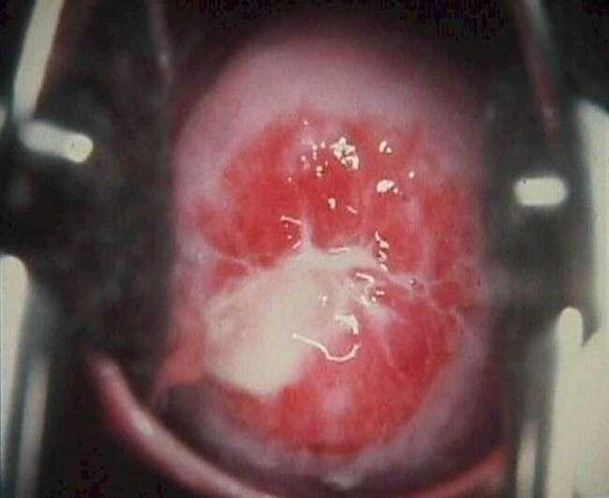
Fig. 18: Purulent discharge in endocervical gonococcal infection.Source(Health Jade)

Although infection occurs in the female but involves the urethra pharynx, and rectum more commonly in homosexual men they usually don't present symptoms and tend to be asymptomatic. Retrograde spread might lead to severe complications such as salpingitis/endometritis, pelvic inflammatory disease (PID), and tubo-ovarian abscesses in about 20% of women with cervicitis. In rare cases, frank peritonitis or perihepatitis (Fitz-Hugh–Curtis syndrome) can occur. In men with gonococcal urethritis, complications like epididymitis or epididymo-orchitis may develop.(fig. 19)
Fig. 19: Gonococcal Urethritis mucopurulent discharge in males. Source(Cambridge University Press)

Disseminated gonococcal infection follows approximately 1% of genital infections, with 75% occurring in women. The risk is higher during menstruation or pregnancy if mucosal infection takes place. Its features include skin rashes, fever, joint pain (arthralgias), migratory polyarthritis, septic arthritis, endocarditis, and meningitis.
Neonates who acquire gonorrheal infection during birth may show symptoms of ophthalmia neonatorum and can develop disseminated infection. In adults, conjunctivitis can also result from direct bacterial contact, posing a risk of blindness if not treated promptly.

Laboratory Diagnosis
Laboratory diagnosis of gonorrhea involves specific specimen collection and various testing methods:

Specimen Collection:
For men, urethral swabs are preferred, collected by cleaning the urethral meatus with saline-soaked gauze and gathering discharge.
Swabs made up of dacron or rayon are recommended the most as cotton and alginate swabs inhibit gonococci growth.
In cases of minimal discharge in chronic urethritis, prostatic massage or collecting the morning secretion is advised.
Transport specimens immediately or use charcoal-coated swabs in specific transport media like Stuart’s or Amies medium, or utilize commercial transport devices.
Microscopy:
In gram staining of urethral exudates it is characteristic of gram-negative intracellular kidney-shaped diplococci. It's highly specific and sensitive in symptomatic males but less reliable in females due to the presence of similar Neisseria species.(fig. 20)
Fig. 20: Gram-negative N.gonorrhoeae. Source(Wikipedia)
Culture:
Endocervical culture, using selective media like Thayer Martin medium, shows a sensitivity of 80–90%.
Blood and synovial fluid cultures are essential in the diagnosis of Disseminated Gonococcal Infection (DGI).
Identification:
Species identification is crucial to distinguish gonococci from other normal commensal flora of Neisseria species. Gonococci are catalase and oxidase positive and ferment glucose but not maltose or sucrose.
Automated systems like MALDI-TOF can aid in identification.
Molecular Methods:
PCR targeting specific genes (like 16s or 23s rRNA) are available for detecting N. gonorrhoeae in clinical specimens. These tests are highly sensitive and specific.

Treatment
Treatment for gonorrhea is recommended in various scenarios:
Indications for Treatment:
Detection of Gram-negative intracellular diplococci on genital tract smear microscopy.
Positive culture or PCR results for N. gonorrhoeae from any site.
Recent sexual partners of confirmed infected cases.
Consideration based on epidemiological grounds in sexual assault cases.
Antibiotics:
First-line therapy typically comprises ceftriaxone 500mg as a single intramuscular (IM) dose combined with azithromycin 1g orally, also taken as a stat dose.
Alternative regimens is with cefixime 400mg orally as a stat dose (although treatment failures have been reported), spectinomycin 2g as a single IM dose, cefotaxime 500mg as a single IM dose, cefoxitin 2g as a single IM dose (with probenecid 1g orally), cefpodoxime 200mg orally as a single dose, and quinolones (e.g., ciprofloxacin 500mg orally as a single dose) not recommended except for confirmed sensitive infections.

References
- Torok, E., Moran, E., & Cooke, F. (2016). Oxford handbook of infectious diseases and microbiology. Oxford University Press.
- Kasper, D., & Fauci, A. (2013). Harrison’s infectious diseases, 2/E (2nd ed.). McGraw-Hill Professional Publishing.
- Sastary A, Bhat S. (2019). Essential of Medical Microbiology, 2/E (2nd ed.).Jaypee Brother Medical Publishers
- Jayaram Paniker, R. A. C. (2020a). Ananthanarayan and Paniker’s textbook of microbiology. Universities Press.

